ANTIBACTERIAL EFFECT OF TANNASE PRODUCING BACTERIA - ISOLATED FROM GOAT FAECAL SAMPLE

B. Aruna, Assistant Professor,
Department of Microbiology, St. Francis College for Women,
Begumpet, Hyderabad-500016, Telangana State, India
kaviliaruna@sfc.ac.in

Aarthi Kunwar Rathore, Post Graduate Student
Department of Microbiology, St. Francis College for Women,
Begumpet, Hyderabad-500016, Telangana State, India

aarthi.rathore855@gmail.com

ABSTRACT
The faecal samples of goat were used to isolate tannase producing bacteria. The tannase producing isolates (T1 and T2) were identified as Corynebacterium xerosis and Corynebacterium kutser. The tannase activity found to be, 15.2 U/mL (T1 isolate) and 16.5 U/mL (T2) at 37ºC; 16.2 U/m L (T1) and 16.1 U/mL (T2) at pH 8 by using tannin as a substrate. The tannase activity was maximum at 37ºC and pH 8. The activity of Tannase of the isolates was confirmed by detection of gallic acid by TLC (Thin layer chromatography) and glucose by DNS (3, 5-Dinitrosalicylic acid) method. The T2 Tannase showed antibacterial activity with gram-positive and gram-negative bacteria. Tannins are found in industrial effluents that are toxic to the plant. Tannase producing bacteria that degrade tannins, reduce the toxic effect of tannins towards plants in contaminated environments and help in plant growth.

Keywords: Tannase; Tannase activity; Corynebacterium; Gallic acid; Antimicrobial activity

I. INTRODUCTION
Tannase, also known as tannin acyl hydrolase, microbial enzyme that can be induced under specific conditions. Its primary function is to catalyze the hydrolysis of ester and depside bonds found in gallo-tannin, epigallocatechin-3-gallate, gallic acid esters and other hydrolysable compounds, tannins are hydrolyzed to gallic acid and glucose. The fungi, bacteria, and yeast produce Tannase. The tannins exhibit antimicrobial property (1), they can also act as a source of nutrients or substrate for certain microbes. The microorganisms utilize tannins with the help of hydrolytic enzyme called Tannase. With a composition of glucose and gallic acid in a 1:9 ratio, tannic acid forms a heteropolymer known for its diverse commercial uses. Tannin serves as a crucial factor impacting tannase activity and industrial bioconversion of tannic acid is achieved with Tannase (2). Gallic acid plays a crucial role in the field of food and pharmaceutical industries (3) due to its diverse applications. Propyl gallate, is an antioxidant, produced by using Gallic acid as precursor. Gallic acid is also used as intermediary compound in the synthesis of trimethoprim, an antibacterial drug used in the pharmaceutical field. The researchers have discovered a connection between tannase-producing bacteria and colon cancer, suggesting the potential of bacterial tannase as a biomarker in detection of colon cancer (4, 5). Tannase enzymes have proven to be valuable hydrolyzing agents, helping in the removal of highly polluting tannins from the effluent generated by the leather industry. The widespread industrial applications of tannase in fields such as food, beverage, pharmaceuticals, and bioremediation have elevated its status as one of the most significant enzymes in current research. Tannase is also used in the preparation of wine (6).
Tannase, can be extracted from diverse sources, microbes, plants, and animals. Plant sources include leaves, branches, and bark, while animal sources are bovine stomachs and ruminal mucous. However, the most significant and preferred source for obtaining this enzyme is through microbial means, as the produced enzymes demonstrate superior stability compared to those obtained from other sources (4).
Bacteria: Over the past 25 years, researchers have successfully isolated numerous bacterial strains exhibiting tannase activity. Several of these strains have shown promising potential for various applications in industries such as food, pharmaceuticals, and biotechnology. The species that belong to the genus Bacillus, Lactobacillus, Staphylococcus, Serratia, Pseudomonas and some of the genera falling in the Enterobacteriaceae family are identified as Tannase producers (7, 8).
Fungi: The species that belong to the genus Aspergillus, Penicillium, Trichoderma, Fusarium, Paecilomyces and Rhizopus identified as Tannase producers (7).

II. MECHANISM OF TANNASE ACTION

Tannase (tannin acyl hydrolase, E.C.3.1.1.20) is an extracellular hydrolase enzyme that catalyzes the hydrolysis of ester and depside bonds in hydrolysable tannins or gallic acid esters, liberating glucose and gallic acid (GA) (9, 10, 7, 11). The Figure 1, below illustrates the bonds that are hydrolyzed by tannase. The condensed tannins cannot be hydrolyzed by tannase. Tannase is capable of hydrolyzing hydrolysable tannins. Hydrolysable tannins, also known as gallotannins. These compounds are polyphenolic in nature and consist of glucose or other sugar molecules esterified with gallic acid. Hydrolysable tannins can be broken down through hydrolysis, a chemical reaction that involves the cleavage of the ester bonds, leading to the release of gallic acid and other hydrolyzable components by tanaase.

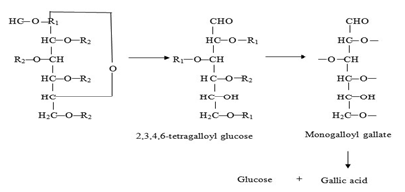

Figure 1: Hydrolysis pathway of tannic acid by tannase
(Source: https://www.biotech-asia.org/vol5no1/tannase-enzyme-the-most-promising-biocatalyst-for-food-processing-industries/)

Tannase, derived from different sources, shows variations in molecular masses. For example, in fungi and yeasts, tannase exists as glycoproteins and often forms hetero- or homo-oligomers comprising two to eight subunits. On the other hand, bacterial tannases are found as monomers, lacking complex structures (11). The enzyme's dual activities contribute to its broad substrate specificity, which depends on the source and production methods employed for isolation (10, 11). Besides its bi-functional nature, tannase also exists in the form of isoenzymes. It exhibits hydrolytic activity towards various substrates, such as methyl gallate, propyl gallate, digallic acid, epicatechin gallate, and epigallocatechin gallate, releasing gallic acid (12). Furthermore, tannase acts on ellagitannins like rosacyanin or phyllanemblinin, selectively hydrolyzing the galloyl moieties, resulting in the production of gallic acid and degalloylated ellagitannins (13).
Tannases are members of the serine esterases family, known for their catalytic triad that includes a crucial serine residue within the conserved pentapeptide motif (-Gly-X-Ser-X-Gly-). This serine residue plays a fundamental role in their catalytic activity (10, 11).The enzyme's mechanism of action was extensively described by Ren et al. (2013) for the Lactobacillus plantarum tannase.

III. APPLICATION OF TANNINS IN VARIOUS INDUSTRY

Tannins, naturally occurring polyphenolic compounds, find applications in various industries due to their diverse properties:

A. In the food and beverage industry, tannins play an important role in winemaking, contributing to the color, flavor, and mouthfeel of wines. They are also utilized in brewing, imparting astringency and stabilizing proteins. Moreover, tannins serve as natural food additives due to their antioxidant properties and act as preservatives in food products.

B. Tannins have a long history of application in the leather industry, used to convert animal hides into leather. By binding to collagen fibers, tannins enhance the leather's durability, flexibility, and resistance to decay.

C. In the pharmaceutical industry, tannins are highly valued for their antimicrobial, anti-inflammatory, and antioxidant properties. These properties make them valuable components in the development of pharmaceutical products. Tannins have been used in traditional medicine for various purposes, including wound healing, diarrhea treatment, and managing different ailments.

D. In the textile industry, tannins find application as natural dyes or mordants to enhance the colorfastness of textiles. They offer a wide range of rich and vibrant colors, making them suitable for use with both natural and synthetic fibers.

E. Tannins prove highly effective in water treatment processes, used for the removal of organic matter and heavy metals. As natural coagulants and flocculants, they play a crucial role in purifying water, serving industries such as municipal water treatment and wastewater management.

F. Within the wood and paper industry, tannins serve various purposes. They are essential components in wood adhesives, contributing to improved bonding properties. Additionally, tannins find application in the paper manufacturing process as natural dispersants and fillers, enhancing the quality and strength of paper products.

G. The cosmetics and personal care industry utilizes tannins for their astringent properties. In skincare products, they effectively tighten pores, regulate excess oil, and provide a toning effect on the skin, making them valuable additions to cosmetic formulations.

H. Tannins and their derivatives demonstrate remarkable antibacterial properties, effectively targeting a wide range of bacteria, Aeromanas, Bacillus, Clostridium, Enterobacter, Helicobacter, Klebsiella, Proteus, Pseudomonas, Shigella, Escherichia, Staphylococcus, Streptococcus and fungi, Aspergillus, Coniophora, and Penicillium. The ability of tannins to bind with urinary tract epithelium and intestinal epithelium prevents the attachment of disease-causing organisms, contributing to their antibacterial action.
Tannic acid is used as an inhibitor and immunomodulatory agent against multidrug-resistant bacteria (MDR). The antibacterial property of tannins have been studied not only in animals but also in plants. One of the study involved the use of a crude methanol extract from Sapium baccatum to combat Ralstonia solanacearum, the causal agent of bacterial wilt in tomatoes. This extract mainly contains gallic acid, methyl gallate, corilagin, tercatain, chebulagic acid, chebulinic acid, and quercetin 3-O-α-L-arabinopyranoside, all of which exhibit robust antibacterial activity, with the exception of one tannin-based product, quercetin 3-O-α-L-arabinopyranoside. These findings highlight the significant potential of tannins and their derivatives as potent antibacterial agents, applicable in both animal and plant systems.

IV. MATERIAL AND METHODS

A. Tannase Producing Bacteria - Isolation and Screening
The goat faecal samples were collected, serially diluted, and inoculated on TAA (Tannic acid agar medium) and incubated at 37ºC for 96 hours. The isolate that produces tannase has the ability to hydrolyze tannic acid in the medium. The hydrolysis of tannin around the colonies was identified as zone of clearance by flooding the TAA plates with Gram’s iodine instead of FeCl₃ (14). The Gram’s iodine produces a dark brown complex with tannic acid but not with hydrolysed tannic acid and giving a sharp distinct zone around the tannase producing colonies.

B. Identification of tannase producing bacteria
To identify tannase-producing bacteria, the isolated microorganism was cultured again on nutrient agar medium. Observations were made regarding colony characteristics, size, shape, texture, consistency, and transparency. Further, Gram nature of the isolates was studied. The biochemical tests, such as the Indole test, Methyl red test, Voges-Proskauer test, Triple sugar iron (TSI) agar test, and Carbohydrate utilization test, were performed to analyze the characteristics of the isolate.

C. Tannase Estimation by Folin lowry method
The isolate that exhibited the largest zone in TAA (Tannic Acid Agar) plate was selected for further analysis. It was inoculated into a 50 ml broth containing tannic acid as substrate, incubated at 37ºC for 24 hours. After incubation, the culture was subjected to centrifugation and the supernatant was used as the crude enzyme for the study of tannase assay by colorimetric method. The concentration of Tannase in the culture supernatants of isolates were estimated by Folin lowry method (1951), using BSA (Bovine serum albumin) as Standard (15) with a concentration of 0.1 mg/ ml.

D. Thin Layer Chromatography - Analysis of Gallic Acid
The tannase hydrolyzes, tannin to glucose and gallic acid. The active culture of isolates was inoculated into Nutrient broth containing Tannic acid and incubated for 24 – 48 hours. The culture was subjected to centrifugation, and the presence of the gallic acid in the culture supernatant of isolates was detected by Thin Layer Chromatography (TLC). The solvent system consisting of ethyl acetate: chloroform: acetic acid in a ratio of 50:50:1 was used for the detection of gallic acid of two isolates and pure gallic acid (standard) by TLC. The Rf (Retention factor) value of gallic acid of isolate culture supernatants and the standard (pure gallic acid) was calculated by using the following formula:
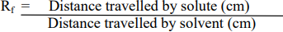

E. Detection of Glucose by DNS Method
The concentration of glucose for respective isolates was estimated by DNS (3, 5-Dinitrosalicylic acid), by using glucose as standard (1 mg/ ml).

F. Temperature and pH effect on Tannase activity and determination of glucose by DNS method
The activity of Tannase was determined by estimating glucose liberated using DNS method. To 1 ml of culture supernatant (crude enzyme), 1 ml of acetate buffer (0.1M) of pH 7.0, 1ml of tannic acid (0.5%) as substrate was added and incubated for 15 min at 5°C, 27°C, 37°C, 48°C respectively; 0.5 ml of DNS was added to all the respective labelled test tubes; the test tube contents were mixed and incubated for 10 min in a boiling water bath; cooled to room temperature; 0.5 ml of distilled water was added to all tubes, contents were mixed and absorbance was recorded at 540 nm.
Tannase activity was determined by estimating the glucose liberated using DNS method. To 1 ml of supernatant (crude enzyme), 1ml of tannic acid (0.5%) as substrate and 1 ml of acetate buffer (0.1M) adjusted pH to 4.0, 5.0, 6.0 and 8.0 was added to respectively labelled test tubes; the test tube contents were mixed and incubated for 10 min in a boiling water bath; cooled to room temperature; 0.5 ml of distilled water was added to all tubes, contents were mixed and absorbance was recorded at 540 nm.
The activity was tannase was calculated by using the formula:
Enzyme Activity = (Amount of Product formed) / (Time) / (Volume of enzyme solution)

G. Antibacterial activity of tannase
The agar well diffusion method was used to observe the antimicrobial activity. The active culture (indicator organism) was spread evenly over the entire surface of the agar plate. The wells (with a diameter of 6 to 8 mm) were made aseptically with a sterile cork borer and a volume (20 µl) of the culture supernatants (T1 and T2) were added into respective labelled wells. The plates were incubated at 37°C for 24 hr. The antimicrobial agent, tannase, diffuses into the agar medium and inhibits the growth of the indicator organism.

V. RESULTS AND DISCUSSION

A. Tannase Producing Bacteria - Isolation and Screening
The six isolates were obtained from goat faecal samples, showed tannic acid hydrolysis on Tannic acid agar medium (TAA) plates. Out of six isolates T1 and T2 exhibited maximum zone (25 mm) of tannic acid hydrolysis, were selected for further study. The Bacillus subtilis showed clear zone of clearance after 72 hr of incubation on TAA (8); tannase producing bacteria were isolated from tannin rich sources (16) and these studies were in correspondence with the present data.
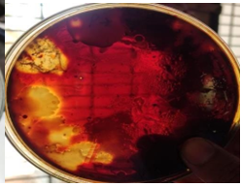

Figure 2: Tannic acid hydrolysis by T1 & T2 bacterial isolate detected by addition of iodine

B. Identification of isolates
The cultural, morphological and biochemical properties of isolates (T1 & T2) were studied (Figure 3, Figure 4 and Table 1). The colony of T1 was large in size, irregular, wavy, opaque and cream in colour with moist consistency. The T1 and T2 isolates were gram positive and non-motile. T1 isolate was positive for MR test, fermentation (glucose, maltose and lactose) test (Table 3); triple sugar iron test and citrate test. The T2 isolate colony was medium in size, round, smooth, opaque and cream in colour with moist consistency. T2 isolate was positive for MR test and fermentation (glucose and lactose) test; negative for maltose fermentation test and citrate test. Both the isolates (T1 and T2) were positive for indole test and negative for Voges Prauskauer test (Table 2, Figure 5). Based on cultural, morphological, biochemical properties and Bergey’s Manual of Systematic Bacteriology, isolates were identified as Corynebacterium xerosis (T1) and Corynebacterium kutseri (T2). The Corynebacterium striatum III B 8914 (17) isolated from tea waste dump soil site was positive for MR test, the results were in accordance with the present data.

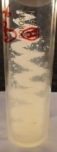
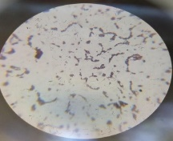

Figure 3: T1 Isolate - Growth on nutrient agar slant and
Microscopic view – Gram positive short rods
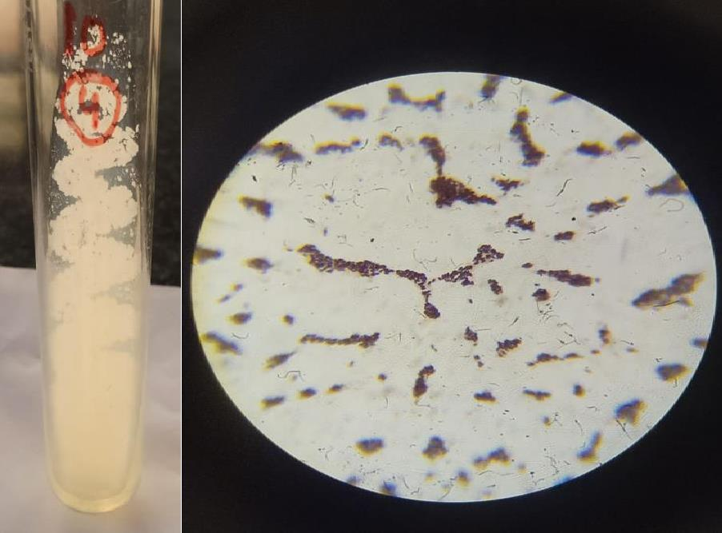

Figure 4: T2 Isolate - Growth on nutrient agar slant and

Microscopic view – Gram positive short rods

Table 1: Colony morphology and Gram nature studies of isolates

Isolate | Colony  characters | Morphological characters
 |  | Gram nature, Shape of the cell | Endospore | Acid fast | Motility | Identification
T1 | Large, Irregular, Opaque, Moist Cream colour | Positive, short rods | - | - | - | Corynebacterium xerosis
T2 | Medium in size, Round, Smooth, Opaque, Cream colour, Moist consistency | Positive, short rods | - | - | - | Corynebacterium kutseri

Table 2: Biochemical tests
Biochemical Test | T1 Isolate | T2 Isolate
Indole | - | +
Methyl red | + | +
Voges Proskauer | - | -
Citrate | + | -
Catalase | + | +
Oxidase | - | -
Starch | - | +
H₂S | - | -
Urease | - | +

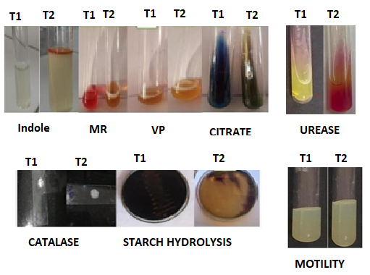

Figure 5: Biochemical tests

Table 3: Carbohydrate fermentation tests

Isolate | Glucose |  | Lactose |  | Mannitol
 | Acid | Gas | Acid | Gas | Acid | Gas
T1 | +ve | +ve | -ve | -ve | +ve | +ve
T2 | +ve | -ve | +ve | +ve | +ve | +ve
+ve: Positive, -ve: Negative,

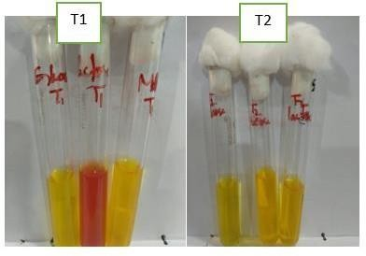

Figure 4.5: Carbohydrate fermentation tests

C. Estimation of tannase by Folin Lowry method
The maximum tannase production was observed in T2 isolate, 0.61mg/ml compared to T1 isolate, 0.49 mg/ml (Figure 6). The study result was in accordance with purification method of tannin acyl hydrolase and maximum tannase production (0.61mg/ml) was by Bacillus subtilus (18).

Figure 6: Estimation of tannase by Folin Lowry method

D. Thin Layer Chromatography – Gallic Acid detection
The Rf value of T1 isolate was 2.2; T2 isolate was 2.4 and standard (pure Gallic acid) was 2.5 (Figure 7). The Rf value of isolates was nearer to the standard (pure Gallic acid). The study showed that the isolates were producing Tannase, hydrolyzed tannic acid to Gallic acid. The Rf value of tannic acid produced by Bacillus megaterium was 0.90 and standard gallic acid was 1.0 (19), this investigation was in correspondence with the present data.

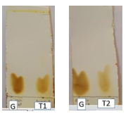

Figure 7: Thin layer chromatography of gallic acid by isolate T1 and T2
G: Gallic acid

E. Detection of glucose by DNS method
The concentration of glucose produced by hydrolysis of tannic acid was estimated by DNS method and it was observed as 0.32 mg/ml by T1 isolate and 0.31mg/ml by T2 isolate (Figure 8). The tannase assay was studied by spectrophometrically and concentration of glucose produced by hydrolysis of tannase was estimated as 0.35mg/ml (20), which was correspondence to the present data.

Figure 8: Detection of glucose by DNS method

F. Temperature and pH effect on Tannase activity and determination of glucose by DNS method
The T2 isolate showed maximum tannase activity, 16.5 U/mL at 37ᴼC (Figure 9). The maximum tannase activity was at 37 °C (21) and at 30°C (22). The maximum tannase activity was observed at pH 8 (Figure 10) with both the isolates T1 (16.2 U/mL) and T2 (16.1 U/mL). The optimum tannase activity was observed at pH of 7 (21, 23) and pH of 6 (21, 23).

Figure 9: Effect of Temperature on Tannase activity

Figure 10: Effect of pH on Tannase activity

G. Antibacterial activity of Tannase
The Staphylococcus aureus showed maximum sensitivity, E. coli showed least sensitivity, Pseudomonas sp and Proteus sp were resistant to tannase of T2 isolate. The indicator organisms were resistant to tannase of T1 isolate The Staphylococcus aureus and Bacillus sp showed maximum sensitivity to tannase produced by Citrobacter sp (24).

Zone of inhibition (mm)
Indicator organism | T1 | T2
E.coli | - | 0.2
Pseudomonas sp | - | -
Staphylococcus aureus | - | 0.6
Bacillus sp | - | 0.5
Klebsiella sp | - | 0.4
Proteus sp | - | -

Figure 10: Antibacterial activity of Tannase

VI. CONCLUSION

The bacterial isolates were isolated from goat faecal sample and investigated for having natural property of degrading Tannin. Out of six isolates, two (T1 and T2) showed the property of degrading Tannin. The isolates were identified as Corynebacterium xerosis and Corynebacterium kutseri, based on morphological, biochemical characteristics and Bergey's Manual of Systematic Bacteriology. The temperature played a major role in tannase production. The T2 isolate showed maximum tannase activity (16.5 U/mL) at 37ºC for 15 mins of incubation period. The T2 and T1, both showed maximum tannase activity (16.2 U/mL and 16.1 U/mL) at pH 8 for 15 min of incubation period.

REFERENCES
[1] Bhat, T. K., Singh, B. and Sharma, O. P. (1998). Microbial degradation of tannins-A current perspective. Biodegradation. 25: 343-357.
[2] Mondal, K. C., Banerjee, D., Jana, M. and Pati, B. R. (2001). Colorimetric assay method for determination of tannin acyl hydrolase (E.C. 3.1.1.20)
activity. Anal Biochem 295: 168-171.
[3] Pourrat H, Regerat F, Morvan P, Pourrat A. (1987). Microbiological production of gallic acid from Rhus coriaria L. Biotechnol. Lett. 9: 731-734.
[4] Lekha, P.K., Lonsane, B. K. (1997). Production and application of tannin acyl hydrolase: state of the art. Adv. Appl. Microbiol. 44: 215-260.
[5] Das Mohapatra, P.K., Mondal, K. C. Pati, B. R., Halder, S. K., Maity, C. and Jana, A. 2012). Rapid screening of tannase producing microbes by
using natural tannin. Braz. J. Microbiol. 43(3):1080-1083
[6] Koichi, Y. and Tokuji, T. (1972). Wine making using Tannase in fermentation process, Japanese patent 2224100.
[7] Belur, P. D., Gopal, M., Nirmala, K. R and Basavaraj, N. (2010). Production of novel cell-associated tannase from newly isolated Serratia ficaria
DTC. Journal of Microbiology and Biotechnology. 20(4): 732-736.
[8] Jana, A., Maity, C., Halder, S.K., Mondal, K.C., Pati, B.R.and Mohapatra, P.K.D. (2013). “Enhanced tannase production by Bacillus subtilis PAB2
with concomitant antioxidant production”. Biocatalysis Agricultural Biotechnology, 2: 363-371.
[9] Haslam, E. and Stangroom, J. E. (1966). The esterase and depsidase activities of tannase. Journal of Biochem. 99: 28-31.
[10] Rodriguez-Dur´an, L. V., Valdivia-Urdiales, B., Contreras-Esquivel, J. C., Rodriguez- Herrera, R. and Aguilar, C.N. (2011). Novel
Strategies for Upstream and Downstream Processing of Tannin Acyl Hydrolase. Enzyme Research. 823619.
[11] Ren, B., Wu, M., Wang, Q., Peng, X., Wen, H., McKinstry, W.J. and Chen, Q. (2013). Crystal structure of Tannase from Lactobacillus
plantarum. Journal of Molecular Biology. 425: 2737-2751.
[12] Curiel, J. A., Rodriguez, H., Acebrion, I., Mancheno, J. M., de Blanca Rivas, L. and Munoz, R. (2009). Production and physicochemical
properties of recombinant Lactobacillus plantarum tannase. Journal of Agricultural and Food Chemistry. 57 (14): 6224-6230
[13] Lu, M. J. and Chen, C. (2007). Enzymatic tannase treatment of green tea increases in vitro inhibitory activity against N-nitrosation of
dimethylamine. Process Biochemistry. 42: 91285–1290.
[14] Rakesh Kumar., Ashwani Kumar., Ravinder Nagpal., Jitender Sharma and Anju Kumari. (2010). A novel and sensitive plate assay for screening
of tannase-producing bacteria. Annals of Microbiology. 60: 177-179.
[15] Lowry, O. H., Rosebrough, N. J., Farr, A. L., Randall, R. J. (1951). Protein measurement with the Folin phenol reagent. J Biol Chem.193(1): 265-
75.
[16] Hamada A. Abou-Bakr., Malak A. El-Sahn and Amr A. El-BannaInt. (2013). International Journal of Agricultural and Food Research. 2 (3): 1-
12.
[17] Dave, A., Modi., H.A., Chavada, N. (2011). Study and isolation of tannase enzyme production bacteria from tea waste dump soil site. Int. J. Pharm.
Appl. Sci. 2(1): 20-22.
[18] Iibuchi, S., Monida, Y. and Yamada, K. (1967). Studies on tannin acylhydrolase of micro-organisms Part III. Purification of enzyme and some
properties of it. Agr. Biol. Chem. 32: 803-809.
[19] Archana D. Tripathi, Kajal Sharma and Lakshmi B. (2016). Study on Tannase Producing Bacillus megaterium Isolated fromTannery Effluent. Int.
J. Adv. Res. Biol. Sci. 3(7): 28-35.
[20] Sharma, S., Bhat, T.K. and Dawra, R.K. (2000). A Spectrophotometric Method for Assay of Tannase using Rhodonine. Analytical Biochemistry.
278: 8589.
[21] Selwal, M.K., Yadav, A., Selwal, K.K., Aggarwal, N.K., Gupta, R. and Gautam, S.K. 2010. Optimization of culture conditions for tannase
production by Pseudomonas aeruginosa III B 8914 under submerged fermentation. Wolrld J. Micrbiol. Biotechnol. 26: 599-605.
[22] Kumar, R. A., Gunasekaran, O. and Lakshmanan, M. (1999). Biodegradation of tannic acid by Citrobacter freundii isolated from tannery
effluent. Journal of Basic Microbiology. 39:161-168
[23] Mondal, K.C., Banerjee, D., Banerjee, R and Pati, B.R. (2001). Production and characterization of tannase from Bacillus cereus KBR9. The
Journal of general and applied microbiology.47: 263-267.
[24] Wilson, P.A., Rojan, P.J., Kumar, P. and Sabu, T. (2009). Tannin Acyl Hydrolase Production by Citrobacter species isolatedfrom Tannin rich
Environment, using Tamarindus indica seed, powder. Journal of Applied Sciences and Environmental Management.13: 95-97.

