IMPACT OF CLIMATE CHANGE ON BUMBLEBEES
Babita kaushal, Meena Thakur, Diksha devi and Deepali Bakshi

Introduction
Bumblebees are highly efficient pollinators because of their unique characteristics. They can "buzz pollinate" certain plants, which involves vibrating their flight muscles to dislodge pollen from flowers that are difficult for other pollinators to access. This technique is particularly beneficial for crops like tomatoes, eggplants, peppers, and blueberries, which rely on buzz pollination for optimal fruit set. These are large, furry and hard-working bees that thrive best in temperate regions of the world. Bumblebees pollinate several important fruit and vegetable crops. Bumblebee pollination services are important in maintaining many agricultural crops and natural habitats. Bumblebees possess several benefits as they increase the quality of produce, increases yield, provide pollination throughout the year, ability to pollinate in enclosed & open area, are exceptional pollinator of greenhouse-grown crops, are easy to apply and are low maintenance. As a result of climate change, temperatures are anticipated to increase significantly, especially in higher elevations and latitudes [1]. Climate change has an impact on biodiversity's spatial distribution, often moving species towards greater elevations and latitudes [2]. Overall, probable variations in range shifts at high elevations involve the extinction of populations at lower elevations and the colonization of higher elevations by more species.

How climate change is affecting bumblebees?
Climate change has significant impacts on bumblebees, just as it does on many other species. Bumblebees are crucial pollinators, playing a key role in the reproductive success of various plants and crops. There are several effects of climate change, including increased temperatures, fewer cycles of frost and flowering seasons, less snow cover, higher levels of drought, and more. Climate change can lead to timing mismatches between bees and flowering times. Bumble bees are frequently more in danger in the warmer regions of their ranges because of their intolerance for extremely hot weather. However, they are vulnerable to changes in their environment, and the effects of climate change can disrupt their life cycles and habitat, leading to several adverse consequences:

- Shift in the geographic range: As temperatures rise, bumblebees may face challenges as they try to adapt to their changing environment. Some bumblebee species might find their historical habitats unsuitable due to increasing temperatures, while others might expand into new regions that were previously too cold for them. This could lead to changes in the distribution of bumblebee populations [3]. If elevation continues to rise, the more generalist bumblebees (habitat use and flower visits) will probably start sharing the same area as the more specialized species, resulting in a decline in specialist species abundance [4].

- Decline in species richness: Bumblebees are at a high risk of becoming extinct due to climate change, hence efforts must be made to manage habitats to decrease exposure to the increasing frequency of temperatures which are high compared to the species tolerances. In regions of North America and Europe where the rising frequency of climatic conditions surpassed the tolerances of the species, the diversity of bumble bee species decreased [5].

- Altered flowering patterns: Bee populations may be impacted by climate change directly through changes to survival and reproduction or indirectly through resource changes. It can cause shifts in the timing and duration of flowering in plants, impacting the availability of nectar and pollen for bumblebees. If the timing of flowering and bumblebee emergence becomes mismatched, it can disrupt the critical relationship between bees and plants, leading to reduced reproductive success for both. Aspects of flower phenology varied throughout a 43-year period in ways that point to species-specific impacts on bees. According to studies, bee population responses to climate change may be significantly influenced by changes in the phenology of floral resources caused by the climate [6].

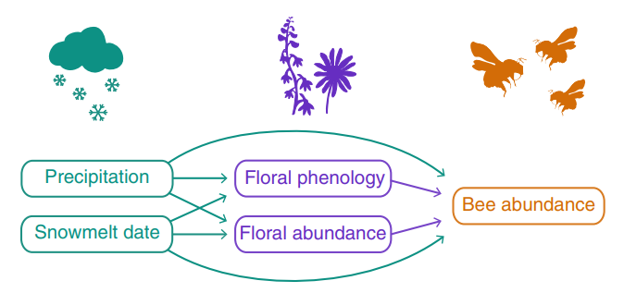
Fig.1. Path diagram displaying all proposed direct and indirect connections between climate, flower, and bumblebee abundance variables [6].

- Plant-pollinator mismatch: Major threats to biodiversity include global warming, which affects both species and interactions among them. The mutual dependence among pollinators and the host plants is a basic ecological connection in terrestrial ecosystems. When species do not co-occur due to climate change, mismatches in space and time might result. Changes in host receptivity and foraging patterns, morphological changes, and changes in the nutritional value of plant resources can all contribute to this. which extent the inconsistencies do exist.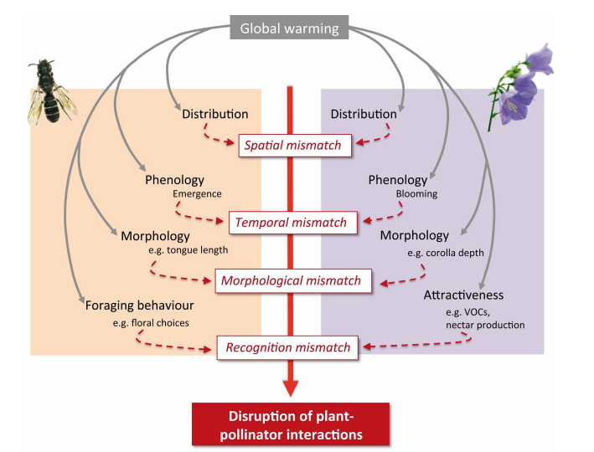
Fig2. Potential effects of climate change on the relationship between plants and pollinators [8].

- Functional mismatch: Mutualisms develop as a result of functional features matching between partners, including plant flower tube depth and pollinator tongue length. Shorter-tongued pollinators are broader, while long-tongued pollinators engage in flowers having deep corolla tubes. Climate change-related guild losses could destabilize mutualisms and endanger partner species. According to a study, tongue length reductions have been evolving in two species of alpine bumble bees for the past 40 years. The imbalance between shorter-tongued bees and the deep corolla flowers they originally pollinated resulted from declining floral resources brought on by warmer summers favoring generalist foraging [7].
- Changes in behavior and phenology: Bumblebees rely on environmental cues, such as temperature and day length, to time their life cycle events, like hibernation, emergence, and nesting. With climate change altering these cues, bumblebees may experience mismatches between their internal clocks and the availability of resources, affecting their ability to find food and establish new colonies [8].
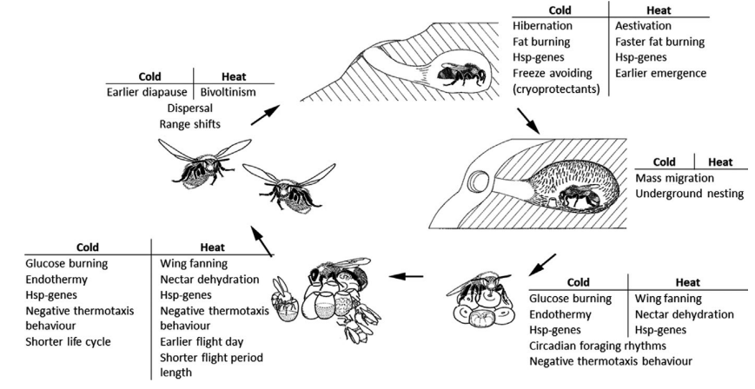
Fig.3 Five stages make up the life cycle: hibernation by the queen, nesting by the queen, colony development, worker foraging, new queens, and male emergence (Drossart et al, 2019) [9].

- Increased vulnerability to diseases and parasites: Warmer temperatures may facilitate the spread of diseases and parasites that affect bumblebees. Pathogens and pests that were previously limited to certain regions due to colder climates may now thrive in new areas, posing additional threats to already stressed bumblebee populations.

- Reduced genetic diversity: Climate change can create isolated populations of bumblebees, limiting gene flow between groups. Reduced genetic diversity can make populations more vulnerable to environmental challenges and less adaptable to changing conditions.

- Extreme weather events: Extreme weather events like heatwaves, droughts, and storms could become more frequent and more intense as a result of climate change. These events can directly impact bumblebee populations by destroying their nests, disrupting foraging, and causing mortality.

- Loss of habitats: Changes in temperature and precipitation patterns can lead to shifts in plant communities, affecting the availability of suitable nesting sites and food sources for bumblebees. Additionally, human activities, such as land-use changes and driven by climate change, can further fragment and degrade bumblebee habitats. urbanization

What can we do to conserve bumblebees?
Habitat conservation: Conserve and create high-quality bumble bee habitats in your local area. The greatest strategy to preserve bumblebee numbers and, ideally, reverse population trends is to protect, restore, enhance, and create new bumble bee habitats. Food resource conservation: Plant indigenous floral plants, particularly ones that can withstand drought and frost. Ensure you have a diverse plant selection, providing both early and late blooming nectar and pollen sources.
Overall, the combined effects of climate change on bumblebees can lead to population declines and potential extinctions, which can have cascading effects on ecosystems and agriculture, as many plants depend on bumblebees for pollination. Conservation efforts, including habitat protection, restoration, and climate change mitigation, are essential to support bumblebee populations and their critical role in ecosystems.

References:
- IPCC. 2014 Contribution of Working Groups I, II and III to the Fifth Assessment Report of the Intergovernmental Panel on Climate Change. In Climate change 2014: synthesis report (ed. IPCC). Geneva, Switzerland.
- Bellard C, Bertelsmeier C, Leadley P, Thuiller W, Courchamp F. 2012 Impacts of climate change on the future of biodiversity. Ecol. Lett. 15, 365–377.
- Marshall, L., Perdijk, F., Dendoncker, N., Kunin, W., Roberts, S. and Biesmeijer, J.C., 2020. Bumblebees moving up: shifts in elevation ranges in the Pyrenees over 115 years. Proceedings of the Royal Society B, 287(1938), p.20202201.
- MacLean SA, Beissinger SR. 2017 Species’ traits as predictors of range shifts under contemporary climate change: a review and meta-analysis. Glob. Change Biol. 23, 4094–4105.
- Soroye, P., Newbold, T. and Kerr, J., 2020. Climate change contributes to widespread declines among bumble bees across continents. Science, 367(6478), pp.685-688.
- Ogilvie, J.E., Griffin, S.R., Gezon, Z.J., Inouye, B.D., Underwood, N., Inouye, D.W. and Irwin, R.E., 2017. Interannual bumble bee abundance is driven by indirect climate effects on floral resource phenology. Ecology letters, 20(12), pp.1507-1515.
- Miller-Struttmann, N.E., Geib, J.C., Franklin, J.D., Kevan, P.G., Holdo, R.M., Ebert-May, D., Lynn, A.M., Kettenbach, J.A., Hedrick, E. and Galen, C., 2015. Functional mismatch in a bumble bee pollination mutualism under climate change. Science, 349(6255), pp.1541-1544.
- Gérard, M., Vanderplanck, M., Wood, T. and Michez, D., 2020. Global warming and plant–pollinator mismatches. Emerging topics in life sciences, 4(1), pp.77-86.
- Drossart, M., Rasmont, P., Vanormelingen, P., Dufrêne, M., Folschweiller, M., Pauly, A., Vereecken, N., Vray, S., Zambra, E., D'Haeseleer, J. and Michez, D., 2019. Belgian red list of bees.

