TITLE PAGE:
Type of Manuscript: Research.
Title: Design, Development and evaluation of Herbal soap against bacterial skin infections.
Dr. Yelmate A.A.*
Dayanand College of Pharmacy, Latur, Maharashtra, India.
archanayelmate1@gmail.com. Mob. 09822336268.
Dr. Satpute K.L²
Dayanand College of Pharmacy, Latur, Maharashtra, India.
Satputekranti80@gmail.com
Ms. Gaikwad S.P. ²
Dayanand College of Pharmacy, Latur, Maharashtra, India.
Ms. Patil V.P. ²
Dayanand College of Pharmacy, Latur, Maharashtra, India.

Corresponding author:
archanayelmate1@gmail.com
Ph.no-9822336268.

Title: Design, Development and evaluation of herbal soap against bacterial skin infections.
ABSTRACT:
Bacterial infections are more common and use of herbs on skin disorders has been for thousand years. Numerous chemical toxins, micro- organisms present in the atmosphere may cause chemical infection and damage to skin. Medicinal plants have attracted worldwide owing to its wide range of medicinal properties. Murraya koneigii leaves have been demonstrated to exhibit anti- inflammatory, antihyperglycemic, antiulcer, antimalarial, antifungal, antibacterial, and anticancer properties. The herbal soap using Murraya koneigii leaves extract find effective antimicrobial activity against S. aureus, Candida albicans and B. subtilis.
Keywords: herbal soap, Murraya koneigii, Antimicrobial etc.
INTRODUCTION
Soap is a salt fatty acid used in variety of cleansing and lubricating products. In a domestic use soap are usually used for washing, bathing and other types of householding. In industry soaps are used as thickeners, components of some lubricants and precursors to catalyst. When used for cleaning, soap solubilizes particles and grime which can then be separated from the article being cleaned. Soap is created mixing fats and oils with a base as opposed to detergent which is created by combining chemical compound in a mixture. Humans have used soap for cleaning for millennia. Herbal soaps are made of natural plants and ingredients that healthier and beneficial for the skin are less likely to cause any damaging. (1)
Herbal treatments to offer the best treatment solution for the skin infections and 100% natural herbal soaps have found to highly beneficial for the skin. The herbs selected in these soaps have therapeutic action and healing characteristics that offer specific benefits for skin, such as nourishment, strength, healing and moisturizing. These soaps also contain coconut oil which is beneficial to the goodness of skin and overall health. Herbal soaps are also effective in curing different dermal diseases. These soaps also contain glycerin along with coconut oil which is generally not used in commercial soaps. (2) Glycerin helps in retaining the moisture in the skin thereby making these soaps dry for dry skin conditions. The soap is used for cleaning agent has always been associated with man’s inherent instinct to keep his body and other belonging clean. Soap helps to remove slag from skin to make skin a brilliant glow. The principal raw material soap is oil and fats. According to these raw materials the quality of soap and category of soap is changed. (3)
Soap is defined as a mixture of chemical compound resulting from the interaction of fatty acid with a metal radical. Soap may also be described as any water-soluble salt of those fatty acid, which contain eight or more carbon atom. The metals commonly used in soap making are sodium and potassium, which produce water. Soluble soap that are used for laundry and cleaning purposes. Herbal soap preparation is a medicine or drugs it contains ant-bacterial and anti-fungal agent which mainly uses of part of plant such as leaves. (4)
Herbs are natural product could be found in the treatment of almost all diseases and skin problem owing to their high medical value, cost effectiveness, availability and compatibility. The attributes of soap include gentleness on the skin, rich lather, protection against various skin disorder, treatment of skin infection (such as ringworm), protection of even skin toning and smoothness of the skin. In comparison to chemical goods, herbal treatment has benefits of being inexpensive, readily available and having less adverse effects. The soap should have good ingredient which have the ability to kill bacteria but not to damage body tissue. Health care worker should use soap according to criteria of health and hygiene. In this way many immunocompromised or low immunity patient can be protected from transfer of pathogenic or opportunistic pathogen. (5)
Aim and Objectives:
- To formulate and evaluate the herbal soap for dermal disorders.
- To promote utilization of coconut oil and plant extract as a raw material for soap making.
Materials and Methods:
Plant used in formulation of herbal Soaps:
Sr.no | Materials
1 | Murraya Koneigii (Murraya koneigii)

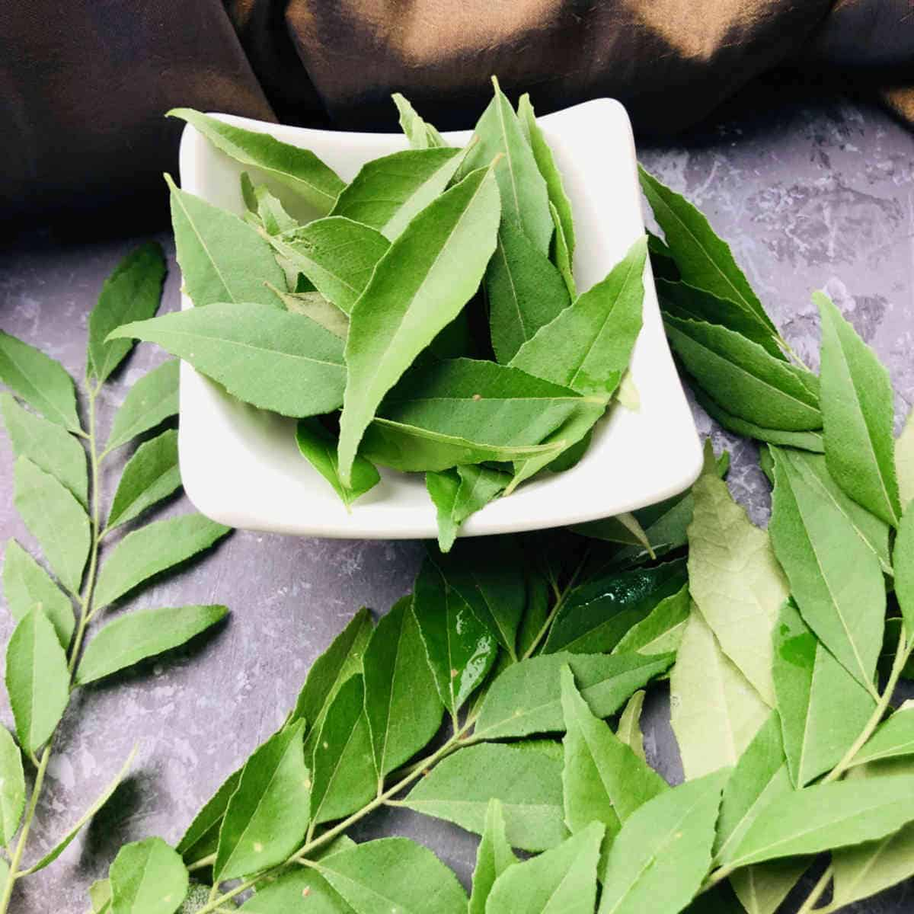
Murraya koneigii
The herb used in formulation is Murraya koneigii (Curry) leaves selected on the basis of documented literature. Collection and identification and processing of plant: The leaves of Murraya koneigii were collected from different matured plant and plant samples authenticated at Dayanand science college Latur.
Extraction: The Murraya koneigii were extracted with water by maceration process. 100 gm of above stated powder was taken in conical flask and extracted with water for 72 hours with occasional agitation then filtered. Obtained filtrate were concentrated on water bath to get semisolid residue. Obtained extract Murraya koenigii, was incorporated into a soap formulated with basic glycerin soap. (6, 7)

Murraya koneigii (Curry leaves) and Neem Extraction
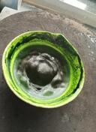

Murraya koneigii leaves extract
EXPERIMENTAL WORK
Preparation of basic glycerin soap:
Formula of Soap base
Sr.no | Ingredients | Quantity
1 | Sodium hydroxide | 20gm
2 | Coconut oil | 50ml
3 | Glycerin | 10ml
4 | Distilled Water | Quantity sufficient

Procedure for Basic Glycerin –
- Take sodium hydroxide than add water in that and dissolve it than add glycerin stir it and leave for half hour.
- Take coconut oil heat it and then add sodium hydroxide solution in it. Cook for 5 min.
- Then add water and add to any container leave it for 1 day.
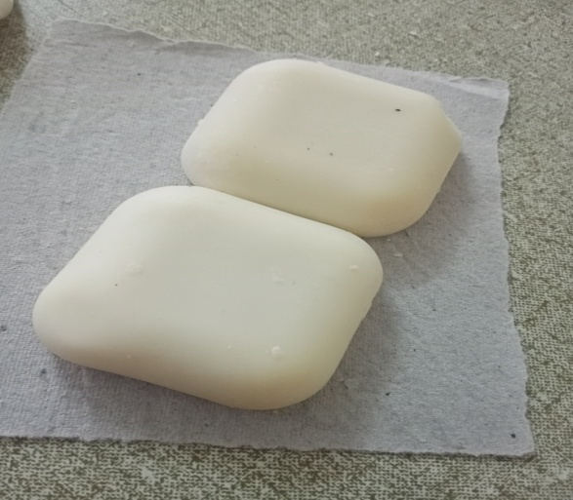
Fig: Soap Base

Formulation of Herbal Murraya Koenigii (Curry Leaves) Soap:
Murraya commonly call as curry leaves is an aromatic shrub upto 6 m in height found in India. In traditional system of medicines, it is used as an antiemetic, antidiarrheal, blood purifier flavoring agent in curries and chutneys. (12, 13)
Formulation Table for Preparation of Murraya Koenigii (curry leaves) soap (F3):
Sr.no | Ingredients | Quantity |  |  | Uses
 |  | F1 | F2 | F3
1 | Soap base | 20gm | 20gm | 20gm | Soap base
2 | Curry leaves extraction | 0.5gm | 1gm | 1.5gm | Antiseptic
3 | Shikekai | 1.5gm | 1.5gm | 1.5gm | Cleanser
4 | Sandal wood oil | 1.5 ml | 1.5 ml | 1.5 ml | Perfume

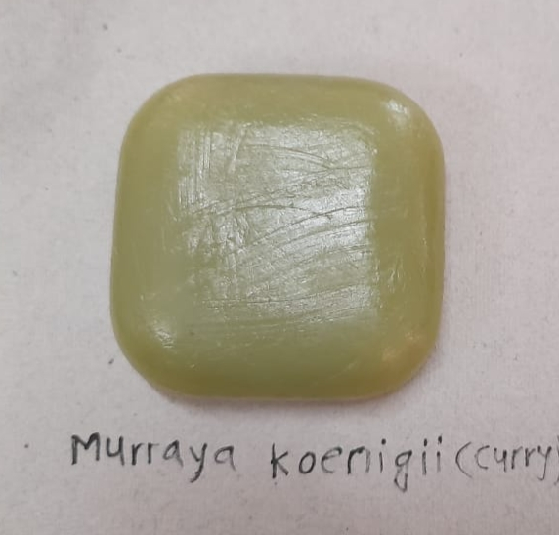z

EVALUATION TEST OF SOAP:
1. Organoleptic Evaluation:
Color - Color was checked by naked eyes.
Odor – The smell of formulation was checked by applying preparation on hand and feels the fragrance of perfume.
2. Physical Evaluation:
PH- The pH was determined by using pH paper, the pH was found to be basic in nature.
Foam Retention- 25ml of 1% soap solution was taken into a 100ml graduated measuring cylinder was covered with hand and shaken 10 times. The volume of foam at a 1 minute interval for 4 minute was recorded it was found to be 5 minutes.
Foam Height- 0.5 gm of sample soap was taken dispersed in 25ml of distilled water. Then, transferred it in to 100ml measuring cylinder, volume was make up to 50ml with water.25 strokes were given and stand still aqueous volume measured up to 50ml and measured the foam height, above the aqueous volume was measured.(8,9)

Result and Discussion:
Sr.No | Evaluation Test | Murraya Koneigii  (curry leaves)
1 | PH | 7
2 | Color | Green
3 | Odor | Pleasant
4 | Foam height | 5.4cm
5 | Foam retention | 35%
6 | Washability | Good  washable

3. Anti-microbial Activity: Overnight cultures were kept ready for anti-microbial activity. Assay of the antimicrobial activity of soaps were done by Agar well diffusion method. Agar well diffusion method was used to detect antimicrobial activity. The standardized 0.1 ml saline suspension of test organisms were inoculated on the surface of sterile Nutrient agar plates. Prepared sample from different concentrations of the prepared soap were aseptically transferred directly into the surface of plates with the help of a sterile pipette. All plates were incubated at 37⁰C for 24-48 hours and then were examined for zone of inhibition around the well. (12)The zone of inhibition was determined by measuring the diameter in millimeters of zone to which the soap inhibited the growth of the organism. The present research investigation was carried out to determine the antimicrobial efficacy of prepared herbal soap of Curry leaf against skin micro flora isolates Staphylococcus aureus, Bacillus subtilis and Candida albicans. Results obtained from the experimental data revealed that prepared soap have antimicrobial activity. We have studied the anti-microbial activity on the bacteria such as Staphylococcus Aureus, Candida Albicans, and Bacillus Subtilis bacteria cause skin infections. (13, 14)
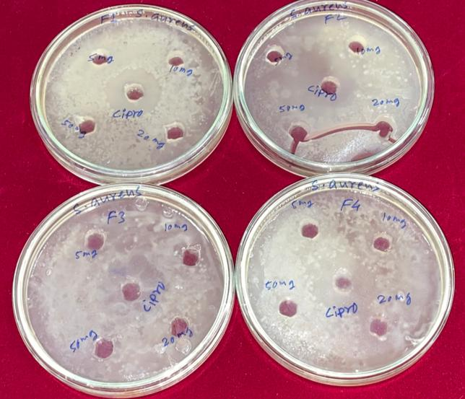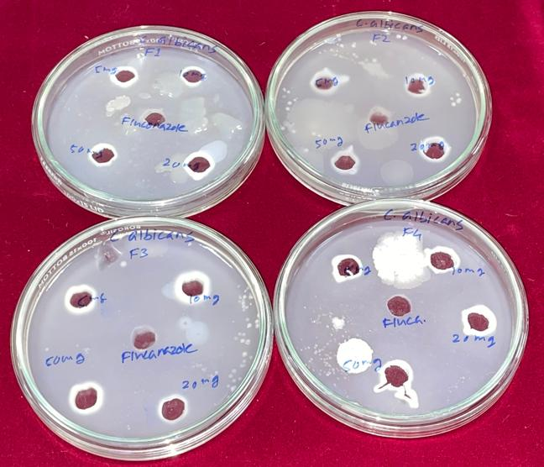
Bacillus subtilis Staphylococcus aureus
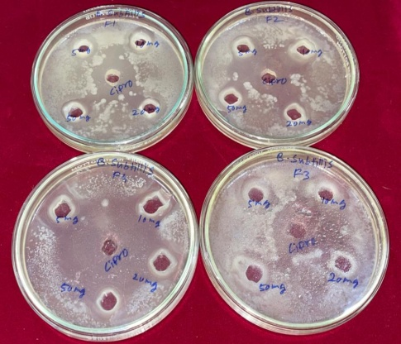
Candida albicans
Antimicrobial activity: Zone of inhibitions
Sr.  No. | Sample (Conc. mg/ml) | Staphylococcus aureus | Bacillus subtilis | Candida albicans
 |  | Zone of inhibition in mm
1. | F1
 | 5 | 3 | 5 | 4
 | 10 | 5 | 8 | 6
 | 20 | 4 | 8 | 8
 | 50 | 5 | 9 | 9
2. | F2
 | 5 | 2 | 4 | 6
 | 10 | 3 | 5 | 4
 | 20 | 5 | 7 | 7
 | 50 | 6 | 8 | 8
3. | F3
 | 5 | 3 | 8 | 7
 | 10 | 5 | 7 | 7
 | 20 | 5 | 8 | 10
 | 50 | 6 | 7 | 11

Among the different concentrations of herbal soaps, highest concentration of plant extract containing soaps showed highest antimicrobial activity against all pathogen studied. F3 formulation shows highest activity against candida albicans as compared Staphylococcus aureus and Bacillus subtilis. The soaps are cleaning agents routinely used for cleaning purposes and removing germs. Soaps and detergents disrupt the microbial cell membrane and disrupt cells proteins. Soaps tested in the present research work showed varied levels of activity against the pathogenic microbes tested. The main aim of this study was to identify the antimicrobial activity herbal soaps.
Conclusion:
The plant Murraya Koneigii (curry leaves) extract prepared using water and subjected to various preliminary phytochemical test as per guidelines of standardization of herbals. The prepared formulations of herbal soap when tested for antimicrobial activity against different microorganisms shown good results. It does not give any irritancy to skin it was determined by using these soap by few volunteer hence it is proved that soap does not give any irritancy to skin. Furthermore, the prepared herbal soaps were standardized by evaluating various physico chemical properties such as pH, appearance, odor, color, foam height, foam retention and washability in which all prepared soaps exhibit satisfactory effect. The prepared soap shows greater zone of inhibition against selected microorganisms. The soap is routine requirement of life, but it should have good active ingredients or plant extracted material which has the ability to kill bacteria but not to harm body tissues when used constantly.

References:
- Chaudhari VM. Studies on antimicrobial activity of antiseptic soaps and herbal soaps against selected human pathogens. Journal of Scientific and Innovative Research. 2016; 5(6):201-4.
- Inoue Andrade F, Purgato GA, Faria Maia TD, Pais Siqueira R, Lima S, Diaz G, Diaz MA. Chemical constituents and an alternative medicinal veterinary herbal soap made from Senna macranthera. Evidence-Based Complementary and Alternative Medicine. 2015 Mar 3; 2015.
- Yelmate A, Rajkumar M, Swami J. Anti-mycobacterial potentiality of leaves and stem extracts of Argemone mexicana Linn. Journal of Global Trends in Pharmaceutical Sciences. 2015; 6(4):2933-7.
- Nadaroglu H, Baran A. The Antimicrobial Activity of Herbal Soaps against Selected Human Pathogens. Tenside Surfactants Detergents. 2020 Sep 16; 57(5):354-60.
- Yelmate AA, Thonte SS. Antibacterial activity of some Indian medicinal plants against methicillin resistant Staphylococcus aureus (MRSA). Journal of Pharmacognosy and Phytochemistry. 2019; 8(5):376-80.
- Igbeneghu OA. The antimicrobial assessment of some Nigerian herbal. African Journal of Traditional, Complementary and Alternative Medicines. 2013 Oct 14; 10(6):513-8.
- Yelmate AA, Thonte SS, Satpute KL. Trace Element Determination in Medicinal Plant Samples by ED-XRF Analysis. InHerbs and Spices-New Advances 2022 Dec 8. IntechOpen.
- Wijayawardhana N, Cooray D, Jayasuriya B, Uluwaduge I, Meedin F, Arawwawala M. Antimicrobial activity of a combination of three natural plant extracts and development of a herbal soap. Pharmaceutical Sciences Asia. 2021 Nov 1; 48(6).
- Yelmate AA, Thonte SS. Ethnobotanical survey of plants on hattibet (Deverjan) district Latur Maharashtra. Journal of Pharmacognosy and Phytochemistry. 2018; 7(3):1345-8.
- Karnavat DR, Amrutkar SV, Patil AR, Ishikar SK. A Review on Herbal Soap. Research Journal of Pharmacognosy and Phytochemistry. 2022 Jul 1; 14(3):208-13.
- Abdu AN OA, Agboola GO, Igbeneghu IO, Omobuwajo OR. Preliminary investigation of an herbal soap incorporating Cassia senna (L) Roxb leaves and Ageratum conyzoides Linn whole plant powders. cont. j. pharm. Sci. 2011:1-0.
- Archana Y, Gundewar P. NOVEL THERAPEUTIC APPROACHES TOWARDS TYPE 1 DIABETES MELLITUS. European Journal of Biomedical. 2018; 5(7):176-85.
- Lima S, Diaz G, Diaz MA. Antibacterial Chemical Constituent and Antiseptic Herbal Soap from Salvinia auriculata Aubl. Evidence-Based Complementary and Alternative Medicine. 2013 Jan 1; 2013.
- Oladele AT, Dairo BA, Elujoba AA, Oyelami AO. Management of superficial fungal infections with Senna alata (“alata”) soap: A preliminary report. Afr J Pharm Pharmacol. 2010 Mar 1; 4(3):98-103.

