**A narrative overview on crucial role of gut microbes in chronic infectious and inflammatory disease**

Prity Chatterjee1a, Riya Dey1a, Shweta Kumari1, Shreetama Mukherjee1, Sumana Roy Chowdhury2, Krishnendu Adhikary3*

1 Department of Biotechnology, Paramedical College Durgapur, West Bengal- 713212, India

2 Department of Microbiology, Paramedical College Durgapur, West Bengal- 713212, India

3 Department of Interdisciplinary Science, Centurion University of Technology & Management, Odisha-761211, India

a Prity Chatterjee and Riya Dey contributed equally

**\*Corresponding Author:**

Krishnendu Adhikary, Department of Interdisciplinary Science, Centurion University of Technology & Management, Odisha-761211, India,

Contact: +91 8759369702, Mail: [krisskrishnendu@gmail.com](mailto:krisskrishnendu@gmail.com)

**ABSTRACT**

The Numerous microorganisms in the human gut microbiota (GM) fight pathogens in infectious diseases and suppress or induce inflammation in various immunological situations. A significant microbial community that is vital to human existence is the human gut microbiome. It promotes the proliferation, development, and differentiation of epithelial and immunological cells, which aids in the maintenance of intestinal homeostasis. Disorders that affect the microbiota induce an imbalance in the host's immunological regulation. Research analysis suggests that the gut microbial ecology is linked to the onset and increment of several infectious and inflammatory disorders. Understanding the connection between gut microbiota and control of the immune system is therefore critical for understanding the mechanisms involved in various illnesses .Review focuses on the main gut bacteria capable of influencing the immune response in various pathologies, as well as a possible target for disease prevention and treatment due to the control and mechanism of GM on gastrointestinal, metabolic, and neurological diseases.

**Keywords:** Gut microbiota, neurodegenerative disorders, homeostasis, gastrointestinal diseases, immune system

**1. Introduction**

Chronic infection is defined by the persistence of infectious viruses beyond the first infection and might involve chronic or recurring disease (Boldogh et al., 1996). Chronic infections are a significant public health problem. The challenge in influencing them would have been easy to comprehend if chronic foci bacteria had exhibited high antibiotic resistance or if immunological weaknesses were consistently observed in individuals with persistent infections. Nonetheless, there seem to be situations of severe disease during which the bacteria become antibiotic-resistant but the immunity of the body is functioning normally (Malyshkin, 2014).Inflammation is a medical condition. When an infecting agent comes into interaction with the host (including certain pathogens, or toxic chemicals) or suffers a trauma, the immune response is triggered.Immune mediators and inflammatory mediators are the immunological system's initial reactions.These cells generate an immune response in order to capture pathogenic microbes or to repair damaged tissue.Therefore, as a reaction, individuals might experience pain, inflammation, discoloration, or reddening. However, inflammation impacts biological systems that are not visible (Yang et al., 2022).

Infectious diseases continue to be the leading causes of human and animal morbidity and mortality rates, resulting in enormous healthcare spending in India.The introduction of new human infections and the revitalization of old diseases are severe issues in this decade(Mourya et al., 2019).India is the most populated country, with altering sociocultural and epidemiological patterns that have drawn international interest in recent times (Patil et al., 2002). In India, either contagious or non-modifiable diseases are said to affect various social and economic groups adversely (Banerjee & Dwivedi, 2016). Some common communicable diseases that have spread rapidly in India in recent years areCOVID-19, Malaria, Typhoid, Tuberculosis, AIDS, Hepatitis, Influenza, and so on (Most Communicable Diseases in India, 2023).A disease's transmission does not end in a nation's territory. Germs spread more quickly as more people live in congested cities and travel to other nations. Communicable diseases that begin from one area of the globe can quickly spread to another. AIDS, Malaria, COVID-19, and Tuberculosis are among the primary diseases now afflicting countries around the world (Table 1). Several world health issues exist in addition to disease propagation. Medicine resistance, such as antibiotic resistance, seems to be increasing. This makes specific disorders more difficult to control. Natural and man-made calamities result in refugee populations experiencing both acute and long-term health issues. Extreme weather, as well as a scarcity of food and healthy drinking water, are international issues that can have an impact on people's health. Many regions and health authorities are cooperating and transmitting ideas on this or other health-related topics (Figure 1) (Global Health, n.d.).

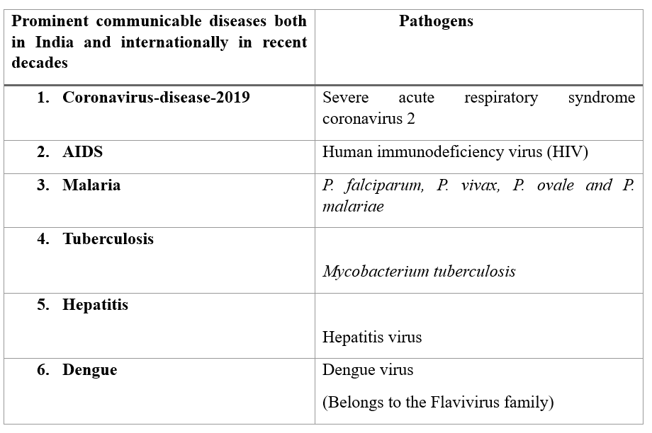

Table 1: - Nowadays disease is not just trapped in one nation as more people live in congested cities and travel to other nations. Communicable diseases that begin in one area spread to another part of the globe. The above table represents the most prominent communicable diseases present both in India and globally and the pathogen that causes them (Did You Know?, 2021).



Figure 1: - As we all know the microbiota present in the gut is actually a group of microscopic organismsthat help to fight pathogens and can also prevent different diseases at the ground level. The above-shown arrow diagram represents how the microbiota present in the gastrointestinal tract is related with the majority of illnesses, as well astodifferent body functions in the human body(“Gut Microbiota,” 2023).

The contemporary era's enormous psychological and biological changes pose a severe threat to human wellness. An individual's microbiota contains a diverse agglomeration of microbiotas,which impacts the ratio of wellness and pathology in their environment. Such microbes provide significant biochemical advantages to their hosts, such as immunological modulation and disease resistance(Khor et al., 2021). The mutual link between gut bacteria and its symbiont organism has received a lot of attention. While the digestive tract's mechanics and anatomy are complicated in itself, the microbial residents of the gut all have their unique activities(Hill et al., 2014).Bacterial, archaebacteria, viral, and multicellular microorganismsinhabit the gastrointestinal tract and make up the gut microbiome(Ullah et al., 2023).Researchers have found that the microbiome in the gastrointestinal tract has quite a profound influence upon its onset and progression ofmajor human diseases for which there are presently no treatment options. Having fats in your liver is natural, but when it accounts for any further than 10% of its weight, it may end up suffering. Heavy drinking is a prevalent trigger for fatty liver disease. However, several individuals grow it without drinking heavily (Younossi et al.,2018).Non-alcoholic fatty liver disease (NAFLD) refers to a set of liver illnesses ranging from hepatic steatosis to non-alcoholic steatohepatitis (NASH), with or without fibrosis, and can lead to cirrhosis of the liver or hepatocellular cancer(Xia et al., 2022).NAFLD which is regarded as a major public health concern worldwide, has sparked rising interest in the field of liver disease research. Pathophysiological medication therapies for NAFLD are being studied, but the absence of licensed treatments is due to acknowledged rates. These pharmacological therapies tend to have limited effectiveness, mainly in treating fibrosis.Despite extensive drug development, there are currently no FDA-approved drugs addressing NASH, and no specialized treatment may be prescribed.The drugs that are now used to treat NASH are administered off-label all around the globe. Probiotics are used as microbial therapies in the treatment of NAFLD. Countless potential therapeutic investigations for the management and cure of NAFLD and NASH have been conducted as a consequence of the impacts of the gut microbiota. Nonetheless, probiotics such as *Lactobacillus, Bifidobacterium, and Pediococcus*are useful in the prevention of NAFLD in experimental studies. Probiotics eliminate NAFLD in rodents by reintroducing microbiologicalbalance in the stomach, which decreaseslipogenesis and, as a result, liver inflammation. Prebiotics, pre- and probiotic combinations (synbiotics), medications, and FMT (Fecal microbiotatransplantation) are some of the other potential techniques (Figure 2) for modifying gut microbiome assemblages for NAFLD management (Gupta et al., 2022).

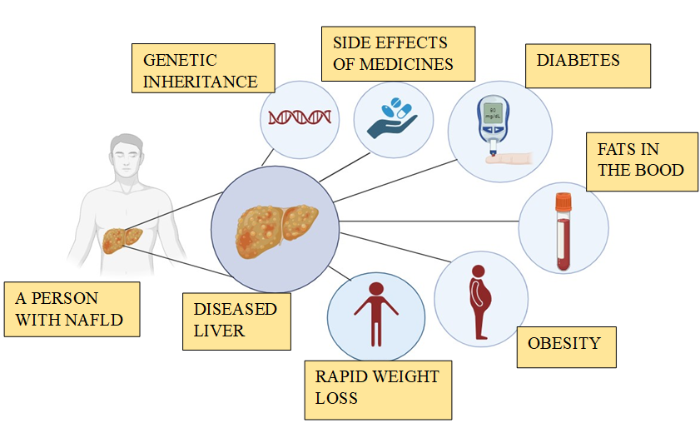

Figure 2: - NAFLD,as the name implies is a fatty liver disease that is not caused by alcohol, and the causes of NAFLD in a non-drinker are represented in the picture above (NAFLD & NASH - Symptoms, Causes, Differences & Treatment Options, 2022).

**2. Gut microbes and inflammations**

The microbiota is the aggregate of all microorganisms, including the bacterium, fungus, virus, and their related genes, that exist naturally occurring on and throughout biological systems. Despite bacteria being microscopic organisms that have to be viewed under a microscope, they have a significant impact on human health and welfare. They defend us from viruses, contribute to the formation of our immunity, and allow us to break down food to process energy (Cresci & Bawden, 2015).

The microbiome in the gut has an important role in immunological function and physiology, (Figure 3) involving microorganism invasion, prevention, and immunological reaction regulation(Xia et al., 2022). The links involving both gut microbiome formation and illness status have been heavily publicized, and current research has shown that the gut microbiome influences remote organs, mucosal response, and immunological activity.A significant amount of work is currently being put into investigating the biology of microbiota creation in individuals for medical consequences, as well as expanding our understanding of microbiome-host biomolecule interactions. These initiatives eventually aim to create effective methods for rehabilitating disrupted human microbial communities to restore safety and reduce disease. Configurational and physiological abnormalities in the gut microbiota have been observed in the case of various autoimmune disorders, and there is mounting consensus that agitated gutmicrobiome contributes to associated immunopathogenesis (Vijay & Valdes, 2021).

Even though the concentration of the human gut microbiota varies over time, in healthy communities, there is a diverse range of shared microbiological genes. Firmicutes and Bacteroidetes groups contribute to even more than 90% of the overall inhabitants of gut microbiota in most situations. The gut microbiota, on the other hand, varies widely between individuals and under illness situations. The change could be represented by decreased flora variation or varying microbiological density (Cheng et al., 2020).Gut flora diversity is widely assessed utilizing DNA-based approaches including analysis of the genes for 16S ribosomal RNA or all including genome sequencing permitting the interpretation of microbial functions. Bioconversion products can now be quantified in faeces and serum using metagenomic methods.The microbiota in the gut is essential for the digestion of substrates that are inadequately digested, such as dietary fibres and endogenous gastrointestinal mucus. Fermentation encourages the growth of bacteria that produce short-chain fatty acids (SCFAs) and fumes. The main SCFAs produced are acetate, propionate, and butyrate(Valdes et al., 2018).

Bile acids and short-chain fatty acids (SCFAs) from the gut microbiota can help maintain the host's health by providing nutrition and energy while also regulating the host's immune system. These molecules include both small compounds created directly by commensal bacteria and end products of dietary substrates digested by commensal bacteria, both of which play an important role in host health.Since they induce the production of host antimicrobial peptides, primary bile acids, such as chenodeoxycholic acids, have been found to have antimicrobial action against microbial pathogens.Secondary bile acids produced by biological agents and symbiotic products such as propionate also hinder bacterial pathobiont colonization such as C. difficile.Overweight, Vascular dementia and disorders that disrupt intestinal epithelial integrity have all been linked to GM-derived SCFAs. SCFAs can also help to maintain intestinal homeostasis by modulating the immune system (Figure 4). Relative to healthy individuals, Crohn's disease (CD) patients have a lower concentration of butyrate-producing species of bacteria in the Ruminococcaceae family(Zhang et al., 2021).



**Figure 3:** The above-shownpictureis that of a whole digestive system,but the main focus is on the gut containing different microbes making up the gut microbiota or the gut microbiome,and as the picture depicts it correlates to everyother organ and having an axis between them(Afzaal et al.,2022).

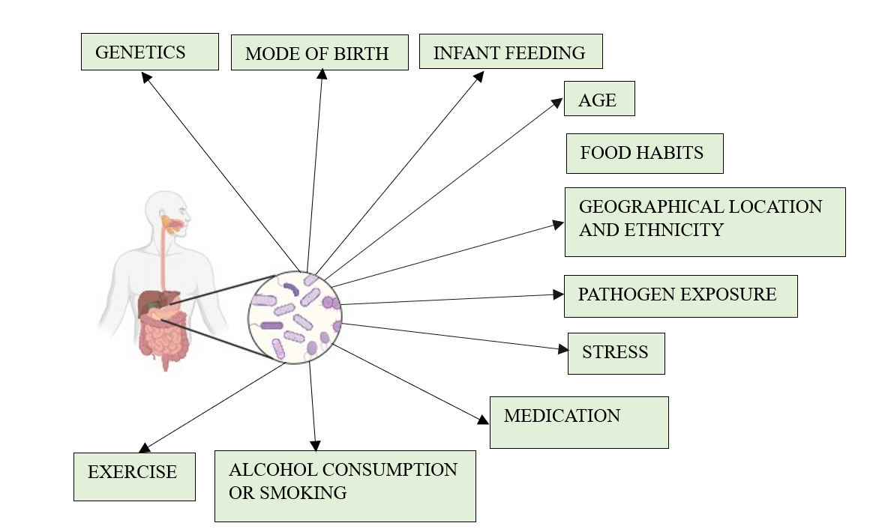

**Figure 4:** The microbiome of the gut is a combination of microorganisms comprised of many types of bacteria, fungi, viruses, and so on. Bacteroidetes and Firmicutes are both present in more amounts compared to the others in the gut of a healthy human. Many factors can disrupt the composition of these microorganisms present in the gut as shown in the picture above (Liang et al., 2022).

**3. Macrophage and inflammation**

Macrophages are a special (myeloid) type of immune cell that is spread throughout the body. They participate in phagocytosis, the elimination of bacteria and other harmful organisms (Varol et al., 2015). Macrophages are also known as antigen-presenting cells. Having MHC class II on their surface, They serve the purpose of presenting antigen to T lymphocytes to initiate the process of inflammation by releasing cytokines that help to activate other immune cells (Harding et al., 1992).Macrophages developed from CD14+ CD16+ monocyte cells that departed from the circulation and differentiated in different tissues such as infection or tumor sites, to encourage continued inflammation or tissue healing. (Yang et al., 2014)

There are different names for tissue macrophages according to the site where they are present; for example, macrophages that are present in adipose tissue are known as adipose tissue macrophages; kupffer cells are found in hepatic; The central nervous system(CNS) contains microglial cells.; There are osteoclast cells in bone tissues.; and so on. (Italiani et al., 2015).

Inflammation plays a crucial role in your body’s ability to repair. During injury Immune cells or inflammatory cell travel to the injured region and cause the inflammatory process to begin to heal that site. Chronic inflammation may result from inflammatory cells remaining too long ( inflamation: What Is It, Causes, Symptoms & Treatment, n.d.). There are two types of inflammatory macrophages found in humans and higher animals. M1 macrophages and M2 macrophages, both of which are responsible for the inflammatory response. M1 macrophages are recognised for their pro-inflammatory reaction, whereas M2 macrophages are recognised for their anti-inflammatory reaction. (Yunna et al., 2020) The human body is very complex; whenever it faces injury from inside or outside, it goes through a complete series of cellular responses to heal that injury, starting from inflammation to tissue damage and then to healing. They also promote fibrosis and clear cell debris (Oishi et al., 2018)The inflammatory process needs some signal for initiation and also needs signals to stop. Both signals work in a controlled manner, but whenever the two signals are out of balance, the inflammation process spreads unchecked and leads to tissue damage. In the inflammatory activity, macrophages play 3 important task. 1. Antigen presentation 2. Phagocytosis; and 3. Very important, immunomodulation by releasing various cytokines and growth factor (Fujiwara et al., 2004)

Pattern recognition receptors or inflammatory lymphokine such as interferon Gama (IFN‐γ) stimulate the activation of M1 macrophage after the activation of the M1 macrophage it starts releasing Pro-inflammatory cytokines like tumor necrosis factor alpha (TNF- α), interleukin 1(IL-1), and IL-6. However, M2 macrophages also activate alternatively by IL-4, IL-10, or IL-13 and express some receptors such as Arginase 1 (Arg-1), and CD206. Anti-inflammatory macrophages’ main responsibilities include tissue repair and homeostasis, whereas proinflammatory macrophages’ key responsibilities include the destruction of tumors and infections through the generation of inflammatory cytokines and phagocytosis. M1 Macrophage Pro inflammatory macrophage presents the antigen to CD8+ T lymphocytes similar to a dendritic cell. Comparable to how immature DCs cross-present, anti-inflammatory macrophages may also serve in immunological tolerance to “self” proteins, commensal microorganisms, and dietary components. Anti-inflammatory macrophages help in tissue regeneration or tissue repair, proliferation, angiogenesis, and immunomodulation. (Muntjewerf et al., 2020)

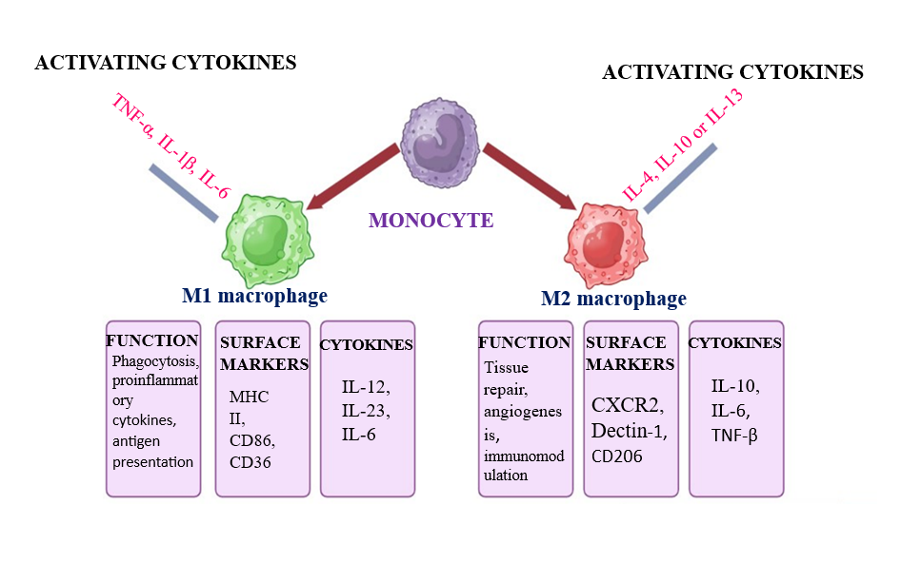

**Figure 5:** Macrophage is a special type of immune cell which has a diverse role. IIt is essential in causing inflammation the above figure represents the origin of different tissue resistant macrophage from monocyte their function, surface marker and cytokine (Kadomoto et al., 2021).

**4. Macrophage in wound healing**

There are different stages of wound healing, which is the process by which damaged tissue is repaired and returned to homeostasis after being subjected to mechanical or infectious trauma. (Kim et al. 2019). The key actor in the process of tissue repair is the M2 macrophage. it is activated by cytokines (like IL-4, IL-13) of Th2 cells. TNF-α, IL-6, IL-1, ROS, and nitric oxide (NO) are all produced by pro-inflammatory macrophages. Additionally, MMP-2 and MMP-9 are secreted by these cells to degrade the extracellular matrix and create space for inflammatory cells to invade. To promote cellular proliferation, the creation of granulation tissue, and angiogenesis, Growth factors like Platelet-derived growth factor (PDGF), insulin-like growth factor 1 (IGF-1), Vascular endothelial growth factor (VEGF), and Transforming growth factor 1 (TGF-1) are secreted in greater amounts by macrophages that promote wound healing. (Krzyszczyk et al. 2018)

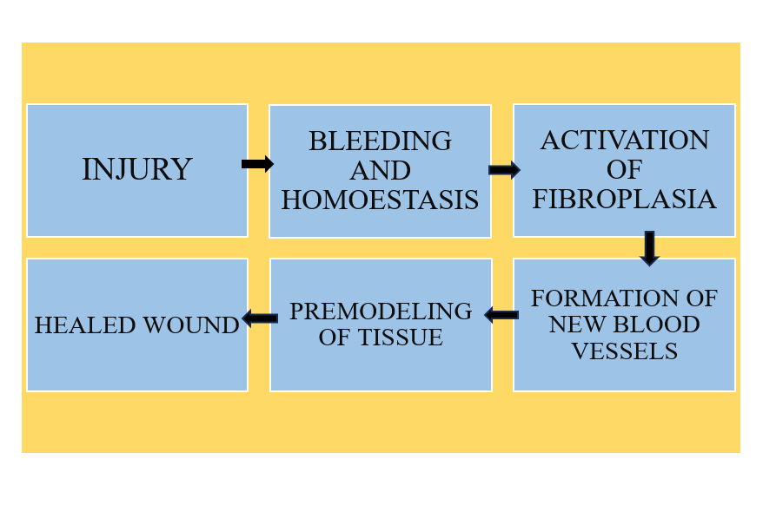

**Figure 6:** wound healing is an important physiological mechanism of all living organisms . It starts from homeostasis and ends eith tissue healing .The above figure represent the common steps in wound healing (Themes, 2017).

**GUT MICROBIOTA AND INFLAMMATORY BOWEL DISEASE**

A long-term inflammatory condition that affects the digestive tract is inflammatory bowel disease. The two subtypes are ulcerative colitis and Crohn’s disease (Fabián et al., 2022). In crohn’s illness different people face inflammation in different part of small intestine. On the other hand, people with ulcerative colitis, they face inflammation in the large intestine and ultimately develop an ulcers due to unusual immune system reaction. IBD is very common among the group of people aged 15–30; it is not specific to any age or gender It can develop in people at any time (inflammatory bowel disease: Symptoms, Treatment & amp; Diagnosis, n.d.).

There is no specific reason for the cause of this disease, but somehow there is some hypothetical reason for this disease, such as when environmental triggers for example the unbalanced microorganism in the gut make an improper immune reaction, Due to which inflammation occurs in the digestive tract. Additionally, genetic appear to be important. It is more likely for someone to experience this incorrect immune response if their family has a history of IBD (Ko et al., 2014).



**Figure 7:** IBD is a long term inflammatory condition occur in intestine. The above figures represents symptoms, prevention, and risk factor of inflammatory bowel disease (Kumar et al., 2019). There are specific microbes in the human gut that are crucial to maintaining good health..In newborns, gut microbioms differs significantly from that of adults in terms of composition and temporal pattern. In addition to strengthening the host’s natural defenses, gut bacteria also support the gut’s regular functioning. Imbalance microorganism in the gut Due to which the good microorganisms in the gut decrease and the bad microorganisms increase and damages the intestinal microbial barriers, is a common symptom of inflammatory bowel disease. Different metabolites can be manufactured by different microorganism present in gut. To stop the spread of harmful bacteria Along with encourage intestinal homeostasis. The mucus released by path cells and the bacteria in the gut are essential components of the digestive tract’s chemical barrier. The imbalanced microbiota in humans leads to inflammatory bowel disease (thursby & juge, 2017).

**5.1. Microbiota in the treatment of IBD**

From the studies, it is supposed that certain types of probiotic supplements and Fecal microbiota transplantation (FMT) this two techniques has taken in a used in the treatment of intestinal inflammation in some animal models for example in E. coli and salmonella growth can be inhibited by a probiotic known as Nissle 1917. Due to the critical role gut microbiota plays in the aetiology of BD, faecal microbiota transplantation can help IBD patients reestablish intestinal mucosal immunological homeostasis. A good diet play a very important rule to keep the balance of good microorganisms in the gut to control inflammatory bowel disease. The effects of diet mainly occur through three mechanisms. First, certain diets have the potential to alter the intestine microbiology’s composition while also indirectly influencing the intestinal immune system. Some dietary component can control the IBD to some extent. Healthy people has good microorganism in their gut ( As show in Table 2) as compare to IBD patient (Qiu et al., 2022).

|  |  |  |  |  |  |
| --- | --- | --- | --- | --- | --- |
| **Good microorganism** | **Amount in a healthy person** | **Amount in IBD patient** | **Bad microorganism** | **Amount in a healthy person** | **Amount in IBD patient** |
| *Clostridium* *groups* *lV* | More | Less | *Ruminococcus* *gnavus* | Less | More |
| *Bifidobacterium* | More | Less | *Proteobacteria* | Less | More |
| *Lactobacillus* | More | Less | *Fusobacterium* *sp.* | Less | More |
| *Faecalibacterium* *prausnitzii*. | More | Less | *Candida* *albicans* | Less | More |
| *Saccharomyces* *cerevisiae* | More | Less | *Caudovirales* | Less | More |

**Table 2:** The gut microbiota has diverse functions in living organisms. There are various types of Microorganisms present in the persons gut and playing different functions there. The above table represents some good microorganisms and some bad microorganisms and their amounts in healthy humans and in IBD patients (Aldars-García et al., 2021).

**6. Gut microbiota and Obesity**

Gut microbiota refers to the microorganisms that reside in the human body. These microorganisms play an important role in humans. The types of microorganisms that are generally found in the human body are bacteria (archaebacteria and eubacteria), viruses, protozoa, fungus, and archaea. They are together known as the human microbiota (Jandhyala SM et al., 2023). The bacteria that live in the digestive tracts are referred to as gut flora or gut microbiota. Gut is generally the internal part-stomach (Gastrointestinal tract)which secrete HCL, hence highly acidic in nature(Sasso JM et al.,2023).The digestive tract constitute the part of human body from mouth to anus. Firmicutes (which includes *lactobacilli*), Bacteroidetes, *Actinobacteria* (which includes *Bifidobacteria*), and Proteobacteria are the four major phyla found in the human gut. The *Fusobacteria* and *Verrucobacteria* are two more phyla that are less prevalent.The relative amount of study interest in each of these taxonomic groupings is depicted in this presentation. *Bacteroides, Clostridium, Fusobacterium, Eubacterium, Ruminococcus, Peptococcus, Peptostreptococcus, and Bifidobacterium* are the most common bacterial genera.To begin, the phylum Firmicutes is made up of the classes Bacilli and Clostridia, which are gram-positive organisms with diverse physiology (anaerobic, aerobic) and include naturally occurring and beneficial bacteria such as Lactobacillus, Ruminococcus, Clostridium, Staphylococcus, Enterococcus, and Faecalibacterium. Second, the phylum Bacteroidetes includes the class Bacteroidetes, that involves gram-negative organisms found in the environment (e.g., dirt, ocean, and animal stomachs); examples include Bacteroides and Prevotella. Third, the phylum Proteobacteria is divided into two classes: Gammaproteobacteria and Betaproteobacteria, which contain gram-negative species such as Escherichia and Pseudomonas. Fourth, the phylum Actinobacteria includes the class Actinobacteria, which includes gram-positive organisms with a variety of morphologies, such as Bifidobacterium, Streptomyces, and Nocardia (Figure 8).



**Figure 8:** Different classes of bacterial phylum which includes- Actinobacteria, Bacteriodetes, Firmicutes, Proteobacteria with their examples (Sasso JM et al., 2023).

There are substantially fewer members of other genera, such Escherichia and Lactobacillus (Thomas et al., 2012). In the human gut, there are 23 species of bacteria from the genus Bacteroides, which accounts for around 30% of all bacteria (Jandhyala et al., 2015). Dysbiosis due to IBD (Inflammatory bowel disease) is particularly linked to both- decline in Firmicute diversity and increase in Proteobacteria. Since Firmicutes generate necessary short-chain fatty acids like acetic and butyric acids, which are known to have anti-inflammatory properties, they are low in numbers. The decreased abundance of Firmicutes bacteria from two important functional families of the human gut microbiota: Ruminococcaceae and Lachnospiraceae to which the majority of butyrate-producing bacteria in the human gut belong, is a common feature of the microbial dysbiosis among IBD patients. Therefore, it is seen that the observed abnormalities, such as a decreased ability of the IBD microbiota to produce butyrate, are due to the reduction of these bacterial groups in IBD. Because it acts as the primary source of energy for colonocytes, improves the attachment of the epithelial barrier, and reduces inflammation, butyrate is used in treatment for IBD. Gut homeostasis may be restored by a probiotics treatment that includes human consumption of butyrate-producing bacteria to promote in situ butyrate production. According to a recent study, taking a combination of bacteriophages that target a strain of Klebsiella pneumoniae related to IBD orally lowered intestinal inflammation.

Human body is made up of billions of cells, but it is interesting to know that the human body contains more bacterial cells than human cells—roughly 40 trillion bacterial cells vs 30 trillion human cells. The gut microbiota functions as a 'superorganism' within the human host, which are responsible in food absorption, producing metabolites that nourish the host , protecting the body from infection, maintaining the function and morphology of intestinal epithelial cells, and regulating host immunity (Dekaboruah et al,2020).The gut microbiota performs a range of biological tasks, including xenobiotic metabolism, dietary fiber fermentation, vitamin production, pathogen defense, and immunological modulation. The gut microbiota are responsible for the development of diseases such as obesity and asthma, as well as psychological disorders such as Parkinson's disease, in addition to digestive and skin disorders (Figure 9).

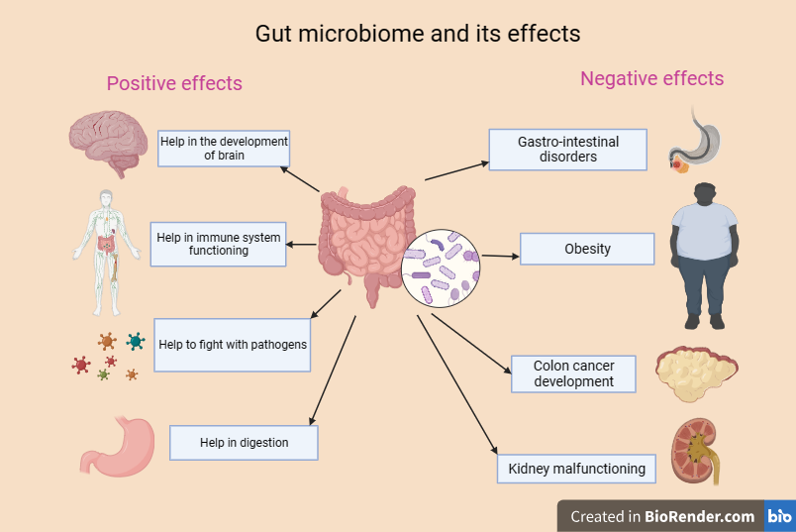

**Figure 9:** Gut microbiome and its effects-positive and negative effects in human body (Dekaboruah et al., 2020).

The gut and the brain are correlated, with the gut microbiota and its metabolic production playing an important role. This is known as the gut microbiome-brain axis. Dysbiosis, or disruptions in microbiota homeostasis caused by imbalances in their functional composition and metabolic activities, causes dysregulation of these pathways and changes in the blood-brain barrier (BBB) permeability, resulting in pathological malfunctions such as neurological and functional gastrointestinal disorders. In turn, the brain, via the autonomic nervous system, can influence the structure and function of gut microbiota by controlling gut motility, intestinal transit and secretion, and gut permeability (Macfarlane et al., 2003).The gut microbiome-brain axis, a neuro-immuno-humoral network of signaling pathways that comprises the vagus nerve, the immune system, the hormone system, and bacterial metabolites and products, connects the gut and brain. Dybiosis or disruption of microbiota homeostasis caused by an imbalance in their functional composition and metabolic activities, causes changes in the permeability of the blood brain barrier (BBB), neuroinflammation, and other pathological malfunctions, including a variety of neurodevelopmental and neurodegenerative disorders. Although the gut microbial community will remain relatively stable over time, many factors, including genetics, age, region, lifestyle, drugs, infections, and diet, may influence the composition and relative abundance of different microbes, with diet being the most important factor. To detect the gut microbiota, a range of approaches are available, including fluorescence-based quantitative polymerase chain reaction, 16S ribosomal RNA amplicon sequencing, metagenomics, metatranscriptomics, metaproteomics, and microbial microarrays. Although the following methods can show the composition and potential of the gut microbiota, the in situ functions of the microbiota remain unknown.

**6.1. Obesity**

Obesity is the condition in which human gain weight than normal body mass. Body mass index (BMI) is a screening measure for both children and adult obesity and is defined as weight (in kilograms) divided by height (in meters) squared. Obesity is described as an excessive buildup of fat.

**6.2. Relationship between gut microbiota and obesity**

Depleted microbial richness of gut microbiota in adults eating a Western diet (heavy in fat, sugar, and animal proteins) has been linked to an increase in obesity, coronary vascular disease, and metabolic syndrome. A favorable carbohydrate-based diet (rich in both complex carbs and simple sugars) was connected with the advantageous Prevotella(Bacteriods).Obese people had a higher Firmicutes/Bacteroidetes ratio and more Proteobacteria than lean people, though there was variance between studies. Turnbaugh et al. examined the fecal microbial communities of 154 adult female monozygotic and dizygotic twin pairs (along with their mothers) to see if they were in relation with normal weight or obesity. The study revealed that patients with obesity had a lower proportion of Bacteroidetes and a larger proportion of Actinobacteria than patients with normal weight. Obese children had different gut microbiota composition and function compared to lean children, including more proinflammatory bacterial taxa. Similar relationships have been discovered in mice, obesity was associated with a decrease in Bacteroidetes and a proportional increase in Firmicutes in obese mice compared to lean mice.Chierico et al. compared the composition of gut microbiota to metagenome functional content in obese adolescents and adults to similar in age participants with normal weight. Primary bile acid biosynthesis, steroid acid biosynthesis, fructose metabolism, mannose metabolism, galactose metabolism, butanoate metabolism, pentose phosphate metabolism, and glycolysis/gluconeogenesis were all associated with obesity in teenagers. Adolescents with normal weight, on the other hand, had a stronger connection with secondary bile acids, steroid hormone metabolism, lipoic acid metabolism, and glycan production and metabolism. Primary bile acids are those produced by the liver, while secondary bile acids are the consequence of colonic bacteria converting primary bile acids. Secondary bile acids have a favorable effect on energy expenditure and glucose homeostasis. According to studies, the brains of obese people have undergone structural alterations .In order to understand the underlying process causing this comorbidity, it is crucial to research the adipose-brain axis or connection between the two organs. The countless billions of bacteria that inhabit our digestive system, are crucial for controlling the adipose-brain axis. The gut-adipose-brain (GAB) axis is established through the homeostatic regulation of the adipose-brain axis by gut bacteria. So maintaining inter-organ communication and living a healthy life require a healthy microbiome. The major way that this enormous population of gut microbiota can interact with the host is through secreting various substances.

**6.3. Mechanism of obesity by gut microbiota**

**6.3.1. Energy absorption**

According to studies, genetically obese mice eat more protein and carbs through the gut bacteria to supply energy to the host. In animal studies, it was discovered that when there were no dietary or weight differences between the mice, the germ-free mice colonised by the "obese microbiota" had considerably more total body fat than the mice colonised by the "lean microbiota". This research suggests that the gut microbiota of people who are fat is more capable of absorbing energy from food. A multiomics investigation revealed that obese hosts absorbed more lipids. The genes that regulate lipid absorption were downregulated by Clostridia colonisation in germ-free mice. Thus, the gut microbiota of obese patients may encourage energy absorption, leading to an abnormal buildup of energy. Carbohydrates are converted by the gut microbiota into short-chain fatty acids (SCFAs), which are either absorbed by the gut or eliminated in faeces. For the control of energy homeostasis, SCFAs are essential. The primary constituents in SCFAs are acetate, propionate, and butyrate. By secreting peptide YY, glucagon-like peptide-1, and other intestinal hormones, acetate can improve the host's energy metabolism. It can also lower levels of proinflammatory cytokines and systemic lipolysis while increasing lipid oxidation and energy expenditure. Propionate encourages intestinal lipolysis and energy balance in mice. Intestinal epithelial cells get the majority of their energy from the oxidation of butyrate, which is the colon's principal energy source. The increase in butyrate-producing bacteria in the gut microbiota enhances butyrate production, thereby improving lipid metabolism.

**6.3.2. Chronic inflammation**

One of the main characteristics of metabolic diseases like obesity is chronic inflammation. Evidence suggests that these illnesses are characterised by the intestinal barrier being broken by the gut microbiota and its metabolites, which affects different metabolic organs such the liver and adipose tissue and causes chronic inflammation. The microbiota of healthy mice was transferred into animals with chronic colitis using faecal microbiota transplantation. By controlling the expression of proinflammatory genes, antimicrobial peptides, and mucin, transplantation of faecal microbiota may be able to improve colitis in animals with chronic intestinal inflammation. Endotoxin lipopolysaccharide (LPS) has been found to be expressed at high levels in obesity and inflammation of adipose tissue. LPS activates a pro-inflammatory cascade in the gut by binding to Toll-like receptor 4 on immune cells. According to studies, a reduction in the number of the LPS family S247 is caused by a rise in the butyrate-producing Ruminococcaceae and Lachnospiraceae, which reduces chronic low-grade inflammation. By preventing cannabinoid receptor type 1 from activating, the gut bacteria can also avoid intestinal barrier dysfunction brought on by high-fat diets. Its activation can boost hunger and food intake because the endocannabinoid system plays a significant role in regulating the creation of fat in the gut and fat cells. The effects of antibiotic intake on the microbiota are sufficient to prevent obesity.The interaction of the gut microbiota with the activation or inhibition of the inflammatory cascade depends heavily on SCFAs. An anti-inflammatory metabolite called butyrate is known to block the cytokine production pathways that contribute to inflammation. Butyrate increases adipoliolysis and mitochondrial oxidative phosphorylation through epigenetic interactions, resulting in increased energy expenditure and the prevention of obesity. Butyrate, has also been demonstrated to decrease LPS in the gut, hence minimising LPS-related symptoms.Acetate, has a more important function in obesity and chronic inflammation,can be utilised as a substrate for the production of cholesterol which can aid to elevate blood cholesterol levels and increase the risk of obesity, reduce hunger and lower the risk of obesity. Acetate is a significant metabolite, and it plays a complex function in the control of obesity and the gut flora. Therefore, further research is required to determine the precise processes behind the connections between SCFAs and obesity, microbiota composition, and chronic inflammation.

**6.4. Prevention of Obesity**

1. Probiotics- Probiotics consist of beneficial bacteria including Lactobacillus, Bifidobacterium, and Streptococcus (Swanson et al,2020)

2. Prebiotics- Prebiotics are intentionally fermented foods that improve the host's health by altering the composition or function of the gastrointestinal tract.

3. Synbiotics- Probiotics and prebiotics are combined to form "synbiotics" .When compared to prebiotic or probiotic consumption alone; synbiotics have the potential to have a greater positive impact on the gut microbiota. They encourage the implantation and survival of live microbial dietary supplements in the host's digestive system.

4. Fecal microbiota transplant-Fecal microbiota transplant (FMT) is a procedure that involves ingesting stool from a healthy donor into a recipient using tablets, nasogastric/nasojejunal tubes, colonoscopy, enema, rectal tube, or sigmoidoscopy in order to restore microbial balance to new gut microbiota.

**7. Gut microbes and Neurodegenerative disorders**

Alzheimer's disease, Lou Gehrig's disease, and Parkinson's disease are examples of neurodegenerative disorders that damage the nerve cells (neurons) in the brain and spinal cord (Sorbon et al., 2022). They are chronic, frequently fatal diseases that cause neurons to gradually deteriorate and die.There are several varieties of neurodegenerative illnesses, each with specific origins and signs and symptoms. The development of these illnesses may be influenced by environmental factors.Recent research has shown that the Central Nervous System (CNS) homeostasis and dysfunction are significantly influenced by the gut microbiota (Mucke et al., 2012). Along with the known link between altered gut microbiota and gastrointestinal illnesses, intestinal and blood-brain-barrier (BBB) permeabilities may also rise. Short Chain Fatty Acids, SCFA, and other molecules derived from the gut microbiota may accumulate in the brain as a result of which it may then alter homeostasis to favour pro-inflammatory conditions. This may lead to neurodegenerative disorders such as Parkinson's disease (PD), Alzheimer's disease (AD), multiple sclerosis (MS), and amyotrophic lateral sclerosis (ALS).An increase in the levels of the microbiota's metabolites in the blood as well as humoral (like pro-inflammatory cytokines) or cellular (like monocytes) peripheral immune effectors might result in further pathological alterations caused by the microbiota. Microbiota affects the activity of microglia, which functionally correspond to brain-resident macrophages, as well as the activation of regulatory T-cells (Treg). This interplay between the peripheral immune system and the central neuroinflammatory response may play a role in the neuropathogenesis of several neurodegenerative disorders (Figure 10).

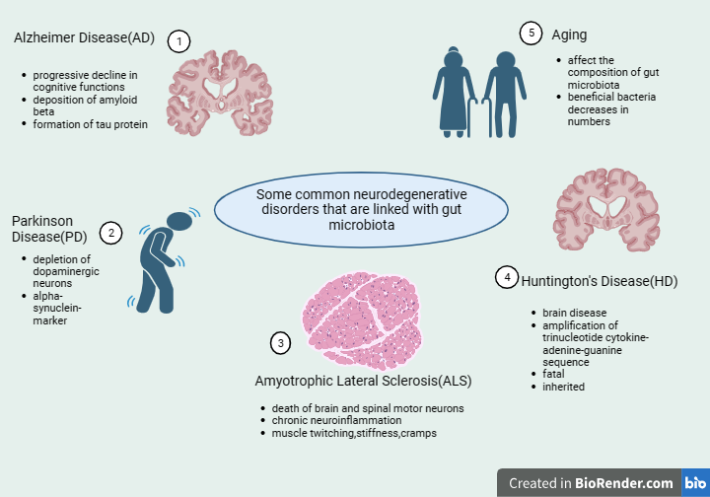

**Figure 10:** Some common Neurodegenerative disorders that are linked with gut microbiota-1.Alzheimer’s Disease 2. Parkinson’s disease 3. Amyotrophic Lateral Sclerosis 4.Huntington’s Disease 5. Aging and their characteristics (Sorboni et al., 2022).

**7.1. Relation between gut microbiota and neurodegenerative disorders**

The CNS, ENS, and gastrointestinal (GI) bacteria govern the complex biochemical signaling, referred to as the gut-brain axis (GBA), between the GIT and the brain. Recent research on GBA has demonstrated the significance of intestinal microbiota involvement in these bidirectional interactions, namely via neurological, immunological, humoral, and endocrine linkages from the GI microbiota to the brain and vice versa. Since abnormalities in the GI microflora can affect the brain's physiology, cognition, and behavior, research on the GBA has received a lot of focus recently (Ojeda,2021). Since abnormalities in the GI microflora can affect the brain's physiology, cognition, and behavior, research on the GBA has received a lot of focus recently.The stomach and brain are connected by two different neuroanatomical routes. First, the vagus nerve (VN) and the autonomic nervous system (ANS) in the spinal cord provide direct communication between the brain and the gastrointestinal tract. Second, the bilateral contact between the gut and the brain is caused by the communication of Enteric Nervous System ( ENS) and GIT, which also results from the ANS and VN. Through the VN and activation of ENS afferent neurons, bacteria create a direct neurological link between the brain and GI microflora. Additionally, vagal stimulation has several beneficial effects on the gut microbiota and the probiotic stem as a result of its anti-inflammatory properties .Intestinal disorders like inflammatory bowel disease (IBD) and irritable bowel syndrome (IBS), as well as neurological illnesses and psychiatric conditions like anxiety, depression, have implications with an imbalance of the gut microbial communities or "dysbiosis" in the gut microbiota, according to a number of preclinical studies.

**7.2. Communication of gut and brain through Chemical Signaling**

The GI microbiome interacts with the CNS primarily through immune-related, neurological, endocrine, and metabolic signalling pathways because there are several interactions within the microbiome-gut-brain axis (MGBA) via diverse mechanisms (Doshi et al, 2017). The brain and the resident microbes in the gut communicate using neurotransmitters like dopamine,γ-aminobutyric acid (GABA), serotonin, or 5-hydroxytryptamine (5-HT), neuropeptides, hormones (like the secretion of corticotropin-releasing hormone in the hypothalamic-pituitary-adrenal [HPA] axis), and short-chain fatty acids (SCFAs).Additionally, the control of the release of neurotransmitters like serotonin is influenced by the gut bacteria. For instance, by raising plasma levels of tryptophan, a precursor to serotonin, Bifidobacterium infantis influences central serotonin transmission (Thomas et al., 2012) . Additionally, it has been claimed that several bacterial species may synthesise a number of neurotransmitters, including acetylcholine, dopamine, noradrenaline, and serotonin. Bidirectional MGBA interactions are mediated by microbiota-derived metabolites, such as neuroactive metabolites, neurotransmitters, and vitamins, which affect host neurophysiology and immunology. Since the blood-brain barrier (BBB) and a number of feedback loops prevent direct access to the brain, it is still unclear how these microbial compounds affect brain function. As a result, they have an effect either immediately after passing through the BBB or indirectly through neuroendocrine, immunological, or vagal pathways.

**7.3. Alzheimer Disease (AD)**

Alzheimer's disease (AD) is a long-term, irreversible brain condition that causes memory loss and cognitive decline as a result of the gradual degradation of brain cells. The majority of older people with dementia (a group of symptoms that affect memory, thinking, and social abilities) suffer from this kind. Patients with AD have significant memory, behavior, and learning problems that interfere with daily tasks. In addition to amyloid-(Aβ) deposition around or outside of neurons, AD is characterized by neuronal cell death in the brain and progressive synaptic failure, as well as abnormal phosphorylation of the microtubule-associated protein tau (or proteins) in cortical neurons, dendrites and axons (Mucke et al,2012).The two main neuropathological markers of AD are still extracellular amyloid beta(Aβ) deposition (neurotic plaques) and intracellular accumulation of hyperphosphorylated tau (p-Tau; neurofibrillary tangles).Protein buildup and aggregation results in decreased microtubule stability, synaptic failure, and disruption of Ca2+ homeostasis in neurons, all of which eventually cause neuronal death . According to certain reports, amyloid may function as an AMP in the brain. Recent research has revealed a connection between the etiology of AD and CNS neuroinflammation brought on by external infections. Mice infected with the herpes simplex virus type 1 (HSV-1) exhibit traits that are typical of tau and Aβ deposition in AD individuals. Both the generation of Aβ and AD susceptibility are modulated by the elevated intracellular concentrations of cholesterol 25-hydroxylase (CH25H) brought on by viral infection. The possible associations between AD and various microbial diseases, such as fungal, Chlamydia pneumonia, and spirochaete infections, have also been shown in earlier research. Although there hasn't been a clear cure for AD for several decades, there have been some signs of optimism with the finding that the gut microbiota may play a crucial role in the pathogenesis of AD (Wimo et al,2017). Although it is not regarded as a novel idea, some research has shown that AD could have a microbiological origin. Correlations between microbe-derived compounds from the gut microflora and AD biomarkers such as phosphorylated tau and tau/A42 in the cerebral fluid of people with AD point to the involvement of the gut microbiota in the development of AD. Firmicutes and Actinobacteria counts were lower in AD patients, but Proteobacteria and Bacterioidetes numbers were higher and associated with a more severe form of AD. Furthermore, the presence and development of AD were linked to Enterobacteriaceae. From healthy controls to moderate cognitive impairment and dementia stage, the prevalence of "pro-inflammatory bacteria" such as Gammaproteobacteria, Enterobacteriales, and Enterobacteriaceae grew progressively. Additionally, there was a strong correlation between these alterations and AD's clinical severity (Leblhuber et al., 2021). Stool calprotectin content, which is known to be higher in people with dementia, may be used to quantify intestinal inflammation. The CSF fluid (cerebro-spinal fluid) and brain of AD patients both have considerably higher amounts of calprotectin, which promotes amyloid aggregation and co-aggregation with Aβ. Patients with AD might simultaneously have immune activation symptoms shown in their serum (neopterin) and faeces.

**7.4. Parkinson’s disease (PD)**

Parkinson's disease (PD) is a multicentric, progressive neurodegenerative disorder caused by the accumulation of Alpha-synuclein (aSyn) in the dopaminergic nerve cells of the substantia nigra, a region in the center of the brain (Braak et al., 2006). Lewy bodies, which are spherical lamellated eosinophilic cytoplasmic inclusions, are encouraged to gradually assemble via these mechanisms. Although the precise pathophysiology of PD is still unknown, it is likely a complex illness, and several ideas have been put out in that regard. A number of cellular pathways are affected by ageing, which impairs these activities and results in neurodegeneration. Ageing is a significant risk factor for the development and progression of Parkinson's disease (PD) (Poewe et al., 2017). It is possible that the same chemical changes that young neurons can tolerate have fatal impacts on older ones. Impaired motor symptoms, such as muscle stiffness, resting tremor, akinesia, and postural instability, are the main clinical signs of PD that first appear (Dickson et al., 2009). Before the age of 50, PD is uncommon, but as you age, your chances of getting it increase 5- to 10-fold. 5 to > 35 new cases per 100,000 people are reported each year, and it mostly affects men. Progressive dopaminergic neuron degeneration is accompanied by non-motor symptoms including sadness, dementia, and gastrointestinal (GI) issues like constipation, inappropriate salivation, defecatory dysfunction, nausea, and dysphagia. PD symptoms differ from person to person (Twelves et al., 2003). Numerous studies have suggested that intestinal dysbiosis and α-synuclein deposits in the enteric nervous system (ENS) are related to GI problems in PD patients. Up to 80% of people with PD experience abnormal gastrointestinal functioning, notably constipation, which can occur years before motor symptoms. The relationship between the gut microbiota and PD has been studied in several ways. Bifidobacterium, Lactobacillus, Akkermansia, and the opportunistic pathogens Porphyromonas and Corynebacterium have a high frequency in PD patients while Prevotellaceae, Lachnospiraceae, and Faecalibacterium, which produce SCFAs, are less common. The generation of the SCFA butyrate and the release of anti-inflammatory mediators by Faecalibacterium is shown to sustain the gut-barrier function. The Movement Disorder Society-Sponsored Revision of the Unified Parkinson's Disease Rating Scale (MDS-UPDRS) part III motor scores and depression are associated with lower butyrate levels in PD patients who have a lower Faecalibacterium count. In PD patients compared to controls, other butyrate-producing taxa, such as Blautia, Caprococcus, Rosburia, and Prevotella, also display immunomodulatory activities. According to these findings, a research on 39 Parkinson's disease (PD) patients and their healthy spouses in central China found a negative correlation between Prevotella abundance and disease severity, demonstrating the critical role that inflammation plays in the development of illness. Bifidobacterium and Lactobacillus are typically included in probiotic comes together because they are widely regarded as advantageous (Varesi et al., 2022). With only a few exceptions, most investigations revealed their unexplained enrichment in the faeces of PD patients; this might be a compensatory strategy to restore intestinal homeostasis.Low levels of plasma trimethylamine N -oxide(TMAO) assessed at an early stage of the disease may be used as a prognostic marker to predict the development of dementia. Additionally, urolithin, an anti-inflammatory protein generated by the gut microbiota in response to polyphenol ingestion, has been linked to decreased urine levels of disease severity. Urolithin, a measure of dysbiosis, is low when the wholesome Lachnospiraceae and Gordonibacter overgrow at the expense of the pro-inflammatory Enterobacteriaceae.

**8.** **Gut microbiota to combat stress**

Stress is a response, that causes physical, emotional, and other intellectual reactions. Stress alters the shape and activity of the gut microbial community, which is now widely acknowledged as one of the causes of dysbiosis (Carding et al., 2015). Both the brain and hormone levels change as a result of stress. This can, in extreme circumstances, have detrimental consequences on the heart and possibly cause heart failure or a heart attack. More frequently, it might cause mood swings, irregular or difficult menstrual cycles, and gastrointestinal (GI) symptoms brought on by stress. Other facets of your health may suffer as a result of stress. Risky behaviors like smoking (Yoon et al., 2021), binge drinking, abusing drugs, and addiction may become more prevalent. Stress indirectly raises your chance of having a stroke (Table 3).

|  |  |
| --- | --- |
| HEALTH PROBLEMS RELATED TO STRESS | |
| 1)HEART DISEASES | 7)ALZHEIMER’S DISEASE |
| 2)TAKOTSUBO SYNDROME | 8)INFLAMMATION |
| 3)OBESITY | 9) IRREGULAR PERIODS |
| 5)HEADACHE | 10)INFECTIONS |
| 6)GASTROINTSTINAL ISSUES | 11)HYPERGLYCEMIA |

**Table 3:** Common health problems related to stress .(stress can cause release of cholesterol in blood stream causing heart diseases and increase level of cortisol on abdomen causing obesity. Takotsubo syndrome is due to high level of epinephrine, norepinephrine. Irregular periods, occur when stress affects hormones regulating the reproductive system.

8.1. Mechanism of Stress

Several brain regions, including the hypothalamus, amygdala, and prefrontal cortex (Buijs & Van Eden, 2000) are involved in the stress response and anxiety. The hypothalamus is hypothesized to play a role in the physiological stress response, which involves receiving information about the stressful circumstance and then controlling the endocrine, autonomic, and behavioral systems. The process of categorizing situations according to their emotional valence determines how the individual will react to them. For instance, if a situation is judged to be positive, the individual will approach it; however, if the situation is judged to be negative, the individual will try to avoid it or become defensive against it. Positive and negative emotional valence has diverse effects on the activity of hypothalamic corticotropin neurons; negative emotional valence results in increased activity, whereas positive emotional valence results in decreased activity. Acute stress activates the noradrenergic projections in the locus coeruleus, which consequently causes an increase in behaviors associated with anxiety (Alpár et al., 2018). The strengthening of memories is another process involving the locus coeruleus noradrenergic projections; in this case, noradrenaline release brought on by stress enables the person to be extremely vigilant, which facilitates memory consolidation.

8.2. ROS (Reactive Oxygen Species) and it’s role in Mitochondria

ROS are highly oxidizing agents formed from diatomic oxygen (O2) (Chakraborti, et al., 2019). In other words ROS is a broad term used collectively for free radicals and non-free radicals of the biological system. Electron Transport Chain (ETC): The primary source of ROS production in mitochondria is the electron transport chain, which is responsible for generating cellular energy in the form of ATP. During the ETC, electrons move through a series of protein complexes, ultimately transferring energy to generate ATP. However, a small fraction of electrons can prematurely leak from the ETC, particularly at complex I and complex III. These leaked electrons can interact with molecular oxygen (O2) to generate superoxide anion radicals (O2−), which is an example of ROS.

* Complex I (NADH-ubiquinone oxidoreductase): Complex I is a significant site of electron leakage in the ETC. Electrons from NADH (a molecule that carries high-energy electrons) are transferred through complex I to ubiquinone. Some electrons Superoxide is created when some electrons break free from the chain and interact with oxygen.
* Complex III (Ubiquinol-cytochrome c oxidoreductase) is a significant additional source of ROS. Here, ubiquinol transfers its electrons to cytochrome c. Similar to complex I, electron leakage can happen and result in the creation of ROS.
* Flavin-containing Enzymes: Several flavin-containing enzymes, such as those involved in fatty acid oxidation and the Krebs cycle (TCA cycle), can also contribute to the formation of ROS inside the mitochondrial matrix. As they engage in redox interactions with oxygen, flavin molecules can produce ROS (Figure 11).

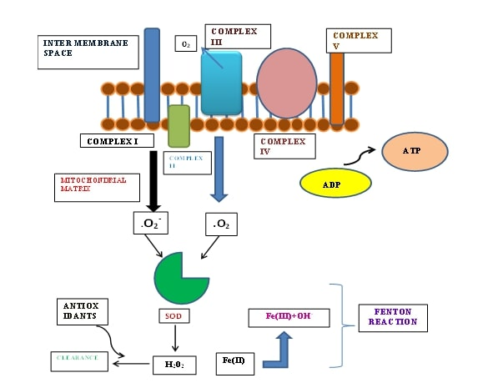

**Figure 11:** Diagram depicting formation of ROS in mitochondria. Comprises of 5 complexes. Superoxide anion radicals (O2) are a natural by-product of the electron transport chain (ETC) activity that causes (OXPHOS) Oxidative phosphorylation is the formation of O2- ,complex I , III,OH- via iron mediated reaction known as Fenton reaction.

Mitochondrial Membrane Potential (m): During electron transport, the inner mitochondrial membrane develops a potential that might affect the generation of ROS. The chance of electron leakage and ROS can rise with a greater membrane potential. Although ROS are thought to be detrimental chemicals because of their ability to produce oxidative stress, it is crucial to remember that cells have developed antioxidant defense systems to combat their negative effects. Superoxide dismutase (SOD) (Lui et al., 2019) catalase and glutathione peroxidase are a few examples of the enzymes that operate to combat ROS and stop cellular damage.

8.3. Healthy gut and diseased gut

Gut is said to be healthy if the gastrointestinal tract is having a good balance of gut bacteria and can properly digest and absorb nutrients. Both health and sickness are greatly influenced by the relationship between the host and the microorganisms. The diversity of the gut microbiota is strongly influenced by a variety of host characteristics, such as diet, human lifestyle, age, and environmental influences. The gut microbiota is now thought to be modulated by a number of important factors, including nutrition. The human microbiota has the potential to change appetite, increase nutritional uptake, and exert energy from different food constituents. Additionally, microbes play a crucial part in the metabolism of xenobiotics (Sutherland et al., 2020) In the process of xenobiotic metabolism; different gut microorganisms change the chemical composition of numerous foods, medications, pollutants, and many pesticides (Adhikary et al., 2023; Banerjee et al., 2022) (Figure 12).

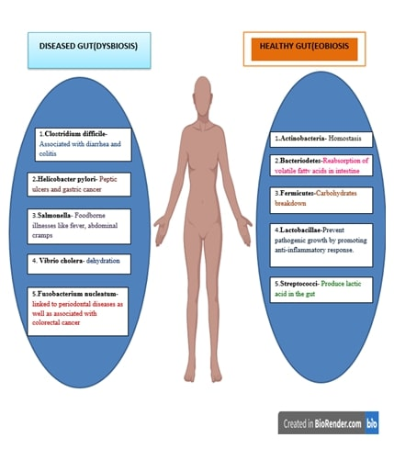

**Figure 12:** Diagram showing list of healthy and diseased gut microbes.

**Conclusion**

India spends a staggering amount of money on healthcare since infectious illnesses continue to be the main causes of human and animal morbidity and death rates. Bile acids and short-chain fatty acids (SCFAs), two types of gut microbiome metabolites that influence host immunity as well as provide nutrition and energy, can maintain the host healthy. These metabolites include minute compounds made directly by commensal bacteria as well as the byproducts of commensal bacteria digesting dietary substrates, both of which are essential for the health of the host. Much emphasis has been paid to the relationship between gut bacteria and the creature that serves as their symbiont. While the mechanics and structure of the digestive system are already complex, each of the microbial inhabitants of the gut has its own special functions. The gut microbiome is made up of bacteria, archaea, viruses, and eukaryotic creatures that live inside the digestive tract. The onset and progression of serious human diseases for which there are now no effective treatments have been revealed to be significantly influenced by the gut flora.

**References**

1. Boldogh, I., Albrecht, T., & Porter, D. D. (1996). Persistent Viral Infections. In S. Baron (Ed.), Medical Microbiology (4th ed.). University of Texas Medical Branch at Galveston. <http://www.ncbi.nlm.nih.gov/books/NBK8538/>
2. Malyshkin, A. P. (2014). Chronic infections: Causes and possible approach to treatment. Research Journal of Infectious Diseases, 2(1), 3. https://doi.org/10.7243/2052-5958-2-3
3. Yang, N. N., Lin, L. L., Li, Y. J., Li, H. P., Cao, Y., Tan, C. X., Hao, X. W., Ma, S. M., Wang, L., & Liu, C. Z. (2022). Potential Mechanisms and Clinical Effectiveness of Acupuncture in Depression. *Current neuropharmacology*, *20*(4), 738–750. <https://doi.org/10.2174/1570159X19666210609162809>
4. Mourya, D. T., Yadav, P. D., Ullas, P. T., Bhardwaj, S. D., Sahay, R. R., Chadha, M. S., Shete, A. M., Jadhav, S., Gupta, N., Gangakhedkar, R. R., Khasnobis, P., & Singh, S. K. (2019). Emerging/re-emerging viral diseases & new viruses on the Indian horizon. The Indian Journal of Medical Research, 149(4), 447–467. <https://doi.org/10.4103/ijmr.IJMR_1239_18>
5. Patil, A. V., Somasundaram, K. V., & Goyal, R. C. (2002). Current health scenario in rural India. The Australian journal of rural health, 10(2), 129–135. <https://doi.org/10.1046/j.1440-1584.2002.00458.x>
6. Banerjee, K., &amp; Dwivedi, L. K. (2016). Burden assessment of infectious and cardiovascular diseases in India for the decade 2004-2014. Epidemiology and Health. https://doi.org/10.4178/epih.e2016057
7. Insurance, T. C. H. (2023, May 25). Most communicable diseases in India. Care Health Insurance. https://www.careinsurance.com/blog/health-insurance-articles/most-communicable-diseases-in-india-you-must-know-about
8. U.S. National Library of Medicine. (n.d.). Global health. MedlinePlus. https://medlineplus.gov/globalhealth.html
9. (HG), B. H. G. (2021). Did you know? the top 5 most common communicable diseases worldwide. Humanitarian Global. <https://humanitarianglobal.com/did-you-know-the-top-5-most-common-communicable-diseases-worldwide/>
10. Mina, P. R., &amp; Immunology, D. of. (2023). Gut microbiota: A future clinical magic bullet to manifest pathogenic disease in the current future. Journal of Pure and Applied Microbiology. https://microbiologyjournal.org/gut-microbiota-a-future-clinical-magic-bullet-to-manifest-pathogenic-disease-in-the-current-future/
11. Khor, B., Snow, M., Herrman, E., Ray, N., Mansukhani, K., Patel, K. A., Said-Al-Naief, N., Maier, T., &amp; Machida, C. A. (2021, February 26). Interconnections between the oral and gut microbiomes: Reversal of microbial dysbiosis and the balance between Systemic Health and disease. MDPI. https://doi.org/10.3390/microorganisms9030496
12. Hill, C. L., Sharma, A., Shouche, Y., & Severson, D. W. (2014). Dynamics of midgut microflora and dengue virus impact on life history traits in Aedes aegypti. Acta tropica, 140, 151–157. <https://doi.org/10.1016/j.actatropica.2014.07.015>
13. Ullah, H., Arbab, S., Tian, Y., Liu, C., Chen, Y., Qijie, L., Khan, M. I. U., Hassan, I. U., & Li, K. (2023). The gut microbiota–brain axis in neurological disorder. Frontiers in Neuroscience, 17. <https://www.frontiersin.org/articles/10.3389/fnins.2023.1225875>
14. Younossi, Z., Anstee, Q. M., Marietti, M., Hardy, T., Henry, L., Eslam, M., George, J., & Bugianesi, E. (2018). Global burden of NAFLD and NASH: trends, predictions, risk factors and prevention. Nature reviews. Gastroenterology & hepatology, 15(1), 11–20. https://doi.org/10.1038/nrgastro.2017.109
15. Xia, Y., Ren, M., Yang, J., Cai, C., Cheng, W., Zhou, X., Lu, D., &amp; Ji, F. (2022). Gut microbiome and microbial metabolites in NAFLD and after bariatric surgery: Correlation and causality. Frontiers in Microbiology, 13. https://doi.org/10.3389/fmicb.2022.1003755
16. Gupta, H., Min, B.-H., Ganesan, R., Gebru, Y. A., Sharma, S. P., Park, E., Won, S.-M., Jeong, J.-J., Lee, S.-B., Cha, M.-G., Kwon, G.-H., Jeong, M.-K., Hyun, J.-Y., Eom, J.-A., Park, H.-J., Yoon, S.-J., Choi, M.-R., Kim, D.-J., &amp; Suk, K.-T. (2022). Gut microbiome in non-alcoholic fatty liver disease: From mechanisms to therapeutic role. Biomedicines, 10(3), 550. https://doi.org/10.3390/biomedicines10030550
17. Hospitals, P. (2022). NAFLD &amp; Nash - symptoms, causes, differences &amp; treatment options. Pace Hospitals | Best Hospitals in Hyderabad. https://www.pacehospital.com/non-alcoholic-fatty-liver-disease-causes-symptoms-diagnosis-and-treatment
18. U.S. Department of Health and Human Services. (n.d.). Microbiome. National Institute of Environmental Health Sciences. https://www.niehs.nih.gov/health/topics/science/microbiome/index.cfm
19. Vijay, A., &amp; Valdes, A. M. (2021). Role of the gut microbiome in chronic diseases: A narrative review. European Journal of Clinical Nutrition, 76(4), 489–501. https://doi.org/10.1038/s41430-021-00991-6
20. Cheng, X., Zheng, J., Lin, A., Xia, H., Zhang, Z., Gao, Q., Lv, W., &amp; Liu, H. (2020). A review: Roles of carbohydrates in human diseases through regulation of imbalanced intestinal microbiota. Journal of Functional Foods, 74, 104197. https://doi.org/10.1016/j.jff.2020.104197
21. Valdes, A. M., Walter, J., Segal, E., &amp; Spector, T. D. (2018). Role of the gut microbiota in nutrition and health. BMJ. https://doi.org/10.1136/bmj.k2179
22. Zhang, C., Franklin, C. L., &amp; Ericsson, A. C. (2021). Consideration of gut microbiome in murine models of diseases. Microorganisms, 9(5), 1062. https://doi.org/10.3390/microorganisms9051062
23. Afzaal, M., Saeed, F., Shah, Y. A., Hussain, M., Rabail, R., Socol, C. T., Hassoun, A., Pateiro, M., Lorenzo, J. M., Rusu, A. V., &amp; Aadil, R. M. (2022, August 31). Human Gut Microbiota in health and disease: Unveiling the relationship. Frontiers. <https://www.frontiersin.org/articles/10.3389/fmicb.2022.999001/full>
24. Liang, J., Li, T., Zhao, J., Wang, C., & Sun, H. (2022). Current understanding of the human microbiome in glioma. *Frontiers in oncology*, *12*, 781741. <https://doi.org/10.3389/fonc.2022.781741>
25. Varol, C., Mildner, A., & Jung, S. (2015). Macrophages: development and tissue specialization. Annual review of immunology, 33, 643–675. <https://doi.org/10.1146/annurev-immunol-032414-112220>
26. Harding, C. V., & Geuze, H. J. (1992). Class II MHC molecules are present in macrophage lysosomes and phagolysosomes that function in the phagocytic processing of Listeria monocytogenes for presentation to T cells. The Journal of cell biology, 119(3), 531–542. <https://doi.org/10.1083/jcb.119.3.531>
27. Yang, J., Zhang, L., Yu, C., Yang, X. F., & Wang, H. (2014). Monocyte and macrophage differentiation: circulation inflammatory monocyte as biomarker for inflammatory diseases. Biomarker research, 2(1), 1. <https://doi.org/10.1186/2050-7771-2-1>
28. Italiani, P., & Boraschi, D. (2015). New Insights Into Tissue Macrophages: From Their Origin to the Development of Memory. Immune network, 15(4), 167–176. <https://doi.org/10.4110/in.2015.15.4.167>
29. Professional, C. C. medical. (n.d.). Inflammation: What is it, causes, symptoms &amp; treatment. Cleveland Clinic. <https://my.clevelandclinic.org/health/symptoms/21660-inflammation#:~:text=Inflammation%20is%20an%20essential%20part,may%20lead%20to%20chronic%20inflammation>.
30. Yunna, C., Mengru, H., Lei, W., & Weidong, C. (2020). Macrophage M1/M2 polarization. European journal of pharmacology, 877, 173090. <https://doi.org/10.1016/j.ejphar.2020.173090>
31. Oishi, Y., & Manabe, I. (2018). Macrophages in inflammation, repair and regeneration. International immunology, 30(11), 511–528. <https://doi.org/10.1093/intimm/dxy054>
32. Fujiwara, N., & Kobayashi, K. (2005). Macrophages in inflammation. Current drug targets. Inflammation and allergy, 4(3), 281–286. <https://doi.org/10.2174/1568010054022024>
33. Muntjewerff, E. M., Meesters, L. D., & van den Bogaart, G. (2020). Antigen Cross-Presentation by Macrophages. Frontiers in immunology, 11, 1276. <https://doi.org/10.3389/fimmu.2020.01276>
34. Kadomoto, S., Izumi, K., &amp; Mizokami, A. (2021, December 23). Macrophage polarity and Disease Control. MDPI. <https://www.mdpi.com/1422-0067/23/1/144>
35. Kim, S. Y., & Nair, M. G. (2019). Macrophages in wound healing: activation and plasticity. Immunology and cell biology, 97(3), 258–267. <https://doi.org/10.1111/imcb.12236>
36. Krzyszczyk, P., Schloss, R., Palmer, A., & Berthiaume, F. (2018). The Role of Macrophages in Acute and Chronic Wound Healing and Interventions to Promote Pro-wound Healing Phenotypes. Frontiers in physiology, 9, 419. <https://doi.org/10.3389/fphys.2018.00419>
37. Themes, U. (2017, May 5). Wound healing. Basicmedical Key. <https://basicmedicalkey.com/wound-healing-4/>
38. Fabián, O., & Kamaradová, K. (2022). Morphology of inflammatory bowel diseases (IBD). Morfologie zánětlivých střevních onemocnění (IBD). Ceskoslovenska patologie, 58(1), 27–37.
39. Professional, C. C. medical. (n.d.-b). Inflammatory bowel disease: Symptoms, treatment &amp; diagnosis. Cleveland Clinic. <https://my.clevelandclinic.org/health/diseases/15587-inflammatory-bowel-disease-overview>
40. Ko, J. K., & Auyeung, K. K. (2014). Inflammatory bowel disease: etiology, pathogenesis and current therapy. Current pharmaceutical design, 20(7), 1082–1096. <https://doi.org/10.2174/13816128113199990416>
41. Kumar, M., Garand, M., &amp; Khodor, S. A. (2019). Integrating omics for a better understanding of inflammatory bowel disease: A step towards Personalized Medicine – Journal of Translational Medicine. BioMed Central. <https://translational-medicine.biomedcentral.com/articles/10.1186/s12967-019-02174-1>
42. Thursby, E., &amp; Juge, N. (2017). Introduction to the human gut microbiota. The Biochemical journal. <https://www.ncbi.nlm.nih.gov/pmc/articles/PMC5433529/>
43. Qiu, P., Ishimoto, T., Fu, L., Zhang, J., Zhang, Z., &amp; Liu, Y. (2022, February 22). The gut microbiota in inflammatory bowel disease. Frontiers in cellular and infection microbiology. <https://www.ncbi.nlm.nih.gov/pmc/articles/PMC8902753/#:~:text=Based%20on%20the%20key%20role,also%20a%20current%20research%20hotspot>.
44. Aldars-García, L., Chaparro, M., &amp; Gisbert, J. P. (2021b, April 30). Systematic review: The gut microbiome and its potential clinical application in inflammatory bowel disease. MDPI. <https://www.mdpi.com/2076-2607/9/5/977>
45. Sasso, J. M., Ammar, R. M., Tenchov, R., Lemmel, S., Kelber, O., Grieswelle, M., & Zhou, Q. A. (2023). Gut Microbiome-Brain Alliance: A Landscape View into Mental and Gastrointestinal Health and Disorders. *ACS chemical neuroscience*, *14*(10), 1717–1763. <https://doi.org/10.1021/acschemneuro.3c00127>
46. Linares, D. M., Ross, P., & Stanton, C. (2016). Beneficial Microbes: The pharmacy in the gut. Bioengineered, 7(1), 11–20. <https://doi.org/10.1080/21655979.2015.1126015>
47. Jandhyala, S. M., Talukdar, R., Subramanyam, C., Vuyyuru, H., Sasikala, M., & Nageshwar Reddy, D. (2015). Role of the normal gut microbiota. World journal of gastroenterology, 21(29), 8787–8803. <https://doi.org/10.3748/wjg.v21.i29.8787>
48. Macfarlane, S., & Macfarlane, G. T. (2003). Regulation of short-chain fatty acid production. The Proceedings of the Nutrition Society, 62(1), 67–72. <https://doi.org/10.1079/PNS2002207>
49. Dekaboruah, E., Suryavanshi, M. V., Chettri, D., & Verma, A. K. (2020). Human microbiome: an academic update on human body site specific surveillance and its possible role. *Archives of microbiology*, *202*(8), 2147–2167. <https://doi.org/10.1007/s00203-020-01931-x>
50. Thomas, C. M., Hong, T., van Pijkeren, J. P., Hemarajata, P., Trinh, D. V., Hu, W., Britton, R. A., Kalkum, M., & Versalovic, J. (2012). Histamine derived from probiotic Lactobacillus reuteri suppresses TNF via modulation of PKA and ERK signaling. *PloS one*, *7*(2), e31951. <https://doi.org/10.1371/journal.pone.0031951>
51. De Biase, D., & Pennacchietti, E. (2012). Glutamate decarboxylase-dependent acid resistance in orally acquired bacteria: function, distribution and biomedical implications of the gadBC operon. *Molecular microbiology*, *86*(4), 770–786. <https://doi.org/10.1111/mmi.12020>
52. Swanson, K. S., Gibson, G. R., Hutkins, R., Reimer, R. A., Reid, G., Verbeke, K., Scott, K. P., Holscher, H. D., Azad, M. B., Delzenne, N. M., & Sanders, M. E. (2020). The International Scientific Association for Probiotics and Prebiotics (ISAPP) consensus statement on the definition and scope of synbiotics. *Nature reviews. Gastroenterology & hepatology*, *17*(11), 687–701. https://doi.org/10.1038/s41575-020-0344-2
53. Sorboni, S. G., Moghaddam, H. S., Jafarzadeh-Esfehani, R., & Soleimanpour, S. (2022). A Comprehensive Review on the Role of the Gut Microbiome in Human Neurological Disorders. *Clinical microbiology reviews*, *35*(1), e0033820. <https://doi.org/10.1128/CMR.00338-20>
54. Neurological Disorders. Clinical microbiology reviews, 35(1), e0033820. <https://doi.org/10.1128/CMR.00338-20>
55. Sarangi, A. N., Goel, A., Singh, A., Sasi, A., & Aggarwal, R. (2017). Faecal bacterial microbiota in patients with cirrhosis and the effect of lactulose administration. BMC gastroenterology, 17(1), 125. <https://doi.org/10.1186/s12876-017-0683-9>
56. Doshi, A., & Chataway, J. (2017). Multiple sclerosis, a treatable disease . *Clinical medicine (London, England)*, *17*(6), 530–536. <https://doi.org/10.7861/clinmedicine.17-6-530>
57. Ojeda, J., Ávila, A., & Vidal, P. M. (2021). Gut Microbiota Interaction with the Central Nervous System throughout Life. Journal of clinical medicine, 10(6), 1299. https://doi.org/10.3390/jcm10061299
58. Leblhuber, F., Ehrlich, D., Steiner, K., Geisler, S., Fuchs, D., Lanser, L., & Kurz, K. (2021). The Immunopathogenesis of Alzheimer's Disease Is Related to the Composition of Gut Microbiota. *Nutrients*, *13*(2), 361. <https://doi.org/10.3390/nu13020361>
59. Wimo, A., Guerchet, M., Ali, G. C., Wu, Y. T., Prina, A. M., Winblad, B., Jönsson, L., Liu, Z., & Prince, M. (2017). The worldwide costs of dementia 2015 and comparisons with 2010. *Alzheimer's & dementia : the journal of the Alzheimer's Association*, *13*(1), 1–7. <https://doi.org/10.1016/j.jalz.2016.07.150>
60. Mucke, L., & Selkoe, D. J. (2012). Neurotoxicity of amyloid β-protein: synaptic and network dysfunction. *Cold Spring Harbor perspectives in medicine*, *2*(7), a006338. <https://doi.org/10.1101/cshperspect.a006338>
61. Mucke, L., & Selkoe, D. J. (2012). Neurotoxicity of amyloid β-protein: synaptic and network dysfunction. *Cold Spring Harbor perspectives in medicine*, *2*(7), a006338. <https://doi.org/10.1101/cshperspect.a006338>
62. Braak, H., de Vos, R. A., Bohl, J., & Del Tredici, K. (2006). Gastric alpha-synuclein immunoreactive inclusions in Meissner's and Auerbach's plexuses in cases staged for Parkinson's disease-related brain pathology. *Neuroscience letters*, *396*(1), 67–72. <https://doi.org/10.1016/j.neulet.2005.11.012>
63. Poewe, W., Seppi, K., Tanner, C. M., Halliday, G. M., Brundin, P., Volkmann, J., Schrag, A. E., & Lang, A. E. (2017). Parkinson disease. Nature reviews. Disease primers, 3, 17013. <https://doi.org/10.1038/nrdp.2017.13>
64. Varesi, A., Campagnoli, L. I. M., Fahmideh, F., Pierella, E., Romeo, M., Ricevuti, G., Nicoletta, M., Chirumbolo, S., & Pascale, A. (2022). The Interplay between Gut Microbiota and Parkinson's Disease: Implications on Diagnosis and Treatment. International journal of molecular sciences, 23(20), 12289. <https://doi.org/10.3390/ijms232012289>
65. Dickson, D. W., Fujishiro, H., Orr, C., DelleDonne, A., Josephs, K. A., Frigerio, R., Burnett, M., Parisi, J. E., Klos, K. J., & Ahlskog, J. E. (2009). Neuropathology of non-motor features of Parkinson disease. *Parkinsonism & related disorders*, *15 Suppl 3*, S1–S5. <https://doi.org/10.1016/S1353-8020(09)70769-2>
66. Twelves, D., Perkins, K. S., & Counsell, C. (2003). Systematic review of incidence studies of Parkinson's disease. *Movement disorders : official journal of the Movement Disorder Society*, *18*(1), 19–31. <https://doi.org/10.1002/mds.10305>
67. Mulak, A., & Bonaz, B. (2015). Brain-gut-microbiota axis in Parkinson's disease. World journal of gastroenterology, 21(37), 10609–10620. https://doi.org/10.3748/wjg.v21.i37.10609
68. Carding, S., Verbeke, K., Vipond, D. T., Corfe, B. M., & Owen, L. J. (2015). Dysbiosis of the gut microbiota in disease. *Microbial Ecology in Health &amp; Disease*, *26*(0). https://doi.org/10.3402/mehd.v26.26191.
69. Yoon, H., Lee, D. H., Lee, J. H., Kwon, J. E., Shin, C. M., Yang, S.-J., Park, S.-H., Lee, J. H., Kang, S. W., Lee, J.-S., &amp; Kim, B.-Y. (2021). Characteristics of the gut microbiome of healthy young male soldiers in South Korea: The effects of smoking. Gut and Liver, 15(2), 243–252. <https://doi.org/10.5009/gnl19354>
70. Buijs, R. M., &amp; Van Eden, C. G. (2000). The integration of stress by the hypothalamus, amygdala and prefrontal cortex: Balance between the autonomic nervous system and the neuroendocrine system. Progress in Brain Research, 117–132. <https://doi.org/10.1016/s0079-6123(00)26011-1>.
71. Alpár, A., Zahola, P., Hanics, J., Hevesi, Z., Korchynska, S., Benevento, M., Pifl, C., Zachar, G., Perugini, J., Severi, I., Leitgeb, P., Bakker, J., Miklosi, A. G., Tretiakov, E., Keimpema, E., Arque, G., Tasan, R. O., Sperk, G., Malenczyk, K., … Harkany, T. (2018). Hypothalamic            <scp>cntf</scp>            volume transmission shapes cortical noradrenergic excitability upon acute stress. *The EMBO Journal*, *37*(21). https://doi.org/10.15252/embj.2018100087
72. Kaliszewska, A., Allison, J., Martini, M., & Arias, N. (2021). Improving Age-Related Cognitive Decline through Dietary Interventions Targeting Mitochondrial Dysfunction. *International journal of molecular sciences*, *22*(7), 3574. https://doi.org/10.3390/ijms22073574
73. Sutherland, V. L., McQueen, C. A., Mendrick, D., Gulezian, D., Cerniglia, C., Foley, S., Forry, S., Khare, S., Liang, X., Manautou, J. E., Tweedie, D., Young, H., Alekseyenko, A. V., Burns, F., Dietert, R., Wilson, A., &amp; Chen, C. (2020). The gut microbiome and xenobiotics: Identifying knowledge gaps. Toxicological Sciences, 176(1), 1–10. <https://doi.org/10.1093/toxsci/kfaa060>
74. Liu, B. N., Liu, X. T., Liang, Z. H., & Wang, J. H. (2021). Gut microbiota in obesity. *World journal of gastroenterology*, *27*(25), 3837–3850. <https://doi.org/10.3748/wjg.v27.i25.3837>
75. Adhikary, K., Banerjee, P., Barman, S., Bandyopadhyay, B., & Bagchi, D. (2023). Nutritional Aspects, Chemistry Profile, Extraction Techniques of Lemongrass Essential Oil and It's Physiological Benefits. *Journal of the American Nutrition Association*, 1–18. Advance online publication. <https://doi.org/10.1080/27697061.2023.2245435>
76. Banerjee, P., Adhikary, K., Chatterjee, A., Sarkar, R., Bagchi, D., Ghosh, N., & Das, A. (2022). Digestion and gut microbiome. In *Elsevier eBooks* (pp. 123–140). https://doi.org/10.1016/b978-0-12-821232-5.00029-x