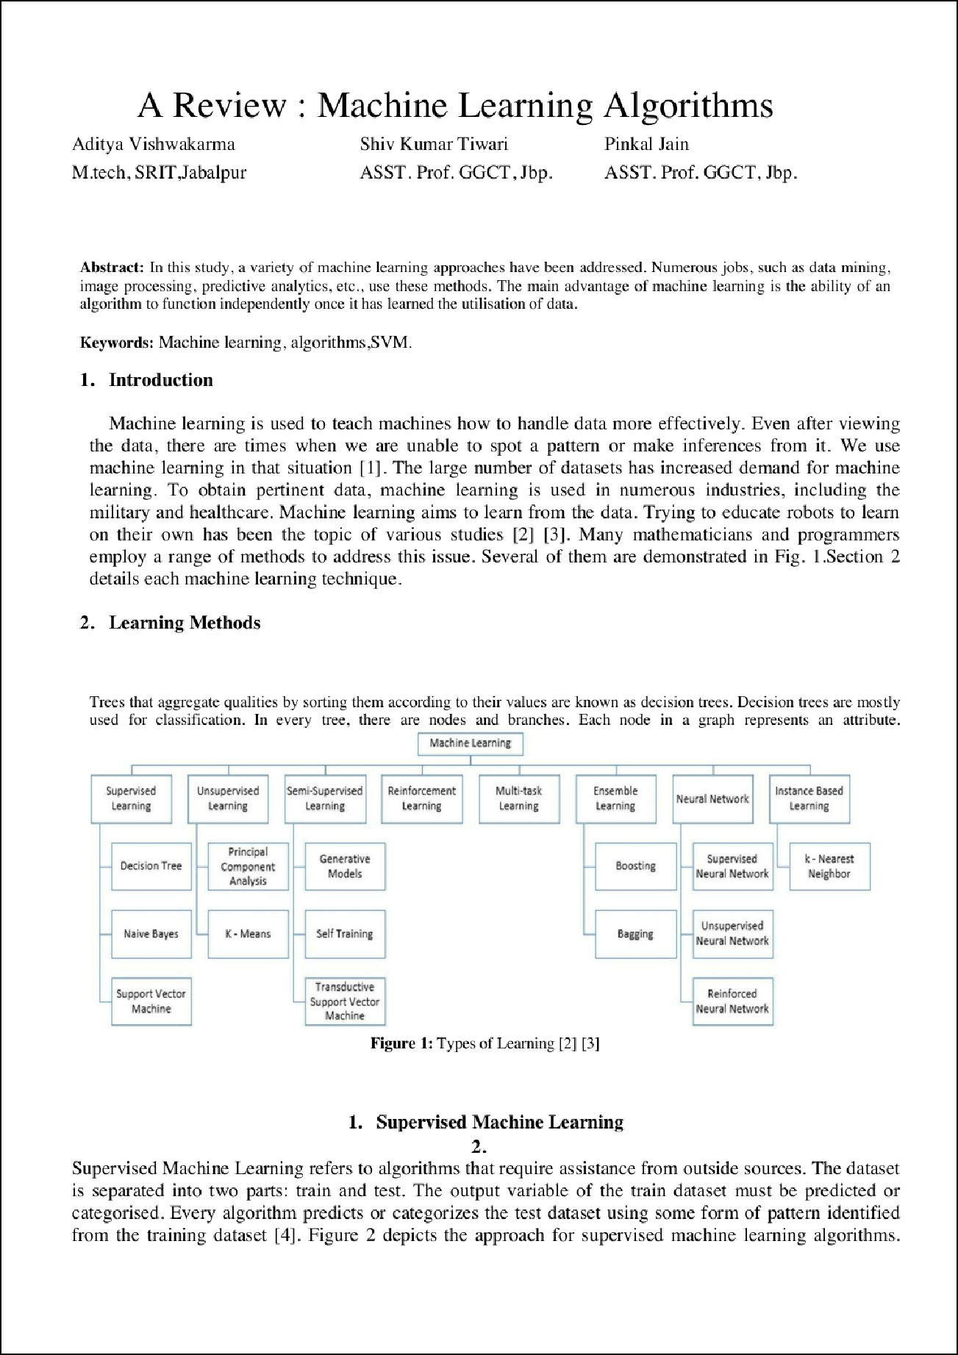

19

21
21
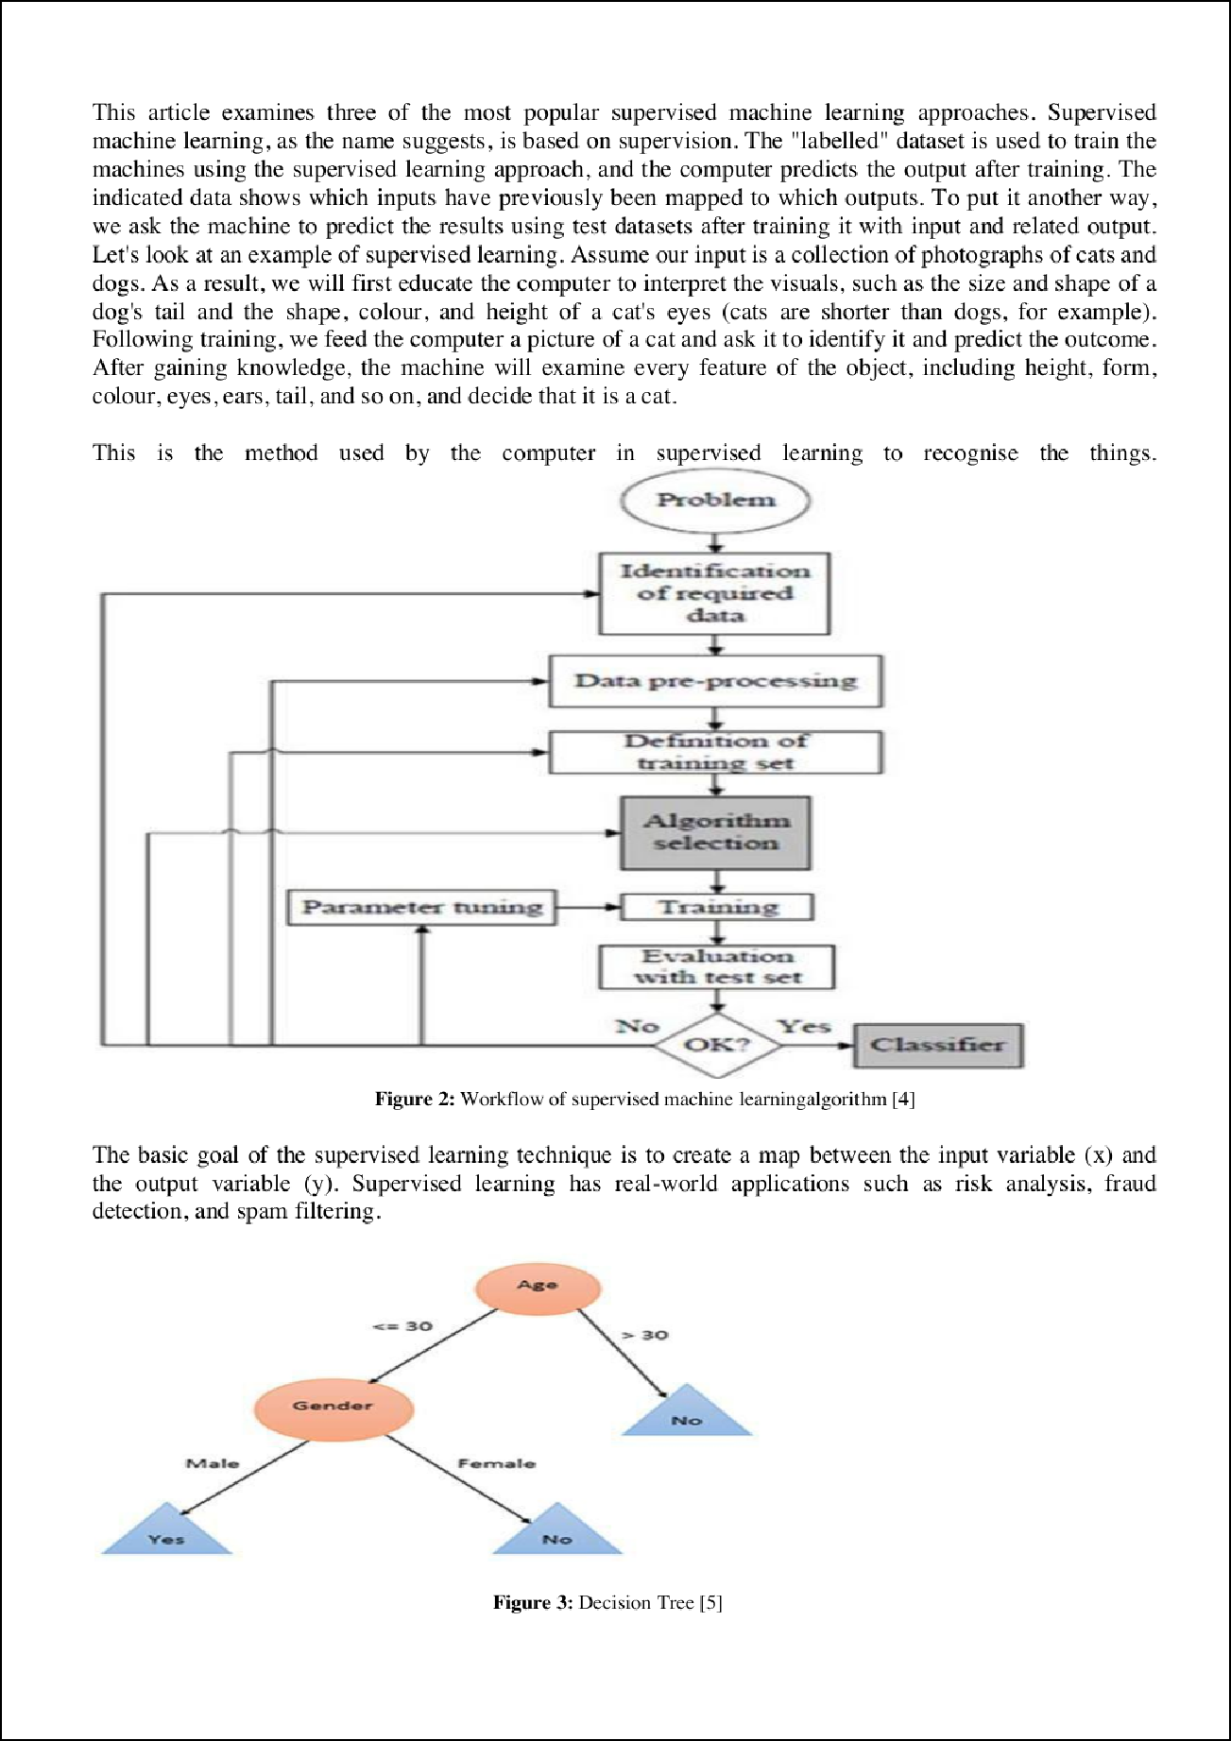

2

15

2

4

3

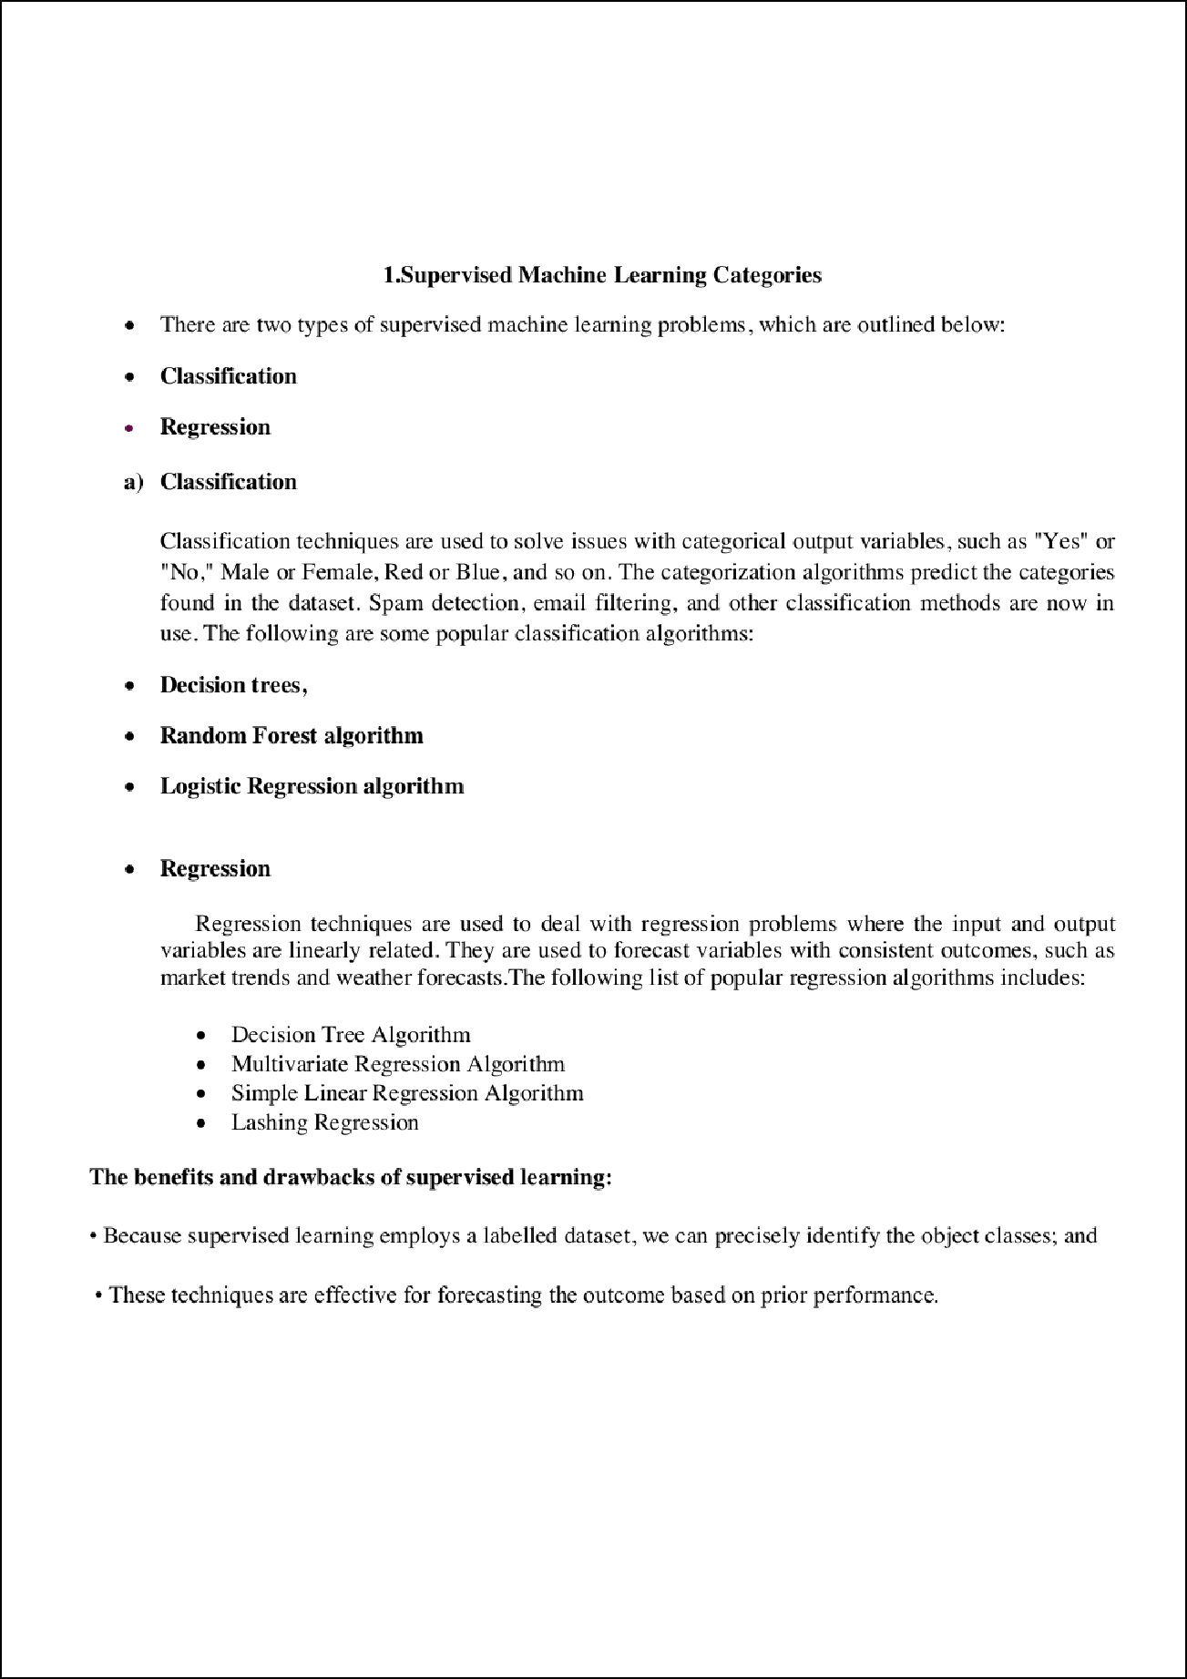

10

8

8

10

7

4

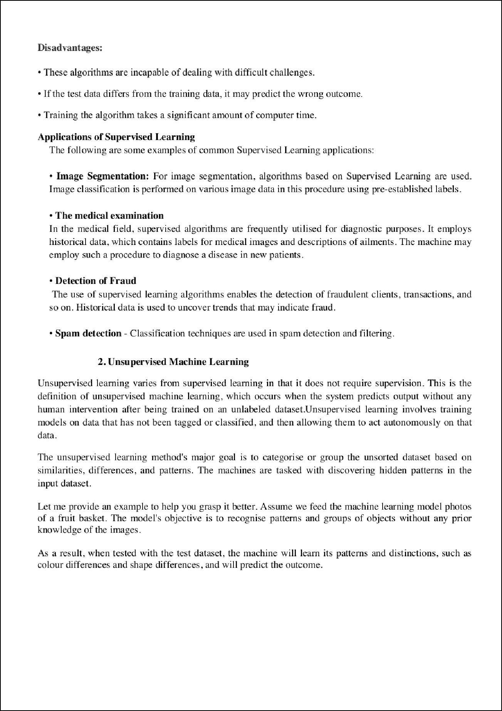

10

4

8

10

2
7
1

3

7

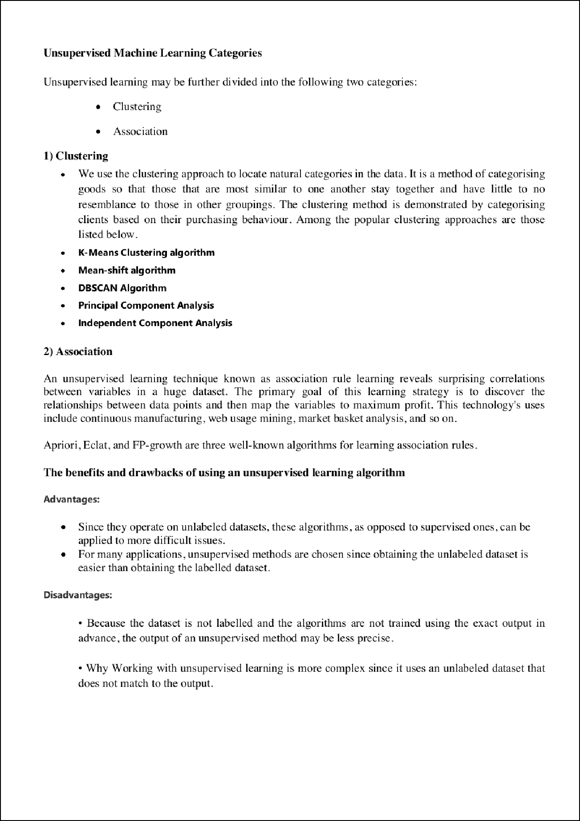

2

2
3

12

4

3

4

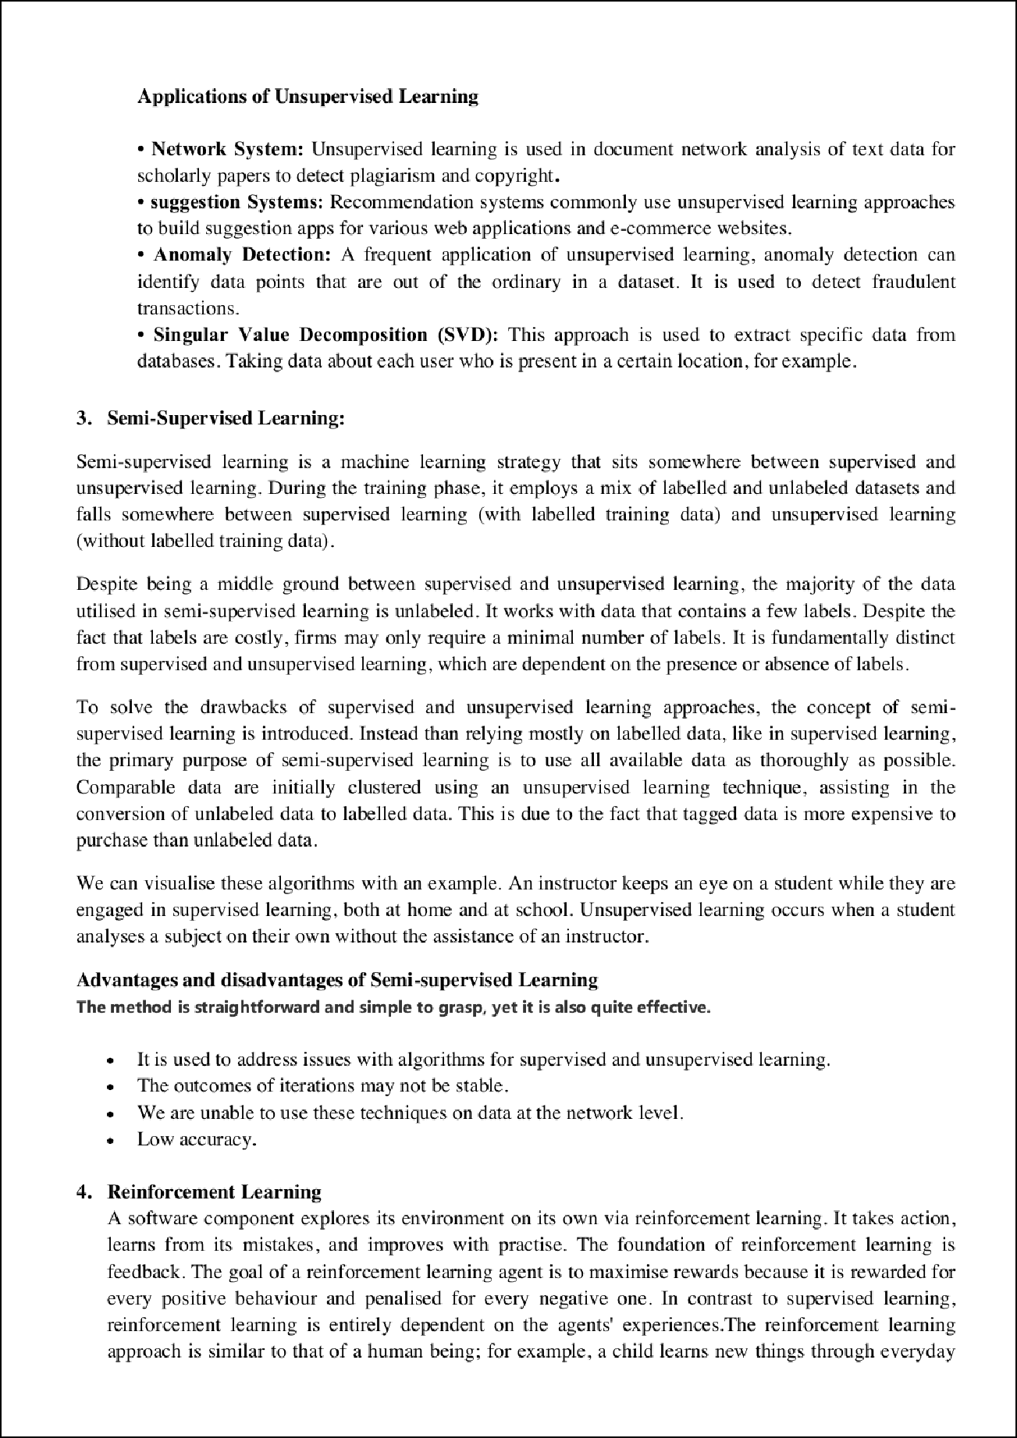

8

3

4

4

12

10

2
2
3

2

18
18

3
20

2

3

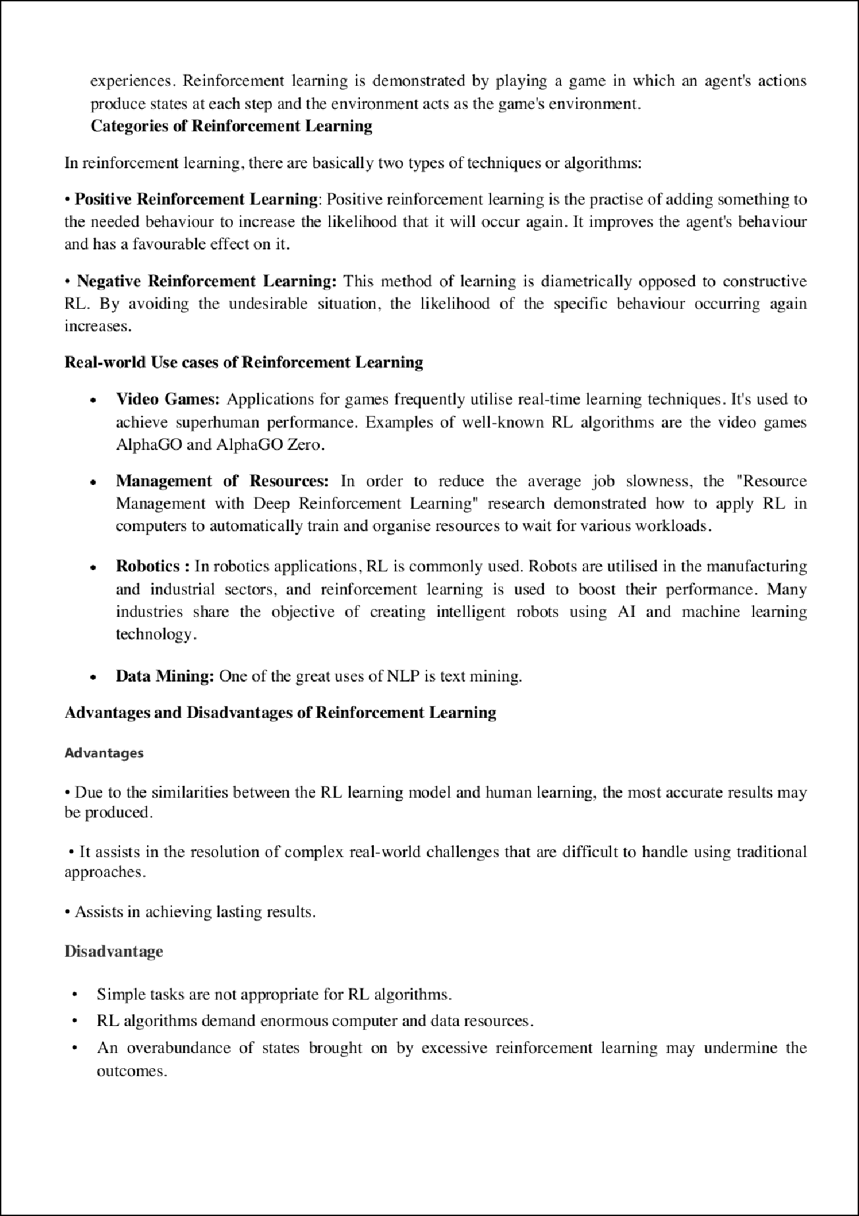

4

2
2

3

8

3

4

4

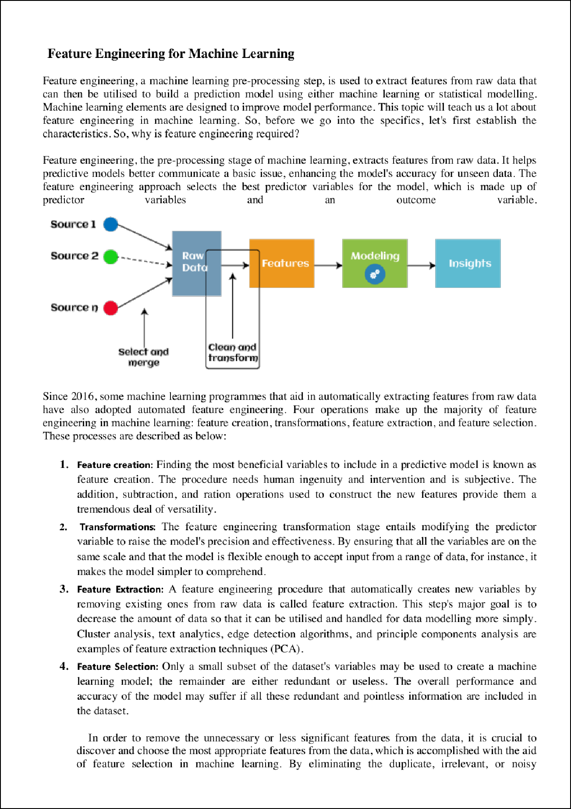

3

3 3

3

1

1

1

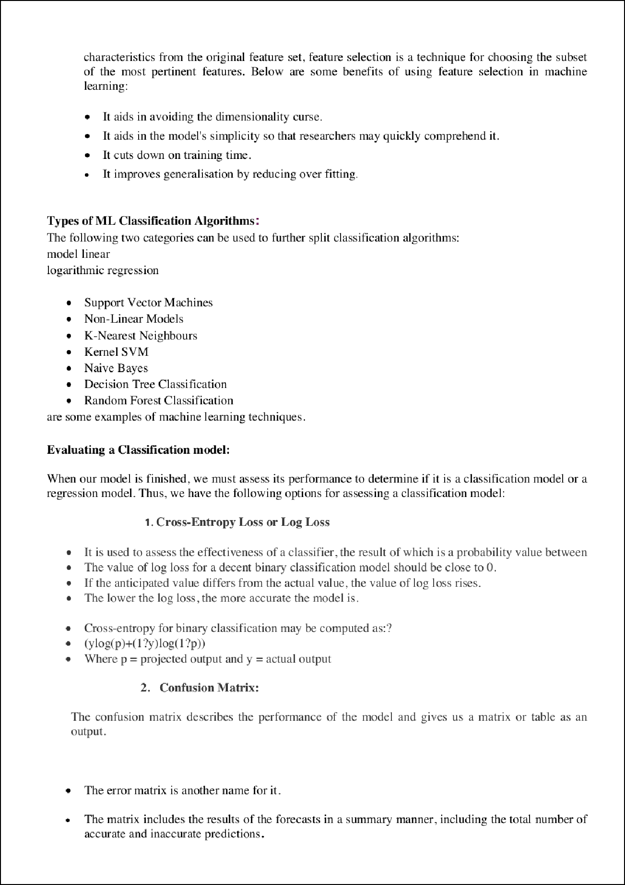

1

23

6

1

11

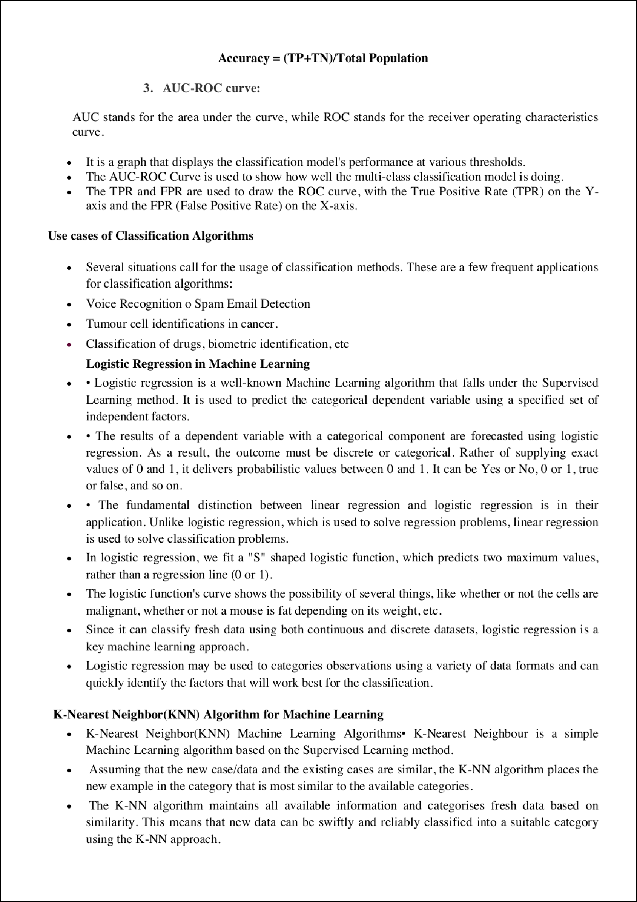

6

6

16

5

5

22
14

7
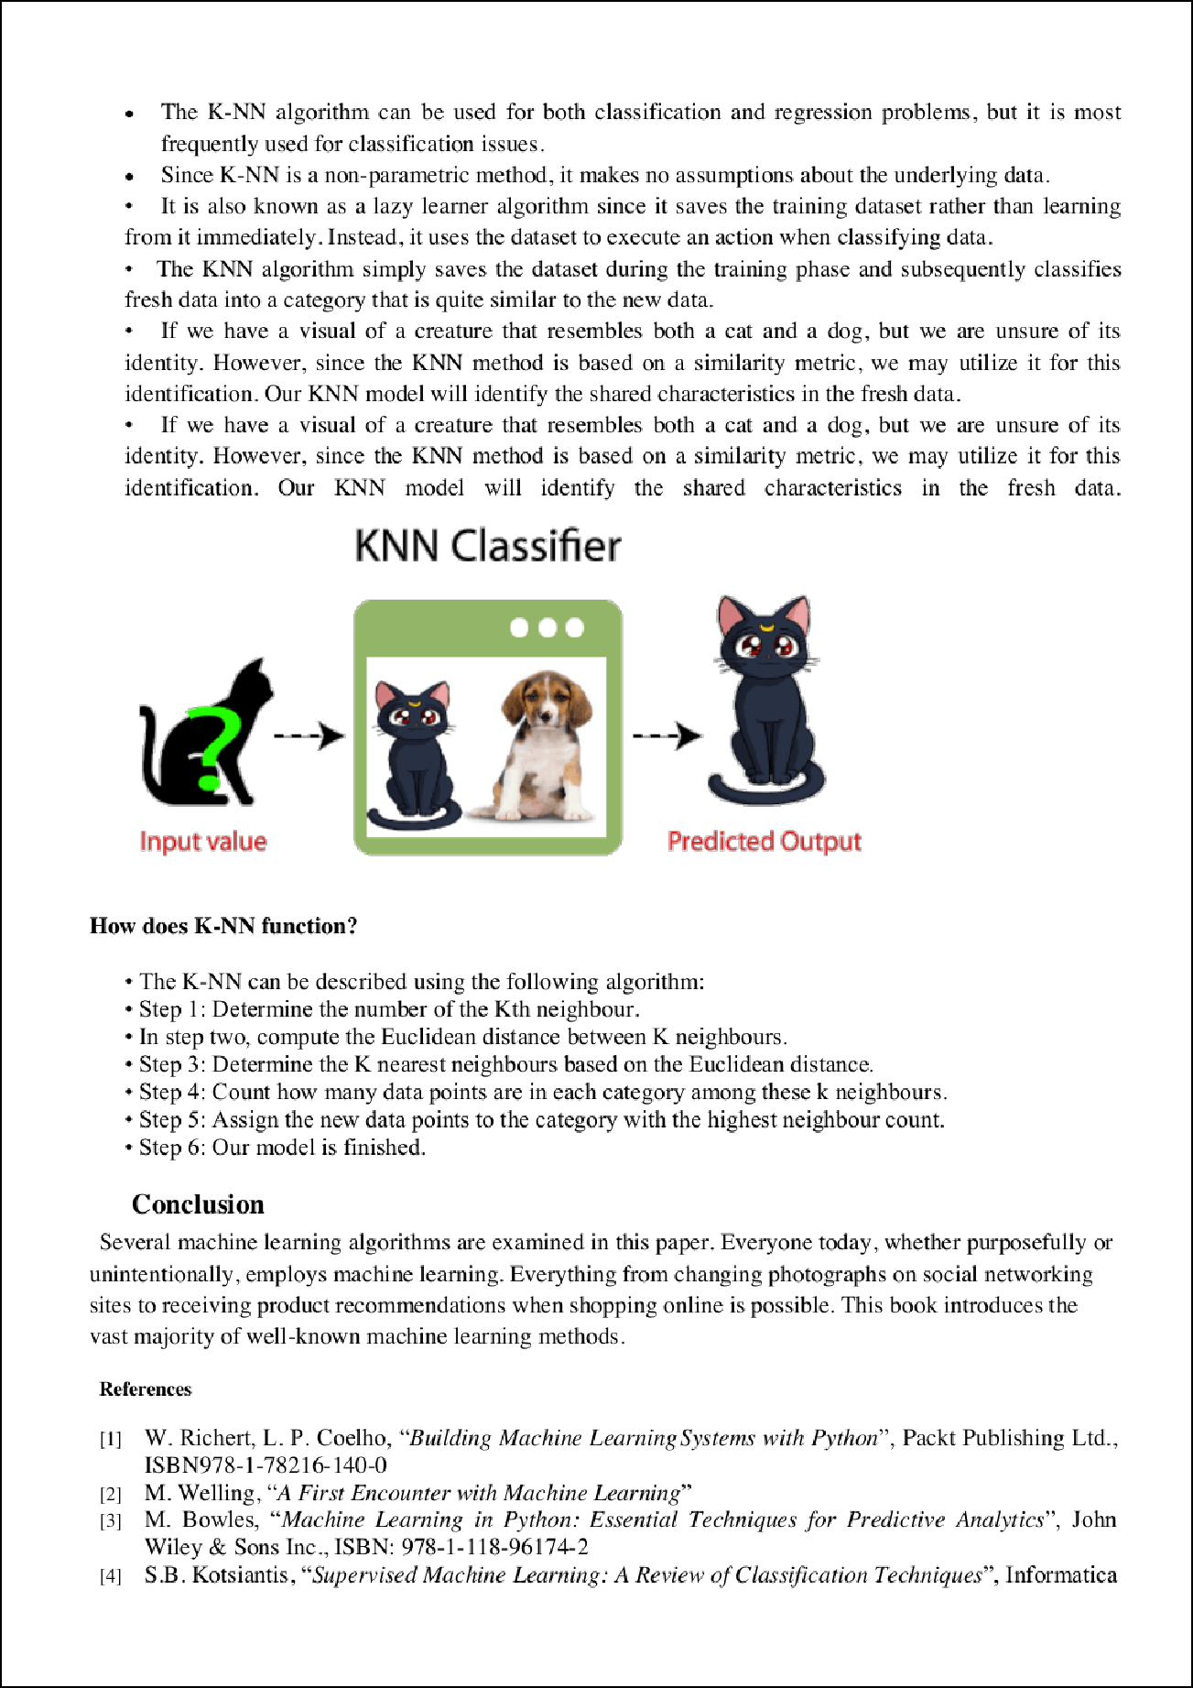

9

9

13

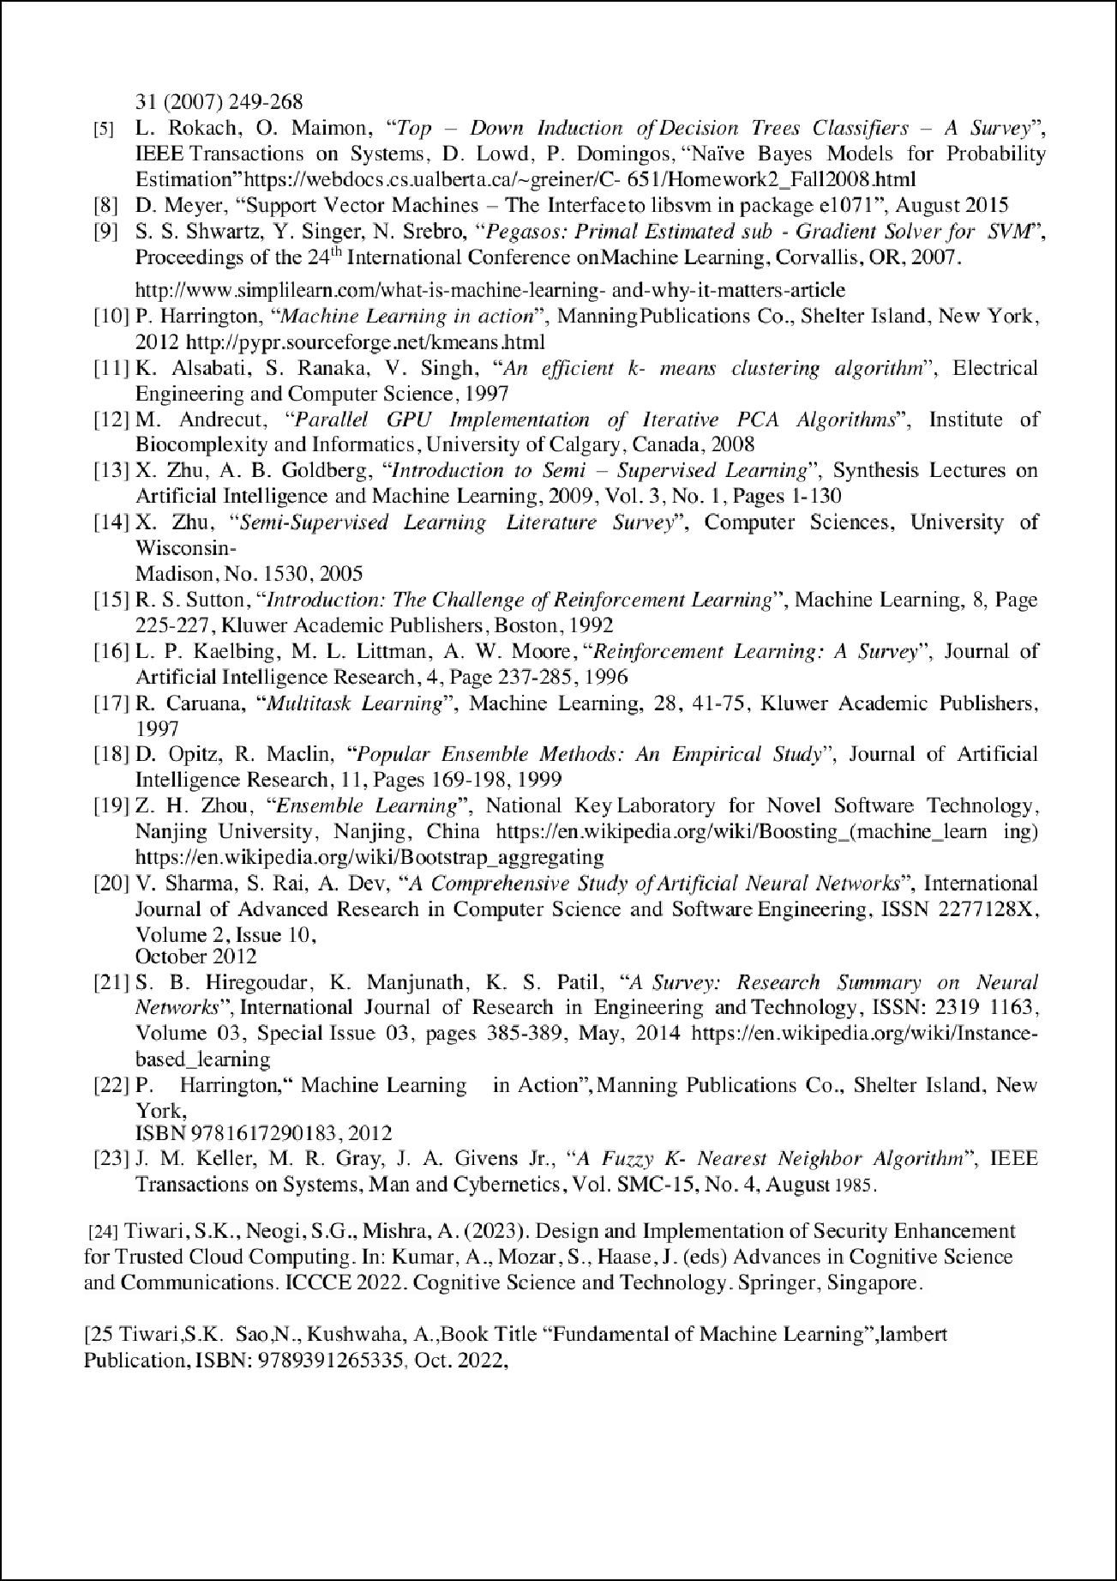

iip202382AD10C7A50763D.docx
55
ORIGINALITY REPORT

%
SIMILARITY INDEX
50%
INTERNET SOURCES
11%
PUBLICATIONS
45%
STUDENT PAPERS

PRIMARY SOURCES

www.analyticssteps.com
1
Internet Source

2 Submitted to Higher Education Commission Pakistan
Student Paper

www.javatpoint.com
3
Internet Source

www.researchgate.net
4
Internet Source

www.irjmets.com
5
Internet Source

www.simplilearn.com
6
Internet Source

Submitted to Coventry University
7
Student Paper

Submitted to Edith Cowan University
8
Student Paper

9 Submitted to Asia Paciﬁc Instutute of Information Technology
12%
6%
6%
5%
4%
4%
3%
2%
2%

10

11

12

13

14

15

16

17

18

19
Student Paper

www.ijraset.com
2
Internet Source %

Submitted to University of Huddersﬁeld
1
Student Paper %

Submitted to University of North Texas
1
Student Paper %

ijsrst.com
1
Internet Source %

pdfcoﬀee.com
1
Internet Source %

Submitted to Indian Institute of Technology Guwahati
1%
Student Paper

Submitted to University of Wales Institute, Cardiﬀ
1%
Student Paper

Submitted to King Fahd University for Petroleum and Minerals
1%
Student Paper

Submitted to Khalifa University of Science Technology and Research
1%
Student Paper

Submitted to RMIT University
1
Student Paper %

20

21

22

23
Submitted to Sunway Education Group
Student Paper %
1

Submitted to University of Salford
1
Student Paper %

Submitted to Manipal University
1
Student Paper %

www.coursehero.com
1
Internet Source %

Exclude quotes Oﬀ Exclude bibliography On
Exclude matches < 1%

