Fabrication of Economical Vertical Axis Wind Mill

B.Venkatesh¹  Professor, Mechanical Engineering  Vardhaman College of Engineering  Hyderabad , India 501218  Bvt2275@gmail.com | S.B.Sai Krishna²  Student, Mechanical Engineering  Vardhaman College of Engineering  Hyderabad , India 501218 | B.Deepak Raj³  Student, Mechanical Engineering  Vardhaman College of Engineering  Hyderabad , India 501218 | L.Tej Vardhan Reddy⁴  Student, Mechanical Engineering  Vardhaman College of Engineering  Hyderabad , India 501218
C.Anil Kumar Reddy⁵
JRF, Mechanical Engineering
Vardhaman College of Engineering
Hyderabad , India 501218

ABSTRACT

The world’s energy demand is steadily increasing, as is the demand for fossil fuels. We will not be able to meet future demand for fossil fuels at our current pace of consumption, and the detrimental environmental impact of carbon emissions will continue to hurt the world. We need to move toward more sustainable solutions with alternative energy technology to keep up with the growing demand for energy and reduce our reliance on fossil fuels. Rather than keeping a single central production location, the alternative energy industry has been decentralizing (i.e., multiple production sources are spread out over a vast area). If a node in a network falls down, a decentralized alternative energy market allows each individual in the community to maintain themselves and the network. Wind energy is a non-conventional form of energy that will never run out.. Conventional sources will be phased out in the near future. In a percentage basis, wind has been the fastest-growing power source on the planet. Many times, we notice that street lights are illuminated during the day. These lights are intended to be turned off early in the morning, but due to the negligence of linemen, they are illuminated irregularly. It is a hot topic for debate, especially in larger cities. The person in charge of these lights must turn them on immediately before or during sunset, and they must be turned off shortly before sunrise. However, because to the tiredness of the linemen, these street lights are sometimes left on during the day. Every day, a significant amount of energy is squandered in this manner; as a result, automatic street light control instruments are required and should be installed everywhere. As a result, this project work is created, which automatically energizes the streetlights when natural light disappears and de energizes them when natural light returns using vertical axis windmill to charge the battery. The goal of this project, which includes a vertical-axis windmill, is to further individual sustainability design. The vertical-axis windmill shown is low-cost, compact, and capable of supporting a load. Propellers, a LDR unit, and a generator will make up the vertical-axis windmill’s three elements. Each component has a distinct purpose. Wind energy is converted into mechanical energy by the propellers, mechanical energy is converted to electrical energy by the generator, and then further, the energy is stored in battery and sent to the LDR unit and circuit to lighten up and turn off the streetlights depending upon the light fallen on LDR unit.
Keywords—Energy, Fossil fuels,vertical axis wind mill, battery,LDR Unit.

INTRODUCTION

A combination of rapidly growing costs and a decrease in supply and demand the search for sustainable energy alternatives is being fuelled by concerns about global climate change. Some of the proposed alternatives, such as large-scale biofuel use, may not be practical or sustainable in the long run. Other outlandish possibilities, such as geothermal energy, may exist, but only on a tiny and limited scale. Because solar cells are tiny, expensive, and inefficient, they are still in their infancy. As a result, oil, coal, natural gas, and wind appear to be the world’s primary energy sources. Energy is one of the main components of economic infrastructure and is the fundamental input to sustain economic growth. The connection between economic progress and energy usage is substantial. The more a country develops, the greater the per capita usage of energy and vice versa. Human civilization depends on several energy sources.[1] Our globe has enough wind to provide most, if not all, of humanity’s energy needs. Wind was the world’s fastest increasing power source in terms of percentage gain from 1990 to 2002. Europe and the United States have a large number of winds generating stations. In 2004, the global wind capacity was 47,317 MW. Something new is clearly needed if the wind is to contribute considerably to the worldwide production of electricity. This item might be a windmill on the vertical axis.
Vertical axis windmills have the distinct advantage of being able to take wind from any direction and without requiring the complex head mechanics seen in traditional horizontal axis windmills. As a result, new vertical axis designs capable of significant power generation must be developed and tested. The usage of energy increased dramatically over the twentieth century. At the beginning of the 20th century, coal was the prevalent energy source and because of its higher energy density, oil was the major rival. Following WWII, there was a shift from coal to oil, which is still the dominant energy source today. Economic and demographic growth have been spurred by the availability of low-cost energy. More than 40percent of global energy use is accounted for by oil. There have been several forecasts regarding when oil might run out or become too expensive to extract. Windmill is now the most cost-effective means to gather horizontal wind power. They are located in a known area of wind on land or at sea. The two or three layers of most horizontal axis mills. On the top of a turbine are the primary rotor shaft and the power generator. And the wind should go. Small mills are marked by a simple wind vane whereas big mills are usually connected to a servomotor via a wind sensor. It comprises mostly of a gearbox that makes the low turning of the blades into a faster, more suited rotation for driving a generator.
The various horizontal turbines provide several sizes and power ratings. The biggest electricity-generating turbine has blades of high school height length. The wind turbine has an extraordinary height of 20 storeys and the rotors have a diameter of up to 25 feet. An power supply to a water pump, residence, or telecommunications system is available from a wind turbine of this size. A tiny turbine can produce 50 kW of electricity. The power generation is done via a wind farm. A wind farm is formed by several windmills gathered together. The electric power generated by the turbines is transferred from a power grid to clients. The power grid functions much like a regular power station.

MATERIALS AND METHODS

Renewable energy exploration is a technique which reduces our reliance on fossil fuels. Wind energy is the only resource in this study among various renewable energy resources. The project concentrates on the utilization of wind for the clean and safe provision of electricity as a renewable resource.. The project is aimed at fabricating and implementing a vertical axis windmill with LDR unit. The key benefit is that this prototype may be used at any area or building under maximum operating circumstances and work in less wind. We have chosen this power generation project. Power production is proportional directly to the size of assembly that comprises mainly the number of blades, capacity of generator, etc. The compact vertical axis windmill rotates when wind comes contacts with the blades, making the dc generator generating energy. This energy is stored in a battery which is used by the LED’s passing through the LDR unit which detects absence of light and the resistors resists the amount of electricity sent to the LEDs depending upon the intensity of light detected.
2.1 Materials Required
a) D.C motor
b) PVC blades shaft
c) LDR circuit
d) battery
e) relay
f) white LEDs
g) bearing

Fabrication of blades
We used a 75mm PVC pipe to fabricate the wind blades. We used a cutting machine to cut the pipe into 4 parts. Each blade is of 0.4cms thick and 39cms in length. We could have also used to stainless steel blades, but to avoid formation of rust and heavy weight of overall setup, we used PVC pipes which were easily available in local market and are of light weight too.

Fabrication of shaft
After fabricating the blades, we move on to fabricating of shaft with mild steel rod. The length of the shat we fabricated is maintained to be 41 cms and thickness is more than 2 cms.

Fabrication of stand
We used mild steel rods again here to make a support stand using arc welding in nearest welding shop. The height of the stand which is attached to the bottom of the setup is to be 14cms in height, length is about 30cms and coming to thickness of single rod in stand is 2.45cms. This stand is attached to a 350rpm DC generator. Also, “+” shaped mild steel rods are welded to the main shaft to which the blades are fixed using screws and bolts. One at the top of the shaft and one at the middle of the shaft. 2 attachments are made so as to give a proper and fixed placement of the blades.

assembling of shaft and rotating part
As above mentioned, the shaft of given specifications is fabricated and is joined to the pitch bearing of height 5.5cms with the help of arc welding.

making of LDR and relay unit
As shown in above chapters and following the circuit diagram, a LDR unit and relay unit are fixed on a cardboard sheet with a 12 volt battery ( 4 sets of three batteries connected in series) on one end of it. A small model of streetlight is also made using cardboard and bunch of LED lights.

Assembly
Finally, the blades are fixed to the rods the stand is connect to the shaft and the generator and shaft of blades are connected and welded together and the dc generator wires are connected to the batteries using a small 3 pin connecter.
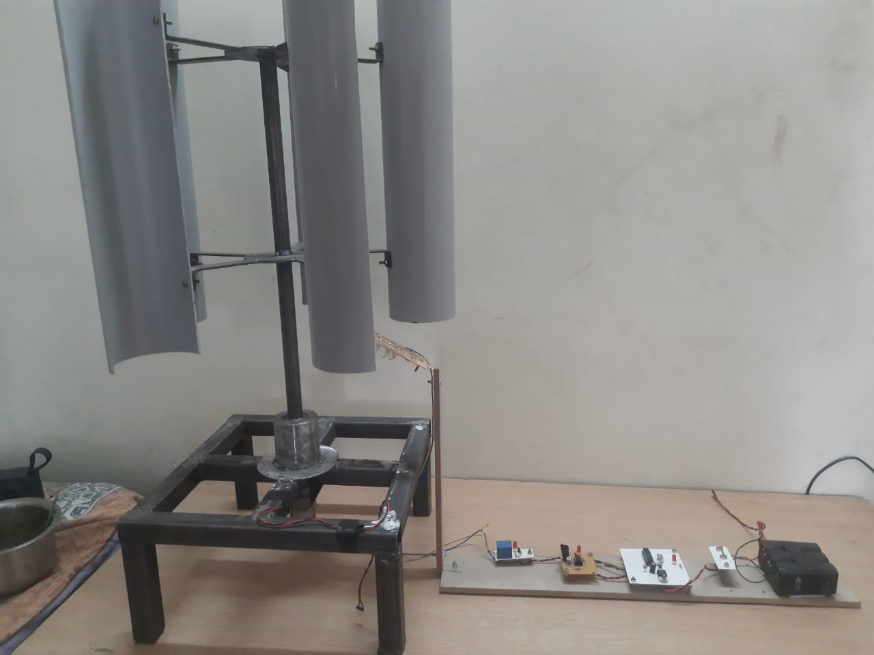  Figure 1: Assembled prototype | 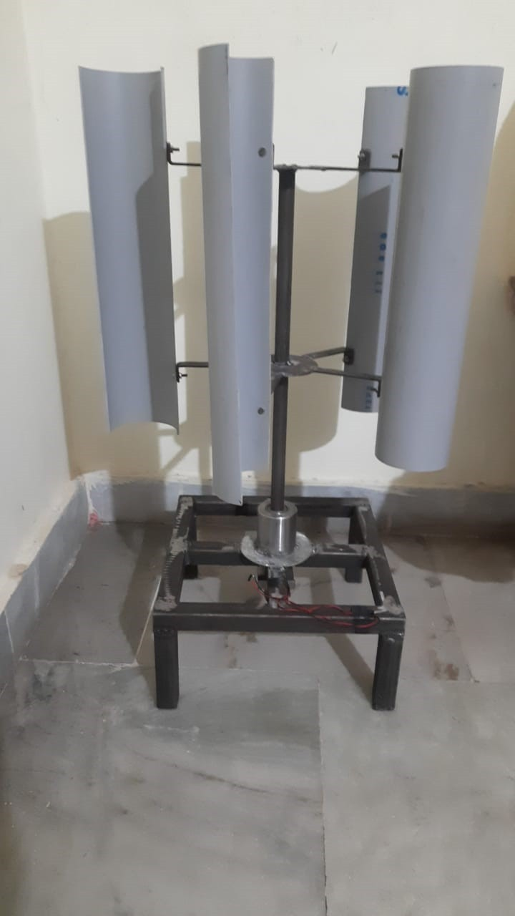  Figure 2: Wind Mill

RESULTS AND DISCUSSIONS

By the experiment, we learnt that a wind turbine’s output swings according on wind rates or wind speeds. The output voltage increases when the wind speed increases, vice versa. The produced voltage is used for power charges such as lights and ventilators. The angular rate is measured by means of a non-contact tachometer of a windmill, which can also measure wind turbine rpm and measure output voltage via a voltmeter.

Calculations

The turbine power is linked to the generated kinetic energy. The volume V’ flowing in unit time through an area A, with wind speed V is denoted by AV and mass M is the product of Volume V’ and density so:
M = ρ ∗ A ∗ V (1)
By including the M in kinetic energy the equation that we receive
Kinetic Energy = 0.5 ∗ ρ ∗ A ∗ V ³ (2)
Power, on the other hand, is nothing more than the kinetic energy created by the turbine.
Hence:

Where:
Power = 0.5ρ ∗ A ∗ V ³ (3)

Air Density(ρ) = 1.225kg/m³ (4)

Sr. No | Speed of the windmill  (in RPM) | Output voltage  (in Volts) | Angular velocity  (Rad/Sec) | Power in watts
1 | 25 | 1.72 | 2.57 | 0.51
2 | 50 | 3.49 | 5.2 | 4.59
3 | 75 | 5.26 | 7.81 | 15.65
4 | 100 | 7.0 | 10.4 | 37.2
5 | 120 | 8.4 | 12.5 | 64

Area (A) = Swept Area of turbine blades Velocity (V) = wind speed in m/s
The formula below depicts major parameters that affect a wind turbine’s performance. It’s worth noting that the wind speed, V, has a 3 exponent. As a result, even a slight increase in wind speed results in a significant gain in power. As illustrated in the Wind Speeds Boost with Height graph, a taller tower will increase the productivity of any wind turbine by allowing it access to higher wind speeds. The formula for calculating power is as follows:
Power = k ∗ Cp ∗ 1/2 ∗ ρ ∗ A ∗ V ³ (5)
where : P = Power output, kilowatts Cp = Maximum power coefficient, ranging from 0.25 to 0.45, dimension less (theoretical maximum = 0.59)
ρ = air density, kg/m³ (6)
A = Rotor swept area, π ∗ D²/4 (7)
V = Wind speed, KMPH
k = 0.000133 A constant to yield power in kilowatts.

IV. CONCLUSION
The main advantages of using wind as a source are that it is relatively inexpensive and that it is a natural power source that can be used to create energy affordably. This is a non-polluting and clean power source. Maglev wind turbines assist to lower noise factor compared to conventional wind turbines since noise factor is quite low and may be presumed to be zero. It does not need to be lubricated. The blades of this wind turbine may be rotated by wind from any direction.
We opted to build a windmill project for our main project. In the beginning, we felt it was a pretty basic initiative that would show us the natural resources that are not exploited sufficiently in our nation. We chose, however, to do a wind energy experiment after investigation instead, and we thus started the project which involves a little amount of electrical background projects that may enable us to improve the appropriate use of the energy source. It offered us a holistic and mechanical understanding due to the amount of mechanical knowledge needed to build an actual windmill. The compilation of electronics was straightforward as the windmill was created and the one great difficulty, we were not aware of was the choosing of our power generator and the creation of the LDR-circuit.
Many information about practical elements and how to execute various things in the workshop was acquired through the manufacturing process. The weather was not very helpful during the testing. Sometimes even 10 m/s at once blew incredibly strong winds. It was just about 1-2 m/s sometimes. Sometimes rain arrived to the celebration as well and in only a few seconds it got everything wet.
But at the end of the day these things were the most significant and essential things in the future and the lessons that they taught. Sometimes the bravery improved during the simulation period contributed to the manufacturing and testing. They were all good lessons, therefore.
Although our project did not create as much power as we originally planned, with an efficiency assessed at 7,52 percent it could provide a reasonable quan tity of electricity. Overall, the project has taught us engine selection, power generation, ratings for efficiency, mechanical design, problem resolution and other abilities. Even though we were able to make this design of Vertical Axis Wind Mill but there is always a procedure to enhance innovations and new ideas. Wind turbines are a beginning for civilization to minimize damage to the world by not utilizing pollution-generating energy sources.
Hopefully, the project may promote VAWM Frameworks research and tests, and provide insight for various gatherings, so that vertical windmills may be further tested and enhanced productivity and execution. The project will give a competent lighting system approach and facilitate and efficiently save the entire energy process. As the quantity of light output may be changed based on the external state, an invention with a large number of future applications is undoubtedly not only possible in many modern technicians such as headlights, street light, parking lights, industrial lights, and many more. There is no question that the use of the intelligent lighting system will revolutionize the world we see today. The most cost-efficient source of electricity in the foreseeable future is wind power. In fact, it might be argued that this status has already been obtained. There is no genuine knowledge of the exact life-cycle cost for fossil fuels, but likely significantly greater than the present wholesale pricing.
The possible depletion of these sources of energy will require quick price increases which, on average, will lead to postponed real prices that are unacceptable to the current norm during the short term of usage. And this even does not take into account the environmental and political cost of using fossil fuels that rise every day quietly and not so quietly.
Thus, it can create more energy constantly with efficient output using wind and sun energy using hybrid power generation techniques. By using these strategies and changing the output capacity of the wind turbine in the top- most buildings, it may also grow. By analyzing the wind blade PVC with other materials, we found that PVCs are less weightless and the generation of energy is higher than the other substances.

REFERENCES

- Peter South and Raj S Rangi. “A wind tunnel investigation of a 14 ft diameter vertical axis windmill”. In: (1972).
- Mohammed Hadi Ali et al. “Experimental comparison study for Savonius wind turbine of two & three blades at low wind speed”. In: International Journal of Modern Engineering Research (IJMER) 3.5 (2013), pp. 2978– 2986.
- Javier Castillo Tudela. “Small-Scale vertical axis wind turbine design”.B.S. thesis. Universitat Polit`ecnica de Catalunya, 2012.
- UK Saha, S Thotla, and D Maity. “Optimum design configuration of Savonius rotor through wind tunnel experiments”. In: Journal of Wind Engineering and Industrial Aerodynamics 96.8-9 (2008), pp. 1359–1375.
- D Sarkar, AR Sengupta, P Bhadra, S Alam, and B Debnath. “Review of the Hybrid H-Savonius Rotor’s Design and Performance”. In: Recent Advances in Mechanical Engineering. Springer, 2021, pp. 33–40.
- M Abid, KS Karimov, HA Wajid, F Farooq, H Ahmed, and OH Khan. “Design, development and testing of a combined Savonius and Darrieus vertical axis wind turbine”. In: Iranica Journal of Energy and Environment 6.1 (2015), pp. 1–4.
- S Rassoulinejad-Mousavi, M Jamil, and M Layeghi. “Experimental study of a combined three bucket H-rotor with savonius wind turbine”. In: World Applied Sciences Journal 28.2 (2013), pp. 205–211.
- S Brusca, R Lanzafame, and M Messina. “Design of a vertical-axis wind turbine: how the aspect ratio affects the turbine’s performance”. In: International Journal of Energy and Environmental Engineering 5.4 (2014), pp. 333–340.
- Kristy L Hansen, Richard M Kelso, and Bassam B Dally. “Performance variations of leading-edge tubercles for distinct airfoil profiles”. In: AIAA journal 49.1 (2011), pp. 185–194.
- Franklyn Kanyako and Isam Janajreh. “Implementation and economical study of HAWT under different wind scenarios”. In: Sustainable Cities and Society 15 (2015), pp. 153–160.
- Nawfal M Ali, Sattar Aljabair, and AK Abdul Hassan. “An Experimental and Numerical Investigation on Darrieus Vertical Axis Wind Turbine Types at Low Wind Speed”. In: International Journal of Mechanical & Mechatronics Engineering IJMME-IJENS 19.06 (2019), pp. 97–110.
- Bavin Loganathan, Harun Chowdhury, Israt Mustary, Md Masud Rana, and Firoz Alam. “Design of a micro wind turbine and its economic feasibility study for residential power generation in built-up areas”. In: Energy Procedia 160 (2019), pp. 812–819.

