ENTREPRENEURIAL COMPETENCIES AND RISK RESILIENCE: INSIGHTS FROM A BIBLIOMETRIC ANALYSIS
*Niraj Plaha, Research Scholar, MSB, Lovely Professional University
**Dr. Pooja Sharma, Associate Professor, MSB, Lovely Professional University

ABSTRACT:
Entrepreneurial capabilities and the ability to manage risk effectively play a vital role in driving business growth. Successful entrepreneurs need to possess a diverse range of skills, encompassing knowledge, innovation, creativity, and the adeptness to spot opportunities and surmount significant entrepreneurial obstacles, especially when confronted with unfavourable circumstances. Given the dynamic shifts in the global market, there is a growing interest in understanding the impact of entrepreneurial competencies and resilience against risks on business expansion. This research aims to conduct a thorough bibliometric analysis of the existing body of work concerning entrepreneurial competencies and risk resilience. The time frame considered spans from 2000 to 2021, during which a total of 443 and 353 studies were respectively published.
The study's primary objectives include identifying prominent journals within this domain, pinpointing the most frequently cited studies, recognizing prolific authors, and determining the level of involvement from various countries. By applying bibliometric analysis, this research not only sheds light on crucial statistical aspects but also reveals collaborative networks intrinsic to this subject. To accomplish this, data was sourced from the Scopus database, and the creation of a co-authorship network map was facilitated by the utilization of VOSviewer software. The findings of this research contribute significantly to the existing knowledge base on entrepreneurial competencies and risk resilience. Leveraging bibliometric techniques offers a more comprehensive and dependable perspective on this field, enhancing our understanding of its intricate dynamics.
KEYWORDS: Entrepreneurs, Entrepreneurial Competencies, Risk Resilience, Bibliometric analysis
1. INTRODUCTION
1.1. Entrepreneurial Competencies
Competencies are often motivated by a desire to improve performance and as a result, the opportunity for financial benefit or company success(Bhardwaj, 2016; Vinet & Zhedanov, 2011; Wasowska, 2019). The term competency was first used by Boyatzis in 1982, to distinguish superior from the average performance of managers which further describes the underlying characteristic of an individual that is causally related to effective or superior performance (Wickramasinghe & de Zoyza, 2009). The competence of managers considering managerial skills is one of the main factors of success in any organization. The effectiveness of managers in terms of their competencies i.e. managerial skills can help the organization to build up the reputation and achieve the goals and objectives (Ghorbani, S., Khodayari, A., & Mohammadi, 2014). The competencies include many variables such as knowledge and various skills like leadership, team management, and many more. Here, knowledge plays an important role because all the competencies are based on specific knowledge of each variable included its knowledge. Hence, Knowledge can be defined as the possession and understanding of the principle, facts, processes, and many more things (Krabel, 2018; Shah et al., 2020).
Research on entrepreneurial competencies has rapidly grown over the past twenty years. A wide variety of studies have been conducted on various topics related to entrepreneurial competencies (Bloemer et al., 2013; Botha et al., 2019; Cortellazzo et al., 2020; Rambe et al., 2015). However, only a handful of studies could be found that have attempted to provide a bibliometric analysis or review of the available literature on entrepreneurial competencies. So far, the most significant review study has been conducted by Fagadar 2021. The study has covered 160 articles. Those articles were related to only subjects like education, economics, and business management. The other subject’s related articles were not considered. This was the gap identified in this paper. Furthermore, the following were extracted: the article title, author name(s) and affiliation, journal name, number, volume, pages, date of publication, abstract, and cited references. Then the bibliometric analysis was conducted by VosViewer.

1.2. Risk - Resilience
The term risk resilience refers to the ability to get better to a steady state after being exposed to a disruptive situation. (Enoch, 2012; Gee & Casey, 2015; Mikami & Hinshaw, 2006; Winn et al., 2011). Disruptions are unavoidable, and there are a variety of internal and external variables that contribute to disruptions in companies. When it comes to resilience, the main concerns are organizational vulnerability, disruptions, and complexities, as these are the main challenges that affect the system's resilience. Vulnerability to a disruptive event can be defined as a mix of the likelihood of disruption and the severity of the disruption (Escamilla-Fajardo et al., 2021; Gulati & Weiler, 2021; Petzold et al., 2020).

2. RESEARCH METHODOLOGY:
Bibliometric analysis serves the purpose of quantifying shifts within a specific realm of research. It also offers insight into publication trends surrounding a particular subject, revealing the publication inclination within that field. The outcomes of such investigations yield practical, valuable, and timely insights, benefiting both professionals and experts seeking to assess these scholarly endeavours. Furthermore, the merits of bibliometric analysis extend to enabling an objective, quantifiable examination of a designated discipline.

Figure 1: Research Methodology
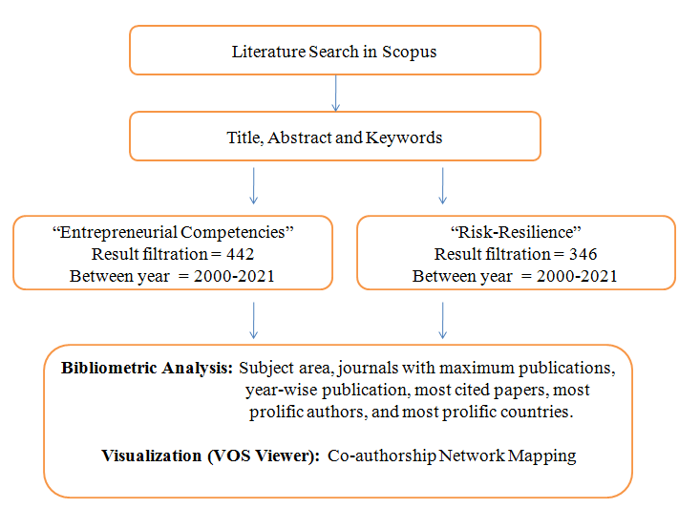
(Source: Author’s creation)

To locate publications related to "entrepreneurial competencies" and "risk resilience" spanning the period between 2000 and 2021, the Scopus database was harnessed. The preference for this database stems from its extensive collection of high-quality journals. To refine the search, filters were implemented to retrieve studies incorporating the terms "entrepreneurial intentions" and "risk-resilience," independently, within their titles, abstracts, or keywords.

In the realm of Entrepreneurial competencies, the initial search yielded a comprehensive total of 443 studies. To ensure the alignment of these studies with the intended subject, the author meticulously reviewed the title, abstract, and keywords of each paper. Consequently, it was established that among the 443 studies, one was conducted prior to the year 2000, rendering it ineligible for consideration. Furthermore, from the remaining pool of 353 studies, seven had been conducted before the year 2000 and were subsequently excluded.

The author took a hands-on approach in scrutinizing the title, abstract, and keywords of each paper, a step deemed essential to validate the relevance of the studies identified through the search. Additionally, an organized categorization of these studies was undertaken, encompassing subject areas, journals boasting maximal publications, year-wise distribution of publications, identification of the most frequently cited studies, recognition of the most prolific authors, and delineation of the most active countries in terms of contributions.

3. RESULTS AND FINDINGS:

3.1 SUBJECT AREA:
It has been observed that maximum studies are written in the subject area of Management and Accounting. Furthermore, subject area such as Economics and Social science also has 113 and 78 studies respectively. There are 30 studies in Decision science and 10 in Engineering.

Figure 2: Subject Area
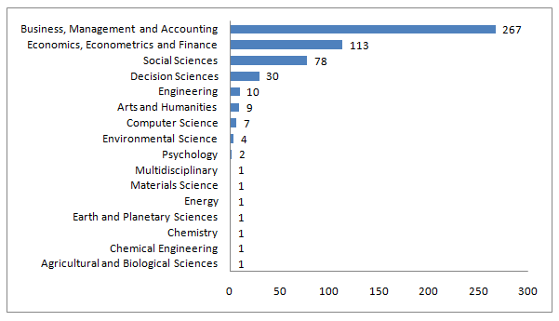(Source: Scopus Data Base)

3.2 JOURNALS WITH MAXIMUM PUBLICATIONS:
The entirety of the 437 studies encompassed within this research is attributed to their respective 135 journals. The ensuing table presents a compilation of the leading twenty journals, each of which has exhibited the highest publication volume with regards to studies concerning Entrepreneurial Competencies. The preeminent contributor is the "Education and Training" journal, boasting a notable 12 studies. Moreover, the "Journal of Entrepreneurship Education" and the "Journal of Small Business and Enterprise Development" have made significant contributions, accounting for 9 and 8 studies respectively.

Table 1: Journals with maximum publications
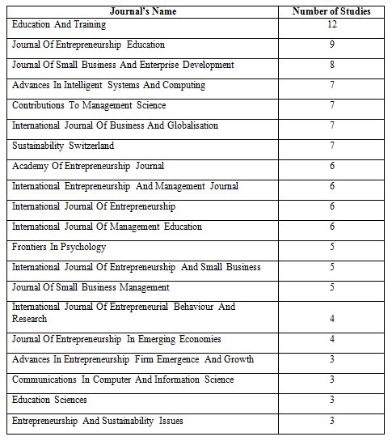
(Source: Scopus Data Base)
3.3 YEAR WISE PUBLICATION:
This table provides an overview of the volume of studies published between the years 2000 and 2021, showcasing the evident growth in research dedicated to entrepreneurial competencies. Notably, the number of published studies was rather minimal during the period from 2000 to 2014. Subsequently, there was a remarkable upsurge in research output from 2014 to 2019, with the number of studies escalating from 16 to 75.

Furthermore, a discernible pattern emerges in the distribution of studies, with the majority being concentrated within the last five years. The trajectory of growth is strikingly evident, as the number of studies surged from 32 in 2016 to 68 in 2021. The pinnacle of research output was witnessed in 2019, which saw a publication count of 75 studies. This unmistakably underscores the exponential rise in researchers' interest within this domain, particularly in recent times.
Figure 3: Year-wise Publications
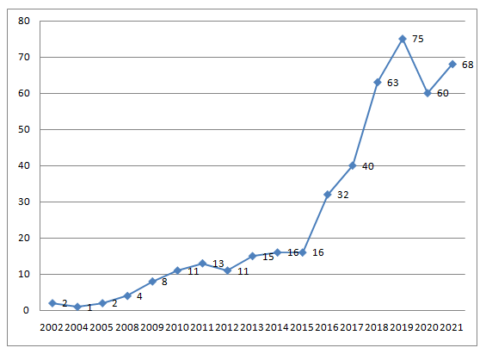
(Source: Scopus Data Base)
3.4 MOST CITED PAPER:
Focussing on the Scopus content, a list of the twenty most cited studies is presented in the table. The most cited paper 572 citation is by Man T.W.Y., Lau T., Chan K.F. In this work, a conceptual model is constructed to link the characteristics of owner-managers of small and medium-sized businesses (SMEs) and their company' performance. Competitive scope, organizational capabilities, entrepreneurial talents, and performance are the four constructs of the model (Man et al., 2002).

The second most cited paper with 328 citations is “Entrepreneurial competencies: A literature review and development agenda” by Mitchelmore S., Rowley J. The goal of this paper is to conduct a literature review of entrepreneurial competence research to provide an integrated account of contributions relating to entrepreneurial competencies by different authors working in different countries, different industry sectors, and at different times; and develop an agenda for future research and practice about entrepreneurial competencies (Mitchelmore & Rowley, 2010)

Furthermore, the third most cited paper with 267 citations is “The Evolution of Entrepreneurial Competencies: A Longitudinal Study of University Spin-Off Venture Emergence” by Rasmussen E., Mosey S., Wright M. The goal of this article is to gain a better understanding of how entrepreneurial skills development in non-commercial academic settings to start new businesses. To assist identify these competencies and explain their development trajectories, we use an evolutionary viewpoint that considers where resources come from (Rasmussen et al., 2011).

Then the fourth most cited paper with 246 citations is “A competency-based perspective on entrepreneurship education: Conceptual and empirical insights” by Morris M.H., Webb J.W., Fu J., Singhal S. The competencies required for entrepreneurial action are studied in this research. Competencies are viewed as an outgrowth of the learning of scripts derived from interactions between the individual and the environment, based on structuration theory. The distinction between managerial and entrepreneurial skills is made, with the latter helping to define the subject of entrepreneurship education (Morris et al., 2013).

Table 2: Most cited studies
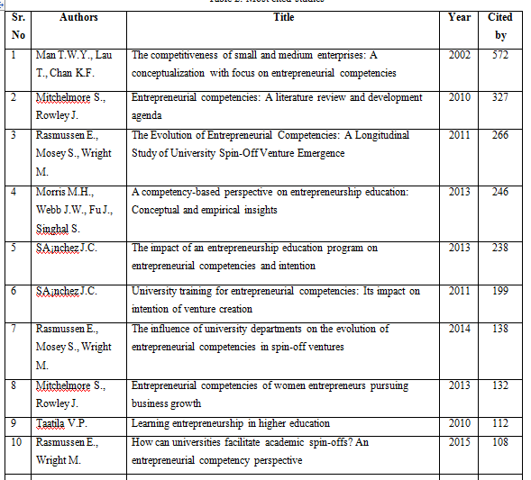
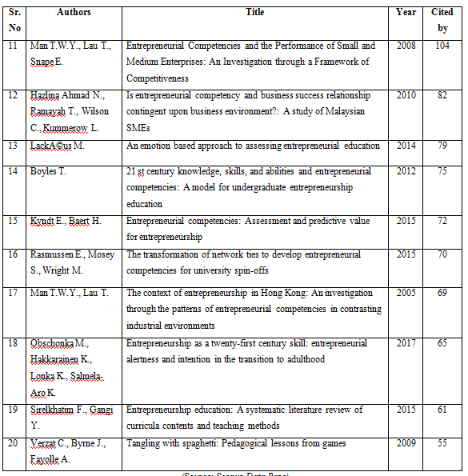
(Source: Scopus Data Base)

3.5 MOST PROLIFIC AUTHORS:
The compilation showcases the twenty authors who have displayed exceptional prolificacy. Among the 437 studies, they collectively belong to 159 distinct authors. Following meticulous scrutiny of the data, a comprehensive list of the top twenty authors, distinguished by their extensive publication record, was formulated. Notably, the duo of Mamun, A. A., and Zali, M. R. emerges as the most prolific authors within the entrepreneurial competencies realm, having contributed seven studies each. Accompanying them, Ahmad, N. H., Al Mamun, A., and Fazal, S. A., have each authored six studies.

Additionally, noteworthy contributions are made by Botha, M., and Zainol, N. R., who have each authored five studies (Al Mamun & Fazal, 2018; Botha et al., 2019; Botha & Taljaard, 2019), as indicated by their publications.
Figure 4: Most Prolific Author
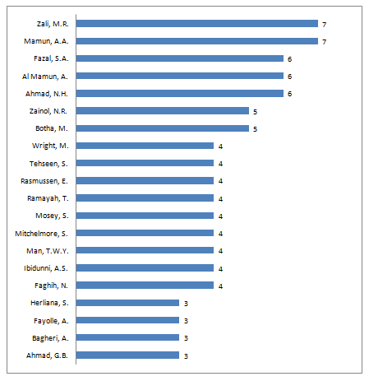
(Source: Scopus Data Base)
3.6 MOST PROLIFIC COUNTRIES:
The collective body of studies aligns with the efforts of authors from over 80 diverse countries. Within this panorama, the manuscript highlights the top twenty nations that have demonstrated a notable contribution in terms of studies pertaining to entrepreneurial competencies. Topping this list is Malaysia, boasting a substantial count of 48 studies. Following closely, the United Kingdom and Indonesia both share an impressive publication record of 38 studies each. In addition, Spain and India have each contributed 27 and 22 studies, respectively, further accentuating their significance within this domain.
Figure 5: Most Prolific countries

(Source: Scopus Data Base)

3.7 AFFLICTION OF AUTHORS
The depicted figure illustrates the affiliations of authors, revealing prominent institutions to which they are associated. A notable observation is the prevalence of authors affiliated with the University Sains Malaysia, with a substantial count of 13 individuals. In the second position, the University Malaysia Kelantan is affiliated with 12 authors. Meanwhile, the University of Tehran boasts affiliations with 9 authors. Additionally, the University of Pretoria and the Institute Technology Bandung both have 7 authors affiliated with their institutions.
Figure 6: Affliction of Authors

(Source: Scopus Data Base)

3.8 CO-AUTHORSHIP NETWORK MAPPING:
The figure shows the co-authorship network map generated by the VOSviewer software. The figure consists of big and small circles connected with several lines. Those authors who have co-authored with more authors are assigned bigger circles and labels. The figure shows the names of the top 96 authors, who have co-authored with the maximum number of other authors in the data set.

Figure 7: Co-authorship Network Mapping
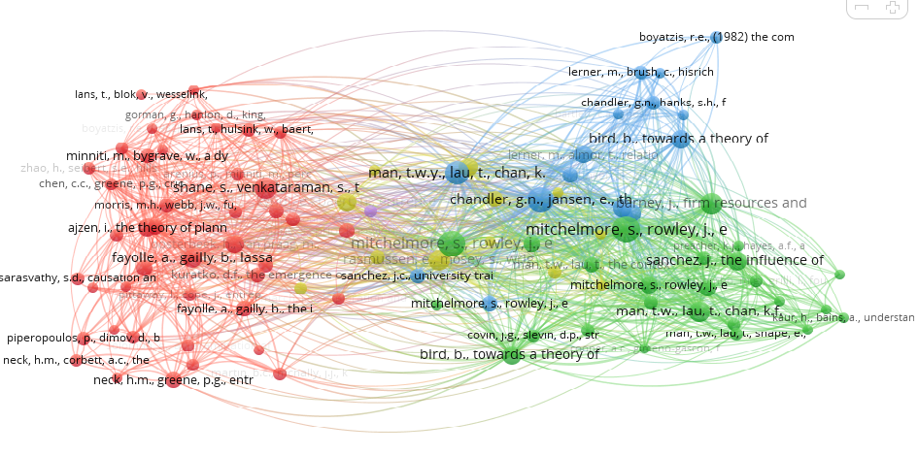
(Source: VOS viewer)

4. RISK - RESILIENCE
Resilience pertains to a company's capacity to navigate and flourish within an ever-changing and uncertain environment. It signifies the company's aptitude to rebound and thrive after experiencing a perturbing circumstance. Such disruptions are inherent and encompass an array of factors both internal and external in nature. Within the realm of resilience, the central focal points encompass organizational susceptibility, disruptions, and intricacies, for these factors profoundly influence the robustness of the system. Specifically, vulnerability to disruptive occurrences can be understood as a blend of the likelihood of encountering disruptions and the magnitude of their impact.
4.1 SUBJECT AREA:
It has been observed that maximum studies are written in the subject area of Social Science with 139 studies. Furthermore, the subject area such as Medicine and Social Science also has 92 and 76 studies respectively. There are 53 studies in Environmental Science and 43 in Engineering.
Figure 8: Subject Area
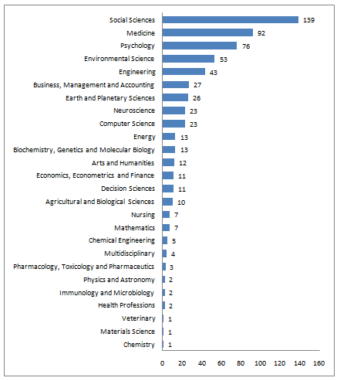
(Source: Scopus Data Base)
4.2 JOURNALS WITH MAXIMUM PUBLICATIONS:
The entirety of the 342 studies within this research aligns with their respective 136 journals. Presented below is a table featuring the top twenty journals, distinguished by their extensive publication of studies pertaining to Entrepreneurial Competencies. The highest number of studies finds its place in the "Journal of Early Adolescence," accounting for an impressive 12 studies. Additionally, the journals "Sustainability Switzerland," "Structure of Infrastructure Engineering," and "International Journal of Disaster Risk Science" each contribute 5 studies,further reinforcing their significance in this field.
Table 3: Journals with maximum Citations
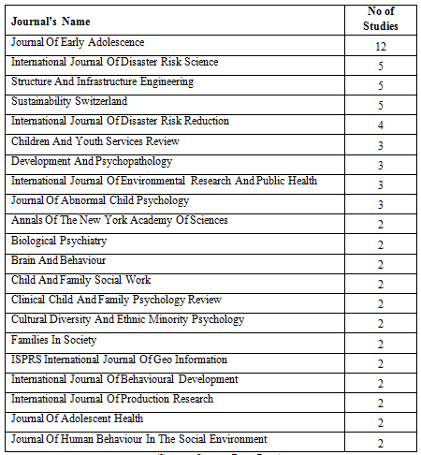
(Source: Scopus Data Base)
4.3 YEAR-WISE PUBLICATIONS:
This table provides a visual representation of the quantity of studies published between the years 2000 and 2021, underscoring the escalating interest in research focused on risk resilience. Notably, the number of published studies remained quite modest during the period spanning from 2000 to 2012. Subsequently, a noteworthy surge in research output is observed from 2014 through 2021, with the study count surging from 20 to 47.

Furthermore, a distinct pattern emerges in the temporal distribution of studies, with a concentrated surge in the past five years. The trajectory of growth is especially evident, as the number of studies rose from 31 in 2019 to 47 in 2021. The pinnacle of research activity was observed in 2020, which witnessed the publication of 48 studies. This unequivocally indicates a substantial spike in research enthusiasm within this field, particularly in recent times.
Figure 9: Year wise Publications
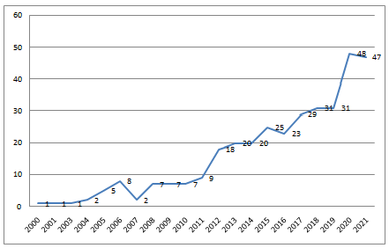
(Source: Scopus Data Base)
4.4 MOST CITED STUDIES:
With a focus on Scopus content, the table provided unveils a roster of the twenty most frequently cited studies. The paper amassing the highest citations, a remarkable 372 in total, is titled "The role of early life stress as a predictor for alcohol and drug dependence," penned by Enoch, M.-A. The runner-up, with 209 citations, is the paper "Beyond risk, resilience, and dysregulation: Phenotypic plasticity and human development," authored by Belsky, J., Pluess, M. (Belsky & Pluess, 2013).

Table 4: Most cited studies
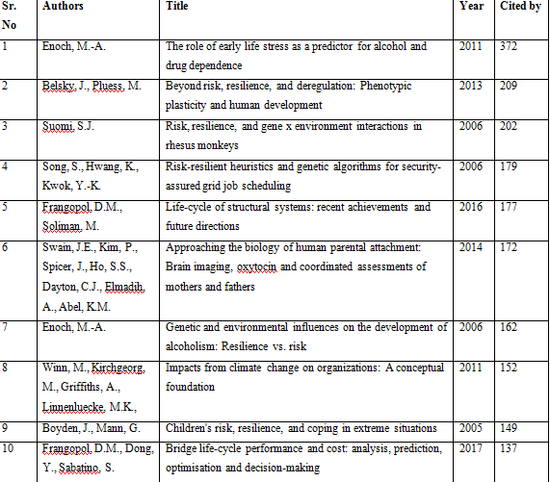
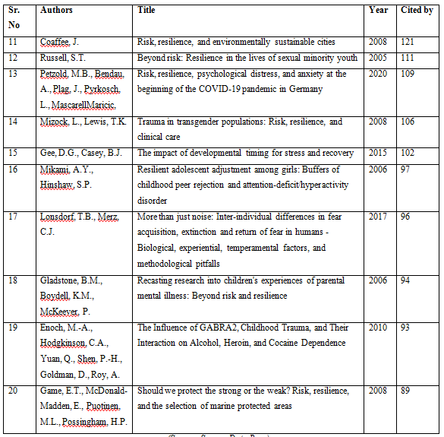
(Source: Scopus Data Base)
Continuing the list, the third most cited paper, boasting 202 citations, is titled "Risk, resilience, and gene x environment interactions in rhesus monkeys," composed by Suomi, S.J. Following suit, the fourth most cited paper, accumulating 179 citations, goes by the title "Risk-resilient heuristics and genetic algorithms for security-assured grid job scheduling," credited to Song, S., Hwang, K., Kwok, Y.-K (Song et al., 2006).

4.5 MOST PROLIFIC AUTHORS:
It shows the top twenty most prolific authors. All the 342 studies belong to the respective 159 authors. Upon analyzing the data, a list of the top twenty authors with maximum publications was prepared. Further, it was found that the most prolific author on risk resilience is Enoch, M.A.with six studies. The authors Shahar, G, Frangopol, D.M., and Dong, Y.each has published five studies. Furthermore, Botha, M. and Zainol, N.R. have published five studies.(Botha & Taljaard, 2019; Rizvi et al., 2012)(Enoch, 2006; Enoch et al., 2010; Frangopol et al., 2017; Frangopol & Soliman, 2016; Phong et al., 2020; Rizvi et al., 2012) (Ghorbani, S., Khodayari, A., & Mohammadi, 2014; Vinet & Zhedanov, 2011).

Figure 10: Most Prolific author
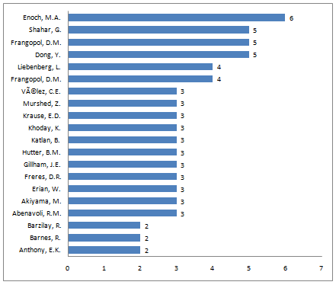
(Source: Scopus Data Base)
4.6 MOST PROLIFIC COUNTRIES:
The comprehensive collection of studies is the combined effort of authors from over 55 diverse countries. The paper highlights the top twenty nations contributing significantly to research on risk resilience. Leading this list is the United States, contributing a noteworthy 41% of the total studies. Following suit, the United Kingdom and Canada each contribute 10% and 9% of the studies, respectively. Moreover, Australia and China each account for 7% and 5% of the studies, underscoring their substantial involvement within this domain.
Figure 11: Most Prolific Countries

(Source: Scopus Data Base)
4.7 AFFLICTION OF AUTHORS
The figure shows the affiliation of authors. It has been observed that maximum authors are afflicted to Lehigh University with 9 in numbers and secondly from Pennsylvania State University, the University of Pennsylvania and University of Toronto have 7 each.
Figure 12: Affliction of authors

(Source: Scopus Data Base)

4.8 CO-AUTHORSHIP NETWORK MAPPING:
The figure shows the co-authorship network map generated by the VOS viewer software. The figure consists of big and small circles connected with several lines. Those authors who have co-authored with more authors are assigned bigger circles and labels. The figure shows the names of the top 29 authors, who have co-authored with the maximum number of other authors in the data set.
Figure 13: Co-authorship Network Mapping

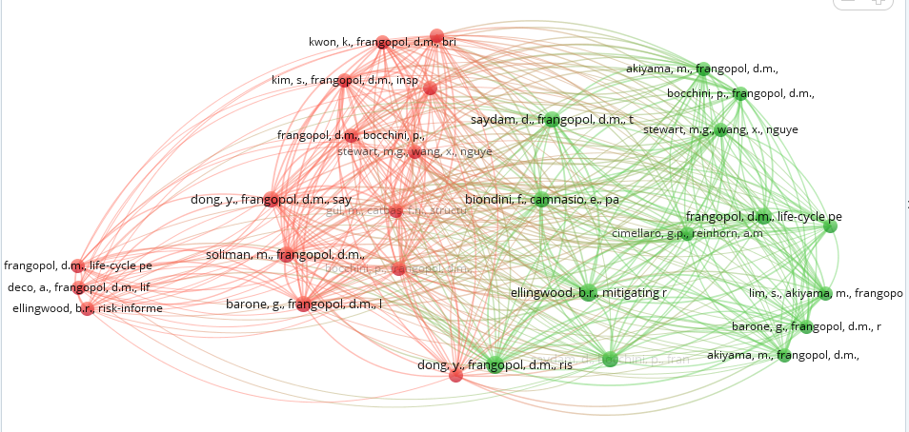
(Source: VOS viewer)

CONCLUSION:

A bibliometric analysis is carried out in this study to analyze the research on entrepreneurial competencies from the year 2000 to 2021. The maximum number of studies related to Entrepreneurial competencies is in education and training with 12 studies. A maximum paper on entrepreneurial competencies has been published in 2019. Maximum studies on risk resilience have been published in 2020 with 48 studies and maximum were published in the US.

REFERENCES:

Al Mamun, A., & Fazal, S. A. (2018). Effect of entrepreneurial orientation on competency and micro-enterprise performance. Asia Pacific Journal of Innovation and Entrepreneurship, 12(3), 379–398. https://doi.org/10.1108/apjie-05-2018-0033
Belsky, J., & Pluess, M. (2013). Beyond risk, resilience, and dysregulation: Phenotypic plasticity and human development. Development and Psychopathology, 25(4 PART 2), 1243–1261. https://doi.org/10.1017/S095457941300059X
Bhardwaj, A. (2016). Assessing planning and administration competency of working managers: A preliminary study. International Journal of Advanced Research in Management and Social Sciences, 5(7), 46–56. https://www.indianjournals.com/ijor.aspx?target=ijor:ijarmss&volume=5&issue=7&article=006
Bloemer, J., Pluymaekers, M., & Odekerken, A. (2013). Trust and affective commitment as energizing forces for export performance. International Business Review, 22(2), 363–380. https://doi.org/10.1016/j.ibusrev.2012.05.002
Botha, M., Carruthers, T. J., & Venter, M. W. (2019). The relationship between entrepreneurial competencies and the recurring entrepreneurial intention and action of existing entrepreneurs. The Southern African Journal of Entrepreneurship and Small Business Management, 11(1), 1–15. https://doi.org/10.4102/sajesbm.v11i1.191
Botha, M., & Taljaard, A. (2019). The bidirectional relationship between entrepreneurial intention and entrepreneurial competencies for nascent and existing entrepreneurs. South African Journal of Economic and Management Sciences, 22(1), 1–12. https://doi.org/10.4102/sajems.v22i1.2230
Cortellazzo, L., Bonesso, S., & Gerli, F. (2020). Entrepreneurs’ behavioural competencies for internationalisation: Exploratory insights from the Italian context. International Journal of Entrepreneurial Behaviour and Research, 26(4), 723–747. https://doi.org/10.1108/IJEBR-12-2018-0806
Enoch, M. A. (2006). Genetic and environmental influences on the development of alcoholism: Resilience vs. risk. Annals of the New York Academy of Sciences, 1094, 193–201. https://doi.org/10.1196/annals.1376.019
Enoch, M. A. (2012). The influence of gene-environment interactions on the development of alcoholism and drug dependence. Current Psychiatry Reports, 14(2), 150–158. https://doi.org/10.1007/s11920-011-0252-9
Enoch, M. A., Hodgkinson, C. A., Yuan, Q., Shen, P. H., Goldman, D., & Roy, A. (2010). The Influence of GABRA2, Childhood Trauma, and Their Interaction on Alcohol, Heroin, and Cocaine Dependence. Biological Psychiatry, 67(1), 20–27. https://doi.org/10.1016/j.biopsych.2009.08.019
Escamilla-Fajardo, P., Parra-Camacho, D., & Núñez-Pomar, J. M. (2021). Entrepreneurship and resilience in spanish sports clubs: A cluster analysis. International Journal of Environmental Research and Public Health, 18(10). https://doi.org/10.3390/ijerph18105142
Frangopol, D. M., Dong, Y., & Sabatino, S. (2017). Bridge life-cycle performance and cost: analysis, prediction, optimisation and decision-making. Structure and Infrastructure Engineering, 13(10), 1239–1257. https://doi.org/10.1080/15732479.2016.1267772
Frangopol, D. M., & Soliman, M. (2016). Life-cycle of structural systems: recent achievements and future directions. Structure and Infrastructure Engineering, 12(1), 1–20. https://doi.org/10.1080/15732479.2014.999794
Gee, D. G., & Casey, B. J. (2015). The impact of developmental timing for stress and recovery. Neurobiology of Stress, 1, 184–194. https://doi.org/10.1016/j.ynstr.2015.02.001
Ghorbani, S., Khodayari, A., & Mohammadi, S. (2014). The relationship between managerial skills with organizational climate in managers and staff in national Olympic committee of Iran. European Journal of Experimental Biology, 4(1), 321–326. https://www.primescholars.com/articles/the-relationship-between-managerial-skills-with-organizational-climate-in-managers-and-staff-in-national-olympic-committee-of-iran.pdf
Gulati, B., & Weiler, S. (2021). Risk, recessions and resilience: towards sustainable local labor markets through employment portfolio analysis. Sustainability (Switzerland), 13(14), 1–20. https://doi.org/10.3390/su13147926
Krabel, S. (2018). Are entrepreneurs made on campus? The impact of entrepreneurial universities and graduates’ human capital on graduates’ occupational choice. Journal of International Entrepreneurship, 16(4), 456–485. https://doi.org/10.1007/s10843-017-0218-z
Lonsdorf, T. B., & Merz, C. J. (2017). More than just noise: Inter-individual differences in fear acquisition, extinction and return of fear in humans - Biological, experiential, temperamental factors, and methodological pitfalls. Neuroscience and Biobehavioral Reviews, 80, 703–728. https://doi.org/10.1016/j.neubiorev.2017.07.007
Man, T. W. Y., Lau, T., & Chan, K. F. (2002). The competitiveness of small and medium enterprises: A conceptualization with focus on entrepreneurial competencies. Journal of Business Venturing, 17(2), 123–142. https://doi.org/10.1016/S0883-9026(00)00058-6
Mikami, A. Y., & Hinshaw, S. P. (2006). Resilient adolescent adjustment among girls: Buffers of childhood peer rejection and attention-deficit/hyperactivity disorder. Journal of Abnormal Child Psychology, 34(6), 825–839. https://doi.org/10.1007/s10802-006-9062-7
Mitchelmore, S., & Rowley, J. (2010). Entrepreneurial competencies: A literature review and development agenda. International Journal of Entrepreneurial Behaviour & Research, 16(2), 92–111. https://doi.org/10.1108/13552551011026995
Morris, M. H., Webb, J. W., Fu, J., & Singhal, S. (2013). A competency-based perspective on entrepreneurship education: Conceptual and empirical insights. Journal of Small Business Management, 51(3), 352–369. https://doi.org/10.1111/jsbm.12023
Petzold, M. B., Bendau, A., Plag, J., Pyrkosch, L., Mascarell Maricic, L., Betzler, F., Rogoll, J., Große, J., & Ströhle, A. (2020). Risk, resilience, psychological distress, and anxiety at the beginning of the COVID-19 pandemic in Germany. Brain and Behavior, 10(9), 1–10. https://doi.org/10.1002/brb3.1745
Phong, N. D., Thao, N. T. P., & Nguyen, N. P. (2020). Entrepreneurial intent of business students: Empirical evidence from a transitional economy. Cogent Business and Management, 7(1). https://doi.org/10.1080/23311975.2020.1747962
Rambe, P., Africa, S., Makhalemele, N., & Africa, S. (2015). Emerging Technology Firms And Business Internet Cafés Performance In South Africa. International Business & Economics Research Journal, 14(4), 678–692, July/August,.
Rasmussen, E., Mosey, S., & Wright, M. (2011). The Evolution of Entrepreneurial Competencies: A Longitudinal Study of University Spin-Off Venture Emergence. Journal of Management Studies, 48(6), 1314–1345. https://doi.org/10.1111/j.1467-6486.2010.00995.x
Shah, I. A., Amjed, S., & Jaboob, S. (2020). The moderating role of entrepreneurship education in shaping entrepreneurial intentions. Journal of Economic Structures, 9(1). https://doi.org/10.1186/s40008-020-00195-4
Song, S., Hwang, K., & Kwok, Y. K. (2006). Risk-resilient heuristics and genetic algorithms for security-assured grid job scheduling. IEEE Transactions on Computers, 55(6), 703–719. https://doi.org/10.1109/TC.2006.89
Vinet, L., & Zhedanov, A. (2011). A “missing” family of classical orthogonal polynomials. Journal of Physics A: Mathematical and Theoretical, 44(8), 3–16. https://doi.org/10.1088/1751-8113/44/8/085201
Wasowska, A. (2019). Social-cognitive antecedents of new venture internationalization: The role of entrepreneur intention, self-efficacy, and positive orientation. Baltic Journal of Management, 14(3), 462–479. https://doi.org/10.1108/BJM-09-2018-0325
Wickramasinghe, V., & de Zoyza, N. (2009). A comparative analysis of managerial competency needs across areas of functional specialization. Journal of Management Development, 28(4), 344–360. https://doi.org/10.1108/02621710910947371
Winn, M., Kirchgeorg, M., Griffiths, A., Linnenluecke, M. K., & Gunther, E. (2011). Impacts from climate change on organizations: A conceptual foundation. Business Strategy and the Environment, 20(3), 157–173. https://doi.org/10.1002/bse.679

