Synthesis, Characterization and antibacterial applications of ZnO nanoparticles utilizing seed source of Myristica fragrans (Nutmeg)

Suchismita Acharya  ªCenturion University of Technology and Management  Odisha, India  *suchismita.acharya@cutm.ac.in | Priyanka Dash  ^{b}Siksha ‘O’ Anusandhan (Deemed to be University  Bhubaneswar, Odisha, India
M. Priyanka
ªCenturion University of Technology and Management
Odisha, India

ABSTRACT
ZnO nanoparticles were fabricated using plant seed extract from the Myristica fragrans species, utilising the solution combustion method and their antibacterial activities are investigated. ZnO nanoparticles are characterized by using Fourier Transform Infrared Spectroscopy (FT-IR), X-ray Diffraction Techniques (XRD), Field Emission Scanning Electron Microscopy (FE-SEM), Transmission Electron Microscopy (TEM). The antibacterial activity against Pseudomonas aeruginosa, Staphylococcus aureus, Bacillus subtilis, Escherichia coli and Acinetobacter baumannii were determined by using Broth-based turbidometry method. ZnO nanoparticles were found to be spherical and have an average particle size of 7±2 nm after all characterization analyses were completed. Antibacterial experiments support the maximum percentage of inhibition of ZnO nanoparticles, which was seen in Bacillus subtilis with IC50 values of 7.3 g/ml. These findings clearly show that ZnO nanoparticles may act as an antibacterial agent.
Key words- Myristica fragrans, Antibacterial, ZnO, XRD, FESEM

- INTRODUCTION
With the increasing demand, the creation of effective green chemistry methods for the manufacture of ZnO nanoparticles has gained significant attention from researchers. [1-3] They have looked into methods for producing well-characterized ZnO nanoparticles that are environmentally beneficial. The use of organisms to create ZnO nanoparticles is one of the approaches that is most frequently considered. [5-10] Plants appear to be the most suitable among these organisms for producing ZnO nanoparticles on a wide scale due to fabrication of most stable ZnO nanoparticles in a faster rate. [11,12] The tunable characteristics of ZnO nanoparticles make them useful for a wide range of applications, such as biosensing, catalysts, optics, antimicrobial, antibacterial, antifungal, anticancer, computer transistors, electrometers, chemical sensors, wireless electronic logic and memory schemes, medical imaging, nanocomposites, filters, drug delivery, and medical diagnosis, among others. [13-18]
Recently, material scientists have focused heavily on developing sustainable methods for producing nanoscale materials. In this context, the green synthesis of ZnO nanoparticles, especially when using plant extracts, is a trend that is considered to be simple, inexpensive, and innocuous in green chemistry. Additionally, nanotechnology has improved people's quality of life by addressing a number of issues that people deal with on a daily basis, such as the role it plays in energy security, combating climate change, and advancing the fashion, beauty, and health sectors, including the treatment of fatal diseases like cancer and Alzheimer's. [19-21] Over the past ten years, intensive research into metal oxide nanoparticles has been focused on account of their numerous uses in several technical domains. ZnO-NPs are an intriguing inorganic substance among them, offering a variety of advantages. ZnO-NPs are nontoxic and biocompatible and have considerable medical applications in targeted medication administration, wound healing, and bioimaging. Additionally, they have antibacterial, anti-inflammatory, and anti-cancer properties. [22] Different techniques (chemical, physical, and biosynthetic) can be used to fabricate nanoproducts, which have a wide range of properties and extensive applications. Although the plant-based synthesis of ZnO-NPs has been previously reported, there is little literature on their wide range of biological features, including their antibacterial, antilarvicidal, protein kinase, and anticancer activities. Myristica fragrans (also known as Jaiphal) has a number of known medicinal purposes, although its main usage are as an analgesic, anti-inflammatory, and sex stimulant. [23] In this study, we present a plant-based method for producing zinc oxide nanoparticles that makes use of the aqueous fruit extracts of M. fragrans. ZnO-NPs may be produced environmentally friendly and have a variety of biomedical uses. For the manufacture of biogenic ZnO-NPs, the metabolites present in the aqueous extract of M. fragrans serve as an oxidizing, reducing, and capping agent. Modern methods including FTIR, XRD, FESEM, TEM, EDX analysis, etc. will be used to analyses the green produced nanoparticles. The antibacterial properties of ZnO nanoparticles are investigated.

- EXPERIMENTAL

  - Materials
Zinc nitrate hexahydrate (Zn (NO₃)_{2.}6H₂O), Luria Broth (LB), Mueller–Hinton (MH) agar, Nutrient broth, Phosphate buffer saline (PBS) and Gentamicin, Nutrient agar [Hi media], DMEM Media (Dulbecco's Modified Eagle's medium, Dimethyl sulfoxide (DMSO) [C₂H6SO], MTT (3-(4,5-dimethylthiazol-2-yl)-2,5-diphenyltetrazolium bromide) assay 97.5%, Sigma Aldrich are purchased from the Sigma Chemical Co. (St. Louis, Mo, USA), Myristica fragrans seeds were purchased from local market from Bhubaneswar, Odisha.

  - Fabrication of ZnO nanoparticles using plant extract:
An aqueous extract of Myristica fragrans plant seeds was prepared by milling 25gm of seeds in electric blinder. Subsequently, mixed the paste with 100ml distilled water in conical flask by mixing it with magnetic stirrer. Now filter the aqueous extract for further use in ZnO nanoparticle synthesis. Solution combustion synthesis (SCS) methods were used to produce ZnO nanoparticles. [24-27] An oxidant and a fuel, respectively, are exhibited by Zn (NO₃)₂.6H₂O and an aqueous extract of Myristica fragrans seed. Under continuous stirring, 35 ml of the aqueous extract from the seeds of the Myristica fragrans plant and 1.0 g of Zn (NO₃)₂.6H₂O in 5 mL of double-distilled water were completely dissolved. After that, a magnetic stirrer was used to agitate the mixed solution. The mixture was put into a muffle furnace in a crystallizing dish that was warmed early by keeping temperature of the furnace at 500⁰C. The setup bubbles in 10 to 15 minutes due to the quick fuel consumption. After subsequent steps, a white fine powder of ZnO nanoparticles were obtained.

Figure-1: Schematic diagram showing the fabrication of ZnO nanoparticle using Myristica fragrans seeds

  - Antibacterial Study

C.1. Bacterial strain identification

Three Gram-negative bacteria and two Gram-positive bacteria were utilized as test organism in this study. They are Acinetobacter baumannii (MTCC 1425), Pseudomonas aeruginosa (MTCC 1688), Bacillus Subtilis (MTTC 5981), Staphylococcus aureus (MTTC 96) and Escherichia coli (MTCC 443) and they were all obtained from the Institute of Life Science, India.

C.2. Evaluation of Antibacterial activity of plant mediated ZnO nanoparticles by turbidimetric assay method

Using a broth-based turbidometry test method, the antibacterial properties of plant seeds mediated ZnO nanoparticle against gram negative bacteria were investigated. 100μl of inoculum, equivalent to 10⁵ CFU were incubated with 100μl of sample (100μg/ml) at 37 °C for 2 h at 200 rpm. After incubation, 3 ml of LB was added to 90μl of above mixture, and again it was incubated at 37 °C for 18 hr. At 600 nm, the optical density of this mixture was measured. The control was made in the same way, with the exception that the percentage of ZnO nanoparticle inhibition for treated samples was determined and the same was done in triplicate. [28-30]

- CHARACTERIZATION

The structural and morphological properties of plant seeds mediated ZnO nanoparticles were characterized by X-ray diffraction (XRD) studies, Field-emission scanning electron microscope (FESEM), Transmission Electron Microscopy (TEM) respectively. XRD studies were carried out using X-ray diffractometer make equipped with a monochromatic Cu Kα radiation source (1.54 Å). Elemental analysis was carried out by Energy-Dispersive X-ray (EDX) analyser. Fourier Transform Infrared (FTIR) Spectroscopy was used to identify the functional groups present within the nanoparticles.

- RESULTS AND DISCUSSION

- X-ray Diffraction (XRD) Analysis
The ZnO samples were analyzed using XRD by employing an X-ray diffractometer with a monochromatic Cu K_{α} radiation source (1.54 Å). All the patterns have characteristic peaks, which corresponding to (100), (002), (101), (110), (200), (004) planes/orientations of ZnO, respectively, which correspond to the typical diffraction peaks of hexagonal wurtzite ZnO (JCPDS No. 36e1451) are shown by Fig.1.

Figure-2: XRD patterns of the Myristica fragrans seeds synthesized ZnO nanoparticles

- Fourier Transform Infrared (FTIR) Spectroscopy
The functional groups utilized as a capping and reducing agent in the synthesis of ZnO nanoparticles are identified via FTIR analysis. Fig. 2 displays the transmittance percentage with respect to different wavelengths. In the fingerprint region, which is below 1000 cm-1, metal oxides show inter-atomic vibration-driven absorption, according to FTIR studies. The soluble components in plant extract may have served as a coating agent to avoid the aggregation of nanoparticles in solution and to significantly contribute to the formation and structure of these particles. Due to plant material, it has contained aromatic rings. 1045 cm⁻¹, 1406 cm⁻¹, 1482cm⁻¹, 2829cm⁻¹ peaks predict aromatic compounds, carboxyl groups, carbonyl groups respectively.

Figure-3: FTIR analysis of Myristica fragrans seeds synthesized ZnO nanoparticles

- Field Emission Scanning Electron Microscopy (FESEM), Transmission Electron Microscopy (TEM) and Energy-Dispersive X-ray (EDX)
High energy electron beam is used during FESEM analysis inorder to identify the morphology by imaging the sample of Myristica fragrans seeds synthesized ZnO nanoparticles. The electrons interact with the atoms in the sample, allowing the composition, morphology, and size of the nanoparticles to be determined. Figure 4 depicts the FESEM picture of fabricated ZnO nanoparticles made from Myristica fragrans seeds. The above information clearly indicates that ZnO nanoparticles have a spherical form and are evenly distributed. TEM image was used to confirm the size and distribution of the chemically synthesized ZnO nano particles. In accordance with Figure 5, the particles were uniformly disseminated and ranged in size at 7±2 nm.
Figure-4: FESEM images of Myristica fragrans seeds synthesized ZnO nanoparticles
Figure-5: TEM images of Myristica fragrans seeds synthesized ZnO nanoparticles
EDX was carried out with the instrument attached to HRTEM and the result has been shown in Figure 6. According to this, the synthesized sample is of high purely with highly intense peaks of Zn as well as oxygen peaks due to the Cu originated became of the copper grid used during HRTEM analysis. After that observed minor peaks due to possible contamination of during propagation of sample for HRTEM analysis.
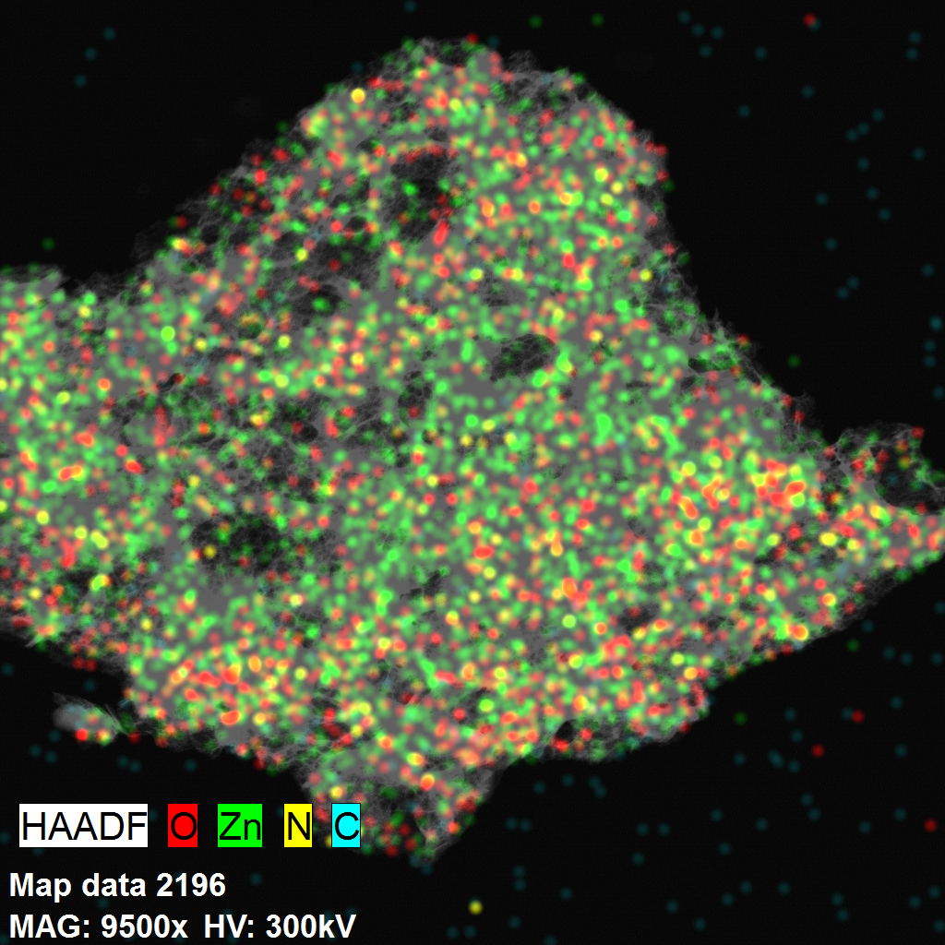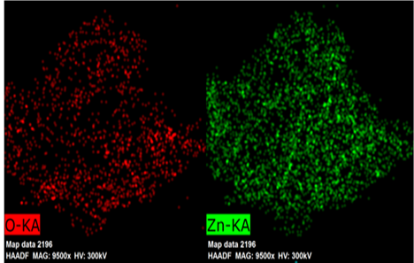
Figure-6: EDX data and picture of Myristica fragrans seeds synthesized ZnO nanoparticles

- Antibacterial Study
By using the OD600 measurement method as previously published, the antibacterial activity of ZnO nanoparticles were assessed. The turbidometry assay is based on the idea that bacterial growth is inversely correlated with turbidity. Utilizing a UV spectrophotometer at 600 nm, the turbidity of the broth and changes in the number of bacteria were noted. The precision of the agar-based tests cannot be accomplished when the inhibition zone is not circular since they often rely on the skill and judgement of the researchers. As a result, rather of utilising an agar-based assay, the antibacterial activity of protein fractions were assessed using a broth-based turbidometry assay.

Figure-7: Effect of ZnO nanoparticle on bacteria
The Myristica fragrans seeds synthesized ZnO nanoparticles were added at different concentration 5-40µg/ml. Two test tubes with bacteria-infected nutrition ager were present. After that, the media turbidity was assessed using an OD600 scale while all the test tubes were incubated at 37ºC. Under the same test conditions, the control was administered and treated. In general, it was shown that Myristica fragrans seeds synthesized ZnO nanoparticles were connected to comparatively lowered bacterial turbidity levels in comparison to the control. Graphical analysis was used to determine IC50 values. Percentages of inhibition of M. fragrans are shown in figure at IC₅₀ values are shown in table 1.

Table-1: IC₅₀ Values of Micro-organisms
SL. NO.. | NAME OF MICRO ORGANISMS | IC₅₀ VALUE(µg/ml)
1 | Pseudomonas aeruginosa | 9.2
2 | Staphylococcus aureus | 10.9
3 | Bacillus subtilis | 7.3
4 | Escherichia coli | 15.3
5 | Acinetobacter baumannii | 17.6

Myristica fragrans mediated ZnO nanoparticle demonstrated antibacterial activity of all the investigated microorganisms in a dose-dependent manner. The percentage of inhibition of turbidity of ZnO nanoparticle of M. fragrans against above bacteria at concentration 40µg /ml was found to be 84.92%, 76.92%, 82.64%, 53.92%, 60.65% respectively. The IC₅₀ values of Zn nanoparticle of M. fragranas against Pseudomonas aeruginosa, Staphylococcus aureus, Bacillus subtilis, Escherichia coli, Acinetobacter baumannii was found to be 9.2%,10.9%,7.3%,15.3%,17.6% respectively.

V. CONCLUSION
In summary, this work demonstrates a novel strategy to achieve the synthesis of ZnO nanoparticle along with Myristica fragrans extract using a simple solution combustion method. The structural and microstructure data of ZnO nanoparticles from Myristica fragrans extract are obtained by using XRD, FTIR, FESEM, TEM and EDX spectroscopy. The structural analysis has confirmed that the synthesized samples are crystalline by nature having hexagonal wurtzite structure. FESEM and TEM analysis revealed that zinc nanoparticles were spherical in shape with average particle size of 7± 2nm. Antibacterial studies conclude that ZnO nanoparticle have maximum percentage of inhibition which was observed in Bacillus subtilis with IC₅₀ values 7.3µg/ml. Thus, concluding the ZnO nanoparticle of Myristica fragrans can be used as bacterial agent. Further studies can be taken on drug delivery and advanced medical applicants.

ACKNOWLEDGEMENTS
All the authors are thankful to the authorities of Centurion University of Technology and Management, Odisha and Siksha ‘O’ Anusandhan (Deemed to be University), Bhubaneswar, Odisha for their support and valuable advices.
REFERENCES
[1] R. Sharma, R. Garg, R., and A. Kumari, “A Review on Biogenic Synthesis, Applications and Toxicity Aspects of Zinc Oxide Nanoparticles,” EXCLI Journal, vol. 19, pp. 1325-1340, 2020.
[2] K. Ali, S. Dwivedi, A. Azam, Q. Saquib, M. S. Al-said, A. A. Alkhedhairy, “Aloe vera extract functionalized zinc oxide nanoparticles as nanoantibiotics against multi-drug resistant clinical bacterial isolates,” J. Colloid Interface Sci, vol. 472, pp. 145–156, 2016.
[3] S. Jafarirad, M. Mehrabi, B. Divband and M. Kosari-Nasab, “Biofabrication of zinc oxide nanoparticles using fruit extract of Rosa canina and their toxic potential against bacteria: a mechanistic approach,” Mater. Sci. Eng. C., vol. 59, pp. 296–302, 2016.
[4] M. A. Albrecht, C. W. Evans, C. L. Raston, “Green chemistry and the health implications of nanoparticles,” Green Chem., vol. 8, pp. 417−432, 2006.
[5] H. Agarwal, S. Venkat Kumar and S. Rajesh kumar, “A review on green synthesis of zinc oxide nanoparticles – An eco-friendly approach,” Resource-Efficient Technologies, vol. 3, pp. 406–413, 2017.
[6] H. Abdul, R. Sivaraj and R. Venckatesh, “Green synthesis and characterization of zinc oxide nanoparticles from Ocimum basilicum L. var. purpurascens Benth.- lamiaceae leaf extract,” Mater. Lett, vol. 131, pp. 16–18, 2014.
[7] R. Javaid, and U. Y. Qazi, “Catalytic oxidation process for the degradation of synthetic dyes: an overview,” Int. J. Environ. Res. Public Health, vol. 16, pp. 1-27, 2019.
[8] L. Mahlaule-Glory, Z. Mbita, B. Ntsendwana, M. Mathipa, N. Mketo, and N. Hintsho-Mbita, “ZnO nanoparticles via Sutherlandia frutescens plant extract: physical and biological properties,” Mater. Res. Express, vol. 6, pp. 085006, 2019.
[9] S.N.A.M. Sukri, K. Shameli, M. M. T. Wong, S. Y. Teow, J. Chew, and N.A. Ismail, “Cytotoxicity and antibacterial activities of plant-mediated synthesized zinc oxide (ZnO) nanoparticles using Punica granatum (pomegranate) fruit peels extract,” J. Mol. Struct., vol. 1189, pp. 57-65, 2019.

[10] G., Prashanth, P. Prashanth, B. Nagabhushana, S. Ananda, G. Krishnaiah, H. Nagendra, H. Sathyananda, C. Rajendra Singh, S. Yogisha, and S. Anand, “Comparison of anticancer activity of biocompatible ZnO nanoparticles prepared by solution combustion synthesis using aqueous leaf extracts of Abutilon indicum, Melia azedarach and Indigofera tinctoria as biofuels,” Artif Cells Nanomed Biotechnol, vol. 46, pp. 968-979, 2018.

[11] B. A. Abbasi, J. Iqbal, R. Ahmad, L. Zia, S. Kanwal, T. Mahmood, C. Wang, and J. T. Chen, “Bioactivities of Geranium wallichianum Leaf Extracts Conjugated with Zinc Oxide Nanoparticles,” Biomolecules, vol. 10, pp. 38, 2020.

[12] J. Osuntokun, D. C. Onwudiwe, and E. E. Ebenso, “Green synthesis of ZnO nanoparticles using aqueous Brassica oleracea L. var. italica and the photocatalytic activity,” Green Chem Lett Rev, vol. 12, pp. 444–457, 2019.

[13] S. Saifa, A. Tahirb, T. Asimb, Y. Chena, M. Khand, and S. F. Adil, “Green synthesis of ZnO hierarchical microstructures by Cordia myxaandtheir antibacterial activity,” Saudi J. Biol. Sci., vol. 27, pp. 1364-1371, 2019.

[14] M. Chennimalai, J. Y. Do, M. Kang, and T. Senthil, “A facile green approach of ZnO NRs synthesized via Ricinus communis L. leaf extract for Biological activities,” Mater. Sci. Eng., C, vol. 103, pp. 109844, 2019.

[15] R. Yuvakkumar, J. Suresh, A. J. Nathanael, M. Sundrarajan, and S. I. Hong, “Novel green synthetic strategy to prepare ZnO nanocrystals using rambutan (Nephelium lappaceum L.) peel extract and its antibacterial applications,” Mater. Sci. Eng. C, vol. 41, pp. 17–27, 2014.

[16] S. Azizi, R. Mohamad, A. Bahadoran, S. Bayat, R. A. Rahim, and A. Ariff, “Effect of annealing temperature on antimicrobial and structural properties of bio-synthesized zinc oxide nanoparticles using flower extract of Anchusa italica.,” J Photochem Photobiol B Biol., vol. 161, pp. 441–9, 2016.

[17] S. Acharya, S. K. Biswal, and S. N. Sarangi, “Effect of structure and morphology on the UV photo detection of ZnO nanostructures and microstructures,” Chemical Physics, vol. 523, pp. 99–105, 2019

[18] S. N. Sarangi, S. Acharya, S. K. Biswal, and K. K. Nanda, Dependence of Cu doping on structure, morphology, magnetic and biomedical properties of ZnO nanostructures, Materials Today Communications, vol. 31, pp. 103803, 2022.

[19] I. Persaud, A. J. Raghavendra, A. Paruthi, N. B. Alsaleh, V. C. Minarchick, J. R. Roede, R. Podila, and J. M. Brown, “Defect-induced electronic states amplify the cellular toxicity of ZnO nanoparticles,” Nanotoxicology, vol. 14, 145-161, 2019.

[20] M. Murali, S. Anandan, M. A. Ansari, M. A. Alzohairy, M. N. Alomary, S. M. M. Asiri, A. Almatroudi, M. C. Thriveni, S. B. Singh, H. G. Gowtham, M. Aiyaz, C. Srinivasa, A. Urooj, and K. N. Amruthesh, “Genotoxic and Cytotoxic Properties of Zinc Oxide Nanoparticles Phyto-Fabricated from the Obscure Morning Glory Plant Ipomoea obscura (L.) Ker Gawl,” Molecules, vol. 26, pp. 891, 2021.

[21] L. Lai, C. Zhao, M. Su, X. Li, X. Liu, H. Jiang, C. Amatore, X. Wang, “In vivo target bio-imaging of Alzheimer’s disease by fluorescent zinc oxide nanoclusters,” Biomater. Sci., vol. 4, pp. 1085− 1091, 2016.

[22] R. Gopikrishnan, K. Zhang, P. Ravichandran, S. Baulchamy, V. Ramesh, S. Biradar, P. Ramesh, J. Pradhan, J. C. Hall, A. K. Pradhan, and G. T. Ramesh, “Synthesis, characterization and biocompatibility studies of zinc oxide (ZnO) nanorods for biomedical application,” Nano Micro lett., vol. 2, pp. 31-36, 2010.

[23] G. Periasamy, A. Karim, M. Gibrelibanos, and G. Gebremedhin, “Nutmeg (Myristica fragrans Houtt.) Oils: Essential Oils in Food Preservation, Flavor and Safety,” Elsevier, pp. 607−616, 2016.

[24] G. V. Trusov, A. B. Tarasov, E. A. Goodilin, A. S. Rogachev, S. I. Roslyakov, S. Rouvimov, K. B. Podbolotov, and A. S. Mukasyan, “Spray Solution Combustion Synthesis of Metallic Hollow Micro-spheres,” J. Phys. Chem. C., vol. 120, pp. 7165−7171, 2016.

[25] S. C. Pillai, J. M. Kelly, R. Ramesh, and D. E. McCormack, “Advances in the Synthesis of ZnO Nanomaterials for Varistor Devices,” J. Mater. Chem. C., vol. 1, pp. 3268−3281, 2013.

[26] D. Suresh, R. M. Shobharani, P. C. Nethravathi, M. A. Pavan Kumar, H. Nagabhushana, and S. C. Sharma, “Artocarpus Gomezianus Aided Green Synthesis of ZnO Nanoparticles: Luminescence, Photocatalytic and Antioxidant Properties,” Spectrochim. Acta, Part A, vol. 141, pp. 128−134, 2015.

[27] D. Suresh, P. C. U. Nethravathi, H. Rajanaika, H. Nagabhushana, and S. C. Sharma, “Green Synthesis of Multifunctional Zinc Oxide (ZnO) Nanoparticles Using Cassia Fistula Plant Extract and Their Photodegradative, Antioxidant and Antibacterial Activities,” Mater. Sci. Semicond. Process. vol. 31, pp. 446−454, 2015.

[28] J. Asgarpanah, and N. Kazemivash, “Phytochemistry and pharmaco-logic properties of Myristica fragrans Hoyutt.: A review,” Afr. J. Biotechnol., vol. 11, pp. 12787−12793, 2012.

[29] S. K. Francis, B. James, S. Varughese, and M. S. Nair, “Phytochemical investigation on Myristica fragrans stem bark,” Nat. Prod. Res., vol. 33, pp. 1204−1208, 2019.

[30] A. Piras, A. Rosa, B. Marongiu, A. Atzeri, M. A. Dessì, D. Falconieri, and S. Porcedda, “Extraction and separation of volatile and fixed oils from seeds of Myristica fragrans by supercritical CO2: Chemical composition and cytotoxic activity on Caco-2 cancer cells,” J. Food Sci., vol. 77, pp. C448−C453, 2012.

