Title: To Assess the application of solar light tube in office building to improve energy efficiency.
Ar.Gautami Sathe
MIT Art, Design & Technology University, School of Architecture, Loni Kalbhor, Pune. gautami.sathe@mituniversity.edu.in
Abstract:
Solar energy as green energy has been gaining more popularity in the last few decades. Solar energy is used in the form of solar PV panels, solar hot water systems, cooking purposes, solar light tubes etc. for homes, offices, and industrial units. Solar energy is opting as clean energy and it is available freely in nature as well as clean renewable energy sources. In many commercial offices, it was found that people or employees were facing issues with natural daylight in the workplace and due to a lack of natural light they were suffering from different dieses and deficiencies of vitamins. It has been observed that it also influences the quality or productivity of work.
To find the solution to the current scenario, we have to integrate passive renewable solar energy sources like solar light tubes into the existing infrastructure. The aim of this research is to improve indoor air quality and minimize the lighting energy consumption by retrofitting solar light tubes in existing buildings. The intent is to assess the energy saving and daylight area calculation for existing buildings by running the Ecotect software.
Keyword: Solar light energy, Indoor air quality, Energy saving.
Introduction:
Daylight can be considered as one of the most important principles of sustainable architecture. Using a daylight controller system increases space natural light quality and decreases building lighting consumption by 60%. In a world newly concerned about carbon emissions, global warming, and sustainable design, the planned use of natural. light in non-residential buildings has become an important strategy to improve energy efficiency by minimizing lighting, heating, and cooling loads. The introduction of innovative, advanced daylighting strategies and systems can considerably reduce a building’s electricity consumption and significantly improve the quality of light in an indoor environment. Benefits of daylighting in office buildings are well known. Due to economic reasons and spatial requirements of the workplace, deep plan buildings have become a common practice in middle and high-rise office building design.
Daylighting is the controlled admission of natural light, direct sunlight, and diffused skylight into a building to reduce electricity. lighting and saving energy.
By providing a direct link to the dynamic and perpetually evolving patterns of outdoor illumination, daylighting helps create a visually stimulating and productive environment for building occupants, while. reducing as much as one-third of total building energy costs. The energy savings from reduced electric lighting using daylighting strategies can directly reduce building cooling energy usage by an additional 10% to 20%. Daylight can be considered as one of the main factors of sustainable architecture. Light is one of the effective strategies in building energy optimization.

Passive Solar Lighting Technology

Solar Daylighting, also known as passive lighting, is a form of passive solar design. Daylighting uses direct, diffused, or reflected sunlight to provide supplemental lighting for building interiors. Types of solar lighting technologies are:
- Clerestory windows- are an important part of daylighting in museums and churches. Skylights, when combined with sensors and other lighting elements. Clerestory windows are rows of windows positioned high on the wall, well above eye level. Typically, they are tucked right under the roofline, creating a light and airy feel. Clerestory windows are a great way to bring more natural light into a room without taking up wall space that could be used to position artwork, furniture, or storage solutions. Coatings and glazing on the windows can control the amount of light or heat. The heating effect of daylighting can be increased by window coatings that are antireflective.
- Skylights- Skylights admit more light per unit area than windows and distribute it more evenly over a space. They are a good choice when daylight is being used to illuminate a space. The optimum number of skylights varies according to climate, latitude, and the characteristics of the skylight.
- Light shelves- They are placed so that the sunlight drawn in by the windows is reflected and lights a room from top to bottom. These shelves can bring natural light deeper into a room. Energy-efficient daylighting requires the correct application of light shelves on building façades and curtainwall. Light shelves are most effective with south-facing glass.
- Solar Light Tubes – They are placed so that the sunlight drawn in by the windows is reflected and lights a room from top to bottom. These shelves can bring natural light deeper into a room.

Methodology-
In this research the solar light tube was studied by simulating a existing office building. The office building is located in Pune, Maharashtra. The climate of the city is warm and humid. The building faces towards the west side. Ecotect software was used for simulation of daylight analysis.
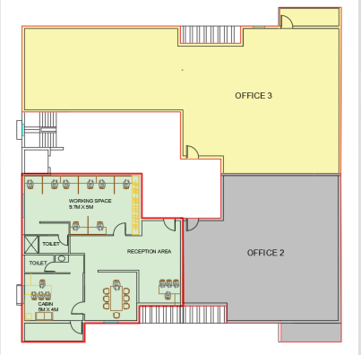 | 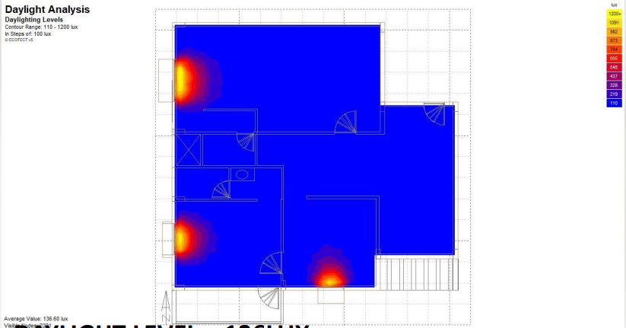 | 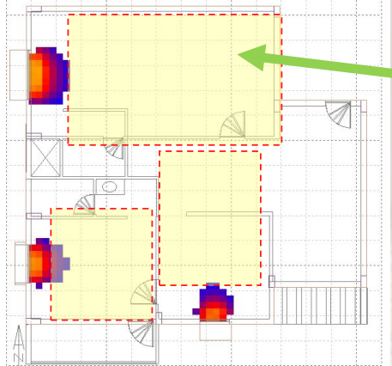  Area where natural daylight not receiving.
Fig 1 – Typical Floor Plan | Fig 2 – Existing daylight lux – 136 lux | Fig 3 – Office floor plan

Data Used for simulation of building.
City – Pune, Types of climate – Warm and Humid
Window Sizes-
W1- 1.2m x 1.2m Height of floor – 3.0m
W2 – 1.5m x 1.2 m Window Projection – 0.60 m
W32.0 m x 1.2m Type of Window – Single Glazing Window

Existing issues facing the building.
- Insufficient natural lighting, which influences employee’s health and quality of work.
- Due to lack of natural lighting, more lighting energy consumption.
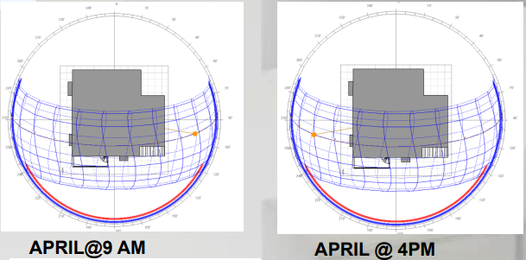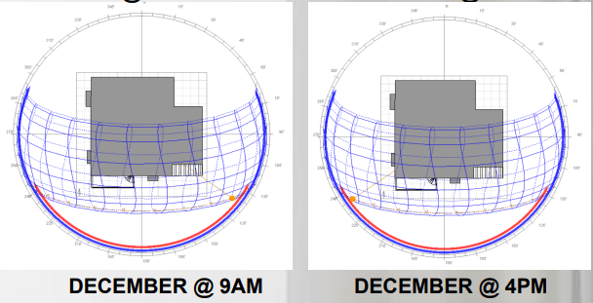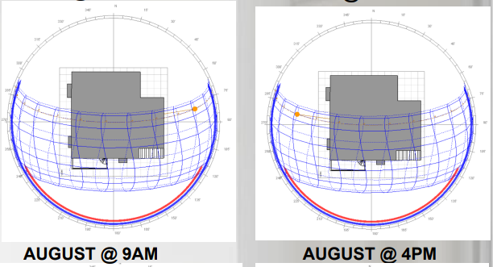

Fig 4 – Analysis of sun path diagram
Application of Solar Light Tubes –

The Light Pipe Solar Daylighting System has a light collector, light transfer pipe and light diffuser assembly. The entire system can deliver light into building spaces for length of 15 meters. “To Successfully daylight a space, the day lighting system should optimize sunlight collection to given climatic region. Sunlight collection system designed for certain regions are Not effective for other climatic regions.” Sky shade provides optimized design for light collection systems specific to regions.
The Light pipe solar lighting system delivers clean light energy into building spaces giving a feel of well-being and saving electrical energy for lighting during Daytime. It delivers sunlight without any colour shift. The outer end of a solar tube light is usually sealed with a weather-proof plastic dome, and the interior-facing end is a porthole-style diffuser that directs the light into your home or business. Additionally, the tubes have a shiny interior that reflects light back and forth, resulting in tunnelling that brightens and illuminates most spaces without the need for electrical power. The diameter can range from 10 to 14 inches, which is much smaller than a standard skylight.

Working of Solar light tube –

A solar tube is a device used to bring natural sunlight into interior spaces that would otherwise have limited or no access to direct sunlight. A solar tube light or sun tunnel can be an energy-efficient and eco-friendly way to brighten up dark areas in buildings, such as hallways, bathrooms, closets, and other rooms with no windows or limited natural light.

The solar tube has three parts: a clear dome on the roof, a reflective tube and a lens inside the room. When sunlight hits the dome, it bounces down the tube and spreads into the room through the lens, giving a soft, natural light similar to a skylight. Solar tubes are smaller than regular skylights, so they are perfect for bringing daylight into small spaces where big windows wouldn’t fit. They help save energy and create a nicer, more pleasant environment by using the sun’s light instead of electricity.
As per ECBC 2017 Floor area shall meet or exceed 90 %the useful daylight illuminance (UDI) area requirements.

Specification Of Solar light tube-
The tubes are made with metal sheets that are polished on the inside.
- Size of Light pipe – 300 mm, Equivalent Wattage of electrical lighting 90 W
- Lumen Output – 4000Lumens, Electrical saving 320 kwhs
- Area Coverage approximately- 150 sqft
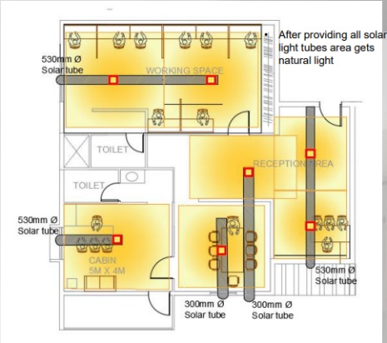
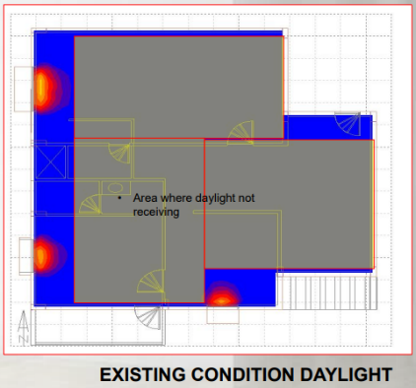

Fig 5 – Existing condition of daylight Fig 6 – After Application of Solar light tubes

 | Existing lighting consumption | Proposed Solar light tube
Electric Consumption/ Year | 1046 Kw/year | 112 Kw/year
Saving | 89 % saving
Table No 1- Lighting Energy saving

Conclusion –
This research has shown that solar light tubes can achieve max lighting saving for existing commercial or office buildings. It is a better option to retrofit to achieve sufficient natural daylight in the building. The application of solar light tubes has minimized the lighting energy consumption and improve the indoor air quality.
References –

References
(n.d.).
- Garcia Hansen, d. E. (2003). NATURAL ILLUMINATION OF DEEP-PLAN OFFICE BUILDINGS:. ISES .
- Garcia Hansen, E. (2003). NATURAL ILLUMINATION OF DEEP-PLAN OFFICE BUILDINGS:. ISES .
- K. Vasilakopoulou a b, D. K. (2017). Analysis of the experimental performance of light pipes. ELSEVIER, 242-249.
- Laura Aeleneia, H. G. (2013). From solar building design to Net Zero Energy Buildings:. ELSVIER, 1236 – 1243.
- N. Khan, N. A. (January 2011). Comparative study of energy saving light sources. ELESVIER, 296-309.
- Veronica Garcia Hansen*, I. E. (2001). THE USE OF LIGHT PIPES FOR DEEP PLAN OFFICE BUILDINGS. ANZAsCA.

Website –
BEE INDIA
https://beeindia.gov.in/sites/default/files/BEE_ECBC%202017.pdf
Griha
https://www.grihaindia.org/

