Phyto-phospholipid complexes and its application in cancer therapy
Juti Rani Devi*, Arijit Dutta, Trishna Sarma, Bhargab Jyoti Sahariah
NETES Institute of Pharmaceutical sciences, Shantipur, Mirza, Kamrup, Assam

Abstract:

Cancer is one of the leading causes of death worldwide. It has continued to provide a substantial challenge for treatments now being used and is still not completely resolved. The traditional cancer treatment options, such as surgery, chemotherapy, radiation therapy, etc., have serious side effects. The potential to improve the efficacy of conventional cancer therapy through the use of herbal active ingredients is enormous. It has been shown that natural plant active ingredients exhibit significant pharmacological activity in vitro but limited in vivo absorption. Phytosomes are one of the emerging nanotechnologies that can be used to improve the miscibility of bioactive phytoconstituents in lipid-rich barriers and overcome their poor bioavailability in order to increase their bioavailability and absorption and get around the drawbacks and adverse effects of conventional herbal extracts. For the targeted distribution of phytoconstituent at the site of action, a variety of cutting-edge drug delivery vehicles are used. The well-known biocompatible nanocarriers known as phyto-phospholipid complexes can be used to improve the solubility and permeability of phytopharmaceuticals in a variety of innovative drug delivery systems (NDDS). The primary focus of this review was on numerous traditional and cutting-edge techniques as well as diverse Nano carriers employed in cancer therapy. Including an overview of the most recent studies on the creation and application of phytosomes as a superior delivery system for herbal components in the treatment of cancer. Moreover, it contains details on the preparation, the method of characterisation, and the mechanism of drug release from the phytosome. Additionally, research is being done on some of the main phytosome-derived active components of herbs that have demonstrated anticancer action. Finally, difficulties and prospects for using phytosomes to treat cancer are also explored.

Keywords: Phytosomes, Cancer therapies, Targeted drug delivery, Herbal extract, Nanocarrier

I.Introduction:
It is predicted that the number of individuals diagnosed with cancer would double in the future decades as the incidence of new cancer cases or cancer mortality rates are rising in the digital age. There is thus a growing demand for the development of more effective anticancer drugs from conventional sources in order to boost their therapeutic potential [1]. In particular, novel drug delivery systems that enhance the pharmacodynamics and bioavailability of medicines and deliver precise drug concentrations to cancer cells with little cytotoxicity to healthy cells have made significant strides in the development of new anti-cancer medications in recent years [2]. Traditional cancer treatment modalities include surgery, chemotherapy, radiation therapy, hormone therapy, immunotherapy, targeted therapy, or a combination of these have advanced significantly. improved the prognosis for cancer patients in recent years to some extent [3]. These techniques are harshly criticized since there is insufficient medication bioavailability at the desired site, which can have a number of negative side effects, including death. To overcome the aforementioned issues, several scientists and researchers have worked to develop targeted or location-specific medicine delivery techniques. The future of medical research and a unique and focused medication delivery mechanism for the treatment of cancer is nanotechnology. For the treatment of cancer, nanostructures such as nanoparticles, liposomes, dendrimers, and micelles have been used as controlled delivery systems. [4].
In order to generate potential nano-based treatments for illnesses like cancer; research has been focused on the potential uses and properties of tropical plant extracts [5].Because of their innate antibacterial properties, plants have been used in medicine. Extracts of natural materials are widely tested for expected bioactivities. The bioactive components are then isolated and identified by fractionation of extracts that demonstrate the requisite bioactivity. Particularly plants are a naturally occurring source whose anti-cancer benefits have been carefully investigated [6]. Strong in-vitro pharmacological effects have been elucidated for active components of plants, but only moderate in-vivo absorption [7]. The issue of poor water solubility, or reduced in vivo absorption, calls for the development of a novel medication delivery technique. Nanotechnology-based drug delivery techniques are being created to address the bioavailability issue with low-solubility chemicals [8].
Phytophospholipid complexes, sometimes referred to as Phytosomes, have emerged as one of the most efficient ways to increase the bioavailability of the active components [7].The name "Phytosome," which is also known as "herbosome" in some publications, is made up of the terms "phyto" and "some," which refer to both plants and cell-like structures. Liposomes and Phytosomes have many similarities. Phytosome is a cutting-edge vesicular drug delivery system, include plant extracts or hydrophilic phytochemicals in phospholipids to enhance their bioavailability and absorption while avoiding the disadvantages and adverse effects of conventional herbal extracts [9]. They are micelles created by the interaction of phospholipids and water. Polyphenolic plant extracts are used to improve the connection. Through hydrogen bonding and polar contact, the polar functional groups of lipophilic substances bind to the charged phosphate head of phospholipids to create micelles. These micelles hold the polyphenolic chemicals in place. In contrast to liposomes, phytosomes contain the bioactive substance either within the core cavity or in the spaces between the shell membrane layers. The bioactive substance is a crucial component of the micelle in phytosomes, where the molecules are bonded chemically to the polar heads of the phospholipids. Only water-soluble substances are delivered by liposomes, whereas both water- and lipid-soluble substances can be delivered by phytosomes. Phytosomes are used to convey both water- and lipid-soluble chemicals, whereas liposomes are utilized to carry solely water-soluble compounds.
As a vesicular medication delivery mechanism for cancer, phytosomes are employed. Drug carriers are passively targeted by vesicular drug delivery systems, which avoid detection by the immune system. Nevertheless, in the case of tumor treatment, phytosomes with a molecular weight larger than 40 kDa and a nanometric size range of 100–1200 nm actively targets cancer cells because of improved permeability and retention. While active targeting directly delivers medications to the place of action, passive targeting enhances drug bioavailability. To transport bioactive chemicals, several techniques are integrated in phytosomes [10]. Over the past two decades, growing evidence of phytosome's potential for drug delivery has emerged. These applications include those for the treatment of cardiovascular disease, inflammation, hepatoprotection, and cancer [11]. Due to a strong chemical contact between the phytosome phospholipid and phytochemical, the production of phytosomes is simple, does not necessitate complicated or expensive equipment, and does not interfere with the herbal constituents that are encapsulated [12]. Thus, this study emphasizes the use of phytosomes in cancer diagnostics, as well as their formulation, characterisation, mechanism of action, difficulties, and potential for the future in cancer therapy.
II. Role of ethno medicine in cancer treatment:
The leading cause of death in the world today is cancer. It stands out for its incredibly quick growth, ability to resist growth inhibitors, replicative immortality, and immunity evasion. most cancer patients underwent surgery, radiation therapy, or conventional chemotherapy. Extreme tiredness, hair loss, bruising, bleeding, anemia, nausea, and vomiting are just a few of the serious side effects that patients who receive this systemic medication endure. As a result, complementary cancer medications and therapies must be created [13].
For many years, the mainstay of medical care in developing countries has been and still is herbal therapies. Plants have been employed in treatments because of their innate antibacterial properties. As a result, research has advanced to look at the potential use of extracts from terrestrial plants for the creation of future medicines based on nanomaterials as in cancer. While many plants are consumed for their health benefits in modern nations, natural herbs have been used in traditional medicine for thousands of years by people in Asia and Africa. The World Health Organization (WHO) reports that some countries still largely employ plant-based medications, and developing countries are making use of the therapeutic benefits of compounds obtained from naturally occurring sources. Based on the correlation between a number of clinical symptoms and tridoshas, the ayurvedic classification of neoplasms. Group I: Illnesses that canonically fall within the category of cancer. Group II includes conditions like growths and ulcers that could turn cancerous. Group III comprises illnesses with an increased risk of turning cancerous, such as intractable leukorrhea, intractable sinusitis, and intractable jaundice [14]. Extracts that are rich in nutraceuticals and have medicinal value are used in ayurveda therapies since they provide numerous health benefits for humans. We can use these ayurvedic remedies in a number of methods, such as chewing, applying to the skin, swallowing, and consuming milk, ghee, tea, honey, etc. Up till now, Indian traditional medicine has used more than 25,000 plant-based or herbal medicines. There are more than 75 formulations for improving human health and vitality available on the Indian market. Triphala, a supplement with potent anticancer effects, is present in more than 219 formulations. The ability of several plant extracts to enhance treatment results and act as adjuvants in cancer therapy regimens is well known [15]. In circumstances where the biomedical treatment has failed or is not available, an Ayurvedic strategy emphasizing increasing tissue metabolism, tonifying digestion, eliminating toxins, and restricting tumor growth is thought to be useful [16]. For a variety of reasons, including limited water solubility, insufficient molecular size, and decreased systemic availability, phytomedicines have been found to have decreased in vivo activity. Extracts of numerous phytoconstituents exhibit biological structural fragility, frequent biotransformation, gastric or enzymatic destruction, early drug loss by rapid clearance, and structural biological fragility [17]. Therefore, a cutting-edge approach that promotes cancer cell-specific targeting through the use of nanotechnology is a current research trend to counteract these adverse consequences [18]. These biopharmaceutical issues may be resolved by nanotechnology, a young science that first gained traction a few decades ago. Nanotechnology has changed the pharmaceutical and medical industries in order to fulfill unmet needs. Other advantages of nano-based herbal creation include maintaining the release profile, improving solubility, bioavailability, toxicity, pharmacological activity, stability, and physical and chemical stability to assist achieve desired safety and efficacy[17].
III. Various approaches for cancer treatment:
There are many types of cancer treatment. The type of treatment that patient receive will depend on the type of cancer, stages and individual patient factors.
Some people who are affected with cancer will have one treatment and some other will have combine treatment, such as surgery with chemotherapy or radiation therapy.
There are two types of approaches. They are discussed below:
AConventional approaches for cancer treatment
- Surgery
- Radiation therapy
- Chemotherapy
B. Novel approaches for cancer treatment
- Immunotherapy
- Gene therapy
- Precision medicine
- Nano particle drug delivery
A. Conventional approaches for cancer treatment:
- Surgery:
The most popular kind of cancer therapy for non-haematological tumors is surgery. The malignant tissues are surgically removed from the body by the surgeon. Surgery can either entirely or partially cure cancer. If cancer has spread to other parts of the body, there is no surgical technique that can completely eliminate it. If the tumor is small and contained, surgery is an effective therapeutic option for cancer [19].

- Chemotherapy:
Chemotherapy primarily affects cancer cells by halting their growth and proliferation. Cancer cells frequently divide and grow far more quickly than healthy cells do, and they physically experience very high amounts of endogenous stress. As a result, the drugs can destroy them more rapidly and effectively than other nearby cells. The choice of whether to utilize chemo-preventive drugs alone or in combination is greatly influenced by the kind and stage of cancer. The main objectives of these drugs are to fight cancerous cells and minimize the stress caused by the growth of the tumor [20]. Cutting, abrading, suturing, treating severe diseases and wounds, or eliminating blockages from persistent and slowly progressing problems are all examples of surgery [21].

- Radiation therapy:
Radiation is used as a physical agent to kill cancer cells. Because it creates ions (electrically charged particles) and deposits energy in the cells of the tissues it passes through, the radiation employed is known as ionizing radiation. This accumulated energy may either kill cancer cells or change their genetic makeup [22]. By directly killing cancer cells or by inflicting DNA damage that results in tumor cell death, radiation has proven to be beneficial[23].
B.Novel approaches for cancer treatment
1. Immunotherapy:
Immunotherapy improves the immune system's capacity to combat cancer. This is sometimes referred to as biological treatment since it mobilizes the body's built-in defenses against disease to fight cancer. The use of monoclonal antibodies, which train the body's defense mechanism to recognize and kill cancer cells, has been studied extensively. By adhering to cancer cells, these antibodies prevent a certain protein from performing its function. This is a safe method [19]
2. Gene therapy:
Ex vivo and in vivo cytokine gene transfer, drug sensitization utilizing prodrug delivery genes, and protection against high-dose chemotherapy using drug-resistant genes in the bone marrow are all examples of gene-based cancer treatments now being tested in clinical trials. Gene replacement and oncogene as well as tumor suppressor gene inactivation are two strategies for combating the underlying genetic damage in cancer cells[24].
3. Nano particle drug delivery:
Nanoparticles are organized and generally range in size from 10 to 1000 nm, depending on their intended function. In the drug delivery region,[25] the medicine is solubilized, contained, trapped, or attached to a nanoparticle matrix. It has been found that NPS deep tissue penetration enhances the permeability and retention (EPR) impact. Furthermore, by effectively crossing epithelial fenestration, surface characteristics influence the bioavailability and half-life. The release rate of drugs or active moieties can be increased by modifying the particle polymer characteristics. Together, NPS's distinctive qualities regulate its therapeutic effect in the detection and treatment of cancer [26].
IV. Phytosomes as a novel approach for cancer management:
With a structure similar to a liposome, phytosomes are a ground-breaking lipid-based delivery technology that may be utilized to entrap diverse phytoconstituents with polyphenolic bases to improve their absorption when supplied (Table 1). The first phytosomes were developed by the Italian business Indena in the late 1980s with the goal of enhancing the bioavailability of drugs by complexing them with phospholipids [12]. Combining phytoconstituents with phospholipids like phosphatidylcholine (PC) to form lipid-compatible molecular complexes that can boost the absorption and bioavailability of the phytochemical is a patented technology. Phytosomes have been successfully employed in pharmacokinetic studies to enhance the formulation of several herbal extracts (including ginkgo, green tea, and milk thistle) and phytochemicals (such as silybin, curcumin, and ginkgolides) [27]. It is a nano-delivery system made up of conjugates of phospholipids and phytocompounds. The primary distinction between phytosomes and liposomes is that the active ingredient in liposome is dispersed in the medium within the cavity or in the layers of the membrane, whereas in phytosome, the molecules are stabilized through hydrogen bonds to the polar head of the phospholipids, making them an integral part of the membrane (Fig. 1) [7]. In this, the phospholipids that make up the liposome interact on a molecular level with the trapped phytochemicals. According to one theory, a hydrogen bond forms between the trapped phytochemical and the polar head group of the phospholipid [28]. Phospholipids and plant chemicals, such as phosphatidylcholine(PC),phosphatidylethanolamine, phosphatidylserine, soy phospholipid, and egg lecithin, are combined to form phytosomes. PC is the most well-known phospholipid among them.
Table 1: Difference between Phytosome and liposome
Phytosome | Liposome
Chemical bond (Hydrogen bonding) is present | No chemical bonds are present
Drug molecular compound with a 1:1 or 2:1 phospholipid ratio | Around the drug, thousands of phospholipid molecules congregated
The bioactive compounds are adhered to the polar tip of the phospholipids via encapsulation H-bonds. | Encapsulation of Active components can be found in the lipid bilayer membrane or the aqueous inside of the vesicles.
Route of administration is oral and tropical | Route of administration is Tropical and parental
Bioavailability is High | Bioavailability is low
Stability is High | Stability is High

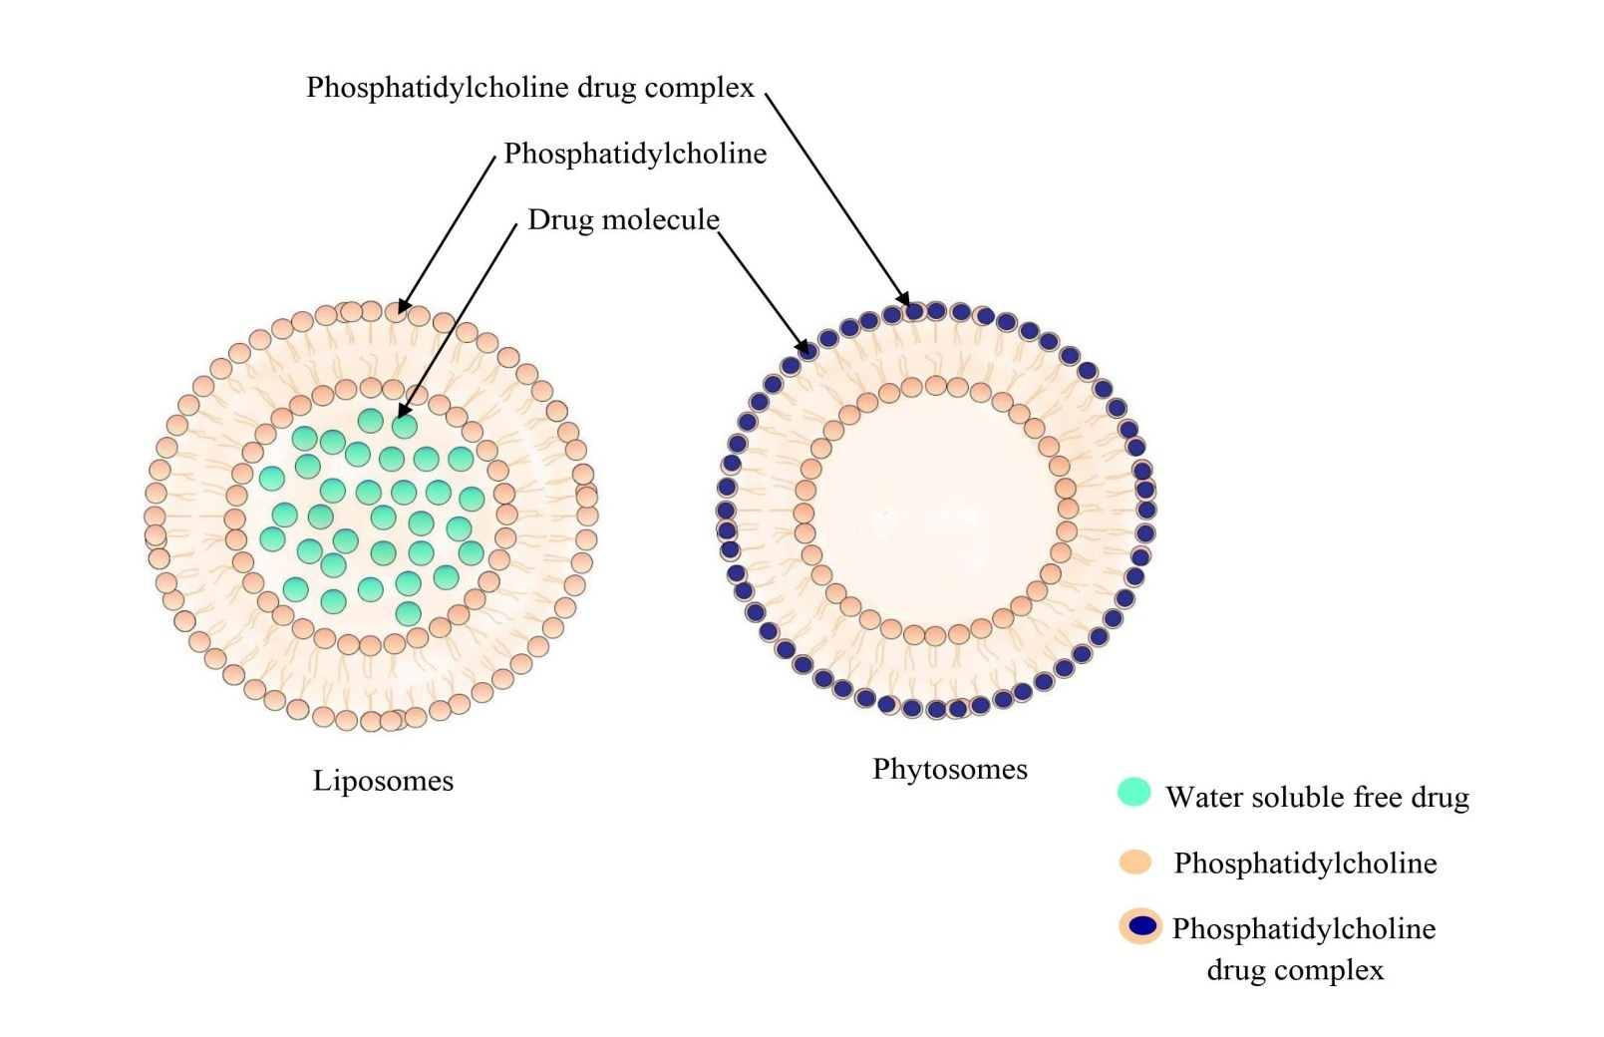

Fig 1: structural difference between liposome and phytosome
A. Method of preparation:
There are three basic methods for creating phyto-phospholipid complexes: solvent evaporation, freeze drying, and anti-solvent precipitation (Fig. 2). [7]. Standardized plant extracts need stoichiometric interactions with either natural or synthetic phospholipids to form phytosomes complexes. Molar ratios (phospholipid: phytoconstituents) range from 0.5 to 3. However, the normal recommendation for the molar ratio was 1:1 [2]. Five essential procedures are required to create a phytosome: combining biomaterials; dissolving the biomaterial in a clear solution using phospholipids or an inorganic solvent; letting the solvent evaporate and generating a thin film; hydrating the mixture; and sonicating the combination.

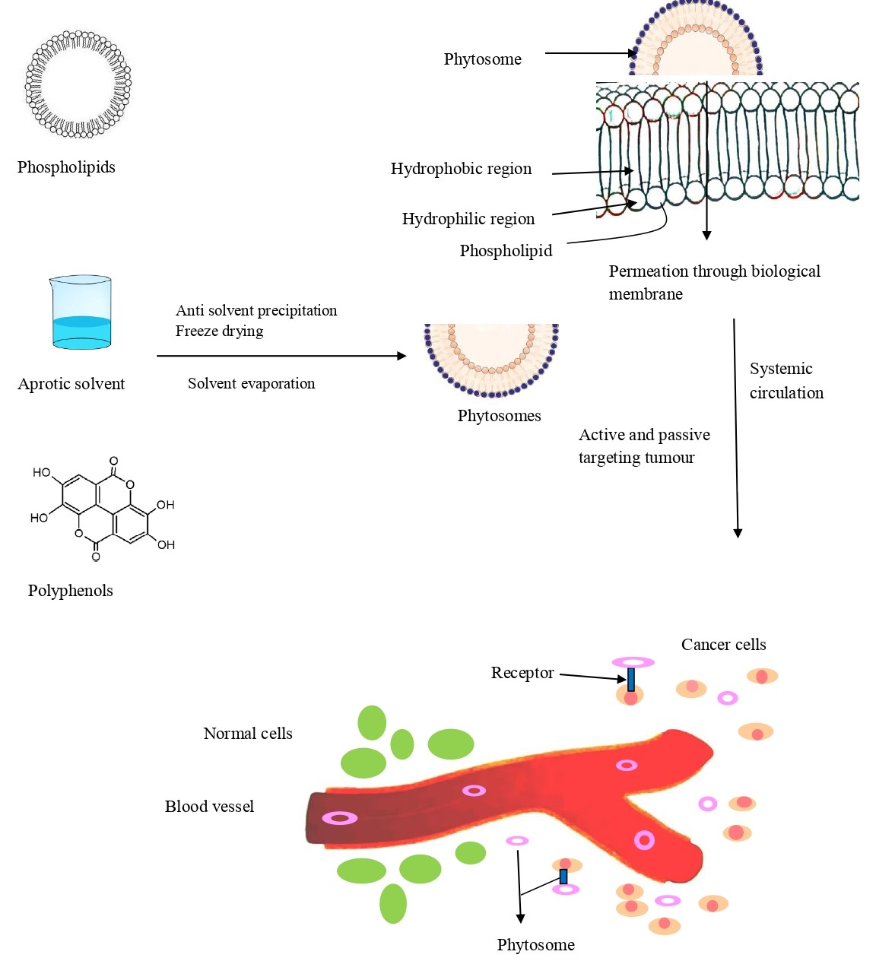

Fig2: Synthesis and mechanism of drug release from phytosomes

The methods are discussed below:
1. Solvent evaporation/thin film hydration method : Solvent evaporation is a well-known and common method for creating phospholipid compounds. In the shared circular bottom, phosphatidylcholines and active substances were mixed. A good solvent was then added, and the mixture was heated at the perfect constant temperature for the specified period of time. By evaporating the solvent while maintaining vacuum, complexes that have already been formed can be obtained [7].By using the solvent evaporation approach, ZhenqingHou et al. created phytosomes that were loaded with the mitomycin C (MMC) soybean phosphatidylcholine complex. To create the clear magenta mixture, they used 12.5 mL of tetrahydrofuran (THF), 10 mg of MMC powder, and 30 mg of soyabean phosphatidylcholine (SPC), which were all codissolved. The resulting solution was then transferred to a glass pressure vessel and vigorously stirred for 4 hours in a water bath at 40 °C. THF was then removed using a rotary evaporator and vacuum rotary evaporation [29].
2. Anti-solvent precipitation: It is the second most used technique for making phytosomes. Lawsone and soy lecithin were refluxed with dichloromethane during this process, keeping the temperature under 60 °C. The precipitate was then given N-hexane in order to keep it overnight in vacuum desiccators [30]. By using anti-solvent precipitation in this refluxing process, Nabil A. Alhakamy et al. were able to construct ICA-phytosomes. The ICA (27 mg) and Phospholipon® 90H (32, 64, or 96 mg) were carefully weighed and dissolved in dichloromethane (20 mL) as per the experimental protocol. The solution was refluxed at the temperature and for the period prescribed by the experimental design, yielding a concentrate of roughly 5 mL. The concentrate was lyophilized for 72 hours in order to get the phytosomal complex. After drying, the complex was kept at 4 °C in an airtight amber-colored glass container until usage [31].
3. Freeze drying or lyophilization: In this, the phytosomes are made using a lyophilizer or freeze dryer. In this totally dissolved diosmin (DSN) in dimethylsulphoxide (DMSO), May S. Freag et al. manufactured diosmin (DSN) phytosome by freeze drying process. A t-butylalcohol-dissolved SPC solution was combined with the resultant DSN solution, and the mixture was then agitated for three hours on a magnetic stirrer until complex formation took place. To isolate the complex, lyophilization was employed. Prior to being put into a Cryodos-50 lyophilizer with a condenser temperature of 70 °C, the vials were frozen for 4 hours at 80 °C. Following a second day of secondary drying at 25 °C, lyophilization was performed for one day at a pressure of 40 mbar and a shelf temperature of 40 °C.The sample was then taken out of the freeze drier and stored in the desiccator. The phospholipid type, drug:lipid ratio, and co-solvent type all have an impact on these approaches [32].
B. Characterization of phytosomes:
1. Visualization: Using atomic force microscopy (AFM), scanning electron microscopy (SEM), and transmission electron microscopy (TEM), phytosome morphology may be studied. The surface structure of phytosomes may commonly be used to evaluate the trapping processes and possible pollutants on their surface [2]. Surface morphology is widely used to identify entrapment behavior, surface features, and the presence or absence of contaminants on the surface. The SEM gives photomicrographs of the phytosomes at the proper magnification after a very thin gold coating. Phytosome surfaces are generally free of crystalline particles and other surface contaminants. The majority of the time, the spherical bulging on the surface is produced, indicating the spherical form of the phytosomes. The TEM analysis may be utilized to clearly explore the interior structure.The interior milieu in which the medication is imprisoned and its distribution inside the phospholipid mesh may be clearly investigated using the TEM investigation [33].
2. Particle size and zeta potential: This is an important complex quality that is related to repeatability and stability. Phospholipid complexes typically had particles between 50 and 100 nm in size [7]. The particle size of the phytosomes was determined using dynamic light scattering (NANO ZS Malvern equipment), and their zeta potential was calculated using electrophoretic mobility in an electric field [34].
3. Entrapment efficiency: Utilizing ultracentrifugation, this is evaluated. The proportion of drugs entrapped is calculated using the formula below (%)[35].Drug entrapment efficiency can be calculated by using Equation :
Drug entrapment (%) = Actual amount determined / Theoretical amount present
4. Vesicle stability: DLS, SEM, and TEM are the fundamental techniques for assessing the stability of phytosome vesicles in relation to changes in size and shape during pertinent time intervals. The standard vesicular size may be determined using DLS and SEM. The evolution of phytosome structure and morphology was monitored using TEM and SEM [2].
5. Crystallinity: the hydrophilicity and hydrophobicity are balanced by crystallinity, which is lost when phytoactive compounds combine. DSC and X-ray diffraction (XRD) examinations are the two main techniques that are commonly utilized to assess the interaction of phospholipid with phytoconstituents as well as the crystallinity [2].
6. Drug release :Drug release behavior of vesicle carriers has recently been the subject of intense research since the release profile attained in vitro may function as an indicator of the carrier's effectiveness in vivo (Fig. 2). Continuous flow, sample and separate strategies, in situ procedures, and membrane diffusion strategies (dialysis, micro-dialysis, fractionalization, and reverse dialysis) are the most often used conventional techniques to measure the release rate of active compounds [24].
C. Advancement and application of phytosomes in cancer:
Due to its capacity to deliver pharmaceuticals to both passive and active targets, phytosomes technology is expanding in the pharmaceutical sector (Fig. 4). Phytosomes provide a number of advantages (Fig. 3). Compared to the majority of drug carrier preparations, phytosomes have a simpler and easier formulation process. Because the plant elements required to make the phytosomes themselves serve as active medicinal ingredients, this technique is more creative and practical. The potential for phytosome technology to advance is enormous [36]. Chemical components of medicinal plants that have antioxidant properties include flavones, isoflavones, flavonoids, anthocyanins, coumarins, lignins, catechins, and isocatechins. These compounds are principally responsible for the plants' anticancer potential. The many side effects of the currently available, expensive conventional cancer treatments, such as radiotherapy and chemotherapy, may have a major detrimental influence on life quality. Pharmaceuticals generated from plants that have bipolar moiety are more soluble, dispersible, and permeable, which makes them a good anti-cancer agent [37].

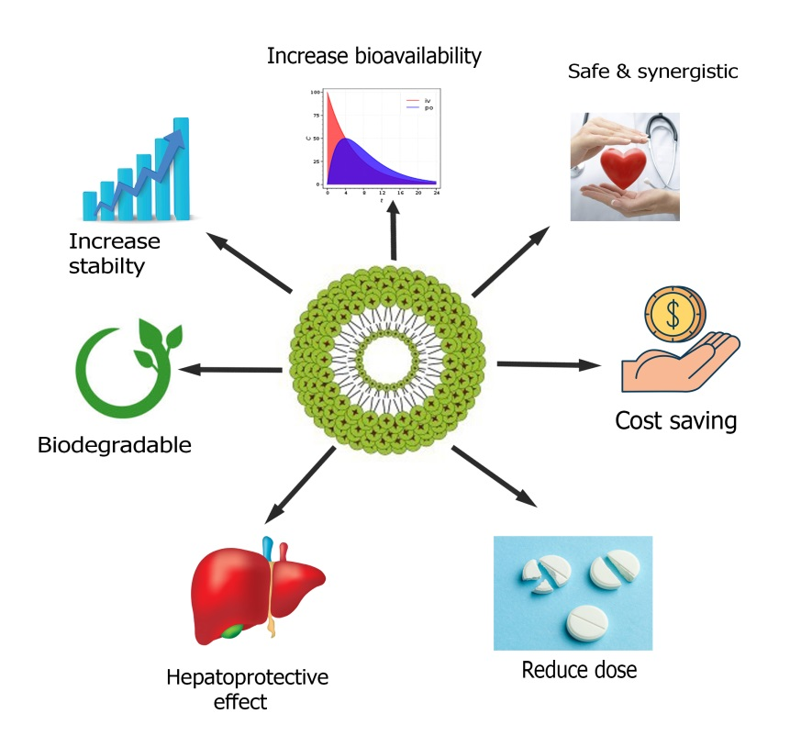
Fig3: Advantages of phytosomal drug delivery
Table 2 lists a number of active herbal ingredients that have demonstrated anticancer activity on various cancer cell lines. Quercetin phytosomes with scorpion venom function were created by Nabil A. Alhakamy and colleagues for the treatment of breast cancer. He constructed optimized phytosomes and evaluated their efficacy against MCF-7 cells. According to his findings, the optimized phytosomes had vesicles that were 116.9 nm in size and had a 31.5 mV zeta potential. Cell cycle studies have shown that the therapy with the enhanced QRT formula significantly stopped the cell cycle at the S phase. The results of the study showed that a QRT phytosome formulation might be a useful therapeutic approach for the treatment of breast cancer. The findings of this study have numerous significant practical applications [38]. Additionally, quercetin phytosomes improved the efficiency of doxorubicin in preventing the spread of MCF-7 human breast cancer cells [39]. In their article, YasmiwarSusilawati et al. reported that the phytosomal drug delivery system performed remarkably well in enhancing quercetin performance. Erythema was significantly (P 0.003) reduced, as were redness, itching, and inflammation. Skin layers were also improved. Hydration levels were raised, and quercetin solubility and absorption were also raised [40]. 160 patients received the lecithin curcumin phytosomal complex (Meriva®) in another controlled research, according to Dina A. Hafez et al. Lecithinized curcumin reduces the side effects of radiotherapy and chemotherapy, proving the value of curcumin phytosomes as an aid in the treatment of cancer [41]. In order to assess the anticancer potential of phytosomal curcumin, ReyhanehMoradiMarjaneh et al. treated CT26 cells to increasing doses of curcumin (0-1000 M) and 5-FU (1-50 mg/ml) for 24, 48, and 72 h, both alone and together. They showed how 5-FU and phytosomal curcumin induced dose-dependent suppression of cell proliferation. Additionally, the 5-FU IC50 value was lowered by co-treating with 5-FU and phytosomal curcumin. They came to the conclusion that phytosomal curcumin improved the anti-antiproliferative effects of 5-FU in both in vitro and in vivo systems [42]. Ibrahim et al. investigated the efficacy of curcumin conjugated with phosphatidylcholine in the treatment of mammary gland tumors. Panahi et al. investigated the efficacy of utilizing phytosomal curcumin in addition to chemotherapy in patients with solid tumors [43]. Mitomycin (MMC) c soybean phosphatidylcholine complex-loaded phytosomes were created by ZhenqingHou et al. Phytosomes are made utilizing a solvent evaporation technique combined with a nanoprecipitation process to make an MMC drug delivery system. The anticancer activity of MMC-loaded phytosomes, according to the author, was astounding. MMC-loaded phytosomes suppressed cancer growth more potently and in a dose-dependent way than free MMC did, without resulting in weight loss. These findings suggest that MMC-loaded phytosomes may be a promising and effective formulation for medication delivery and cancer therapy. A novel formulation of MMC-loaded phytosomes with superior formulation features, such as smaller size, reduced size dispersion, higher zeta potential, and better stability, was made using a straightforward but efficient method. The MMC-loaded phytosomes demonstrated considerably greater cytotoxicity and a higher inhibitory impact compared to MMC [44]. In order to increase their cytotoxicity and ability to induce apoptosis in ovarian cancer cells (OVCAR), Nabil A. Alhakamy et al. created optimized icariin (ICA) phytosomes. He came to the conclusion that phytosome is a very accurate apoptosis indicator. Its phytosome composition significantly enhances the cytotoxic effects of ICA against OVCAR-3 cells [45]. Thymoquinone (TQ) loaded soy-phospholipid-phytosomes were created by Nabil A. Alhakamy et al. and demonstrated their anticancer effectiveness against human lung cancer cells. He comes to the conclusion that this phytosomal delivery would be a fortunate nanocarrier cargo to convey TQ [46]. According to Mehdi Sabzichi et al., doxorubicin sensitivity in MDA-MB 231 cells was increased when luteolin was used as an advanced nanoparticle carrier in phytosomes. Researchers in this study made nanophytosomes of luteolin to promote passive targeting in breast cancer cells and increase luteolin bioavailability. The author came to the conclusion that phytosome increased the therapeutic efficacy of luteolin in addition to making it more water soluble. The pharmacokinetic and pharmacological properties of phytosomes technology have improved, making them a potential choice for therapeutic purposes such cardiovascular, anti-inflammatory, immunomodulator, and anticancer medications [47]. Aloe vera extract is encapsulated with phospholipids in a new phytosome-loaded gel that Manikkampatti et al. created. The phospholipid that is attached to aloe vera has a bigger molecular size, and the zeta potential values suggest that the stable nature is still intact. The MCF-7 cell line is inhibited by aloe vera that has been loaded with phospholipids, and this inhibition is very concentration-dependent. Studies carried out in vitro have shown that phytosome gel has powerful anticancer effects. A lower IC-50 value is a sign of more anticancer activity [48]. Phytosomes produced from Terminalia arjuna bark were created by Sharma Shalini et al. and tested using the MTT method for their ability to inhibit the proliferation of the human MCF-7 cell line. The results suggest that pure methanolic plant extract and pure quercetin have less antiproliferative effects on MCF-7 cells than do quercetin phytosomes and Terminalia arjuna bark extract phytosomes, respectively. The author came to the conclusion that the phytosome formulation had stronger antiproliferative activity than pure extract [49]. The sinigrin-phytosome combination was discovered to be cytotoxic to A-375 melanoma cells in the first phytosome investigation on skin cancer. In comparison to free sinigrin, which lowered cell viability by more than 46%, the complex reduced it by more than 74% at 0.14 mg/mL. The second study looked into how silymarin affected in vitro nanostructured lipid carriers (NLC). Silymarin-NLC showed a higher decrease of cell viability than a commercial formulation of an unidentified phytosome (IC50: 21 g/mL vs. 26 g/mL) [50]. Additionally, it has been demonstrated that silybin has anticancer action and that its phospholipid complex, IdB1016, can enhance the effects of cisplatin. Tumor growth was significantly diminished in mice that received IdB1016 treatment on a regular basis along with human ovarian cancer xenografts. Turmeric has perhaps undergone the most investigation of any dietary supplement when it comes to its possible advantages in the treatment of cancer. The bioavailability of pure curcumin and the active component of turmeric, MerivaTM (curcumin-PHYTOSOME®), was evaluated in rats. Five times more bioavailable than the parent compound, MerivaTM was discovered to be. In order to boost curcumin's bioavailability and consequently improve its biological action, MerivaTM appears to be the ideal alternative [51].
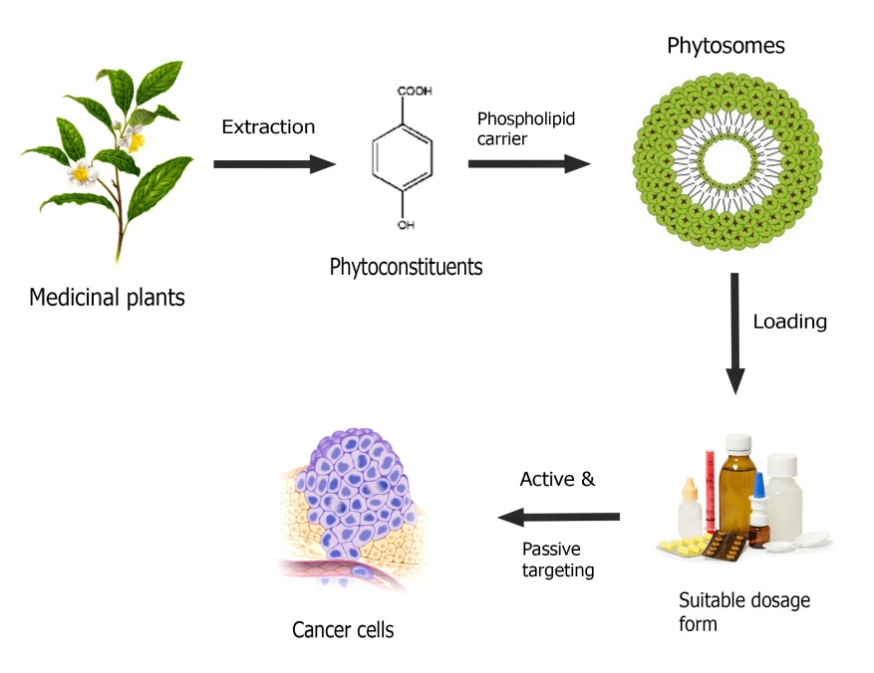
Fig.4. Advancement of phytosomal drug delivery system

Table 2: Phytosomes showing anticancer activity
Active Herbal constituent | Biological source | Preparation techniques | Types of cancer | Cell line study | Major findings
Curcumin | Curcuma Longa | Rotary evaporation technique | Pancreatic cancer | Myeloma cell line | The curcumin loaded phytosome have capability of efficiently controlling the release of medication.
Icariin | Epimedium grandiflorum | Anti-solvent preparation | Ovarian cancer | OVCAR-3 cells | ICA-phytosomes can cause cell death by increasing apoptosis,caspase 3, ROS production and MMP disruption
Quercetin | Terminalia Arjuna bark | Anti-solvent preparation | Breast cancer | MCF-7 cells | The optimised QRT formulation have potential to treat breast cancer.
Mitomycin | Streptomyces caespitosus | Solvent evaporation method | Anticancer | H22 cells (solid tumour-bearing mice) | Both oral bioavailability and accumulation in cancer tissue have improved.
Luteolin | Vegetables and fruits | Thin layer hydration method | Breast cancer | MDA-MB231 cells | Increased luteolins water solubility and therapeutic effectiveness.
Aloe | Aloe vera extract | Thin film hydration | Anticancer | MCF 7 cells line | The aloevera loaded phytosomes are biocompatible and had a growth inhibiting impact on MCF-7 cancer cell line.
Thymoquinone | Nigella sativa L | Anti-solvent preparation method | Lung cancer | Human lung cancer cell line (A549) | The apoptotic potential of TQ-phytosomes against A549 cells for lung cancer was increased threefold.
Genistein | Dyers Genistatinctoria L. | Solvent evaporation method | Breast cancer | Ehrlich Ascites Carcinoma (EAC) | Breast cancer specific Gen phytosome have strong chemotherapeutic effects on breast cancer.
Emodin | Rhubarb | Solvent evaporation | Anticancer | - | Solubility and dissolution rate of emodin was increased.
Chrysophanol | Colubrine gregii | Anti-solvent preparation | Anticancer | - | Increased superior solubility, dissolution and amorphous properties. Also increases therapeutic usefulness and GI tract absorption.

V. Current phytosomal delivery against various cancers:
Lung cancer is the second most common malignancy and can be treated with effective phytosomal delivery. The possibility for treating lung cancer with the phytochemicals elemense, dioscin, docetaxel, hydroxycamptothecin, paclitaxel, and vinorelbine is the focus of the majority of research. Breast cancer is the most typical malignancy among women. The phytochemicals curcumin, docetaxel, paclitaxel, piperine, and resveratrol may be used to treat breast cancer. Colorectal cancer is the third most typical cancer worldwide. The phytochemicals galbanic acid, berberine, curcumin, and luteolin may be able to prevent colon cancer. The main phytochemicals that are used to treat leukemia are curcumin, phytol, quercetin, and vincristine. Cervical cancer is one of the top causes of death among women. Resveratrol, curcumin, and podophyllotoxin all showed promise as cervical cancer treatments. According to the WHO, liver cancer is the fourth most frequent cancer that results in death globally. Hepatocellular carcinoma may be successfully treated with 6-gingerol, betulinic acid, resveratrol, and triptolide, among other phytochemicals. Pancreatic cancer is the development of cancer in pancreatic tissue. Treatment options for pancreatic cancer included curcumin, gemcitabine, and paclitaxel. Brain cancer may be treated with phytochemicals like vincristine and doxorubicin [52]. Fig. 5 shows the current phytosomal strategy against different tumors; phytoconstituents can be administered as phytosomes to cure cancer.
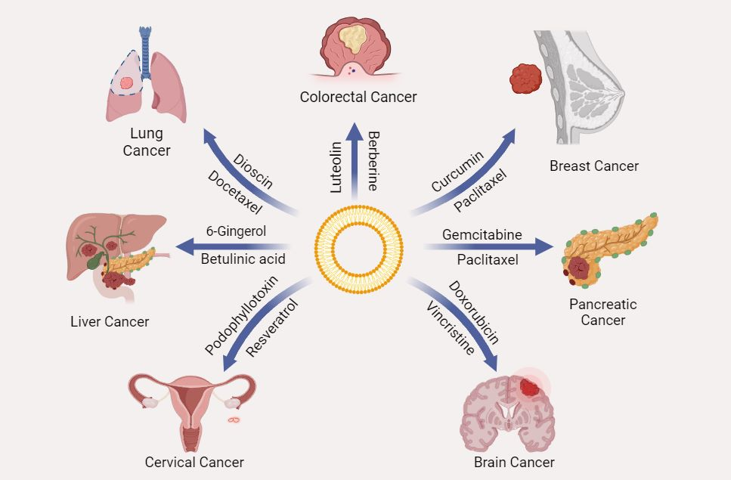
Fig. 5: Various phytosomal strategy against different tumours
VI. Challenges:
Comprehensive optimization, quantitative and qualitative analysis, and investigation of the phytosomal drug delivery mechanism and its impact on various illness situations [53] should receive more focus. Despite substantial research in the field, more needs to be done to focus on the difficulties associated with formulation, stability, and the true clinical superiority of such drug delivery systems. For the formulation of phyto-phospholipid complexes, the solvent evaporation method has traditionally been employed. The process involves a lot of unit operations, which takes time, and the drying method used—which hasn't been optimized in any of the research—often determines the quality of the completed product in terms of particle size, appearance, and hygroscopicity. The supercritical fluid technique can be utilized to solve the drawbacks of current technologies since particle size and dispersion can be more accurately controlled at very low temperatures. There have been no studies that link the pharmacological efficacy of pharmaceuticals in their phospholipid complex forms with enhanced in vivo and in vitro pharmacokinetic properties.
While clinical aspects of produced formulations have been neglected, much attention has been paid to characterizing and evaluating phyto-phospholipid complexes' pharmacokinetic properties. To close this gap and connect the rise in bioavailability to clinical efficacy, more study is required [54]. The second challenge is the large-scale production of phytosomes. The product's qualities should be kept, nevertheless, as it scales up. This pertains to the utility of laboratory techniques in an industrial setting. The formulation process for many different types of phytosomes is typically simple, but the poor physicochemical stability of pH-sensitive phytosomes made their commercial manufacturing challenging. A lot of time passes between product creation and effective commercialization. Despite all the benefits, only a small number of phytosomal products have been released on the market. The verification of safety following the creation of a powerful formulation is a significant barrier to phytosome commercialisation. But before they are put on the market, certain factors including bioaccumulation, biocompatibility, metabolism, and excretion should be examined. To further prove a phyto-some's advantage over pure phyto-constituents, pharmacokinetic and pharmacodynamic properties in both animals and humans should be studied after development. To increase the completed product's absorption and effectiveness, choosing the best dosage form is a further stage in the marketing process [48]. Only a few anti-cancer studies have used phytosome as a carrier in cancer therapy, despite the technology's obvious potential. Only a small number of products, including Meriva® (curcumin phytosomes) and Siliphos® (silybin phytosomes), have been released as a result. The production of nanophytosomes on a bigger scale is a significant component of this aspect. The ease of manufacture and simplicity of phytosomes made them more potent to be scaled up, although not being used on an industrial scale yet. The main reason for the non-industrial scale-up may be the pH sensitivity of phytosome structures. This is a major issue that impacts the physicochemical stability of phytosomes and ought to be handled in the future for the production of these kinds of nanocarriers on a large scale. The high cost of raw materials continues to be a problem, despite recent improvements in industrial-level manufacturing of vesicular systems, such as extruding technologies, which offer optimistic hopes for the commercial fabrication of these systems. Pegylated soy phosphatidylcholine is one potential hazard to this development [55].
VII. Future prospect:
The advancement of phytophospholipid complex technology as a progressive factor in figuring out how well herbal extracts are absorbed systemically. The irrational fears regarding plant-based drugs have been successfully addressed by this way. These novel drugs make great candidates for dose-escalation treatment. Originally used in cosmetics, phytosomes are now often utilized in the treatment of cancer, heart disease, inflammation, tumors, and other liver-related illnesses. With this newly created formulation tool, Phytosomes has reiterated the significance of herbals in modern drug targeting techniques [53]. By binding specific ligands and antigens to the cellular structures, phyto-phospholipid complexes can also be strong candidates for active targeting in addition to passive targeting. As a result, more illnesses, such as cancer, osteoarthritis, and rheumatism, can be treated using phyto-phospholipid complexes. The dimension of the result may be altered to a number of restricted ranges by utilizing more modern techniques, such as supercritical fluid systems, and optimizing the temperature, pressure, and various other aspects. Such size-controlled products would be helpful in more precisely targeting various microbiological regions such as inflammation and tumors because to their greater penetrability and higher retention. The molar ratios of drug candidates with phospholipids, as well as the temperature and other variables, can be optimized using additional statistical tools such as factorial design, spherical symmetric designing, and others in order to achieve the highest level of entrapment efficiency and the best drug release profile. By reducing barriers brought on by insufficient lipid solubility and improving the bioavailability of bioactive phytochemicals like silybin, ginkgo, and polyphenolic compounds found in olive oil, nanotechnology-based phytosomes may have an influence on drug delivery. As phytosomes, several phytochemicals have been effectively produced, and it is anticipated that further phytochemicals may benefit from similar formulations. Future research may find synergistic benefits when using phytosomes in conjunction with other phytochemicals or when combining a drug and a phytochemical in a nano-vesicle [54] . Phospholipids significantly boost bioavailability when compared to chemically equivalent non-complexed forms. The potential of phyto-phospholipid complex has a promising future for usage in the pharmaceutical business with the assistance of doctors and other researchers. This might create a significant window of opportunity to employ the drug for further medical needs. In fact, the use of safe phytoconstituents like curcumin in combination with creative drug delivery methods may pave the way for the development of safe, eco-friendly medicines for the most prevalent human ailments. One crucial area that may be researched is the consumption of complete curcumin NPs for targeted distribution to various tissues, including malignancies [56]. In conclusion, Phytosomes is a boon for naturally occurring extracts with low bioavailability and well-proven analytical and processing techniques. It provides a variety of advantages over other traditional forms of medicine. On the market, there are a number of pharmaceutical products with registered patents. According to this study, Phytosomes have added a fresh perspective to pharmaceutical research and development that has a wealth of unrealized promise [57]. The popularity of the product is another factor in its successful marketing. People's interest for this form of treatment has grown recently due to factors such as biocompatibility, cost, and safety of natural ingredients. Additionally, the commercialization of phytosomes is a speedy process due to the basic production process and uncomplicated encouragement of the use of phytosomal technology on an industrial scale. Many pharmaceutical companies researched the advantages and biological functions of phytosome formulations as well as the improved bioavailability of polar phytoconstituents. The overall evidence for these formulations motivates the researchers to carry out more field study. The FDA has approved a few nano-particulate medication delivery devices for cancer treatment. One of the numerous emerging nanocarriers, lipid-based nanoparticles, have several advantages over conventional drug carriers, including biocompatibility and biodegradability, cost and ease of access to raw materials, and a lengthy history of study. Since combining both natural and synthetic anti-cancer medicines into nanophytosomes considerably increases oral bioavailability and inhibits tumor development, it is anticipated that nanophytosomal delivery methods for cancer therapy will progress and extend in the near future. The use of hydrophilic plant compounds in the treatment of cancer may be transformed by the application of phytosome technology in the nano-formulation of nutraceuticals [2]. Future research may find that using phytosomes along with other phytochemicals or putting a drug and a phytochemical together in a nano-vesicle has stimulatory effects [12].
VIII.Conclusion:
The solubility and permeability of phytopharmaceuticals among diverse NDDS can be increased by using phytosomes, which are well-known biocompatible nanocarriers. Phytosomes, a novel and emerging vesicular drug delivery method, include plant extracts or hydrophilic phytochemicals in phospholipids to enhance their bioavailability and absorption and avoid the disadvantages and adverse effects of conventional herbal extracts. Phytosome characterisation and formulation methods have been well-established. There are several advantages to phytosome technology, including improved stability, bioavailability, hepatoprotective effects, etc. However, there are also some disadvantages, including the rapid loss of phytoconstituents from the phytosome and PH-sensitivity. The verification of safety following the creation of an effective formulation is a significant barrier to the commercialization of phytosomes. It is evident that adding both organic and synthetic anti-cancer medicines to nano-phytosomes considerably increases oral bioavailability and inhibits tumor growth. Hydrophilic plant compounds are now employed in cancer treatment, but the utilization of phytosome technology in the nano-formulation of nutraceuticals has the potential to change that. Future research may find stimulatory effects when using phytosomes in combination with other phytochemicals or when combining a drug and a phytochemical in a nano-vesicle.
REFERENCES
[1]. M.P. Murugesan, M.V Ratnam., Y. Mengitsu, and K. Kandasamy, “Evaluation of anti-cancer activity of phytosomes formulated from aloe vera extract,” Mater. Today: Proc., vol. 42(2), pp. 631–636, 2020.
[2]. A. B. Zadeh, M. Zenial, and H. Hamishehkar, “Nano-phytosome: a developing platform for herbal anti-cancer agents in cancer therapy,” Curr. Drug Targets, Vol. 19(2), pp. 170–180, 2018.
[3]. F. Tao, Y. Zhang, and Z. Zhang, “The role of herbal bioactive components in mitochondria function and cancer therapy,” Evid. Based Complementary Altern. Med., Vol. 9, pp.1–12, 2019.
[4]. T. Mateti, S. Aswath, A.K. Vatti, A. Kamath, and A. Laha, “A review on allopathic and herbal nanofibrous drug delivery vehicles for cancer treatments,” Biotechnol. Rep., Vol. 31,pp.1–9, 2021
[5]. A. Palmier, “Cancer & ayurveda as a complementary treatment,” J. Compl. Integr. Med., Vol. 6,2017.

[6]. K.M. Yap, M. Sekar, S. Fuloria, Y.S.Wu, S.H. Gan, N.N.I.M. Rani., V. Subramaniyan, C. Kokare, P.T Lump, and S M.Y. Begum, “Drug delivery of natural products through nanocarriers for effective breast cancer therapy: a comprehensive review of literature,” Int. J. Nanomed.,Vol. 16, pp. 7891–7941, 2021.

[7]. M. Lu, Q. Qiu, X. Luo, X. Liu, J. Sun, C. Wang, X. Lin, Y. Deng, and Y. Song, “Phyto-phospholipid complexes (phytosomes): a novel strategy to improve the bioavailability of active constituents,” Asian J. Pharm., Vol. 14(3),pp. 265–274, 2019.

[8]. N.A. Alhakamy, S.M. Badr-Eldin, U.A. Fahmy, N.K. Alruwaili, Z.A. Awan, G. Caruso, M.A. Alfaleh, L. A. Alaofi, F.O. Arif, and O.A.A. Ahmed, “Thymoquinone-loaded soy-phospholipid-based phytosomes exhibit anticancer potential against human lung cancer cells,” Pharmaceutics., Vol. 12(8), pp.1–17,2020..

[9]. M. Karpuz, M.S. Gunay,and A.Y. Ozer, “Advances and Avenues in the Development of Novel Carriers for Bioactives and Biological Agents,” Liposomes and phytosomes for phytoconstitutents, pp. 525–553, 2020.
[10]. N.A. Azeez, V.S. Deepa, and V. Sivapriya, “Phytosomes: emergent promising nano vesicular drug delivery system for targeted tumor therapy,” Adv. Nat. Sci. Nanosci. Nanotechnol., Vol. 9(3), pp. 1–6, 2018.
[11]. A. Semalty, M. Semalty, M.S. Rawat, and F. Franceschi, “Supramolecular phospholipids-polyphenolics interactions: the PHYTOSOME strategy to improve the bioavailability of phytochemicals,” Fitoterapia., Vol. 81(5), pp.306–314, 2010.
[12]. W.S. Alharbi, F.A. Almughem, A.M. Almehmady, S.J. Jarallah, W.K. Alsharif, N.M. Alzahrani, and A.A. Alshehri, “Phytosomes as an emerging nanotechnology platform for the topical delivery of bioactive phytochemicals,” Pharmaceutics.,Vol.13(9), pp. 1–20, 2021.
[13]. D.M. Anwar, M. El-Sayed, A. Reda, J.Y. Fang, S.N. Khattab, and A.O. Elzoghby, “Recent advances in herbal combination nanomedicine for cancer: delivery technology and therapeutic outcomes,” Expet Opin. Drug Deliv., Vol.18(11), pp.1609–1625, 2021.
[14]. B.B. Aggarwal, H. Ichikawa, P. Garodia, P. Weerasinghe, G. Sethi, I.D. Bhatt, M.K. Pandey, S. Shishodia, and M.G Nair, “From traditional Ayurvedic medicine to modern medicine: identification of therapeutic targets for suppression of inflammation and cancer,” Expert Opin.Ther.Targets. Vol. 10(1), pp. 87–118, 2006.
[15]. B. Koul, “Herbs for Cancer Treatment,” pp. 1–1174, 2020.
[16]. A. Dhruva, F.M. Hecht, C. Miaskowski, T.J. Kaptchuk, G. Bodeker, D. Abrams, V. Lad, and S.R. Adler, “Correlating traditional ayurvedic and modern medical perspectives on cancer: results of a qualitative study,” J. Alternative Compl. Med. Vol. 20(5), pp. 364–370, 2014.
[17]. M. Handa, S. Beg, R. Shukla, M.A. Barkat, H. Choudhry, and K.K. Singh, “Recent advances in lipid-engineered multifunctional nanophytomedicines for cancer targeting,” J. Contr. Release., Vol. 340, pp. 48–59, 2021.
[18]. V.P. Chavda, D. Vihol, B. Mehta, D. Shah, M. Patel, L.K. Vora, M. Pereira-Silva, and A.C. Paiva-Santos, “Phytochemical-loaded liposomes for anticancer therapy: an updated review,” Nanomedicine., Vol. 17(8), pp. 547–568, 2022.
[19]. J.J. Wang, K.F. Lei, F. Han, “Tumor microenvironment: recent advances in various cancer treatments,” Eur. Rev. Med. Pharmacol. Sci., Vol. 22(12), pp. 3855–3864, 2018.
[20]. U. Anand, A. Dey, A.K.S. Chandel, R. Sanyal, A. Mishra, D.K. Pandey, et. al., “Cancer chemotherapy and beyond: current status, drug candidates, associated risks and progress in targeted therapeutics,” Genes Dis., Vol. 10(4),pp. 1367- 1401, 2022.
[21]. L. Gautam, A. Jain, P. Shrivastava, S. Vyas, and S.P. Vyas, “Emergence of novel targeting systems and conventional therapies for effective cancer treatment,” Nano Drug Delivery Strategies for the Treatment of Cancers; pp. 1–35. 2021.
[22]. R. Baskar, K.A. Lee, R. Yeo, and K.W. Yeoh, “Cancer and radiation therapy: current advances and future directions,” Int. J. Medical Sci., Vol. 9(3), pp.193–199, 2012.
[23]. D. Abshire, and M.K. Lang, “The evolution of radiation therapy in treating cancer,” Semin. Oncol. Nurs., Vol.34(2),pp. 151–157, 2018.
[24]. M.A. Zaimy, N. Saffarzadeh, A. Mohammadi, H. Pourghadamyari, P. Izadi, A. Sarli, L.K. Moghaddam, S.R. Paschepari, H. Azizi, and S. Torkamandi, “New methods in the diagnosis of cancer and gene therapy of cancer based on nanoparticles,” Cancer Gene Ther., Vol. 24(6), pp. 233–243, 2017.
[25]. K. Ozturk-Atar, H. Eroglu, and S.Calıs, “Novel advances in targeted drug delivery,” J. Drug Target., Vol. 26(8), pp. 633–642, 2018.
[26]. S. Gavas, S. Quazi, and T.M. Karpiński, “Nanoparticles for cancer therapy: current progress and challenges,” Nanoscale Res. Lett., Vol. 16(1), pp.1–21, 2021.
[27]. H. Mirzaei, A. Shakeri, B. Rashidi, A. Jalili, Z. Banikazemi, and A. Sahebkar, “Phytosomal curcumin: a review of pharmacokinetic, experimental and clinical studies,” Biomed. Pharmacother.,Vol85:102–112.
[28]. H.T.H. Vu, S.M. Hook, S.D. Siqueira, A. Müllertz, T. Rades, and A.McDowell, “Are phytosomes a superior nanodelivery system for the antioxidant rutin,” Int. J. Pharm. Vol. 548(1), pp.82–91,2018.
[29]. Z. Hou, Y. Li, Y. Huang, C. Zhou, J. Lin, Y. Wang, et al., “Phytosomes loaded with mitomycin C-soybean phosphatidylcholine complex developed for drug delivery,” Mol. Pharm., Vol.10(1), pp.90–101, 2013.
[30]. M. Barani, E. Sangiovanni, M. Angarano, M.A. Rajizadeh, M. Mehrabani, S. Piazza, et al., “Phytosomes as innovative delivery systems for phytochemicals: a comprehensive review of literature,” Int. J. Nanomed.,Vol. 16, pp. 6983–7022, 2021.
[31]. N.A. Alhakamy, U.A. Fahmy, S.M. Badr Eldin, O.A.A. Ahmed, H.M. Aldawsari, S.Z. Okbazghi, et.al., “Scorpion venom-functionalized quercetin phytosomes for breast cancer management: in vitro response surface optimization and anticancer activity against MCF-7 cells,” Polymer., Vol. 14(1), pp. 1–21, 2022.
[32]. M.S. Freag, Y.S.R. Elnaggar, and O.Y. Abdallah, “Lyophilized phytosomal nanocarriers as platforms for enhanced diosmin delivery: optimization and ex vivo permeation,” Int. J. Nanomed., Vol.8, pp.2385–2397, 2013.
[33]. S. Tripathy, D.K. Patel, L. Baro, and S.K. Nair, “A review on phytosomes, their characterization, advancement & potential for transdermal application,” J. Drug Deliv. Therapeut., Vol.3(3), pp.147–152, 2013.
[34]. S. Sharma, and A. Sahu, “Development, characterization, and evaluation of hepatoprotective effect of abutilon indicum and piper longum phytosomes,” Pharmacogn. Res., Vol. 8(1), pp.29–36, 2016.
[35]. K. Gnananath, K.S. Nataraj, and B.G. Rao, “Phospholipid complex technique for superior bioavailability of phytoconstitutents,” Adv. Pharmaceut. Bull., Vol. 7(1), pp.35–42, 2017.
[36]. V.P. Chavda, D. Vihol, B. Mehta, D. Shah, M. Patel, L.K. Vora, et. al., “Phytochemical-loaded liposomes for anticancer therapy: an updated review,” Nanomedicine., Vol.17(8), pp. 547–568, 2022.
[37]. N.A. Azeez, V.S.Deepa, V. Sivapriya, “Phytosomes: emergent promising nano vesicular drug delivery system for targeted tumor therapy,” Adv. Nat. Sci. Nanosci. Nanotechnol., Vol. 9(3), pp.1–6, 2018.
[38]. P.S. Chivte, V.S. Pardhi, V.A.Joshi, and A. Rani, “A review on therapeutic applications of phytosomes,” J. Drug Deliv. Therapeut., Vol.7(5), 2017
[39]. N.A. Alhakamy, U.A. Fahmy, S.M. BadrEldin, O.A.A. Ahmed, H.M. Aldawsari, S.Z. Okbazghi, et.al., “Scorpion venom-functionalized quercetin phytosomes for breast cancer management: in vitro response surface optimization and anticancer activity against MCF-7 cells,” Polymer., Vol.14(1), pp.1–21, 2022.
[40]. S. Gavas, S. Quazi, and T.M. Karpiński, “Nanoparticles for cancer therapy: current progress and challenges,” Nanoscale Res. Lett., Vol. 16(1), pp.1–21, 2021.
[41]. Y. Susilawati, A.Y. Chaerunisa, and H. Purwaningsih, “Phytosome drug delivery system for natural cosmeceutical compounds: whitening agent and skin antioxidant agent,” J. Adv. Pharm. Technol. Research, Vol.12(4), pp.327–334, 2021.
[42]. R.M. Marjaneh, F. Rahmani, S.M. Hassanian, N. Rezaei, M. Hashemzehi, A. Bahrami,et. al., “A. Phytosomal curcumin inhibits tumor growth in colitis-associated colorectal cancer,” J. Cell. Physiol., Vol. 233(10), pp.6785–6798, 2018.
[43]. H. Mirzaei, A. Shakeri, B. Rashidi, A. Jalili, Z. Banikazemi, A. Sahebkar, “Phytosomal curcumin: a review of pharmacokinetic, experimental and clinical studies,” Biomed.Pharmacother., Vol.85, pp.102–112, 2017.
[44]. Z. Hou, Y. Li, Y. Huang, C. Zhou, J. Lin, Y. Wang, et al., “Phytosomes loaded with mitomycin C-soybean phosphatidylcholine complex developed for drug delivery,” Mol. Pharm., Vol.10(1), pp.90–101, 2013.
[45]. N.A. Alhakamy, U.A. Fahmy, S.M. Badr-Eldin, O.A.A. Ahmed, H.Z. Asfour, H.M. Aldawsari, et al., “Optimized icariin phytosomes exhibit enhanced cytotoxicity and apoptosis-inducing activities in ovarian cancer cells,” Pharmaceutics., Vol.13(1), pp.346, 2020.
[46]. N.A. Alhakamy, S.M. Badr-Eldin, U.A. Fahmy, N.K. Alruwaili, Z.A. Awan, G. Caruso, et al. “Thymoquinone-loaded soy-phospholipid-based phytosomes exhibit anticancer potential against human lung cancer cells,” Pharmaceutics., Vol. 12(8), pp.1–17, 2020.
[47]. M. Sabzichi, H. Hamishehkar, F. Ramezani, S. Sharifi, M. Tabasinezhad, M. Pirouzpanah, et al., “Luteolin-loaded phytosomes sensitize human breast carcinoma MDA-MB 231 cells to doxorubicin by suppressing Nrf2 mediated signalling,” Asian Pac. J. Cancer Prev.,Vol.15(13), pp.5311–5316, 2014.
[48]. M.P. Murugesan, M.V. Ratnam, Y. Mengitsu, and K. Kandasamy, “Evaluation of anti-cancer activity of phytosomes formulated from aloe vera extract,” Mater. Today: Proc., Vol. 42(2), pp. 631–636, 2020.
[49]. S. Sharma, R. Roy, and B. Shrivastava, “Antiproliferative effect of phytosome complex of methanolicextact of Terminalia arjuna bark on human breast cancer cell lines (MCF-7)”, Int. J. Drug Dev. Res., Vol. 7(1),pp.173–182, 2015.
[50]. M. Barani, E. Sangiovanni, M. Angarano, M.A. Rajizadeh, M. Mehrabani, S. Piazza, et al., “Phytosomes as innovative delivery systems for phytochemicals: a comprehensive review of literature,” Int. J. Nanomed., Vol.16, pp.6983–7022, 2021.
[51]. A. Semalty, M. Semalty, M.S.M. Rawat, and F. Franceschi, “Supramolecular phospholipids-polyphenolics interactions: the PHYTOSOME strategy to improve the bioavailability of phytochemicals,” Fitoterapia., Vol.81(5), pp.306–314, 2010.
[52]. V.P. Chavda, D. Vihol, B. Mehta, D. Shah, M. Patel, L.K. Vora, et al. “Phytochemical-loaded liposomes for anticancer therapy: an updated review,” Nanomedicine., Vol.17(8), pp.547–568, 2022.
[53]. S. Kumar, A. Baldi, and D.K.Sharma, “Phytosomes: a modernistic approach for novel herbal drug delivery - enhancing bioavailability and revealing endless frontier of phytopharmaceuticals,” J. Dev. Drugs., Vol. 9(2), pp.1–8, 2020.
[54]. J. Khan, A. Alexander, A. Saraf, S. jazuddin, and S. Saraf, “Recent advances and future prospects of phyto-phospholipid complexation technique for improving pharmacokinetic profile of plant actives,” J. Contr. Release., Vol.168(1),pp.50–60, 2013.
[55]. A. Baba Zadeh, M. Zenial, H. Hamishehkar, “Nano-phytosome: a developing platform for herbal anti-cancer agents in cancer therapy,” Curr.Drug Targets., Vol.19(2),pp.170–180, 2018.
[56]. V.S. Ipar, A. Dsouza, and P.V. Devarajan, “Enhancing curcumin oral bioavailability through nanoformulations,” Eur. J. Drug Metab. Pharmacokinet., Vol.44(4), pp.459–480, 2019.
[57]. A. Agarwal, P. Chakraborty, D.D. Chakraborty, and V.A. Saharan, “Phytosomes: complexation, utilisation and commerical status,” J. Biol. Act. Prod. Nat., Vol. 2(2), pp.65–77, 2012.

