The shoulder is the joint that is the most frequently dislocated, which represents more than half of all joints. due to range of motion, unstable. Among the static and moving parts that stabilize the shoulder are the ligaments, muscles around it, and the labrum. Disorders that have one or more stabilizing factors may result in instability. The most frequent reason for shoulder instability is trauma. Depending on the direction of instability, damage to the shoulder is usually classified as internal, posterior, or inferior. Most shoulder dislocations are forward, accounting for more than 95% of all dislocations. Although posterior dislocations are thought to account for only 0.5% of all shoulder dislocations, posterior dislocations are thought to occur between 2% and 4%. Although shoulder injury is a common cause of instability, soft tissue or muscle imbalances can cause shoulder instability even without a serious injury. Non-traumatic instability differs from traumatic instability in that it is often multifaceted. It is important to understand the mechanisms underlying failure. Removing an obstacle will result in an inability to deal effectively with conflicts. For the long-term maintenance of the disease, it is necessary to recognize the pathology as well as the instability. The analysis model is also important in terms of determining the underlying pathophysiology of instability and evaluating the disease in a way that provides appropriate treatment, as well as the general evaluation. CT scans and radiography provide important information about bone structure and bone loss. A complete evaluation of tissue structure with magnetic resonance imaging reveals problems that need to be addressed in treatment. Treatment options for shoulder instability include reconstructive procedures, surgical repair, or restoration of damaged structures. In the absence of dangerous situations, failure management is a good way to manage initial instability. If there is no serious bone loss at the beginning of the period and the risk of recurrence (young age, male gender, sports, and bone loss) is high enough, the problem is reversible. But when a major blow occurs to the bones, in cases where the teenager has had an accident or has come into contact with an athlete, more and more complex treatments will be needed to rebuild the shoulder. The timing of surgery is also important in terms of good management because surgery needs to be done better when bone damage increases with relapse. Shoulder rehabilitation is particularly important to restore the feel and strength of the dynamic stabilizer of the shoulder. Unstable recovery after medical or surgical treatment will not be possible without appropriate treatment. For proper treatment, the cause of shoulder instability needs to be properly diagnosed and treated for each patient. Root causes of risk must be identified in order to develop effective prevention and treatment strategies.
Biomechanics of shoulder instability Surgeons should consider bone loss (glenoid defects and Hill-Sachs lesions) commonly encountered when treating patients with shoulder instability. Bankart therapy is widely considered the gold standard, with many articles reporting its clinical benefits. However, severe bone loss has been shown to cause postoperative shoulder instability. Many studies have shown how bone damage affects stability. Bone grafting is recommended if glenoid bone loss exceeds 25% of glenoid width. Since there is always contact between the Hill-Sachs lesion and the glenoid margin, glenoid bone loss should be considered when calculating the significance of the Hill-Sachs lesion. In 2007, a special glenoid running concept was presented. This concept allows us to calculate bone loss and determine whether a severe Hill-Sachs disease is 'on tract and off tract '. This idea has been used many times. The normal glenoid orbit width was determined as 83% of the glenoid width. However, since the glenoid tract is defined as the contact of the glenoid with the humeral head, the width of the glenoid scar seems to be affected by many aspects of the shoulder. MRI research has allowed healthcare professionals to better understand the relationship between various aspects of movement and the glenoid orbit. The results showed that the narrower the width of the glenoid, the greater the horizontal extension angle of traction and external rotation. The angle of horizontal extension in the sitting position can be used to calculate the individual glenoid orbital width. The concept of the glenoid orbit is supported by the medical community and evaluation of the glenoid orbit is recommended for surgical decisions. In order to understand the results of the treatment of patients who underwent surgery according to this theory, 94 patients were studied. The overall recurrence rate of patients who underwent glenoid orbital surgery was 4.3% during the 2-year follow-up period. These findings support the application of the glenoid orbit concept to surgical decisions to prevent postoperative recurrence and instability. "Typical" cases with less than 25% glenoid defects can be treated with arthroscopic Bankart repair. In patients whose lesions have "disappeared" and whose glenoid deformity is less than 25%, we should surgically treat Hill-Sachs lesions again. In patients with "normal" pain with more than 25% glenoid defect, we need to perform a bone graft, such as the Latarjet procedure, to correct glenoid bone loss. Bone grafting can be used even if there is an 'out of path' wound with more than 25% glenoid defect, as a bone graft can transform an 'out of path' wound into an 'endpoint'. Various concepts have been proposed for the classification of glenohumeral instability. The patient's signs and symptoms are recorded as a model for describing his illness. When classified, treatment should be systematic or algorithmic. Because there are many factors (etiology, direction of instability, laxity, patient age, activity, expectations, and bone loss) that must be considered before treating a patient's instability, there is no clear definition that fits all examples. The surgeon must carefully evaluate the patient's history, physical examination, and visual examination to administer appropriate therapy. According to Thomas and Matsen's classification system, patients with disorders are divided into two groups: patients with trauma, disorder, Bankart lesion, or surgery, and patients who experience less stress and more conflict. While this approach is valid, it does not take into account mysterious situations or individuals who may be affected by the disease. Static instability, dynamic instability, and voluntary dislocation are the three categories created by Gerber and Nyffeler to classify instability and excessive relaxation. Patients with grade B injuries are usually young and active. Stanmore's classification includes three types of polarity: non conflict injury and disorder and non-conflict muscles, that is, a triangle. Posture, muscle tone, and glenohumeral instability of the patient are considered separately to distinguish between acute and non-acute pain.

Figure 1 illustrates an algorithm for treating individuals with anterior glenohumeral instability.

Anterior Glenohumeral Instability
Bone block Procedure

Non-Surgical Treatment
Bankart repair+ Remplissage
Bankart repair
Off-track
On-track
Hill-Sachs Lesion
Glenoid bone defect > 25%
defect < 25%
Glenoid bone defect < 25%
No
Yes
>2 Recurrence
No
Yes
Risk factor
Young age, male, Athletes, Sports Person

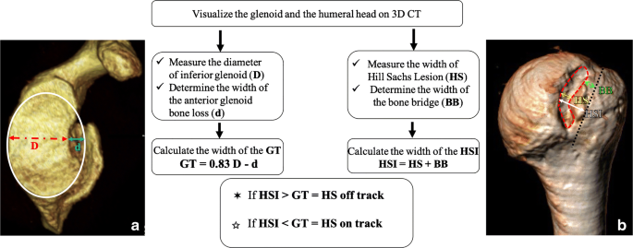 Figure2: -on track – off track Glenoid defect
Surgery: an open method proposed by Latarjet-Patte in 1958 for the treatment of large bones resulting from anteroinferior instability of the glenohumeral joint, popularized in the 1990s and 2000s by Bankart arthroscopic stabilization. Glenoid and humerus problems occur again when they cannot be detected. Losses are presented. Lafosse and Boyle reported a recurrence rate of 2-4.9%, a satisfaction rate of 98%, more concern, and less graft resorption for the arthroscopic Latarjet technique. Patients with failed coracoid metastases, abnormal coracoid morphology, or large glenoid defects are generally considered candidates for Eden-Hybinette surgery.
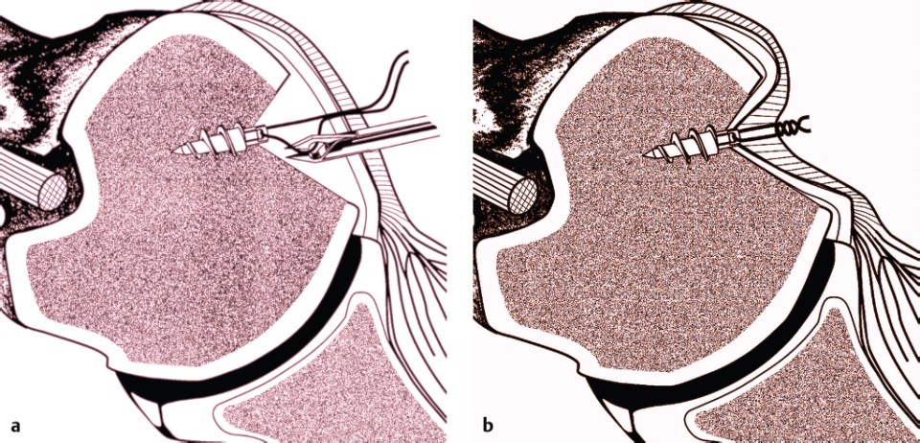
Figure 3: - Remplissage Procedure
The word "remplissage" in French means "to write". Hill-Sachs bone defects have been treated with a variety of treatments, including bone grafting, retrograde desilting, arthroplasty, partial humeral head resurfacing, and humeral rotational osteotomy. Remplissage is a procedure that includes arthroscopic Bankart repair, infraspinatus tenodesis, and posterior capsulodesis to fill Hill-Sachs syndrome. This method was developed by Wolf Et al. Reported by in 2007. He worked as an adjunct to arthroscopic anterior shoulder stabilization surgery to treat severe Hill-Sach syndrome. The Remplissage approach has been shown to be effective in reducing the incidence of recurrent shoulder dislocations when used in conjunction with the arthroscopic Bankart procedure.
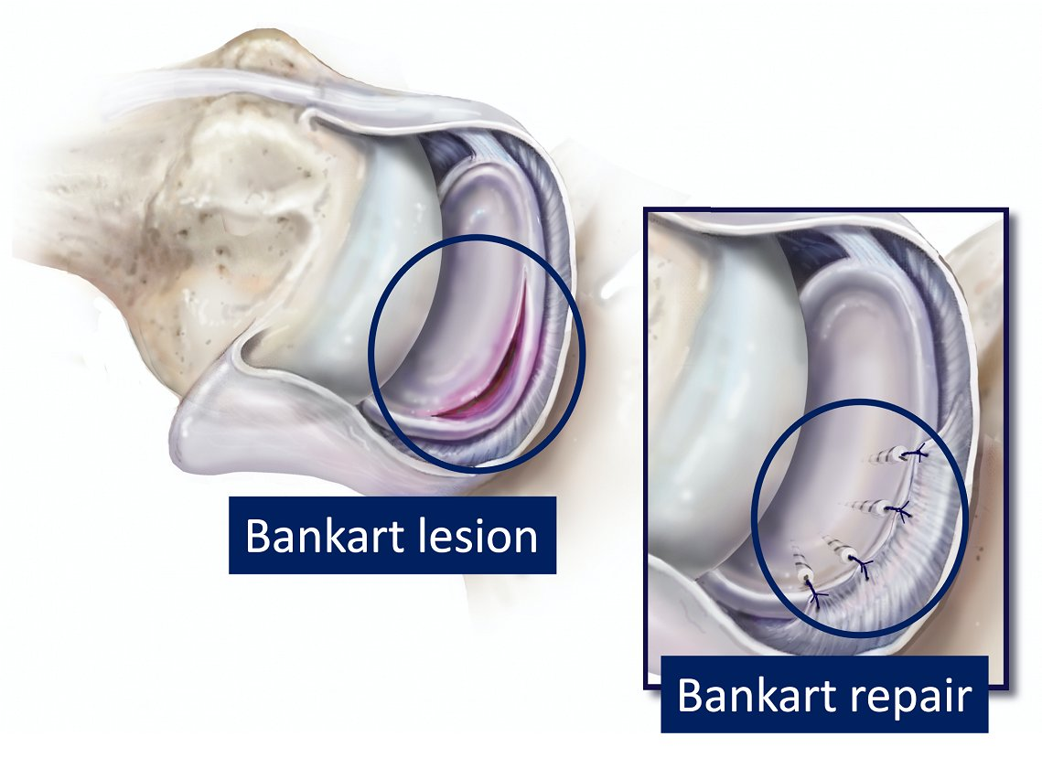
Figure 4: - Bankert lesion and repair

