MICROBIAL HERBICIDE
Arya P. Mohan ¹ and Varshalazar²
1 Department of Botany, St. Teresa’s college (autonomous), Ernakulam, Kerala, India, aryamhn@gmail.com
2 Department of Botany, St. Teresa’s college (autonomous), Ernakulam, Kerala, India, varshalazar25@gmail.com
Abstract
Weeds are a trouble in any agriculture land. The use of bacteria, fungi and viruses for eradication of weeds are an effective alternative for chemicals hence they attracted great attention over some decades. There are several advantages and disadvantage of microbial herbicides which is discussed in the chapter. This chapter collectively presents details on various microbial herbicides, examples, formulations and discusses its eco-friendly approach for the management of agricultural weeds.
Key words
Herbicides, Bacteria, Viruses and Fungi
Introduction
Weeds can cause serious ecological problems and are capable of altering the process of the ecosystem, altering the native flora and fauna. They may also support populations of invasive animals and microbes. There are more than 30,000 widely distributed weeds species among them 1800 species causing major menace and yield loss. Weeds cause injury to living beings, contamination water etc. Biological weed management practice is a selective process against targeted weeds without damaging non-target living beings and the environment. Herbicides or weedicides are used to control unwanted plant growth.
A microorganism that controls the annoying plant growth without harming the other organism is called microbial herbicide. In agriculture, weed control through chemical herbicides, adversely affect the environment. Pesticide and herbicides residues in food commodities can directly or indirectly affect human health. These lead to the search for eco-friendly weed management. Microbial herbicides can be compounds or secondary metabolites derived from microbes such as fungi, bacteria, protozoa or phytotoxic plant residues, extracts derived from other plant species. Some are effective enough to control weeds in a wide range and it is applied in many countries. The microbial herbicides are now contributing as an alternative to chemical herbicides is a boon for the environment. The microbial herbicide was first isolated from fungi called mycoherbicide. It was put to use in 1981 and the herbicide is
Phytophthora palmivora, shown in Fig :1
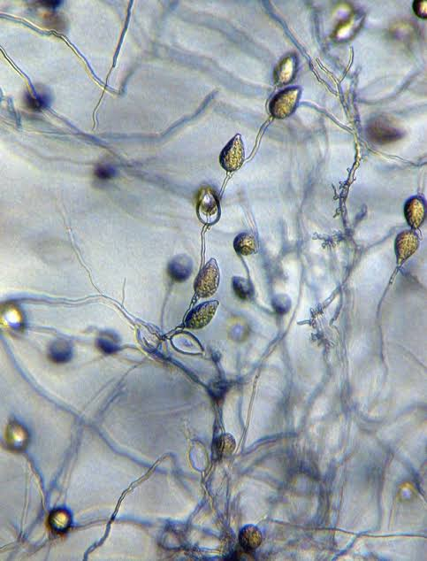
Fig:1- Phytophthora palmivora Butler EJ. (1919). Report of the imperial mycologist, Science Report institute Pusa. 82 pp.
Table 1: List of some herbicide (a-d) and insects (e-f) to check growth of some selected weeds
 | Herbicide/ insects | Weeds | Country
a. | Puccinia chondrillina | Chondrilla juncea | Australia
b. | Cercosporella riparia | Ageratina riparia | Hawaii
c. | Phragmidium violaceum | Rubus fruticosus | Chile, Australia and New Zealand
d. | Cercospora rodmanii | Eichhornia crassipes | Florida
e. | Cactoblastis cactorum | Opuntia basilaris | India and Australia
f. | Chrysolina beetles | Hypericum perforatum | Australia and Canada

Fungal spores are best for marketing because they can tolerate adverse conditions and can remain viable for long periods. They are now available to be sprayed over weeds for their elimination, Devine and Collego are examples of fungal spores. The microbial herbicides have been explored for many years, however, there are many challenges to overcome before their wide application in agricultural, range and forest lands, or waterways. The major factors that should be considered are
a) Improving the efficacy of the microbial activity
b) Survival of microorganisms
c) Persistence of the suppressive compound
d) Delivery systems
e) Determining host range
f) Avoiding injury to non-target organisms
g) Interactions with chemical herbicides
h) Regulations
i) Commercialization and mass production
j) Economic feasibility.
The application of microbial herbicides is an eco-friendly approach for the management of agricultural weeds. A worldwide programme has been growing up to control the invasive weed species for better crop production and a stable ecosystem. Classical bio-control is not at all successful over the bio-herbicide approach. Although a number of microbial herbicides have been developed to date, only a few of them are available in commercial forms due to several constraints in the formulation, application and commercialization. Bio-control are living organisms agents and fail to be marketed internationally because of the fear to introduce them from foreign countries.
Screening and genetic modification of potent microbial species are highly encouraged for better commercial mycoherbicide development. In microbial herbicide, the organism or active principles are multiplied artificially and similar to chemical herbicides applied to weeds directly. Microbial herbicides reduce dependence on synthetic herbicides that reduces the ecological implications hence it is environment-friendly practice and theoretically reduce costs of chemical weed control in agriculture and aquatic systems. Thus, the development of microbial herbicides is less expensive than chemical herbicides. The role of microbial herbicides in agriculture, however, is still challenging and insignificant. However, to reduce the dependence on chemical herbicides, bioherbicides could make a significant contribution to weed control. In the future, the constraints can be resolved through improved target selection, formulation and marketing.
History of microbial herbicide
The exploitation of plant pathogens for weed control was first reported in the early 1900s. After the Second World War, the use of microbial herbicides to control weeds attracted scientists and plant pathologists. The parasitic weed dodder was controlled in Russia by mass-production of spores of Alternaria cuscutacidae and Chinese mass-produced a different fungus Colletotrichum gloeosporiodes for the same weed. In the late 1960s herbicide control of weeds commenced to find out a pathogen for sorrels or docks in the United States and blackberries in Chile (Zvonko Pacanoski et.al., 2015). The number of scientific articles on microbial herbicide, number of potential pathogens, US patents published and microbial herbicide projects research has enlarged expressively at the end of 19 th century.
Ideal characteristics of microbial herbicides
The microbial herbicide produces ample and long-lasting inoculum in culture and should be developed in artificial media. Capable of abundant spore production and are stable in storage. Mainly effective under field conditions and tolerant to variations in temperature. Compatible with other chemicals and cultural practices and possess a high degree of specificity of target weed. They do not have an effect on non-target and beneficial plants or animals. Absence of residue build-up in the environment and are genetically stable. They are capable of killing a significant portion of the weed population under a variety of environmental conditions and are effective for managing herbicide-resistant weed populations.
Advantages and disadvantages of microbial herbicide
Advantages
Microbial herbicides are normally the plant extracts, phytopathogenic microorganisms or microbial phytotoxins and shows weed control. They usually do not possess persistent characteristics in the environment for long periods. They are less likely to cause soil and water contamination. They usually do not cause any adverse effects on non-target organisms. Most of the microbial herbicides are prepared from secondary metabolites, derived from microbes thus they are negligibly harmful to the bio-ecosystem and human health. Allelochemical microbial herbicides often employ multiple modes of action, which reduces the risk of herbicide resistance.
Disadvantages
Low efficiency and difficulty in mandating the quality have made microbial herbicides less suitable than the current synthetic herbicides, particularly at the field scale. The microbial herbicide has a relatively short environmental half-life although this is ideal for reducing environmental toxicology. An effective herbicide should persist for a long period and show high efficacy for a long period on weed species. Secondary metabolites in plants from the same area or from the same taxonomic group may not show the same quantity or content hence they may not show the same quality of allelochemicals. Additionally, many allelochemicals are expensive to use as agrochemicals due to their isolation and structural complexity. Some microbial herbicides prepared from phytotoxic plant residue are often very poisonous. Hence the usage should be performed after proper screening prior to wide application.
Steps in microbial herbicide development
The development of microbial herbicide contains three major phases they are
1) Discovery phase
The discovery phase involves the
a) Collection of diseased plant material
b) Isolation of the causative organism
c) Demonstration of Koch’s postulates
e) Identification of the pathogen
f) Culture of the pathogen on artificial media
g) Maintenance of the pathogen cultures in short-term and long-term storage.
2) Development phase
a) The development phase involves the determination of optimum conditions for spore production
b) Determination of optimum conditions for disease development and host damage
c) Examination of the infection process
d) Determination of the mode of action of weed pathogens or toxins
e) Determination of host range and quantification of the efficacy of the microbial herbicide as a control option.
3) Deployment phase
a) The deployment phase involves close collaboration between non-industrial and industrial sectors through the formulation
b) Scale-up
c) Field evaluation
d) Marketing stages of the commercialisation process of a new microbial herbicide project.
Commercial microbial herbicides
Commercial microbial herbicide was introduced in the market in USA in the early 1980s with the release of the products such as Devine, Collego and BioMal. This worked as the best analogues of chemical herbicides for weed management. Plant pathologists and weed scientists have identified over 100 microorganisms that can be utilized as a commercial microbial herbicide.
- DEVINE- Abbott laboratories, USA
The first mycoherbicide derived from fungi Phytophthora palmivora is a facultative parasite that produces lethal root and collar rot in its host plant Morrenia odorata. It persists in the soil as saprophytes for extended periods of residual control. This was the first product that registered as a mycoherbicide. The weed, strangler wine infecting citrus plantation of Florida was successfully controlled by the mycoherbicide. Devine shown in fig: 2

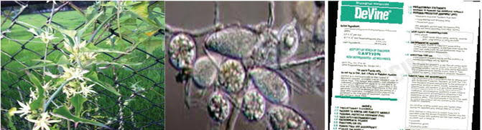
Fig: 2- Devine (Courtesy Aneja K.R. et al. 2013. Potential Bioherbicide: Indian perspectives)
- COLLEGO
COLLEGO(shown in fig:3), is the first commercially available mycoherbicide for use in annual weed in annual crops with more than 90% control efficiency. It is a formulation of endemic anthracnose fungus Colletotrichum gloeosporioides f. sp. Aeschynomene was developed to control northern joint vetch in rice and soyabean field. Dry powder formulation containing 15% spores of this fungus as an active ingredient was registered in 1982 under the trade name Collego, having a shelf-life of 18 months.
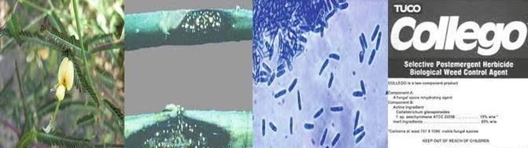
Fig: 3- Collego - (Courtesy Aneja K.R. et al. 2013. Potential Bioherbicides: Indian Perspective)..
- BIOMAL - BioMal by Philom Bios, Canada
The Collego was successful that lead to discovery of another Colletotrichum based mycoherbicide. It contains spores of Colletotrichum gloeosporioides. It is used to control Malva pusilla in Canada and USA. The application is more effective at an early stage, while efficiency is relatively consistent at any stage of weed growth. Further, the rust fungus Puccinia canalicutais commercialised under the name Dr. Biosedge for control of yellow nut sedge.
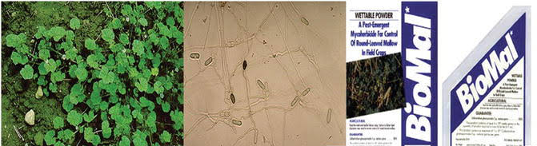
Fig:4- Biomal- Courtesy Aneja K.R. et al. 2013. Potential Bioherbicides: Indian perspectives.
Microbial herbicide using bacteria, viruses and fungi
1) Microbial herbicide using bacteria
A number of bacteria have been investigated as potential biological weed control agents. Of these Pseudomonas fluorescens and Xanthomonas campestris have attracted more attention. Bacterial biological weed control has several advantages over fungi. It shows rapid growth of the bioherbicide agents. They are relatively simple to handle and appropriateness for genetic modification.
2) Microbial herbicide using viruses
Viruses that have been investigated for the potential to control invasive or undesirable species include Tobacco Mild Green Mosaic Tobamovirus for control of tropical soda apple in Florida and Araujia Mosaic virus for control of moth plant in New Zealand. Impatiens glandulifera,is an invasive weed of central and Western Europe .It is controlled by a virus resembling Tobacco Rattle Virus has also been reported (Kollmann et al., 2007). Weed Solanum nigrum was reported to be controlled by Obuda Pepper Virus and Pepino Mosaic Virus (Kazinczi et al., 2006).
3) Microbial herbicide using fungi
Fungi that have been to control weeds include BioMal a formulation of Colletotrichum gloeosporioides introduced for the control of round leaf mallow and Colletotrichum gloeosporioides f. sp. Aeschynomene was developed to control northern joint vetch in rice and soyabean field in the United States in 1982 as Collego (Daniel et al., 1973). Several other fungi have been registered as microbial herbicides for use in forestry or ecosystem management in Canada and the US. The deciduous tree species in coniferous plantations was controlled by two separate strains of Chondrostereum purpureum have been registered in Canada and the US.
Microbial technology related to herbicides
The process of natural selection has unquestionably enhanced the ability of microorganisms harbouring herbicide degradation genes. The study of the great biochemical diversity associated with phylogenetic diversity can therefore be the basis for the wide system of responses to herbicides in bacteria. The bioactive compounds involved in the herbicidal activity in bacteria is important for the survival of organisms in adverse environments.
Formulation of microbial herbicide
The formulation of microbial herbicide is the combination of secondary metabolites. It contains the biological propagules with a carrier that can be effectively delivered to the target weed. The formulations of the biological control agents are based upon the use of organic solvents, surfactants and drying methods, to biological propagules.
The majority of microbial herbicide formulations are concentrated on maintaining agent viability in storage and reducing dew period requirements. Liquid and solid formulations of microbial herbicide are two different approaches. It infects above and below-ground parts of the weed species.
1) Liquid formulation
The liquid formulation includes aqueous, oil or polymer-based products, oil suspension emulsion, inverted emulsion etc. It is used as sprays to leaf and stem diseases on the weed host. Water is the simplest microbial herbicide delivery system. It contains the propagules of the agent formulated as a sprayable suspension in water. Application of microbial herbicide formulation modifies the action of a principal active ingredient. A variety of microorganisms produces some potent surfactants and can be used as bio-surfactant in the herbicide formulation. Application of adjuvants in the formulation of herbicide caused up to a hundred percent of the death of target weed within a short time. An inverted emulsion formulation of Myrothecium verrucaria was prepared by mixing an aqueous spore suspension with an oil phase, where only the oil emulsion carrier was effective in many weed plants species. An oil suspension emulsion formulation for the control of Xanthium spinosum was developed by Auld.
2) Solid formulation
Fungal pathogens infect weeds at or below the soil are best studied to solid of granular formulations which may consist of grains, peat, charcoal, clay, vermiculite, alginate, bagasse, mineral soil or filter mud as carrier. Some microbial herbicides (Collego, BioMal) were commercially available as a wettable powder (Boyette et al., 1996). The powder formulation contains spores harvested from liquid fermentation. They are mixed with a carrier such as Kaolin and stored before suspension in water.
Solid formulations of microbial herbicides are better suited to early applications, attacking weed seedlings as they emerge from the soil. Granular formulations contain dried propagules, they have a longer shelf life than liquid-based formulations. Thus they are important for a commercial herbicide (Auld, 1992). In recent decades increasing interest has been noticed on the synthetic beads of various materials for immobilization of herbicides, microorganisms, cells and enzymes, antibodies, animal embryos and artificial seeds (Cosby and Dukelow, 1990; Ling-Fong et al., 1993). Biodegradable carriers include sodium alginate, skim milk was developed for the bacterial inoculation of plants. A granular formulation of Alternaria macrospora for control of Anoda cristata was developed. Mycelium of the pathogen was grown in a liquid formulation, mixed with the horizontal vermiculite, exposed to diurnal light for 24 h to allow sporulation and air-dried for 24-48 h. The field application of the granular inoculums ensures almost cent percentage of infection of Anoda cristata giving good control.
Limitations of microbial herbicide
In spite of considerable research in microbial herbicides, the commercially available microbial herbicides products are low worldwide. This is mainly due to limitations in microbial herbicide development, which need to be overcome to ensure commercial success of microbial herbicides. Limitations in microbial herbicide development can be classified as either environmental, biological or technological-commercial.
1) Environmental limitations
Environmental limitations play a significant role in the action of biological agents. It influences the formulation, the action of microbial herbicides as inoculum production is dependent on sporulation of the formulation. This process even though rapid and takes some weeks following to applications and might cause variable environmental conditions. Temperature and humidity are major factors influencing the quality of microbial herbicides.
2) Biological limitations
A good microbial herbicide acts relatively quickly and has acceptable efficacy in the control of weeds. But many of the discovered weed pathogens may provide partial control of only one weed species, even under ideal conditions. This host particularity is related to the fundamental bio-physiology of the pathogen and to host changeability and resistance as well. In other words, within a population of weed species, there will usually be a range of genetically diverse biotypes that may include some resistant biotypes, just as there may be a range of biotypes of microorganisms for instance within fungal species so that there is potential to mix and vary the biotypes of a species used as a microbial herbicide.
3) Technological-commercial limitations
Pathogenic strains, method formulations and the interaction of these two parameters affect the shelf life of the formulations at room temperature. High concentrations and the alteration of formulations are needed to increase microbial herbicide activity. Compatibility testing of formulation components that range from registered agricultural products to novel substances can consume a great deal of time and resources.
Future prospects for microbial herbicides in sustainable ecosystem
The advancement in microbial technology will enhance the method of development of microbial herbicides thus better biocontrol of weeds are expected in future. The area of biological control using soil microorganisms needs further investigations. The future of biocontrol is full of possibilities with the many successful biocontrol agents.
Formulations are needed to increase the shelf life of the living organisms to improve survival and efficacy. Research and development of each biocontrol agent are needed to enhance the improve efficacy and thus development in the industrial, marketing and economy. No one method or approach can be used to characterize and follow biocontrol agents or to isolate and research additional novel plant-microbe interactions. The future is bright for the continued development of microbial herbicides to reduce chemical herbicides and options in weed management.
Conclusion
The development of sustainable agriculture and consciousness of the human environment to protect agriculture in an ecologically healthy way. Government and enterprises will pay more attention to the study of the exploitation of microbial pesticides and because of their potential benefit for the environment .More than 27 exotic plant pathogens have been investigated for classical biocontrol of weeds and 67 weeds have been targeted using at least 107 fungal taxa as bioherbicide agents and 18 weed species have been targeted using deleterious rhizobacteria. From this literature it can be assumed to be the good potential of microbial weed control in future as the use of microbial herbicide will increase tremendously by 20% every year. It is necessary to overcome the constraints in this approach. New pesticides based on biosynthesis and molecular modification by gene technology would be the integrative steps for the exploitation of potential microbial herbicides.
Multiple-pathogen strategy is a novel approach to increase the level of control of the targeted weed.There are many opportunities for the development of bioherbicide for some specialised niches, such as parasitic, urban and allergenic weed. The development of broad-spectrum bioherbicide not only for a particular species but also for a weed community of a specific agricultural field or crop is highly demandable. Although most biological control agents are host specific to individually address mixed weed population in agronomic mixed crops, they can be targeted to manage those weeds that have the maximum impact on crop yield in high valued crops where control options are limited. There are numerous approaches for improving biocontrol efficacy by disrupting the target weeds defence mechanism. This includes the use of herbicide or other compounds that disturb key enzymes, obstructing the synthesis of secondary plant metabolites etc. Development of multi-combination formulation and commercially accessible products of bioherbicide would be the probable method for effective weed management.

References
Auld, B.A., (1992). Development and commercialization of biocontrol agents. Proceedings of the 1st International Weed Congress, February 17-21, 1992, AgMedia, Malbourne, Australia, pp: 269-272.
Boyetchko, S. and E.N. Rosskopf, (2006). Strategies for Developing Bioherbicides for Sustainable Weed Management. In: Handbook for Sustainable Weed Management, Singh, H.P., D.R. Batish and R.K. Kohli (Eds.), Haworth Press, Inc., New York. USA., pp:393-420.
Boyette, C.D., P.C. Quimby Jr., A.J. Caesar, J.L. Birdsall and W.J. Connick Jr. et al., (1996). Adjuvants, formulations and spraying systems for improvement of mycoherbicides. Weed Technol., 10: 637-644.
Charudattan, R., (2001). Biological control of weeds by means of plant pathogens: Significance for integrated weed management in modern agro ecology. Biocontrol, 46: 229-260.
Cosby, N.C. and W.R. Dukelow, (1990). Microencaptulation of single, multiple and zone pellucida-free mouse preimplantation embryos in sodium alginate and their development in vitro. J. Report. Fretil., 90: 19-24.
Daniel, J. T., Templeton, G.E., Smith, R. J., and Fox, W. T. (1973). Biological control of northern jointvetch in rice with an endemic fungal disease. Weed Sci. 21, 303-307.
Kazinczi, G., Lukacs, D., Takacs, A., Horvath, J., Gaborjanyi, R., Nadasy, M., et al., (2006). Biological decline of Solanum nigrum due to virus infections. J. Plant Dis. Protect. 325-330.
Kollmann, J., Banuelos, M.J., and Nielsen, S. L. (2007). Effects of virus infection on growth of the invasive alien Impatiens glandulifera. Preslia 79, 33-34.
Ling-Fong, T., K. Leng-Khim, L. Chiang-Shiong and E. Khor, (1993). Alginate chitosan coacervation in production of artificial seeds. Biotechnol. Bioeng., 42: 449-452.
Zvonko Pacanoski, (2015). Bioherbicides, Herbicides, Physiology of Action & Safety, Andrew Price, Jessica Kelton and Lina Sarunaite, Intech Open, DOI: 10. 5772/61528.

