Development of battered and breaded fish and fishery products: A Review

Sedyaaw P¹, Koli J. M², Vishwasrao V. V²., Sawant S. S². and Sadawarte R. K.²
--------------------------------------------------------------------------------------------------------------------------------------
- Post Graduate student, College of Fisheries, Shirgaon, Ratnagiri.
- Professor, College of Fisheries, Shirgaon, Ratnagiri.
---------------------------------------------------------------------------------------------------------------------------------------
Abstract
Battered and breaded seafood products play a significant role in the global food industry, offering consumers convenient and appetizing options for incorporating fish and shellfish into their diets. This review aims to provide a comprehensive analysis of battered and breaded products derived from fish and shellfish, focusing on their quality attributes, nutritional composition, and consumer perception. Quality attributes of battered and breaded seafood products are multifaceted, encompassing sensory characteristics, texture, and overall acceptability. Factors such as coating thickness, crispiness, and moisture retention play pivotal roles in determining product quality. Studies have explored various techniques for improving batter adhesion and texture, including the incorporation of different breading materials, additives, and processing methods. These advancements have contributed to enhancing product quality, resulting in greater consumer satisfaction.

Key words: Battered and Breaded, Quality attributes, Additives and Fishery Products

Introduction

These coated products constitute an extensive sector in ready meal market (Flick, G. J. et al.,1990). because of their convenience, appearance and taste these products is extensively preferred by most consumers. In accordance with the increasing demand, the technology applied for coating has made several advances during the past few years. Most developments originated from United States, Europe and Japan (Venugopal.V.,2006). Today a variety of coated products are available such as fish stick, fish cutlet, coated stretched shrimp (Nobashi), coated squid rings and different bivalves.
Development in coated technology has been synchronized with the development in machinery and equipment’s, prior to introduction of machinery all the process used to be done manually in which the maintain of hygiene was a problem. This article gives a brief note on the procedure of breading and battering for making coated seafood procedure of breading and battering for making coated seafood products, some trouble shooting which are faced during its making and also has discussed about some commercially important coated seafood products.
Value addition is the most talked about word in food processing industry, particularly in export oriented fish processing industry because of the increased realization of valuable foreign exchange. Value can be added to fish and fishery products according to the requirements of different markets. These products range from live fish and shellfish to ready to serve convenience products. As far as fish processing industry is concerned value addition is one of the possible approaches to raise profitability since this industry is becoming highly competitive and increasingly expensive. There is great demand for seafood/seafood based products in ready to eat ―convenience‖ form. A number of such diverse products have already invaded the western markets. One factor responsible for such a situation is more and more women getting educated and taking up employment. Reasonably good expendable income, education, awareness and consciousness towards hygiene and health, increased emphasis on leisure pursuits etc. are some of the other reasons. Marketing of value added products is completely different from the traditional seafood trade. It is dynamic, sensitive, complex and very expensive. Market surveys, packaging and advertising are a few of the very important areas, which ultimately determine the successful movement of a new product. Most of the market channels currently used is not suitable to trade value added products. A new appropriate channel would be the super market chains which want to procure directly from the source of supply. Appearance, packaging and display are all important factors leading to successful marketing of any new value added product. The retail pack must be clean, crisp and clear and make the contents appear attractive to the consumer. The consumer must be given confidence to experiment with a new product launched in the market. Packaging requirements change with product form, target group, market area, species used and so on. The latest packaging must also keep abreast with the latest technology.

Preparation of batter and breading’s
- Washing fish dressing (fillet)
- Fillets shaped into fingers
- Mixing with salt.
- Frying Ginger, Garlic, Onion, Green chilly paste in oil
- Slurry of Bengal gram flour with water.
- Adding fried paste to slurry.
- Salt & other spices.
- Mixing.
- Dipping finger in batter
- Rolling over bread crumb
- Deep fry in oil.
Battered and breaded cutlets were prepared from Catla (Catla catla) having 30 g weight, 5 cm diameter and 1 cm thickness. Cutlets were prepared using cooked Catla meat (40.16%), cooked potato (28.11%), onion (10.04%), bread powder (8.03%), oil for frying (4.02%), green chili (2.01%), coriander leaves (2.01%), ginger (2.01%), garlic (2.01%), table salt (1.20%), pepper powder (0.12%), clove powder (0.12%), cinnamon powder (0.08%) and turmeric powder (0.08%) as standardized by Pawar et al. (2012). All easily available ingredients were used in formulation were specifically standardised for Catla cutlets, with highest overall acceptability. Coated in standardized batter mix developed by Pagarkar et al. (2012) containing 77.5% refined wheat flour, 9.7% corn flour, 9.7% Bengal gram flour, 1.20% salt, 0.47% sodium tri polyphosphate (STTP), 0.47% turmeric powder and 0.96% carboxy methyl cellulose (CMC) mixed with water in the proportion of 1:2 (Solid: Liquid) and blended to homogeneity. Further rolled in bread crumbs and flash fried in sunflower oil at 180 _C for 30 s., later packed aerobically in polypropylene pouches and chilled stored for further analysis (Fig. 1) (Pawar et al 2020).

Preparation of batter mix
The batter mix consisting of wheat flour (77.5% w/w), Bengal gram powder (10% w/w), cornflour (10% w/w), common salt (1.5% w/w), sodium tri-polyphosphate (0.5% w/w), guar gum (0.25% w/w), and turmeric powder (0.25% w/w) was prepared with a powder to liquid mix ratio of 1:2 (Xavier et al. 2017). The internal temperature of the batter solution was maintained at 20°C throughout the experiment. The viscosity of the batter used in the experiment was 25 cP (Chinmaya et al 2020).

Preparation of bread crumbs
Locally available white breads (crust portion removed) were used for preparing bread-crumb coating. Initially, the crust-free loaves were blended in an electric blender for 1 min at room temperature. The final-blended bread powder was again dried (moisture level <5% (w/w) of the dried sample) in an electric drier at 50°C. The dried crumbs were then sieved twice with a 4 mm followed by 3 mm sieve to attain uniform particle size (3–4 mm). Bread crumbs were stored in polyethene pouches in a dry cool place until further use. Similarly, dry-pressed rice and noodle vermicelli were crushed and sieved using 4 mm followed by 3 mm sieve to uniform particle size (3–4 mm) and stored in a dry cool place (Chinmaya et al 2020).
Types of batter
Batter: Classified into 2 groups viz;
i). Conventional or adhesive batter

- Used with supplemental breading or bread crumbs.
- Purpose is to increase crumb adhesion by acting as an interface between food & coating.
- Typical ratio of batter mix to water is 1:2.
- Always associated with a supplemental breading or bread crumb
- 1⁰ Purpose: to increase the adhesion
- By acting as an interface b/n the food & the subsequent coating uniformity & thickness acceptability of the finished product
- The formulation & viscosity of the batter determine the amount of coating pickup
- Consistent batter produce uniformly coated products
- Batter viscosity depends on the ratio of the flour to water the temperature of mixing
- Typical ratio of batter mix to water is 1:2
ii) Puff or tempura batter
- Batter used to provide an aerated crisp coating with or without application of other coating.
- Combination of wheat & rice flour with a chemical raising agent are used.
- Purpose: to provide aerated crisp coating with or without the application of any other coating, a combination of wheat & corn flour is used along with a chemical raising agent
- Tempura batters used at very high viscosity levels and containing raising agents
- Batter mix- powder-reconstituted with water--desired viscosity
- Final texture –frying the coated product in oil at 180⁰-220⁰C
- Submersion is used rather than overflow batter application
Types of breading
A). Extruded crumbs
- Extruded crumbs are produced by a continuous process where high starch ingredients are cooked under high pressure.
- When the pressure is suddenly released, the moisture expands rapidly as steam and the extradite expands.
- In the extrusion cooking process, the heated dough exists from the extruder die as a fully cooked glassy material is quickly flashes off and, in effect, there is no drying system required.
- Because of its lighter density the extruded crumbs have a tendency to float in oil, potentially leading to contaminating black spots in the fryer and rapid deterioration of oil quality.
B). Japanese crumbs
- Also called as ‘oriental or panko crumb’
- Has characteristic flake-like elongates structure → excellent visual & provides unique surface structure when fried
- It has an open & porous texture imparts a light tender crispiness
- Baked Electrical induction heating process
- one half the time taken for conventional baking
- results in a loaf –crust-free & of low density
- loaves are cooled, shredded through specially designed mills and dried to low final moisture level

Coating ingredients
1.Polysaccharides –wheat flour, corn flour, starch, farinaceous material, modified derivatives of cellulose and gums.
2.Proteins – milk powder, milk protein fractions, egg albumin, cereal flours & seed proteins
3.Fats and hydrogenated oil
4.Seasonings – sugar, salt, pepper, other spice extractives
5.Water
Coating parameters
The coating parameters evaluated include coating pickup, adhesion degree, frying yield, cooked loss, fat uptake, and oil reduction. Processing parameters of the samples, that is, the coating pickup, cooked yield, and frying loss, were measured by the methods described by Hsia, Smith, and Hasia (1992)
Functions of coating
- Enhance the appearance of food products
- Enhance the taste characteristics by providing food products with crispier texture
- Improve the nutritional value of the product
- Provide the more desirable colour
- Acts as a moisture barrier and minimise moisture loss during frozen storage and microwave reheating
- Acts as food sealant by preventing natural juices from flowing out and seal in the flavour
- Enhance appearance, flavour & texture of food product.
- More desirable colour.
- Acts as moisture barrier, minimize moisture loss during microwave heating & frozen storage.
- Acts as food sealant, prevent natural juices from coming out during freezing or reheating & seal flavour.
- Maintain crisp on the outside, tender and juicy inside.
- Improved overall acceptability of the product
Steps involved in the production of a coated fish products
a) Portioning/Forming:
- The fish stick is usually cut from fish blocks in a series of separate band saw operation.
b) Pre-dusting:
- Pre-dust is very fine, dry, raw flour material.
- Sprinkled on the moist surface of the frozen seafood substrate before any coating
- Creates more conducive surface for batter adhesion
- Most commonly used: wheat flour, gums & proteins, spices.

c) Application of batter:
  - Pre-dusted product conveyed to batter applicator
  - Transferred to next conveyor which draw it through batter.
  - Fish portion totally submerged in batter.

d) Application of breading:
- Pressure roller –apply sufficient force to press crumbs onto battered product.
- Specially designed breading machines – apply uniform particle size distribution or granulation to both top & bottom of the product with minimum crumb breakdown.
e) Pre-frying:
- Pre-frying in oil is followed by freezing the product.
- Pre-frying set the batter /bread coating on the fish portion.
- Frying develops a characteristic crust and gives the product a fried oily appearance and taste
- Frying temperature is between 180-200 °C
f) Freezing:
- Fried fish portion for freezing is air cooled.
- Allow the batter cooking to recover from the frying shock
- Freezing is performed through spiral freezer and completed when external temperature of the product is around -10°C.
g) Packaging & storage:
- Packing of coated seafood should be done in thermoformed containers andusually stored at -10°C or lower.
Types of breaded and battered products
Fish mince based products
1.Fish finger: Prepared from the skinless and bone less fish mince. Forming machines are used for reshaping large sections of mince blocks slabs are cut into thin finger, battered and breaded & then flash fried.

Fig. No. 1. Fish finger
Ingredients:
Fish meat/fillet, salt, onion, garlic, ginger, green chilly, chili powder, pepper, cumin powder, coriander powder, besan, bread crumb, baking powder, refined oil.
Method:
1.Washing fish
2.Dressing (fillet)
3.Fillets shaped into fingers
4.Mixing with salt
5.Frying ginger, garlic, onion, gr. chili paste in oil
6.Slurry of Bengal gram flour with water
7.Adding fried paste to slurry
8.Salt & other spices
9.Mixin all ingredients
10. Dipping finger in batter
11.Rolling over bread crumb
12. Deep fry in oil.

2.Fish Cutlet:
Mince starch based, spiced & deep fried product. prepared using cooked. fish mince which is mixed with cooked potato, fried onion and spices. formed into square shape weighing about 40 g formed cutlets are battered, breaded and flash fried.
Method:
Dress fish by removing head, fins, scales & viscera. Pick meat free of bones and keep it aside. Boil potato for 15 min, cool, peel & mash into paste. Mix fish meat with smashed potato, onion, garlic, ginger & green chilli paste thoroughly, add salt, chilli, turmeric, pepper powder, garam masala, coriander powder, MSG, baking soda & mix well. Shape about 25 grams into ova/round shape. Dip into egg white, roll over bread crumbs. Pack in polythene packs, store in deep freezer. Fry in oil before use & serve hot with sauce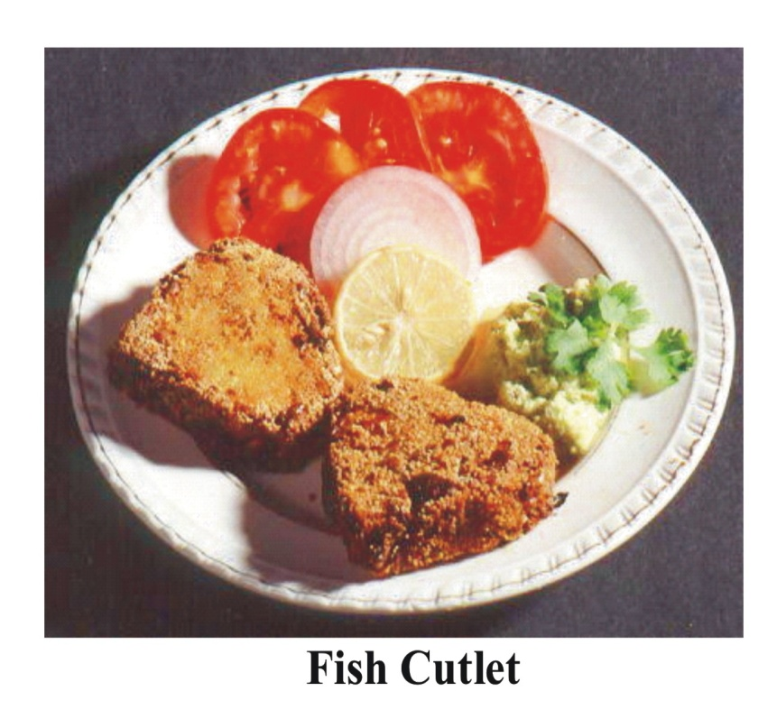
Fig. No. 2 Fish Cutlet

3.Fish soup powder
Any good edible fish like grouper or seer can be used. They are cooked and the edible meat separated as in the case of preparation of salad.
Recipe
Cooked meat :1 kg, chopped onion:500g, Vanaspati :90g, refined salt :60g, maida :250g, pepper powder:15g and monosodium glutamate:2.5 g. The ingredients are mixed and ground thoroughly to give a homogenous dough. It is then freeze-dried or vacuum dried, powdered and packed in a air tight containers like cans or laminated pouches, preferably under an inert atmosphere like nitrogen. The freeze-dried material packed in cans remains in good condition for more than two years. The powder is suspended in water at 10 percent level and boiled for a minute to give a wholesome soup ready for the table. The species can be varied to suit individual tastes Nimish et al 2018

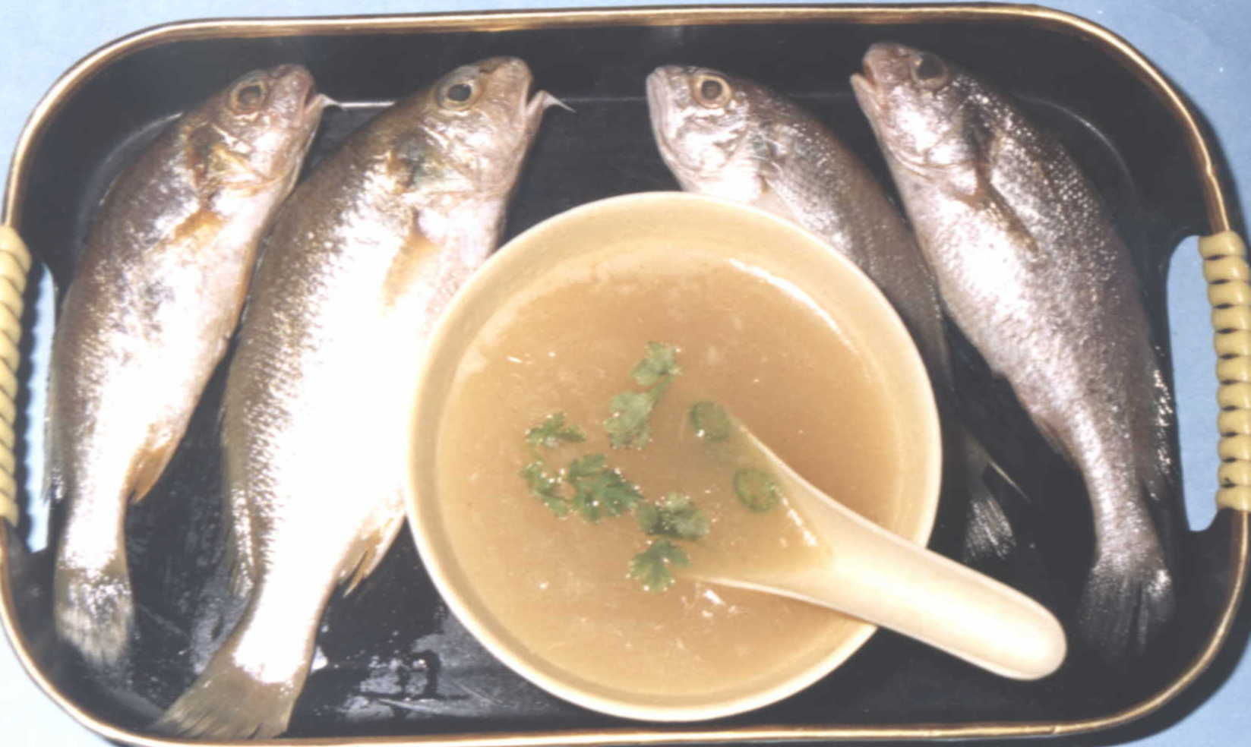

Fig No. 3. Fish soup
4.Fish Flakes/Wafers
Cheaper varieties of fishes like threadfin breams, sciaenid’s, catfish, etc., can be used for the preparation of this product. The fishes are dressed, cleaned, cooked in water for 30 minutes, cooled and edible meat alone separated.
Recipe
Cooked and picked meat:1kg, starch (refined tapioca powder is the cheapest that can be used) :1kg, salt :40g, and water :2.5 litres. All the ingredients are homogenized into a fine slurry and poured in thin layers (1 mm) in flat aluminium trays (previously smeared with oil to prevent sticking), cooked in steam, cooled, cut into desired shaped and dried. The product swells several times on frying in oil, become very crisp and wholesome ( Nimish et al 2018).
5.Nobashi – Coated stretched Shrimp
In this the length of peeled and deveined shrimp is increased by application of pressure and the curling effect is reduced by making different cuts at the bottom. This increases the length by 1-2 cm depending on the size of the shrimp. As the surface area is increased by this method so the shrimp will have a more coating pickup and a good appearance. Then this are packed in thermoformed trays under vacuum and frozen at -40⁰C (Das et al 2014).

Fig. No. 5 Nobashi

6.Bivalves

Bivalves such as clams, oysters and mussels can be used for preparing coated products. For clam products, the meat is shucked from live depurated clam and blanched. Then the meat is battered, breaded and flash fried. Then the product is frozen and packed. Other bivalves such as oysters, mussels, etc. can also be made into coated products by same method (Das et al 2014)

Conclusion
In conclusion, battered and breaded seafood products offer a convenient and popular way to incorporate fish and shellfish into consumers' diets. Advances in processing techniques, nutritional optimization, and consumer-driven product development have significantly improved the quality and acceptance of these products. Future research should continue to explore novel technologies and ingredients to further enhance the nutritional value and sustainability of battered and breaded seafood products, catering to the evolving preferences and needs of consumers. Furthermore, the nutritional composition of battered and breaded seafood products has been a subject of investigation. Fish and shellfish are known for their high protein content, omega-3 fatty acids, vitamins, and minerals, which provide numerous health benefits. However, the frying process involved in producing battered and breaded products can lead to changes in their nutritional profile, such as increased fat absorption. Researchers have explored strategies to minimize nutrient loss and reduce oil uptake during frying, including the use of alternative cooking methods like baking or air frying. Consumer perception and acceptance of battered and breaded seafood products are influenced by various factors, including taste, appearance, packaging, and price. Studies have highlighted the importance of sensory attributes and product labelling in shaping consumer preferences. Consumer demand for healthier and sustainably sourced seafood products has also driven the development of innovative formulations and eco-friendly packaging options.
References
Chinmaya Nanda , Kasturi Chattopadhyay , Ramakrishna Reddy , Mohammed Akram Javith , Sambit Kisore Das , Amjad K. Balange , Binaya Bhusan Nayak & K. A. Martin Xavier . Evaluation of Different Conventional Breading Materials on Functional Quality Attributes of Battered and Breaded Fish Cutlets, Journal of Aquatic Food Product Technology,2020 DOI: 10.1080/10498850.2020.1786205.
Das, Oishi and Kannuchamy, Nagalakshmi. . Breaded and Battered Seafood Products: Principles and Processing Methods. Breverage and Food World.2014, 41. pp. 26-29.
Flick,G. .J.,Baura,M.. A.., and Enriquez,L.G.,(1990) Processing finfish ,The seafood industry,Martin,R.E. and Flick,G.J.,Eds.Van Nostrand Reinhold,New York,pg.177.
Hsia H.Y., Smith D. M.and Steffe J. F. Rheological properties and adhesion characteristics of flour-based batters for chicken nuggets as affected by three hydrocolloids. J Food Sci., 1992 57(1) pp. 16–18.
Nimish M. S,Balasundari S and Felix S .Fish in nutrition.Tamilnadu Dr.J.Jayalalitha Fisheries University . 2018 pp;83-84
Pagarkar A. U., Rathod N. B., Baug T. E., Pawar P.P., and Desai A. S. Standardisation of batter used for preparation of pangasius (Pangasianodon hypophthalmus) cutlet. Asian J Microbiol Biotechnol Environ Sci. 2012,14(4), pp. 493–496.
Pawar P.P., Pagarkar A. U. , Rathod N. B, Baug T. E, and Rather M. A. Standardisation of recipe for fish cutlet product from fresh water fish Catla (Catla catla). Eur J Exp Biol 2(6):2012, pp. 2043–2048.
Pawar P. P, Pagarkar A. U. and Rathod N. B. Effect of chilled storage on quality characteristics of battered and breaded snack product from large sized Catla (Catla catla). J Food Sci Technol. 2020 Jan;57(1):52-59. doi: 10.1007/s13197-019-04028-6. Epub 2019 Aug 17. PMID: 31975707; PMCID: PMC6952510.
V. Venugopal. .Chapter 9:Coated Products Seafood Processing.2006,pp..259-280.
Xavier, K. A. M., Hauzoukim, K., Kannuchamy, N., Balange, A. K., Chouksey, M. K., and Venkateshwarlu, G. Functionality of chitosan in batter formulations and its effect on physicochemical quality parameters of enrobed fish sticks. Carbohydrate Polymers, 127,2017, pp. 189–194.

