Time History Analysis of Water Tank with Fixed Support
Madhavi Ganesh Katakpure¹
¹M. Tech, Department of Civil Engineering, G H Raisoni University Amravati.

Prof. Hemant Dahake²
²Asst. Professor, Department of Civil Engineering, G H Raisoni University Amravati.

Dr S. D Ambadkar³
³Associate Professor, Department of Civil Engineering, G H Raisoni University Amravati.

Abstract – The tremors are the results of energy exodus from the inner core of the earth that releases the seismic waves. The impact of these waves is enormous on lives, properties and ambient environment as well by virtue of ground shaking and rupture. It is critical to understand the features of ground motion to take precautions against loss of life and structural damage caused by ground motion. Peak ground acceleration (PGA), frequency content, and duration are the most essential dynamic aspects of an earthquake. In examining the behaviour of structures under seismic loads, these properties play a major role. The strength of ground motion is determined by the PGA, frequency content, and duration of the shaking. The frequency content of ground motion varies from low to intermediate to high. The current work is concerned with the investigation of the frequency content of ground motion on a water tank. The structural analysis and design (STAAD Pro) software is used to do linear time history analysis. The suggested method investigates the reaction of a water tank to ground vibrations with fixed and pinned support frequencies.
Keywords: Water tank, ground motion, time history analysis
- INTRODUCTION
The strength of ground motion is determined by the PGA, frequency content, and duration of the shaking. The frequency content of ground motion varies from low to intermediate to high. The current work is concerned with the investigation of the frequency content of ground motion on a water tank. The structural analysis and design (STAAD Pro) software is used to do linear time history analysis.[1] The suggested method investigates the reaction of a water tank to ground vibrations with fixed and pinned support frequencies. Typical geometries of elevated tanks include cylindrical, square, rectangular and toroidal. These raised tanks are supported by a variety of structures, including an RC shaft, an RC braced frame, a steel frame, and a masonry pedestal. In practice, the frame type is the most common style of staging. The basic components of frame staging are columns and braces. Water storage tanks, which are an unavoidable component of the water supply system, are expected to stay operational even after an earthquake. Earthquakes are the most damaging natural disaster in terms of loss of life and property destruction. Water tanks are sensitive to earthquake loading due to their huge bulk and concentration of water at an elevation from the base, and they sustain significant damage as a result of ground movement during an earthquake. A large amount of energy released during this phenomenon reaches the water tank from the point of origin in the form of seismic waves, which have different characteristics such as peak ground acceleration, frequency contents, and effective duration of the ground motion, all of which affect the performance of the water tank. Elevated water tanks are vital structures during earthquakes; hence, damage to these structures may compromise the drinking water supply, as well as fail to avoid big fires and inflict significant economic loss. Because elevated tanks are often utilised in seismic locations, their seismic behaviour should be thoroughly examined, and earthquake loading must be considered a non-stationary process. Some of the elevated tanks were severely damaged or collapsed due to a lack of awareness of the supporting structure.
A. Performance of elevated water tank
Land and seismological disclosures over the twentieth century aided in the development of seismic construction regulations and tremor-resistant constructions and structures. The evolution of seismic design criteria has resulted in more robust, safe, and dependable buildings. Due to the earthquake, many buildings collapsed killing thousands of people.
Many elevated water tanks sustained damage to their staging (support structure) during the January 26th, 2001 earthquake in Bhuj, and at least three of them fell. These water tanks are located within a 125-kilometre radius of the epicentre.[10] Tanks in the most seismically active areas fell, while a couple showed cracks in brace-column junction places. Water tanks, for example, are critical structures that must be carefully designed. Frame-type staging is often viewed as being superior to shaft-type staging for lateral resistance due to their enormous redundancy and a stronger capacity to absorb seismic energy through inelastic movements. In order to resist lateral loads, framed stagings have numerous flexural components in the form of braces and columns. As a result, damage to a few of these components won't cause the entire structure to abruptly collapse.[12] It is possible to design and build sections close to beam ends so that they can dissipate seismic energy while enduring inelastic deformation. The staging could, however, collapse if the frame members and brace column joints are not designed and detailed for inelastic deformations. Designing liquid storage tanks, moving tankers, fuel tank space vehicles, and ships must take slosh, or the movement of the free liquid surface within its container, into consideration from the outset. Elevated water tanks are a crucial part of water supply systems in both large cities and rural areas, and these tanks must continue to function in the case of a severe disaster like an earthquake or fire. The tremors seriously destroyed a few enormous high-water tanks, but others escaped undamaged. An analysis of the dynamic behaviour of such tanks must take into account both the motion of the water relative to the tank and the motion of the water relative to the ground.
II. ANALYSIS METHODS
The analysis of the isolation system can be done in the following ways:
- Linear Static Analysis: Linear analysis methods provide a strong indicator of a structure's elastic capacity and suggest where first yielding will occur. The straight static inquiry technique is limited to small, standard structures.
- Linear Response Spectrum Analysis: The most common method of analysis is linear response spectrum analysis. This is adequate for nearly all isolation systems based on LRB and/or HDR bearings.
- Nonlinear Static Analysis: In a nonlinear static analysis approach, the construction model directly incorporates the nonlinear force-deformation properties of individual parts and pieces as a result of inelastic material response. -Linear Time History Analysis: Although rarely employed, linear time history analysis provides a little bit more information than response spectrum analysis for a much larger degree of work.
- The direct static technique for inquiry is limited to small, conventional constructions. The dynamic analysis in which the loading generates considerable variations in stiffness is known as nonlinear time history analysis.
III. METHODOLOGY
A. Time History Analysis
Time history analysis is a technique used in structural engineering and other fields to study the dynamic behaviour of structures subjected to time-varying loads or forces. It is a computational method that involves analyzing the response of a structure over time-based on the input of a known time history of forces or displacements.
In time history analysis, the structure's response is determined by solving the equations of motion considering the dynamic forces acting on the structure at each time step. The analysis takes into account the mass, stiffness, and damping properties of the structure, as well as the time-varying external loads. It provides valuable insights into how a structure behaves under transient or dynamic loading conditions, which cannot be accurately predicted using simpler static analysis methods.[8]
Time history analysis is particularly important for structures subjected to severe dynamic events, such as earthquakes, windstorms, or explosions. By simulating the actual time-varying loads experienced by the structure, engineers can assess its dynamic behaviour, identify potential weaknesses or failure modes, and optimize its design for enhanced performance and safety.
It offers several advantages over simplified methods, making it a crucial tool in the analysis and design of structures subjected to dynamic forces. Here are some key benefits:
-Realistic Representation: By considering the time-varying nature of loads, time history analysis provides a more accurate representation of the actual behaviour of structures. This enables engineers to better understand the dynamic response and identify potential vulnerabilities.
-Evaluation of Safety: Dynamic events such as earthquakes can pose significant risks to the safety of structures. Time history allows engineers to assess the performance of a structure under extreme loading conditions, helping them ensure its safety and durability.
-Design Optimization: Through time and history, engineers can iteratively refine the design of a structure to enhance its performance. By evaluating different scenarios and considering the dynamic response, they can make informed decisions to achieve an optimal design solution.
-Compliance with Codes and Standards: Many building codes and standards require the consideration of dynamic loads in the design process. Time history analysis enables engineers to meet these requirements and ensure that structures adhere to the necessary regulations.
IV.STRUCTURAL MODELING
A. Proposed Work
Elevated water tanks with a capacity of 1000m3 are considered in this study. The tank's diameter is 10m. The tank's boundary conditions are set. The water level in a full tank is 3.41m, and the freeboard is 0.59m. The tank container is cylindrical. Young's modulus and concrete weight per unit volume are calculated as 27386MPa and 25kN/m3, respectively. The container is filled with 1000 kg/m3 water.
Model Input Data
Capacity | 1000 m3
Diameter | 10m
Column dimension | 0.5m x0.5m
Tank height | 5m
Plate thickness of tank | 0.125m
Floor beam | 0.2m x 0.4m
Ring beam | 0.4mx0.4m
Brace beam | 0.4m x 0.4m
Floor slab thickness | 0.3m
Staging height considered | 10m,12m,15m
The boundary condition at the base | Fixed

B.Structural Modeling
Concrete is the most commonly utilised building material. It is strong in compression but weak in tension, thus steel, which is strong in both tension and compression, is utilised to strengthen the tensile capacity of concrete, resulting in reinforced cement concrete, a composite construction. RC buildings are made of structural members made of reinforced concrete, which is made of concrete and steel. Steel resists tension forces, while concrete resists compression forces. The term structural concrete refers to all types of concrete that are utilised in structural applications.
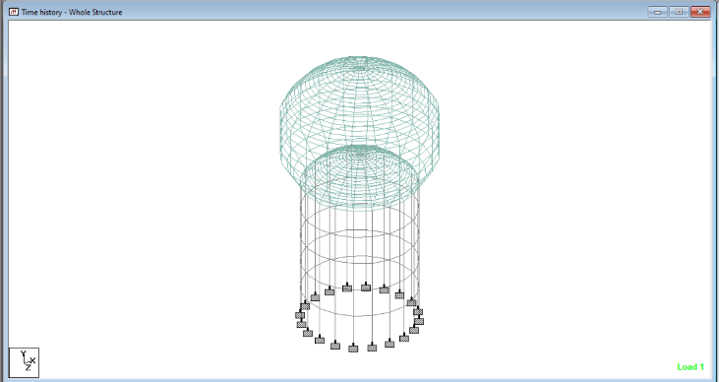
Fig 1. Two-dimensional design of elevated water tank with Fixed support
V.GROUND MOTION AND TIME HISTORY ANALYSIS
A.Ground Motion
An earthquake is a ground tremor induced by a sudden release of energy in the earth's lithosphere. This energy may be primarily derived from tensions created during tectonic processes, which entail interaction between the crust and the earth's interior side. Strain energy trapped inside the ground will be released, with the majority of it converting to heat and sound, and remaining as seismic waves. Seismology is the science of earthquakes. Seismology is the science that studies the origin and nature of earthquakes.
Natural earthquake sources include tectonic, volcanic, rock fall or cavity collapse, mining-induced earthquakes, reservoir-generated earthquakes, and controlled sources (explosives). In reality, plate tectonics is responsible for 90% of earthquakes. African, American, Antarctic, Australia-Indian, Euro-Asian, and Pacific plates are the six continental-sized plates.[8]
Strong ground motion is defined as motion with sufficient force to affect humans and the environment. Three transitions and three rotations characterise it. The effect of the three rotations is so minor that it can be overlooked. Peak ground acceleration (PGA) is the largest absolute value of ground acceleration. The most relevant earthquake characteristics are PGA, frequency content, and duration. The rock site receives greater acceleration, while the soil site experiences greater velocity and displacement.
B.Ground Motion Records
Ground motions are experienced by water tanks. Dynamic parameters of ground motion include peak ground acceleration (PGA), peak ground velocity (PGV), peak ground displacement (PGD), frequency content, and duration. These dynamic properties are important in researching the behaviour of RC structures under seismic loads.[7]
For the fixed support condition peak ground acceleration value was found as 0.129g peak ground velocity was found as 3.66 mm/sec and the peak ground acceleration was found as 0.113mm as per the result found after execution of time history analysis on the water tank.
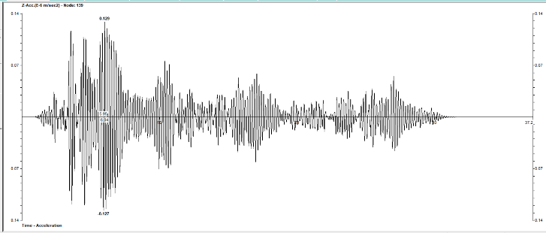
Fig 2 Peak ground acceleration for water tank with fixed support.

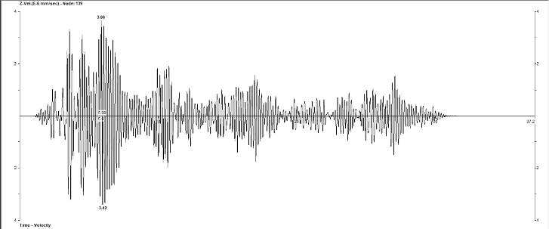
Fig 3 Peak ground velocity for water tank with fixed support.
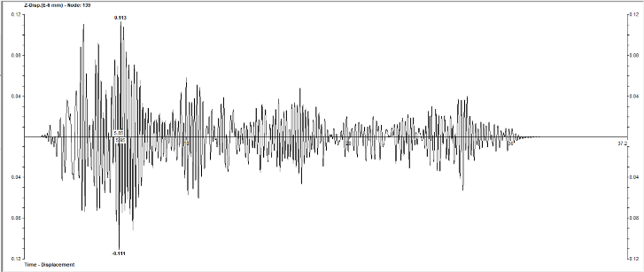
Fig 4 Peak ground displacement for water tank with fixed support.
VI.CONCLUSION
PGA represents the maximum acceleration experienced by the ground during an earthquake. It directly affects the inertia forces acting on the structure. In the case of a water tank with fixed support, higher PGA values would result in larger inertial forces being exerted on the tank. This can induce larger hydrodynamic forces within the tank and increase the potential for sloshing and dynamic loading on the walls. If the tank is not designed to withstand these forces, it may lead to structural damage, such as cracking, deformation, or even failure.
PGV represents the maximum velocity of ground motion during an earthquake. It measures how fast the ground is moving at a specific location. In the case of a water tank, higher PGV values would result in faster movement of the ground, which can induce dynamic forces on the tank walls. These forces can cause the water inside the tank to slash, leading to additional pressure on the walls. If the tank is not designed to withstand such forces, it may result in excessive stress and potential damage to the structure.
PGD represents the maximum displacement of the ground during an earthquake. It measures the distance the ground moves from its original position. In the case of a water tank with fixed support, higher PGD values would result in larger ground movements. These movements can induce additional forces on the tank, including horizontal and vertical displacements. If the tank is not designed to accommodate such displacements, it may lead to structural failure, including sliding, overturning, or buckling.
To ensure the safety and integrity of a water tank under seismic conditions, it is crucial to consider the design and construction aspects, including factors such as material strength, structural stiffness, and appropriate reinforcement. Design codes and standards provide guidelines for determining the suitable design parameters, load combinations, and safety factors to account for the effects of PGA, PGV, and PGD values on structures. Consulting with a qualified structural engineer or seismic design professional is recommended for a thorough analysis and appropriate design considerations specific to your water tank.
It is found A structure with a fixed support, such as a fixed base or fixed connections, can provide enhanced earthquake resistance due to its ability to resist lateral forces and maintain stability during seismic events. Fixed supports offer greater stiffness compared to pinned support. This increased stiffness helps to limit excessive displacements and deformations during an earthquake. Stiffer structures have a higher natural frequency, which means they are less likely to resonate with the shaking frequency of an earthquake, reducing the potential for significant damage

VI.REFERENCES
[1] "Structural Analysis And Design (STAAD Pro) software," Bentley Systems, Inc.
[2] A. Baghchi, Evaluation of the Seismic Performance of Reinforced Concrete Buildings, Ottawa: Department of Civil and Environmental Engineering, Carleton University, 2001.
[3] T. Cakir, "Evaluation of the effect of earthquake frequency content on seismic behaviour of cantilever retaining wall including soil-structure interaction," Soil Dynamics and Earthquake Engineering, vol. 45, pp. 96-111, 2013.
[4] S. K. Nayak and K. C. Biswal, "Quantification of Seismic Response of Partially Filled Rectangular Liquid Tank with Submerged Block," Journal of Earthquake Engineering, 2013.
[5] "Pacific Earthquake Engineering Research Center: NGA Database," 2005. [Online]. Available: http://peer.berkeley.edu/nga/data?doi=NGA0185. [Accessed 2013].
[6] IS 1893 (Part 1), Indian Standard CRITERIA FOR EARTHQUAKE RESISTANT DESIGN OF STRUCTURES PART 1, 6.1 ed., New Delhi 110002: Bureau of Indian Standards, 2002.
[7] H. Hao and Y. Zhou, "RIGID STRUCTURE RESPONSE ANALYSIS TO SEISMIC AND BLAST INDUCED GROUND MOTIONS," Procedia Engineering, vol. 14, pp. 946-955, 2011.
[8] A. K. Chopra, Dynamics of Structures Theory and Applications to Earthquake Engineering, Third Edition ed., New Delhi: Pearson Education, Inc., 2007.
[9] "Pacific Earthquake Engineering Research Center: NGA Database," 2005. [Online]. Available: http://peer.berkeley.edu/nga/data?doi=NGA0855. [Accessed 2013].
[10] Durgesh C Rai. "Performance of elevated tanks inM w 7.7 Bhuj earthquake of january 26th, 2001" , Journal of Earth System Science, 2003 [11] C. Chhuan and P. Tsai, International Training Program for Seismic Design of Building Structures.
[12] Ajay Kumar Pathak, Abhishek Mishra. "Seismic assessment of different vertical bracing systems in staging of elevated liquid retaining tank" , Materials Today: Proceedings, 2023
[13] D. M. BOORE, "Simulation of Ground Motion Using the Stochastic Method," Pure and Applied Geophysics, no. 160, pp. 635-676, 2003.
[14] E. M. Rathje, F. Faraj, S. Russell and J. D. Bray, "Empirical Relationships for Frequency Content Parameters of Earthquake Ground Motions," Earthquake Spectra, vol. 20, no. 1, pp. 119-144, February 2004.
[15] Y. Chin-Hsun, "Modeling of nonstationary ground motion and analysis of inelastic structural response," Structural Safety, vol. 8, no. 1-4, pp. 281-298, July

