ULTRASONIC RADAR SYSTEM FOR OBJECT DETECTION
¹Mr R Praveen Kumar, ²Miss.M.Divya
¹Assistant Professor, ²UG Scholar
^{1,2}Department of CSE(AI&ML)
¹praveenvitshyd@gmail.com, ²phularidivya26@gmail.com
Vignan Institute of Technology and Science
ABSTRACT
In a variety of settings, including military installations and commercial use, the use of RADAR SYSTEM, which uses electromagnetic waves for the detection of different physical components such as distance, speed, position, range, direction, size, etc., which may be either fixed or in motion, is made possible. Radar technology has substantially evolved, particularly in navigation. We looked at the status of navigational technology in this study and proposed an Arduino-based radar system. The system consists of a simple ultrasonic sensor installed on a servo motor that rotates at a predetermined angle and speed. Both the servo motor and this ultrasonic sensor are wired to the digital input and output pins of the Arduino.
The objective of this paper is to construct an ultrasonic transceiver, which is essentially a form of radar system that can gauge the precise distance and angle of stationary objects placed around it using the speed of ultrasonic waves in open space. An Arduino microcontroller was used to transmit and receive 40 KHz ultrasonic waves in order to meet the needs of flexible usage. Sound reflection is controlled by the time delay between the sent and received waves. We construct a basic radar employing an ultrasonic sensor; this radar measures non-contact distances between 3 and 40 cm and angles between 15 and 180 degrees.A tiny servo motor is used to regulate the sensor's movement.
The goal of this study is to build an ultrasonic radar system using an Arduino interface and ultrasonic waves. To make advantage of these frequency range waves, we can employ the ultrasonic sensor HC-SR04. When an Arduino, a control and sensing device, is linked to this sensor. The Arduino will allow companies to produce a lot more distinctive products without having to spend a lot of money on numerous rigid circuit boards. This radar system can be used as proximity detectors and range metres in industries. Hardware for the ultrasonic sensor is linked to an Arduino. This measurement technique is a rapid and reliable way to find the objects. The distance between a barrier and the sensor is measured using ultrasonic technology.
Keywords:Proximity Detector,HC-SO4 Ultrasonic Sensor,Arduino Uno, Ultrasonic Radar

1. INTRODUCTION
There are numerous experiences to be found in every field in the developing world of today. In any industry, little requirements are essential for creating complex computations. By merging different sources, we may modify it to suit our needs and use it across a range of fields. But digitalization today is at an all-time high. Therefore, we use a suitable display unit for RADAR SYSTEM. Using ultrasonic sensors, we can convert sound waves, also known as ultrasonic waves, into different units of measurement such as speed and distance. This technique for an ultrasonic radar system in the air involves a burst of pulses being sent to the transmission medium, known as the continuous pulse echo method.
Ultrasonic sensors work well for determining distance and locating items at a distance without making direct contact. It can be used for a number of things, including as liquid level measurement, proximity detection, and, more recently, car self-parking and anti-collision systems. Finding the location and angle of the items can be done quickly and precisely in this way. In this paper, we used an Arduino and the HC-SR04 Ultrasonic Sensor to calculate the separation between an obstruction and the sensor. The essential building block of an ultrasonic radar system is ECHO. Sound waves that strike the ground travel across the surrounding area and then bounce back to the source as an ECHO.

2. LITERATURE SURVEY
The advancement of radar research and development has significantly changed computers. Researchers who are working on radar will eventually be able to design, develop, and improve security and user interfaces as well as be able to meet the necessary performance criteria demanded in a variety of scenarios. An ultrasonic radar is one that substitutes ultrasonic waves for electromagnetic waves in a radar. Radar is an object detecting technology that employs electromagnetic waves to estimate the distance, altitude, direction, or speed of both moving and stationary objects, including automobiles, ships, aeroplanes, and other moving things like the sky and terrain. Any ultrasonic radar's main components are its ultrasonic sensors. Ultrasonic sensors analyse echoes of radio or sound waves to determine a target's characteristics in a manner similar to radar or sonar. In order to determine the range and angle of the sensor's detection as well as the presence of any obstacles in front of it, this paper employs an ultrasonic sensor that is connected to an Arduino Uno board and transmits a signal to a laptop screen.
3. COMPONENTS USED
a. The Arduino Component:It is the main part of the circuit where the desired output's coding or programme is discharged. Powerful single-board computers like the Arduino microcontroller have become quite popular in both the professional and hobby markets. The Arduino is an open-source platform that may be used to create interactive things that can be controlled by a wide range of LEDs, motors, and other physical outputs.
b.Ultrasonic Sensor:An ultrasonic sensor is a piece of equipment that measures the distance to a target item with ultrasonic sound waves and converts the sound that is reflected back into an electrical signal. Compared to audible sound, which is the kind of sound that people can hear, ultrasonic waves move more swiftly. The two main components of an ultrasonic sensor are the transmitter, which generates the sound using piezoelectric crystals, and the receiver, which hears the sound after it has travelled to and from the target.
c.Servomotor:the servomechanism. It is a closed-loop servomechanism, meaning that its motion and ultimate position are controlled by position feedback. An analogue or digital signal that represents the output shaft's requested position is the control system's input.
d.Interface:A USB cable (A plug to B plug) serves as the interface between the PC and microcontroller. The USB port or an external power source are used by the Arduino automatically.
e.The Part of the Indicator:It is the area where the position and angle of the obstacle are displayed on a computer screen.
4. PROPOSED WORK
Turn on the power supply after assembling all the parts in accordance with the circuit schematic and uploading the code to the Arduino. The transmitter portion of the ultrasonic sensor begins to produce sound waves at the same time. When an object passes in front of the sensor, the sound wave is reflected back to the sensor receiving section from the object's surface.
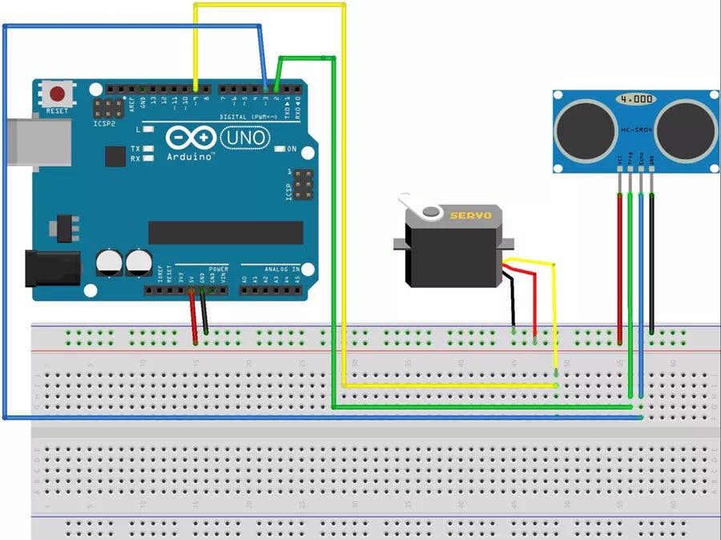
Schematic diagram of Ultrasonic RADAR System
s = (v x t)/2
Now that the sound wave is reflected, the ultrasonic sensor detects it, and the sensor echo pin emits a strong pulse. The time interval between the sent and received sound waves is represented by this output pulse duration. The Arduino then read the sensor echo pin's high pulse output. Arduino does the time duration calculation, distance measurement, and angle measurement this manner.
Where s is the separation between the item and sensor. V is equal to the sound speed in air (340 m/s or 0.034 cm/s). The time interval (t) at which an object's surface reflects back sound waves. Because time will double as the waves travel and reflect back from the object, we must divide the distance value by 2.
5. RESULTS
Testing the system can produce the findings. The non-contact distance range for this radar is 3 cm to 40 cm, and the angle range is 15 degrees to 180 degrees. A tiny servo motor is used to regulate the sensor's movement. The outcome will be shown on a computer screen by Processing Development Environment" software using data from the sensor.

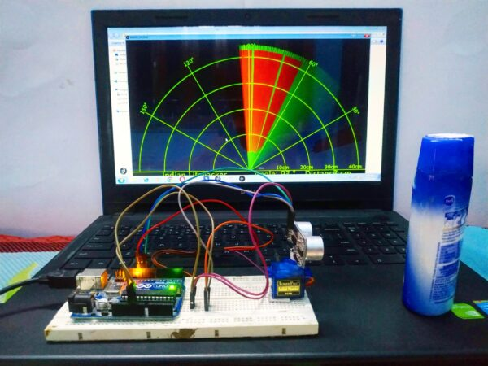
6. CONCLUSION
This radar system was created using an Arduino, a servomotor, and an ultrasonic sensor. It can detect the location and distance of obstacles in its path and transform that information into a form that can be shown visually. Robotics can use this system for object detection and avoidance, or it can be used to detect intrusions in specific locations. The system's range is dependent on the kind of ultrasonic sensor being used. We used the 3 to 40 cm wide HC-SR04 sensor. The radius of the ultrasonic radar is dependent on the 180° rotation of the radar.
1. The system can find the position and angle of the object.
2. The system provide low cost and efficient solution.

7. REFERENCES
- Kulkarni, A. U., Potdar, A. M., Hegde, S., & Baligar, V. P. (2019, July). Radar based object detector using ultrasonic sensor. In 2019 1st International Conference on Advances in Information Technology (ICAIT) (pp. 204-209). IEEE.
- Arun Francis, G., Arulselvan, M., Elangkumaran, P., Keerthivarman, S., & Vijaya Kumar, J. (2020). Object detection using ultrasonic sensor. Int. J. Innov. Technol. Explor. Eng, 8, 207-209.
- Oria, J. P., & Gonzalez, A. M. G. (1993, November). Object recognition using ultrasonic sensors in robotic applications. In Proceedings of IECON'93-19th Annual Conference of IEEE Industrial Electronics (pp. 1927-1931). IEEE.
- Vidhya, D. S., Rebelo, D. P., D’Silva, C. J., Fernandes, L. W., & Costa, C. J. (2016). Obstacle detection using ultrasonic sensors. IJIRST–International Journal for Innovative Research in Science & Technology, 2(11).
- Kumar, K. K., Pooventhan, D., Pranesh, S., & Sandeep, P. K. (2023, April). Ultrasonic Sensor Based Automatic Power Saving-System. In 2023 2nd International Conference on Smart Technologies and Systems for Next Generation Computing (ICSTSN) (pp. 1-6). IEEE.
- Singh, B., & Kapoor, M. (2021). A framework for the generation of obstacle data for the study of obstacle detection by ultrasonic sensors. IEEE Sensors Journal, 21(7), 9475-9483.

