Title: Chromatography Techniques for Separation and Analysis of Biological Samples: Enhancing Characterization and Quantification of Complex Mixtures
Name: Shamim*, Anshu, Rustam Ekbbal
Designation: Assistant Professor
Affiliation: IIMT College of Medical Sciences, IIMT University, Meerut, Uttar Pradesh, India-250001
Mobile No: 9506696061
E-mail id: pharmacistshamim1@gmail.com

Address for correspondence
Name: Shamim
Designation: Assistant Professor
Affiliation: IIMT College of Medical Sciences, IIMT University, Meerut, Uttar Pradesh, India-250001
E-mail id: pharmacistshamim1@gmail.com

Abstract
Chromatography techniques play a pivotal role in the separation and analysis of biological samples, enabling the characterization and quantification of complex mixtures. This abstract provides an overview of the various chromatographic methods employed in the separation of biological samples, including gel chromatography, affinity chromatography, ion exchange chromatography, etc. Separation of biological samples through such techniques based on their differential partitioning between a stationary phase and a mobile phase due to their enhanced detection and identification capabilities, enabling the analysis of complex biological matrices. These methods are widely employed for the separation of compounds such as proteins, peptides, nucleic acids, carbohydrates, and small molecules and acknowledged for versatility, efficiency, and compatibility with various detectors, including UV/Vis, fluorescence, and mass spectrometry. It has gained significant attention in analyzing biomolecules and opened several ways to discover and develop novel components.
Moreover, advancements in chromatographic technology have led to the development of hybrid techniques, such as liquid chromatography-mass spectrometry (LC-MS), and their combinations offer complementary separation and detection capabilities, enhancing the identification and quantification of analytes in complex biological samples. In conclusion, chromatography techniques are indispensable for separating and analyzing biological samples. The diverse range of chromatographic methods available and their compatibility with various detection techniques enables the comprehensive investigation of complex mixtures, leading to significant advancements in biochemistry, pharmaceuticals, clinical diagnostics, and environmental analysis.
Keywords: Chromatography techniques, Biological samples, Gel chromatography, Affinity chromatography, Ion exchange chromatography, Stationary phase, Mobile phase, Detection capabilities, Complex biological matrices, Proteins, Peptides, Nucleic acids, Discovery, and development

1. Chromatographic Ion Exchange:
Chromatography is the technique of dissolving an amalgam of chemicals into their constituent parts based on how they react with an inert matrix—also referred to as " Ion exchange is a form of "ion chromatography." a method that separates ionic components or highly polar compounds according to their affinity for ionic affinity to get exchange (Fekete et al., 2015). Therefore, separation foundation is the exchange of reversible ions between the ions on the ion exchangers and the target ions in the sample solution. This procedure can use two distinct types of exchangers, anionic and cationic exchangers. Cationic exchangers with a negative charge are going to positive energy attractions to themselves. These exchangers are called "Acidic ion exchange" materials since the source of their negative charges is the ionization of acidic groups (Nesterenko & Paull, 2017). Using anionic exchangers, positively charged anions may be converted to negatively charged anions, known as "Basic ion exchange" materials. The most used technique for ion exchange chromatography is column chromatography. On the other hand, the ion exchange principle is the basis for various thin-layer chromatographic methods. Concept (Kim & Kuga, 2001).
1.1 The ion exchange chromatography principle.
An analytical and an oppositely charged stationary phase, or ion exchanger, are attracted to one another in this sort of chromatography (Ec et al., 2019)
- In the ion exchangers, charged groups are effectively covalently linked to the surface of an insoluble matrix.
- The charged groups in the matrix might be positively or negatively charged.
- When the matrix is suspended in an aqueous solution, ions with the opposite charge will surround the charged groups of the matrix.
- This "ion cloud" allows for the reversible transfer of ions without changing the matrix's makeup or properties.
1.2 Ion exchange chromatography properties
Ion exchange chromatography is widely used to separate charged biological parts such as proteins, peptides, amino acids, or nucleotides. Amino acids, which are zwitterion compounds with positively and negatively charged chemical groups, are the building blocks of proteins. (Thurston et al., 2022)

- The inorganic solvents, including chloroform, benzene, carbon tetrachloride, and water, are not soluble.
- Their nature is complicated. In essence, polymers are typical.
- They have counterions or active ions that can easily interchange with other ions.
1.3 Classification of Chromatography by Ion Exchange
The process of ion exchange chromatography is a versatile separation technique widely used in various fields, including biochemistry, pharmaceuticals, environmental analysis, and industrial processes. It involves the separation of charged investigations \ according to how they interact with ion exchange resins. Ion exchange is based on many characteristics, such as the nature of the sample; chromatography may be divided into several categories. Stationary phase, the mode of operation, and the charge of the analyses (Harinarayan et al., 2006).
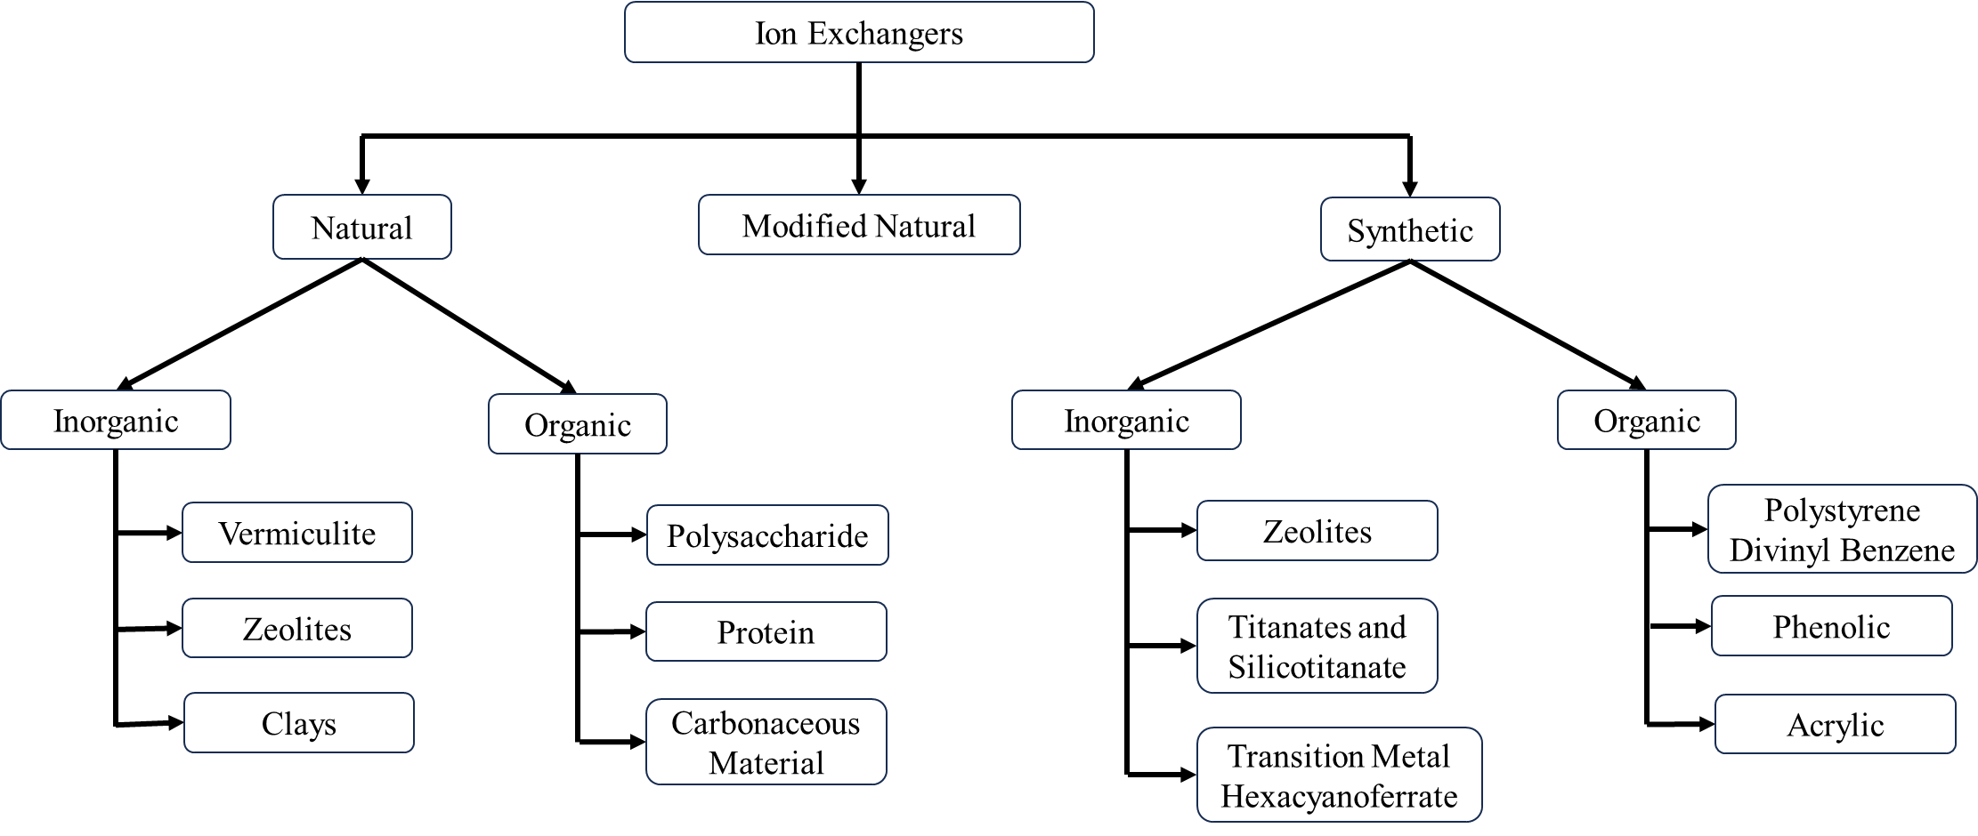
Fig 1: Classification of Chromatography by Ion Exchange

1.4 The equipment used in ion exchange chromatography
A pump, Injector, column, suppressor, detector, and recorder or data system are the most common instruments used in ICs. (Bhusnure & Mali, 2015)
1.4.1 Pump
One of the most vital parts of the system, the IC pump, provides a constant flow of eluent through the IC injector, column, and detector.
1.4.2 Injector
Various techniques can be used to complete a sample introduction. Utilizing an injection valve is the easiest option. Liquids are added immediately; they need to dissolve in water solid samples with the proper solvent. A liquid sample should be able to be injected with superior repeatability and pressure (up to 4000 psi) using an injector with a volume between 0.1 and 100 milliliters.
1.4.3 Columns
The material based on the usage and location, the column might be made of glass, an inert material, titanium, or stainless steel material like PEEK. The column size can be anywhere between 2mm and 5 cm, and its length can be between 3 cm and 50 cm, based on whether it will be applied to routine analytical tasks, microanalysis, high-speed analyses, or preliminary work.
There is a watch column in front of the separating queue. The separation column's lifespan and usefulness are increased due to this safety measure. These strong columns were created to filter or eliminate debris that blocked the separating column.
1.4.4 suppressor
Enhancing the measurement of the suppressor conductivity of the ions under investigation by reducing the chemical mixtures used to elute samples from the ion exchange column has a background conductivity. Membrane-based devices known as IC suppressors improve sensitivity by converting the ionic eluent to water.
1.4.5 Detectors
Commonly used as an electrical conductivity detector (Galaev, 1998).
1.4.6 Data system
A computational integrator with pre-programmed instructions may be adequate for routine analysis in which automation is not required. A more advanced gadget is needed for higher control levels, like a data station or minicomputer (Ngere et al., 2023).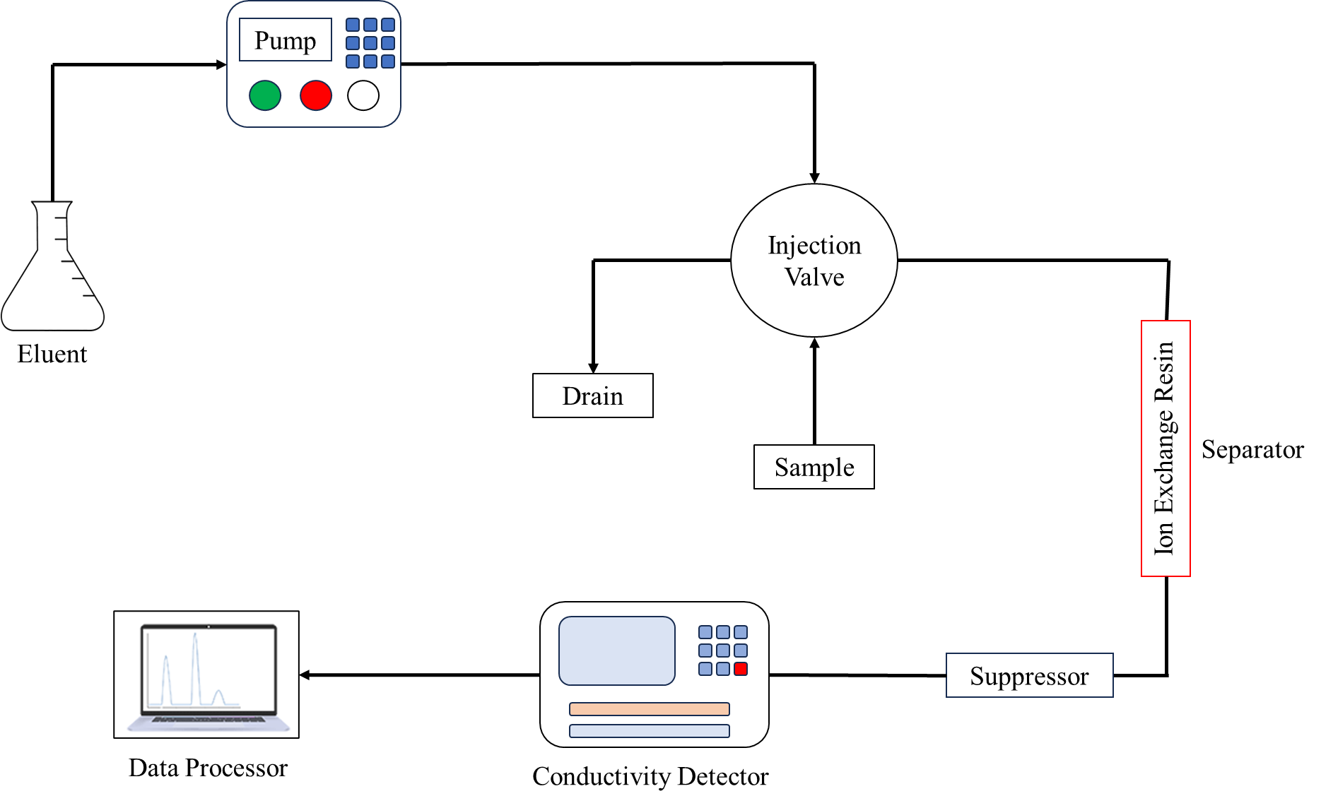
Fig 2: Instrumentation of ion exchange chromatography
  - Ion-exchange process mechanisms
The Chromatographic separation, known as the "ion exchange chromatography" technique, primarily dependent on the protein's net charge, is frequently utilized to track deamidation and succinimide production. The chromatographic matrix is directly connected to molecules with positive (cationic) or negative (anionic) charge (Lenhoff, 2016)
- The ion diffuses to the surface of the exchanger. This happens in a homogeneous solution reasonably rapidly.
- The ion diffuses from the matrix structure to the exchange site depending on the degree of resin cross-linkage and the solution's concentration. This process's rate-determining phase is the ion exchange step.
- Ion exchange occurs instantaneously until equilibrium is reached at the exchange location.
- The exchanged ion diffused to the surface through the exchanger.
- The bound molecules can be released by altering the pH, the ionic concentration, or affinity delusion, which makes use of the ion with the highest affinity for the exchanger.
  - Technique for sample analysis
The sample is prepared so that specific analytical equipment can inspect it. Examples of sample preparation techniques include crushing and dissolving, chemical digestion using sample preparation, sample extraction, sample cleaning, and sample pre-concentration (Duong-Ly & Gabelli, 2014)
- Columns with an ion exchanger are where most ion exchange separations are done.
- It is possible to buy these ionic exchangers commercially. Styrene and divinyl benzene are the main ingredients. Example. In contrast to DEAE-cellulose, a cationic exchanger, CM-cellulose acts as an anionic exchanger.
- The chosen exchanger will depend on how charged the particles need to be separated. In contrast to the "Cationic exchanger," which separates cations, the "Anionic exchanger" does the same for anions.
- The sample is applied, the ion exchanger is added, and the buffer is finally added. Phosphate widely used buffers include pyridine buffer, acetate buffer, citrate buffer, and tris buffer.
- Buffers and particles with a high affinity for the ion exchanger will descend the column together.
- The Next move involves employing a suitable buffer that can separate the particles that are connected firmly.
- These particles' spectroscopic analysis is then conducted.
  - Resins that exchange ions
The terms "ion-exchange polymer" and "ion-exchange resin" refer to a resin or polymer that serves as a medium for ion exchange. It is a substrate constructed from an organic polymer that is a support structure or insoluble matrix—often appearing as tiny microbeads (0.25-1.43 mm in radius) that are white or yellowish. The process is known as ion exchange because the beads are usually porous (having a specific appropriate size distribution alters their characteristics), offering a sizable surface area on and inside of them where the ion trapping and the concomitant additional ions are released (Kosanović et al., 2017). Ion-exchange resin comes in many different varieties. Polystyrene sulfonate is the main component of most commercial resins, followed by polyacrylate (Nesterenko et al., 2007).
Ion exchange resins are employed in various decontamination, purification, and separation procedures. Water filtration and water softening are the two most common examples. Ion exchange resins are a more adaptable substitute for natural or synthetic zeolites commonly employed in these procedures. When filtering biodiesel, ion exchange resins are also quite effective. (M. & E., 2013).
Types of resins
- Anion resins
- Resin for cation exchange
- Anion-exchange resin
  - Characteristics Ion exchange Resins
The following characteristics are typically used to define ion exchange resins (Duong-Ly & Gabelli, 2014).
    - Capacity
Indicates how many ions may be exchanged or held in one unit of resin mass and is usually expressed as milligrams ion per milligram (mg/g) of resin.
    - Swelling
Resins may swell (increase in volume) when in contact with a solvent. A resin's chemical makeup, polymer structure, and cross-linking all impact how it behaves as it swells. Compared to resins with lower levels of cross-linking, those with higher levels show less swelling tendency. When exposed to a particular solvent, swelling is commonly stated as the resin's percentage increase in volume or weight.
    - Selectivity
This describes the resin's preference for or capacity to exchange or adsorb specific ions over others. It is a critical characteristic that governs how well the resin separates or expels particular.
Ions in a solution.
    - Stability
To determine the resin's integrity, determined by the beads' resistance to mechanical and chemical forces.
  - Factors Affecting Ion–Exchange
Ion chromatography's selectivity series is best described by the interaction of electrostatic attraction (ES) and enforced pairing (EP), which is caused by hydrophobic attraction and water-enforced ion pairing. (Yu & Sun, 2012)

    - Nature of Exchange Resins
The cross-linking and swelling characteristics of the exchange are critical in ion exchange. Resins stiffen and expand less when there is more cross-linking agent present, and there is less ion separation when there is less cross-linking agent present. Various sizes transform problematic since there are so many different kinds of pores, they can't fit through the full pore, and if the swelling is more significant, the separation fails.
Ions in the exchanger's nature
- When the concentration is low and the temperature is average, the exchange increases as the valence increases.
Na<Ca<Al
- The size of the hydrated ion decreases with a similarly charged ion exchange increasing.
Li<H<Na<NH₄
- The more polarizable ion has a greater exchange capacity.
I¯<Br¯<Cl¯<F¯
- Polyvalent anions are frequently preferred to other ions in diluted solutions.
- Exchange is favored at greater concentrations, and vice versa, if the solution has a lower positive charge and the resin has a higher positive control.
  - Applications of ion exchange chromatography
Biochemistry, pharmaceuticals, environmental studies, and industrial operations are examples of the many industries that employ the potent known separation technique of ion exchange chromatography. Here are a few uses for ion exchange chromatography. (Kabytaev et al., 2016).
- The regular examination of mixtures of amino acids is a significant application of chromatography using ion exchange.
- The 20 essential amino acids are isolated from blood serum or protein hydrolysis in clinical diagnostics.
- The best method of water filtration is this one. Water (or a non-electrolyte solution) can be entirely deionized by changing the solute cations and anions into hydrogen and hydroxyl ions. A technique for softening drinking water is frequently used to achieve this.
- While analyzing the outcomes of nucleic acid hydrolysis. This way, we learn about the biological significance of these molecules' structural makeup as genetic information carriers.
- Chelating resins are used to remove trace metals from saltwater.
- To evaluate rare traces of elements on Earth and lunar materials.
  - Advantages of ion exchange chromatography
Chromatography applications are a potent separation method in analytical and preparative ion exchange. It has numerous benefits, such as: (Michalski, 2014).
- It is one of the most excellent methods for dividing charged particles.
- It is possible to use almost any charged molecule with it, including large proteins, tiny nucleotides, and amino acids.
- Ion exchange has analytical and preparative uses in laboratories, with more prevalent analytical services.
- Ion exchange chromatography can also be used to identify inorganic ions.
  - Disadvantages of Ion exchange chromatography
Like each analytical method, ion exchange chromatography has some drawbacks. Ion exchange chromatography has several disadvantages, some of which are listed below: (Duong-Ly & Gabelli, 2014)
- This approach can only be used for distinct charges ions or polar compounds.
- The resin used in this process is susceptible to damage from several chemicals.
- A large number of samples are required.
- The apparatus is costly and requires buffers, which are pricey chemicals.

- Gel Chromatography
Gel chromatography, commonly called gel filtering, using variations in the speeds at which different chemical compounds flow through a bed of porous, semisolid material, is a technique used in analytical chemistry to separate chemical compounds. Proteins, peptides, amino acids, enzymes, and other low-molecular-weight substances may all be separated using this technique from one another (Liu et al., 2013). Based on the differences in their molecular sizes, the components of a mixture can be separated using gel chromatography. Large molecules cannot penetrate the pores and tend to flow unimpeded, whereas small molecules tend to disperse into the inside of the porous particles, restricting their flow. As a result, the molecules with the highest molecular weight exit the bed first, followed by those with decreasing molecular weight. The most used bed materials are polyacrylamide and a polymer made of dextran and epichlorohydrin. Typically, appropriate agents are used to suspend the dry polymers, creating a semisolid homogenous mixture (Ackers, 1970).
  - Principle of Gel Chromatography
Molecules are divided differently between a fixed phase and a dynamic phase, which is the underlying concept of gel chromatography. In gel chromatography, a cross-linked matrix of porous polymers, such as agarose or polyacrylamide, is the stationary phase. Many different pore sizes exist in the gel matrix, resulting in a network of interconnecting channels. (Ó’Fágáin et al., 2017)
- GPC uses the analyses’ hydrodynamic volume (radius of gyration) or size to separate the analyses. Alternative Separation techniques, on the other hand, depend on chemical or physical interactions to find analyses. We utilize a column of porous beads for particle separation.
- Smaller analyses spend more time in pores because they can enter them more rapidly, which results in a longer retention duration. These smaller molecules elute later because they stay in the column longer. While on the other hand, more extensive analyses spend little to no time in the pores and are rapidly removed. In each column, different molecular weights may be split.
- Analyses that are too big won't be preserved, while those that are too little will be kept entirely. Analyses that are not retained are eluted using the free volume outside of the particles (VO). At the same time, the volume of solvent contained in the pores is used to elute analyses that are retained. The following equation may be used to calculate both the total volume, Vt, as well as the volume of the polymer gel:
  - Vt = Vg + Vi + Vo
  - Equipment for gel chromatography
An effective gel permeation chromatographic setup contains the following essential components:
Gels
The chemical makeup and molecular dimensions of the analyses that may be separated using the GPC method significantly impact the gel choice. For stationary phases in gel permeation chromatography equipment, xerogels are frequently utilized. (Wieland & Determann, 1967).
The GPC process employs only organic gels in its utilization. The trade names for the many varieties of gels that are sold on the market are Polyacrylamide-containing BioGel p-2.
- Sephadex G-10-200 (Dextran)
- Styrogel (modified polystyrene gels)
- Agarose
Sepharose and BioGel A are brand names for gel agarose. These gels have hydrogen bonds and can withstand temperatures of 0 to 30 °C and a pH range of 5 to 8. All of the gels used in the gel filtration procedure have the following qualities in common:
- They are inert chemically.
- They are stable mechanically.
- They have consistent pore and particle sizes.
    - Gel chromatography column
Eluent can flow under gravity in a semi-permeable, porous polymer-filled column utilized in the GPC device. The gels in the chromatographic column have a well-defined range of pore sizes. Using a buffer solution to clean the column before testing will eliminate any air bubbles (Liu et al., 2011)
    - Eluent
In gel permeation chromatography, the mobile phase, often called the eluent, should be a solvent appropriate for polymers. In general, organic solvents can be used as an eluent in the GPC instrument (Blaha & Berek, 1981).
- THF, or tetrahydrofuran.
- O-Dichlorobenzene
- Trichlorobenzene
- Polyalkenes
- M-Cresol
- O-Chlorophenol
    - Pump
In the GPC approach, piston or peristaltic pumps are employed to distribute the mobile phase uniformly or at a constant flow rate (Ó’Fágáin et al., 2017)
    - Chromatographic detector
- The detector can measure an appropriate physical characteristic of the effluent, such as its refractive index, absorbance, fluorescence intensity, and other electrical parts, much as in conventional chromatographic techniques.
- The GPC analysis employs a variety of detector types. Generally speaking, they fall into two groups:
- The first group of detectors measures light absorption and includes concentration-sensitive devices, including UV, RI, IR, and density detectors.
- Two molecular weight-sensitive detectors are included in the second category: low-angle light scattering (LALLS) and multi-angle light scattering (MALLS). (Kara & Fisher, 2012)
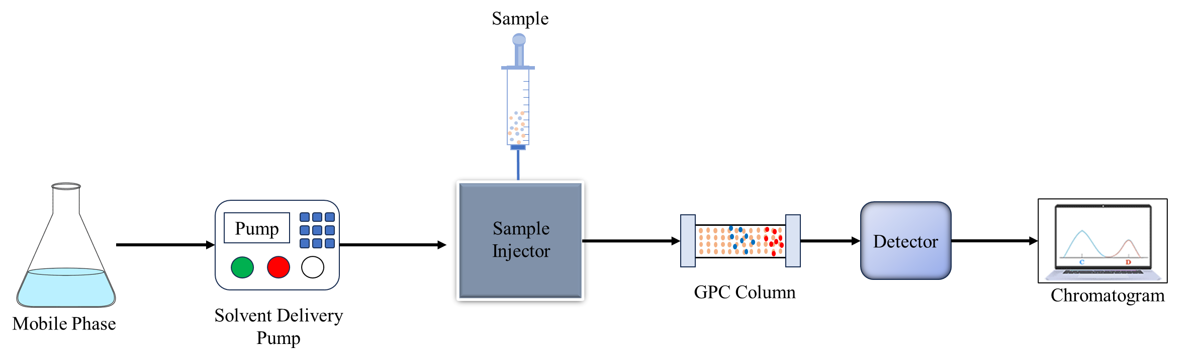
Fig 3: Instrumentation of Gel Chromatography
  - Sample analysis procedure
- Chromatography columns are used for almost all gel permeation chromatography. The experimental model resembles previous liquid chromatography methods quite closely. Samples are in a suitable solvent, dissolved —usually an organic one for GPC— injected into a column, and then filtered—the column-based separation of a complex mixture. Using a pump guarantees a constant flow of new eluent to the column. A detector is required because most analyses cannot be seen with the human eye. Several detectors are frequently employed to get more details about the polymer sample.
- The GPC stationary method is the gel. When applying the gel to a specific separation, the size of the gel's pores requires close attention. The lack of ionizing groups and poor affinity of the gel-forming agent for the components to be separated in a particular solvent are two additional desirable qualities.
- The GPC column's packing material is a microporous interior. The gel is added to the gel filtration column, which is then filled with the gel.
- The polymer needs a suitable solvent in the eluent (mobile phase) to activate the detector and wet the packing surface. Most frequently, the tetrahydrofuran components of GPC polymers (THF) dissolve at room temperature.
- The two pump types for uniform distribution of relatively tiny Pumps for GPC's liquid volumes might be piston or peristaltic.
- A detector will continually track the weight-based polymer concentration in the eluting solvent in GPC. There are two main categories in which detectors may be divided. Some of the first forms of concentration-sensitive detectors include UV absorption, differential refractometer (DRI) or refractive index (RI) detectors, infrared (IR) absorption, and density detectors (Winzor, 2003).

  - The use of gel chromatography
The molecular weight distribution and relative molecular weight of polymer compounds are frequently assessed using GPC.GPC evaluates the size and form of molecules based on their innate viscosity. This comparative information may be used to calculate molecular weights with 5% precision under identical circumstances. Polystyrene standards with variations of less than 1.2 are frequently used to calibrate the GPC. (Ruzicka et al., 1968).
Advantages of Gel Chromatography
Gel chromatography, commonly called size exclusion chromatography (SEC), is used in analytical chemistry to sort and purify molecules according to size. The following are some benefits of gel chromatography: (Shen et al., 2016)
It is the ideal method for separating molecules with different molecular weights because:
- Separation may be carried out in any setting since it is unaffected by alterations in temperature, pH, ionic strength, or buffer composition.
- When compared to other approaches, zonal dispersion is reduced.
- The molecular weight and elution volume are linked.
- An essential method for protein purification.
- By fractionating without the necessity for protein binding, this innovative separation method reduces the risk of protein loss.
  - Disadvantages of Gel Chromatography
A standard method for sorting and purifying biomolecules according to their size is gel chromatography, commonly called size exclusion chromatography or gel filtration chromatography. While using gel chromatography has many benefits, it also has certain drawbacks, such as: (Caltabiano et al., 2018)
- The GFC run's brief time scale can only resolve a finite number of peaks.
- The instrument must pass through filters before being used to prevent dust and other particles from damaging the columns and interfering with the detectors.
- Affinity Chromatography
Chromatography is a crucial biophysical method for separating, identifying, and purifying a mixture's parts for qualitative and quantitative analyses. Analysis. This separation technique involves coming into contact with a mobile phase that conveys a variety and a stationary phase that is selectively absorbent. To separate, purify, or Analyse specific components of materials, A type of liquid chromatography is used called affinity chromatography. It utilizes the affinity-based molecular recognition method, which describes the compelling force provided to varying amounts of atoms to keep them together. In biology, affinity uses this reversible mechanism to keep molecular links intact. Some examples are an enzyme, an inhibitor, an antigen, an antibody, etc. (Rodriguez et al., 2020).
Meir Wilcheck and Pedro Cuatrecasas are the authors of the discovery.
  - Principle of Affinity Chromatography
The stationary phase in affinity chromatography is constructed of a support medium (such as cellulose beads) on which the substrate (or occasionally a coenzyme) has been covalently bonded to expose the reactive groups necessary for enzyme binding. (Ostrove, 1990).
- The reactive groups necessary for the tethering of the target molecule are still accessible because, in the stationary phase, the substrate (ligand) is still affixed to the support material covalently.
- In a chromatography column, a crude chemical mixture is run, and only the compounds with binding sites for the immobilized substrate bond to the stationary phase; all other substances are eluted into the column's mobile phase Interior.
- The bound target molecules can be freed after the other substances have been removed using techniques such as introducing a rival ligand to the mobile phase or modifying the solution's pH, ionic strength, or polarity.
  - Instrumentation of Affinity Chromatography
Affinity chromatography separates biological mixtures with an exact relationship, such as one between an antigen and an antibody, an enzyme and a substrate, or a receptor and a ligand (Hage et al., 2012).
    - Matrix
  - A ligand can be connected to the matrix directly or indirectly as an inert support.
  - Specific characters are necessary for the matrix to function well, including:
  - The matrix must be inert both chemically and physically.
  - It must not dissolve in the buffers and solvents used in the procedure.
  - It must be stable in both chemical and mechanical terms.
  - Connecting to a ligand or spacer arm that can accommodate the ligand must be straightforward.
  - It must have good flow properties and a substantial surface area for attachment.
  - Agarose and polyacrylamide are the best matrix materials.
    - Spacer arm
Reducing the effects of steric hindrance helps the ligand and target molecule better bond.
    - Ligand
  - It describes a chemical's reversible binding to a particular goal molecule.
  - Once the kind of extracted macromolecule has been chosen, the ligand can only be selected has been identified.
  - The hormone itself is a prime choice for the ligand when a hormone receptor protein has to be purified using affinity chromatography.
  - To isolate antibodies, a ligand such as employing an antigen or hapten is possible.
  - The immobilized ligand for the purification of an enzyme may be an analog of a cofactor, an effector, a substrate, or an inhibitor (Zhang et al., 2018).
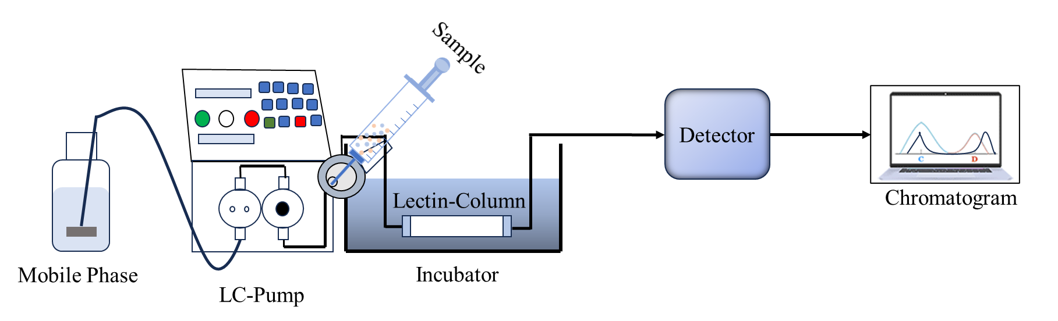
Fig 4: Instrumentation of Affinity Chromatography
  - Sample analysis procedure
The physical removal of the sample from the target population, preservation of the model, and preparation of the piece for analysis are the three phases that typically comprise the sampling plan implementation process. It is generally easy to Analyse a sample when an analytical method is selective for the analysis (Arora et al., 2017).
  - In the binding buffer, the affinity medium is balanced.
  - The sample application encourages the target molecule(s) to bind particularly to a complementary ligand. Exactly reversible attachment of the target compounds to the ligand occurs, and unbound material is flushed through the column.
  - Elution can be carried out precisely or randomly by modifying the polarity, pH, or ionic strength while using a competing ligand. The concentrated, purified version of the target protein is collected.
  - The affinity medium is rebalanced using a binding buffer.
The following three significant steps can be used to summarize these actions:
    - Preparation of Column
- Sepharose, cellulose, and agarose are just a few of the sturdy support materials used to fill the column.
- Ligands are chosen according to what is desired isolation.
- A spacer arm is connected to the solid support and ligand.
    - Loading of Sample
The solution mixture containing the chemical is added to the elution column and permitted to flow at a specified pace.
    - Elimination of the Ligand-Molecule Complex
Modifying the environment to encourage the release of the bound molecules allows extraction of the target substance.
  - Uses for Affinity Chromatography
  - Affinity chromatography is one of the top techniques for separating and purifying certain compounds.
  - It functions mainly as a sample purification procedure for biological substances like proteins.
  - The division of a complex mixture.
  - Impurity removal or purification procedure.
  - During enzyme tests
  - Identifying substrates
  - Research into enzyme binding locations
  - In vitro antibody-antigen interactions
  - Nucleic acid analysis for mutations and single nucleotide polymorphisms (Hage, 2017).

  - Advantages of Affinity Chromatography
  - Affinity chromatography is a potent separation method using the specific interactions between a ligand and a target molecule immobilized on a solid substrate. Affinity chromatography has the following benefits: (Bi et al., 2015)
  - Extreme specificity
  - Highly pure target molecules can be obtained.
  - One step of purification.
  - The matrix might be utilized right away.
  - The matrix is sturdy and is not difficult to dry or clean.
  - Provide a high yield of a purified product.
  - Certain pollutants like proteases can also be removed via affinity chromatography.
  - Disadvantages of Affinity Chromatography
Based on the unique interactions biomolecules have with ligands immobilized on a solid substrate, affinity chromatography is a potent technology for cleansing and separating biomolecules. While affinity chromatography provides many benefits, there are some drawbacks as well. Affinity chromatography has the following disadvantages: (Moaddel & Wainer, 2009).
- The expense of resins can make affinity chromatography costly.
- High production costs for resin.
- Limited selection of resin.
- Resins need to be customized for specific goals.
- Storage conditions might affect resin sensitivity.
  - Limitations of Affinity Chromatography
Affinity chromatography is a potent technology used in molecular biology and biochemistry to separate and purify specific target molecules from complicated mixtures. Nevertheless, it has several restrictions, much like any analytical or separation process. Affinity chromatography has the following typical drawbacks: (Arora et al., 2015).
    - An approach that takes time.
    - More solvents are needed, which might be pricey.
    - Prolonged labor
    - Non-specific adsorption can only be reduced, not completely removed.
    - The high price and dearth of immobilized ligands.
    - If the proper pH is not changed, proteins get denatured.
Conclusion
Chromatography is a versatile technique used to separate and analyze complex mixtures based on their interactions with stationary and mobile phases. Ion exchange chromatography is a form of chromatography that separates ionic components or highly polar compounds based on their affinity for charged groups in an ion exchanger. Gel chromatography, also known as gel filtration or size exclusion chromatography, separates molecules based on size by utilizing porous gel beads as the stationary phase. Affinity chromatography employs specific interactions between a ligand immobilized on a solid support and a target molecule to purify and separate biomolecules with high specificity. Ion exchange chromatography is widely used to separate charged biological components such as proteins, peptides, amino acids, or nucleotides. It utilizes anionic or cationic exchangers with charged groups covalently linked to an insoluble matrix. Gel chromatography is particularly effective in assessing polymer compounds' molecular weight distribution and relative molecular weight. It is used in a wide range of applications, such as water filtration, protein purification, and analysis of nucleic acids. Affinity chromatography is precise and allows for the purification and separation of biomolecules based on their interactions with immobilized ligands. It is commonly used for enzyme purification, antibody-antigen interactions, and nucleic acid analysis. Each chromatographic method has its advantages and disadvantages, and the choice of technique depends on the specific analytical or purification goals and the properties of the sample being analyzed. Chromatography is a powerful tool with various applications in biochemistry, pharmaceuticals, environmental analysis, and industrial processes.
Future Scope
Automation of chromatography systems will continue to improve, leading to higher throughput, reduced human intervention, and improved reproducibility of results. This will make chromatography more efficient and user-friendly for various applications. Advancements in microfluidics and miniaturization techniques will enable the development of portable and handheld chromatography devices. These miniaturized systems could revolutionize point-of-care diagnostics, on-site environmental monitoring, and resource-limited settings. Researchers will continue to explore and develop novel stationary phases with improved selectivity and sensitivity. These advancements will allow for better separation and analysis of complex samples, including biomolecules and pharmaceutical compounds. Integrating multiple chromatographic dimensions, such as ion exchange with size exclusion or affinity chromatography, will enable higher resolution and separation power for complex samples. Combining artificial intelligence and data analytics into chromatography systems will enhance data processing, interpretation, and pattern recognition, making the analysis more efficient and accurate. The future of chromatography is promising, with ongoing research and technological advancements expected to expand its capabilities and applications across various industries and scientific disciplines.
References
- Ackers, G. K. (1970). Analytical gel chromatography of proteins. Advances in Protein Chemistry. https://doi.org/10.1016/S0065-3233(08)60245-4
- Arora, S., Ayyar, B. V., & O’Kennedy, R. (2015). Affinity chromatography for antibody purification. Methods in Molecular Biology. https://doi.org/10.1007/978-1-62703-977-2_35
- Arora, S., Saxena, V., & Ayyar, B. V. (2017). Affinity chromatography: A versatile technique for antibody purification. In Methods. https://doi.org/10.1016/j.ymeth.2016.12.010
- Bhusnure, O. G., & Mali, S. N. (2015). RECENT TRENDS IN ION-EXCHANGE CHROMATOGRAPHY. International Journal of Pharmaceutics and Drug Analysis.
- Bi, C., Beeram, S., Li, Z., Zheng, X., & Hage, D. S. (2015). Kinetic analysis of drug-protein interactions by affinity chromatography. In Drug Discovery Today: Technologies. https://doi.org/10.1016/j.ddtec.2015.09.003
- Bleha, T., & Berek, D. (1981). Gel chromatography with mixed eluents. Partition of solute due to the preferential solvation of gel. Chromatographia. https://doi.org/10.1007/BF02314761
- Caltabiano, A. M., Foley, J. P., & Striegel, A. M. (2018). Aqueous size-exclusion chromatography of polyelectrolytes on reversed-phase and hydrophilic interaction chromatography columns. Journal of Chromatography A. https://doi.org/10.1016/j.chroma.2017.12.007
- Duong-Ly, K. C., & Gabelli, S. B. (2014). Using ion exchange chromatography to purify a recombinantly expressed protein. In Methods in Enzymology. https://doi.org/10.1016/B978-0-12-420119-4.00008-2
- Ec, E., Obbina, I., & VA, W. (2019). Applications of Column, Paper, Thin Layer and Ion Exchange Chromatography in Purifying Samples: Mini Review. SF Journal of Pharmaceutical and Analytical Chemistry.
- Fekete, S., Beck, A., Veuthey, J. L., & Guillarme, D. (2015). Ion-exchange chromatography for the characterization of biopharmaceuticals. In Journal of Pharmaceutical and Biomedical Analysis. https://doi.org/10.1016/j.jpba.2015.02.037
- Galaev, I. Y. (1998). New methods of protein purification. Displacement chromatography. Biochemistry (Moscow).
- Hage, D. S. (2017). Analysis of biological interactions by affinity chromatography: Clinical and pharmaceutical applications. In Clinical Chemistry. https://doi.org/10.1373/clinchem.2016.262253
- Hage, D. S., Anguizola, J. A., Bi, C., Li, R., Matsuda, R., Papastavros, E., Pfaunmiller, E., Vargas, J., & Zheng, X. (2012). Pharmaceutical and biomedical applications of affinity chromatography: Recent trends and developments. In Journal of Pharmaceutical and Biomedical Analysis. https://doi.org/10.1016/j.jpba.2012.01.004
- Harinarayan, C., Mueller, J., Ljunglöf, A., Fahrner, R., Van Alstine, J., & Van Reis, R. (2006). An exclusion mechanism in ion exchange chromatography. Biotechnology and Bioengineering. https://doi.org/10.1002/bit.21080
- Kabytaev, K., Durairaj, A., Shin, D., Rohlfing, C. L., Connolly, S., Little, R. R., & Stoyanov, A. V. (2016). Two-step ion-exchange chromatographic purification combined with reversed-phase chromatography to isolate C-peptide for mass spectrometric analysis. Journal of Separation Science. https://doi.org/10.1002/jssc.201500989
- Kara, D., & Fisher, A. (2012). Modified silica gels and their use for the pre-concentration of trace elements. In Separation and Purification Reviews. https://doi.org/10.1080/15422119.2011.608765
- Kim, U. J., & Kuga, S. (2001). Ion-exchange chromatography by dicarboxylic cellulose gel. Journal of Chromatography A. https://doi.org/10.1016/S0021-9673(01)00800-7
- Kosanović, M., Milutinović, B., Goč, S., Mitić, N., & Janković, M. (2017). Ion-exchange chromatography purification of extracellular vesicles. BioTechniques. https://doi.org/10.2144/000114575
- Lenhoff, A. M. (2016). Ion-exchange chromatography of proteins: The inside story. Materials Today: Proceedings. https://doi.org/10.1016/j.matpr.2016.10.038
- Liu, H., Nishide, D., Tanaka, T., & Kataura, H. (2011). Large-scale single-chirality separation of single-wall carbon nanotubes by simple gel chromatography. Nature Communications. https://doi.org/10.1038/ncomms1313
- Liu, H., Tanaka, T., Urabe, Y., & Kataura, H. (2013). High-efficiency single-chirality separation of carbon nanotubes using temperature-controlled gel chromatography. Nano Letters. https://doi.org/10.1021/nl400128m
- M., Y., & E., R. (2013). Ion Exchange Chromatography - An Overview. In Column Chromatography. https://doi.org/10.5772/55652
- Michalski, R. (2014). APPLICATION OF ION CHROMATOGRAPHY IN CLINICAL STUDIES AND PHARMACEUTICAL INDUSTRY. Mini-Reviews in Medicinal Chemistry. https://doi.org/10.2174/1389557514666141013142203
- Moaddel, R., & Wainer, I. W. (2009). The preparation and development of cellular membrane affinity chromatography columns. Nature Protocols. https://doi.org/10.1038/nprot.2008.225
- Nesterenko, P. N., Fedyanina, O. N., Volgin, Y. V., & Jones, P. (2007). Ion chromatographic investigation of the ion-exchange properties of microdisperse sintered nanodiamonds. Journal of Chromatography A. https://doi.org/10.1016/j.chroma.2007.02.019
- Nesterenko, P. N., & Paull, B. (2017). Ion chromatography. In Liquid Chromatography: Fundamentals and Instrumentation: Second Edition. https://doi.org/10.1016/B978-0-12-805393-5.00009-9
- Ngere, J. B., Ebrahimi, K. H., Williams, R., Pires, E., Walsby-Tickle, J., & McCullagh, J. S. O. (2023). Ion-Exchange Chromatography Coupled to Mass Spectrometry in Life Science, Environmental, and Medical Research. In Analytical Chemistry. https://doi.org/10.1021/acs.analchem.2c04298
- Ó’Fágáin, C., Cummins, P. M., & O’Connor, B. (2017). Gel-filtration chromatography. In Methods in Molecular Biology. https://doi.org/10.1007/978-1-4939-6412-3_2
- Ostrove, S. (1990). Affinity chromatography: General methods. Methods in Enzymology. https://doi.org/10.1016/0076-6879(90)82031-V
- Rodriguez, E. L., Poddar, S., Iftekhar, S., Suh, K., Woolfork, A. G., Ovbude, S., Pekarek, A., Walters, M., Lott, S., & Hage, D. S. (2020). Affinity chromatography: A review of trends and developments over the past 50 years. In Journal of Chromatography B: Analytical Technologies in the Biomedical and Life Sciences. https://doi.org/10.1016/j.jchromb.2020.122332
- Ruzicka, J. H., Thomson, J., Wheals, B. B., & Wood, N. F. (1968). The application of gel chromatography to separating pesticides part I. organophosphorus pesticides. Journal of Chromatography A. https://doi.org/10.1016/0021-9673(68)80003-2
- Shen, Y., Roberge, A., Tan, R., Gee, M. Y., Gary, D. C., Huang, Y., Blom, D. A., Benicewicz, B. C., Cossairt, B. M., & Greytak, A. B. (2016). Gel permeation chromatography as a multifunctional processor for nanocrystal purification and on-column ligand exchange chemistry. Chemical Science. https://doi.org/10.1039/c6sc01301e
- Thurston, J. R., Marshak, M. P., & Reber, D. (2022). Monitoring Ion Exchange Chromatography with Affordable Flame Emission Spectroscopy. Journal of Chemical Education. https://doi.org/10.1021/acs.jchemed.2c00455
- Wieland, T., & Determann, H. (1967). Some recent developments in gel chromatography, with special reference to thin layers. Journal of Chromatography A. https://doi.org/10.1016/s0021-9673(01)85919-7
- Winzor, D. J. (2003). Analytical exclusion chromatography. In Journal of Biochemical and Biophysical Methods. https://doi.org/10.1016/S0165-022X(03)00071-X
- Yu, L. L., & Sun, Y. (2012). Trace adsorption of positively charged proteins onto Sepharose FF and Sepharose FF-based anion exchangers. Journal of Chromatography A. https://doi.org/10.1016/j.chroma.2012.07.004
- Zhang, C., Rodriguez, E., Bi, C., Zheng, X., Suresh, D., Suh, K., Li, Z., Elsebaei, F., & Hage, D. S. (2018). High-performance affinity chromatography and related separation methods for analyzing biological and pharmaceutical agents. In Analyst. https://doi.org/10.1039/c7an01469d

