RADIOPHARMACEUTICAL SCIENCE

Dr. Deepak Bharati¹, Sakshi Nirhali, Jishaan Alam Khan¹, Pratiksha Umale¹, Prajwal Bari¹

Department of Pharmacology, St. John Institute of Pharmacy & Research, Palghar, India

Dr. Deepak Bharati, Email: deepakbharti007@gmail.com
Sakshi Nirhali, Email: sakshi2004@sjipr.edu.in
Jishaan Alam Khan, Email: jishaan2003@sjipr.edu.in
Pratiksha Umale, Email: pratiksha3004@sjipr.edu.in
Prajwal Bari, Email: prajwal2002@sjipr.edu.in

ABSTRACT

Radiopharmaceutical science is a multidisciplinary field that plays a pivotal role in nuclear medicine, utilizing radiopharmaceutical agents for diagnostic imaging, therapeutic applications, and molecular target-specific therapy. This abstract provides an overview of the key aspects and advancements in radiopharmaceutical science.
In the realm of diagnostic imaging, radiopharmaceuticals are employed to visualize and assess physiological and pathological processes at the molecular level. Techniques such as Single-Photon Emission Computed Tomography (SPECT) and Positron Emission Tomography (PET) have revolutionized medical imaging by enabling the non-invasive evaluation of organ function and the early detection of diseases like cancer, cardiovascular disorders, and neurological conditions.
On the therapeutic front, radiopharmaceuticals are utilized for targeted radiation therapy, known as Radionuclide Therapy or Molecular Radiotherapy. This approach involves administering radiopharmaceuticals that selectively accumulate in specific disease sites, delivering precise and localized radiation to cancerous cells or diseased tissues. The development of innovative alpha and beta-emitting radionuclides has significantly expanded the therapeutic potential, allowing for personalized treatment strategies and improved patient outcomes.
Furthermore, the synthesis, production, and quality control of radiopharmaceuticals poses unique challenges. Advanced radiochemistry techniques and automated systems have streamlined the production process, enhancing the availability and accessibility of these vital agents. Ensuring strict adherence to regulatory guidelines and radiopharmaceutical-specific safety protocols is crucial to guaranteeing the highest standard of patient care.
The integration of artificial intelligence, machine learning, and image processing algorithms has propelled radiopharmaceutical science into the era of precision medicine. These cutting-edge technologies enable more accurate image analysis, patient-specific dosimetry, and treatment planning, optimizing therapeutic efficacy while minimizing potential side effects.

Keywords – Radiopharmaceuticals, Radiopharmaceutical science, Radiopharmaceutical Kits, Nucleotides, Isotopes, Nuclear medicine
- Introduction
History- The history of nuclear medicine is a fascinating journey that incorporates various scientific achievements and spans multiple fields. Because of the multidisciplinary character of nuclear medicine and the slow evolution of fundamental concepts and technology, pinpointing a single birthdate is challenging. Several notable milestones and contributions by various scientists, on the other hand, have altered the field over time.
Frédéric Joliot-Curie and Irène Joliot-Curie discovered artificial radioactivity in 1934 when they published the first artificial creation of radioactive material in the magazine Nature. This finding paved the way for radiopharmaceuticals to be used in nuclear medicine.[1]
Experiments with Radionuclides (1920s): In Freiburg, Germany, George de Hevesy conducted studies using radionuclides that were given to rats. The tracer principle, which serves as the foundation for many nuclear medicine diagnostic imaging procedures, was demonstrated in this paper.
Early Therapeutic Applications (1930s): In the 1930s, Taro Takemi researched the use of nuclear physics in medicine. One of the earliest uses of man-made radionuclides in patients was phosphorus-32, which was employed by John Lawrence, the "father of nuclear medicine," to treat leukemia in 1936.
Publication of Important Articles (1946): On May 11, 1946, radioactive iodine (RAI) was successfully used to treat Graves' disease, according to a JAMA article. The public's acceptance of nuclear medicine as a prospective specialty was greatly aided by this essay and others by Sam Seidlin[2].
The development of technetium-99m: C. Perrier and E. Segre's 1937 discovery of technetium-99m led to its use as a key component in nuclear medicine. Technetium-99m was made more generally available for medical usage when a generator system was created in the 1960s, and it is still frequently utilized in nuclear medicine imaging tests today [3].
The first rectilinear scanner was created by Benedict Cassen, and in the early 1950s, Hal O. Anger's scintillation camera (often known as the "Anger camera") helped turn nuclear medicine into a fully-fledged medical imaging field.
Niels A. Lassen, David H. Ingvar, and Erik Skinhj created methods to monitor blood flow in the brain using radionuclides in the 1960s, which gave them invaluable knowledge about neuropsychiatric illnesses [4].
The development of technetium-99m: C. Perrier and E. Segre's 1937 discovery of technetium-99m led to its use as a key component in nuclear medicine. Technetium-99m was made more generally available for medical usage when a generator system was created in the 1960s, and it is still frequently utilized in nuclear medicine imaging tests today.
The Radiopharmaceutical Sciences aims to give open access to publications on the development of largely innovative radiopharmaceuticals and their application for basic and practical studies in biology and medicine. The development of radiopharmaceuticals takes into account the design, synthesis, and radio labelling of the drugs, as well as their biological and preclinical evaluation and, finally, clinical use. Contributions may concern targeted, pre-targeted, and non-targeted radiopharmaceuticals ranging from small molecules to peptides, peptidomimetics, antibodies, and derivatives thereof for use in gamma scintigraphy, including single photon emission tomography (SPECT), positron emission tomography (PET), and endoradiotherapy. The field of diagnostic imaging and (radio)pharmaceutical therapy guided by diagnostic imaging is of great interest. Physics and dosimetry are two linked concepts [5].
Radiopharmaceutical science, also known as nuclear pharmacy or radiopharmacy, is a specialized field within the pharmacy and nuclear medicine that focuses on the preparation, compounding, dispensing, and safe use of radioactive substances, known as radiopharmaceuticals. These radiopharmaceuticals are used in diagnostic imaging and therapeutic procedures to diagnose and treat various medical conditions.[6]

Key aspects of radiopharmaceutical science include:
- Radiopharmaceuticals: Radiopharmaceuticals are drugs that contain radioactive substances. These substances emit radiation, which can be detected by specialized imaging devices like gamma cameras or PET (Positron Emission Tomography) scanners. The radioisotopes used in these drugs have short half-lives, allowing for safe usage and minimizing the exposure of patients to radiation.
- Diagnostic Imaging: Radiopharmaceuticals play a crucial part in diagnostic imaging procedures such as SPECT and PET scans. These imaging techniques assist clinicians in visualizing and assessing the structure and function of organs and tissues, hence assisting in the diagnosis and monitoring of a variety of medical illnesses such as cancer, heart disease, and neurological disorders.
- Therapeutic Applications: Radiopharmaceuticals can be utilized for therapeutic applications in addition to diagnostic imaging. Specific radiation dosages are supplied to malignant cells during radiation therapy to kill them while causing the least amount of harm to healthy tissues around them.
- Quality Control and Safety: Radiopharmaceutical scientists ensure radiopharmaceutical quality, purity, and safety. They adhere to tight norms and regulations to preserve the integrity of these radioactive medications and avoid any negative impacts on patients, healthcare professionals, and the environment.
- Research and Development: Radiopharmaceutical science constantly researches and develops new radiopharmaceuticals with increased diagnostic and therapeutic efficacy. As new technology and isotopes become available, the field continues to evolve.
- Collaboration: In cancer care, radiopharmaceutical scientists frequently collaborate with nuclear medicine specialists, radiologists, oncologists, and other healthcare professionals to produce personalized treatment strategies for patients.
- Regulatory Compliance: To ensure the safe handling, storage, and administration of radiopharmaceuticals, several health authorities have established severe laws and standards.
- Radiopharmaceutical science is a critical discipline that bridges pharmacy and nuclear medicine to provide valuable tools for diagnosing and treating diseases, particularly in the fields of oncology and neurology. Through continuous research and adherence to strict safety standards, radiopharmaceutical scientists contribute to advancing medical knowledge and improving patient outcomes [6].

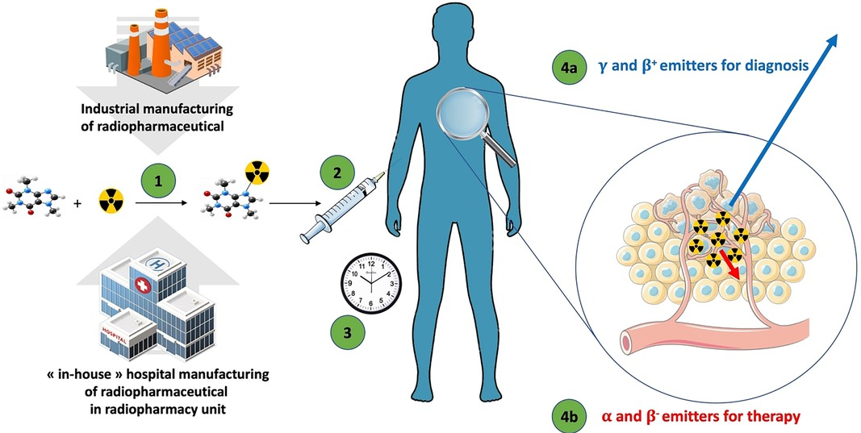

FIGURE 1. The general flow of radiopharmaceuticals. (1) The radiopharmaceutical compound is manufactured by the industry or “in-house” hospital radiopharmacy unit under GMP or PIC/S regulation, respectively. (2) The radiopharmaceutical compound is injected into the patient in the nuclear medicine department. (3) After the elapsed time needed for the specific pharmacological distribution of the radiopharmaceutical, the radioactivity is used depending on the purpose: (4a) an emission of radioactivity outside the body for external detection (diagnostic) with γ or β⁺ emitters; or (4b) local irradiation for therapeutic purpose with α, β⁻, or Auger emitters.[7]

- Definitions and terminology – [8]

Chemical purity: is a measure of how much of a desirable chemical material is present in a given chemical form, with restrictions on the presence of chemical contaminants in radiopharmaceutical preparations.
Half-life: A radionuclide's half-life is the amount of time it takes for it to decay to half of its initial value. The symbol for it is T1/2.

- Isotopes:
Isotopes are nuclides of an element with a similar chemical makeup and the same atomic number (Z), but differing mass numbers (A).

- Isotopic carrier:
An element's stable isotope that is combined with or added to its radioactive isotope is known as an isotopic carrier.
Kit for Radiopharmaceutical Preparation:
To manufacture a radiopharmaceutical for administration, a kit for radiopharmaceutical preparation is made up of radionuclides and non-radioactive reagents.

- Nuclide:
An elemental species known as a nuclide can be identified by its mass number (A), atomic number (Z), and nuclear energy state. Period of Validity or Shelf-Life: The time during which a radiopharmaceutical preparation complies with the standards outlined in the monograph is known as the period of validity or shelf-life.

- Radioactive Concentration:
The radioactivity of a radionuclide per unit volume of the radioactive preparation is known as radioactive concentration.

- Radioactivity:
Radioactivity is the radiation released as a result of a radionuclide's spontaneous transition. Additionally, it alludes to the actual size of this occurrence.

- Radiochemical Purity:
The proportion of the target radionuclide in a given chemical form to the preparation's overall radioactivity.

- Radionuclide:
A radionuclide is a nuclide with an unsteady configuration of protons and neutrons that spontaneously transforms.

- Radionuclide generator:
A system or equipment that uses a parent radionuclide to create a daughter radionuclide for radiopharmaceutical manufacture is known as a radionuclide generator.

- Radionuclidic Purity:
The ratio of the intended radionuclide's radioactivity to the total radioactivity of the radioactive preparation is known as radionuclidic purity.

- Radiopharmaceuticals:
A radiopharmaceutical is a drug or pharmaceutical that contains one or more radionuclides and is used by people for treatment or diagnosis.

- Radiopharmaceutical Precursor:
A chemical substance or ligand used in the manufacture of a radiopharmaceutical preparation is referred to as a radiopharmaceutical precursor.

- Specific Radioactivity:
The radioactivity of a radionuclide per unit mass of the element or chemical form is known as specific radioactivity.

- Total Radioactivity:
A radionuclide's radioactivity is measured per unit of the radioactive formulation that was dispensed.

- Units of Radioactivity:
In the International System (SI), the unit of radioactivity is expressed in Becquerel (Bq), or the previous unit, in Curie (Ci).
Comprehension of nuclear medicine and radiopharmaceutical science's guiding principles and methods requires a comprehension of the words and ideas listed above. They are essential to the efficient and safe application of radiopharmaceuticals in medical settings.

- Drug nomenclature

A family of medications known as radiopharmaceuticals are used in nuclear medicine for either medicinal or diagnostic purposes. It contains a radioactive element. Various organizations have set rules for drug nomenclature to guarantee clarity and uniformity in the name of these medications. The following three criteria are used to name radiopharmaceuticals:

- International Nonproprietary Names (INNs):
The World Health Organisation (WHO) is in charge of giving pharmaceutical chemicals, including radiopharmaceuticals and international non-proprietary names. These names, which give each medicine a distinctive and standardized name, are widely recognized and aid in preventing confusion.[9]

- United States Pharmacopeia (USP) names:
The United States Pharmacopeia is a non-governmental organization that sets quality standards for medicines and healthcare products in the United States. USP names are widely used in the US and follow similar guidelines to INNs in providing standardized names for radiopharmaceuticals.[9]

- IUPAC names:
The International Union of Pure and Applied Chemistry (IUPAC) is responsible for establishing standards for chemical nomenclature. IUPAC names are systematic names based on the chemical structure of the drug and are used to describe the precise molecular composition of radiopharmaceuticals.[9]

- While there are some slight stylistic changes in how the names are presented, these three naming standards generally result in names for radiopharmaceuticals that are comparable. The main objective is to provide each radiopharmaceutical a clear name to facilitate effective communication and secure application in clinical settings.[10]

- It should be noted that radiopharmaceutical use is a highly specialized topic and that the choice and administration of these medications are normally carried out by qualified specialists, such as nuclear medicine doctors and technologists.

- Composition – [11]

Radiopharmaceuticals are drugs that contain a radioactive component and are used in nuclear medicine for diagnostic or therapeutic purposes. The radioactive component emits gamma rays, positrons, or other types of radiation that can be detected externally by imaging devices or used to treat specific medical conditions. The composition of radiopharmaceuticals can vary depending on their intended use, but in general, they consist of the following components:

- Radionuclide:
The radioactive component is typically a specific radionuclide, which is an unstable form of an element that undergoes radioactive decay. The choice of radionuclide depends on the medical application. Commonly used radionuclides include technetium-99m, iodine-131, gallium-67, and fluorine-18.

- Carrier Molecule:
The radionuclide is chemically attached or bound to a carrier molecule. This carrier molecule is designed to target specific organs, tissues, or biological processes in the body. By attaching the radionuclide to a carrier, the radiopharmaceutical can be directed to a particular site of interest in the body, which is essential for accurate diagnosis or treatment.

- Ligand:
The carrier molecule often acts as a ligand, which is a molecule that binds specifically to a target receptor or biomolecule. The ligand is chosen to ensure that the radiopharmaceutical selectively accumulates in the desired location within the body, thereby improving the accuracy of the procedure.

- Stabilizing Agents:
Radiopharmaceuticals need to be stable during preparation, transportation, and storage to maintain their effectiveness. Stabilizing agents are added to prevent premature radioactive decay or chemical degradation of the radiopharmaceutical.

- Solvents and Buffers:
These are used to dissolve and stabilize the components of the radiopharmaceutical, ensuring they remain in a usable form for administration to the patient.

- Sterile Saline or Water:
Radiopharmaceuticals are often formulated in sterile saline or water to ensure they are safe for intravenous injection or ingestion.It's important to note that radiopharmaceuticals are carefully designed, and their use is strictly regulated to ensure patient safety and minimize radiation exposure to healthcare providers and the public. They are typically administered under the guidance of trained nuclear medicine physicians or radiologists.
The combination of the carrier molecule with the radioactive isotope yields a radiopharmaceutical that can be safely supplied to the patient. The carrier molecule assures targeted administration to the intended place, while the radioactive isotope delivers the essential signals for imaging or therapeutic reasons.[11]
Radiopharmaceuticals are commonly employed in nuclear medicine for diagnostic imaging as well as targeted radionuclide therapy to treat a variety of medical problems, including certain forms of cancer and hyperthyroidism. The selection of the suitable carrier molecule and radioactive isotope is critical to the radiopharmaceutical's effectiveness and safety for the specific medical purpose.
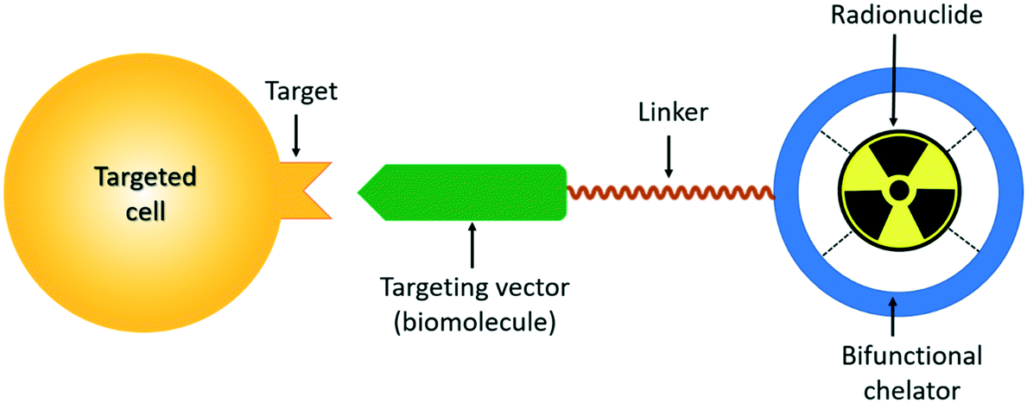

FIGURE 2-Schematic Overview of Targeted Peptide Receptor Radionuclide [The chelator enables labeling the ligand with radionuclides that enable both imaging and therapy][12]

- Principle- [13]

Some unstable or radioactive isotopes are utilized in diagnostic or therapeutic procedures because of their ability to break down or decay through the emission of nuclear particles.

There are 3 main kinds of radiation decay: γ Rays, α particles, and β particles:

- α Particles:
The biggest mass is found in α particles. However, because of the high charge, it does a considerable degree of harm to the nearby area by destroying DNA.

- β Particles:
There are electrons in β particles. Although they can be employed therapeutically, particles are less damaging than particles.

- γ Rays:
These are electron magnetic vibrations with a shorter wavelength than light yet similar to light.

- Mechanism of localization of RP [14]

The method of localization to disease cells is crucial to the effectiveness of molecular imaging technology using radioisotope-labeled molecules, also known as radiopharmaceuticals. In the sections that follow, we will go through various methods of radiopharmaceutical localization used in either the imaging or treatment of disorders.

Compartmental localization
Compartmentalization, or compartmental localization, is the word used to describe the phenomena in which the desired species are dispersed inside a bounded space. In essence, this bounded space is referred to as a compartment. In radiopharmacy, compartment-localization specifically refers to deploying a radiotracer in a constrained area and maintaining it there long enough to scan it. Fluids (either liquid or gas) can be found in the bounded space. Normal conditions cause the compartmental fluids to move predictably, while pathologic changes result in abnormal compartmental fluid mobility. If ignored and untreated, these conditions have the potential to be lethal. However, standard diagnostic methods are unable to pinpoint the precise area of the anomaly, which is where radio pharmacy comes in.
The vascular system (blood vessels), pulmonary airways, cerebrospinal fluid (CSF) space, abdominal (peritoneal) cavity, gastrointestinal (GI) tract, urine system, and lymphatic vessels are the compartments of biological systems.

The compartmental localization could be in the form of:
- Uniform distribution inside compartment
- Non-uniform distribution within compartment
- Outflow from compartment
- Flow within the compartment

a. Uniform distribution inside compartment:
The vascular system is the most common example of uniform dispersion inside a compartment. The tracer dilution method can be used to quantitatively analyze blood volume. The volume of blood plasma is measured using a radiopharmaceutical called I-125 RISA (Radio-Iodinated Serum Albumin), which diffuses evenly in blood plasma.
Another radiotracer used to measure the bulk of red cells (volume of red cells in the blood) is RBCs that have been labeled with Cr-51. This radiotracer evenly disperses throughout the cellular portion of the blood.
Using gated blood-pool scanning, a different radiotracer, technetium-99 m labeled RBCs, homogenously diffuses in blood, is utilized to assess the left ventricular expulsion fraction and wall movement.

b. Non-uniform distribution within compartment:
Radiopharmaceuticals are not always dispersed uniformly. They sometimes reveal non-uniform dispersion, which indicates a disrupted physiological process (due to a disease or damage). A radiopharmaceutical's increasing concentration in an organ or tissue is correlated with changes in that organ or tissue's normal physiological function (pathologic alterations).
Examples:
A bright-red bulge on the skin that has additional blood vessels and is quite rubbery is called a hemangioma. More blood means more blood vessels in that area. RBCs that have been technetium-99 m labelled exhibit enhanced localization in this area as a result of the increased blood volume.

c. Outflow from compartment:
Due to various pathologic changes (disturbances in normal physiological function), an unusual escape of content from compartmental space occurs. There are many tracers available in radiopharmacy that can detect and locate compartmental leakage with pinpoint accuracy.

d. Flow within the compartment:
The consequences of some pathologic alterations are changes in the extent, pace, and direction of compartmental flow, which must be evaluated and addressed. The best tool for determining how quickly gastric contents leave the stomach is 99mTc-sulfur colloids. Because 99mTc-sulfur colloid is not absorbed by the gastrointestinal tract, it is appropriate for this study. While 99mTc-sulfur colloid is mixed with water to measure the liquid emptying rate, it is bonded in scrambled eggs to measure solid emptying rate. Then, with a margin of error of two standard deviations, experimental values are contrasted with normal values. The scans also examine the frequency and existence of urine bladder to kidney backflow (caused by infections).

Passive diffusion:
To achieve homogeneity, passive diffusion refers to the random movement of molecules from higher to lower concentrations. The most typical example of passive diffusion is the evaporation of tea from a teabag into water. However, this movement often involves molecules moving across a membrane in a biological system. Molecules' ability to cross membranes is influenced by variables like pH, ionization, size, and lipid solubility.
As phospholipids, glycolipids, sphingolipids, and sterols are the prevalent types of lipids that make up membranes, with phospholipids serving as their fundamental component, lipid solubility is the main determining factor. Therefore, only molecules that are soluble in lipids, or lipophilic, can traverse membranes, whereas polar hydrophilic ones cannot.
Mechanism of 99mTc-DTPA (diethylene triamine penta-acetic acid)
The brain-blood barrier, also known as the BBB, is a significant element in the localization mechanism of radiotracers in the brain. It essentially consists of a homogeneous layer of endothelial cells from cerebral vessels that prevents the diffusion of lipophilic molecules and permits only lipophilic ones. This barrier is broken because of some physiological disorders, allowing hydrophilic substances to diffuse into the brain's tissues. While immunoglobulins (large particles), many lipophobic radiotracers, and other lipophobic (hydrophilic) particles cannot cross the barrier under normal circumstances, the radiotracers accumulate at the area of disruption when the barrier is disrupted. Oxygen, electrolytes, CO, glucose, water, and other smaller molecules diffuse passively across the barrier and use active mechanisms to move in the neural cells.
A common radiopharmaceutical used in 99mTc-DTPA brain imaging. Due to its lipophobic nature, it normally cannot diffuse across the barrier readily, but when the barrier is disturbed by abnormalities such as tumors and infections, 99mTc-DTPA can passively travel across the barrier and assemble in the infected area of the brain. Its biologic half-life is 1-2 hours, the plasma clearance half-time is 70 minutes, and 90% of the tracer is excreted via the urine system in 24 hours.

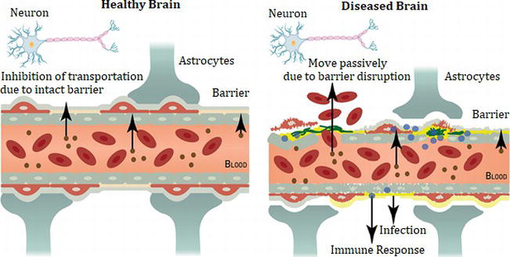

FIGURE 3 - Mechanism of localization of RP [14]

Phagocytosis:
The term "Phagocytosis" is taken from the Greek and means "Cell Eating" (a process in which a cell engulfs and internalizes a particle). As an illustration, Kupffer cells, also known as phagocytic cells, are found in the liver's lining and are involved in the destruction of red blood cells, entrapped radioactive colloidal particles after intravenous injection.

Capillary blockade:
This method relies most precisely on the micro-embolization phenomenon, which traps radiolabeled particles in the capillary bed and is used to measure the perfusion of organs like the brain, heart, and lung. Technetium-labeled macro aggregated albumin particles are typical radiolabeled particles utilized in pulmonary perfusion studies. The diameter of 99mTc-MAA particles is around 10 to 50 m, whereas the typical diameters of pre-capillaries and capillaries are 20 to 25 m and 8 m, respectively. Therefore, 99mTc-MAA particles administered intravenously physically impede blood flow to the distal portion of the lung by being lodged in arteriocapillary beds.

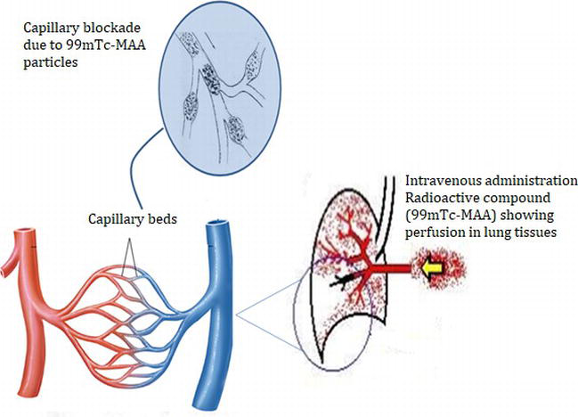

FIGURE 4 – Illustration of capillary blockade due to ^{99m}Tc-MAA accumulation in capillary beds. [14]

Cell sequestration:
The potentially saturable mechanism, which is mostly related to the spleen, describes the process of removing damaged and outdated RBCs from circulation. Given the comparatively limited number of cells employed for imaging, it is doubtful. Red blood cells are in vitro labelled with technetium-99m using the modified Brookhaven labeling process to create the radiopharmaceutical preparation. The cells are then damaged by being heated for fifteen minutes at 49°C.

Separate cell
Add ^{99m}Technetium
Reduce ^{99m} Tc
Incubate tube for 12-15 minutes at 49.5ºC
Inject
Centrifugation
Mix
Mix

FIGURE 5 Cell sequestration [14]

Chemisorption:
Chemisorption, often referred to as physiochemical adsorption, is the process by which phosphate-type substances such as methylene diphosphate (MDP), pyrophosphate (PYP), and hydroxy diphosphate (HDP) bond to the surface of bones. As a result, there is a greater buildup of radiopharmaceuticals at that surface with increased bone metabolism, including tumor, fracture, and infection. This process is used by 99mTc-MDP, 99mTc-PYP, and 99mTc-HDP to bind to bone tissues.

Example:
Chemisorption mechanism of 99mTc-PYP
Acute myocardial infarction imaging with 99mTc-PYP is an illustration of the chemisorption mechanism of localization. When myocardial cells become necrotic and calcium ions begin to enter the cells, myocardial infarction begins. Ca2+ ions and the body's circulating phosphate ions react, forming Ca3 (PO4)2 crystals. Hydroxyapatite crystals that were created as a result are found in the bone tissues. As seen in, 99mTc-PYP binds aggressively and irreversibly to calcium phosphate crystals near the infarct periphery where some perfusion is maintained. Following two hours of post-injection imaging.

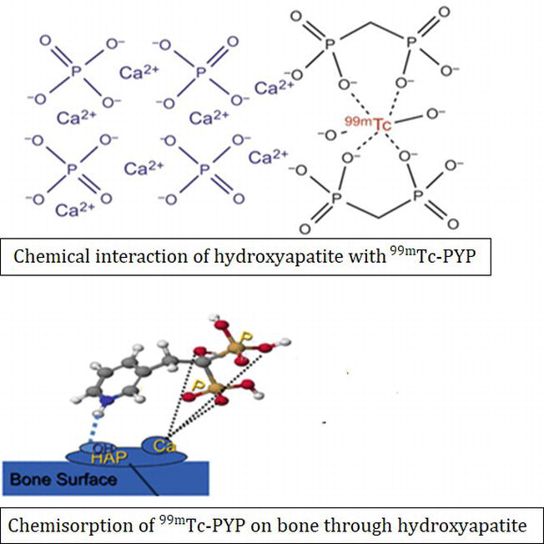

FIGURE 6 Chemisorption [14]

Filtration:
A prominent instance of diffusion known as filtration occurs when carrier molecules are forced to move through several channels and pores due to an osmotic or hydrostatic pressure gradient. The kidney's glomerular filtration provides an important illustration of this mechanism. To determine renal morphology or renal functioning, radiopharmaceuticals are used efficiently in renal imaging. Renal imaging is a result of two physiological processes, including tubular secretion and glomerular filtration. To further understand the glomerular filtration rate (GFR), agents cleared by glomerular filtration are used.

Active transport:
To advance a radiopharmaceutical through a cell membrane and into a cell, a body has an active transport pathway that is carrier-mediated, metabolic, and energy-reliant. ATP provides the energy needed for this reaction, enabling the transit of molecules up or down a concentration gradient. It is carrier selective, which explains how it can achieve saturation, or the maximal response offered when all carriers are engaged, by fitting a small number of molecules onto a specific carrier.
Example: An outstanding illustration of active transport is the concentration of iodide in the thyroid gland.

Facilitated diffusion:
Facilitated diffusion is a type of carrier-mediated membrane transport. It is a selective carrier membrane because, in essence, a carrier is used to transport the molecule across the membrane (i.e., only specific molecules can fit into the carrier). The presence of comparable molecules that can fit inside the carrier as a result inhibits it. Due to the scarcity of carriers, saturation might be reached to its maximum. Facilitated diffusion requires a concentration gradient to operate since it uses passive energy. However, in assisted diffusion, no external energy is used.
Example: The best illustration of enhanced diffusion is glucose.

Cellular migration:
A cell-directed physiological migration that occurs most often in response to certain stimuli. The primary illustration is the response of WBCs to inflammatory chemokines and cytokines. Ex-vivo labeling of phagocytic leukocytes (mostly neutrophils) with 99mTc-HMPAO and 111In-oxyquinoline are often utilized complexes for infection and sterile inflammatory site studies. In reality, research have expanded the use of leukocytes for radiolabeling that not only infiltrate pathogens but also identify infection foci. Autologous leukocytes chemotactically travel towards pathogens physiologically. For a higher-quality image, at least 2000 leukocytes per microliter should be labeled. These complexes were more susceptible to neutrophil-mediated infections because the majority of the labeled leukocytes were neutrophils. The place of infection, virulence, and stage of the infection all affect the absorption and movement of radiolabelled cells.

- How does RP work? [15]

Nuclear medicine therapy, which employs radiopharmaceuticals, is an effective and targeted method of treating specific types of cancer. As part of a therapeutic plan to cure, control, or alleviate the disease, radiation is delivered directly to tumorous lesions, either selectively or throughout the body.

The Benefits of Targeted Radionuclide Therapy:

- Specific Targeting:
Radiopharmaceuticals used in targeted therapy have a strong affinity for tumor cells, allowing them to deliver radiation to malignant cells while sparing healthy tissues. This selectivity decreases the possibility of adverse effects and injury to normal cells.

- Systemic Treatment:
Targeted Radionuclide Therapy is a systemic treatment that, unlike typical external beam radiation therapy, can reach cancer cells throughout the body via the bloodstream. This enables the therapy to target not only the original tumor but also distant metastases.

- Reduced Resistance:
Compared to other cancer therapies, targeted radionuclide therapy provides an advantage since cancer cells are less likely to develop radiation resistance.

- An ideal radiopharmaceutical for therapeutic purposes should comprise of :

- High Tumour Affinity:
The radiopharmaceutical should adhere to tumor cells firmly, ensuring efficient radiation delivery to malignant lesions.

- Target All Tumour Cells:
The radiopharmaceutical should be able to target all tumor cells, no matter where they are in the body.

- Healthy Tissue Protection:
The therapy should protect healthy tissues and organs from severe radiation exposure while delivering maximum radiation doses to the tumor.

- High Efficacy:
The radiopharmaceutical should effectively kill malignant tumor cells, resulting in tumor reduction and better patient outcomes.

How the therapy works?
The biological activity of radiopharmaceuticals is determined by the type of ionizing radiation generated by the radionuclide employed in therapy. Radionuclides emitting (alpha) or (beta) particles are recommended for targeted radionuclide therapy. These particles have small penetration ranges, allowing them to deliver their energy near their targets (tumor cells). This tremendous energy release in the tumor location maximizes the cancer-cell-damaging effect.
Nuclear medicine imaging procedures, on the other hand, frequently employ radionuclides that produce (gamma) radiation that can permeate the body for imaging purposes.
Overall, targeted radionuclide therapy is a promising method in cancer treatment, and continuous research and advances in radiopharmaceutical development are improving its effectiveness and safety.

- Radiation exposure & and units of radiation dose. [16]

- Exposure, limits of exposure of workers:
The Atomic Energy Regulatory Board (AERB) is India's regulatory institution in charge of guaranteeing radiation safety. Rule 15 of the Atomic Energy (Radiation Protection) Rules, 2004, is most likely concerned with the establishment of dosage limits for ionizing radiation exposures for workers and members of the public. These dose limits are set to keep radiation exposure safe and to safeguard persons from potentially hazardous effects.
For the most up-to-date and accurate information on the particular dose limits imposed by the AERB under Rule 15, I recommend visiting the Atomic Energy Regulatory Board's official website or researching the applicable laws and regulations from a credible legal source in India.

- Absorbed dose:
Several crucial ideas regarding radiation dosimetry and the assessment of radiation exposure are explained in the section you gave.

- Radiation absorbed dose:
The radiation absorbed dose is the energy that radiation exposure transfers to and absorbs by a unit mass of material. The radiation absorbed dose (rad), which is the most often used measurement of absorbed dose, is equal to 0.01 joules (J) of energy absorbed per kilogram (10-2 J/kg) of any material. The Grey (Gy), which is equal to 1 J/kg in the International System of Units (SI), is the unit for absorbed dosage. 100 rads are equal to 1 Gy.

- Roentgen and Rad Equivalence:
For soft tissue, the Roentgen (R) and the rad have roughly comparable magnitudes at moderate energies. The ionization of air caused by X-rays or gamma rays is measured by the Roentgen exposure unit. As was already mentioned, the rad measures absorbed dose.

- Critical organ:
The body's functionally crucial organ that receives the maximum radiation dose following the administration of a radiopharmaceutical is known as the critical organ. Given that this organ might be more vulnerable to the effects of radiation, it is crucial to take into account the dose given to it.

- Quality factor:
The quality factor is a dimensionless metric that is used to compare how well various radiation types affect biological responses. The level of ionization that is created in water determines QF values. A QF of 1 is assigned to radiation that deposits 3.5-kilo electron volts (KeV) of energy per micron and generates 100 ion pairs in 1 micron of water. QF = 2 is awarded to those who produce 100–200 ion pairs, and so forth.

- Dose equivalent:
The dosage equivalent is calculated by multiplying the absorbed dose by the quality factor. It accounts for the diverse biological consequences of various radiation types. The Roentgen-equivalent-man (rem), which is the conventional unit for dosage equivalent, is 1 rem, which is numerically equivalent to the absorbed dose in rad multiplied by the appropriate quality factor. The SI system uses the Sievert (Sv) as the unit for measuring dose equivalents, with 1 Sv being numerically equivalent to the absorbed dosage in Grey times the necessary quality factor.
So, to effectively measure and quantify radiation exposure and its potential biological consequences on human tissues and organs, it is crucial to comprehend these ideas. The switch from conventional measurements (rad and rem) to SI units (Gy and Sv) guarantees a standardized measurement system and globally accepted system for radiation dosimetry and safety.

- Annual limit of intake:
The Annual restriction on Intake (ALI) is a secondary dose restriction that is used to compare committed effective doses from ingesting particular radionuclides with the corresponding worker dose limits. The ALI is the quantity of a specific radionuclide that, if ingested over the course of a year, would cause a committed effective dose equivalent to the suitable equivalent dosage limit for employees.
Regulatory authorities ensure that workers' radiation exposure from certain radionuclides stays below acceptable limits by determining the ALI. The maximum annual equivalent dose from a radionuclide will always fall below the equivalent dosage limit if consumption is limited to less than its corresponding ALI, even if intake occurs every year for 50 years.

Table 1 - Annual limit for intake (ALI) of important radionuclides [16]

Radionuclide | ALI (ingestion) (Ci) | ALI (inhalation) (Ci) | Derived air conc. (DAC) (inhalation) (Ci/ml)
Tc-99m | 8 x 104 | 2 x 105 | 1 x 10-4
F-18 | 5 x 104 | 7 x 104 | 3 x 10-5
I-125 | 4 x 101 | 6 x 101 | 3 x 10-6
P-32 | 6 x 103 | 3 x 103 | 1 x 10-6
I-131 | 9 x 101 | 5 x 10 1 | 2 x 10-8

- Radioisotopes and Radiopharmaceuticals [17]

Collaboration and Communication:
Promote candid dialogue and teamwork among medical personnel involved in the patient's care. This makes it easier for people to share important information and ensures that the proper medication is provided at the right time and via the right channel.
The administration of radiopharmaceuticals can be carried out in a secure, dependable, and easy-to-understand manner by following these recommendations and upholding a strong commitment to patient safety and care.

Radioisotopes are radioactive forms of unstable elements that emit radiation to transform into more stable forms. They have unique properties. These make radioisotopes useful in a variety of industrial settings, including medicine, where they are utilized to create radiopharmaceuticals.

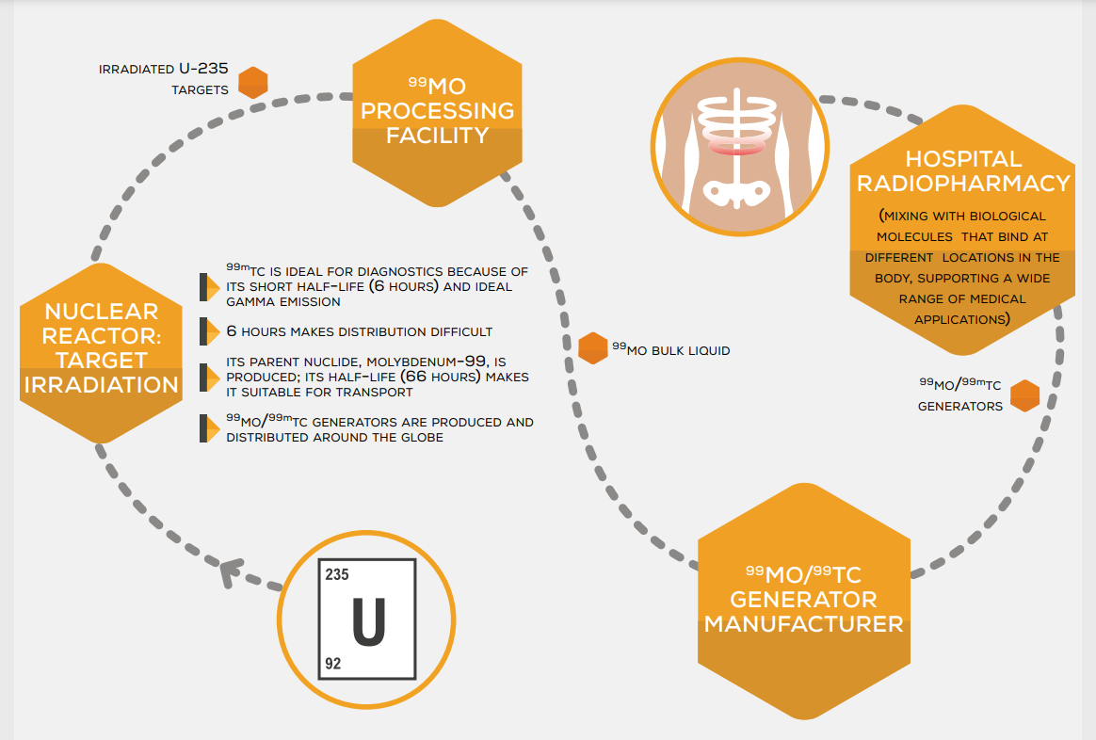

FIGURE 8 - THE PRODUCTION OF TECHNETIUM-99m RADIOPHARMACEUTICALS: ONE POSSIBLE ROUTE [17]

In research reactors and accelerators, radioisotopes are primarily created artificially but can also arise naturally. They are used in many different industries, including nuclear medicine, where radiopharmaceuticals are important.
In addition to having features that make them useful markers in medical diagnostic or therapeutic operations, radiopharmaceuticals are compounds that contain a radioisotope. Medical experts can receive precise information from the chemical makeup of radiopharmaceuticals to aid in diagnostics and therapies. The availability of 99mTc is currently reliant on the production of 99Mo in research reactors, which is used in 80% of all diagnostic medical scans performed globally.
With an increased focus on radionuclide therapy employing radiopharmaceuticals for the treatment of cancer, the number of medical operations requiring the use of radioisotopes is expanding globally.

Radioisotopes in metabolic therapies and applications:[18]

Table 2 of radioisotopes used for metabolic therapy: radioactive period (half-life), the energy of radiations, and applications [18]

Isotope | Half-life  (days) | Energy in keV  Gamma Beta |  | Main Therapeutic indications
Iodine-131 | 8 | 365 | 606 | Thyroid cancers  Treatments of neuroblastoma  Liver tumors
Phosphorus 32 | 14.3 |  | 1710 | Treatments of polyglobulias
Samarium 135 | 1.95 | 103 | 634.703.  807 | Treatments of bone metastases
Strontium 89 | 50.7 |  | 1492 | Treatments of bone metastases and prostate cancers
Yttrium 90 | 2.7 |  | 2294 | Treatment of rheumatism
Erbium-169 | 9.40 |  | 344.352 | Treatment of rheumatism
Rhenium 189 | 3.78 |  | 939.1077 | Treatment of rheumatism

- Nuclear Pharmacy [11]

- Quality control:
Quality control of radionuclides is a crucial aspect of ensuring the safety, efficacy, and reliability of radiopharmaceuticals used in nuclear medicine. The quality control process aims to verify that the radionuclide and any attached vectors, if present, meet specific acceptance criteria based on their nature, preparation process, and intended use. Here are some key elements of quality control for radionuclides:

- Radionuclidic Purity:
Radionuclidic purity ensures that the radiopharmaceutical contains the desired radionuclide in the required amount without the presence of other radioactive contaminants. Testing is performed to detect and quantify any impurities or unwanted radionuclides.

- Radiochemical Purity:
Radiochemical purity assesses the proportion of the desired radiopharmaceutical compound in the preparation, excluding any impurities or by-products. High radiochemical purity is essential to ensure that the radiopharmaceutical functions as intended.

- Specific Radioactivity:
Specific radioactivity refers to the amount of radioactivity per unit mass of the radiopharmaceutical compound. It is critical to determine the appropriate dosage for effective imaging or therapy while minimizing unnecessary radiation exposure.

- Half-Life Verification:
The half-life of the radionuclide should be verified to ensure that it aligns with the intended application and allows sufficient time for the radiopharmaceutical to reach its target tissue.

- Absence of Radionuclide Decay Products:
The presence of radionuclide decay products should be assessed to ensure that they do not interfere with the intended imaging or therapeutic process.

- Stability Studies:
Stability studies are conducted to evaluate the shelf life of the radiopharmaceutical and to determine its stability under various storage conditions.

- Physiological Distribution Studies:
For radiopharmaceuticals that involve vectors or carriers, physiological distribution studies may be performed to assess the biodistribution and targeting of the radiopharmaceutical within the body.

- Sterility and Apyrogenicity:
Sterility testing confirms the absence of viable microorganisms in the radiopharmaceutical preparation, while pyrogenicity testing ensures that the preparation is free from fever-inducing substances (pyrogens).

- Particle Size (if applicable):
For radiopharmaceuticals in particulate form (e.g., colloids), particle size analysis is important to ensure proper biodistribution and targeting within the body.

- Compliance with Regulatory Standards:
Quality control procedures should adhere to relevant national and international regulations, guidelines, and pharmacopoeial standards.

Documentation:
Detailed documentation of all quality control tests and results is essential for traceability, regulatory compliance, and continuous improvement of the quality control process.Overall, quality control of radionuclides is a comprehensive process that involves a series of tests and assessments to verify the quality and safety of radiopharmaceuticals before they are administered to patients for diagnostic or therapeutic purposes. This process helps ensure that radiopharmaceuticals are of high quality and meet the necessary standards to deliver accurate and effective results.

Procurement [11]
Procurement of radiopharmaceuticals is a critical aspect of nuclear pharmacy operations due to the short half-lives of these radioactive drugs.

Here's a breakdown of the key points mentioned:

- Ordering from the Manufacturer:
Given the short life of radiopharmaceuticals, nuclear pharmacists typically order these drugs directly from the manufacturer. This approach ensures that the radiopharmaceuticals are as fresh as possible when they reach the pharmacy, maximizing their efficacy for diagnostic or therapeutic purposes. Overnight delivery is often used to minimize transit time.

- Isotope Storage Areas:
Since radiopharmaceuticals contain radioactive isotopes, their storage areas must adhere to strict rules and regulations. These storage areas are designed to ensure the safe containment and handling of radioactive materials. Shielding materials and appropriate safety measures are employed to protect pharmacy staff and the surrounding environment from potential radiation exposure. Separate Labs for Manipulation and Calibration: To prevent cross-contamination and maintain a safe working environment, nuclear pharmacies typically have two separate laboratories. One lab is dedicated to the manipulation and preparation of radiopharmaceutical dosage, where pharmacists and trained staff handle the radioactive drugs to create patient-specific doses. The other lab is specifically used for the calibration of doses, ensuring accuracy and consistency in the administered radioactive doses. Quality measures are essential to comply with regulations, maintain safety standards, and ensure the quality and effectiveness of radiopharmaceuticals used for diagnostic imaging or therapeutic purposes. Nuclear pharmacists play a vital role in handling these specialized drugs and ensuring they are prepared and administered safely and accurately.

Production of Radionuclides
The production of radiopharmaceuticals involves the synthesis and labeling of radioactive compounds with specific radionuclides for use in various medical applications, such as diagnostic imaging and targeted therapy. The process of radiopharmaceutical production typically involves the following steps:
Selection of Radionuclide: The first step is to choose the appropriate radionuclide based on the specific medical application. Different radionuclides emit different types of radiation (gamma rays, positrons, alpha particles, etc.), and their physical properties determine their suitability for various imaging or therapeutic purposes.
Radionuclide Production: Radionuclides are usually produced through nuclear reactions using particle accelerators (cyclotrons) or nuclear reactors. These reactions convert stable isotopes into radioactive ones, and the produced radionuclide is then separated and purified.

- Radiolabeling:
The selected radionuclide is attached to a specific molecule (ligand) that targets a particular biological process or organ in the body. The radiolabeling process may involve complex chemical reactions to introduce the radioactive isotope into the ligand while maintaining its biological activity.

- Quality Control:
Radiopharmaceuticals must undergo rigorous quality control to ensure their safety and efficacy. This includes testing for radiochemical purity, radionuclide identity and purity, chemical identity, and sterility.

- Formulation:
After quality control checks, the radiopharmaceutical is formulated into the desired dosage form (e.g., injectable solution, tablet, capsule) suitable for administration to patients.

- Dispensing and Distribution:
Radiopharmaceuticals are often dispensed in single-patient doses due to their short half-lives, which can range from minutes to hours. The radiopharmaceuticals are then distributed to medical facilities equipped with appropriate imaging or therapy equipment.

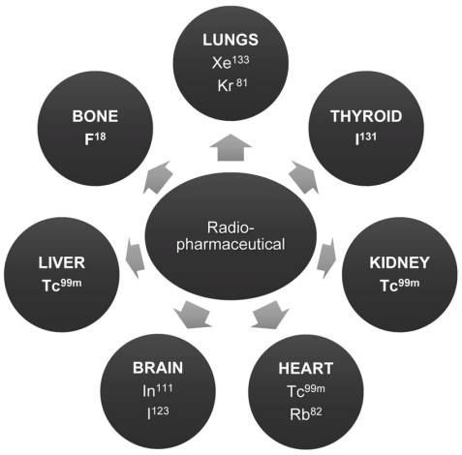

FIGURE 9 -Radiopharmaceuticals and their tissue distribution pattern. [39]

- Imaging or Therapy:
The radiopharmaceutical is administered to the patient according to the specific imaging or therapeutic protocol. In diagnostic imaging, the emitted radiation is detected by imaging devices (e.g., PET, SPECT, gamma cameras) to create images that reveal the distribution of the radiopharmaceutical in the body. In targeted therapy, the radiopharmaceutical is designed to selectively deliver radiation to specific cancer cells, destroying them while minimizing damage to healthy tissues.

- Waste Management:
After use, any remaining radiopharmaceutical or its by-products are handled as radioactive waste and disposed of following strict regulations and guidelines. The production of radiopharmaceuticals requires expertise in nuclear medicine, radiopharmacy, and radiophysics, as well as adherence to strict regulations to ensure safety and quality. Radiopharmaceuticals play a crucial role in modern medicine, aiding in the diagnosis, staging, and treatment of various diseases, including cancer, heart disease, and neurological disorders. The radiopharmaceutical product status is determined using extremely well-specified production quality criteria.
The final product quality must meet the requirements outlined in the marketing authorization dossier and be authorized by the various drug regulators. Furthermore, the production process must be repeatable from batch to batch. Radionuclides and labeled substances produced using a method other than the one officially approved by the authorities and linked to an approved pharmaceutical manufacturing process are referred to as "radiochemicals," as opposed to the officially approved "radiopharmaceuticals."
The compounds utilized in the development of a novel tracer or medicine have the status of radiochemical products. Those injected into humans in the context of clinical research, however, are subject to the same types of controls as licensed radiopharmaceuticals. As a result, they must adhere to the same product-quality guidelines to avoid injuring or risking the lives of patients.[19]

The Development of Radiopharmaceuticals [19]

Historical Context:
The successful application of iodine in the treatment of thyroid cancer was a significant milestone in the use of radioisotopes for therapeutic purposes. However, after this initial success, progress in therapeutic radiopharmaceuticals seemed to stall for a considerable period. Despite this, research during those years contributed to a better understanding of the mechanisms involved in the action of radioisotopes, improved imaging techniques, and the identification of suitable isotopes for therapy.

Advancements and Research:
With time and advancements in technology, researchers now have the tools and knowledge to develop ideal radiopharmaceutical molecules. The industry has matured, and the focus is on developing more effective second-generation and third-generation radiopharmaceuticals. Researchers are exploring new avenues, including alpha therapy, to improve cancer treatment options.

Time and Investment:
Developing a new drug, including radiopharmaceuticals, requires a significant amount of time and financial investment. The process involves extensive research, preclinical studies, clinical trials, regulatory approvals, and manufacturing, all of which contribute to the lengthy development timeline.

Third Generation and Beyond:
The text mentions the evaluation of third-generation radiopharmaceutical products. These newer molecules may offer improved efficacy and safety profiles compared to earlier generations. Ongoing research in laboratories continues to explore new approaches and potential breakthroughs, such as alpha therapy, for enhanced cancer treatment. In summary, the development of radiopharmaceuticals for cancer therapy is a complex and time-consuming process. Over the years, progress has been made, leading to the emergence of more effective radiopharmaceutical molecules in the twenty-first century. Continued research and investment in the field hold promise for further advancements and improvements in cancer treatment using radiopharmaceuticals.

Challenges in the production of RP [20]
There are currently over 100 radiopharmaceuticals made using reactor or cyclotron-produced radioisotopes that are utilized for the diagnosis of various prevalent ailments and the therapy of a few selected diseases, including cancer. The manufacture of radiopharmaceuticals necessitates the handling of huge amounts of radioactive material as well as chemical processing. Import, operation, and maintenance of processing facilities, compliance with codes of current good manufacturing practices (cGMP), ensuring effective quality assurance and quality control (QA & QC) systems, registration of products with national/regional health authorities, and radioactive material transport are all aspects that must be addressed in radiopharmaceuticals production, including radioisotope production.
Unlike normal pharmaceutical production, radiopharmaceutical production is still on a small scale, and establishing the cGMP rules that apply to the drug business is both difficult and costly. Ensuring cGMP compliance is a difficult undertaking for a small-scale company since it requires attention to various factors before, during, and after production. These include the training of qualified personnel, the use of controlled materials and procedures, the availability of qualified equipment, the production of products in designated clean areas, the use of validated processes and analytical methods, full process documentation, and the release of the final product by a qualified person. The application of clean room standards in radioisotope laboratories in general, and hot cells in particular (Fig. 2), is technically challenging to be consistent with both radiological and pharmaceutical safety criteria. By providing required papers, holding training courses, and supporting technical cooperation projects, the Agency enables its Member States to improve radiopharmaceutical manufacturing to achieve cGMP as adapted to radioactive goods.
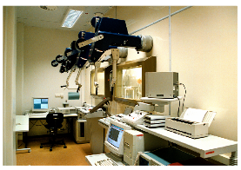
FIGURE 10: Hot cells with manipulators used for radioisotopes/radiopharmaceuticals production are available from commercial sources. [21]

The use of PET in routine diagnostic imaging has increased over the last decade, as has the use of PET radiopharmaceuticals, particularly fluorine-18 in the form of fluorodeoxy glucose (18F-FDG). Thicker shielding and more advanced handling mechanisms are required for the accompanying 511 keV high-energy radiation. Because of the short half-lives, the emphasis is shifting to process validation and rigorous adherence to approved protocols in all stages of manufacturing, rather than relying just on final QC test findings. The invention of microprocessor-driven automated synthesis modules has resulted from the necessity for the rapid, remote, and dependable synthesis of PET radiopharmaceuticals. This knowledge has also led to the creation of comparable automated synthesis module systems for additional radiopharmaceuticals.

- Quality assurance [13]

Radiopharmaceutical quality assurance is a critical process that ensures the safety, potency, and dependability of these products. Quality assurance methods are implemented throughout a radiopharmaceutical's lifecycle, from raw material procurement to patient administration. Here are some major components of radiopharmaceutical quality assurance:

- GMP (Good Manufacturing Practises):
Radiopharmaceutical manufacturing facilities must follow GMP requirements. These practices provide the standards for radiopharmaceutical manufacturing, testing, and quality control to assure consistent and dependable production.

- Radiochemical Purity:
Testing is performed to ensure that the radiopharmaceutical contains the proper radioactive isotope and that there are no major impurities that could compromise the product's safety or efficacy.

- Chemical Purity:
The non-radioactive components of the radiopharmaceutical are analyzed to verify they meet defined purity parameters.

- Quality Control Testing:
Extensive quality control testing is undertaken at various stages of manufacture to guarantee that the radiopharmaceutical satisfies specifications and is safe for usage. This involves testing for radionuclide identity, purity, radiochemical purity, and sterility (if applicable).

- Stability studies:
Are performed on radiopharmaceuticals to evaluate their shelf life and how environmental conditions such as temperature, humidity, and light may affect their integrity.

- Calibration and Dosimetry:
The equipment used to administer radiopharmaceuticals, such as dose calibrators, is calibrated and checked regularly to ensure correct and consistent dosages.

- Personnel Training:
Personnel engaged in the production, handling, and administration of radiopharmaceuticals receive extensive training in quality assurance processes

- Documentation and Record Keeping:
To follow the history of each radiopharmaceutical batch and to promote traceability and accountability, detailed documentation of all production and quality control activities is maintained.

- Radiation Safety Standards:
To protect both patients and employees from unwanted radiation exposure, strict radiation safety standards are followed during production, handling, and delivery.

- Regulatory Compliance:
Radiopharmaceutical manufacturing facilities must adhere to local and international regulatory standards and undergo frequent inspections to ensure adherence to safety and quality criteria.

- Adverse Event Reporting:
Adverse events associated with radiopharmaceutical usage are observed, reported, and evaluated to detect potential problems and enhance safety.

- Concentration of Radionuclide:
The radiopharmaceutical must contain the precise concentration of the desired radioactive isotope. This ensures that the dose provided is precise and consistent.

- Radiochemical Purity:
The radiochemical purity of a radiopharmaceutical refers to the percentage of the radioactive isotope that is present in its designated chemical form. It assures that there are no substantial contaminants that could compromise the safety or efficacy of the product.

- Sterility:
To prevent infections in patients, radiopharmaceuticals intended for injection or infusion must be sterile. To ensure that the product is devoid of living germs, sterility testing is required.

- Apyrogenicity:
Apyrogenicity means that the radiopharmaceutical does not contain any compounds that cause fever (pyrogens). To avoid unpleasant responses in patients, radiopharmaceuticals that are injected or infused should be free of pyrogens.

- Absence of Visible Foreign Particle Matter:
Radiopharmaceuticals should be free of any visible foreign particle matter that could damage patients during injection or infusion.

- Particle size:
If the radiopharmaceutical is administered as a particulate suspension or aerosol, the particle size should be within prescribed limitations to ensure proper distribution and delivery to the target area.

- pH:
The pH of the radiopharmaceutical solution is monitored and maintained to ensure that it is stable and compatible with the target tissue or organ.

- Packaging [13]

In the packaging radiation safe packing of radioactive pharmaceuticals. Radioactive pharmaceutical packaging from the industry must be packed and transported according to strict federal regulations. These regulations protect the public and transportation workers from the radiation exposure.

Industrial Packaging:
This type of packaging is used for materials that are considered to have low levels of radioactivity and are only slightly hazardous. It is designed to retain and protect the contents during regular transportation activities.
Examples of items shipped in industrial packaging include laboratory samples and smoke detectors.

Type-A Packaging:
When radioactive materials have higher levels of radioactivity than those considered safe for industrial packaging, they are shipped using Type-A packaging. This type of packaging ensures that the contents are protected and maintains sufficient shielding during transportation.
For example -Type-A packages are commonly used for transporting radiopharmaceuticals and certain regulatory-qualified industrial products.

Type-B Packaging:
When the radioactivity of the materials exceeds the limits for Type-A packaging, Type-B packaging is required. This type of packaging is used for transporting materials with high levels of radioactivity. Type-B packages are typically larger and heavier than Type-A packages, providing enhanced shielding against radiation. An example of materials shipped using Type-B packaging is spent fuel from nuclear power plants.
The strict federal regulations for radioactive pharmaceutical packaging and transportation are in place to safeguard the public and transportation workers from potential radiation exposure, ensuring the safe handling and transport of these materials.

- Handling [13]

Precautions while handling RP
The standards outlined are critical safety precautions that must be taken when working with radioactive substances. Following these standards protects employees and the environment from potential radiation dangers. Let's go over each criterion in depth:

- Reduce Radio Toxicity:
When working with radioactive materials, make every effort to use isotopes with the lowest radio toxicity feasible. Choosing proper isotopes helps to prevent potential risks to those who work with the drugs.

- Minimise Use:
Use only the amount of radioactive material required for the desired process or experiment. The risk of unnecessary exposure and contamination is reduced by reducing the quantity.

- Protective Clothing:
When working with radioactive materials, always wear suitable protective clothes such as lab coats, gloves, and shoe covers. These things serve as barriers against potential skin contact and help to keep contamination at bay.

- Hygiene and Contamination Prevention:
Thorough hygiene practices are essential for preventing internal contamination. This involves regularly washing hands and avoiding contacting the face, mouth, or eyes while working with radioactive materials.

- Hand washing:
It is critical to properly wash hands after working with radioactive materials to remove any potential contamination.

- Safe Pipetting:
Instead of utilizing oral pipettes, which pose the risk of inadvertent consumption, use specialized pipetting instruments designed for securely handling radioactive chemicals.

- Radiation Level Checks:
Check the radiation levels in the workstation and any objects utilized during the experiment regularly. This guarantees that radiation exposure remains within safe limits and aids in the early detection of any possible problems.

- Proper Disposal:
Dispose of all radioactive waste in appropriately labeled containers. Follow recognized processes and standards for radioactive waste disposal.

Role of Radiopharmacist in handling RP. [13]

- Clinical Role and Patient Care: Radiopharmacists can actively assist in patient treatment within the nuclear medicine section as part of their clinical role. They can work with nuclear medicine doctors and other medical experts to offer advice on how radiopharmaceuticals should be used for particular medical diseases. They might also work on patient-specific treatment programs and dose optimization.

- Research and Development: Radiopharmacists can participate in the investigation and development of novel radiopharmaceuticals. This could entail taking part in studies, clinical tests, and medication development initiatives. They are crucial in developing the field and enhancing patient outcomes because of their knowledge of radiopharmaceuticals.

- Radiation Safety: Radiation safety is an important part of radiopharmacy practice. To safeguard themselves and patients, radiopharmacists are well-versed in radiation safety procedures and must ensure that all staff members involved in radiopharmaceutical handling follow adequate safety practices.

- Interdisciplinary Collaboration: Radiopharmacists frequently work in interdisciplinary teams, partnering with nuclear medicine specialists, radiologists, technologists, and other healthcare professionals. This collaboration is critical for providing complete patient care and getting the best treatment outcomes.

- Quality Control and Assurance: Radiopharmacists are responsible for maintaining high-quality standards in radiopharmaceutical manufacturing and distribution. Before administering the products, they perform quality control procedures to ensure their purity and potency.

- Patient Counselling: Radiopharmacists can provide patients receiving radiopharmaceutical therapy with important information and counseling. This ensures that patients are aware of the procedures, potential side effects, and any precautions that must be taken.
Overall, radiopharmacists have a varied role in radiopharmaceutical safety and efficacy. Their clinical knowledge, research participation, educational contributions, and commitment to quality make them vital members of the nuclear medicine healthcare team.

- Storage [13]

Unquestionably, safe management of radiopharmaceuticals requires adequate storage and respect for national radiation protection guidelines. The following are some crucial considerations:

- Designated Storage Location: Radiopharmaceuticals should be stored in a location that has been specifically designated for that purpose. To avoid any possible cross-contamination or unintentional radiation exposure, this area should be isolated from other medications and supplies used for everyday life.

- Tightly Closed Containers: To reduce the possibility of radiation leakage and preserve the quality of the product, radiopharmaceuticals should always be stored in containers that are securely closed.

- Radiation Protection Standards: Strictly follow all applicable international and national radiation protection regulations. When working with ionizing radiation, these regulations are intended to protect the environment, staff, and patients.

- Shielding and Containment: To prevent unneeded radiation exposure, the storage facility should have the requisite shielding and containment procedures in place. This comprises radiation-blocking containers or cabinets lined with lead to safeguard the personnel handling the radiopharmaceuticals.

- Monitoring and Dosimetry: Implement regular monitoring and dosimetry procedures to gauge the personnel's and the storage area's radiation exposure levels. This aids in making sure that radiation levels stay within safe ranges and that any possible problems are quickly identified.

- Education and Training: Everyone who handles radiopharmaceuticals should receive thorough instruction on radiation safety, including the proper handling, storage, and disposal techniques. Staff members are kept up to date on safety procedures and best practices through ongoing education.

- Segregation and Waste Disposal: Separate radioactive waste properly and dispose of it by recommended procedures.

- Waste Segregation and Disposal: Use proper waste segregation techniques and follow approved disposal protocols for radioactive waste. This prevents environmental pollution and lessens risks to waste handlers and the general public.

- Emergency procedures: Have precise emergency procedures in place in the case of a spill or accident with radiopharmaceuticals. Personnel should be able to respond quickly and safely to minimize any potential harm.

- J. Regulatory Compliance: Make sure that all handling and storage procedures adhere to the rules and regulations established by the appropriate national and international regulatory agencies.
The handling and storage of radiopharmaceuticals can be done with the highest level of safety and adherence to radiation protection requirements by adhering to certain best practices and safety precautions. In addition to assuring the efficient use of this crucial medical equipment, this safeguard both the patients and the healthcare professionals.

- Labelling [13]

To maintain patient safety and regulatory compliance, all radiopharmaceutical manufacturers must adhere to labeling rules. To ensure that radiopharmaceuticals are handled and administered correctly by patients and healthcare personnel, their containers must be properly labeled. The following details need to be on the major container's label:

- Radioactivity Symbol: Either the global radioactivity symbol or a clear indication that the item is radioactive should be present on the label. The purpose of this notice is to inform staff and patients about potential radiation concerns.
- Name of the Radiopharmaceutical Preparation: To facilitate identification, the precise name of the radiopharmaceutical should be prominently written on the label.

- Medical or Diagnostic Intent: The label of the preparation should identify whether it is intended for medical or diagnostic use.

- Route of Administration: To assist healthcare professionals during the administration procedure, the recommended route of administration (such as intravenous, oral, or intramuscular) should be specified.
- Expiration Date and Time: To make sure that the radiopharmaceutical is used before it loses its effectiveness or becomes hazardous, the expiration date and, if appropriate, the time, should be provided.

- Manufacturer's Allocated Batch (Lot) Number: To enable tracking and quality control, the batch (lot) number assigned by the manufacturer should be provided.

- Total Volume: For solutions, it is important to specify the radiopharmaceutical's complete volume in the container.

- Storage Requirements: To preserve the radiopharmaceutical's stability and integrity during storage, any special storage requirements relating to temperature and light should be listed on the label.

- International Radiation Symbol or Radioactive Statement: The product's outside container needs to bear either the international radiation symbol or a statement stating that it is radioactive. This makes people more aware of radioactive material's presence even before handling the inner container.
Radiopharmaceutical producers can help ensure the safe and efficient use of their products by following certain labeling recommendations, which also help them meet regulatory obligations by guaranteeing proper handling, administration, and disposal.
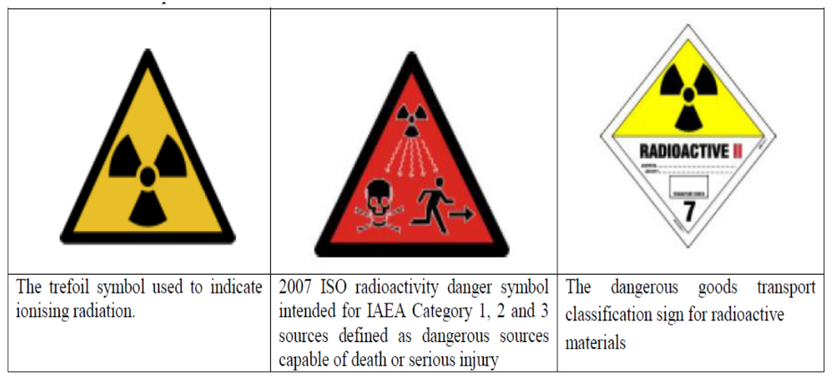

FIGURE 11: LABELLING OF RADIOPHARMACEUTICALS [13]

- Dispensing [13]

The distribution of radiopharmaceuticals is a crucial component of medical practice, and it is crucial to guarantee safety, dependability, and simplicity. The actions listed below can be followed to accomplish this:

a. Patient History and Assessment: It's important to look over the patient's medical background and current state before prescribing any radiopharmaceuticals. Take into account details including the patient's current health, previous medical conditions, allergies, and any other pertinent information that may have an impact on the radiopharmaceutical choice or dosage.

b. Patient's weight and body surface area: Radiopharmaceutical dosages are frequently modified by a patient's weight and body surface area. As they might considerably affect the efficacy and safety of the treatment, be sure the suggested dosage considers them.

c. Appropriate Dosage and Dosage Form: The right dosage and dosage form should be carefully chosen based on the patient's medical needs and the particular radiopharmaceutical that has been prescribed. This choice should be made by accepted procedures and standards.

d. Double-Check Procedures: Implement stringent guidelines and practices to double-check every step of the prescription and dispensing process. This entails checking the patient's identity as well as the accuracy of the medication, dosage, and dosage form.

e. Barcoding and Electronic Systems: Utilise barcoding and computer systems to track and manage radiopharmaceuticals, ensuring that the right medication is given to the right patient at the right time. The possibility of human error during the dispensing procedure can be considerably decreased by these devices.

f. Training and Education: Ensure that everyone participating in the dispensing process has received thorough instruction on how to handle radiopharmaceuticals safely. Maintaining a high level of safety and dependability requires regular training sessions and updates on best practices.

g. Quality Assurance Programs: Establish quality assurance programs to systematically examine and audit the dispensing procedure. This can support the ongoing improvement of safety and dependability by pointing out any potential problems or places for improvement.

h. Standard Operating Procedures (SOPs): Develop concise and thorough standard operating procedures (SOPs) for the whole dispensing procedure, from prescription review to patient administration. SOPs guarantee that each process is standardized and carried out consistently, reducing the possibility of mistakes.

i. Collaboration and Communication: Promote candid dialogue and teamwork among medical personnel involved in the patient's care. This makes it easier for people to share important information and ensures that the proper medication is provided at the right time and via the right channel.

The administration of radiopharmaceuticals can be carried out in a secure, dependable, and easy-to-understand manner by following these recommendations and upholding a strong commitment to patient safety and care.

XViI. Disposal [22]

a. Compliance with Regulations and Guidelines: When disposing of radiopharmaceuticals, care must be taken to follow all applicable municipal, state, and federal laws as well as the recommendations of reputable organizations that deal with radiation protection and waste management.

b. Disposal of Remaining Radiopharmaceuticals: Any radiopharmaceuticals that have not been used should be disposed of properly by the relevant rules. This could entail using authorized radioactive waste disposal facilities or giving the provider the leftovers.

c.Bodily Fluid Disposal: To avoid any potential contamination, patient urine, feces, and other bodily fluids that may have residues of radiopharmaceuticals should also be handled and disposed of correctly.

d. Decommissioning and decontamination:
To avoid any unintentional radiation exposure, equipment that comes into contact with radiopharmaceuticals should be properly decommissioned and decontaminated before it may be used again.

e. Record-keeping: It's important to keep precise records of how radiopharmaceuticals are disposed of. This comprises information on the kind and quantity of the material disposed of, the date of disposal, and the disposal technique.

f. Safety precautions: To reduce the risk of radiation exposure, radiopharmaceuticals should be handled carefully and disposed of according to established safety standards.

g. Environmental factors: To avoid any potential harm to the environment, disposal techniques should also take environmental factors into account.
Healthcare facilities and experts can ensure the safe and proper disposal of radiopharmaceuticals, minimizing potential dangers, and conforming to regulatory requirements by following these recommendations and best practices. The efficient and secure use of radiopharmaceuticals in medical imaging and therapy depends on responsible and knowledgeable disposal procedures.
- Phenomenon of radioactive decay & the radiation modes of radioactive decay
The section gives a summary of radioactive decay, the various particles and rays that are released throughout the process, and the properties of each form of radiation.

Radioactive Decay and Stability:
Radioactive decay is the process by which a radioactive nucleus changes from an unstable state to one that is more stable. The total quantity of nucleons (protons and neutrons) and the protons to neutrons ratio determine the stability of the nucleus. According to the p/n ratio and other nuclide characteristics, elements with lower atomic numbers may have stable and radioactive isotopes while elements with higher atomic numbers typically have unstable isotopes.

Types of Emissions:
Various particles and rays may be emitted from the nucleus during radioactive decay. These are some examples:

- Alpha (α) particles: Are helium nuclei made up of two protons and two neutrons. They have minimal penetration and can be halted by matter as small as a few micrometers to a few tens of micrometers.
- Negatrons (electrons) or positrons (positively charged electrons) are beta particles. For total attenuation, beta particles require several millimeters to several centimeters of materials.
- Gamma (λ) rays are the most energetic photons of electromagnetic radiation and have the greatest penetrating capability. They can be dampened by a few centimeters of thick material, such as lead.

Other Emissions:
In addition to gamma rays, radioactive decay can entail isomeric transition (IT), electron capture (EC), internal conversion (IC), and X-ray and Auger electron emission. These processes have the potential to influence the overall energy release and radiation emitted during decay.

Decay Laws and Half-Life:
A radionuclide decays according to probability laws with a characteristic decay constant and follows an exponential law. The half-life (T1/2) of a radionuclide is the time it takes for a given quantity to decay to half its initial value. Each radionuclide has a unique half-life, radiation energy, and emission type.

Penetrating Power:
Different forms of radiation have different penetrating capabilities. Alpha particles have the least penetration, beta particles have moderate penetration, and gamma rays have the most penetrating power. Dense materials such as lead are used to attenuate gamma rays, with higher-density materials giving greater radiation attenuation.
Overall, understanding the features of radioactive decay and the qualities of radiated radiation is critical for radiation safety, radiation shielding, and numerous uses in nuclear medicine, industry, and research.

- Alpha decay
Alpha decay is a type of radioactive decay that occurs when an unstable atomic nucleus produces an alpha particle to acquire higher stability. An alpha particle has a mass of 4 atomic mass units (AMU) and a charge of +2 elementary charges since it is made up of two protons and two neutrons. It is virtually comparable to a helium-4 nucleus or a helium ion with a charge of +2 due to its composition.
Natural alpha decay occurs when radioactive nuclei with an excess of nucleons (protons and neutrons) in their nucleus emit an alpha particle to lower the quantity of nucleons and migrate toward a more stable configuration. The energy of the released alpha particles typically ranges from 1.8 to 11.7 MeV (million electron volts).
On the other hand, alpha particles (He ions) can be created and accelerated to even higher energies in artificial processes. Particle accelerators, such as cyclotrons and linear accelerators, may accelerate alpha particles to energies of many GeV (gigaelectron volts). These high-energy alpha particles are employed in nuclear physics investigations, medical therapies (such as targeted alpha therapy for cancer treatment), and material science studies. Scientists and researchers may examine and alter matter at the atomic and subatomic levels thanks to the high energy of artificially accelerated alpha particles.

- Negatron decay
Beta decay (β- decay):In nuclei containing extra neutrons, a form of radioactive decay known as beta decay (also known as - decay) takes place. In this process, a neutron turns into a proton and the nucleus releases an electron (-) and an antineutrino (v*). The electron (β-): which arises from the nucleus at the time of decay, has the same mass and electrical charge as an orbital electron.
Because a neutron is converted into a proton during the beta decay process, the atomic number is increased by 1.
The nuclear reaction n p + - + v*, where n stands for a neutron, p for a proton, - for the electron that is emitted, and v* for the antineutrino that is emitted, can be used to describe the occurrence of - decay.
The antineutrino (*) is a subatomic particle that carries energy but has no mass or charge. It is crucial for the beta decay process's momentum, spin, and energy conservation.
A particular radionuclide's emission of - particles (electrons) can have a variety of energies, generating a continuum spectrum with energies ranging from a few KeV to 14 MeV.
The decay of 32P into 32S, which releases a beta particle and an antineutrino in the process, is an example of beta decay.

- Positron decay
When radioactive nuclei lack enough neutrons to form a stable structure, positron (+) decay takes place. A proton turns into a neutron during this process, and the nucleus also releases a positron (an electron with a positive charge) and a neutrino (v).
The nuclear reaction p n + + +, where p denotes a proton, n denotes a neutron, + denotes the positron emitted, and denotes the neutrino emitted, can be used to express the positron (+) decay.
A neutrino is also released during the positron decay process to maintain momentum, spin, and energy. Similar to - particles, + particles have a range of energies.
A proton becomes a neutron during positron decay, producing the mass of two electrons (one positron plus the difference between a neutron and a proton).
Energy must be at least 1.02 MeV for + decay to take place. When a proton becomes a neutron, this energy is required to change the mass equivalent to two electrons (1.02 MeV).
The conversion of fluorine-18 (18F) into oxygen-18 (18O) by generating a positron and a neutrino is an illustration of + decay: 18F → 18O + β+ + v.
Einstein's mass-energy equation (E=mc2) states that antimatter particles called fermions and electrons in matter destroy each other when they come into contact. This results in the transformation of mass into energy.
The positron emits all of its energy as it moves through matter during positron emission, eventually colliding with an electron to cause its annihilation. Two photons with a combined energy of 511 keV are released as a result of this operation and move in opposing directions.
The nuclear medicine imaging procedure known as "positron emission tomography" (PET) makes use of radiopharmaceuticals that have been tagged with positron-emitting radionuclides. When a positron and an electron annihilate, two photons are released at an angle of 180 degrees, and PET depends on the coincidence counting of these photons.
Overall, + decay is important for nuclear physics and is useful for medical imaging methods like PET, giving us important new information about a variety of physiological processes and aiding in illness diagnosis.

- Electron capture
In radioactive nuclei with fewer neutrons than required for a stable configuration and insufficient energy for positron + decay, electron capture (EC) decay takes place.
An orbital electron is taken into the nucleus during the electron capture process. This makes it easier for a proton to become a neutron, resulting in a nuclide with an atomic number reduction of 1.
The formula for the EC reaction is p + e- n + v, where p stands for a proton, e- for the captured electron, n for the neutron, and v for the neutrino that was released.
Because an atom (except for elements with extremely low atomic numbers) has several orbital electrons, electron capture is a probabilistic occurrence. The likelihood of EC varies depending on different electron shells, such as K-shell (innermost shell) and L-shell electrons.
In radioactive nuclei with fewer neutrons than required for a stable configuration and insufficient energy for positron + decay, electron capture (EC) decay takes place.
An orbital electron is taken into the nucleus during the electron capture process. This makes it easier for a proton to become a neutron, resulting in a nuclide with an atomic number reduction of 1. The formula for the EC reaction is p + e- n + v, where p stands for a proton, e- for the captured electron, n for the neutron, and v for the neutrino that was released.
Because an atom (except for elements with extremely low atomic numbers) has several orbital electrons, electron capture is a probabilistic occurrence. The likelihood of EC varies depending on different electron shells, such as K-shell (innermost shell) and L-shell electrons.

- Gamma decay
An atom's nucleus emits gamma rays when it changes from an excited state to a lower-energy state (the ground state). This transition can take place after other processes of radioactive decay, such as alpha decay, beta decay, or electron capture, have left the nucleus in an excited state.
Gamma-ray emission is a method for the nucleus to discharge extra energy and arrive at a more stable state. Gamma rays carry away the difference in energy levels between the excited and ground states of the daughter nucleus.
In comparison to X-rays, gamma rays have substantially higher energy. From several keV (thousands of electron volts) to several MeV (millions of electron volts), their energy can vary. Compared to that, X-rays typically have energies in the range of a few keV to a few hundred keV.
Gamma rays can penetrate electromagnetic waves because of their tremendous intensity. They are widely employed in many disciplines, including industrial radiography, nuclear medicine, gamma scintigraphy, and single-photon emission computed tomography (SPECT), all of which can penetrate a wide range of materials, including human tissue.
Unlike alpha particles (helium nuclei) and beta particles (electrons), gamma rays are not charged particles but are instead just electromagnetic radiation. Since they aren't charged, they can move across space in a straight line.
Gamma-ray emission occurs in conjunction with the majority of radioactive decays, but not all decays do so. The exact nuclear transition in question as well as the energy disparity between the initial and final nuclear states are important factors.
In conclusion, gamma rays are important in nuclear processes and have a variety of uses, including industrial imaging, materials testing, and medical diagnostics. They are also very energetic and piercing.

- Isomeric transition
Nuclear decay known as isomeric transition occurs when an excited nucleus de-excites by generating a delayed gamma ray. A nuclear isomer of the parent nucleus is created as a result of this procedure.
After a radioactive decay or nuclear transmutation, the nucleus changes from an excited state to a lower-energy state (ground state), which results in the emission of gamma rays.
Gamma-ray emissions often happen swiftly, in the range of nanoseconds, as the daughter nuclide's nucleus de-excites from the excited state to its ground state.
However, unique nuclear physics laws may make it difficult for the de-excitation process to occur from the higher state to the ground state under some circumstances. When this occurs, the excited state is said to be "metastable," which means it has a longer lifetime and de-excites more slowly.
The symbol "m" following the isomer's atomic number designates the excited state of a metastable nuclide. For instance, the technetium-99 isotope has a metastable state represented by 99mTc.
The daughter nucleus of nuclear isomers contains the same amount of protons and neutrons as the parent nucleus, but their arrangement is more stable.
Nuclear isomers and isomeric transitions are important nuclear physics phenomena with a variety of uses in fields like research, medicine, and industry. Understanding atomic behavior and nuclear decay processes depends heavily on the existence and characteristics of nuclear isomers.

- Practical use

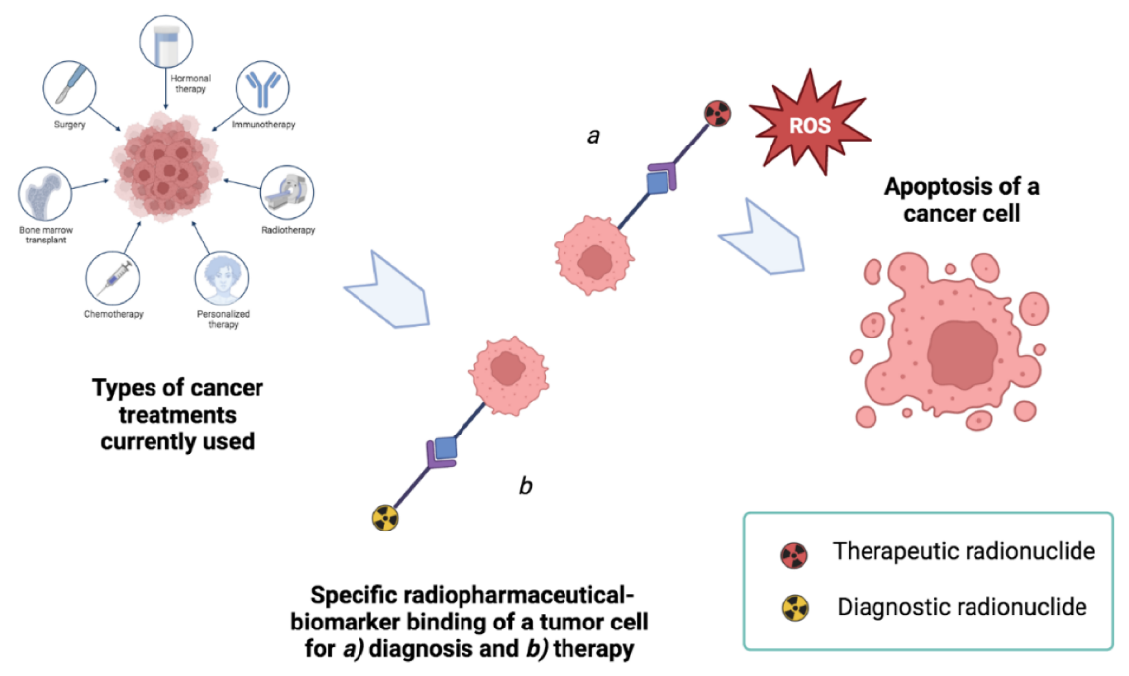

FIGURE 12: The concept of radio theranostics within the framework of treatments used in the case of cancer. In this case, the objective of the research is to develop pharmaceutical formulations that keep the radionuclide component unchanged but adapt the ligand component according to its (a) diagnostic or (b) therapeutic purpose [23]

- Diagnostic RP
Every organ in our bodies behaves differently in terms of chemistry. Several substances that are absorbed by specific organs have been identified by doctors and chemists. The thyroid, for example, absorbs iodine, while the brain uses large amounts of glucose. Radio pharmacists can use this information to attach various radioisotopes to biologically active drugs. When a radioactive form of one of these compounds enters the body, it is absorbed by regular biological processes and eliminated normally.[24]
Diagnostic radiopharmaceuticals can be used to monitor bone growth, and blood flow to the brain, liver, lungs, heart, or kidney function, and to corroborate other diagnostic tests. Another key application is predicting the effects of surgery and assessing changes since therapy.
The amount of radiopharmaceutical administered to a patient is just enough to gather the required information before it decays. The radiation dose received is negligible from a medical standpoint. The patient feels no pain throughout the test, and after a short time, there is no indication that the test was ever performed. This technique is a powerful diagnostic tool because of its non-invasive nature and ability to view an organ operating from outside the body. A radioisotope used for diagnostics must generate enough gamma rays to escape from the body and have a short enough half-life to decay away shortly after imaging is completed

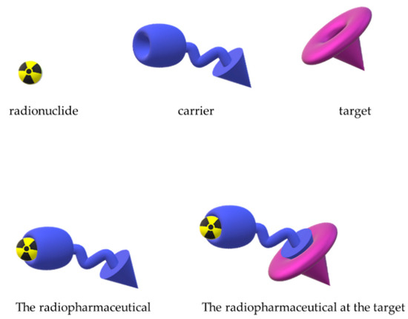

FIGURE 13 -Schematic representation of the linkage of the carrier and the radioactive atom to form the radiopharmaceutical that interacts with a specific biological target. [38]

Diagnostic radiopharmaceuticals are radioactive substances used in medical imaging to diagnose and evaluate various conditions and diseases. They are often administered to patients and emit gamma rays or positrons that can be detected by specialized imaging equipment, such as PET or SPECT scanners. These imaging techniques allow medical professionals to visualize and assess the function and structure of organs and tissues in the body. Here is a list of diagnostic radiopharmaceuticals and their uses: [25][26][27][28][29][30][31]

Ammonia N 13 Injection:
Indication: Diagnostic PET imaging of the myocardium under rest or pharmacologic stress conditions to evaluate myocardial perfusion in patients with suspected or existing coronary artery disease.
Chromium 51 (28 d) as chromium chloride injection:

Uses: Labeling red blood cells and quantifying gastrointestinal protein loss. Also used in a cyanocobalamin preparation for diagnosing pernicious anemia.

Dysprosium 165 (2 h):
Use: Aggregated hydroxide for synovectomy treatment of arthritis.

Fluorine 18 (F-18) as Fluoro-2-Deoxy-D-Glucose (FDG):
Uses: Imaging cerebral, myocardial, and tumor glucose metabolism using PET.

Holmium 166 (26 h):
Use: Being developed for the diagnosis and treatment of liver tumors.
Iodine 125 (60 d) as iothalamate sodium:

TABLE 3 [32]

Name | Investigation | Route of administration | In-vitro / in-vivo | Imaging / non-imaging
I125-fibrinogen | Clot imaging | IV | in-vivo | Imaging

Uses: Diagnostic evaluation of kidney filtration rate and diagnosing deep vein thrombosis. Also used in radioimmunoassays to detect hormones in small quantities.
Iodine 131 (8 d) as sodium iodide:

TABLE 4 [32]

Name | Investigation | Route of administration | In-vitro / in-vivo | Imaging / non-imaging
I131-Iodide | Thyroid uptake | Oral | In-vivo | Non-imaging
I131-Iodide | Thyroid metastases imaging | Oral or IV | In-vivo | Imaging
I131-MIBG (m-  iodobenzylguanidine) | Neuroectodermal tumor imaging | IV | In-vivo | Imaging

Uses: Diagnostic aid for studying thyroid gland function and scanning the thyroid to determine the size, position, and possible tumor location. Also used as sodium iodohippurate for studying kidney function.

Iron 59 (46 d) as ferric chloride solution:
Use: Studies of iron metabolism in the spleen.

Lofetamine HCl 123 (IMP):
Use: Non-invasive evaluation of local cerebral blood flow in cerebrovascular accidents.

Oxygen-15 as H2O:

TABLE 5 [32]

Name | Investigation | Route of administration | In-vitro / in-vivo | Imaging / non-imaging
O15-Water | Cerebral blood flow imaging  Myocardial blood flow imaging | IV bolus | In-vivo | Imaging

Uses: Equilibrium studies of tissue water content and as a tracer for regional blood flow.

Potassium 42 (12 h) as potassium chloride injection:
Use Determination of exchangeable potassium in coronary blood flow.

Rubidium 86 as rubidium chloride injection:
Use Determination of myocardial blood flow.

Selenium 75 (120 d):
TABLE 6 [32]

Name | Investigation | Route of administration | In-vitro / in-vivo | Imaging / non-imaging
Se75-Selenorcholesterol | Adrenal gland imaging | IV | In-vivo | Imaging
Se75-SeHCAT (23-Seleno-25-homo-tauro-cholate) | Bile salt absorption | Oral | In-vivo | Imaging

Use: Studies of digestive enzyme production using seleno-methionine.
Sodium 24 (15 h) as sodium chloride injection:

TABLE 7 [32]

Name | Investigation | Route of administration | In-vitro / in-vivo | Imaging / non-imaging
Na24-Na+ | Electrolyte studies | Oral or IV | In-vitro | Non-imaging

Use: Studying sodium exchange.

Xenon-133 (5 d):
Use: Pulmonary (lung) ventilation studies.

Gallium 67 (78 h) as gallium citrate:
Uses: Tumor imaging and localization of inflammatory lesions (infections).

Indium 111 (2.8 d):

TABLE 8 [32]

Name | Investigation | Route of administration | In-vitro / in-vivo | Imaging / non-imaging
In111-DTPA (diethylenetriaminepenta-acetic acid) | Ventriculo-peritoneal shunt (LaVeen Shunt) | intraperitoneal injection | In-vivo | Imaging the radioactive substance
In111-DTPA (diethylenetriaminepenta-acetic acid) | Cisternography | Intra-cisternal | In-vivo | Imaging
In111-Leukocytes | Infection/inflammation imaging | IV | In-vivo | Imaging
In111-Platelets | Thrombus imaging | IV | In-vivo | Imaging
In111-Pentetreotide | Somatostatin receptor imaging | IV | In-vivo | Imaging
In111-Octreotide | Somatostatin receptor imaging (Octreoscan) | IV | In-vivo | Imaging

Uses: Imaging of neuroendocrine tumors using indium-111 pentetreotide. Also used for radiolabeling autologous leukocytes and platelets and for imaging prostate cancer with indium-111 cepromab peptide.

Strontium 89 chloride:
Use: It is a radioisotope used to deliver radiation to cancer sites, particularly for decreasing bone pain in certain cancer types.
Thallium 201 (73 h) as thallous chloride:

TABLE 9 [32]

Name | Investigation | Route of administration | In-vitro / in-vivo | Imaging / non-imaging
Tl201-Tl+ | -Non-specific tumor imaging  -Thyroid tumor imaging  -Myocardial imaging  -Parathyroid imaging | IV | In-vivo | Imaging

Uses: Diagnosis of coronary artery disease, and other heart conditions such as heart muscle death, and locating low-grade lymphomas.
These radiopharmaceuticals play a crucial role in modern medicine, helping healthcare professionals gain valuable insights into patients' conditions and facilitating appropriate diagnosis and treatment planning.

- Therapeutic RP
Therapeutic Radiopharmaceuticals are radiolabeled compounds that are used to give therapeutic doses of ionizing radiation to sick areas. The hypothesis that some radionuclides with particle emission, such as alpha and beta radiations or low-energy low-range electrons (Auger electrons), have the power to damage sick cells has given rise to therapeutic applications of radiopharmaceuticals. In therapy approaches, the dual features of these agents represent either curative or palliative therapies. In contrast to the normal need that intravenous injections be genuine solutions, some radiopharmaceuticals are purposefully particle to achieve site-specific radioactivity localization in the body.
These specialized dosage forms enable imaging of the reticuloendothelial system's primary organs (liver, spleen, and bone marrow) with radiolabeled colloidal particles, the cardiac blood pool with radiolabeled red blood cells, and lung perfusion with albumin aggregates.[33]
Radioisotopes are useful both internally and outside. The dose could be ended by removing the sources if the radioisotopes are employed externally or as implants in sealed capsules in a tissue. When administered as an unsealed source, the dose cannot be stopped by removing the source. In therapeutic applications, the total dosage can be computed using the isotope's effective half-life, concentration, and the kind and energy of radiation emitted[34]
The harmful effect of high-energy radiation on human cells is exploited in therapeutic applications. Therapeutic radioisotopes have longer half-lives and higher energy than diagnostic radioisotopes.[24]
Radioisotopes have been utilized in medicine for their ability to deliver targeted radiation to specific cells or tissues, making them valuable tools in treating certain diseases. The following are a few examples of how radioisotopes are utilized for therapeutic purposes
Radioimmunotherapy for Non-Hodgkin's Lymphoma: Radioimmunotherapy (RIT) involves attaching a radioisotope to an antibody, which can then deliver radiation specifically to certain cells. In the case of non-Hodgkin's lymphoma, the radiopharmaceuticals I-131 tositumomab Y-90 ibritumomab, and Y-90 epratuzumab have been used as treatment options. [24]
Treatment of Cancers and Tumors: Various radioisotopes have been employed in the treatment of different types of cancers and tumors. Some of these isotopes include Americium-241, Californium-252, Cobalt-60, Gold-198, Holmium-166, Iodine-125, Iodine-123, Iodine-131, Rhenium-186, Iridium-192, Palladium-103, Samarium-153, Strontium-89, and Yttrium-90. Each isotope may have different properties and applications, but they are generally used to deliver targeted radiation to cancerous cells or tumor sites.[35]
Treatment of Thyroid Disease with Iodine-131: Iodine-131 (I-131) is commonly used for therapeutic purposes in the treatment of thyroid cancer and certain thyroid conditions such as hyperthyroidism. The isotope emits beta particles with a physical half-life of 8.1 days. It is selectively taken up by thyroid tissue and can be used to ablate any remaining thyroid tissue after surgery or to treat residual or metastatic thyroid cancer.

TABLE 10 [32]

Name | I131-Iodide | I131-Iodide | I131-Iodide | I131-MIBG (m-iodobenzylguanidine)
Treatment of | Thyrotoxicosis | Non-toxic goiter | Thyroid carcinoma | Malignant disease
Route of administration | IV OR ORAL | IV OR ORAL | IV OR ORAL | IV

Palliative Treatment of Bone Metastasis: Bone metastasis occurs when cancer spreads to the bones, and palliative treatment aims to alleviate pain and improve the quality of life. Radioisotopes like Samarium-153 (Sm-153), Strontium-89 (Sr-89) chloride, and Phosphorus-32 (P-32) sodium phosphate are commonly used for this purpose. These isotopes target areas of bone proliferation and emit beta particles that provide localized radiation to the affected bone tissue.[24]
Treatment of Arthritis: In the treatment of arthritis, two radioisotopes mentioned are Erbium-169 and Yttrium-90. Erbium-169 is used to relieve arthritis pain in synovial joints, while Yttrium-90, in the form of a silicate colloid, is used for relieving arthritis pain in larger synovial joints. Both isotopes are pure beta emitters and can provide targeted radiation to the affected joint, helping to reduce pain and inflammation[35]
It's important to note that the use of radioisotopes in medical treatments requires careful consideration and must be performed by qualified medical professionals. The choice of treatment depends on the specific condition and the individual patient's needs.

Other Uses of Radiopharmaceuticals
Radiosynoviorthesis, also known as radiosynovectomy is a therapeutic technique used to treat joint pain and inflammation, particularly in conditions such as rheumatoid arthritis. In this procedure, a radiopharmaceutical is injected directly into the affected synovial compartment, which is the space inside the joints that are filled with lubricating fluid.
The radiopharmaceutical used for radiosynoviorthesis is typically a beta-emitting radionuclide, which emits beta particles during radioactive decay. The beta radiation targets the inflamed synovial membrane, leading to the destruction of the abnormal synovial tissue. This, in turn, helps reduce pain and inflammation in the joint.
Various radionuclides have been utilized in radiosynoviorthesis, and the choice of radiopharmaceutical depends on the specific characteristics of the joint being treated. Some of the commonly used radionuclides for this purpose include:

TABLE 11 Phosphorus-32 (P-32)- [32]

Name | P32-Phosphate
Treatment of | Polycythemia and related disorders
Route of administration | IV or Oral

TABLE 12 Yttrium-90 (Y-90) -[32]

Name | Y90-Silicate | Y90-Silicate
Treatment of | Arthritic conditions | Malignant disease
Route of administration | Intra-articular | Intracavitary

TABLE 13 Samarium-153 (Sm-153)-[32]

Name | Sm153-EDTMP  (Ethylenediaminotetramethylenephosphoric acid)
Treatment of | Bone metastases
Route of administration | IV

TABLE 14 Erbium-169 (Er-169)-[32]

Name | Er169-Colloid
Treatment of | Arthritic condition
Route of administration | Intra-articular

The radiation properties of each therapeutic radionuclide determine its suitability and effectiveness for treating different joint sizes and conditions. The choice of the specific radiopharmaceutical and the dosage administered are carefully considered by medical professionals based on the patient's condition and the target joint.
Radiosynoviorthesis is a beneficial treatment option for managing joint pain and inflammation in certain cases of inflammatory joint diseases, especially when other conservative treatments have not been effective. It is a valuable addition to the range of therapeutic options available for patients with these conditions. However, as with any medical procedure involving radiation, it requires careful assessment and monitoring by experienced healthcare providers to ensure patient safety and optimal outcomes.

- Safety Considerations [16]

The security of those handling radiopharmaceuticals is unquestionably of utmost concern. To reduce radiation exposure and related hazards, it is crucial to put in place strict safety measures and abide by the ALARA (As Low As Reasonably Achievable) concept given their possible harmful effects on cellular structures.

Monitoring Personnel Safety:

- Radiation Monitoring gear: To quantify their radiation exposure, employees handling radiopharmaceuticals should wear the proper radiation monitoring gear, such as dosimeters. These tools aid in monitoring cumulative radiation doses and ensuring that exposure stays below acceptable ranges.

- Regular Training: Individuals handling radiopharmaceuticals must receive the proper instruction and training. Training should cover regulatory compliance, correct handling methods, emergency procedures, and radiation safety standards.

- Health Monitoring: Regular health examinations for employees who handle radiopharmaceuticals can identify any early-stage consequences of radiation exposure.

- Controlling Risk in Critical Operations:
Manufacturing and compounding of radiopharmaceuticals should be done in specialized facilities with sufficient ventilation and radiation protection. The quality and safety of the radiopharmaceutical products are guaranteed by strict adherence to GMP (Good Manufacturing Practises) regulations.

- Transport and Storage: To reduce radiation exposure, radiopharmaceuticals should be transported to approved places with the proper radiation protection. Radiopharmaceuticals should be delivered safely by adhering to the appropriate transport protocols.

- Testing and Quality Control: To guarantee the integrity and potency of radiopharmaceuticals, rigorous testing, and quality control processes are crucial. Critical elements of quality control include routine radiation level assessments and equipment calibration.

- Dispensing and Administration: To reduce radiation exposure during patient treatment, safe dispensing, and administration procedures should be followed. Personal protection equipment (PPE) that is suitable should be used during these processes.

ALARA Principle Considerations:

- Exposure Time: To lower cumulative radiation exposure, spend as little time as possible near radiopharmaceuticals.

- Distance: Follow the inverse square law and keep a larger gap between workers and radioactive sources wherever possible. Radiation exposure is decreased by moving further away from the source.

- Radiation Shielding: To prevent employees from unnecessarily being exposed to radiation, use the proper shielding materials, such as lead-lined cabinets or containers.
The ALARA concept and these specialized risk management strategies can help to reduce the potential negative effects of radiopharmaceuticals on employees. A thorough safety program in nuclear medicine facilities must include appropriate training, adherence to safety procedures, and strict radiation exposure monitoring.

TABLE 15 - RADIATION SIGN [16]

Restricted area | < 2 mR/h and < 100 mR/year
Caution, Radiation Area | may exceed 5 mR/h at 30 cm from the source
Caution, High Radioactive Area | may exceed 100 mR/h at 30 cm from the source
Danger, Very High Radiation Area | may reach 500 R/h at 1 m from source 952 (not in NM)
Caution Radioactive Material | 100 Ci for Cs-137 and Sr-89 954  1 mCi for Mo-99,  I-123 and Co-57 955 10 mCi for Tc-99m,  Ga-67 and Xe-133.

TABLE 16 -RADIATION SAFETY INSTRUMENTS [16]

GM survey meters | Laboratory survey
Portable ion chambers (cutie pies) | High-level exposure rate monitoring (In RPD)
Pocket dosimeter | Personnel exposure monitoring
Wipe test counters | GM counters to detect low-level activity
Film badges | To detect and measure personnel exposure
Thermoluminescent dosimeters | More sensitive than film badges

Scintillation detectors
- Scintillation survey detectors for gamma imaging of lab surfaces that are portable
- Single channel analyzers of the well type for measuring wipe tests
- Identification and measurement of gamma contamination using a multiwell gamma-ray spectrometer

- Radiopharmaceuticals and their kits [36]

The function of a Radiopharmaceutical Kit: A radiopharmaceutical kit is a product that comes in a vial and comprises non-radionuclide chemical components. Usually, these parts are sterilized and prepared for usage. The kit's goal is to make it possible to manufacture a radiopharmaceutical by adding the right radioisotope.
Applications for Diagnostic and Therapeutic Use: Radiopharmaceutical kits are used for both therapeutic and diagnostic applications. While therapeutic kits are used for targeted radiation therapy, diagnostic kits are utilized in SPECT and PET imaging (single-photon emission computed tomography).
In general, radiopharmaceutical kits are crucial equipment in nuclear medicine because they make it possible to prepare radiopharmaceuticals quickly and safely for both diagnostic and therapeutic uses. Nuclear medicine is progressing and finding more uses in healthcare thanks to the availability of such kits from suppliers like Parsisotope.

Theranostics
The term "theranostics," which combines the words "therapeutic" and "diagnostics," refers to a developing field of nuclear medicine where pharmaceuticals or methods are utilized in conjunction to diagnose and treat patients. After being labeled with radionuclides that have the right radiation for various uses, paratope theranostic radiopharmaceutical kits are utilized for diagnostic and therapeutic applications. These kits can be used to track and follow up on treatment using diagnostic imaging methods like SPECT or PET after the disease or linked cancer has been treated.

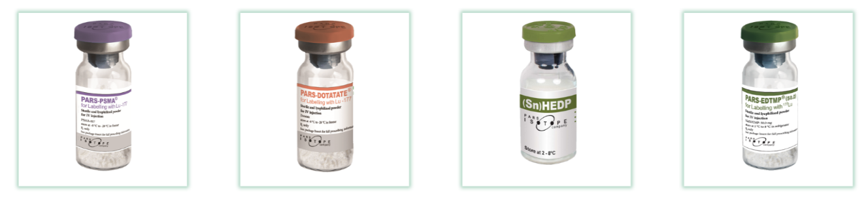

FIGURE 14 -PARS-LUTOPSMA, PARS-DOTATATE, PARS-HEDP, PARS-EDTMP [36]

Diagnostic / SPECT kits
The most often used radionuclide in nuclear medicine for diagnostic reasons is technetium-99m, which is used in morphological and dynamic imaging of numerous bodily organs to diagnose various disorders. This radionuclide is added to SPECT diagnostic radiopharmaceutical kits, which are subsequently used to image different human organs. One of the company's key and strategic products is its line of Parsisotope Diagnostic / SPECT kits, which are highly diverse, capable of detecting a variety of tumors and cancers, including neuroendocrine tumors and prostate cancer, and can diagnose the majority of diseases or organ failures in different body parts, including the brain, heart, liver, and kidney.
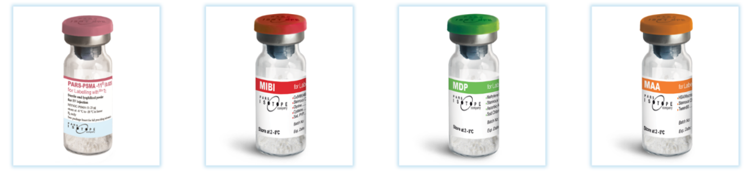

FIGURE 15 PARS-TECTO PSMA, MIBI, MDP, MAA [36]

Diagnostic/PET radiopharmaceutical kits
The PET scanning scanner is today regarded as one of nuclear medicine's most advanced, precise, and cutting-edge instruments since it can pinpoint the precise site of a tumor and track the development and spread of disease throughout the body. One of the most modern and effective diagnostic tools is the Parsisotope Diagnostic/PET radiopharmaceutical kit, which may be detected by a PET scanning scanner after being labeled with positron-emitting radioisotopes.

FIGURE 16 PARS-Galu-PSMA, PARS-Galu-TATE, PARS-Galu-FAPI [36]

- RP market and future trends.[20]

The sentence emphasizes the important role that regional manufacture and distribution of radiopharmaceuticals have had in the expansion of nuclear medicine specialties around the world. In addition to satisfying local demand and stabilizing the cost of imported radiopharmaceuticals, the availability of locally made radiopharmaceuticals also eliminates the need to ship radioactive materials across international borders.
Transporting radioactive materials presents difficulties and delays, thus adherence to transportation laws and regulations is essential. Multiple users of technetium-99m generators may be negatively impacted by cascading delays in raw material shipments of molybdenum-99, for example. Short-lived radioactive elements like thallium-201 and technetium-99m generators may have significant decay losses as a result of some nations' security procedures, such as holding up cargo before loading it onto aircraft. Patient appointments may be impacted, and the availability and use of radiopharmaceuticals may be impacted by the delays and decay losses.
A formal "Approval or Registration" process is required for marketing authorization for both locally produced and imported radiopharmaceuticals to ensure adequate control and supply of those drugs. Some nations have centralized radiopharmacies that examine and regulate radiopharmaceuticals before giving them to end users. Before joining the distribution chain, suppliers must be verified as adhering to Good Manufacturing Practices (GMPs) and product dossiers must be submitted. Many Member States who don't have a formal market authorization mechanism for radiopharmaceuticals could benefit from this method.
There is a global increase in demand for diagnostic and therapeutic radiopharmaceuticals, even in developing nations, despite regional variations in the level of local availability and utilization of radiopharmaceuticals. Through its technical cooperation support, the International Atomic Energy Agency (IAEA) aids nations in enhancing their capacities for the use of radiopharmaceuticals.
For a stable and effective supply of radiopharmaceuticals, to support the expansion of nuclear medicine practices, and to satisfy the rising demand for diagnostic and therapeutic radiopharmaceuticals globally, local production, proper distribution, and formal market authorization processes are crucial.

- RP EMERGING AS NEW CANCER THERAPY.[37]

CANCER TREATMENT RADIOTHERAPY
Radiotherapy is a vital and popular therapy for the treatment of cancer. It entails the use of radiation, such as X-rays, gamma rays, or particles, either alone or in conjunction with surgery or chemotherapy, to injure and eradicate tumors. Depending on the particular situation and tumor location, radiotherapy can be given either internally (brachytherapy) or externally (teletherapy).

Teletherapy
- The most popular form of radiotherapy used to treat cancer is teletherapy.
- It entails transferring radiation from a distant external source to the patient's body.
- Teletherapy frequently makes use of cobalt units, which deliver high-energy gamma rays, or linear accelerators, which produce high-energy X-rays or electrons.
- To gradually affect the tumor while minimizing harm to healthy tissue, treatment is typically administered daily for several weeks.
- To administer an even dose of radiation to the target and spare healthy tissues as much as possible, higher-energy beams and multiple angles of therapy are used.Modern teletherapy techniques:
- Newer methods including 3-D conformal radiation, intensity-modulated radiotherapy (IMRT), and image-guided radiotherapy (IGRT) have been made possible by technological advancements.
- These methods enable the radiation beam to be precisely shaped to fit the tumor's shape, increasing the tumor's dose while decreasing the radiation exposure to the surrounding healthy tissues.
- Similar to receiving an X-ray, patients often feel nothing physically during radiation.
- There could be side effects, including early reactions in quickly dividing tissues mimicking "sunburn," and late consequences in slow-dividing tissues like the kidney or the vasculature supporting the brain and spinal cord Geographical Sparing and Radiobiological Research:
- By better protecting essential organs during radiotherapy, modern technology reduces radiation exposure to healthy tissues.
- To achieve the greatest results, radiobiological research assists in selecting the most efficient treatment plans and optimizing the dose and delivery.

Quality Assurance
- A thorough quality assurance program is essential for guaranteeing the security and efficacy of radiation treatments.
- To ensure the precision of treatment planning, delivery, and dosimetry, regular quality assessments and protocols are in place.
Overall, radiation is essential for the treatment of cancer because it offers a focused, efficient method for eliminating cancer cells while sparing healthy tissues. The accuracy and results of radiation for cancer patients are continually being improved by ongoing research and technical improvements.

RADIONUCLIDE THERAPY
For the treatment of some forms of cancer, targeted radionuclide-based radiopharmaceuticals are a specialized and efficient method known as nuclear medicine therapy. Through the direct delivery of radiation to tumor cells while sparing surrounding healthy tissues, the therapy hopes to minimize adverse effects and enhance therapeutic results.
Radiopharmaceuticals in Therapeutic Purposes:
Therapeutic radiopharmaceuticals are made to have a strong affinity for tumor cells. They can connect precisely to antigens or receptors that are tumor-target structures. The radionuclide attached to the carrier molecule emits ionizing radiation that destroys the cancer cell's DNA and causes the tumors to shrink and disappear.

Key Characteristics of Ideal Radiopharmaceuticals for Therapy:
- Specificity to Malignant Tumours: To prevent harm to healthy tissues, the radiopharmaceutical should only act on cells of malignant tumors.
- Broad Coverage of Tumor Cells: All malignant tumor cells, regardless of where they are in the body, should be exposed to the radiopharmaceutical.
- Preservation of Healthy Tissues: The radiopharmaceutical should preserve healthy tissues and organs from severe radiation exposure while administering the maximal radiation to the tumor.
- Effective Elimination of Malignant Cells: A successful therapeutic outcome should result from the therapy's high efficacy in eradicating malignant tumor cells.

Biological Action and Radionuclides for Therapy:
- A radiopharmaceutical's biological effects are influenced by the type of ionizing radiation that the radionuclide emits. Radionuclides that produce (gamma) radiation are employed in nuclear medicine imaging to penetrate the body and offer diagnostic data.
- Radionuclides with short penetration ranges, such (alpha) or (beta) emitters, are chosen for radionuclide therapy. These radionuclides maximize the harm to cancer cells while preserving the surrounding healthy tissues since they release their energy near their targets (the tumor cells).
- Advantages of Targeted Radionuclide Therapy:
- Targeted radionuclide therapy provides a systemic treatment strategy by using the circulation to reach cancer cells all over the body.
- Targeted radionuclide therapy, as opposed to conventional chemotherapy, directly targets sick cells, minimizing side effects and harm to healthy tissues.

Diagnostic Radiopharmaceuticals:
Radioisotopes attached to biological molecules to target particular organs, tissues, or cells in the human body are known as radiopharmaceuticals. These radioactive medications can be used to diagnose illnesses and, in a growing number of cases, to treat them.
The number of radiopharmaceuticals being used in clinical settings is expanding quickly, giving the medical community improved access to detailed information on the traits of the various cancer forms.
A radiopharmaceutical is a substance consisting of a radionuclide and a carrier molecule that has a strong affinity, or binding power, for a tissue or a particular function of an organ in the human body. If a radioisotope exhibits the necessary biological characteristics, it may also consist exclusively of that radioisotope.

- Applications [42]

- Targeted radionuclide therapy is used to treat a variety of tumors, including bone metastases, thyroid cancer, and lymphomas. It is a powerful therapeutic approach that is frequently combined with other treatment techniques like surgery and chemotherapy to treat, lessen, or control these disorders.
- In general, radiopharmaceutical-based nuclear medicine therapy has revolutionized cancer treatment and offers a focused and precise method of battling cancer while minimizing damage to healthy tissues. The efficacy and safety of this important therapeutic alternative are always being improved by ongoing research and technical breakthroughs.
- Radiopharmaceutical science plays a crucial role in various medical applications, enabling the use of radioactive substances for diagnostic imaging, therapy, and research.
- Some of the key applications of radiopharmaceutical science include:
Diagnostic Nuclear Medicine Imaging: Radiopharmaceuticals are extensively used in nuclear medicine for diagnostic imaging. They are administered to patients, and their distribution and accumulation in specific organs or tissues are detected using specialized imaging techniques like PET (Positron Emission Tomography), SPECT (Single-Photon Emission Computed Tomography), and gamma camera imaging. These imaging modalities allow medical professionals to visualize the functioning and structure of organs and tissues, aiding in the diagnosis and staging of various diseases, including cancer, heart conditions, neurological disorders, and more.

Positron Emission Tomography (PET) Scans:
PET scans use radiopharmaceuticals labeled with positron-emitting radionuclides, such as Fluorine-18 (F-18) and Fluoro-2-Deoxy-D-Glucose (FDG). PET imaging is particularly valuable in oncology for detecting and characterizing tumors, assessing treatment response, and monitoring disease progression.
Single-Photon Emission Computed Tomography (SPECT) Imaging: SPECT scans employ radiopharmaceuticals labeled with gamma-emitting radionuclides, like Technetium-99m (Tc-99m). SPECT is widely used for imaging various organs, including the heart, brain, bones, and thyroid, aiding in the diagnosis of conditions such as myocardial infarction, brain disorders, and bone metastases.

Radionuclide Therapy:
Radiopharmaceuticals with therapeutic radionuclides are used for targeted radiation therapy in the treatment of certain cancers and other diseases. These radiopharmaceuticals selectively accumulate in specific tissues or tumor cells, delivering a therapeutic dose of radiation to the target area while sparing surrounding healthy tissues.
Thyroid Disorders: Iodine-131 is used for diagnosing and treating thyroid disorders, including hyperthyroidism and thyroid cancer. It is administered orally to assess thyroid function and selectively destroy thyroid tissue in cases of hyperthyroidism or thyroid cancer.

Radiosynoviorthesis:
Radiopharmaceuticals are injected into inflamed synovial joints to treat joint pain and inflammation, particularly in rheumatoid arthritis. Beta-emitting radionuclides are commonly used for this purpose.
Targeted Molecular Imaging: Radiolabeled antibodies or peptides are employed for targeted molecular imaging, enabling visualization of specific biomarkers associated with diseases. This approach allows non-invasive assessment of molecular and cellular processes in the body.

Quality Control and Research:
Radiopharmaceutical science also plays a vital role in the development, production, and quality control of radiopharmaceuticals used in medical applications. Research in this field focuses on improving the design and effectiveness of radiopharmaceuticals and exploring new applications for nuclear medicine.
Overall, radiopharmaceutical science has revolutionized medical imaging and therapy, allowing for more accurate diagnoses, targeted treatments, and a deeper understanding of physiological processes. Its applications continue to expand, contributing to advancements in personalized medicine and improved patient outcomes.

- ADVANTAGES AND DISADVANTAGES OF RP

Advantages [40]
- Diagnosis and Treatment: Radiopharmaceuticals serve a dual purpose. They can be used for diagnostic imaging, providing valuable information about the structure and function of organs and tissues. Additionally, they can be utilized as a targeted treatment for certain medical conditions.

- Fast Onset of Pain Relief: Radiopharmaceuticals can be employed for pain relief, particularly in cases of bone pain caused by cancer or other conditions. They offer rapid relief, making them a valuable tool in palliative care.

- Cancer Treatment: Radiopharmaceuticals are commonly used in the treatment of cancer. Radioactive substances are administered to target and destroy cancerous cells while minimizing damage to healthy tissues nearby.

- Treatment for Multiple Disease Sites: Radiopharmaceuticals can be designed to target specific disease sites within the body. This targeted approach makes them highly effective in treating conditions such as cancer, thyroid disorders, and bone metastasis.

- Widely Available Mode of Treatment: Radiopharmaceuticals are widely available in healthcare facilities, including hospitals and specialized nuclear medicine centers. This accessibility makes them an integral part of medical care.

- Direct Tumor Treatment: Radiopharmaceuticals can be tailored to directly treat tumors. The radioactive substances are designed to accumulate in the tumor, delivering a concentrated dose of radiation precisely where it is needed.

- Single Dose Effectiveness: In some cases, a single dose of a radiopharmaceutical can be sufficient for treatment. This offers convenience to patients and reduces the need for multiple treatment sessions.

- Applicability to Pediatric Patients: Nuclear medicine tests using radiopharmaceuticals can be safely performed on children, aiding in the diagnosis and management of pediatric diseases.

- Minimal Side Effects and Safety: Radiopharmaceuticals used in nuclear medicine procedures are generally well-tolerated, causing minimal side effects compared to other treatments like chemotherapy. Additionally, when administered and handled correctly, they pose no long-term risk to the patient or healthcare provider.

Disadvantages [41]
- While radiopharmaceuticals offer several advantages in healthcare, they also come with certain disadvantages and potential risks. Here are some of the drawbacks associated with their use:

- Prolonged Inconvenience and Discomfort: In some cases, the administration of multiple fractions of radiopharmaceuticals for treatment purposes can lead to prolonged inconvenience and discomfort for patients. This may be due to the need for repeated procedures or treatment sessions.

- Potential for Adverse Effects on Specific Organs: Higher doses of radiation, especially in the head and neck region, can be associated with various complications such as cardiovascular issues, thyroid dysfunction, and pituitary axis dysfunction. These risks are particularly relevant when treating tumors or diseases in these areas.

- Non-Recommended for Pregnant Women: Nuclear medicine tests involving radiopharmaceuticals are generally not recommended for pregnant women, as unborn babies are more sensitive to radiation than children or adults. The potential risk to the developing fetus outweighs the benefits of the procedure.

- Distortion in Dental Imaging: In dental imaging procedures that use radiopharmaceuticals, such as filling materials in teeth, dental braces, or permanent bridges, there may be some distortion around the mouth area, which can affect the accuracy of imaging results.

- Allergic Reactions: Some patients may experience allergic reactions to radiopharmaceuticals. Although such reactions are rare, they can occur and range from mild to severe.

- Radiation Risk: As the name suggests, radiopharmaceuticals involve the use of radiation. While the doses used in medical procedures are carefully controlled to minimize harm, there is still a risk of radiation exposure. Proper safety measures are taken to ensure that the benefits outweigh the potential risks.

- Myelosuppression: Myelosuppression refers to the reduction in the production of blood cells, which can occur as a side effect of radiopharmaceutical treatments, especially in patients who have received prior chemotherapy. This can lead to a decreased ability of the bone marrow to produce red blood cells, white blood cells, and platelets.

- Conclusion

Radio Pharmaceutical Science stands at the forefront of modern medicine, revolutionizing the fields of diagnostic imaging and targeted therapy. Its multidisciplinary nature brings together expertise from chemistry, physics, biology, and medicine to create and utilize radiopharmaceuticals that have transformative impacts on patient care. Diagnostic imaging techniques like SPECT and PET have redefined how we visualize and understand the inner workings of the human body. With the ability to assess molecular processes in real-time, clinicians can make more accurate diagnoses, detect diseases at early stages, and tailor treatment plans to individual patients, thereby improving overall outcomes and quality of life.
The advent of Radionuclide Therapy, with its targeted approach and minimal impact on healthy tissues, has shown great promise in the management of cancer and various other diseases. As research continues, we can expect further refinements in treatment strategies, leading to even more effective and personalized therapies.
However, challenges remain in the production, standardization, and regulatory aspects of radiopharmaceutical development. Efforts to optimize production methods, enhance quality control processes, and ensure widespread availability of radiopharmaceuticals are essential to advancing this field and making these groundbreaking treatments accessible to patients worldwide.
Moreover, the integration of artificial intelligence and machine learning is unlocking new opportunities in radiopharmaceutical science. These technologies facilitate improved image analysis, dosimetry calculations, and treatment planning, enabling clinicians to make data-driven decisions that maximize treatment efficacy while minimizing potential side effects.
As the field continues to advance, researchers, healthcare professionals, and regulatory bodies must collaborate and share knowledge. By fostering an environment of continuous learning and innovation, we can accelerate the translation of research findings into practical applications, leading to even greater advancements in the realm of nuclear medicine.
In the future, we can expect Radio Pharmaceutical Science to play an increasingly prominent role in healthcare, as its applications expand beyond oncology to encompass neurology, cardiology, immunology, and other medical disciplines. With its capacity to unlock the mysteries of disease at the molecular level, this field offers boundless possibilities for improving patient outcomes and ushering in a new era of precision medicine.

REFERENCES

1. Edwards, C. L. (1979). "Tumor-localizing radionuclides in retrospect and prospect". Seminars in Nuclear Medicine. 9 (3): 186–9. doi:10.1016/s0001-2998(79)80030-6. PMID 388628
2. Hertz S, Roberts A (May 1946). "Radioactive iodine in the study of thyroid physiology; the use of radioactive iodine therapy in hyperthyroidism". Journal of the American Medical Association. 131: 81–6. doi:10.1001/jama.1946.02870190005002. PMID 21025609
3. Henkin R, et al. (1996). Nuclear Medicine (First ed.). ISBN 978-0-8016-7701-4
4. Lassen NA, Ingvar DH [in Swedish] (1961). "Quantitative determination of regional cerebral blood flow in man". The Lancet. 278 (7206): 806–807. doi:10.1016/s0140-6736(61)91092-3

5. Radiopharmaceutical Sciences -A section of Pharmaceuticals (ISSN 1424-8247) https://www.mdpi.com/journal/pharmaceuticals/sections/radiopharmaceutical_sciences
6. Radiopharmaceutical Science- https://en.wikipedia.org/wiki/Radiopharmaceutical
7. Front. Nucl. Med., 07 September 2022 Sec. Radiopharmacy and RadiochemistryVolume 2 - 2022 | https://doi.org/10.3389/fnume.2022.990330
8. https://www.researchgate.net/publication/351343882_12_RADIOPHARMACEUTICALS) and terminologies
9. Iverson (2007), "15.9.2 Radiopharmaceuticals", in Cheryl; et al. (eds.), AMA Manual of Style (10th ed.), Oxford, Oxfordshire: Oxford University Press, ISBN 978-0-19-517633-9
10.https://en.wikipedia.org/w/index.php?title=Radiopharmaceutical&section=1&oldid=1138045840&action=edit
11. https://www.researchgate.net/publication/351343882_12_RADIOPHARMACEUTICALS
12.https://www.google.com/url?sa=i&amp;url=https%3A%2F%2Fpubs.rsc.org%2Fen%2Fcontent%2Farticlehtml%2F2022%2Fmd%2Fd1md00364j&amp;psig=AOvVaw1E4nglwt4u9sGZBbTYteD&amp;ust=1690619660683000&amp;source=images&amp;cd=vfe&amp;opi=89978449&amp;ved=0CBEQjRxqFwoTCMjztZb_sIADFQAAAAAdAAAAABAZ)
13 https://www.researchgate.net/publication/351343882_12_RADIOPHARMACEUTICALS
14. S. Komal et al., ‘Localization Mechanisms of Radiopharmaceuticals’, Medical Isotopes. IntechOpen, Jan. 07, 2021. doi: 10.5772/intechopen.94099.
15. https://www.iaea.org/topics/radionuclide-therapy
16. https://www.who.int/docs/default-source/medicines/norms-and-standards/current-projects/qas13-542rev2-general-chapter-radiopharmaceuticals.pdf?sfvrsn=516dbf81_2
17. https://www.iaea.org/interactive/world-of-na/download/15-radioisotopes-and-radiopharmaceuticals.pdf
18. https://radioactivity.eu.com/doctor/metabolic_therapies
19. Zimmermann, Richard. "8. The Production of Radiopharmaceuticals". Nuclear medicine: Radioactivity for diagnosis and therapy, Les Ulis: EDP Sciences, 2017, pp. 161-180. https://doi.org/10.1051/978-2-7598-2149-5.c011
20. International Atomic Energy Agency: Radiopharmaceuticals production and Availability PDF
21. Radioisotope Handling Facilities and Automation of Radioisotope Production. IAEA-TECDOC-1430
22. https://noteskarts.com/wp-content/uploads/2023/01/Chapter-6-Radio-Pharmaceuticals-Storage-dispensing-and-disposal-of-Radio-Pharmaceuticals.pdf
23. https://doi.org/10.3390/diagnostics13071210
24. Jennifer Lilly Gutiérrez; Jennifer Gutiérrez B.S; Continuing Ed; Review of Radiopharmaceutical Use in Medicine; 2012; April 4
25. Chilton H.M and Witcofski R. L; Nuclear Pharmacy,Lea & Febiger, Philadelphia; 1986.
26. Wang Y; CRC Handbook of Radioactive Nuclides; Chemical Rubber Co., Cleveland, Ohio; 1969.
27. Davey R.J and Wallace M.E; Diagnostic and Investigational Uses of Radiolabeled Blood Elements; Am. Assoc. of Blood Banks, Arlington; 1987.
28. Sweetman S.C; Martindale; The Complete Drug Reference; Pharmaceutical Press, London, 34th ed; 2005;1522-1526.
29. Freeman L.M and Blaufox M.D; Physician’s Desk Reference for Radiology and Nuclear Medicine Editorial Consultants, 5th ed, Medical Economics Co., Oradell, N.J; 1976.
30. Gennaro A.R; Remington: The Science and Practice of Pharmacy; 20th ed., Lippincott Williams & Wilkins, Baltimore, MD; 2000; 469-482.
31. Swanson D.P et al.; Pharmaceuticals in Medical Imaging. Macmillan Publishing Co., Inc., New York, 1990.)
32. https://en.wikipedia.org/wiki/Radiopharmaceutical
33. MK Dar, MH Masoodi, S Farooq; Medical uses of Radiopharmaceuticals; PharmaTutor; 2015; 3(8); 24-29
34. Kowalsky R.J, and Falen S.W; Radiopharmaceuticals in Nuclear Pharmacy and Nuclear Medicine. USA; American Pharmacists Association (APhA); 2004; 6.
35. Radioisotopes in Medicine; Nuclear Issues; 2004.
36. https://parsisotope.com/radiopharmaceutical-kits/
37. https://www.cancer.gov/news-events/cancer-currents-blog/2020/radiopharmaceuticals-cancer-radiationtherapy#:~:text=Once%20a%20radiopharmaceutical%20has%20stuck,to%20radiation%2Dinduced%20DNA%20damage.
38. Boschi, A.; Uccelli, L.; Martini, P. A Picture of Modern Tc-99m Radiopharmaceuticals: Production, Chemistry, and Applications in Molecular Imaging. Appl. Sci. 2019, 9, 2526. https://doi.org/10.3390/app9122526
39. Intricacies in the Approval of Radiopharmaceuticals – Regulatory Perspectives and the Way Forward - Scientific Figure on ResearchGate. Available from: https://www.researchgate.net/figure/Radiopharmaceuticals-and-their-tissue-distribution-pattern_fig2_330338244 [accessed 31 Jul, 2023]
40. Wei J, Mingfeng Q, Xia S, Yungping Q, Mingming S. Preparation of slow release pellets. Advances in Therapy. 2004;21(4):238-48.
41. Heng PW, Wang L, Tang E, Liew CV. Drying efficiency and particle movement in coating-impact on particle agglomeration and yield. Int J Pharm. 2008;350(12):172-80.
42. Production and Applications of Radiopharmaceuticals: A Review April 2019 DOI:10.5330/ijpi.2019.2.8 https://www.researchgate.net/publication/336103271_Production_and_Applications_of_Radiopharmaceuticals_A_Review

