THERMOPHILIC CONSORTIA FOR METHANE PRODUCTION THROUGH BIOCHEMICAL DIGESTION OF RICE STRAW

Shashikala K J ¹, Srinidhi R Kulkarni ² and Dr. C. M Kalleshappa ³.
- Assistant Professor, Department of Chemical Engineering, BIET, Davangere-04.
- Assistant Professor, Department of Chemical Engineering, BIET, Davangere-04.
- Professor, Department of Chemical Engineering, BIET, Davangere-04.

ABSTRACT
From the remnants of agricultural stubble emerge lush paddy fields, wheat fields, and bountiful grain harvests. The phenomenon of biochemical digestion keeps promising potential for the generation of biogas. This study aimed to explore the viability of utilizing a thermo-philic strain derived from rice straw. The digestion process was meticulously conducted in a batch reactor, with a carefully maintained pH range of 7 to 8 and a constant temperature of 55ºC for duration of 24 days. The bio-gas digester's feedstock was prepared by maintaining a nitrogen-to-carbon ratio of 1:20. This mixture contained 8% dry biomass in solid form, comprising 65.9% volatile solids. The chapter is divided into two parts. The first segment outlines the CHNS methodology employed to assess the elemental and proximate composition of paddy straw. Notably, the C:N ratio within the paddy straw was determined to be 60:1. Furthermore, the hydrogen-to-carbon ratio in the cellulose feedstock was established at 1:7. Proximate analysis indicated that volatile solids constituted 65.20% of the total weight. The second part of the chapter delves into the bio-gas production process. Analytical findings revealed that the average composition of carbon dioxide and methane in the generated bio-gas was 52.95% and 45.98%, respectively. The bio-gas yield was measured at 0.484 m3/kg of volatile solids.
Outline
Preamble of the chapter
Aim of the Chapter
Methodology adopted in the chapter
Chapter Analytical results
Production of Bio-gas

Conclusion of the Chapter

Preamble
Rice straw is a by-product of rice production at harvest [1]. It is upper layer of the rice grains during harvest also ends up being piled out in the agricultural land depending on harvested manually and adopting machines [2]. Due to advancements in collection and utilization technologies, rice straw is progressively being harvested from the fields. It's now repurposed for more beneficial applications, including mushroom and energy production, as well as for use as cattle feed. [4]. Collecting rice straw remains a significant hurdle within the rice straw supply chain. Once harvested from the fields, rice straw bundles require compression into bales to enhance compactness and minimize transportation expenses. The advent of combine harvesters, which often leave rice straw behind in the fields, has further exacerbated the difficulty and increased the expense associated with rice straw collection. [7].
Due to increased difficulty and higher expenses, individuals have resorted to the practice of seasonal crop residue burning known as "stubble burning." This practice, predominantly carried out by farmers in Punjab and Haryana, significantly adds to the air pollution issues in the national capital. The resultant air pollution has dire implications for public health. In response to the air pollution crisis in the Delhi National Capital Region (NCR), both the central and state governments have introduced various awareness initiatives and subsidies. These endeavors aim to motivate farmers to cease the practice of stubble burning and instead adopt alternative methods for managing straw. [11] Since farmers lack cost-effective alternatives, they often resort to burning straw. To address this issue, we've worked on developing a processing technology that can convert agricultural residues like paddy straw into biogas. This innovative approach not only helps prevent straw burning but also generates revenue, providing farmers with an incentive to avoid burning straw altogether.
Aim of the work is to generate biogas from rice straw, study composition of rice straw (CHNS Analysis). Study optimization of parameters for anaerobic digester. study the characteristics and compositions of Biogas.
Methodology adopted in the chapter
Paddy straw biomass sourced from the local Davanagere region was selected as the primary material for biogas production. To optimize the biogas generation process, the paddy straw feedstock was fragmented into small 1 cm sections. Subsequently, these small sections were further ground down to 1 mm in size. This grinding process was undertaken to significantly increase the surface area of the biomass. The enhanced surface area facilitated better accessibility for fermentative microbes within the biogas digester.
For the formulation of the biogas digester feedstock, a C: N ratio of 20:1 was maintained, along with a solid content of 8%. Approximately 40 g of dry biomass was meticulously measured, revealing volatile solids (VS) content of 66.2% [10]. The paddy straw biomass was finely ground to a size ranging from <0.25 to 5.5 mm. This ground biomass was then immersed in water at a ratio of 1:10 and left to soak for duration of 24 hours. During this soaking process, the thermophilic consortium present in the soil was isolated. This consortium, obtained from a dump yard, was subsequently refrigerated at 4ºC for preservation [15].
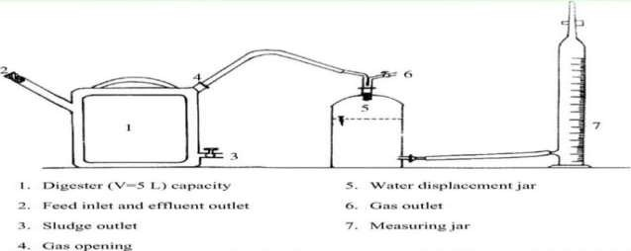
The exact temperature was maintained from 50 to 55ºC. It is composition of hydro-lytic, acido-genic, aceto-genic and methano-genic bacteria’s to conduct experiment under anaerobic condition to attain efficiently. [12]. The CHNS content of raw rice straw was ascertained using an elemental approach that relied on the carbon, hydrogen, nitrogen, and sulfur composition. The standard procedure was employed to estimate the Total Solids (TS) and total Volatile Solids (VS) present in the rice straw. [13]. The day to day production of methane by anaerobic digester was noted adopting the water displacement technique [18] and volume of methane with the respect to cumulative is estimated. Methane is appraised by adopting a gas chromatograph technique [19] with nitrogen as carrier gas. Selected feedstock was soaked for 24 h, before the plant setup, since this defines as a pre-treatment process (Fig 3.1).

Fig: 3.1 LABORATORY SETUP
Anaerobic process, plants release situations that enhance the natural break-down of organic matter using bacteria without air [16]. The occurrence of three primary products includes Biogas, which is a blend of carbon dioxide (CO2) and methane (CH4), utilized for generating heat and electricity. Fibre - can be adopted to enrich the soil by nutrient conditioner, and Liquor - can be adopted as liquid fertiliser. The phenomenon inside digester is composed with a warm and sealed without air containers. The digestion tank is processed with warm and mixed continuously to generate the optimum conditions for conversion into biogas [16].
In an anaerobic digestion plant, there are two types of process:

Mesophilic digestion – It is generally adopted in phenomenon during anaerobic digestion, especially in sludge treatment. Disintegration of the volatile suspended solids (VSS) is about 40% of attainment time between 15 and 40 days and temperature from 30 to 40ºC, which requires bigger digestion containers. It is generally more robust compare to thermophilic phenomenon, but the production of bio-gas is to be less along with sanitization is usually continued [17].

Thermophlic digestion – It is common and not as mature methodology when compared to mesophilic digestion. The digester temperature was maintained at 55ºC and kept for a period from 12 to 15 days. Thermophilic digestion Technique (TDT) gives maximum biogas production and an enhanced pathogen and virus, this technology is ‘kill’, more expensive, extra energy is required also it is essential to get more sophisticated with controled & instrumentation. The process of anaerobic digestion consists of four distinct phases: Hydrolysis, acidogenesis (which generates acids), acetogenesis (which produces acetic acid), and methanogenesis (responsible for methane production). [17].
Water Displacement technique (WDT) is day to day production of methane in each anaerobic digester is noted by adopting the WDT. The amount of water substituted within the vessel matches the overall volume of the gas. A unidirectional gas transfer device links the biogas setup on one end and an inverted measuring cylinder containing water on the other. The measured quantity of gas corresponds to the milliliters of water displaced. The biogas is gathered in the inverted measuring cylinder as water is displaced. [18].
Gas chromatography is technique is used to appraise the Methane. This technique is equipped with a thermal conductivity detector (TCD). The TCD senses which is turned in the thermal conductivity of the column liquid waste and compares with the reference flow of carrier gas, here nitrogen is used as carrier [19].
Elemental analysis involves examining a sample of a substance (such as soil, drinking water, bodily fluids, minerals, and chemical compounds) to determine its elemental and occasionally isotopic makeup. This analytical process serves both qualitative purposes, identifying the constituent elements, and quantitative purposes, measuring the relative proportions of each element present. [20]. Analytical chemistry encompasses elemental analysis. CHNS analysis swiftly determines carbon, hydrogen, nitrogen, and sulfur in organic matter (like rice straw) and various material types. It adeptly manages an array of sample formats—solids, liquids, volatiles, and viscous substances—in fields such as pharmaceuticals, polymers, chemicals, ecosystems, food, and energy. [20].
Proximate analysis is a standard test method of analysis (ASTM E1756-08, and E872-82) were used to analyze the proximate estimation is used to measure the Moisture content (MC), Total Solids (TS), Volatile Solids (VS), and Ash content in each bio-mass [21].

Results and Discussion of the chapter
Elemental analysis is depend on carbon, hydrogen, nitrogen and Sulphur composition was conducted in rice straw on daily basis. Table 2 displays the mean analytical results of the gathered rice straw samples.
Table 1 CHNS estimated value of rice straw (wt % basis)
Sample of rice straw (250gm) | Carbon (%) | Nitrogen (%) | Hydrogen (%) | Sulphur (%)
Sample 1 | 34.9 | 0.49 | 4.8 | 0.035
Sample 2 | 35.4 | 0.53 | 4.9 | 0.035
Sample 3 | 35.4 | 0.52 | 4.9 | 0.04
Average | 35.26 | 0.51 | 4.9 | 0.04
Proximate analysis, The gathered organic materials' biomass was assessed through proximate analysis to determine factors such as volatile solids and organic matter. These factors play a crucial role in the anaerobic digestion process, facilitating the generation of bio-gas. The proximate estimation adhered to established ASTM standards, enabling the calculation of moisture content (MC), total solids (TS), volatile solids (VS), and ash content in each biomass sample, as outlined in the provided table..

Table 2 Proximate estimation of various samples collected for biogas production in %
Sample Paddy straw (250 gm) | Moisture content % | Fixed carbon% | Volatile solids% | Ash content %
Sample 1 | 6.69 | 13.29 | 66.20 | 13.8
Sample 2 | 6.68 | 13.28 | 66.20 | 13.7
Sample 3 | 6.70 | 13.30 | 66.23 | 13.6
Average | 6.69 | 13.29 | 66.21 | 13.70

Production of biogas gives the details taken time to produce biogas. The study reveals that to generate biogas about four weeks was completed. It is clearly showed that biogas production was more in pioneer stage and initial period of incubation.
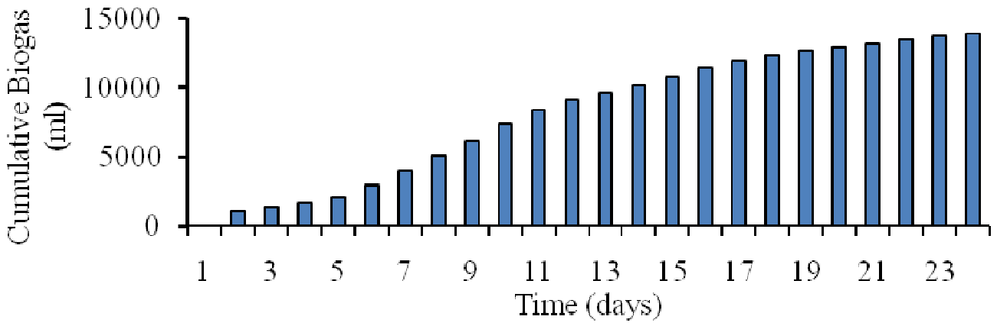
Fig. 1 Cumulative time to generate biogas production using paddy straw
From the first to the second week of incubation, the pioneer stage displayed a similar pictorial depiction and gradually increased. However, the rate of biogas generation that was notably at its highest ranged from 0 to 10775 ml during a set period of time. The output of biogas increased steadily over the first and second weeks of the experiment study, reaching a peak between 10,150 and 10,775 ml at the end of the time period. Except for a slight dip in week 3, biogas production experienced its pinnacle during the last and fourth weeks, reaching a peak of around 14,000 ml. The amount of biogas produced each day has climbed steadily over the last three to four days, totaling 600 ml by day's end.

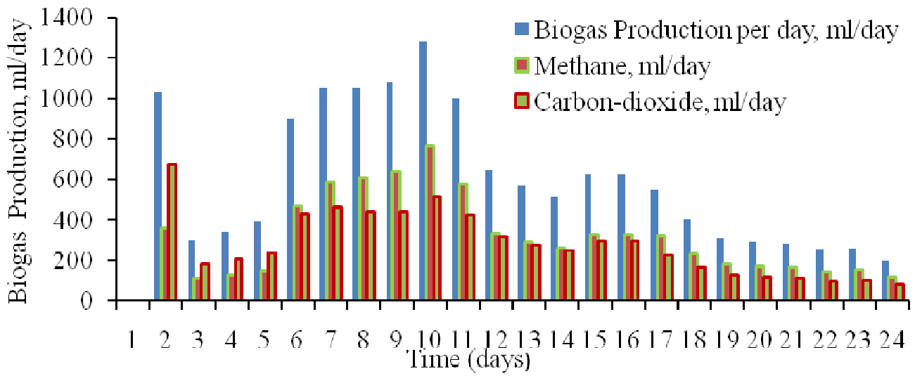

Fig. 2 Production of biogas, methane and carbon dioxide during anaerobic condition using rice straw
During the initial stage of the digestion process, the production of carbon dioxide (CO2) surpasses that of methane (CH4) in terms of volume. The cumulative CO2 levels experience a rapid increase, reaching a peak production of 1301.92 milliliters. This amount is approximately 58% higher than the CH4 produced within the same study period. Throughout this phase, a thermophilic consortium experiences a lag phase due to the relatively lower temperature in the biochemical reactions. However, as the reactions progress, the concentrations of desirable components become dominant in the digestion process.
The optimal quantity of methane production is observed on the 8th and 9th days of the digestion process. The proportions of CH4 and CO2 present in the biogas vary in response to factors such as temperature, raw material composition, and the microbial control of biochemical reactions.

Conclusion of the Chapter
The CHNS analysis results indicate that paddy straw contains a notably high carbon content, averaging at 35.26%. This substantial carbon content, coupled with its elevated moisture content, could potentially lead to a significant increase in volatile matter content upon decomposition. During the initial phase of incubation, known as the pioneer stage, the lag phase becomes evident and continues for a span of five days. Throughout this lag phase, a total of 2,060 ml/day of biogas is produced, with a CH4 to CO2 production ratio of 1:2.
Starting from the 6th day of incubation and extending to the 11th day, the production of biogas, CH4, and CO2 follows an exponential pattern, with CH4 production surpassing CO2 production in this period. Subsequently, from the 12th to the 16th day of incubation, a phase of stationary growth is observed, eventually transitioning to a death phase due to a decline in biomass.
The pinnacle of biogas production occurs on the 10th day of incubation, coinciding with a methane production of 766.72 ml/day. In the anaerobic digestion of paddy straw, utilizing a thermophilic strain, a total gas volume of 13,940 ml is recorded. Within this volume, CH4 production accounts for 7,436.86 ml, while CO2 production constitutes 6,493.74 ml. This yields methane to carbon dioxide composition ratio of approximately 1.149:1 in the biogas generated.
Further experimentation within the temperature range of 50ºC to 54ºC demonstrates the thermophilic consortia's capacity to tolerate and perform well, resulting in increased biogas production. The achieved biogas yield stands at 0.484 m3/kg of volatile solids.

Reference
- Jameson Filer, Hujhuang H. Ding and Sheng Chang,School of Engineering, University of Guelph, Published: 1 May 2019.
- A Haryanto, B P Sugara, M Telaumbanua and A R B Rosadi, IOP Conf Series; Earth and Environmental science, The university of Lampung, IOP Publishing doi:10.1088/1755-1315/147/1/012032.
- H Zhang P Zhang, j-Ye, y. Wu,W.Fang, X.Gou and G.Zeng, Int.Biodeterioe,2016,113,9.
- A.A. Adamu and E. O. Aluyour, Global journal of Engineering researcher VOL 12,2013:63-68., Published; 16/july/2013.
- Keanoi, napon, Hussaro, kanokom and teekasap sombat, American journal of environmental science, Published:2013,9(6) 529.
- Tahseen Sayara and Antoni Sanchez, department of environment and sustainability Agriculture Faculty of Agricultural Sciences and Technology, Palestine Technical University-Kadoorie, Tulkarm, Palestine, Published 2019, nov 1.
- Mariana Ferdes, , Mirela Nicoleta Dincă , Georgiana Moiceanu , Bianca S, tefania Zăbavă and Gigel Paraschiv ; Department of Biotechnical Systems, Politehnica University of Bucharest, 060042 Bucharest, Romania; Department Management and Entrepreneurship, Politehnica University of Bucharest,060042 Bucharest, Romania;
- C. J. Creevey, W. J. Kelly, G. Henderson and S. Leahy, Microbial. Biotechnology, Published:2014, 467.
- E. Rouches, I. Herpoël-Gimbert, J. P. Steyer and H. Carrere,Renew. Sustain. Energy Rev, Published: 2016, 59, 179.
- Shiwei Wang, Fang Ma ,Weiwei Ma, Ping Wang, Guang Zhao and Xiaofei Lu State Key Laboratory of Urban Water Resource and Environment, Harbin Institute of Technology, Harbin 150090, China; Published:12/jan/2019.
- Darwin, J. Cheng , Z. M. Liu, J. Gontupil and O. S. Kwon, Int. J. Agric. Biol. Eng., 2014, 7(6), 7
- Phutela Urmila Gupta and Sahni Nidhi, African Journal of Microbiology Research, 2013, 7(21), 2689.
- E. Rouches, I. Herpoël-Gimbert, J. P. Steyer and H. Carrere, Energy Rev., 2016,
- S. Achinas, V. Achinas and G. J. Euverink, Engineering, Published 2017.
- Gomez C D C 2013 Biogas as an energy option: an overview The Biogas Handbook: Science, Production and Applications, ed A Wellinger et al. (Cambridge: Woodhead Publishing Limited) pp 1–16.
- Koyama, Tadashiro (1963). "Gaseous metabolism in lake sediments and paddy soils and the production of atmospheric methane and hydrogen". Journal of Geophysical Research. 68 (13): 3971–3973. Bibcode:1963JGR....68.3971K. doi:10.1029/JZ068i013p03971
- Yue, Zhengbo; Teater, Charles; Liu, Yan; MacLellan, James; Liao, Wei (2010). "A sustainable pathway of cellulosic ethanol production integrating anaerobic digestion with biorefining". Biotechnology and Bioengineering. 105 (6): 1031–9. doi:10.1002/bit.22627. PMID 19998279. S2CID 25085927
- Ubong Williams Robert, Sunday Edet Etuk and Agbasi Okechukwu Ebuka. (2019). Modified water displacement method and its use for determination of bulk density of porous materials, Journal Renewable Energy & Mechanics (REM), Vol.01 No.01 2019: 1-16. DOI: 10.25299/rem.2019.vol1(01).2292
- Santos, F., and Galceran, M. (2002). The application of gas chromatography to environmental analysis. TrAC Trends in Analytical Chemistry, 21(9-10), 672–685. doi:10.1016/s0165-9936(02)00813-0
- ABM Helaluddin1, Reem Saadi Khalid1, Mohamed Alaama and Syed Atif Abbas. (2016). Main Analytical Techniques Used for Elemental Analysis in Various Matrices Tropical Journal of Pharmaceutical Research February 2016; 15 (2): 427-434.
- Betz, J. M.; Nikelly, J. G. (1987). Determination of Ethanol In Alcoholic Beverages by Liquid Chromatography Using the UV Detector. Journal of Chromatographic Science, 25(9), 391–394. doi:10.1093/chromsci/25.9.391

