FERTILITY PRESERVATION- OBSTETRICAL PERSPECTIVES
Author:
Prof.Mrs.Latha.P
M.Sc.(N), Ph.D
Principal
Nishad College of Nursing & Allied Sciences,
Satna, Madhya Pradesh- 485001.
Mail: lathamoorthy82@gmail.com
Abstract:
Early loss of ovarian function, which is one of the long-term devastating consequences of combined chemotherapy and/or radiotherapy, not only puts the patients at risk for menopause-related complications at a very young age, but is also associated with loss of fertility. These data combined with the fact that more women are surviving their cancer diagnosis have led to more discussion and implementation of fertility preservation techniques. Increased awareness of the effects of various cancer treatments on fertility resulted in a surge in the number of patients seeking help to preserve their fertility. This surge in demand is now mirrored by a proliferation of techniques to preserve fertility via assisted reproduction and cryopreservation.
Introduction:
Fertility preservation is the effort to help cancer patients retain their fertility, or ability to procreate. To help ensure the possibility of conception in the future. Medical fertility preservation aims to protect and preserve fertility for the future using various treatment options. Cancer affects reproductive health and preservation options are growing, sparked in part by the increase in the survival rate of cancer patients. Preserving fertility involves freezing eggs, sperm, embryos or reproductive tissue so that can hopefully have a biological family in the future.
Terminologies:
- Onco-fertility is a term coined for fertility preservation in cancer patients.
- Fertility preservation is the effort to help cancer patients retain their fertility, or ability to procreate.
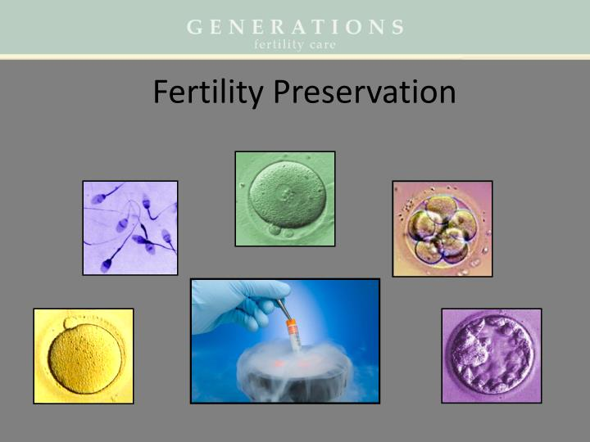
Incidence:
- According to the American Cancer Society, approximately 852,630 women in the United States are newly diagnosed with cancer.
- The probability of a woman developing an invasive cancer is 1 in 18 from birth to age 49.
- These data combined with the fact that more women are surviving their cancer diagnosis have led to more discussion and implementation of fertility preservation techniques. Young women with breast cancer or males with testicular cancer, for example, have a 5-year survival of over 90%.
- The 5-year survival rate in children and youth with cancer has increased from <30% to approximately 80%.
- Fertility preservation may be discussed in women who will be undergoing surgical removal of both ovaries or anticipated chemotherapy for other medical reasons that may impact future fertility.
- For males, the American Cancer Society notes that estimated new cancer cases in males in the U.S. approaches 836,150.
- The probability of developing invasive cancer in males from birth to 49 years old is 1 in 30 and from 50 to 59 years old is 1 in 16.
Cancer and Future Fertility:
Patients of reproductive age often find prospect of infertility one of the most difficult components of their disease and treatment. Surveys of cancer survivors have identified an increased risk of emotional distress in those who become infertile because of their treatment. Long-term quality of life is affected by unresolved grief and depression. 57% of women age 40 and younger at diagnosis of breast cancer recalled concerns about fertility. 29% reported that infertility concerns influenced treatment decisions.
Fertility Preservation Society of India:
Fertility preservation society of India is the 1st ever initiative by professional experts from India to promote science and practice of fertility preservation. The mission of the society is to increase awareness and educate reproductive medicine specialists, oncologists, gynecologists', urologists, embryologists' and the lay public about fertility preservation. The fertility preservation society India is a registered by a group of reproductive specialist’s issues of young cancer survivors, patients suffering from medical illness that need to gonad toxic treatments and genetic issues that cause premature ovarian insufficiency.
Historical perspectives of fertility preservation:
The first successful human birth from in vitro fertilization (IVF) occurred on July 25, 1978 in Great Britain. On December 28, 1981, the first baby conceived through IVF was born in the United States, in Norfolk, Virginia. Since that time, IVF and related technologies have achieved a prominent niche in the clinical management of infertility. In 1996 in the United States, 300 clinics reported initiating 44,647 IVF cycles, 3,768 donor oocyte cycles and 688 cycles of ART for host uterus. A total of 14,702 deliveries were reported. Worldwide over 100,000 children have been born.
Fertility and age:
- Egg count and quality decline with age
- Women are born with their entire supply of eggs approximately 1 to 2 million at birth.
- About half are gone by puberty, and by age 35, only about 20% of eggs remain.
- As women get older, and egg count decreases, it becomes more difficult for ovaries to respond to the stimulation medication used during egg freezing and other fertility treatments.
- Women more likely to need multiple cycles to achieve a number of eggs that give a good chance for pregnancy later.
- Egg quality decline is directly correlated with age.
Effect of chemotherapy on fertility:
- Chemotherapeutic agents have a wide and variable range of impact on male fertility.
- Alkylating agents such as cyclophosphamide, chlorambucil, procarbazine, and busulfan cause the greatest impairment in male fertility.
Whereas antimetabolites, platinum-based agents, vinca alkaloids, and topoisomerase inhibitors are also noted to be gonadotoxic.
Effect of radiation therapy on fertility:
- Direct damage to ovaries
- Damage to hypothalamic-pituitary axis
- Dose dependent; total dose and fractionation schedule
- Age dependent; size of primordial follicle pool
- Radiation field dependent
- Could also affect uterine function (M/C, IUGR, Premature deliveries).
- Somniferous tubules are particularly sensitive to radiation with energies as low as 0.1 gray (Gy), resulting in temporary arrest of spermatogenesis. Increasing doses have been shown to cause azoospermia.
No. of surviving primordial follicles following exposure correlates inversely to dose of chemotherapy.

Indications for Fertility Preservation:
- Cancer in children
- Breast cancer
- Cancer of the cervix
- Autoimmune and hematological diseases
- Benign ovarian disease
- Patients receiving pelvic radiation
- Prophylactic oophorectomy
- Hematopoietic stem cell transplantation

Fertility Preservation - Where Does It Fit?
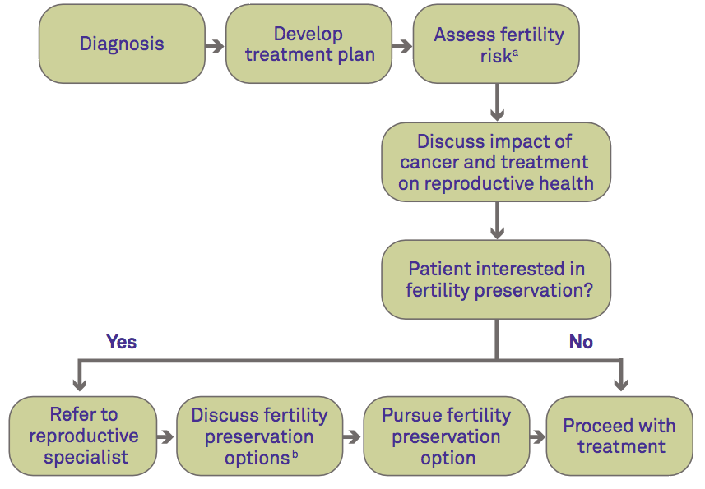
When should couples consult a health care provider?
Couples should consult with a health care provider about fertility problems if they have had unprotected sex for 1 year without a successful pregnancy.
Exceptions to this recommendation apply to:
- Women older than age 35 who have had 6 months of unprotected sex without a successful pregnancy.
- Women who suspect they may have underlying problems that will affect fertility, such as irregular periods.
- Individuals who have been diagnosed with specific conditions that are known to reduce fertility.
How can women preserve fertility before cancer treatment?
- Embryo cryopreservation.
- Egg freezing (oocyte cryopreservation)
- Gonadal shielding
- Ovarian transposition (oophoropexy)
- Surgical removal of the cervix (radical trachelectomy).
- Ovarian tissue cryopreservation.
- Ovarian suppression before cancer therapy.
What can men do to preserve fertility before cancer treatment?
- Sperm cryopreservation.
- Gonadal shielding.
- Hormonalgonado-protection
- Pharmacological protection
- Other methods.
Guidelines for Fertility Preservation:
- Interventions to preserve fertility
- Fertility preservation options in males
- Fertility preservation options in females
- Special fertility preservation considerations for children and adolescents
- Fertility preservation centers
- Costs
- Time
Importance of Fertility Preservation Counseling:
- Endometrial cancer - 53%
- Ovarian Cancers
- Cervical cancer -25 – 35 yrs
- Improve the quality of life of patients.
- Reduce anxiety and depressive symptoms, suicidal thoughts, feelings of anger, shame and low self-esteem
- Radiotherapy.
Fertility Preservation Services:
- Programmatic requirements for a fertility preservation program
- Rapid access
- It should be available as there is a shortage of time.
- Interdisciplinary medical team
- Interdisciplinary medical team is required which should include oncologists, reproductive endocrinologists and urologists, and reproductive surgeons trained in Fertility preservation techniques.
Laboratory requirements:
- Fertility preservation programs should be associated with an experienced ART program capable of providing a full complement of Fertility preservation techniques all the year round.
- Ideally, programs also should be able to counsel pre-pubertal patients and provide access to procedures such as ovarian and testicular tissue cryopreservation, both of which are still considered experimental.
Counselors:
- Mental health professionals: To counsel patients and help them in the decision-making process
- Genetic counselors: Some diseases are heritable so a genetic counselor should be available to discuss any potential risks of transmission of the disease to the resulting offspring and available genetic testing
- Financial counselors.
Interdisciplinary collaboration:
- Collaboration between medical and surgical oncologists, reproductive endocrinologists, and urologists is important.
- Oncologists have the initial responsibility to discuss the reproductive risks of intended cancer therapies.
- An experienced reproductive endocrinologist or urologist should discuss in detail the appropriate Fertility preservation techniques.
- Ideally all adolescents and individuals of reproductive age should be referred.
Medical considerations:
- Patients in need of fertility preservation should be given all the options available for preservation of their gametes, as well as alternatives such as the use of donor gametes, donor embryos, surrogacy, and adoption.
- The potential safety of future pregnancy after cancer should be addressed, taking into account the type of cancer and proposed treatment.
- Consent forms should include options for gamete disposition in the event of demise of the patient.
Legal challenges:
- Informed consent
- Medical negligence claims
Adverse effects:
- Stroke
- Myocardial infarction
- Peripheral arterial embolism.
- Venous thrombo-embolism
Case Scenario: 1
- A 15-year-old boy diagnosed with high-risk acute lymphoblastic leukemia (ALL).
Treatment on a protocol that contained 2 g/m 2 of cyclophosphamide.
- Relapsed while on maintenance therapy.
- Restarted
- More aggressive chemotherapy
- Approached about the possibility of sperm banking.
- Unfortunately, because he was in the middle of therapy,
- He was azoospermic and was unable to cryopreserve sperm prior to starting the more aggressive and gonadotoxic regimen.
- Note: This case highlights the importance of approaching all teenage boys about sperm banking at diagnosis, regardless of the perceived gonadotoxicity of the planned therapeutic regimen
- Therefore, we recommend asking all teenage boys newly diagnosed with cancer to cryopreserve sperm before any treatment is delivered.
Case Scenario: 2
- Case 2: Cervical Cancer in a Young Adult Case 0f 25-year-old gravida 0 married female with a diagnosis of stage IB poorly differentiated squamous cell carcinoma of the cervix.
- Approximately 1 month before her fertility preservation consultation, robotic radical hysterectomy with pelvic lymph node dissection and bilateral oophoropexy, where each ovary was fi xed to the paracolic gutter out of the pelvis.
- She was referred to a reproductive endocrinologist for consultation after surgery. But prior to her planned treatment with whole pelvic radiation and cisplatin chemotherapy.
- It was anticipated that treatment would be initiated a few weeks later. On examination with transvaginal ultrasound, her ovaries were dif fi cult to visualize.
- Her body mass index was 19 kg/m 2 and her anti-Müllerian hormone (AMH) level was 1.9 ng/ml.
- She underwent ovarian stimulation with an antagonist protocol and her peak estradiol level was 898 pg/ml on cycle day 10.
- Transabdominal oocyte retrieval yielded nine oocytes, and three embryos were available to be frozen on day 3.
- Approximately 1 year after she had completed therapy, she was benefited with preservation.
Success rates:
The following success rates are from the Human Fertilization and Embryology Society and include healthy people having treatment using insemination and IVF.
- For women under 35, the success rate is around 20 births out of 100 treatments (20%).
- For women aged 35 to 49, the success rate is around 15 out of 100 (15%).
- For women aged more than 49, the success rate is around 7 out of 100 (7%).
Success of fertility preservation:
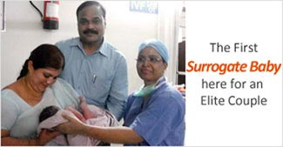
Conclusion:
Onco-fertility is a ﬁeld that has grown remarkably in recent years, and the education of patients and clinicians, the implementation of fertility preservation programs, and the development of fertility preservation techniques have all advanced the ﬁeld. Clinicians treating reproductive-aged males with newly diagnosed malignancy should discuss possible fertility preservation options. The number of options to preserve fertility is growing. These options vary depending on the patient's age, the time available, type of cancer and whether the likelihood of ovarian involvement is high. Physicians should take a comprehensive approach in counseling their patients regarding fertility preservation procedures. In many cases, rapid referral to appropriate centres with adequate experience in fertility preservation will ensure that the patient has enough time for adequate counseling, and can resort to one or more of the procedure.
References:
- Blumenfeld Z, Shapiro D, Shteinberg M, Avivi I and Nahir M (2000) Preservation of fertility and ovarian function and minimizing gonadotoxicity in young women with systemic lupus erythematosus treated by chemotherapy. Lupus 9,401±405.
- Chia CM, Chan WB, Quah E and Cheng LC (2020) Triploid pregnancy after ICSI of frozen testicular spermatozoa into cryopreserved human oocytes: case report. Hum Reprod 15,1962±1964.
- Fertil Steril 64,987± 990. Fisher B and Cheung AY (2019) Delayed effect of radiation therapy with or without chemotherapy on ovarian function in women with Hodgkin's disease. Acta Radiol Oncol 23,43±48.
- Feldman JE (1989) Ovarian failure and cancer treatment: incidence and interventions for premenopausal women. Oncol Nurs Forum 16,651±657.
- Gook DA, McCully BA, Edgar DH and McBain JC (2001) Development of antral follicles in human cryopreserved ovarian tissue following xenografting. Hum Reprod 16,417±422.
- Mazza P, Prudenzano A, Amurri B, Palazzo G, Pisapia G, Stani L and Pricolo G (2003) Myeloablative therapy and bone marrow transplantation in Fertility preservation in female patients. Downloaded from https://academic.oup.com/humupd/article/10/3/251/682124 by guest on 14 July 2023.
- Oktay KH and Yih M (2002) Preliminary experience with orthotopic and heterotopic transplantation of ovarian cortical strips. Semin Reprod Med 20, 63±74.

