Principles of the Fabrication: Synthesis and Applications of Highly-Efficient Heterogeneous Photocatalysts
Rajpal Tyagi^{a, *}, Anuj Mauryaª, Haridutt Sharma^{b}
ª Assistant Professor, Department of Chemistry, Multanimal Modi College, Ghaziabad, India-201204
^{b} Assistant Professor, Department of Chemistry, M.M.H. College, Ghaziabad, India-201204
* Corresponding author
Abstract
Heterogeneous photocatalysis, which uses photo-excited semiconductor materials to reduce water and oxidize harmful pollutants when exposed to sunlight, has a lot of potentials as a renewable energy replacement and as an environmental safeguard. Heterogeneous photocatalysts are gaining popularity due to their wide range of applications in environmental cleanup, sensing, optoelectronic devices, energy storage, drug delivery, and photocatalysis. The fabrication methods play important role in tuning the properties of these nanomaterials. Physical, chemical, and mechanical processes are a few well-known methods to make nanomaterials. The synthesis of heterogeneous photocatalysts can be achieved using a range of methods such as hydrothermal, solvothermal, sol-gel, photoreduction, microplasma–liquid interaction, ball-milling, etc. This paper presents a comprehensive review of the fabrication of highly-efficient photocatalysts. Firstly, the fundamental principles of photocatalysis are discussed, Secondly, the different strategies for the synthesis of photocatalysts, including physical and chemical methods, are described. Thirdly, recent advances in the fabrication of highly efficient photocatalysts are discussed, with a focus on the use of nanostructures to improve light capture efficiency and surface area. Finally, the applications of heterogeneous semiconductor photocatalysis for the treatment of pollutants in water, air cleaning, and degradation of various organic contaminants and medicinal products.

Keywords: Photocatalysis, Fabrication methods, Environmental application, etc.

- Introduction
A major difficulty we have in the twenty-first century is finding clean, renewable, and environmentally friendly energy sources.[1, 2] Solar energy stands out as the most renewable energy source among all others. But it remains a significant challenge to efficiently harvest and convert solar energy.[1, 3, 4] Therefore, it is urgently necessary to make advances in synthesis methods, and applied technologies to make it possible for solar energy to be harnessed in a way that is both highly effective and cost-effective. A photocatalyst is a material that absorbs light to bring it to a higher energy level and provides such energy to a reacting substance to make a chemical reaction occur.[4-7] It is used in a variety of applications, such as air and water purification, water splitting, CO₂ and CH₄ conversion, self-cleaning surfaces, and energy conversion.[1, 8-11] A heterogeneous photocatalyst is a type of catalyst that is composed of two or more different materials. It is used to speed up chemical reactions by absorbing light energy and converting it into chemical energy. This type of catalyst is often used in the production of fuels, chemicals, and other materials.[1, 3] Examples of heterogeneous photocatalysts include titanium dioxide (TiO₂), zinc oxide (ZnO), copper oxide (CuO), and iron oxide (Fe₂O₃).[2, 12-17] Heterogeneous photocatalysts can be synthesized using a variety of methods, including sol-gel, hydrothermal, and electrochemical methods.[1, 3, 18] Synthesis of heterogeneous photocatalysts are challenging, as it requires careful control of the different components' particle size, shape, and composition. The synthesis of heterogeneous photocatalysts typically begins with the selection of the appropriate semiconductor components and their subsequent preparation. This includes choosing the right materials, synthesizing the materials, and purifying them. Next, the components are combined in a specific proportion to create the desired hybrid nanomaterial.[7, 18, 19].
There are numerous advantages of the synthesis of heterogeneous photocatalyst such as: (a) They have improved electrical, optical, and magnetic properties.[20, 21] (b) Increased Efficiency: The incorporation of multiple functionalities into a single material can lead to increased efficiency. This is especially true when the functionalities are mutually beneficial or complementary. (c) Reduced Cost: By combining multiple functionalities into a single material, the cost of creating a functional device can be reduced. This is because the cost of creating a single functional material is much lower than the cost of creating multiple individual functional materials. (d) Increased Versatility: heterogeneous photocatalysts offer increased versatility and can be used in a wide variety of applications. This offers manufacturers and researchers a wide range of options for creating functional devices. (e) Improved Durability: The incorporation of multiple functionalities into a single material can lead to increased durability and reliability. This is because the multiple functionalities are less likely to be affected by external factors such as temperature, moisture, and other environmental factors.[2, 4, 7, 8, 12, 21, 22]
In recent years, interest in photocatalysis has focused on the use of semiconductor materials as photocatalysts for the removal of ambient concentrations of organic and inorganic species from aqueous or gas phase systems in environmental clean-up, drinking water treatment, industrial and health applications. This is because of the ability of TiO₂ to oxidize organic and inorganic substrates in air and water through redox processes. In this context, TiO₂ has not only emerged as one of the most fascinating materials in both homogeneous and heterogeneous catalysis, but has also succeeded in engaging the attention of physical chemists, physicists, material scientists and engineers in exploring distinctive semiconducting and catalytic properties.
This review provides an overview of the synthesis of heterogeneous photocatalysts, including the various techniques and strategies used for their preparation. Additionally, it reviews the recent advancements in the field and presents potential opportunities for future research. The basics of creating extremely effective photocatalysts are thoroughly reviewed in this work. The basic concepts of photocatalysis are first presented, covering crucial elements such the function of light, the semiconductor-liquid interface, redox processes, and the significance of surface area and morphology. Second, various approaches for creating photocatalysts, including both physical and chemical ones, are outlined. Thirdly, recent developments in the creation of extremely effective photocatalysts are described. Finally, the finally the modification done in photocatalysts to specific applications enhancing photocatalyst activity and improving performance. The future potential for photocatalyst development is also looked at.

- Fundamentals of photocatalysis
Photocatalysis is a process in which light energy is used to accelerate chemical reactions. It involves the use of a photocatalyst, which is a material that absorbs light and produces electrons and holes. These electrons and holes can then react with reactants in the system, leading to the desired reaction. Photocatalysis can be used to produce a variety of products, including hydrogen, oxygen, and other chemicals. It can also be used to break down pollutants, such as organic compounds, into harmless byproducts shown in Figure 1.[1, 13, 16, 20, 22] A simple division of the energy transmission process into four steps is possible. (1) The catalyst enters the photoexcited state, which is called photoexcitation. At this stage, the absorption of photons excites the negatively charged electrons from the valence band to the conduction band and creates the positively charged holes in the valence band to form electron-hole pairs. (2) The electron-hole pairs are separated, which is the charge separation and transportation, and are then moved to their active sites on the surface of a cocatalyst or photocatalyst. (3) Charge recombination, in which a portion of the photogenerated electrons and holes undergo radiative or nonradiative recombination or are captured by defects in the bulk material and/or on the surface of the photocatalyst. (4) The fourth stage is the photo-assisted redox process, where the holes and electrons on the cocatalyst/photocatalyst surface function as reducing and oxidizing agents, respectively, to drive the required reduction and oxidation chemistry. [1, 2, 4, 15, 19, 23-26]
Three of the main potential uses of photocatalysis are the photocatalytic degradation of organic contaminants, the photoreduction of CO₂, and solar water splitting.[1, 9, 20, 21]

  - Photocatalytic Degradation
Semiconductor nanomaterial-based heterogeneous photocatalysts are used for the photocatalytic destruction of dye molecules in wastewater treatment. The main obstacle in photocatalysis, meanwhile, is to find a practical means of increasing its spectral sensitivity up to the solar spectrum for its prospective uses. Additionally, it has been successfully accomplished by researchers in recent years through a variety of adjustments, as was also previously stated. As discussed in the above paragraph that photocatalyst produces charge carriers, specifically electrons and holes in the CB and VB under the impact of UV radiation.[2, 13, 21] These separated charge carriers travel to the surface where they interact with adsorbed water molecules (H₂O) or ambient oxygen (O₂) to form a variety of ROS, including OH°, O₂°, and other compounds. The creation of OH° is essential for the photocatalytic destruction of organic compounds such as dyes etc. as shown in Figure 1(a).[2, 13, 18]

  - Photoreduction of CO₂
Photoreduction of CO₂ is a process in which carbon dioxide is reduced to form other products, such as formic acid, methanol, and formaldehyde, using light energy.[27, 28] This process is used to convert CO₂ into useful chemicals and fuels and is an important part of the development of renewable energy sources shown in Figure 1(b).[29] This method is advantageous in two ways: first, it aids in reducing emissions, and second, it provides industry with important chemicals. Since the last few years, there has been a rapid advancement in the manufacture of new and prospective photocatalyst materials for the photocatalytic reduction of CO₂.[27, 28, 30] Despite the fact that numerous research papers have been published on the subject, the utilization of solar energy to convert CO₂ into usable goods lacks the efficiency required for real-world applications.

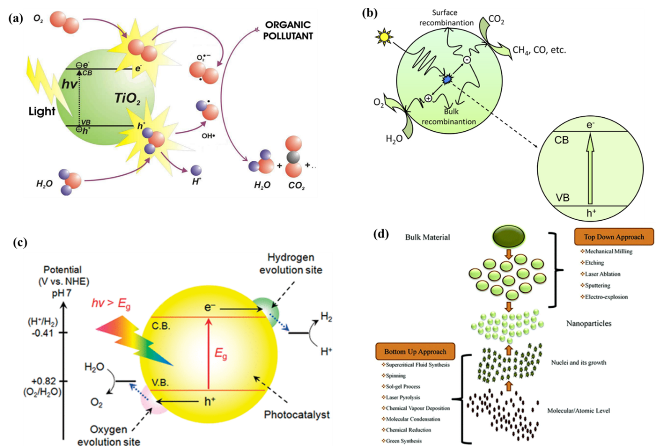

Figure 1. (a) Schematic of photocatalytic degradation.[18] (b) Schematic illustration of the photoexcitation and electron transfer process for the photocatalytic reduction of CO₂ with H₂O as a reductant.[29] (c) Schematic image of the photocatalytic water splitting process.[32] (d) The synthesis of nanomaterials via top-down and bottom-up approaches.[33]
  - Solar water splitting
Photocatalytic water splitting is a process in which water molecules are split into hydrogen and oxygen using light energy. This process is used to produce hydrogen fuel, which can be used as a clean energy source. The process involves the use of a photocatalyst, which is a material that absorbs light and uses energy to catalyze the reaction Figure 1(c).[1, 9, 31, 32] The most common photocatalysts used for this process are titanium dioxide (TiO₂) and zinc oxide (ZnO). Due to the fact that photocatalytic water splitting uses solar energy and matches both the redox reaction type and the thermodynamics of natural photosynthesis, it is thought to be artificial photosynthesis that generates solar fuel. [32]

- Fabrication methods of heterogeneous photocatalysts
Synthesis methods are crucial for controlling the size and surface area of the photocatalyst. These are important for creating new photocatalysts with desired properties. By controlling the synthesis parameters, such as temperature, pressure, reactants, and reaction time, scientists are able to tailor the photocatalysts to have specific characteristics.[7] This enables the synthesis of photocatalysts with unique functionalities that can be used in a variety of applications, such as nanoelectronics, sensing, drug delivery, and energy storage.[7, 22] Synthesis methods also allow for the creation of novel heterogeneous photocatalysts with properties that are not found in nature. By understanding and controlling the synthesis parameters, scientists can create photocatalysts with the desired properties and ensure they are safe and effective in their intended applications.
In general the nanomaterials are synthesized by using two primary methods such as Top-down and Bottom-up methods as shown in Figure 1(d).[33]
Top-down Synthesis: Top-down synthesis involves breaking down larger structures into smaller nanostructures. Common techniques used in top-down synthesis include mechanical crushing, grinding, milling and lithography.[34]
Bottom-up Synthesis: Bottom-up synthesis is the opposite of top-down synthesis, where larger nanostructures are built from smaller molecules. Common techniques used in bottom-up synthesis include solgel, hydrothermal, solvothermal, chemical vapor deposition, electrochemical deposition, and molecular self-assembly.[34]

  - Hydrothermal Method
The term "hydrothermal" often refers to heterogeneous reactions that take place at high temperatures and pressures in the presence of aqueous solvents and mineralizers.[7, 35] The autoclaves used for this synthesis process are pressure containers composed of steel. These Teflon-lined autoclaves operate under high temperature and pressure controls i.e., 100 °C temperature which is more than the boiling point of water and pressure greater than 1 atm. This approach makes it simple to regulate the size and shape of the generated nanostructure. Throughout the process, there is relatively minimal energy usage. A product with controlled particle size and the required morphology structure can be obtained by making adjustments to the reaction temperature, duration, pH, reactant concentration, and a wide range of other parameters. This method is used in the synthesis of various dimensional nanostructures such as zero-dimensional(0D), one-dimensional (1D), two-dimensional (2D), and three-dimensional (3D). A short-time hydrothermal method is developed to prepare CuBi₂O₄ nanocolumn arrays. By using Bi(NO₃)₃·5H₂O in acetic acid and Cu(NO₃)₂·3H₂O in ethanol as precursor solutions, tetragonal CuBi₂O₄ with good visible light absorption can be fabricated within 0.5 h at 120 °C shown in Figure 2. [36] Tetragonal structured CuBi₂O₄ can be formed after 15 min hydrothermal treatment, however it possesses poor visible light absorption and low photocatalytic activity. Extending the hydrothermal treatment duration to 0.5 h results in a significant improvement invisible light absorption of the tetragonal CuBi₂O₄.

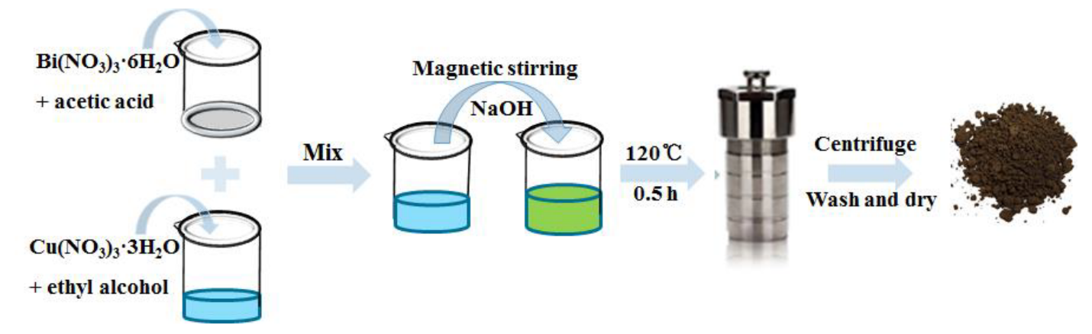
Figure 2. Schematic showing hydrothermal synthesis of CuBi₂O₄. [36]

  - Solvothermal Method
The hydrothermal technique serves as the foundation for the solvothermal method, which uses a non-aqueous solvent as the reaction media to create photocatalytic hybrid materials. As compared to the hydrothermal process, a variety of organic solvents have greater boiling points, allowing the solvothermal approach to operating at higher temperatures.[7, 37, 38] The range of organic solvents with high boiling points is to blame for this. The solvothermal approach often allows for the improvement and control of nanoparticle size, shape, distribution, and crystallinity. The solubility, diffusion behavior, and reactivity of reacting species are all impacted by solvents with a variety of chemical and physical properties.[38] The ability or polarity of the solvent, in particular, can have an impact on the morphology.[ 37, 39] The synthesis of binary and ternary oxide- and sulfide-based hybrids in 2D or 3D, both layered and unlayered, is also done using the solvothermal approach. In Figure 3, experimental conditions (temperature and reaction time) were established to synthesize BiOCl microspheres by a solvothermal method with high photocatalytic efficiency on the degradation of 3,4,5-trihydroxybenzoic acid (gallic acid). BiOCl materials were synthesized according to a design of experiment (DoE) where temperature and reaction time were selected as varying parameters. Obtained BiOCl materials with the highest and lowest degradation toward gallic acid, were characterized using several techniques. [40]

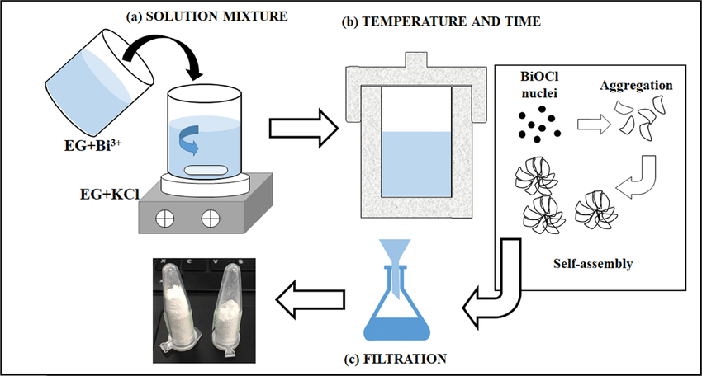
Figure 3. Schematic showing the solvothermal process to obtain BiOCl materials. [40]
Results showed that the applied temperature is the most important parameter during solvothermal synthesis, which influences not only morphology and structure of BiOCl, but also its thermal stability and optical properties. Overall, the solvothermal method has proven to be a reliable and efficient method for the synthesis of heterogeneous photocatalysts.

  - Sol-Gel Method
The production of hybrid metal oxide nanocomposite materials is frequently carried out using the sol-gel process. In this procedure, a liquid-based polycondensation process of a molecular precursor produces a colloidal solution.[21] In particular, the sol-gel approach offers excellent control over the variables that result in the synthesis of a variety of metal oxides and their nanocomposites. Using this technique, the materials can be formed into the desired forms, such as powder, thin films for coatings, or nanofibers.[22, 23, 34] The typical steps in the sol-gel production of nanocomposites are as follows: Precursors are first dissolved in a homogeneous solvent, which could be water or an organic solvent. The finished product is obtained by molding the produced solution into the desired form through thermal heating or sintering after treating it with an appropriate acid or base reagent to transform it into a sol.
The main advantage of the sol-gel approach is that it enhances the creation of polycrystalline particles with extraordinary properties by homogeneously mixing metal ions at the molecular level.[21, 23, 34] Additionally, different dopants/molecules may be added at any time throughout the procedure. These active dopants/molecules are added to the sol during the gelation stage, allowing them to interface directly with the support, increasing the photo efficiency of the hybrid photocatalysts.[21, 23]. The sol-gel method provides the ability to precisely control the size, shape, and composition of the photocatalyst particles, allowing for the optimization of their properties. Furthermore, this method is also suitable for the scale-up production of photocatalysts. Therefore, the sol-gel method is a promising technique for the synthesis of heterogeneous photocatalysts with enhanced performance. For example, the TiO2 synthesis by sol-gel method was carried out from a two-step process: (i) formation of sol–gel and (ii) thermal treatment as shown in Figure 4. [41] Initially, a solution of titanium (IV) isopropoxide and absolute ethanol was prepared and constantly stirred for 30 min. Separately, a solution of absolute ethanol and distilled water was prepared, and
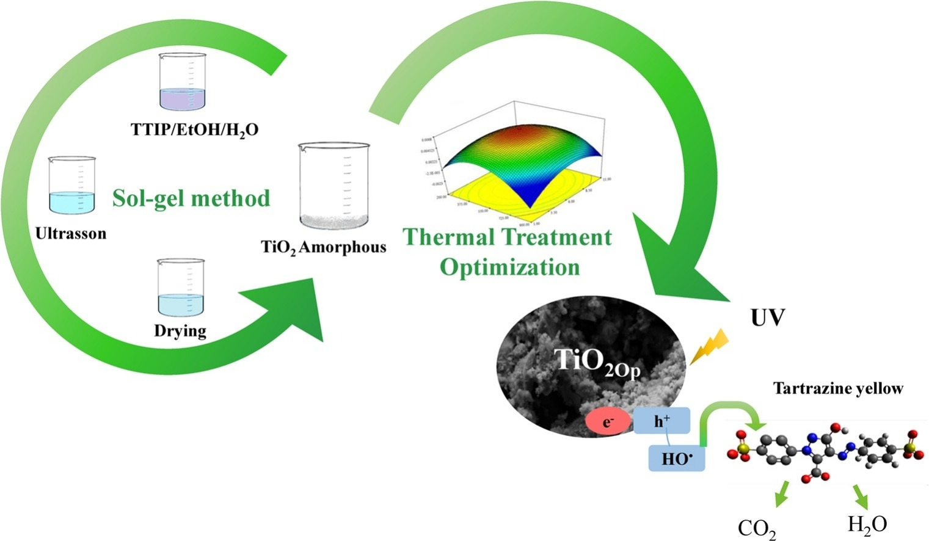
Figure 4. Schematic showing the sol-gel process to obtain TiO2 via response surface methodology. [41]
slowly added in the main solution containing the titanium, which later was kept under stirring for 30 min. Then, H₂SO₄ (95%) was added to the solution and it was stirred for 30 min. The formed gel was sonicated for 10 min at 50 °C, using an ultrasound system, and then, kept at rest in this temperature for 2 h.
  - Coprecipitation Method
The coprecipitation method is a simple and cost-effective method for the synthesis of heterogeneous photocatalysts. This method involves the precipitation of two or more metal salts in an aqueous solution, followed by the calcination of the precipitate to form a solid photocatalyst.[42] The metal salts used in this method are typically metal oxides, such as TiO₂,ZnO, ZrO₂, Fe₂O₃ etc.[43, 44] The coprecipitation method is often used to synthesize photocatalysts with a wide range of properties, including high surface area, high porosity, and high photocatalytic activity.[44]
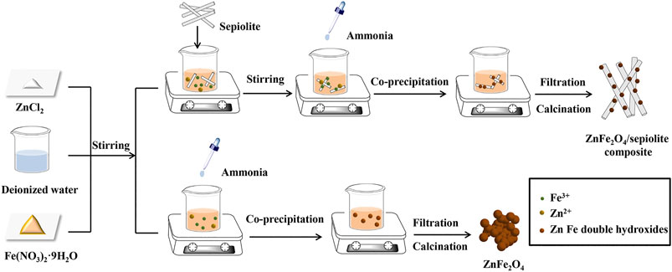
Figure 5. Schematic for the fabrication of ZF-Sep composite using Co-precipitation Method. [45]
Recently, the ZnFe₂O₄/sepiolite (ZF-Sep) composites were synthesized using a co-precipitation method. [45] ZnCl₂ and Fe(NO₃)₃⋅9H2O were dissolved in deionized water, and a certain amount of sepiolite which were prepared by an acid treatment were added into the solution. Next, the pH of suspension was adjusted to 11 by adding aqueous ammonia dropwise. After aging for 12 h at room temperature, the precursor slurry was washed with ethanol and deionized water until the presence of chloride ions cannot be detected with silver nitrate standard solution. Then the filter cake was calcined in a muffle furnace for 3 h at 600 °C. Finally, the ZnFe₂O₄/sepiolite composite (ZF-Sep) was obtained, and the schematic diagram was shown in Figure 5. [45] Overall, the use of a surfactant facilitates the formation of a stable colloidal suspension. The method is fast, cost-effective, and environmentally friendly, making it a popular choice for synthesizing heterogeneous photocatalysts.
  - Photoreduction Method
Another interesting technique for synthesizing heterogeneous photocatalyst semiconductor nanomaterials is photoreduction. It is a type of chemical reduction process in which molecules are reduced using light energy. The light energy is absorbed by a photosensitizer, which then transfers the energy of the light to an electron donor.[46, 47] The electron donor is then reduced and a product is formed. In materials science, photoreduction is used to produce semiconductor materials or nanocomposites. The synthesis takes place under photoirradiation and in the presence of precursors of nanomaterials.[21] This technique is based on the photocatalysis phenomena such as when a metal oxide semiconductor is activated by UV light, e⁻ and h⁺ are produced in CB and VB, respectively. These ions then reduce the metal ions on the metal oxide surface into a metallic form, resulting in the creation of metal NPs.[21, 46, 47]
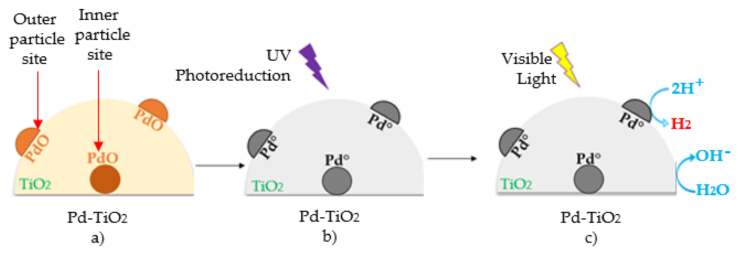
Figure 6. Schematic Representation of: (a) The synthesized photocatalysts following calcination at 500 °C with most of the Pd being present as PdO, (b) The photoreduction of the PdO to Pd° using a UV-Lamp for 1 h, (c) The H₂ production using a photoreduced Pd-TiO₂, with molecular H₂ being generated on the semiconductor. [48]

A photoreduced Pd-TiO₂ was synthesized using a sol-gel methodology, following calcination at 500 °C. With most of the Pd being present as PdO, considering that palladium oxidizes during the calcination step, the resulting photocatalyst had to be reduced in a subsequent step described in Figure 6. [48] To accomplish this, the synthesized semiconductor was placed in a flow reactor unit under an atmosphere of 1 cm3/s of Ar/H₂ (g) (90/10%, Praxair) at 500 °C for 3 h [49]. Given that this reduction with hydrogen was incomplete, a further and critical Pd-TiO₂ photoreduction step was implemented in the Photo-CREC Water-II (PCW-II), by exposing the photocatalyst to near-UV light at room temperature for 60 min. The results of this method have been demonstrated to be reproducible and reliable, and the catalysts synthesized are highly active, selective, and stable. Furthermore, the photoreduction method is easy to operate and cost-effective, making it an attractive choice for the synthesis of heterogeneous photocatalysts.
(b)
  - Microplasma–liquid interaction Method
Microplasma-liquid interaction is a relatively easy, quick, and environmentally friendly process. Without the usage of chemical-reducing agents, the ambient microplasma can directly give a significant number of electrons into the solution, which can subsequently be used to reduce metal ions from the precursor solution.[50-52] There is no need for any additional reducing or capping agents, this method can provide direct adhesion of bare metal particles on the semiconductor surface. This could improve the effectiveness of the photocatalytic process by facilitating electron transfer between the hybrid nanocomposite.[50, 53]Lee et al.[53] created TiO₂-Au hybrid nanoparticles by utilising atmospheric microplasma-liquid interaction and study their photocatalytic activity as shown in Figure 7. [54] Furthermore, this method is suitable for the synthesis of photocatalysts with uniform size, shape, and composition. Therefore, the microplasma-liquid interaction method is an attractive and promising approach for the synthesis of heterogeneous photocatalysts.

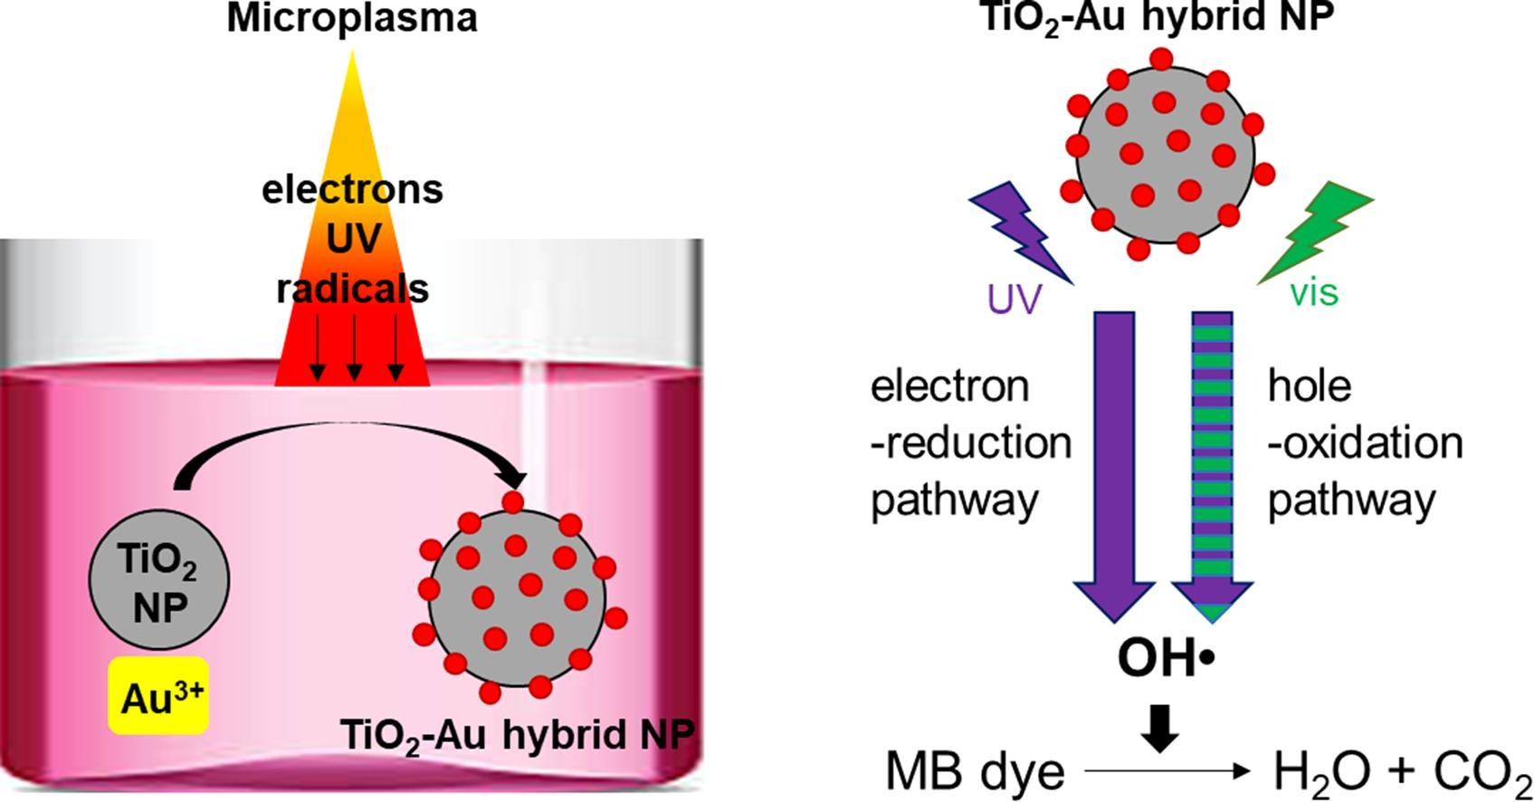

Figure 7: Schematic showing synthesis and photocatalytic degradation of dye by TiO₂–Au hybrid NPs. [54]

  - Microemulsion method
Microemulsion method is a novel technique used to synthesize hybrid semiconductors. It involves the preparation of a microemulsion, which is a dispersion of two immiscible liquids stabilized by the presence of an amphiphilic surfactant.[23, 55] This microemulsion is then used as a reaction medium to prepare hybrid semiconductor materials such as metal oxides, nitrides and phosphates. In this method, metal salts dissolved in an organic phase are reacted with an inorganic precursor in an aqueous phase. The amphiphilic surfactant stabilizes the reaction medium and helps prevent the formation of large particles.[23, 55, 56]
The microemulsion method has several advantages over traditional methods for the synthesis of hybrid semiconductors. For example, it offers better control of the particle size, crystal structure and surface morphology of the materials. Furthermore, the technique is more cost-effective and environmentally friendly than traditional methods.[23, 55, 57] The microemulsion method has been successfully used to synthesize a variety of hybrid semiconductors.
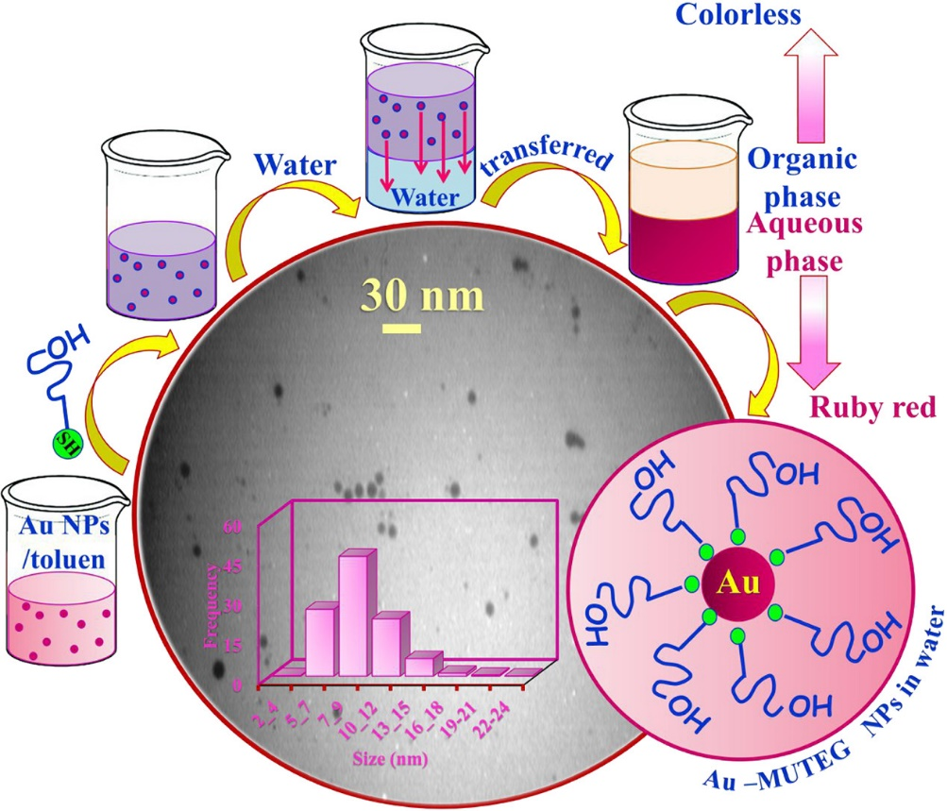
Figure 8: Colloidal synthesis by a microemulsion technique (b) A schematic representation of
Schematic illustration of the preparation procedure of water soluble AuNPs stabilized by MUTEG ligand using w/o microemulsion system. [58]
The materials synthesized by this method have been found to possess superior properties such as high electron mobility, low leakage current and good stability in different environmental conditions. The technique is promising for the fabrication of optoelectronic devices, sensors and catalysts.[83, 85] Synthesize of functionalized gold nanoparticles has attracted a great deal of interest due to their favorable optical properties and broad range of biomedical applications. A simple methodology based on microemulsion system was introduced in the manufacturing of biocompatible and stable water-soluble gold nanoparticles protected by a monohydroxy thioalkylated PEG ligand shown in Figure 8. [58] Furthermore, the microemulsion method has been demonstrated to be an effective way of controlling the size and shape of photocatalysts, providing a basis for further optimization of their performance. Therefore, the microemulsion method is an attractive alternative for the synthesis of heterogeneous photocatalysts.
  - Ball milling Process
In the latter half of 1960, Benjamin and his coworkers at the International Nickel Company created this procedure. A powder combination is placed in the ball mill, where it is subjected to high-energy collisions from the balls during the ball milling process.[59] In addition to creating new materials, high-energy ball milling can change the conditions under which chemical reactions typically occur by altering the reactivity of the solids as they are being ground (mechanical activation, which speeds up reactions and lowers reaction temperatures) or by causing reactions to occur while the solids are being ground .[60]
The powder and ball movements are depicted in the figure below. The centrifugal forces alternatively synchronize because of the bowl and turn disc rotate in opposing directions. To grind the powder mixture, the hardened milling balls alternately rolled on the bowl’s inner wall and struck the opposing wall, causing friction.[88] The milling balls' impact energy in the normal direction can be up to 40 times more than that caused by gravity acceleration. Consequently, high-speed milling can be done in a planetary ball mill.[59-61] In conclusion, the ball milling method is an advantageous method for synthesizing heterogeneous photocatalysts and is suitable for achieving desired photocatalytic performances. A scheme describing the preparation of Cu x O−TiO₂ NPs via solid state reaction followed by a ball milling technique shown in Figure 9. [62] Fabrication steps are numbered from 1 to 4: (1) grind the mixture of source materials for about 2 h then compress to pellet/s, (2) sinter the pellet/s at different predetermined temperatures (1000−1050 °C) under different environments, (3) ball mill for 20 h, and (4) dry the as-prepared Cu x O−TiO₂ NPs. Note that the ball milling grinding vial is shown in a sectional view.

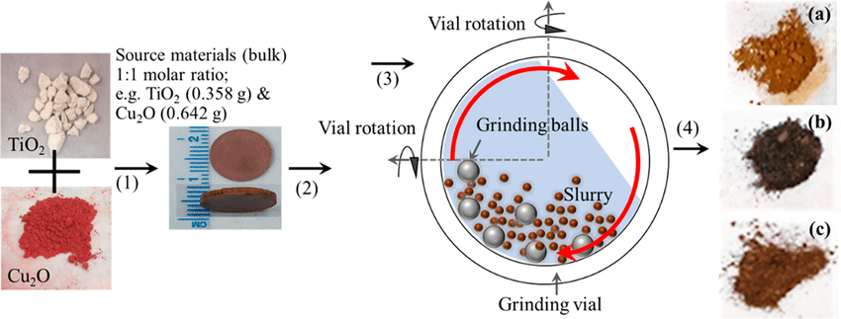
Figure 9: Schematic showing synthesis of Cu x O−TiO₂ NPs via solid state reaction followed by a ball milling technique. [62]

- Recent advances in the fabrication of highly efficient photocatalysts
Recent advances in the fabrication of highly efficient photocatalysts have made it possible to harness the power of sunlight for a variety of applications. These photocatalysts are capable of converting light energy into chemical energy, which can be used for a variety of purposes, such as the production of clean energy, water purification, and air purification. One of the most important advances in the field of photocatalysis is the development of nanomaterials.[63-65] These materials have enabled the fabrication of highly efficient photocatalysts with high surface area-to-volume ratio, which is essential for efficient light harvesting. Additionally, nanomaterials can be tuned to absorb specific wavelengths of light, allowing for more efficient utilization of the sunlight.
Another recent advancement in the field of photocatalysis is the development of hybrid materials, which combine two or more materials to create a synergistic effect. For example, the combination of titania and carbon nanotubes has enabled the fabrication of highly efficient photocatalysts with improved light harvesting capabilities. Finally, the use of advanced characterization techniques, such as scanning electron microscopy and X-ray diffraction, has enabled researchers to better understand the structure of photocatalysts and optimize their performance. This has resulted in the development of highly efficient photocatalysts with improved light harvesting capabilities and higher conversion efficiencies.[1, 17, 23, 29]
Overall, recent advances in the fabrication of highly efficient photocatalysts have enabled the utilization of the sun's energy for a variety of applications, from clean energy production to water purification.

- Applications of Photocatalysis
Selected applications of photocatalysis are given in Tables 2 and Table 3. Heterogeneous photocatalysis has been demonstrated as a low cost and sustainable technology for the treatment of a host of pollutants in air and water including organics and heavy metals, etc., with Japan, USA, India and China as major users of this technology as partly demonstrated by the number of research publications in this area. Unlike reverse osmosis, nano and ultrafiltration, photocatalysis is a cheap and a potential “stand alone” technology for water treatment. As photocatalysis makes use of sunlight or UV radiation, the technology is inexpensive, environmentally friendly and can be applied worldwide. It requires minimal equipment, is highly deployable and appropriate for developing countries and remote sites with no access to electricity. Photocatalysis has also been used successfully in many developing nations to destroy pathogens and algal blooms in fresh water supplies. [66, 67] Photo-disinfection sensitized by TiO₂ has been used to degrade the green algae, treat humic substances which act as substrates for bacterial growth, inhibit bacterial degradation of impurities in natural water, and aid the transport of metals in the environment and complex with Fe, Pb, Mn, making it harder to remove them.[68]

  - Water Treatment
Growth in the global population, the diminishing supply of clean water, heightened environmental concerns, and the strong link between water quality and human health require the identification and employment of effective sustainable water treatments to meet the urgent global need for clean water. Advanced oxidation processes (AOPs) have shown tremendous promise in water purification and treatment, including for the destruction of naturally occurring toxins, contaminants of emerging concern, pesticides, and other deleterious contaminants. One of the first references to AOPs was by Glaze in 1987 as processes that involve the generation of hydroxyl radicals in sufficient quantity to affect water purification.
Table 2. Selected applications of photocatalysis.[67]
Property | Category | Application
Self-cleaning | Materials for residential and office buildings | Exterior tiles, kitchen and bathroom components, interior furnishings, plastic surfaces, aluminum siding, building stone and curtains, paper window blinds
 | Indoor and outdoor lamps and related systems | Translucent paper for indoor lamp covers, coatings on fluorescent lamps and highway tunnel lamp cover glass
 | Materials for roads | Tunnel wall, soundproofed wall, traffic signs and reflectors
 | Others | Tent material, cloth for hospital garments and uniforms and spray coatings for cars
Air cleaning | Indoor air cleaners | Room air cleaner, photocatalyst-equipped air conditioners and interior air cleaner for factories
 | Outdoor air purifiers | Concrete for highways, roadways and footpaths, tunnel walls, soundproof walls and building walls
Water purification | Drinking water | River water, ground water, lakes and water-storage tanks
 | Others | Fish feeding tanks, drainage water and industrial wastewater
Antitumor activity | Cancer therapy | Endoscopic-like instruments
Self-sterilizing | Hospital | Tiles to cover the floor and walls of operating rooms, silicone rubber for medical  catheters and hospital garments and uniforms
 | Others | Public rest rooms, bathrooms and rat breeding rooms

Property | Category | Application
Self-cleaning | Roads | Tunnel lighting, tunnel walls, traffic signs and sound proof walls
 | House | Tiles on kitchen walls and bathrooms, exterior tiles, roofs and windows
 | Building | Aluminum panels, tiles, building stone, crystallized glass and glass film
 | Agriculture | Plastic and glass greenhouses
 | Electrical and electronic  equipment | Computer displays and cover glass for solar cells
 | Vehicles | Paint work, coatings for exterior surfaces of windows and headlights
 | Daily necessities and consumer products | Tableware, kitchenware and spray-on anti-fouling coatings
 | Paint | General-purpose paints and coatings
Anti-fogging property | Roads | Road mirrors
 | House | Mirrors for bathrooms and dressers
 | Stores | Refrigerated showcases
 | Electrical and electronic  equipment | Heat exchangers for air conditioners and high-voltage electric  transmission equipment
 | Vehicles | Inside surfaces of windows, glass films, rear-view mirrors and windshields
 | Daily necessities and consumer products | Spray-on antifogging coatings and films
 | Paint | General-purpose paints and coatings
 | Optical instruments | Optical lenses
Bio-compatibility | Medical instruments and | Contact lenses and catheters
Table 3. Applications of super hydrophilic technology.[67]

The definition and development of AOPs have evolved since the 1990s and include a variety of methods for generating hydroxyl radical and other reactive oxygen species including superoxide anion radical, hydrogen peroxide, and singlet oxygen. However, hydroxyl radical is still the species most commonly tied to the effectiveness of AOPs. Most organic compounds react with hydroxyl radical by addition or hydrogen abstraction pathways to form a carbon-centered radical. The resulting carbon-centred radical reacts with molecular oxygen to form a peroxyl radical that undergoes subsequent reactions, ultimately producing a host of oxidation products such as ketones, aldehydes and alcohols.[69]
Hydroxyl radical can also abstract an electron from electron-rich substrates to form a radical cation, which in aqueous media, is readily hydrolysed, ultimately leading to an oxidized product. The oxidation products are often less toxic and more susceptible to bioremediation. AOPs include UV/O₃, UV/H₂O₂, Fenton, photo-Fenton, non-thermal plasmas, sonolysis, photocatalysis, radiolysis and supercritical water oxidation processes. Problematic substances in wastewater can include organic matter and/or different trace contaminants and industrial wastewater may also contain heavy loads of metals or organic compounds and these cannot be treated by disinfection. In drinking water production microbe contamination is a problem especially in developing countries and remote locations without access to a centralized drinking water supply.
In Europe, conventional technologies for wastewater treatment are in most cases able to meet the current water quality standards. The chances and potential fields of application of photocatalytic systems with artificial UV-sources include new water treatment plants or plants where conventional methods need to be replaced and the treatment of water contaminated with trace contaminants such as estrogens, the treatment of industrial wastewater contaminated with high loads of organic compounds or metals as well as small scale systems, for example, for the disinfection of swimming pools. [67,68]
Globally, 1 billion people lack access to safe water supplies and 2.6 billion are without access to basic sanitation.[66] This is especially true for the least developed regions of Asia, Central and South America, and Africa, innovative methods for water treatment are needed urgently. In the most developed markets such as the USA, Canada, Japan, and most of Western Europe, the success of a new water treatment method is mainly based on its ability to improve the quality of drinking water and/or to reduce water contamination. The beneficial effects of clean water are obvious. Most importantly, the improvement of water supply, sanitation, hygiene, and management of water resources could prevent almost one-tenth of all diseases worldwide. Nanotechnology is one of the most promising emerging technologies for efficient, economical and environmentally friendly water and waste water treatment offering great potential for manufacturers in Europe.
The demand for water treatment products globally reached $44.6 billion in 2008 and it is predicted, by Freedonia Group Inc., to increase annually by 5.7% reaching $59 billion by 2013.[66] The fastest annual growth was predicted to be in large developing countries like China and India due to rapid industrialization and increased efforts to expand access to safe water supplies and adequate sanitation facilities especially in rural areas. The worldwide turnover of nanotechnological applications in water and wastewater treatment reached $1.6 billion in 2007 and was predicted to increase to $6.6 billion in 2015. In 2015 the leading countries in water treatment with nanoparticle-based methods are the USA, Germany, Japan, and China.[70] Disinfection is one of the fastest growing market segments with broad applications and benefits; photocatalysis with nano-catalysts is a promising method for disinfection. In addition, photocatalysts combined with filtration membranes can reduce membrane fouling and thus enhance water cleaning efficiency significantly. Small-scale photocatalytic systems with artificial UV-light have already been on the market for several years whereas solar photocatalytic water treatment plants are at a demonstration phase and pilot projects for drinking water purification in developing countries have only just started.
Recently, humic substance was also decomposed both in highly saline and natural seawater using different photocatalytic materials. The decomposition rate of humic substances in seawater was slow compared with pure water media and no toxic byproducts were detected during the decomposition. Minero and other workers studied the decomposition of dodecane and toluene in crude oil in seawater media and found that no chlorinated compounds were detected during the irradiation. [68,71–74] Complete decomposition was achieved after a few hours of irradiation. Another study conducted on the decomposition of seawater-soluble crude-oil fractions found that it can be decomposed under illumination of nanoparticles of TiO₂ using artificial light.[75]
Photocatalysis can also be used to destroy bacteria and viruses. [67,68,76] The increasing incidence of algal blooms in fresh water supplies and the consequent possibility of cyanobacterial microcystin contamination of potable water Microcystin toxins are also degraded on immobilized titanium dioxide catalyst. Photo-disinfection sensitized by TiO₂ had some effect on the degradation of the green algae which has a thick cell wall. This is being used to great advantage in many developed and developing nations to treat water especially in remote and disaster areas without portable water supply or electricity.

  - Removal of Trace Metals
Trace metal such as mercury (Hg), chromium (Cr), lead (Pb) and others metals are considered to be highly health hazardous. Thus, removing these toxic metals is essentially important for human health and water quality. The environmental applications of heterogeneous photocatalysis include removing heavy metals such as (Hg), chromium (Cr), lead (Pb), Cadmium (Cd), lead (Pb), Arsenic (As), nickel (Ni) copper (Cu). The photo-reducing ability of photocatalysis has been used to recover expensive metals from industrial effluent, such as gold (Au), platinum (Pt) and silver (Au).[77]

  - Destruction of Organics
Photocatalysis has been used for the destruction of organic compounds such as alcohols, carboxylic acids, phenolic derivatives, or chlorinated aromatics, into harmless products, for example, carbon dioxide, water, and simple mineral acids. Water contaminated by oil can be treated efficiently by photocatalytic reaction. Herbicides and pesticides that may contaminate water such as 2,4,5-trichlorophenoxyacetic acid, 2,4,5 trichlorophenol, S-triazine herbicides and 1,1,1-trichloro-2,2-di(4-chlorophenyl)ethane (DDT) have also been successfully degraded.[77]

  - Removal of Inorganic Compounds
In addition to organic compounds, wide ranges of inorganic compounds are sensitive to photochemical transformation on the catalyst surfaces. Inorganic species such as bromate, or chlorate, azide, halide ions, nitric oxide, palladium and rhodium species, and sulfur species can be decomposed. Metal salts such as AgNO₃, HgCl and organometallic compound (e.g., CH₃HgCl) can be removed from water as well as cyanide, thiocyanate, ammonia, nitrates and nitrites.[77]

  - Degradation of Natural Organic Matter
Humic substances have also been degraded photochemically. Humic are naturally occurring biogenic heterogeneous organic substances characterized as being yellow brown and having high molecular weights They can also be described as the fraction of filtered water that adsorbs on non -ionic polymeric adsorbent at pH 2. They are the main constituents of the dissolved organic carbon pool in surface and ground waters, imparting a yellowish-brown color to the water system. The concentration of humic substances varies from place to place, the values in seawater being normally from 2–3 mg/L. Humic substances affect the behavior of some pollutants in natural environments, such as trace metal speciation and toxicity, solubilization and adsorption of hydrophobic pollutants. They act as substrates for bacterial growth; inhibit the bacterial degradation of impurities in natural water, complex with heavy metals such as Fe, Pb, Mn making it harder to remove them. Advanced oxidation has been used to decrease the organic content in water including humic acid and it has the advantage of not leaving any toxic byproducts or sludge.[104] Bekbolet and Ozkosemen investigated the photocatalytic degradation using humic acid as a model and observed that after 1 h irradiation and in the presence of 1.0 g/L TiO₂ (P25), 40% TOC and 75% of the colour (400 nm) were removed.[73] On the other hand, Eggins and coworkers found the suspension of TiO₂ (P25) irradiated by a mercury lamp showed a very efficient reduction of humic acid concentration of about 50% in 12 min. Heterogeneous photocatalysis has also been coupled with other physical methods in order to increase the degradation rate of organic molecules including humic substances.[68,73]

  - Medical Applications
Application in TiO₂ Fabrics is a major and important application of TiO₂ photocatalysis. The ability of TiO₂ to disinfect microbes, viruses and bacteria has been put into good used by Japanese researchers. Hospital garments worn by doctors and nurses have “doses” of TiO₂ added to the fabric during processing operations and the fabric are used to make hospital garments that are worn to control hospital infections, including MRSA. Many lives have been lost because of methicillin resistant Staphylococcus (MRSA) and research is concentrating efforts on “TiO₂ fabrics” as well as the use of antimicrobial photodynamic therapy (APDT) to decolonize MRSA from patients.[67]

  - Application Photodynamic Therapy
Targeting cancer such as colon or kidney cancer (tumor therapy) in an organism with a source of irradiation is easy. However, tumors in rats have shown to respond to PDT treatment. Basically, TiO₂ is introduced in the site of the cancer and illuminated by and is photo sensitized using an optic fiber cable to introduce the illumination.[67] The activation of the photo sensitizer on illumination creates reactive oxygen species that kill the surrounding cells of the tumor.

  - Applications in Construction
TiO₂ cement (“pellite cement”) containing TiO₂ has been used in road construction (tunnels) in some European countries to control exhaust emissions due principally to NO and NO₂. These are especially severe in summer months especially in dense and large urban cities with high traffic levels. This application however, is not new to the market.[78]

- Conclusion
This review provides a complete overview of recent developments of synthesis of hybrid semiconductor and effect of synthesis parameters on their morphological and optical properties. Synthesis of multifunctional hybrid semiconductor nanomaterials has been a major focus of research in recent years. This research has enabled the development of novel nanomaterials with enhanced properties and functionalities. These materials have the potential to revolutionize the way we use and interact with technology. The synthesis of these materials requires careful consideration of the various components and their interactions. By combining different materials, it is possible to create nanomaterials with unique properties and functionalities. The synthesis of multifunctional hybrid semiconductor nanomaterials has opened up a wide range of possibilities for the development of new materials with improved properties and applications. The principles and methods covered in this review apply to all photocatalyst materials in general. It is now possible to tailor catalysts to specific applications and there are ways of enhancing photocatalyst activity and improving performance. As well as destruction of viruses and bacteria, heterogeneous photocatalysis has been used to decompose natural organic matter, volatile organic compounds in water, air and soil and there are applications in consumer goods, food and medicine.

Acknowledgment
The authors acknowledge the support provided the CSIR-UGC and the Government of India. We are also grateful to Department of Chemistry, Multanimal Modi College, Ghaziabad India, for supporting us.

References
[1] Huang C-W, Nguyen V-H, Zhou S-R, Hsu S-Y, Tan J-X, Wu KCW. Metal–organic frameworks: preparation and applications in highly efficient heterogeneous photocatalysis. Sustainable Energy & Fuels. 2020;4:504-21.
[2] Samriti, Shukla K, Gupta R, Gupta RK, Prakash J. Highly efficient visible light active doped metal oxide photocatalyst and SERS substrate for water treatment. Environmental Science Pollution Research.2022:1-15.
[3] Zhao S-N, Song X-Z, Song S-Y, Zhang H-j. Highly efficient heterogeneous catalytic materials derived from metal-organic framework supports/precursors. Coordination Chemistry Reviews.2017;337:80-96.
[4] Chakraborty A, Ruzimuradov O, Gupta RK, Cho J, Prakash J. TiO2 nanoflower photocatalysts: Synthesis, modifications and applications in wastewater treatment for removal of emerging organic pollutants. Environmental Research.2022;212:113550.
[5] Prakash J, Krishna SBN, Kumar P, Kumar V, Ghosh KS, Swart HC, et al. Recent Advances on Metal Oxide Based Nano-Photocatalysts as Potential Antibacterial and Antiviral Agents. 2022;12:1047.
[6] Prakash J. Mechanistic Insights into Graphene Oxide Driven Photocatalysis as Co-Catalyst and Sole Catalyst in Degradation of Organic Dye Pollutants. Photochem2022. p. 651-71.
[7] Gupta T, Cho J, Prakash J. Hydrothermal synthesis of TiO2 nanorods: formation chemistry, growth mechanism, and tailoring of surface properties for photocatalytic activities. Materials Today Chemistry.2021;20:100428.
[8] Prakash J. Fundamentals and applications of recyclable SERS substrates. International Reviews in Physical Chemistry. 2019;38:201-42.
[9] Hou J, Huang B, Kong L, Xie Y, Liu Y, Chen M, et al. One-pot hydrothermal synthesis of CdS–CuS decorated TiO2 NTs for improved photocatalytic dye degradation and hydrogen production. Ceramics International.2021;47:30860-8.
[10] Zheng Z, Wang T, Han F, Yang Q, Li B. Synthesis of Ni modified Au@ CdS core–shell nanostructures for enhancing photocatalytic coproduction of hydrogen and benzaldehyde under visible light. Journal of Colloid Interface Science.2022;606:47-56.
[11] Lin Q, Zeng G, Yan G, Luo J, Cheng X, Zhao Z, et al. Self-cleaning photocatalytic MXene composite membrane for synergistically enhanced water treatment: Oil/water separation and dyes removal. Chemical Engineering Journal. 2022;427:131668.
[12] Samriti, Joshi MC, Gupta RK, Prakash J. Hydrothermal synthesis and Ta doping of TiO2 nanorods: Effect of soaking time and doping on optical and charge transfer properties for enhanced SERS activity. Materials Chemistry Physics. 2022;278:125642.
[13] Singh N, Prakash J, Misra M, Sharma A, Gupta RK. Dual Functional Ta-Doped Electrospun TiO2 Nanofibers with Enhanced Photocatalysis and SERS Detection for Organic Compounds. ACS Applied Materials & Interfaces. 2017;9:28495-507.
[14] Prakash J, Kumar V, Erasmus LJB, Duvenhage MM, Sathiyan G, Bellucci S, et al. Phosphor Polymer Nanocomposite: ZnO:Tb3+ Embedded Polystyrene Nanocomposite Thin Films for Solid-State Lighting Applications. ACS Applied Nano Materials. 2018;1:977-88.
[15] Sansenya T, Masri N, Chankhanittha T, Senasu T, Piriyanon J, Mukdasai S, et al. Hydrothermal synthesis of ZnO photocatalyst for detoxification of anionic azo dyes and antibiotic. Journal of Physics and Chemistry of Solids. 2022;160:110353.
[16] Ansari F, Sheibani S, Fernandez-García M. Surface modification of Cu2O-CuO photocatalyst on Cu wire through decorating with TiO2 nanoparticles for enhanced visible light photocatalytic activity. Journal of Alloys and Compounds. 2022;919:165864.
[17] George JK, Bhagat A, Bhaduri B, Verma N. Carbon Nanofiber-Bridged Carbon Nitride-Fe2O3 Photocatalyst: Hydrogen Generation and Degradation of Aqueous Organics. Catalysis Letters. 2022.
[18] Ibhadon AO, Fitzpatrick P. Heterogeneous Photocatalysis: Recent Advances and Applications. Catalysts. 2013;3:189-218.
[19] Joseph CG, Taufiq-Yap YH, Letshmanan E, Vijayan V. Heterogeneous Photocatalytic Chlorination of Methylene Blue Using a Newly Synthesized TiO2-SiO2 Photocatalyst. 2022;12:156.
[20] Wang H-N, Zou Y-H, Sun H-X, Chen Y, Li S-L, Lan Y-Q. Recent progress and perspectives in heterogeneous photocatalytic CO2 reduction through a solid–gas mode. Coordination Chemistry Reviews. 2021;438:213906.
[21] Prakash J, Kumar A, Dai H, Janegitz BC, Krishnan V, Swart HC, et al. Novel rare earth metal–doped one-dimensional TiO2 nanostructures: Fundamentals and multifunctional applications. Materials Today Sustainability. 2021;13:100066.
[22] Prakash J, Sun S, Swart HC, Gupta RK. Noble metals-TiO2 nanocomposites: from fundamental mechanisms to photocatalysis, surface enhanced Raman scattering and antibacterial applications. Applied Materials Today. 2018;11:82-135.
[23] Grabowska E, Marchelek M, Paszkiewicz-Gawron M, Zaleska-Medynska A. Metal oxide photocatalysts. 2018.
[24] Huang X, Liu L, Xi Z, Zheng H, Dong W, Wang G. One-pot solvothermal synthesis of magnetically separable rGO/MnFe2O4 hybrids as efficient photocatalysts for degradation of MB under visible light. Materials Chemistry Physics. 2019;231:68-74.
[25] Mezni A. Ternary hybrid Au@ Pt–TiO2 nanocomposites: highly thermally stable photocatalyst with highly efficient visible-light photocatalytic activity. Journal of Materials Research Technology. 2020;9:15263-72.
[26] Yilmaz M, Mengelizadeh N, khodadadi Saloot M, Balarak D. Facile synthesis of Fe3O4/ZnO/GO photocatalysts for decolorization of acid blue 113 under solar, visible and UV lights. Materials Science in Semiconductor Processing. 2022;144:106593.
[27] Nahar S, Zain MFM, Kadhum AAH, Hasan HA, Hasan MR. Advances in Photocatalytic CO2 Reduction with Water: A Review. Materials2017.
[28] Ran J, Jaroniec M, Qiao S-Z. Cocatalysts in Semiconductor-based Photocatalytic CO2 Reduction: Achievements, Challenges, and Opportunities. Advanced Materials. 2018;30:1704649.
[29] Huang C, Li Z, Zou Z. A perspective on perovskite oxide semiconductor catalysts for gas phase photoreduction of carbon dioxide. MRS Communications. 2016;6:216-25.
[30] Low J, Cheng B, Yu J. Surface modification and enhanced photocatalytic CO2 reduction performance of TiO2: a review. Applied Surface Science. 2017;392:658-86.
[31] Yang Y, Niu S, Han D, Liu T, Wang G, Li Y. Progress in Developing Metal Oxide Nanomaterials for Photoelectrochemical Water Splitting. Advanced Energy Materials. 2017;7:1700555.
[32] Maeda K, Domen K. Photocatalytic Water Splitting: Recent Progress and Future Challenges. The Journal of Physical Chemistry Letters. 2010;1:2655-61.
[33] Khanna P, Kaur A, Goyal D. Algae-based metallic nanoparticles: Synthesis, characterization and applications. Journal of microbiological methods. 2019;163:105656.
[34] Baig N, Kammakakam I, Falath W. Nanomaterials: A review of synthesis methods, properties, recent progress, and challenges. Materials Advances. 2021;2:1821-71.
[35] Park W, Shin H, Choi B, Rhim W-K, Na K, Keun Han D. Advanced hybrid nanomaterials for biomedical applications. Progress in Materials Science. 2020;114:100686.
[36] Wang Y, Cai F, Guo P, Lei Y, Xi Q, Wang F. Short-time hydrothermal synthesis of CUBI2O4 nanocolumn arrays for efficient visible-light photocatalysis. Nanomaterials. 2019;9(9):1257.
[37] Lai J, Niu W, Luque R, Xu G. Solvothermal synthesis of metal nanocrystals and their applications. Nano Today. 2015;10:240-67.
[38] Xie R-C, Shang JK. Morphological control in solvothermal synthesis of titanium oxide. Journal of materials science. 2007;42:6583-9.
[39] Siwińska-Stefańska K, Kubiak A, Piasecki A, Dobrowolska A, Czaczyk K, Motylenko M, et al. Hydrothermal synthesis of multifunctional TiO2-ZnO oxide systems with desired antibacterial and photocatalytic properties. Applied Surface Science2019;463:791-801.
[40] Mera AC, Rodríguez CA, Pizarro-Castillo L, Meléndrez MF, Valdés H. Effect of temperature and reaction time during solvothermal synthesis of BiOCl on microspheres formation: Implications in the photocatalytic oxidation of gallic acid under simulated solar radiation. Journal of Sol-Gel Science and Technology. 2020;95(1):146–56.
[41] Souza IPAF, Crespo LHS, Spessato L, Melo SAR, Martins AF, Cazetta AL, et al. Optimization of thermal conditions of sol-gel method for synthesis of tio2 using RSM and its influence on photodegradation of tartrazine yellow dye. Journal of Environmental Chemical Engineering. 2021;9(2):104753.
[42] Petcharoen K, Sirivat A. Synthesis and characterization of magnetite nanoparticles via the chemical co-precipitation method. Materials Science and Engineering: B. 2012;177:421-7.
[43] Andhare DD, Patade SR, Kounsalye JS, Jadhav KM. Effect of Zn doping on structural, magnetic and optical properties of cobalt ferrite nanoparticles synthesized via. Co-precipitation method. Physica B: Condensed Matter. 2020;583:412051.
[44] Jan T, Iqbal J, Ismail M, Badshah N, Mansoor Q, Arshad A, et al. Synthesis, physical properties and antibacterial activity of metal oxides nanostructures. Materials Science in Semiconductor Processing. 2014;21:154-60.
[45] Zhang C, Han X, Wang F, Wang L, Liang J. A facile fabrication of ZNFE2O4/sepiolite composite with excellent photocatalytic performance on the removal of tetracycline hydrochloride. Frontiers in Chemistry. 2021;9.
[46] Courrol LC, de Oliveira Silva FR, Gomes L. A simple method to synthesize silver nanoparticles by photo-reduction. Colloids Surfaces A: Physicochemical Engineering Aspects. 2007;305:54-7.
[47] Moridi Mahdieh Z, Shekarriz S, Afshar Taromi F, Montazer M. A new method for in situ synthesis of Ag–TiO2 nanocomposite particles on polyester/cellulose fabric by photoreduction and self-cleaning properties. Cellulose. 2018;25:2355-66.
[48] Rusinque B, Escobedo S, de Lasa H. Photoreduction of a pd-doped mesoporous tio2 photocatalyst for hydrogen production under Visible light. Catalysts. 2020;10(1):74.
[49] Salas, S.E.; de Lasa, H. Photocatalytic Water Splitting using a Modified Pt-TiO2. Kinetic Modeling and Hydrogen Production Efficiency. Ph.D. Thesis, The University of Western Ontario, London, ON, Canada, 27 August 2013.
[50] Patel J, Maguire P, Mariotti D. Microplasma-liquid interactions for nanomaterials synthesis. APS Annual Gaseous Electronics Meeting Abstracts2012. p. ET1. 002.
[51] Lin L, Wang Q. Microplasma: a new generation of technology for functional nanomaterial synthesis. Plasma Chemistry Plasma Processing. 2015;35:925-62.
[52] Du C, Xiao M. Cu2O nanoparticles synthesis by microplasma. Scientific reports. 2014;4:1-5.
[53] Lee SY, Do HT, Kim JH. Microplasma-assisted synthesis of TiO2–Au hybrid nanoparticles and their photocatalytic mechanism for degradation of methylene blue dye under ultraviolet and visible light irradiation. Applied Surface Science. 2022;573:151383.
[54] Lee SY, Do HT, Kim JH. Microplasma-assisted synthesis of tio2–au hybrid nanoparticles and their photocatalytic mechanism for degradation of methylene blue dye under ultraviolet and visible light irradiation. Applied Surface Science. 2022;573:151383.
[55] Soleimani Zohr Shiri M, Henderson W, Mucalo MR. A Review of The Lesser-Studied Microemulsion-Based Synthesis Methodologies Used for Preparing Nanoparticle Systems of The Noble Metals, Os, Re, Ir and Rh. Materials. 2019;12:1896.
[56] Yu M, Liu B, Zhang Y, Huang S, Zhao Z. Plasmon-enhanced upconversion luminescence with the hybrid structure of semiconductor-insulator-semiconductor. Ceramics International. 2023;49:4956-63.
[57] Liu Z, Xu X, Fang J, Zhu X, Chu J, Li B. Microemulsion synthesis, characterization of bismuth oxyiodine/titanium dioxide hybrid nanoparticles with outstanding photocatalytic performance under visible light irradiation. Applied Surface Science. 2012;258:3771-8.
[58] Salabat A, Mirhoseini F. A novel and simple microemulsion method for synthesis of biocompatible functionalized gold nanoparticles. Journal of Molecular Liquids. 2018;268:849–53.
[59] Tobergte D, Curtis S. Synthesis of nanomaterials by high energy ball milling. J Chem Inf Model. 2013;53:1689-99.
[60] Paul KT, Satpathy S, Manna I, Chakraborty K, Nando G. Preparation and characterization of nano structured materials from fly ash: a waste from thermal power stations, by high energy ball milling. Nanoscale Research Letters. 2007;2:397-404.
[61] Ansari SA, Cho MH. Highly Visible Light Responsive, Narrow Band gap TiO2 Nanoparticles Modified by Elemental Red Phosphorus for Photocatalysis and Photoelectrochemical Applications. Scientific Reports. 2016;6:25405.
[62] Basnet P, Anderson E, Zhao Y. Hybrid cuxO–tio2 nanopowders prepared by ball milling for solar energy conversion and visible-light-induced wastewater treatment. ACS Applied Nano Materials. 2019;2(4):2446–55.
[63] Gupta R, Verma R, Kango S, Constantin A, Kharia P, Saini R, et al. A Critical Review on Recent Progress, Open Challenges, and Applications of Corrosion-resistant Superhydrophobic Coating. Materials Today Communications. 2022:105201.
[64] Vicentini FC, Silva LR, Stefano JS, Lima AR, Prakash J, Bonacin JA, et al. Starch-based electrochemical sensors and biosensors: a review. Biomedical Materials Devices. 2022:1-20.
[65] Chen Z, Zhang G, Chen H, Prakash J, Zheng Y, Sun S. Multi-metallic catalysts for the electroreduction of carbon dioxide: Recent advances and perspectives. Renewable Sustainable Energy Reviews. 2022;155:111922.
[66] Solid Water Project. Available online: http://cordis.europa.eu/documents/documentlibrary/ 122807461EN6.pdf (accessed on 20 February 2013).
[67] Akira, F.; Rao, T.; Tryk, D. Titanium dioxide photocatalysis. J. Photochem. Photobiol. C 2000, 1, 1–21.
[68] 100. Eggins, B.R.; Palmer, F.L.; Bryne, J.A. Photocatalytic treatment of humic substances in drinking water. Water Res. 1997, 31, 1223–1226.
[69] Al-Rasheed, R.A. Water Treatment by Heterogeneous Photocatalysis: An Review. In Proceedings of the 4th SWCC Acquired Experience Symposium, Jeddah, Saudi Arabia, 7 May 2005.
[70] Kerc, A.; Bekbolet, M.; Saatci, A.M. Effect of partial oxidation by ozonation on the photocatalytic degradation of humic acids. Int. J. Photoenergy 2003, 5, 75–80.
[71] Eggleston, C.M. Toward new uses for hematite. Science 2008, 320, 184–185.
[72] Matatov, M.Y.I.; Sheintuch, M. Catalytic abatement of water pollutants. Ind. Eng. Chem. Res. 1998, 37, 309–326.
[73] Bekbolet, M.; Ozkosemen, G. A preliminary investigation on the photocatalytic degradation of a model humic acid. Water Sci. Technol. 1996, 33, 189–194.
[74] Praire, M.R.; Stange, B.M.; Evans, I.R. Photocatalytic Purification and Treatment of Water and Air; Ollis, D.F., Al-Ekabi, H., Eds.; Elsevier Science Publishers: Amsterdam, The Netherlands, 1993; pp. 353–363.
[75] Memming, R. Applications in Semiconductor Electrochemistry; Wiley-VCH: Weinheim, Germany, 2007.
[76] Fukushima, M.; Tatsumi, K.; Moimoto, K. Influence of Fe (III) and humic acid on the phototodegradation of pentachlorophenol. Environ. Toxicol. Chem. 2000, 19, 1711–1716.
[77] Bekbolet, M.; Boyacioglu, Z.; Ozkaraova, B. The influence of solution matrix on the photocatalytic removal of color from natural waters. Water Sci. Technol. 1998, 38, 155–162.
[78] Ohama, Y.; van Gemert, D. Application of Titanium Dioxide Photocatalysis to Construction Materials; Springer: London, UK, 2011; pp. 15–33.

