3D Printing Applications in Biomedical Field

¹Narendra Dnyanoba Dudhmal, ²Dr. Siddharth K. Undirwade
¹Assistant Professor, Dept. of Mechanical Engineering, P.E.S. College of Engineering, Aurangabad, M.S., India.
¹Email: nddudhmal@gmail.com, ¹Mob No.: 9922994358

²Professor, Mechanical Engineering & Dean IQAC, P.E.S. College of Engineering, Aurangabad, M.S., India.

Abstract: This paper presents the importance of Mechanical Engineering Aspects in Biomedical field. It highlights the importance of the application of Mechanical Engineering in Biomedical aspects. In this, the role of 3D printing is elaborated in surgical 3D models, surgical guides, and implants. And the 3D models and guides can be printed by using SLA (Stereo lithography) and FDM (fused deposition modeling), implants are usually printed using SLS (Selective laser sintering), SLM (Selective laser melting), or EBM (Electron beam melting).

Introduction:
Three-dimensional (3D) printing is based on additive technology in which layers of materials are gradually placed to create 3D objects. In this technology objects are created by controlled addition of material, rather than subtraction.
The technology, which started as a method used for rapid prototyping, was first patented by Charles Hull in 1984. Hull described his invention as: “A system for generating three-dimensional objects by creating a cross-sectional pattern of the object to be formed at a selected surface of a fluid medium capable of altering its physical state in response to appropriate synergistic stimulation [1]. Hull is considered the inventor of the stereo lithography (SLA) method, which is based on solidifying layers of photopolymer resin.
Historically, 3D printing was developed for industrial and engineering use. Early on, it focused on rapid prototyping, generating physical models of a component or system for visualization purposes. The technology developed to allow for rapid manufacturing of complete complex products [2].
The world of 3D printing is a rapidly evolving field in the medical industry as well as in most sectors of our lives and lately even assimilating into many households, which acquire the technology due to the cost-reduced options in the market and the possibilities hidden inside it for almost any of us. Nowadays almost everyone knows the technology exists.
Personalized medicine can be defined as selecting appropriate therapies based on a patient’s genetic content or other molecular or cellular analysis. This approach is rapidly developing in cancer treatment, for example.
When talking about 3D printing and personalized medicine, we use 3D imaging for planning and creating solutions based on the physical structure of a specific tissue

2. A brief review of the research already done in the field.
There are different classification methods for the different printing modalities. One way to classify the printing methods relies on the basic material used: solid, liquid, and powder.
There is much confusion among clinicians regarding the differences between different technologies for 3D printing. For example, most do not know the difference between selective laser sintering, direct metal laser sintering, and selective laser melting, all of which are members of the powder-based methods.
We will describe the main methods from each group, emphasizing the differences, advantages, and disadvantages [3,4].
- Liquid based: This category contains the oldest form of rapid prototyping, SLA. Stereo lithography is based on an ultraviolet laser which polymerizes light-curable resin, solidifying specific areas in layers on a mobile platform which descends as the process
progresses into a container of resin, thus successive layers of resin are cured on top of each other.
- Solid based: Awidespreadexampleofasolid-basedprintingmodalityisthefuseddeposition modeling (FDM) which is based on continuous deposition of material. In this method layers are created by the deposition of a heat-softened thermoplastic material. This method is used in most economical consumer printers.
- Powder based: Selective laser sintering (SLS) is based on a powder bed in which a high- powered laser heats the powder particles to a point that the powder can fuse on the molecular level, forming a solid layer. The tray then descends and a new layer is fused on top of the previous one. Selective laser melting (SLM) is a bit different. When the laser heats up the material powder to just below the melting point it is considered as SLS, and if it heats to just above the melting point it is considered as SLM. The differences are mainly in the porosity of the material; in SLS there is some porosity, which does not exist in SLM. On the other hand, SLM requires a purer substance, while in SLS alloys may be used. The term direct metal laser sintering refers to the same process as SLS but includes only metal alloys, while SLS includes a variety of materials. Another technology with rising popularity is electron beam melting (EBM). It is similar to SLM, and the difference is that EBM uses an electron beam instead of laser. There are other technologies in the liquid, solid, and powder-based groups; however, it is beyond the scope of this paper to further elaborate on each of them.
It is important to define what the objective of the print is. For printing models to allow pre adaptation of fixation plates, presenting findings or preoperative planning of the surgery one can use SLA or FDM. When printing implants, SLS is usually the way to go. Common sterilization techniques for objects used intra operatively or for implantation include high-temperature, chemical, or radiation sterilization [5]. It is important to remember that many of the materials used to create surgical guides are heat-sensitive due to their low melting point and thus require special sterilization protocols such as ethylene oxide [6,7] However, metal powder bed fusion results in implants which can withstand autoclaving.
An important note is that in contrast to SLA and FDM, which most often require support structures to print overhangs in objects, SLS does not need supports because the surrounding powder supports the unconnected parts; this allows for printing of previously impossible geometries. In SLA and FDM supports are essential because of the time required for the thermoplastic material to harden and thus for the bonding of the layers [8]

2. Bio-medical World
Most of the surgical departments nowadays have tried using 3D printing in one way or another, starting from visual-tactile aids for preplanning surgery and up to complete virtual planning of the surgery and customized surgical guides as well as patient-specific implants (PSI)which stay in the living body.
Most of the applications of 3D printing in surgery focused on these three categories: surgical 3Dmodels, surgical guides, and implants. While models and guides can be printed using SLA and FDM, implants are usually printed using SLS, SLM, or EBM. There are many reports in the literature describing the use of all three categories in surgery.

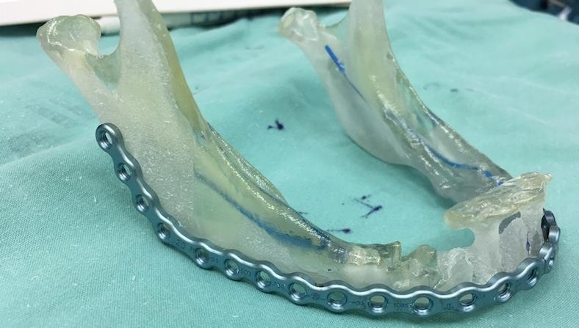

Fig1: 3D Printed Model of Lower Jaw
Printing life-size anatomic models can benefit in several aspects, including education of young surgeons on models allowing for tactile and 3D inspection of the tissues. The models can also be further used for performing mock surgeries thus improving the prediction of the outcomes. Thesemodelsmayalsobeusedforpresurgicaladaptationofinstrumentation, thus reducing the operation time and achieving superior compatibility. [9,10]
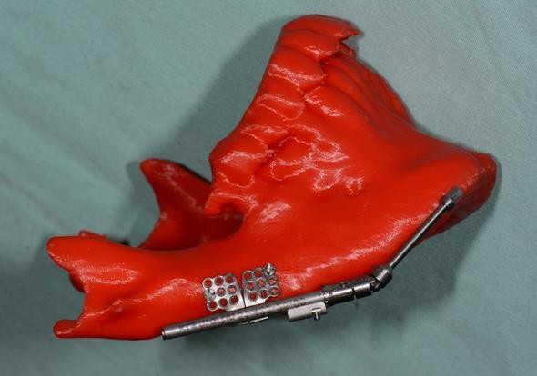.

Fig2: 3D Printed lower Jaw Model
Three-dimensional printed models were shown to be superior in preoperative planning comparedto3Dimages.[11]Theapplicationswereusedinmanyfieldssuchasvascularsurgeryforprintingaorticmodels,inendovascularaneurysmrepairtoselecttheproperdevice,[12,13]incardiacsurgeryforpresurgicalplanningoftumorresectionsandrepairofcongenitaldefects,[14,15]inneurosurgeryfornavigationtraining,[16]andinorthopedicsurgeryforplanningoftumorresectionandtreatmentof trauma injuries.[17,18]The 3D printed models in cranio-maxillofacial surgery for pre-bending of reconstruction titanium plates on a 3D model of the skull prior to resections, it allows to restore the correct position of the remaining bones accurately while reducing the operation length (Figure 1).
As virtual planning gains more popularity, especially with virtual reality developing rapidly and PSI becoming a standard of care, printing 3D models will lose its current popularity, yet an interesting application gaining momentum is surgical guides. These allow for accurate surgical resections or osteotomies based on preoperative imaging. Using these guides with the intention of inserting PSI is essential as accuracy is of very high importance, especially when metal implants are used which are extremely difficult to amend during surgery.
One of the most described uses of surgical guides in cranio-maxillofacial surgery is their application for bone resections and free flap reconstruction using a fibula free flap, for example(Figure3). We have used 3D planning and intraoperative guides for accurate rib grafting and fixation in mandibular ramus deficiencies. Another popular use is for ortho gnathic surgery. Orthognathic surgery is a corrective surgery, aiming to restore the proper anatomic and functional relationship in patients with dentofacial skeletal anomalies. The classic approach involved using an articulator and dental casts to transfer the skeletal relations, mock surgery on the casts based on our measurements, and acrylic wafers as guides in the operation room for repositioning of the jaws.

Nowadays, 3D preplanned waferless operations can be used for performing accurate osteotomies and perfect positioning of the unaligned jaw. Three-dimensional printing of cutting guides for the osteotomies and 3D printed patient-specific fixating plates for accurate final positioning of the jaws, based solely on the 3D preoperative planning, greatly reduce the incorporation of human errors (Refer Figure4). Intra operative 3D printed dental splints for accurate repositioning of the jaws/mid face based on 3D preoperative planning can also be prepared in cases where patient-specific fixating plates are not an option (Figure 5). In orthopedics cutting guides were used as drill guides and as guides for harvesting cartilage as well as for resections.
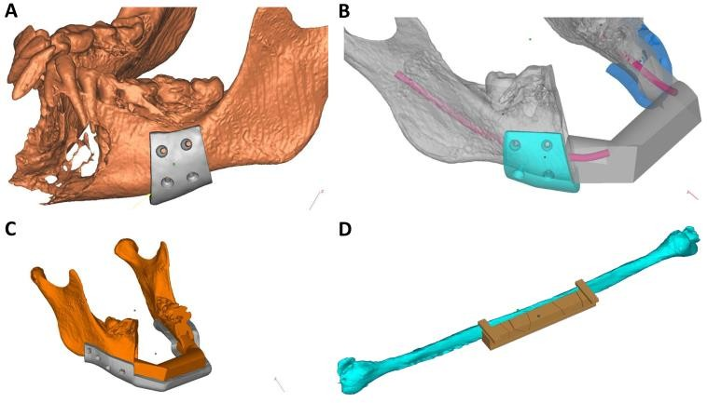
Fig.3: Surgical Guides
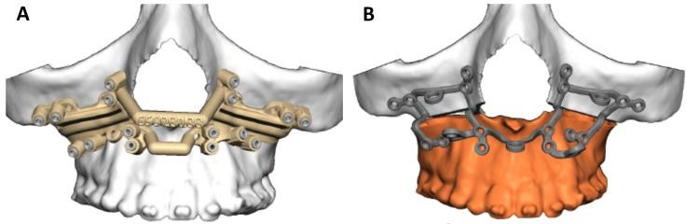
Fig.4: Cutting Guides in Orthogmathic surgery

Fig 5: In Ortho gnathic Surgeries One Can Use Intraoperative 3D Planned and Printed Dental Splints for Accurate Repositioning of the Jaws/Mid face

3. Why 3D printing in bio-medical?
Surgical planning is performed nowadays by engineers. This is due to several reasons. For one, most of the CAD programs available today were intended for the industrial fields, and thus are not user- friendly for the surgeon who usually lacks appropriate education. Another reason is the need for structural analysis of the implants with respect to biomechanical aspects. This way of planning results in the need for a cross-talk between the engineer and the surgeon, who are often in different countries and speak different languages. With time, planning will be simplified and become more user-friendly, taking into account mechanical issues and implementing rules for virtual planning, making sure the implant will maintain stability under physiological forces. This will shift the planning process to the surgeon, thus saving the time-consuming, costly cross-talk between engineers and surgeons.

Using PSI results in a more precise and durable method for reconstruction, with lower morbidity and shorter operation time. Yet these alloplastic materials have their disadvantages: they are still foreign bodies and are thus prone to infection and oral/cutaneous dehiscence, and the fixating screws can loosen and create an inflammatory reaction
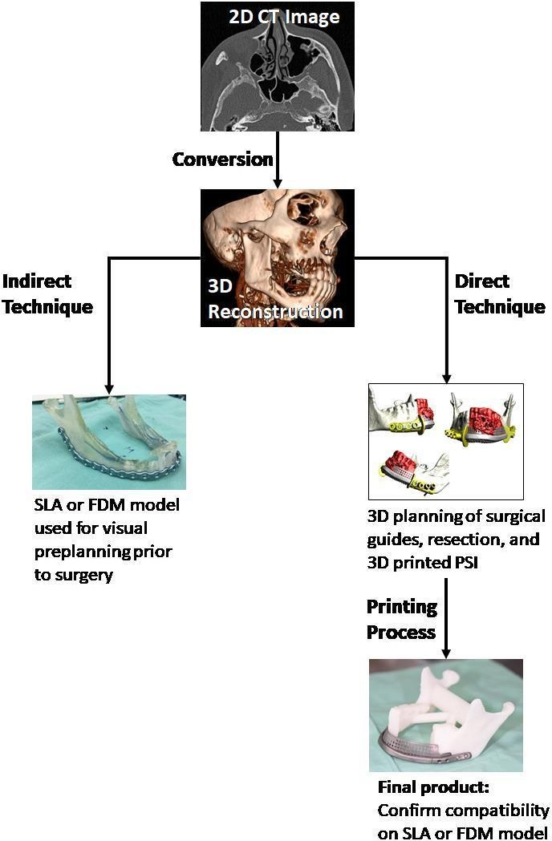

The future lies in 3D bio-printing of viable cells which will compose the missing bone and soft tissue. The field of bio-printing is extensively investigated, leading to improvement in technologies, materials, and protocols. Although the field is considered to be in its early phases of development, human-scale tissues have already been printed; examples include skin, cartilage, vascular tissue, aortic valve, and kidney. Technological challenges include the need for increased resolution, speed, and compatibility with biologically relevant materials. Of course, vascularization, which is a great challenge in tissue engineering, is also a major obstacle in bio- printing: proper vascularization of the 3D printed tissue must be achieved for long-term viability. Until bio-printing becomes a standard, a noteworthy application is 3D printing of bio-resorbable implants. An example is creation of a bio-resorbable poly-caprolactone airway splint that was implanted in a boy suffering from tracheobronchomalacia.

4. Conclusions: The use 3D printing technology in biomedical area constructs a bridge between a mechanical engineering and bio-medical area. The patient specific 3D CAD models of different organs can be prepared by mechanical engineers by using various CAD software such as Auto Cad, Solid works Catia etc. from the patients CT scan and then printing it by various techniques such as SLS, SLA, FDM SLM etc. These models may be used in surgical planning or as surgical implants. This helps reducing the surgical time and in performing a precise surgery by the doctors. In addition to this the bio-printing of viable cells is possible by using the bones and soft tissues such as human-scale tissues have already been printed which includes the skin, cartilage, vascular tissue, aortic valve, and kidney.

References
- Hull C W. Apparatus for production of three-dimensional objects by stereo lithography: Google Patents. 1986. [accessed July10, 2018]. Available at: http://bit.ly/2O5GArX.
- Caulfield B, McHugh P, Lohfeld S. Dependence of mechanical properties of polyamide components on build parameters in the SLS process. Journal of Materials Processing Technology. 2007;182:477–88. doi: 10.1016/j.jmatprotec.2006.09.007.
- Petzold R, Zeilhofer H-F, Kalender W.R apid prototyping technology in medicine—basics and applications. Comput Med Imaging Graph. 1999;23:277–84. doi: 10.1016/S0895-6111(99)00025-7.
- Rosochowski A, Matuszak A. Rapid tooling: the state of the art. J MatProcTech.2000;106:191–8.doi:10.1016/S0924-0136(00)00613-0.
- Rutala WA, Weber DJ Healthcare Infection Control Practices Advisory Committee(HICPAC) Guideline for disinfection and sterilization in healthcare facilities. 2008. [accessedJuly10, 2018]. Available at: http://bit.ly/2zZfVd5.
- Pruksakorn D, Chantarapanich N, Arpornchayanon O, Leerapun T, Sitthiseripratip K, Vatanapatimakul N. Rapid-prototype endoprosthesis for palliative reconstruction of an upper extremity after resection of bone metastasis. Int J Compute Assist Radiol Surg. 2015;10:34–50.doi:10.1007/s11548-014-1072-2.
- Smith P N, Palenik C J, Blanchard S B. Microbial contamination and the sterilization/disinfection of surgical guides used in the placement of endostealim plants. Int J Oral Maxillofac Implants.2011;26:274–81.
- Mitsouras D, Liacouras P, Imanzadeh A, et al. Medical 3D printing for the radiologist. Radiographics. 2015;35:1965–88. doi: 10.1148/rg.2015140320.
- Yan X, Gu P. A review of rapid prototyping technologies and systems. Computer-AidedDesign.1996;28:307–18.doi:10.1016/0010-4485(95)00035-6.
- Alexander P, Allen S, Dutta D. Part orientation and build cost determination in layered manufacturing. Computer-Aided Design. 1998;30:343–56.doi:10.1016/S0010-4485(97)00083-
3.
- Zheng YX, Yu DF, Zhao JG, Wu YL, Zheng B. 3D printout models vs. 3D-rendered images: which is better for preoperative planning? J SurgEduc.2016;73:518–23.doi:10.1016/j.jsurg.2016.01.003.
- Håkansson A, Rantatalo M, Hansen T, Wanhainen A. Patient specific biomodel of the whole aorta: the importance of calcified plaque removal. Vasa. 2011;40:453–9. doi: 10.1024/0301-1526/a000148.
- Tam MD, Laycock SD, Brown JR, Jakeways M. 3D printing of an aortic aneurysm tofacilitatedecisionmakinganddeviceselectionforendovascularaneurysmrepairincomplexneck anatomy. J Endovasc Ther. 2013;20:863–7. doi: 10.1583/13-4450MR.1.
- Farooqi K M, Gonzalez-Lengua C, Shenoy R, Sanz J, Nguyen K. Use of a three dimensional printed cardiac model to assess suitability for biventricular repair. World J Pediatr Congenit Heart Surg. 2016;7:414–16. doi: 10.1177/2150135115610285.
- Schmauss D, Gerber N, Sodian R. Three-dimensional printing of models for surgical planning in patients with primary cardiac tumors. J Thorac Cardiovasc Surg. 2013;145:1407–8.doi:10.1016/j.jtcvs.2012.12.030.
- Waran V, Pancharatnam D, Thambinayagam H C, et al. The utilization of cranial models created using rapid prototyping techniques in the development of models for navigation training. J Neurol Surg ACentEurNeurosurg.2014;75:12–15.
- Kacl G M, Zanetti M, Amgwerd M, et al. Rapid prototyping (stereolithography) in the management of intra-articular calcaneal fractures. Eur Radiol. 1997;7:187–91. doi:10.1007/s003300050132.
- Tam M D, Laycock S D, Bell D, Chojnowski A. 3-D print out of a DICOM fileto aid surgical planning in a 6-year-old patient with a large scapular osteochondroma complicating congenita ldiaphyseal aclasia. J Radiol Case Rep. 2012;6:31–7. doi: 10.3941/jrcr.v6i1.889.

