Quality control approaches for standardization of medicinal plant
Author information
Rustam Ekbbal*, Aakash Kumar Jaiswal
ª IIMT College of Medical Sciences, IIMT University, O Pocket, Ganga Nagar, Meerut, Uttar Pradesh 250001.
^{b} School of Pharmaceutical Sciences, IIMT University, O Pocket, Ganga Nagar, Meerut, Uttar Pradesh 250001.

Rustam Ekbbal: rustamekbbal@gmail.com
Aakash Kumar Jaiswal: akj03241994@gmail.com

Corresponding address
Rustam Ekbbal
Associate professor
IIMT College of Medical Sciences,
IIMT University, O Pocket, Ganga Nagar,
Meerut, Uttar Pradesh 250001
Figure and table captions
Figure 1: Enlisted of extraction methods used in herbal industries 8
Figure 2: Infusion of tea 9
Figure 3: Decoction of green tea 10
Figure 4: Extraction of the crude material by microwave digestion system 11
Figure 5: Extraction of crude drug by maceration method 12
Figure 6: Percolation assembly 14
Figure 7: Extraction of the crude drug through reflux method 15
Figure 8: Soxhletion assembly 17
Figure 9: Supercritical fluid extraction machine 19
Figure 10: Ultrasound-assisted extraction (UAE) system 21
Figure 11: Microwave-assisted extraction (MAE) system 22
Figure 12: Clevenger apparatus 23
Figure 13: Schematic representation of compound isolation to elucidation with their involved techniques 30
Figure 14: Flesh column chromatography 34
Figure 15: paper chromatography 36
Figure 16: Separation of components by CTLC 37
Figure 17: Developed PTLC and separation of compounds 39
Figure 18: HPTLC instrumentation and chromatogram of developed HPTLC of herbal samples 40
Figure 19: High-performance liquid chromatography system 41
Figure 20: Instrumentation of HPLC 42
Figure 21: HPLC chromatogram of polyphenols analysis 43
Figure 22: Instrumentation of GC 44
Figure 23: 6.18. Ion chromatography (IC)/ion-exchange chromatography of proteins 46
Figure 24: Size-exclusion chromatography (SEC) 47
Figure 25: Countercurrent chromatography 48
Figure 26: UV spectra of quercetin as standard and isolated quercetin 52
Figure 27: IR spectra of gallic acid showing –COOH and –OH stretching at 3492 and 3370 cm-1, -C=O and aromatic protons stretching at 1615 and 1265 cm-1. 55
Figure 28: Simple instrumentation of NMR 58
Figure 29: Proton NMR spectra of quercetin, figure representaing the chemical shift (PPM) and signals of proton 60
Figure 30: carbon NMR spectra of quercetin, figure representaing the chemical shift (PPM) and signals of proton 60

Table 1: List of some different sorbents/solid phases used in chromatography 28
Basics of phytochemistry

Introduction
Since 2000 years of the history of medicine we can imagine for most of the period, mankind had no other major source of medicine than plants, either fresh or dried. Over 248,000 species of higher plants have been identified and from these 12,000 plants are known to have medicinal plants engaged with a multi-dimensional role in therapeutic values. However, less than 10% of all plants have been investigated from a phytochemical and pharmacological point of view. The importance of medicinal plants is demonstrated by the fact for their quality, safety, and efficacy not only in developed countries even in developing countries [1–3]. According to the World Health Organization (WHO), in India, 65% of the population in rural areas uses Ayurveda or traditional medicines as an alternative and complementary medicine for treating various disorders [4]. The aims of medicinal plant research can be summarized as
- Qualitative and quantitative analysis of the constituents of
medicinal plants
- Isolation of plant-originated, biologically active, purified
fractions and molecules with new structures.
- Optimization of the amount and/or ratio of medicinal plant
compounds responsible for therapeutic effects.
As it is known with the complexity of phytochemicals in medicinal plants, evaluation of therapeutic potential concerning the phytochemical specification is one of the challenging endeavors to validate the medicinal plants for their regulatory purpose. Several conventional and nonconventional extraction techniques are strongly hyphenated for the establishment of targeted and non-targeted plant matrices based on successive extraction, target-based bio-guided fraction, or phytochemical enrichment extraction methods [2].
Chromatographic techniques are liable for the separation of phytochemicals from a complex plant matrix using suitable mobile and stationary phases. Besides the chromatographic separation, the selection of appropriate stationary and mobile phase provides robustness in chromatographic separation. Optimization of targeted bioactive phytoconstituents from herbal medicine is one of the important steps from separation science to biological science [5]. Chromatography and spectroscopy techniques such as thin layer chromatography (TLC), high performance thin layer chromatography (HPTLC), high performance liquid chromatography (HPLC), Ultra performance liquid chromatography (UPLC), liquid chromatography and mass spectroscopy (LC-MS), gas chromatography and mass spectroscopy (GC-MS), nuclear magnetic resonance (NMR) etc are mainly hyphenated with target-based isolation, identification and quantitation of phytoconstituents from a huge diversity of phytoconstituents as well as help us to optimized and evaluate single constituents than the complexity of phytoconstituents [6,7].
This chapter includes a comprehensive review concerning modern methods of extraction and the techniques (chromatographic and spectroscopic) used for isolation, purification and identification of crude drugs from the medicinal plants.

Selection of extraction approaches
The fundamental steps in the analysis of medicinal plants are the selection of extraction method, as it is essential to extract the desired phytoconstituents from the plant materials for further chromatographic and spectroscopic identification or even characterization. The extraction method generally depends upon several factors
- Type of plant, part of the plant to be extracted, availability of solvent and nature of the bioactive compounds
- Pre-washing, drying or freeze-drying and grinding of crude plant material are often improving the analytic extraction kinetics with increased contact of the sample surface with the solvent system
- During extraction, it should be highly identifiable that potential active constituents are not lost, degraded during the extract preparation. Generally, extraction methods, such as decoction/boiling under reflux, sonification, soxhlation etc results in degradation of thermolabile phytoconstituents such as carotenoids, terpenoids etc and drops unfavorable conditions to reach out successive extraction.
- If the selection of plants was made based on ethnobotanicals perspective, then it is necessary to prepare the extract as described in traditional literature in order to mimic unfavorable conditions.
For example, if indigenous people approach a specific extraction method or use water, alcohol/alcoholic water as extracting solvent with heat or without heat, then a similar method should be approached in the laboratory to mimic the loss of molecular integrity so that same natural product can be extracted [8].

Selection of solvent for extraction
The selection of solvent for the extraction of phytoconstituents depends on the target-based isolation of phytoconstituents. Besides, polarity-based extraction and isolation of phytoconstituents are one of the necessities concerning their ethnobotanical purpose. In case, if the extraction method is not directly used for the ethnobotanical perspective, target-based isolation is the main perspective, the selection of solvent system mostly is influenced by the specific nature of the targeted bioactive compound [8]. Verities of solvent systems are accessible to extract the bioactive compound from the plant material and it largely depends upon the polarity index of acting solvent.
- The extraction of hydrophilic phytoconstituents uses semi-polar/polar solvents such as ethyl-acetate, ethanol, methanol, n-butanol, water etc.
- Extraction for lipophilic compounds, dichloromethane or dichloromethane: methanol (1:1), chloroform etc. used as the universal and more compatible solvents
- Extraction using hexane is purposed only to remove chlorophyll [9].
For example, extraction of non-polar compounds such as carotenoids, terpenoids, steroids, etc dichloromethane can be used as the extracting solvent using any specified extraction method without application of heat as it can cause degradation of desired components in the crude plant matrix.

Modern methods of extraction

Extraction
Extraction is a process to separate the targeted or untargeted classes of phytoconstituents from herbal/crude plant material when it is brought into contact of a solvent in which the substance of interest is soluble, but the other substances present are insoluble. The selection of the solvent is crucial for solvent extraction. Selectivity, solubility, cost and safety should be considered in the selection of solvents. The constituents that pose a similar polarity value near to the polarity of the solvent are likely to perform better miscibility and vice versa. Alcohols (ethanol and methanol) and water are being considered as universal solvents for the extraction of phytochemicals and their investigation [10].
The extraction of natural products progresses through the following stages:
- The solvent penetrates into the solid matrix.
- The solute dissolves in the solvents.
- The solute is diffused out of the solid matrix.
- The extracted solutes are collected.
Generally, the finer the particle size is better the result for extraction can be achieved. The extraction efficiency will be enhanced by the small particle size due to the enhanced penetration of solvents and diffusion of solutes, however, too fine a particle size will cost the excessive absorption of solute in solid and may cause difficulty in subsequent filtration [11].
During liquid-liquid extraction, the conventional way is to select two miscible solvents such as water–dichloromethane, water–ether, and water–hexane. In all the combinations, water is present because of its high polarity and miscibility with an organic solvent. The compound to be extracted using liquid-liquid extraction should be soluble in an organic solvent but not in water to ease the separation. Furthermore, the solvent used in extraction is classified according to its polarity, from n-hexane which is the least polar to water the most polar [8].

Methods of extraction
There are various types of conventional and non-conventional methods which are widely used for the extraction of targeted and untargeted metabolites from natural or crude plant material [1,3,12], [9].
Methods of extraction

Conventional methods
- Infusion
- Decoction
- Digestion
- Maceration
- Percolation
Non-Conventional methods
- Reflux method
- Soxhelation method
- Ultrasonic Assisted Extraction (UAE)
- Microwave Assisted Extraction (MAE)
- Pressurized liquid extraction (PLE)
- Supercritical fluid extraction (SFE)
- Pulsed electric field (PEF) extraction
- Enzyme assisted extraction (EAE)
- Hydro distillation and steam distillation
Figure 1: Enlisted of extraction methods used in herbal industries

Conventional methods of extraction

Infusion:
Infusion is the process of extracting chemical compounds from plant material in a solvent such as water by allowing the material to remain suspended in the solvent over a short period of time.
Principle
The drug material is grinded into a fine powder and then placed inside a clean container. The extraction solvent hot or cold is then poured on top of the drug material, soaked, and kept for a short period of time. This method is suitable for the extraction of bioactive constituents that are readily soluble. In addition, it is an appropriate method for the preparation of fresh extract before use. The solvent to sample ratio is usually 4:1 or 16:1 depending on the intended use.
Advantages
- No degradation of phytoconstituents
- Safe in consumption if used as medicinal purpose
- Economic and easy establishment
Disadvantages
- Less extractive yield
- Solvent restricted metabolites achievement

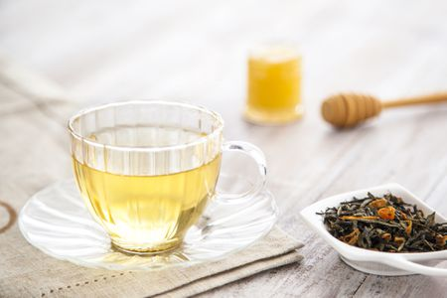
Figure 2: Infusion of tea

Decoction
A process of extracting chemical compounds from crude material boiled with a specified volume of water for a defined time at atmospheric temperature.
Principle
A dried, grinded, and powdered plant material is placed into a clean container. Water is then poured and stirred. Heat is then applied throughout the process to hasten the extraction [13]. The process has lasted for a short duration usually about 15min. The ratio of solvent to the crude drug is usually 4:1 or 16:1. It is used for the extraction of water-soluble and heat-stable plant material
Advantages
- More efficient than infusion
- High extraction yield
- Safe in consumption if used as medicinal purpose
- Economic and easy establishment
Disadvantages
- Decoction contains a large amount of water-soluble impurities.
- Decoction cannot be used for the extraction of thermolabile or volatile components.
Example: Preparation of green tea, ordinary tea etc.
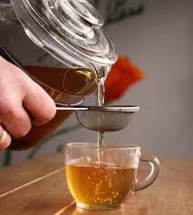
Figure 3: Decoction of green tea

Digestion
It is a form of maceration where gentle heat is needed during the process of extraction. It is used when the moderately elevated temperature is not objectionable. The solvent efficiency of menstruum is thereby increased.
Principle
The solvent of extraction is poured into a clean container followed by powdered drug material. The mixture is placed over a water bath or in an oven at a temperature of about 50º C. Heat was applied throughout the extraction process to decrease the viscosity of the extraction solvent and enhance the removal of secondary metabolites.
Eg. Extraction of morphine through digestion extract.
Advantages
- More efficient than infusion and decoction
- High extraction yield
- Suitable for readily soluble plant materials.
Disadvantages.
- This method cannot be used for the extraction of thermolabile or volatile components.

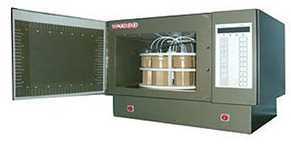
Figure 4: Extraction of the crude material by microwave digestion system

Maceration
Maceration is a simple extraction process in which consistent maintenance of direct contact between the crude material and distilled water or another extracting solvent (depends on the polarity and targeted natural products) is being processed for a period of time at room temperature.
Principle
In this method, coarsely powdered drug material either leaves or stems bark or root bark is placed inside a container; the menstruum is poured on top until completely covered the drug material. The container is then closed and kept for at least three days. The content is stirred periodically, and if placed inside the bottle it should be shaken from time to time to ensure complete extraction. At the end of extraction, the micelle is separated from marc by filtration or decantation. Subsequently, the micelle is then separated from the menstruum by evaporation in an oven or on top of a water bath.
Eg- Extraction of total phenols and total anthocyanins from chokeberry fruit
Advantages
- Majorly hyphenated for the extraction of thermolabile components from natural sources
- Economic and easy establishment
Disadvantages
- Long extraction time and low extraction efficiency
- High consumption of extraction solvent
- The process is labor-intensive
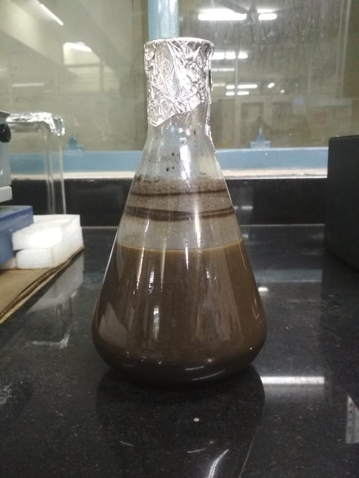
Figure 5: Extraction of crude drug by maceration method

Percolation
Percolation, it is a continuous process in which the saturated solvent is constantly being replaced by fresh solvent and the extracted contents being collected. This method is more efficient than maceration because of its continuous process. This process is performed at room temperature and occasionally under heat.
Principle
The apparatus used in this process is called a percolator. It is a narrow-cone-shaped glass vessel with an opening at both ends. A dried, grinded, and finely powdered plant material is moistened with the solvent of extraction in a clean container. More quantity of solvent is added, and the mixture is kept for a period of 4h. Subsequently, the content is then transferred into a percolator with the lower end closed and allow to stand for a period of 24h. The solvent of extraction is then poured from the top until the drug material is completely saturated. The lower part of the percolator is then opened, and the liquid is allowed to drip slowly. Some quantity of solvent was added continuously, and the extraction has taken place by gravitational force, pushing the solvent through the drug material downward. The addition of solvent stopped when the volume of solvent added reached 75% of the intended quantity of the entire preparations. The extract is separated by filtration followed by decantation. The marc is then expressed and the final amount of solvent is added to get the required volume.
Advantages
- Higher extraction efficiency and less time required than maceration.
- It can be used for tinctures and resinous drugs
- Economic and easy establishment
Disadvantages
- There may be chances of blasts due to over swelling of drugs
- Restricted to tinctures and resinous drugs only
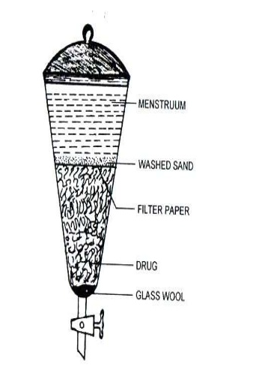
Figure 6: Percolation assembly

Non-Conventional methods

Reflux extraction
Reflux extraction is a solid-liquid extraction process at a constant temperature with repeatable solvent evaporation and condensation for a particular period of time without the loss of solvent. It involves the technique of condensation of vapors and the return of this condensate to the system from which it originated.
Principle
A coarsely powdered drug was placed to the round bottom flask (RBF) with the extracting solvent in 1:8 ratio (drug : solvent) for proper extraction. A condenser is placed to the RBF which condenses the solvent vapors thus mimic the loss of solvent during extraction. This process is performed continuously for 8-10 hrs to achieve proper extraction and high extractive yield. After the extraction process, the extract is filtered, concentrated and stored at room temperature for further use.
Example: Refluxing with 70% ethanol provided the highest yield or good extraction efficiency of active ingredients. The reflux method was found to be better than the decoction method.
Advantage
- Required moderate solvent consumption with high extraction efficacy and yield
- Reflux extraction is more efficient than percolation or maceration and requires less extraction time and solvent
Disadvantage: It can not be used for the extraction of thermolabile natural products.
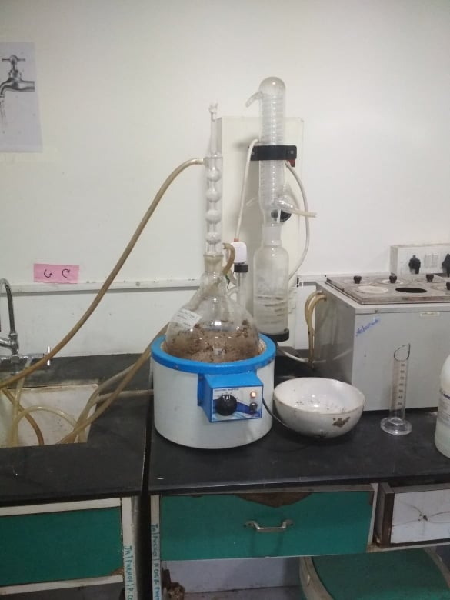
Figure 7: Extraction of the crude drug through reflux method

Soxhlet extraction method
The Soxhlet extraction method integrates the advantages of reflux extraction and percolation. It is an automatic continuous extraction method with high extraction efficiency that requires less time and solvent consumption than maceration or percolation. The process utilizes the principle of reflux and siphoning to continuously extract the herb with fresh solvent [14].
Principle
The coursly powdered biomass of dried plant material is placed in a soxhlet thimble constructed of filter paper, through which solvent is continuously refluxed. After reaching a level of soxhlet thimble with the extracting solvent, it empty its content into the RBF. Further, the fresh solvents enter into the soxhlet thimble by the reflux condenser. The cycle of up and down enter of extracting solvent from RBF to soxhlet thimble is continuously processed till the complete extraction can not be achieved. this process takes a minimum 10-15 hrs to complete the extraction process. After reaching the complete extraction, the extract is filtered through the Whatman's filter paper and concentrated for further use.
For example, in a study, ursolic acid was isolated from the Cynomorium (Cynomorii Herba) extract obtained through the soxhlet method, the yield of ursolic acid was found as 38.21 mg/g. Besides, using the same method for extraction, the degradation of catechins in tea was also observed in Soxhlet extraction due to the high extraction temperature applied. The concentrations of both total polyphenols and total alkaloids from the Soxhlet extraction method at 70 °C decreased compared to those from the maceration method applied under 40 °C.
Advantages:
- Integrates the advantages of the reflux extraction and percolation.
- High extraction efficiency.
- Less time and solvent consumption
Disadvantages:
- The high temperature and long extraction time will increase the possibilities of thermal degradation.
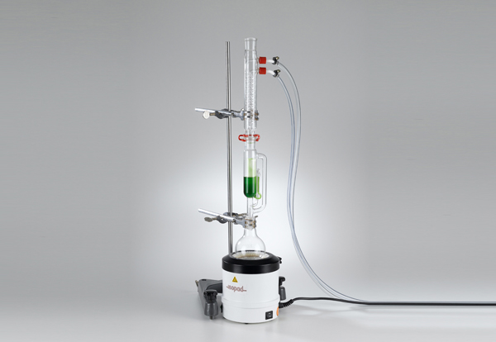
Figure 8: Soxhletion assembly

Supercritical fluid extraction (SFE)
Supercritical fluid extraction (SFE) uses supercritical fluid (SF) as the extraction solvent. SF has similar solubility to liquid and similar diffusivity to gas, and can dissolve a wide variety of phytoconstituents. The solvating properties dramatically changed near their critical points due to small pressure and temperature changes. Supercritical carbon dioxide (S-CO₂) was widely used in SFE because of its attractive merits such as low critical temperature (31°C), selectivity, inertness, low cost, non-toxicity, and capability to extract thermally labile compounds.
Working principle
There are main there steps that are associated with the extraction phenomenon.
Maximizing diffusion
This can be achieved by increasing the temperature, swelling the matrix, or reducing the particle size. Matrix swelling can sometimes be increased in proportion to the acting solvent pressure, and by adding modifiers to the solvent it can be regulated to achieve the successive extraction. Some polymers and elastomers, in particular, are swelled dramatically by CO2, with diffusion being increased by several orders of magnitude in some cases.

Maximizing solubility
Generally, optimized pressure and temperature will increase the solubility or dissolving power of phytoconstituents with no loss of their chemical integrity. At pressures well above the critical pressure, solubility is likely to increase with temperature. Besides, the addition of low levels of modifiers (sometimes called entrainers), such as methanol and ethanol, can also significantly increase solubility, particularly of more polar compounds.
Optimizing flow rate
Flow rate must therefore be determined depending on the competing factors of time and solvent costs, and also capital costs of pumps, heaters and heat exchangers. The optimum flow rate will probably be somewhere in the region where both solubility and diffusion are significant factors.
For example, in a study, Conde-Hernández extracted the essential oil of rosemary (Rosmarinus officinalis) by three methods such as S-CO₂ extraction, hydro distillation and steam distillation. He found that both yields of essential oil and the antioxidant activity of SFC extract were higher than those from the other two methods. S-CO₂ modified with 2% ethanol at 300 bar and 40 °C gave higher extracting selectivity of vinblastine (an antineoplastic drug) from Catharanthus roseus, which is 92% more efficient for vinblastine extraction compared to traditional extraction methods [15].
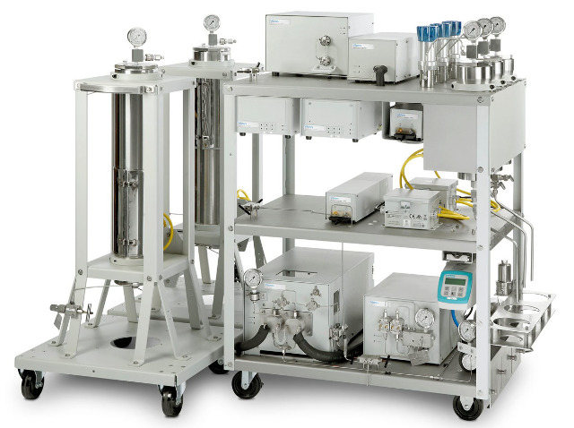
Figure 9: Supercritical fluid extraction machine

Advantage
- The process can facilitate the collection of pure CO₂ solvent (gas), such that it can be recirculated into storage for re-use, thus reducing total energy costs (less CO₂ collection required) thereby reducing energy consumption and increasing the overall sustainability of SCF-based extractions.
- Precise and rapid extraction
- Selectivity of this method beings this into a more considerable instrument for the extraction of non-polar constituents. As the properties of the supercritical fluid can be altered by varying the pressure and temperature, allowing selective extraction.
Disadvantage
Unfortunately, SFE-based methods are not without their own shortcomings; two major ones being are associated with the same as
- The high establishment cost; and
- The selective solvent nature of CO₂, i.e., that CO₂ only dissolves small non-polar molecules

Ultrasound-assisted extraction (UAE)
Ultrasonic-assisted extraction (UAE), also called ultrasonic extraction or sonication, uses ultrasonic wave energy in the extraction. Ultrasound in the solvent-producing cavitation accelerates the dissolution and diffusion of the solute as well as the heat transfer. Acoustic cavitation generated by UAE destroys the cell wall and reduces the particle size, thereby enhancing the contact between the solvents used in UAE.
Working principle
A coarsely powdered drug was placed in the conical flask with the extracting solvent in 1:8 ratio (drug : solvent) for proper extraction. The container is placed to the sonicator at the optimized extraction condition. This process is performed continuously for 5-8hrs to achieve proper extraction and high extractive yield. After the extraction process, the extract is filtered, concentrated and stored at room temperature for further use.
For example, a higher yield of polyphenols from Thymus serpyllum L. by UAE at an optimized condition (50% ethanol as solvent; 1:30 solid-to-solvent ratio; 0.3 mm particle size and 15 min time) than other extraction methods such as maceration and heat-assisted extraction methods. Hence, it is reported that the reflux method and UAE had the advantages of time-saving, convenient operation and high extract yield and that UAE is relatively better than reflux methods for TCM Dichroae Radix using the extract yield and content of febrifuge as the indexes [16].
Advantage:
- UAE improves the extraction efficiency with low solvent and energy consumption, and the reduction of extraction temperature and time.
- UAE increases the yield of the extract with short extraction times.
- UAE is applicable for the extraction of thermolabile and unstable compounds.
- In addition, there are some other advantages to this method, such as simplicity, speed, and low energy consumption, compared with traditional extraction methods.
Disadvantage:
- Associated demerits such as their time consumption, inefficiency, and uneconomical nature.
Figure 10: Ultrasound-assisted extraction (UAE) system

Microwave-assisted extraction (MAE)
This is one of the advanced extraction procedures which involves the mechanism of dipole rotation and ionic transfer by displacement of charged ions present in the solvent and drug material.
Principle
It involves the application of electromagnetic radiation in frequencies between 300 MHz and 300 GHz and wavelengths between 1cm and 1 m. The microwaves applied at a frequency of 2450 Hz yielded energy between 600 and 700 W. The technique uses microwave radiation to bombard an object, which can absorb electromagnetic energy and convert it into heat. Subsequently, the heat produced facilitates the movement of solvent into the drug matrix.
When the polar solvent is used, dipole rotation and migration of ions occur, increase solvent penetration, and assist the extraction process. However, when the non-polar solvent is used, the microwave radiation released will produce only small heat; hence, this method does not favor use of nonpolar solvents. Microwaves generate heat by interacting with polar compounds such as water and some organic components in the plant matrix following the ionic conduction and dipole rotation mechanisms. The MAE is based on the assistance of electromagnetic radiation with frequencies from 0.3 to 300 GHz, which induce heat inside the material via dipolar rotation and ionic conduction of the molecules [17]. The activation of these molecules and the heat generated in this process may weaken or break the cell walls thereby the bioactive compounds can be released more easily from material matrix to the extraction solvent[18].
Advantages:
- The application of MAE provides many advantages, such as increasing the extract yield, decreasing the thermal degradation and selective heating of vegetal material.
- MAE is also regarded as a green technology because it reduces the usage of organic solvents.
- MAE method for the extraction of polar and non-polar constituents
Disadvantages
This method is suitable only for phenolic compounds and flavonoids. Compounds such as tannins and anthocyanins may be degraded because of high temperature involved.
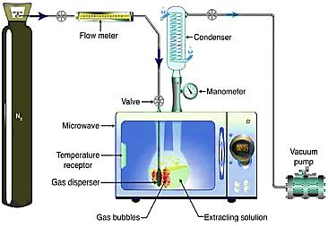
Figure 11: Microwave-assisted extraction (MAE) system

Hydro distillation and steam distillation
Essential oils are extracted from natural resources especially plant resources which contain hundreds of constituents belongs o the group of terpenes and phenylpropenes. Hydro distillation (HD) and steam distillation (SD) are commonly used methods for the extraction of volatile oil/essential oil in a Clevenger apparatus.
Principle
Hydro distillation (HD) and steam distillation (SD) are commonly used methods for the extraction of volatile oil. In brief, the crude material is placed to the RBF on which the Clevenger apparatus is attached. After providing the optimized temperature to RBF through the heating source, essential oil or volatile oils is convert in vapors and condensed along with the vapors of water which is collected in the graduated cylinder reservoir. In this reservoir, the condensed liquid contains two phases, the upper phase represents the essential oil and other represents to hydrosol (water contains some of the most polar volatile constituents).
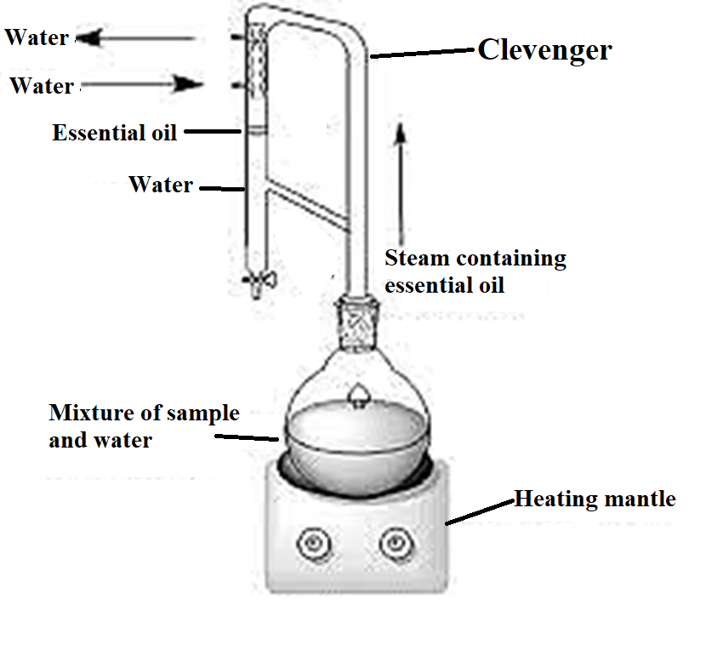
Figure 12: Clevenger apparatus
Application: Extraction and purification of essential/volatile oils.

Separation method
The components in the extract from the above methods are complex and contain a variety of natural products that require further separation and purification to obtain the active fraction or purely natural products. The separation depends on the physical or chemical difference of the individual natural product. Chromatography, especially column chromatography, is the main method used to obtain pure natural products from a complex mixture.

Fraction and purification methods
Fractionation is a process of separation of plant extracts into various fractions. It further segregates the fractions into portions comprising a number of compounds. The process continues until the pure compound is isolated [19]. When several solvents are required for the fractionation, they should be added according to the order of increasing polarity. Fractionation techniques are classified into the physical or chemical methods.

Physical methods
Physical methods used in the separation of compounds from mixtures include the separation funnel method, chromatographic techniques, fractional distillation, fractional crystallization, fractional liberation, and sublimation [20]

Separation funnel method
When four different solvents (n-hexane, chloroform, acetone, and n-butanol) are selected, fractionation begins by moistening or complete dissolution of the crude extract with 250mL of water. This is followed by transfer into a separating funnel, shaken, and allowed to settle. Furthermore, to 250mL of n-hexane, the least polar solvent was added and shaken. The content can settle, and the bottom of the separating funnel opened to remove the aqueous layer. The remaining content in the separating funnel was poured into a clean container to get n-hexane fraction. An equal volume of n-hexane was added again, shaken, and separated. The addition continued until after adding n-hexane and shaken no reasonable quantity of extract appeared to move into the n-hexane portion. A similar cycle was performed for chloroform, acetone, n-butanol to get chloroform, acetone, and n-butanol fractions. The remaining portion left after the fractionation is termed as a residual aqueous fraction (RAF) as the crude extract was first dissolved in water.

Fractional distillation
This is the process of separating or purifying compounds from a mixture. It is usually used in the separation of hydrocarbons such as crude oil, citral, and eucalyptol. Purification is achieved based on the differences in their boiling points. The fractional distillation apparatus is constructed in such a manner that when heat is applied each compound will evaporate and separates at its boiling point. Consequently, each compound fractionated will condense and be collected as a separate entity through several siphons attached to the fractional distillation apparatus.

Fractional crystallization
Large numbers of compounds that exist naturally in plant extracts are crystal in nature. Separation is achieved via the formation of crystals during the concentration of an extract using heat or refrigeration. Hence, the process of chemical crystallization from the fraction called Fractional crystallization

Fractional liberation
This method is suitable for separating compounds that can easily form precipitates from the mixture. The precipitate is usually formed by changing the compounds into their salt form or treating the sample (containing a large amount of single compound) to the solvent pose opposite polarity nature. Fractional liberation is commonly applicable in the separation or purification of natural products from rich fractions [20].

Sublimation
This method involves changing from solid to gaseous state without passing through the liquid state. Substances such as camphor and volatile oils when heated get separated and converted directly into a gas.

Chromatography
A technique enables that enables the isolation, purification and identification of the components of a mixture for qualitative and quantitative analysis. The various constituents of the mixture travel at different speeds, causing them to separate. The separation is based on differential partitioning between the mobile and stationary phases.
Based on this approach three components form the basis of the chromatography technique.
- Stationary phase: This phase is always composed of a “solid” phase or “a layer of a liquid adsorbed on the surface a solid support”.
- Mobile phase: This phase is always composed of “liquid” or a “gaseous component.”
- Separated molecules: phytochemicals or chemicals separated on/by stationary phase based on their polarity or molecular integrity
These are special techniques used in the separation of compounds from mixtures based on their size, shape, and charge. The concept of chromatography involves the use of the mobile phase, which is the solvent of extraction and the stationary phase such as silica gel and Sephadex mixed with calcium sulfate as a binder.

Chromatography techniques based on analysis
- Generally, chromatography may be Preparative “to separate the components of a mixture for later use, and is thus a form of purification”
- Analytical chromatography technique is used for identification of components present in smaller amount”. The chromatography method going to be used for the separation of plant constituents can be classified from different points of view are

The most used stationary phase in separation science
- Silica gel is used for parting amino acids, sugars, fatty acids, lipids, and alkaloids.
- Sephadex is applicable in the isolation of proteins and amino acids.
- Aluminum Oxide is useful in the separation of vitamins, carotenes, phenols, steroids, and alkaloids. Cellulose powder is used in the separation of amino acids, food dyes, and alkaloids.
- Celite is applicable in the separation of organic cations and steroids.

The physical state of the phases employed for separation
- If the mobile phase is a gas and the stationary phase
is a solid or liquid, the separation techniques are known as gas-solid chromatography or gas-liquid chromatography (GSC and GLC or often simply GC).
- In liquid chromatography (LC), the mobile phase is a liquid, ranging from a single pure solvent to a multi-component mixture. Supercritical fluid chromatography (SFC) uses a mobile phase (usually CO2) in the supercritical state at high temperature and pressure.

Types of chromatography based on mechanism of separation
In chromatography methods, the stationary phase facilitates separation depends upon four main basic mechanisms of separation are
Basis of shape
  - Column Chromatography: Open column, flash, vacuum
  - Planar Chromatography: TLC, HPTLC, OPLC, Centrifugal TLC
Mode of Separation
  - Adsorption (NPC, LSC): separates molecules based on polarity, least polar eluting first
  - Partition - (RPC, LLC): Separates molecules based on a combination of solubility parameters, partition coefficients, and polarity, most polar eluting first
  - Ion exchange: Separates molecules on basis of molecular charge
  - Size exclusion (GPC, GFC): separation based on molecular size, largest eluting first
  - Affinity: Based on affinity with ligand
Basis of Mobile Phase
  - Liquid Chromatography: LLC, LSC
  - Gas chromatography: GLC, GSC
  - Polarity relationship between the mobile and stationary phases
The separation of phytoconstituents depends upon their polarity and the relation of polarity between the mobile phase and stationary phase.
According to their relation, the stationary phase divides into main two parts.
    - Normal phase: First separation of non-polar compounds
    - Reversed-phase: First separation of polar compounds
Table 1: List of some different sorbents/solid phases used in chromatography
Sorbents | Mechanism | Applications
Silica gels | Adsorption | Amino acids, alkaloids, hydrocarbons, vitamins
Hydrocarbon modified silica | Modified partition | Nonpolar compounds
Cellulose | Partition | Amino acids, nucleotides, carbohydrates
Alumina | Adsorption | Hydrocarbons, alkaloids, food dyes, lipids
Kiselguhrs | Partition | Sugars, fatty acids
Ion-exchange celluloses | Ion-exchange | Nucleic acids, nucleotides
Polyamide | Adsorption  (H-bonding) | Anthocyanin's, aromatic acids, flavonoid

How to start isolation of natural products
- Know the nature of the compound to determine the approach to be followed
  - Solubility, hydrophobicity/hydrophilicity, acid-base properties, charge stability, size etc.
- What you want to isolate is important
- All metabolites of an organism – above info less useful
- Known compound? Most info is available –search literature
- Unknown molecule – no info available – best to determine nature
- Hydrophobicity/hydrophilicity – dry the sample and try dissolving in different solvents covering the whole polarity range
- Acid/base properties – adjust aqueous soln with acid/base pH 3, 7, 10 and do partitioning experiments
- Heat stability – heat at 80-90oC for 10 minutes
- Size- proteins can be eliminated by ultrafiltration membranes
- Localization of activity – leaves, stem, root, bark
- Microbial broth – free medium or associated with cells
General Isolation Procedure for Natural Products with associated techniques
The isolation process begins from extraction and fraction of plant matrix to get partially purified compound. Later, the yield of partially purified compounds can be accustomed to obtain pure isolated compounds through PTLC/HPLC/CC/CCC. Finally, the extract proceed to determine the chemical identity by using the analytical technique such as IR/MS/NMR etc. the schematic representation of a phytoconstituents from isolation to structure elucidation is summarised in figure

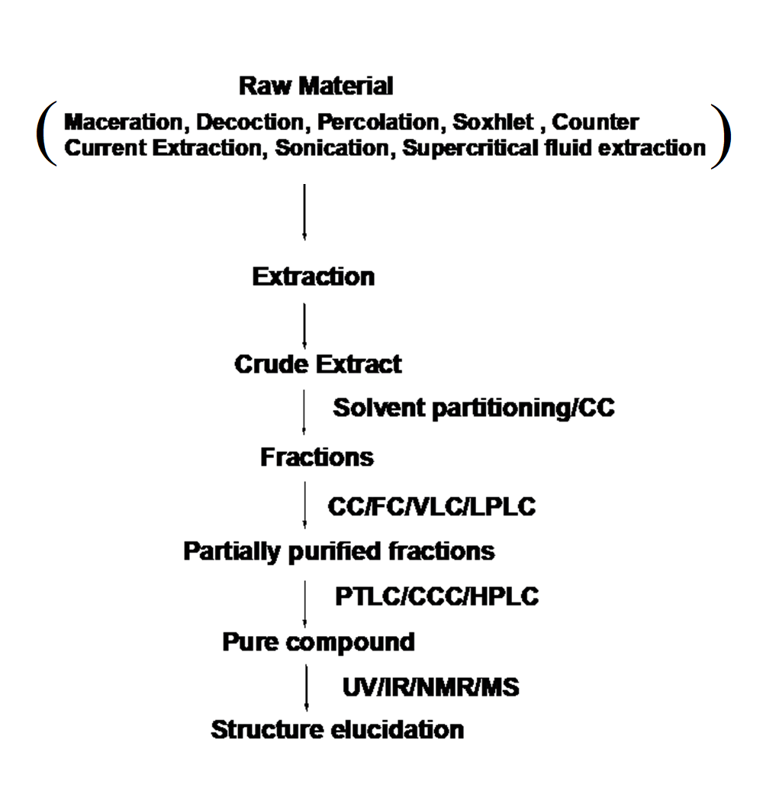
Figure 13: Schematic representation of compound isolation to elucidation with their involved techniques

Type of Chromatography techniques based on separation
Column Chromatography
- Prep Column Chromatography
- Flash Chromatography (FC)
- Vacuum liquid chromatography (VLC)
- Ion Exchange Chromatography
- Gel Chromatography
- Gel Filtration (GFC)
- Gel Permeation (GPC)
Pressure Liquid Chromatography
- Low-Pressure LC
- Medium Pressure LC (MPLC)
- High-Pressure LC (HPLC)
Normal Phase and Reverse Phase Chromatography
Liquid-liquid Chromatography
- Countercurrent Chromatography (CCC)
- Droplet Countercurrent Chromatography (DCCC)
Planar Chromatography
- Prepparative Thin Layer Chromatography (PTLC)
- Centrifugal TLC
- Overpressure layer Chromatography (OPLC)
Gas Chromatography
- Gas-Liquid Chromatography
- Gas-Solid Chromatography

Column chromatography
Column chromatography method used for isolation and purification of a compound from a mixture. Chromatography is able to separate substances based on differential adsorption of compounds to the adsorbent; compounds move through the column at different rates, allowing them to be separated into fractions. According to their relation, the stationary phase divides into main two parts.
- Normal-phase column chromatography
(NP) CC, the sorbent is more polar than the mobile phase and the interaction of polar compounds will be more than non-polar compounds. So it will elute non-polar than polar compounds. NPLC which has a good separation power – plays a very important role, especially in isolation strategies.
- Reversed-phase column chromatography
CC, the stationary phase is less polar than the mobile phase and interaction of non-polar compounds will be more than polar compounds and elute first than non-polar.

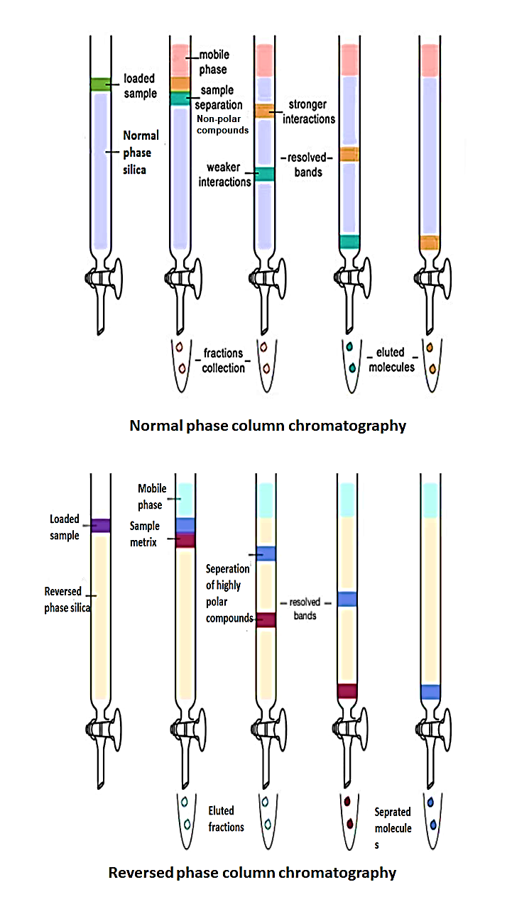

Elution Pattern of natural products in column chromatography based on the stationary phase
- Normal Phase
  - Alkanes olefins aromatics organic halogen compounds sulfides ethers nitro compounds esters/aldehydes/ketones alcohols/amines sulfones sulfoxides amides carboxylic acids.
- Reverse Phase
  - Carboxylic acids alcohols/phenols amines ethers/aldehydes ketones organic halogen compounds aliphatics
In RP, readily water-soluble substances are eluted more rapidly than hydrophobic ones. Aq. Solutions can be directly used, gives good separation for polar compounds. No deactivators are required.

Flesh column chromatography
A method for normal phase separation through purification. The chromatography is based on “ an air pressure driven hybrid of medium and short column chromatography optimized for rapid separation of biomolecules. FC Unlike with gravity column chromatography, using air pressure to force the solvent through the column reduces the chromatography time, therefore making the column and running the separation could take less than 10-15 minutes.
Principle
The principle is that the eluent which is a liquid, under gas/air pressure (normally nitrogen or compressed air) is rapidly pushed through a short glass column. The glass column is packed with an adsorbent of defined particle size with large inner diameter. The most used stationary phase is silica gel 40 – 63 μm, but obviously packing with other particle sizes can be used as well. Particles smaller than 25 μm should only be used with very low viscosity mobile phases because otherwise, the flow rate would be very low. Normally gel beds are about 15 cm high with working pressures of 1.5 – 2.0 bars. Originally only unmodified silica was used as the stationary phase so that only normal phase chromatography was possible. In the meantime, however, and parallel to HPLC, reversed-phase materials are used more frequently in flash column chromatography.
Selecting a Solvent System
The compound of interest should have a TLC Rf of ≈0.15 to 0.20 in the solvent system you choose. Binary (two-component) solvent systems with one solvent having a higher polarity than the other are usually best since they allow for easy adjustment of the average polarity of the eluent. The ratio of solvents determines the polarity of the solvent system, and hence the rates of elution of the compounds to be separated. The higher polarity of the solvent increases the rate of elution for ALL compounds. Common binary solvent systems in order of increasing polarity are dichloromethane/hexane, ether/hexane, hexane/ethyl acetate, and dichloromethane/methanol. Hexane/ethyl acetate can be used on the bench, all other solvents should be used in the hood. If your Rf is a ≈0.2, you will need a volume of solvent ≈5X the volume of the dry silica gel in order to run your column.
Application
- Separation, isolation and purification of natural products
- Role in pharmaceutical and agriculture industries to remove out impurities from finished products
- One of the most popular applications of the technique is in the drug discovery process

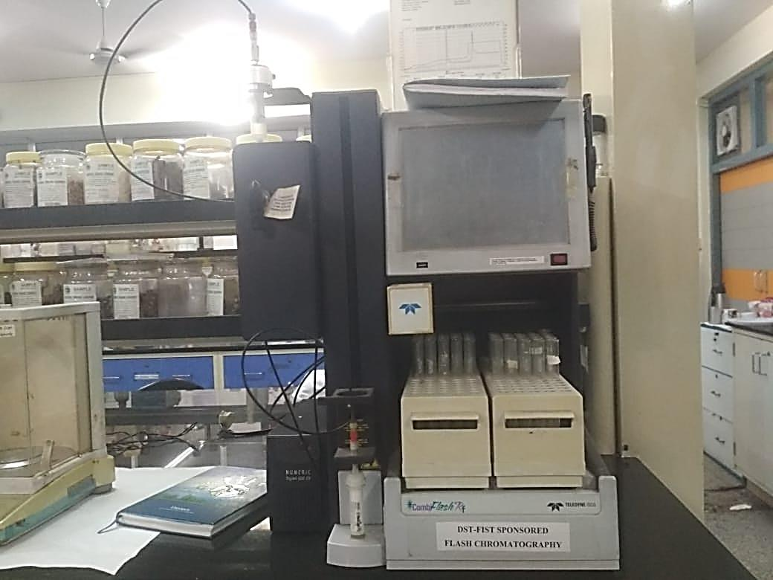
Figure 14: Flesh column chromatography

Vacuum Liquid Chromatography
VLC, a fast method in order to meet the needs of efficient purification of products from natural resources on both large and small scale under vacuum conditions. It is used for the fractionation of extract to meet desired components as per their polarity/category.
Principle
VLC is considered as a preparative thin-layer chromatography (PTLC) as separation is carried out on TLC grade silica gel or aluminum oxide and the column is dried after each fraction as in PTLC plates are dried and re-run to enhance the separation. The packed VLC columns can be reused for the same or similar separation thoroughly washing the column with methanol and scrapping away the decomposed polar material or band from the top of the adsorbent column. Gradient elution is very effective and can be used for the separation of small as well as large amounts of mixtures. The apparatus is suitable for the chromatography of extracts of reaction mixtures of less than 1 g. In this case, only 10-15 ml fractions are collected at each polarity step, and a complete chromatography can be readily contained. In our experience, the bed layer of silica gel should not exceed 5 cm in height for better optimistic outcomes. For small-scale separations (sample < 100 mg), a column of 0.5-1.0 cm internal diameter and 4 cm high should be used. For 0.5-1.0 g of the sample, a column approximately 2.5 X4 cm is appropriate, while for 1-10 g of sample for separation, a 5 cm diameter X 5 cm high column would be adequate. The continuous passes of solvent through VLC during the experimental process should be maintained if the column goes to dried, inadequacies will occur.
Application
- it is mainly used for the isolation and purification of chemical components from the mixture, pigments of natural or synthetic origin at large and small scale.
- Identification of a "target protein" which may have therapeutic value.
- industrial and institution application on large scale isolation of the therapeutic molecule

Planner chromatography
Planar chromatography is one branch of the discipline, defined by having the stationary phase of the process take place on a plane.

Paper chromatography
In paper chromatography, support material consists of a layer of cellulose paper highly saturated with water. A thick filter paper comprised the support, and water drops settled in its pores made up the stationary “liquid phase.” Mobile phase consists of an appropriate fluid placed in a developing tank. Paper chromatography is a “liquid-liquid” chromatography, and a planar chromatography system wherein a cellulose filter paper acts as a stationary phase on which the separation of compounds occurs.
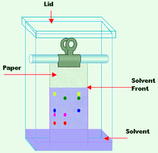
Figure 15: paper chromatography
Application
- It is used in scientific studies to identify unknown organic and inorganic compounds from a mixture.
- Separation of proteins, colored pigments and sequencing of DNA and RNA

Centrifugal Thin Layer Chromatography
A planner chromatography where the centrifugal force is generated by the spinning of the support disk and the mobile phase is applied at a constant flow rate. As the mobile phase elutes, it carries the sample along with it thereby creating spherical bands of the separated components. The separated components are then swirled off from the edge of the rotor together with the mobile phase.
Principle
A technique in which circular-shaped paper is about its center to speed up the motion of the mobile phase through the effect of centrifugal force thus it is called centrifugal chromatography. Its scaleup to a preparative technique eventually led to the construction of the "Chromatotron", which acts as the operational parameters of centrifugal thin-layer chromatography. Separation of compounds occurs in the direction of solvent flow.
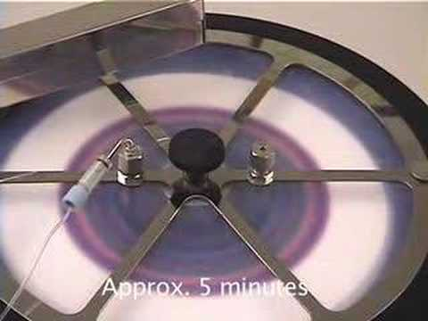
Figure 16: Separation of components by CTLC
Application
- CTLC is widely used in quality control standardization of herbal products or nature-derived medicines
- It is used in the separation of compounds that belongs to the same group in a plant matrix

Thin layer chromatography
Thin-layer chromatography is a type of adsorption chromatography, where the separation of compounds occurs at the stationary phase (silica gel/aluminum oxide) in form of a compounds library at different retardation factors (Rf). Separation of molecules occurs based on the nature of silica gel used as stationary phase. Basically, thin layer chromatography is classified in two major forms
- Preparative thin-layer chromatography (PTLC)
- Analytical thin-layer chromatography (HPTLC)

Preparative thin-layer chromatography:
Preparative thin-layer chromatography (PTLC) is used to separate and isolate compounds at a larger scale. The quantities processed range for PTLC is required at least 10 mg to 1 gram. In preparative TLC, materials to be separated are often applied as long streaks, rather than spots, in the sample application zone. After development, specific components may be recovered by scraping the sorbent layer from the plate in the region of Interest and eluting the separated material from the sorbent using a strong solvent. The material that is recovered from the layer may require further purification by TLC or other chromatographic methods, or the purity may be adequate for identification and structure determination by elemental analysis or spectrometry, for use in biological activity or chemical synthesis studies, or use as standard reference material for comparison with unknown samples.
Though being an old technique, TLC is still progressively associated for the analysis of phytoconstituents or a complex mixture of compounds obtained from the herbal matrix. This is due to the evolution of the instrumentation, automation, and the development of new adsorbents and supports (Shewiyo et al. 2012). Moreover, TLC features in a broad range of applications, such as the analysis of herbal medicines, dietary supplements, biological and clinical samples, food and beverages, environmental pollutants and chemicals
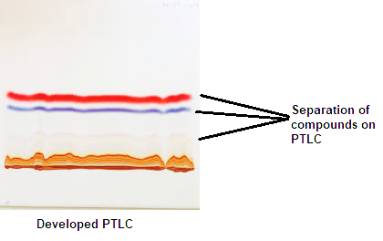
Figure 17: Developed PTLC and separation of compounds

High-Performance Thin Layer Chromatography
HPTLC is an advanced form of instrumental TLC, which does not only include the use of high-performance adsorbent layers (e.g. silica gel with refined uniform particles, approximately 5 µm in diameter, as compared to 12 µmin TLC) but also adopted instrumentation, for example, the development chambers. It usually also implies a standardized methodology for development, optimization, documentation, and the use of validated methods. The HPTLC technique is applied in qualitative and quantitative estimation of compounds in mixtures, where the quantitative mode operates in a more optimized way (standardized with a known method).
In HPTLC, samples are being spotted by the automatic sampler on a TLC with the help of HPTLC and then the plate is kept inside the saturated TLC chamber for 30 min. After drying, the plate is monitored by the UV system or visualizing reagents. To make results comparable between different laboratories and literature references, several parameters like the saturation of the TLC chamber, mobile-phase composition, water content of the silica stationary phase, etc. have to be controlled. Meanwhile, HPTLC can be regarded as an established method with application in GMP-compliant quality control of medicinal plant
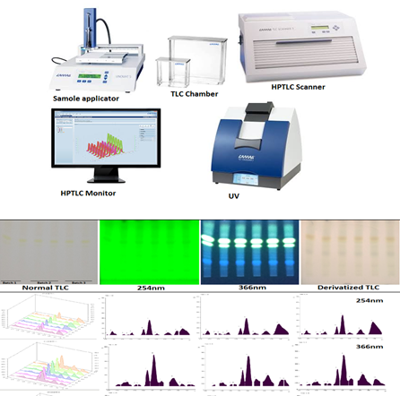
Figure 18: HPTLC instrumentation and chromatogram of developed HPTLC of herbal samples

Application of TLC
- Phytochemical analysis
- Biomedical analysis
- Herbal drug quantification
- Analytical analysis,
- Fingerprint analysis

High-performance liquid chromatography
This technique uses the mechanism of adsorption to achieve effective separation. It is suitable for the partitioning of both organic and inorganic compounds. The mobile phase is a suitable solvent, whereas the stationary phase is solid particles tightly joined together. Separation is initiated via the interaction of the compounds in the mixture with the solid particle of the stationary phase. The apparatus consists of a solvent reservoir, sample injector, pressure pump, HPLC tube, and diode detector.
Principle
The process begins by injecting the mixture to be separated at the bottom of HPLC. In addition, a suitable solvent is poured into the solvent reservoir. The tap is now opened to allow the movement of solvent downward, which is then pushed by a pressure pump to mix up with the injected sample. Finally, the mixture moved into the diode detector, which separated the compounds, removed the waste, and pumped the final content to processing units.
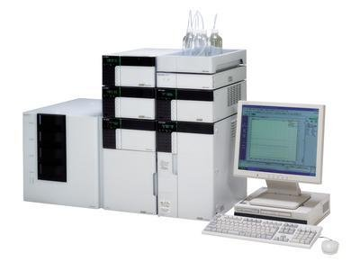
Figure 19: High-performance liquid chromatography system
HPLC Columns
 | Particle size | Column ID | Sample Load
Analytical | 3-5 m | 0.3-4.6 mm | ng-mg
Semi-prep | 10 m | 8-10 mm | 1-100 mg
Preparative | 10-30 m | 5-200 mm | Gram scale

An HPLC column consists of a stainless steel tube that is sealed with fittings on both ends. Steel frits in the end fittings keep the packing material in the column. Analytical columns have inner diameters of 1 - 10 mm and lengths of 25 - 250 mm. They are operated at flow rates of 60 µl - 5.0 ml/min. In preparative chromatography columns with an inside diameter of 200 mm and a length of 600 mm are used. To protect the actual separation column from chemical contamination, a guard column with the same packing material as the separation column is installed [21].
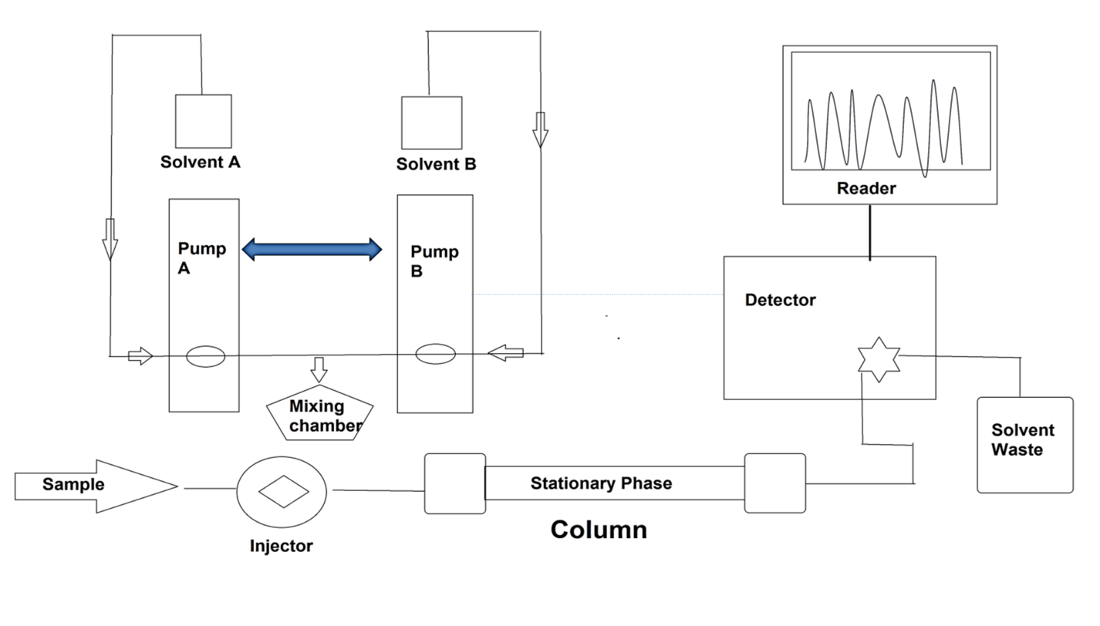
Figure 20: Instrumentation of HPLC
For example, in a study, polyphenols rich fraction was prepared of Tinospora cordifolia, the sample analysis was performed using RP-HPLC. Three major phenols were observed in the sample. The chromatogram of the analyzed sample is depicted as
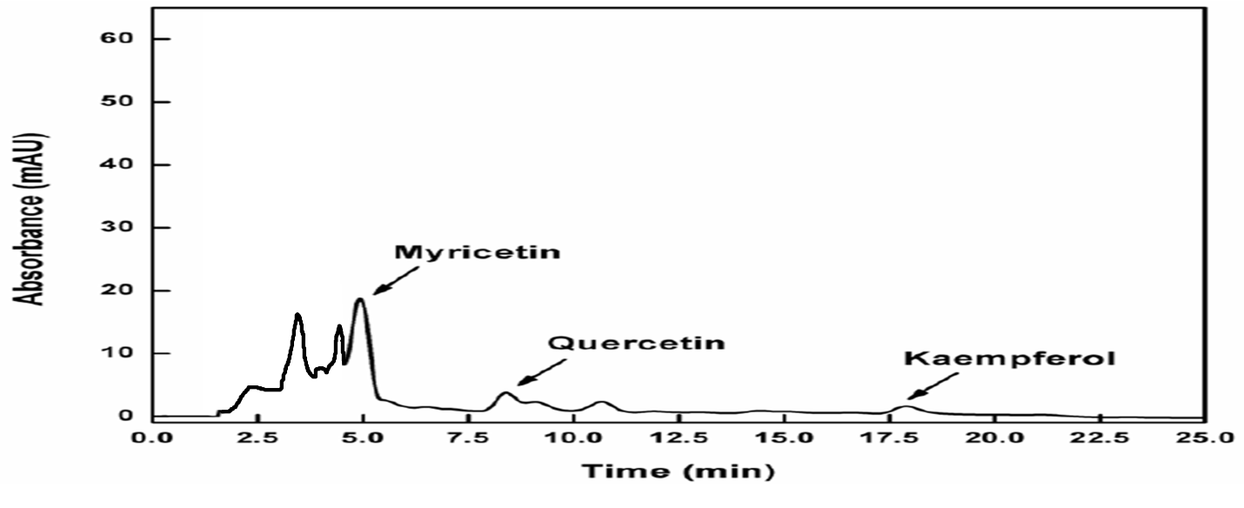
Figure 21: HPLC chromatogram of polyphenols analysis
Application
- Application of HPLC includes isolation, purification, and identification of the components from a complex biological sample, or of similar synthetic chemicals in research institutes and industries.
- Estimation and quantification of vitamins like Vit-D, C, E, etc.
- Assessment of drug in blood samples, determine loss or gain of an allele, quantitate the amount of RNA expressed, and detect a single nucleotide change.
- This technique is also used for the stability study of a drug molecule in the research industry.

Gas chromatography
Gas chromatography (GC) is a well-established analytical technique used in analytical chemistry for separating and analyzing compounds (qualitative and quantitative identification) that can be vaporized without decomposition. Typical uses of GC include testing the purity of a particular substance or separating the different components of a mixture.
Principle
It utilizes a capillary column which depends on the column's dimensions, as well as the phase properties between different molecules in a mixture and their relative affinity for the stationary phase of the column, which will promote separation of the molecules as the sample travels the length of the column. The separate compounds fall at the specific retention time in the proportion of their polarity index which may be further identifiable for the acquisition purpose. The most used carrier in GC used as helium and nitrogen as mobile phase.
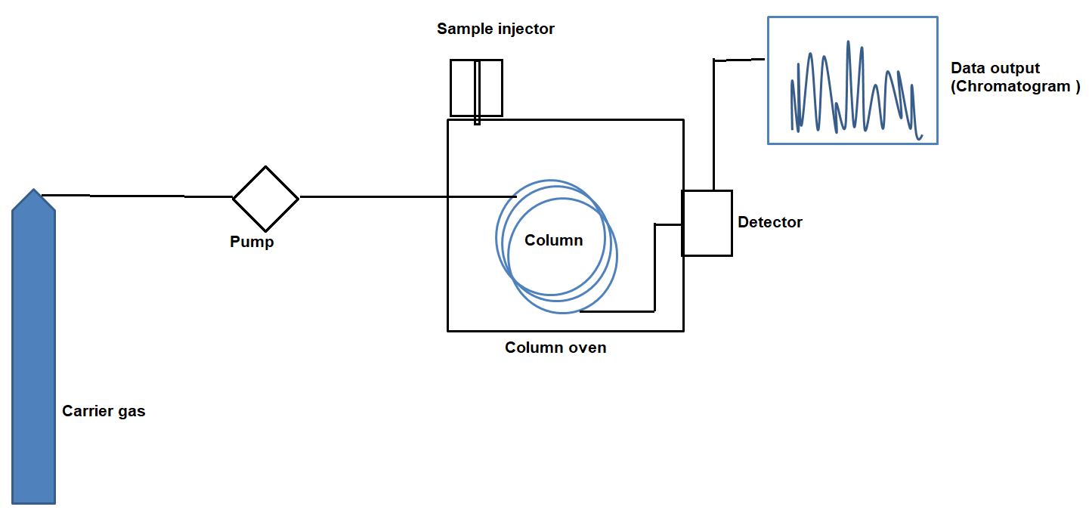
Figure 22: Instrumentation of GC
Advantages
- It is the most precise technique for the analysis of volatile/essential oils
- Qualitative and quantitative estimation of non-polar organic and inorganic compounds
- Assessment of GC in agriculture department for the analysis of pesticides
- Analysis of biological samples
- Analysis of blood sample in forensic science
Disadvantages
- Despite its advantages, the major limitation of GC is that it is restricted to volatile compounds, and the derivatization process is necessary to detect various metabolites which pose difficulties in sample preparation and identification due to multiple additives or derivative products.
- GC analysis of herbal products is usually limited to the essentials oils because of possible degradation of thermo-labile compounds and the requirement of volatile compounds makes GC unsuitable for many herbal compounds

Ion chromatography (IC)/ion-exchange chromatography
Ion-exchange chromatography (IEC) is part of ion chromatography which is an important analytical technique for the separation and determination of ionic compounds, together with ion-partition/interaction and ion-exclusion chromatography. The stationary phases used in ion chromatography are also known as ion exchangers that separate ions or polar molecules based on their affinity to the ion exchanger/charged molecule including large proteins, small nucleotides, and amino acids. The two types of ion chromatography are anion-exchange and cation-exchange.
Cation-exchange chromatography is used when the molecule of interest is positively charged.
Anion-exchange chromatography is used when the stationary phase is positively charged and negatively charged molecules.
Principle
Ion-exchange chromatography which is designed specifically for the separation of differently charged or ionizable compounds comprises mobile and stationary phases similar to other forms of column-based liquid chromatography techniques. Mobil phases consist of an aqueous buffer system into which the mixture to be resolved. The stationary phase is usually made from inert organic matrix chemically derivative with ionizable functional groups (fixed ions) which carry displaceable oppositely charged ion. Ions that exist in a state of equilibrium between the mobile phase and stationary phases giving rise to two possible formats, anion and cation exchange are referred to as counterion. Exchangeable matrix counter ions may include protons (H+), hydroxide groups (OH-), single charged monoatomic ions (Na+, K+, Cl-), double-charged monoatomic ions (Ca2+, Mg2+), and polyatomic inorganic ions (SO42-, PO43-) as well as organic bases (NR2H+) and acids (COO-). Cations are separated on cation-exchange resin column and anions on an anion exchange resin column [10]. Separation is based on the binding of analytes to positively or negatively charged groups that are fixed on a stationary phase and which are in equilibrium with free counter ions in the mobile phase according to differences in their net surface charge well as organic bases (NR2H+) and acids (COO-). Cations are separated on a cation-exchange resin column and anions on an anion exchange resin column. Separation based on the binding of analytes to positively or negatively charged groups that are fixed on a stationary phase and which are in equilibrium with free counterions in the mobile phase according to differences in their net surface charge
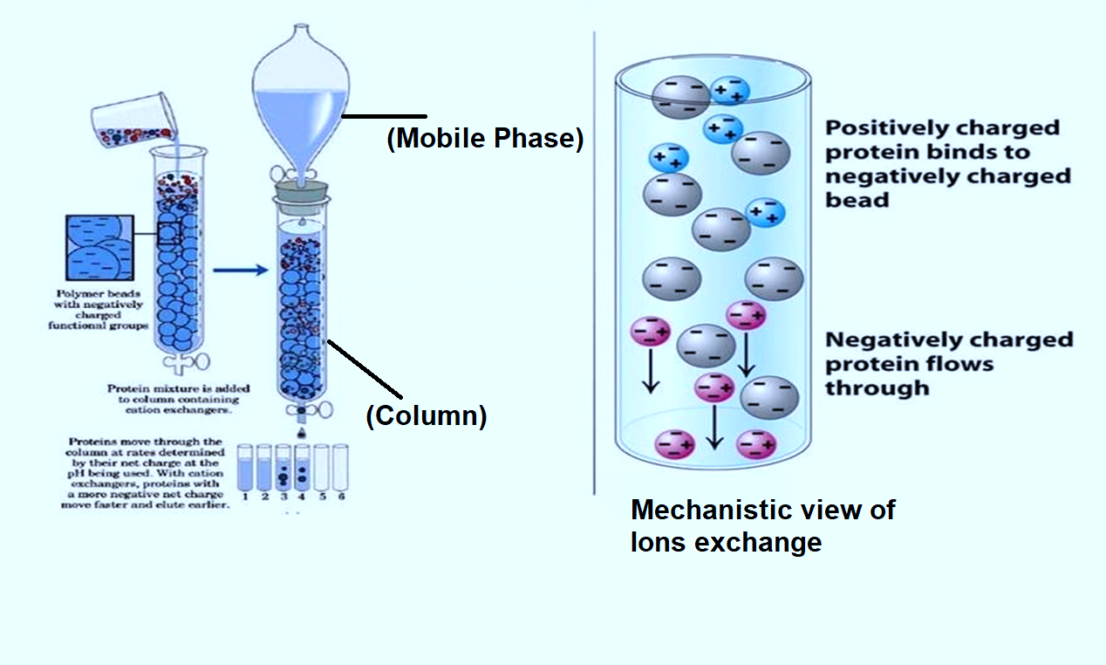
Figure 23: 6.18. Ion chromatography (IC)/ion-exchange chromatography of proteins
Application
- Ion-exchange chromatography has become one of the most important and extensively used of all liquid chromatographic technique
- The most significant development related to ion chromatography is to separation and purification of a charged biomolecule like proteins/amino acid nucleotides. And to improve stabilities and solubility properties of pharmaceutical active drugs molecules in research industries.
- In speciation analysis, for determination of metal and metalloid ions seems the most prospective.
- The advantages of ion chromatography in cation determinations include the following: simultaneous determination of alkaline and alkaline earth metals and ammonium ions.

Size-exclusion chromatography (SEC)
Size exclusion chromatography (SEC) is a form of chromatography that separates molecules by size. It is also known as gel-filtration chromatography (GFC) and gel permeation chromatography (GPC) which often refers to SEC with organic solvents.
Principle
It is a separation technique, difference in size and geometry of the molecules separated based on their size. The chromatographic column is packed with fine, porous beads which are composed of dextran polymers (Sephadex), agarose (Sepharose), or polyacrylamide. The pore sizes of these beads are used to estimate the dimensions of macromolecules. It is usually applied to large molecules or macromolecular complexes such as proteins, amino acids and industrial polymers.
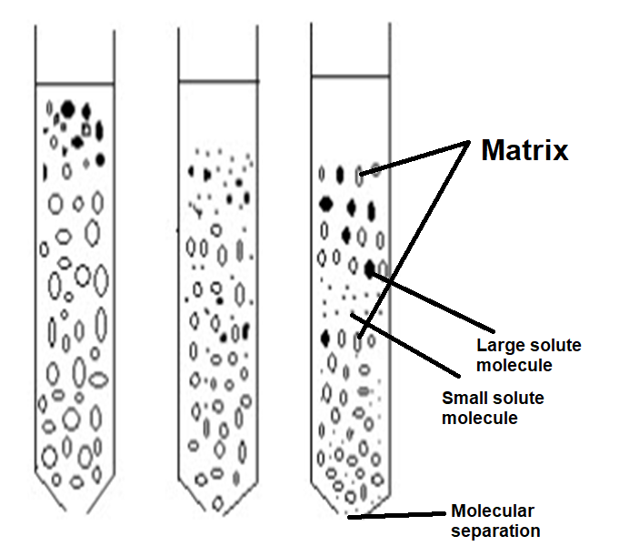
Figure 24: Size-exclusion chromatography (SEC)

For the separation of biomolecules in aqueous systems, SEC is referred to as gel filtration chromatography (GFC),
while the separation of organic polymers in non-aqueous systems is called gel permeation chromatography (GPC).
Application:
- The technique is used to separate and determine the proteins/amino acids and nucleotides as well as for large molecular weight drugs.
- SEC is also used for quantitative and qualitative analysis of polydispersity of a synthesized polymer in polymer/hydrocarbon industries

Countercurrent chromatography
Countercurrent chromatography is a form of liquid-liquid chromatography that uses a liquid stationary phase that is held in place by centrifugal force, and it is used to separate, identify, and quantify the chemical components of a mixture. In its broadest sense, countercurrent chromatography encompasses a collection of related liquid chromatography techniques that employ two immiscible liquid phases without solid support and the partition process takes place in an open column space where one phase (stationary phase) is retained and the other phase (mobile phase) continuously passes through it.
Principle
In this chromatography technique, separation of molecules is occurred based on their ionic affinity in the applied electric field for their chromatographic separation. The dynamic mixing and settling action allow the components to be separated by their respective solubility and selectivity of solvent systems.
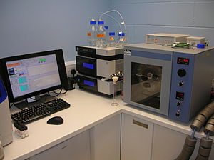
Figure 25: Countercurrent chromatography
Application of Countercurrent chromatography :
- Countercurrent chromatography have been used on both industrial and laboratory scale to purify a wide variety of chemical substances like proteins,, antibiotics, vitamins, natural products, pharmaceuticals, pesticides, polyaromatic hydrocarbons from environmental samples.
- It also has the advantage of accommodating chemically complex samples with undissolved particulates.

Spectroscopic techniques for the structure elucidation of natural products

Definition: The branch of science is concerned with the investigation and measurement of spectra produced when matter interacts with or emits electromagnetic radiation.
Spectrum: A plot of the response as a function of wavelength or more commonly frequency is referred to as a spectrum.
Spectrometry: An analytical method for identification of a component according to their property (as mass or energy) of the emission and the amount of dispersion is measured nuclear magnetic resonance spectrometer.
Spectroscopy is often used in physical and analytical chemistry for the identification of substances through the spectrum emitted from or absorbed by them. Spectroscopy is also heavily used in astronomy and remote sensing.

Types of spectroscopy
- Fluorescence spectroscopy
- X-ray spectroscopy and crystallography
- Flame spectroscopy
    - Atomic emission spectroscopy
    - Atomic absorption spectroscopy
    - Atomic fluorescence spectroscopy
- UV spectroscopy
- IR spectroscopy
- NMR spectroscopy
- Photothermal spectroscopy
- Mass Spectroscopy

The perspective of spectral analysis
Ideally, identification or structural elucidation of isolated natural compounds from the complex matrix of compounds is part of the furtherance approach to validate the identity of the targeted or untargeted compounds. The current technique requires the micrograms (mg) of material to determine the structure of compounds. Although, a large quantity of the isolated compounds can be a sign of benefit for their further biological evaluation (bioactivity) which saves time and economic value in perspective to pharmaceuticals industries settings. Besides, the perspective in the structure identification is no need to preserve the large biomass, the mg of the natural products enough to elucidate the structure analysis of natural products.

UV/Vis spectrophotometry
Ultraviolet-visible spectroscopy refers to absorption spectroscopy or reflectance spectroscopy in part of the ultraviolet and the full, adjacent visible spectral regions.
UV spectroscopy obeys the Beer-Lambert law, which states that when a beam of monochromatic light is passed through a solution of an absorbing substance, the rate of decreases in the intensity of radiation with the thickness of the absorbing solution is proportional to the incident radiation as well as the concentration of the solution.
The expression of Beer-Lambert law is-
A = log (I₀/I) = Ecl
Where, A = Absorbance
I₀ = Intensity of light incident upon sample cell
I = Intensity of light leaving sample cell
C = Molar concentration of solute
L = Length of sample cell (cm)
E = Molar absorptivity
Principle
The basic principle behind UV spectroscopy is the absorption of visible and UV radiation (200–400 nm) is associated with the excitation of electrons, in both atoms and molecules, from lower to higher energy levels. Since the energy levels of matter are quantized, only light with the precise amount of energy can cause transitions from one level to another will be absorbed. UV spectrophotometric methods based on the principle of additivity and absorbance, recording and mathematical processing absorption spectra of standard solutions and sample solution in the same way or differently. The working principle of UV, the light source of diffuses to the reference and sample solution through monochromators and falls to the detector which reads the specific wavelength of the light and gives the data output in form of signals.
For example, in a study, a flavonoid was isolated from dried leaves Carica papaya and UV spectra analysis was conducted of identification by using quercetin as the standard. In the UV spectra, major intense peaks of quercetin and sample represent that the isolated compound was found as quercetin.
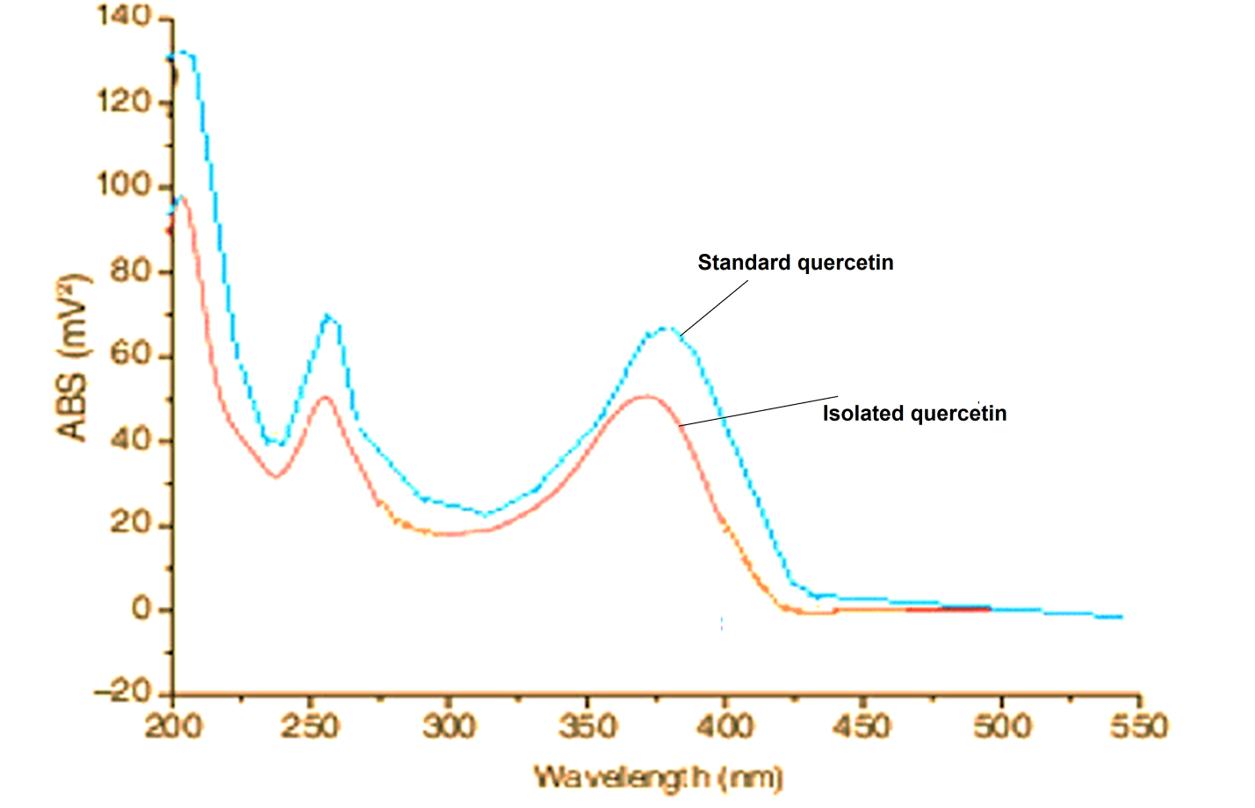
Figure 26: UV spectra of quercetin as standard and isolated quercetin
Application of UV spectrophotometry
- UV spectroscopy is routinely used in pharmaceutical industries or for the quantitative determination of different analytes, such as transition metal ions, highly conjugated organic compounds, and biological macromolecules.
- Qualitative and quantitative analysis of phytoconstituents in medicinal plants
- Utilization in agriculture industries for the assessment of pesticides

Infrared spectroscopy
IR spectroscopy is the subset of spectroscopy that deals with the
infrared region of the electromagnetic spectrum. It covers a range of techniques, the most common being a form of absorption spectroscopy. As with all spectroscopic techniques, it can be used to identify compounds or investigate sample composition.
Infrared spectroscopy offers the possibility to measure different
types of inter-atomic bond or functional group vibrations at different frequencies. Especially in organic chemistry, the analysis of IR absorption spectra shows what types of bonds are present in the sample. Infrared spectroscopy exploits the fact that molecules have specific frequencies at which they rotate or vibrate corresponding to discrete energy levels.
Principle
The IR region in the electromagnetic spectrum is divided into three regions. These areas are defined as near-infrared (near-IR, 13500–4000 cm−1780–2500 nm), mid-infrared (mid-IR, 4000–400 cm−1; 2500–25000 nm), and far-infrared (far-IR, 400–10 cm−1; 25000–1000000 nm).
IR spectroscopy is based on the analysis of IR light interacting with a molecule, which can be analyzed in three different ways as
- Absorption
- Emission
- Reflection
The underlying principle for acquiring such spectroscopic data is the interaction of a sample with propagating light so that the information can be recorded and interpreted from the targeted area.
Chemical bonds will vibrate more energetically when the molecule interacts with IR light, thus causing vibrational and rotational changes in the molecule. However, atoms are constrained by quantum mechanics so that only a few specific energy levels are allowed. The possible rotations are around the axis of symmetry for a given molecule or either of the two perpendicular axes. If there are only two atoms, the only vibration will be seen as stretching. When three or more atoms are involved, bonds can also bend. Typical mid-IR spectra represent numerous absorbance peaks due to fundamental transitions and are approximately divided into four regions generalized as the X–H stretching region (4000–2500 cm−1), the triple-bond region (2500–2000 cm−1), the double-bond region (2000–1500 cm−1) and the fingerprint region (1500–600 cm−1). The fingerprint region is normally a complex area showing many bands specific to the molecular structure of the sample, frequently overlapping each other.
Preparation of sample for IR analysis
Prepare a mixture of drug and KBr in (1: 8 w/w) ratio. The obtained content should be mix thoroughly to get the uniformity of the content. If the sample is in large crystals, grind the sample separately before adding KBr. Thereafter, place the content into a pellet die and compress the content with high pressure to get in form of a pellet.
Application of IR spectroscopy:
- It is useful in determining the functional group of compounds and measuring the degree of polymerization in polymer manufacture.
- Infrared Spectroscopy is in the food industry to measure the concentration of various compounds in different food products
- It is also used in forensic analysis in both criminal and civil cases, for example in identifying polymer degradation.
- It can be used in determining the blood alcohol content of a suspected drunk driver.

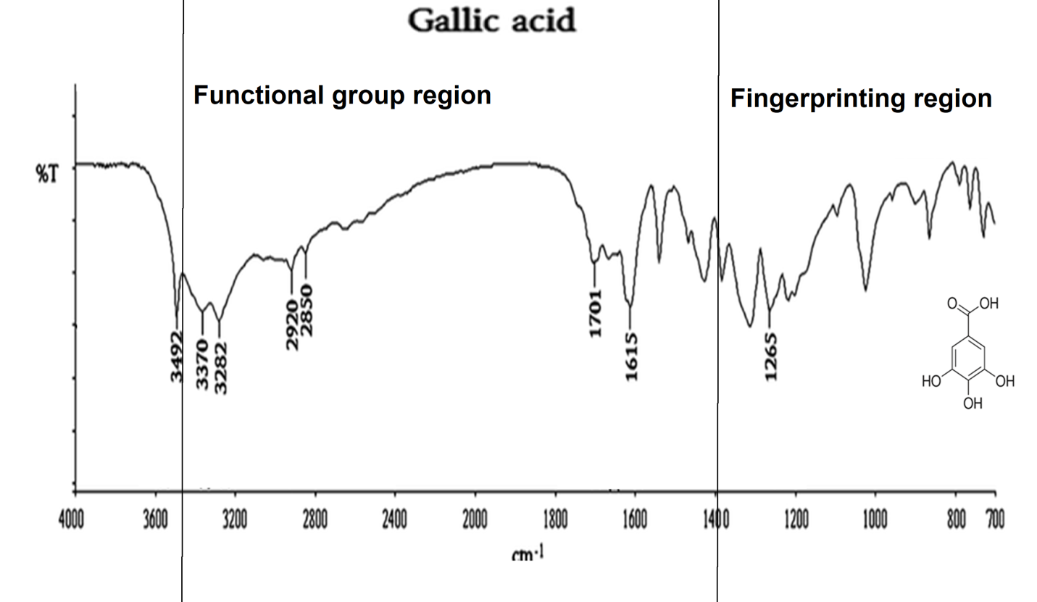
Figure 27: IR spectra of gallic acid showing –COOH and –OH stretching at 3492 and 3370 cm-1, -C=O and aromatic protons stretching at 1615 and 1265 cm-1.

Mass spectrometry
MS is generally accounted for the conversion of molecules into the charged or ionization state and further, the subsequent identification of charged molecules or their fragments would be done based on their obtained mass or fragmented pattern (m/z). Many technologies are accessible for ionization and their ion prediction with different combinations for ionization of the analyte system.
Principle
It works for nebulization and conversion of liquid samples into the fine spray of the charged droplets and after evaporation, the electrical charge is transferred to the analyte in presence of applied principle heat and dry nitrogen. The ionized molecule is then transferred to the mass spectrometer through series of applied voltages. The analysis of the charged analyte operates under the two different modes i.e. positive and negative ion mode. Besides, small analyte with one or two functional groups gives a predominant electrical charge and evolves to coordinate with the proton (M+H⁺) when operated in positive ion mode while operated in negative ion mode gives a loss of proton to the analyte (M+H⁻). The molecules which exhibit multiple charge-carrying functional groups result in the adoption of an ion such as M+2H2⁺, M+3H3⁺ etc.
Mostly used ion source in MS
- Electrospray ionization source (ESI): for identification of numerous metabolites (polar and semi-polar), peptides and xenobiotics
- Atmospheric pressure chemical ionization source: For identification of semi-polar or non-polar metabolites
- Atmospheric pressure photo-ionization source

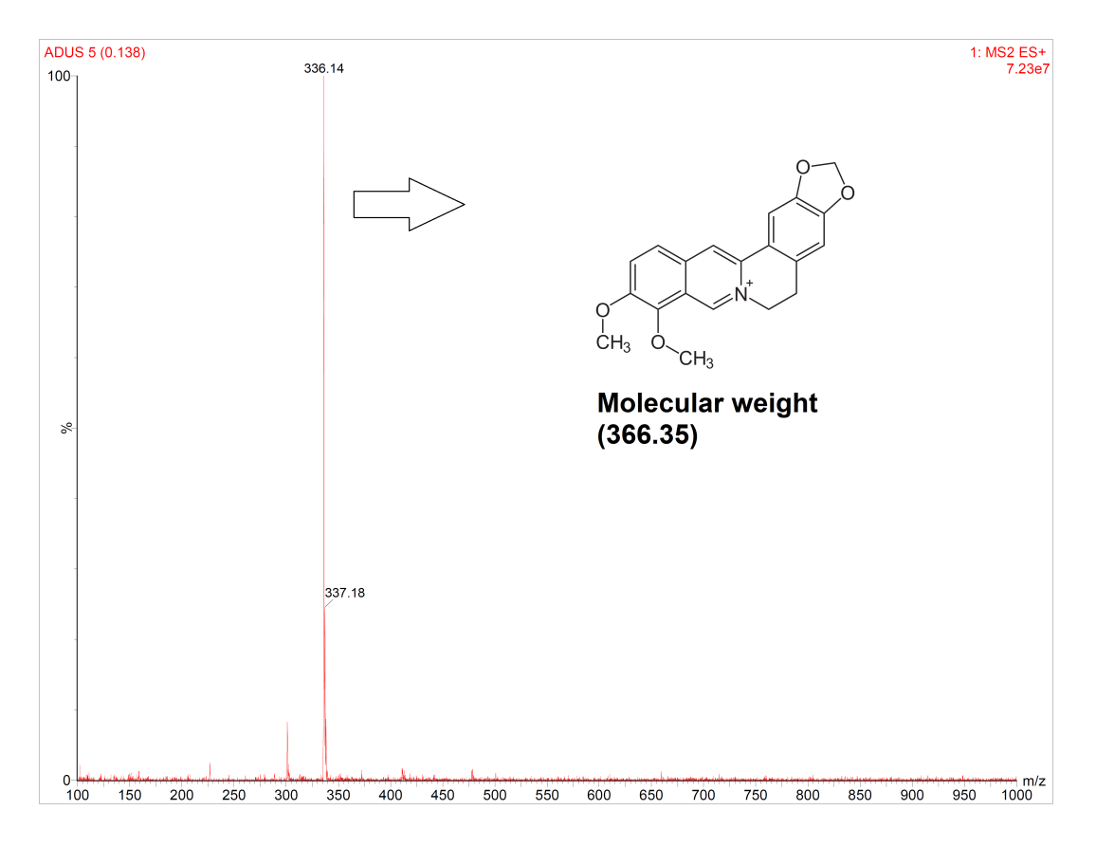
Application
- Identification of natural drugs from plant, marine, animal sources
- Isotope dating and tracing
- Membrane-introduction mass spectrometry: measuring gases in solution
- Trace gas analysis
- Atom probe analysis
- Pharmacokinetics analysis
- Protein characterization in biological samples

NMR spectroscopy
Nuclear magnetic resonance (NMR) spectroscopy is one of the most significant analytical techniques that has been developed in the identification of the broad range of organic and inorganic chemical molecular geometry.
In this technique, local magnetic fields are produced by excitation of the nuclei in form of signals which are detected with sensitive radio receivers. The intramolecular magnetic field around an atom in a molecule changes the resonance frequency, thus giving access to details of the electronic structure of a molecule and its functional groups.
The most common types of NMR are proton(H¹) and carbon(C¹³) NMR spectroscopy, but it applies to any kind of sample that contains nuclei possessing spin [22,23].
Working principle
NMR is based on the spins of atomic nuclei. Nuclei with an odd mass or odd atomic number have "nuclear spin" (in a similar fashion to the spin of electrons). Since a nucleus is a charged particle in motion, it will develop a magnetic field. When the nuclei with non-zero spins are placed in a strong magnetic field with respect to the applied magnetic field with the supply of appropriate energy, these nuclei flip to a higher energy state from a lower energy state. The energy difference between the two states depends on the applied field. The energy absorbed during this transition is a function of the nucleus type and its chemical environment in the molecule. The magnetic field is increased and the excitation or “flipping” of nuclei from one orientation to another is detected as an induced voltage resulting from the absorption of energy from the radiofrequency field. The free induction decay, which is in the time domain gives its equivalent frequency domain signal on Fourier transformation. The area under a peak is proportional to the number of nuclei “flipping” and by observing the field strength at which protons absorb energy, one can know about the structure of a molecule [24,25].

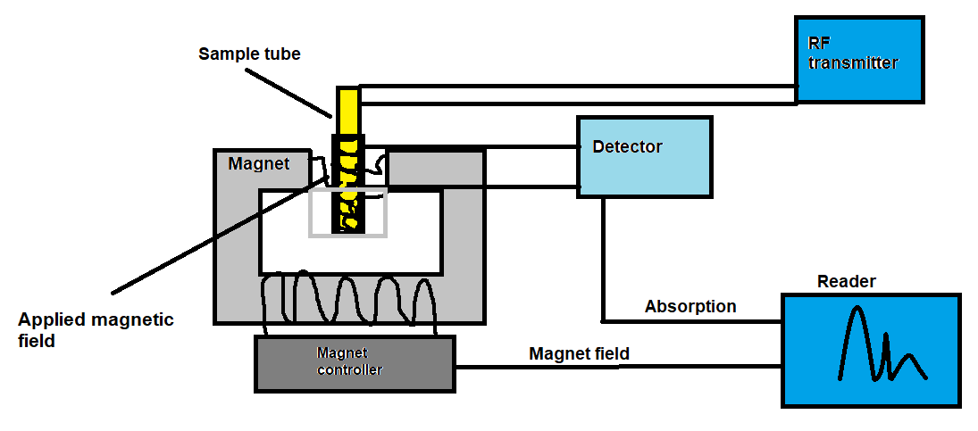
Figure 28: Simple instrumentation of NMR

NMR sample preparation
- NMR users are advised to provide 5-20 mg of the sample depending upon its molecular weight for proton NMR spectra. At least 30 mg of sample is necessary for obtaining 13C NMR spectra with a reasonable signal-to-noise ratio.
- The sample should be completely soluble in the given deuterated solvent.
- NMR samples should be provided the information to the NMR operator about the sample details: such as type, amount, the solvent used spectral range require etc. in the given job card or samples accompanied by a letter containing analysis details.
Commonly used solvents in NMR analysis
The deuterated solvents are used for the NMR analysis. Common solvents include chloroform-D, acetone-D6, benzene-D6, deuterium oxide (D2O), DMSO-D6, ethanol-D6, and methanol-D4. Other, less common deuterated solvents can be used in the analysis which are easily available from Cambridge Isotope Laboratories or Sigma-Aldrich.
Chemical Shift
The movement of the electrons creates a magnetic field in and around the nucleus. This magnetic field created is different in the direction as compared with the outer magnetic field. Any change in the magnetic field causes a similar change in the spectrum of the NMR. This sum of the shift is controlled by the nature of the nucleus and the nature of the motion of electrons in its surrounding atoms and molecules. This phenomenon is called “chemical shift (CS).” A reference compound is needed to measure CS and to determine and differentiate magnetically inequivalent nuclei present in a molecule
Types of NMR analysis
There are two types of NMR analysis that are used in the analysis of chemicals constituents
- Proton NMR (¹HNMR)
- Carbon NMR (¹³CNMR)
Proton NMR (¹HNMR)
Proton is the initial and the most frequent atom to be used in NMR spectroscopy. It is also called hydrogen-NMR ( 1 H-NMR) that provides information about the different varieties of hydrogen present in the molecule and also gives information about its adjacent surroundings. ¹HNMR spectrum of main materials shows small CS range for usual compound is being studied. This c hemical shift ranges from +14 to –14 ppm and a broad difference in extent of coupling constant was observed.
Carbon NMR (¹³CNMR)
This technique is a significant tool to recognize carbon atoms in any organic material. It also gives detailed information regarding the chemical structure of the organic compound being studied. ¹³CNMR is less responsive to carbon in view of the fact that the main isotope of carbon is 12 C, which is not magnetically active; therefore, it cannot be detected through this technique. The intensities of the signals in carbon-NMR are not usually comparative to the number of corresponding 13 C atoms. They are strongly reliant on the numerals of adjacent spins up to the 250 ppm ranging of chemical shift [26].
Example
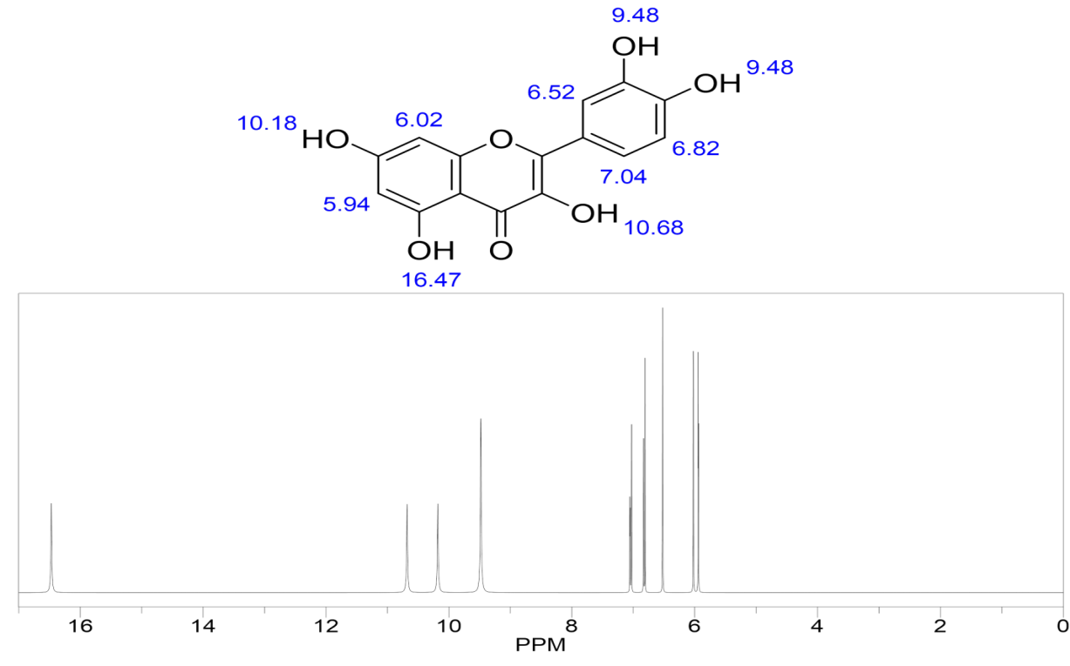
Figure 29: Proton NMR spectra of quercetin, figure representing the chemical shift (PPM) and signals of proton
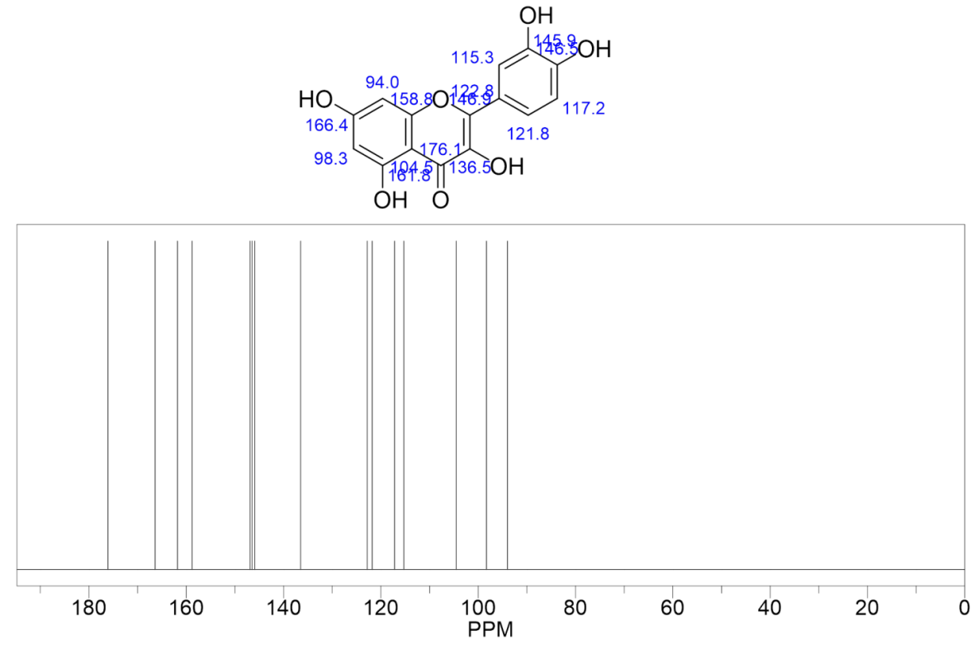
Figure 30: Carbon NMR spectra of quercetin, figure representing the chemical shift (PPM) and signals of proton
Application
NMR spectroscopy is used for identification for providing detailed information about the structure, dynamics, reaction state, and chemical environment of molecules.

References
1. Gaurav; Khan, M.U.; Basist, P.; Zahiruddin, S.; Ibrahim, M.; Parveen, R.; Krishnan, A.; Ahmad, S. Nephroprotective Potential of Boerhaavia Diffusa and Tinospora Cordifolia Herbal Combination against Diclofenac Induced Nephrotoxicity. South African J. Bot. 2022, 000, doi:10.1016/j.sajb.2022.01.038.
2. Gaurav; Sharma, I.; Khan, M.U.; Zahiruddin, S.; Basist, P.; Ahmad, S. Multi-Mechanistic and Therapeutic Exploration of Nephroprotective Effect of Traditional Ayurvedic Polyherbal Formulation Using In Silico, In Vitro and In Vivo Approaches. Biomedicines 2023, 11, doi:10.3390/biomedicines11010168.
3. Gaurav; Zahiruddin, S.; Parveen, B.; Ibrahim, M.; Sharma, I.; Sharma, S.; Sharma, A.K.; Parveen, R.; Ahmad, S. TLC-MS Bioautography-Based Identification of Free-Radical Scavenging, Α‑amylase, and Α‑glucosidase Inhibitor Compounds of Antidiabetic Tablet BGR-34. ACS Omega 2020, doi:10.1021/acsomega.0c02995.
4. Vecchiato, N.L. Traditional Medicine. Ecol. Heal. Dis. Ethiop. 2019, 157–179, doi:10.4324/9780429310232-10.
5. Ahmad Dar, A.; Sangwan, P.L.; Kumar, A. Chromatography: An Important Tool for Drug Discovery. J. Sep. Sci. 2020.
6. Altemimi, A.; Lakhssassi, N.; Baharlouei, A.; Watson, D.G.; Lightfoot, D.A. Phytochemicals: Extraction, Isolation, and Identification of Bioactive Compounds from Plant Extracts. Plants 2017.
7. Duarte, K.; Rocha-Santos, T.A.P.; Freitas, A.C.; Duarte, A.C. Analytical Techniques for Discovery of Bioactive Compounds from Marine Fungi. TrAC - Trends Anal. Chem. 2012.
8. Gautam, G.; Parveen, R.; Ahmad, S. LC-MS-Based Metabolomics of Medicinal Plants. In Omics Studies of Medicinal Plants; 2023.
9. Abubakar, A.R.; Haque, M. Preparation of Medicinal Plants: Basic Extraction and Fractionation Procedures for Experimental Purposes. J. Pharm. Bioallied Sci. 2020.
10. Li, P.; Xu, G.; Li, S.P.; Wang, Y.T.; Fan, T.P.; Zhao, Q.S.; Zhang, Q.W. Optimizing Ultraperformance Liquid Chromatographic Analysis of 10 Diterpenoid Compounds in Salvia Miltiorrhiza Using Central Composite Design. J. Agric. Food Chem. 2008, doi:10.1021/jf073020u.
11. Yi, Y.; Zhang, Q.W.; Li, S.L.; Wang, Y.; Ye, W.C.; Zhao, J.; Wang, Y.T. Simultaneous Quantification of Major Flavonoids in “Bawanghua”, the Edible Flower of Hylocereus Undatus Using Pressurised Liquid Extraction and High Performance Liquid Chromatography. Food Chem. 2012, doi:10.1016/j.foodchem.2012.05.010.
12. Agarwal, P.; Nagesh, L.; Murlikrishnan Evaluation of the Antimicrobial Activity of Various Concentrations of Tulsi (Ocimum Sanctum) Extract against Streptococcus Mutans: An in Vitro Study. Indian J. Dent. Res. 2010, 21, 357–359, doi:10.4103/0970-9290.70800.
13. Pandey, A.; Tripathi, S.; Pandey, C.A. Concept of Standardization, Extraction and Pre Phytochemical Screening Strategies for Herbal Drug. J. Pharmacogn. Phytochem. JPP 2014.
14. Ekbbal, R.; Iqubal, A.; Ansari, M.; Ahmad, S.; Haque, S. Evaluation of Cardioprotective Potential of Isolated Swerchirin against the Isoproterenol-Induced Cardiotoxicity in Wistar Albino Rats. Pharmacogn. Mag. 2022, doi:10.4103/pm.pm_500_20.
15. Falcão, M.A.; Scopel, R.; Almeida, R.N.; do Espirito Santo, A.T.; Franceschini, G.; Garcez, J.J.; Vargas, R.M.F.; Cassel, E. Supercritical Fluid Extraction of Vinblastine from Catharanthus Roseus. J. Supercrit. Fluids 2017, doi:10.1016/j.supflu.2017.03.018.
16. Koepfli, J.B.; Mead, J.F.; Brockman, J.A. An Alkaloid with High Antimalarial Activity from Dichroa Febrifuga. J. Am. Chem. Soc. 1947, doi:10.1021/ja01199a513.
17. Brusotti, G.; Cesari, I.; Dentamaro, A.; Caccialanza, G.; Massolini, G. Isolation and Characterization of Bioactive Compounds from Plant Resources: The Role of Analysis in the Ethnopharmacological Approach. J. Pharm. Biomed. Anal. 2014.
18. Shrivastava, R.; Mishra, J. Extraction, Phytochemical Screening, Isolation and Identification of Bioactive Compounds from Extract of the Plant Euphorbia Thymifolia Linn. J. Drug Deliv. Ther. 2019, doi:10.22270/jddt.v9i3.2608.
19. Banu, K.S.; Cathrine, L. General Techniques Involved in Phytochemical Analysis. Int. J. Adv. Res. Chem. Sci. 2015.
20. Hamuel, J. Phytochemicals: Extraction Methods, Basic Structures and Mode of Action as Potential Chemotherapeutic Agents. In Phytochemicals - A Global Perspective of Their Role in Nutrition and Health; 2012.
21. Ujang, Z.B.; Subramaniam, T.; Diah, M.M.; Wahid, H.B.; Abdullah, B.B.; Rashid, A.H.B.A.; Appleton, D. Bioguided Fractionation and Purification of Natural Bioactives Obtained From&lt;I&gt;Alpinia Conchigera&lt;/I&gt; Water Extract with Melanin Inhibition Activity. J. Biomater. Nanobiotechnol. 2013, doi:10.4236/jbnb.2013.43033.
22. Barroso, P.T.W.; de Carvalho, P.P.; Rocha, T.B.; Pessoa, F.L.P.; Azevedo, D.A.; Mendes, M.F. Evaluation of the Composition of Carica Papaya L. Seed Oil Extracted with Supercritical CO2. Biotechnol. Reports 2016, doi:10.1016/j.btre.2016.08.004.
23. Freire, R.S.; Morais, S.M.; Catunda, F.E.A.; Pinheiro, D.C.S.N. Synthesis and Antioxidant, Anti-Inflammatory and Gastroprotector Activities of Anethole and Related Compounds. Bioorganic Med. Chem. 2005, doi:10.1016/j.bmc.2005.03.058.
24. Lee, K.M.; Jeon, J.Y.; Lee, B.J.; Lee, H.; Choi, H.K. Application of Metabolomics to Quality Control of Natural Product Derived Medicines. Biomol. Ther. 2017.
25. Akhtar, M.T.; Sarib, M.S.B.M.; Ismail, I.S.; Abas, F.; Ismail, A.; Lajis, N.H.; Shaari, K. Anti-Diabetic Activity and Metabolic Changes Induced by Andrographis Paniculata Plant Extract in Obese Diabetic Rats. Molecules 2016, doi:10.3390/molecules21081026.
26. Al-Zahrani, S.H.M. Antibacterial Activities of Gallic Acid and Gallic Acid Methyl Ester on Methicillin-Resistant Staphylococcus Aureus. J. Am. Sci. 2012.

