Comparison of three endodontic rotary system shaping in curved canals – An In-vitro study

Dr.Yesh Sharma
Assistant Professor, Department of Conservative Dentistry And Endodontics, Pacific Dental College, Udaipur, Rajasthan

ABSTRACT: Anatomical abnormalities of the root canal system are frequently seen in specialist endodontic practice, and represent a challenge to be faced with skill and thoroughness, beginning with an accurate diagnostic phase and devising the most appropriate treatment plan. Thus, flexibility and resistance to fracture are ideal properties that endodontic instruments should have. The aim of the study was to compare the shaping ability of three different nickel-titanium rotary instruments in simulated S-shape root canals by measuring transportation and canal volume change CVC.

Keywords – Protapper Gold rotary system, Vortex Blue, HyFlex CM

MATERIALS AND METHODS: A total of 60 S-shaped canals in resin blocks were randomly allocated into 3 groups (n=20): Vortex Blue (Dentsply-Tulsa Dental Specialties), HyFlex CM (Coltène/Whaledent) and Protapper gold. Canals were filled with dye and secured in a jig for instrumentation stabilization and imaging standardization. After patency was confirmed using a size 10 K-file, groups were instrumented using a crown down technique from size 40 to 20/.04 and then apically enlarged to size 30/.04 using constant sterile water as an irrigant. Pre- and post instrumentation images were taken and layered for evaluation. Transportation and the CVC at the cervical, middle, and apical levels were measured/computed. Data obtained were statistically analyzed using a one-way ANOVA test and Tukey post hoc test.

RESULTS: Instrumentation with HyFlex CM resulted in significantly (p<0.05) less canal volume enlargement overall and at all levels compared to the other two files. No significant differences (p>0.05) were observed between the files for apical transportation.

Conclusion: HyFlex CM showed better shaping ability than Vortex Blue and Protapper Gold but similar apical transportation.

INTRODUCTION
Cleaning and shaping of the root canal space is the primary objective of endodontic therapy. Its purpose is to prepare the canal space in order to improve disinfection with the use of irrigants as part of chemo mechanical preparation (1). Infiltration and subsequent infection of the root canal system by microorganisms and their by-products is the primary aetiology of endodontic pathosis (3). Chemo-mechanical preparation aims to remove microorganisms, remaining pulp tissue, and dentin debris from the root canal system (2).
The main objective of shaping is to maintain or develop a continuously tapering funnel from the canal orifice to the apex; however the complex canal anatomy causes instrumentation challenges, iwhich may prevent adequate disinfection of the root canal system, or cause procedural errors such as instrument separation, transportation, ledges, or perforations (3).
NiTi is a very unique alloy compared other alloys used in endodontics because of its mechanical properties. These include its shape memory effect and super elasticity characteristics (4). The special mechanical property called super elasticity refers that NiTi alloy is able to undergo a non-diffusive transformation of the lattice structure into a martensitic phase when suitably stressed(5). The stress-induced martensitic is reversible, and consequently the material shows a remarkably large elastic range and is able to recover from a much higher strain than stainless steel can withstand without breaking (6).
Basically it provides more flexibility allowing the instrument to effectively follow the original root canal pathway (7).
New file designs and alloys with better mechanical properties have been and continue to be introduced by manufacturers. These new and more flexible instruments work more efficiently and safely thus preventing unwanted changes when shaping curved canals (8). HyFlex Controlled Memory (CM) rotary instruments (Coltene-Whaledent, Allstetten, Switzerland) are one of these new improved endodontic instruments. The manufacturer claims CM NiTi files have increased flexibility that is superior in maintaining the overall root canal shape due to a thermomechanical processing that control the material’s memory (9).
It is claimed that due to their increased flexibility HyFlex CM instruments are best suited to prepare curved root canals and possess a superior centring ability compared with conventional NiTi instruments (10). Currently there is only limited information available regarding the shaping ability of HyFlex CM instruments.
On the other hand, Protapper gold and Vortex Blue are rotary file systems that are made with traditional nickel-titanium and M-Wire technology, respectively. M-Wire technology was created by Dentsply Tulsa Specialties, using a thermos cycling process, which gives the characteristics of being more flexible and resistant to cyclic fatigue. Previous studies have showed better fatigue resistance of M-Wire rotary files compared with the conventional NiTi file (11).
PTG (2015) (Dentsply, Tulsa Dental Specialties, Tulsa, OK, USA) has been metallurgically enhanced through proprietary heat treatment technology. Files have a variable taper design and exhibit the exact geometries as ProTaper Universal (PTU) but show increased cyclic fatigue resistance and flexibility than PTU.
To investigate the shaping ability of endodontic files, studies often use simulated canals with standardized lengths, curvatures, and tapers in resin blocks. Two of the main advantages of these resin blocks are that the intracanal preparation can be visualized andthey are simply reproducible something that cannot be achieved with natural teeth (12).
The purpose of the study was to compare the shaping ability of three different nickel- titanium rotary instruments in simulated S-shape root canals by measuring transportation, and canal volume change (CVC) at the cervical, middle, and apical levels.
The NiTi rotary instruments were selected to encompass three different manufacturing processes, yet similar cross sectional design: traditional Protapper Gold (Figure -1), CM wire (HyFlex CM-Figure-2) and processed M-Wire (Vortex Blue –Figure 3). Sixty simulated S-shaped root canals in clear resin blocks (Endo Training Bloc-S; Dentsply Maillefer, Ballaigues, Switzerland), each with 20 degree apical curvature (3.5 mm radius), 30 degree coronal curvature (5 mm radius), and 16 mm canal length, were randomly assigned to 3 experimental groups (n= 20/group): HyFlex CM, Protaper Gold , and Vortex Blue groups.

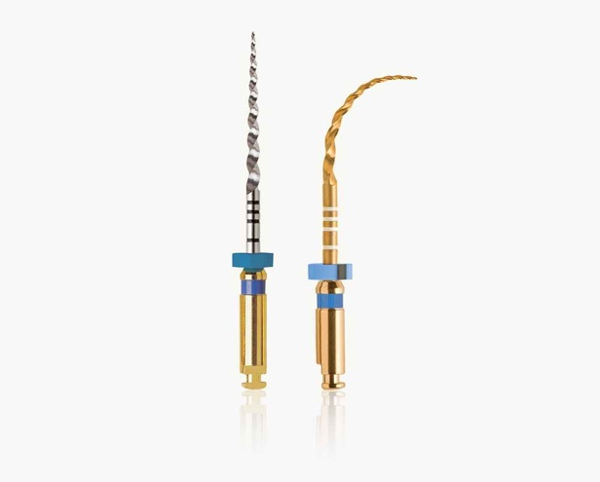
Figure 1 – Protapper Gold File

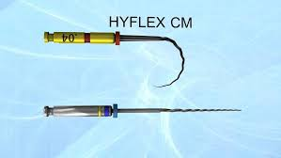
Figure 2 – HyFlex CM File
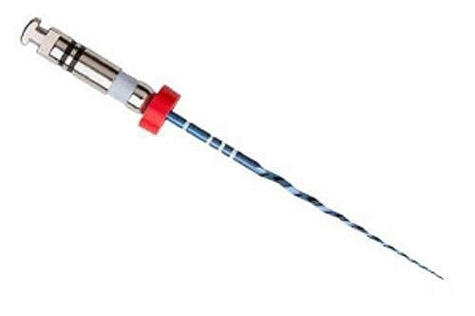
Figure 3- Vortex Blue
Simulated S-Shaped root canals were dyed with India ink using a 30-gauge insulin syringe . A no. 10 K-file (Dentsply Tulsa Dental Specialties) was introduced into the canal to assure penetration of the ink and prevent bubble formation. The canals were stored at room temperature for 48 h to allow for the ink to dry. A small scalpel mark was cut into the resin block near the canal top to allow for consistent orientation and placement. The canals were covered with adhesive tape and placed in a specially designed jig that allowed for resin block stabilization (Figure 5).

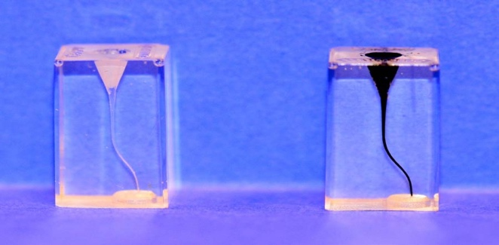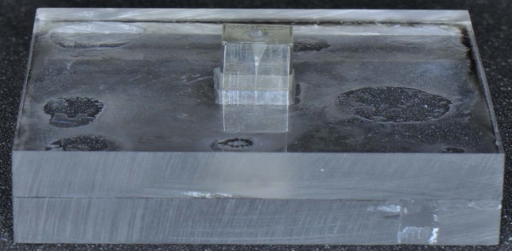
Figure 4 – S-shape resin blocks Figure 5- Stabilization Jig.
All rotary files were operated by a 1:16 reduction contra angle handpiece (Contra- angle ATR; Dentsply/Maillefer) powered by a torque-limited electric motor (ATR Technika Vision; Dentsply/ Maillefer). Patency was confirmed using a size 10 K-file (Dentsply Tulsa Dental Specialties). Each canal was shaped with new instruments lightly coated with Glyde File Prep (Dentsply Tulsa Dental Specialties). In each group, instrumentation was carried out with a crown-down technique starting with the 40/.04 instrument at 500 rpm and 2-Ncm torque as suggested by the manufacturers, followed by 35/.04, 30/.04, and 25/.04. As each instrument was changed, the canal was irrigated with 1 mL of sterile water using a 30-G side vented needle (Max-iprobe; Dentsply Rinn, Elgin, IL). In each group, the canals were instrumented to working length with 30/.04 with the same corresponding file system. The three file systems were used in a similar manner to standardize preparations for comparison during this study.
Before and after canal shaping, pre and post-instrumentation images were acquired by scanning the S-Shaped simulated canals with an Epson Expression 1680 flatbed scanner at 2400 dpi, 24bit color. The pre-instrumentation image (Image A) was dyed with the black ink. Dye was not used for the post-instrumentation image (Image B). The canals were scanned with a solid green background to provide a contrasting color compared with the original canal and instrumented canal.
Scanned images were positioned within a template in Photoshop CS6 911 pixels wide and 1563 pixel high. Image A was positioned so that the canal base was positioned at pixel row 111. The canal base started at row 1 and canal opening at row 1563. The image was saved as Image A. Image B was added as a layer and made partially transparent to facilitate positioning of the canal base so that Image B corresponded with the canal base of Image A. The canal base and the scalpel mark were used to align Image A and Image B. Upon alignment, Image A was hidden, transparency of Image B was eliminated, and Image B was saved as a JPG .
Image processing occurred through a locally developed application using Delphi XE2 Version 16. The image processing extracted and reported the left and right edge of the canal from the 2 dimensional image for 9 benchmark locations: at the base of the canal, 0.5 mm above the base, and at 1 mm increments above the base of the canal (1 mm to 8 mm). The image processing performed the following algorithm and recorded values. Image processing iterated through an area of interest from the top of the image to the bottom of the image, between columns 100 and 525. Evaluation combinations were used to identify the canal in Image A and the instrumented canal in Image B. A pixel was considered “identified” if the R, G, and B values met one of the conditions.

Table 1. Evaluation conditions for image A and Evaluation Conditions for Image
Evaluation Conditions for Image A
Condition 1 | R value < 100 |  | G value < 190 |  | B value < 55
Condition 2 | R value > 150 |  | G value < 50 |  | B value < 50
Condition 3 | R value > 100 |  | G value < 185 |  | B value > 50
Evaluation Conditions for Image B
Condition 1 |  | R value < 120 |  | G value < 170 |  | B value < 50
Condition 2 |  | R value > 100 |  | G value < 170 |  | B value < 30
Condition 3 |  | R value > 90 |  | G value < 200 |  | B value > 50

For each row, the furthest left identified pixel column and furthest right identified pixel column were recorded in an array. Upon identification of all rows, the left and right edges were smoothed by averaging the left and right edges, respectively, between 3 rows above and 3 rows below. The smoothed left and right edges as well as the identified pixels were written to a JPG file. Then the left and right pixel columns were written to a file for the 9 benchmark locations. The area within the canal was computed as the sum of pixels between the smoothed left and right edges. Four area totals were computed, total – all pixels between 0 and 9 mm benchmark, and totals for each third of the benchmarks (0- 2, 3-5, and 6-8 mm).The Canal/Edges image was opened after image processing in Photoshop as a layer with the respective image . The layer was made transparent as a visual verification that left and right edges corresponded with the edges from the image.
Data was collected electronically and transferred to Excel (Microsoft Corporation, Redmond, WA) for further analysis. Apical transportation was defined as the distance from the pre- to the post-instrumented canal wall 0.5mm from the apex and measured on both the left and right proximal sides of the simulated canal. Transportation and the CVC were measured/computed at the cervical, middle, and apical levels.
Data obtained were statistically analyzed using a one-way ANOVA test and Tukey post hoc test for multiple comparisons to look at a significant difference in mean between the 3 shaping procedures. The software Statistical Package for the Social Sciences (SPSS) was used and the level of significance was set at P=0.05.

RESULTS

The mean percentage of area increase was 245%, 288%, and 286%, in the HyFlex CM, , Protapper gold and Vortex Blue group, respectively (Table 2). Figure 8 graphically displays that the use of HyFlex CM instruments resulted in significantly (p<0.05) less canal volume enlargement overall and at all levels compared to Vortex Blue and Protapper Gold.

The results for apical transportation are summarized in Table 3. Results were similar and no significant differences (p>0.05) were obtained between the three experimental groups. No protapper gold or Vortex Blue files fractured during the study. However four HyFlex CM .04/30 instruments fractured during instrumentation.

Table 2. Canal Area Change
File | Canal Area Increase due to Instrumentation (%)
 | 0-2 mm | 3-5 mm | 6-8 mm | Total
Protapper gold | 310.6 ± 36.2 | 283.0 ± 18.3 | 286.4 ± 17.3 | 288.6 ±  18.0 c
Vortex Blue | 322.5 ± 55.6 | 268.6 ± 28.1 | 281.4 ± 23.4 | 286.247  ± 29.4 b
HyFlex CM | 260.6 ± 67.1 | 250.7 ± 39.3 | 240.3 ± 34.2 | 245.1 ±  40.9 a

Table 3. Apical Transportation *
Values of means of apical transportation ± standard deviation.
There are no significant (p>0.05) differences between the groups with the same letters.

File | N | Apical Transportation  (mm)
Protapper gold | 20 | .038 ±.056 ª
Vortex Blue | 20 | .059 ±.069 ª
HyFlex CM | 20 | .020 ±.120 ª

Table 4. Transportation at Various Distances along the Canal

File | Transportation (mm)
 | 0 mm | 1 mm | 2 mm | 3 mm | 4 mm | 5 mm | 6 mm | 7 mm | 8 mm
Pro tapper gold | .523±.5  75 ª | .665±.0  65 b | .643±.0  57 b | .626±.0  42 b | .600±.3  1 b | .670 ±  .044 b | .770 ±  .042 b | .720 ±  .037 b | .794 ±  .025 c
Vortex Blue | .495±.1  21 ª | .510±.0  67 b | .630±.0  95 b | .600±.0  64 b | .615 ±  0.42 b | .690 ±  0.56 b | .730 ±  0.57 b | .750 ±  .042 b | .730 ±  .028 b
HyFlex CM | .426±.1  19 ª | .444±.0  84 ª | .534±.1  03 ª | .544 ±  0.45 a | .594 ±  .027 ª | .536 ±  .088 ª | .645 ±  .521 ª | .640 ±  .030 ª | .653 ±  .039 ª

DISCUSSION

Understanding materials properties and its influence on instrument performance is critical for the clinician. During the past decade many different rotary systems have been introduced to endodontics, each with their distinctive characteristics but all with the same purpose of avoiding procedural errors.
Numerous approaches to modify the way the instruments are manufactured which results in variation in the physical properties have been done by manufacturers. Recently thermomechanical treatment processes has been attempted to improve flexibility and fatigue resistance. Studies evaluating the influence of this property on the shaping ability of files manufactured by this procedure are limited, with variation in assessment criteria. In this study 3 systems were chosen that are different in their NiTi processing. No studies have compared Protapper Gold, Vortex Blue and HyFlex CM rotary file systems in terms of transportation and canal volume change at three canal levels. Thus this study was a comparison between the 3 file systems using simulated canals in resin blocks; it does not reflect the action of the instruments in natural root canals because of the differences in the surface texture and hardness as well as cross- section (13). However, investigators promoted those studies comparing the effects of root canal instrumentation on canal anatomy should also consider details of preoperative geometry that is why similarity was an essential factor for the design of the study (14). Clear resin blocks allow a direct comparison under identical conditions of the shapes acquired with different instruments.

References

- Klayman SM, Brilliant JD. A comparison of the efficacy of serial preparation versus Giromatic preparation. Journal of Endodontics 1975;1(10):334-337.

- Heard F, Walton RE. Scanning electron microscope study comparing four root canal preparation techniques in small curved canals. International Endodontic Journal 1997;30(5):323-331.

- Parris J, Wilcox L, Walton R. Effectiveness of apical clearing: histological and radiographical evaluation. Journal of Endodontics 1994;20(5):219-224.

- Reynolds MA, Madison S, Walton RE, Krell KV, Rittman BR. An in vitro histological comparison of the step-back, sonic, and ultrasonic instrumentation techniques in small, curved root canals. Journal of Endodontics 1987;13(7):307-314.

- Peters OA. Current challenges and concepts in the preparation of root canal systems: a review. Journal of Endodontics 2004;30(8):559-567.

- Lentine FN. A study of torsional and angular deflection of endodontic files and reamers. J Endod 1979;5(6):181-191.

- Eldeeb ME, Boraas JC. The effect of different files on the preparation shape of severely curved canals. International Endodontic Journal 1985;18(1):1-7.

- Orstavik D, Kerekes K, Molven O. Effects of extensive apical reaming and calcium hydroxide dressing on bacterial infection during treatment of apical periodontitis: a pilot study. International Endodontic Journal 1991;24(1):1-7.

- Salzgeber RM, Brilliant JD. An in vivo evaluation of the penetration of an irrigating solution in root canals. Journal of Endodontics 1977;3(10):394-398.

- Ram Z. Effectiveness of root canal irrigation. Oral Surgery, Oral Medicine, Oral Pathology 1977;44(2):306-312.

- Chow TW. Mechanical effectiveness of root canal irrigation. Journal of Endodontics 1983;9(11):475-479.

- Usman N, Baumgartner JC, Marshall JG. Influence of instrument size on root canal debridement. Journal of Endodontics 2004;30(2):110-112.

- Rollison S, Barnett F, Stevens RH. Efficacy of bacterial removal from instrumented root canals in vitro related to instrumentation technique and size. Oral Surg Oral Med Oral Pathol Oral Radiol Endod 2002;94(3):366-371.

- Card SJ, Sigurdsson A, Orstavik D, Trope M. The effectiveness of increased apical enlargement in reducing intracanal bacteria. Journal of Endodontics 2002;28(11):779-783.

