Researcher Name: Lovelina Banerjee
Author Name : Lovelina Banerjee
Designation: Rehabilitation Psychologist (A73740)
Title – Effect of quantitative art based therapeutic intervention on the empowerment of women with disabilities
University- The Techno India University, West Bengal

Dedication- I want to dedicate this work to all person with autism of Pradip Centre for Autism Management, kolkata.
Acknowledgement- I would like to acknowledge the entire team of AIMS Media, Delhi from where i have learnt artology and use quantitative measurement of improvement through art, my PhD guide Dr. (prof.) Mallika Banerjee to guide at any difficult situation. And obviously all students of Pradip Centre for Autism Management, Kolkata who are the participants of the research work.
Abstract
Empowerment is a new concept. It has been used for over 100 years to advocate for women's rights (initially in North America), then for civil rights, and finally around the world to advocate and promote the freedom and self-determination of a disaffected group or individual. Empowerment means a lot to people with disabilities, giving them more control over their lives, providing rights and services, and helping us realize what needs to be seen, helping us understand that people should be valued for who they are, not with "Equal" damage.
While social leadership still needs progress for the problem, progress in supporting people with disabilities has made our field better. Further progress will continue towards improving the effectiveness and efficiency of diagnostic and social care, the benefits of the program, and the organization of society as a whole. Therefore, in this study, researchers will try to use a treatment method that does not affect many aspects of performance to reduce problems in the daily lives of women with disabilities.

Title – The Impact of Quantitative Art-Based Therapeutic Interventions on the Empowerment of Women with Disabilities
Introduction
Empowerment
Empowerment is the process by which community programs teach support and support, participate in the services they receive.
Women's Empowerment
Women's empowerment can be defined as empowering women's sense of self, their ability to make their own choices, and their right to influence and change for themselves and others.
Empowering people with disabilities
It is important for people to have a say and control over their own life. It helps people with all kinds of disabilities reach their maximum level of independence as part of participation, responsibility and equality in society.
Seeking to Empower People with Disabilities: -
1. Making the Way to a Better Society
We play an important role in change and growth when we help others, helping them find and achieve their goals. We can enable more people to join the workforce by providing health services, such as affordable health care for people with disabilities.
This joint effort to help people with disabilities ultimately leads to economic growth and overall social development.
2. Promote tolerance and respect between people with and without disabilities
Simply put, people with disabilities face inequality and discrimination because of their limitations. It is therefore important to educate and inform the public about various disabilities and how to communicate with people with disabilities. This can be done through public education events and workshops.
With the right information, many people will treat people with disabilities with patience and kindness and create an atmosphere of harmony. In addition, this event will lead to greater integration between sectors and enable more people with disabilities to contribute to social development.
3. Reducing the neglect and eventual elimination of people with disabilities
There are many types of disabilities and they affect people in different ways. Unfortunately, other people are often unaware of a person's disability.
If people are not aware of the various barriers, the affected people will be ignored.
Empowering people with disabilities is important because it is possible to provide support to affected people and their families. This can be done by creating programs that provide medical care and housing for people with neglected disabilities.
4. Help raise responsible people who contribute to society
Disability does not make a poor worker in society.
We promote trust and understanding for people with disabilities by providing equal and equal opportunities. This leads to a positive growth habit, in which a person contributes to society by finding a goal and striving to reach it, despite his disability.
5. Empowering people with disabilities benefits the economy
By supporting programs that give people with disabilities the ability and ability to work, taxes will decrease when people with disabilities feel more empowered. This not only improves the business; It also improves the quality of life.
6. Help people with disabilities come forward and get good help
There are people with disabilities who hide or do not know whether they have a disability. This is so unfortunate. That's why we need to raise awareness about these barriers and create a platform to address them and support these people.
Because these individuals may require additional care, it is necessary to have the knowledge necessary to support the program.
7. Bridging the gap between minorities and achieving equality
In order to support people with disabilities, we must teach each other the importance of human solidarity without limits. Advocating the rights and equality of persons with disabilities with the aim of creating a peaceful world of tolerance and acceptance.
Above all, kindness unites all people, regardless of physical or mental limitations. When we work together to help people who don't know themselves, we get closer and make the world a better place.
8. Addressing and reducing cases of abuse of persons with disabilities
In some third world countries, reports that persons with disabilities are being used for fraud and other crimes have expanded. By supporting people with disabilities, we can expose this dangerous behavior and protect victims in the process.
This problem can also be solved by enacting laws that protect people with disabilities and punish abuse and exploitation of people with disabilities. In order for this not to happen, representatives of persons with disabilities must have the authority to act.
9. Access to all services
People with disabilities need the same services and opportunities as people without disabilities. For example, they need to go to school, get medical care and earn money.
They also need access to specialized services such as rehabilitation and assistive devices such as wheelchairs or Braille.
We improve lives by partnering with people with disabilities in further decision-making, providing them with essential services.
10. Raise people with disabilities awareness of their rights and ensure they are protected
Supporting people with disabilities includes educating them about their rights and privileges, informing them about legal issues, and generally providing information on all aspects of their health. Disabled people are often excluded from many legal decisions, are not aware of their rights, and are exposed to abuse and exploitation.
Art Event
Art Based Therapy "focuses on developing and overcoming a person's different challenges, difficulties and abilities in art therapy?
The Red Book (1914-30) is a self-written and illustrated collection recording Jung's exploration of the unconscious. It is believed that 90% of our actions are based on the subconscious mind.
In the 1940s, many psychology writers began to describe their work with people in therapy as "medical art." Although art has existed for many years and is believed to express emotions, expression, sign language or communication, British artist Arden Hill saw the health benefits of painting and drawing in 1942 while recovering from tuberculosis. Art is believed to have health benefits. Through a variety of materials and creative processes, it helps to explore emotions, relieve stress, personal growth and other mental health issues.
Eighteen activities focused on different roles and other areas in sixteen different skills, including drawing, drawing techniques and drawing. He said that people with mental and developmental disabilities can use art as therapy to overcome their problems. There is a lot of scientific evidence that art can improve brain function. It affects brain wave patterns and mood, nervous system and affects mood and behavior, appetite and digestion, sleep and memory etc. It can raise levels of serotonin, an important chemical and neurotransmitter thought to help regulate Research shows that art is therapeutic and helps children, teens and adults explore emotions, improve self-esteem, manage addictions, reduce stress, improve symptoms of anxiety and depression, and prevent physical and disability.
As a means of expression, art can help people communicate, overcome stress, and explore different aspects of themselves.
Art affects the human body in four different ways - mind - heartbeat, breathing and muscles.
Heart - open the two hemispheres of the brain (right and left brain)
Consciousness - change your sense of direction and create your own meaning and purpose in life.
Spirit - Connection with Spirit and self-awareness.
The process of becoming strong and confident, especially in the management of life and affirming authority.
Literature review
Implications for social work
Leonard, Hafford-Letchfiels, and Couchman (2018) documents a growing body of evidence supporting the arts and humanities in helping social workers and their patients better communicate their knowledge. Skills help people recognize their ability to be creative and prepare for change. Art techniques can help bridge cultural differences, so they can be a great way to work with people from different cultures. Skills are not only beneficial to the employee-client relationship, but can also contribute to better job training. Using the arts in social work education means integrating a variety of creative teaching methods that can help students from different backgrounds and experiences (ibid.).
). Although there is no published research on this topic in Sweden, it appears to be a topic of interest to many social work students who write about it in degree courses. This work will hopefully help by adding names to the list, making the art and its potential more visible in social and work.
Problem statement
Considering the challenges to empowerment of the people within the same system that is part of their oppression and with the help of professionals employed by that system, it can be worthwhile to explore the possibilities of working outside the welfare system using non-traditional methods. Non-governmental organisations have more autonomy and can have more open and flexible relationships with their clients in comparison to welfare state organisations. Existing research shows that art is an important medium for social change (Moxley, 2013) which is why it was interesting to explore the ways marginalised groups can be supported by non-government organisations working 10 with art projects. Both indigenous people and prisoners are marginalised groups whose rights and resources are limited, and so is the trust they have for the government systems which is why nongovernmental organizations can have an important role in their empowerment.
Relational art - can be defined in various ways, and one might even argue there is no clear definition nor way of knowing what art is. Nicolas Bourriaud’s defines art as relational, as “an activity consisting in producing relationships with the world with the help of signs, forms, actions and objects” (Bourriaud, 1998/2002, p. 107). This perspective on art emphasises human interactions and social context rather than aesthetic and cultural goals. Bourriaud sees art as an interactive, user-friendly and relational concept that has the possibility to connect people from different realities who would otherwise rarely meet. Important issues that artists should raise are art’s links to society, history and culture. Relational art gives space for interaction and dialogue around those issues. Art comes from the meeting between different levels of reality and is inviting people to dialogue. Bourriaud's view on art and its role in human relations and society was used in this research as a starting point since it emphasizes art’s role in raising important social issues as well as influencing dialogue and human interactions.
Art and empowerment Research project “What does the culture do” is an empirical critical analysis whose aim was to understand the complex connection between culture and well-being (Gustafsson, 2015). Research analysed culture’s content, role and importance in working with older people. It was shown that cultural activities bring memories, evoke emotions and give opportunities for feelings of achievement and trust in one's own strength. Research results also show how involvement in an art activity at home for the elderly changes the relationships between the caregivers and caretakers. They become more equal which creates balance and reciprocity which in return improves the quality of care. Cultural activities, like painting or singing, give opportunities for both caregivers and caretakers to see each other in a new context and from a new perspective. In those activities, they are side by side under the “leadership” of the artist. The author uses the word culture for the activities I define as art (such as singing or painting workshops), and therefore I have included this research since we are talking about he same things, only calling them by different name. Mukhuba (2017) analysed South African women writings and came to conclusions about writing as a way to both discover oneself and present oneself to others. The author labels most of the writing as “work of the disempowered articulating their voice and reclaiming agency and authority” (s. 8600). Women used art as a way to assert themselves and to change society’s stereotypes. Through writing one can express their own personality even if writing fictional stories. Mukhuba calls fiction “indirect autobiography” since it reflects and represents the writer’s self. Fictionalised characters and stories enable exploring and commenting on existing social norms. 16 Boehm and Boehm (2003) did a case study of a group of six women, a social worker and a director involved in a community theatre project in Israel. They define community theatre as a theatre where community members are involved and leading the project whose aim is to raise community issues. Their results show that involvement in the project contributed to members’ empowerment by enabling them to express their inner voice and influencing their self-esteem. Involvement in the project raised women’s awareness of their conditions, resources and limitations. Women became more aware of their capabilities to effect change and started taking a more active role and showing initiative. This research showed that involvement in a community theatre, besides contributing to women’s empowerment, affected also their spontaneity and creativity. They were able to transfer stories from their life into the play and through acting, practice new ways of approaching situations. Here they could voice their opinions, express their emotions, and practice taking action. Sonn and Quayle (2014) studied a community based arts program led by a community cultural development agency in rural Western Australian Communities with a relatively large Aboriginal population. Their results show that participation in those projects opened up new ways of knowing and doing. Participants learned new skills and became more active participants in their communities. They experienced both having fun and healing by sharing their stories which additionally helped them to deal with social issues. Rawdon and Moxley (2016) give examples of positive effects of different art projects on the participants. One of them is engaging homeless people in a visual arts project which resulted in increased self-esteem and self-worth together with the feeling of accomplishment. Expressing through art has also given the participants a way to release their anger and frustration. Brewster (2015) gives an overview of interdisciplinary research on prison arts education. Research shows that prison arts education helps inmates develop a greater sense of self-worth, competence and accomplishment. Involvement in prison arts programs can improve inmates’ academic performance, motivate them for getting or completing their education and also improves their discipline and work ethic.They found out that the indigenous people define empowerment in terms of dignity, unity, capacity for learning, increased capabilities, meeting new challenges and redistribution of assets in the community. The author talks about relational understanding of empowerment since it is seen as a transformation of human relations; changes in the relationships between people and between groups. These changes include transformation of economic and productive structures and shifting of power between social groups.

Hypothesis
- There is no significant relationship between quantitative art intervention and various component of empowerment

Method
Scale - House Tree Person Test
Sample selection process – Simple Random Sampling
Participation was voluntary and consent taken from parent participant.
Materials Used – White paper, pencil, pen, eraser, colors- crayon, water color, pencils, stitch board, thread, needle.
Details of Variable:-
IV
ART based rehabilitation related therapeutic Intervention

DV
- Various component of Empowerment
Organismic Variables
- Women with disability with different age group

PROCEDURE:
Step – 1: Systematic literature review.
Step – 2: Sample selection through random sampling method on the basis of above Variables 5 N (pilot study)
Step – 3: House Tree Person Test (Pre Test)
Step – 4: Art based rehabilitation related therapeutic intervention twice a week.
Step – 5: House Tree Person Test (Post Test)
Step – 6: Quantitative improvement Analyses
Step – 7: Report writing

Scoring Procedure
- Identify the problem area through HTP Test
- Need to Fixed the Focused Area
- Select the activity
- Recognize the strength used in each session
- Scoring guidelines for each session –

- Duration:-30 minutes & above – 4 Marks
20 to 30 minutes – 3 Marks
10 to 20 minutes – 2 Marks
0 to 10 minutes – 1 Mark

- Prompts & Cues - Physical Prompt – 1 Marks
Verbal Prompt – 2 Marks
Cues – 3 Marks
Independent – 4 Mark

- Focused Area - 1 mark for each Focus area’s improvement (motor, eye hand coordination, Emotion expression, Hypo-activity, Hyperactivity, Conceptual learning, etc.)

- Strength - 1 mark for each recognized strength in every session

- Total Score will be received after the Summation of Duration, Prompts & Cues, Focused Area, and Strength.

Result -
Case-1, Severe Autism with Cerebral Palsy
Session :- 01 (1st) Session:- 10 (Last)
Domain | Score
Duration | 1
Prompts & Cues | 1
Focused Area | 1
Strength | 1
Total Score | 4
Domain | Score
Duration | 3
Prompts & Cues | 2
Focused Area | 3
Strength | 3
Total Score | 11

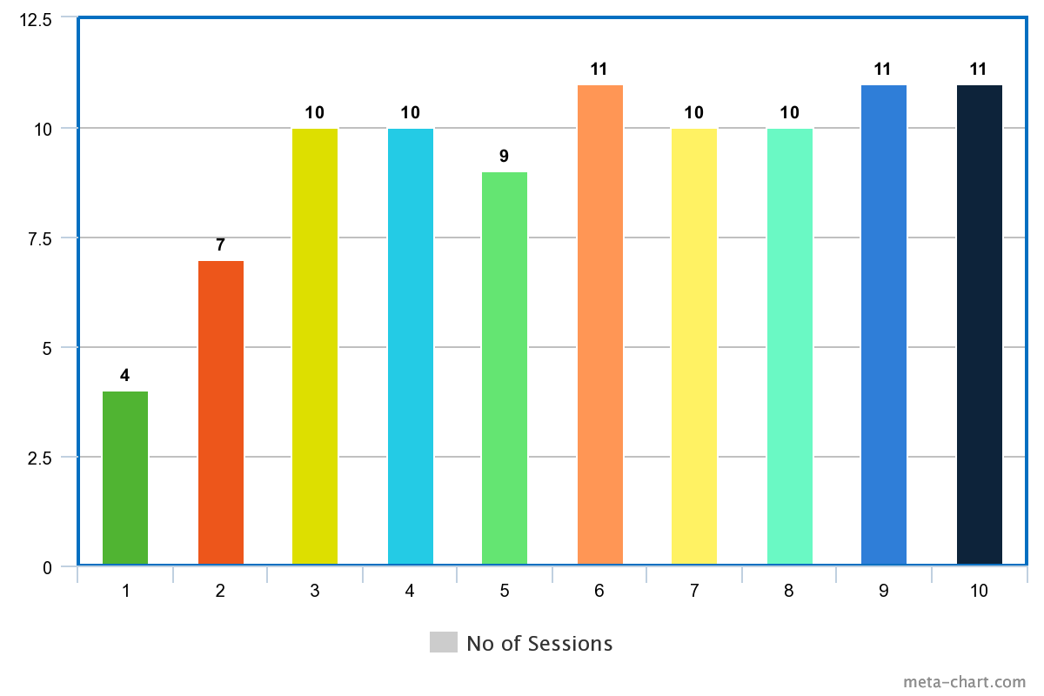

Case -2, Severe Autism
Session :- 01 (1st) Session:- 10 (Last)
Domain | Score
Duration | 2
Prompts & Cues | 1
Focused Area | 1
Strength | 2
Total Score | 6
Domain | Score
Duration | 4
Prompts & Cues | 3
Focused Area | 5
Strength | 4
Total Score | 16

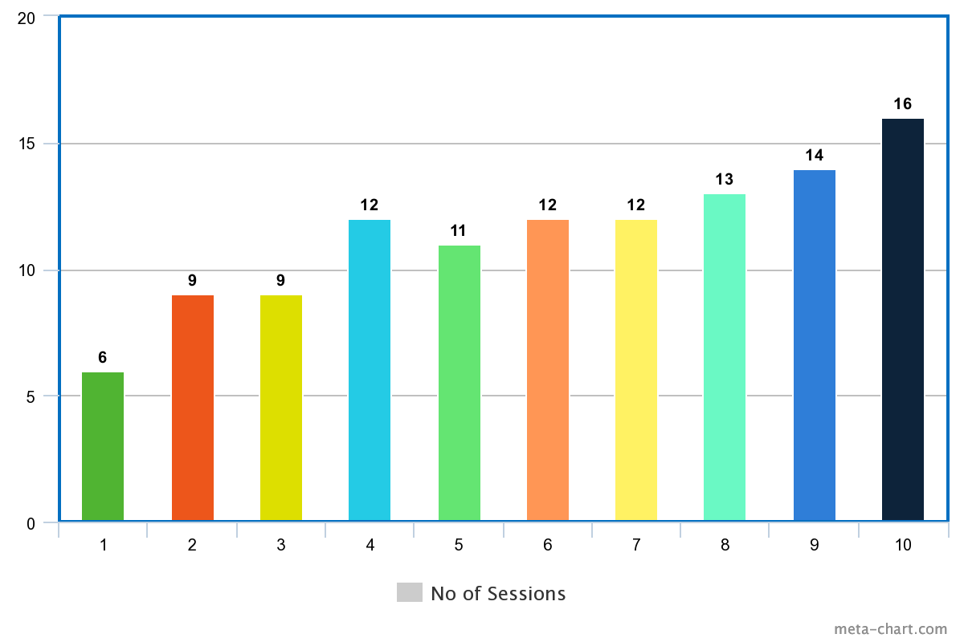

Case -3, Non-verbal severe autism
Session :- 01 (1st) Session:- 10 (Last)
Domain | Score
Duration | 1
Prompts & Cues | 1
Focused Area | 1
Strength | 1
Total Score | 4
Domain | Score
Duration | 3
Prompts & Cues | 2
Focused Area | 3
Strength | 3
Total Score | 11

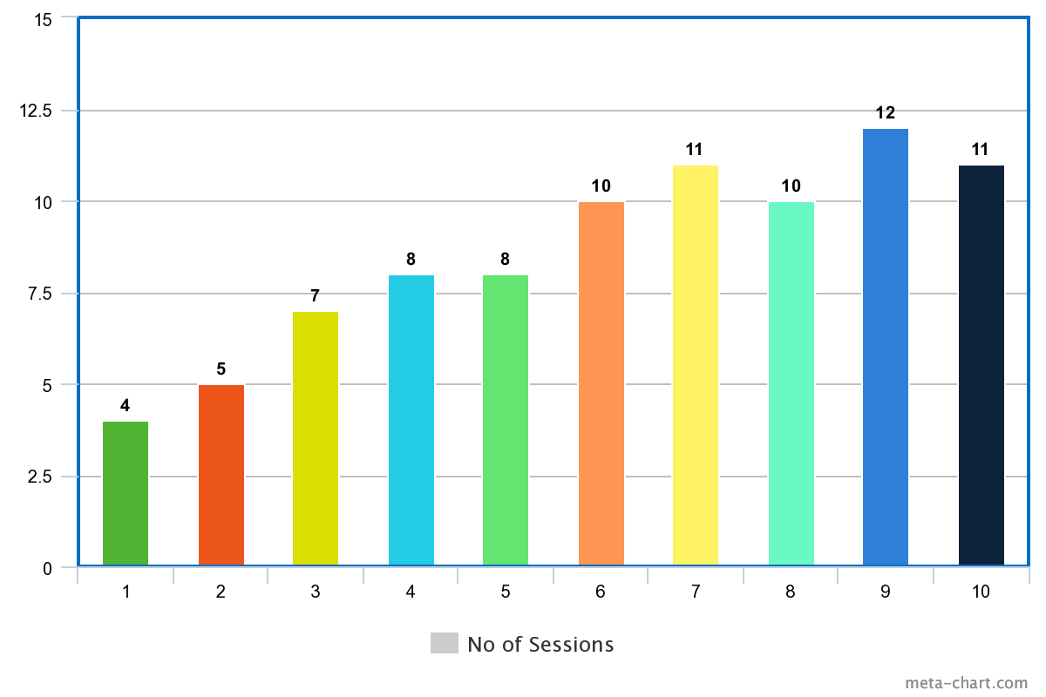

Case- 4, Mild Autism
Session :- 01 (1st) Session:- 10 (Last)
Domain | Score
Duration | 3
Prompts & Cues | 3
Focused Area | 2
Strength | 3
Total Score | 11
Domain | Score
Duration | 4
Prompts & Cues | 4
Focused Area | 6
Strength | 5
Total Score | 19

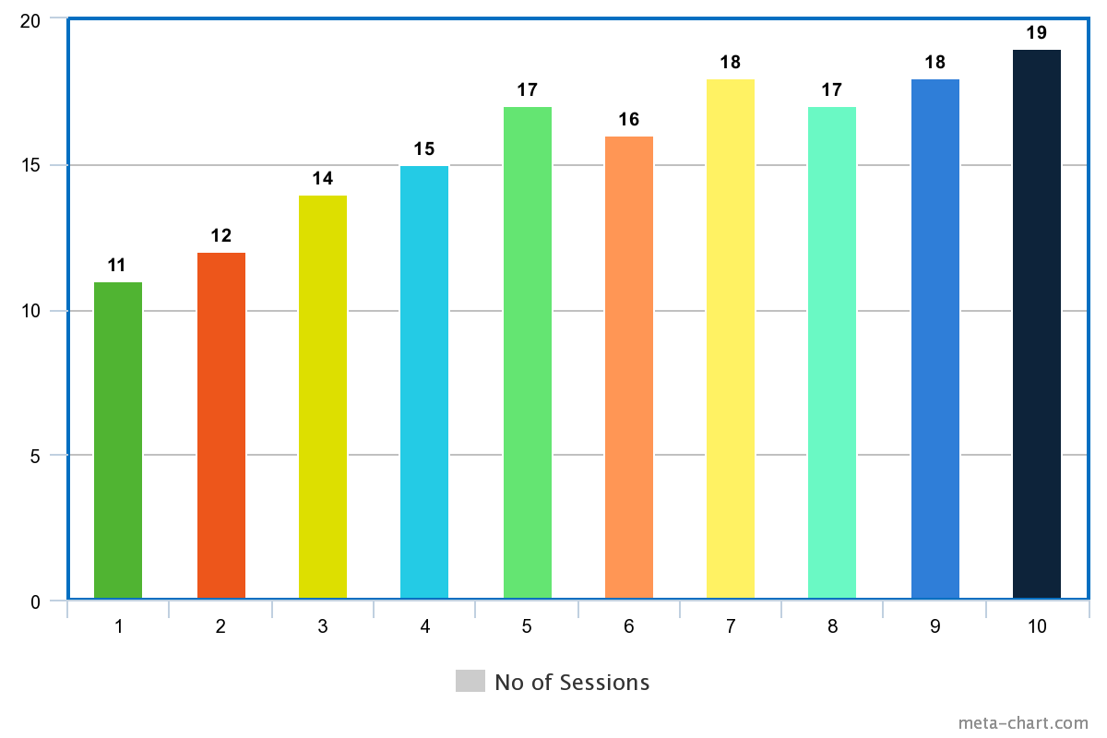

Case – 4, Mild autism with average I.Q

Session :- 01 (1st) Session:- 10 (Last)
Domain | Score
Duration | 1
Prompts & Cues | 2
Focused Area | 1
Strength | 1
Total Score | 5
Domain | Score
Duration | 3
Prompts & Cues | 3
Focused Area | 6
Strength | 5
Total Score | 17

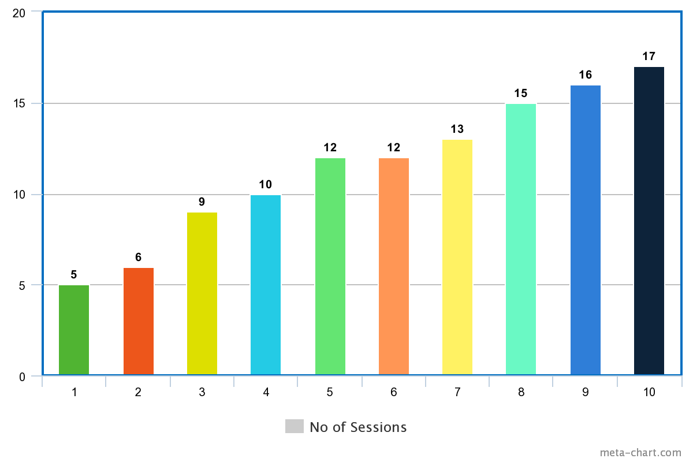

Explanation
According to the above information and the picture, it can be explained that the first part score of the 1st case was 4 and gradually increased to 11 in the 10th part. The Case 2 meeting starts with 6 points and increases to 16 points over 10 matches. Case 3 also started the class with at least 4, with some ups and downs between classes, but ended with 11 in the final year. Case 4 starts with a very high score of 11 and performs very well in grade 10 with a score of 19. Finally, there is a big change in Case 5, where it starts at 5 and reaches 17 in the last session.
Discussion
According to the description, there seems to be a positive change in scores. There seems to be improvement not only in grades but also in daily life. Some areas are likely to improve, such as hand-eye coordination, motor skills, attention, intelligence, learning concepts, self-confidence, hypocrisy, and courage to act. Efficacy reported by parents and teachers after intervention. It is difficult to integrate the concept of empowerment into disability if there is no good knowledge.
However, they have self-confidence and feel bad when they can't do something or when someone criticizes them. So from that perspective, if we try to make people understand that when you do better, that will be their main point of strength. Obviously people with disabilities, but business advice and proper art knowledge can help them support themselves. Knowing about laws and regulations will help them succeed in life.
Legislation - Rights and Disability
In order to effectively support persons with disabilities, government should involve representatives of minorities in the law and general jurisdiction.
The opportunities offered by international service support our mission to create an inclusive society where people with disabilities are treated with the same respect, love and kindness as everyone else in the world.
When people with disabilities can make their voices heard and claim their rights, the impact can really change. But we all need help. This is why empowerment is important because it can unlock the potential of people with disabilities and lead to real change in society.
Results
✓ Rejection of the Zero Hypothesis
✓ Art can improve mental health
✓ Quantitative Measures of Art Intervention Studies
✓ Improvements 4 Quantitative Art Behavior People Coping with Factors Human Empowerment Effects
Limitations of the Study
- Sample - This sample is simple and not perfect to generalize.
- But even if there is no detail for scientific purpose, the model can reflect the positive result. Wants to get a general idea of ​​how art can be used in different ways.
- Language – Instruction may vary, depending on the candidate's comfort level.
- Sessions - Total session varies from person to person.
- Process - After the main goal is achieved, the number of target areas will increase.
References

https://www.worldvision.com.au/womens-empowerment/#:~:text=What%20is%20women's%20empowerment%3F,change%20for%20themselves%20and%20others.
https://thedocs.worldbank.org/en/doc/517421606767152867-0050022020/original/WBL2020DisabilityTopicNote.pdf
https://www.google.com/search?q=empowerment+definition&rlz=1C1CHBF_enIN982IN982&sxsrf=AJOqlzWj
https://www.zenartsupplies.co/blogs/inspiration/successful-women-art-as-empowerment
https://epgp.inflibnet.ac.in/epgpdata/uploads/epgp_content/women_studies/gender_studies/07._women_and_law/32.__women_and_disability_laws/et/8055_et_et_32.pdf
http://docs.manupatra.in/newsline/articles/Upload/7102F404-0902-4EEC-BA55-F8EFC25DA6D4.pdf
www.diva-portal.org
www.enableme.ke
https://onlinelibrary.wiley.com/
www.coursehero.com
www.mdpi.com
www.seniorcare2share.com

