ARTIFICIAL INTELLIGENCE IN ORAL HEALTH CARE

Dr. Varnit Jain¹ ; Dr. Vidushi Goel²
^{INTERN}
Subharti Dental College and Maxillofacial Hospital, SVSU
Meerut, U.P., India
Jainvarnit2430@gmail.com ; vidugl31@gmail.com

ABSTRACT
In medical science, AI has become an indispensable tool in diagnostic precision, leveraging its ability to analyze complex medical images with unprecedented accuracy. Radiologists and clinicians benefit from AI's keen eye in spotting subtle abnormalities in X-rays, MRIs, and CT scans, leading to early disease detection and more precise treatment planning. AI's predictive analytics harnesses vast patient datasets, enabling personalized medicine by predicting disease risks, optimizing treatment responses, and contributing to drug discovery. Natural Language Processing (NLP) is utilized to extract valuable insights from medical records and research papers, facilitating data-driven decision-making. These advancements culminate in the emergence of personalized medicine, where AI tailors treatment strategies to the individual, ushering in a new era of more targeted and effective therapies.
In the realm of dentistry, AI plays a pivotal role in enhancing diagnosis, treatment, and patient engagement. Image analysis powered by AI elevates the interpretation of dental images, enabling early detection of oral diseases and precise treatment planning. AI-driven treatment simulations empower patients to visualize outcomes, leading to greater confidence and satisfaction. Remote monitoring facilitated by AI devices ensures real-time dental health data, promoting timely interventions. Patient engagement is enriched through AI-driven chatbots and virtual assistants, offering information, appointment scheduling, and post-treatment guidance. Additionally, AI extends its capabilities to forensic dentistry, assisting in the identification of individuals based on dental records and bite mark analysis in forensic investigations.
Keywords— Artificial intelligence, Dentistry, Oral health, Diagnosis
CONTENTS
- INTRODUCTION
- ARTIFICIAL INTELLIGENCE IN MEDICAL SCIENCES
- ARTIFICIAL INTELLIGENCE USED IN ORAL HEALTH CARE
- ARTIFICIAL INTELLIGENCE USED IN VARIOUS BRANCHES IN DENTISTRY
- ARTIFICIAL INTELLIGENCE USED IN ORAL MEDICINE AND RADIOLOGY
- ARTIFICIAL INTELLIGENCE USED IN PERIODONTOLOGY
- ARTIFICIAL INTELLIGENCE USED IN PAEDODONTICS
- ARTIFICIAL INTELLIGENCE USED IN ORAL SURGERY
- ARTIFICIAL INTELLIGENCE USED IN PROSTHODONTICS
- ARTIFICIAL INTELLIGENCE USED IN ORTHODONTICS
- ARTIFICIAL INTELLIGENCE USED IN CONSERVATIVE AND ENDODONTICS
- ARTIFICIAL INTELLIGENCE USED IN ORAL PATHOLOGY
- ARTIFICIAL INTELLIGENCE USED IN PUBLIC HEALTH DENTISTRY
- ARTIFICIAL INTELLIGENCE USED IN FORENSIC ODONTOLOGY
- FUTURISTIC ASPECT OF ARTIFICIAL INTELLIGENCE IN DENTISTRY
- ROBOT DENTIST
- CONCLUSION
- REFERENCES
- INTRODUCTION
The introduction of artificial intelligence (AI) in medical science and dentistry has revolutionized the way healthcare professionals approach diagnosis, treatment, research, and patient care. AI, powered by advanced algorithms and computational capabilities, has become a transformative tool that enhances the accuracy, efficiency, and effectiveness of medical and dental practices. Let's explore how AI is making a profound impact in these fields.

- ARTIFICIAL INTELLIGENCE IN MEDICAL SCIENCES
Artificial intelligence (AI) has made significant advancements in the field of medical sciences and healthcare, revolutionizing various aspects of patient care, research, and diagnostics. Here are some key areas where AI is making a profound impact:
- Medical Imaging: AI is used to analyze medical images such as X-rays, MRIs, and CT scans, aiding in the detection of diseases like cancer, identifying abnormalities, and assisting radiologists in making more accurate diagnoses.
- Disease Prediction and Early Detection: AI can analyze large datasets to predict the likelihood of diseases in individuals, based on factors such as genetics, lifestyle, and medical history. This early detection allows for timely interventions.
- Drug Discovery and Development: AI algorithms can predict the potential of new drug compounds, analyze molecular interactions, and accelerate the drug discovery process. This reduces the time and cost required for developing new treatments.
- Personalized Medicine: AI can help tailor medical treatments to individual patients based on their genetic makeup, allowing for more effective and targeted therapies.
- Natural Language Processing (NLP): NLP techniques enable the extraction of valuable information from medical records, research papers, and clinical notes, aiding in data analysis and decision-making.
- Robot-Assisted Surgery: AI-driven robots and surgical systems can assist surgeons in performing complex procedures with higher precision and fewer risks.
- Healthcare Management and Resource Allocation: AI can optimize hospital operations, patient scheduling, and resource allocation, leading to improved patient outcomes and cost savings.
- Remote Monitoring and Telemedicine: AI-powered devices can monitor patients remotely, providing real-time data to healthcare providers and allowing for timely interventions.
- Medical Research: AI can analyze vast amounts of medical data to identify trends, patterns, and potential research avenues, accelerating the pace of medical discoveries.
- Patient Care and Assistance: AI-driven chatbots and virtual assistants can provide patients with information, support, and even basic medical advice.
- While AI offers tremendous potential in medical sciences, it also raises ethical and regulatory challenges related to data privacy, transparency, bias, and the need for clinical validation. Collaboration between healthcare professionals, AI experts, and policymakers is essential to ensure the responsible and effective integration of AI in the medical field.

FIGURE 1: ARTIFICIAL INTELLIGENCE IN MEDICINE

    - ARTIFICIAL INTELLIGENCE USED IN ORAL HEALTH CARE
Artificial intelligence (AI) is being increasingly applied in oral health care to improve diagnosis, treatment, and overall patient experience. Here are some ways AI is used in this field:
- Dental Imaging and Analysis: AI helps dentists and oral radiologists analyze X-rays, panoramic images, and other dental scans for the early detection of oral health issues, such as cavities, periodontal diseases, and oral cancers. AI algorithms can highlight anomalies and assist in the diagnosis.

- Orthodontics and Treatment Planning: AI can aid in orthodontic treatment planning by analyzing 3D models of patients' teeth and suggesting optimal treatment approaches for conditions like malocclusion. This technology streamlines the process and improves the accuracy of treatment.

- Oral Cancer Detection: AI algorithms can be trained to identify patterns and features associated with oral cancers, enabling earlier detection and potentially saving lives.

- Personalized Treatment: AI can analyze a patient's dental records, medical history, and genetic factors to suggest personalized treatment plans, taking into account factors such as allergies, sensitivities, and the effectiveness of various dental materials.

- Patient Communication: AI-driven chatbots and virtual assistants can help dental clinics efficiently handle appointment scheduling, answer common patient questions, and provide post-treatment guidance.

- Teledentistry: AI-powered tools can assist in remote consultations, allowing dentists to examine patients' conditions through video calls and provide recommendations for follow-up care.

- Patient Monitoring: AI can help in monitoring oral health conditions over time, especially for chronic issues. This could involve tracking changes in gum health, tooth movement, or oral hygiene habits.

- Speech and Language Therapy: AI can be utilized in speech and language therapy, helping individuals with speech disorders or oral communication challenges.

- Data Analytics and Research: AI can analyze large datasets of dental records, research papers, and patient outcomes to identify trends, assess treatment effectiveness, and contribute to dental research.

It's important to note that the adoption of AI in oral health care should be accompanied by proper validation, adherence to privacy regulations, and collaboration between dental professionals and AI experts. While AI can enhance dental practices, human expertise remains essential for interpreting results, making clinical decisions, and ensuring the overall well-being of patients.
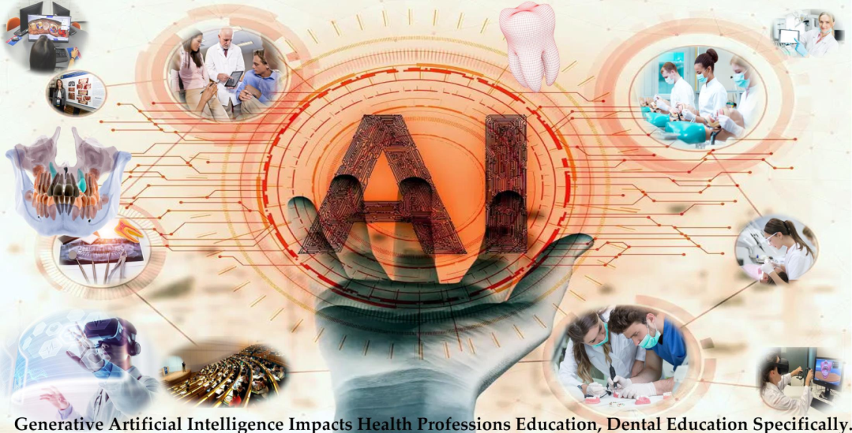
FIGURE 2:ARTIFICIAL INTELLIGENCE IN DENTISTRY

- ARTIFICIAL INTELLIGENCE USED IN VARIOUS BRANCHES IN DENTISTRY

      - ARTIFICIAL INTELLIGENCE USED IN OMR
Artificial intelligence (AI) is playing a significant role in advancing oral medicine and radiology. Here are some specific ways in which AI is used in this field:

- Image Analysis and Interpretation: AI algorithms can analyze oral radiographic images, such as dental X-rays,panoramic radiographs, and cone-beam computed tomography (CBCT) scans. AI can detect and highlight anomalies, lesions, and early signs of diseases like dental caries (cavities), periodontal diseases, and oral tumors.

- Early Detection of Oral Diseases: AI can aid in the early detection of oral diseases, leading to timely intervention and improved patient outcomes. For example, AI systems can help identify potentially cancerous lesions in oral tissues, assisting oral healthcare professionals in making informed decisions regarding biopsies and treatment plans.

- Treatment Planning and Simulation: AI can assist in treatment planning for various oral health conditions. It can help dentists and oral radiologists simulate treatment outcomes based on patient-specific data, aiding in the selection of appropriate interventions, such as orthodontic treatments, implant placements, or surgical procedures.

- Automated Reporting: AI can generate automated reports based on the analysis of oral radiographic images, providing concise summaries of findings to dental practitioners. This streamlines the reporting process and ensures consistent and standardized documentation.

- Quantitative Assessment: AI can provide quantitative measurements and assessments of oral health parameters, such as bone density, tooth alignment, and changes in tissue morphology over time. This information is valuable for tracking the progress of treatments and evaluating treatment effectiveness.

- Integration with Electronic Health Records: AI can integrate with electronic health record (EHR) systems used in oral medicine and radiology, making it easier to manage patient data, retrieve historical records, and ensure comprehensive patient care.

- Continuing Education: AI-powered educational tools can assist in the continuous learning of oral healthcare professionals. These tools can provide access to the latest research, case studies, and treatment recommendations, helping professionals stay up-to-date with the rapidly evolving field.

- Research and Data Analysis: AI can analyze large datasets of oral radiology images, patient records, and research articles to identify trends, patterns, and potential areas for further investigation in oral medicine and radiology.

While AI offers numerous benefits in oral medicine and radiology, it's essential to address challenges such as data privacy, validation of AI models, and the need for human expertise in interpreting results. A collaborative approach involving dental experts, radiologists, and AI specialists is crucial for the responsible integration of AI in this field.
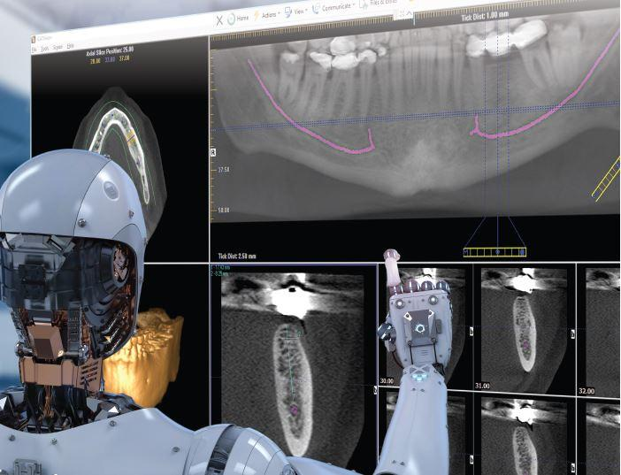
FIGURE 3:ARTIFICIAL INTELLIGENCE USED FOR NERVE TRACING

- ARTIFICIAL INTELLIGENCE USED IN PERIODONTOLOGY

Artificial intelligence (AI) is increasingly being applied in the field of periodontology to enhance diagnosis, treatment planning, patient management, and research. Here are some ways AI is used in periodontology:

- Periodontal Disease Detection: AI algorithms can analyze clinical and radiographic data to detect and diagnose periodontal diseases, such as gingivitis and periodontitis. These algorithms can identify patterns and changes in periodontal tissues that might be missed by the human eye.

- Risk Assessment: AI can assess the risk of periodontal diseases in individual patients based on factors such as age, oral hygiene practices, genetics, and systemic health. This information can help dentists and periodontists develop personalized preventive strategies.

- Treatment Planning: AI can assist in treatment planning for patients with periodontal diseases. It can help determine the severity and extent of disease, suggest appropriate treatment approaches, and predict the likely outcomes of different interventions.

- Orthodontic Considerations: In cases where orthodontic treatment is planned, AI can analyze the impact of orthodontic movements on periodontal health, ensuring that tooth movements are within acceptable limits to avoid detrimental effects on the periodontal tissues.

- Implant Placement: AI can aid in the placement of dental implants by analyzing bone density, tissue morphology, and anatomical structures. This can help ensure optimal implant placement and reduce the risk of complications.

- Follow-up and Monitoring: AI can help in monitoring the progress of periodontal treatments. It can analyze changes in periodontal tissues over time, assess the effectiveness of interventions, and provide insights for adjustments in the treatment plan.

- Patient Education: AI-driven educational tools can help patients understand the importance of good oral hygiene practices, the consequences of untreated periodontal diseases, and the benefits of preventive measures.

- Research and Data Analysis: AI can analyze large datasets of periodontal records, research articles, and clinical outcomes to identify trends, patterns, and potential areas for further research in periodontology.

While AI offers valuable opportunities in periodontology, it's important to ensure that AI models are properly validated, privacy regulations are followed, and the human expertise of periodontal specialists is integrated into the decision-making process. Collaborative efforts between periodontists, dental professionals, and AI experts are essential for the responsible and effective use of AI in periodontology.
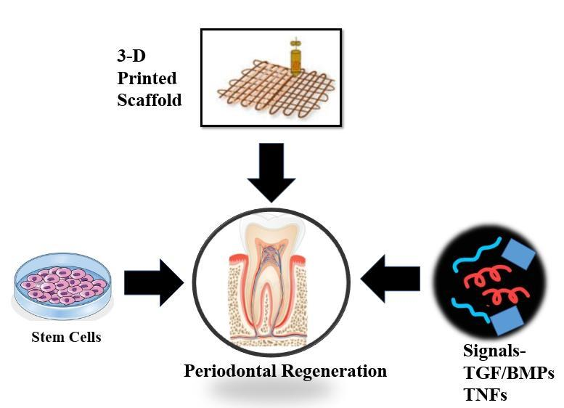
FIGURE 4: ARTIFICIAL INTELLIGENCE IN ASSESSING PERIODONTAL FIBRES
- ARTIFICIAL INTELLIGENCE USED IN PAEDODONTICS

Artificial intelligence (AI) has several applications in the field of pediatric dentistry, also known as pedodontics. These applications can improve diagnosis, treatment planning, patient engagement, and overall dental care for children. Here are some ways AI is used in pedodontics:
- Early Orthodontic Assessment: AI algorithms can analyze dental images and 3D scans of a child's mouth to assess the development of teeth and the alignment of the dental arch. This aids in early detection of orthodontic issues, allowing for timely intervention.
- Caries Detection: AI can assist in the early detection of dental caries (cavities) in children. It can analyze dental images, such as X-rays or intraoral photographs, to identify carious lesions, helping dentists take appropriate preventive or restorative actions.
- Behavior Management: AI-powered tools can be used to create interactive and engaging experiences for young patients, reducing anxiety and fear associated with dental visits. Virtual reality (VR) and augmented reality (AR) can be used to distract and comfort children during procedures.
- Personalized Treatment Planning: AI can analyze a child's dental records, medical history, and growth patterns to recommend personalized treatment plans for oral health maintenance, preventive measures, and orthodontic interventions.
- Patient Education: AI-driven educational tools can provide children and their parents with information about proper oral hygiene, dietary habits, and the importance of regular dental check-ups. These tools can be interactive and tailored to different age groups.
- Appointment Scheduling and Reminders: AI-powered systems can streamline the appointment scheduling process, helping parents find convenient times for their children's dental visits. AI can also send automated reminders to parents, reducing missed appointments.
- Data Management: AI can assist in managing and analyzing large datasets related to pediatric dental health. This includes tracking children's oral health progress over time, identifying trends, and contributing to research in pediatric dentistry.
- Pediatric Dental Research: AI can analyze existing pediatric dental research and clinical outcomes, identifying best practices and potential areas for further investigation. This can contribute to evidence-based pediatric dental care.
As with any medical application of AI, it's crucial to ensure that the technology is properly validated, adheres to privacy regulations (especially concerning data related to minors), and complements the expertise of pediatric dentists and oral healthcare professionals. Collaboration between pedodontists, dental experts, and AI specialists is essential for the responsible integration of AI in pedodontics.

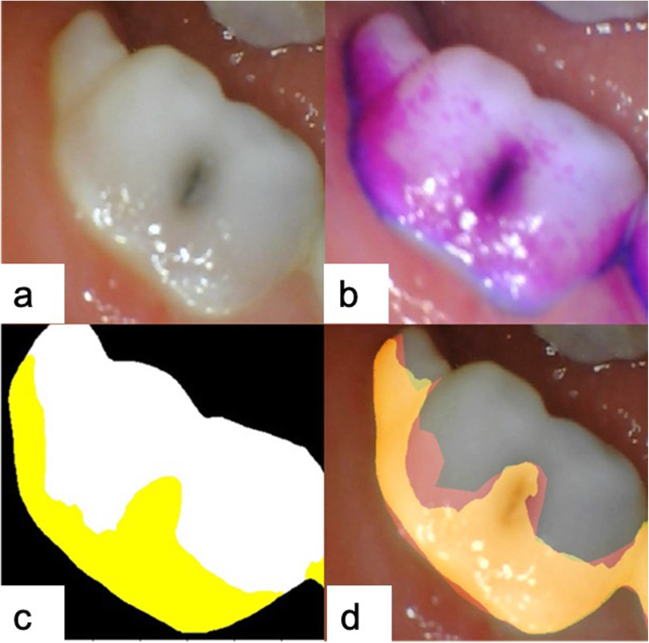
FIGURE 5: DENTAL PLAQUE DETERMINATION BY ARTIFICIAL INTELLIGENCE

- ARTIFICIAL INTELLIGENCE USED IN ORAL SURGERY

Artificial intelligence (AI) is being applied in various aspects of oral surgery to improve patient outcomes, enhance surgical planning, and streamline procedures. Here are some ways AI is used in oral surgery:
- Surgical Planning: AI can assist in preoperative planning for oral surgeries, such as dental implant placements, orthognathic surgeries, and maxillofacial procedures. It can analyze 3D scans and create virtual surgical simulations, allowing surgeons to visualize the procedure and make more accurate decisions.
- Implant Placement: AI can analyze bone density, anatomical structures, and occlusion patterns to optimize the placement of dental implants. This ensures proper integration of the implant and reduces the risk of complications.
- Nerve and Vessel Detection: AI algorithms can identify and highlight critical structures, such as nerves and blood vessels, in 3D images. This helps prevent accidental damage during surgery.
- Robot-Assisted Surgery: AI-driven robotic systems can be used in complex oral surgeries to enhance precision and control. Surgeons can perform procedures with higher accuracy, especially in delicate areas.
- Real-time Navigation: During surgery, AI-based navigation systems can provide real-time feedback, guiding the surgeon's movements and helping ensure that the procedure stays on the planned course.
- Postoperative Monitoring: AI can aid in monitoring the healing process after surgery. It can analyze follow-up imaging, track changes in the surgical site, and alert the surgeon to any concerns.
- Predictive Analytics: AI can analyze patient data to predict the likelihood of postoperative complications and assist in personalized aftercare plans.
- Education and Training: AI-driven simulations and virtual reality tools can be used for training oral surgeons, allowing them to practice procedures in a safe and controlled environment.
- Data-driven Insights: AI can analyze surgical outcomes, complications, and patient data to identify patterns and trends, contributing to research and the improvement of surgical techniques.
While AI offers significant benefits in oral surgery, it's essential to validate AI models, ensure data privacy, and maintain the crucial role of experienced oral surgeons in decision-making. Collaboration between oral surgery specialists and AI experts is vital for the responsible integration of AI in this field.

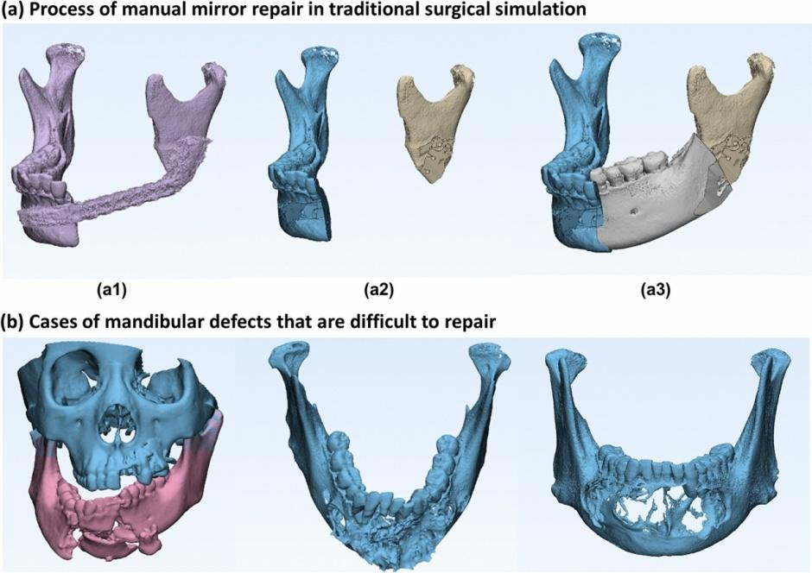
FIGURE 6: USE OF ARTIFICIAL INTELLIGENCE TO RECOVER MANDIBULAR MORPHOLOGY AFTER DISEASE

- ARTIFICIAL INTELLIGENCE USED IN PROSTHODONTICS

Artificial intelligence (AI) is making notable contributions to the field of prosthodontics, which focuses on the restoration and replacement of teeth and oral structures. Here are some ways AI is used in prosthodontics:
- Digital Impressions: AI-driven digital scanners can create highly accurate and detailed digital impressions of a patient's oral structures. This eliminates the need for traditional messy impression materials and ensures precise prosthodontic work.
- Prosthetic Design: AI can assist in designing dental prostheses, such as crowns, bridges, and dentures. It can analyze the patient's anatomy, occlusion, and aesthetic preferences to create prostheses that fit and function optimally.
- Implant Planning: AI helps with implant placement planning by analyzing 3D scans of the patient's jawbone and oral structures. It can suggest the ideal implant positions and angles, ensuring the best outcomes for implant-supported restorations.
- Treatment Simulation: AI can simulate the expected outcomes of prosthodontic treatments. Patients and prosthodontists can visualize how the final restorations will look and function before the actual procedures.
- Material Selection: AI can recommend suitable materials for dental prostheses based on factors such as the patient's oral health, aesthetic preferences, and the mechanical properties required.
- Customization: AI enables the creation of highly personalized dental prostheses. It can take into account individual patient characteristics, resulting in more comfortable and functional restorations.
- Prosthesis Fit: AI can analyze the fit of dental prostheses, ensuring that they align properly with the patient's oral structures and minimizing the risk of complications.
- Virtual Try-In: AI-powered virtual try-in systems allow patients to see how their new dental prostheses will look and make real-time adjustments to achieve the desired appearance.
- Data Analysis and Research: AI can analyze large datasets of prosthodontic cases, research papers, and clinical outcomes, identifying trends, best practices, and potential areas for improvement.
The integration of AI in prosthodontics requires proper validation, adherence to privacy regulations, and collaboration between prosthodontists and AI specialists. While AI offers valuable benefits, it is crucial to maintain the expertise of prosthodontic professionals in treatment planning, patient care, and decision-making to ensure the best possible results for patients.

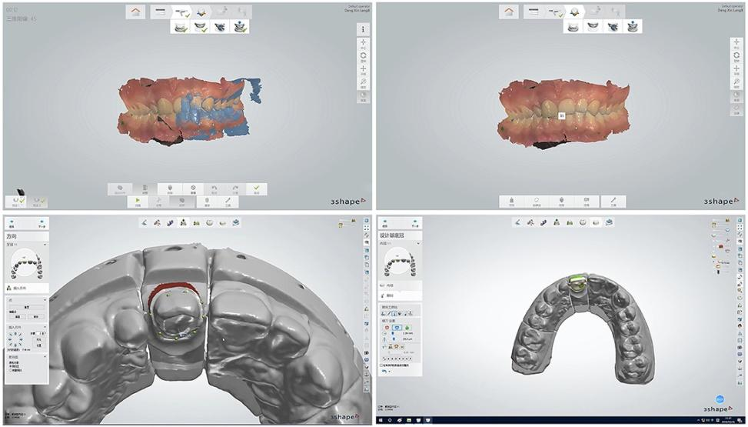
FIGURE 7: ARTIFICIAL INTELLIGENCE IN BIOMEDICAL APPLICATIONS OF ZIRCONIA

- ARTIFICIAL INTELLIGENCE USED IN ORTHODONTICS

Artificial intelligence (AI) is playing an increasingly important role in the field of orthodontics, providing advanced tools for diagnosis, treatment planning, monitoring, and patient engagement. Here are some ways AI is used in orthodontics:
- Digital Imaging and Analysis: AI can analyze digital orthodontic images, such as cephalometric X-rays and 3D scans, to assist in the diagnosis of malocclusions (misalignments of teeth and jaws). It can provide precise measurements and identify orthodontic issues.
- Treatment Planning: AI can help orthodontists in developing treatment plans by analyzing a patient's dental records, facial features, and growth patterns. It can simulate the progression of treatment and predict the expected outcomes, aiding in decision-making.
- Brackets and Appliance Placement: AI can optimize the placement of orthodontic brackets and appliances on teeth, ensuring the most effective and efficient treatment. It can consider factors such as tooth anatomy and occlusion.
- Invisalign Treatment Planning: For clear aligner therapy (such as Invisalign), AI can assist in designing the sequence of aligners needed to achieve the desired tooth movements, ensuring a customized and accurate treatment plan.
- Progress Monitoring: AI can analyze follow-up scans to track the progress of orthodontic treatment. It can detect tooth movements, root resorption, and other changes, helping orthodontists adjust treatment as needed.
- Predictive Analysis: AI can predict the likelihood of specific treatment outcomes based on historical data, patient characteristics, and treatment protocols. This helps in setting realistic expectations for patients and refining treatment plans.
- Patient Communication: AI-driven educational tools can help patients understand their orthodontic conditions, treatment options, and the importance of compliance with instructions. This enhances patient engagement and cooperation.
- Research and Data Analysis: AI can analyze large datasets of orthodontic cases and research papers, identifying trends, best practices, and contributing to the advancement of orthodontic techniques.
It's essential to ensure that AI models in orthodontics are properly validated, adhere to privacy regulations, and complement the expertise of orthodontists. A collaborative approach between orthodontic specialists and AI experts is crucial for the responsible integration of AI in orthodontics, ultimately benefiting both practitioners and patients.
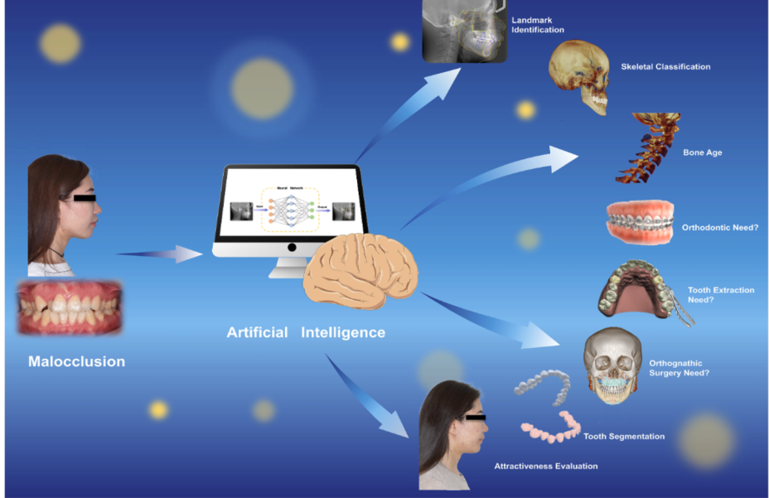
FIGURE 8: ARTIFICIAL INTELLIGENCE IN EVALUATING AND CORRECTING THE MALOCCLUSION

- AI USED IN CONSERVATIVE AND ENDODONTICS
Artificial intelligence (AI) is increasingly being integrated into the fields of conservative dentistry (also known as restorative dentistry) and endodontics to enhance diagnosis, treatment planning, and patient outcomes. Here are some ways AI is used in these areas:
Conservative Dentistry:
- Caries Detection: AI algorithms can analyze dental images, such as X-rays and intraoral photographs, to detect early signs of dental caries (cavities) in a patient's teeth. This aids in the early intervention and preventive treatment of carious lesions.
- Restorative Treatment Planning: AI can assist in planning the restoration of damaged teeth. By analyzing the extent of tooth decay or damage, AI can recommend appropriate restorative materials and techniques for the best functional and aesthetic outcomes.
- Color Matching: AI can aid in matching restorative materials, such as dental crowns or fillings, to the natural color of the patient's teeth. This ensures a seamless blend with the surrounding dentition.
- Marginal Fit: AI can assess the fit and adaptation of dental restorations to the tooth structure, ensuring precise margins and minimizing the risk of secondary caries or restoration failure.
- Prosthesis Design: In cases where fixed or removable prostheses are needed, AI can assist in designing and optimizing the shape and fit of these prostheses, such as dental crowns or bridges.
Endodontics:
- Diagnostic Aid: AI can assist in the diagnosis of complex endodontic cases by analyzing radiographic images and identifying root canal anatomy, calcifications, or fractures that may not be easily detectable by the human eye.
- Root Canal Treatment Planning: AI can help in the planning of root canal procedures by analyzing 3D images and providing insights into the number of canals, their curvatures, and the best instrumentation approach.
- Apex Locators: AI-driven apex locators can assist in precisely determining the length of the root canals during treatment, reducing the risk of over-instrumentation or underfilling.
- Outcome Prediction: AI can analyze historical endodontic treatment data to predict the likelihood of successful outcomes based on specific case parameters, aiding in patient counseling.
While AI offers valuable support in conservative dentistry and endodontics, it should be integrated thoughtfully alongside the expertise of dental professionals. Proper validation, adherence to privacy regulations, and ongoing collaboration between dentists and AI specialists are crucial for its responsible use in these fields.
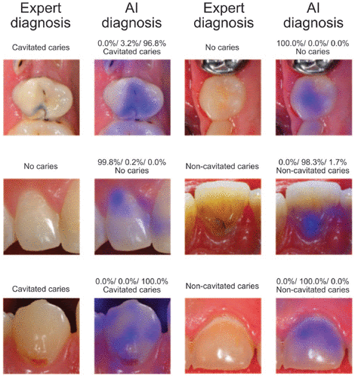
FIGURE 9: ARTIFICIAL INTELLIGENCE USED IN DETECTION OF CARIES

- AI USED IN ORAL PATHOLOGY

Artificial intelligence (AI) is making significant strides in the field of oral pathology, revolutionizing the diagnosis, analysis, and research of oral diseases. Here are some ways AI is used in oral pathology:
- Automated Image Analysis: AI algorithms can analyze histopathological images of oral tissues, such as biopsies, to detect and identify cellular and tissue abnormalities indicative of various oral diseases, including oral cancers.
- Disease Classification and Grading: AI can classify oral lesions and cancers based on their characteristics and severity, providing valuable information for treatment planning and prognosis assessment.
- Early Detection of Oral Cancers: AI can assist in the early detection of oral cancer by analyzing visual and molecular markers. This early detection is crucial for improving patient outcomes.
- Diagnostic Assistance: AI can serve as a diagnostic aid, providing insights to pathologists by highlighting areas of interest in slides, suggesting potential diagnoses, or providing differential diagnoses based on the analysis of patient data.
- Data Mining and Analysis: AI can analyze large datasets of oral pathology cases, research articles, and clinical outcomes to identify patterns, trends, and potential correlations, advancing our understanding of oral diseases.
- Predictive Modeling: AI can predict disease progression, treatment responses, and recurrence risks based on historical data, contributing to personalized treatment planning.
- Educational Tools: AI-driven educational tools can help train and educate pathologists, allowing them to learn from a diverse range of cases and receive real-time feedback.
- Virtual Tumor Board: AI can facilitate collaborative decision-making among oral pathologists, oncologists, and other specialists in a virtual tumor board setting, ensuring comprehensive and well-informed treatment plans.
- Telepathology: AI can be integrated into telepathology systems, enabling remote consultation and second opinions, particularly valuable in areas with limited access to oral pathology expertise.
- Research and Drug Discovery: AI can assist in identifying potential therapeutic targets and predicting drug responses based on genetic and molecular data from oral tissues.
It's essential to ensure that AI models in oral pathology are properly validated, adhere to privacy regulations, and complement the expertise of pathologists. A collaborative approach between oral pathology specialists, medical professionals, and AI experts is crucial for the responsible integration of AI in oral pathology, ultimately benefiting both practitioners and patients.

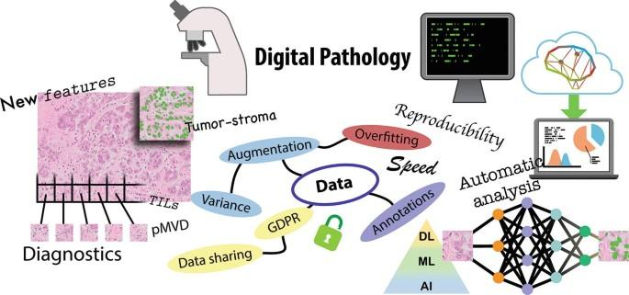
FIGURE 10: ARTIFICIAL INTELLIGENCE USED IN STUDY OF MALIGNANT TUMORS

- ARTIFICIAL INTELLIGENCE USED IN PUBLIC HEALTH DENTISTRY
Artificial intelligence (AI) has the potential to significantly impact public health dentistry by improving preventive efforts, data analysis, resource allocation, and overall oral health management at a population level. Here are some ways AI is used in public health dentistry:
- Oral Health Surveillance: AI can analyze large datasets of oral health information, including epidemiological data, oral disease prevalence, risk factors, and treatment outcomes. This enables public health officials to monitor oral health trends, identify at-risk populations, and develop targeted interventions.
- Risk Assessment: AI can predict the risk of oral diseases at the individual and community levels based on various factors, such as demographics, socioeconomic status, lifestyle, and access to dental care. This information aids in prioritizing preventive measures.
- Optimizing Resource Allocation: AI can assist in allocating dental resources, such as community clinics, dental personnel, and preventive programs, to areas with the greatest need. It ensures that resources are efficiently distributed to improve access to dental care.
- Early Detection and Intervention: AI-driven systems can identify individuals or communities at higher risk for oral diseases, enabling public health agencies to implement targeted screening, education, and early intervention programs.
- Education and Outreach: AI can assist in developing and disseminating oral health education materials tailored to specific populations, making the information more accessible and effective in promoting better oral hygiene practices.
- Remote Monitoring: AI-powered tools can facilitate remote monitoring of oral health conditions, especially for underserved or rural populations. This can include tele-dentistry consultations, virtual check-ups, and providing oral health advice via digital platforms.
- Emergency Response: AI can help public health agencies respond to oral health emergencies, such as disease outbreaks or natural disasters, by providing real-time data analysis, resource coordination, and crisis management.
- Data-Driven Decision Making: AI-driven insights from data analysis can guide public health officials in making informed decisions regarding policy development, allocation of funding, and the implementation of preventive measures.
- Public Health Research: AI can analyze vast amounts of public health data, contributing to research on oral health disparities, disease trends, and the effectiveness of public health initiatives.
While AI offers great potential in public health dentistry, it's essential to address ethical considerations, data privacy, and community engagement. A collaborative approach involving dental public health experts, healthcare professionals, policymakers, and AI specialists is essential to ensure the responsible and effective use of AI in improving oral health at a population level.
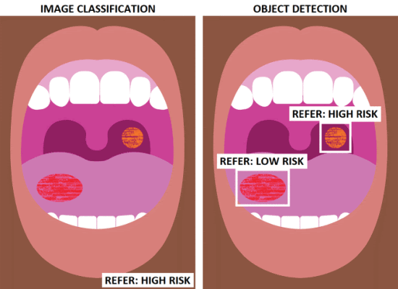
FIGURE 11: ARTIFICAL INTELLIGENCE USED IN SCREENING OF ORAL DISEASES

- ARTIFICIAL INTELLIGENCE USED IN FORENSIC ODONTOLOGY
Artificial intelligence (AI) has several applications in forensic odontology, a specialized field that involves the identification of individuals using dental records, analysis of bite marks, and other dental-related evidence in forensic investigations. Here are some ways AI is used in forensic odontology:
- Dental Record Matching: AI algorithms can compare dental records (such as dental X-rays and photographs) of a missing person with post-mortem dental records to establish a positive identification. AI can streamline the matching process by identifying common features, discrepancies, and unique dental characteristics.
- Bite Mark Analysis: AI can assist in analyzing bite mark patterns left on victims or objects, helping forensic odontologists determine potential suspects or corroborate evidence in criminal cases.
- Age Estimation: AI models can estimate the age of individuals based on dental developmental stages, tooth eruption patterns, and other dental morphological features. This information can be valuable in narrowing down the age range of unidentified remains.
- Trauma Analysis: AI can help in analyzing dental trauma, such as fractures or dental work, to provide insights into the cause and timing of injuries. This information can be crucial in reconstructing events leading to the individual's death.
- Pattern Recognition: AI can assist in identifying dental patterns, such as dental restorations, dental anomalies, and unique dental features, aiding in the comparison of ante-mortem and post-mortem dental records.
- Database Management: AI-driven systems can manage large forensic dental databases, improving the efficiency of record retrieval, cross-referencing, and identification efforts.
- Virtual Dental Autopsy: AI can be integrated into virtual autopsy systems, assisting forensic odontologists in examining virtual 3D models of dental structures and identifying relevant details.
- Case Prioritization: AI can prioritize cases based on factors such as the complexity of identification, urgency, and available resources, allowing forensic experts to focus on cases that require immediate attention.
While AI can enhance the efficiency and accuracy of forensic odontology, it's crucial to validate AI models, ensure proper data privacy, and maintain the expertise of forensic odontologists in interpreting results. Collaboration between forensic experts, AI specialists, and legal professionals is essential for the responsible integration of AI in forensic odontology, ultimately aiding law enforcement and contributing to justice.
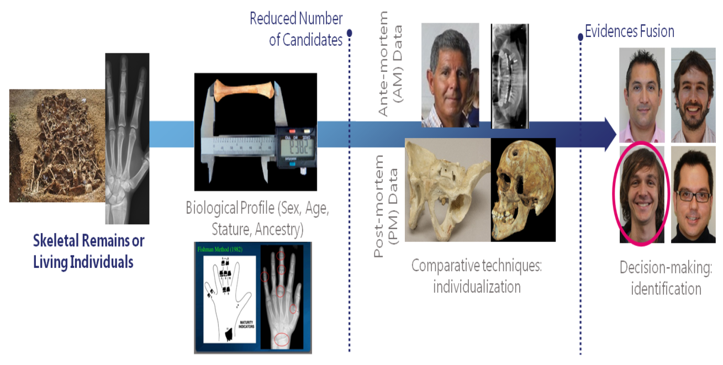
FIGURE 12: ARTIFICIAL INTELLIGENCE USED IN FORENSIC ANTHROPOLOGY

  - FUTURISTIC ASPECT OF ARTIFICIAL INTELLIGENCE IN DENTISTRY
The futuristic aspects of artificial intelligence (AI) in dentistry hold the potential to reshape the field in exciting ways. While some of these possibilities are still in the research or early development stages, they offer a glimpse into the innovative future of dentistry:
- Predictive Dentistry: AI could be used to predict oral health issues based on individual patient data, genetic factors, and lifestyle. Dentists may be able to proactively address potential problems before they become more serious.
- Personalized Treatment Plans: AI-driven algorithms could create highly personalized treatment plans, taking into account a patient's unique oral health history, genetic predisposition, and preferences. This could lead to more effective and efficient treatments.
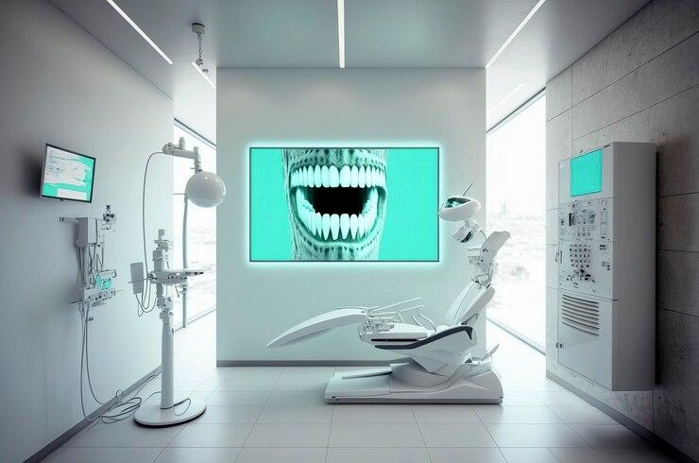
FIGURE 13: FUTURE OF DENTISTRY WITH ARTIFICIAL INTELLIGENCE

- Fully Automated Dental Procedures: Advanced robotics and AI could lead to fully automated dental procedures, where robots handle routine tasks, such as tooth cleanings or even simple restorations. Dentists could focus on complex cases and decision-making.
- 3D Printing of Dental Prosthetics: AI-assisted 3D printing could become a standard for creating custom dental prosthetics, such as crowns, bridges, and dentures, with high precision and minimal human intervention.
- Tele-Dentistry Advancements: AI could enhance remote dental consultations by providing real-time data analysis, allowing dentists to remotely guide patients through certain procedures, and expanding access to dental care.
- Real-time Chairside Decision Support: AI-powered tools integrated into dental chairs could provide real-time diagnostic support to dentists during procedures, helping with immediate treatment decisions.
- Non-Invasive Treatments: AI-driven advancements may lead to innovative non-invasive treatments, potentially reducing the need for invasive procedures in some cases.
- Dental Education and Training: AI-driven simulations and virtual reality could revolutionize dental education and training, providing students with realistic scenarios and allowing them to practice a wide range of procedures in a controlled environment.
- Enhanced Research and Data Analytics: AI can analyze vast datasets of dental records, research papers, and clinical outcomes to identify trends, correlations, and novel treatment approaches, accelerating advancements in the field.
- AI Ethics and Regulation: As AI becomes more integral to dentistry, there will likely be a focus on ethical considerations, guidelines, and regulations to ensure patient safety, privacy, and the responsible use of AI technologies.
While these futuristic aspects of AI in dentistry are promising, it's essential to address challenges related to data privacy, regulatory frameworks, ethical considerations, and the ongoing need for human expertise in complex decision-making. Collaborative efforts among dental professionals, AI researchers, policymakers, and regulatory bodies will be crucial to harness the full potential of AI in dentistry while ensuring its responsible and ethical use.
  - ROBOT DENTIST
Robot dentists represent an innovative intersection of technology and healthcare in the field of dentistry. While not entirely replacing human dentists, these robotic systems play a significant role in assisting dental professionals with various tasks. These robots are equipped with advanced sensors, precision tools, and artificial intelligence algorithms, enabling them to perform tasks such as teeth cleaning, plaque removal, and even simple dental procedures with a high degree of accuracy. Robot dentists have the potential to enhance the efficiency and precision of dental treatments, reduce patient discomfort, and increase access to dental care, especially in remote or underserved areas. However, their use is typically in collaboration with human dentists, ensuring that patients receive the best possible care by combining the expertise of dental professionals with the precision and consistency of robotic technology.

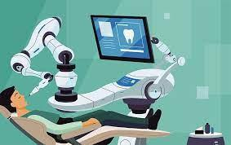
FIGURE 14: ROBOT DENTIST

  - CONCLUSION
As AI's integration into medical science and dentistry unfolds, the benefits are undeniable, from improved diagnostic accuracy to more personalized and efficient healthcare delivery. However, ethical considerations, data privacy, regulatory standards, and the importance of human expertise remain paramount. Collaboration among healthcare professionals, AI experts, policymakers, and regulatory bodies is essential to harness AI's potential responsibly, ensuring it leads to better patient care, streamlined workflows, and groundbreaking medical and dental research. The future holds exciting possibilities as AI continues to reshape the landscape of medical science and dentistry, offering innovative solutions and contributing to the advancement of healthcare worldwide.

  - REFERENCES
1. Stevenson A. Oxford Dictionary of English. USA: Oxford University Press (2010).
2. Poplin R, Varadarajan AV, Blumer K, Liu Y, McConnell MV, Corrado GS, et al. Prediction of cardiovascular risk factors from retinal fundus photographs via deep learning. Nat Biomed Eng. (2018) 2(3):158–64. doi: 10.1038/s41551-018-0195-0
3. Khanagar SB, Al-ehaideb A, Maganur PC, Vishwanathaiah S, Patil S, Baeshen HA, et al. Developments, application, and performance of artificial intelligence in dentistry—a systematic review. J Dent Sci. (2021) 16(1):508–22. doi: 10.1016/j.jds.2020.06.019
4. Khanagar SB, Al-Ehaideb A, Vishwanathaiah S, Maganur PC, Patil S, Naik S, et al. Scope and performance of artificial intelligence technology in orthodontic diagnosis, treatment planning, and clinical decision-making—a systematic review. J Dent Sci. (2021) 16(1):482–92. doi: 10.1016/j.jds.2020.05.022
5. Mahmood H, Shaban M, Indave BI, Santos-Silva AR, Rajpoot N, Khurram SA. Use of artificial intelligence in diagnosis of head and neck precancerous and cancerous lesions: a systematic review. Oral Oncol. (2020) 110:104885. doi: 10.1016/j.oraloncology.2020.104885
6. Farook TH, Jamayet NB, Abdullah JY, Alam MK. Machine learning and intelligent diagnostics in dental and orofacial pain management: a systematic review. Pain Res Manag. (2021) 2021:6659133. doi: 10.1155/2021/6659133
7. AbuSalim S, Zakaria N, Islam MR, Kumar G, Mokhtar N, Abdulkadir SJ. Analysis of deep learning techniques for dental informatics: a systematic literature review. Healthcare. (2022) 10(10):1892. doi: 10.3390/healthcare10101892
8. Mohammad-Rahimi H, Motamedian SR, Pirayesh Z, Haiat A, Zahedrozegar S, Mahmoudinia E, et al. Deep learning in periodontology and oral implantology: a scoping review. J Periodont Res. (2022) 57(5):942–51. doi: 10.1111/jre.13037
9. Turing AM, Haugeland J. Computing machinery and intelligence. MA: MIT Press Cambridge (1950).
10. McCarthy J, Minsky M, Rochester N, Shannon CE. A proposal for the dartmouth summer research project on artificial intelligence. AI magazine. (2006) 27(4):12–14. http://jmc.stanford.edu/articles/dartmouth/dartmouth.pdf
11. Tatnall A. History of computers: hardware and software development. In: Encyclopedia of Life Support Systems (EOLSS), Developed under the Auspices of the UNESCO. Paris, France: Eolss. (2012). https://www.eolss.net
12. Weizenbaum J. ELIZA—a computer program for the study of natural language communication between man and machine. Commun ACM. (1966) 9(1):36–45. doi: 10.1145/365153.365168
13. Hendler J. Avoiding another AI winter. IEEE Intell Syst. (2008) 23(02):2–4. doi: 10.1109/MIS.2008.20
14. Schmidhuber J. Deep learning. Scholarpedia. (2015) 10(11):32832. doi: 10.4249/scholarpedia.32832
15. Liebowitz J. Expert systems: a short introduction. Eng Fract Mech. (1995) 50(5–6):601–7. doi: 10.1016/0013-7944(94)E0047-K
16. McDermott JP. RI: an expert in the computer systems domain. AAAI Conference on artificial intelligence (1980).
17. Krizhevsky A, Sutskever I, Hinton GE. Imagenet classification with deep convolutional neural networks. Commun ACM. (2017) 60(6):84–90. doi: 10.1145/3065386
18. Russakovsky O, Deng J, Su H, Krause J, Satheesh S, Ma S, et al. Imagenet large scale visual recognition challenge. Int J Comput Vis. (2015) 115(3):211–52. doi: 10.1007/s11263-015-0816-y
19. Campbell M, Hoane Jr AJ, Hsu F-h. Deep blue. Artif Intell. (2002) 134(1–2):57–83. doi: 10.1016/S0004-3702(01)00129-1
20. Chao X, Kou G, Li T, Peng Y. Jie ke versus AlphaGo: a ranking approach using decision making method for large-scale data with incomplete information. Eur J Oper Res. (2018) 265(1):239–47. doi: 10.1016/j.ejor.2017.07.030
21. Open AI. Chat GPT. Optimizing language, odels for dialogue. Available at: https://openai.com/blog/chatgpt/ (accessed on 7 February 2023).
22. Fang G, Chow MC, Ho JD, He Z, Wang K, Ng T, et al. Soft robotic manipulator for intraoperative MRI-guided transoral laser microsurgery. Sci Robot. (2021) 6(57):eabg5575. doi: 10.1126/scirobotics.abg5575
23. Flowers JC. Strong and weak AI: deweyan considerations. AAAI Spring symposium: towards conscious AI systems (2019).
24. Hastie T, Tibshirani R, Friedman J. Overview of supervised learning. In: Hastie T, Tibshirani R, Friedman J, editors. The elements of statistical learning. New York, NY, USA: Springer (2009). p. 9–41. doi: 10.1007/978-0-387-84858-7_2
25. Ray S. A quick review of machine learning algorithms. International conference on machine learning, big data, cloud and parallel computing (COMITCon); 2019 14–16 Feb (2019).
26. Hastie T, Tibshirani R, Friedman J. Unsupervised learning. In: Hastie T, Tibshirani R, Friedman J, editors The elements of statistical learning. New York, NY, USA: Springer (2009). p. 485–585. https://doi.org/10.1007/978-0-387-84858-7_14
27. Zhu X, Goldberg AB. Introduction to semi-supervised learning. Synth Lect Artif Intell Mach Learn. (2009) 3(1):1–130. doi: 10.1007/978-3-031-01548-9
28. Zhou Z-H. A brief introduction to weakly supervised learning. Natl Sci Rev. (2017) 5(1):44–53. doi: 10.1093/nsr/nwx106
29. Agatonovic-Kustrin S, Beresford R. Basic concepts of artificial neural network (ANN) modeling and its application in pharmaceutical research. J Pharm Biomed Anal. (2000) 22(5):717–27. doi: 10.1016/S0731-7085(99)00272-1
30. LeCun Y, Bengio Y, Hinton G. Deep learning. Nature. (2015) 521(7553):436–44. doi: 10.1038/nature14539
31. Nam CS. Neuroergonomics: Principles and practice. Gewerbestrasse, Switzerland: Springer Nature (2020). doi: 10.1007/978-3-030-34784-0
32. Goodfellow I, Pouget-Abadie J, Mirza M, Xu B, Warde-Farley D, Ozair S, et al. Generative adversarial nets. Adv Neural Inf Process Syst. (2014) 27. 2672–80. doi: 10.5555/2969033.2969125
33. Gui J, Sun Z, Wen Y, Tao D, Ye J. A review on generative adversarial networks: algorithms, theory, and applications. arXiv preprint arXiv:200106937 (2020).
34. Aggarwal A, Mittal M, Battineni G. Generative adversarial network: an overview of theory and applications. Int J Inf Manage Data Insights. (2021): 33(1):100004. doi: 10.1016/j.jjimei.2020.100004
35. Wu J, Zhang C, Xue T, Freeman WT, Tenenbaum JB. Learning a probabilistic latent space of object shapes via 3d generative-adversarial modeling. Proceedings of the 30th international conference on neural information processing systems (2016).
36. Schleyer TK, Thyvalikakath TP, Spallek H, Torres-Urquidy MH, Hernandez P, Yuhaniak J. Clinical computing in general dentistry. J Am Med Inform Assoc. (2006) 13(3):344–52. doi: 10.1197/jamia.M1990
37. Chae YM, Yoo KB, Kim ES, Chae H. The adoption of electronic medical records and decision support systems in Korea. Healthc Inform Res. (2011) 17(3):172–7. doi: 10.4258/hir.2011.17.3.172
38. Norgeot B, Quer G, Beaulieu-Jones BK, Torkamani A, Dias R, Gianfrancesco M, et al. Minimum information about clinical artificial intelligence modeling: the MI-CLAIM checklist. Nat Med. (2020) 26(9):1320–4. doi: 10.1038/s41591-020-1041-y
39. Huang Y-P, Lee S-Y. An Effective and Reliable Methodology for Deep Machine Learning Application in Caries Detection. medRxiv (2021).
40. Fukuda M, Inamoto K, Shibata N, Ariji Y, Yanashita Y, Kutsuna S, et al. Evaluation of an artificial intelligence system for detecting vertical root fracture on panoramic radiography. Oral Radiol. (2020) 36(4):337–43. doi: 10.1007/s11282-019-00409-x
41. Vadlamani R. Application of machine learning technologies for detection of proximal lesions in intraoral digital images: in vitro study. Louisville, Kentucky, USA: University of Louisville (2020). doi: 10.18297/etd/3519
42. Setzer FC, Shi KJ, Zhang Z, Yan H, Yoon H, Mupparapu M, et al. Artificial intelligence for the computer-aided detection of periapical lesions in cone-beam computed tomographic images. J Endod. (2020) 46(7):987–93. doi: 10.1016/j.joen.2020.03.025

