EARLY PREDICTION OF VERICOSE VEIN CHRONIC
DISEASE USING IOT

R. Kalai Selvi ¹, K. Suganthi ² ,T.S Murunya³ , B. Dhivya ⁴, T.T Swetha ⁵ , R. Swetha Bharathi ⁶ ,
Assistant Professor ^{1,2,3} , U.G Student ^{4,5,6} , Department of Computer Science and Engineering,
Arasu Engineering College, Kumbakonam, Tamil Nadu, 612501, India.

ABSTRACT

A disease which is to be closely monitored occurs mainly in legs due to circulation of blood is not proper which creates further problems to our body from legs to heart. This type of disease is a chronic disease and is termed varicose vein. Nearly 10 million people in India were affected by varicose vein. Blood in our body passes through the legs in affected veins is collected called statis which damages the blood value creates abnormal situation to the whole body. Varicose veins are inflammatory lesions on veins that occurs mostly on legs.many therapy methods are undergone to cure this problem. Technical methods such as the internet of things which plays a dominant role in prediction for detecting varicose veins and providing therapeutic treatment. The proposing system aims to provide an accurate and early diagnosis of varicose veins, which can help prevent further complications and improve the patient's quality of life. By using IoT, the system can provide real-time monitoring and analysis of the data collected from the sensors, which can help doctors and healthcare professionals make informed decisions regarding the treatment of varicose veins. The therapeutic treatment provided by the system, which includes a Peltier crystal and a vibrator, aims to alleviate pain and discomfort associated with varicose veins.

Keyword:
Varicose Vein , Therapeutic Treatment, Sensor, Peltier Crystal, Non-Invasive Method.

INTRODUCTION

Swollen modes, which are diseased modes beneath the skin inner layer, nature of person giving force to support and that area mature mainly in legs, but varices can form anywhere. They may also result in many side effects like pain, clots, itching etc. According to the World Health Organization, varicose modes are of different segments and can be brought on by a variety of reasons, including sedentary lifestyles, gestation, heat exposure, obesity, wearing tight clothing and shoes, etc. Legs are the most common area in which this varicose mode reduces the functioning due to continuous standing or inactive position for a long duration.

The creation of swollen modes in the body increases based on age and women suffers a lot. Based on the world population, almost in the age of 35 and it increases during the age of 50 t0 60.
A thin turquoise blue line, also itching, fatigue and heaviness begins as an aesthetic problem in first to fourth grade of swollen modes. When this mode starts and indicates with small differences like bumps in face and it should be immediately treated or it follows with side effects like ulcers, and heavy defense to injury to large areas of legs.

The discovery of suspicious swollen modes in addition of feeling itching, cramping brings to the medical condition and these symptoms are taken in serious for the treatment of varicose.

EXISTING SYSTEM

CBP procedures can enable prompt edoema control even though there are issues in heart and venous problems in the range of the therapeutic situations. still, CBP measurements can now be performed with little hard model. In this work, we presented an innovative method to modify the heavily enforced oscillometric style in at-home arterial blood pressure observers to accomplish best CBP measurements. In this being system, CBP system is featured with a detector blue light photo plethysmography, to find the skin movements and beatings. The results of this work gives out the proposed CBP system can track original CBP changes convinced at various situations of venous traffic.A multi set CBP is demonstrated at the places of finger tips and toes in our body with 40 cases with multiple effects happened by the disesase.

BLOCK DIAGRAM

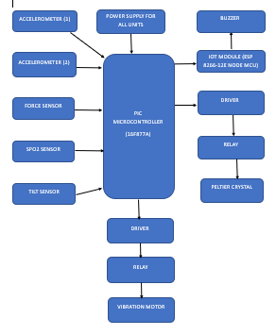

HARDWARE & SOFTWARE REQUIREMENTS

FORCE SENSOR
This force perceptivity is optimized for use in mortal touch control of electronic bias similar as automotive electronics, medical systems, and in artificial and robotics operations. The standard 400 detector is a round detector7.62 mm in periphery. Custom detectors can be manufactured in sizes ranging from 5 mm to over 600 mm. Womanish connector and short tail performances can also be ordered. The resistive element is misshaped against the substrate when external force is applied to the detector. The conductive material on the substrate makes contact with the active area's corridor when air from the spacer aperture is forced through the air articulation in the tail.

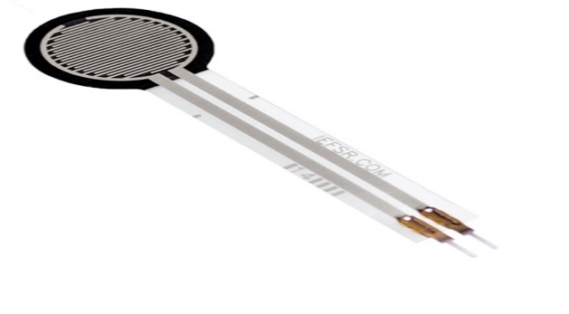

TILT SENSOR

A tiny, less powered ,user friendly ,low cost sensors used for monitoring the tilt in all axes with reference to gravity. A complete detection due to orientation or inclination. Tilt sensor is the one having the above properties which is utilized in this work.

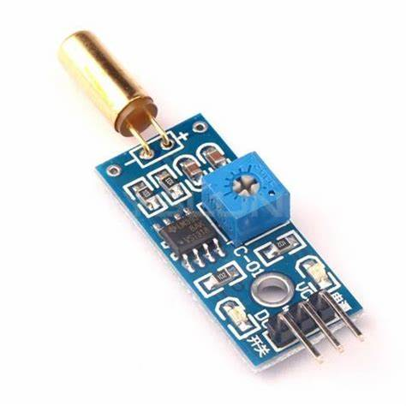

ACCELERATION MEASURING SENSOR

Proper acceleration is measured using an accelerometer, which is different from coordinate acceleration. An accelerometer, for instance, will measure an acceleration of g = 9.81 m/s2 straight upwards when it is at rest on the surface of the Earth. However, accelerometers in free fall will register zero.

PIC16F877A MICROCONTOLLER

PIC( Programmable Interface Controller) are the worlds lowest microcontroller.that can be programmed to carry out huge range of task The real-time operating system (RTOS)-enabled PIC18F microcontroller provides efficient results for general purpose tasks that are coded in C and hold a sophisticated communication protocol stack.

SPO2 SENSOR

The amount of oxygen bound to the hemoglobin cell in the circulatory system is indicated in SpO2 or partial pressure of oxygen. It can be stated more simply as the quantity of oxygen carried by each red blood cell. SpO2 is supplied in at random; the average value is 96. The letter "S" represents achromatism.

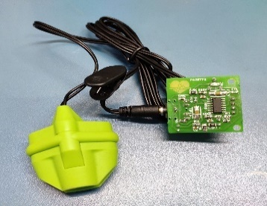

VIBRATION MOTOR

The vibration motor is a tiny, coreless DC motor that alerts the blind person when it is detected. This motor's primary function is to prevent stoners from entering the cell without sounding or stumbling. The vibrator motor characteristics primarily cover type and maximum operating characteristics. The cylinder-shaped vibrator motor is another name for the bar type. In general, this motor is properly balanced. This force causes the motor to move and jolt due to its high-speed disruption.
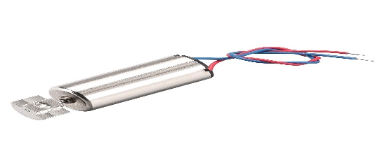

IOT

The Internet of Things (IoT) is a network of tangible, everyday items that have connectivity, electronics, software, sensors, and other components that allow for data exchange. A small networked computer is typically connected to something, enabling information transfer to and from that something. A small networked computer can be connected to anything around you, including such as lightbulbs, refrigerators, watches, suckers, trains, automobiles etc, to accept input (especially object control) or to gather and induce educational activity (typically expostulate status or other sensitive data). This indicates that computers will be ubiquitously ingrained in our surroundings, uniquely recognized, and connected to the Internet.

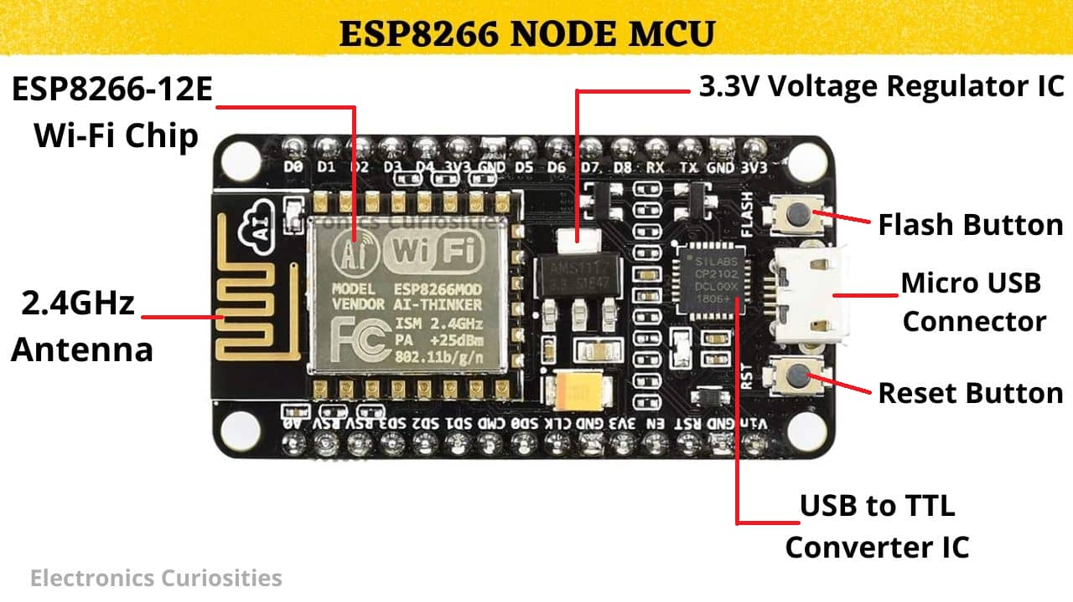

PELTIER CRYSTAL

On each side, it causes a temperature difference. The temperature changes from one side to the other. Consequently, depending on which side is used, they can be used to either warm something up or chill something down. Temperature differences can also be used to produce electricity.

RESULT

The proposed IoT-based solution for the prevention of varicose vein detection using various sensors, a PIC microcontroller, and therapeutic treatment using a Peltier crystal and vibrator has several potential benefits. In this detailed results and discussion, we will explore the outcomes of this system with the use of Cayenne IoT cloud server. Firstly, the sensors used in the system can provide real-time data on the patient's leg movement, positioning, and pressure distribution. This data can be analyzed and processed by the microcontroller to provide immediate feedback to the patient. The use of the Cayenne IoT cloud server can help to store and visualize the collected data from the sensors. It can provide real-time data on the patient's leg movement, positioning, and pressure distribution. The data can be viewed by the healthcare professional, the patient, or their family members, allowing for remote monitoring and care. Secondly, the therapeutic treatment provided by the Peltier crystal and vibrator can help alleviate the symptoms of varicose veins and improve overall blood flow. The use of the Cayenne IoT cloud server can help to provides the effectiveness of the therapeutic treatment. The system can monitor the patient's development and modify the treatment plan as required by analyzing the data gathered from the sensors. Third, use of Cayenne IoT cloud server can help to alert healthcare professionals if any abnormalities are detected. For example, if the sensors detect an unusual drop in blood oxygen levels, it can alert the healthcare professional or emergency services immediately. This can help to prevent potential complications and provide timely intervention. The proposed IoT-based solution can have several benefits in the prevention of varicose vein detection. By continuously monitoring the patient's leg movement, positioning, and pressure distribution, it can provide immediate feedback to the patient and alert healthcare professionals if any abnormalities are detected. The therapeutic treatment provided by the Peltier crystal and vibrator can help alleviate the symptoms of varicose veins and improve overall blood flow. The use of the Cayenne IoT cloud server can help to monitor and track the patient's progress and adjust the treatment plan as necessary, allowing for remote monitoring and care.

CONCLUSION

Habitual venous complaint is a enervating health issue gives a symptoms, including swollen modes, inordinate swelling and heaviness in leg and also ulceration. This study developed a sensitive method for detecting lower leg movement, based on accelerometer, cock angle, force detector, and SPO2 detector unit. An experiment was created to evaluate the suggested sensitive system for detecting leg movements in three different body postures: sitting, standing, and walking. Collected sensitive data from a manly subject is reused and anatomized in the posterior section and also covered through IoT. The proposed IoT- grounded result for precluding varicose tone discovery using multiple detectors, a snap microcontroller, and remedial treatment using a Peltier demitasse and vibrator can be enhanced further by integrating it with a Cayenne IoT server. By integrating the system with Cayenne, the collected detector data can be stored securely in the pall, furnishing easy access to both the case and the medical professionals. The Cayenne IoT pall garçon can also enable remote monitoring of the case's condition, allowing croakers
to give timely feedback and acclimate the treatment plan consequently. likewise, the Cayenne dashboard can give real- time visualizations of the detector data, making it easier for both the case and the healthcare provider to interpret the data and track progress. The dashboard can also warn the healthcare provider if any abnormality is detected, icing timely intervention andtreatment.In conclusion, the integration of the proposed IoT- grounded result with Cayenne IoT pall garçon can significantly enhance the system's functionality, enabling remote monitoring, secure data storehouse, real- time visualization, and timely cautions. This can affect in better operation of varicose tone conditions and bettered patient issues.

REFERENCE

[1] H. Lau, J. Chang, N. Daut, A. Tahir, E. Samino, And M. H. Hijazi, ‘‘Exploring Edge-Based Segmentation Towards Automated Skin Lesion Diagnosi,’’ Adv. Sci. Lett., Vol. 24, No. 2, Pp. 1095–1099, 2018.
[2] E. S. Asl, M. Ghazal, A. Mahmoud, A. Aslantas, A. Shalaby, M. Casanova, G. Barnes, G. Gimel’farb, R. Keynton, And A. El Baz, ‘‘Alzheimer’s Disease Diagnostics By A 3d Deeply Supervised Adaptable Convolutional Network,’’ Frontiers Biosci., Vol. 23, No. 2, Pp. 584–596, 2018.
[3] J. Kawahara, C. J. Brown, S. P. Miller, B. G. Booth, V. Chau, R. E. Grunau, J. G. Zwicker, And G. Hamarneh, ‘‘Brainnetcnn: Convolutional Neural Networks For Brain Networks; Towards Predicting Neurodevelopment,’’ Neuroimage, Vol. 146, Pp. 1038–1049, Feb. 2017.
[4] W. Shen, M. Zhou, F. Yang, C. Yang, And J. Tian, ‘‘Multi-Scale Convolutional Neural Networks For Lung Nodule Classification,’’ In Information Processing In Medical Imaging, Vol. 24. Cham, Switzerland: Springer, 2015, Pp. 588–599.
[5] Y. Yuan, M. Chao, And Y.-C. Lo, ‘‘Automatic Skin Lesion Segmentation Using Deep Fully Convolutional Networks With Jaccard Distancw,’’ Ieee Trans. Med. Imag., Vol. 36, No. 9, Pp. 1876–1886, Sep. 2017.
[6] M. A. Al-Antari, M. A. Al-Masni, M.-T. Choi, S.-M. Han, And T.-S. Kim, ‘‘A Fully Integrated Computer-Aided Diagnosis System For Digital X-Ray Mammograms Via Deep Learning Detection, Segmentation, And Classification,’’ Int. J. Med. Inform., Vol. 117, Pp. 44–54, Sep. 2018.
[7] J. Xu, L. Xiang, Q. Liu, H. Gilmore, J. Wu, J. Tang, And A. Madabhushi, ‘‘Stacked Sparse Autoencoder (Ssae) For Nuclei Detection On Breast Cancer Histopathology Images,’’ Ieee Trans. Med. Imag., Vol. 35, No. 1, Pp. 119–130, Jan. 2016.
[8] J. Shi, Y. Qian, J. Wu, S. Zhou, Y. Cai, Q. Zhang, X. Feng, And C. Chang, ‘‘Ultrasound Image Based Tumor Classification Via Deep Polynomial Network And Multiple Kernel Learning,’’ Current Med. Imag. Rev., Vol. 14, No. 2, Pp. 301–308, 2018. [9] M. A. Moreno-Eutimio, L. Espinosa-Monroy, T. Orozco-Amaro, Y. Torres-Ramos, A. Montoya-Estrada, J. J. Hicks, E. Rodriguez, P. Del Moral, J. Moreno, And J. Cueto, ‘‘Enhanced Healing And Antiinflammatory Effects Of A Carbohydrate Polymer With Zinc Oxide In Patients With Chronic Venous Leg Ulcers: Preliminary Results,’’ Arch. Med. Sci., Vol. 14, No. 2, Pp. 336–344, 2018.
[10] Y. Kinomura, T. Tanaka, T. Aoyama, M. Hatasa, S. Minatoguchi, M. Iwasa, Y. Yamada, T. Nawa, H. Kanamori, M. Kawasaki, Y. Esaka, B. Uno, K. Nishigaki, And S. Minatoguchi, ‘‘Endogenous Adenosine May Be Related To Left Ventricular Dysfunction, Dilation, And Wall Thinning In Patients With Heart Disease,’’ Circulat. J., Vol. 82, No. 5, Pp. 1319–1326, 2018.
[11] C. Ferraresi, C. De Benedictis, D. Maffiodo, W. Franco, A. Messere, R. Pertusio, And S. Roatta, ‘‘Design And Simulation Of A Novel Pneumotronic System Aimed To The Investigation Of Vascular Phenomena Induced By Limb Compression,’’ J. Bionic Eng., Vol. 16, No. 3, Pp. 550–562, 2019.
[12] B. Kozma, K. Candiotti, R. Póka, And P. Takács, ‘‘The Effects Of Heat Exposure On Vaginal Smooth Muscle Cells: Elastin And Collagen Production,’’ Gynecologic Obstetric Invest., Vol. 83, No. 3, Pp. 247–251, 2018.
[13] P. Gloviczki, A. J. Comerota, M. C. Dalsing, B. G. Eklof, D. L. Gillespie, M. L. Gloviczki, J. M. Lohr, R. B. Mclafferty, M. H. Meissner, M. H. Murad, F. T. Padberg, P. J. Pappas, M. A. Passman, J. D. Raffetto, M. A. Vasquez, And T. W. Wakefield, ‘‘The Care Of Patients With Varicose Veins And Associated Chronic Venous Diseases: Clinical Practice Guidelines Of The Society For Vascular Surgery And The American Venous Forum,’’ J. Vascular Surg., Vol. 53, No. 5, Pp. 2s–48s, 2011.
[14] H. J. Welch, L. Kabnick, M. A. Vasquez, D. L. Monahan, F. Lurie, And G. Jacobowitz, ‘‘Proposal For A National Coverage Determination For The Treatment Of Varicose Veins And Venous Disease Due To Disparate Centers For Medicare And Medicaid Services Local Coverage Determination Policies,’’ J. Vascular Surg., Venous Lymphatic Disorders, Vol. 5, No. 3, Pp. 453–459, 2017.
[15] E. L. Chaikof, R. L. Dalman, M. K. Eskandari, B. M. Jackson, W. A. Lee, M. A. Mansour, T. M. Mastracci, M. Mell, M. H. Murad, L. L. Nguyen, G. S. Oderich, M. S. Patel, M. L. Schermerhorn, And B. W. Starnes, ‘‘The Society For Vascular Surgery Practice Guidelines On The Care Of Patients With An Abdominal Aortic Aneurysm,’’ J. Vascular Surg., Vol. 67, No. 1, P. 2-77.E2, 2018.
[16] B. Santler And T. Goerge, ‘‘Chronic Venous Insufficiency—A Review Of Pathophysiology, Diagnosis, And Treatment,’’ J. Deutschen Dermatologischen Gesellschaft, Vol. 15, No. 5, Pp. 538–556, 2017. [17] O. Nelzén And I. Fransson, ‘‘Varicose Vein Recurrence And Patient Satisfaction 10–14 Years Following Combined Superficial And Perforator Vein Surgery: A Prospective Case Study,’’ Eur. J. Vascular Endovascular Surg., Vol. 46, No. 3, Pp. 372–377, 2013.
[18] P. A. Patel, A. M. Barnacle, S. Stuart, J. G. Amaral, And P. R. John, ‘‘Endovenous Laser Ablation Therapy In Children: Applications And Outcomes,’’ Pediatric Radiol., Vol. 47, No. 10, Pp. 1353–1363, 2017.
[19] Y. Liu, Y. M. Li, W. B. Yang, And G. Cao, ‘‘Endovenous Laser Ablation Versus Conventional Surgery For Great Saphenous Varicose Veins: Metaanalysis Of Randomized Trials,’’ Zhonghua Yi Xue Za Zhi, Vol. 93, No. 23, Pp. 1822–1826, 2013.
[20] G. D. Baxter, L. Liu, S. Tumilty, S. Petrich, C. Chapple, And J. J. Anders, ‘‘Low Level Laser Therapy For The Management Of Breast Cancer-Related Lymphedema: A Randomized Controlled Feasibility Study,’’ Lasers Surg. Med., Vol. 50, No. 9, Pp. 924–932, 2018.
[21] E. Depopas And M. Brown, ‘‘Varicose Veins And Lower Extremity Venous Insufficiency,’’ Seminars Intervent. Radiol., Vol. 35, No. 1, Pp. 56–61, 2018.
[22] Y. Chen, J. Wang, X. Zhu, X. Chen, X. Yang, K. Zhang, Y. Fan, And X. Zhang, ‘‘The Directional Migration And Differentiation Of Mesenchymal Stem Cells Toward Vascular Endothelial Cells Stimulated By Biphasic Calcium Phosphate Ceramic,’’ Regenerative Biomater., Vol. 5, No. 3, Pp. 129–139, 2018.
[23] B. D. James And J. B. Allen, ‘‘Vascular Endothelial Cell Behavior In Complex Mechanical Microenvironments,’’ Acs Biomater. Sci. Eng., Vol. 4, No. 11, Pp. 3818–3842, 2018.
[24] M. Sorelli, A. Perrella, And L. Bocchi, ‘‘Detecting Vascular Age Using The Analysis Of Peripheral Pulse,’’ Ieee Trans. Biomed. Eng., Vol. 65, No. 12, Pp. 2742–2750, Dec. 2018.
[25] Q. Fu, F. Shao, And M. Santello, ‘‘Inter-Limb Transfer Of Grasp Force Perception With Closed-Loop Hand Prosthesis,’’ Ieee Trans. Neural Syst. Rehabil. Eng., Vol. 27, No. 5, Pp. 927–936, May 2019.
[26] C. Veinidis, A. Danelakis, I. Pratikakis, And T. Theoharis, ‘‘Effective Descriptors For Human Action Retrieval From 3d Mesh Sequences,’’ Int. J. Image Graph., Vol. 19, No. 3, Pp. 1950018–1950030, 2019.
[27] A. S. Shadrina, M. A. Smetanina, K. S. Sevost’yanova, A. I. Shevela, E. I. Seliverstov, E. A. Zakharova, E. N. Voronina, E. A. Ilyukhin, I. A. Zolotukhin, A. I. Kirienko, And M. L. Filipenko, ‘‘Polymorphism Of Matrix Metalloproteinases Genes Mmp1, Mmp2, Mmp3, And Mmp7 And The Risk Of Varicose Veins Of Lower Extremities,’’ Bull. Exp. Biol. Med., Vol. 163, No. 5, Pp. 650–654, 2017.
[28] A. J. J. Ijsselmuiden, C. Simsek, A. G. Van Driel, D. Bouchez, G. Amoroso, P. Vermeersch, And P. P. Karjalainen, ‘‘Comparison Between The Stentys Self-Apposing Bare Metal And Paclitaxel-Eluting Coronary Stents For The Treatment Of Saphenous Vein Grafts (Adept Trial),’’ Netherlands Heart J., Vol. 26, No. 2, Pp. 94–101, 2018.

