INTRODUCTION:
Management by Objectives is a Boon for healthcare Administration. The concept of management by objectives (MBO) was introduced by Peter Drucker in 1954. However many elements used in MBO were actually developed earlier, George Odiorne, Dale D, McConkey, and others are credited with giving MBo a substantial boost in mid-1960s. Though these conceptshave usually been designed with business and industries in mind, but it also has important implications in nursing.
DEFINITION:
- MBO is defined as ‘a process whereby the superior and subordinate managers of an organization jointly identify its (the organization’s) common goals, define each individual’s major area of responsibilities in terms of the results expected of an individual, and use these measures as guides for operating the unit and assessing the contribution of each of its members’.
–Odiorne

- ‘MBO is a comprehensive managerial system that integrates many key managerial activites in a systematic manner, consciously directed towards the effective and efficient achievement of organizational objectives’.
–Heinz Weihrich and Harnold koontz

- ‘MBO is a result-centered, non specialist, operational managerial process for the effective utilization of material, physical and human resources of the organization by integrating the individual with the organization and organization with the environment’.
–SK Chakraborty
- ‘The philosophy of MBO is a collective endeavor to create an environment in which each individual is provided with optimum opportunity to realize his full potential. It is a system in which each employee participates in determining personnel objectives as well as the means by which he or she hopes achieve these objectives. It makes each employee a manager of his or her own particular work’.
–George Terry
FEATURES OF MBO:
The features of MBO are identified as bellow:
- Objectives at all levels
- Emphasis on all significant priority areas
- Participation of concerned managers in objective setting and performance reviews
- Periodic reviews of performance
- Appropriate systems and procedures
- Role clarity
- Multiple accountability
OBJECTIVES/PURPOSES OF MBO:
- To translate mission statements into operational terms
- To give directions and set standards for the measurement of performance
- To set both long term and short term objectives
MBO is often achieved using set targets. It introduced the SMART criteria; the objectives of MBO must be:
- Specific
- Measurable
- Agreed
- Realistic
- Time specific
Ultimate objective:
To aid each manager and supervisor in promoting the most effective use of the human resources such that each members, as a part of a team, makes an optimum contribution to the organizational performance and profitability.
PRINCIPLES OF MBO:
- Cascading of organizational vision, goals and objectives.
- Specific objectives for each member.
- Participative decision making.
- Explicit time period.
- Performance evaluation and feedback.
PROCESS OF MBO:
MBO is essentially a philosophy of management based on identifying purpose, objectives, strategy, desired result and evaluating performance in achieving them. It has 8 steps:
- Setting of objectives at the top
- Identifying key result areas (KRAs)
- Clarifying organizational roles
- Setting subordinates objectives
- Holding periodical meetings
- Assess strengths and weaknesses of key resources
- Evaluation of results or performance appraisal
- Recycling or re-evaluating the process
Setting of objectives at the top:
First step in setting objectives is for the top manager is to determine the purpose or mission of the organization under given appropriate planning premises. These are based on the analysis and judgement. Then long range and strategic objectives, short term organizational objectives, departmental, unit objectives and individual manager’s objectives are developed.
Identifying key result areas (KRAs):
It indicates the priorities for organizational performance. It also indicates the present state of an organizational health and the top management perspectives for the future.
Clarifying organizational roles:
Each goal and sub goal should be of one person’s clear responsibility. Hence the specific parts of each co-ordinating manager’s contribution to the program goal should be identified.
Setting subordinates objectives:
After setting all levels objectives, identifying KRAs, the superior can then proceed to work with subordinates in setting their objectives. The action plan is made with them. The subordinates’ contribution or participation is very important at every stage.
Holding periodical meetings:
Periodical meetings are conducted by the superior to discuss the progress of work and implementation of the plans with their subordinates.
Assess strengths and weaknesses of key resources:
The strengths and weakness of key resources like human, financial, physical are assessed. The allocation and movement of resources are done in consultation with subordinate managers.
Evaluation of results or performance appraisal:
This aspect of MBO tries to measure whether the subordinate is achieving the objectives or not, what are the problems and how these problems can be overcome. This is a continuous process and view to find out the deficiencies in the work and also to remove those deficiencies.
Recycling or re-evaluating the process:
The result of performance appraisal is used as an input for recycling objectives and other actions. Since the objective setting is a joint process through interaction between superior and subordinates, each level may affect other levels also.
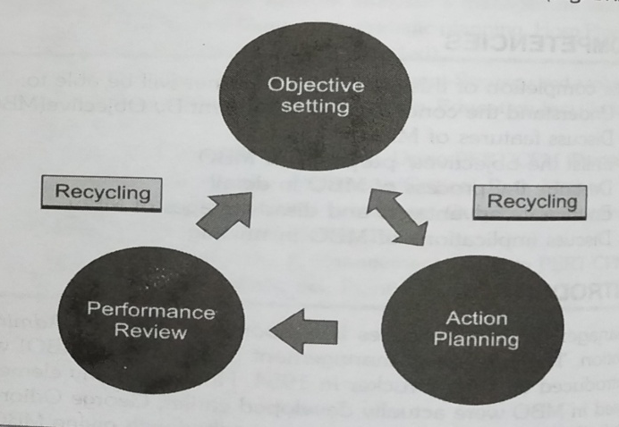
Fig: Recycling aspect of MBO

ADVANTAGES OF MBO:
- It identifies problems of management, including structure, strategies and practices.
- It focuses attention and effort on priority areas.
- Planning becomes more precise and useful.
- It makes objectives explicit and directs work activity towards their achievement.
- It provides clear standards of control and facilitates self control.
- It sharpens accountability.
- It highlights interdependence within the organization.
- MBO provides a vehicle for delegation of authority. It is an effective instrument for managing decentralized operation.
- It emphasizes development and utilization of human resources.
- It stimulates organizational change enabling the top management to initiate plan, direct and control the direction and speed of change by providing guidelines for planned change.
- It provides clarity in organization action. The organization can look forward to what it intends to do in future, in short and long run.
- It provides greatest opportunity for personnel satisfaction by adopting participatory approach.
- It establishes good interpersonal relationship between management and employees. All the superiors and subordinates work together with a team spirit and minimize the differences between them.
- It increases efficiency of management and the organization as a whole as the decisions are taken both by superiors and subordinates.
- It helps in coordinating the activities of different units and departments.
- It is the welding technique that joins personal-centered management to result centered management.
LIMITATION OR DISADVANTAGES OF MBO:
- Difficulty in objective setting.
- It is a time consuming process especially in the initial stages.
- Lack of cooperation between superiors and subordinates can be there due to differences in their opinions during setting objectives.
- It represents the danger of inflexibility in the organization, particularly when the objectives need to be changed.
- MBO can be in failure, if competent and trained mangers are not available. It can lead to a lot of frustrations among subordinates, if the decisions are taken under pressure from the subordinates.
- It is one of the greatest of managerial illusions because it fails to take adequately into account the deeper emotional components of emotions.
ESSENTIAL CONDITIONS FOR SUCCESSFUL EXECUTION OF MBO:
- Support from all
- Acceptance of MBO programme by managers
- Training of managers
- Organizational commitment
- Allocation of adequate time and resources
- Provision of uninterrupted information feedback
IMPLICATIONS OF MBO IN NURSING:
MBO is not only essential and useful for business managers, but is equally important to nursing administrators to improve the efficiency of nursing personnel. MBO based on Taylorist principles can be used in nursing managerial process. The implementations of MBO are as follow:
- It measures and judge performance.
- It correlates individual performance to organizational goals.
- It clarifies the job responsibilities expected from staff
- It fosters the increasing competence and growth of the subordinates.
- It provides a data base for estimating the salary and promotion.
- It stimulates the subordinate's motivation.
- It helps in organizational work control and integrating the activities.
RESEARCH STUDY:

A study on using Management By Objectives as a performance appraisal tool for employee satisfaction. The study was conducted Islami X. and Mustafa N. in 2018 in Kosovo.

Abstract:
This study deals with the importance of applying Management by Objectives (MBO) method, as a method for performance appraisal (PA) in enhancing employees’ effectiveness. A self- administered questionnaire was used, the number of participants included the survey is 172 employees from 13 firms operating in Kosovo. The study aim is to identify the importance of creating objectives, communication objectives, planning goals, setting control points, employees’ commitment to determine objectives, freedom and independence in fulfilling duties, continuous communication, as steps for realizing MBO method in employees’ effectiveness. The questionnaire of the study has been prepared, the responses obtained, the econometric model is constructed in order to test empirically this relationship, passed through the IBM SPSS v.23.0 program has been utilized for the obtained findings. Results and proposals are brought forward by the matched t-test, independent sample t-test, anova, pearson and correlation used as the hypothesis tests. Econometric results suggested that MBO method should be used as a method of performance appraisal as the employees’ effectiveness is enhanced. Also it resulted that the evaluation of individual employees’ performance and a clear definition of results are the hugest parameters from all the other activities of MBO method which we took in the study to raise employees’ effectiveness in organization.
CONCLUSION:
Management by Objectives is a strategic management model that aims to improve the performance of an organization by clearly defining objectives that are agreed to by both management and employees. It is the process of defining specific objectives within an organization that management can convey to organization members, then deciding how to achieve each objective in sequence. This process allows managers to take work that needs to be done one step at a time to allow for a calm, yet productive work environment. This process also helps organization members to see their accomplishments as they achieve each objective, which reinforces a positive work environment and a sense of achievement.
BIBLIOGRAPHY:
- Vati Jogindra. Collective bargaining. Principles and Practice of Nursing Management and Administration. 1st ed. 2013. Jaypee brothers medical publishers (P) Ltd. 189-191.
- Prasad L. M. Mission and objectives. Principles and Practice of Management. 6th ed. 2001. Sultan Chand and sons educational publishers. 190-192.
- Basavanthappa BT. Role of employees union in administration. Nursing Administration. 2nd ed. 2009. Jaypee brothers medical publishers (P) Ltd. 356-358.
- Masih Shabnam. Professional advancement. Essentials of Nursing Management in Service and Education. 2nd ed. 2012. Lotus publishers. 232-234.
- https://www.managementstudyguideline.com
- https://www.toolshero.com>managementbyobjectives
- https://iedunote.com>management-by-objectives
- https://doi.org/10.1016/j.fbj.2018.01.001

