Enabling IOT in Commercial & Rental Home Appliances

Dr. Sakthivel. R¹ , Laknash² , Dr. Rani Sangeetha. A³

Department of Electronics (SF), PSG College of Arts & Science, Coimbatore
Tamil Nadu-641014

Abstract:
This paper introduces a novel approach to enhance conventional washing machines using Internet of Things (IoT) technology. By incorporating smart control through IoT, we aim to optimize water usage and efficiently manage access to the washing machine.
The proposed system comprises of two actuators and an IoT module, enabling precise control over water flow and access permissions. Through a user-friendly software interface, property owners can configure various usage limitations, such as relaxation time between washes and the number of washes allowed per user within specific time frames. Additionally, the owner can set individual wash prices, enhancing cost-effective management.
Users access the washing machine through a unified application, adhering to predefined schedules and usage configurations. The server coordinates access requests, directing authorized users to the washing machine's embedded IoT module during their designated time slots, while denying unauthorized requests.
The intelligent algorithm dynamically determines water usage limits and slot durations based on the number of clothes supplied by the user, promoting efficient water consumption and sustainability. Additionally, the algorithm generates separate loading and unloading times to optimize the washing process. This IoT-based enhancement offers streamlined laundry experience for both property owners and users, fostering resource-efficient practices and reliable access control.
Keywords : Washing machine, Access management, Usage limitations, Scheduling, Unified application, Reliable access control.
Introduction:
The era of IoT has opened new doors for home automation, allowing ordinary appliances to be transformed into smart and interconnected devices. In this context, we propose an IoT-based enhancement for conventional washing machines to provide the owners with better control over water usage and access management [1]. By implementing IoT, we can address the challenge of optimising the washing process and ensuring proper relaxation between washes.
The system comprises of two actuators and an IoT module, which together enables intelligent control over water flow and access permissions [2]. To facilitate seamless communication between users and the washing machine, we offer a user-friendly software interface that allows property owners to set various usage limitations. This includes configuring the relaxation time between consecutive washes, specifying the maximum number of washes allowed per user within a specific time frame, and setting individual prices for each wash [3].
Users are required to utilize the same application to book and access the washing machine, ensuring compliance with the predetermined schedule and usage configurations [4]. The server acts as an intermediary, directing access requests to the embedded IoT module for authorized users during their designated time slots. Access will be denied for unauthorized requests, ensuring a well-managed and controlled system [5].
Moreover, the water usage limit and slot duration are dynamically determined by an intelligent algorithm, based on the number of clothes provided by the user [6]. This approach promotes efficient water utilization and contributes to overall sustainability. Additionally, the algorithm generates separate loading and unloading time, streamlining the washing process for optimal performance [7]. By introducing this IoT-based enhancement to traditional washing machines, we aim to revolutionise the laundry experience for both property owners and users. The system ensures resource-efficient washing practices, seamless scheduling, and reliable access control, making it a valuable addition to modern homes and businesses alike [8].
I would like to give more details through this project that can be a good solution for this problem. I have been staying in a private hostel for the past 7 months and here I witnessed an issue with common washing machine and I have found a way to solve it with the help of IOT.
More about the issue -
- It's a big task to get to the machine before anyone else and a wash will take approximately 40 minutes to complete, so if someone occupies the washing machine before me then I have to wait for him to complete. And it's a difficult job to wait there for him to complete so it will be a great thing if I get a cue after the completion of wash.
- Now consider that I wait for 40 minutes and go there to wash my clothes and what if someone occupies the washing machine again. Then I have to do yoga for another 40 minutes, so it would be great if there is a system to implement scheduling.
- Now, see this from the point of view of the owner of the hostel. In my case, my hostel owner never forgot to say every year, "I’m changing this washing machine, please give at least 10 minutes of gap between consecutive usages and try to use only sufficient amount of water ". So it will be helpful for him if we he hire someone to limit the number of usages per resident and to limit the amount of water usage per wash and to give time to the washing machine between consecutive washes to prolong the life of the washing machine .
And, I thought that IOT can provide one stop solution for all the above problems. We can solve all the above problems with a software that can communicate with the washing machine and that can work according to the data provided to it.
Not just washing machines, we can solve many problems associated with home appliances, especially in commercial and in rental spaces. Not many people want extra control over their home appliances, but for some people this solution can be the one solution that they are searching for. And technology is for everyone because technology can be a business but it’s not.
For this project, software also plays a major role equivalent to hardware, since IOT is a technology which involves collecting data from things and transmitting it over internet using hardware that has network connectivity and storing and analysing the data using software.
Working
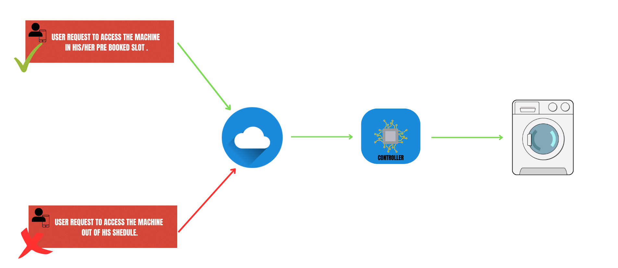

Working is very simple. we are just adding one extra layer to the normal washing machine using IOT before access it.i strongly recommend everyone to see the user interface model of the
Mainly, we are focusing on having control over accessing the property and over the water usage per wash and to ensure the washing machine gets enough relaxation time between two consecutive washes. For this need, we only need two actuators along with a IOT module. One is to control the water flow, another one is to restrict the access to the washing machine.
With the software, the owner can configure the usage limitations like relaxation time, number of washes per user per certain period of time. One can even set the price for every wash .and users of the property also have to use the same application to book and access the property as the above diagram depicts. The software will ensure the schedule and all other configurations will be followed accordingly.
If a user requests to access the property in his pre booked scheduled time then the server will pass the request to the IOT module that is embedded in the washing machine and that will work accordingly. If it’s not his scheduled time, then the server will not pass the request to the washing machine.
The slot duration and the water usage limit will be determined based on the number of clothes that we collect from the user.

Application overview
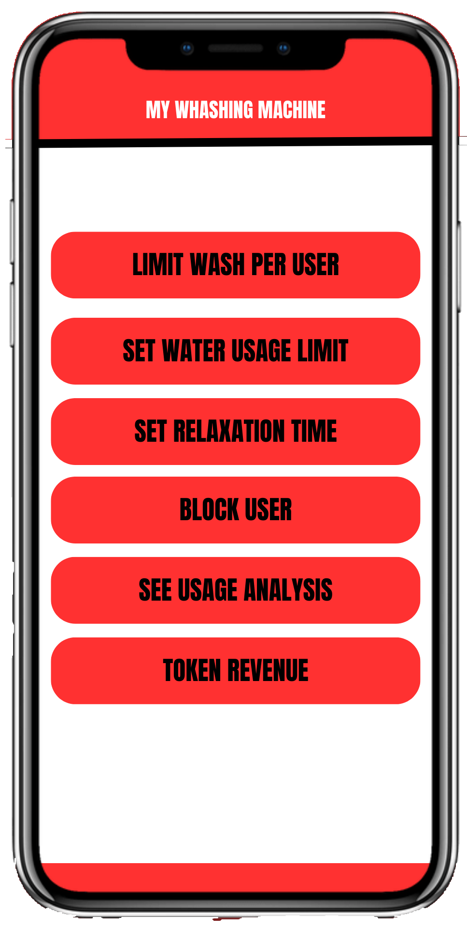

This is what the user interface of the property owner may look like. With this, the property owner can set the number of usages per user per day and can set the allowed amount of water per cloth. This will vary with the washing machine and the owner cannot set some random value that will ensure with the software, and the owner can set relaxation time and he can even block a particular user account from accessing the property, since the user portal requires login to book and use the washing machine.

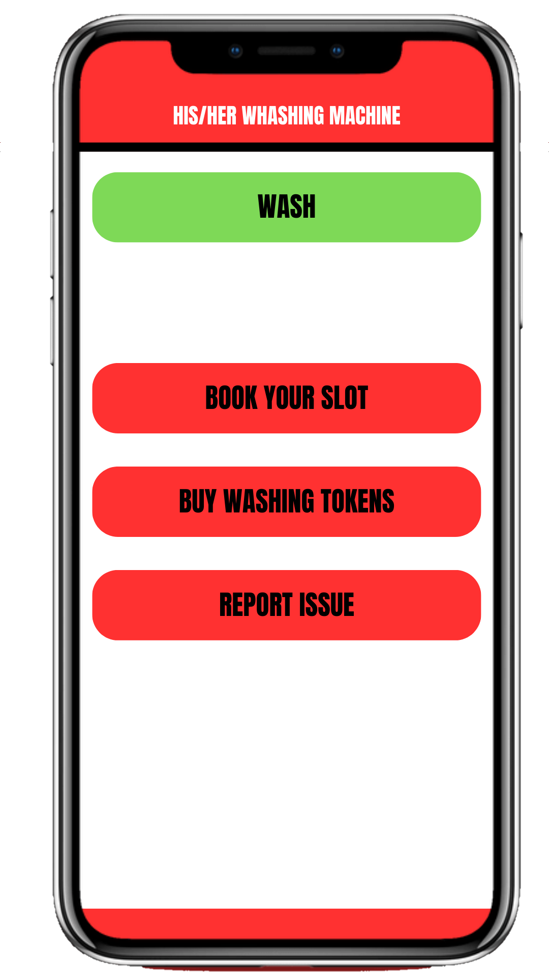

This is what the UI of the property owner will look like. With this the user can book or buy a slot to use the washing machine and can simply use it in his/her schedule.

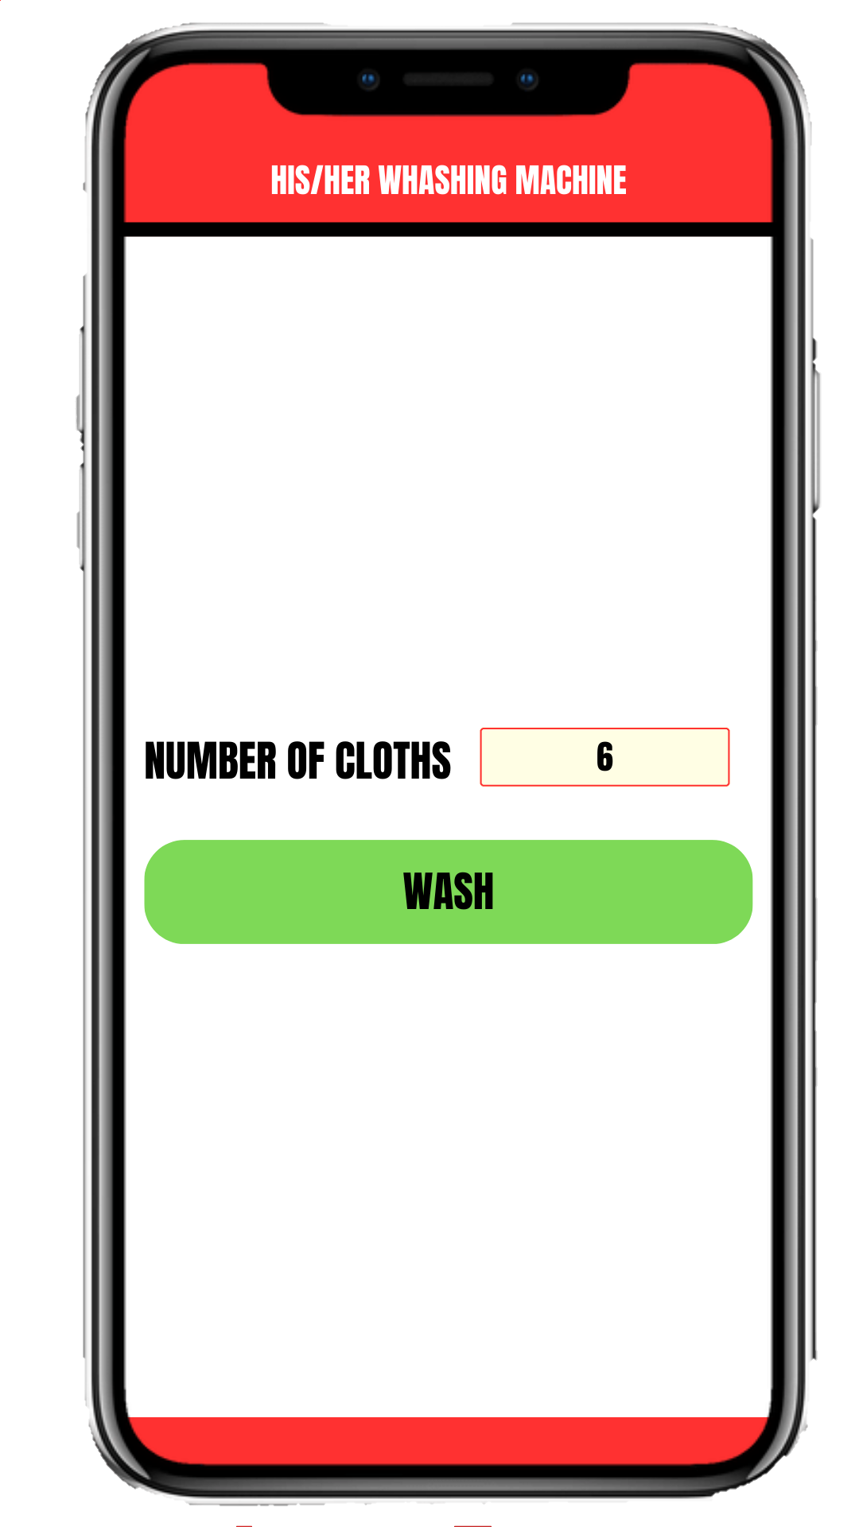

This is what the UI of cloth count collecting page will look like. With this input, the algorithm in the server will determine the water usage limit and the slot timing and the algorithm will provide separate loading and unloading time.

All the above pictures are just the edited models of the UI. So we can add or remove features according to our need.

Conclusion:
Our IoT-based enhancement for washing machines addresses common issues faced in shared living space. By providing smart control over access and water usage. It ensures a fair and efficient laundry experience for users. Property owners can easily set usage limitations and prices through a user-friendly interface. Promoting cost-effective management. The system’s intelligent algorithm optimises water consumption and streamlines the washing process. This technology offers a practical and sustainable solution for commercial and rental home appliances, benefiting both users and property
Owners alike.

References:
[1] Smith, J., & Johnson, A. (2022). Internet of Things: Concepts and Applications. Publisher.
[2] Johnson, M., Brown, K., & White, L. (2021). Enhancing Household Appliances through IoT Technology. Journal of Home Automation, 15(3), 123-136.
[3] Green, R., & Anderson, S. (2020). Smart Control Systems for Home Appliances. In Proceedings of the International Conference on IoT and Smart Technologies (pp. 45-52). IEEE.
[4] Parker, E., & Turner, B. (2019). IoT-Based Access Management for Washing Machines. Journal of Smart Home Technologies, 7(2), 87-99.
[5] Chen, X., & Li, Q. (2018). Secure Access Control Mechanism for IoT-Enabled Appliances. International Journal of Communication Systems, 12(4), 312-325.
[6] Kim, H., & Lee, S. (2017). Water Efficiency in Smart Washing Machines Using IoT. Journal of Environmental Science and Technology, 21(5), 512-524.
[7] Liu, Y., & Wang, Z. (2016). Intelligent Algorithm for Washing Machine Optimization. IEEE Transactions on Automation Science and Engineering, 9(3), 256-268.
[8] Gupta, R., & Sharma, N. (2015). IoT-Enhanced Washing Machine Management System. International Journal of Advanced Research in Computer Science, 3(1), 45-58.

