DETERMINATION OF SEX BY ANALYSING BITE MARK SAMPLES USING STYROFOAM PLATE
AMAL DAS K.P
ASSISTANT PROFESSOR
DEPARTMENT OF FORENSIC SCIENCE TECHNOLOGY
SCHOOL OF ALLIED HEALTH SCIENCES PUDUCHERRY
VINAYAKA MISSIONS RESEARCH FOUNDATION
(DEEMED TO BE UNIVERSITY)
amaldaskp2000@gmail.com
ABSTRACT
From the very beginning of records, bite marks have been applied to identify victims and assailants. It is characterised by a variety of punctuate haemorrhages, ranging from small petechia to large ecchymosis. The bite mark may be photographed, or an impression of the bite mark may be taken, or the skin of the bite mark may be removed and preserved. Bite marks most often are seen in cases of rape, murder, child abuse and spousal abuse etc. It's possible for it to be done deliberately or by accident. While almost no one dies from a human or even animal bite, such injuries may lead to loss of function, infection and gross disfigurement. Bite marks however may place an assailant who performed rape, murder, child abuse or spousal abuse in proximity of the victim.

In this study for the collection of samples consent letter has to be provide to each individual. Styrofoam plates which have been cut into pieces of required sizes and the individuals should bite gently on the plate to get the full and proper impression. The impressions of the upper jaw and lower jaw of the individuals has been separately marked on the plates using a permanent marker. Then the OHP sheets can be used for tracing the bitemarks. Later with the help of scale the distance from the middle line to maxilla and mandible is measured.
After evaluating the data collected it is concluded that in comparison of male and female average bitemark value, the maxilla of the male bitemark is greater than those of female bitemark.
Keyword: Bitemark, mandible, maxilla, Styrofoam plate.

INTRODUCTION

Human bites are discovered when teeth are used as weapons of anger, excitement, control or destruction. Imprints are often left on skin, erasers, pencils or pens and can also be seen on musical instruments, cigarettes and foods such as cheese, fruit, potatoes, chocolate, etc. This square measure is common in crime cases including murder, kidnapping, abuse and sexual assault, as well as at sporting events, and is often used for the purpose of stuffing the wrong person. The terms commonly used in bite analysis are victim – the person receiving the bite and perpetrator – the person causing the bite ^{[1]}. Although bite marks on the body are caused intentionally, bite marks on food products are sometimes clearly left at the crime scene by the offender. Therefore, to identify a suspect, dental molds of the suspect are measured for dental material ready for abuse and matched. The bite mark, if analyzed correctly, will prove the involvement of one or more selected persons in an elaborate crime. West et al. reasoned that bite marks on human skin were often created experimentally to allow comparison with bite marks produced when the object was combative or critical. One of the most important and often most difficult challenges in rhetorical dentistry is the identification, restoration, and analysis of bite marks in respected tooth-biters.
Various bite mark analysis methods as a gift like impression such as making impressions from bite substances by dental stones and hand tracing from dental research models, photography, methods, stars computer-aided imaging and overlay methods. Previous studies showed that computer-generated overlays provided the most accurate examples of composition. One of the parameters of the investigation is the measurement of the inter canine distance (ICD) because the imprint of the anterior teeth is sometimes the clearest and certainly measurable. The analysis of bite marks is based on “the principle that no two mouths are identical”. Consistent with Pretty and Turnbull, the central philosophy of bite mark analysis rests on two assumptions: first, that human teeth are distinctive, and second, that appropriate details of distinctiveness are expressed throughout the bite method to facilitate easy identification ^{[4]}.
COLLECTION PROCEDURE
Styrofoam plates which have been cut into pieces of required sizes and the individuals can be asked to bite gently on the plate to get the full and proper impression. Before biting the impressions of the upper jaw and lower jaw of the individuals has been separately marked on the plates using a permanent marker. It is done for to identify the mandible and maxilla for the later analysis of the sample. The folded end of the Styrofoam sheets is placed inside the mouth. Then the suspects were instructed to bite on the sheets. The sheets are removed from the mouth and unfolded so that the bite pattern was obtained in the same plane as the typical horseshoe shaped pattern facing each other. After biting always check for any imperfections in the sample. Styrofoam plates are brittle in nature so if the biting force is very high there will be chances for causing the breaking of the plate. So, in these circumstances always take a new sample for the examination. Dental castes are widely used for collecting the control sample for the comparison but its costly and time taking in nature.
The collection of bitemarks from the victim includes photographs, salivary swabbing, impressions and tissue samples. Even collection of bitemarks from the suspect is also needed, which includes history, photos, extra oral examination, impressions, intraoral examination, sample bites and study casts.
Description of bitemarks: In the case of a living victim or a deceased individual, the odontologists should determine and record certain vital information. Those are,
- Name of the victim
- Case number
- Date of examination
- Referring agency
- Person to contact
- Age of the victim
- Sex of the victim
- Name of the examiner
These details should be added in the package for the transportation of the evidence to the laboratory.
PRESERVATION OF SAMPLES
The Styrofoam sheet is one the best method to preserve the bite mark because it does not decay with time and are also very cheap and readily available but it should be handled with care because Styrofoam sheet are brittle this can also be an alternate method when dental cast are not available. Photography provides a permanent record of bitemarks. No time should be wasted to collect the pictures. Since the injuries change its appearance rapidly color and black and white photos from different angles may be taken. Take repeat photographs, include two scales place at the right angle to each other together and parallel to the lens. The traced OHP sheets can also use for the preservation of the bitemark sample.

ANALYSING OF BITEMARK SAMPLES
First the Styrofoam plates were prepared and the impressions of different individuals were taken in the Styrofoam plates. After the collection of samples using the Styrofoam plate, the impressions are marked with a permanent marker on the Styrofoam plate. These marks are then traced into a OHP sheets. An imaginary line is drawn in middle of the bitemark and the distance from the middle line to maxilla and mandibles respectively are measured. Then the collected measures can be further studied. The measurements have to be taken in centimetres. After taking the measurements, both the distance from midline to maxilla and mandible are greater in males compared to female.
Sexual dimorphism is greater in male bitemark compared to female bitemark, it could be due to the fact that men have larger faces than women and thus there is possibility of getting bigger bite mark. There is variation in the impression because of the force and pressure applied by the candidates to the Styrofoam plate while biting, therefore the force and pressure applied by the individual varies which will make it an individual characteristic to identify an individual. In males the force is greater than female bitemark because while conducting the research it is observed that male bitemark caused deeper impression and few of the male bitemark caused rupture of the Styrofoam plates.

FORENSIC SIGNIFICANCE
The present study is based on the importance and value of bitemarks in crime investigation of cases such as murder, homicide, Physical Assault, and sexual offences. It also helps in solving or getting clues related to the particular cases. The Present study has the scope of finding sex of the individuals from the bitemarks present in body of individual. This study is also helpful to compare the bite mark samples of males and females according to certain age group and find out whether it can be differentiated. It also gives a new method for the preservation of bitemark samples by using the Styrofoam plates. The accuracy this method provides is similar to any other methods that we are currently using in forensic investigations. Other parameters such as Intercanine distance, MCI, arch length cannot be measured as the bitemark samples were collected in Styrofoam plates and for these measurements to be done dental casting is required.

CONCLUSION

Knowledge about bite mark investigation is relatively new and of temporary value. This review has contributed to criminal investigations of murder, sexual assault and abuse cases. The human dentition is changed by genetic and ecological factors that determine the position of the teeth on the jaw. Dentists in training regularly observe the uniqueness of the human dentition, but there is no database to quantitatively express this uniqueness of the human dentition. The serious nature of bite mark crimes often requires the application of the highest degree of forensic ideals and the need for individuals competent and experienced in the identification, collection and analysis. This type of evidence is growing, the analysis of such injuries should be considered only if they are unique or under certain conditions that have class characteristics. With recent advances in research, more objective methods of bite mark analysis, such as recovery of salivary DNA and bacterial genotyping, have become key to investigating such crimes.
Sex estimation is an important aspect that helps identify person’s identity in forensic investigation. These studies could also be done with the help of advanced techniques and equipment’s which will make it easy for identification, evaluation and recognition. Some of the other methods that can be used are Computer based, radiographic, xerographic, image perception Technology and dental cast and those method helps us to study more parameters like intercanine distance, MCI, Incisoral width, intercanine ratio, Arch length in detail and gives more accuracy for sex determination using bitemark samples. In this study the sex determination is identified from distance between the middle line to maxilla and mandible of bitemark but the studied carried out using this parameter is very limited and difficult to find any related information. Hence this could be and experimental study which can be done in future with more samples and other advanced methods.
REFERENCES
- M. K. Sunil, Upender Malik, Sourav Malhotra, Arishah Gulzar , Radhika Sharma “Bite Marks: An Indispensible Tool for Forensic Odontological Evidence” (2019).
- Anirban Maji, A Novel Computer-Assisted Method of Bite Mark Analysis for Gender Determination, 2018, Journal of environmental and public health.
- R. K. Gorea, O. P. Jasuja, A. A. Abuderman, and A. Gorea, “Bite marks on skin and clay: a comparative analysis,” Egyptian Journal of Forensic Sciences, vol. 4, no. 4, pp. 124–128, 2014.
- N. A. Osman, A. Z. Omer, and A. H. Abuaffan, “Comparative study on two methods for bite mark analysis,” ARC Journal of Forensic Science, vol. 2, no. 1, pp. 12–16, 2017.
- Bowers CM, Johansen RJ. Photographic evidence protocol, the use of digital imaging methods to rectify angular distortions and create life size reproductions of bitemark evidence. J Forensic Sci. 2002; 47(1):178-85.
- Rothwell BR. Bite marks in forensic dentistry: A review of legal, scientific issues. Journal of American Dental Association. 1995; 126:223- 232.
- Forensic Odontology. Forensic Medicine. info: www.allabout-forensicscience.com/ forensic -science-online.html.
- Bhargava K, Bhargava D, Yadav M, Paul M, Paul R, Singla A, Jagadeesh H G. Bite Marks: Teeth as Weapons of Violence. Journal of Indian Academy of Forensic Medicine 2012; 34(3):255-259.
- Pretty IA, Sweet D. A Look at Forensic DentistryPart I: The Role of Teeth in Determination of Human Identity. British Dental Journal. 2001; 190: 359-366
- Rothwell BR. Bite marks in forensic dentistry: a review of legal, scientific issues. J Am Dent Assoc 1995; 126(2): 223−232.
- Bowers CM, Johansen RJ, Bitemark Evidence, in Modern Scientific Evidence. MJ Saks, ed. West Publishing Co.: New York, 2002.
- https://teachmeanatomy.info/the-basics/embryology/head-neck/teeth/
- Nandan, Manisha Mahipal Singh Sankhla, Mayuri Kumari, Kirti Sharma, Rajeev Kumar (2016), Investigation of Statutory Offences Cases Through Bite Marks Identification – A Review Study, International Journal of Social Connectedness & Concern.

APPENDIX

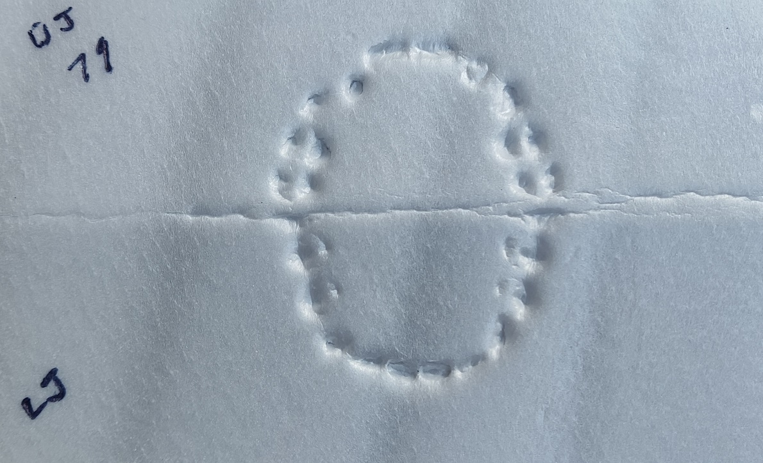
Bitemark impression on Styrofoam plate

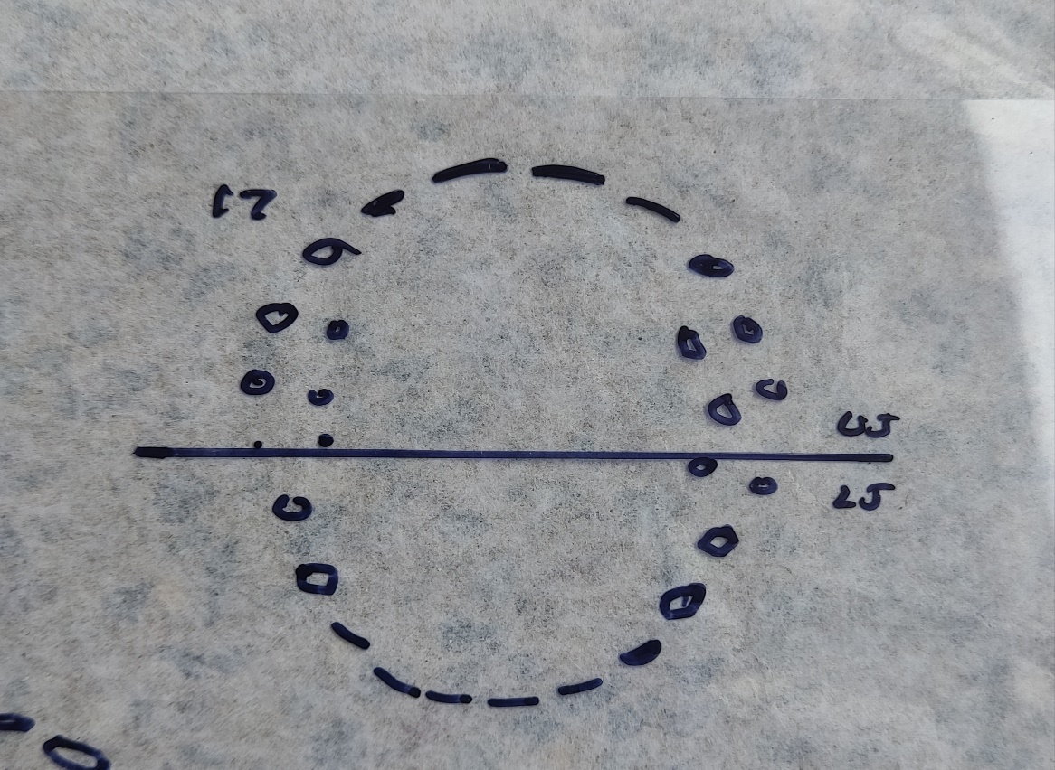
Traced bitemark impression on OHP sheet

