EFFET OF THICKNESS OF DIFFERENT SHAPE MEMORY POLYMER LAYERS ON DAMPING PERFORMANCE
M.Prasanth Kumar, Betha Hemanth
^{b}Assoc.Professor, Department of Mechanical Engineering, ANITS, Visakhapatnam, India-531162
^{a*} Asst.Professor, Department of Mechanical Engineering, Chaitanya Engineering college, Visakhapatnam, India-530048
Abstract
Unconstrained layer damping, also known as extensional damping, is a surface damping treatment for vibration suppression. This investigation utilized UTM and DMA tests and analytical studies on polyurethane, silicone, and butyl rubbers for symmetrical and unsymmetrical configurations. Results showed that butyl rubber provided better results in reducing vibration amplitude in rectangular and Tubular cavities. Extensional damped samples were modeled using Solid Works, and modal analysis was conducted on the ANSYS R19 workbench.

Keywords: Free layer damping, optimization, symmetrical and asymmetrical structure;
- Introduction:
Damping is the energy dissipation property of a material, converting mechanical energy into thermal energy. It is caused by friction and determined by loading and unloading phases of a process. Surface damping treatments are passive methods of reducing vibration, typically associated with sheet metal structure vibration. There are two types of damping treatments: Free Layer Damping (FLD) treatment and Constrained Layer Damping (CLD). Unconstrained Layer Damping is a free-layer treatment where a coating of a damping material is applied to one or both sides of a structure. Shape memory alloys like Polyurethane rubber, Silicone rubber, and Butyl rubber were used as damping materials in this study, as they can return from a deformed shape to its original shape when induced by temperature changes. The Ross-Kerwin-Ungar (RKU) equations can predict unconstrained-layer damping treatment performance, considering the case with zero constrained-layer thickness. The constrained-layer damping treatment's performance depends on the constraining layer's geometry and type. Sandwich damping treatments achieve maximum shear strain when the constraining layer is the same type and geometry as the structure being damped.
- Modal Analysis:
This study examines a FLD structure consisting of AA 6063 base metal and Epoxy Adhesive-based damping materials like polyurethane, silicone, and Butyl rubbers with 75 Shore A hardness [1].

FLD samples were created using SOLIDWORKS software, following ASTM-E756 standards. These samples were made from Polyurethane, Silicone, and Butyl rubbers with cavities in different configurations. The base plate was made of AA6063, and the layer material was glued to it using epoxy resin. The damping effect from the adhesive was ignored due to the small adhesive thickness of around 3 micron meters [2][3].

Table 1: Shape of the Free Layer Damped Specimen
Specimen | Materials | Length (mm) | Thickness (mm) | Width (mm)
Base plate | AA6063 | L₁ = 300 | h₁ = 3 | 25.4
Layer | Polyurethane, Silicone and Butyl Rubbers | L₂ = 250 | h₂ = 30, 40, 50  (symmetric and asymmetric) | 25.4

Fig.1 Basic Shape of FLD sample without cavities

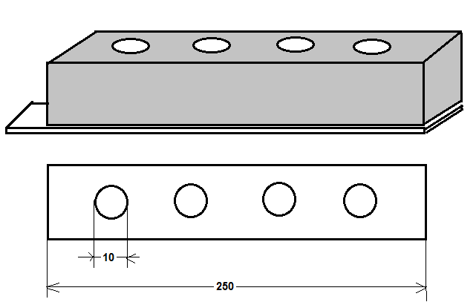

Fig.2 FLD beam with Tubular cavities of each
10mm diameter

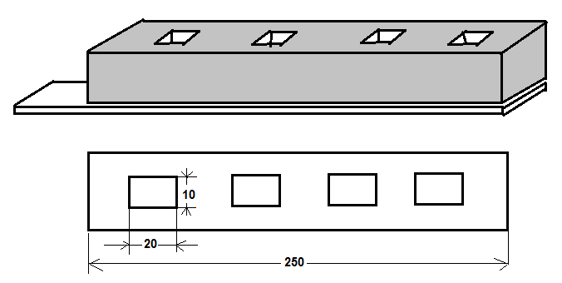

Fig.3 FLD beam with rectangular cavities of size
10mm X 20mm

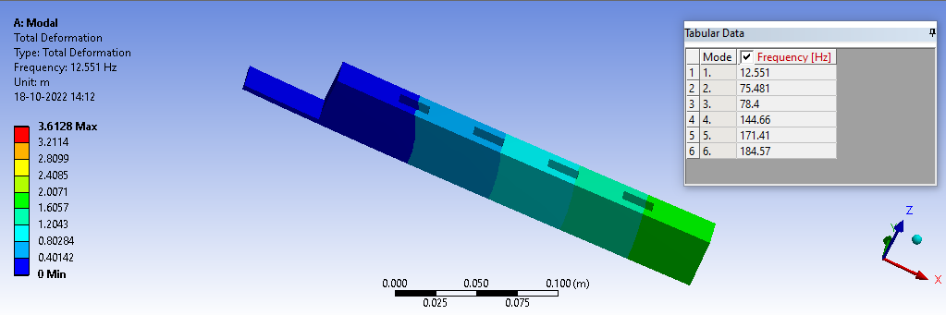
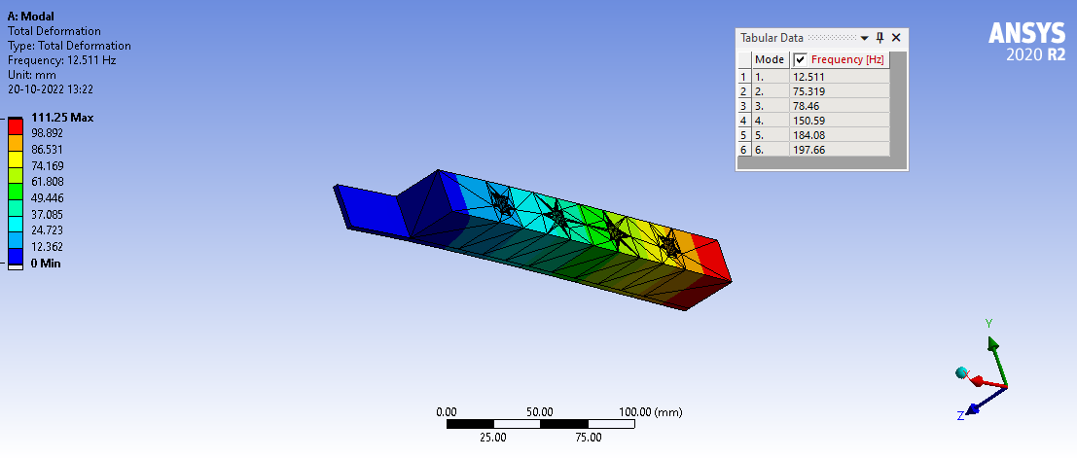

Fig.4(b) Asymmetrical FLD beam- 30mm thick PU rubber layer with Tubular cavities
Fig.4(a) Asymmetrical FLD beam- 30mm thick PU rubber layer with Rectangular cavities
.

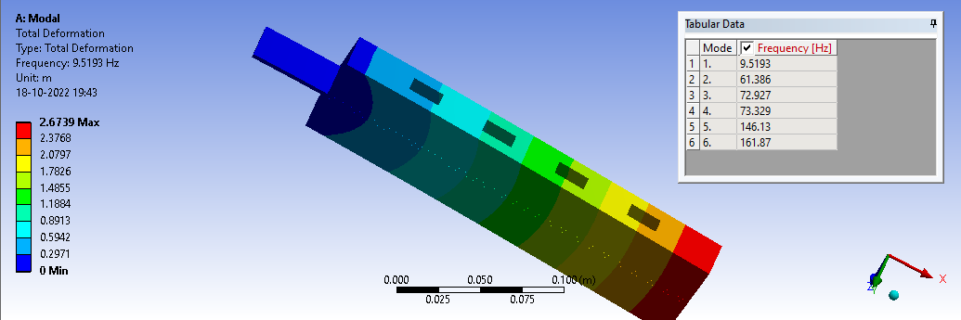
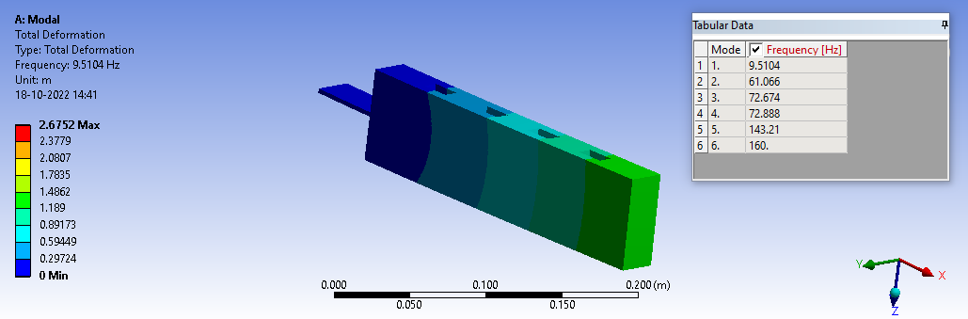

Fig.4(d) Proportioned FLD beam- 30mm thick PU rubber layer with Tubular cavities
Fig.4(c) Proportioned FLD beam- 30mm thick PU rubber layer with Rectangular cavities

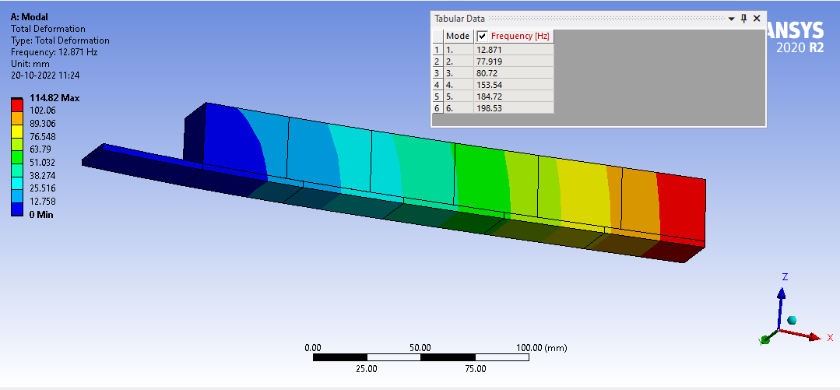
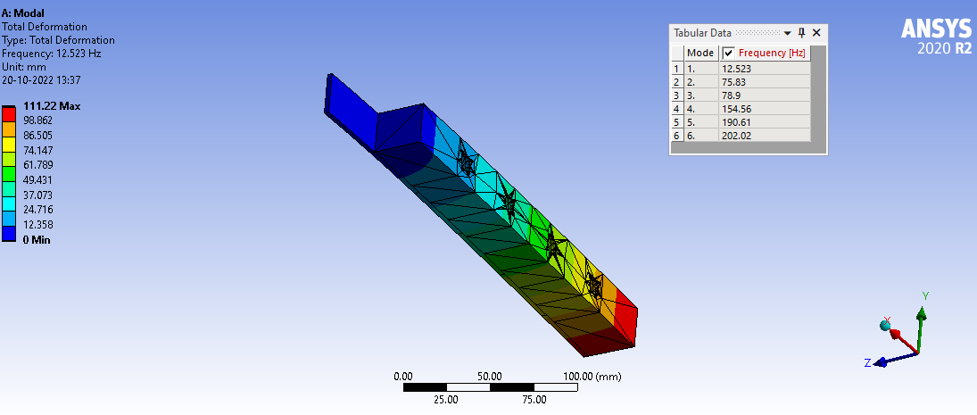

Fig.4(f) Asymmetrical FLD beam- 30mm thick Silicone rubber layer with Tubular cavities

Fig.4(e) Asymmetrical FLD beam- 30mm thick Silicone rubber layer with rectangular cavities

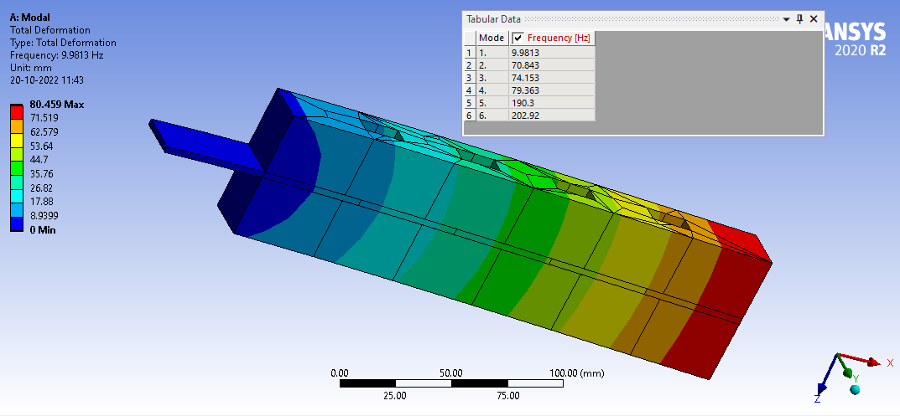
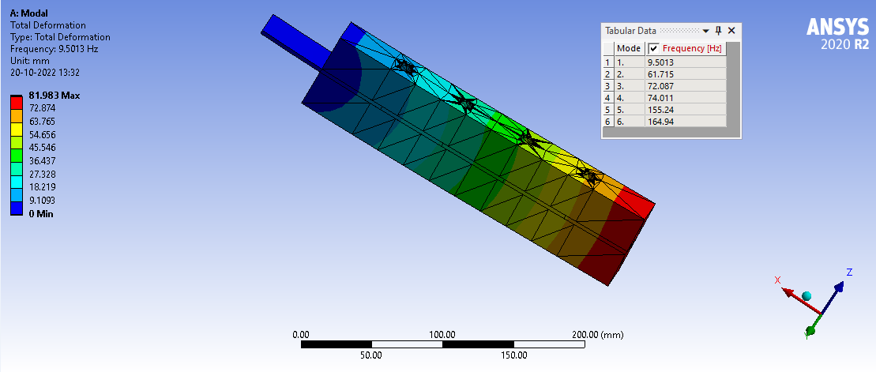

Fig.4(h) Proportioned FLD beam- 30mm thick Silicone rubber layer with Tubular cavities
Fig.4(g) Proportioned FLD beam- 30mm thick Butyl rubber layer with rectangular cavities

Fig.4(j) Proportioned FLD beam- 30mm thick Butyl rubber layer with rectangular cavities
Fig.4(i) Proportioned FLD beam- 30mm thick silicone rubber layer with rectangular cavities

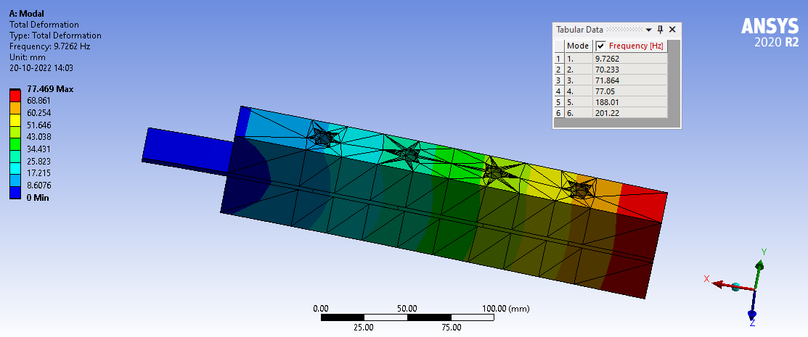

Fig.4(l) Proportioned FLD beam- 30mm thick Butyl rubber layer with rectangular cavities
Fig.4(k) Proportioned FLD beam- 30mm thick Butyl rubber layer with Tubular cavities
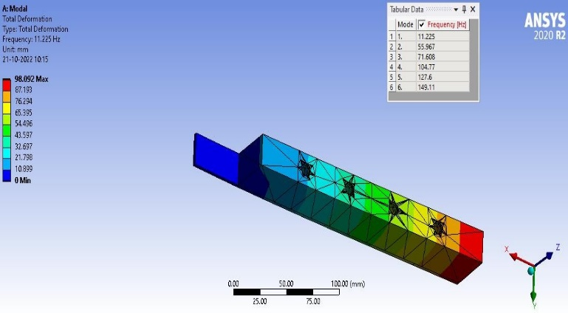

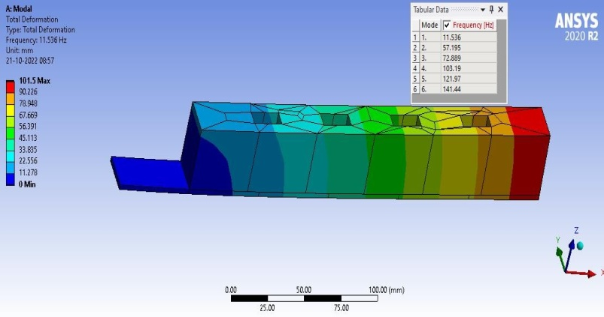
Fig.5(a) Asymmetrical FLD beam- 40mm thick PU Fig.5(b) Asymmetrical FLD beam-40mm PU
rubber layer rubber layer with Rectangular cavities with Tubular cavity

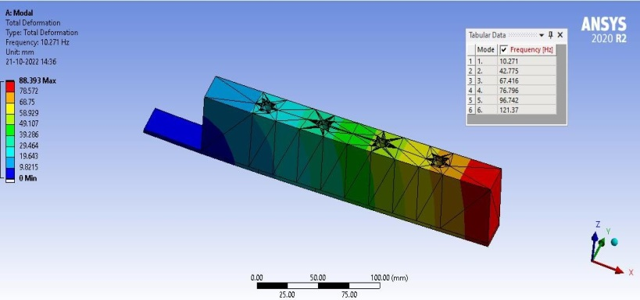
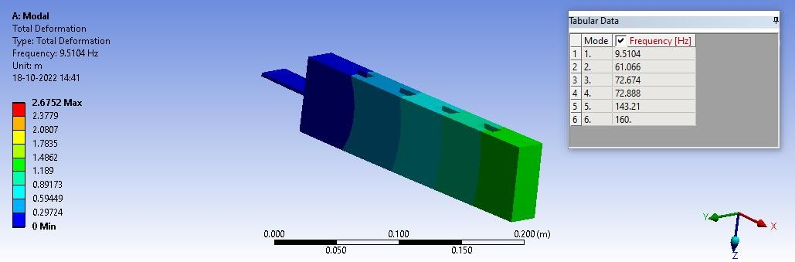

Fig.5(c) Proportioned FLD beam 40mm thick PU rubber layer Fig.5(d) Proportioned FLD beam 40mm thick PU rubber layer with rectangular cavity with Tubular cavity

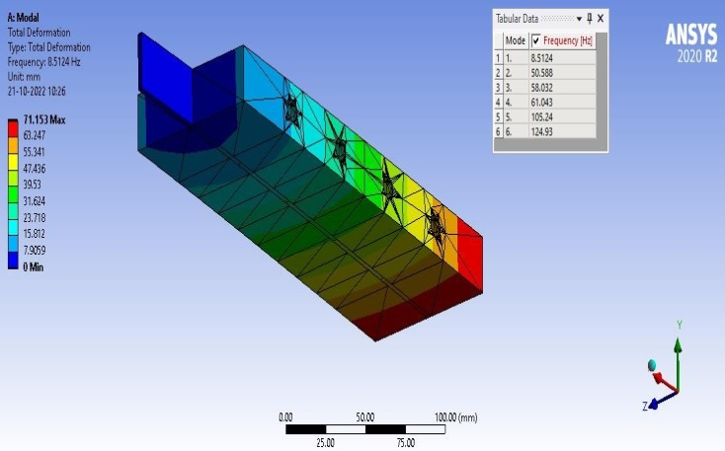
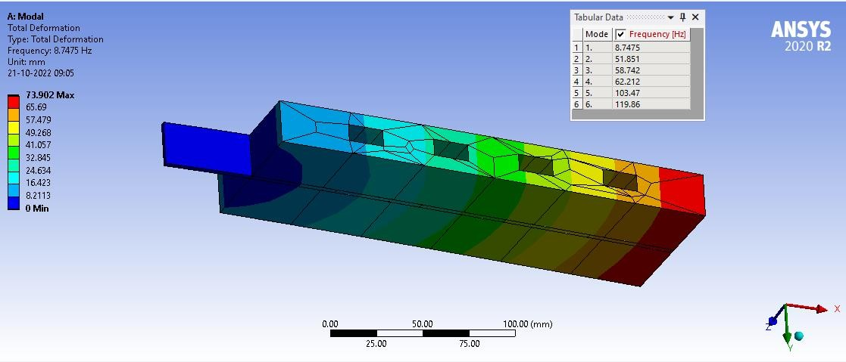

Fig.5(e) Proportioned FLD beam 40mm thick silicone rubber with Fig.5(f) Proportioned FLD beam 40mm thick Rectangular cavity silicone rubber with Tubular cavity

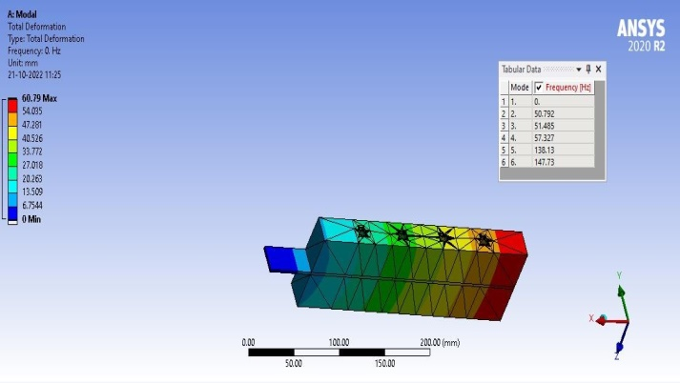
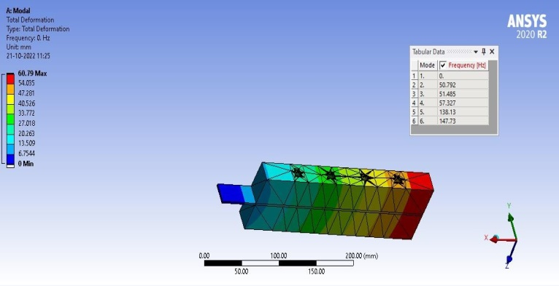

Fig.5(g) Proportioned FLD beam 40mm thick butyl rubber with Fig.5(h) Proportioned FLD beam 40mm thick butyl Cylindrical cavity rubber with Tubular cavity

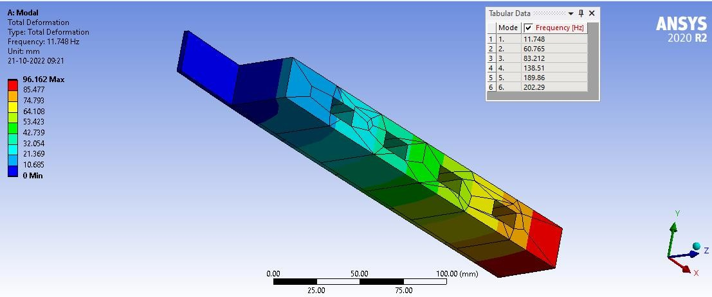
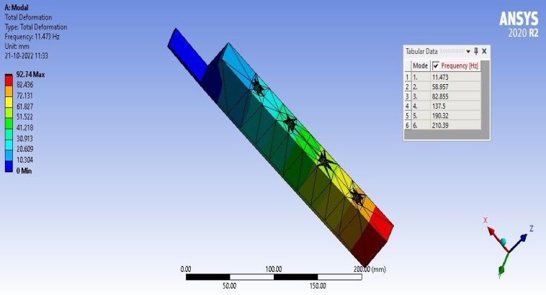

Fig.5(i) Asymmetrical FLD beam 40mm thick butyl Fig.5(j) Asymmetrical FLD beam 40mm thick butyl rubber with Rectangular cavity rubber with Tubular cavity

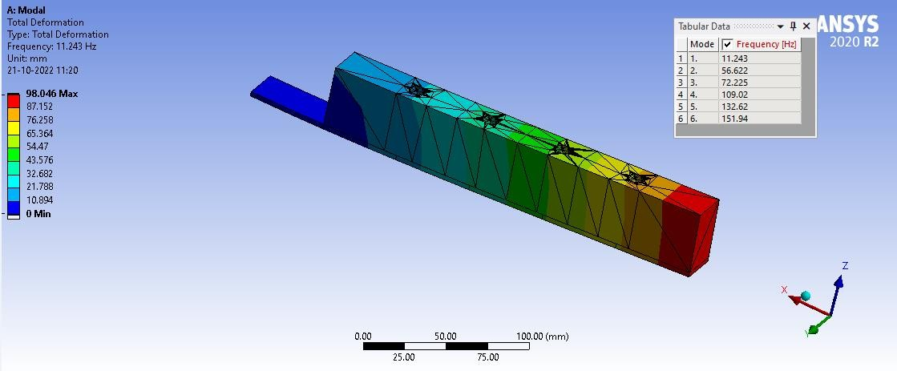
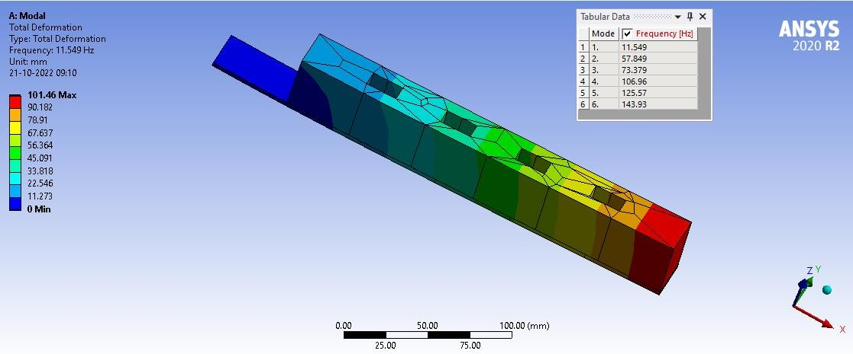
Fig.5(k) Unsymmetrical FLD beam 40mm silicone rubber with Fig.5(l) Unsymmetrical FLD beam 40mm silicone Rectangular cavity with Tubular cavity

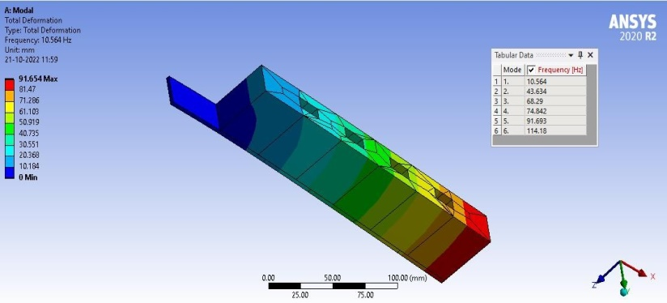
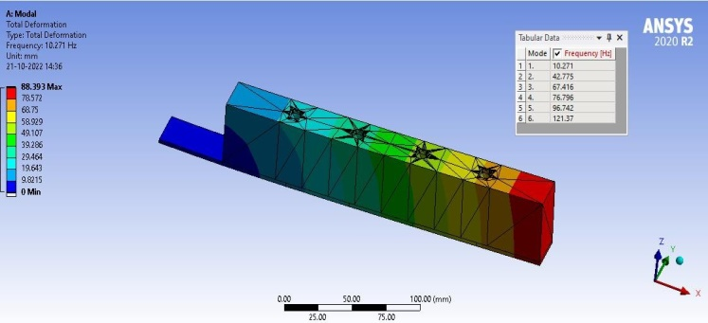
Fig.6(a) Asymmetrical FLD beam 50mm thick PU Fig.6(b) Asymmetrical FLD beam 50mm thick
Rubber with rectangular cavity PU rubber with Tubular cavity

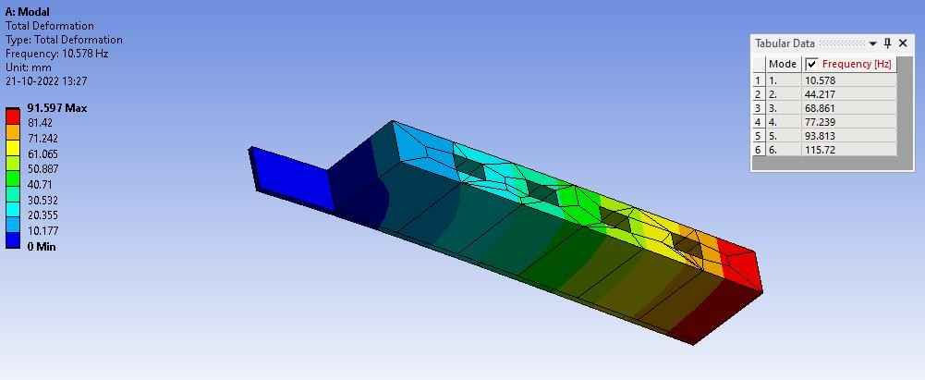
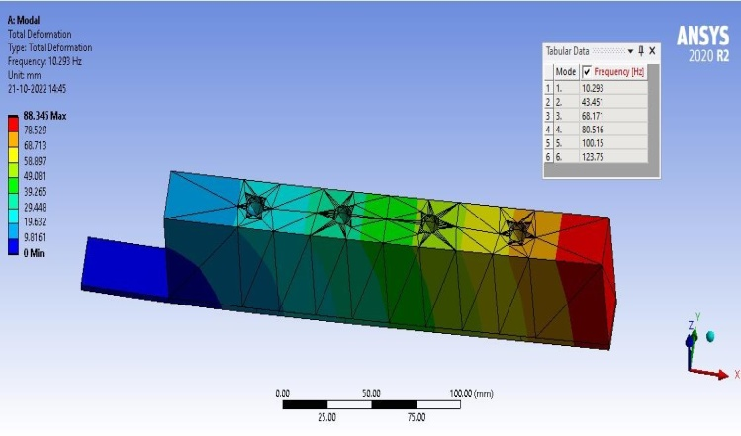

Fig.6(c) Asymmetrical FLD beam 50 mm thick silicone Fig.6(d) Asymmetrical FLD beam 50mm thick
Rubber with rectangular cavity silicone rubber with Tubular cavity

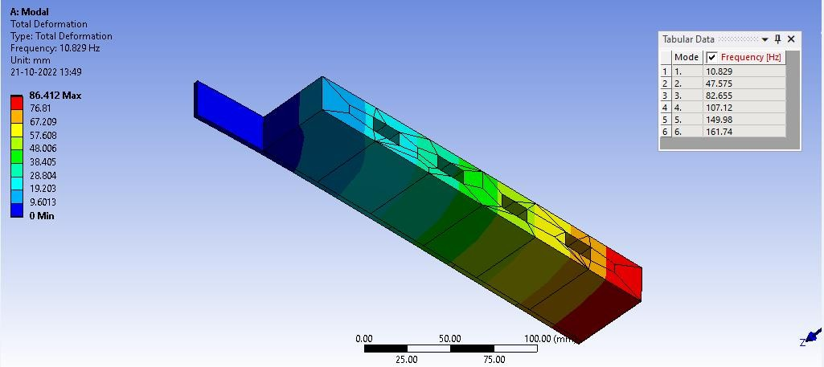
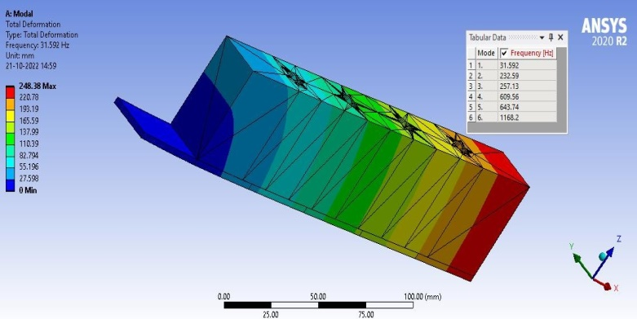

Fig.6(e) Asymmetrical FLD 50mm thick beam butyl rubber Fig.6(f) Asymmetrical FLD beam butyl rubber with Rectangular cavity with Tubular cavity

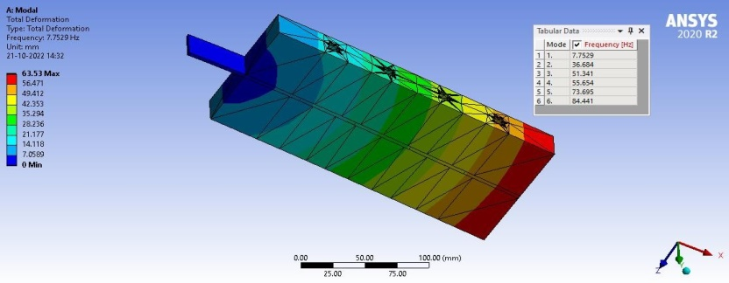
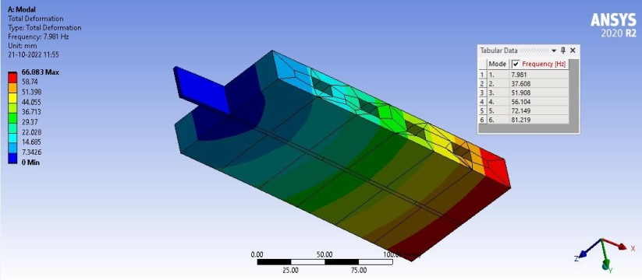

Fig.6(g) Proportioned FLD beam of 50mm PU Fig.6(h) Proportioned FLD beam of 50mm thick
rubber with rectangular cavity PU rubber with Tubular cavity

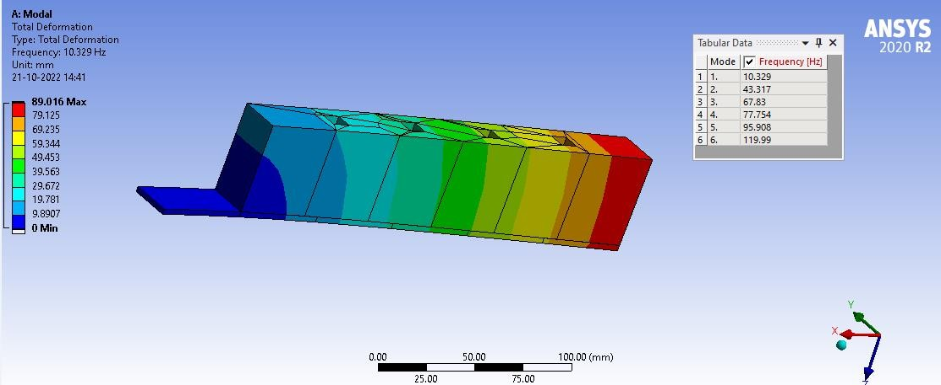
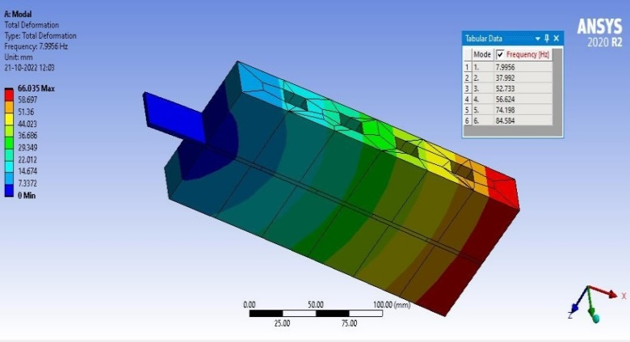

Fig.6(i) Proportioned FLD beam of 50mm silicone rubber Fig.6(j) Proportioned FLD beam of 50mm silicone
With rectangular cavity rubber with Tubular cavity

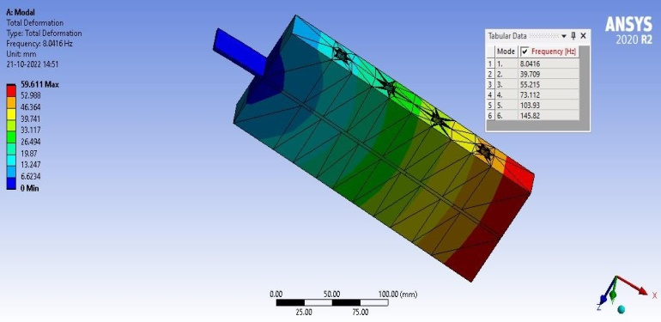
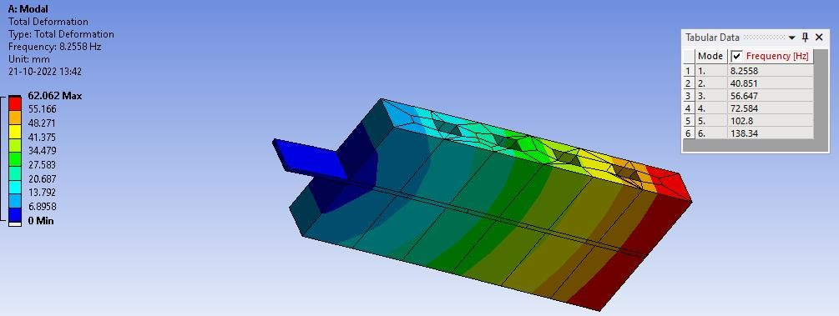
Fig.6(k) Proportioned FLD beam of 50 mm butyl rubber
With Rectangular cavity Fig.6(l) Proportioned FLD beam of 50mm butyl
rubber with Tubular cavity
Table 2 displays natural frequency values from modal analysis of Polyurethane, Silicone, and Butyl rubber under symmetrical and unsymmetrical damping of 30, 40, and 50 mm thickness [4 to 7].

Table 2: Natural frequencies of FLD beams
S.No. | Type of  SMP | Thickness  (mm) | Form of Cavity | Natural Frequency with Proportioned shape  (Hz) | Natural Frequency with Asymmetrical shape  (Hz)
1 | Polyurethane rubber | 30 | Rectangular | 61.01 | 75.48
 |  | 30 | Tubular | 62.11 | 75.32
 |  | 40 | Rectangular | 52.73 | 57.19
 |  | 40 | Tubular | 50.08 | 55.97
 |  | 50 | Rectangular | 37.61 | 43.63
 |  | 50 | Tubular | 36.68 | 42.78
2 | Silicone rubber | 30 | Rectangular | 61.39 | 77.92
 |  | 30 | Tubular | 61.72 | 75.83
 |  | 40 | Rectangular | 51.85 | 57.85
 |  | 40 | Tubular | 50.59 | 56.62
 |  | 50 | Rectangular | 37.99 | 44.22
 |  | 50 | Tubular | 43.32 | 43.45
3 | Butyl rubber | 30 | Rectangular | 70.84 | 79.62
 |  | 30 | Tubular | 70.23 | 77.12
 |  | 40 | Rectangular | 54.98 | 60.77
 |  | 40 | Tubular | 50.79 | 58.96
 |  | 50 | Rectangular | 40.85 | 47.58
 |  | 50 | Tubular | 39.71 | 44.59

The above study reveals that increasing mass or lowering stiffness lowers natural frequency, while reducing mass or increasing stiffness increases it [8 to 10]. Asymmetrical configurations can operate at higher speeds without noise, wear, metal fatigue, or uneven performance. Modal analysis shows that asymmetrical configurations provide better resonant frequency response than symmetrical [11 to 13].

CONCLUSIONS

This study examines the damping performance of various shape memory polymers, including Polyurethane, Silicone, and Butyl rubbers. DMA tests and modal analysis are conducted using ANSYS R19 software to determine the best damping properties of the materials. Python programming is used to determine optimal values. The results show that the unsymmetrical configuration of butyl rubber with a rectangular cavity at 79.62 Hz has better results for natural frequency.
REFERENCES
[1] Prasanth Kumar M, Mamatha B, Bhaskara Raju VVS, N.Ramanaiah, (2017) “Effect of thickness on asymmetric Extensional Damping Treatment using Viscoelastic Materials”. International Journal of Engineering Trends and Technology (IJETT).
[2] N.Ramanaiah, Prasanth Kumar Mallipudi, VVS. Bhaskara Raju, et al. (2017) “Effectiveness of Extensional Damping using Rubber as Layer”. Trends in Mechanical Engineering &Technology (TMET).

[3] C.V.Ramachandrareddy, N.Ganesn, Narayanan.B.V “The response of plates with unconstrained layer damping treatment to random acoustic excitation” (1979).
[4] A.D.Roberts and C.A. Brackley, “Surface treatment of rubber to reduce friction”, Journal of Natural Rubber Research, Volume 4, Number 1, pp. 1-21, March (1989).
[5] H.H.Law, P.L.Rossiter, G.P.Simon, L.L.Koss, “Characterization of mechanical vibration damping by piezoelectric materials”, Journal of Sound and VibrationVolume 197, Issue4, Pages 489-513, October (1996).
[6] Roynganesan, “The theoretical and experimental investigations on the damping effectiveness of partially applied unconstrained layer damping treatments on rectangular plates having central rectangular cutouts” (2003).
[7] Doo-holee,Woo-Seok Hwang, “Optimization of length for unconstrained viscoelastic damping layer of beams” (2004).
[8] Ramji Koona, Ganesh Kumar PVS and M.Lavanya “Optimization of surface damping treatments for random vibration control of structures Dynamic excitation results in vibration of machinery and supports of the structures”(2005).
[9] Laurent hazard, “Design of viscoelastic damping for vibration and noise control, modeling, experiments and optimization” (2006).
[10] H.H.Hilton, and Sung Yi, M. Fouad Ahmad “Dynamic Responses of Plates with Viscoelastic Free Layer Damping Treatment” journal of vibration and acoustics 362/vol.118, (2008).
[11] Craig A.Gallimore, Dr. Kevin B.Kochersberger “Passive Viscoelastic Constrained Layer Damping Application for a Small Aircraft Landing Gear System” (2008).
[12] Francesca Cura, Andrea Mura1 and Fabrizio Scarpa, “Modal strain energy based methods for the analysis of complex patterned free layer damped plates”, Journal of Vibration and Control,18(9) pp.1291–1302, (2011).
[13] Ashish M. Dharme, Pravin P. Hujare and Sinhgad “Analysis of performance of FLD and CLD technique”, International Journal of Engineering Sciences &Research Technology, pp.340-343, ISSN: 2277-9655, (2015).

