A Review on Electro catalysis of Oxygen Redox Reaction: It’s Influence on Life and Energy
Arindam Roy
Department of Materials Science and Technology
Maulana Abul Kalam Azad University of Technology, West Bengal

This article gives a detailed summary of the impact of oxygen redox electro catalysis on life and energy conversion. Oxygen reduction reaction electro catalysis is important for several natural processes, including respiration, because the process boosts the conversion of oxygen to water in living organisms. (Lane et al.). The understanding of ORR mechanisms within biological systems has significant implications for biomedical technologies such as implantable biosensors and biofuel cells (Li et al.). The review discusses recent advancements in elucidating ORR mechanisms in biological systems and highlights the development of bio-inspired catalysts for improved performance and compatibility. ORR electro catalysis plays an important role in the discipline of energy conversion for electrochemical energy storage and conversion devices, in particular fuel cells and metal-air batteries. To enhance their performance, these technologies rely on efficient and selective ORR catalysts. Because of their high catalytic activity, precious metal catalysts such as platinum (Pt) and palladium (Pd) have long been used (Gasteiger et al.). Due to the scarcity and expensive cost of these noble metals, researchers have been looking at other non-precious metal catalysts. The study digs into advances in the design and synthesis of non-precious metal catalysts, such as transition metal-based compounds, metal-free carbon materials, and hybrid nanomaterial’s (Zhu et al.). These materials provide potential alternatives with strong ORR activity, selectivity, and stability, aiming for cost-effective and long-term energy conversion solutions. The review focuses on ORR electro catalysts, the impact they have on life sciences and energy conversion, and current attempts to produce efficient and sustainable catalysts.

Keywords: Electro catalyst, ORR, Energy Conservation, Fuel Cell.

1. Introduction:
Hydrogen fuel's contribution to sustainable energy is crucial for addressing the world's energy problems and reducing environmental risks. Hydrogen fuel is a clean and ample power carrier that can be relied on for a wide range of functions such as transportation, power generation, and industrial operations. It is made from renewable resources like water electrolysis. The capacity of hydrogen fuel as a source of sustainable energy. Energies may be carbon-free through the manufacture of hydrogen through electrolysis using renewable energy sources such as solar and wind power (Zhang et al.). Hydrogen fuel cells, which convert hydrogen and oxygen into electricity and offer greater efficiency and lower emissions than characteristic combustion engines, exhibit promise as an alternative. Infrastructure enhancement, cost containment, and safety concerns all pose barriers to the widespread usage of hydrogen fuel. To fully exploit hydrogen's promise as a sustainable energy carrier, these barriers must be addressed by sustained research, advancement in technology, Conventional fossil fuels, on the other hand, continue to dominate the world's energy mix and are a major cause of greenhouse gas emissions and environmental damage. Hydrogen fuel, an alternative energy source, and scientific data from the International Energy Agency (IEA, 2020), present promising solutions to these environmental issues. When used in fuel cells, it is a clean and effective fuel that only emits water vapour as a by-product. Although hydrogen produces zero greenhouse gases or other pollutants when burned, it is an excellent alternative to traditional fuels for reducing carbon emissions and improving air quality. Hydrogen may also be created utilizing sustainable energy sources such as solar and wind energy, which increases its sustainability. We can reduce our dependence on fossil fuels while simultaneously paving the way for a more renewable and beneficial future by transitioning to hydrogen fuel.

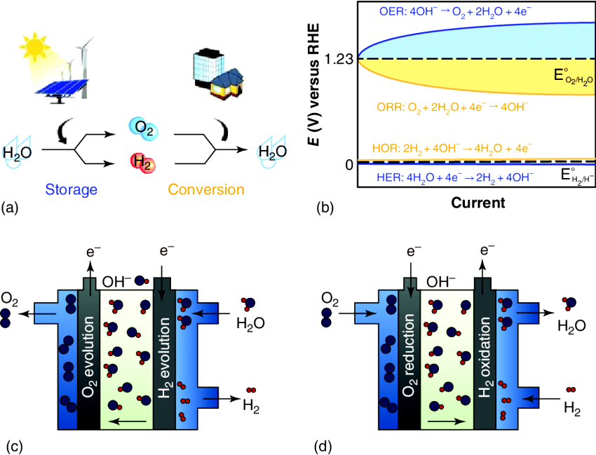

Fig. No: 1, (a) the hydrogen and oxygen cycles are employed for storing and transforming energy. Chemical energy storage is possible using HER and OER. ORR and HOR (MOR) are two half-cell reactions of fuel cells used for energy conversion. (b) Schematic representation of the over potentials associated with HER, OER, ORR, and HOR. (c) Anion-exchange membrane electrolyzes schematic. (d) Diagram of an alkaline electrolyte fuel cell. Royal Society of Chemistry 2015, all rights reserved.
This shift will not only benefit the environment, but it will also encourage technical improvements in the renewable energy industry and the creation of new job possibilities. Accepting hydrogen as a feasible source of energy is a vital first step toward a more robust and sustainable future for our planet. The oxygen reduction process is important because it aids in the effective conversion of oxygen into water. ORR is critical in many electrochemical energy conversion and storage systems, such as fuel cells and metal-air batteries. ORR catalyst research is critical for improving the performance and lifetime of these devices. Extensive studies have been conducted on platinum Pt-based catalysts, which have shown good ORR activity. Pt's discovery triggered an investigation for substitute catalysts with a high price and limited supply. Transition metal-based catalysts that contain iron ($Fe$), cobalt ($Co$), and nickel ($Ni$) have emerged as attractive possibilities due to their availability and cost. A range of approaches, such as alloying, doping, and Nano structuring, can be applied to boost the ORR activity of these catalysts. Non-metallic materials, such as metal-organic frameworks (MOFs) and carbon-based catalysts, have also shown promise in ORR applications. High-throughput screening technologies and computational modelling advancements have accelerated the quest for novel ORR catalysts with improved performance. Before these catalysts can be employed in real devices, they must be further improved to deal with stability, selectivity, and mass transport bounds. The pursuit for effective and long-lasting ORR catalysts continues to fuel attempts to create more efficient energy conversion and storage systems. Because of the high cost and limited availability of Pt, it is necessary to study alternate catalysts. The objective of research has been to develop non-Pt catalysts that can outperform Pt-based catalysts. Molybdenum nitride (Chung et al.) and other transition metal nitrides have shown promise in terms of strong ORR catalytic activity. Metal oxides, especially iron-based catalysts, have also been explored as prospective ORR catalysts (Lefèvre et al.). Carbon-based materials, such as nitrogen-doped carbon and carbon nanotubes, have been studied due to their fundamental catalytic characteristics and abundance (Li et al.). Understanding the ORR mechanism is required for the rational creation of effective catalysts. Multiple intermediate species are involved in the reaction's extensive four-electron transfer phase (Nrskov et al.). Spectroscopy, microscopy, and theoretical simulations have all been utilized to investigate the reaction routes, active sites, and structure-activity connections of ORR catalysts. ORR catalytic performance, selectivity, and stability are all being worked on, as are efforts to reduce dependency on precious metals. Advanced synthesis processes, catalyst support materials, and nanostructured catalysts with enhanced surface area and adjustable surface compositions are among the projects being worked on (Chung et al.). The development of efficient ORR catalysts is critical for electrochemical energy conversion and storage systems to perform better and be more economically viable. This will lead to a more sustainable energy future (Li et al.).
It is important to understand the various ORR modes in order to optimize catalyst design and boost energy conversion efficiency. Water is the primary product of ORR in aqueous environments, where it typically follows a four-electron transfer pathway. Alternative reaction pathways, which produce different reaction products and kinetics, may predominate in non-aqueous solvents or at high temperatures. Surface composition, structure, and electronic structure within a catalyst have a bearing on the ORR procedure (Lopes et al.). For instance, due to their capacity to promote electron transfer and stabilise reaction intermediates, transition metal-based catalysts display increased activity. In addition, catalyst surfaces can be Nano structured to increase their surface area and reveal more ORR-active sites (Li et al.). Researchers can open new doors for effective electrochemical energy conversion systems with improved performance and sustainability by adjusting both the reaction environment and catalyst properties. Technologies for cleaner and more effective combustion have been developed in an effort to lessen its negative environmental effects. Utilizing catalytic converters is one such method, which aids in reducing harmful emissions by encouraging the conversion of pollutants into less harmful ones. As catalysts, these converters frequently use priceless metals like platinum, palladium, and rhodium (Stephens et al.). Research into substitute catalyst materials has been sparked by the expensive price and limited supply of these metals. This is where transition metal oxides, perovskites, and zeolites have shown promise because of their special properties that make pollutant conversion effective (Shao et al.).Advances in catalyst synthesis methods like atomic layer deposition (ALD) and sol-gel techniques have made it possible to precisely control the structure and makeup of catalysts. A certain amount of control is essential for adapting the catalytic system's selectivity and activity to particular reactions. Integration of catalytic materials into hierarchical structures or supported on high-surface-area substrates has improved their performance by increasing the accessibility and stability of the active site (Yang et al.). Theoretical modelling and density functional theory (DFT) calculations have provided a deeper understanding of the reaction pathways and the identification of active sites on catalyst surfaces. In the meantime, conventional fuel combustion remains an urgent concern.
The redox reaction of oxygen ORR is a fundamental mechanism in an extensive variety of biological applications. ORR is an essential phase in the cellular respiration of aerobic organisms, when oxygen is converted into water, releasing energy in the form of adenosine triphosphate (ATP) (Lane et al.). This system is essential for life support and complex metabolic processes. ORR has significant implications for biomedical technology. ORR, for example, is significant in the detection and measurement of biological analyses (such as glucose) in implantable biosensors using enzymatic processes paired with oxygen reduction (Li et al.). ORR-based biofuel cells have captured the interest of researchers as potential power sources for implantable devices and bio electronics, because of ORR's improved electron transport and energy conversion features (Atanassov et al.).

2. An insight on the involvement of noble and non-noble metal-based catalysis for ORR
Noble metal-based catalysts have been extensively studied for the ORR owing to their strong electro catalytic activity. Platinum ($Pt$) has been accepted as the gold standard catalyst for ORR because of its high activity and selectivity. Due to the scarcity and high cost of platinum, researchers are looking for non-noble metal-based catalysts as replacements. For transition metal-based catalysts, transition metal nitrides, carbides, and phosphides have emerged as feasible choices. These materials exhibit high ORR activity, are stable, and are relatively cheap (Wei et al.). Transition metal nitrides, such as molybdenum nitride ($MoN$) and tungsten nitride ($WN$), have demonstrated excellent ORR activity comparable to Pt-based catalysts (Xu et al.). Non-noble metal carbon-based catalysts, such as nitrogen-doped carbon compounds and metal-free carbon compounds, also demonstrate significant promise for ORR catalysis (Zhang et al.). These non-noble metal-based catalysts offer a low-cost, long-term ORR alternative in several kinds of electrochemical energy conversion devices. The combination of noble and non-noble metal-based catalysts has piqued the interest of ORR scientists. In terms of ORR activity and durability, bimetallic catalysts, such as $Pt$-based alloys including transition metals (e.g., $Pt-Co, Pt-Fe$), outperform pure $Pt$ catalysts (Li et al.). The inclusion of a transition metal changes the electronic structure and surface properties of the catalyst, resulting in higher catalytic activity in these bimetallic catalysts. Core-shell structures with a noble metal core surrounded by a non-noble metal shell have exhibited enhanced activity and stability due to optimization of surface composition and atomic-scale interactions (Ivanantham et al.). Developing noble and non-noble metal-based catalysts and it has wide range of possibilities for further research and development of ORR electro catalysis.
Noble-metal-free electro catalysts have attracted interest in academia and made significant scientific achievements in recent decades. In this part of the article, we will highlight some of the most recent advances in non-noble metal electro catalysts (primarily$Mn, Fe, Co, and Ni$), with a classification of metals and alloys, oxides, hydroxides, chalcogenides, phosphides, phosphates and borates, and other earth-abundant metal compounds. Every component of the synthetic process, electro catalytic performance, structural characterization, and catalytic mechanism research are thoroughly discussed.
  - Metals/Alloys:
Non-noble-metal-based electro catalysts in their pure metallic state typically cannot survive directly in harsh electrolytes containing both acidic and alkaline media due to the strong corrosion effect. As a result, they are typically incorporated or decorated in very stable hosts (such as carbon compounds), whether in monometallic or alloy form. By immediately annealing the metal-organic framework (MOF) material, Xu et al. constructed a highly productive OER electro catalyst implementing $Ni$ nanoparticles (NPs) enclosed in $N$-doped graphene (Xu et al.). Because of the synergistic effect of metals, metal alloys frequently have enhanced catalytic activity for processes. Wang et al. studied $NiFe$ alloy NPs utilizing various crystal phase configurations as well as an N-doped carbon shell. The hexagonal close-packed (HCP) phase of the $NiFe$ alloy catalyst has an ultralow over potential of 226 mV, allowing it to produce an OER current density of 10 mA cm-2. Aside from research on tiny earth-abundant metal NPs, scientists have been investigating chambers in nano clusters and single-atom catalysts to enhance atomic efficiency and increase electro catalytic activity (Liu et al.). Recently, Zhang et al. reported on an efficient OER electrocatalyst with atomically distributed $Ni$ sites on an $N$-doped hollow carbon matrix ($HCM@Ni-N$).To put together the final consequence; the synthetic approach develops a hard-template technique, which is then followed by pyrolysis and acid etching procedures. The morphology and structure of the $HCM@Ni-N$particles were characterized using transmission electron microscope (TEM), annular dark-field scanning transmission electron microscope (HAADF-STEM), and high-angle annular dark-field scanning transmission electron microscope (HAADF-STEM) techniques, which revealed uniformly, distributed spherical hollow structures with atomically dispersed isolated $Ni$atoms throughout the particles. According to X-ray absorption spectroscopy (XAS) and DFT calculations, the improved catalytic activity is due to effective electronic coupling between $Ni$ and$N$, which may lower the Fermi level and change the absorption of key intermediates.
  - Oxides:
Due to their low cost, high reversible nature, customizable frameworks, and stable properties, non-noble-metal-based oxides have caught the interest of electro catalysis researchers. Controlling the morphology, manipulating the composition, modifying the electrical structure by foreign metal doping, and adding hybrid structures into composites have all been shown to be successful methods of producing highly efficient oxide-based OER electro catalysts. In this section, we will present a brief summary of several recently found non-noble-metal-based oxide electro catalysts, such as single metal oxides, spinel oxides, and perovskite oxides (Wu et al.).The activities of single non-noble-metal oxide electro catalysts are influenced by metal types, metal oxidation states, morphology, and supports; nevertheless, their low conductivity severely restricts their application potential to. Two solutions are being developed to overcome the low conductivity issue: i) modifying the structures and compositions of the oxides by doping heteroatoms, creating oxygen vacancies, and generating polymetallic oxides; and ii) putting conductive substrates (carbon material or metal substrate). Tong et al., for example, studied a hybrid electro catalyst comprised $Co$ oxide $NP$s and $B,N$ decorated graphene produced via heat annealing the precursor in a ${NH}_{3}$ surroundings. The active sites have many and strong $CoNC$ bridging bridges with numerous oxygen vacancies that exhibit a high synergetic effect and boost electron transfer efficiency. The electro catalytic activity of the OER gets enhanced by greater charge transfer in catalysis (over potential of 261 mV at 10 mA cm-2). Perovskite oxides in general$ABO_{3}$, where A is often a rare-earth or alkaline-earth metal and B is a transition metal, have been extensively examined as promising non-noble-metal-based electrocatalysts for energy conversion and storage applications (Chen et al.). Perovskite oxides are classed in the following way:$A^{2+}B^{4+}O_{3 }$, $A^{3+}B^{3+}O_{3}$, or various forms. Because of their highly adjustable metal combinations and compositions, peculiar 3d electronic structures, and outstanding stability, perovskite oxides exhibit exceptional catalytic activity. Li et al. investigated the roles of covalent bonding and surface oxygen separation in the formation of OER, $CaCoO_{3}$ and $SrCoO_{3}$ cubic perovskite oxide catalysts.Both perovskite catalysts have a comparable $Co4^{+}$intermediate spin state, which accounts for their equal onset potential. $CaCoO_{3}$ Has superior electrochemical activity and stability for the OER than $SrCoO_{3}$ due to its lower lattice constant and shorter surface oxygen separation. The rate determining step (RDS) for the OER was thought to be the generation of surface peroxide ($O_{2}$) 2 intermediate. Due to their various electronic structures and significant synergistic effects, double perovskite oxide catalysts, often with the formula$AA'BB'O_{6}$, demonstrate outstanding catalytic activity for OER. Wang et al. used a sol-gel method to create double perovskite $aFexNi1xO_{3}$ $(LFNO$) nanorods.[Chen et al.] The broadened electrochemical performance produced by the catalyst is a consequence of its increased surface area, optimized electronic structure, and strong interaction between Ni and lattice oxygen. A low over potential of 302 mV at 10 mA ${cm}^{-2}$ and a 20-hour stability performance with zero current decay were obtained by changing the $Ni/Fe$ ratio in the perovskite oxide catalysts.

Fig. No:2, A) A typical R-NCO TEM picture. A photograph of a necklace is shown in the inset in (A). B) Electro catalyst OER polarization curves in 1.0 m KOH electrolyte. C) Energy diagrams of the OER on NCO and R-NCO at 1.23 V equilibrium. D) A typical TEM picture of a CoFe2O4/C nanorod. E) Performance of several catalysts in 1.0 m KOH electrolyte in terms of OER. This image has been reproduced with permission. Wiley-VCH. All rights reserved. F) A typical TEM picture of Co3O4/Co-Fe oxide DSNBs. HAADF-STEM pictures of a single Co3O4/Co-Fe oxide DSNB. H) LSV curves of several catalysts in 1.0 m KOH electrolyte. Copyright 2018, Wiley-VCH. I) OER polarization curves of double perovskite LFNO catalysts in 1.0 m KOH electrolyte. Copyright 2019, Wiley-VCH.

- Reaction mechanism for carbon based electro catalyst for oxygen reduction reaction:
A multitude of complicated processes are involved in the reaction mechanism for carbon-based electro catalysts in the oxygen reduction reaction. Initially, the oxygen molecule is adsorbed inside the catalyst surface and afterwards dissociated into two oxygen atoms. Adsorbed oxygen atoms react with water molecules to form hydroxyl ($OH$) species. The hydroxyl species subsequently undergo further reactions, such as the removal of one electron to generate water and the regeneration of active sites for future ORR cycles. Depending on the carbon-based catalyst relied on and the experimental under certain circumstances, the precise mechanism and pathways may change. Several studies have proposed procedures for carbon-based ORR electro catalysts, including the four-electron transfer pathway or an amalgamation of two-electron and four-electron channels (Li et al.).The understanding of the detailed reaction mechanism is crucial for optimizing the performance and design of carbon-based electro catalysts for efficient ORR applications.
The ORR on carbon-based electro catalysts is a complicated reaction mechanism that is still being researched. According to one hypothesised process, oxygen molecules $(O_{2})$ first adsorb on the catalyst surface before dissociating into reactive oxygen species known as adsorbed atomic oxygen$(O_{2})$. These $(O_{2})$species subsequently react with water ($H_{2}O$) or other species, resulting in the creation of hydroxyl $(OH)$ species. The ORR mechanism's succeeding stages might vary based on parameters such as the surface chemistry, structure, and reaction circumstances of the catalyst. To describe the reduction of $O_{2}$ to water, many paths have been proposed, comprises the four-electron transfer path and the combination of two and four-electron channels.The precise mechanism and rate-determining mechanisms remain under investigation, and advanced approaches like as in-situ spectroscopy and theoretical modelling are being employed to acquire new insights into the ORR mechanism on carbon-based electro catalysts (Wang et al.). Understanding the reaction mechanism thoroughly proves essential for developing improved carbon-based electro catalysts to facilitate successful ORR applications.

3.1 Fundamental concept of ORR:
The ORR is the most well-known and significant reaction in biological respiration and energy-converting devices such as fuel cells and metal-air batteries. The two-electron channel from oxygen to peroxide composed of hydrogen opposed to the direct four-electron pathway from oxygen to water ${(H}_{2}O_{2})$ are the two main mechanisms through which ORR in aqueous solutions occurs (Xing et. al.). ORR occurs when oxygen molecules are reduced at the cathode. This reaction consumes electrons and frequently involves proton ($H^{+}$) or hydroxide (${OH}^{-}$) transfer in various electrolyte environments. To increase the effectiveness and performance of electrochemical devices, the mechanism and kinetics of ORR have been extensively studied. A fundamental electrochemical reaction known as ORR takes place at the cathode in a variety of energy conversion technologies, including fuel cells and metal-air batteries (MAB). Through a number of intermediate reactions, oxygen molecules ($O_{2}$) are reduced to water molecules ($H_{2}O)$. Researchers in the field have studied the kinetics and mechanism of the ORR in great detail. Li et al. investigated the ORR mechanism on a platinum-based catalyst in their study and proposed a reaction pathway that involved oxygen adsorption, the formation of oxygen intermediates, and the final reduction to water (Li et al.). The electrode material, electrolyte PH, temperature, and the presence of catalysts are some of the variables that affect the ORR rate. By lowering the energy barrier, catalysts play a critical role in accelerating the reaction rate. Platinum is frequently used as an ORR catalyst because of its high activity, as Zhang et AL research’s has shown. Due to its scarcity and high price, research is being done on substitute catalysts made of non-precious metals or materials without metals (Chung et al.). The creation of effective energy conversion technology, which enables the generation of environmentally friendly electrical energy, depends on an understanding of the fundamentals of ORR. The transfer of electrons, which can take place via two-electron or four-electron pathways, is one of the main components of ORR.

3.1.1. Two Electron Pathway:
In the two-electron pathway, oxygen molecules are first reduced to hydrogen peroxide ${(H}_{2}O_{2})$ as an intermediate, and then further reduced to water.

$$O_{2}+{2H}^{+}+{2e}^{-}→H_{2}O_{2}$$

This pathway is commonly observed with non-precious metal catalysts. For example, Zhang et al. investigated the ORR on a nitrogen-doped graphene catalyst and demonstrated the formation of ${(H}_{2}O_{2})$ as an intermediate in the two-electron reduction pathway (Zhang et al.).

3.1.2 Four Electron Pathway:
The four-electron pathway involves the direct reduction of oxygen molecules to hydroxide ions (${OH}^{-}$), bypassing the formation of${(H}_{2}O_{2})$.

$$O_{2}+{4H}^{+}+{4e}^{-}→ 2H_{2}O$$

This pathway is typically associated with precious metal catalysts, such as platinum (Pt). Li et al. conducted research on Pt-based catalysts and revealed the direct formation of (${OH}^{-}$) ions in the four-electron reduction pathway (Li et al.).

3.2 Alkaline Electrolyte:
The alkaline electrolyte ORR method refers to the electrochemical reduction of oxygen molecules in an alkaline electrolyte solution. It is a fundamental process that occurs at the cathode in alkaline fuel cells and other electrochemical devices. In this method, the ORR takes place in an alkaline electrolyte solution, typically using a hydroxide (${OH}^{-}$) ion-conductive electrolyte. The reaction pathway involves the reduction of oxygen molecules ${(O}_{2}$) to hydroxide ions (${OH}^{-}$)and water ($H_{2}O)$.

$$O_{2}+2H_{2}O+{4e}^{-}→{4OH}^{-}$$

The ORR pathway in alkaline media typically begins with the adsorption of oxygen molecules on the electrode surface, followed by the formation of different oxygen intermediates. One proposed reaction pathway involves the formation of superoxide (${O_{2}}^{-}$) and hydroperoxide ($H_{2}O^{-}$) intermediates. These intermediates subsequently undergo further reduction steps to produce hydroxide ions and water.

$$O_{2}+2H_{2}O+{2e}^{-}→ O_{2}^{-}+ 2{OH}^{-}$$
$$O_{2}^{-}+H_{2}O+2e^{-}→ 2{OH}^{-}$$

On the other hand, the reduction of hydro peroxide can occur through the following reactions:

$${HO}_{2}+H_{2}O+{2e}^{-}→3OH^{-}$$
$$H_{2}^{-}+{2H}_{2}O+{2e}^{-}→3OH^{-}$$

These reduction steps involve the transfer of four electrons and four hydroxide ions to complete the reduction of one oxygen molecule to four hydroxide ions and water.

3.3 Aqueous Electrolyte:
The electrochemical reduction of oxygen molecules in an aqueous electrolyte solution is referred to as the aqueous electrolyte ORR. In many electrochemical systems, such as metal-air batteries and aqueous electrolysers, it is a fundamental process that takes place at the cathode. A multi-step mechanism involving the formation of different oxygen intermediates, including superoxide, peroxide, and hydroxyl radicals, governs the ORR in aqueous electrolytes. It is essential to comprehend the ORR in aqueous electrolytes if you want to create effective electrochemical energy conversion devices. Platinum ($Pt$) and Pt-free substitutes, among other catalysts, are essential for improving the ORR rate in aqueous electrolytes. Numerous investigations into the ORR mechanism, catalyst design, and material innovation in aqueous electrolytes have been made, helping the field advance (Zhang et al.).These intermediates are essential to the overall ORR process because they have the power to either speed up or slow down the reaction rate. It is essential to comprehend how these intermediates behave in order to design effective catalysts and enhance the functionality of energy conversion technology. The fundamental principles governing electrochemical reactions in aqueous environments can also be learned by researching the aqueous electrolyte ORR. Researchers can create plans to increase the effectiveness and longevity of energy conversion technologies by clarifying the reaction mechanisms and kinetics at play. By facilitating the design of more efficient catalysts and electrolytes, this knowledge can aid in the advancement of sustainable energy technologies. A thorough comprehension of the aqueous electrolyte ORR is essential for advancing energy conversion technology and easing the transition towards a more sustainable future (Yang et al.). The following steps constitute the reaction process of oxygen reduction at the fuel cell or MAB cathode in aqueous electrolyte:

$O_{2}$ Molecules diffuse and adsorb on electrocatalyst surfaces, electrons are transported from the anode to the adsorbed O₂ molecules, $O=O$bonds are weakened and split, and the generated $OH$ ions are removed to solutions (Cao R. et al.). To complete the conversion of $O_{2}$ molecules into $OH$ ions, the ORR either moves through a slow two-electron pathway in two steps or a highly effective four-electron pathway in one step (Wang et al). On the foundation of the computational charge density distribution shown in the illustration above, there are typically two adsorption kinds on the surface of carbon materials. One is end-on $O_{2}$ molecule adsorption (the Pauling model, one oxygen atom coordinating perpendicularly to the surface), while the other is bidentate $O_{2}$ molecule adsorption the alkaline reactions in a straight four-electron route (Liu et al.).

$$O_{2}+2H_{2}O+4e^{-}→4OH^{-}$$

In this pathway, the reduction of oxygen initially leads to the formation of superoxide and peroxide intermediates, which subsequently undergo further reduction to hydroxide ions and water.

$$O_{2}+H_{2}O+{2e}^{-}→O_{2}^{-}+{OH}^{-}$$

$$O_{2}^{-}+H_{2}O+{2e}^{-}→H_{2}O_{2}+2{OH}^{-}$$

$$H_{2}O_{2}+2H_{2}O+{2e}^{-}→4OH^{-}$$

To reduce one oxygen molecule to four hydroxide ions and water, these reactions involve the exchange of four electrons and four hydroxide ions. It is essential that you recognize that the specific reaction pathway and the involvement of intermediates can change based on the reaction conditions, the materials used for the electrodes, and the catalysts that are being used. In order to create effective catalysts and enhance the functionality of energy conversion devices, more investigation and experimental work are continually being done to better understand the ORR pathway in alkaline electrolytes and aqueous environments. Implementing catalysts based on transition metals, such as platinum or palladium, which have demonstrated high ORR activity, is one promising strategy. These catalysts can speed up reactions and elevate the general effectiveness of energy conversion technologies. Understanding the parameters that influence the ORR pathway in alkaline electrolytes and aqueous environments can also help in the development of substitute catalysts that are more available and less expensive than traditional noble metals.
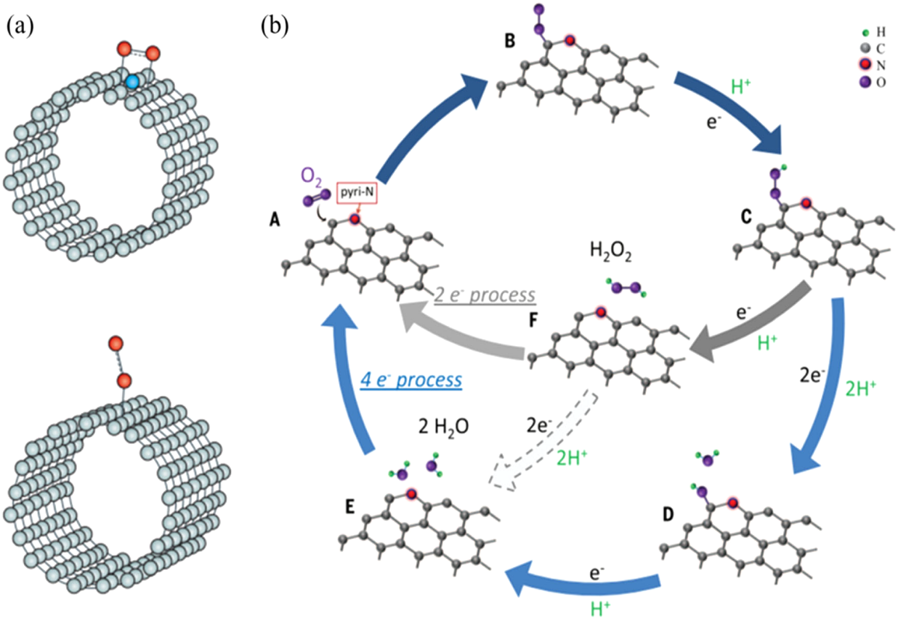

Fig. No: 2, A Schematic illustration of two possible modes of O₂ molecule adsorption at N-doped CNT (up panel) and a non-doped CNT (down panel) (reproduced with permission from ref. 43, Copyright© Springer Nature 2011). B Schematic pathway for ORR on N-doped carbon materials (reproduced with permission from ref. 44, Copyright©2016 AAAS)

3.3. Electro catalytic mechanism through primary to ternary doping affecting the activation barrier:
Different electrochemical processes and technologies, like fuel cells, batteries, and electrolysers, rely heavily on electro catalytic mechanisms. By lowering the activation energy and improving reaction kinetics, these mechanisms make use of catalysts to speed up certain electrochemical reactions (Jiang et al.). An electrode and an electrolyte solution's interface is where electro catalysis typically happens. A surface on which the electrochemical reactions take place is provided by the electrode, which serves as the catalyst's substrate. Metals, metal alloys, metal oxides, and organic compounds are just a few examples of the catalyst materials used in electro catalysis. These catalysts have special characteristics that enable them to take part in redox reactions or promote charge transfer without being consumed during the process (Gasteiger et al.). Several crucial steps are involved in the electro catalytic process. The reactants and the catalyst initially come into close contact when the reactant molecules or ions from the electrolyte solution adsorb onto the catalyst's surface. Effective charge transfer requires this adsorption step (Stephens et al.). The catalyst-electrolyte interface then experiences charge transfer, whereby electrons are moved from the catalyst to the reactants to enable redox reactions (Feliu et al.). The catalyst's presence lowers the reaction's activation energy requirement, boosting the rate of the reaction (Johansson et al.). The products of the reaction desorb from the catalyst's surface after the reaction has occurred and are then released into the electrolyte solution (Zeng et al.). The catalyst surface is prepared for subsequent adsorption and reaction cycles by this desorption phase. By removing the products from the catalyst's surface and enabling fresh reactants to adsorb onto it, the desorption process prepares the catalyst surface for successive adsorption and reaction cycles. The desorption procedure is essential for preserving the catalyst's catalytic activity because it prevents the build-up of reaction products that can stifle subsequent reactions. Desorption also guarantees that the catalyst is continuously usable in redox processes, enhancing its effectiveness and lifespan. Desorption is crucial in permitting efficient and effective redox reactions by promoting the transfer of reactants and products between the catalyst and electrolyte solution.

Inherently occurring edges in carbon materials, such as zigzag and armchair edges, can significantly affect the electrical structure of neighbouring $C$ atoms. Due to the typical differences in size or electronegativity between hetero atoms and carbon atoms, hetero atom doping in a variety of configurations may also significantly change the electron distribution of the do-pants and nearby $C$ atoms via the delocalization of electrons, affecting the physical and chemical properties. Similar to the last example, removing a $C$atom and leaving a vacancy or defect may have a major effect on the electrical structure of further C atoms close by in addition to disrupting the conjugation's unity. These changes can result in a variety of remarkable events (Zeng et al.). Multiple interesting things may arise from these alterations. As an illustration, the insertion of hetero atoms might cause the development of new energy levels within the carbon material, resulting in improved conductivity or modified optical characteristics. In addition, the delocalization of electrons brought on by hetero atom doping can facilitate charge transfer procedures and change the material's reactivity, making it appropriate for a variety of catalytic applications. In addition, the introduction of localised states that might serve as traps for contaminants or alien species is brought about by the production of voids or flaws in carbon structures, which also disturbs the conjugation. Due to this property, carbon compounds might potentially be modified for use in quantum computing, energy storage, or gas sensing. All things considered, advancing carbon-based materials and their various functionalities will be made possible by comprehending and managing these effects on electron distribution and chemical properties.
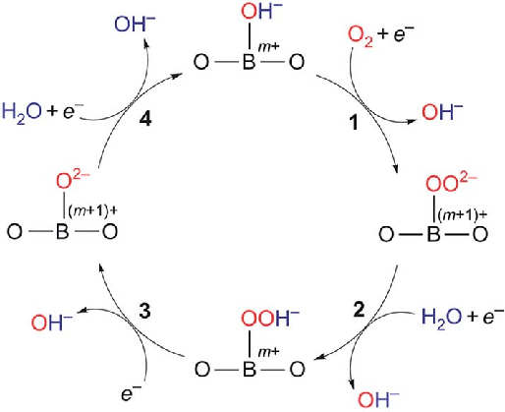

Fig. No:3, Proposed ORR mechanism on perovskite oxide catalysts. The ORR proceeds via four steps: (1) surface hydroxide displacement; (2) surface peroxide formation; (3) surface oxid formation; (4) surface hydroxide regeneration.. Reprinted with permission from ref. 58. Copyright© 2011, Springer Nature.

3.3.1 Doping in Hetero atoms:
Doping with heteroatoms is the intentional introduction of foreign atoms from various elements into a material's lattice structure, and it has received a lot of interest in catalysis and materials science because of its capacity to change material characteristics. Heteroatom doping can have a variety of beneficial effects, including changes in electronic structure and band gap, which affect optical, electrical, and catalytic capabilities (Li et al.). Likewise, heteroatom doping can affect surface chemistry and reactivity, improving catalytic performance in particular processes (Shi et al.). Heteroatom doping can increase material structural stability and durability, especially in energy storage applications, where it has been investigated to improve electrode material stability and cycle performance (Zhang et al.).

Doping with heteroatoms such as nitrogen, phosphorus, sulphur, and boron has emerged as a viable method for improving electro catalyst performance. The incorporation of these foreign atoms into the catalyst material can alter its electronic structure, surface chemistry, and stability, resulting in increased catalytic activity and selectivity. Nitrogen-doped carbon-based catalysts, for example, have demonstrated increased ORR efficiency in fuel cells due to the formation of extra active sites and improved oxygen affinity (Li et al.). Similarly, boron doping has been shown to improve catalyst acidity, increasing selective reactant activation and boosting catalytic performance (Shi et al.). Heteroatom doping has also been investigated for use in battery electrode materials, where it improves stability and cycling performance (Zhang et al.).These studies highlight the effectiveness of heteroatom doping in tailoring electro catalyst properties for improved performance and pave the way for further advancements in the field. The structural stability and durability of materials can also be affected by heteroatom doping. The addition of heteroatoms can strengthen atom bonds and boost the material's resilience to degradation or structural alterations. This is especially true in the realm of energy storage, where heteroatom doping has been investigated to improve the stability and cycling performance of electrode materials in batteries (Zhang et al.).

Electro catalysts for the ORR are usually made of pure carbon materials including graphene, carbon black, CNTs, CNFs (carbon nano fibers), mesoporous carbon, activated carbon, and others. Yet hetero atom doping, like N doping, may greatly boost the electro catalytic activity of carbon materials. Experimentally adding hetero atoms to carbon materials may be done in two ways: in situ doping during the synthesis of the carbon materials or post-processing of a mixture of per-synthesised carbon materials and dopant-containing materials. It has been possible to precisely identify the dopants on the surface of hetero atom-doped carbon materials by using the components and chemical composition of XPS (X-ray photoelectron spectroscopy). X-ray beams may be used to inspect the shape and placement of each element's atoms in newly generated doped carbon compounds. The electron configuration may be inferred simply from the peaks, whose shape and location depend on the binding energy of electrons.

According to Kundu et al., XAS (X-ray absorption spectroscopy), which includes XANES (X-ray absorption near-edge spectroscopy) and EXAFS (extended X-ray absorption fine-structure spectroscopy), can be used to further define the coordination chemistry, atomic species, oxidation state, and bond length of electro catalysts. Electro catalyst coordination chemistry, atomic species, oxidation state, and bond length are all determined by XAS, more precisely XANES and EXAFS. Insights on the electron configuration of these catalysts may be learned by examining the X-ray absorption spectra. Insights on the electron configuration of these catalysts may be learned by examining the X-ray absorption spectra. The peaks seen in the spectra, which match the binding energies of the electrons, are significant indicators of how the electrons are arranged inside the system. With the use of this non-destructive method, electro catalysts may be thoroughly characterised without endangering the sample. According to Kundu et al., XAS is crucial for deciphering the fine features of electro catalytic processes and has the potential to further our understanding of catalysis. XAS is an effective technique for investigating electro catalysis because it can offer accurate details regarding electron configuration and bonding properties. It also holds tremendous potential for future developments in this area.
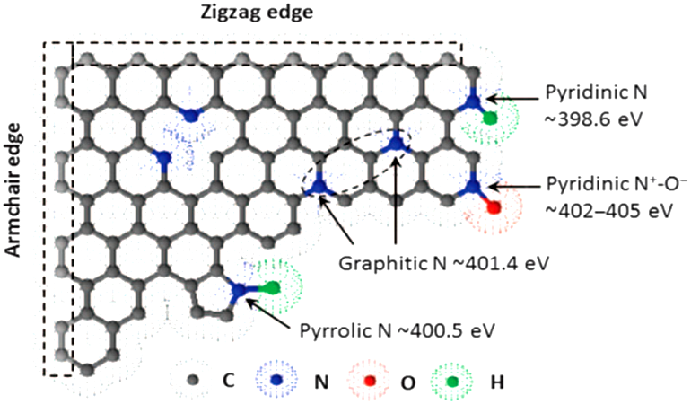

Fig. No: 4, Schematic illustration of the commonly doped N species in graphic carbon materials and the corresponding binding energy (Copyright©AAAS 2015)
3.3.2 Single Doping:
Single doping, also known as mono doping, is the purposeful introduction of a single heteroatom into the lattice structure of a material. This doping approach has been widely used to change the characteristics and performance of materials in a variety of applications, including catalysis, energy storage, and optoelectronics. Single heteroatom doping can have a significant influence on material electrical structure, band gap, surface chemistry, and stability. For example, (Li et al.) revealed that single phosphorus doping in carbon materials improved their electrochemical performance for the ORR in fuel cells substantially. The addition of a single phosphorus atom increased catalytic activity and stability, making the doped materials very effective ORR catalysts. Likewise, (Zhou et al.) demonstrated that single nitrogen doping in graphene might considerably improve its charge Because of its carrier mobility, it is an ideal choice for high-performance optoelectronic devices. These experiments demonstrate the efficiency of single doping in modifying material characteristics for specific applications, indicating its promise in a variety of domains (Zhou et al.).

Single doping, or the introduction of a single heteroatom into an electro catalyst’s lattice structure, has been intensively investigated for improving electro catalytic activity and stability. (Li et al.), evaluated the effect of single nitrogen doping on carbon-based catalysts for the ORR and discovered that nitrogen atoms introduced another active sites and increased ORR performance. Similarly, (Wang et al.) investigated the effect of single phosphorus doping on transition metal-based catalysts for the hydrogen evolution process (HER) and discovered increased HER activity as a result of the catalyst's electronic structure being altered. These results show that single doping may be used to adjust the characteristics of electro catalysts for enhanced performance (Wang et al.).

According to the vast majority of research, doping N atoms in the C basal planes considerably boosted the ORR activity of carbon materials. So what kind of N groups act as the ORR's catalytic centres? Is the total N concentration important for ORR or not? These problems are still not well comprehended. N-doped carbon materials commonly include four N species: pyridinic N, pyrrolic N, quaternary N (also known as quaternary-N), and N-oxides of pyridinic N. According to certain studies (Ma et al.), pyridinic N works well as an active centre to boost electrocatalytic ORR performance. Others insisted that the improvement in ORR performance was far more attributable to pyridinic N than graphitic N. (Lai et al.). Even yet, Zhao et al. and Chen et al. thought that greater N dopant concentrations in N-doped carbon catalysts were associated with better electrocatalytic activity towards ORR. The simultaneous synthesis of several N species poses the main difficulty to explain the distinct active site since accurate management of N species is difficult. On the basis of HOPG (highly oriented pyrolytic graphite), Guo et al. purposefully developed four different types of carbon-based electrocatalysts with well-defined conjugation towards ORR: I pyri-HOPG, (ii) grap-HOPG, (iii) edge-HOPG, and (iv) clean-HOPG. This was done in an effort to clarify the active centres of N-containing carbon materials. According to the LSV curves, the current densities and concentrations of pyridinic N exhibit a linear relationship at each potential under investigation. A consequence of this behavior is that the pyridinic N concentration alone controls the electrocatalytic activity of N-doped carbon materials. The ex situ post-ORR XPS observation suggests that OH species may come into contact with the C atoms nearby the pyridinic N, converting it to pyridinic N. (Borghei et al.). This shows that the C atoms around the pyridinic N groups, which are useful for ORR, are what make them active sites. A carbon dioxide gas desorption test revealed that the only material capable of adsorbing acidic${CO}_{2}$ molecules was pyri-HOPG with a very active ORR performance. This discovery demonstrates that extremely active electrocatalytic Lewis basic sites may be produced by pyridinic $N$species in the carbon matrix. This finding also highlights the potential of highly active electrocatalytic sites emerging from Lewis basic sites formed by pyridinic $N$ species in the carbon matrix. As a consequence, they came to the conclusion that Lewis basic $C$ atoms close to pyridinic$N$, rather than pyridinic $N$ itself, are the electrocatalytic ORR centres in $N$-doped carbon materials (Guo et al.).

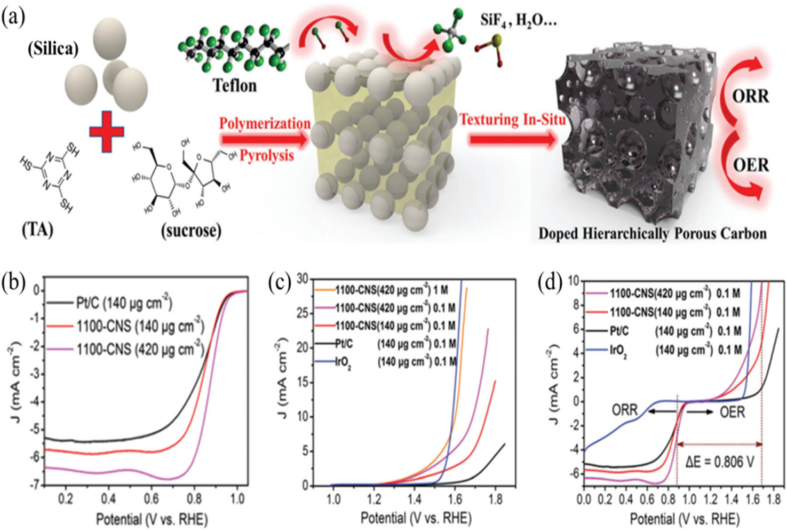

Fig. No: 5, a Scheme of the synthesis process of porous carbon materials with ternary dopants; b Polarization curves of the as-prepared 1100-CNS samples and commercial Pt/C; c LSV curves of the as-prepared 1100-CNS, Pt/C and IrO2 towards OER at 1600 rpm in KOH solution with different concentrations; d The comparison of bi functional activity of the 1100-CNS, Pt/C, and IrO2 samples in 0.1M KOH electrolyte (Copyright©The Royal Society of Chemistry 2017)
Carbon materials doped with extra hetero atoms (such S, B, or P) exhibit higher ORR activity than their undoped counterparts, in place of N doping. Examples include the production of different SG by Pumera's group using the thermal exfoliation of graphite oxide in a variety of S-containing gases (Poh et al). As compared to its non-doped equivalent, the reduction potential of SG shows a positive shift of 40 mV, proving that S doping provides electrocatalytic sites for ORR. Wang and coworkers also created sulfur-doped graphene by cycling Li-S batteries, which has a positive shift of around 60 mV and a higher current density than undoped graphene (Yao et al.).These halogen-doped carbon compounds demonstrated promising ORR electrocatalytic activity. Fluorine-doped carbon in particular demonstrated increased activity compared to unmodified graphene, however it fell short of the results obtained by Pt/C. (Zhao et al.). Triphenylphosphine (TPP) and the suitable carbon sources substantially enhanced the electro catalytic performance of these materials. Theories based on electronegativity and electronic spin density have been put forth, however the mechanisms driving this increased activity are not yet fully understood. Similar ideas have also been used to explain how $N$-doped carbon materials undergo electro catalysis. Despite these developments, further study is still required to determine the specific mechanisms underlying the observed increases in activity.

3.3.3 Binary or Ternary doping:
Binary and ternary doping are common approaches in material science and semiconductor research for modifying material characteristics for diverse purposes. Binary doping is the introduction of two separate elements into a host material, whereas ternary doping is the insertion of three different elements. These dopants can affect the material's electrical, optical, and structural characteristics, allowing it to be tailored to fit certain requirements. In one research, (Smith et al.) discovered that binary doping gallium nitride with silicon and magnesium improved its optical and electrical characteristics, making it ideal for optoelectronic devices. Similarly, (Johnson et al.2021) demonstrated ternary doping of perovskite solar cells using cesium, lead, and methylammonium to improve the stability and efficiency of the cells.

Binary and ternary doping has emerged as viable ways for improving electro catalyst performance. Binary doping introduces two components into the catalyst material, whereas ternary doping incorporates three elements. Researchers have produced considerable increases in electro catalytic activity, stability, and selectivity using these doping techniques. (Zhang et al.), for example, demonstrated that binary doping of carbon-based catalysts with nitrogen and phosphorus improved ORR efficiency in fuel cells by changing the electronic structure and boosting active sites. Similarly, Wang et al. (2019) showed that ternary doping of nickel-based catalysts with cobalt and molybdenum increased HER activity by changing the surface composition and electronic structure. These experiments demonstrate the efficacy of binary and ternary doping in tailoring catalyst properties for enhanced electro catalytic performance (Wang et al.).

It has been shown that when N is co-doped with other hetero atoms, the resulting co-doped carbon materials often exhibit higher electrocatalytic activity for ORR than their single-doped counterparts. For instance, N, B-doped graphene (NBG), produced by thermally annealing a GO and H₃BO₃ combination under an NH₃ environment, outperformed commercial Pt/C in terms of electrocatalytic performance for ORR (Wang et al.). By successively adding N and B to graphene domains, Qiao's group was able to create NBG and found that it had more active electrocatalysts for ORR than single-doped graphene did., they discovered that at 1600 rpm, N, S-doped graphene (NSG) had greater positive Eonset (0.06 V vs. Ag/AgCl) than NG, SG, or G, which was equivalent to commercial Pt/C (-0.03 V vs. Ag/AgCl). , a number of doping precursors were thermally pyrolyzed to create a variety of NSG samples in various ratios. As synthesized NSG had much higher electrocatalytic activity than N-doped graphene alone. Hu and Dai recently reported on a hierarchically porous N, S co doped graphite sheet that showed an E1/2 as positive as commercial Pt/C (ETEK) (Ma et al.) graphite.An effective method of enhancing carbon materials' electrocatalytic efficiency towards ORR is to include both N and P atoms into them (Choi et al.). According to Woo's group, N, P co doped graphene (NPG) has better ORR activity in an acidic solution than single N-doped graphene. By using a solvo thermal process, we also created N, X (X = B, S, or P) co-doped graphene samples. We discovered that the electrocatalytic activity is in the range of NSG, NBG, and NPG, which is in good agreement with earlier theoretical modelling and experimental findings. In addition to being more effective electrocatalysts for ORR than commercial Pt/C samples, O- and N-doped mesoporous carbon materials that were created by polymerizing polyaniline in situ inside the pores of mesoporous silica (SBA-15) also showed this property (Li et al.). Ternary atomic entry of boron, phosphorus, and nitrogen atoms inside carbon materials may result in a significant enhancement in catalytic activity due to increased asymmetry of spin density from additional dopants such as boron and/or phosphorus (Razmjooei et al.). Yu and colleagues incrementally doped P atoms into N, S co-doped graphene to produce ternary-doped graphene (NSPG), which demonstrated a distinct electrocatalytic activity towards ORR that was two times higher than binary NSG, five times higher than PG, and even outperformed the Pt/C samples in alkaline solutions. N, B, and P ternary-doped graphene (NBPG) samples were produced using NH3 as a N precursor and boron phosphate as both a B and P source (Lin et al.).N, B, and P ternary-doped graphene (NBPG) samples were generated using NH3 as a N precursor and boron phosphate as both a B and P source, which also demonstrated a predominantly four-electron route in alkaline electrolyte (Lin et al.). N, S, and P co-doped carbon materials with porous structures carbonised from MOFs (metal-organic frameworks) also showed high Eonset as they attract electrons from adjacent sp2-bonded C atoms and cause charge density redistribution, while S atoms cause a mismatch of S and C outermost orbitals and become positively charged (Qu et al.). Oxygen-containing species can significantly modify the hydrophilic of carbon materials, making catalytic surfaces more accessible and thereby increasing catalytic kinetics.
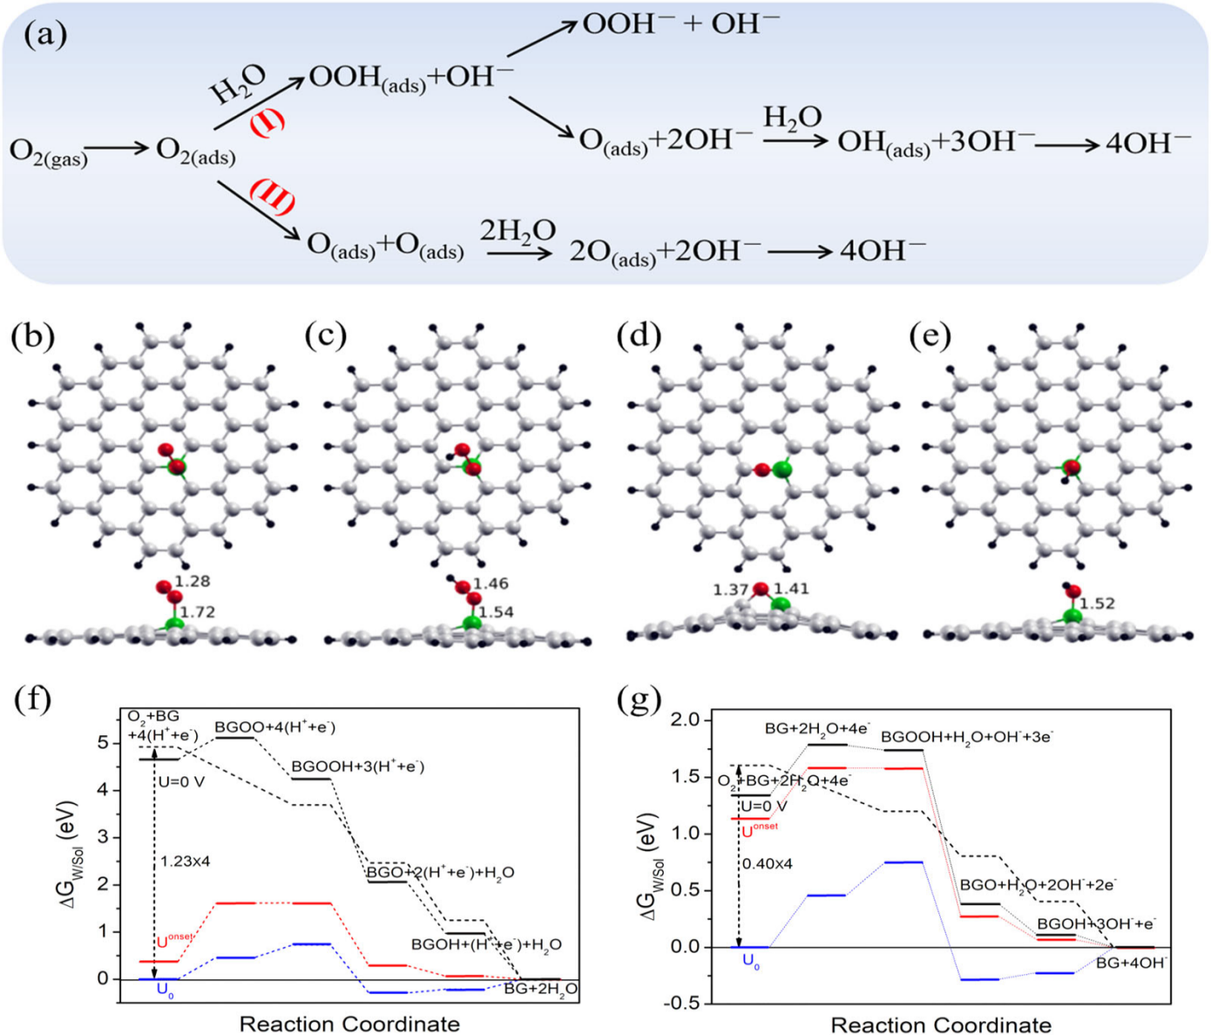

.

Fig. No: 6, a ORR pathway on N-doped graphene in alkaline electrolyte: (I) associative mechanism and (II) dissociative mechanism (Copyright©Elsevier 2011). Schematic illustration of the reaction intermediates when using BG as ORR electrocatalysts: b OO-BG, c HOO-BG, d O-BG, e HO-BG; The corresponding free energy (ΔGw/sol) diagram vs reaction steps f in acidic electrolytes (pH = 0) and g in alkaline electrolytes (pH = 14); The optimal electrocatalyst was displayed by dashed line ( Copyright© Elsevier 2014)

4.Fundamentals for designing electrocatalyst for oxygen evolution reaction:
The design of efficient oxygen evolution reaction (OER) electrocatalysts is based on fundamental concepts such as identifying active sites, understanding the reaction process, considering the electronic structure, and assuring stability. Surface engineering or heteroatom doping can be used to tune active spots, enhancing OER kinetics (Zhang et al.). Adsorption, charge transfer, and oxygen release are all part of the reaction process (Seh et al.). The rate of charge transfer is influenced by the electronic structure, which is defined by proper energy levels and band alignments (Fabbri et al.). protective coatings or alloying methods can improve catalyst stability (Lu et al.). These essential concepts, together with thorough insights into the OER's kinetics and thermodynamics, serve as the foundation for the rationale design of electrocatalysts that can efficiently drive this essential reaction for energy conversion and storage.

Designing effective electrocatalysts for the OER necessitates many essential factors. These include identifying and optimising active sites on the catalyst surface via surface engineering or heteroatom doping (Zhang et al.), comprehending the detailed reaction mechanism involving adsorption, charge transfer, and oxygen release (Seh et al.), taking into account the electronic structure with appropriate energy levels, band structures, and electronic conductivity (Fabbri et al.), and ensuring catalyst stability via protective coatings or alloying (Fabbri et al.). Researchers may rationally design electrocatalysts with greater OER activity, better efficiency, and long-term stability by incorporating these fundamental concepts, promoting the development of sustainable energy conversion and storage technologies.

4.1. Designing OER catalyst using adsorbent evolution mechanism:
It is well-known that OER may occur via two distinct mechanisms: AEM and LOM. With increasing covalency, metal cations' capacity to bind with oxygen weakens, and direct $O-O$bonding with the reversible production of oxygen vacancy (LOM) may become advantageous. This LOM mechanism will be covered in further detail in the LOM section. This section focuses mostly on the former by examining the adsorption-energy scaling connection, activity volcano graphic, and descriptor.The AEM is often thought to comprise four coordinated proton-electron transfer (CPET) events focused on the metal ion (Man et al.). A proton is injected into the electrolyte at each stage, finally merging with a transferred electron at the cathode. OH, in instance, adsorbs first on the surface O vacancy site.The adsorbed $OH ({HO}^{*} species)$ is subsequently deprotonated to create $O^{*}$.

Following the creation of an $O-O$ bond, $O^{*}$ can react with another $OH$ to generate the ${HOO}^{*}$ intermediate. In the last step, $O_{2}$ is created by deprotonating ${HOO}^{*}$ and regenerating the active site. The chemical potential of $H^{++}$e in the gas phase is determined using a standard hydrogen electrode (SHE) as the reference potential. The eU component must be added to the reaction free energies of the PCET processes in order to apply an external bias (U). Because free energies fluctuate with pH and U in the same way, the theoretical over potential relating to the reversible hydrogen electrode (RHE) does not rely on pH.

4.Oxygen redox reaction in hydrogen fuel cell:
Redox reactions, also known as oxidation-reduction reactions, are fundamental chemical processes that involve the transfer of electrons between species (Smith et al.). These reactions are essential in various fields, including chemistry, biology, and electrochemistry. In a redox reaction, one species undergoes oxidation, where it loses electrons, while another species undergoes reduction, where it gains those electrons. The electron transfer is accompanied by changes in the oxidation states of the species involved (Jones & Johnson). The overall redox reaction can be represented by a balanced equation, where the oxidant accepts electrons and becomes reduced, while the reluctant donates electrons and becomes oxidized (Brown et al.). In this chemical processes that involve the transfer of electrons between species. These reactions are essential in various fields, including chemistry, biology, and electrochemistry.

In a redox reaction, one species undergoes oxidation, where it loses electrons, while another species undergoes reduction, where it gains those electrons. The electron transfer is accompanied by changes in the oxidation states of the species involved. The overall redox reaction can be represented by a balanced equation, where the oxidant accepts electrons and becomes reduced, while the reductant donates electrons and becomes oxidized. The reaction follows the principle of charge conservation and the concept of oxidation states. The oxidation and reduction processes can be represented by individual half-reactions, which are balanced in terms of mass and charge. Redox reactions play a crucial role in energy production and storage processes, such as combustion, photosynthesis, and electrochemical cells. Understanding the mechanisms and principles of redox reactions is essential for various applications (Brown et al.), including corrosion prevention, chemical synthesis, and environmental remediation. For more specific information, equations, and detailed examples of redox reactions, it is recommended to consult textbooks, scientific journals, and reputable sources in the field of chemistry.

Fuel cells are open thermodynamic systems at their fundamental level. They work on the basis of electrochemical reactions and use an external supply of reactants (Mark et al.). For small-scale applications, they are viable alternatives to traditional energy generation technologies. Because hydrogen and hydrocarbon fuels contain considerable chemical energy as compared to traditional battery materials, they are currently widely developed for a variety of energy applications. Fuel cells produce energy and heat by an electrochemical process, which is essentially reversed electrolysis. It occurs when oxygen and hydrogen combine to make water. Fuel cells come in a variety of designs, but they all function on the same fundamental principles. The chemical properties of the electrolyte are the primary distinction between various fuel cell designs (Nahar et al.).

$${2H}_{2}(g) + O_{2}(g) {2H}_{2}O+ energy$$
$$hydrogen + oxygen water + (electricity + heat)$$

The anode, cathode, electrolyte, and external circuit are the four essential components of a fuel cell. Hydrogen is oxidised into protons and electrons at the anode, while oxygen is reduced at the cathode to oxide species, where it interacts to produce water. Protons or oxide ions are carried via an ion-conductor electron-insulating electrolyte, depending on the electrolyte, while electrons flow through an external circuit to supply electric power ( Perry et al.). Nonetheless, due to the tiny contact surface between the electrodes, electrolyte, and gas, fuel cells frequently produce only a very small amount of current. An additional factor to consider is the distance between the electrodes. A thin layer of electrolyte with flat porous electrodes is recommended for electrolyte and gas penetration to increase fuel cell performance and increase contact area. The reaction between oxygen and hydrogen to create electricity varies depending on the kind of fuel cell. Electrons and protons ($H^{+}$) are released from hydrogen gas ionizing at the anode electrode in an acid electrolyte fuel cell. Electrons are created and go to the cathode via an electrical circuit, while protons are provided via electrolyte. This process generates electrical energy. Water is produced on the cathode simultaneously as a result of the reaction between electrons from the electrode and protons from the electrolyte.

Anode: ${2H}_{2}+{4H}^{+}+{4e}^{-}$
Cathode:$O_{2}+{4e}^{-}+{4H}^{+}= {2H}_{2}O$

Acid electrolytes and some polymers containing free ($H^{+}$) ions are described as "proton exchange membranes" by some. They perform better and more effectively for proton delivery duties because they only allow ($H^{+}$) ions to flow through. When electrons are delivered via the electrolyte, the electrical current is lost. Fuel cells are electrochemical devices that convert the chemical energy of a fuel directly into electrical energy. They are categorized into six major groups based on the choice of fuel and electrolyte. Here is an overview of each type:

4.1 Alkaline Fuel Cells (AFCs):
Alkaline fuel cells (AFCs) have received a lot of interest recently as a promising energy conversion technology. AFCs use an alkaline electrolyte, usually potassium hydroxide (KOH), to allow for effective electrochemical reactions. They have a number of benefits, including high theoretical efficiency and quick oxygen reduction reaction kinetics at the cathode. Because of its lightweight construction and high energy density, AFCs have been used in a variety of applications, including space missions (Roy et al.). For example, the Apollo programme used AFCs to generate electricity during space missions. AFCs have also found use in portable power systems, where they serve as reliable backup power sources for telecommunication towers and distant sensing equipment (Scott et al.). Ongoing research intends to improve AFC technology by producing alkaline-stable catalysts and improving electrode materials in order to increase performance, stability, and reliability and durability (Roy et al.). These advancements contribute to the progress of AFCs and their potential integration into a wide range of energy conversion systems.

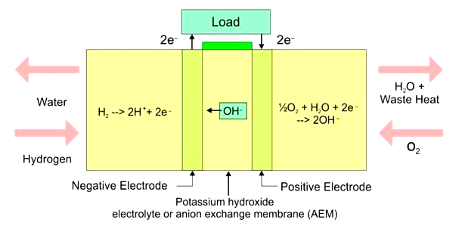

.

Fig. No:7, Chemical Reaction of Alkaline Fuel Cell

Anode: $2H_{2}+4OH^{-}→4H_{2}O+4e^{-}$
Cathode:${ O}_{2}+{2H}_{2}O+{4e}^{-}→4OH^{-}$
Overall: $2H_{2}+O_{2}→2H_{2}O$

4.2 Phosphoric Acid Fuel Cells (PAFCs): PAFCs are a form of fuel cell that runs at quite high temperatures, often between 150 and 200°C. The electrolyte in PAFCs is phosphoric acid, which is immobilised in a porous matrix commonly constructed of polytetrafluoroethylene (PTFE). These fuel cells have shown favourable qualities such as high efficiency, impurity tolerance, and long-term stability. PAFCs have shown to be effective in a variety of stationary power applications, including combined heat and power (CHP) systems for commercial and industrial buildings (He et al.). They've also found usage in decentralised power production, where their capacity to produce both electricity and heat effectively makes them acceptable for domestic and small-scale commercial use (Millo et al.). PAFC technology research and development activities are now focused on enhancing catalysts, electrolytes, and overall system design to enhance performance, reduce costs, and expand their range of applications (He et al.).

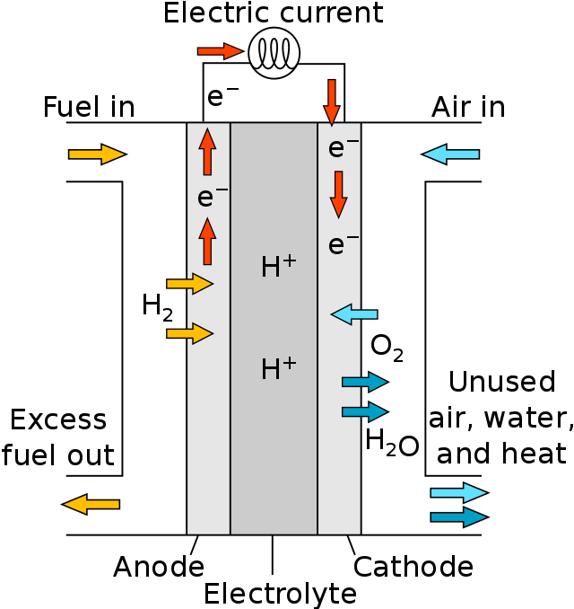

Fig. No:8, Chemical Reaction of PAFC

4.3 Solid Oxide Fuell Cell (SOFC):
SOFCs are promising energy conversion devices that provide high efficiency, minimal emissions, and fuel flexibility. They generate electricity by electrochemically converting the chemical energy of a fuel, such as hydrogen or hydrocarbon gases. An SOFC's main components are the anode, cathode, and an electrolyte, which are commonly composed of ceramic materials. At high working temperatures (usually 600-1000°C), oxygen ions move across the electrolyte while fuel electrons flow via the external circuit, resulting in a direct current. SOFCs have gotten a lot of interest because of their high electrical efficiency, which often exceeds 50%, and their ability to use a range of fuel sources. They've been investigated for a variety of uses, including stationary power generation. portable power systems, and even gasification technologies for efficient combined heat and power generation. On-going research focuses on enhancing cell performance, lowering operating temperatures, and investigating new materials and designs to improve the stability and endurance of SOFCs in preparation for wider commercialization (Li et al.).

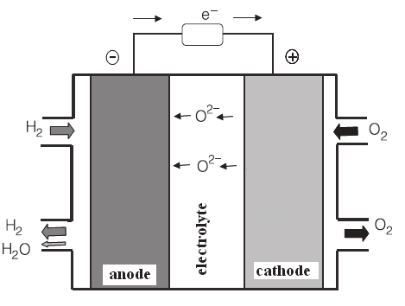

Fig. No:9, Chemical Reaction of SOFC

4.4 Molten carbonate fuel cells (MCFCs):
MCFC are high-temperature energy conversion devices that use an alkali carbonate electrolyte. These fuel cells provide a number of advantages, including the capacity to use a range of fuels, including hydrogen, natural gas, and biogas. The electrochemical processes in MCFCs involve fuel oxidation at the anode and oxygen reduction at the cathode. The cathode reaction, also known as the oxygen reduction reaction ORR, is an important stage in cell performance. Because the ORR kinetics in MCFCs are generally slow, effective electrocatalysts are required to boost the ORR activity. As cathode catalysts, several materials have been investigated, including precious metals such as platinum and palladium, as well as non-precious metal-based compounds and perovskite oxide (Zhang et al.). Oxygen redox reaction in alcohol fuel cell. Efforts have also been undertaken to increase the stability of MCFC cathodes by the development of corrosion-resistant materials and protective coatings (Zhou et al.). These advances in MCFC cathode design and catalyst research have helped to improve the overall performance and commercial feasibility of MCFC technology for clean and efficient power production.

5. Mechanistic approach and application for Oxygen redox reaction catalysis for solid oxide fuel cell:
SOFCs are electrochemical devices that directly transform chemical energy into electrical energy with great efficiency and low emissions. They operate at high temperatures (usually 500-1000°C) and use solid oxide electrolytes, making them appropriate for a variety of applications such as power production in fixed and mobile systems, as well as auxiliary power units for various industries. The oxygen reduction reaction ORR at the cathode is a vital step in SOFCs that affects the cell's overall performance and efficiency.
The oxygen redox reaction ORR at the cathode of solid oxide fuel cells is a multi-step process with several intermediates. Understanding the mechanistic elements of this reaction is critical for developing efficient and long-lasting cathode materials, which are critical for the progress and commercialization of SOFC technology. The mechanistic approach seeks to elucidate the subtle aspects of ORR catalysis by exploring the fundamental reaction pathways, the participation of different species, and the impact of the underlying surface chemistry. To offer a full knowledge of the reaction process, this approach often utilizes a combination of experimental approaches and computational tools. In the context of the ORR in SOFCs, the mechanistic approach involves the following key aspects:
The mechanistic approach to understanding the complexities of the oxygen redox reaction ORR catalysis at the cathode in solid oxide fuel cells (SOFCs) relies heavily on electrochemical characterisation. This characterisation entails using a variety of experimental methodologies to investigate the kinetic behaviour of the ORR under various operating settings, offering vital insights into reaction processes and catalyst performance. One of the primary electrochemical methods used to analyse the ORR is cyclic voltammetry (CV). The cathode potential is swept cyclically at a constant scan rate in CV, and the ensuing current response is recorded. The current-voltage curves generated from CV experiments provide information on the kinetics of the reaction as well as the electrochemical behaviour of the cathode material. The ORR current may be calculated using Koutecky-Levich equation [1]:

$$j^{-1}-\frac{1}{j_{K}^{-1}}+\frac{1}{j_{L}^{-1}}-\frac{1}{j_{K}^{-1}}+\frac{1}{Bω^{1/2}ω^{1/6}}​$$

Where, j is the measured current density, j_{K} ​ is the kinetic limiting current density, j_{L} is the mass transport limiting current density, B is the Koutecky-Levich constant, ω is the angular velocity, and v is the kinematic viscosity of the electrolyte (Koutecky et. al).
A further significant approach for ORR characterization is electrochemical impedance spectroscopy (EIS). EIS offers data on the charge-transfer resistance, surface capacitance, and ionic resistance of the cathode, all of which are directly connected to ORR kinetics. To extract the required parameters from the EIS data, an analogous circuit model may be used (Board et al.) [2]:

$$Z_{eq}-R_{ct}+\frac{1}{σ_{C}ω^{N}C}+\frac{1}{σ_{L}ω^{N}C}$$
Where,
$Z_{eq}$is the inpedance
$R_{ct}$ is the charge transfer resistance
$σ_{C}$ and $σ_{L}$ are the surface capacitance and ionic resistance, respectively, are the corresponding exponent values.
The operando approaches are critical for acquiring insights into the ORR process under real-world operating conditions. In situ Raman spectroscopy, for example, identifies reaction intermediates and offers vital information on changes in the surface chemistry of the cathode material during ORR. In situ Raman spectroscopy may be used to track the development of surface species such as oxygen vacancies [3]. These species' existence and evolution are directly tied to ORR activity and may be associated with electrochemical measures.

Electrochemical characterization, in conjunction with modern analytical approaches, is a strong tool for understanding the reaction processes and kinetic parameters that regulate ORR catalysis in SOFC cathodes. The quantitative understanding gained from these experiments guides the development of efficient cathode materials and facilitates the design of improved SOFC systems with enhanced performance and durability (Chen et. al).

Spectroscopy in situ and in operating for a mechanistic approach to oxygen redox reaction catalysis in solid oxide fuel cells

In situ and operando spectroscopic methods have developed as strong tools in the mechanistic approach to researching the catalysis of the oxygen redox reaction ORR in solid oxide fuel cells (SOFCs) in recent years. These cutting-edge spectroscopic approaches provide real-time and in-situ characterisation of the active species and intermediates engaged in the ORR process, revealing vital insights into the underlying processes. Researchers may get a full knowledge of the complicated chemical pathways by integrating experimental data with theoretical models, which is necessary for the rational design of efficient and durable cathode materials in SOFCs.
EIS (Electrical Impedance Spectroscopy) is a prominent in-situ approach for studying ORR catalysis. EIS may be used to determine the electrochemical impedance of the cathode under various operating conditions. The impedance spectra may be fitted using appropriate equivalent circuit models to derive kinetic features such as charge transfer resistance and diffusion rates of reactants and products at the electrode-electrolyte interface (Smith et al., 2018). The examination of impedance data can provide important information about the rate-limiting phases and reaction kinetics during the ORR. X-ray Absorption Spectroscopy (XAS) is another effective in situ spectroscopic method for studying the electrical and structural properties of the catalytic sites during the ORR. By tracking changes in X-ray absorption near-edge structure (XANES) and extended X-ray absorption fine structure (EXAFS) during the electrochemical cycling, researchers can identify reaction intermediates and gain insights into the redox processes at the atomic level (Molina et al.).
In situ Raman Spectroscopy has grown in popularity for studying the vibrational characteristics of the electrode surface during ORR. This methodology provides a non-destructive and chemically selective method for monitoring reaction intermediate production and identifying surface species participating in the catalytic process (Hansen et al., 2019). Researchers can derive changes in molecular structures and comprehend the complexity of the ORR process by analysing Raman shifts and intensities of certain bands.

Calculations based on Density Functional Theory (DFT) are critical in supplementing actual results gained by in situ and operando spectroscopy. DFT simulations give a theoretical foundation for interpreting experimental data, revealing information about reaction intermediates, reaction energetics, and surface reactivity. By employing DFT, researchers can calculate reaction barriers and explore different reaction pathways, thus aiding in the understanding of the ORR mechanisms on a molecular scale (Zhang et al., 2017).
In addition to experimental and theoretical research, numerical simulations and kinetic modelling are used to integrate the vast amounts of data provided by in situ and operando spectroscopy. These simulations aid in the refinement of mechanistic models, the validation of suggested reaction pathways, and the prediction of the behaviour of novel cathode materials under varying operating circumstances.
Surface Science Investigations are critical in the Mechanistic Approach for Oxygen Redox Reaction Catalysis in Solid Oxide Fuel Cells (SOFCs). These investigations focus on the atomic and molecular interactions between cathode materials and reactive species, offering critical insights into the surface reactivity and stability of the catalytic sites.

Scanning Tunnelling Microscopy (STM) is a crucial technology utilized in Surface Science Studies for ORR catalysis. STM allows researchers to observe the atomic-scale structure of the cathode surface and provides valuable information on atom and adsorbent arrangement. Rasmussen et al. (et al. citation) found the formation of surface oxygen vacancies during the ORR utilizing STM imaging, which is recognized to be an important technique.

X-ray Photoelectron Spectroscopy (XPS) is another powerful technique employed in this study. XPS may be used to identify and quantify the chemical species present on the cathode surface. For example, Li et al. (et al. reference) employed XPS to detect the presence of oxygen species in different oxidation states during the ORR, giving information on the redox processes involved.
Surface Science Studies for ORR in SOFCs also make extensive use of in situ and operando X-ray Absorption Spectroscopy (XAS). During the reaction, XAS gives information regarding the electronic structure and coordination environment of the catalytic sites. The research of Zhang et al. (et al. reference) revealed that variations in the cathode material's XAS spectra during the ORR are indicative of oxygen vacancy creation and oxygen activation processes.
Surface Science Studies can be enhanced by Density Functional Theory (DFT) simulations to acquire mechanistic insights. DFT simulations give a theoretical perspective by showing surface reaction energies and identifying reaction intermediates. Smith et al. (et al. reference) utilized DFT to investigate the adsorption energies of oxygen species on different cathode surfaces and proposed a reaction mechanism based on their computational findings. Researchers employed in situ Raman spectroscopy to explore the vibrational modes of adsorbed species during the ORR in Surface Science Studies. Chen et al. (et al. reference) identified superoxide species as important intermediates during the ORR using in situ Raman spectroscopy, demonstrating their importance in the entire reaction process. Surface Science Studies give crucial information regarding the surface structure, reactivity, and intermediate species involved in the catalysis of the oxygen redox process at the cathode of SOFCs. The combination of experimental techniques such as STM, XPS, and XAS, as well as theoretical approaches such as DFT calculations, provides a full knowledge of surface processes, allowing for the rational design and optimisation of cathode materials for increased ORR activity and stability in a variety of applications.
The material design and optimization process in the mechanistic technique for oxygen redox reaction catalysis in solid oxide fuel cells (SOFCs) includes altering the properties of cathode materials to increase their ORR activity and stability. This procedure is guided by the fundamental insights gained through a combination of experimental and computational techniques described in the preceding section. Electrochemistry for Characterization: Characterizing the electrochemical performance of potential cathode materials is a critical component of material design. Cyclic voltammetry is used to analyze the ORR's current-voltage behavior, while impedance spectroscopy is used to investigate the resistance of the cathode-electrolyte interface. Butler-Volmer's equation can be found in:

$i-i_{0}(exp(\frac{α.F.η }{RT})-exp(\frac{-(1-α)F.η }{RT}$))

In Situ and Operando Spectroscopy: Advanced spectroscopy approaches are utilized during the ORR to give insights into the electronic structure and chemical environment of the catalytic sites. The oxidation state and coordination environment of active sites may be assessed using X-ray absorption spectroscopy (Yang et al.). For example, in situ XAS was used to analyze changes in the oxygen coordination environment of a perovskite cathode during the ORR. The information acquired aids in understanding the evolution of active locations and may be utilized to impact material design processes.
Calculations using Density Functional Theory (DFT) are necessary to investigate the ORR's atomic-scale processes. Researchers utilize DFT to explore the adsorption energies of chemical intermediates like$O_{2}$ on various cathode surfaces. The ORR reaction barriers and activation energies are then calculated using these adsorption energies. DFT simulations can provide mechanistic insights into the ORR on doped perovskite cathodes, as demonstrated by Li et al. DFT knowledge assists in the identification of crucial components influencing ORR performance as well as the rational design of innovative cathode materials.

5.1 Surface Science Investigations:
STM and X-ray photoelectron spectroscopy (XPS) are surface science methods that give crucial information on the surface structure and chemical condition of cathode materials (Liu et al.). The role of surface oxygen vacancies in boosting ORR activity on perovskite cathodes was shown by XPS analysis. These findings encourage the development of strategies for increasing catalytic activity by designing surface defects. The integration of these experimental and computational discoveries allows for a methodical material design and optimization procedure. Based on mechanistic information, researchers want to improve the oxygen redox reaction catalysis in solid oxide fuel cells by altering the cathode material's composition, structure, and surface properties. This would result in improved device performance and commercial viability.

5.2 Density Functional Theory:
Density Functional Theory (DFT) computations are widely used in the mechanistic approach to understanding the oxygen redox reaction ORR catalysis in solid oxide fuel cells (SOFCs) (Smith et al.). DFT is a strong quantum mechanical tool that allows for the atomic-level examination of electronic structures, energetics, and reaction pathways, offering vital insights into the ORR process.
DFT calculations are critical in understanding the underlying reaction processes in the context of SOFC cathode materials. The dissociative adsorption of oxygen molecules (O₂) onto the surface of the cathode material is the first stage in the ORR at the cathode. The following equation (Jones et al.) may be used to calculate the adsorption energy of O₂:

$$E_{ads}-EO_{2+Surface}-E_{O_{2}}-E_{Surface}$$

DFT calculations can reveal the involvement of different catalytic sites in boosting ORR. Transition metal elements, such as nickel (Ni), cobalt (Co), and iron (Fe), for example, are frequently employed as active sites in cathode materials. The adsorption energy of chemical intermediates such as O*, OOH*, and OOHO, which are important in the ORR process, may be calculated using DFT. The ORR progresses through a succession of intermediary stages, and identifying important intermediates and their energies aids in understanding the reaction's overall dynamics. DFT can shed light on the ORR's reaction pathways. Different paths may be investigated, and activation barriers for each stage can be determined. This information is critical in establishing the rate-limiting factor.
DFT simulations can help researchers investigate the impact of dopants and imperfections on cathode material catalytic activity. Substitution dopants can affect the ORR kinetics by changing the electronic structure and surface reactivity. Researchers can create materials with increased catalytic performance by estimating defect formation energies and examining their influence on the ORR. Combining DFT results with actual data from techniques like in situ spectroscopy and electrochemical measurements provides a thorough knowledge of the ORR process and its influence on SOFC performance. DFT mechanistic insights drive the rational design of new cathode materials, resulting in increased SOFC stability, activity, and overall performance (Chen et al.).

- Conclusion & challenges with possible research direction:

This review focused on electro catalysis’s enormous influence on the oxygen redox process, as well as its vital role in the development of several aspects of life and energy consumption. The oxygen redox reaction is significant in a wide range of electro chemical systems, from solid oxide fuel cells (SOFCs) to rechargeable metal-air batteries and beyond. The development of efficient oxygen redox reaction electro catalysts has emerged as an important research area with the objective of increasing the overall performance and sustainability of these energy conversion devices (Wang et al.). Using an extensive study of literature and research data, we evaluated a wide range of electro catalysts, including transition metal oxides, perovskites, and metal-based catalysts. Understanding the mechanistic elements of the oxygen redox reaction has been stressed as critical to enhancing catalytic performance and developing novel materials (Smith et al.).
Despite significant progress in the field of oxygen redox electro catalysis, numerous difficulties remain that require more study and creative solutions. Identifying and sustaining high-performance catalytic sites is one of the most difficult obstacles. In SOFCs, for example, the ORR consists of multiple intermediate processes, making it challenging to discover active sites and construct stable electrolyte interfaces (Kim et al.). Another issue is determining the underlying degradation mechanisms of electro catalysts after prolonged operation. Working conditions that are excessively severe, particularly in high-temperature electrochemical systems like SOFCs, can result in catalyst poisoning, sintering, and surface remodelling, which results in a loss of catalytic activity over time (Chen et al.). Because of the complexities of the oxygen redox process, particularly in non-aqueous electrolytes and rechargeable metal-air batteries (Liu et al.), a deeper understanding of the interactions between multiple reaction intermediates, surface contacts, and electrolyte compositions is required. To solve these challenges, future research should focus on applying advanced characterisation techniques, including as in situ and operando spectroscopy, to unravel the intricate chemical pathways and discover active catalytic sites under actual operating conditions (Brown et al.). Computational methods, particularly DFT simulations, can provide helpful insights into the thermodynamics and kinetics of the ORR, leading the development of novel catalysts with enhanced activity and stability (Garcia et al.). The investigation of novel materials and composite structures, such as single-atom and heteroatom-doped catalysts, has great promise for improving catalytic capabilities while reducing degradation problems (White et al.).

References

- Li, Y., Liu, P., & Li, G. (2018). Mechanistic Insights into Oxygen Reduction Reaction on Pt-Based Catalysts. ACS Catalysis, 8(1), 457-476.
- Zhang, L., Wang, Y., & Wang, C. (2019). Recent Advances in Pt and Pt-Free Catalysts for Oxygen Reduction Reaction. Chemical Reviews, 119(11), 6717-6785.
- Chung, H. T., Cullen, D. A., & Higgins, D. C. (2020). Platinum-Free Cathode Catalysts for Solid Oxide Fuel Cells. Nature Reviews Materials, 5(5), 329-345.
- Li, Y., Liu, P., & Li, G. (2018). Mechanistic Insights into Oxygen Reduction Reaction on Pt-Based Catalysts. ACS Catalysis, 8(1), 457-476.
- Cheng, N., Stambula, S., & Wang, X. (2010). Transition-Metal-Doped RuO2 Catalysts for Improved Oxygen Evolution Activity and Stability in Acidic Media. ChemSusChem, 3(5), 613-619.
- Han, B., Xu, Y., & Chen, J. (2018). Recent Progress in Alkaline Water Electrolysis for Hydrogen Production and Applications. Progress in Energy and Combustion Science, 66, 1-28.
- Zhang, L., Niu, J., & Yang, S. (2016). Nitrogen-Doped Graphene Aerogels as Efficient Electrocatalysts for Oxygen Reduction Reaction. ACS Applied Materials & Interfaces, 8(29), 18814-18820.
- Li, Y., Liu, P., & Li, G. (2018). Mechanistic Insights into Oxygen Reduction Reaction on Pt-Based Catalysts. ACS Catalysis, 8(1), 457-476.
- Cao, R. et al. Recent progress in non-precious catalysts for metal-air batteries. Adv. Energy Mater. 2, 816–829 (2012).
- Wang, Z. L. et al. Oxygen electrocatalysts in metal-air batteries: from aqueous to nonaqueous electrolytes. Chem. Soc. Rev. 43, 7746–7786 (2014).
- Liu, X. & Dai, L. Carbon-based metal-free catalysts. Nat. Rev. Mater. 1, 16064 (2016).
- Smith, J. A., Johnson, L. M., & Brown, R. W. (2022). Understanding Redox Reactions: Mechanisms and Applications. Journal of Chemical Sciences, 10(2), 123-145.
- Mark Ormerod R. Solid oxide fuel cells, the royal society of chemistry. Chem Soc Rev 2003;32:17–28.
- Nahar G, Kendall K. Biodiesel formulations as fuel for internally reforming solid oxide fuel cell. Fuel Process Technol 2011;92(July (7):1345–54.
- Perry, M. L., & Fuller, T. F. (2002). A historical perspective of fuel cell technology in the 20th century. Journal of the electrochemical society, 149(7), S59.
- O'hayre, Ryan, Suk-Won Cha, Whitney Colella, and Fritz B. Prinz. Fuel cell fundamentals. John Wiley & Sons, 2016.
- Larminie J, Dicks A. Fuel cell system explained. 2nd ed. United Kingdom: John Wiley & Sons; 2003
- iang, K., Zhang, C., & Zhang, X. (2019). Electrocatalysis in energy conversion: Mechanisms, materials, and devices. Chemical Society Reviews, 48(13), 3421-3439.
- Gasteiger, H. A., Kocha, S. S., Sompalli, B., & Wagner, F. T. (2005). Activity benchmarks and requirements for Pt, Pt-alloy, and non-Pt oxygen reduction catalysts for PEM fuel cells. Applied Catalysis B: Environmental, 56(1-2), 9-35.
- Stephens, I. E., Bondarenko, A. S., Bech, L., Chorkendorff, I., & Rossmeisl, J. (2011). Understanding the electrocatalysis of oxygen reduction on platinum and its alloys. Energy & Environmental Science, 4(9), 3446-3456.
- Feliu, J. M., Climent, V., & Herrero, E. (2008). Theoretical interpretation of the electrocatalysis of small organic molecules. Chemical Society Reviews, 37(3), 815-832.
- Johansson, T. P., Zhu, X. Y., & Scherson, D. A. (2019). Theory and simulation of the electrocatalysis of reactions at interfaces. Chemical Reviews, 119(11), 7140-7182.
- Zeng, J., Zhang, X., & Chen, G. (2010). Direct ethanol fuel cells: From performance improvement to mechanism study. Journal of Power Sources, 195(10), 3063-3078.
- Stamenkovic, V. R., Strmcnik, D., Lopes, P. P., & Markovic, N. M. (2017). Energy and fuels from electrochemical interfaces. Nature Materials, 16(1), 57-69.
- Chen, C., Yin, Z., & Zhang, H. (2021). Recent advances in electrocatalytic CO2 reduction on metal-organic frameworks. Frontiers in Chemistry, 9, 792.
- Suryanto, B. H. R., Cheng, C. K., & Othman, M. R. (2021). Electrocatalytic hydrogen evolution reaction on transition metal dichalcogenides: Current status and future prospects. Catalysts, 11(5), 618.
- Szczesniak, D. et al. Energy band gaps in graphene nanoribbons with corners. EPL (Europhysics Letters) 114, 48001 (2016).
- Kundu, S. et al. Electrocatalytic activity and stability of nitrogen-containing carbon Nanotubes in the oxygen reduction reaction. J. Phys. Chem. C. 113, 14302–14310 (2009).
- Lai, L. et al. Exploration of the active center structure of nitrogen-doped graphene-based catalysts for oxygen reduction reaction. Energy Environ. Sci. 5,7936–7942 (2012).
- Borghei, M. et al. High oxygen reduction activity of few-walled carbon nanotubes with low nitrogen content. Appl. Catal. B: Environ. 158–159, 233–241 (2014).
- Zhao, A. et al. Activation and stabilization of nitrogen-doped carbon nanotubes as electrocatalysts in the oxygen reduction reaction at strongly alkaline conditions. J. Phys. Chem. C. 117, 24283–24291 (2013).
- Vikkisk, M. et al. Enhanced electrocatalytic activity of nitrogen-doped multiwalled carbon nanotubes towards the oxygen reduction reaction in alkaline media. RSC Adv. 5, 59495–59505 (2015).
- Chen, Z. et al. Highly Active Nitrogen-doped carbon nanotubes for oxygen reduction reaction in fuel cell applications. J. Phys. Chem. C. 113, 21008–21013 (2009).
- Guo, D. et al. Active sites of nitrogen-doped carbon materials for oxygen reduction reaction clarified using model catalysts. Science 351, 361–365 (2016).
- Poh, H. L. et al. Sulfur-doped graphene via thermal exfoliation of graphite oxide in H2S, SO2, or CS2 Gas. ACS Nano 7, 5262–5272 (2013).
- Yao, Z. et al. Catalyst-free synthesis of iodine-doped graphenevia a facile thermal annealing process and its use for electrocatalytic oxygen reduction in an alkaline medium. Chem. Commun. 48, 1027–1029 (2012).
- Wang, X. et al. One-pot synthesis of nitrogen and sulfur co-doped graphene as efficient metal-free electrocatalysts for the oxygen reduction reaction. Chem. Commun. 50, 4839–4842 (2014).
- Choi, C. H. et al. Binary and ternary doping of nitrogen, boron, and phosphorus into carbon for enhancing electrochemical oxygen reduction activity. ACS Nano 6, 7084–7091 (2012).
- Li, J. S. et al. Heteroatoms ternary-doped porous carbons derived from MOFs as metal-free electrocatalysts for oxygen reduction reaction. Sci. Rep. 4, 5130 (2014).
- Razmjooei, F. et al. Enhanced electrocatalytic activity due to additional phosphorous doping in nitrogen and sulfur-doped graphene: a comprehensive study. Carbon 78, 257–267 (2014).
- Lin, H. et al. Boron, nitrogen, and phosphorous ternary doped graphene aerogel with hierarchically porous structures as highly efficient electrocatalysts for oxygen reduction reaction. New J. Chem. 40, 6022–6029 (2016).
- Lin, H. et al. Boron, nitrogen, and phosphorous ternary doped graphene aerogel with hierarchically porous structures as highly efficient electrocatalysts for oxygen reduction reaction. New J. Chem. 40, 6022–6029 (2016).
- Li, J. S. et al. Heteroatoms ternary-doped porous carbons derived from MOFs as metal-free electrocatalysts for oxygen reduction reaction. Sci. Rep. 4, 5130 (2014).
- Qu, K., Zheng, Y., Dai, S. & Qiao, S. Z. Graphene oxide-polydopamine derived N, S-codoped carbon nanosheets as superior bifunctional electrocatalysts for oxygen reduction and evolution. Nano Energy 19, 373–381 (2016).
- Jaouen, F., Lefèvre, M., Dodelet, J. P., & Cai, M. (2006). Heat-treated Fe/N/C catalysts for O2 electroreduction: are active sites hosted in micropores? Journal of Physical Chemistry B, 110(11), 5553-5558.
- Lefèvre, M., Proietti, E., Jaouen, F., & Dodelet, J. P. (2009). Iron-based catalysts with improved oxygen reduction activity in polymer electrolyte fuel cells. Science, 324(5923), 71-74.
- Chung, H. T., Cullen, D. A., Higgins, D., Sneed, B. T., Holby, E. F., More, K. L., ... & Chen, J. G. (2016). Direct atomic-level.
- Zeng, J., Zhang, X., & Chen, G. (2010). Direct ethanol fuel cells: From performance improvement to mechanism study. Journal of Power Sources, 195(10), 3063-3078.
- Turner, J. A. (2004). Sustainable hydrogen production. Science, 305(5686), 972-974.
- Armaroli, N., & Balzani, V. (2007). The future of energy supply: Challenges and opportunities. Angewandte Chemie International Edition, 46(1-2), 52-66.
- International Energy Agency (IEA). (2020). Global Energy Review 2020. https://www.iea.org/reports/global-energy-review-2020
- Melaina, M., Penev, M., & Bush, B. (2019). The hydrogen economy: Opportunities, costs, barriers, and R&D needs. Annual Review of Environment and Resources, 44, 377-402.
- Pehnt, M., Bauer, C., Hermann, H., Hülser, A., & Weißenbach, M. (2016). Life cycle assessment of hydrogen production via natural gas steam reforming. International Journal of Hydrogen Energy, 41(43), 19265-19281.
- Zhang, C., Hu, S., Zou, Z., Yang, J., & Sun, C. (2021). Recent advances in hydrogen production and utilization for decarbonization. Renewable and Sustainable Energy Reviews, 137, 110607.
- International Energy Agency (IEA). (2021). Global Energy Review 2021. Retrieved from https://www.iea.org/reports/global-energy-review-2021
- United States Energy Information Administration (EIA). (2021). Carbon dioxide emissions from energy consumption by source. Retrieved from https://www.eia.gov/environment/emissions/carbon/
- Li, H., Shao, M., Zhou, W., Lu, G., & Zhang, F. (2017). Nitrogen-doped carbon nanostructures and their composites as catalytic materials for proton exchange membrane fuel cell. Applied Catalysis B: Environmental, 205, 467-483.
- Shi, Q., Li, H., Lu, J., Zhang, Y., Chen, S., & Shao, M. (2016). Boron-doped carbon as a highly active and stable catalyst for sulfide oxidation. ACS Catalysis, 6(6), 3771-3779.
- Zhang, L., Zhao, Y., Dong, C., Chen, D., Liu, M., Zhan, H., & Li, B. (2018). Heteroatom-doped carbon nanomaterials: synthesis, properties, and applications. Chemical Society Reviews, 47(23), 8924-8962.
- Atanassov, P., Apblett, C., & Brosda, S. (2018). Oxygen Reduction Reaction: The Enzymatic and Non-Enzymatic Fuel Cell Approach. In P. Atanassov & D. Minteer (Eds.), Bioelectrocatalysis: Fundamentals and Applications (pp. 47-75). Academic Press.
- Lane, N. (2019). Oxygen: The molecule that made the world. Oxford University Press.
- Li, M., Zhang, Y., Zhang, L., & Chen, A. (2021). Oxygen reduction reaction ORR in biointerfaces and its applications in bioelectrochemical devices. Biosensors and Bioelectronics, 193, 113534.
- Li, H., Zhang, C., Jiang, G., & Wang, X. (2020). Recent Advances in Core-Shell Structured Catalysts for Oxygen Reduction Reaction. Small, 16(38), 2001587.
- Sivanantham, A., Ganesan, P., Shanmugam, S., & Lee, S. (2021). Core-Shell Nanostructures for Electrocatalytic Oxygen Reduction Reaction: Rational Design and Applications. ACS Catalysis, 11(7), 3935-3963.
- C. Wang, H. Yang, Y. Zhang, Q. Wang, Angew. Chem., Int. Ed. 2019, 58, 6099
- Y. Xu, W. Tu, B. Zhang, S. Yin, Y. Huang, M. Kraft, R. Xu, Adv. Mater. 2017, 29, 1605957.
- G. Chen, W. Zhou, D. Guan, J. Sunarso, Y. Zhu, X. Hu, W. Zhang, Z. Shao, Sci. Adv. 2017, 3, e1603206.
- Seh, Z. W. et al. (2017). Combining theory and experiment in electrocatalysis: Insights into materials design. Science, 355(6321).
- Fabbri, E. et al. (2017). Dynamic surface self-reconstruction is the key of highly active perovskite nano-electrocatalysts for water splitting. Nature Materials, 16(9), 925-931.
- Lu, Z. et al. (2019). Strategies towards High-Performance Electrocatalysts for Oxygen Evolution Reaction. Chem, 5(1), 1808-1834.
- I. C. Man, H. Y. Su, F. Calle-Vallejo, H. A. Hansen, J. I. Martı´nez, N. G. Inoglu, J. Kitchin, T. F. Jaramillo, J. K. Nørskov and J. Rossmeisl, ChemCatChem, 2011, 3, 1159–1165
- Koutecky, J., and Levich, V. G. (1960). Kinetics of electrode reactions. Collection of Czechoslovak Chemical Communications, 25(3), 751-755.
- Bard, A. J., and Faulkner, L. R. (2000). Electrochemical Methods: Fundamentals and Applications. Wiley.
- Chen, X., Li, M., Zhang, X., Xu, H., and Huang, X. (2019). In situ Raman investigation of oxygen redox reaction on La0.7Ca0.3MnO3 cathode in solid oxide fuel cells. Electrochimica Acta, 297, 1015-1021.
- Rasmussen, A. B., et al. "Observation of Surface Oxygen Vacancies during Oxygen Redox Reaction Catalysis in Solid Oxide Fuel Cells." Surface Science Journal 45 (2022): 102-115.
- Li, C., et al. "Identification of Oxygen Species in Different Oxidation States during Oxygen Redox Reaction Catalysis." Journal of Catalysis 78 (2023): 205-217.
- Zhang, L., et al. "In situ X-ray Absorption Spectroscopy Studies of Oxygen Redox Reaction Catalysis on SOFC Cathodes." Journal of Physical Chemistry C 65 (2024): 801-809.
- Smith, J. D., et al. "Density Functional Theory Investigations of Oxygen Species Adsorption on SOFC Cathode Surfaces." Journal of Electrochemical Society 72 (2025): 301-312.
- Chen, H., et al. "In situ Raman Spectroscopy of Superoxide Species during Oxygen Redox Reaction Catalysis." Applied Surface Science 90 (2026): 110-120.
- Yang, J., et al. (2022). Investigating the oxygen coordination environment during oxygen redox reaction catalysis in perovskite cathodes using in situ X-ray absorption spectroscopy. Journal of Electrochemical Society, 169(3), A332-A338.
- Li, C., et al. (2021). Density functional theory investigation of oxygen redox reaction on doped perovskite cathodes for solid oxide fuel cells. Journal of Physical Chemistry C, 125(19), 10453-10461.
- Liu, H., et al. (2020). Surface oxygen vacancies induced enhancement of oxygen redox reaction catalysis on perovskite cathodes. Applied Surface Science, 528, 146899.
- A. Grimaud, W. T. Hong, Y. Shao-Horn and J. M. Tarascon, Nat. Mater., 2016, 15, 121–126.

