Assessing Parental Perceptions and Practices for Groundwater Sustainability: A Spatial Case Study in Alandur Taluk and its Implications for Sustainable Water Resource Management
E Grace Selvarani ¹ & P. Sujatha²
1 Research Scholar, Dept. of Geography, Bharathi Women’s College (A), Chennai-108, TN, India.,
graceselvarani2492@gmail.com
2 Asst. Professor, Dept. of Geography, Bharathi Women’s College (A), Chennai-108, TN, India, sujathaj3998@gmail.com

ABSTRACT
Despite significant advancements in modern technology during the first decade of the twenty-first century, natural resources continue to be extensively utilized to meet human requirements. However, the focus has shifted from mere conservation to sustainable usage, recognizing the importance of preserving resources for future generations. Water, being fundamental to sustainable development, serves as a crucial indicator for various global concerns, encompassing energy, food, health, peace, security, and poverty eradication (UN Water).
The objective of this study is to analyze the distribution of water sources and their accessibility to the population. Additionally, the study aims to understand the perception of parents towards groundwater sustainability and their role in practicing sustainable water resource management. Recognizing parents as the bedrock of a community's journey towards a healthy and sustainable future, their perspectives are vital in shaping effective policies and planning strategies by the government. Based on the study's findings, actionable suggestions will be formulated to align with government policies and foster sustainable practices.
Key words: Water Source, consumers, Population, water supply, Sustainability, development.

Introduction
Throughout human history, water has been recognized as a crucial resource essential for both human well-being and economic prosperity. Second only to oxygen, water plays a pivotal role in supporting life on our planet. It is rightfully regarded as a priceless national asset and a precious natural resource. Among all naturally occurring resources, water stands out as the most extensively utilized to sustain life. The survival of all living organisms depends on access to clean water, emphasizing its vital significance.

Source of water supply –Tamil Nadu
Tamil Nadu faces various challenges in its water supply due to its geographical location, climate, and population growth. Situated in southern India, the state is characterized by unpredictable monsoons and hot, dry weather, which places immense strain on the existing water distribution system and exacerbates water scarcity issues.
The region relies heavily on the northeast monsoon for its water resources since the southwest monsoon brings limited rainfall. Unfortunately, Tamil Nadu has experienced fluctuations in the monsoon patterns, leading to inadequate water storage in reservoirs and the depletion of groundwater levels. Consequently, water scarcity has become a pressing concern, particularly in rural areas where agricultural activities are prevalent.

  - Rainfall
Tamil Nadu experiences the majority of its rainfall between October and December, mainly during the northeast monsoon season. The state's tropical climate is characterized by hot summers and mild winters. The northeast monsoon, also known as the winter monsoon, brings abundant rainfall, playing a crucial role in replenishing water supplies in the region. However, in recent years, there has been a noticeable inconsistency in rainfall patterns, leading to dry periods and water scarcity.

Adequate rainfall is essential for agriculture, groundwater recharge, and maintaining water levels in reservoirs. To mitigate the impacts of Tamil Nadu's unpredictable rainfall, effective water resource management and sustainable practices are vital. By adopting such measures, the state can better cope with fluctuations in rainfall and ensure a more stable and secure water supply for its population and various sectors.
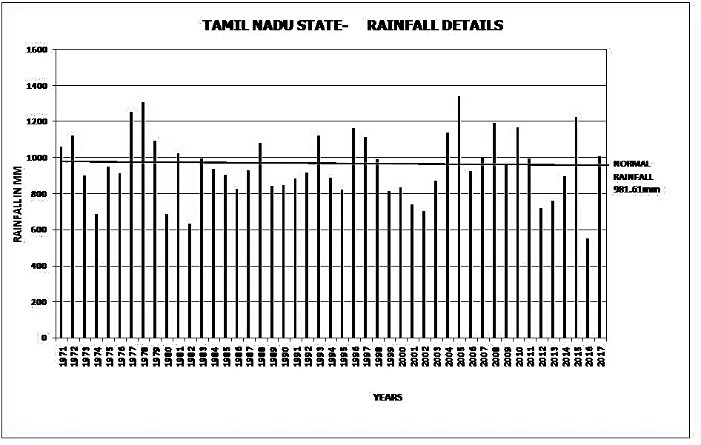
Source:TWAD
Fig. No.1.1
  - Surface Water Potential:
The total surface water potential for Tamil Nadu's river basins is estimated to be 24160 MCM (853 TMC). This potential is distributed among various components: 347 TMC is available through the storage capacity of 39000 tanks, and an additional 243 TMC is provided by 79 reservoirs. Moreover, 261 TMC is contributed by other states, highlighting the significance of inter-state water resources. Additionally, there is an extra 2 TMC of storage capacity from additional facilities.
In terms of water movement, the average runoff or surplus flow from Tamil Nadu's 17 basins to the sea amounts to 177.12 TMC. This runoff plays a crucial role in maintaining water balance and ensuring water availability for various purposes, including agricultural irrigation, domestic use, and industrial needs in the state. Effective management and utilization of these water resources are essential for sustaining Tamil Nadu's water needs and promoting overall development.

1.5. Ground Water Level:
The groundwater levels from 47 TWAD (Tamil Nadu Water Supply and Drainage Board) observation wells have been analyzed for both the post-monsoon and pre-monsoon periods. The average groundwater level, measured in meters below ground level, has been calculated for these periods starting from 1991. This analysis provides valuable insights into the fluctuations and trends of groundwater levels in Tamil Nadu over the years, aiding in the assessment of water availability and sustainability in the region. Understanding these groundwater variations is crucial for implementing effective water management strategies and ensuring the long-term availability of this vital natural resource for various needs, including drinking water supply, irrigation, and industrial usage in the state.
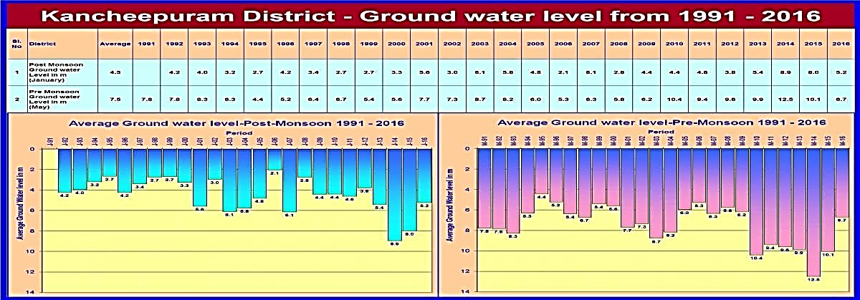
Fig No.1.2
- Study Area
Alandur Taluk, located at a latitude of 13.0025 and a longitude of 80.20611, stands out as the highest populated area in Kancheepuram District, accommodating a total population of 680,852 individuals. Interestingly, this region is entirely urban, with no rural areas identified within its boundaries. According to the Census, the area comprises of a diverse set of administrative units, including 4 Municipalities: Alandur, Pallavaram, Anakaputhur, and Pammal, 3 Town Panchayats: Nandambakkam, Thruneermalai, and Meenambakkam, 1 Cantonment Board: St. Thomas Mount – Pallavaram, 3 Census Towns: Polichalur, Tirusulam, and Moovarasampettai, and 1 Out Grown Area: Cowl Bazaar (Ref Map No: 2.1 & 2.2). This urban conglomeration represents a significant urban hub in the district and plays a crucial role in the socio-economic development of the region.
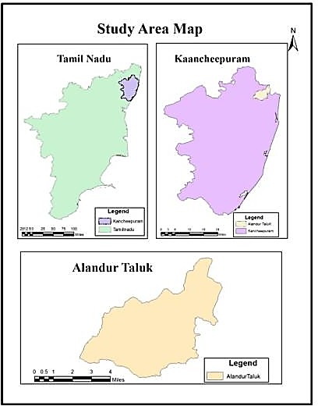
Map No: 2.1
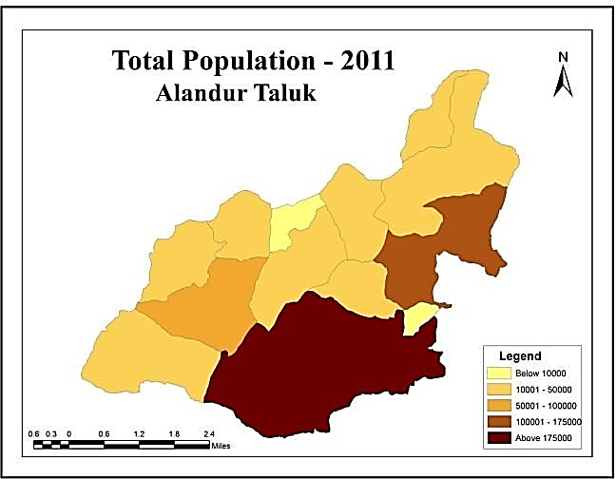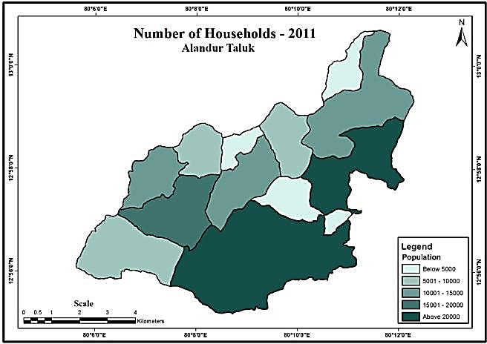
Map No: 2.2 Map No: 2.3

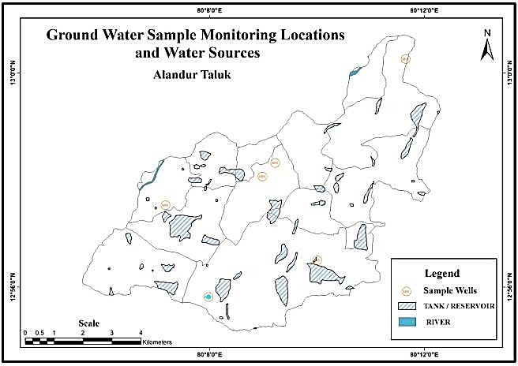
Source: CGWB
70.00%
60.00%
50.00%
40.00%
30.00%
Water Usage for drinking
20.00%
10.00%
0.00%
tap water
from treated source
tap water covered uncovered
from
untreated source
well
well
Map No: 2.4 Fig No: 2.1 (Source: Census 2011)

According to the census conducted in 2011, Alandur Taluk, with a total of 172,733 households (ref. Map No: 2.4), relies on tap water as the primary source for drinking water. Out of the surveyed households, approximately 61.01% of them depend on tap water from treated sources, ensuring access to safe and clean drinking water. Additionally, 10.67% of households use tap water from untreated sources, indicating that a portion of the population may face potential health risks due to the lack of water treatment.
Furthermore, the data reveals that a small percentage of households, 4.03%, access drinking water from uncovered wells. Such water sources may be exposed to contamination risks and raise concerns about the overall water quality. Additionally, 2.24% of households use covered wells as a source of drinking water, which may offer some protection from contamination but still require vigilance in terms of water safety.
Overall, while a significant majority of households in Alandur Taluk rely on treated tap water, there is a need to address the usage of untreated tap water, uncovered wells, and covered wells to ensure better water quality and promote the well-being of the community. Appropriate measures and interventions can be implemented to improve access to safe drinking water and enhance the overall water infrastructure in the region.
.
20.00%
Ground Water for Drinking
15.00%

10.00%

5.00%

0.00%
handpump tubewell spring river/canal tank/pond other
Fig No: 2.2 (Source: Census 2011)
As per the census conducted in 2011, in Alandur Taluk, a significant proportion of households, approximately 22%, depend on direct groundwater sources for their drinking water needs. Out of these households, 2.98% rely on handpumps, which are commonly used to access groundwater at shallow depths. Additionally, 15.63% of households utilize tubewells, which are deeper groundwater extraction points.
Furthermore, approximately 9.19% of households in the Taluk use springs as their source of drinking water. Springs are natural sources of groundwater that emerge from the Earth's surface and often provide clean and accessible water for communities.
Moreover, a small percentage of households, 0.46%, rely on rivers or canals as their source of drinking water. It is crucial to monitor water quality from such sources, as they may be susceptible to contamination from various environmental factors.
Additionally, 0.15% of households depend on tanks or ponds for their drinking water needs. These water bodies can be vital sources of water, but proper management and conservation are essential to maintain water quality and availability.
Finally, 2.64% of households depend on other sources for drinking water. These sources may include rainwater harvesting systems or private water supply arrangements.
Overall, the data highlights the diverse sources of drinking water used by households in Alandur Taluk. Ensuring the safety, accessibility, and sustainability of these water sources is crucial for the well-being of the community and requires proper water resource management and conservation efforts. (Fig No: 2.2).

AIM & OBJECTIVES
  - AIM
The Aim of this study is to have an ethnographic approach towards sustainable water management.

OBJECTIVES
    - To illustrate the distribution of water sources and assess the level of consumption among the population.
- To analyze and present the Total Dissolved Solids (TDS) levels in the water sources under investigation.
- To investigate the perception of parents regarding groundwater sustainability and their role in practicing sustainable water resource management.

METHODOLOGY
To achieve the objectives of the present study, a combination of secondary and primary data was utilized. A total of 130 couples were evaluated, resulting in 260 individual samples, to assess the community members' perceptions regarding water contamination as a source of concern. Additionally, secondary data was obtained from reputable sources such as the Ground Water Department from Taramani, TWAB, and CWDB. The collected data was further processed and analyzed using both statistical tools and Geographic Information System (GIS) to transform it into spatial and non-spatial datasets, facilitating a comprehensive analysis.

THE FINDINGS OF SPATIAL ANALYSIS
  - Distribution of Total Population
According to the data presented in Map No. 2.3, Alandur Taluk in the Kancheepuram District has a significantly high population of 680,852 individuals, as recorded in the 2011 Census. It stands as the most densely populated area in the district.

  - Distribution of Household
Map No. 2.4 displays the distribution of households in Alandur Taluk, revealing a total count of 172,733 residential units within the area. This data provides valuable insights into the housing density and living conditions of the population residing in the taluk.

  - Distribution of water sources on ground
According to Map No. 2.5, the water sources, both on the ground and underground water levels in Alandur Taluk, appear to be sparsely distributed. The data suggests that there might be challenges in accessing sufficient water resources, and sustainable water management practices should be considered to address potential scarcity issues in the region.

  - Distribution of water needed

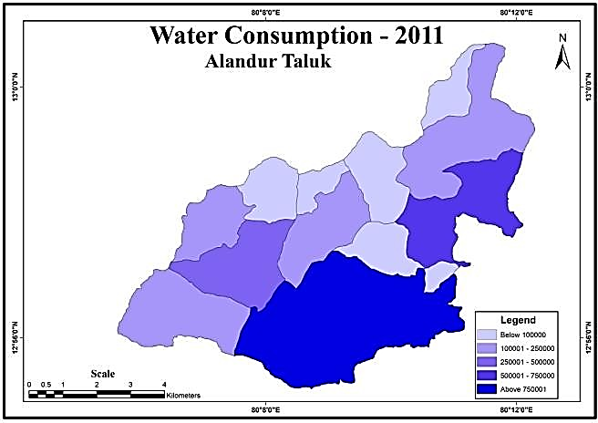
Map No: 5.1
According to the World Health Organization (WHO), an average person requires approximately 3.7 liters of water daily. Considering the population subdivision in Alandur Taluk, the total water requirement for the region amounts to approximately 25,09,881.7 liters per day. This estimation highlights the significant demand for water resources to meet the daily needs of the residents and underscores the importance of sustainable water management practices to ensure sufficient water availability.

5.5. Total Dissolved Solids (TDS)

Total Dissolved Solids (TDS) refers to the cumulative concentration of various inorganic and organic compounds that are dissolved in water. Typically expressed in parts per million (ppm) or milligrams per liter (mg/L), TDS measurement represents the total amount of dissolved solids present in a specific volume of water.

Natural sources of TDS in drinking water include minerals and salts found in soil and geological formations. Water passing through rocks and soil can pick up dissolved substances such as calcium, magnesium, potassium, sodium, carbonates, sulphates, and chlorides, contributing to the total TDS content. The concentration of TDS in water is significantly influenced by the presence of these natural minerals.

On the other hand, human activities are responsible for anthropogenic sources of TDS in drinking water. Agricultural practices, industrial discharges, and urban runoff introduce various chemicals and pollutants into water systems, elevating the TDS levels. Contaminants like fertilizers, pesticides, heavy metals, and salts from industrial processes are among the anthropogenic contributors to TDS in water.

Evaluating the TDS content in drinking water is a crucial factor in assessing water quality and its suitability for consumption. High TDS levels can affect the taste, odor, and appearance of water. In extreme cases, water may appear cloudy or discolored, and a salty or metallic flavor can be detected.

To ensure safe water consumption, regulatory authorities establish recommended or maximum permissible TDS concentrations in drinking water standards and guidelines. The permissible TDS levels can vary depending on the water source and the regulations in a particular region or country. Generally, TDS levels below 500 mg/L are considered safe for drinking water, but the specific limits may vary based on local regulations and environmental factors.

Regular monitoring and management of TDS levels in drinking water are essential to maintain water quality, safeguard public health, and promote safe and sustainable water usage practices.

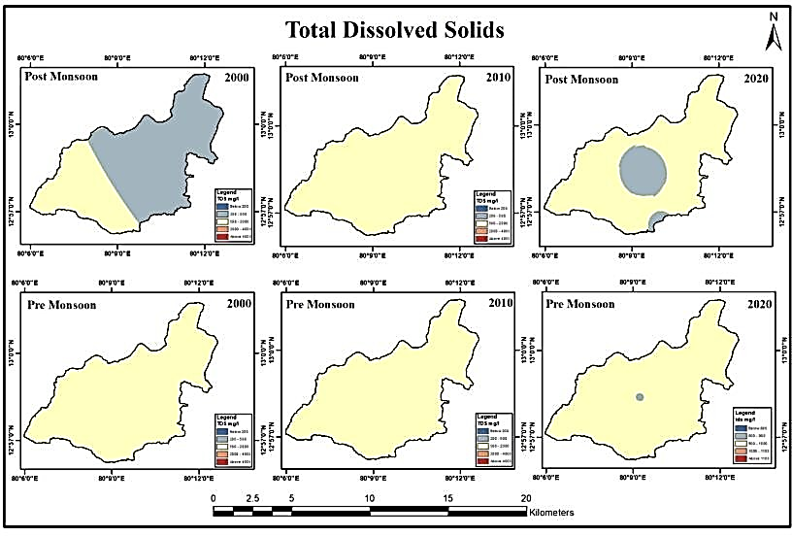
Spatial Distribution of Total Dissolved Solids (TDS)
Map No: 5.2

Map No. 5.2 provides valuable insights into the distribution of Total Dissolved Solids (TDS) levels from the years 2000 to 2020. The acceptable limit for TDS in water is set at 500 mg/l, while the permissible limit is slightly higher at 2000 mg/l, as per the Bureau of Indian Standard (2012) guidelines. Samples with TDS levels below 1000 mg/l are categorized as freshwater (Freez and Cherry, 1979).
In the year 2000, during the post-monsoon season, TDS levels were recorded at 563, while during the pre-monsoon season, the levels were slightly higher at 658, with the lowest recorded value being 792. In 2010, post-monsoon TDS levels reached a maximum of 1728, while the lowest recorded value was 860. In the pre-monsoon season of the same year, the highest value stood at 1419, and the lowest value was recorded at 869. Moving forward to 2020, the post-monsoon season saw TDS levels reach a high of 621 and a low of 500, while the pre-monsoon season recorded the highest value as 635 and the lowest value as 607.
These data points provide valuable information on the temporal variation of TDS levels in the water, indicating fluctuations over the years. Continuous monitoring and management of TDS levels are crucial to ensure compliance with water quality standards and to safeguard the availability of safe and potable water for various uses, including drinking, agriculture, and industrial processes.

Insights from the Sample Survey: Analyzing and Interpreting Water Management Practices among Parents:
The findings, analysis, and interpretation of the sample survey provided valuable insights into the underlying issues hindering progress towards sustainable water management systems, particularly among parents who play a critical role in shaping their children's attitudes and behaviors. Through this in-depth survey, we gained a comprehensive understanding of the distribution of water sources and water consumption levels in the region. It also shed light on the challenges that need to be addressed to create awareness and implement effective solutions for sustaining and managing groundwater resources. These findings serve as a crucial foundation for developing targeted interventions and strategies to ensure a sustainable water future for the community.

  - Age Group of the Participants and the educational qualification
Impact of Water quality
160
140
120
100
80
60
40
20
0
Health Economy
Age
140

120

100

80

60

40

20

0
25-30 30-35 35-40 40-45
Educational Qualification
140

120

100

80

60

40

20

0
<12 UG
PG >PG

Fig no. 6.1 Fig no. 6.2 Fig no. 6.3
Among the 260 individuals, who were part of the 130 couples, a significant proportion, aged between 25 to 45 years, possessed educational qualifications ranging from 12th-grade to post-graduate level. Their primary concern regarding water quality revolved around health implications, followed closely by its economic impact.

  - Concern of people in the community about water contamination – Perception
A chi-square test was conducted to examine the potential association between the participants' educational qualifications and their introspective rating of the current status of their Rain Water Harvest Plant. The purpose was to determine if there was any significant relationship between the two variables within the sample group.

    - Hypothesis:
Educational background does not show any significant association with rainwater harvesting plant maintenance.
Chi-Square Tests
 | Value | df | Asymptotic Significance (2-sided)
Pearson Chi-Square | 19.812ª | 3 | <.001
Likelihood Ratio | 21.193 | 3 | <.001
Linear-by-Linear Association | .269 | 1 | .604
N of Valid Cases | 260
a. 2 cells (25.0%) have expected count less than 5. The minimum expected count is 1.38.
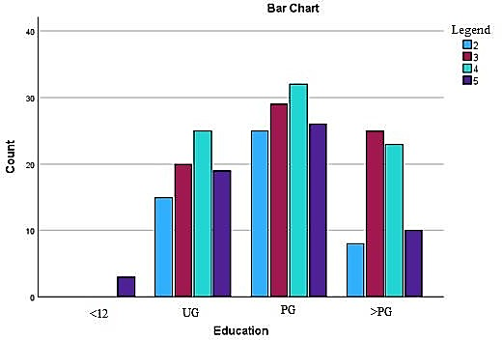
Fig no.6.1

Statistical Inferences from Chi-Square Test Results in Rainwater Harvesting Plant Maintenance
Pearson Chi-Square:
The chi-square test results indicate a significant association between educational background and rainwater harvesting plant maintenance. The Pearson chi-square test statistic (19.812) and the Likelihood Ratio test statistic (21.193) both have p-values less than 0.001, providing strong evidence to reject the null hypothesis. This suggests that there is a meaningful relationship between these variables.
However, the Linear-by-Linear Association test, with a test statistic of 0.269 and a p-value of 0.604, does not show a significant linear trend or association between the variables in a linear fashion. This may indicate that the relationship between educational background and rainwater harvesting plant maintenance is not strictly linear but can be better captured using other statistical approaches.
The low p-values in the Pearson chi-square and Likelihood Ratio tests suggest that individuals' educational qualifications play a significant role in their perception of and engagement in rainwater harvesting plant maintenance. This finding highlights the importance of education in promoting sustainable water management practices among community members.
It is important to note that while the Linear-by-Linear Association test did not show a significant linear trend, it does not discount the meaningful association revealed by the other two tests. The chi-square test statistics and p-values together provide compelling evidence that educational background influences attitudes and behaviors towards rainwater harvesting plant maintenance.
In conclusion, the results from the Pearson chi-square and Likelihood Ratio tests strongly support the rejection of the null hypothesis, indicating a significant association between educational background and rainwater harvesting plant maintenance. These findings underscore the potential of education in driving sustainable water resource management practices among individuals, especially when promoting the importance of rainwater harvesting in ensuring water security and sustainability.
    - Hypothesis:
There is no significant association between fathers and mothers regarding challenges or resistance faced from their children in adopting sustainable water management practices.
Chi-Square Tests
 | Value | df | Asymptotic Significance (2-sided)
Pearson Chi-Square | 128.182ª | 2 | <.001
Likelihood Ratio | 144.119 | 2 | <.001
Linear-by-Linear Association | 18.988 | 1 | <.001
N of Valid Cases | 260
a. 0 cells (0.0%) have expected count less than 5. The minimum expected count is 20.00.

Symmetric Measures
 |  | Value | Asymptotic Standard Errora | Approximate Tb | Approximate Significance
Nominal by Nominal | Contingency Coefficient | .575 |  |  | <.001
Interval by Interval | Pearson's R | .271 | .064 | 4.518 | <.001c
Ordinal by Ordinal | Spearman Correlation | .346 | .068 | 5.917 | <.001c
N of Valid Cases |  | 260
a. Not assuming the null hypothesis.
b. Using the asymptotic standard error assuming the null hypothesis.
c. Based on normal approximation.
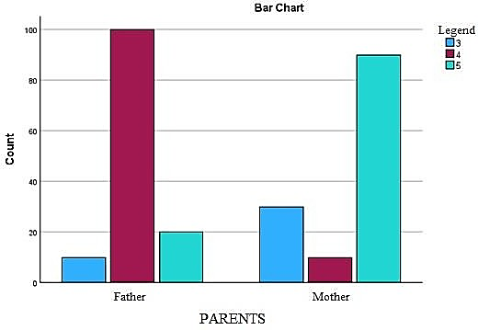
Fig no.6.2
INTERPRETING CHI-SQUARE TEST AND SYMMETRIC MEASURE: KEY INFERENCES
      - CHI-SQUARE TEST:
PEARSPM CHI-SQAURE:
The results of the chi-square tests and symmetric measures provide valuable insights into the association between the variables being analyzed. The Pearson chi-square test statistic yielded a significant value of 128.182 with 2 degrees of freedom, and the associated p-value was less than 0.001. This strong evidence leads to the rejection of the null hypothesis, indicating a significant association between the variables.

LIKELIHOOD RADIO:
Similarly, the likelihood ratio test statistic also demonstrated a significant value of 144.119 with 2 degrees of freedom, and the p-value was less than 0.001. The rejection of the null hypothesis in this test further confirms the presence of a significant association between the variables under study.
Furthermore, the linear-by-linear association test, with a test statistic of 18.988 and 1 degree of freedom, exhibited an asymptotic significance value of less than 0.001. This outcome indicates a significant linear trend or association between the variables, reinforcing the conclusions drawn from the previous tests.
Overall, these findings suggest that there is strong evidence to support the existence of a significant association between the variables considered in the analysis. The Pearson chi-square, likelihood ratio, and linear-by-linear association tests all provided consistent results, strengthening the validity of the inferences. These statistical analyses are crucial in understanding the relationships between the variables and contribute valuable insights to the research objectives.

      - SYMMETRIC MEASURE
The results from both the Chi Square test and the symmetric measures offer compelling evidence against the null hypothesis, indicating a significant association between the father and mother when it comes to facing challenges or resistance from their children in adopting sustainable water management practices. The contingency coefficient, which assesses the strength of association between two nominal variables, was found to be 0.575, and the associated asymptotic significance value was less than 0.001, further confirming the presence of a significant association.
Moreover, the interval by interval analysis using Pearson's correlation coefficient demonstrated a significant correlation of 0.271 between the father and mother, with a low asymptotic standard error of 0.064. The t-value of 4.518 and the p-value of less than 0.001 provided additional evidence supporting the significant correlation between two interval variables.
Similarly, the ordinal by ordinal analysis using the Spearman correlation coefficient showed a significant correlation of 0.346 between the father and mother, with an asymptotic standard error of 0.068. The t-value of 5.917 and the significance value of less than 0.001 further bolstered the conclusion of a significant correlation between two ordinal variables.
The collective findings from these statistical analyses consistently demonstrate a significant association and correlation between the father and mother in relation to challenges and resistance faced from their children when adopting sustainable water management practices. The rejection of the null hypothesis is further supported by the visual interpretation from the bar graph, which clearly illustrates that the mother encounters more challenges in this context than the father.
In summary, the study provides robust evidence of an association and correlation between parents regarding challenges and resistance from their children in adopting sustainable water management practices. These results have important implications for understanding parental roles and perspectives in water sustainability efforts.

- CONCLUSION
The research paper highlights the inequitable distribution of water to consumers in the study area. It examines the Total Dissolved Solids (TDS) measurements for the years 2000, 2010, and 2020 during post-monsoon and pre-monsoon periods. TDS serves as an indicator of water quality, and the findings reveal fluctuations in TDS concentrations over the two decades. In 2000, post-monsoon TDS levels were relatively lower than during the pre-monsoon period, suggesting better water quality. However, by 2010, TDS concentrations increased, indicating a potential decline in water quality. Fortunately, by 2020, there was a slight improvement with lower TDS concentrations.
The research paper also delves into the relationship between educational background and rainwater harvesting plant maintenance. The Chi-Square test and symmetric measures show significant evidence against the null hypothesis, indicating a strong association between educational background and plant maintenance. Although the Linear-by-Linear Association test does not show a significant linear trend, the overall results support the rejection of the null hypothesis, suggesting a substantial association between educational background and maintenance.
Furthermore, the paper explores the association between fathers and mothers in facing challenges or resistance from their children in adopting sustainable water management practices. Both analyses reveal a significant association between the parents, and the bar graph visually represents the challenges faced by mothers more than fathers in this context.
The research paper concludes with recommendations on addressing challenges in adopting sustainable water management practices. The government can play a vital role by educating children through their schools, emphasizing environmental awareness and behavioral skills. Parents can serve as role models by practicing sustainable water management and involving children in decision-making processes. Practical tips and tools can be offered to children for easy implementation of sustainable practices, fostering a long-lasting impact on water conservation.
However, parents should be patient and persistent in instilling sustainable practices in children, recognizing that change takes time. By consistently implementing these strategies, parents can help their children embrace sustainable water management practices, promoting water conservation for generations to come.
In summary, the research paper sheds light on the uneven distribution of water resources and the importance of water quality assessment. It also emphasizes the significant role of education and parental influence in promoting sustainable water practices. The findings and recommendations contribute to the understanding and implementation of effective water resource management and conservation measures, addressing challenges in adopting sustainable water practices for a more sustainable and water-secure future.

REFEREBCES

- E, G. S. (2021, June 30). Water and the Consumers at Chromepet, Alandur Taluk – A Case Study based on the Pandemic. Revista Gestão Inovação E Tecnologias, 11(2), 2272–2281. https://doi.org/10.47059/revistageintec.v11i2.1909
- Merkel, L., Bicking, C., & Sekhar, D. (2011, June 30). Parents’ Perceptions of Water Safety and Quality. Journal of Community Health, 37(1), 195–201. https://doi.org/10.1007/s10900-011- 9436-9
- Iliev, R. (2021). Generalized Net Model of the Water Resources Assessment Process and Water Use Management. Information & Security: An International Journal. https://doi.org/10.11610/isij.4903
- Jones, A. Q., Dewey, C. E., Doré, K., Majowicz, S. E., McEwen, S. A., Waltner-Toews, D., Henson, S. J., & Mathews, E. (2005, December). Public perception of drinking water from private water supplies: focus group analyses. BMC Public Health, 5(1). https://doi.org/10.1186/1471-2458-5-129
- Roche, S. M., Jones-Bitton, A., Majowicz, S. E., Pintar, K. D. M., & Allison, D. (2013, December). Investigating public perceptions and knowledge translation priorities to improve water safety for residents with private water supplies: a cross-sectional study in Newfoundland and Labrador. BMC Public Health, 13(1). https://doi.org/10.1186/1471-2458-13-1225
- Cai, X., McKinney, D. C., & Lasdon, L. S. (2002, June). A framework for sustainability analysis in water resources management and application to the Syr Darya Basin. Water Resources Research, 38(6), 21–1. https://doi.org/10.1029/2001wr000214
- Iliev, R. (2021). Generalized Net Model of the Water Resources Assessment Process and Water Use Management. Information & Security: An International Journal. https://doi.org/10.11610/isij.4903
- Polemio, M., & Voudouris, K. (2022, July 1). Groundwater Resources Management: Reconciling Demand, High Quality Resources and Sustainability. Water, 14(13), 2107. https://doi.org/10.3390/w14132107
- Seehamat, L., Sanrattana, U., & Tungkasamit, A. (2016, April 26). The Developing on Awareness of Water Resources Management of Grade 6 Students in Namphong Sub-Basin. International Education Studies, 9(5), 156. https://doi.org/10.5539/ies.v9n5p156
- Cha, S., Jin, Y., Elhag, M. S., Kim, Y., & Ismail, H. A. H. A. (2021, October 15). Unequal geographic distribution of water and sanitation at the household and school level in Sudan. PLOS ONE, 16(10), e0258418. https://doi.org/10.1371/journal.pone.0258418
- Tang, B., Mao, R., Song, J., Sun, H., Kong, F., Cheng, D., & Gao, X. (2021, November 29). Assessing the Impact of Optimization Measures on Sustainable Water Resource Management in the Guanzhong Area, China. Frontiers. https://doi.org/10.3389/fenvs.2021.805513
- EL-Nwsany, R. I., Maarouf, I., & Abd el-Aal, W. (2019, March). Water management as a vital factor for a sustainable school. Alexandria Engineering Journal, 58(1), 303–313. https://doi.org/10.1016/j.aej.2018.12.012

