Study of Innovative Deep Learning Architectures/Algorithms For Time Series Data And IOT

DaljeetKaur Husnara Khan
Department of Computer Science Department of Computer Science
Gyan Ganga College of Technology Gyan Ganga College of Technology
Jabalpur, M.P, India - 482002 Jabalpur, M.P, India - 482002
Email: daljeetkaurkalsi83@gmail.com Email: husnarakhn@gmail.com

ABSTRACT

Deep learning is a recent area of study in machine learning (ML). There are numerous hidden layers of artificial neural networks. The deep learning approach uses high-level model abstractions and nonlinear transformations in large databases. Artificial intelligence has benefited greatly from the recent huge advancements achieved by deep learning architectures in a number of fields. An up-to-date overview of the contributions and cutting-edge uses of deep learning is provided in this article. The review that follows shows, in chronological order, the primary applications that deep learning algorithms have been used in. The advantages and benefits Compared with those of the more conventional algorithms utilised in everyday applications, the nonlinear operations and hierarchy of layers of the deep learning technique are also discussed. How is the state of In this study, we assess the best deep learning architectures for forecasting and recognising trends over time using data collected by IoT sensors. It is advised to assist applications in this strategy industries like smart cities, industry 4.0, sustainable agriculture, robotics, etc. where IoT is advancing technologyCNN (Convolutional Neural Networks) are primarily used to recognise human activity; LSTM (Long-Short Term Memory) and RNN (Recurrent Neural Networks) are hybrid architectures with a convolutional layer for data pre-processing and CNN (Convolutional Neural Networks) are used for data fusion from various sensors and time series data.

INTRODUCTION

The Internet of Things (IoT) is a network of various linked devices that has the ability to send massive volumes of data. Agriculture, smart cities, smart homes, health care, and human activity detection are just a few of the businesses that employ it today. The longer these IoT sensors are in operation, the more information they may gather. This information may assist users predict how machines and other systems will behave, which is useful for jobs like system maintenance, yield performance resource allocation, business planning, and other tasks. Deep neural networks, however, have recently dominated challenging tasks like image recognition using CNN and understanding human language. utilising LST gaming with reinforcement learning, etc. It is pertinent.
The application of methodologies and strategic data mining in educational environments is the main focus of the analysis field of educational data mining. EDM focuses on investigating, creating, and using machine learning, data processing, and applied math methodologies to find patterns in massive volumes of educational data that will ideally be impossible to study [1].

EDM uses e-learning tools such as Learning Management Systems (LMS), Intelligent Tutoring Systems (ITS), and, more recently, Massive Open Online Courses (MOOC) to collect multimodal data about students' academic learning activities. For instance, these systems track when students use a learning resource, how often they do, whether they provide the right answer to an exercise, or how much time they spend on a particular task. Interest in Deep Learning (DL), which has changed the area of machine learning by delivering superior outcomes in perception tasks like image and speech recognition, has increased over the past ten years.Major companies like Google, Facebook, Microsoft, Amazon, and Apple are heavily investing in the development of new software and hardware in this field in an effort to make advantage of the promise of DL in the production of smart goods.Data-driven learning (DL) is a technique that modifies input data in both linear and nonlinear ways using neural network topologies with several layers of processing units.Any type of data, including text, audio, pictures, numbers, and combinations of these, may be utilised with these systems.Numerous scientific domains have benefited from the usage of these technologies,
The Internet of Things (IoT) is a new paradigm that facilitates connection between electrical gadgets and sensors through the Internet, making life easier for everyone. IoT uses smart devices and the Internet to offer creative answers to a range of issues and difficulties faced by diverse organisations, governments, and public/private sectors worldwide [1]. IoT is permeating every part of our life and is growing more and more significant. IoT, as a whole, is a development that unites several intelligent systems, frameworks, devices, and sensors (Figure 1). Additionally, it uses nano- and quantum-technology to store data at previously unimaginable rates and to retrieve it even faster [2]. Numerous research investigations have been carried out and are available in print and online.

The Internet of Things (IoT) is a new paradigm that facilitates connection between electrical gadgets and sensors through the Internet, making life easier for everyone. IoT uses smart devices and the Internet to offer creative answers to a range of issues and difficulties faced by diverse organisations, governments, and public/private sectors worldwide [1]. IoT is permeating every part of our life and is growing more and more significant. IoT, as a whole, is a development that unites several intelligent systems, frameworks, devices, and sensors (Figure 1). It also uses quantum and nanotechnology to store data faster than ever before and retrieve it even faster [2]. Numerous research investigations have been carried out and are available in print and online.

Many elements of contemporary life are powered by machine learning society: from web searches to social network content screening to e-commerce website suggestions, It is becoming more common in consumer goods like cameras and cellphones. Machine-learning algorithms are used to choose relevant search results, recognise things in photos, convert voice to text, match news articles, messages, or goods with users' interests, and identify objects in photographs.These applications are increasingly using a group of methods known as deep learning.
Traditional machine-learning methods have a restricted number of the capacity to process natural data directly. Building a pattern-recognition or machine-learning system requires a lot of work over decades. a feature extractor was created using meticulous engineering and extensive domain knowledge to modify the raw data (such as the pixel values).

The use of methodologies and strategic data mining in educational contexts is the main focus of the analysis field of educational data mining. EDM focuses on investigating, creating, and using machine learning, data processing, and applied math methodologies to find patterns in enormous volumes of educational data that are preferably not researchable [1].
EDM uses online learning tools like Learning Management Systems (LMS), Intelligent Tutoring Systems (ITS), and, more recently, Massive Open Online Courses (MOOC), to increase student success.

obtain made and multimodal data from students' academic learning activities. For instance, these systems track when students use a learning resource, how often they do, whether they offer the right answer to an exercise, or how much time they spend on a particular task.

The practise of removing pertinent and helpful information from a sizable database is known as data mining. Knowledge Discovery (KD) is the process of extracting information from a sizable database. Before drawing conclusions about the links between the data, it enables users to analyse the data from several perspectives and then classify it. A fascinating topic of research in the fields of data mining and web mining is the extraction and analysis of online pages.The World Wide Web has become the primary repository for the gathering and dissemination of information to consumers thanks to the Internet.The number of gadgets and devices connected to the Internet is growing, according to the present trend. The web was formed as a result of the rise in internet connections.

Big data is a collection of very large amounts of data that must be retrieved and analysed using specialised database management systems [1]. Big data refers to a broad variety of techniques for gathering and processing data in ways that were not feasible prior to the advent of contemporary personal computing. online scraping, which is the automatic collecting of data from online sites, is one method of big data that has a lot of potential for end users [2]. We will be able to discover novel treatments and gain a better understanding of various diseases and healthcare thanks to big data analytics [3, 4]. Due to the fact that most industries now use big data, it has become quite crucial.
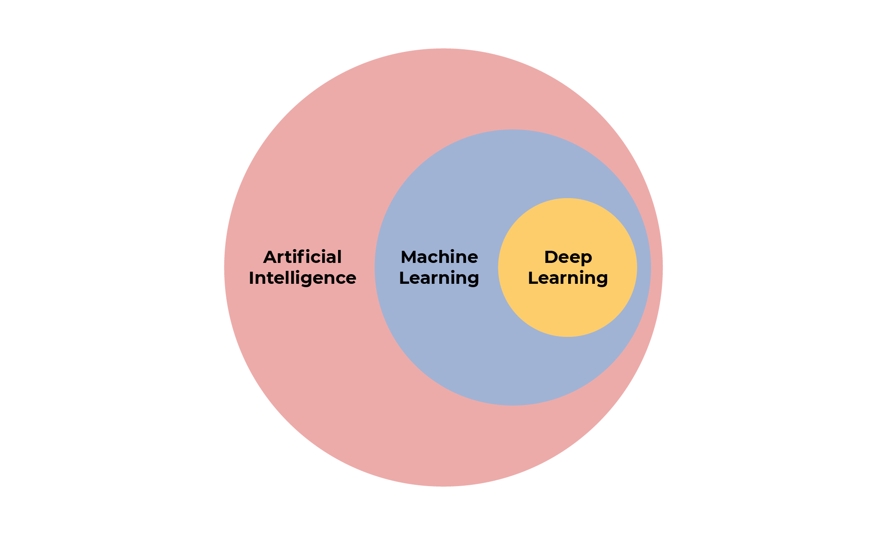

challenge of object localisation. This area has received a significant lot of attention recently. Identifying the locations of items in a given image (object localization) and classifying each object according to its category (object classification) is the definition of the object detection issue. Consequently, the pipeline for a standard object detection model may be separated into three primary sections:
selecting the information region, extracting the features, and classifying the data. choosing lucrative geographic areas. It makes sense to scan the whole image using a multiscale sliding window since various items can appear anywhere in the image and have various aspect ratios and sizes. This thorough approach has apparent flaws despite being able to discover every conceivable location for an item. The calculation is complicated by the enormous number of candidate windows.,
There may be unsatisfactory regions. Extracting features. Extraction of visual characteristics necessary for meaningful and reliable representations of distinct objects is required for object recognition. The SIFT HOG and hair-like features are frequent examples. This is because these operations have the ability to produce expressions that are connected to the intricate cells in the human brain. However, it is challenging to manually build comprehensive feature descriptors that accurately characterise all sorts of objects due to the range of looks, lighting setups, and backdrops. classification. Additionally, a classifier is required to set the target item apart from all other categories and to improve the representation's hierarchy, semantics, and visual perception. Deformable parts-based models (DPM) and supported vector machines (AdaBoost) are frequently wise alternatives. DPM is a versatile classifier among them.
Data mining area using DL architecture. This article provides an overview of the literature on DL methods applied to educational data mining from its inception in 2015 to the present. The main contributions of this article are:

1. Summarize most EDM tasks and categorize the actual work with DL applied for each of these tasks.
2. Identify tasks that have received a lot of attention and have not yet been researched. 3. Describe and classify the most common public and private datasets used for training and testing DL models in educational data mining tasks.
4. Presents key DL ideas and technologies and describes the most commonly used techniques and constructs in educational data mining and its specific tasks.
5. Based on the data collected during this study, we discuss future directions for the analysis of DL as applied to educational data mining.

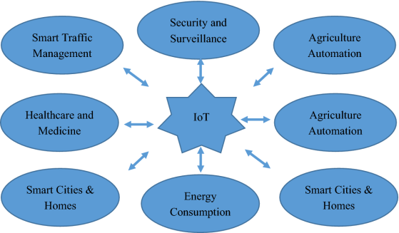

RELATED WORK

The Internet of Things has an interdisciplinary vision to take use of its benefits in a variety of industries, including transportation, public/private, medical, and industrial. According to their specific areas of expertise and viewpoints, many scholars have varied descriptions of the Internet of Things. IoT applications across a range of industries demonstrate its strength and promise. Some of the potential IoT application areas are depicted in Figure 2. His IoT innovations have revolutionised the market in recent years with a number of significant ventures. Some of the most significant IoT projects that rule the industry are depicted in Figure 3. The global distribution of these IoT initiatives across the Americas, Europe, and Asia Pacific is depicted in Figure 3. Healthcare and smart supply chain initiatives benefit more from contributions from the Americas than from Europe, as can be shown.
A study on IoT intelligent energy control systems that would help smart city applications was done by Kajeenasiri et al. [10]. They said that only a very tiny number of applications that benefit both technology and humans are presently using IoT. IoT has a very broad range of potential applications, and in the near future, it will be able to address practically all of them. They said that energy conservation is a crucial aspect of civilization and that IoT might aid in the creation of intelligent energy control systems that reduce expenses and energy consumption. They used the idea of a smart city to demonstrate IoT architecture. The writers also talked about how his IoT hardware and software's infancy is one of the challenges in attaining this aim. They argued that these problems needThe future of deep learning

Unsupervised educationDeep learning interest was rekindled during the years 91–98, but since then, it has been eclipsed by the successes of pure supervised learning. Although this whitepaper does not specifically address it, we anticipate that over time, unsupervised learning will gain significantly greater significance. Learning occurs primarily unattended in both humans and animals.

We learn about the structure of the world by observation, not by telling ourselves what each object's name is. Human vision is an active process that progressively scans optical arrays in an intelligent and task-specific manner using a tiny high-resolution fovea and a wide low-resolution surroundings. We believe that a fully trained system that combines his ConvNet with his RNN and uses reinforcement learning to decide where to look would lead to numerous future advancements in vision. Though still in their infancy, systems that integrate deep learning and reinforcement learning have already surpassed passive vision systems99 on classification tasks and shown outstanding results when trained to play a range of video games100. Another area where deep learning is anticipated is natural language comprehension.

CASE STUDY OF Climate Change Impact on the Global Food Supply

Machine learning technology drives many aspects of modern society.
They are rapidly being utilised in consumer goods like cameras and smartphones, from online searches to screening social media material to making suggestions on e-commerce websites. Machine learning algorithms are used to choose pertinent search results, recognise objects in photographs, translate voice to text, and customise news, postings, and items to your preferences. These programmes increasingly employ a group of methods known as deep learning. Natural data in its raw form can only be processed to a limited extent using traditional machine learning approaches. Designing feature extractors, which convert raw data (such as pixel values in an image) into suitable internal representations or feature vectors for the learning subsystem, has traditionally required painstaking engineering and considerable expertise. These are discovered from data using a classifier and conventional learning methods. Deep learning is making significant progress in addressing issues that, for many years, have defied the best efforts of the artificial intelligence field. highly effective at detecting
There are several uses for its capacity to interpret the intricate structures of high-dimensional data in business, government, and research. Not only have they shattered records in voice recognition 5-7 and picture recognition 1-4, but they have also been effective in recreating brain circuits 11, forecasting the activity of possible medicine molecules 8, examining mutations 13, and analysing particle accelerator data 14. For predicting impacts, we also have strong machine learning technologies. - Coding DNA for illness and gene expression12,13. Deep learning has, perhaps even more surprisingly, demonstrated highly promising results for a number of natural language comprehension tasks14, including subject categorization, sentiment analysis, question answering, and language translation16,17. Given that deep learning requires little manual intervention, we anticipate it to be much more successful in the near future.
Heer et al.'s [15] further research revealed that his IP-based IoT solution has a security flaw. You said that the Internet serves as the foundation for all device connectivity in Internet of Things systems. Security concerns with his IP-based IoT system are thus quite serious. Additionally, the lifetime and purpose of each item in the IoT system should be taken into account while designing the security architecture. This entails using security standards and trustworthy outside parties. It would be ideal to have a security architecture that could grow from the IoT's modest to huge scales. According to the study, new ways for various items to communicate across a network are being created by the Internet of items, therefore conventional end-to-end Internet protocols cannot offer the essential support for this.
Another IoT area that needs potential solutions to improve security is authentication and access control. An authentication and access control system was introduced by Liu et al. [16]. To confirm who you are speaking with and stop the leak of sensitive information, authentication is crucial. Elliptic Curve Cryptosystem-based authentication method presented by Liu et al. [16] was tested against various security risks. B. Attacks including eavesdropping, man-in-the-middle situations, key control, and replay. They claimed that the suggested approach would make it possible for IoT-based communications to have improved access control and authentication. After that, Kothmayr et al. [17] suggested a two-way authentication system for the Internet of Things based on Datagram Transport Layer Security (DTLS). On the Internet, thieves are busy all the time, stealing safe data. The suggested method can offer message security,
From the standpoint of cloud platforms, Lee et al. [18] offered a dynamic approach to data-centric IoT applications. Due to the requirement for appropriate hardware, software configurations, and infrastructure, efficient solutions are required to serve a variety of IoT applications running on cloud platforms. IoT researchers and developers are working hard to provide solutions that take into account the variety of IoT objects and devices as well as the vast platform. The idea of an architecture based on Software Defined Networking (SDN) that functions effectively even when a well-defined architecture is not available was presented by Oliver et al. [19]. They recommended that his IoT security architecture based on SDN would be more adaptable and effective.
According to Luke et al. [20], a secure sensor network's (SSN) primary functions are to offer privacy, defence against replay attacks, and authentication. They talked about his two well-known SSN services, TinySec and ZigBee. While ZigBee gives pretty good security but uses a lot of power, both of his SSN services are effective and dependable. They claimed that while TinySec uses relatively little electricity, it is less secure than ZigBee. They suggested a different MiniSec architecture, showed its effectiveness on the Telos platform, and it provides strong security and low power consumption. According to Yang et al. [23], trust management is a crucial IoT subject. Without having to worry about uncertainty difficulties, trust management enables consumers to comprehend and believe IoT services and applications.
Interoperability in the IoT is crucial because it allows for the integration of services and devices from several dissimilar platforms to deliver effective and dependable services, according to Noura et al. [25]. The significance of interoperability has been the subject of several more studies, which have also covered some of the difficulties the subject now faces in the IoT [26, 27, 28]. Regarding climate change, Kim et al. [29] suggested an IoT-based ecological monitoring system. They claimed that current methods take a long time and involve a lot of manual labour. In order to get data from the sensors placed at the inspection site, it also need routine inspections. Additionally, several details were omitted, and the analysis was not particularly precise. IoT-based frameworks may thereby resolve this issue and deliver extremely accurate
One of the most significant industries in the world is agriculture. A number of elements influence agriculture. Geographical, ecological, etc. factors B. According to Qigu et al. [31], the methods utilised to govern ecosystems are crude and unintelligent. They claimed that IoT researchers and developers could find this to be a useful use case.An intelligent monitoring platform architecture for plant agroecosystems based on IoT was presented by Qiu et al. [31] and comprises of four levels of management mechanisms for agroecosystems. Each layer is in charge of a certain duty, and frameworks cooperate to improve the ecosystem with minimal human involvement.

Climate change brought on by global warming is another significant issue on a global scale. The "IIS" for integrated information system was first introduced by Fang et al. a service that combines Internet of Things, geospatial, cloud computing, global positioning system ("GPS"), and geographic information system ("GIS"). effective environmental monitoring and control systems made possible by electronic science. They claimed that the IIS he presented would improve data collecting, analysis, and climate control decision-making. Another big issue facing the world is air pollution. There are several tools and methods available to gauge and regulate air quality. AirCloud is a cloud-based air quality and monitoring system that was proposed by Chen et al. [33]. They set up his AirCloud and assessed its performance using data from his five months across two consecutive months. Temgrid et al. [34] take into account service quality.

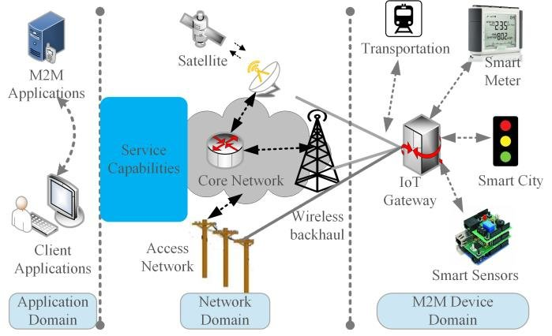

IoT architecture and technologies

The IoT architecture is made up of five essential layers that specify all of the system's capabilities. These layers include the business layer, the network layer, the middleware layer, and the application layer. The perception layer, which is made up of actual objects, is the foundation of the Internet of Things architecture. B. Physical devices linked to IoT networks, such as sensors, RFID chips, barcodes, etc. These gadgets gather data to transmit to the network layer. Information is sent from the perceptual layer to the information processing system using the network layer as a communication medium. This information may be transmitted via any wired or wireless technology, including 3G/4G, Wi-Fi, and Bluetooth. The middleware layer is the next layer. This layer's primary duty is to process

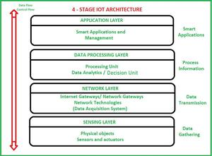

There are many uses for Internet of Things (IoT) technology, and its use is accelerating quickly. The Internet of Things functions as it was intended or created to in accordance with the many application areas for which it has been used. However, it lacks a widely adhered-to standard defined architecture of working. The functioning and application of IoT in various domains determine its architecture. However, there is a fundamental process flow upon which IoT is founded.
In order to encourage the connection between IoT systems and devices, there has been an increase in interest in adaptable frameworks and architectural designs. This is so that they can be categorised across many application domains and geographical areas, which is how IoT systems are made. As a result, it generates a lot of dependencies across platforms, domains, and services. Due to the interdependence of IoT systems and devices, a framework that is intelligent and connection-aware is now required. This is where IoT architecture comes into play.Imagine having one "brain" in charge of all of your smart IoT devices, from sensors and actuators to internet gateways and data acquisition systems! The IoT architecture may be thought of as the brain in this scenario, and its usefulness and applicability are closely correlated with the standard of In its simplest form, an IoT architecture is a collection of various components, such as sensors, protocols, actuators, cloud services, and layers.
The Internet of Things (IoT) architectural layers are differentiated in order to track a system's consistency across protocols and gateways in addition to devices and sensors. Researchers have put out a variety of designs, and it is clear that no one architecture has gained widespread acceptance for the Internet of Things. A three-layer architecture is the most fundamental kind.
The perception, network, and application layers are the three separate layers.
- The physical layer, which includes sensors for perceiving and gathering environmental data, is the perception layer. It detects certain physical factors or other intelligent items in the surrounding environment.
- The network layer is in charge of relating to servers, network devices, and other smart objects. Additionally, the features are employed to transmit and analyse sensor data.
- Application-specific services may be effectively delivered to the user through the application layer. It outlines a variety of use cases for IoT services, including smart homes, smart cities, and smart health.

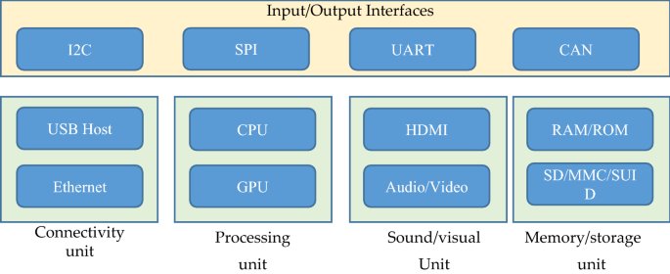

I/O activities, connection difficulties, processing, audio/video monitoring, and storage management are all handled by many important functional blocks. Together, these useful building components make up an effective Internet of Things system. This is necessary for the best performance. Technical standards for a number of reference designs have been offered, but they are still far from being universal architectures appropriate for the global IoT [39]. As a result, no adequate architecture has yet been developed to satisfy needs for the global IoT. An IoT system's basic organisational structure is depicted in the figure. 7. Figure 7 illustrates how IoT depends on particular application characteristics. IoT gateways are crucial for IoT communication because they make it possible for various apps to connect to her IoT servers and IoT devices.

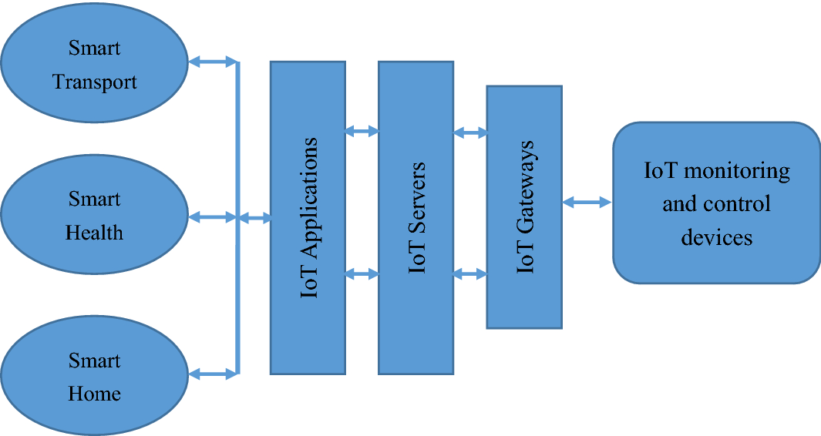

For effective IoT designs in diverse contexts, scalability, modularity, interoperability, and openness are key design principles. The requirements of cross-domain contact, multi-system integration with the possibility for easy and scalable management, massive data analysis and storage, and user-friendly applications should be addressed by an IoT architecture. Additionally, the design should allow for the expansion of functionality as well as the addition of intelligence and automation to the system's IoT devices.

Additionally, IoT systems need effective designs that can manage massive quantities of streaming data due to the growing amount of data created by connection between IoT sensors and devices. Cloud and fog/edge computing are two well-liked IoT system topologies that facilitate processing, monitoring, and analysis of enormous volumes of data in IoT systems. IoT technology

The sensors and actuators at Level 1 of the architecture are crucial components. The actual world comprises of natural settings, people, animals, technology, advanced vehicles, structures, etc. These real-world signals and data streams are captured by sensors, which then convert them into information that may be utilised for additional analysis. Actors can also change the course of reality. B. Adjust the temperature, reduce the speed, turn off the lights, and so on. As a result, Stage 1 assists in gathering actual data that can be valuable for subsequent research. Operating sensors, actuators, gateways, and data gathering systems are within Level 2's purview. This phase aggregates and optimises the massive amount of data created in Phase 1 in an organised manner appropriate for processing. once there was a lot of data

Major key issues and challenges of IoT

Various technologies connected to data transfer between embedded devices have complicated matters and produced a number of issues and obstacles as IoT-based systems have become integrated into every part of human existence. In a culture that values technology highly, these problems have also presented challenges for his IoT developers. As technology has grown, so has the need for his IoT systems, which are both difficult and sophisticated. IoT developers must thus consider fresh issues and offer solutions.

Due to numerous threats, hacks, hazards, and vulnerabilities, security and privacy are among the most crucial and difficult IoT challenges [41]. Insufficient permission and authentication, unsafe software, firmware, web interfaces, and inadequate transport layer encryption are issues that affect device-level data protection [42]. Security and data protection concerns are crucial factors for boosting the dependability of IoT systems from a variety of perspectives [43]. Security procedures should be incorporated into the IoT architecture at all tiers to thwart security risks and assaults [23]. Multiple protocols have been created and effectively implemented at each level of the communication channel to guarantee the security and privacy of IoT-based systems [44, 45]. Among the cryptographic protocols are Secure Socket Layer (SSL) and Datagram Transport Layer Security (DTLS).Interoperability/standard issues

The ability to transmit data between various IoT systems and devices is known as interoperability. The hardware and software that are being used have no impact on this information transmission. The heterogeneity of various technologies and solutions utilised for IoT development causes interoperability problems. The four interoperability layers are organisational, technological, semantic, and syntactic [47]. In order to enable communication between various items in diverse contexts, IoT systems include a number of interoperability-enhancing capabilities. Additionally, based on their capabilities, many IoT platforms may be combined to offer various solutions to IoT consumers [48]. Researchers have recommended a number of methods, sometimes known as interoperability processing techniques, because interoperability is a significant problem [49]. These approaches might be built on adapters/gateways, virtual networks/overlays, service-oriented architectures, etc. Nevertheless, the method of dealing Ethics, law and regulatory rights

The ethical, legal, and regulatory rights of IoT developers are another problem. To protect moral norms and stop people from transgressing them, there are some laws and guidelines in place. The sole distinction between ethics and law is that while both words refer to specific constraints set by the government, ethics are principles that individuals believe in. But both ethics and law work to uphold standards and quality while safeguarding individuals from unlawful usage. His Internet of Things (IoT) invention has helped to tackle certain real-world issues, but it also presents difficult moral and legal issues[50]. Some of the problems are data usability, data security, privacy, and dependability. Additionally, the majority of IoT users have been shown to favour governmental standards and guidelines for data.Scalability, availability and reliability

Another crucial element for IoT is quality of service (QoS). QoS is a metric that measures the effectiveness, efficacy, and performance of IoT systems, architecture, and devices [34]. Reliability, cost, energy consumption, security, availability, and service time are crucial and necessary Quality of Service criteria for IoT systems [53]. The QoS criteria must be met by a more intelligent IoT environment. Any IoT service or device's QoS metrics must first be specified in order to guarantee dependability. Users could also be able to specifically state their demands and requirements. There are a variety of ways that may be used for QoS assessment, however as stated by White et al. [54], there is a trade-off between methodologies and quality criteria. As a result, high-quality models must be used.

Major IoT applications

A system is scalable if more functions, tools, and gadgets may be added without degrading overall system performance. Supporting a large number of devices with varying memory, computation, storage capability, and bandwidth is a key challenge for the Internet of Things [28]. The issue of availability is also crucial. In a layered IoT system, scalability and availability must be supplied concurrently. His cloud-based IoT solution, which completely supports the extension of IoT networks by adding extra devices, storage, and processing capacity as necessary, is an excellent illustration of scalability. However, the development of frictionless IoT frameworks that fulfil universal demands is made possible by this globally dispersed IoT network . The resources of the real object must be accessible independent of the requester's location or time of day. IoT connects commonplace utilities like home appliances, security systems, culinary appliances, thermostats, automobiles, baby monitors, and more via integrated unique identifiers (UIDs), enabling seamless communication between people and things. Without requiring computer-to-computer interaction, the linked devices communicate data via the internet.

By 2023, there will be 3.5 billion mobile IoT devices that are connected, a significant increase. IoT is being used by businesses of all sizes to run more efficiently. Businesses may use IoT to make better decisions, provide better customer service, and generate more revenue. Furthermore, the accessibility of cloud platforms enables people and enterprises to use and scale up infrastructure without controlling it.

Emerging economy, environmental and health-care

IoT is dedicated to bringing about fresh societal and economic advancements and advantages for people and society. Several different public institutions are included in this. B. Industrialization, welfare, maintaining water quality, and economic growth. Overall, the Internet of Things aims to accomplish the United Nations Progressive Stage's social, health, and economic goals. Sustainability of the environment is a key issue. To counteract the negative consequences, an IoT developer must consider the influence that his IoT systems and devices will have on the environment [48]. One of the issues associated to pollution is the power consumption of IoT devices. Modern technologies and the proliferation of internet-enabled services are both contributing to a sharp rise in energy usage. In order to create innovative, high-quality low-power IoT devices, further research is required in this field.
By allowing hospitals to keep tabs on their patients' health while they are at home, wearable IoT devices can shorten hospital stays while still giving up-to-the-second real-time information that might save lives. Smart beds reduce the wait time for available space in hospitals by keeping the personnel aware of availability. The addition of IoT sensors may make the difference between life and death by reducing malfunctions and boosting dependability.IoT makes providing care for elderly people much more comfortable. Sensors can tell if a patient has fallen or is having a heart attack in addition to the real-time home monitoring stated above.

Smart city, transport and vehicles

With the notions of a smart city, smart house, intelligent car, and transportation, the Internet of Things changes the conventional social framework of society into a high-tech structure. The understanding of the need for and use of technology in the home is rapidly improving with the use of assistive technologies like machine learning and natural language processing [58]. To implement an effective smart city, several technologies, including cloud server technology and wireless sensor networks, must be deployed. Consideration of smart cities' environmental implications is a further crucial subject. As a result, green and energy-efficient technology should be taken into account while designing and developing the infrastructure for smart cities. Additionally, newly developed cars equipped with smart equipment can identify traffic jams and offer the best possible detours to drivers.
\
Agriculture and industry automation

By 2050, it is predicted that there will be roughly 10 billion people on the planet. In our life, agriculture is significant. It is necessary for present agricultural techniques to change in order to feed such a big population. Therefore, it is necessary to combine agriculture and technology to increase output effectively. The utilisation of greenhouse technology is one strategy that might be used. offers a method to regulate environmental factors to increase output. However, manual control of this technology is inefficient, expensive to operate manually, and results in energy loss and decreased output. Smart devices and sensors will make it simpler to monitor and regulate the environment within the chamber as the IoT develops, which will save energy and enhance productivity Additionally, industry automation.
IoT enables monitoring and managing microclimate conditions for indoor planting a reality, which in turn boosts output. IoT-enabled devices can monitor soil moisture, nutrients, and meteorological information to better manage irrigation and fertiliser systems for outdoor planting. For instance, this avoids resource waste if sprinkler systems only release water when necessary.

Importance of big data analytics in IoT

A network of interconnected sensors and gadgets is known as the Internet of Things (IoT). The number of these sensors and devices is increasing quickly as a result of the broad development and expansion of IoT networks. Large volumes of data are sent between these devices and among them over the Internet. Big data refers to data quantities that are so huge that they stream continuously. The ongoing growth of IoT-based networks brings up challenging problems with data collecting, administration, storage, processing, and analysis. The B. Oxygen level control, smoke/noxious gases, and brightness measures are just a few of the smart building issues that may be resolved with the aid of the IoT Big Data Smart Building Framework [59]. These programmes may gather information from sensors placed in buildings and carry out data processing.

The Internet of Things in the Future

So, given the foregoing, what exactly does the Internet of Things' future hold?

According to a Gartner research, there will eventually be 20.6 billion linked devices using various technologies. According to HP, that number might reach 1 trillion by 2025, which is an astounding amount. IoT devices will reportedly generate $14.4 trillion in value over the course of the next ten years across a variety of businesses, including those stated above, according to a Cisco research.

In other words, both in terms of our personal and professional lives, the Internet of Things is set to bring about life-changing circumstances. Many of the advances described are, in some form or another, already in use. There's no doubt about it: there's

Conclusions

Researchers and developers from all around the world are interested in recent developments in IoT. Researchers and IoT developers collaborate to advance technology for the benefit of society as a whole. However, advancements are only feasible when taking into account numerous issues and flaws in existing technical paradigms. This study discussed certain problems and difficulties that IoT developers should take into account while creating better models. For IoT developers and academics, it also covers important IoT application areas. This is due to the fact that IoT not only creates a tonne of data but also offers services. As a result, we also go over the significance of big data analytics, which may produce precise judgements that can be utilised to develop better IoT systems. A method called deep learning has shown tremendous success

This study examined the rise of DL applications to EDM, a development that began in 2015 with the publication of three articles and has since increased annually with the publication of 19 publications in 2019. Following a thorough search, 41 works in this region were located. It is noteworthy that these techniques have been discussed in pertinent EDM venues, including the yearly International Conference on Educational Data Mining, where 7 papers were published in the most recent edition (for a total of 16 in the previous three years).Only 4 of the 13 activities suggested in that study have been addressed by DL approaches, according to the taxonomy of EDM applications provided by[11]. This demonstrates that there are several untapped potential applications for DL.

The entire World Wide Web has developed into a massive information repository that is expanding quickly in terms of both the number of websites and the amount of meaningful material. When the size of the html documents increases, web data extraction takes longer. If the number of data rose, the Single Document Object Model (DOM) did not extract multimedia data, such as images, particularly efficiently. However, when a different JavaScript Object Notation approach, known as Wrapper Hybrid DOM and JSON (WHDJ), is introduced in the upgraded model, the time spent for extracting an image and its information is lowered to 50% less than with the DOM technique. The duplication of identical filenames in picture extraction remains this model's shortcoming, despite improvements in execution time.
Complementary

The use of DL and IoT approaches in numerous fields, including smart homes, smart cities, smart transportation, energy, localization, the health sector, security, agriculture, etc., has been reviewed in this study. Researchers and business units have focused on DL and IoT recently since both have demonstrated their beneficial effects on human life, cities, and the environment. It is evident that DL resources support a wide range of IoT applications. DL models are powerful tools for using data analysis to solve complex issues. Due to the availability of the most recent IoT frameworks and open source libraries to gather the same, big size datasets are being created at an ever-increasing rate, which we addressed when training and developing the DL model.

To sum up, we can conclude that IoT technology has the potential of aligning innovation with effective data management, analysis, and exploitation. This is accomplished via a solid, resilient, scalable, and secure IoT architecture.

Creating an IoT ecosystem that is functional, scalable, adaptable, maintainable, and affordable is the core characteristic of an IoT architecture, which may offer a variety of solutions for various sectors. Make sure you have a clearly defined and effective IoT architecture if you want to build appealing and future-proof IoT initiatives.

References

- . Abadi M, Barham P, Chen J, Chen Z, Davis A, Dean J, Devin Ma, Ghemawat S, Irving G, Isard M, et al. Tensorfow: a system for large-scale machine learning. In: 12th {USENIX} Symposium on operating systems design and implementation ({OSDI} 16), 2016; p. 265–283.
- Abdel-Basset M, Hawash H, Chakrabortty RK, Ryan M. Energy-net: a deep learning approach for smart energy management in iot-based smart cities. IEEE Internet of Things J. 2021
- Aggarwal A, Mittal M, Battineni G. Generative adversarial network: an overview of theory and applications. Int J Inf Manag Data Insights. 2021; p. 100004.
- ] N. Homer, S. Szelinger, M. Redman, D. Duggan, W. Tembe, J. Muehling, et al., Resolving individuals contributing trace amounts of DNA to highly complex mixtures using high-density SNP genotyping microarrays, PLoS Genet.
- 4 (2008). [2] R. Wang, Y.F. Li, X.F. Wang, H. Tang, X.Y. Zhou, Learning your identity and disease from research papers. In: formation leaks in genome wide association study, in: CCS ’09 Proceedings of the 16th ACM Conference on Computer and Communications Security, vol. 10, 2009 (1145), 534-544, Chicago, Illinois.
- MAHDAVINEJAD, Mohammad Saeid, et al. Machine learning for Internet of Things data analysis: A survey. Digital Communications and Networks, 2018, vol. 4, no 3, p. 161-175.
- MUANGPRATHUB, Jirapond, et al. IoT and agriculture data analysis for smart farm. Computers and electronics in agriculture, 2019, vol. 156, p. 467-474.
- KIM, Tai-hoon; RAMOS, Carlos; MOHAMMED, Sabah. Smart city and IoT. 2017.
- SAMUEL, S. Sujin Issac. A review of connectivity challenges in IoT-smart home. En 2016 3rd MEC International conference on big data and smart city (ICBDSC). IEEE, 2016. p. 1-4.
- KIM, Yonghee; PARK, Youngju; CHOI, Jeongil. A study on the adoption of IoT smart home service: using Value-based Adoption Model. Total Quality Management & Business Excellence, 2017, vol. 28, no 9-10, p. 1149-1165.
,

