Solar drying characteristics on commercial crop of Red chilli in Tamilnadu

P Sivamurugan¹, E Murali²,
^{1,2} Vel Tech Rangarajan Dr. Sagunthala R&D Institute of Science and Technology, Chennai – 600062, INDIA.
drsivamurugan@veltech.edu.in

Abstract
This article deals with the design and fabrication of flat plate hybrid collector with dryer (FPHCD). The FPHCD was conceded various analysis on commercial crop of Red chilli which was performed three modes of operation such as solar sun drying with forced convection, solar sun drying with natural convection and open sun light drying. Numerous parametric studies also handled in this article such as solar radiation intensity, moisture removal, outlet air temperature from the collector. In general, solar radiation was provided a sources of generating energy to drive a solar dryer. The FPHCD has been provided the electrical and thermal energy to run a solar dryer. The solar dryer was tested by 14 kg of red chilli in the drying air temperature in the range of 32⁰C – 59⁰C. The initial moisture content of the red chilli was 73% (weight basis) and was reduced to the final moisture content of 11% (weight basis) in 6 days with clear sunny days in the month of July 2020. The FPHCD was operated between 9 hours to 16 hours. Finally, comparative study was also handled for better understanding in FPHCD, in which solar sun drying with forced convection mode attained better results than other two modes of operations.
Keywords: flat plate hybrid collector, commercial crop, red chilli, electrical and thermal efficiency.

Introduction
Agriculture is a primary sector in Indian Economy. Variety of crops in India such as food crops, cash crops, commercial crops, horticulture crops and other related crops. Among the crops, Red chilli is a predominant crop in food system of India. This article shows various drying kinetics of red chilli which can be compared
with conventional form of drying. Kern and Russell [1] presented the pioneering concept of water or air as a fluid medium on the photovoltaic thermal collector. Wolf [2] proposed the concept of PV/T collectors for the first time using heat energy generated from the panel. The enhancing the solar panel temperature by 1⁰C was known to cause 0.5 % decrement in electrical efficiency for silicon cells [3– 4]. Srimanickam et al. [5] analysed the various air channels in photovoltaic thermal hybrid system. It concluded that thermal, equivalent thermal and overall thermal efficiency were found to be 18.9 %, 36.5 % and 48.8 % respectively. Yadav et al. [6] enriched the heat transfer area in the air channel with rectangular roughness on the absorber surface. Srimanickam et al. [7] assessed the performance of single glazing flat plate solar photovoltaic thermal hybrid system. It concluded that electrical and electrical thermal efficiency have been attained 12.40 % and
34.43 %, respectively. Articles [8 – 12 ] investigated the performance of solar collector with V-groove.
Author claimed that V-groove is more efficient than traditional geometrical roughness. Articles [13 – 19] investigated various geometrical roughness with baffles on the absorber plate which claimed better performance than without baffles. Srimanickam et al. [20] studied the various performances of photovoltaic thermal hybrid system such as electrical, thermal and exergy. Sawhney et al. [21] investigated various wavy winglet vortex roughness on the absorber plate and found the thermo hydraulic performances. Dongxu Jin et al. [22] Performed the different geometrical shape of V shaped ribs on the absorber plate and attained better thermal performance.

Srimanickam et al. [23] investigated energy and exergy efficiency of various air channels configurations with two types of air mass flow rates through experimentally. The results show that electrical, thermal and exergy efficiency were obtained 13.9 %, 25.9 % and 49.4 % respectively.

Srimanickam et al. [24] have performed five types of mild steel air channels with two kinds of mass flow rates by experimentally. The results were found that electrical and thermal efficiencies were attained 14.27 % and
20.81 % respectively. Adem et al. [25] investigated circular ring turbulators with various hole geometries on the absorber plate of the solar air collector. Deep Singh Thakur et al. [26] studied the artificial roughened hyperbolic ribs such as rectangular, triangular and semi-circular on the absorber plate of the solar air heater. Anil et al. [27] investigated the multiple arc shaped aluminum wire roughness on the absorber plate. Omer and Zala [28] investigated air based PVT collector by experimentally. Author ascertained that electrical and thermal efficiency was attained 20 %, 44 % respectively when the mass flow rate was enhanced in the range of 0.024 to 0.057 m³/s.

Slimani et al., [29] studied the flowing of air behind absorber surface which generating better thermal energy in the Algiers climatic conditions. Hasanuzzaman et al. [30] studied as the glazing temperature upsurges the performance of electrical energy of the PV system recedes significantly. On account of this, maximum electrical energy of the PV system could be attained by extracting the heat through circulation of air, water or mixed of both. Hans et al. [31] executed the broken arc rib roughness geometry on the absorber plate which influenced better performance than nil roughness geometry. According to above reported literature few journals were given direct solar dryer. This article was established photovoltaic thermal system with dryer which can also be compared with open sun light drying. Finally, solar sun drying has been produced better outcome than other two modes of drying.

Experimental procedure
The FPHCD is a diverse kind of heat exchangers. In general, sun shine falls on the solar panel that transforms solar energy or photo energy or light energy into heat energy. Top surface of solar panel absorbs the incoming solar radiation and convert it into heat energy and electrical energy simultaneously. Then heat energy transfers to a moving fluid that fluid travels from inlet duct to outlet duct of air passage. The experimental set-up is designed and tested at Chennai (13.0827° N, 80.2707° E). Chennai is situated in South India where has a grand potential of receiving solar energy due to its location in the tropical region. The external dimensions of hybrid collector are 1115 mm x 670 mm. The experimental setup of solar air collector with dryer is shown in Fig. 1. This system consists of solar collector, fan, drying chamber and aluminium roof air vent. Hot fluid air comes from the solar collector which feeds to the drying chamber with the help of small fan. The moisture of red chilli with in the drying chamber is evaporated with the help of thermal energy.

As a result, moisture is removed from the red chilli which makes into dry chilli subsequently. In this research work, moisture content, temperature of the red chilli, pressure of the drying chamber, air velocity and other related energy measurements were utilized for testing the complete setup. Relative humidity and temperature of red chilli in the drying chamber were monitored with the help of various sensors which were mounted at the selected location of the drying chamber. Solar panel was welded with air channel medium which was tilted 13⁰. The inclination of solar collector is designed in a way to extract more absorbed energy from the incident solar intensity. Experimental readings were taken between 9 am to 4 pm with a regular interval of 30 minutes during all the test days.

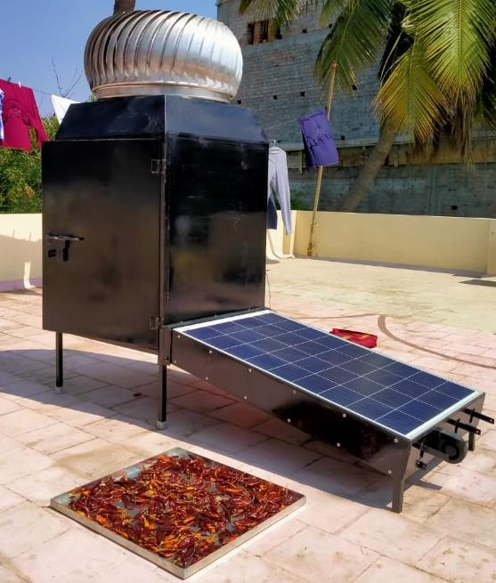
Fig. 1. Pictorial view of open sun light drying and hybrid dryer set up.

Table 1. Detailed dimensions of the FPHCD.
Operating parameters & System parameters
Air velocity at the entry of the channel (v) | 1.2 & 1.8 m/s
Ambient temperature (Ta) | 307 - 316 K
Area of the panel, A | 0.7471 m²
Fan power | 18 Watts
Height of the drying chamber | 1.050 m
Length of the drying chamber | 0.700 m
Length of the panel | 1.115 m
Open circuit voltage of solar panel, V_{oc} | 18.98 V
Short circuit current of solar panel, I_{sc} | 5.26 A
Slope of the solar panel surface | 13ᵒ
Solar radiation (G) | 400-1100 W/m²
Thickness of the panel | 0.035 m
Width of the drying chamber | 0.690 m
Width of the panel | 0.670 m

Methodology

Moisture content of the product

The initial and final stage of moisture level of the particular commodity with respect to time t which were designed with the assistance of following equations as follows [32].

M = mi − md
o
mi
M = ms − md
f
ms
M = mt − md
t
mt
(1)

(2)

(3)

Where, mi, Initial mass of the commodity (kg), m_{d}, Mass of dry matter in the dryer (Kg), m_{s}, Mass of the dried commodity in the solar dryer (Kg), m_{t}, Mass of the sample at time t (kg).

Electrical Efficiency Performance
Electrical efficiency performance of a PV panel could be determined as a ratio of electrical energy output of the PV panel to the solar energy (or) light energy falls on the solar panel which is carried out as given below [23, 24, 33, 34, 35].

𝞰_{el} = $\frac{Vmp. Imp }{A.G}= \frac{Eel}{A.G}$ (4)
Where, Ėel is an outlet electrical power (W), G = solar radiation, W/m², A = PV module area, m².

Thermal Efficiency Performance
Thermal efficiency performance has been conducted with various parameters such as heat energy generation (KJ), area of the panel (m²) and solar radiation intensity (W/m²). The following equations were compiled the finding of thermal performance of solar hybrid collector as given below [11, 20, 23].
The equation of mass flow rate of air (Kg/s) is expressed by
ṁ =ρAv (5)
Where, ṁ = mass flow rate of air, kg/s, ρ = density, kg/m³,A = PV module area, m²,V = velocity of air, m/s.

Qu = mCp (Tout −Tin )
(6)

Where, Qu is gained from the system, Cp is a specific heat capacity of air (KJ/Kg K) and Tin and Tout shows input and output fluid air temperatures in the solar hybrid collector, respectively. Equation 7 describes the thermal efficiency has been generated from the FPHCD. Further, thermal energy were generated by forced convection through mini fan which has been included in the equation 8, as follows.

ηther = u
Q

AG
η = Qu

(8)

(7)

ther
( AG + Pfan )

Where, Thermal efficiency (ɳther),Pfan, (W) is the fan power using to generate thermal energy or heat energy in the solar hybrid collector which can be used to dry the commodities in the solar dryer.

Results & Discussions
The FPHCD was used to perform various analysis on Red chilli. The performance tests were conducted on days with clear sky condition. In this study, various analyses were carried out such as electrical and thermal efficiency of FPHCD. In addition to that, removal of moisture from the Red chilli by conventional form of drying which was compared with solar drying in natural and forced convection mode of operation.

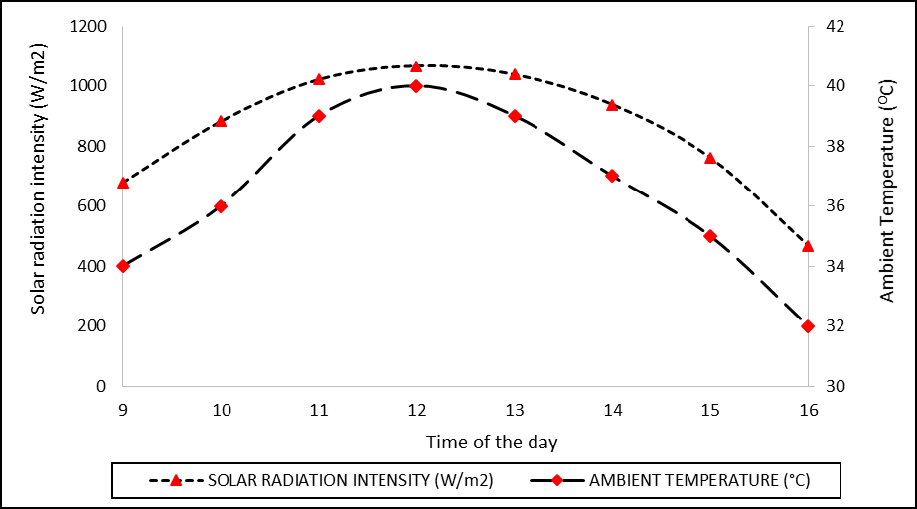
Fig. 2. Average solar radiation and ambient temperature with time (hrs).

Typical hourly values of average solar radiation and ambient temperature since 9 hr to 16 hr are indicated in Fig. 2. The maximum solar radiation was found to be 1068 W/m² at 12 hr and minimum solar radiation was found to be 467 W/m² at 16 hrs. Similarly, the maximum ambient temperature was found to be 40 °C at 12 hrs and minimum ambient temperature was found to be 32 °C at 16 hrs respectively. Solar radiation is always higher at midday and low in the morning and evening hours. On all test days, solar radiation range was from 467 W/m² to 1068 W/m². Evidently, thesolar radiation and ambient temperature from 9 hr to 16 hr seems to be existing a dome-shaped structure as shown in Fig.2.

Typical hourly values of electrical efficiency and glazing surface temperature of FPHCD since 9 hr to 16 hr are shown in Fig. 3. Evidently, from 9 hr to 12 hr there was increase in glazing temperature and decreased electrical efficiency then vice versa till 16 hr. It was observed that when glazing surface temperature was maximum, electrical efficiency was minimum between 11 hr to 13 hr. Due to high glazing surface temperature the electrical performance was poor.
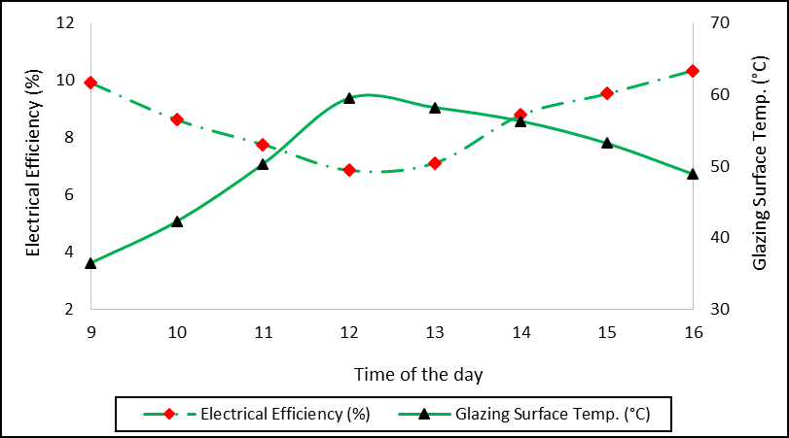

Fig. 3. Electrical efficiency and glazing surface temperature of FPHCD.
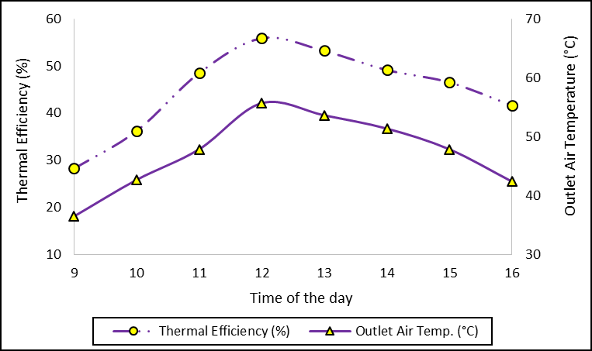

Fig. 4. Thermal efficiency and Outlet air temperature of FPHCD.

Typical hourly values of Thermal efficiency and Outlet air temperature of FPHCD is exposed in Fig. 4. Thermal performance increased with increase in air mass flow rate and solar radiation. Air extracted more heat energy from the tedlar side as a result better performance of the system is noticed. The hourly variations of thermal efficiency Vs outlet air temperature of FPHCD was calculated by using Eqs. 5 to 8. Evidently, outlet air temperature was found maximum between 12 hrs to 14 hrs, due to maximum solar radiation available during those hours.

Typical hourly values of Thermal efficiency and Fan power with Thermal efficiency of FPHCD is shown in Fig. 5. Forced convection can be generated by mini fan which was consumed by 18 watts. Fig. 5 describes two kinds of results in which normal thermal efficiency and thermal efficiency along with fan power. Electrical efficiency was generated by the solar panel which can be utilized by mini fan at energy of 18 watts.
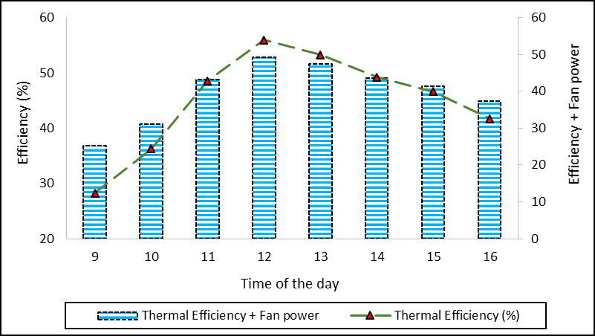

Fig. 5. Thermal efficiency and Fan power with Thermal efficiency of FPHCD.

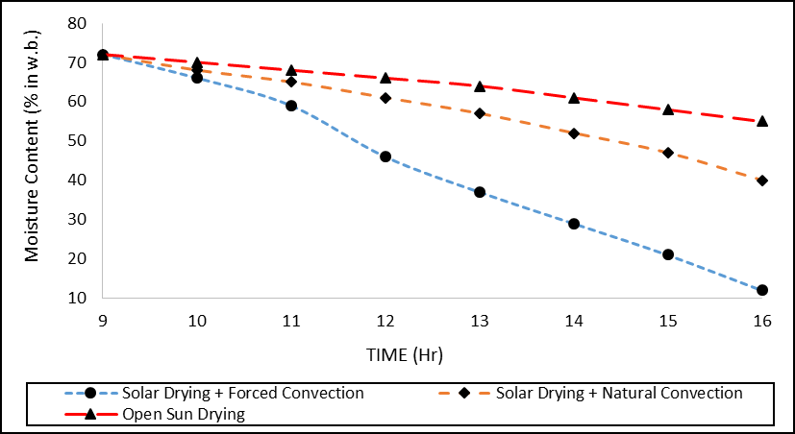

Fig. 6. Open sun light drying with hybrid drying by natural and forced convection of FPHCD.

Fig. 6. shows the comparative results of open sun light drying, solar drying along with natural and forced convection of FPHCD. As per the average test days of the experimental study deals with various hours of drying in solar drying with forced convection, solar drying with natural convection and open sun light drying 7 hrs 10 mins, 13 hrs 30 mins and 18 hrs 20 mins respectively. Open sun light drying has many demerits such as product quality will be deteriorated, contaminated items mixed together which made nil quality. Whereas, the solar dried chilli was free from dirt and clean nature.
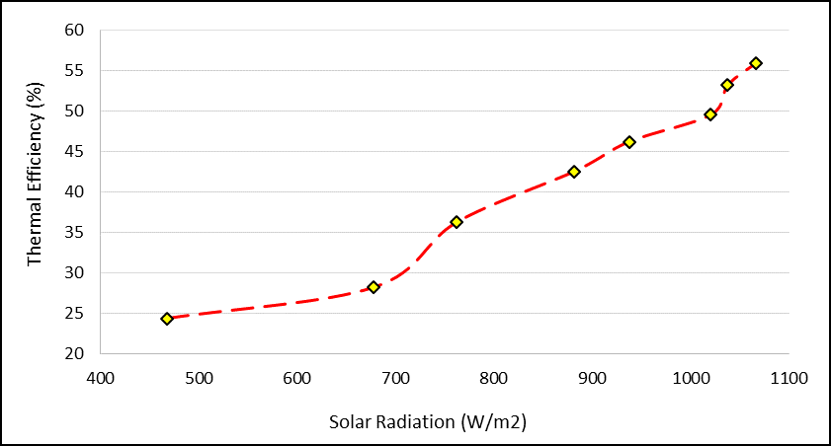

Fig. 7. Solar radiation intensity Vs Thermal efficiency of FPHCD.

Typical hourly values of solar radiation Vs Thermal efficiency of FPHCD is shown in Fig. 7. When solar radiation has been enhanced thermal efficiency was increased. As per the diagram, 24.38 % of thermal efficiency can be reached at 468 W/m², whereas 55.96 % of thermal efficiency can be attained at 1037 W/m².
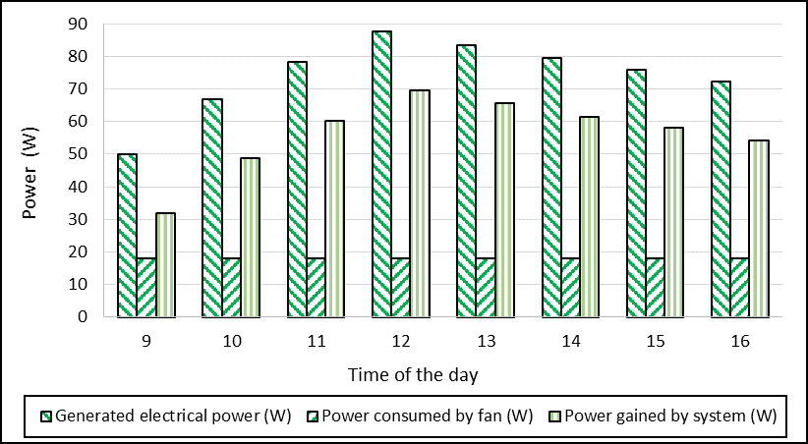

Fig. 8. Electrical power generated, consumed by fan and gained by the system.

Typical hourly values of Generated electrical power, power consumed by fan and power gained by the system is revealed in Fig. 8. As electrical energy was increased power gained by the system also enhanced, however power consumed by the fan was used at a constant scale at 18 watts. According to the system that electrical power generated at a maximum quantity at 12 Noon, during this period power gained by the system was reached at 69.55 watts. However, power consumed by the fan since 9 am to 4 pm 18 watts only.

Conclusion
Major conclusions can be drawn as given below.
- Electrical and thermal efficiency were achieved by FPHCD such as 11.12 %, 56.48 %, respectively.
- Commercial crop of Red chilli has been dried at all three modes, among this forced convection has significantly produced better results. However, open sun light drying was performed at a poor level.
- Mass flow rate of air might have enhanced better heat energy generation and thermal efficiency. As a result, drying time will be reduced significantly in the forced convection mode of drying.

References
- Kern JEC, Russell MC. Combined photovoltaic and thermal hybrid collector systems. In: Proceedings of the 13th IEEE photovoltaic specialists. Washington, DC, USA; 1978. p.1153.
- Wolf, M., 1976. Performance analyses of combined heating and photovoltaic power systems for residences. Energy Convers. 16, 79–90.
- J. Ji, J. Han, T. Chow, H. Yi, J. Lu, W. He, W. Sun, Effect of fluid flow and packing factor on energy performance of a wall-mounted hybrid photovoltaic/water-heating collector system, Energy and Buildings, 38 (2006) 1380-1387.
- E. Skoplaki, J.A. Palyvos, On the temperature dependence of photovoltaic module electrical performance: A review of efficiency/power correlations, Solar Energy, 83 (2009) 614-624.
- Srimanickam. B, Vijayalakshmi. M. M & Natarajan. E 2015, ‘Thermal Analysis on Photovoltaic Thermal Hybrid System with Cooling Channel with V-Baffles’, Indian Journal of Science and Technology, vol. 8, no. 36, pp 111-120.

- Yadav S, Kaushal M, Varun, Siddartha. Nusselt number and friction factor correlations for so-lar air heater duct having protrusions as roughness elements on absorber plate. Exp Therm fluid Sci 2013; 44:34-41.
- Srimanickam. B, Vijayalakshmi. M. M & Natarajan. E., 2015, Experimental performance assessment of single glazing flat plate solar photovoltaic thermal (PV/T) hybrid system. Progress in Industrial Ecology, an International Journal, vol. 9, no. 2, pp. 111-120.
- Parker, B.F., 1981. Derivation of efficiency and loss factors for solar air heaters. Sol. Energy 26 (1), 27– 32.
- Parker, B.F., Lindley, M.R., Colliver, D.G., Murphy, W.E., 1993. Thermal performance of three solar air heaters. Sol. Energy 51 (6), 467–479.
- Karim, M.A., Hawlader, M.N.A., 2006. Performance evaluation of a v-groove solar air collector for drying applications. Appl. Therm. Eng. 26 (1), 121–130.
- Karim, MA., Hawlader, MNA., 2006. Performance investigation of flat plate, v-corrugated and finned air collectors. Energy 31 (4), 452–470.
- Elshafei, E.A.M., Awad, M.M., El-Negiry, E., Ali, A.G., 2010. Heat transfer and pressure drop in corrugated channels. Energy 35 (1), 101–110.
- Chaube, Sahoo PK, Solanki SC. Analysis of heat transfer augmentation and flow characteristics of a solar air heater. Renew Energy 2006; 31: 317-31.
- Kumar S, Saini RP. CFD based performance analysis of a SAH duct provided with artificial roughness. Renew Energy 2009; 34: pp.1285-1291.
- Karmare SV, Tikekar AN. Analysis of fluid flow and heat transfer in a grit roughened surface solar air heater using CFD. Sol Energy 2010; 84:409-17.
- Yadav AS, Bhagoria JL. A numerical investigation of square sectioned transverse rib roughened solar air heater. Int J Therm Sci 2014; 79:111-3.
- Kumar A, Kim M-H. Effect of roughness width ratios in discrete multi V-rib with staggered rib roughness on overall thermal performance of solar air channel. Sol Energy 2015; 119: pp.399-414.
- Singh S, Singh B, Hans VS, Gill RS. CFD (computational fluid dynamics) investigation on Nusselt number and friction factor of solar air heater duct roughened with non-uniform cross-section transverse rib. Energy 2015; 84:509-17.
- Dongxu J, Zhang M, Wang P, Shasha X. Numerical investigation of heat transfer and fluid flow in a solar air heater duct with multi V-shaped ribs on the absorber plate. Energy 2015;89: 178-90.
- Srimanickam. B, Vijayalakshmi. M. M & Natarajan. E., 2015, ‘Experimental Study of Exergy Analysis on Flat Plate Solar Photovoltaic Thermal (PV/T) Hybrid System’, In Applied Mechanics and Materials (vol. 787, pp. 82-87).
- J.S. Sawhney, Rajesh Maithani, Sunil Chamoli., “Experimental investigation of heat transfer and friction factor characteristics of solar air heater using wavy delta winglets”, Applied Thermal Engineering 117 (2017) 740–751.
- Dongxu Jin, Jianguo Zuo, Shenglin Quan, Shiming Xu, Hao Gao., “Thermohydraulic performance of solar air heater with staggered multiple V-shaped ribs on the absorber plate”, Energy 127 (2017) 68-77.
- Srimanickam. B, Vijayalakshmi. M. M & Natarajan. E., 2018, ‘Energy and exergy efficiency of flat plate PVT collector with forced convection’, Journal of Testing and Evaluation, vol. 46, no. 2, pp. 1-15.
- Srimanickam. B., & Saranya. A., 2019 “Thermal performance of single glazing flat plate photovoltaic thermal hybrid system with various air channels,” Journal of Testing and Evaluation, vol. 49, no. 3.
- Adem Acır, Ismail Ata, Mehmet Emin Canlı, “Investigation of effect of 560 the circular ring turbulators on heat transfer augmentation and fluid flow characteristic of solar air heater” Experimental Thermal and Fluid Science 77 (2016) 45–54.
- Deep Singh Thakur, Mohd. Kaleem Khan, Manabendra Pathak., “Performance evaluation of solar air heater with novel hyperbolic rib geometry” Renewable Energy 105 (2017) 786-797.

- Anil P. Singh, Varun, Siddhartha, “Heat transfer and friction factor correlations for multiple arc shape roughness elements on the absorber plate used in solar air heaters” Experimental Thermal and Fluid Science 54 (2014) 117–126.
- Omer, K.A., Zala, A.M., 2018. Experimental investigation of PV/thermal collector with theoretical analysis. Renew. Energy Focus 27, 67–77.
- Slimani, M.E.A., Amirat, M., Kurucz, I., Bahria, S., Hamidat, A. and Chaouch, W.B., 2017. A detailed thermal-electrical model of three photovoltaic/thermal (PV/T) hybrid air collectors and photovoltaic (PV) module: Comparative study under Algiers climatic conditions. Energy conversion and management, 133, pp.458-476.
- Hasanuzzaman, M., Malek, A.B.M.A., Islam, M.M., Pandey, A.K. and Rahim, N.A., 2016. Global advancement of cooling technologies for PV systems: A review. Solar Energy, 137, pp.25-45.
- V.S. Hans, R.S. Gill, Sukhmeet Singh, “Heat transfer and friction factor correlations for a solar air heater duct roughened artificially with broken arc ribs” Experimental Thermal and Fluid Science 80 (2017) 77–89.
- D.V.N. Lakshmi, P. Muthukumar, Apurba Layek, Prakash Kumar Nayak, Drying kinetics and quality analysis of black turmeric (Curcuma caesia) drying in a mixed mode forced convection solar dryer integrated with thermal energy storage. 10.1016/j.renene.2017.12.053.
- Alta, D., Bilgili, E., Ertekin, C. and Yaldiz, O., 2010. Experimental investigation of three different solar air heaters: Energy and exergy analyses. Applied Energy, 87(10), pp.2953-2973.
- Esen, H., 2008. Experimental energy and exergy analysis of a double-flow solar air heater having different obstacles on absorber plates. Building and Environment, 43(6), pp.1046-1054.
- Akpinar, E.K., and Koçyiğit, F., 2010. Energy and exergy analysis of a new flat-plate solar air heater having different obstacles on absorber plates. Applied Energy, 87(11), pp.3438-3450.

