"REVOLUTIONIZING HRM: EXPLORING THE IMPACT OF AI ON HUMAN RESOURCE MANAGEMENT"

Dr. K. BHAVANI SELVI
Assistant Professor
Department of Commerce
DRBCCC Hindu College
Pattabiram, Chennai
TamilNadu
India
Introduction to AI in HRM:
Artificial Intelligence (AI) is revolutionizing various aspects of our lives, and Human Resource Management (HRM) is no exception. In recent years, AI has emerged as a powerful tool that transforms traditional HR practices by leveraging technology to streamline processes, enhance decision-making, and create more personalized employee experiences.
AI involves the development of computer systems that can perform tasks that typically require human intelligence, such as learning, reasoning, problem-solving, and decision-making. In the context of HRM, AI is being utilized to automate routine administrative tasks, analyze large datasets to extract insights, and provide valuable assistance in talent management, employee engagement, and more.
The integration of AI into HRM brings forth a new era of efficiency and innovation. Tasks like resume screening, initial candidate assessments, and even employee performance evaluations can now be augmented by AI algorithms, leading to faster, more accurate results. This technology enables HR professionals to shift their focus from transactional activities to strategic initiatives that drive organizational success.
However, the adoption of AI in HRM is not without its challenges. Ethical considerations, data privacy concerns, and potential biases in AI algorithms need to be carefully addressed to ensure fairness and transparency in HR practices. Balancing the benefits of AI-driven automation with the human touch required for effective employee engagement and communication is also a key consideration.
In this journey into the realm of AI in HRM, we will explore how AI is transforming various HR practices, from recruitment and onboarding to performance management and beyond. We will delve into the advantages and disadvantages of implementing AI in HRM, and discuss best practices for harnessing AI's potential while maintaining the human element that is vital in creating a thriving workplace culture. Let's embark on this exploration of AI's role in shaping the future of HRM practices.

Role of AI in HRM Practices:
AI plays several crucial roles in HRM practices:
- Recruitment and Selection: AI automates candidate sourcing, screening, and shortlisting by analyzing resumes and assessing candidates' qualifications, skills, and fit for the role.
- Employee Onboarding: AI-driven tools provide new hires with personalized onboarding materials, answer their queries, and guide them through company policies and procedures.
- Talent Management: AI identifies high-potential employees and recommends suitable career paths, helping HR create targeted development plans and retain top talent.
- Performance Management: AI assesses employees' performance using data from various sources, offering real-time feedback, and helping HR make more accurate evaluations.
- Learning and Development: AI tailors training content to individual employee needs, learning styles, and career aspirations, facilitating continuous skill enhancement.
- Employee Engagement: AI analyzes employee sentiment through surveys, communication channels, and social media to gauge engagement levels and identify areas for improvement.
- Predictive Analytics: AI predicts turnover, identifies flight risks, and forecasts skill gaps, enabling HR to take proactive measures to address workforce challenges.
- HR Analytics: AI analyzes workforce data to provide insights into productivity, diversity, and trends, guiding HR decisions on resource allocation and organizational strategies.
- Well-being and Work-Life Balance: AI monitors employee well-being by analyzing communication patterns, helping HR identify signs of stress and implement interventions.
- Diversity and Inclusion: AI helps mitigate bias in hiring and promotion decisions, fostering diversity and inclusion by focusing on objective data and criteria.
- Compensation Analysis: AI ensures fair compensation by analyzing market data and internal factors, helping HR set competitive salary structures.
- Employee Relations: AI-powered chatbots provide employees with a platform to discuss concerns and conflicts, offering confidential and neutral channels for resolution.
- Compliance and Ethics: AI assists in ensuring HR practices adhere to legal and ethical standards, identifying potential risks and suggesting compliance measures.
- Remote Work Management: AI tracks remote employees' productivity and engagement, providing insights to HR for effective remote work management.
- Strategic Decision-Making: AI provides data-driven insights for strategic HR decisions, aligning workforce strategies with organizational goals and market trends.
- Cost Optimization: AI automates manual tasks, reducing administrative costs and freeing up HR resources for more strategic initiatives.
The role of AI in HRM practices is to streamline operations, enhance decision-making, improve employee experiences, and contribute to the overall success of the organization. It complements human expertise by handling routine tasks and providing valuable insights that help HR professionals make informed and impactful choices.
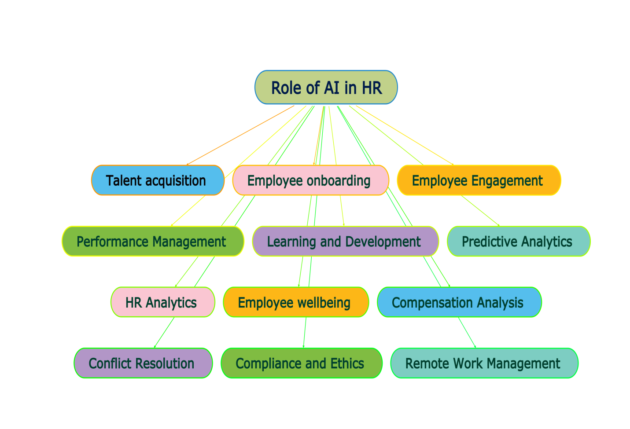

Importance of AI in HRM Practices:
AI brings several important benefits to HRM practices:
- Efficiency: AI automates repetitive tasks like resume screening and data entry, allowing HR professionals to focus on strategic initiatives and more value-added tasks.
- Data-Driven Insights: AI analyzes vast amounts of data to provide actionable insights, helping HR teams make informed decisions about workforce planning, talent management, and employee engagement.
- Accuracy and Consistency: AI reduces the risk of human error, ensuring consistent and unbiased handling of tasks such as candidate assessments and performance evaluations.
- Personalization: AI tailors learning and development plans, feedback, and recommendations to individual employees' needs, enhancing their growth and job satisfaction.
- Cost Savings: AI-driven tools can lead to cost savings by reducing the time and resources spent on manual processes and repetitive tasks.
- Enhanced Recruitment: AI identifies the most suitable candidates by analyzing their qualifications and skills, improving the quality of hires and reducing time-to-fill positions.
- Employee Engagement: AI helps gauge employee sentiment and engagement, enabling HR to address issues proactively and create a more positive workplace culture.
- Predictive Analytics: AI predicts trends such as turnover rates and skill gaps, allowing HR to take preemptive actions to retain talent and address skill shortages.
- 24/7 Availability: AI-powered chatbots provide assistance and information to employees around the clock, enhancing their experience and accessibility to HR services.
- Adapting to Change: AI can quickly adapt to changes in the business environment, helping HR adjust workforce strategies in response to market fluctuations or organizational shifts.
- Data Privacy and Compliance: AI tools can assist in ensuring HR practices comply with data protection regulations by automatically identifying and flagging potential breaches.
- Remote Work Support: AI tools assist in monitoring remote employees' well-being, productivity, and engagement, helping HR manage distributed teams effectively.
- Strategic Focus: By automating routine tasks, HR professionals can allocate more time to strategic initiatives like succession planning, leadership development, and organizational transformation.
- Objective Decision-Making: AI reduces bias in decision-making by relying on data and algorithms, contributing to fairer hiring, promotions, and performance evaluations.
- Employee Satisfaction: AI streamlines processes and provides quicker responses, enhancing the overall employee experience and satisfaction with HR services.
Overall, AI in HRM practices enhances efficiency, accuracy, and strategic decision-making, leading to improved organizational performance and a more engaged and satisfied workforce.

Advantages and Disadvantages of AI in HRM practices:
Here are the advantages and disadvantages of using AI in HRM practices:
Advantages:
- Efficiency: AI automates time-consuming tasks, such as resume screening and data entry, allowing HR professionals to focus on more strategic activities.
- Data-Driven Insights: AI analyzes large amounts of data to provide valuable insights, helping HR make informed decisions about talent management and workforce planning.
- Accuracy: AI reduces human error and bias in tasks like candidate assessment and performance evaluations, leading to more consistent and fair outcomes.
- Personalization: AI tailors learning and development plans to individual employee needs, enhancing their skills and career growth.
- Cost Savings: AI-driven tools reduce the need for manual labor in administrative tasks, leading to cost savings in terms of time and resources.
- Predictive Analytics: AI predicts turnover rates, skill gaps, and other trends, enabling HR to take proactive measures to address potential challenges.
- Enhanced Recruitment: AI improves candidate matching by assessing qualifications and skills, resulting in better-quality hires and shorter time-to-fill positions.
- Employee Engagement: AI analyzes sentiment to gauge employee engagement and satisfaction, allowing HR to address concerns promptly.

Disadvantages:
- Data Privacy Concerns: Collecting and analyzing employee data through AI raises concerns about privacy and data security, requiring careful handling and compliance with regulations.
- Bias and Fairness: AI algorithms can inherit biases from historical data, leading to potential bias in recruitment, promotions, and other HR decisions.
- Loss of Human Touch: Over-reliance on AI may reduce personal interaction between employees and HR professionals, impacting the human touch in HR management.
- Implementation Costs: Integrating AI systems can be expensive, requiring investments in technology, training, and infrastructure.
- Initial Learning Curve: HR teams may require time to learn how to effectively use AI tools, potentially causing disruptions during the implementation phase.
- Job Displacement Concerns: The fear of AI replacing human jobs can lead to resistance and uncertainty among HR professionals and employees.
- Inaccurate Insights: AI algorithms might not always provide accurate insights, leading to incorrect decisions if the data used is incomplete or biased.
- Limited Context Understanding: AI lacks the ability to understand complex human contexts and emotions, which can be crucial in certain HR situations.
- Dependency on Technology: Overreliance on AI systems can lead to issues if there are technical glitches, downtime, or system failures.
- Resistance to Change: Employees and HR professionals may resist the integration of AI into HRM practices due to concerns about job roles and changes in processes.
Balancing the advantages and disadvantages of AI in HRM requires careful planning, ongoing monitoring, and a focus on ethical considerations and data privacy to ensure that its implementation benefits both the organization and its employees.
Conclusion:
AI has enabled HR professionals to automate time-consuming tasks, analyze vast amounts of data to extract actionable insights, and provide personalized experiences to employees. The recruitment process has become more precise, with AI helping to identify the best-fit candidates faster, while onboarding and training have become more tailored to individual needs, resulting in enhanced engagement and skill development. Performance management has evolved into a data-driven process, offering real-time feedback and accurate evaluations.
In this era of AI, the successful integration of technology and human expertise will shape the future of HRM practices. By harnessing AI's power responsibly, HR professionals can create a workplace that fosters innovation, empowers employees, and achieves organizational success while maintaining the core values that make HR a pivotal force in building a thriving and motivated workforce.
Reference:
https://www.gopakumarpillai.com/ai-human-resource-management/
https://www.emerald.com/insight/content/doi/10.1108/JEIM-11-2020-0436/full/html
https://www.softwaresuggest.com/blog/ai-in-hr/
https://www.businessnewsdaily.com/how-ai-is-changing-hr
https://www.sciencedirect.com/science/article/pii/S2772662223000899

