Simultaneous determination of Paracetamol, Phenylephrine hydrochloride and Loratadine in tablet dosage form by multitudinal chemometric assisted analytical methods

Keerthisikha Palur
Department of Pharmaceutical Analysis
Sri Padmavathi School of Pharmacy
Tiruchanoor, India
Keerthi8spsp@gmail.com

Sreenivasa Charan Archakam
Department of Pharmaceutical Analysis
Sri Padmavathi School of Pharmacy
Tiruchanoor, India
Charan4ma@gmail.com

ABSTRACT
Simultaneous determination of drugs in multi-component formulations without prior separation imposes a big challenge to the analyst in developing simple, precise and accurate analytical methods. This can be achieved by the application of Chemometrics to the conventional analytical methods. In this work, chemometric assisted UV-Spectrophotometry and RP-HPLC methods were applied for the quantification of Loratadine (LOR), Paracetamol (PRT) and Phenylephrine hydrochloride (PEH) in their combined dosage form. UV-Spectrophotometric analysis was carried out by applying two chemometric models namely, Principal Component Regression (PCR) and Partial Least Squares Regression (PLS). These two models were successfully validated and applied for resolving the complex UV-spectra in the wavelength range of 225-300 nm with a data interval of 5 nm. Chromatographic analysis was developed and optimized by using Central Composite Design (CCD), a type of response surface methodology. The CCD was applied to study the critical factors and their interactions with the responses. The identified critical factors were mobile phase pH in the range of 2.8-3.2, acetonitrile content in the range of 60-70%v/v and flow rate in the range of 0.6-0.8 mL/min and the responses affected by these factors were retention time of the 1st eluted drug (Rt₁), retention time of the 3rd eluted drug (Rt₃) and resolution between first and second eluted drugs (RS_{1,2}). Derringer’s desirability function was used for the optimization of the chromatographic method and the optimization was carried out using a mobile phase of phosphate buffer (pH 3.2) and acetonitrile in the ratio of 64 :36 using 0.7 mL/min flow rate at a detection wavelength of 275 nm. All the developed methods showed good accuracy and precision for the quantification of drugs in their combined dosage form.

Keywords- Chemometrics, Principal component regression, Partial least square regression, Central composite design, Derringer’s desirability, RP-HPLC.

INTRODUCTION

Multicomponent formulations have acquired significance in the field of pharmaceuticals by exhibiting beneficial effects with respect to the efficacy and potency. Development of analytical methods for simultaneous determination of compounds in these formulations has become a difficult task [1-3]. Conventional spectrophotometric methods require more time and the results obtained were unsatisfactory and devised by low resolution [4-6]. Analysis of drugs without prior separation and without using sophisticated methods has now become possible by using chemometrics which uses the application of mathematical tools in resolving the analytical data of complex mixtures [7-9]. In general, chromatographic studies were predicated on univariate approach which uses only one variable at a time (OVAT) approach which seems to be easier but it should not be considered due to the requirement of a greater number of trials, more time consumption, inconsideration of interaction effects between variables and complicated optimization involving several factors [10-13].
The combination of Loratadine (LOR), Paracetamol (PRT) and Phenylephrine hydrochloride (PEH) is effectively used in the treatment of common cold and in the reduction of pain and fever. Extensive literature survey revealed that only two RP-HPLC methods were reported and no chemometric assisted analytical method was reported for the simultaneous determination of LOR, PRT and PEH in pharmaceutical dosage forms [14-15]. The reported methods were based on one factor at a time (OFAT) approach and these methods did not considered the interaction effects between variables. Application of chemometric tools to OFAT approach provides interaction effects and also helps in robust method transfer. Hence, in the present work, an attempt has been made to analyse LOR, PRT and PEH present in a tablet dosage form by using Ultraviolet and reversed phase high performance liquid chromatographic methods with the application of chemometric tools. SNIZID PLUS tablets containing 5 mg LOR, 500 mg PRT and 7.5 mg PEH were used in this study. UV spectral analysis was carried out by the application of two chemometric models namely principal component regression (PCR) and partial least squares regression (PLS). RP-HPLC method development and validation were carried out by using design of experiments and the experimental design used in the study was central composite design – response surface methodology (CCD-RSM). The results obtained by the developed methods were compared by using one way ANOVA to know whether there are any significant differences between them.

MATERIALS AND METHODS
- Instrumentation and software
Shimadzu (UV 1800) double beam UV-Visible spectrophotometer with 1 cm quartz cells and linked to a computer equipped with UV probe software was used to acquire the spectral data. PCR and PLS chemometric tools were executed in UNSCRAMBLER X version 10.5 software (Camo analytics). Statistical and regression analysis was carried out by using Microsoft excel 2010. Chromatographic measurements were carried out with an isocratic liquid chromatograph (Shimadzu) equipped with LC 20AT pump, SPD 20A UV–VIS detector and a rheodyne injector and LC solutions software. Phenomenex ODS analytical column (250 × 4.6 mm; 5 μ) was used for the separation of drugs. Design expert v.10 software was used for the optimization of HPLC method.

- Materials and reagents
Pure samples of LOR (98.7%), PRT (99.7%) and PEH (99.7%) were procured from Raffles Pharmaceuticals, Tirupati and TCI Chemicals (India) Pvt. Ltd., Chennai. Methanol (HPLC grade & AR grade), acetonitrile (HPLC grade), potassium dihydrogen phosphate (AR grade), phosphoric acid, sodium hydroxide (AR grade) were used in the analysis. Marketed formulation Snizid plus tablets (manufactured by Profile Organic pvt.ltd) containing 5 mg LOR, 500 mg PRT and 7.5 mg PEH were used as sample in the current study for the determination of quantity of drugs.

- PCR and PLS chemometric UV methods
Calibration curves were constructed for LOR, PRT and PEH in the concentration ranges of 4-20 µg/mL, 2-10 µg/mL and 18-90 µg/mL respectively using methanol as a solvent. Standard mixture solutions containing different ratios of the drugs in their calibration curve ranges were prepared as given by multilevel multifactor experimental design and were scanned in UV-VIS spectrophotometer in the wavelength range of 200-400 nm using methanol as a blank. Sample enrichment technique was used to prepare the sample solution and the concentrations of drugs were chosen in their linearity ranges. The sample solution was prepared to get a concentration of 12 µg/mL of PRT, 12 µg/mL of LOR and 12 µg/mL of PEH. Chemometric analysis was carried out in the spectral region of 225-300 nm with 5 nm data interval. PCR and PLS models were constructed by framing ten standard mixture solutions into the calibration set and five standard mixture solutions into the test set as shown in Table 1. Statistical analysis was used to optimize the calibration set and then applied for quantification of drugs in the chosen dosage form.

Table 1: Calibration and validation sets for PCR and PLS methods

Calibration set |  |  |  | Validation set
Mixture | PRT  (μg/mL) | PEH  (μg/mL) | LOR  (μg/mL) | Mixture | PRT  (μg/mL) | PEH  (μg/mL) | LOR  (μg/mL)
 | 6 | 90 | 8 | 11. | 6 | 72 | 20
 | 6 | 36 | 12 | 12. | 6 | 18 | 16
 | 2 | 72 | 16 | 13. | 4 | 18 | 4
 | 4 | 54 | 12 | 14. | 10 | 36 | 8
 | 10 | 36 | 4 | 15. | 8 | 18 | 8
 | 6 | 54 | 4
 | 10 | 54 | 20
 | 2 | 90 | 4
 | 8 | 36 | 20
 | 4 | 72 | 8
- CCD-RSM chromatographic method
Initial chromatographic conditions for the simultaneous estimation of LOR, PRT and PEH were chosen based on the literature and physicochemical properties of these drugs. Various trials were performed by injecting the standard mixture solution containing 20µg/mL of all the drugs with varying mobile phase pH, composition, flow rate and detection wavelengths. From the preliminary trials, it was noticed that proper elution of the three drugs was observed using the conditions of mobile phase pH (Factor A) in the range of 2.8-3.2, acetonitrile content (Factor B) in the range of 60-70%v/v and flow rate (Factor C) in the range of 0.6-0.8 mL/min and these showed a greater impact on the separation of LOR, PRT and PEH. Central composite design- response surface methodology was applied for the optimization of chromatographic method. 20 runs were executed as given by CCD and all the responses which were influenced by the input variables were studied. Among all the responses, three responses were found to be majorly influenced by the given input variables, which were retention time of the 1st eluted drug that is PEH (Rt₁), retention time of 3rd eluted drug that is LOR (Rt₃) and resolution between first and second eluted drugs (RS_{1,2}) i.e., PRT and PEH. Prediction of responses was done through regression analysis and statistical parameters obtained from ANOVA revealed the significance of the model. Main effects and interaction effects of factors on responses were studied using perturbation, 2D contour and 3D response surface plots. Derringer’s desirability function was used in optimization of the chromatographic responses. Optimization was done using a mobile phase of phosphate buffer (pH 3.2) and acetonitrile in the ratio of 64 :36 using 0.7 mL/min flow rate at a detection wavelength of 275 nm.

- Validation and comparison of chemometric UV and RP-HPLC methods
PCR and PLS calibration models were validated by using k-fold cross validation method. Statistical analysis was done for the optimized calibration set. The optimized calibration set was applied to the test set to predict the concentrations of LOR, PRT and PEH and the validation parameters like accuracy and RMSEP were calculated to define the predictive ability of the models. Chemometric assisted RP-HPLC method was validated according to ICH guidelines by performing all the validation parameters like linearity, precision, system suitability, accuracy and robustness. The validated RP-HPLC method was applied to determine the concentrations of LOR, PRT and PEH in the sample solution. Comparison of the developed chemometric assisted UV and RP-HPLC methods was done by one way ANOVA to test whether there are any significant differences between them. The ANOVA results were calculated using Minitab 16 software. Evaluation was done based on the obtained F and P values.

RESULTS AND DISCUSSION

Chemometric assisted UV spectrophotometric methods
In the present study, the chemometric models PCR & PLS resolved the grievous overlapping of the absorption spectra of LOR, PRT and PEH (Fig.1.) with higher degree of precision and accuracy. These models also have the ability to nullify the interfering effects of excipients that were present in the formulation. To develop PCR and PLS models, a calibration set was created for a ternary mixture of LOR, PRT and PEH. The concentrations of drugs in the calibration set were chosen based on individual linearity ranges. Wavelength range selection is crucial and can help to increase the quality of the models. Therefore, the recorded spectral data was preprocessed, and the regions between 200 and 240 nm and above 310 nm were deleted due to noise and very low absorbance values, respectively. On the calibration data set, a cross validation approach incorporating the K-fold procedure was used to find the appropriate number of PCs and LVs in the PCR and PLS models, respectively. The data set was divided into three groups in this approach. One group was used as a test set, while the other two were organized into calibration sets. On the calibration sets, PCR and PLS models were applied to determine the concentration of drugs in the test set. The same procedure was repeated for the other groups. The anticipated concentrations in each test set sample were compared to the actual concentrations, and the errors were identified using RMSECV values. The RMSECV value should be as low as possible, as it shows the correctness and precision of calibration models. In PCR and PLS chemometric models, RMSECV values were determined for each number of PCs and LVs. Other statistical measures such as PRESS, RMSEC, and R² were used to validate the models.
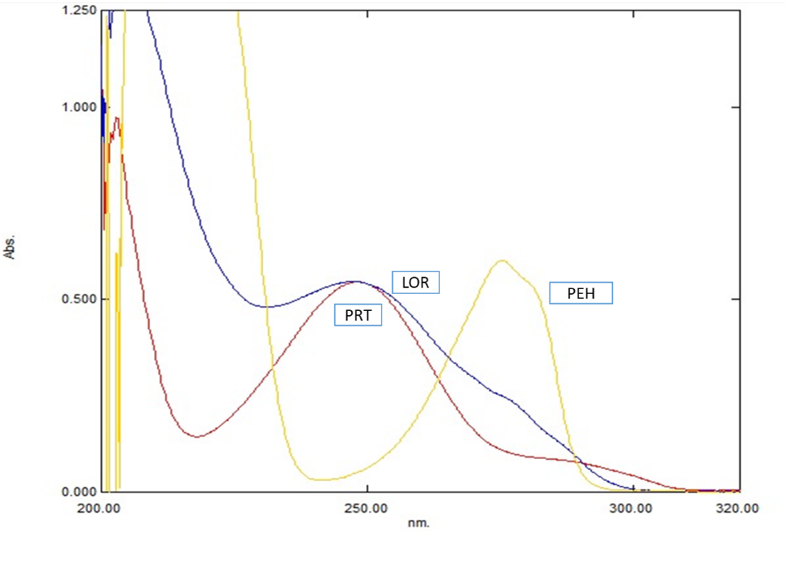
Figure 1. Overlay absorption spectra of PRT, PEH and LOR
The number of PCs in PCR and LVs in PLS were decided based on RMSECV values. The optimal number of PCs and LVs for PRT, PEH and LOR in PCR and PLS methods were found to be 6, 6, and 7 correspondingly (Fig.2). For the simultaneous determination of PRT, PEH and LOR, the calibration set with the lowest RMSECV values was chosen. The calibration set was subjected to PCR and PLS models, and the statistical parameters were examined. The actual and predicted values showed good correlation at the selected PCs and LVs, indicating the accuracy of the developed models and all the statistical parameters were found to be within the limits for both models (Table 2). The optimized models were applied to predict drug concentrations in the dosage form.
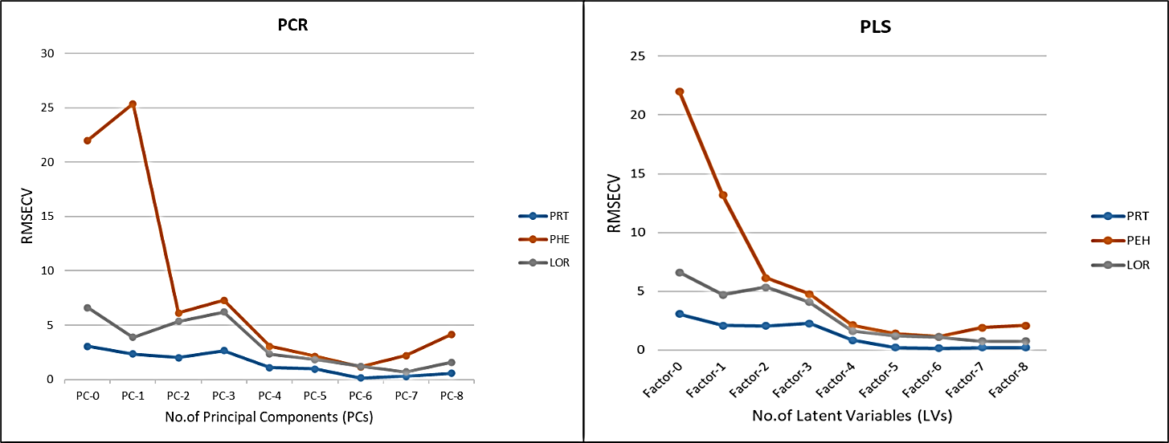
Figure 2. RMSECV plots for PCR and PLS methods
Table 2: Statistical parameters obtained for PRT, PEH & LOR by PCR and PLS methods
Statistical parameters | Principal Component Regression [PCR] |  |  | Partial least squares regression [PLS]
 | PRT | PEH | LOR | PRT | PEH | LOR
Concentration range (µg/mL) | 2-10 | 18-90 | 4-20 | 2-10 | 18-90 | 4-20
No. of factors | 6 | 6 | 7 | 6 | 6 | 7
R² | 0.9998 | 0.9999 | 0.9999 | 0.9997 | 0.9998 | 0.9999
RMSEC | 0.049 | 0.238 | 0.040 | 0.042 | 0.225 | 0.038
RMSECV | 0.142 | 1.156 | 0.699 | 0.134 | 1.114 | 0.738
RMSEP | 0.498 | 2.273 | 0.799 | 0.480 | 2.281 | 0.801
Calibration set Mean ±SD | 99.791  ± 1.255 | 100.000  ± 0.354 | 99.937  ± 0.528 | 99.837  ± 0.979 | 99.997  ± 0.351 | 99.942  ± 0.502
Validation set Mean ± SD | 100.273  ± 1.512 | 103.239  ± 1.984 | 100.064  ± 1.212 | 100.273  ± 1.512 | 103.239  ± 1.984 | 100.064  ± 1.212
Assay Mean ± SD | 97.867  ± 0.539 | 99.825  ± 0.556 | 100.312  ± 0.248 | 98.188  ± 0.585 | 99.609  ± 1.191 | 100.277  ± 0.245

Chemometric assisted RP-HPLC method development
Conventional chromatographic optimization procedures have been used to investigate the effect of one variable on the response value at a time. These methods do not reveal the complete effects of factors and requires greater number of trial runs and thus there will be an increase in time consumption and optimization. This can be overcome by the application of chemometric models to chromatographic methods. The use of chemometrics in chromatography enables method development easier and helps in robust method transfer. Chemometric models also provides essential and powerful tools for all critical stages in the method development for drug separation. Hence, the current study employed a chemometric assisted RP-HPLC method that provided detailed effects of variables. The experimental design used was CCD - RSM. Mobile phase pH (Factor A), acetonitrile content (Factor B) and flow rate (Factor C) were selected as factors as these affect the reverse phase chromatographic retention and elution behaviour of each drug in the mixture because of the polar nature of the drugs and were used in designing mathematical models. CCD generated 20 runs which were shown in Table 3 and among various chromatographic parameters obtained in the chromatograms, the responses Rt_{1,} Rt₃ and RS_{1,2} that were found to have a significant change with these factors were considered in the study.

Table 3: CCD of selected factors & responses for PRT, PEH and LOR
Run | Factor A | Factor B | Factor C | Response 1 | Response 2 | Response 3
 | Mobile phase pH | Acetonitrile content | Flowrate | Rt₁ | Rt₃ | RS_{1,2}
1 | 2.66 | 65 | 0.7 | 3.184 | 7.561 | 1.562
2 | 3.33 | 65 | 0.7 | 3.171 | 7.678 | 1.844
3 | 3.2 | 60 | 0.6 | 3.705 | 10.171 | 1.842
4 | 3.2 | 70 | 0.6 | 3.676 | 8.852 | 1.682
5 | 3 | 65 | 0.7 | 3.16 | 8.975 | 1.728
6 | 3.2 | 70 | 0.8 | 2.807 | 6.72 | 1.557
7 | 3 | 65 | 0.7 | 3.159 | 8.97 | 1.739
8 | 3 | 73.40 | 0.7 | 3.201 | 7.45 | 1.391
9 | 2.8 | 60 | 0.6 | 3.666 | 10.512 | 1.59
10 | 3 | 56.59 | 0.7 | 3.191 | 10.359 | 1.57
11 | 2.8 | 60 | 0.8 | 2.764 | 7.575 | 1.587
12 | 3 | 65 | 0.7 | 3.153 | 8.966 | 1.726
13 | 2.8 | 70 | 0.6 | 3.641 | 9.331 | 1.395
14 | 3 | 65 | 0.7 | 3.15 | 8.962 | 1.728
15 | 2.8 | 70 | 0.8 | 2.8 | 6.184 | 1.541
16 | 3 | 65 | 0.7 | 3.166 | 8.959 | 1.727
17 | 3 | 65 | 0.53 | 4.013 | 11.271 | 1.727
18 | 3 | 65 | 0.7 | 3.16 | 8.967 | 1.734
19 | 3.2 | 60 | 0.8 | 2.754 | 8.834 | 1.56
20 | 3 | 65 | 0.86 | 2.561 | 7.462 | 1.613

CCD-RSM data analysis
The design suggested a quadratic model based on statistical analysis and was found to be significant. The data obtained from the statistical parameters which was shown in Table 4, depicted the significance and fitness of the model. The quadratic equations (Eq.1,2, and 3) obtained for the prediction of responses were shown below.
$${Rt}_{1}=3.1579+0.0083 A+0.0049 B -0.4397 C^{*}+0.0016 AB-0.0096AC^{*}+0.0179BC^{*}+0.0132 A^{2*}+0.0113 B^{2*}+0.0452C^{2*}-(1)$$
$${ Rt}_{3}=8.9658+0.0506 A^{* }{-0.8219 B}^{*}-1.1268C^{*}-0.0364{AB}^{*}+0.2556{AC}^{*}-0.1969{BC}^{*}-0.4666A^{2*}-0.0472B^{2*}+0.1417C^{2*}-(2)$$
$${ RS}_{1,2}=1.7287+0.0653 A^{* }-0.0498B^{*}-0.0334C^{*}+0.0097{AB}^{*}-0.0688{AC}^{*}+0.0383{BC}^{*}-0.0212A^{2*}-0.0909B^{2*}-0.0213C^{2*}-(3)$$
Note: * indicates significant terms.
Table 4: Statistical parameters obtained from ANOVA for PRT, PEH and LOR
Statistical parameter | Rt₁ | Rt₃ | RS_{1,2}
P value | < 0.0001 | < 0.0001 | < 0.0001
R² | 0.9997 | 1.0000 | 0.9996
Adjusted R² | 0.9993 | 1.0000 | 0.9992
% CV | 0.3471 | 0.0953 | 0.2211
Adequate Precision | 173.1092 | 802.9206 | 164.1425
PRESS | 0.0102 | 0.0049 | 0.0009

The quadratic equation for Rt₁ revealed that factor C (flow rate) was found to be more significant when compared with the other factors and the response can be minimized by setting flowrate to its highest level. For the response Rt₃ and RS_{1,2}, all the factors were found to be significant. From the perturbation diagram of Rt₁ (Fig. 3 (a)), it was found that flow rate increased sharply which indicates that the response is very sensitive to this factor. The perturbation plot (Fig. 3(b)) of Rt₃ revealed that factors B and C are showing gradient slopes which indicates that Rt₃ decreases with increase in flow rate and organic phase, whereas the changes in the factor A showed lesser effect on Rt₃. All the three factors are showing effect on the response RS_{1,2} and majorly the response increases with increase in mobile phase pH and decreases with increase in flow rate (Fig. 3 (c)). Interaction effects of factors on the responses Rt_{1,} Rt₃ and RS_{1,2} was studied by the response surface and contour plots which were shown in Figs. 4, 5 & 6 respectively. The RSM and contour plots of Rt₁ revealed that the response Rt₁ can be minimized by using high levels of flow rate with either high or low levels of mobile phase pH and organic phase. Rt₃ can be minimized by using higher levels of flow rate and organic phase. Maximum resolution was noticed at lowest levels of flow rate and organic phase.
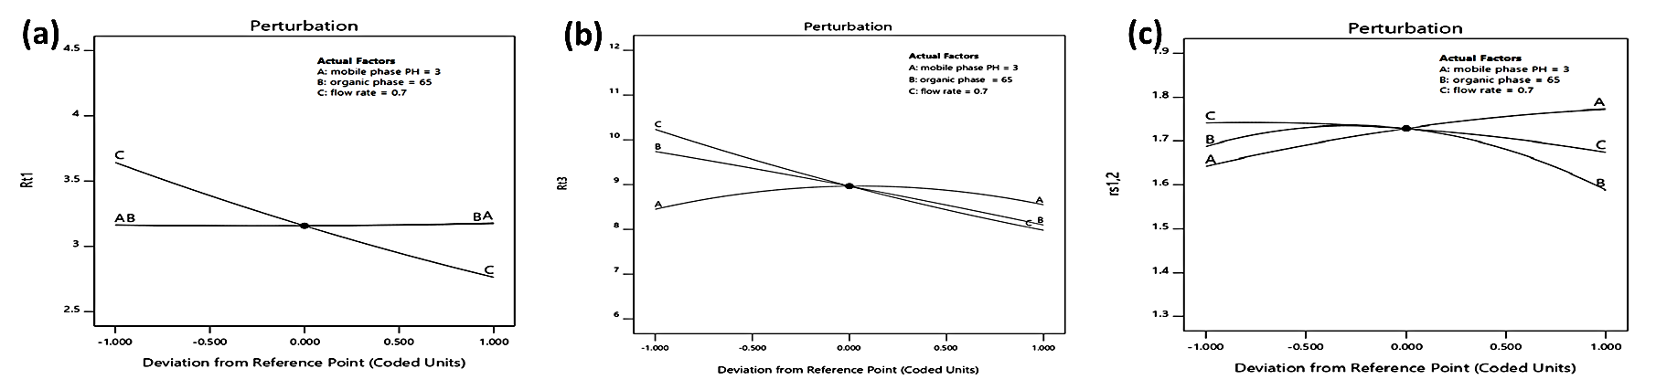
Figure 3. Perturbation plots for (a) Rt₁ (b) Rt₃ and (c) RS_{1,2} for PRT, PEH & LOR

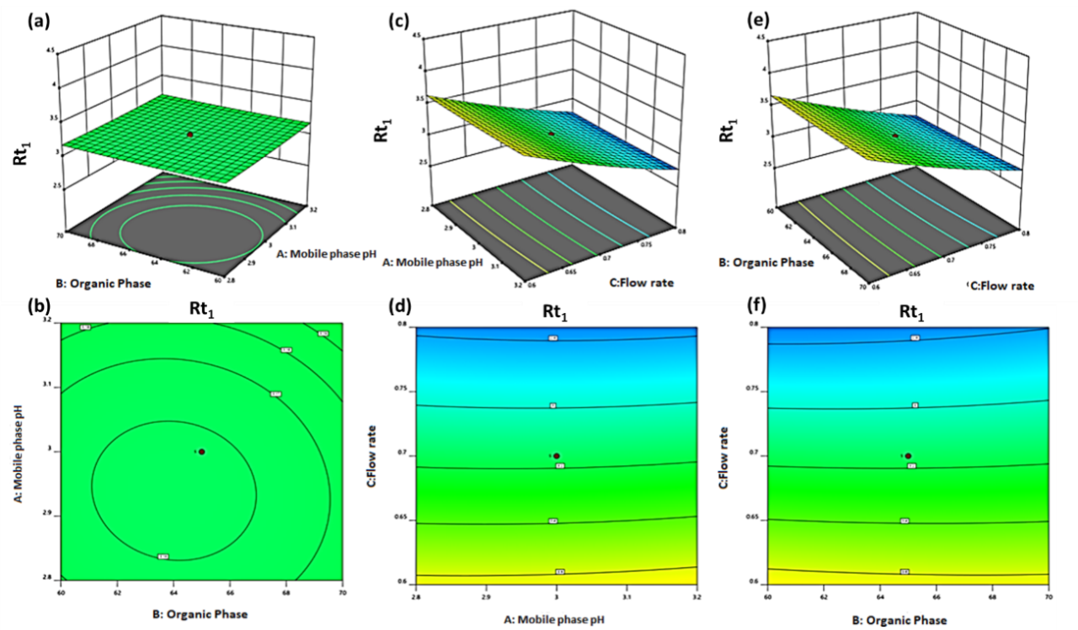
Figure 4. Response surface plots (a,c,e) and contour plots (b,d,e) for the response Rt₁ for PRT, PEH & LOR
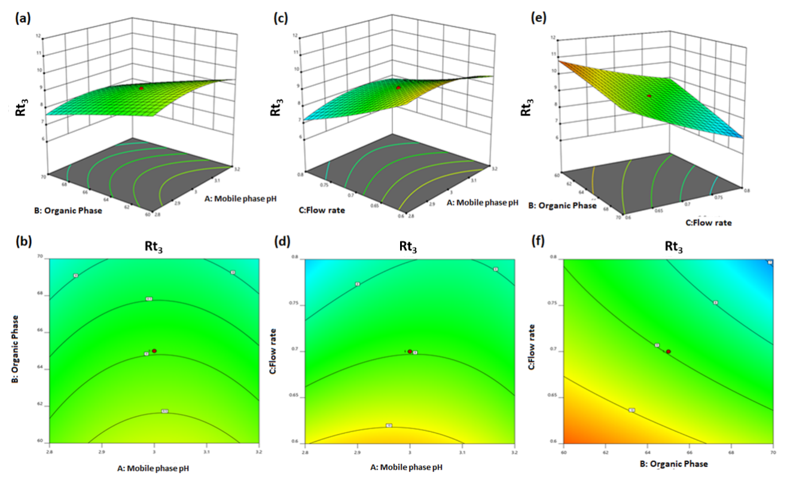

Figure 5. Response surface plots (a,c,e) and contour plots (b,d,e) for the response Rt₃ for PRT, PEH & LOR

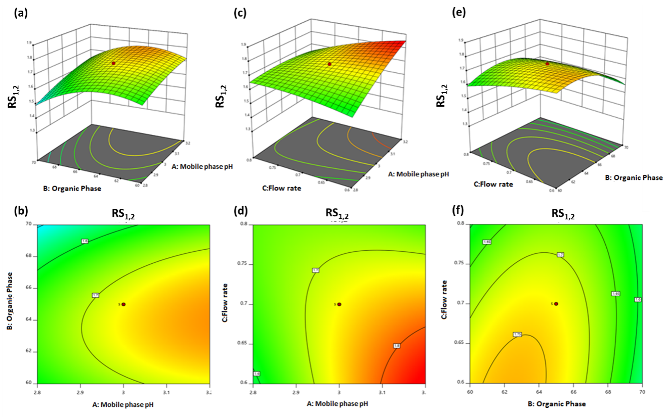
Figure 6. Response surface plots (a,c,e) and contour plots (b,d,e) for the response RS_{1,2} for PRT, PEH & LOR

D. Design adequacy, optimization and validation
Different techniques like studentized residual analysis, data independency and accuracy were tested to ensure the adequacy of the model. The data obtained from these techniques implied the model adequacy and normal distribution of errors for all the three responses. The optimization procedure was executed by Derringer’s desirability function and in this, the criteria given was to minimize Rt₁, to maximize RS_{1,2} and Rt₃ was chosen in the range. Rt₁ was minimized in order to reduce the analysis time and RS_{1,2} was enhanced to acquire good separation efficiency. The optimization was carried out and the obtained desirability was shown in Fig.7. From the global desirability function, coordinates (mobile phase pH-3.2, acetonitrile phase- 64 %v/v & flowrate-0.701 mL/min) producing the maximum desirability (D=0.762) were chosen for the present study. The prediction values obtained from the design were found to have a close agreement with the experimental values which indicated the efficiency of the design employed (Table 5). The optimized method was validated for different parameters like specificity, system suitability, linearity, accuracy, precision and robustness. The results obtained from the validation parameters which were presented in Table 6, depicted that the method was suitable for the analysis of the drugs in dosage form.
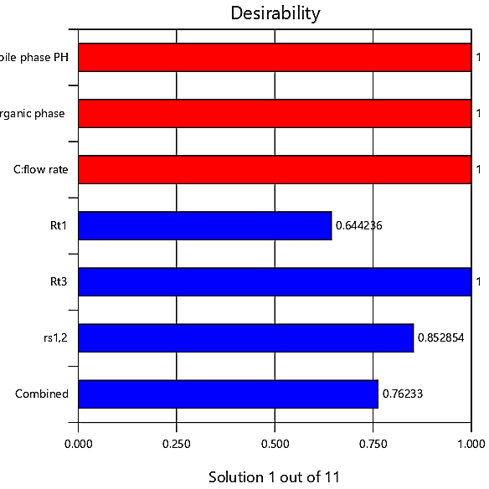
Figure 7. Desirability Bar graph from CCD for PRT, PEH & LOR
Table 5: Comparison of predicted and experimental values under optimal conditions for PRT, PEH and LOR
Optimal conditions | Response | Experimental values | Predicted values | Percentage Error
Acetonitrile- 64 %v/v  Mobile phase pH- 3.2  Flow rate- 0.701mL/min | Rt₁ | 3.158 | 3.172 | 0.44 %
 | Rt₃ | 8.722 | 8.724 | 0.02 %
 | RS_{1,2} | 1.737 | 1.776 | 2.19 %

Table 6: Summary of validation results for PRT, PEH and LOR obtained from Chemometric assisted RP-HPLC method
Method parameters | PRT | PEH | LOR
Linearity(µg/mL) | 10-30 | 10-30 | 10-30
Slope | 33494 | 16726 | 38311
Intercept | 29705 | 10805 | 16413
R² | 0.9994 | 0.9994 | 0.9993
System precision (%RSD) | 1.170 | 1.301 | 0.167
Method precision (%RSD) | 0.42 | 0.59 | 0.77
Accuracy (Mean ± SD) | 98.35±0.31 | 99.52±0.31 | 100.18±0.43

E. Assay of marketed formulation
The optimized chemometric assisted UV and RP-HPLC methods were applied for the simultaneous estimation of PRT, PEH and LOR in tablet dosage form and the assay results were calculated. The assay chromatogram of PRT, PEH and LOR was depicted in Fig.8. One-way ANOVA was executed for the results obtained from the developed methods and the data depicted that there are no significant differences among the methods for the assay of the formulation as evident from F-values & P-values as shown in Table 7.
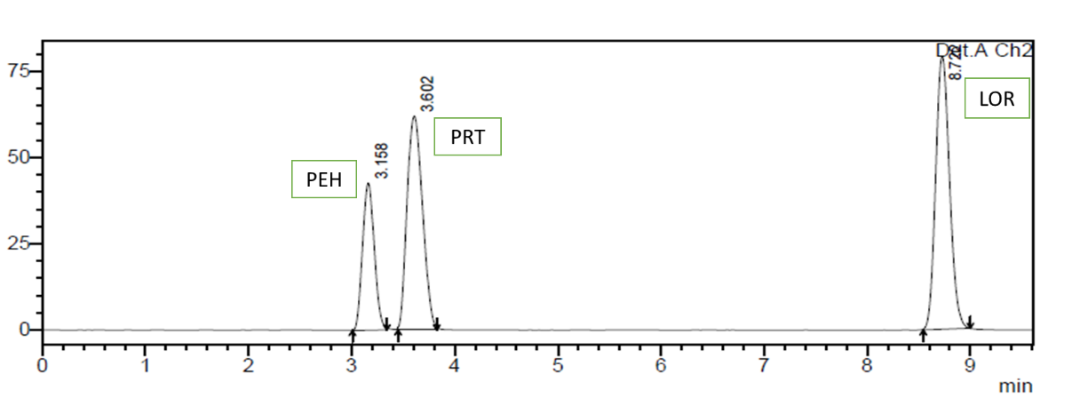
Figure 8. Assay chromatogram of PRT, PEH & LOR

Table 7: One way ANOVA results for the developed methods
Drug | Results | PCR | PLS | RP-HPLC
PRT | Mean Assay ± SD | 97.867±0.539 | 98.188±0.585 | 97.921±0.589
 | F-value | 0.27
 | P-value | 0.771
PEH | Mean Assay ± SD | 99.825±0.556 | 99.609±1.191 | 99.435±0.321
 | F-value | 0.20
 | P-value | 0.828
LOR | Mean Assay ± SD | 100.312±0.248 | 100.277±0.245 | 100.263±0.311
 | F-value | 0.03
 | P-value | 0.975

CONCLUSION
The present study delineates the efficiency of chemometrics in the development of robust sensitive and accurate UV and RP-HPLC methods for the quantitative determination of PRT, PEH and LOR in regular and quality control samples. Application of chemometric tools like PCR & PLS for UV spectroscopic analysis has surmounted the hardships caused by the ordinary UV methods and exhibited profound results. The developed PCR and PLS models were applied in the wavelength range of 225-300 nm with 5 nm data interval. In addition, chemometric tools like Response surface methodology and Derringer’s desirability which expedited the prudent identification of influential factors were applied for the chromatographic analysis of PRT, PEH and LOR in the marketed formulation. The method was optimized using mobile phase consisting of acetonitrile: phosphate buffer pH-3.2 (64:36%v/v) at flow rate of 0.7 mL/min. Statistically significant differences were not observed among the developed methods for the determination of the drugs. Thus, the selection of the method depends on the user flexibility for the analysis of marketed formulation.
REFERENCES
- Erdal Dinc, Dumitru Baleanu, Giuseppina Ioele, Michele de Luca, Gaetano Ragno. Multivariate analysis of paracetamol, propiphenazone, caffeine and thiamine in quaternary mixtures by PCR, PLS and ANN calibrations applied on wavelet transform data. J. Pharm. Biomed. Anal., 2008; 48:1471–1475.
- Heba M Mohamed. A study of selective spectrophotometric methods for simultaneous determination of Itopride hydrochloride and Rabeprazole sodium binary mixture: resolving sever overlapping spectra. Spectrochim. Acta A Mol. Biomol. Spectrosc., 2015; 136:1308–1315.
- Khoshayand M R, Abdollahi H, Shariatpanahi M, Saadatfard A, Mohammadi A. Simultaneous spectrophotometric determination of paracetamol, ibuprofen and caffeine in pharmaceuticals by chemometric methods. Spectrochim. Acta A, 2008; 70:491–499.
- Ghasemi, J. Niazi A. Simultaneous determination of cobalt and nickel. Comparison of prediction ability of PCR and PLS using original, first and second derivative spectra. Microchem. J., 2001; 68: 1–11.
- Kevin N Andrew, Paul J Worsfold. Comparison of multivariate calibration techniques for the quantification of model process streams using diode-array spectrophotometry. Analyst., 1998; 119:1541–1546.
- Shereen M. Tawakkol,Mohamed B. El-Zeiny, A. Hemdan. Full spectrum and selected spectrum based chemometric methods for the simultaneous determination of cinnarizine and dimenhydrinate in laboratory prepared mixtures and pharmaceutical dosage form. Spectrochim. Acta A Mol. Biomol. Spectrosc., 2017; 173:892–896.
- Belal F, Ibrahim F, Sheribah Z A, Alaa H. New spectrophotometric/chemometric assisted methods for the simultaneous determination of imatinib, gemifloxacin, nalbuphine and naproxen in pharmaceutical formulations and human urine. Spectrochim. Acta A Mol. Biomol. Spectrosc., 2018; 198:51–60.
- Mahsa Khalili, Mahmoud Reza Sohrabi, Vahid Mirzabeygi, Nahid Torabi Ziaratgahi. Chemometric simultaneous determination of Sofosbuvir and Ledipasvir in pharmaceutical dosage form. Spectrochim. Acta A Mol. Biomol. Spectrosc., 2018; 194:141–151.
- Veena D Singh, Sanjay J Daharwal. Development and validation of multivariate calibration methods for simultaneous estimation of Paracetamol, Enalapril maleate and hydrochlorothiazide in pharmaceutical dosage form. Spectrochim. Acta A Mol.Biomol. Spectrosc., 2017; 171: 369–375.
- Giriraj P, Sivakkumar T. A rapid - chemometrics assisted RP-HPLC method with PDA detection for the simultaneous estimation of ofloxacin and nimorazole in pharmaceutical formulation. J. Liq. Chromatogr. R T., 2014; 38:904–910.
- Mangmang Sang, Du Guangyan, Jia Hao, Linlin Wang, Erwei Liua, Yi Zhang, Tao Wang, Xiumei Gao, Lifeng Han. Modeling and optimizing inhibitory activities of Nelumbinis folium extract on xanthine oxidase using response surface methodology. J. Pharm. Biomed. Anal., 2017; 139:37–43.
- Prafulla Kumar Sahu, R. Nageswara Rao, Teresa Cecchi, Suryakanta Swain, Chandra Sekhar Patro, Jagadeesh Panda. An overview of experimental designs in HPLC method development and validation. J. Pharm. Biomed. Anal., 2018:147:590–611.
- Sree Janardhanan V, Manavalan R, Valliappan K. Chemometric technique for the optimization of chromatographic system: simultaneous HPLC determination of Rosuvastatin, Telmisartan, Ezetimibe and atorvastatin used in combined cardiovascular therapy. Arab. J. Chem., 2016; 9:51378–51387.
- Bhavsar H, Rohini N, Bhanu R. Simultaneous determination of phenylephrine hydrochloride, acetaminophen and loratadine in pharmaceutical dosage form reverse phase HPLC. Indian Drugs, 2011; 48: 45–50.
- Dubey N, Siddiqui R, Jain D K. Simultaneous determination of paracetamol, phenylephrine hydrochloride and loratadine. Asian J Chem., 2012; 8:5409–10.

