Name of Author- Ajay Kumar Yadava (MBA)
RSMT UP College Varanasi (AKTU Lucknow)
College Code- 108
Postal Address- SA 3/160 C 3 N Bhakti Nagar Colony Gate No. 2 Lalpur Pandeypur Varanasi
Pin Code- 221002
Mob No. 9565190110, 7084777303
Email- ajayk.yadav25@gmail.com

THEME- OPPORTUNITIES FOR ECONOMIC GROWTH & JOB CREATION (DIGITALISATION: A PATH TOWARDS ECONOMIC GROWTH & JOB CREATION OPPORTUNITIES, ISSUES & CHALLENGES )
TITLE OF THE PAPER:-FOR INSTANCE, ADVANCEMENTS IN DIGITAL TECHNOLOGY OFTEN LEAD TO DESTRUCTION OF CREATIVITY IN THIS COVID-19 SITUATION

ABSTRACT
Information and communication technologies (ICTs) provide new opportunities and new challenges for developing economies. ICT adoption, digitalization and automation provide formidable new opportunities in terms of increased efficiency and productivity, the creation of new services and occupations and increased connectivity among agents. However, the extent to which developing economies are able to reap these potential benefits is contingent on a set of other social, economic and institutional dimensions. While economic growth and rising productivity are the major expected outcomes of digitalization, digital divides and related forms of exclusion and inequalities are commonly observed too. India, one of the largest economies in the world, with a remarkable pace of ICT diffusion, represents a relevant case to investigate the impacts of digitalization on economic development. The present book collects a series of novel contributions on this theme, studying the Indian experience in an international cross-country perspective. This introductory chapter presents background information on the Indian case, introduces the main themes on the relationships between ICTs, socio-economic development and digital divides and provides a summary and road map to the chapters included in the book. On the whole, the main message of this book is that the impact of ICTs is contingent upon other assets, capabilities and institutional conditions. National policies should therefore not only promote digitalization as such but also ensure its co-evolution and complementarity with a variety of other country-specific factors.

Keywords: Management, Strategic HRM, Black-box, The Role of Line Managers, Industrial Relations
FULL PAPER CONTENT
INTRODUCTION
The digitalization of the labour market encompasses a variety of occupations from on-demand logistics services like Deliveroo, to highly skilled software developers working remotely to individuals (or ‘influencers’) earning via data transactions generated by social media channels and livestreaming services. Digital workers are distributed around the world with an asymmetrical organization of labour. Digital workers are generally young and male. The skill levels of digital workers are heterogeneous, though with greater representation among those who are highly skilled. Overall, digitalization has penetrated almost all major economic sectors and changed the structure of the labour market. The way that work is conceptualized and how people perform their jobs have been transformed by digitalization. Non-traditional forms of employment relations, such as casual work, have become common. Remote work has become, for some, a new norm and digital entrepreneurship is playing a greater role in economic development and social progress, especially since the COVID-19 pandemic. In addition, e-formality has become an emerging solution to decent work and sustainable development. Yet, despite these efforts, there are widening inequalities across countries, sectors and workers.
Digitalisation is the incorporation of digital technologies into business/social processes, with the goal of improving them. Digitalisation is transformative. It changes how companies interact with their customers and often their revenue streams. 1971 Invention of Charge-Coupled Devices that made conversion from analog data to a digital format easy. 1986 work started on the JPEG format. 1990s Libraries began scanning collections to provide access via the world wide web.
Scholars reported digitalization to be effective in reducing unemployment, improving quality of life, and boosting citizen access to public services. They stated that it allows governments to operate with greater transparency and efficiency, which also impacts the country's economic growth beneficially.
The Make in India initiative has improved the electronic manufacturing sector in India. Digital India plan could boost GDP up to $1 trillion by 2025. Healthcare and education sector has also seen a boost. Improvement in online infrastructure will enhance the economy of the country.

LITERATURE REVIEW
The impact of digitization on Literature is that it acts as a great leveler, such that students and researchers are able to find the digital world as a repository of data, accessible at one's convenience and at lower costs. Digitization thus helps in creating a society that is well informed and knowledgeable. Digital literature, also known as electronic literature, is a form is a style of writing that is characterised by its creation and experience being on a digital platform. Digital literature are works created on digital devices and works that can only be experienced on an electronic device. Digital literacy is important to establishing your presence in the modern world. Lacking the ability to use digital technologies means that there are many things you simply cannot do or access. Possessing digital literacy allows you to improve the efficiency, access to things, fulfillment, and happiness in your life. This can include hypertext fiction, animated poetry (often called kinetic poetry) and other forms of digital poetry, literary chatbots, computer-generated narratives or poetry, art installations with significant literary aspects, interactive fiction and literary uses of social media. The 7 Literary Standards The seven literary standards are: artistry, suggestiveness, intellectual value, spiritual value, permanence, universality and style.
A literature search was conducted through the authors’ library service using the Scopus database, one of the largest multidisciplinary abstract and citation databases of peer-reviewed literature. The database covers research from both major and minor publishers, including Elsevier, Emerald, Springer, and Wiley. Because this database covers peer-reviewed multi-disciplinary research studies, there was a high level of confidence that studies on digitalization and related fields with a business or management focus would be found. Several keywords were used to find relevant articles, such as Internet of Things, Industry 4.0. The articles resulting from the initial search were refined through the three steps described below. To advance understanding of commercializing digitalization efforts, the present study comprises a systematic literature review with specific focus on research related to digitalization and business models. According to Cook et al, a systematic review differs from a general review in that it adopts a replicable, scientific, and transparent process based on theoretical synthesis of existing studies. In this way, bias is limited and the legitimacy of data analysis is enhanced. These benefits lead to more reliable results, which provide a stable basis for drawing conclusions

OBJECTIVES OF THE STUDY
Improving your business processes is always a good idea, and this has been an important objective of companies over time. We’ll take a dive into this and more as we discuss the objectives of digital transformation. Using the power of the internet and modern technology in general, organizations have been able to enhance old ways of working and eliminate redundancies and waste. The game-changer has been the internet, with its powerful capability to create change. This has given rise to the birth of what is known as digital transformation.

1 – To improve service
Service improvement is one of the cornerstones of digital transformation. Any internal enhancements cannot be for the sake of themselves. Customers must enjoy a better service and their needs must be met faster and more fully. This will have a positive effect on revenue and profits.

2 – To increase internal collaboration
If a digital transformation project is large enough, it can touch the whole enterprise and foster better internal collaboration. Typical examples are company intranets being used to improve document management processes. Intranets can also open channels of discussion among workers on teams who would otherwise have had little contact.

3 – To optimize processes
Every business operates through a series of repeated processes. These might be commonly related to manufacturing, marketing, or accounting. Digital transformation allows competencies to be refined to improve processes.
With continuous improvement, operating models get better and the positive results can be felt by the business. Process improvement can touch any part of the business. The beauty of digital transformation is that it can target a few parts of the business, or the entire enterprise at once.

4 – To increase efficiency
Efficiency is the natural result of improved processes. Using the unmatched power of modern technology, workflows can become faster, slicker, and more repeatable. Staff spend less time on mundane tasks so they can focus on ideas and innovations.
Customers also benefit from increased efficiency in their dealings with organizations. Customer tools like extranets, portals, and ordering systems can begin to add true value to when they are streamlined and fulfill customer needs.

5 – To become more agile
In a fast-moving marketplace, organizational agility is a desired trait. Gone are the days of rigid, slow-moving organizations that dictate to customers how they will be dealt with. Nowadays, even the largest companies have to adapt to trends and listen to their consumers.
Technology enables businesses to become connected yet flexible. Decision-making time reduces, and learning cycles are made shorter. With digital transformation, vast amounts of data points can be measured and analyzed with the goal of improvement and greater agility.

6 – To create new business models
The digital revolution has opened several new business models. Improvements in technology mean that old business models can be usurped and taken over in no time. Disruption is a keyword in today’s economy, and disruption is mostly driven by digital technology.
When old iterations of technology are replaced by new ones, the fingerprints of digital technology are all over the change. Think of the journey from owning music on devices such as vinyls and CDs. This model was replaced by owning the device and buying the music digitally, in the form of the iPod. Today, music is streamed by subscription services such as Spotify. These redundancies have been driven by technology.

7 – To reduce costs
Cost-reduction is highly-desired in business. Since the days of the industrial revolution which mechanized hand-driven processes, cost reduction has been the difference between business survival and failure. Today, powerful AI performs menial, repeated tasks and takes headcounts out of businesses to save costs

8 – To improve employee performance
Digital transformation can create a work environment where employees can improve productivity in their daily work lives.

9 – To keep your competitive advantage
As some of the major wins of digital transformation are process enhancement and improved efficiency, it holds that businesses that do this best will reap the rewards. They will create and increase their competitive advantage over rivals.

10 – To allow you to focus on core competencies
It is not uncommon for rapidly-growing companies to expend time and effort on non-core competencies. Digital transformation provides a good opportunity for firms to take a long, hard look at what is essential to their business and what is a sideshow.
From there it is a matter of in-sourcing better, or deciding to outsource for the benefit of the company.

RESEARCH METHODOLOGY

Sampling:- Sample is a piece of data taken from the whole data which is continuous in the time domain. When a source generates an analog signal and if that has to be digitized, having 1s and 0s i.e., High or Low, the signal has to be discretized in time. This discretization of analog signal is called as Sampling.
There are three types of sampling techniques:
- Impulse sampling.
- Natural sampling.
- Flat Top sampling.

Sample size:- 400

Hypothesis Testing:- We have seen three approaches to testing hypotheses: critical values, p-values, and confidence intervals. If you are simply looking to make a decision on a hypothesis, to accept it or reject it, all three methods work equally well.
One common real-life example of hypothesis testing is election polling. In order to predict the outcome of an election, pollsters take a sample of the population and ask them who they plan to vote for. They then use hypothesis testing to assess whether their sample is representative of the population as a whole.
There are three types of hypothesis tests: right-tailed, left-tailed, and two-tailed. When the null and alternative hypotheses are stated, it is observed that the null hypothesis is a neutral statement against which the alternative hypothesis is tested.
Null Hypothesis (H0 ) in the general population there is no change, no difference, or no relationship; the independent variable will have no effect on the dependent variable
Example • All dogs have four legs. • There is no difference in the number of legs dogs have.

Alternative Hypothesis (H1 ) in the general population there is a change, a difference, or a relationship; the independent variable will have an effect on the dependent variable
Example • 20% of dogs have only three legs.

STEP 1: STATE THE HYPOTHESES (EXAMPLE)
Dependent Variable Amount of alcohol consumed the night before a statistics examϖ Independent/Treatment Variable¬ Intervention: Pamphlet (treatment group) or No Pamphlet (control group)ϖ Null Hypothesis (H0¬ ) No difference in alcohol consumption between the two groups the night before aϖ statistics exam. Alternative Hypothesis (H1¬ ) The treatment group will consume more alcohol than the control group.

STEP 2: SET CRITERIA FOR DECISION
Example
Exam 1 (Previous Semester): μ = 85ϖ Null Hypothesis (H0ϖ ): treatment group will have mean exam score of M = 85 (σ = 8) Alternative Hypothesis (H1ϖ ): treatment group mean exam score will differ from M = 85
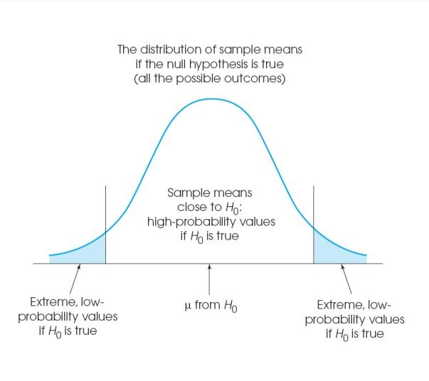

DATA COLLECTION TOOL:-

Data collection software is a computerised system for the collection and storage of qualitative and quantitative data in an electronic form. The benefits of using data collection systems is that they eliminate the use of paper surveys and allow data to be quickly exported for data analysis and reporting.
Here are some of the most common types of data collection used today.
- Surveys. ...
- Online Tracking. ...
- Transactional Data Tracking. ...
- Online Marketing Analytics. ...
- Social Media Monitoring. ...
- Collecting Subscription and Registration Data. ...
- In-Store Traffic Monitoring.

Digital Tools & Resources
- Word processing documents.
- Slide presentation software.
- Electronic reference materials.
- Tablet and cellphone apps.

Research Design:-
It is process of converting analog information into digital format. At the end of the process, the digital image. contains the same information or data as the analog item. Research design is the framework of research methods and techniques chosen by a researcher to conduct a study. The design allows researchers to sharpen the research methods suitable for the subject matter and set up their studies for success.

Demographic Profiles:-
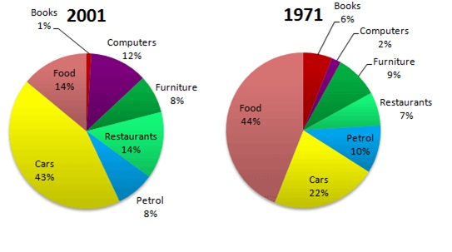
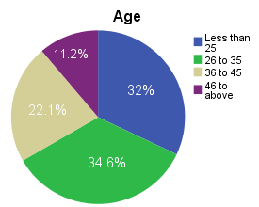

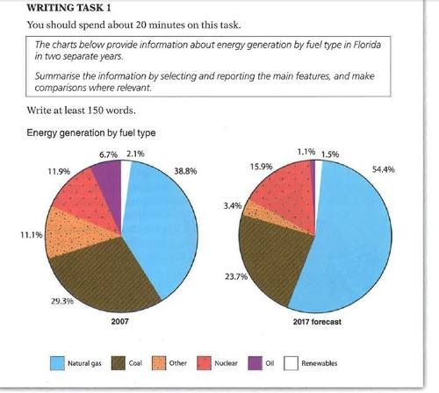

Conceptual Frame Work:-
A Conceptual Framework for Technology Education endorsed the human adaptive systems and domains of knowledge of the Jackson's Mill Industrial Arts Curriculum Theory (Snyder & Hales, 1981) while also focusing on the human as a problem solver who, through the application of the technological method model, could identify. A digital transformation framework is a tool, often used by consultants and organisational leaders, to analyse a business in order to assist it to reposition it in the digital economy.
The framework outlines the four pillars of digital transformation we see today: IT uplift, digitizing operations, digital marketing, and digital businesses.

EFFECT OF COVID-19 SITUATION IN DIGITALIZATION
In just a few months’ time, the COVID-19 crisis has brought about years of change in the way companies in all sectors and regions do business. According to a new McKinsey Global Survey of executives,¹ their companies have accelerated the digitization of their customer and supply-chain interactions and of their internal operations by three to four years. And the share of digital or digitally enabled products in their portfolios has accelerated by a shocking seven years.² Nearly all respondents say that their companies have stood up at least temporary solutions to meet many of the new demands on them, and much more quickly than they had thought possible before the crisis. What’s more, respondents expect most of these changes to be long lasting and are already making the kinds of investments that all but ensure they will stick. In fact, when we asked executives about the impact of the crisis on a range of measures, they say that funding for digital initiatives has increased more than anything else—more than increases in costs, the number of people in technology roles, and the number of customers.

RESULTS AND DISCUSSION
Digitization is the process of converting information into a digital (i.e. computer-readable) format. The result is the representation of an object, image, sound, document, or signal (usually an analog signal) obtained by generating a series of numbers that describe a discrete set of points or samples. Digitalization is the conversion of analog information into texts, photographs, and voices, among others. The transformation is carried out through electronic devices such as scanners or specialized computer chips. Information is organized into bits which can be separately categorized into bytes. There are various advantages to digitalization including increased efficiency, increased productivity, lower operational costs, improved customer experience, higher agility, enhanced employee morale, improved communication, increased transparency, improved competitive advantage, and faster decision making. Digitalization will change the future of business technology in many ways: Automation will become more widespread as machines take over more tasks that people used to do manually. This means that we need fewer people to do those jobs, so we may see a shift toward more part-time work or freelance work.

CONCLUSION
Digital transformation is a powerful and necessary journey that many organizations must take. But this switch does not happen easily. You need a strategy and the tools that will support your objectives of digital transformation. Digital transformation is a powerful way to achieve greater collaboration, agility, efficiency, and productivity. The rewards can be felt across your organization. In conclusion: digitization is digitization. Period. Digitization is the automation of existing manual and paper-based processes, enabled by the digitization of information; from an analog to a digital format.
Digitalization in business has brought many companies to success. From automating their marketing activities to processing their orders, businesses have fully leveraged digital technologies. Digitalization in business helps to improve the efficiency of its operations, making automation possible. Based on the results of hypotheses testing, it can be concluded that digital leadership has indirect impact to business model innovation, where co-creation strategy has a mediating role on the relationship between business model innovation and digital leadership.
E-learning is not just a change of technology. It is part of a redefinition of how we as a species transmit knowledge, skills, and values to younger generations of workers and students. This book makes a few predictions of how e-learning and the functions it serves will continue to develop.
Learning and understanding can be facilitated in learners by emphasizing organized, coherent bodies of knowledge (in which specific facts and details are embedded), by helping learners learn how to transfer their learning, and by helping them use what they learn.

This study draws on evidences that are paving the way on how new technologies are
assisting customers and companies to create value. This article provides cutting-edge
results: on the one hand, the developments achieved in the service industry are being
made in combination with synergies between digital services and other new tech-
nologies, such as AI or IoT; on the manufacturing domain, companies are also pursuing
new venues in ﬁnding competitive advantages by applying innovative digital practices
on their industrial process (e.g. servitization strategies)
This study draws on evidences that are paving the way on how new technologies are
assisting customers and companies to create value. This article provides cutting-edge
results: on the one hand, the developments achieved in the service industry are being
made in combination with synergies between digital services and other new tech-
nologies, such as AI or IoT; on the manufacturing domain, companies are also pursuing
new venues in ﬁnding competitive advantages by applying innovative digital practices
on their industrial process (e.g. servitization strategies)
This study draws on evidences that are paving the way on how new technologies are
assisting customers and companies to create value. This article provides cutting-edge
results: on the one hand, the developments achieved in the service industry are being
made in combination with synergies between digital services and other new tech-
nologies, such as AI or IoT; on the manufacturing domain, companies are also pursuing
new venues in ﬁnding competitive advantages by applying innovative digital practices
on their industrial process (e.g. servitization strategies)
This study draws on evidences that are paving the way on how new technologies are
assisting customers and companies to create value. This article provides cutting-edge
results: on the one hand, the developments achieved in the service industry are being
made in combination with synergies between digital services and other new tech-
nologies, such as AI or IoT; on the manufacturing domain, companies are also pursuing
new venues in ﬁnding competitive advantages by applying innovative digital practices
on their industrial process (e.g. servitization strategies)

REFERENCES
- 1. Porter, M.E.; Heppelmann, J.E. How smart, connected products are transforming companies. Harv. Bus. Rev. 2015, 93, 96–114.
- Cenamor, J.; Sjödin, D.R.; Parida, V. Adopting a platform approach in servitization: Leveraging the value of digitalization. Int. J. Prod. Econ. 2017, 192, 54–65.
- Grubic, T.; Jennions, I. Remote monitoring technology and servitised strategies –factors characterising the organisational application. Int. J. Prod. Res. 2018, 56, 2133–2149.
- Hasselblatt, M.; Huikkola, T.; Kohtamäki, M.; Nickell, D. Modeling manufacturer’s capabilities for the Internet of Things. J. Bus. Ind. Mark. 2018, 33, 822–836. [Google Scholar] [CrossRef]
- IBM. Innovative Analytics (GBE03664-USEN-02); IBM: Somers, NY, USA, 2015. [Google Scholar]
- Baines, T.; Ziaee Bigdeli, A.; Bustinza, O.F.; Shi, V.G.; Baldwin, J.; Ridgway, K. Servitization: Revisiting the state-of-the-art and research priorities. Int. J. Oper. Prod. Manag. 2017, 37, 256–278. [Google Scholar] [CrossRef]
- Visnjic, I.; Neely, A.; Jovanovic, M. The path to outcome delivery: Interplay of service market strategy and open business models. Technovation 2018, 72, 46–59. [Google Scholar] [CrossRef]
- Foss, N.J.; Saebi, T. Fifteen years of research on business model innovation: How far have we come, and where should we go? J. Manag. 2017, 43, 200–227. [Google Scholar] [CrossRef]
- Ritter, T.; Lettl, C. The wider implications of business-model research. Long Range Plan. 2018, 51, 1–8. [Google Scholar] [CrossRef]
- Ziaee Bigdeli, A.; Baines, T.; Bustinza, O.F.; Guang Shi, V. Organisational change towards servitization: A theoretical framework. Compet. Rev. Int. Bus. J. 2017, 27, 12–39. [Google Scholar] [CrossRef]
- Sjödin, D.R.; Parida, V.; Lindström, J. Barriers and conditions of open operation: A customer perspective on value co-creation for integrated product-service solutions. Int. J. Technol. Mark. 2017, 12, 90–111. [Google Scholar] [CrossRef]
- Story, V.M.; Raddats, C.; Burton, J.; Zolkiewski, J.; Baines, T. Capabilities for advanced services: A multi-actor perspective. Ind. Mark. Manag. 2017, 60, 54–68. [Google Scholar] [CrossRef][Green Version]
- Cook, D.J.; Greengold, N.L.; Ellrodt, A.G.; Weingarten, S.R. The relation between systematic reviews and practice guidelines. Ann. Intern. Med. 1997, 127, 210–216. [Google Scholar] [CrossRef]
- Reim, W.; Parida, V.; Örtqvist, D. Product–Service Systems (PSS) business models and tactics—A systematic literature review. J. Clean. Prod. 2015, 97, 61–75. [Google Scholar] [CrossRef]
- Rachinger, M.; Rauter, R.; Müller, C.; Vorraber, W.; Schirgi, E. Digitalization and its influence on business model innovation. J. Manuf. Technol. Manag. 2018. [Google Scholar] [CrossRef]
- Kohtamäki, M.; Helo, P. Industrial services–the solution provider’s stairway to heaven or highway to hell? Benchmarking Intern. J. 2015, 22, 170–185. [Google Scholar] [CrossRef]
- Gauthier, C.; Bastianutti, J.; Haggège, M. Managerial capabilities to address digital business models: The case of digital health. Strateg. Chang. 2018, 27, 173–180. [Google Scholar] [CrossRef]
- Gorissen, L.; Vrancken, K.; Manshoven, S. Transition thinking and business model innovation—Towards a transformative business model and new role for the reuse centers of Limburg, Belgium. Sustainability 2016, 8, 112. [Google Scholar] [CrossRef]
- Ehret, M.; Wirtz, J. Unlocking value from machines: Business models and the industrial internet of things. J. Mark. Manag. 2017, 33, 111–130. [Google Scholar] [CrossRef]
- Krotov, V. The Internet of Things and new business opportunities. Bus. Horiz. 2017, 60, 831–841. [Google Scholar] [CrossRef]
- Eloranta, V.; Orkoneva, L.; Hakanen, E.; Turunen, T. Using platforms to pursue strategic opportunities in service-driven manufacturing. Serv. Sci. 2016, 8, 344–357. [Google Scholar] [CrossRef]

