Impact of Employee Motivation on productivity of organization
Shaik Rahim Basha
Research Scholar, Department of Management, SRI Y.N. College, Narasapur,
Adikavi Nannaya University, Rajamahendravaram
DR.R.Pardhasaradhi
Head of the Department, Department of Management, SRI Y.N. College, Narasapur
…………………………………………………………………………………………………
Abstract
Employees are the beating heart of any business. Employee cooperation cannot be substituted in order for any organization to run efficiently and without interruption. It is critical that an organization's employees not only have a strong relationship with top management, but also have a healthy and professional relationship with their co-workers. The current chapter is focus on how motivating methods influence employee performance for betterment. The chapter also discussed about what are factors which are more influenced and how to boost employee motivation.
Keywords: Employee Motivation, Organization Productivity, psychological trait
1.INTRODUCTION
Motivation is a complex set of variables that each individual goes through, requiring a wide range of approaches. When a someone has a reason to do something, we say that they are motivated. According to Vroom [1], performance is a multiplicative function of talent [2, 3]. {P=F (M.A)}. It is widely accepted within the motivation paradigm that "motivation" refers to "a process governing choices made by persons or lower organisms among alternative forms of voluntary activity" [1]. It suggests that talent accounts for only a marginal share of a worker's production or productivity. His degree of drive is an essential additional consideration.
Jones and George [3] of "Contemporary Management" explore the psychological elements that determine an employee's conduct, effort, and endurance on the job. Management theorists and practitioners alike agree that inspiring one's staff is crucial. People feel that the primary role of human resource management is to motivate workers so that they would be dedicated to their tasks. The field of industrial relations places a premium on research into, and quantification of, the factors that contribute to individual differences in employee performance. Participation, a sense of accomplishment and reward, social interaction, and professional development prospects all play a role in keeping people interested and engaged in their work. Identifying and evaluating these motivational factors is the primary purpose of the instruments at their disposal.
2.CONCEPT OF MOTIVATION
Motivation, along with perception, personality, attitude, and learning, is an important component of behavioral knowledge. According to the definition, motivation is "a process that begins with a physiological deficiency or need and activates a behavior or drive aimed at a goal incentive." state that on a systemic level, needs, wants, and incentives—the three interacting and interconnected components—are what motivate people. Management academics are emphatic that a company cannot achieve its goals unless its members are constantly committed. Only humans have motivation, which is a psychological attribute that determines a person's level of commitment. Motivation is the desire to achieve as manifested by goal-directed behavior. When we say that someone is motivated, we mean that they are working hard to achieve a specific objective. But we need more than motivation to carry out our responsibilities as effectively as possible. In this regard, aptitude is just as important as possessing the necessary information and skills to execute the assignment. It can sometimes decide on effectiveness.
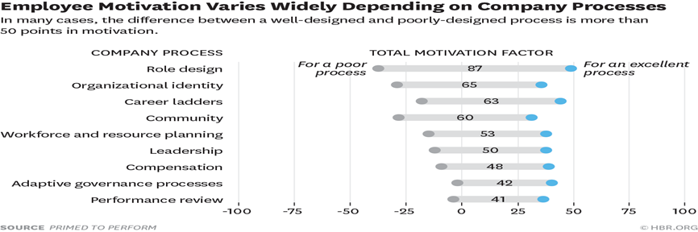
Figure-1

2.1 EMPLOYEES
Employees' ambition to achieve their level of self-actualization is always influenced by physiological safety, social safety, and respect. As motivators for workers, Herzberg [9] identified job satisfaction, accountability, and the potential of promotion. He defined dissatisfiers as hygienic components that have an impact on health, comfort, and social well-being after distinguishing between satisfiers and dissatisfiers. The removal of these aspects will result in employee unhappiness. Company policy, employee interactions, working conditions, salary, and job security are all examples of hygiene factors [10].
2.3 DECISION MAKING
Employees are more likely to be aware of their rights within an organization when they can make their own judgments. The employee benefits from greater consistency in their thinking and work. by connecting the career search with the motivating process. Internal locus of control was the strongest predictor of career development, decision-making, and allowing individuals to perceive their own identities and actions as one of the most significant predictions. i) When it comes to career exploration, various people gain and sustain motivation in different ways. ii) Autonomy and control attitudes were substantially associated to self-exploration and the utility of professional decision-making exploration. Employees may be influenced by both internal and external factors, but the extent to which they are affected depends on their internal and external locus of control.
2.4 PRODUCTIVITY
Productivity is the ratio of an organization's workforce's output or production capability. Improved productivity is the main focus of employee motivation. A successful employee combines a strong skill set with a positive work environment. Employees are essential to a company's ability to create and provide high-quality goods and services. When an employee tries to carry out their job responsibilities, they are affected by a number of internal and external pressures. This has a direct bearing on production.
4. DIFFERENT THEORIES OF MOTIVATION
Organizations use motivation as a strategy to get their staff more interested in and committed to their work, which in turn boosts productivity. In a nutshell, motivation is what gets you going on your own volition.
The term "motivation" has been extensively defined by numerous modern authors. One definition of motivation is "the psychological process that gives behavior purpose and direction," while others say it's "a predisposition to behave purposefully to achieve specific, unmet needs" [8, 9]. In this work, we use an operational definition of motivation as the force that propels people to act in ways that help them achieve their own and their group's goals.
An individual's motivation is the driving force behind their actions. "Motivation refers to the degree to which an organism is ready to pursue some designed goal and implies the determination of the nature and locus of forces inducing the degree of readiness," writes the Encyclopedia of Management. Motivation is the process by which wants cause actions that lead to outcomes that meet those wants.
Maslow’s Hierarchy of Needs: People act with a purpose. To achieve one's goals, one must be motivated to do so. Needs can only be managed and met with determination through inspiration. Maslow's Hierarchy of Needs classified human desires in a scale from basic to higher-level requirements. First, people need to focus on meeting their basic necessities. When needs are met, motivation is no longer necessary. Knowing a person's position in the organizational chart is crucial for inspiring them to achieve their goals.
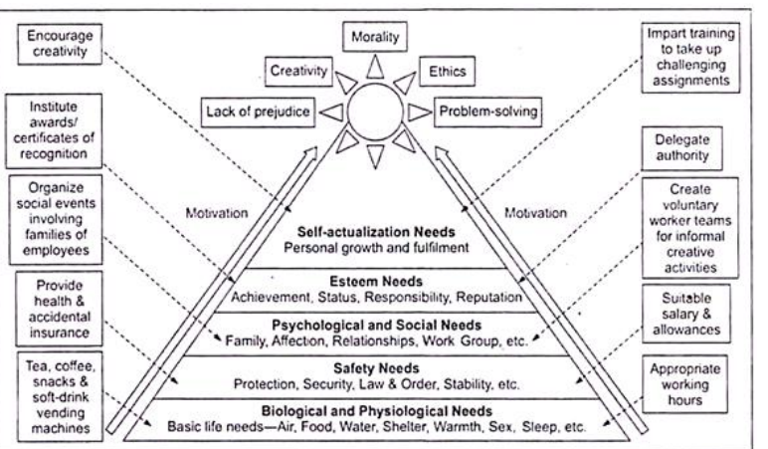
Figure -2
5.Employee Motivation Impacts Productivity
To better understand the ways in which employee motivation affects productivity, we may examine the ways in which it is related to engagement and retention, as well as the ways in which engagement and retention affect productivity.
Employees who are actively disengaged from their jobs cost the global economy $7.8 trillion in lost output, which is equal to 11% of global GDP, according to the State of the Global Workplace: 2022 Report from Gallup.
Lack of involvement also has a negative effect on retention. Businesses in the United States lose one trillion dollars a year to voluntary turnover, and they have a hard time keeping talented workers on staff. These difficulties include low employee satisfaction with pay, inadequate management, few or no prospects for growth, a lack of recognition, a lack of job definition, the demand for more autonomy, and toxic work environments. Businesses in the United States are impacted by voluntary turnover at a cost of $1 trillion yearly.
A domino effect is created that can cripple productivity and adversely harm an organization's profitability when people aren't engaged in their work and the turnover rate is high.
Productivity suffers whenever employees are not actively engaged in their work. Employees who are not engaged in their work are less driven to put in long hours or satisfy their employer's expectations.
6.How to Improve Motivation and Productivity
The best leaders are able to inspire their followers to do what they ask of them because their followers want to do so, not because they are required to do so. The same holds true for one's level of motivation. Employees who enjoy their work are more likely to desire to contribute to the success of the company; therefore, executives who want more productive team members should nurture employees' intrinsic drive.
due of the beneficial effect they have on motivation, strategies that aim to promote employee engagement and retention, as well as practices that support a happy employee experience, can also improve productivity. This is due of the positive feedback loop that results from these strategies.
The following are a few elements that, when combined, have the potential to boost productivity and assist employees continue to be engaged in their positions, dedicated to the goal for the long haul, and driven to accomplish exceptional work.
7.Career Advancement Opportunities
Helping employees satisfy their need for personal development is one of the most important factors in inspiring and engaging staff members. It is critical for employees to have the impression that they are making progress in an area that is meaningful to them. They will be more involved in their work if they believe they are professionally progressing as well as increasing their skills and intellectual capabilities in jobs where they can do both of these things.
Giving employees opportunities to develop themselves, such as through training, tuition reimbursement, leadership development, career-pathing, or coaching, not only helps the individual but also delivers results that are beneficial to the company.
According to research collated by LinkedIn, when employees spend time learning on the job, they are 21% more likely to feel confident and cheerful, 47% less likely to be anxious, and 39% more likely to feel productive and successful in their jobs.
8. Recognition
Recognizing employees' accomplishments, whether in words or deeds, has a significant impact on employee motivation. When employees recognize each other's accomplishments, it spreads across the organization and links an employee's success to that of the company. Bonuses and verbal or written praise are examples of private forms of acknowledgment. Public forms include recognition in corporate newsletters, employee-of-the-month awards, company award ceremonies, and social media posts. Employee peer recognition can be a very successful technique to integrate acknowledgment into the everyday culture of the company.
According to studies, 69% of employees think they would work more if their accomplishments were recognized at work, which supports the idea that recognition boosts productivity.Employees are up to ten times more likely to strongly agree that they belong with the company when their contributions are acknowledged. According to the O. C. Tanner 2023 Global Culture Report, recognition can reduce employee burnout by 80% and attrition rates by 29%, respectively. High motivation and increased productivity are the results of these effects.
9. Incentives and Rewards Programs
Incentives and reward programs can help businesses improve their recognition efforts. Incentives and rewards programs for employees aim to create an environment where workers feel valued and appreciated by the company, align their actions with the company's values and goals, and motivate them to do their best.
There is a wide range of employee incentive and reward programs available. Financial incentives might come in the form of bonuses, raises, profit sharing, tuition reimbursement, gift cards, and the like, while non-financial incentives can take the form of extended vacation time, more flexible working hours, referral programs, and in-person experiences. Motivation is increased by incentive and reward programs because they reinforce the actions that lead to success. This can also lead to greater value convergence and, ultimately, greater output. Incentive schemes have been shown to boost productivity by as much as 44 percent and retention by as much as 66 percent.
Remote or hybrid work solutions that provide autonomy or additional paid time off (PTO) can be a powerful incentive for employees. Employees' well-being and motivation can be improved by allowing them more control over their time off from work to focus on family and other personal matters.
A poll conducted by Jabra in 2021 found that the majority of respondents (75%) preferred working for an employer that allowed them to work remotely if given the choice between a higher pay and the ability to do so. Employees and businesses alike might gain from a more adaptable work environment.
When employees have the information, they need to do their jobs effectively, they are more likely to be driven to do their best and more likely to embrace an improvement culture fostered by consistent feedback.
In the workplace, daily conflict over roles and responsibilities arises when workers are confused about their own tasks and obligations. When workers aren't clear on their roles and the direction of the company, they can lose motivation. As a result, productivity suffers. It is critical for workers to be aware that their efforts are noticed by management, to understand their roles and responsibilities as they evolve, and to receive feedback on their performance. A fantastic strategy to clarify responsibilities and keep teams productive is through open and frequent communication about expectations, such as through regular one-on-one conversations.
Employee motivation is increased because feedback fosters an atmosphere of safety and trust in which workers' ideas and input are recognized and used in decision-making. They are able to see where they can boost output, and they maintain the drive to do so. Organizational cultures that value feedback provide regular, constructive input to employees from their managers and encourage individuals to provide constructive feedback to their peers and superiors.
Staff and leadership can use this information to make course corrections and identify problem areas. This practice of providing and receiving feedback has the potential to foster a high-performance culture in which employees consistently adopt a growth mindset and actively seek out new, novel ways to contribute to the company's success.
In addition to ensuring the physical safety of workers, a safe workplace must also ensure that they do not fear for their own well-being while on the job.
Organizations can encourage high levels of intrinsic motivation among their workers by communicating the good influence their efforts have on the world beyond financial gain.
Leaders that succeed in expanding their teams' impact do so by establishing attainable targets. They assist employees make the connection between their day-to-day work and the organization's wider mission and vision by using impact as a measure of success rather than quotas or profits.
Conclusion
Motivation indeed has a momentous effect on employee performance. pragmatically dominates employees’ will to perform and achieve goals of the respective organization When people feel psychologically comfortable, they know they can speak up without fear of retaliation. Employees are more likely to take risks, provide new ideas, and actively engage in making decisions when they feel safe doing so in the workplace. When people feel comfortable in their workplace, they are more likely to be productive, creative, and collaborative. Employees are more likely to be motivated and productive if they feel like they belong at work, and this sense of belonging can be fostered by maintaining a positive, psychologically safe workplace. In fact, research shows that businesses that prioritize their employees' emotional well-being enjoy a 50 percent increase in output.
Decision-making responsibility, development potential, and future outlook were also taken into account. The systematic breakdown of how inspiration boosts productivity in the workplace. It takes more than an annual review or a few lines in someone's personnel file to keep your employees motivated.
References
Moreover, Authority to make decisions, Growth opportunity and prospects were also considered. The tangible sorting of how motivation is responsible for upliftment of employee performance. Motivating your employees is a delicate and purposeful challenge that requires more than an annual review or jotting a few notes in someone’s personnel Life
Decision-making responsibility, development potential, and future outlook were also taken into account. The systematic breakdown of how inspiration boosts productivity in the workplace. It takes more than an annual review or a few lines in someone's personnel file to keep your employees motivated.
References:
- Alshmemri, M., Shahwan-Akl, L., & Maude, P. (2017). Herzberg’s two-factor theory. Life Science Journal, 14(5), 12-16.
- Anderson, A. (2014). Maslow's hierarchy of needs. The Prairie Light Review, 36(2), pp. 7.
- Datuk Dr. Mahamad Zubir bin Seeht Saad. (2018). The impact of employee motivaton on work performance. International Journal of Scientific and Research Publications, 8(3), 295-308.
- Lepper, M. R. & Greene, D. (2016). The hidden costs of reward. New York: Psychology Press.
- McShane S. & Von Glinow M. (2016). Organizational behavior. (3rd ed.). New York: McGraw-Hill Education.
- Miner, J. B. (2015). Organizational behavior: Essential theories of motivation and leadership. New York: Routledge.
- Nilsson, K. (2017). The influence of work environmental and motivation factors on seniors’ attitudes to an extended working life or to retire. A cross sectional study with employees 55-74 years of age. Open Journal of Social Sciences, 5(07), pp. 30-37.

