Food Fermentation Technology- Significance, Scope and Future Perspectives
Dr. Manjula Kola,
Professor, Food Science Nutrition and Food Technology, Department of Home Science, Sri Venkateswara University, Tirupati-517502 Andhra Pradesh, India
Dr. Kalyani Bandi,
Academic Consultant, Food Technology, Department of Home Science,
Sri Venkateswara University, Tirupati-517502 Andhra Pradesh, India
Corresponding Author: kalyani.mft@gmail.com
Significant occurrences in human history have been largely influenced by technology. Processing food through fermentation is one of the oldest methods of keeping food fresh. The process of fermentation entails the oxidation/reduction of molecules or the conversion of large molecules into tiny ones, which is mediated by particular microbes. The use of fermentation technology has grown rapidly in the market in recent times due to studies that eating foods that have undergone fermentation improves human health and the gut microbiota.
FOOD FERMENTATION TECHNOLOGY – A HISTORICAL PERSPECTIVE
Others claim that the Latin verb fervere, which means "to boil," is the source of the word fermentation, which is derived from the verb fermentare, which means "to leaven." Up until now, the idea of fermentation and its uses have been explained by a number of definitions. Generally speaking, fermentation referred to organic metabolic activities powered by unnamed wild microorganisms. According to the most recent definitions, fermentation is the process by which a material decomposes into a simpler component, usually as a result of the metabolic activity of bacteria or yeast.
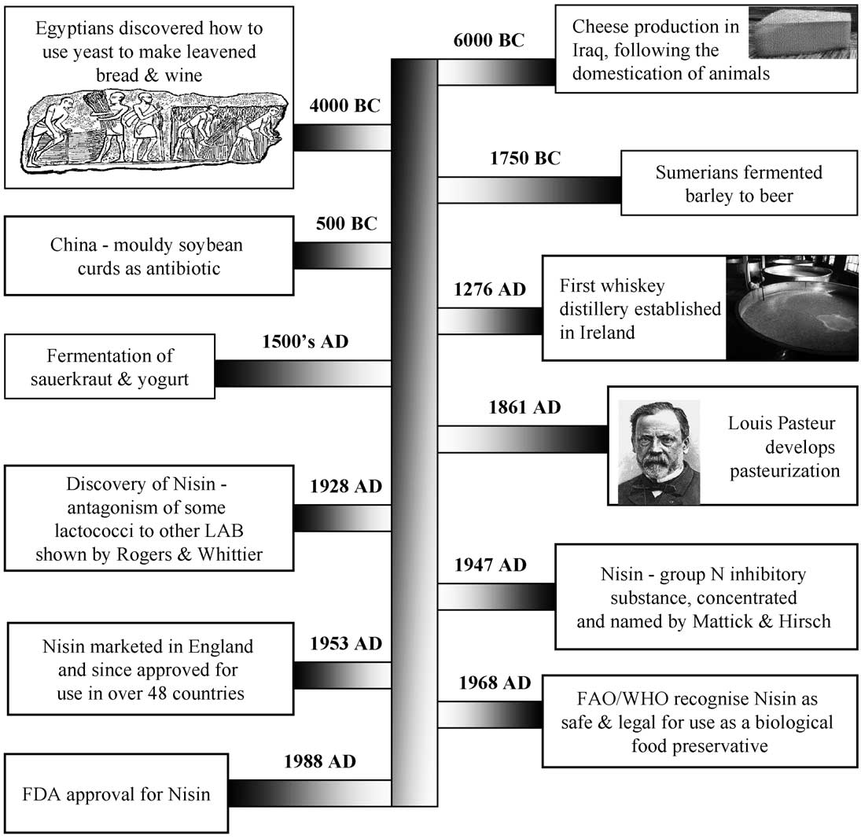
Figure 1: Historical Achievements in Food Fermentation²¹
Source : Ross, R. P., Morgan, S., & Hill, C. (2002). Preservation and fermentation: past, present and future. International journal of food microbiology,

Fermentation processes typically involve metabolic pathways that bring about alterations in organic molecules through the action of microorganisms or enzymes. Around 10,000 BCE, natural fermentation of dairy products occurred due to favorable environmental conditions and the presence of essential microflora, which enabled the preservation of milk from camels, cattle, sheep, and goats. Fermentation-based procedures have held significant interest for humanity since ancient times, owing to their diverse potential applications.
Tracing the exact origins of fermentation is a challenging task, but it is believed that the initial fermentation process was stumbled upon accidentally when salt was inadvertently incorporated into food. Some historians have discovered indications of fermentation dating as far back as 7000 BC. During that period, people were already producing fermented foods like beer, wine, leavened bread (primarily using yeasts), and cheeses (produced with the assistance of bacteria and molds) in regions of the Western world (see Fig. 1). In 2004, archaeologists made a remarkable discovery by conducting chemical tests on Neolithic Chinese pottery dating back to 7,000 BCE. This pottery contained the world's oldest known brewed beverage, comprising fermented rice, honey, and fruit. Remarkably, this ancient brew predates the previous record for the oldest evidence of brewing, found in Iran, by nearly 1,500 years. Elements from this ancient beverage can still be found in modern alcoholic drinks, with fermented fruit used in wine, fermented rice in sake, and fermented honey in mead.
Ancient Egyptians first experimented with yeast in dough fermentation for leavening bread. Bread was a staple in the ancient Egyptian diet, providing a nutrient-dense source of vitamins, minerals, proteins, and starch3. Egyptian fermentation techniques developed between 3,500 and 300 BCE are still in use today. Pickled cucumbers originated in the Tigris Valley, or modern-day Iraq, in 2,000 BCE. While ancient Chinese cultures are known for championing vegetable fermentation, the pickling of cucumbers in the Middle East some 1,700 years earlier truly opened the door (Table 1).
Table 1: Origins of Food Fermentation
Year of Introduction | Food | Region
4000 BC | Mushrooms | China
3000 BC | Fermented milk | Middle East
3000 BC | Wine | North Africa, Europe
3000 BC | Soya Sauce | China, Korea, Japan
2000 BC | Pickled cucumbers | Iraq
2000 BC | Cheese | Middle East
2000 BC | Beer | North Africa, China
1500 BC | Bread | Egypt, Europe
1500 BC | Fermented Meats | Middle East
1000 BC | vegetable fermentation | China

Chinese people started using moldy soybean curds as an antibacterial cure for boils and carbuncles around 500 BCE. Although fermentation was not a novel process, this was the first instance of fermented food being used as medication. Infected wounds were treated with moldy cheese in addition to moldy soybean curds. The creation of later antibiotics like penicillin was modeled after these antiquated, moldy remedies.
The fermentation of tea leaves has its origins dating back to ancient Chinese civilizations, with the earliest documentation dating to around 200 BCE. This process gave rise to the immensely popular and digestive-friendly beverage known as kombucha. Kombucha is created by fermenting a mixture of tea, sugar, bacteria, and yeast over the course of a week, resulting in a slightly sweet, slightly vinegary, and effervescent drink. Depending on the specific brewing process, kombucha typically boasts high levels of antioxidants, minerals, B vitamins, and probiotics.
Among the various historical fermentation stages, the fermentation of cereal-legume combinations stands out as particularly significant. The diverse array of cereals, including wheat, rice, rye, oats, barley, corn, sorghum, and legumes such as beans, peas, and lentils, has given rise to a wide range of fermented products produced worldwide. Individually, cereals and legumes provide a reasonable source of nutrition, but when subjected to fermentation, their nutrient content becomes significantly enhanced, rendering these crops ideal for achieving a diet rich in essential nutrients.⁵
In 1665, Antonie van Leeuwenhoek made the initial identification of microbes, paving the way for Louis Pasteur, a French scientist, to piece together the remainder almost two centuries later. Pasteur discovered in 1856 that live cells are necessary for fermentation, and that yeast is an essential component of the process. Pasteurization was developed later on thanks to his heat-related experiments.
Russian bacteriologist Elie Metchnikoff identified the Bulgarian bacillus bacterial strain in fermented milk during the 1900s. Even though the strain was eventually classed as Lactobacillus acidophilus, he named it after the Bulgarian culture he was investigating for their lengthy longevity. The development of probiotics was made possible by the highly active Lactobacillus strains in the human gut.⁷.
FOOD FERMENTATION PROCESS TECHNOLOGY
The field of food fermentation has experienced substantial advancements in the past century, thanks to progress in microbiology, biotechnology, and process engineering. Throughout the 20th century, fermentation evolved from a method primarily used for preserving household food supplies to a highly sophisticated technology capable of producing pharmaceuticals, biochemicals, food ingredients, and various types of foods and beverages on an industrial scale. These significant advancements were made possible by the progress achieved in microbiology, biotechnology, and process engineering.
Fermentation and technology were combined to enable commercially viable large-scale production. Consequently, the advancements in biotechnology, contemporary engineering, and associated cutting-edge techniques have linked traditional food fermentations with large-scale manufacturing methods that ensure product safety and quality. Evolutionary engineering in conjunction with other biotechnologies and the integrated roles of microbial cells and enzymes have garnered increased interest in recent years. Not only has classical laboratory evolution been shown to be successful in allowing more advantageous mutations to develop that influence multiple genes, but it also has certain intrinsic drawbacks, including an extended evolutionary period and uncontrollably high mutation frequency.³¹.
The advent of the "genomics era" (encompassing genomics, transcriptomics, metagenomics, metabolomics, proteomics, etc.) and the application of "synthetic biology" methodologies have opened up novel avenues for exploring fermentation. These advancements have made it feasible to select markers and enhance cellular transformation techniques. Utilizing molecular biology approaches, the large-scale production of biomolecules through fermentation has become more efficient, less time-consuming, and cost-effective.²⁸.
All elements of fermentation technology development are still ongoing. This is meant to lower production costs and look at environmentally friendly methods while increasing product yield and quality. 6. Optimizing the variables that affect the process from the perspective of the microbe itself, the surroundings, and the technological resources can increase the amount of fermentation products. Other methods use micro/nanotechnology in conjunction with bacteria. This relates to electrochemistry-based techniques, which have been found to be effective when used primarily in the treatment of sludge and wastewater.
The component parts of a fermentation process
• The preparation of culture media for cultivating the process organism during inoculum development and in the production fermenter.
• The sterilization of the medium, fermenters, and associated equipment.
• The generation of a substantial quantity of an active, pure culture for inoculating the production vessel.
• The cultivation of the organism within the production fermenter under optimal conditions for product generation.
• The isolation and purification of the product.
• The management of effluent generated during the process.The major components of Food Fermentation Processing are represented in Fig.2.

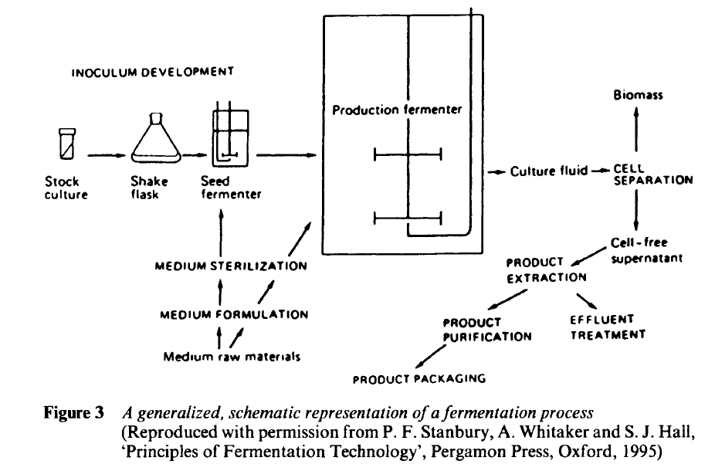
Figure 2: A Schematic Representation of Fermentation Process²⁴
Fermentation-based processes have evolved over time, influenced by cultural, social, technological, and engineering factors. Consequently, fermentation has found widespread use in various cultures worldwide, serving purposes such as improving short to mid-term food storage, crafting beverages, or enhancing local dishes by fermenting sauces, vegetables, meat, or fish to diversify culinary offerings. This type of fermentation is commonly referred to as 'indigenous fermentation' or 'classical fermentation,' involving the production of foods and beverages using natural microbes and traditional techniques rooted in cultural practices. Indigenous fermentation has led to the standardization and commercialization of many products, such as ales using natural yeast, cheeses using natural fungi, and wines employing natural yeast. However, numerous other products are crafted and marketed in limited quantities for specialized markets, or they may remain uncommercialized, representing products of indigenous or local cultures. Examples of such products include kefir, kimchi, sauerkraut, and more. The progression of fermentation-based processes has been made feasible through 'technological fermentations,' offering several advantages for scaling up these processes.⁶
Right now, fermentation is evolving and making a comeback. Traditional/natural fermented foods and drinks are expanding and innovating due to consumer interest in "natural," "clean label," ecologically and ethically sourced, and health-related food products. The industrialization of bread, sausages, sauerkraut, pickles, yogurt, cheese, and wine, beer, and spirits manufacturing has led to the creation of a variety of fermented foods and beverages.
TYPES OF FOOD FERMENTATION - Food Fermentation process is classified in different ways according to stage of fermentation, medium and activity of Microorganisms used in the processes which are very significant for food applications.
Food Fermentation based on Stages of Processing
The microorganisms involved in foods show its activity/reaction in different ways, based on the process it is broadly divided into two phases that is:

Primary fermentation- Raw materials such as fruits, vegetables, and dairy products are rapidly being metabolized by microbes. The water's microorganisms, which are also present in vegetable brine, prevent putrefying bacteria from growing in the food. Yeasts and other microorganisms convert carbohydrates, or sugars, into a variety of different compounds, including acids and alcohols. Secondary fermentation-A prolonged fermentation that may extend for many days or even weeks causes the alcohol content to rise as the yeasts and bacteria perish and their food supply—carbohydrates—becomes more scarce. Alcohol-based beverages are made by brewers and winemakers through secondary fermentation. The pH levels of the fermentation initiated by the winemaker or brewer will not be the same as when it started secondary fermentation, which can impact the chemical reactions that take place between bacteria and their environment. In order to remove the water from the yeast and prevent further fermentation when the alcohol content is between 12 and 15 percent, distilling the yeast will condense the alcohol and produce more alcohol.²⁴.
Food Fermentation based on Types of Medium
Solid State Fermentation (SSF)
Solid-state fermentation, in contrast, entails the cultivation of microorganisms in an environment where free water is either absent or present in minimal quantities. However, there is enough moisture content and water activity to facilitate the growth of the fermenting organisms. In this type of fermentation, solid substrate serves as both a support and a source of nutrients for the microorganisms, particularly when there is no freely flowing liquid available. Solid-state fermentation is employed to produce biomolecules that find applications in the food industry. These biomolecules, known as metabolites, are produced by microorganisms like yeast or bacteria. This fermentation method has ancient origins, and various fungi are utilized in food production processes. Common examples include the fermentation of rice and cheese using fungi. Industrial enzymes are also commercially manufactured through solid-state fermentation. Solid state fermentation is a method of fermenting that is used in many industries, including as food, textile, and pharmaceuticals, to create metabolite bacteria by substituting a solid substrate for a liquid medium. In order to carry out fermentation with the help of extracellular enzymes secreted by fermenting microorganisms, some SSF technologies, such as the production of tempeh and oncom, require the selective growth of organisms like molds that require low moisture levels. These microbiological components of SSF can occur as single pure cultures, mixed identifiable cultures, or fully integrated indigenous microorganisms.
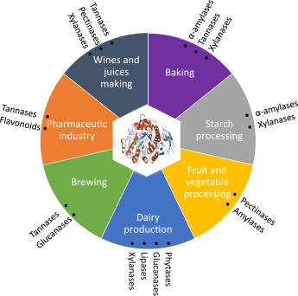
Figure 3: Role of Solid State Fermentation in Food Industry²⁵

Submerged Fermentation (SmF)
The process known as "submerged fermentation" involves precisely growing the chosen microorganisms in closed reactors with medium fermentation and a high concentration of oxygen. The growth of the microorganisms takes place in a liquid broth medium, which is escalated with necessary nutrients to have a better cultivation of microorganisms. Due to the high moisture content required for this process, bacteria are typically used as a source.Submerged fermentation procedures take place in liquid media with free water present, allowing the fermenting organisms to develop while submerged and feed on soluble substrates that contain all of the solid matter.
Sourcing yogurt, brewing beer, and making condiments like vinegar all involve submerged fermentation. Trichoderma viride ATCC 36,316 was used in submerged fermentation to increase the crude protein content and true protein constituent of cassava peel by eight and twenty-two fold, respectively, when the peel was left untreated for three to four days. Solid state fermentation (SSF) has been shown to be able to create greater enzyme yields in laboratory settings, despite the fact that submerged fermentation (SmF) accounts for the majority of the enzyme businesses today (Fig. 3). While the non-enzyme proteins in SmF were more closely linked to stress tolerance and glycometabolism content, those in SSF were engaged in the growth and condition of fungal mycelia. ²⁵.

Food Fermentation based on Types of Microbial Activity:
Fermented foods are defined as "foods or beverages created through the deliberate cultivation of microorganisms and the transformation of food components through enzymatic processes14. The composition of the ingredients utilized and the specific fermenting microorganisms play pivotal roles in shaping the characteristics of fermented foods (Fig.4). Additionally, the processing methods employed and the duration of fermentation also exert an impact on the outcome of food fermentation.
The microorganisms involved in fermentation primarily include lactic acid bacteria, such as Enterococcus, Streptococcus, Leuconostoc, Lactobacillus, and Pediococcus, as well as yeasts and molds, including Debaryomyces, Kluyveromyces, Saccharomyces, Geotrichium, Mucor, Penicillium, and Rhizopus species. These microorganisms also play a role in generating additional enzymes that aid in the digestion process (Table 3).

Table 3: Classification of major types of Food Fermentation

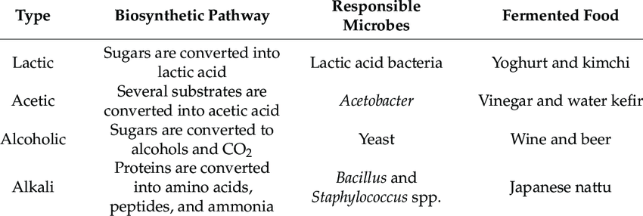
Source: www.researchgate.net/publication/356371347
Lactic acid homofermentation : Glucose → Lactic acid
Homolactic fermentation is conducted by bacteria from the Lactococcus, Enterococcus, Streptococcus, and Pediococcus genera, as well as certain Lactobacillus species. In homofermentative lactic acid bacteria (LAB), glucose is fermented into lactic acid. Lactococcus species are commonly employed in dairy starter cultures.
Lactic acid heterofermentation: Glucose → Lactic acid + Acetic acid + Ethyl alcohol + 2CO2 + H2O
Heterolactic fermentation is conducted by bacteria from the Leuconostoc, Oenococcus, and Weissella genera, as well as heterofermentative lactobacilli. Heterofermentative LAB ferment glucose, producing lactic acid, ethanol/acetic acid, and carbon dioxide (CO2) as by-products.
Propionic acid fermentation: Glucose → Lactic acid + Propionic acid + Acetic acid + CO2 + H2O
The fermentation of propionic acid is performed by various bacteria found in the Propionibacterium genus and the Clostridium propionicum species. In propionic acid fermentation, both sugar and lactate can serve as the initial substrates. When sugar is present, these bacteria utilize the EMP pathway to generate pyruvate, which is subsequently carboxylated to oxaloacetate and then reduced to propionate through a series of intermediates, including malate, fumarate, and succinate. Acetic acid and CO2 are additional end products of propionic fermentation.
Diacetyl and 2,3-butylene glycol fermentation: Diacetyl ↑ Citric acid→ Pyruvic acid + Acetylmethylcarbon ↓ 2,3-Butylene glycol
The fermentation of butanediol is conducted by bacteria belonging to the genera Enterobacter, Erwinia, Hafnia, Klebsiella, and Serratia. The process leading to the formation of 2,3-butanediol includes a double decarboxylation step.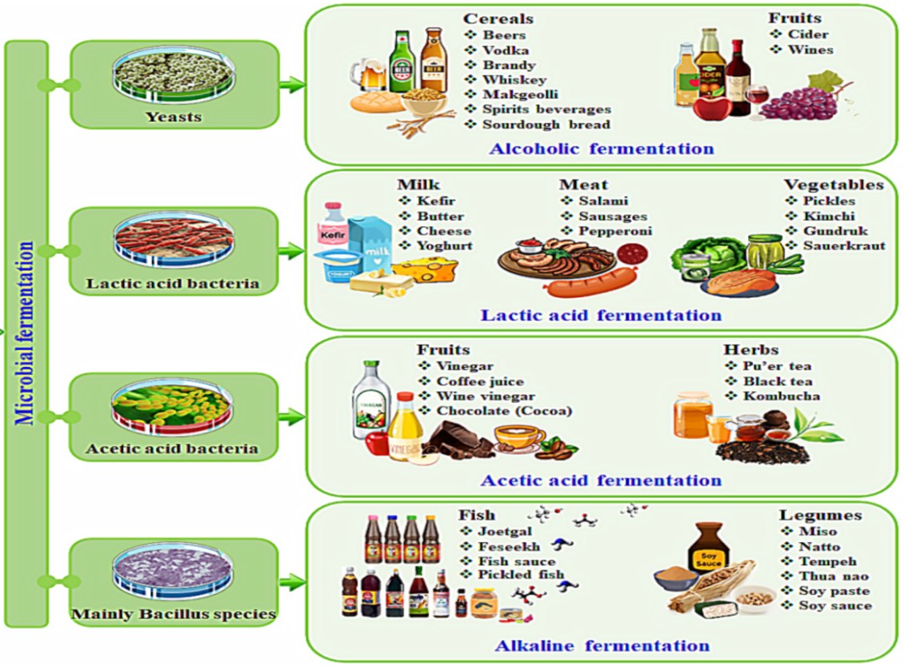
Figure 4: Types of Fermentation and its Applications²³
Alcoholic fermentation: Glucose → Ethyl alcohol
Alcoholic fermentation is one of the most widely recognized fermentation processes. It is conducted by yeasts, as well as some other fungi and bacteria. In the initial stage of the alcoholic fermentation pathway, pyruvate is involved, and yeasts produce it through the EMP pathway, while Zymomonas bacteria utilize the ED pathway to obtain pyruvate. The redox balance in alcoholic fermentation is maintained by the regeneration of NAD during the conversion of acetaldehyde into ethanol.
Top of Form
Butyric acid fermentation: Glucose → Acetic acid + Butyric acid
Butyric acid fermentation is a process commonly observed in various obligate anaerobic bacteria, primarily belonging to the Clostridium genus. In this process, pyruvate is oxidized to form acetyl-CoA, resulting in the production of CO and H . A portion of the acetyl-CoA is further transformed into acetic acid, accompanied by ATP generation. Certain bacteria, like Clostridium acetobutylicum, exhibit a reduced production of acids and a greater formation of neutral products, thereby engaging in acetone butanol fermentation. ^{7,8,9}.
Over the past century, advances in microbiology, biotechnology, and process engineering have greatly benefitted food fermentation processes. A number of fermented foods and drinks, such as bread, sausages, sauerkraut, pickles, yogurt, and cheese, as well as wine, beer, and spirits, are produced industrially Fig. 4. Nonetheless, industrial food fermentation processes are not the same as typical submerged fermentation processes in terms of design and operation, with the exception of those for food ingredients and processing aids like flavorings and enzymes.²¹.

BENEFITS OF FOOD FERMENTATION
One of the first biotechnology techniques for food processing and preservation to be widely used worldwide is fermentation. ²⁵ The significant benefits in food and beverage by fermentation are:
Nutritional Benefits:
The metabolic activity of microorganisms, together with the enzymatic activities occurring in the raw material, changes the nutritive and bioactive properties of food matrices and can produce molecules with health-promoting activity. The desirable flavor of fermented foods is predominantly due to the acid, sugar, and volatile flavor compounds. As the bacteria and/or yeast consume sugars, nonvolatile acids and volatile aroma compounds are formed. Fermentation (bacteria) synthesizes vitamins and minerals, produce biologically active peptides with enzymes such as proteinase and peptidase, and remove some non-nutrients. The biologically active peptides, which are produced by the bacteria responsible for fermentation, are also well known for their health benefits.
Using LABs that produce folate has been seen as an intriguing method for biofortifying fermented foods and dairy products. Vitamin B12, which is essential for the development of new blood cells and the upkeep of the neurological system, is abundant in dairy products. Fermentation can boost its content by up to ten times. Folates, or vitamin B9, are produced by some LAB and Bifidobacteria species in fermented milk. Products with a high vitamin K content are also those that contain mesophilic LAB species, particularly Lactococcus spp. as starter cultures. Fermentation is a long-standing natural chemical process that has been used for millennia to give modern consumers delicious flavors and beneficial bacterial benefits on their digestive systems. Foods with fermentation can also affect a person's health (Table 4). The central nervous system and brain may be modulated by the consumption of fermented foods and probiotics, which improve gut flora.^{14&15}.

Table 4: A few Examples of Food Fermentation and its Benefits

Raw Materials |  | Benefits of Fermentation |  | Fermented Food
Milk | Acts as Preservation |  | Yoghurt, Cheese
 | Enhancement of Safety
Barley | Acid & Alcohol production |  | Beer
Grapes | Acid & Alcohol production |  | Wine
Fruits | Acid Production |  | vinegar
Cassava | Removal of Toxic components |  | Gari, Polviho azedo
Meat | Production of Bacteriocins |  | Salami
 | Enhancement of Nutritional Value
Wheat | Improved Digestibility |  | Bread
Leafy Vegetables | Retention of Micronutrients |  | Kimchi, sauerkraut
Coconut | Increased Fiber content |  | Nata de coco
Milk | Synthesis of probiotic compounds |  | Bifidus milk, Yakult, acidophilus yoghurt
Coffee Beans | Improvement of Flavour |  | Coffee

Technological Benefits:
Fermentation is a metabolic process harnessed by microorganisms. It is a cost-effective method that demands minimal energy and basic infrastructure to preserve foods. Additionally, fermentation enhances these foods by introducing newly generated bioactive compounds, improving their sensory characteristics, digestibility, and nutritional absorption.
Medicinal/Pharmaceutical Benefits:
Fermentation plays a crucial role in producing probiotics, which have seen a surge in popularity over the past decade. According to the National Institute of Health, by 2012, approximately 4 million adults in the United States had experimented with probiotics. Probiotics are celebrated for their health advantages, and their origins are closely linked to the fermentation process. Fermented foods contribute to improving the balance of bacteria, known as the gut biome, in your digestive system. This enhances gut health and supports various bodily functions linked to your digestive system. A healthy biome can also aid in preventing or managing obesity.
The benefits of eating fermented food start in the gut, where it is mostly processed. The stomach is frequently referred to as your "second brain" since it has a major influence on a number of health-related factors, such as immune function, mood, behavior, appetite, and weight. From these peptides, blood pressure-lowering conjugated linoleic acids (CLA), prebiotic exopolysaccharides, antimicrobial bacteriocins, anti-carcinogenic and antimicrobial sphingolipids, and blood pressure-lowering, antioxidant, antimicrobial, opioid antagonist, and blood pressure-lowering bioactive peptides are known.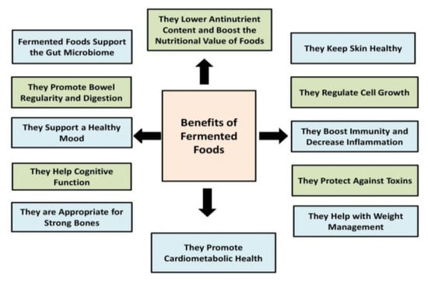
Figure 5: Benefits of Food Fermentation²⁴
Consequently, foods that have undergone fermentation have numerous health advantages, including anti-oxidant, anti-microbial, anti-fungal, anti-inflammatory, anti-diabetic, and anti-atherosclerotic properties. Yogurt has been linked in studies to lowered blood sugar. It aids with metabolic syndrome and the dangerous consequence that follows, type 2 diabetes. Rich in probiotics is yogurt. Consuming yogurt containing various strains of bacteria and yeast can aid in the regulation of blood pressure, cholesterol, and blood sugar (Fig.5). Antibiotics, insulin, growth hormones, vaccinations, and interferons are produced through fermentation.¹⁶.
Economical BenefitsFermentation has potential economic value in the food sector. Several value-added products are produced both locally and industrially, and fermentation is essential to these processes. The fermentation market is anticipated to grow rapidly over the next several years, with a +6% CAGR from 2020 to 2027 and a projected USD $875.21 billion by that time. Consumer demand is undoubtedly rising, and businesses are investing in the fermentation sector at an increasing rate. There are a few different approaches that firms may take: they can either buy businesses in the industry (like PepsiCo and Coca-Cola bought kombucha companies) or they can use their internal knowledge to create fermented plant products (like Danone and Bel). These approaches can also be combined. The largest players in the industry are the dairy market, which is expanding quickly. But there are still a lot of uncharted territories when it comes to fermentation, such fermented vegetables, unusual fermented goods, fermented fruit juices, or unconventional components (like pasta made without gluten from legumes). According to Forbes, the consumption of fermented foods increased to 149% in 2018, indicating not only the enduring popularity of this traditional food type but also how globalization has exposed them to new cultures and palates. ²⁵.
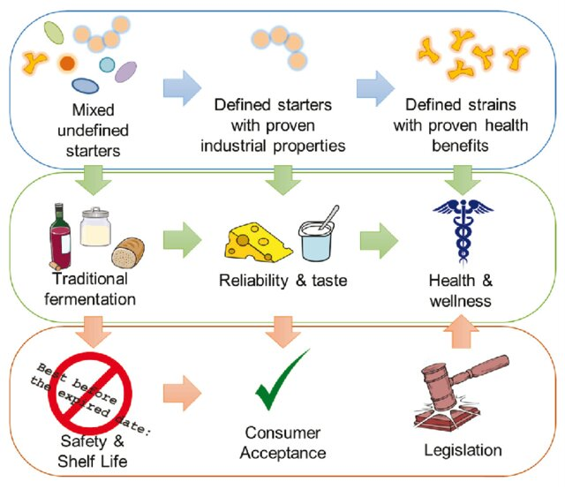
Figure 6: Process of Food Fermentation ¹⁰
Few significant benefits of food fermentation are summarised as:
- 1. The production of a variety of tastes, scents, and textures in food substrates to enrich the diet.
- 2. Use of lactic acid, alcohol, acetic acid, and alkaline fermentations to preserve large quantities of food.
- 3. The addition of vitamins, essential fatty acids, essential amino acids, and protein to food substrates for biological enrichment.
- 4. The removal of antinutrients.
- 5. A reduction in the amount of fuel needed and cooking time.
- 6. Preserves and enriches food, increases food's flavor and taste, and aids digestion.
- Fermentation break down the complex compounds into simple which are easily digestible in human digestive system.
- Fermentation splits cellulose and hemi cellulose structures in the substrate which are indigestible and converted them into simple sugars and sugar derivatives which increase the nutritional value of the food. They cause highly specific and controlled changes to foods by using enzymes.
- food preservation using lactic acid, acetic acid, alcohol, and alkaline fermentation processes.
- Extended shelf life of food.
- The detoxification of undesirable compounds
- Health related product.

LIMITATIONS OF FOOD FERMENTATION
Fermentation has many applications and benefits, there are also some limitations associated with this process¹⁷. Some of the most common limitations of fermented food:
- Risk of contamination- Given that fermentation is a natural process, a variety of variables, including humidity, temperature, and the type of microbes employed, may be relevant. Foods that have undergone incorrect fermentation are susceptible to bacterial contamination from pathogens such as Salmonella or Listeria.
- Allergies- The yeasts or molds used in the fermenting process may cause sensitivities in certain persons. Allergic responses ranging from moderate to severe may result from this.

Acidity - Certain fermented foods, such as sauerkraut and pickles, can contain a lot of acid. Recessive ingestion of acid might lead to upset stomach.

High sodium content - The salt utilized during the fermentation process causes fermented foods to have a high sodium content. The consumption of fermented foods may need to be limited in people who have high blood pressure or other conditions that necessitate a low-sodium diet.

Process Changes- Low-volume production requiring a lot of money and energy, Natural fluctuations throughout time, The final product is unexpected and undesired, the germs thrive and reproduce uncontrollably, and the desirable microbes die. The product is impure and requires more treatment.

APPLICATIONS OF FOOD FERMENTATION TECHNOLOGY
There are several classifications for fermented foods. They could be categorized according to the kind of product, the biochemistry, or the microbes. Meat products, beverages, cereal goods, dairy products, fish products, fruit and vegetable products, legumes, and fish products were the seven categories that Campbell-Platt (1987) classified.².
Many different forms of food, including dairy products like yogurt and cheese, fermented vegetables like sauerkraut and kimchi, alcoholic drinks like beer and wine, and many more, are produced through fermentation. Foods may be preserved by fermentation as well as have their flavor, texture, and nutritional value increased. Different types of food are fermented and used daily in diet. Some examples of these foods are as follows:
Dairy products
For humans, the fermentation of milk and the dairy products that result from it are vital. Fermentation occurs in dairy products such as yoghurt, kefir, cheese, butter, and sour milk. Products made from fermented milk are a good source of probiotics.¹³. Yogurt is a fermented milk product that has immune-system-modulating properties.
Fermented Milks: A particular microbial consortium in which yeasts, Bifidobacteria, and lactic acid bacteria (LAB) thrive in a protocooperative relationship ferments milk to produce fermented milks. Many members of the Lactobacillus, Lactococcus, Streptococcus, Leuconostoc, and Pediococcus genera are among the Lactobacillus-associated bacteria (LAB) that are present in large quantities during the fermentation process and contribute to the unique flavor, texture, and nutritional value of fermented milk.
Yogurt: Yogurt is a coagulated milk product that is made by fermenting lactic acid with the help of Lb. delbrueckii subsp. bulgaricus and Streptococcus thermophilus. The final yogurt product's physical properties can vary depending on the type of starter utilized.
Cheese: Cheese is a concentrated milk product made from milk, cream, partially skimmed milk, buttermilk, or a combination of these products through coagulation and whey separation. You can eat cheese raw or after it has matured. Less than 20 different types of cheese are represented by the more than 400 different varieties. These cheeses are categorized or grouped based on factors such as moisture content, texture, and ripening status—whether the cheese is matured naturally or by the use of bacteria or molds.
Beverages
The process of fermentation for the production of beverages has been used since old times. Fermented beverages are of two types:
- Alcoholic Beverages: Alcoholic beverages have been integral to various cultures throughout history. Alcoholic fermentation takes place in fruits or other high-sugar substances thanks to the action of yeasts. The alcohol content in these beverages serves as a natural preservative, contributing to their extended shelf life. Significant progress has been achieved in enhancing the qualities of fermentation strains, largely driven by the substantial economic incentives tied to the alcoholic beverage industry.
Distilled Spirits: Excessive concentrations of alcohol can impede yeast metabolism. To achieve higher alcohol concentrations, the fermented products must undergo distillation. Distilled spirits such as whiskey, gin, vodka, rum, and liqueurs exemplify this process. Wines are created by fermenting fruit juices rich in fermentable sugars. Beers, on the other hand, are produced from raw materials containing starch, which undergo enzymatic breakdown, malting, and mashing to make the sugars accessible to microorganisms for fermentation.
- Cereal-based food Products
Cereal grains have been a longstanding source of human food. Grains can be transformed into food products through fermentation. For example, "Ogi," a cereal porridge, is made from the fermentation of maize, millet, and sorghum (Osungbaro, 2009). Many cereal-based foods are derived from grains such as maize, wheat, millet, sorghum, or rice. Fermented cereal products can take the form of liquids or solid products, including stiff gels.
Fermented Vegetable Products
Lactic acid fermentation is a widely used method for preserving numerous vegetables globally. Among the commercially significant fermented vegetables are cabbage (for sauerkraut), cucumbers, and olives. Additionally, vegetables like carrots, cauliflower, celery, okra, onions, and peppers are also subjected to this preservation technique. Typically, these fermentations do not require the addition of starter cultures and instead rely on the indigenous microflora present. The primary product of this fermentation process is lactic acid. The inclusion of salt in the process helps extract liquid from the vegetables, which then serves as a substrate for the growth of lactic acid bacteria (LAB). The presence of salt also acts as a barrier against the proliferation of undesirable spoilage microorganisms.
Fermented Meat and Fish Products: Fermented Meat product Sausages, fermented fish products like fish sauces, fish paste.
- Meat Products: Although meat is consumed all around the world, it is highly prone to bacterial infection. Meat must therefore be preserved in order to retain its stability. Meat fermentation12. The process of fermenting sausages with lactic acid bacteria (LAB) preserves the meat and keeps it from going bad.¹⁹.
- Fermented Sausages: Across the globe, various methods have been devised for producing stable, fermented meat sausages. The general approach to preserving the meat involves the addition of salts and the promotion of lactic acid production by bacteria, resulting in a rapid decrease in pH levels. During the fermentation process, micrococci, staphylococci, and yeasts play pivotal roles in developing the sausage's color, taste, and flavor. The preparation of fermented sausages entails blending ground meat with a diverse mix of spices, flavorings, salt, sugar, additives, and frequently, starter cultures. While pork, beef, mutton, or turkey meat can all be used, it is essential for the meat to be fresh and of high quality to ensure favorable sensory properties and safety.
- Fermented Fish: Fish fermentation is particularly prevalent in Southeast Asia, where fish holds a significant place in the human diet. Fermented fish items are renowned for their ability to be stored for extended periods while preserving their nutritional value. In these fermentation processes, Gram-positive micrococci play a pivotal role. This practice has given rise to various popular products, including fermented sausages, fish sauces, and fish pastes. Since the carbohydrate content in fish is typically low, usually less than 1%, an additional source of carbohydrates is necessary for lactic fermentation. Ingredients like rice and garlic are often introduced to provide this carbohydrate source, with garlic containing inulin as a carbohydrate reserve. The primary products derived from fish result from microbial fermentation and the enzymatic degradation of fish through autolysis. These resulting products are commonly referred to as fish sauces and fish pastes.
- Combined Fermentation Products
Microorganisms play a pivotal role in food fermentations by releasing carbon dioxide, serving two primary purposes: (i) functioning as a leavening agent and (ii) facilitating carbonation in beverages. An exemplary application of carbon dioxide is observed in the leavening of dough during the bread-making process. In bread production, gas formation comprises a combination of air introduced during mixing and kneading, alongside CO2 generated from the fermentation of sugars by yeast. The yeast not only contributes to the bread's flavor but also imparts an enticing aroma. During the baking of the loaves, proteins undergo denaturation, establishing the structure, while any trace amounts of ethanol produced by the yeast tend to evaporate.¹².
Sourdough: Sourdough bakery items exhibit an extended shelf life, a result of the fermentation process that synergizes the metabolic actions of lactic acid bacteria (LAB) for souring and yeasts for leavening. The intricate and rich flavor of the bread stems from the production of lactic and acetic acids by LAB, as well as flavor compounds generated through the interplay of inherent cereal enzymes, microbial processes, and the baking procedure. Additionally, the metabolic activities of LAB and yeasts contribute to the creation of a diverse array of appealing aromatic compounds.
Top of Form
- Vinegar: Vinegar stands as one of the oldest culinary products known to humanity. Its origins are believed to trace back to an accidental discovery involving spoiled wine, hence its name derived from the French term "vin aigre," which translates to sour wine. Vinegars with higher strength are often employed in the pickling process, and spirit vinegar, for instance, is created through distillation of an alcoholic solution. Vinegar, widely regarded as a triumph of the preservation industry, finds manifold applications in the food sector. It significantly extends the shelf life of various foods, including pickled vegetables like gherkins, olives, and onions, by immersing them in vinegar. The production of vinegar involves a two-stage fermentation process: initially, an anaerobic, alcoholic fermentation of sugars by yeasts takes place, followed by the oxidation of ethanol to acetic acid by bacteria. This latter reaction is known as acetification and is also a common cause of spoilage in alcoholic beverages.
Kefir: Kefir is created through an acid/alcohol fermentation process involving pasteurized milk and a combination of lactic acid bacteria (LAB), yeasts, and other bacteria. The resulting product is a slightly alcoholic, effervescent liquid to semiliquid with an acidic taste and is commonly enjoyed as a beverage. To initiate the fermentation, kefir grains are introduced into the milk. These kefir grains consist of proteins, polysaccharides, and a blend of microorganisms, primarily including yeasts that ferment lactose, aromatic bacteria, and LAB.
- The primary yeasts are Saccharomyces and Candida kefir, whilst the primary Lactobacillus kefir, Leuconostoc species, and Lactobacillus lactis make up the LAB. The lactobacilli and Leuconostoc species produce lactate, acetate/ethanol, and carbon dioxide from lactose; the yeasts make ethanol and carbon dioxide from lactose; and the lactococci produce lactate from lactose. The ideal room temperature for kefir fermentation is between 17°C and 23°C.
Oriental Fermented Products
The manufacturing process of soy sauce, miso, and sake includes koji fermentation. Koji is composed of soybeans or grains on which molds develop, generating enzymes like proteases, lipases, and amylases. These fungal enzymes break down proteins, carbohydrates, and lipids into nutrients utilized by microorganisms in subsequent fermentation steps. Koji comes in various types, each tailored to the specific products being produced. Variations in koji include the types of molds used, the substrate, the preparation method, and the harvesting stage. ¹⁹.
- Soy Sauce: Soy sauce is a dark brown liquid derived from the fermentation of soybeans and wheat in a salt brine. To achieve the desired acidity for preservation and flavor, lactic acid bacteria (LAB) like Pediococcus soyae or Lb. delbrueckii are cultivated on the moromi. Yeasts such as Saccharomyces rouxii and Torulopsis sp. are also involved in the fermentation process, contributing to alcohol production and flavor development. After aging, the moromi is pressed to extract a liquid, which is then pasteurized to create soy sauce.
- Tempeh: Tempeh is a protein-rich food recognized as one of the earliest meat alternatives globally. The process involves cultivating the mold R. oligosporus or similar species on soaked, dehulled, and partially cooked soybeans, forming a solid cake. This cake can be sliced and deep-fried or cut into cubes to substitute for meat in various dishes, including soups. Tempeh production doesn't primarily focus on extending shelf life; instead, it enhances the overall appeal and nutritional value of its primary ingredient, soybeans.
ARTIFICIAL INTELLIGENCE IN FOOD FERMENTATION
Artificial intelligence (AI) involves the theory and development of computer systems capable of performing tasks typically requiring human intelligence. It traditionally pertains to the creation of human-like intelligence within machines, enabling them to learn, reason, plan, perceive, or process natural language. The application of AI-based predictive analytics is poised to assist food manufacturers in creating new food products that closely align with consumer preferences. With the growing demand in the food industry, AI technologies are being embraced to optimize profits and explore innovative methods of reaching consumers. AI has found utility in various areas, including sorting fresh produce, supply chain management, monitoring food safety compliance, enhancing cleaning in place systems, anticipating consumer preferences, and streamlining the development of new products, ultimately saving time and resources. An example of AI technology in this context is the electronic nose (E-nose), which is employed to detect the flavors of various food items within this category.

Electronic Noses for Fermented Foods
Numerous communities worldwide have incorporated fermented foods and beverages into their regular meals. Volatile organic molecules that are released into the atmosphere are crucial for figuring out the chemical makeup and other details of fermented foods and drinks. Electronic nose (E-nose) technologies have been used for this purpose for many years since they are simple to use, have minimal running costs, and allow for non-destructive monitoring and quick analysis. Different kinds of microorganisms, including bacteria, yeast, and mold, have been employed to alter the chemical composition of fermented foods and beverages, resulting in changes in taste, smell, color, and nutrition. Many methods, including physical quality, nutritional value, microbiological quality, safety, and sensory quality, can be used to evaluate the quality of fermented food and beverages. A variety of tools and methods, including spectroscopies and sensory evaluation techniques, have been developed.
Buck and Axel from Columbia University in the United States conducted the first molecular investigation into the mechanics, odor detection, and limitations of human olfactory perception in 1991. Their finding paved the door for innovative concepts and methods for creating an E-nose system rather than relying on the sophisticated human olfactory sense for a variety of multipurpose uses.24. Three primary components can be identified in the human olfactory system.

a. The olfaction component, comprising olfactory receptor glands and aroma delivery mechanisms,
b. The neural system for transmitting signals between the brain and the body, and
c. A decision-making system capable of recognizing, identifying, and responding to olfactory sensations perceived by the brain.

The sense of smell operates on a highly intricate mechanism. Psychophysical testing has shown that people can distinguish between more than 1 trillion different olfactory stimuli. But human emotions and age have a big impact on how well humans recognize and categorize odors. Furthermore, the presence of hazardous chemicals in the sample and the duration of the test are significant barriers to the detection of scents through the human olfactory system (Fig 7). As a result, the E-nose has emerged as one of the most effective instruments for replacing human judgment of sample aroma.
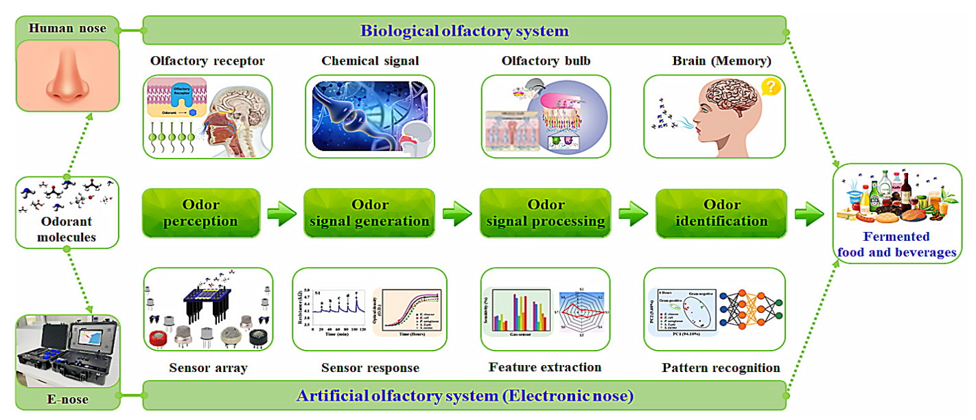
Figure 7: Comparison of Human Nose and E Nose¹
Recent years have seen a significant increase in interest in tools and techniques that allow for non-destructive measurement, quick analysis, and on-site testing with affordable operating costs and ease of use. Electronic noses (E-noses) are among the most useful instruments for quality food and beverage identification that satisfy these requirements. For the qualitative analysis of food and drinks, there is a global trend toward the development of E-nose systems in place of conventional apparatus like GC, GC/MS, SPME/GC-TOFMS, GC-IMS, etc. While a number of review articles have been written about the use of E-nose in food and beverage applications, there are still few in-depth analyses that concentrate on fermented foods and beverages that use E-nose technology.
In the present day, electronic nose (E-nose) systems employing various gas sensor arrays find applications across diverse sectors, including agriculture and forestry, industrial processes, environmental toxin/pollutant analysis, space stations, medical/healthcare, personal authentication, pharmaceuticals, forensic science, military, toxicology/security, and the food and beverage industry. An emerging avenue in this field is the development of mobile and cost-effective devices for individuals experiencing anosmia (loss of smell). Specifically within the food and beverage industry, E-nose systems have been utilized for both direct and indirect odor analysis to serve multiple purposes. These purposes encompass product quality assessment, studies on batch-to-batch consistency, detection of contaminants, identification of spoilage, recognition of adulteration, identification of pathogenic bacteria, investigations into storage conditions and shelf life, as well as the establishment of distinctive sensory profiles. Concerning competitive aspects in the food industry, E-noses have been employed to analyze aromas, make comparisons with rival products, assess the effects of alterations in the production process and components impacting sensory attributes, and evaluate various food formulations.
Furthermore, E-nose systems have demonstrated exceptional capabilities in assessing the quality of a wide range of products, encompassing wine, beer, coffee, carbonated beverages, dairy items, pork, beef, poultry, fish, and shrimp. Nonetheless, it is worth noting that sensors within E-nose systems can exhibit a drift effect, leading to slight measurement biases over different time intervals due to sensor aging. Over the years, research efforts persist in the pursuit of enhancing E-noses, aiming for heightened precision and accuracy, the implementation of online platforms, and achieving quantitative identification.²³.
SCOPE OF FOOD FERMENTATION TECHNOLOGY

Fermentation is a natural process and a more eco friendly substitute: In the upcoming years, fermentation is poised to hold a significant position, particularly in the synthesis of valuable metabolites. These metabolites, presently manufactured through chemical processes, sourced from natural origins, or derived from intensive agricultural practices (such as breeding), exert notable ecological consequences. Fermentation stands as an environmentally sustainable alternative for their production.
- Growing economic opportunity by fermentation: As per the World Economic Forum, there is a projected 100% increase in demand for proteins from now until 2050, and meeting this demand solely with animal-derived proteins will not be feasible. To address this, a viable plant-based alternative can be established using various forms of fermentation, whether it be microbial, biomass, or precision fermentation.

Traditional and all the rage process reflecting a commitment to ecology and solidarity: Fermentation is integrated into societal practices in two distinct ways. Firstly, it is a traditional and culturally significant skill, particularly prevalent in Asian and African regions, offering consumers the chance to explore new culinary experiences. Secondly, it has more recently emerged as a means for society to reengage with its food habits and endorse a circular economy. In fact, fermentation can be easily conducted on a small scale, empowering consumers to extend the shelf life of their fruits and vegetables and thereby reduce food waste. This shift in behavior can be further facilitated by manufacturers, through impactful communication that educates consumers about sustainable food practices and by offering products that encourage DIY (Do It Yourself) fermentation. This allows food manufacturers to demonstrate their commitment to ecological values by supporting consumers in their pursuit of sustainable and environmentally conscious consumption.^{23&27}.

Nutritional aspect: Fermentation is frequently linked with intriguing nutritional advantages. For fermented ingredients, it has the potential to enhance the bioavailability of minerals that are naturally present. Additionally, it has the capability to eliminate undesirable anti-nutritional components. These advantages are also commonly linked to the digestive and intestinal microbiome, especially when probiotics are utilized in specific products. Nevertheless, it is imperative to emphasize that further scientific research is required on this topic before legally asserting these nutritional benefits.

FUTURE CHALLENGES OF FOOD FERMENTATION TECHNOLOGY
Global food and beverage manufacturing operations, as well as additional processes including the synthesis of commercialized biocompounds like hormones, antibiotics, pigments, and bioplastics, are all supported by fermentation. The development of fermentation as a global process has intriguing challenges to address in the near future, despite the intense research efforts on fermentation-based processes, which involve various scientific areas such as plant/microorganism genetics, biochemistry, biomass chemistry, and process engineering.³⁰.
Furthermore, the genomes of numerous pathogenic and spoilage bacteria are now available, which may create new opportunities for the development of novel antibiotics that specifically target the vital functions of these troublesome bacteria. When it comes to food systems, the true challenge of the genomes and proteomics age is to use this abundance of data to enhance culture performance and activities, which will enhance the composition, safety, and quality of the world's food supply.²⁹.
An further significant obstacle pertains to technology. Recent descriptions of certain intriguing microbes for industrial fermentations have shown that they need "extreme conditions" to develop, such as high salt concentrations or extremely acidic pHs. This pertains to bacteria that are either acid thermophilic or halophilic, respectively. Operating in these conditions leads to corrosion, which shortens the half-life of the majority of bioreactors on the market today. This has a detrimental impact on the large-scale use of these microorganisms. Lastly, there is additional work to be done in designing fermentation processes based on the circular economy.²⁴
Some of the current challenges with respect to precision fermentation for food production include:
- Scalability, economic viability, and sustainability: The majority of precision fermentation start-ups that produce food ingredients are still in their infancy, and it is unclear if they will be able to maintain their profitability or sustainability as they grow.
- Consumer perception: Some consumers worry that novel proteins and other compounds that could be harmful or allergic could be introduced into food through synthetic biology. In many jurisdictions (USA, Australia), precision fermentation made substances are exempt from GMO labeling as long as the molecules are nature comparable. This makes it challenging for consumers to make educated decisions. To increase customer trust and adoption of precision fermentation components, appropriate labeling, openness, and consumer education will be necessary.
- Ethical concerns: In its most audacious form, synthetic biology involves creating "a new life form" that fulfills a target vision or application rather than merely altering an organism's genetic makeup. This raises ethical questions as well as risks related to biosafety and biosecurity, such as the potential for these organisms to escape into the environment and replicate uncontrollably, as well as the possibility of intentional misuse by terrorists. Furthermore, the production of food ingredients originating from conventional agriculture, such as steviol glycosides and vanilla, by precise fermentation, has an impact on the livelihood of farmers who depend on these commodities, particularly in underdeveloped nations. This has ramifications for society and ethics. Academic institutions, governmental bodies, and private sector must work together to guarantee biosecurity, moral technology usage, and fair distribution of genetic resource earnings.²⁸.
- Regulatory aspects: Globally, frameworks for policies and regulations controlling synthetic biology and precision fermentation are still being developed, and there are worries that technological advancements in the area could surpass the creation of suitable legislation.
- Capability in large-scale fermentation and downstream processing: The primary obstacles to realizing the full potential of precision fermentation have been found to be a lack of experience with fermentation process engineering in downstream processing and fermentation facilities operating on a commercial scale. The food fermentation capacity that is now available will be used up in 12 to 24 months, emphasizing the necessity of investing in fermentation facilities.³¹.
References:
- Agbai, C. M. (2020). Application of artificial intelligence (AI) in food industry. GSC Biol. Pharm. Sci, 13, 171-178.
- Campbell-Platt, G. (1987). Fermented foods of the world. A dictionary and guide. Butterworths.
- Cavalieri, D., McGovern, P. E., Hartl, D. L., Mortimer, R., & Polsinelli, M. (2003). Evidence for S. cerevisiae fermentation in ancient wine. Journal of molecular evolution, 57, S226-S232.
- Emergen Research. 2020. Global fermented food and ingredients market 2017-2027. Report ID: ER_00375, 250 pp.
- He, B., Tu, Y., Jiang, C., Zhang, Z., Li, Y., & Zeng, B. (2019). Functional genomics of Aspergillus oryzae: Strategies and progress. Microorganisms, 7(4), 103.
- Hesseltine, C. W., & Wang, H. L. (1980). The importance of traditional fermented foods. BioScience, 30(6), 402-404.
- https://eatcultured.com/blogs/our-awesome-blog/fermentation-a-history
- https://ebooks.inflibnet.ac.in/ftp1/chapter/food-fermentation/
- https://stacker.com/food-drink/history-fermentation-around-world
- https://www.researchgate.net/publication/356371347. Evolution of Food Fermentation Processes and the use of Multi Omics in Deciphering the Roles of the Microbiota.
- https://www.webmd.com/diet/ss/slideshow-benefits-fermented-foods
- Hugas, M., Garriga, M., & Aymerich, M. T. (2003). Functionalty of enterococci in meat products. International journal of food microbiology, 88(2-3), 223-233.
- Katz, F. (2001). Active cultures add function to yogurt and other foods: yogurt reinvents itself. Food technology (Chicago), 55(3), 46-49.
- LeBlanc, J. G., Matar, C., Valdez, J. C., LeBlanc, J., & Perdigon, G. (2002). Immunomodulating effects of peptidic fractions issued from milk fermented with Lactobacillus helveticus. Journal of Dairy Science, 85(11), 2733-2742.
- Mannaa, M., Han, G., Seo, Y. S., & Park, I. (2021). Evolution of food fermentation processes and the use of multi-omics in deciphering the roles of the microbiota. Foods, 10(11), 2861.
- Marco, M. L., Heeney, D., Binda, S., Cifelli, C. J., Cotter, P. D., Foligné, B., ... & Hutkins, R. (2017). Health benefits of fermented foods: microbiota and beyond. Current opinion in biotechnology, 44, 94-102.
- Martínez-Espinosa, R. M. (2020). Introductory Chapter: A brief overview on fermentation and challenges for the next future. New Advances on Fermentation Processes, 3.
- McGovern, P. E., Zhang, J., Tang, J., Zhang, Z., Hall, G. R., Moreau, R. A., ... & Wang, C. (2004). Fermented beverages of pre-and proto-historic China. Proceedings of the National Academy of Sciences, 101(51), 17593-17598.
- Osungbaro, T. O. (2009). Physical and nutritive properties of fermented cereal foods. African Journal of Food Science, 3(2), 023-027.
- Puyol, D., Batstone, D. J., Hülsen, T., Astals, S., Peces, M., & Krömer, J. O. (2017). Resource recovery from wastewater by biological technologies: opportunities, challenges, and prospects. Frontiers in microbiology, 7, 2106.
- Ross, R. P., Morgan, S., & Hill, C. (2002). Preservation and fermentation: past, present and future. International journal of food microbiology, 79(1-2), 3-16.
- Şanlier, N., Gökcen, B. B., & Sezgin, A. C. (2019). Health benefits of fermented foods. Critical reviews in food science and nutrition, 59(3), 506-527.
Critical Reviews in Food Science and Nutrition , Volume 59, 2019 - Issue 3.
- Seesaard, T., & Wongchoosuk, C. (2022). Recent Progress in Electronic Noses for Fermented Foods and Beverages Applications. Fermentation, 8(7), 302.
- Stanbury, P. F., Whitaker, A., & Hall, S. J. (2013). Principles of fermentation technology. Elsevier.
- Sun, W., Shahrajabian, M. H., & Lin, M. (2022). Research progress of fermented functional foods and protein factory-microbial fermentation technology. Fermentation, 8(12), 688.
- Tamang, J. P., Cotter, P. D., Endo, A., Han, N. S., Kort, R., Liu, S. Q., ... & Hutkins, R. (2020). Fermented foods in a global age: East meets West. Comprehensive Reviews in Food Science and Food Safety, 19(1), 184-217.
- Terefe, N. S. (2022). Recent developments in fermentation technology: toward the next revolution in food production. Food engineering innovations across the food supply chain, 89-106.
- Vouillamoz, J. F., McGovern, P. E., Ergul, A., Söylemezoğlu, G., Tevzadze, G., Meredith, C. P., & Grando, M. S. (2006). Genetic characterization and relationships of traditional grape cultivars from Transcaucasia and Anatolia. Plant Genetic Resources, 4(2), 144-158.
- Wang, Y., Ling, C., Chen, Y., Jiang, X., & Chen, G. Q. (2019). Microbial engineering for easy downstream processing. Biotechnology advances, 37(6), 107365.
- Zhu, Y., & Tramper, J. (2013). Koji–where East meets West in fermentation. Biotechnology advances, 31(8), 1448-1457.
- Zhu, Z., Zhang, J., Ji, X., Fang, Z., Wu, Z., Chen, J., & Du, G. (2018). Evolutionary engineering of industrial microorganisms-strategies and applications. Applied microbiology and biotechnology, 102, 4615-4627.

