Ancient Indian Architecture: A Glorious Tapestry of Spiritual and Artistic Mastery
Introduction
Ancient Indian architecture is evidence of the Indian subcontinent's rich cultural heritage and artistic prowess. This chapter delves into the fascinating realm of Indian architectural traditions, exploring the key characteristics, spiritual underpinnings, lasting influence of this extraordinary architectural legacy, and the significance they hold in contemporary times. Through a comprehensive analysis of ancient architectural features, including monumental structures, intricate ornamentation, and advanced construction techniques, this chapter shed light on the engineering prowess exhibited by ancient civilizations. It also underscores the harmonious fusion of art, science, and spirituality in the creation of awe-inspiring structures that have withstood the test of time.
Ancient Indian architecture can be divided into two categories: religious monuments and non-religious monuments. Temples, Stupas, Chaityas, and Monasteries are examples of religious monuments, whereas forts, palaces, civic and urban planning structures are examples of non-religious architecture. The chapter would cover both styles of architecture that were built at comparable and notable times, giving the reader a thorough overview of ancient Indian architecture.
The chapter begins by examining the diverse architectural styles that flourished across different periods of Indian history, including the Indus Valley Civilization, Mauryan, Gupta, Post Gupta, Pallava, Chalukya and Chola eras. Each period brought forth unique architectural expressions, characterized by intricate detailing, elaborate ornamentation, and a deep reverence for religious and spiritual symbolism. The chapter further investigates the spiritual significance embedded within ancient Indian architecture. It explores the seamless integration of architecture and spirituality, where temples, stupas, and sacred spaces were designed as cosmic diagrams and symbols of divine presence. From the magnificent rock-cut caves of Ajanta and Ellora to the awe-inspiring temples of Khajuraho and the celestial architecture of Badami, Pattadakal and Aihole, ancient Indian architecture reveals a profound connection between the earthly and the divine.

Indus Valley Civilisation
Discovery and Extent of the Civilisation
The Indus Valley Civilization, also known as the Harappan Civilization, was one of the world's oldest urban civilizations. It existed from approximately 2600 BCE to 1900 BCE in what is now modern-day Pakistan and northwestern India. The civilization was named after the Indus River, which flows through the region. Alexander Cunningham, an East India Company military engineer with an intense curiosity in archaeology, visited Harappa in the 1850s. He carried out a small excavation and discovered the remains of a number of structures. The civilization was largely forgotten until the 1920s when archaeologists under the directorship of John Marshall and excavators like Daya Ram Sahani and RD Banerji began excavating the ruins of Harappa and Mohenjo-daro. Since then, numerous sites have been discovered across the region, shedding light on the ancient civilization's existence and its remarkable achievements. The Harappan Civilization covered a vast region that stretched over 1.2 million square kilometres (about 463,000 square miles). This area included parts of present-day Pakistan, northwest India, and eastern Afghanistan. Its northern most site is Manda near Chenab River in Jammu and southern most sites is Daimabad in Maharashtra covering a distance of 1600kms. Eastern most site is Alamgirpur near hindan river in UP and western most site is Sutkagendor near Dashk river in Baluchistan covering a distance of 1400 kms. Till date there are more than 2800 sites which have been identified with this civilisation and many have been excavated like Mohenjo-Daro, Harappa, Kalibanga, banawali, Ropar, Dholavira, Alamgirpur, Lothal, Rakhigarhi, Bhagwanpura etc. Many of these were urban centres and can be compared with modern day cities with some unique features like town planning, developed drainage system, standards in weight and measures and a complex society.
Features of Architecture
The Indus Valley Civilization was a remarkable ancient civilization with advanced urban planning, trade networks, and technological achievements seen in the construction of public buildings like Great Bath (a swimming pool like structure whose water proofing was carried out using Bitumen some 3500 years ago). It remains a subject of fascination and study for archaeologists, providing valuable insights into the development of early human societies.
1. Town planning was a remarkable aspect of the Indus Valley Civilization's urban development. The cities of Harappa and Mohenjo-Daro, in particular, demonstrate the civilization's sophisticated planning and organisation. Major centres like Harappa and Mohenjodaro were divided into two parts, upper town enclosed like a citadel, which was likely to be occupied by ruling class and a lower town inhabited by common people. Here are some key aspects of Indus Valley Civilization town planning: -
a. Grid System: The cities were laid out in a grid-like pattern, with streets oriented precisely north-south and east-west. Straight streets intersected at right angles, forming a well-organized network. This grid system made it easier to move around and navigate within cities
b. Well-Defined Structures: Well-defined structures, such as houses, public buildings, granaries, and marketplaces, distinguished the cities. The houses were constructed of baked bricks and had multiple rooms, with an open courtyard in the centre. The streets were lined with houses, with wide lanes separating city blocks.
c. Advanced Drainage Systems: The Indus Valley Civilization possessed an impressive drainage system, which reflected their understanding of urban sanitation. The streets had covered drains that collected wastewater and carried it away from the homes. These drains were sometimes covered with bricks, and other times with stone slabs. At Banawali, the remains of streets and gutters have also been discovered. The drains were linked to larger underground sewerage systems, ensuring waste disposal efficiency. Overall, the quality of the domestic bathrooms and drains is exceptional, and Harappa's drainage system is almost unique.
d. Water Supply: The cities possessed a dependable water supply system. Many homes had private wells or had access to communal wells. The Great Bath at Mohenjo-Daro is a large water tank that was probably used for ritual bathing or other communal activities. The city is thought to have had a complex water management system that supplied water to various parts of the city.
e. Fortifications: Some Indus Valley Civilization cities, including Harappa, had fortifications or defensive walls. The cities were protected by these walls, which were built with large bricks. Fortifications indicate a need for defence and protection against potential threats.
f. Public Spaces: The cities had designated public spaces, such as marketplaces and open squares. The marketplaces were most likely economic hubs where goods were bought and sold. Open squares could have hosted social gatherings, religious ceremonies, or other communal activities.
Overall, the town planning in the Indus Valley Civilization demonstrated a high level of organization and engineering skill. The grid system, advanced drainage systems, well-defined structures, and provisions for water supply and defence all contributed to the efficient functioning of the cities. These well-planned urban centres were a testament to the civilization's advanced understanding of urban living and management.
2. Major Structures
a. Great Bath: The great bath, which is a tank like structure, located in the citadel mound and is a fine example of beautiful brickwork, appears to have been the most important public place in Mohenjo-Daro. It is 11.88 X 7.01 metres with a depth of 2.43 metres. Steps at either end lead to the surface, and side rooms are available for changing clothes. The bath's floor was made of burnt bricks. Water was drawn from a large well in another room, and an outlet from the bath's corner led to a drain. It has been argued that the great bath was primarily intended for ritual bathing, which is so significant in Indian religious ceremonies.
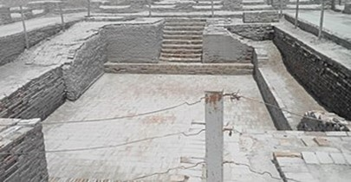
Figure 1. Great Bath of Mohenjo-Daro

b. Granaries: The largest structure in Mohenjo-Daro is a granary which was 45.71 metres long and 15.23 metres wide. However, there are as many as six granaries in Harappa's citadel. These were used for threshing grains and storing them for the use as famine relief.

Mauryan Age: Caves, Pillars and Stupas
The discoveries at Dholavira suggest that the development of monumental stone sculpture and architecture in the Indian subcontinent can be traced back to the Harappan civilization. However, there is a long gap following the decline of that civilization, and it is only during the Maurya period that monumental stone sculpture and architecture reappear on the scene. The Mauryan Empire was founded by Chandragupta Maurya and reached its zenith under the rule of Emperor Ashoka. Mauryan architecture refers to the architectural style that flourished during the Maurya Empire in ancient India, which existed from approximately 322 BCE to 185 BCE. The Mauryan contributed significantly to art and architecture and widely popularised stone masonry.
Features of Architecture
The Mauryan architecture was influenced by various regional architectural styles prevalent in different parts of the empire. Megasthenese, a contemporary Greek traveller claims that the Maurya palace at Pataliputra was as magnificent as the one in Iran's capital. At Kumrahar, on the outskirts of modern Patna, fragments of stone pillars and stumps indicating the existence of an 84-pillared hall have been discovered. Although these ruins do not recall the splendour mentioned by Megasthenese, they do attest to the high technical skill attained by Maurya artisans in polishing the stone pillars, which are as gleaming as the Northern Black Polished Ware. Transporting the massive blocks of stone from the quarries, as well as polishing and embellishing them when they were erected, was a difficult task. The entire process suggests a tremendous feat of engineering. Each pillar is made entirely of buff-colored sandstone. However, it also introduced some unique elements and innovations. Unfortunately, due to the passage of time and limited surviving structures, our knowledge about Mauryan architecture is somewhat limited, and most of our understanding is based on archaeological remains and historical accounts.
Here are some key features and examples of Mauryan architecture:
- Pillars: Mauryan pillars were made from a single piece of highly polished sandstone. The most commonly used stone was buff-coloured or reddish sandstone, although some pillars were made from other materials such as granite. The pillars were tall and slender, ranging from about 12 to 15 meters (39 to 49 feet) in height. They had a circular cross-section and tapered towards the top. The shafts of the pillars were often smooth and unadorned. The capital, or the topmost part of the pillar, was intricately carved and usually consisted of three distinct components: an abacus, a bell-shaped lotus, and an animal figure. The animal figure on the capital is most famous, featuring animals like lions, bulls, elephants, or horses. These animal capitals are often referred to as the "Mauryan lion capital" and are highly regarded for their artistic value. These pillars were often placed in important locations, such as palace complexes, religious sites, and city entrances. The most famous example is the Ashoka Pillar at Sarnath, which features a lion capital with four lions standing back-to-back.

Figure 2. Ashokan Pillar With Lion Capital

- Stupas: Stupas, or large hemispherical structures, were an integral part of Mauryan architecture. Stupas served as Buddhist religious monuments and contained relics of the Buddha or important Buddhist figures. As per the traditions it is believed that Ashoka built almost 84000 stupas all over the country which contains relics of Lord Buddha. The most notable example is the Great Stupa at Sanchi, commissioned by Emperor Ashoka. Others being at Sarnath, Bharhut, Takshashila and Amravati.

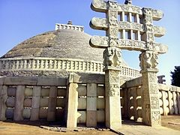
Figure 3. Sanchi Stupa near Bhopal
- Fortifications: The Mauryans constructed fortified cities and citadels to protect their territories. One prominent example is the city of Pataliputra (modern-day Patna), which served as the capital of the Mauryan Empire. The city was surrounded by timber palisades and had elaborate gates which was further reinforced with earthworks, moats, and guard towers.

- Palaces and Buildings: Although very few Mauryan palaces have been discovered, it is believed that they were constructed using wooden materials and have not survived. The remains of buildings in Mauryan cities are sparse, making it difficult to ascertain their architectural characteristics. Chandragupta Maurya constructed a palace in his capital city Patliputra (present day Patna) which was praised by Mgasthenese, a contemporary Greek traveller. In the fifth century AD, during the time of Chandragupta II Vikramaditya, the Chinese traveller Fahiyan was astouned to see the unique beauty of the palace, decorated with bell boots based on giant pillars and gleamed Polish.

- Mauryan Rock-Cut Architecture: The Mauryans also engaged in rock-cut architecture, carving out caves and structures from natural rock formations. One famous example is the Barabar Caves in Bihar, known for their polished interiors and intricately carved doorways and the famous Lomas Rishi Cave, which has an intricately carved facade. The Sudama Cave in Madhya Pradesh is another example of Mauryan cave architecture, featuring a simple cell with a rock-cut facade. However, it is important to note that the Mauryan caves are relatively fewer in number compared to later periods like the Gupta and Buddhist cave complexes. The Mauryan caves were primarily used as dwellings for monks or as places of worship. They were usually excavated in natural rock formations, particularly in hillsides, and consisted of simple cells or chambers carved into the rock. Mauryan cave architecture is known for its simplicity and straightforward design. The caves typically consisted of small, rectangular chambers or cells with basic amenities for the monks. The cave entrances often featured carved rock-cut facades with ornamental motifs and decorative elements. These facades served as an architectural highlight of the caves. Some Mauryan caves also had chaitya windows, which were semi-circular or horseshoe-shaped windows resembling the apsidal windows seen in later Buddhist cave complexes. These windows provided natural light to the interior spaces.

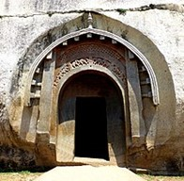
Figure 4. The Horseshoe Shaped Entrance
Mauryan caves occasionally contained inscriptions, either carved on the walls or pillars, documenting the donations made by patrons or providing information about the cave's purpose. It's important to note that the development of cave architecture continued and evolved in subsequent periods, such as the Gupta and post-Gupta eras, with more elaborate cave complexes like Ajanta and Ellora Caves.
- Public Works: The Mauryans paid attention to urban planning and built cities with well-organized layouts, including well-laid-out streets, drainage systems, and public amenities. The Mauryan Empire was known for its ambitious public works projects, such as the construction of roads and canals for efficient transportation and irrigation purposes. These projects contributed to the overall development and prosperity of the cities. A rock in Junagadh, Gujarat, has been discovered with three inscriptions: a set of Ashokan edicts, an inscription of the Kardamaka ruler Rudradaman, and an inscription of the Gupta king Skandagupta. While Ashoka's inscriptions contain his dhamma discourses, the other two tell a unique story of the 1,000-year construction, maintenance, and repair of a water reservoir. The inscription's purpose is to commemorate the Rudradaman's restoration of a reservoir known as Sudarshana Lake. Vaishya Pushyagupta, the provincial governor of Chandragupta Maurya, initiated the construction of this reservoir. During Ashoka's reign, the Tushaspha, a Greek governor of the area, finished it.
Overall, Mauryan architecture exhibited a blend of indigenous traditions with influences from the Persian, Greek, and Hellenistic styles. However, it is important to note that much of the Mauryan architectural heritage has been lost over time, and our understanding of it is limited to a few surviving structures and historical records.

Gupta Era: The beginning of Temple architecture
Gupta architecture refers to the architectural style and developments that emerged during the Gupta Empire in ancient India, which lasted from approximately 320 CE to 550 CE. The Gupta period is often considered a golden age in Indian history, marked by advancements in art, science, and architecture. Gupta cave architecture continued the tradition of rock-cut caves seen in earlier periods. The caves served as monastic retreats, prayer halls, or sanctuaries. The Ajanta Caves in Maharashtra, a UNESCO World Heritage site, exemplify the Gupta cave architecture style with their intricate sculptures and mural paintings. Stupas, Buddhist structures housing relics or serving as places of worship, continued to be constructed during the Gupta period. The Gupta stupas, such as the Dhamekh Stupa in Sarnath, displayed refined architectural features and intricate decorative elements.
Features of Architecture
The Gupta architects made significant advancements in structural engineering. They developed the arch and dome techniques, which allowed for more extensive and sophisticated construction. These innovations enabled the creation of larger temple complexes and more ambitious architectural designs. Gupta architecture emphasized artistic expression through intricate carvings and sculptural details. The temple walls, pillars, and doorways were adorned with sculptures depicting gods, goddesses, celestial beings, and various aspects of Hindu mythology. The artists displayed a high level of skill and craftsmanship in their creations. Gupta architecture showed regional variations across different parts of the empire. For example, the temples in northern India, such as the temples at Deogarh and Eran, displayed distinct features compared to those in central and southern India. The Gupta period witnessed the evolution of Hindu temple architecture. Temples were constructed using stone, and the structural elements of the temples became more elaborate and ornate compared to previous periods. The temples featured distinct shikhara (tower) and mandapa (hall) structures. Gupta architecture set the foundation for subsequent architectural styles in the Indian subcontinent and influenced the development of temple architecture in later periods.
Ajanta Caves
Ajanta Caves, located in Maharashtra, India, are renowned for their exceptional Buddhist rock-cut architecture and exquisite mural paintings. The caves are purely dedicated to Buddhist religion only. These caves were carved into the rocky cliffs during the Gupta period and are considered a UNESCO World Heritage site. There are 30 caves in total at Ajanta. The Ajanta Caves consist of both monasteries (viharas) and prayer halls (chaityas). The viharas served as dwelling places for Buddhist monks, while the chaityas were used for communal worship.
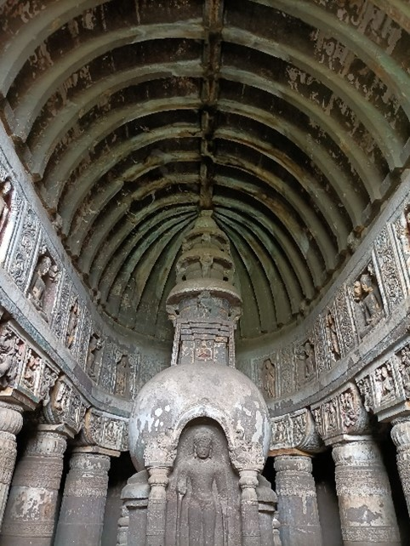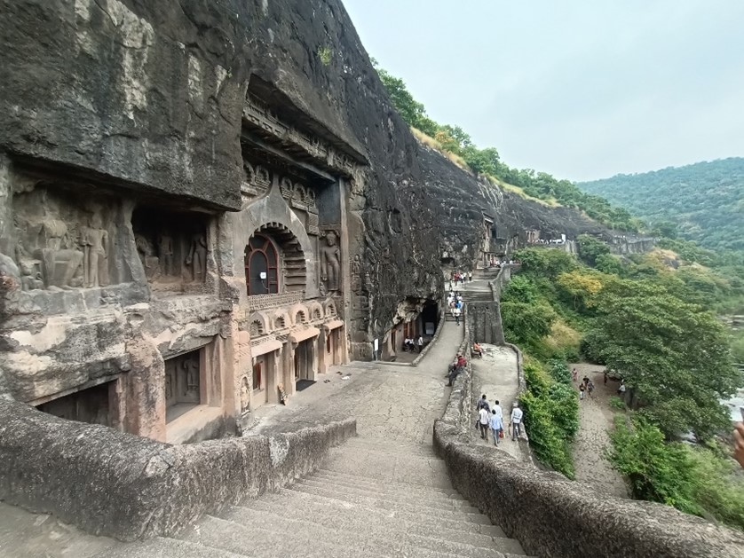
Figure 5. Interior of A Chaitya cave at Ajanta Figure 6. Exterior Designs of Ajanta Caves
These caves were meticulously carved out of solid rock, resulting in impressive architectural structures within the natural surroundings. The entrance facades of the Ajanta Caves are intricately carved and adorned with sculptures and decorative elements. The doorways often have ornate motifs and relief sculptures depicting Buddhist themes and mythical figures. Many of the Ajanta Caves have large pillared halls, known as mandapas, where religious ceremonies and gatherings took place. These halls feature rows of beautifully carved pillars with elaborate capitals and sculptural reliefs. The chaitya caves at Ajanta are characterized by their horseshoe-shaped windows, also known as chaitya arches. These windows serve as apsidal windows, allowing natural light to filter into the prayer hall.
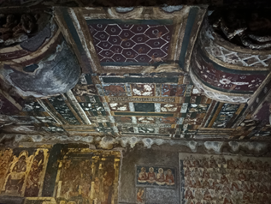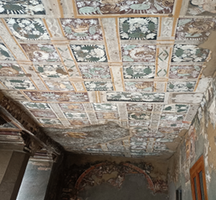
Figure 7. Mural paintings of Buddhist Tales Figure 8. Mural Paintings Seen on the Exterior of a Cave
One of the most remarkable features of Ajanta architecture is the extensive collection of mural paintings that adorn the walls and ceilings of the caves. These paintings depict various Buddhist stories, Jataka tales, and scenes from the life of the Buddha. The murals showcase exquisite artistry, vibrant colours, and intricate details. The sculptures and carvings in Ajanta caves exhibit a rich display of Buddhist iconography. They portray images of the Buddha, Bodhisattvas, deities, celestial beings, and various scenes from Buddhist mythology. The artists skilfully captured the spiritual and divine essence of Buddhism in their artwork.
Ellora Caves
The Ellora Caves are a remarkable complex of rock-cut temples and monasteries in Maharashtra, India. The total number of caves in Ellora is 34. They encompass Buddhist caves (Caves 1 to 12), Hindu caves (Caves 13 to 29), and Jain caves (Caves 30 to 34). While Ajanta is purely Buddhist, Ellora is a synthesis of Hindu, Buddhist, and Jain architectural styles that dates from the 6th to the 10th century CE. The complex stands as a testament to the remarkable craftsmanship and architectural achievements of the time, showcasing the synthesis of different religious traditions in a single location. The Ellora Caves comprise a series of structures carved into the basaltic rock of the Charanandri Hills.
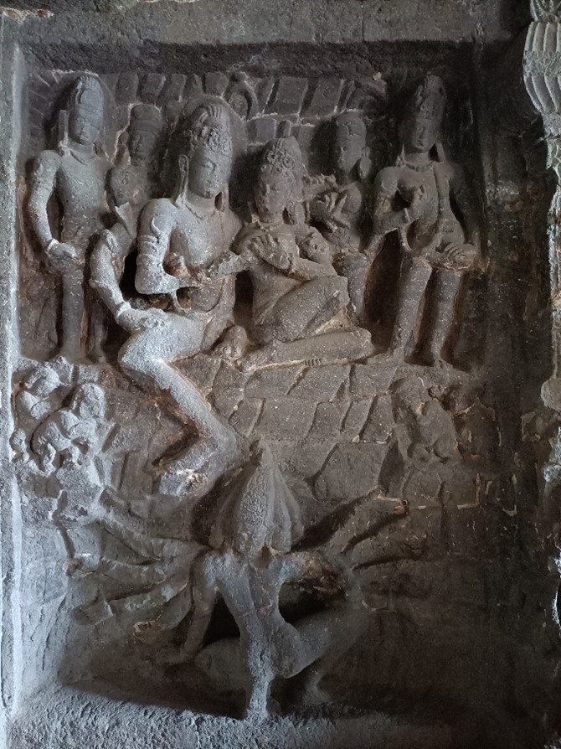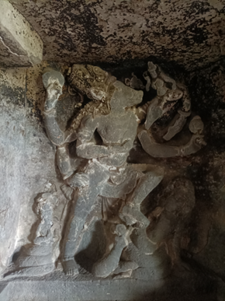
Figure 9. Inner Wall Panel Depicting Ravana Seeking Kailash Figure 10. Vishnu's Varaha Incarnation Saving Bhudevi
The caves are divided into three sections based on the religious affiliations of the structures: Hindu, Buddhist, and Jain. Each section contains a collection of temples and monasteries dedicated to their respective faiths. The Buddhist caves display architectural elements similar to those found in other prominent Buddhist sites, such as Ajanta. The Hindu caves at Ellora showcase a range of architectural styles and deities. Some of the notable cave temples are dedicated to Lord Shiva, Vishnu, and various manifestations of the Hindu pantheon. These caves exhibit elaborate carvings, sculptures, and intricate detailing, reflecting the artistic excellence of the time. The Jain caves at Ellora consist of monasteries, temples, and prayer halls dedicated to Jainism. These caves feature sculptures and reliefs depicting Jain Tirthankaras (spiritual teachers) and intricate ornamentation, highlighting the Jain architectural style. Some caves at Ellora have multiple levels or stories, creating a multilevel architectural design. These structures have upper floors, balconies, and intricately carved columns, giving them a unique and dynamic appearance.
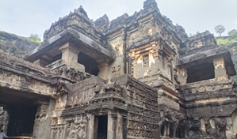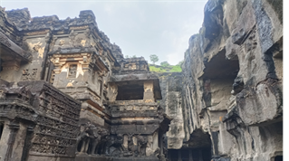
Figure 11. The Famous Monolithic Kailashnath Temple
Temple Architecture
Three types of temple architecture exist in India: Nagara, Dravida, and Vesar. The Dravida style flourished in South India, the Nagara style predominated in North India, and the Vesar style can be viewed as a hybrid of the two. Temples build during Gupta era are of Nagara style with distinct Shikhar and Mandap. Some of the notable temples of this period includes Dashavtar Temple at Deogarh near Jhansi and Bhitargaon Shiv temple near Kanpur. Jagati, Sanctum Sanctorum, Entrance Gateway, Mandap and Shikhara were the main parts of the temple in the Gupta period.

- Jagati: This is the platform on which the temple was built. It increased from two and a half feet to 25 feet, for example Kailashnath Temple of Ellora. The jagati serves several purposes and holds symbolic significance. Here are some key aspects related to the jagati in temple architecture. The jagati provides a solid and stable foundation for the temple structure. It raises the main temple above the ground level, protecting it from moisture, flooding, and other potential damages. The jagati represents the sacred cosmic mountain, Meru or Kailash, in Hindu mythology. It symbolizes the cosmic axis and the abode of gods. By constructing the temple on a raised platform, it is believed to bring the divine realm closer to the earthly realm. The jagati serves as an important space for various rituals and ceremonies conducted in and around the temple. Devotees and priests perform circumambulation (pradakshina) around the temple on the jagati, symbolizing their reverence and devotion. The raised platform of the jagati elevates the temple, enhancing its visual prominence and making it more visible from a distance. It creates a distinct architectural hierarchy, emphasizing the sacredness and significance of the temple. The jagati provides a transition zone between the outside world and the inner sanctum of the temple. It acts as a pathway for devotees to approach the temple and signifies the progression from the mundane to the sacred space.

- Sanctum Sanctorum: This was the temple's main room, where the deity idol was installed and therefore it is the holiest place in the temple. It is positioned in such a way that it represents the center of the universe or the cosmic axis, symbolizing the connection between the divine and the earthly realms. It may be smaller in size compared to the outer structures of the temple, emphasizing its sanctity and exclusivity. The architecture of the sanctum sanctorum may vary based on the regional and religious traditions. Access to the sanctum sanctorum is typically restricted to priests and authorized individuals involved in the worship rituals. Devotees usually offer their prayers and make offerings from the outer areas of the sanctum sanctorum. The sanctum sanctorum is believed to be charged with divine energy and spiritual power. It is considered the most potent and sacred space within the temple, where devotees can experience a closer connection with the divine. The sanctum sanctorum represents the divine abode and serves as a focal point for religious devotion. It symbolizes the ultimate reality, the center of spiritual energy, and the culmination of the temple's architectural and spiritual journey. The sanctum sanctorum was surrounded by walls on all three sides, with the main entrance remaining on one. The sanctum sanctorums were square in shape during the Gupta period. Originally, these walls were saris, but as time passed, the inner and outer walls were decorated with Apsaras, Kinnars, Gandharva animals, and birds as the main decorations. Many turns and folds were later added to the outer walls. Depending on the number of turns in the walls, the sanctum sanctorum or shikhara became known as Triratha, Pancharatha, or Saptratha.
- Entrance Gateway: The entrance gateway of an ancient temple, also known as the gopuram (in South India) or torana (in North India), serves as an important architectural element that marks the transition from the secular to the sacred space. It often represents the grandeur and significance of the temple complex. The entrance was simply marked in ancient times, but the idols of Ganga and Yamuna were installed in both wings. Giant Ganga and Yamuna idols found on Gupta temples built in Ahichhatra are now on display at the National Museum in Delhi. Many ancient temple gateways have multiple levels or tiers, each with its own set of carvings and decorative elements. These levels often rise in a pyramidal or stepped manner, leading to a central pinnacle or spire. The entrance gateway may serve as a ceremonial or ritualistic space. Devotees often pause or perform specific rituals or prayers at the gateway before entering the temple, symbolizing the crossing from the mundane world into the divine realm.
- Mandap: It is a pillared hall or pavilion within a temple complex that serves as an assembly or gathering space. The mandap is usually located in front of the main sanctum sanctorum (garbhagriha) and is used for religious rituals, ceremonies, and community gatherings. The mandap provides a covered space for devotees to gather, perform rituals, and participate in religious ceremonies. It acts as a transitional zone between the external world and the inner sanctum of the temple. Typically, the mandap is an open or semi-open structure supported by pillars. The number and configuration of pillars vary according to architectural style and regional traditions. Extensive carvings, ornamental details, and symbolic representations may be found on the pillars. The mandap is usually located in front of the main shrine, also known as the sanctum sanctorum. It functions as an antechamber or porch to the innermost sanctum. To give the mandap prominence within the temple complex, it may be raised on a platform or elevated level. Devotees gather in the mandap to participate in various rituals, prayers, and offerings. It serves as a space for chanting hymns, reciting religious texts, and conducting ceremonial activities. Offerings such as flowers, lamps, and incense are often made in the mandap. he mandap is adorned with architectural and decorative features such as intricate carvings, sculptures, and reliefs. These elements depict gods, goddesses, mythical beings, and scenes from religious epics. The decorative embellishments enhance the aesthetic appeal and spiritual ambiance of the mandap.
- Shikhar: Shikhara, also known as "vimana," is a term used in Indian temple architecture to describe the towering spire or pinnacle that adorns a Hindu temple's sanctum sanctorum (garbhagriha). It is the tallest and most visible part of the temple's superstructure. The shikhar is typically built of stone or brick and rises above the main body of the temple. It represents Mount Meru, which is thought to be the abode of the gods in Hindu mythology. The shikhar's shape varies according to regional architectural style and period. The shikhar is typically curvilinear in North Indian temple architecture, with multiple horizontal sections, each smaller than the one beneath it, creating a pyramidal effect. This style is commonly found in Nagara temples found in Rajasthan, Madhya Pradesh, and Uttar Pradesh. Intricate carvings of gods, goddesses, celestial beings, and other mythological figures adorn the shikhar. The shikhar takes on a different appearance in South Indian temple architecture. The "gopuram" is a distinctive entrance tower that leads into the temple complex. The gopuram is taller and more elaborate than the shikhar found in North Indian temples. It is frequently adorned with intricate sculptures depicting scenes from Hindu mythology and religious stories. These towering gopurams are prominent in temples built in the Dravidian style in states such as Tamil Nadu, Karnataka, and Andhra Pradesh as seen in Chalukyan, Cholas and Pandyan architecture.
Relevance of Ancient Architecture
For several reasons, ancient Indian architecture remains relevant in modern architectural practises: -
- Cultural Heritage: Ancient Indian architecture represents a rich cultural heritage that has influenced and shaped Indian society's identity. Many architectural elements, techniques, and design principles have been handed down from generation to generation. Architects today frequently draw inspiration from ancient Indian architecture to create modern designs that honour the country's historical and cultural context.
- Innovative Construction Techniques: Ancient Indian architecture demonstrates exceptional engineering and construction techniques. Structures such as the rock-cut caves of Ellora and Ajanta, or the intricately carved temples of Khajuraho, show the mastery of the time's craftsmen and architects. Knowledge of these ancient techniques can be useful in modern construction, inspiring new approaches and pushing the limits of architectural innovation.
- Sustainable Design: Traditional Indian architecture prioritised environmental sustainability and harmony. Passive cooling, natural ventilation, and the use of local materials were all part of ancient Indian architectural practises. In an era when there is a greater emphasis on sustainable design and environmental consciousness, architects are revisiting and incorporating traditional techniques into modern buildings to reduce energy consumption and promote eco-friendly practises.
- Spiritual and Symbolic Significance: Ancient Indian architecture was frequently imbued with profound spiritual and symbolic meanings. Temples were created as sacred spaces that embodied the divine and allowed for spiritual encounters. While modern architecture may not have the same religious connotations as traditional architecture, it can still benefit from the use of symbolism in order to create spaces that evoke emotions, tell stories, and foster a sense of connection and identity for the occupants.
- Aesthetic Inspiration: Ancient Indian architecture's aesthetic beauty and complexity continue to captivate and inspire architects today. Exquisite carvings, ornate details, and balanced proportions can be found in structures such as the Taj Mahal and the Sun Temple at Konark, which serve as timeless examples of architectural excellence. Architects are frequently inspired by this aesthetics, incorporating elements of traditional Indian design into modern structures.
By acknowledging and studying ancient Indian architecture, architects can learn from the wisdom of the past and apply it to current design practices. This not only fosters a connection to cultural heritage but also enriches the architectural landscape by incorporating timeless principles, sustainable techniques, and a deeper understanding of human experiences. Its cultural heritage, sustainable design principles, innovative construction techniques, spiritual and symbolic significance, and aesthetic inspiration continue to inspire and shape modern architecture. Architects can create contemporary designs that honour tradition, promote sustainability, and foster a deeper connection between architecture and the human experience by drawing on the wisdom of the past. Ancient Indian architecture exemplifies the timeless principles of beauty, functionality, and natural harmony, reminding us of the enduring value of our architectural heritage.

