RECENT ADVANCEMENTS IN BIOMEDICAL INSTRUMENTATIONS
1.DHANALAKSHMI K 2. AMRUTHA M 3. DEEKSHITHA M R 4. SPOORTHI K T 5. CHAITHANYA M
Department of ECE, MVJ College of Engineering, Bangalore
1. dhanalakshmik7745@gmail.com 2. ammu26755@gamil.com 3. deekshithashetty5223@gamil.com 4. sporthigowda093@gamil.com 5.chaithanya2363@gmail.com
INTRODUCTION
7[Bioengineering or Biomedical / Biomedical Instrumentation Engineering involves developing new devices and procedures that solve medical and health-related problems by combining their recent advances knowledge in engineering, biology, and medicine to improve human health through cross-disciplinary activities that integrate the engineering sciences with biomedical sciences and clinical practice. Biomedical engineers may spend their days designing electrical circuits and computer software for medical instrumentation. These instruments may range from large imaging systems such as conventional x-ray, computerized tomography and magnetic resonance imaging, to small implantable devices, such as pacemakers, cochlear implants, drug infusion pumps and some of the Prominent biomedical applications include the development of various diagnostic and therapeutic medical devices ranging from common imaging equipment such as MRIs and EEGs, regenerative tissue growth, pharmaceutical drugs and therapeutic biologicals. An evolutionary product is a new model of an existing product that adds new features, improves the technology, and reduces the cost of production. Recent progress of the Nano fibrous structure of chitosan and their biomedical applications in tissue engineering; drug delivery, wound dressing, and antimicrobials are also discussed in this review.]
Bioengineering field is 6[of service to people, working with living systems, and applies advanced technology to the complex problems of medical care. Biomedical engineers may be called upon to design instruments and devices, to bring together knowledge from many sources to develop new procedures, or to carry out research to acquire knowledge needed to solve new problems. It includes:
1. The acquisition of new knowledge and understanding of living systems through the innovative and substantive application of experimental and analytical techniques based on the engineering sciences.
2. The development of new devices, algorithms, processes and systems that advance biology and medicine and improve medical practice and health care delivery]. 3[To measure biological systems and to design a medical instrument, concept of electronics and measurements techniques are needed.] 6[This field seeks to close the gap between Engineering and medicine, Biological Sciences to advance healthcare treatment, including diagnosis, monitoring and therapy.]

The field of biomedical research and technology has seen significant advancements in recent years, particularly in the area of real-time applications. This report delves into the latest developments that have revolutionized various aspects of healthcare, diagnosis, treatment, and monitoring. Through a comprehensive analysis of cutting-edge technologies and methodologies, this report showcases the impact of real-time innovations on patient care, disease detection, and medical research.
The biomedical field has experienced remarkable advancements over the years, with cutting-edge technologies and innovations driving significant improvements in healthcare delivery. Among these advancements, real-time applications have emerged as a game-changer, revolutionizing various aspects of biomedical research, diagnosis, treatment, and patient care. Real-time technologies refer to systems and devices that provide instantaneous data collection, analysis, and feedback, enabling healthcare professionals to make timely and informed decisions. In the context of biomedical applications, real-time advances encompass a wide array of disciplines and methodologies. Real-time imaging and diagnostics, for instance, have ushered in a new era of medical visualization, enabling healthcare providers to observe physiological processes in live action. This real-time insight has led to more accurate diagnoses, more targeted interventions, and enhanced patient outcomes. Additionally, wearable devices and continuous monitoring systems have become an integral part of personalized healthcare. Wearable biometric sensors offer real-time monitoring of vital signs, activity levels, and even blood glucose levels, providing patients and healthcare professionals with immediate feedback on health status and treatment effectiveness. Furthermore, the integration of artificial intelligence (AI) and real-time data analysis has enabled healthcare providers to process vast amounts of medical information rapidly. AI-powered algorithms can aid in early disease detection, predict patient outcomes, and optimize treatment plans in real-time, significantly improving patient care. Telemedicine, virtual health, and telehealth platforms have also leveraged real-time technologies to transcend geographical barriers, bringing expert medical advice and services to remote areas and underserved populations.
3[BIOPOTENTIAL ELECTRODES
A medical instrument performs a specific function on a biological system
• The function may be the exact measurement of physiological parameters like blood pressure, velocity of the blood flow, action potentials of the heart muscles, temperature value of the blood and rates of change of these parameters
In physiological systems, the measurable parameters cover a wide range.
• The living system imposes special constraints on the instrumentation
• The specification must meet the requirements of the living system
• The design must be sufficiently flexible to accommodate the factor of biological variability
• Biomedical measuring devices should cause minimal disturbance to normal physiological function and are to used with safety instrumentation.
DESIGN OF MEDICAL INSTRUMENT
Factors to be considered:
- Accuracy – closeness – approaching true value; degree of conformity to the true value of the quantity under measurement.
- Frequency response – response to various frequency components present in the physiological signal.
- Hysteresis – mechanical friction present in an analog indicating meter can cause the movement of the indicating needle to lag behind corresponding changes in the measured variable. Needle should be selected from the perfect elastic material.
- Electrical isolation - between subjects, on which the measurements are made. Ground is necessary for reasons of electrical safety to avoid any interference between different instruments used simultaneously
- Linearity – degree to which variations in the output of an instrument follow input variation; essential to get accurate values.
- Sensitivity – ability of the instrument to detect even every small change; also expressed in resolution, minimum variation that can be accurately measured. Signal to noise ratio – should be very high to get reliable information.
Bioinstrumentation or Biomedical Instrumentation is an application of biomedical engineering, which focuses on the development of devices and mechanics used to measure, evaluate, and treat biological systems. The goal of biomedical instrumentation focuses on the use of multiple sensors to monitor physiological characteristics of a human or animal for diagnostic and disease treatment purposes. Such instrumentation originated as a necessity to constantly monitor vital signs of Astronauts during NASA's Mercury, Gemini, and Apollo missions. Bioinstrumentation is a new and upcoming field, concentrating on treating diseases and bridging together the engineering and medical worlds. The majority of innovations within the field have occurred in the past 15–20 years, as of 2022. Bioinstrumentation has since been incorporated into the everyday lives of many individuals, with sensor-augmented smartphones capable of measuring heart rate and oxygen saturation, and the widespread availability of fitness apps, with over 40,000 health tracking apps on iTunes alone. Wrist-worn fitness tracking devices have also gained popularity, with a suite of on-board sensors capable of measuring the user's biometrics and relaying them to an app that logs and tracks information for improvements.]
6[Every instrumentation system has at least some of the functional components shown in Figure. The primary flow of information is from left to right. Elements and relationships depicted by dashed lines are not essential. The major difference between this system of medical instrumentation and conventional instrumentation systems is that th source of the signals is living tissue or energy applied to living tissue.]
.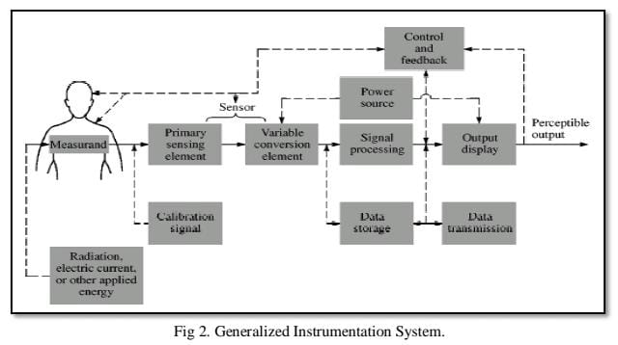
TYPES:
[Measurand: A physical quantity where the instrumentation systems would measure it. The human body would act as the source for measurand that would generate bio-signals. This would include the body surface or blood pressure in the heart.
Sensor/Transducer: This would be where the transducer would convert one form of energy to another form, and this would be usually electrical energy. An example would be the piezoelectric signal that would convert mechanical vibrations into the electrical signal. A usable output depending on the measurand would be produced by the transducer. The source would be used to interface the signal with the human as the sensor would be used to sense the signal from the source.
Signal Conditioner: Signal conditioning circuits would be used to convert the output of the transducer into an electrical value. The instrument system would send the quantity to the display or the recording system. The signal conditioning process would include amplification, filtering, analogue to digital and digital to analogue.
Display: A visual representation of measured parameter or quantity such as chart recorder and cathode ray oscilloscope (CRO). Alarms could also be used to hear the audio signals such as signals made in Doppler Ultrasound Scanner.
Data Storage and Data Transmission: Data storage is meant to record data for future reference and use. An example would be in telemetric systems where data transmission would occur such that data can be transmitted from one place to another on-demand through the Internet.
Circuit sensors: are the most well-known aspect of bioinstrumentation. They include thermometers, brain scans, and electrocardiograms. Sensors take in signals from the body and amplify them so engineers and doctors can study them. Signals from sensors are amplified using circuits, by taking in a voltage source, and modifying them using circuit components such as resistors, capacitors, and inductors. They then let out a certain amount of voltage, which
is used for analysis based on some relationship between the voltage being output and the measurand of interest. The data collected using sensors is often displayed on computer programs. This field of bioinstrumentation is closely related to electrical engineering. Circuits used to measure biological signals such as electrical activity of the heart and brain generally incorporate op-amps as a means of amplifying the relatively minuscule signals for signal processing and data analysis. A commonly used amplifier is the instrumentation amplifier. Instrumentation amplifiers such as the integrated circuit (IC) AD620 amplifier are able to amplify the difference between two different voltage inputs while maintaining little offset voltage and a high CMRR, allowing it to amplify low frequency signals while rejecting noise. These circuits may also incorporate filters to better account for unwanted noise, as the small scale for biological signals requires a wide range of filtering to account for noise generated by factors such as dc offset, interference from other biological signals, or electrical noise from the equipment being used.
CURRENT USES:
Pacemakers: A pacemaker is implanted to monitor the patient's heartbeat and send electrical pulses to regulate it when it is too slow. Electrodes send electrical pulses to the chambers of the heart which allow the heart to contract and pump blood. [citation needed] Pacemakers are for those who have damaged hearts or hearts that are not working properly. The normal electrical conduction of the heart allows impulses that are generated by the SA node to stimulate the cardiac muscle which then contracts. It is the ordered stimulation of the muscle that allows efficient contraction of the heart, pumping blood throughout our body. If the natural pacemaker malfunctions, abnormal heartbeats occur which can be very serious and even lead to death.
Mechanical ventilators: A mechanical ventilator is a form of life support. It helps the patient breathe or ventilate during surgery or when patient cannot breathe on their own. The patient is connected to the ventilator through a hollow tube called an artificial airway that goes in their month and down their trachea. They remain on the ventilator until they can breathe on their own. We use mechanical ventilators to decrease the work of breathing until the patient improves enough to no longer need it. The machine makes sure the patient receives enough oxygen and removes the carbon dioxide from the body. This is necessary for patients in surgery or with critical illnesses that prevent normal breathing. The benefits of mechanical ventilation are the patient does not have to work hard to breathe, so the patient's respiratory muscles can rest. The patient has time to recover and regain normal breathing. It helps the patient get enough oxygen and clear carbon dioxide, and it preserves a stable airway preventing injury from aspiration.
Fitness trackers: Bioinstrumentation in the commercial market has seen a large amount of growth in the field of wearables, with wrist-worn activity tracking devices surging from a market value of 0.75 billion U.S. dollars in 2012, to 5.8 billion U.S. dollars in 2018. Bioinstrumentation has also been added to smartphone designs, with smartphones now capable of measuring heart rate, blood-oxygen levels, number of steps taken, and more depending on the device.

Biomedical optics: Biomedical Optics is the field of performing non-invasive operations and procedures to patients. This has been a growing field, as it is easier and does not require the patient to be opened. Biomedical Optics is made possible through imaging such as CAT (computerized axial tomography) scans. One example of biomedical optics is LASIK eye surgery, which is a laser microsurgery done on the eyes. It helps correcting multiple eye problems and is much easier than option than other surgeries. Other important aspects of biomedical optics include microscopy and spectroscopy.
Genetic testing: Bioinstrumentation can be used for genetic testing. This is done with the help of chemistry and medical instruments. Professionals in the field have created tissue analysis instruments, which can compare the DNA of different people. Another example of genetic testing is gel electrophoresis. Gel electrophoresis uses DNA samples, along with biosensors to compare the DNA sequence of individuals. Two other important instruments involved in genomic advances are microarray technology and DNA sequencing. Microarrays reveal the activated and repressed genes of an individual. DNA sequencing uses lasers with different wavelength, to determine the nucleotides present in different DNA strands. Bioinstrumentation has changed the world of genetic testing, and helps scientists understand DNA and the human genome better than ever before.
Drug delivery: Drug delivery and aiding machines have been improved greatly by bioinstrumentation. Pumps have been created to deliver drugs such as anesthesia and insulin. Before, patients would have to visit doctors more regularly, but with these pumps, they can treat themselves in a faster and cheaper way. Aiding machines include hearing aids and pacemakers. Both of these use sensors and circuits, to amplify signals and reveal when there is an issue to the patient.
Agriculture: Bio instruments are used immensely in the field of agriculture for monitoring and sampling the soil as well as measure plant growth. Biotechnology in agriculture requires handling compound plant genomes that is done using complex instrumentation. Devices such as tensiometers are used to measure the moisture content of the soil that helps to maintain the most favorable conditions for crop growth. Attaching an electrical transducer to it allows the crop data to be monitored at regular intervals in terms of soil moisture and water profile.
Botany: In the field of Botany, bio instruments are widely utilized to gauge plant digestion. The PTM-48A Photosynthesis Monitor is used to register a plant's physiological qualities like carbon dioxide trade, leaf wetness, net photosynthesis and stomatal conductance.[22] PTM-48A is used to analyze the CO2 exchange and the transpiration of the leaves through an automatic open system with four-channels. This device's capabilities include the measurement of the CO2 exchange of the leaves, CO2 concentration in the air, photosynthetically active radiation, Air vapor deficit, etc.[24] The package for the device includes PTM-48A SYSTEM CONSOLE, LC-4B LEAF CHAMBER (4 pcs.), RTH-48 METER, 12 VDC POWER ADAPTER, HOLDER FOR LEAF CHAMBER (4 pcs.), 4-m PVC TWIN HOSE (4 pcs.), STAINLESS STEEL TRIPOD, RS232 COMMUNICATION CABLE FOR PC, DOCUMENTATION and SOFTWARE SETUP CD, CO2 ABSORBER, SPARE AIR FILTER, and USER’S GUIDE.[24]
Imaging systems:An imaging system is a system that creates images of various parts of the body depending on what is needed to be analyzed. the system is used to diagnose conditions before they become too serious. Some examples of imaging systems include x-rays, computed tomography (CT scan), magnetic resonance imaging (MRI), and ultrasound. An x-ray is a non-invasive procedure that analyzes the bones and tumors. A disadvantage of getting an x-ray is the exposure to radiation that may lead to other conditions. A CT scan is a combination of various x-rays that provides a detailed image of organs and layers of tissue in the body. A disadvantage is the slight increased risk of cancer since this non-invasive procedure exposes the patient to radiation.
Bioinstruments such as the ChemiDoc Touch framework is an imaging system for electrophoresis and Western blot imaging integrated with a touchscreen on a supercomputer. It utilizes application particular trays for chemiluminescence and UV identification to offer high sensitivity and picture quality.
Arterial blood pressure:A blood pressure (BP) measurement system specifically a writ-bound BP monitor works through an applanation tonometry with a hemispheric plunger set on the radial artery. Devices such as an ambulatory blood pressure improved the management of hypertension, but remain not being widely used and inconvenient. Uprising innovations such as the HealthSTATS International in Singapore created a wrist-bound BP measurement device (BPro) that would measure BP using arterial tonometry.
Prior to wrist blood pressure cuffs, blood pressures had to be measured invasively by inserting a catheter into one's artery. The catheter is connected to a fluid bag and to a monitor, which picks up the arterial pressure over time. As this is a very invasive procedure, it had to be done inside a medical facility, whereas the new technology of blood pressure cuffs allows monitoring of blood pressure from a person's home. In comparison to write blood pressure measurements, invasive blood pressure monitoring has been shown to result in a more accurate reading, although it does come with drawbacks such as risk of infection.
Space: The importance of astronaut health monitoring systems have been increasing as the duration of space missions have been consistently growing. With existing space suit bioinstrumentation system, the development of next generation of bioinstrumentation systems made it possible to provide improved health monitoring during extra-vehicular activity. This would especially be resourceful in the most physically demanding phases in space flight.[1] The National Aeronautics and Space Administration (NASA) have developed telemetric sensors in order to monitor physiological changes in animal models in space in their Sensors 2000! program. These sensors measure physiological measurands, including temperature, biopotentials, pressure, flow and acceleration, chemical levels, and transmit these signals from the animals to a receiver through a link connection.
Surgery:Biomedical instrumentation has been used in the medical world of surgery since the beginning of time and continues to evolve to improve patient care. The continuous integration of imaging and assistive robotics has allowed for surgeries to be more precise as well as less invasive. Imaging systems devices such as cameras, ultrasounds, X-rays, MRIs, PET and CT scans have been used to pinpoint disorders within the body. During surgery ultrasounds and device attached cameras may be used throughout to allow for sight of the treatment area.
Robotics assistive devices are medical instruments that allow for doctors to complete a surgery with a minimal size incision. The use of the assistive device can allow for complicated surgeries to be completed in less time. The robot mimics the doctors movements within the body precisely, which ensures the safety of the procedure. Robotic assistive technology usually includes a camera, mechanical arm, and a console of some sort to allow for controlling.When using assistive devices for minimally invasive procedures many find that another result is shorter recovery times. Although assistive robotics is used in surgery and there are several pros to their use there are some major considerations. If there happens to be a major complication with surgery the robotic system will be removed and previous methods will have to be used. Along with that robotic assistive technology is still rather expensive, thus more research and improvements are constantly being made.
Advancements in anesthetics have also occurred due to innovations in devices. During surgery an anesthesiologist must monitor and evaluate the patients heart rate, breathing, pain, body temperature, fluid balance, blood pressure and many other vital signs. For this reason, an anesthesiologist station is full of medical devices. One major device being the anesthesia machine, which focuses on administration of vaporous anesthesia medication, oxygenation and ventilation.
Research: Bioinstrumentation in research has a variety of applications from standard data collection to prototype testing. One unique example is the use of bioinstrumentation to characterize bone phenotypes of various animal models through strain gauging and tibial loading. Strain gauges translate deformation into an electrical resistance, and when paired with analytical software it can be utilized to determine a bone's response to mechanical load. Different animals or breeds can have different physical responses to mechanical load, thus experiments involving loading normalize to strain rather than load.[34] Strain gauges allow researchers to apply different loads across a variety of subjects to induce the same strain, which is directly correlated with new bone formation. Bioinstrumentation has many more applications in research from development of new bioinstruments to novel incorporation into new medical devices.
Real-time measurement: Bioinstrumentation has been incorporated into novel diagnostic tools that are utilized for a variety of patients. There is a sufficient challenge to implementing real-time measurement systems that are lightweight, comfortable and efficient, so there has been increased drive for the novel development of more flexible and compact bioinstrumentation. The development of 3D-printed ion selective field effect transistors, or ISFETs, to sense and monitor ion levels in patients is a prime example. Another example of a real-time measurement system is the smart bioelectric pacifier, which was developed to monitor the electrolyte level in vulnerable newborns in
hospital care. The pacifier functions through the intake of saliva through a microfluidic channel, which guides saliva to a reservoir filled with sensory nodes within the soft plastic pacifier. Small circuits integrated with ISFETS provide active measurements of any voltage change within the saliva, which can be directly correlated with the concentration of ions within the newborn's saliva and, due to known correlations between ion concentrations in saliva and blood, the bloodstream.
Novel developments in bioinstrumentation continue to lend itself to the development of real-time measurement systems that can provide flexibility, compactness, and efficiency to better monitor patients.]1
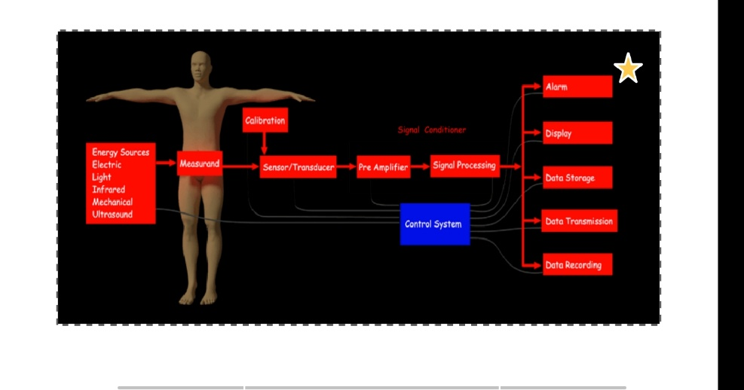
[COMPONENTS OF THE BIO MEDICAL INSTRUMENTATIONSYSTEM:
Clinical laboratory instruments: used to investigate the pH values and concentration of various radicals present in the body fluids.
• To count the blood cells in the blood samples.
• Each switch position connects an instrument for measurement.
• For monitoring, diagnosis, therapy and surgery with the signal processor.
Transducer: Devices capable of converting one form of energy or signal to another. Output is always an electrical signal. For example, the FISO electric signal, which converts mechanical vibrations into the electrical signal. Acts as an impedance matching device between the biological system and the signal processor. Transforms the physiological signal like temperature, pressure, or bio potential into a form that can be read by the signal processor.
Signal processor: Signal processor amplifies, modifies or changes the electrical output of the transducer to run the recording or display devices. Signal conditioner equipment improves the sensitivity of the instruments. The type of signal processing depends upon the functions of the instrument system in therapy. It must feedback the signal to the biological system through the feedback transforms. In surgery, a surgical tool like electrosurgical knife and lasers should be provided.]3
BIOMEDICAL INSTRUMENTS

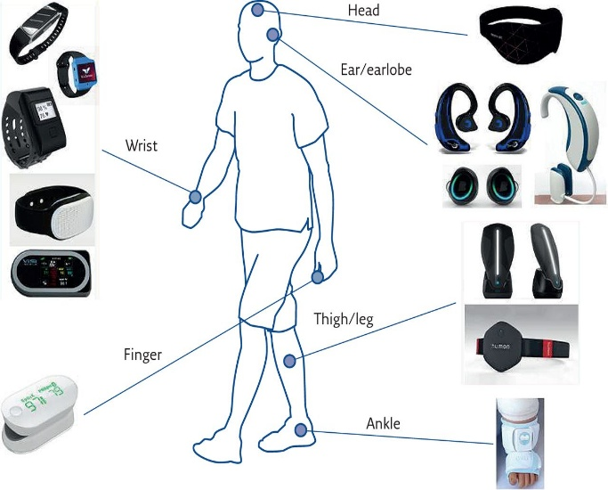 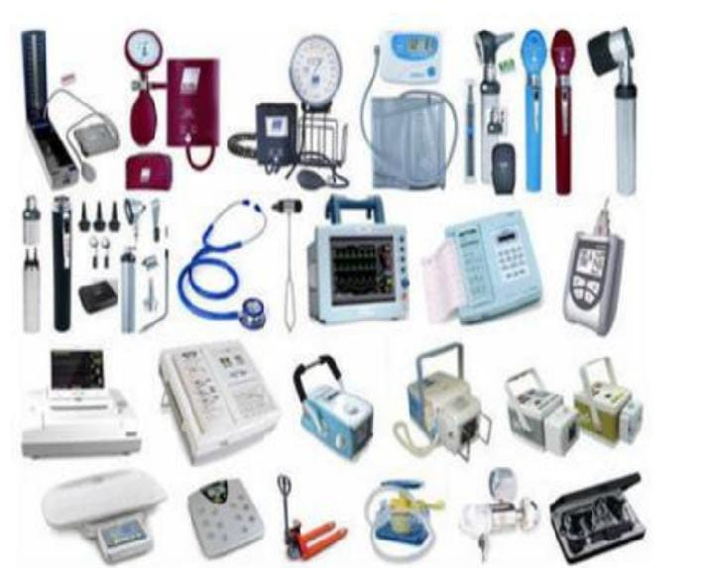 RECENT TECHONOLOGY IN BIOMEDICAL INSTRUMENT:
[Technology and medicine have gone hand and hand for many years. Consistent advances in pharmaceuticals and the medical field have saved millions of lives and improved many others. As the years pass by and new technology in healthcare continues to improve, there is no telling what medical advances will come next.]11
[1. MRNA TECHNOLOGY
mRNA technology has been put under the spotlight recently as the new vaccines for Covid-19 use this science. With their high effectiveness, capacity for rapid development, and potential for low production costs, mRNA vaccines offer an alternative to the traditional vaccine approach.mRNA, or messenger ribonucleic acid, is a single-stranded RNA molecule that carries the genetic information that is derived from DNA. mRNA vaccines work by providing a genetic code to cells to allow them to produce viral proteins, once the proteins have been created the body can then produce an immune response. The success of the Covid-19 mRNA vaccines has given a big boost to efforts to develop other mRNA vaccines for everything, from cancers to Zika virus.
mRNAs potential is thought to extend beyond just vaccines. mRNA can code for just about any protein, so the same basic technology might also allow us to develop all kinds of treatments by getting the body to produce a drug-like response. Many protein-based drugs such as antibodies made outside the body have proved extremely effective – but also extremely expensive. So, by using mRNA technology, development times and costs could be cut by setting thehuman body to work on manufacturing the proteins instead.
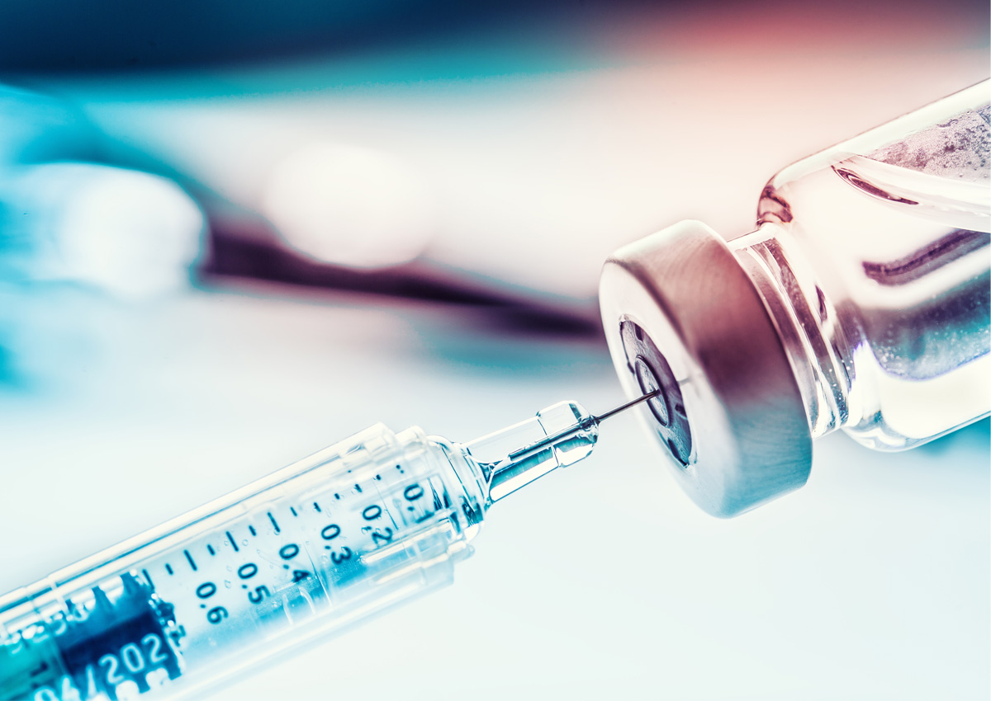
2 NEUROTECHNOLOGY
Neurotechnology holds boundless potential to improve many aspects of life. It is already being practically applied in the medical and wellness industries, but also has many future implications for other contexts including education, workplace management, national security, and even sports.
Neurotechnology encompasses all components that are developed to understand the brain, visualise its processes and even control, repair or improve its functions. These components can be computers, electrodes, or any other devices that can be set up to intercept electric pulses that run through the body.
In healthcare, neurotechnology is currently being used in brain imaging, by recording magnetic fields produced by electrical activity within the brain, neurostimulation, stimulating the brain and nervous system to influence brain activity; and in neurodevices, an emerging technology that monitors or regulates brain activity using an implant. Neurodevices are still mostly in the research phase, but it holds major potential for treating brain disorders. An example of this is Neuralink. Pioneered by Elon Musk, Neuralink is developing a device that would be embedded into the human brain, where it would record brain activity and transmit this data wirelessly to a computer. Researchers would then be able to analyse these findings and use them to electrically stimulate brain activity. If successful, it can possibly be used to cure brain diseases like Alzheimer’s and Parkinson’s. Neuralink has been tested on animals so far, but Elon Musk has said the company hopes to start implanting its chips in humans in 2022.
Neurotechnology, while therapeutically very exciting, remains very controversial. It raises questions around rights to data and privacy. All-in-all, its future applications are not entirely mapped out but with the continued rise and identification of neurological disorders and conditions, neurotechnology is expected to experience considerable growth in the worldwide healthcare market in the coming years.
3. 3D PRINTING
3D printers have quickly become one of the hottest technologies on the market. In healthcare, these game-changing printers can be used to create implants and even joints to be used during surgery. 3D-printed prosthetics are increasingly popular as they are entirely bespoke, with the digital functionalities enabling them to match an individual’s measurements down to the millimetre. The allows for unprecedently levels of comfort and mobility.
Using 3D printing for presurgical planning is also gaining momentum. Using a realistic replica of an actual patient’s anatomy is allowing surgeons to attempt procedures they wouldn’t have previously been able to do. The ability to plan a complex surgery and train prior to the procedure itself by using 3D-printed models has the potential to not only increase success rates but also to reduce time in the operating room and recovery time.
The use of printers can create both long-lasting and soluble items. For example, 3D printing can be used to ‘print’ pills that contain multiple drugs, which will help patients with the organisation, timing, and monitoring of multiple medications. To take 3D printing up another notch, bio-printing is also an emerging medical technology. While it was initially ground-breaking to be able to regenerate skin cells for skin draughts for burn victims, this has slowly given way to even more exciting possibilities. Scientists have been able to create blood vessels, synthetic ovaries and even a pancreas. These artificial organs then grow within the patient’s body to replace the original faulty one. The ability to supply artificial organs that are not rejected by the body’s immune system could be revolutionary, saving millions of patients that depend on lifesaving transplants every year.]2
4. [CRISPR
Clustered Regularly Interspaced Short Palindromic Repeats (CRISPR) is the most advanced gene-editing technology yet. It works by harnessing the natural mechanisms of the immune systems of bacterium cells of invading viruses, which is then able to ‘cut out’ infected DNA strands.]10
CRISPR[ has many potential applications, including correcting genetic defects, treating and preventing the spread of diseases, and improving the growth and resilience of crops. However, despite its promise, the technology also raises ethical concerns,]14[ mostly over humanity’s right to ‘play God’ and worries over gene-editing being used to produce designer babies.]10[ This cutting of DNA is what has the power to potentially transform the way we treat disease. By modifying genes, some of the biggest threats to our health, like cancer and HIV, could potentially be overcome in a matter of years.]13 CRISPR is also looking promising for treating [rare diseases. Cystic fibrosis (CF) is a genetically inherited rare disorder that affects the functioning of the respiratory and digestive systems. The CF gene causes mutations to alter salt regulation across cell membranes, which results in thickening of mucus that causes problems in lungs, pancreas, and other organs. There are multiple cystic fibrosis-causing mutations, and there are currently several on-going clinical trials to see if CRISPR can be used to correct these mutations. CRISPR is also being seen as a possible way of treating sickle cell disease, which is also caused by a genetic mutation. Until recently, bone marrow transplant was the only real treatment for patients, but CRISPR gene therapy has given patients a new hope]8.
[5. Robotic Surgeons and Rehabilitation
Robot manufacturers are making multifunctional robots to assist surgeons in the operating room. Driven by input from doctors, these robotic devices help them manipulate instruments with high precision in ways they could not do alone. This is especially true for minimally invasive surgeries.
Robots are also extremely helpful to people who have suffered strokes or brain injuries when it comes to relearning motor tasks. For example, the Lokomec is a gait training system that uses a robotic exoskeleton and a treadmill to help patients regain basic walking functions. It also allows the therapist to control the walking speed and how much support the robotic legs give to the patient.]9
APPLICATION IN HEALTHCARE:
[To ensure the data collected by the biomedical instruments is reliable, they are tested in different operating conditions. Here is a list of some vital performance parameters used to judge the reliability of biomedical instruments:
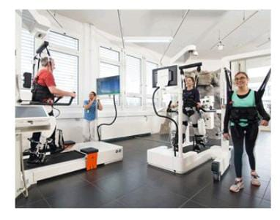
Accuracy and Precision: Accuracy refers to the closeness of the measured values of an instrument to the actual value of the subject. Precision, on the other hand, is the measure of the repeatability of the subsequent readings. A biomedical instrument must possess both qualities.
Frequency Response: A biomedical instrument must be able to perform in a predictable way for a wide range of frequencies.
Isolation and loading effect: The physical parameter under observation should not get affected by taking measurements from the instrument. At the same time, the instrument can also ensure electrical isolation between the measurement circuit and the test subject.
Linearity: Variation of the output signal must be proportional to the change input. Any deviation in linearity must be compensated with suitable calibration techniques.
Sensitivity: The instrument must be able to detect small changes in the physiological parameter being measured.
Signal to Noise Ratio (SNR): SNR is the strength of the measured signal compared to the noise present around it. SNR ratio should be as high as possible for an instrument to work well.
Stability: The instrument must be resilient to external disturbances and should be able to recover from any such disruption within an acceptable time limit]5.
RECENT APPLICATIONS IN BIOMEDICAL FIELDS:
Real-time Imaging and Diagnostics: Real-time imaging and diagnostics have emerged as key components of the real-time advances in the biomedical field. These technological breakthroughs have transformed medical imaging and diagnostic processes, offering healthcare professionals instantaneous and dynamic insights into physiological processes and disease conditions. This section explores the significance of real-time imaging and diagnostics, the technologies involved, and their impact on healthcare.
[ Real-time Magnetic Resonance Imaging (MRI):
Real-time MRI has emerged as a transformative imaging technique in the biomedical field. Unlike traditional MRI, which produces static images, real-time MRI provides dynamic visualization of physiological processes in live action. This capability has opened new avenues in medical research and clinical applications. For example, real-time cardiac MRI allows cardiologists to observe heart motion and blood flow in real-time, aiding in the diagnosis and treatment of cardiac conditions. Furthermore, real-time MRI-guided interventions have improved precision during surgeries and minimally invasive procedures]30. [The ability to monitor changes in real-time enhances patient safety and contributes to better treatment outcomes.]35
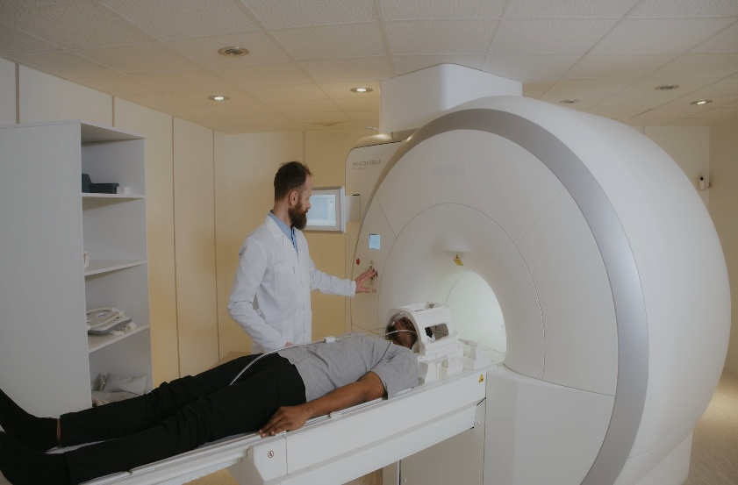
[Real-time Ultrasound: Real-time ultrasound imaging has become an indispensable tool in various medical specialties. Its portability, non-invasiveness, and ability to provide instant feedback make it valuable in emergency settings and point-of-care applications. Real-time ultrasound enables physicians to visualize organ function, blood flow, and fetal development in real-time. This has profound implications in obstetrics, allowing early detection of fetal abnormalities and monitoring pregnancy progress. In critical care, real-time ultrasound assists in rapid diagnoses of conditions such as cardiac tamponade and pneumothorax, facilitating timely interventions.]20
[ Real-time Fluorescence Imaging:

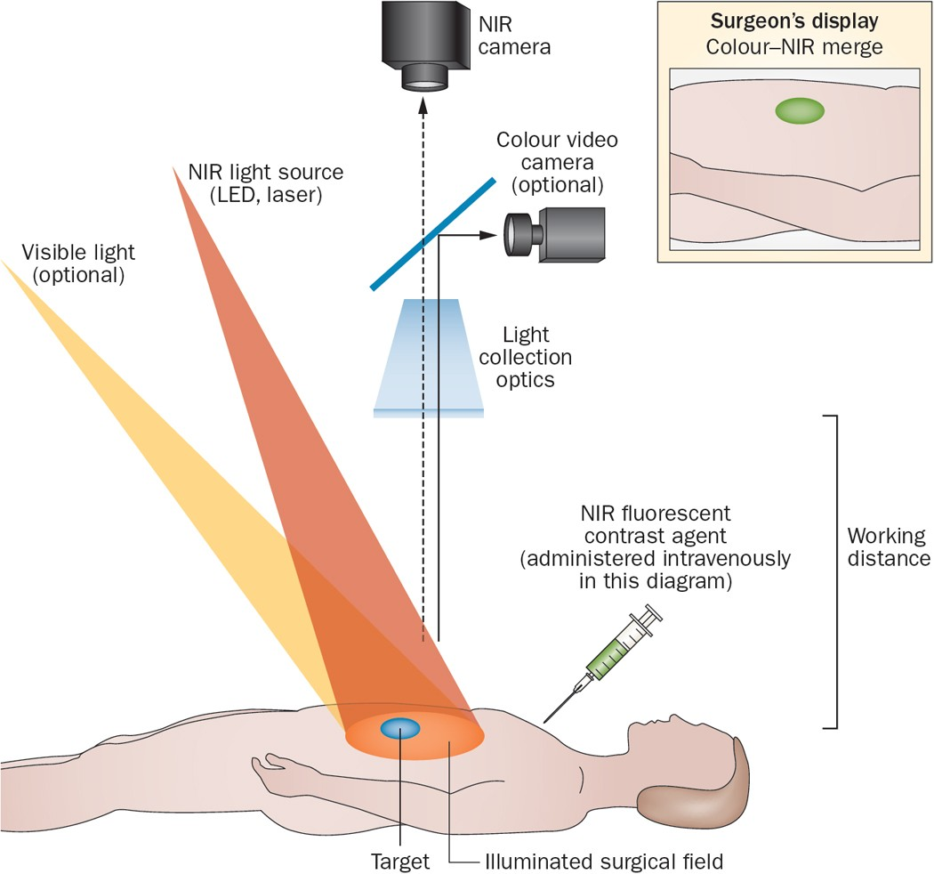
Real-time fluorescence imaging has revolutionized biomedical research and surgical procedures. This technique utilizes fluorescent probes to visualize specific biomolecules or tissues, enabling surgeons to identify tumor margins, lymph nodes, and vascular structures in real-time. In oncology, real-time fluorescence-guided surgery enhances the precision of tumor resection, minimizing damage to healthy tissues. Additionally, real-time fluorescence imaging has applications in studying molecular interactions, cellular dynamics, and drug delivery processes, providing valuable insights into disease mechanisms and treatment responses.]34
Advancements in Real-time Diagnostics:
Recent advancements in real-time diagnostic technologies have accelerated medical decision-making and improved patient care. Point-of-care testing (POCT) devices, which provide rapid results at the patient's bedside, have become crucial in critical care and remote settings. These devices allow for real-time diagnoses of infectious diseases, metabolic disorders, and more, facilitating timely interventions and reducing hospital stays. Lab-on-a-chip technologies have also emerged, enabling miniaturized and portable diagnostic tests with real-time capabilities. Such advances have transformed the diagnostic landscape, empowering healthcare providers with quick and accurate assessments, ultimately leading to better patient outcomes
Real-time imaging and diagnostics have emerged as key pillars in the realm of biomedical advancements, contributing to earlier and more accurate [disease detection, personalized treatment approaches, and improved patient care. As technology continues to evolve]15, real-time imaging and diagnostics [will continue to play a pivotal role in shaping the future of medicine.
Real-time Monitoring and Wearable Devices:
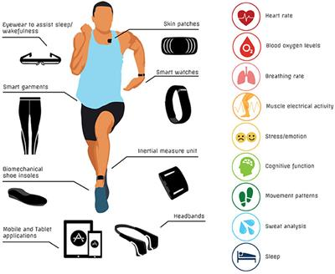
Real-time monitoring and wearable devices have emerged as game-changing technologies in the biomedical field, revolutionizing the way healthcare is delivered and empowering individuals to take control of their health. These advancements have been made possible by the integration of sophisticated sensors, wireless communication, and data analytics, providing continuous and real-time health data to both patients and healthcare professionals. Let'sdelve deeper into the significance of real-time monitoring and wearable devices in the biomedical field]22
Wearable Biometric Sensors:
[Wearable biometric sensors have become increasingly prevalent in the biomedical field, empowering individuals to monitor their health in real-time. These devices can track various physiological parameters, such as heart rate, blood pressure, body temperature, and sleep patterns.]16 Real-time access to such data allows users to gain insights into themoverall health and make informed lifestyle choices. Additionally, healthcare providers can use the data from wearable sensors to monitor patients remotely, particularly those with chronic conditions. For instance, patients with diabetes[ can use continuous glucose monitoring (CGM) wearables to track their blood glucose levels in real-time, leading to better]18 diabetes management and [improved glycemic control.
Continuous Glucose Monitoring (CGM):

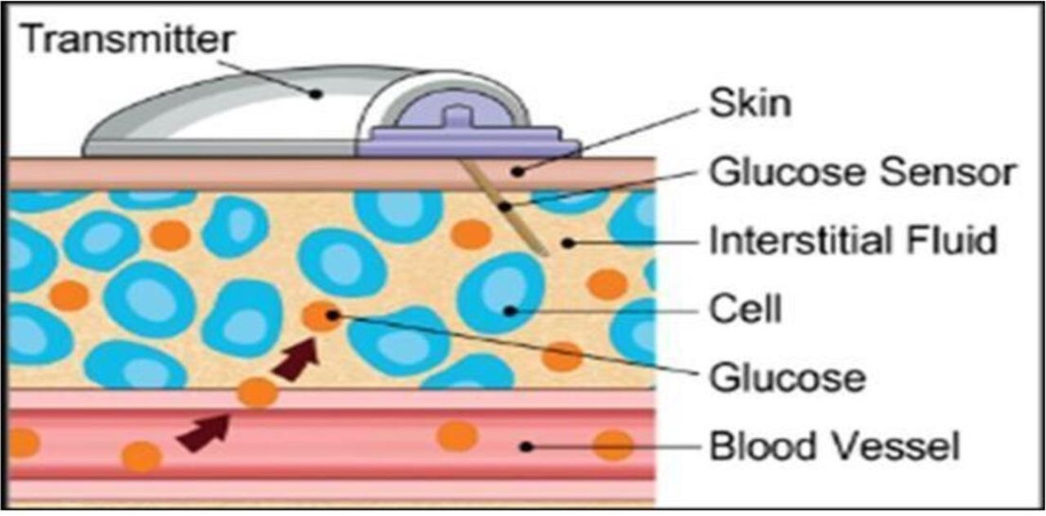
CGM is a revolutionary real-time monitoring technology that has transformed diabetes management. Unlike traditional glucose meters, CGM devices continuously measure glucose levels throughout the day, providing users with real-time data and trend analysis. This technology has been a game-changer for individuals with diabetes, allowing them to adjust their insulin doses and dietary habits promptly. Furthermore, CGM data can be integrated with insulin pumps, enabling closed-loop systems, also known as artificial pancreas systems, which automatically adjust insulin delivery based on real-time glucose levels. The continuous and real-time feedback from CGM devices has significantly reduced the risk of hypoglycemia and hyperglycemia, leading to better long-term health outcomes for individuals with diabetes.]33
Real-time Cardiac Monitoring:
Real-time cardiac monitoring devices have transformed the way cardiovascular diseases are managed and diagnosed. Wearable electrocardiogram (ECG) monitors, such as ECG patches and smartwatches, allow individuals to continuously track their heart rhythms. These devices are particularly valuable in detecting arrhythmias, which may occur sporadically and may not be captured by conventional ECG tests.

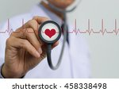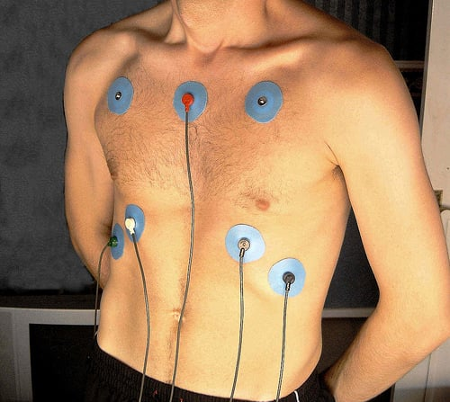
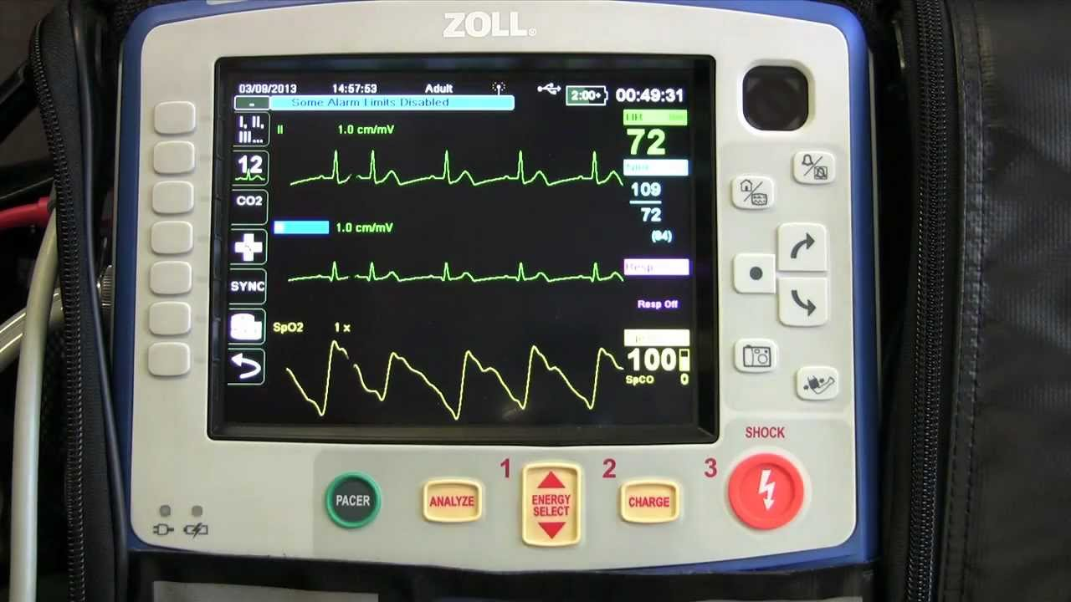
Real-time cardiac monitoring is also instrumental in providing early warning signs of potential cardiac events, such as heart attacks, enabling individuals and healthcare professionals to take prompt action. Moreover, real-time ECG data can be transmitted remotely to healthcare providers, facilitating timely diagnosis and interventions, especially in patients with known cardiac conditions or those at risk for cardiovascular diseases.
Applications of Real-time Monitoring in Healthcare: Real-time monitoring data collected from [wearable devices has a wide range of applications in the healthcare setting. The data can be integrated into electronic health records (EHRs), providing healthcare providers with a comprehensive view of patients' health status and allowing for personalized treatment plans. Real-time monitoring is particularly useful in managing chronic conditions, such as hypertension and heart failure, by enabling early detection of exacerbations and facilitating timely interventions to prevent hospitalizations. Additionally, real-time monitoring data can be utilized in clinical trials and medical research, providing valuable insights into patient responses to treatments and interventions.]28
Real-time Data Analysis and Artificial Intelligence (AI)
The convergence of real-time data analysis and artificial intelligence (AI) has transformed the landscape of biomedical research and healthcare delivery. The ability to process vast amounts of data in real-time and derive actionable insights has revolutionized medical decision-making, disease diagnosis, and treatment strategies. Here's an overview of how real-time data analysis and AI have contributed to the advancement of the biomedical field:
Real-time Data Analysis in Biomedical Research: Real-time data analysis plays a crucial role in biomedical research, enabling researchers to process vast amounts of data in real-time, extract meaningful insights, and make informed decisions. With the advent of high-throughput technologies like next-generation sequencing and advanced imaging modalities, generating large datasets has become routine in biomedical studies. Real-time data analysis tools and algorithms facilitate rapid data processing, allowing researchers to identify patterns, correlations, and trends promptly. For example, in genomics research, real-time data analysis helps identify genetic variants associated with diseases, improving the understanding of disease mechanisms and potential therapeutic targets. Additionally, real-time data analysis in biomedical research aids in the identification of disease outbreaks and trends, contributing to public health surveillance and response.
Machine Learning in Real-time Healthcare:
[The integration of machine learning (ML) with real-time healthcare data has unlocked significant potential in disease prediction, diagnosis, and treatment. ML algorithms can analyze real-time patient data, such as vital signs, lab results, and medical histories, to predict disease progression, identify early warning signs, and personalize treatment plans.. Real-time ML-driven decision support systems have the potential to significantly enhance medical decision-making, leading to better patient outcomes and improved healthcare efficiency.]25

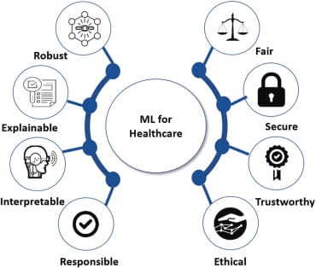

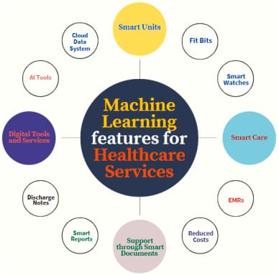
AI in Real-time Diagnosis and Prognosis: Artificial Intelligence (AI) applications in real-time diagnosis and prognosis are transforming healthcare delivery by providing rapid and accurate assessments of patient conditions. AI-driven diagnostic tools can analyze real-time patient data, including medical images, patient records, and genetic data, to make real-time diagnoses with high accuracy. For instance, AI algorithms can analyze real-time ECG data to detect cardiac arrhythmias and alert healthcare providers promptly. In pathology, AI-powered algorithms can analyze real-time histopathological images to aid pathologists in diagnosing cancer and other diseases. AI's role in real-time prognosis is equally significant, as it can analyze patient data to predict disease progression, treatment response, and patient outcomes. Real-time AI-driven prognosis allows healthcare providers to tailor treatment plans and interventions to individual patients, leading to more personalized and effective care.
Ethical Considerations of Real-time AI:
[The integration of real-time AI in biomedical applications raises important ethical considerations that must be addressed to ensure patient safety and privacy. As real-time AI algorithms rely on continuous patient data, there are concerns regarding data security and patient privacy. It is essential to implement robust data encryption and data access controls to protect patient information from unauthorized access. Additionally, real-time AI algorithms must be transparent and interpretable to gain the trust of healthcare providers and patients. Ethical considerations also encompass issues of algorithmic bias and fairness, as real-time AI algorithms must be trained on diverse and representative datasets to avoid biased predictions that may disproportionately affect certain patient populations. Striking a balance between the benefits of real-time AI and the ethical challenges it poses is critical for responsible and effective integration into healthcare practices.]17
In conclusion, real-time data analysis and AI have emerged as powerful tools in the biomedical field, empowering researchers, healthcare providers, and patients with rapid insights, personalized diagnoses, and optimized treatment plans. While these technologies offer tremendous potential for improving patient care and advancing medical research, addressing ethical considerations is crucial to ensure their responsible and ethical implementation. As technology continues to advance, the synergy between real-time data analysis and AI will undoubtedly lead to further breakthroughs in healthcare, transforming the way we approach disease management and patient care.
Real-time Telemedicine and Virtual Health
[Real-time telemedicine and virtual health technologies have revolutionized the healthcare landscape, providing innovative solutions to improve access to medical services, enhance patient care, and optimize healthcare delivery. These advancements have become particularly significant in recent times, as the world faces challenges such as pandemics, increased demand for remote care, and the need for efficient healthcare delivery. Let's explore the impact of real-time telemedicine and virtual health in the biomedical field:]12[
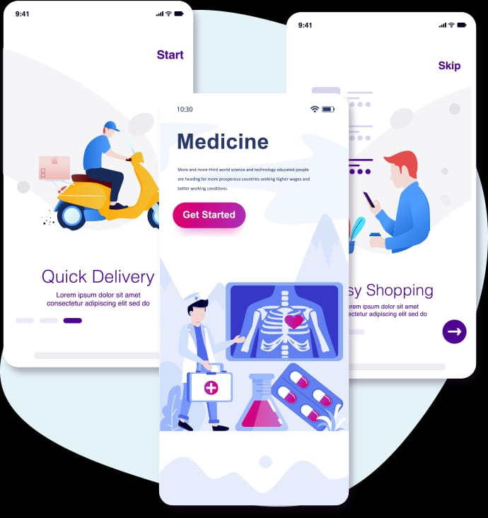

Real-time Telemedicine Platforms and Remote Consultations: Real-time telemedicine has emerged as a transformative approach in the biomedical field, enabling remote medical consultations and enhancing healthcare accessibility. Real-time telemedicine platforms leverage video conferencing and other communication technologies to facilitate virtual consultations between patients and healthcare providers. Patients can access medical advice and expertise from the comfort of their homes, eliminating the need for physical visits, especially in rural or underserved areas. Real-time telemedicine is particularly valuable for non-emergency medical issues, follow-up consultations, and chronic disease management. Healthcare providers can use real-time telemedicine to monitor patients' health, provide timely medical advice, and manage treatment plans effectively. Additionally, real-time telemedicine has been instrumental in telepsychiatry, delivering mental health support to patients in remote or marginalized communities.
Virtual Reality (VR) in Medical Training:
[Virtual reality (VR) has found widespread application in medical education and training, enhancing the learning experience for healthcare professionals. Real-time VR simulations allow medical students and practitioners to practice procedures, surgeries, and clinical scenarios in a safe and controlled environment. This immersive training approach enables learners to gain hands-on experience without putting patients at risk. For example, surgeons can practice complex procedures in virtual operating rooms, improving their skills and precision. Real-time VR training has also proven effective in simulating emergency scenarios, such as cardiac arrest, allowing healthcare teams to refine their response strategies. The integration of real-time VR in medical training has the potential to improve patient safety, reduce medical errors, and enhance overall healthcare quality.]24
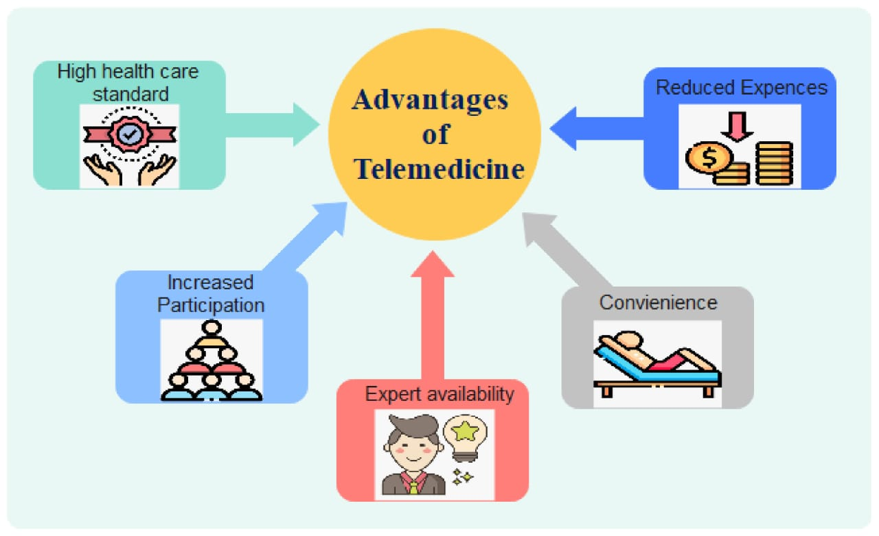
Telemedicine for Mental Health Support:
Real-time telemedicine has significantly impacted mental health support, providing accessible and timely care for individuals in need. Telepsychiatry, a subset of real-time telemedicine, enables mental health professionals to conduct virtual consultations and therapy sessions with patients. This approach eliminates geographic barriers, allowing individuals in remote or rural areas to access mental health services that may not be readily available locally. Real-time telemedicine for mental health support also reduces the stigma associated with seeking help for
mental health issues, as patients can receive care discreetly from their homes. Moreover, real-time telepsychiatry has played a crucial role in crisis interventions and suicide prevention, offering immediate support to individuals in distress.
Advantages and Challenges of Real-time Telemedicine:
Real-time telemedicine offers several advantages that enhance healthcare delivery and patient outcomes. The ability to conduct real-time consultations and remote monitoring increases patient access to medical expertise, especially for those with limited mobility or residing in distant locations. Real-time telemedicine reduces healthcare costs by minimizing travel expenses and hospital stays, benefiting both patients and healthcare providers. Moreover, real-time telemedicine contributes to public health initiatives by facilitating remote disease surveillance, outbreak management, and health education programs.
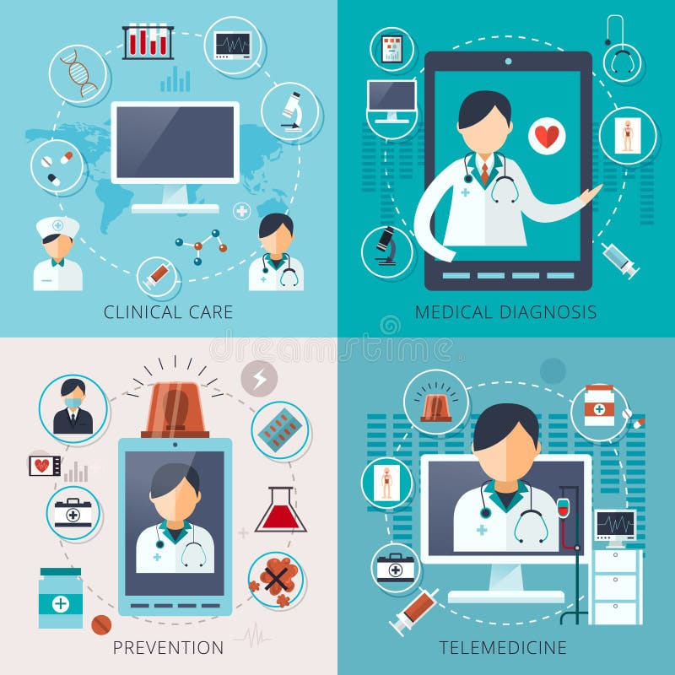

Despite these advantages, real-time telemedicine also faces challenges that must be addressed for its successful implementation. Technological limitations, such as unreliable internet connectivity or low-bandwidth areas, can hinder real-time telemedicine's effectiveness. Ensuring data privacy and security is paramount in real-time telemedicine, as patient information is transmitted over digital channels. Moreover, there may be resistance from some healthcare providers and patients who prefer traditional face-to-face interactions. Addressing these challenges through infrastructure improvements, cybersecurity measures, and proper training and education is crucial to maximize the potential of real-time telemedicine in the biomedical fields.In conclusion, real-time telemedicine and virtual health have transformed healthcare delivery and medical training, providing patients with accessible, timely, and personalized care. The integration of real-time technologies and virtual reality in the biomedical field holds tremendous promise for improving patient outcomes, enhancing medical education, and increasing healthcare accessibility. By addressing challenges and fostering the responsible implementation of real-time telemedicine, we can unlock the full potential of these advancements, ultimately benefiting patients, healthcare providers, and the entire healthcare ecosystem.
REAL TIME DRUG MONITERINF AND DOSING:
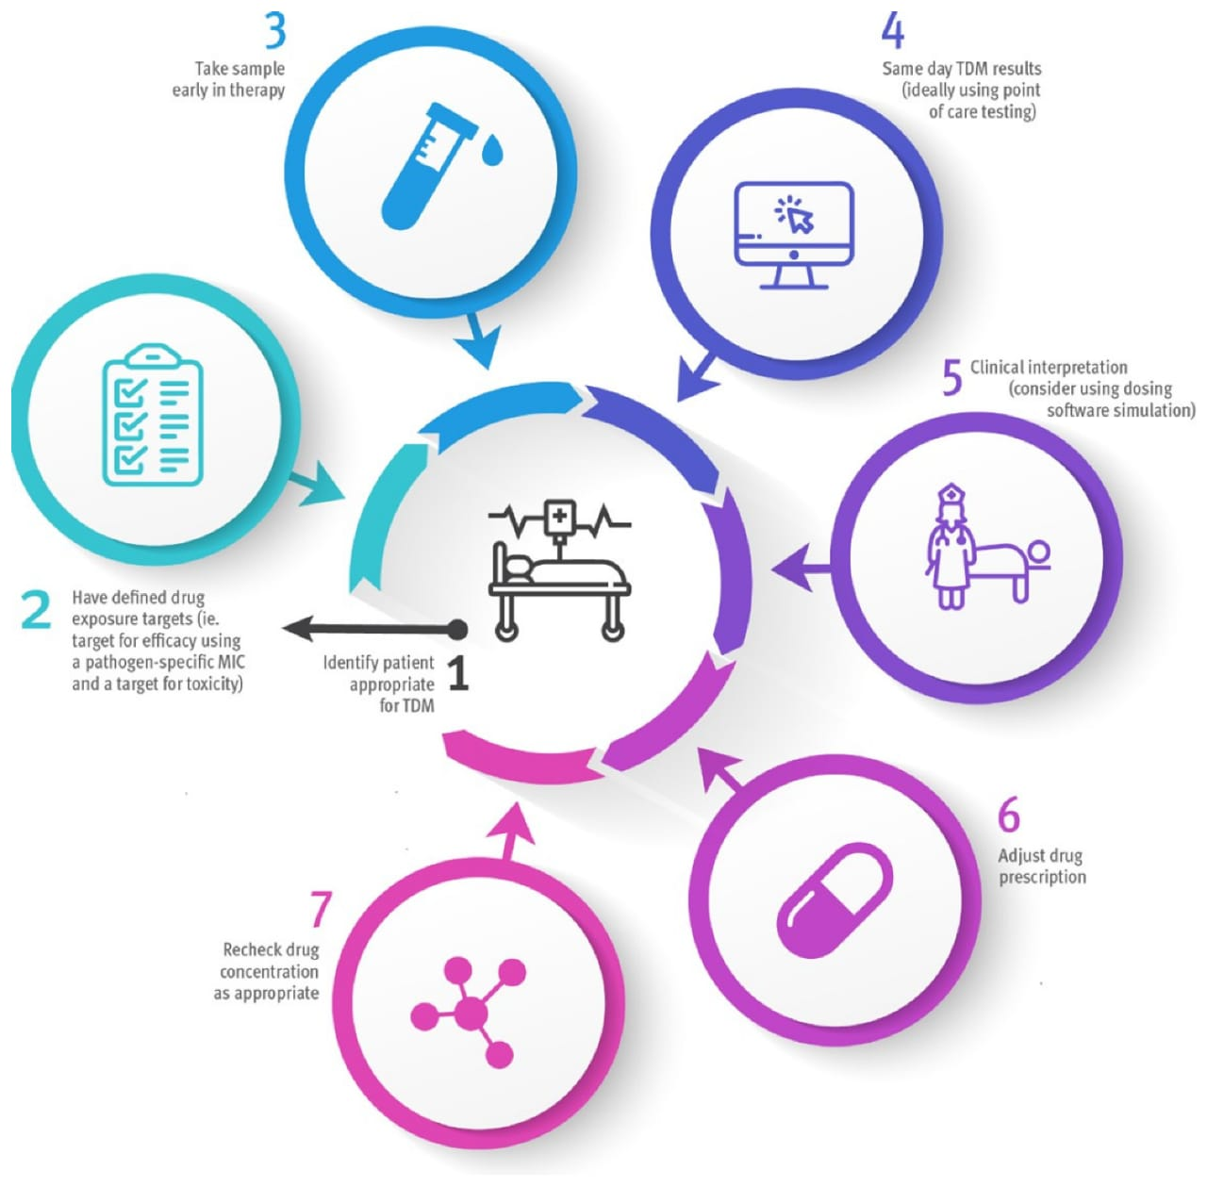
Real-time drug monitoring involves continuous or frequent measurements of drug concentrations in the body, enabling healthcare professionals to adjust drug dosages based on individual patient responses. Therapeutic drug monitoring (TDM) ensures that drug levels remain within a targeted therapeutic window, maximizing efficacy while minimizing adverse effects. Real-time TDM is particularly valuable for medications with a narrow therapeutic index, where small changes in drug concentrations can significantly impact treatment outcomes. By utilizing real-time drug monitoring, healthcare providers can make immediate adjustments to drug dosing, ensuring optimal therapeutic benefits for each patient.
Nanotechnology in Real-time Drug Delivery:
[Nanotechnology has revolutionized drug delivery, offering innovative solutions for targeted and real-time delivery of medications. Nanoparticles can be engineered to carry drugs to specific tissues or cells, increasing drug efficacy while reducing systemic side effects. Real-time drug delivery using nanotechnology can respond to dynamic changes within the body, releasing drugs in response to specific triggers, such as changes in pH or enzymatic activity. These responsive drug delivery systems ensure that medications are released precisely when and where they are needed, enhancing therapeutic outcomes and minimizing off-target effects.]19
Personalized Medicine and Real-time Applications:
Real-time therapeutics is closely linked to the concept of personalized medicine, where treatments are tailored to an individual's unique characteristics, such as their genetic makeup, lifestyle, and disease profile. Real-time applications in personalized medicine use continuous monitoring of patient data, such as genetic information, biomarker levels, and treatment responses, to adapt treatment strategies in real-time. By integrating real-time patient data with advanced analytics and artificial intelligence, healthcare providers can make data-driven treatment decisions, selecting the most effective therapies for each patient throughout their treatment journey.
Real-time Therapeutics in Cancer Treatment:
[Real-time therapeutics is making significant strides in cancer treatment, as it allows for dynamic adjustments to cancer therapies based on a patient's response to treatment. For instance, real-time monitoring of tumor markers and genomic alterations can guide oncologists in selecting the most appropriate chemotherapy or targeted therapies for a specific patient. Additionally, real-time drug delivery systems, such as implantable devices or injectable nanoparticles, offer opportunities for localized drug release to target tumors more effectively, minimizing damage to healthy Tissues. Real-time therapeutics and drug delivery represent a paradigm shift in healthcare, enabling personalized and adaptive treatment strategies that optimize patient outcomes. These advancements promise to transform the way we approach disease management and open new possibilities for precision medicine. As real-time technologies continue to evolve, the integration of real-time therapeutics into routine clinical practice holds immense potential for revolutionizing healthcare delivery and improving patient well-being.]12
Real-time Genome Sequencing and Precision Medicine
[Real-time genome sequencing and precision medicine are at the forefront of the biomedical revolution, offering unprecedented opportunities for personalized and targeted healthcare. These advancements leverage real-time technologies to rapidly analyze an individual's genetic makeup, enabling healthcare professionals to tailor treatments based on a patient's unique genetic profile. Let's delve into the significance of real-time genome sequencing and precision medicine in the biomedical field:
Real-time Genome Sequencing: Real-time genome sequencing has emerged as a transformative technology in the biomedical field, enabling rapid and comprehensive analysis of an individual's DNA. Unlike traditional genome sequencing methods that could take days or weeks to complete, real-time genome sequencing platforms can provide genomic data in a matter of hours. This advancement has significant implications for diagnosing genetic diseases, understanding disease risk factors, and guiding personalized treatment approaches. Real-time genome sequencing allows healthcare providers to make timely and informed decisions based on a patient's genetic profile, enhancing precision medicine applications and optimizing patient care.]12
Applications of Real-time Genome Sequencing:
[Real-time genome sequencing has diverse applications in the biomedical field. One of the most significant applications is in the field of precision medicine, where genomic data is used to tailor medical treatments to individual patients. By understanding a patient's genetic makeup, healthcare providers can identify the most effective medications, predict treatment responses, and prevent adverse drug reactions. Real-time genome sequencing also contributes to disease surveillance and outbreak tracking, as it allows for rapid identification of infectious agents and their transmission patterns. Furthermore, real-time genome sequencing is instrumental in advancing medical research. By analyzing real-time genomic data from large patient populations, researchers canidentify genetic factors associated with specific diseases, enabling the development of novel therapies and interventions.]12
Ethical and Privacy Considerations in Real-time Genomics:
The integration of real-time genome sequencing and precision medicine raises important ethical and privacy considerations. Genomic data is highly sensitive, containing information about an individual's genetic traits and potential health risks. Ensuring patient privacy, data security, and informed consent are critical in the context of real-time genomics. Healthcare providers and researchers must adhere to strict guidelines to protect patient confidentiality and use genomic data responsibly. Moreover, ethical considerations also extend to the potential for incidental findings in genomic data. Incidental findings refer to the discovery of unexpected genetic information unrelated to the patient's primary medical condition. Balancing the disclosure of such findings while minimizing unnecessary anxiety and overdiagnosis presents ethical challenges that must be carefully addressed. In conclusion, real-time genome sequencing and precision medicine represent groundbreaking advancements in the biomedical field. By enabling rapid and comprehensive genomic analysis, real-time genomics holds immense potential in guiding personalized treatment decisions and transforming healthcare delivery. As real-time technologies and bioinformatics algorithms continue to advance, the integration of real-time genome sequencing into routine clinical practice will become increasingly prevalent, ushering in a new era of precision medicine and patient-centered care.

Real-time Monitoring of Infectious Diseases
[Real-time monitoring of infectious diseases has emerged as a critical aspect of biomedical advancements, especially in light of global health challenges such as pandemics and infectious disease outbreaks. Real-time monitoring leverages advanced technologies and data analytics to detect, track, and respond to infectious diseases promptly. Let's explore the significance of real-time monitoring of infectious diseases in the biomedical field:
Real-time Pathogen Detection and Diagnostics: Real-time monitoring technologies facilitate rapid pathogen detection and diagnostics, crucial for timely identification and containment of infectious diseases. Techniques such as polymerase chain reaction (PCR) and nucleic acid amplification tests (NAATs) enable real-time identification of specific pathogens, allowing for quick diagnosis and appropriate treatment. Real-time diagnostics can significantly impact disease outbreaks, providing healthcare professionals and public health authorities with the information needed to implement targeted interventions and prevent further transmission.]27
Syndromic Surveillance and Early Warning Systems: Real-time syndromic surveillance employs data from multiple sources, such as electronic health records, emergency department visits, and community health reports, to track disease trends and detect potential outbreaks. Early warning systems, supported by real-time data analysis and AI-driven algorithms, help identify unusual disease patterns and notify healthcare authorities promptly. By monitoring real-time data on symptoms and disease incidence, healthcare professionals can respond rapidly to emerging infectious threats, mitigating their impact on public health.
Real-time Genomic Surveillance of Pathogens: Real-time genomic surveillance leverages advances in genomics and bioinformatics to monitor the genetic evolution of pathogens in real-time. Sequencing the genomes of infectious agents, such as viruses and bacteria, allows scientists to track their transmission patterns, detect new variants, and assess potential changes in virulence or drug resistance. Real-time genomic surveillance is particularly crucial in the context of emerging infectious diseases and pandemics, where rapid identification and characterization of the causative agent are vital for public health responses.
Virtual Health for Infectious Disease Management:
Real-time monitoring has been instrumental in telemedicine and virtual health applications for infectious disease management. Telemedicine platforms enable remote consultations, allowing individuals with suspected infections to access medical advice without physically visiting healthcare facilities. Virtual health platforms facilitate contact tracing, public health education, and monitoring of quarantined individuals, ensuring efficient containment of infectious diseases while minimizing physical interactions. Real-time monitoring of infectious diseases plays a pivotal role in preventing and controlling outbreaks, enhancing public health responses, and improving patient outcomes. As technology continues to advance, the integration of real-time monitoring with other biomedical advancements promises to provide even more effective and data-driven approaches to combat infectious diseases and safeguard global health.
Future Directions and Challenges: The biomedical field is witnessing a rapid evolution driven by real-time advances that hold immense potential for transforming healthcare. As technology continues to progress, real-time monitoring, diagnostics, therapeutics, and data analysis are becoming increasingly vital components in biomedical research and patient care. Embracing real-time technologies offers exciting possibilities for personalized medicine, proactive disease management, and improved patient outcomes. However, alongside these promising opportunities, significant challenges must be addressed, including data security, privacy concerns, regulatory considerations, and the need for interdisciplinary collaboration. This introduction explores the future directions and challenges that real-time advances bring to the forefront of the biomedical field, paving the way for innovative healthcare solutions and shaping the way we approach medical research and clinical practice.

Integration of Biomedical Data:
The future of real-time biomedical research hinges on the seamless integration of diverse sources of health data. As advancements in medical technology generate an ever-increasing volume of real-time data, the challenge lies in aggregating, analyzing, and interpreting this information in a cohesive and meaningful manner. Integrating data from electronic health records, wearable devices, imaging systems, genomic sequencing, and other sources will provide a comprehensive view of a patient's health status in real-time. Real-time data integration will enable healthcare professionals to make data-driven decisions, leading to earlier disease detection, personalized treatment plans, and improved patient outcomes. Achieving this integration will require the development of standardized data formats, interoperable systems, and robust data analytics platforms to handle the vast and diverse datasets generated in real-time.
Regulatory and Legal Challenges: Real-time biomedical technologies pose unique legal and regulatory challenges that must be addressed to ensure patient safety and data integrity. As these technologies evolve rapidly, existing regulatory frameworks may struggle to keep pace. The approval and oversight of real-time medical devices, such as wearable sensors and AI-driven diagnostics, require adaptive regulatory pathways to balance patient access to innovative technologies with the need for rigorous safety and efficacy evaluations. Additionally, data privacy and patient consent are paramount concerns when dealing with real-time health data. Healthcare institutions and technology developers must navigate complex privacy regulations to safeguard patient information while enabling real-time data sharing for healthcare purposes. Addressing regulatory and legal challenges will involve collaboration between policymakers, industry stakeholders, and healthcare professionals to establish guidelines that foster innovation while upholding patient rights and safety. Security and Data Privacy Concerns:
The real-time nature of biomedical data transmission and analysis raises significant security and data privacy concerns. Real-time health data, including genomic information, vital signs, and medical history, are highly sensitive and attractive targets for cyberattacks. Protecting patient information from unauthorized access, data breaches, and malicious activities is of utmost importance. Implementing robust encryption, multi-factor authentication, and secure data storage protocols will be essential to safeguard real-time health data. Healthcare institutions must also ensure that patient consent and data sharing preferences are respected, while enabling seamless data exchange for medical decision-making. Addressing security and privacy concerns will require a multi-faceted approach involving cybersecurity experts, legal professionals, and healthcare administrators to develop comprehensive security strategies that preserve patient privacy and data integrity.
Collaboration and Interdisciplinary Efforts: The future of real-time biomedical research relies on fostering collaboration and interdisciplinary efforts among researchers, clinicians, and technology experts. Advancing real-time technologies in biomedicine necessitates a collective effort to leverage diverse perspectives, expertise, and resources. Clinicians and healthcare professionals play a critical role in identifying the most pressing clinical needs that real-time technologies can address. Researchers and technologists, on the other hand, are responsible for developing innovative solutions and validating their efficacy through rigorous testing. Collaborative partnerships between academia, industry, and healthcare institutions will drive the development and implementation of real-time biomedical advancements. Furthermore, interdisciplinary teams must be well-versed in ethical considerations, patient-centricity, and the importance of addressing healthcare disparities to ensure that real-time technologies benefit all patient populations equitably.
[FUTURE SCOPE IN INDIA:
India has immense potential in the field of biomedical instrumentation. With a growing population, increasing healthcare needs, and a flourishing technology sector, the opportunities for innovation and development are vast.
Here are a few areas where the field holds great promise:
1.Affordable Healthcare Solutions
India faces unique challenges in providing affordable healthcare to its vast population. Biomedical instrumentation can contribute to the development of cost-effective medical devices and technologies that cater to the specific needs of the Indian market.
2.Telemedicine and Remote Monitoring
The rapid expansion of telemedicine and remote monitoring presents exciting opportunities for biomedical instrumentation. Instruments that enable remote diagnosis, monitoring, and treatment can bridge the gap between urban and rural healthcare, ensuring access to quality care for all.
3.Biomedical Research and Development
India has a rich pool of scientific talent and a thriving research community. Biomedical instrumentation plays a pivotal role in advancing research in areas such as genomics, personalized medicine, regenerative therapies, and nanotechnology, opening doors for groundbreaking discoveries and innovations.
4.Global Opportunities
The field of biomedical instrumentation offers numerous opportunities on a global scale. With increasing awareness of healthcare quality and patient safety, there is a growing demand for advanced medical devices and instrumentation worldwide. Some areas where the field is poised to grow include:
5.Wearable Health Tech: The popularity of wearable devices for health monitoring, fitness tracking, and disease management is on the rise. Biomedical instrumentation is at the forefront of developing innovative wearable technologies, such as smartwatches, biosensors, and implantable devices, which can revolutionize healthcare delivery.
6.Artificial Intelligence (AI) and Machine Learning
The integration of AI and machine learning algorithms with biomedical instrumentation holds great potential for improving diagnostics, treatment planning, and patient outcomes. AI-powered instruments can analyze vast amounts of data, leading to more accurate and personalized healthcare interventions.
7.Point-of-Care Testing
There is a growing need for portable, rapid, and easy-to-use diagnostic devices for point-of-care testing. Biomedical instrumentation can address this demand by developing handheld devices that enable quick and accurate diagnoses, especially in resource-limited settings and remote areas.
CONCLUSION:
Biomedical instrumentation is a dynamic field that has immense potential in both India and abroad. The advancements in this field are transforming healthcare delivery, enabling precise diagnostics, continuous monitoring, and effective therapies. As technology continues to evolve, the opportunities for innovation and growth in biomedical instrumentation are boundless. By embracing this field and fostering collaboration between healthcare professionals, engineers, and researchers, we can shape a future where advanced medical technologies improve the quality of healthcare worldwide. ]4real-time advances in the biomedical field have emerged as a transformative force, reshaping the landscape of healthcare and medical research. Throughout this report, we have explored various aspects of real-time monitoring, diagnostics, therapeutics, and data analysis, highlighting their significance and impact on patient care and biomedical research.
Key findings indicate that real-time technologies enable timely and data-driven medical decision-making, leading to improved patient outcomes and personalized treatment strategies. The integration of wearable devices, remote monitoring, and virtual health platforms has expanded access to healthcare services, particularly in underserved areas and during global health challenges. Real-time genome sequencing and precision medicine offer promising avenues for more targeted and effective therapies, revolutionizing disease management approaches. The report also sheds light on the challenges that accompany real-time advances. Ethical considerations, data security, and privacy concerns underscore the need for responsible implementation of these technologies to protect patient information and preserve trust in the healthcare system. Regulatory frameworks must evolve to keep pace with the rapidly advancing real-time technologies, ensuring that innovation is balanced with patient safety and efficacy evaluations.
Furthermore, interdisciplinary collaboration between researchers, clinicians, and technology experts is essential to drive real-time advancements in the biomedical field successfully. The combined efforts of these stakeholders can foster the development of novel solutions and their seamless integration into clinical practice, propelling precision medicine and personalized healthcare forward.The implications of real-time advances are far-reaching, promising a future where healthcare becomes more proactive, patient-centric, and data-driven. By embracing real-time technologies responsibly, healthcare professionals can address emerging challenges swiftly and efficiently, thereby optimizing healthcare delivery and advancing medical research.In conclusion, real-time advances in the biomedical field represent a revolutionary paradigm shift, empowering healthcare providers with valuable insights and patients with more personalized and effective treatments. As technology continues to evolve, real-time innovations [will continue to play a pivotal role in shaping the future of healthcare, ushering in an era of transformative and patient
focused medical practices. It is through the responsible and collaborative adoption of these real-time technologies that we can build a healthier and more resilient world.]22

References:
- https://en.m.wikipedia.org/wiki/Bioinstrumentation
- https://www.proclinical.com/blogs/2022-4/top-10-new-medical-technologies-2022#:~:text=3D%20printers%20have%20quickly%20become,to%20be%20used%20during%20surgery.
- https://madhavuniversity.edu.in/biomedical-instrumentation.html
- https://engg.dypvp.edu.in/blogs/biomedical-instrumentation-exploring-future-opportunities-in-india-and-abroad#:~:text=India%20has%20immense%20potential%20in,innovation%20and%20development%20are%20vast.&text=India%20faces%20unique%20challenges%20in%20providing%20affordable%20healthcare%20to%20its%20vast%20population.
- https://www.wevolver.com/article/biomedical-instruments-and-the-future-of-digital-healthcare
- https://www.esraa.edu.iq/lect-download-396
- https://en.m.wikipedia.org/wiki/Biomedical_engineering#:~:text=Prominent%20biomedical%20engineering%20applications%20include,growth%2C%20pharmaceutical%20drugs%20and%20therapeutic
- https://www.mayoclinic.org/diseases-conditions/cystic-fibrosis
- www.asme.org/topics-resources/content/top-10-bioengineering-trends
- www.genome.gov/genetics-glossary/CRISPR
- https://www.proclinical.com/blogs/2022-4/top-10-new-medical...
- https://journals.sagepub.com/doi/full/10.1177/1049732319858325
- https://www.ncbi.nlm.nih.gov/pmc/articles/PMC8076725/#:~:text=The%20VR%20technology%20has%20been%20used%20for%20preventing,the%20other%20applications%20of%20VR%20during%20this%20pandemic
- https://www.ncbi.nlm.nih.gov/pmc/articles/PMC8076725/#:~:text=The%20VR%20technology%20has%20been%20used%20for%20preventing,the%20other%20applications%20of%20VR%20during%20this%20pandemic.
- https://www.ncbi.nlm.nih.gov/pmc/articles/PMC8076725/#:~:text=The%20VR%20technology%20has%20been%20used%20for%20preventing,the%20other%20applications%20of%20VR%20during%20this%20pandemic.
- https://www.ncbi.nlm.nih.gov/pmc/articles/PMC7867046/#:~:text=Wearable%20biosensors%20%28WBSs%29%20are%20portable%20electronic%20devices%20that,recording%20and%20calculation%20using%20mobile%20or%20portable%20devices
- https://www.ncbi.nlm.nih.gov/pmc/articles/PMC8963864/#:~:text=To%20fully%20achieve%20the%20potential%20of%20AI%20in,privacy%20are%20all%20important%20factors%20to%20consider%20%2827%29.
- https://www.ncbi.nlm.nih.gov/pmc/articles/PMC8696639/
- https://www.ncbi.nlm.nih.gov/pmc/articles/PMC7097748/#:~:text=Portable%20genome%20sequencing%20technology%20and%20digital%20epidemiology%20platforms,span%20the%20human%2C%20animal%20and%20environmental%20health%20domains.
- https://onetherapy.com/techniques/real-time-ultrasound-imaging/
- https://www.niddk.nih.gov/health-information/diabetes/overview/managing-diabetes/continuous-glucose-monitoring
- https://isg-one.com/articles/digital-and-talent-to-play-a-pivotal-role-in-shaping-the-techade-takeaways-from-the-nasscom-technology-leadership-forum-2022
- https://www.ncbi.nlm.nih.gov/pmc/articles/PMC7867046/#:~:text=Wearable%20biosensors%20%28WBSs%29%20are%20portable%20electronic%20devices%20that,recording%20and%20calculation%20using%20mobile%20or%20portable%20devices.
- https://www.linkedin.com/pulse/improving-patient-safety-strategies-reducing-medical-errors#:~:text=In%20this%20article%2C%20we%20will%20explore%20effective%20strategies,the%20quality%20of%20care%2C%20and%20ultimately%20save%20lives
- https://www.sciencedirect.com/science/article/pii/S1532046422000259
- https://www.credihealth.com/blog/personalized-healthcare-the-new-standard-in-medical-industry/#:~:text=The%20primary%20benefit%20of%20personalized%20healthcare%20is%20improved,allows%20for%20more%20customized%20and%20effective%20treatment%20plans.
- https://www.ncbi.nlm.nih.gov/pmc/articles/PMC8282516/#:~:text=Precision%20medicine%20promotes%20improvements%20in%20healthcare%2C%20medical%20decisions%2C,the%20scope%20of%20precision%20medicine%20has%20increased%20greatly.
- https://www.insiderintelligence.com/insights/remote-patient-monitoring-industry-explained/
- https://www.ncbi.nlm.nih.gov/pmc/articles/PMC8696639/
- https://pubmed.ncbi.nlm.nih.gov/33295674/
- https://www.ncbi.nlm.nih.gov/pmc/articles/PMC8282516/#:~:text=Precision%20medicine%20promotes%20improvements%20in%20healthcare%2C%20medical%20decisions%2C,the%20scope%20of%20precision%20medicine%20has%20increased%20greatly.
- https://www.ncbi.nlm.nih.gov/pmc/articles/PMC8282516/#:~:text=Precision%20medicine%20promotes%20improvements%20in%20healthcare%2C%20medical%20decisions%2C,the%20scope%20of%20precision%20medicine%20has%20increased%20greatly.
- https://www.ncbi.nlm.nih.gov/pmc/articles/PMC8282516/#:~:text=Precision%20medicine%20promotes%20improvements%20in%20healthcare%2C%20medical%20decisions%2C,the%20scope%20of%20precision%20medicine%20has%20increased%20greatly.
- https://www.sciencedirect.com/science/article/abs/pii/S1470204520306008#:~:text=Fluorescence-guided%20surgery%20is%20an%20optical%20imaging%20method%20that,in%20the%20detection%20of%20clinically%20occult%20tumour%20lesions.
- https://psnet.ahrq.gov/perspective/telehealth-and-patient-safety-during-covid-19-response#:~:text=Research%20has%20demonstrated%20that%20it%20promotes%20continuity%20of,particularly%20in%20the%20management%20of%20discrete%20disease%20states.

