Origin and General Appearances of English Language

Dr. Hitendrakumar M. Patel
Assistant Professor, Idar Anjana Patidar H.K.M Arts& P. N. Patel Commerce College, Idar, Sabarkantha, Gujarat
hmpatelenglish1986@gmail.com

Abstract
Language is God’s special gift to mankind. Language is a means of communication, and storehouse of knowledge, it is an instrument of pleasure and sorrow. Without language, man would have remained only a dumb animal. Patanjali, the linguist, says “Language is that human expression which is uttered out by speech organs”. In the Encyclopedia Britannica, “Language defined as a system of conventional spoken or written symbols through which human beings, as members of a social group particulars in its culture, communicate.” English is the most popular of the world languages. It has been widespread almost in all countries of the world. Some of the commonwealth countries have given it importance of a second national language. English language as it exists today, has great potential for becoming an international medium of communication.

Keywords-Outline history, theories, Receptiveness and Heterogeneity, Simplicity and Inflexion, Fixed Word Order, Use of Prepositions and Periphrases, Variety of intonation etc.
Introduction
English is the most commonly spoken language in the world. It is rich and ever-being developed. It is ever growing and its doors are ever open to new words and usages. For historical, political as well as economic reasons, English language is voiced or read by the largest of people in the world.
F.T. Wood in his book, “An Outline History of the English Language” has deliberated four concepts related to the origin of language or speech:

- The Bow-vow theory:
This theory is based on the guess that the original language was made by man’s effort to reproduce some representative sound of the creature or the object to which he/she was mentioning. For instance, the young child, if it is not taught to him, adopts a similar method of expression which was adopted by his adult ancestors, thousands of years ago. For him, the thing that distinguished a dog from any of the other animals. It is the animal that says bow-wow and so very soon he begins to call it a bow-wow. It is supported by some words whose roots seem to go back to very ancient times. In a word like a snake, for instance, we can hear the hissing sound, in wind and in water, there is a liquid sound. Words like quack, cuckoo, splash, buzz and sneeze show a kind of relation with the things or sounds they stand for.

The Ding-dong Theory:
This is a nickname for what is usually known as an inherent concept. This concept is usually connected with the name of the renowned German scholar and philologist - Max Mueller. This theory holds that the beginning of language is to be found in the sense of rhythm which seems to have been inborn in man from a very primitive stage of his existence. This theory is based on man's inclination to imitate, not sounds but movements in nature. It is believed that primitive man, having observed the rhythm in the flowing of a stream and the swaying of the trees in the wind must have ding-donged phonetically to them. According to Butcher, “The most primitive form of speech was a sort of simple rhythmical hum or chant.”

The Pooh-Pooh theory:

According to this theory, the origin of language is to be traced back to the emotional exclamations of discomfort, surprise, desire and sensation etc. The supporters of this theory want us to have confidence in that what is now all language is only a alteration of our emotional interjections like Ah! Oh! Ouch! They are not far removed from the cries of animals. The name of this concept is derived from the expression pooh-pooh which is employed in the phrase to pooh pooh a scheme. The verb to pooh-pooh has been used in spoken communication very commonly. The followers of this theory believe that all languages have invented in this way.

The Gesture theory:

According to this model, speech was heralded by gesticulations. The Gesture theory is advanced by Wilhelm Wundt and later re-started by Sir Richard Paget in his book Human Speech.
According to Wilhelm Wundt, “The earliest method of communication was by sign and the gesture was made with the hands. This sign language is still employed by us when we have to communicate with a deaf person or with a person where language is unknown to us.”
We use our hands to sound anybody and our heads to express agreement and disagreement. It is argued by the defenders of the gesture theory that a gesture by the hand is usually - convoyed. by a corresponding movement of the local organs. Thus, a man is supposed to have passed from sign language to spoken language. For instance, when one lifts the arms to point upwards the tongue also rises so that the lip of it points towards the top palate. At the same time in saying you or thou, the movement is towards the person addressed. The same directional difference is observable between the words here and there. During our communication, we use hand gestures to express our ideas more effectively.
In this way, there are four chief concepts concerning the derivation of human speech, but none in itself looks acceptable. Perhaps the truth is that each is correct up to a point as the speech is a result of a amalgamation of processes rather than any particular procedure. All these theories have us the final word which can be said about the origin of language. Each of these theories is capable of accounting for a certain aspect and explaining a certain probability of the origin of language.

Prominent features of the English language:
There are many reasons outward and inward for its popularity and wide spread. The outward reasons are historical, political, economic and scientific. But there are some inherent characteristics in English which are responsible for its popularity. It would be better to consider them all here while we think of English as a world language.
Before discussing the inherent characteristics of the English language, let us discuss the historical, political, economic and scientific reasons which are responsible for its popularity.

Historical and Political Reasons:
It is a historical fact that British people ruled over many parts of the world. Almost all the commonwealth countries were under British rule. It was quite natural for the Britisher to introduce their mother tongue. English is a national language or language that would be a medium of instruction. As a result of it, a vast majority of foreigners willingly or unwillingly learn the English language. It became almost their mother tongue. It became a second national language in a country where Britishers ruled.

Economic Reasons:
The English-speaking people particularly Britishers and Americans exercise a great influence in the markets of the world. They were and are the best businessmen. Their trading activities made a great influence on the other markets of the world. They all speak the English language; foreigners were compelled to learn their language for their purpose.

Scientific Reasons:
Inventions of science and technology are generally found in two countries where the English language is spoken, read, and understood. The new knowledge of ultra-modern science and technology is found in books which are written in the English language. Foreign countries are interested in this new knowledge and technology which is available in the English language.
The Jutes, the Saxons and the Angles are the founders of the English nation and the English language of these three Teutonic tribes, the Angles were the last to arrive on the scene. But they were more influential than the other two tribes and their name observed that of Jute and Saxon and stamped itself on the land they won. From their name, the nation as well as the language was called English. The word English is derived from the name of the Angels but is used without destruction for the language of all three tribes and all the people living on the Island. The form of the world was first English from Anglisc.
Apart from above mentioned historical, economic, political, and scientific reasons, there are some other inherent characteristics of the English language which are responsible for its popularity in the world. Let us discuss all these salient features in detail:

The Inherent characteristics of the English language:
- Receptivity and Adoptable Heterogeneousness:
Receptivity and Heterogeneousness is the first and most remarkable characteristic of all its characteristics. The English language is remarkable for its receptivity. Because of its receptiveness, it has freely borrowed material from every possible source all over the world. English has borrowed words from Latin, Japanese and Indian languages. Let us take some examples of such loan words in English.

Latin words: Genius, Circus, Album, Status etc.

Greek words: Bible, Tragedy, Chorus, Pathos etc.
French words: Restaurant, Picnic, Canteen etc.

Indian words: Yoga, Sari, Bungalow, Jungle, Pandit etc.
The English language is 'pure' in the 5th and 6th centuries when Anglo-Saxons first conquered English during that particular period. Nowadays passed, it has become a 'mixed' language. All the heterogeneous elements are harmonized by their native spirit. In this way, its copious vocabulary, its heterogeneousness and variety have made English an attractive and effective language.

Simplicity of Inflexions:
The second important characteristic of the English language is its profoundly simple inflexion. To show the interrelation of the words in a sentence, classical languages have inflexions. Languages like Greek, Latin & Sanskrit are highly inflected such languages do not need any fixed word order in a sentence. These languages offered to be considerably free in the arrangement of their words.
(iii) Relatively fixed word order:
But we cannot heap up the words as we please in an English sentence. We must maintain fixed word order. for example: The Lion killed the Lamb.
If we change the subject and the object, the sentence will be “The Lamb killed the Lion”

It is for this reason that in English sentences, we must maintain strict word order. Because of fixed word order, it became easy for any foreign learner to learn the English language.

(iv)Use of Preposition and Periphrases:

The English language is considerably well in conveying messages through the devices of periphrases. It is the most artistic way of expression. Prepositions are mainly used to suggest the cases of the noun and other items to clarify the relationship in a sentence, periphrases mean the same thing can be said in many different sentence constructions.
For example:

This is my book.

This book is mine.

I own this book
This book belongs to me.

Thus, the use of prepositions and periphrases makes the English language rich and popular in the world.

(v) A variety of Intonations:

The fifth and final inherent characteristic of the English language is its development of new varieties of intonation to express different meanings. We can see this kind of intonation in the Chinese language. By intonation, we mean the tone of the voice used differently to express different meanings. For example, we can give many meanings to such a simple word as by changing the Intonation. The same sentence may give different shades of meanings if spoken in different intonations. For example:
“He is going to buy that house.”
This sentence can be uttered as a declaratory or interrogative sentence. Similarly, if we put stress on different words in the sentence, we get different shades of meanings.
For example:
'John kissed Bill's wife,
John' kissed Bill's wife
John kissed 'Bill's wife
John kissed Bill's 'wife
It is for this reason that C.L. Wrenn has rightly remarked, “It may fairly be said that English is among the easiest languages to speak badly, but the most difficult to use well.”
Not all the qualities of the English language are necessarily good nor have they all contributed to the general success of the English language. Its receptivity and heterogeneousness have made its vocabulary too difficult for the brain to remember and use well. The English language is vast and varied only the most educated people can use the language well.

Otto Jespersen sums up the characteristics of English in these words: “The English language is a methodical, energetic, business-like and sober language, that does not care much for finery and elegance but does care for logical consistency and is opposed to any attempt to narrow, in life by police regulations and strict rules either of grammar or of the lexicon.”

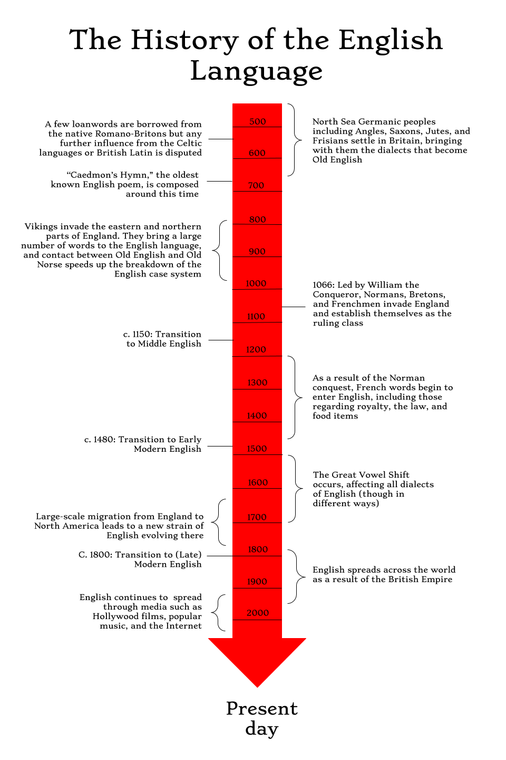Conclusion

Thus, the language reveals the soul of the nation. English language is very humble and obscure in its origin. It is in no sense native to England. The English language is not a result of any human design. It is the total of a series of historical incidents.

References

Yule, George. The Study of Language: An Introduction. Cambridge: Cambridge UP,1985.

Wrenn, C L. The English Language. London: Methuen, 1949.

Manuals of style (MLA Style Sheet, APA Style Sheet, Chicago Style Manual etc)

Wallace, Michael. (2004). Study Skills. Cambridge: CUP.

Kumar, Ranjit. (2012) Research Methodology: A Step-by-Step Guide for Beginners.New Delhi.

Wrenn, C L. The English Language. London: Methuen, 1949.

Manuals of style (MLA Style Sheet, APA Style Sheet, Chicago Style Manual etc)

Wallace, Michael. (2004). Study Skills. Cambridge: CUP.

Wood, F T, An Outline History Of The English Language. 2nd Edition - 1 January 2017. ISBN-13: 978-9351380931 ISBN-10: 9351380939

Mallory, J. P (2005). In Search of the Indo-Europeans. Thames & Hudson. ISBN 0-500-27616-1

Ringe, Donald R. and Taylor, Ann (2014). The Development of Old English - A Linguistic History of English, vol. II, 632p. ISBN 978-0199207848. Oxford.

Shore, Thomas William (1906), Origin of the Anglo-Saxon Race - A Study of the Settlement of England and the Tribal Origin of the Old English People (1st ed.), London

Baugh, Albert and Cable, Thomas. 2002. The History of the English Language. Upper Saddle River, New Jersey: Prentice Hall.

Fennell, B (2001). A History of English: A Sociolinguistic Approach. Oxford: Blackwell Publishing.

Hogg, Richard M. (ed.). (1992). The Cambridge History of the English Language (Vol. 1): the Beginnings to 1066. Cambridge: Cambridge University Press.

Baugh, Albert and Cable, Thomas. 2002. The History of the English Language. Upper Saddle River, New Jersey: Prentice Hall.

