HIGH INTENSITY FOCUSED ULTRASOUND (HIFU)

Author: Rashi Saraswat
Assistant Professor, Department of Radiology and Imaging Technology CT University
Ludhiana, Punjab, India saraswatrashi27@gmail.com

ABSTRACT
High-Intensity Focused Ultrasound (HIFU) is a medical technology that uses ultrasound waves to deliver focused energy at a specific target within the body. This non-invasive technique has gained recognition for its potential in various therapeutic applications. The principle behind HIFU involves using an ultrasound transducer to generate high-frequency sound waves. These waves are focused to a precise point, creating a concentrated area of high intensity. The energy produced can be used to achieve two main effects: thermal ablation and mechanical disruption.
In thermal ablation, the intense heat generated by the focused ultrasound causes coagulative necrosis, leading to the destruction of targeted tissue. This method has been used to treat solid tumors such as prostate, liver, kidney, and breast cancer. HIFU offers advantages over traditional surgical methods as it is non-invasive, avoids the need for incisions, and can be done as an outpatient procedure. It also provides real-time monitoring capabilities, allowing for precise control and adjustment of the treatment. Mechanical disruption, on the other hand, involves using high-intensity ultrasound to induce mechanical effects on tissue, rather than relying solely on thermal energy. This approach has shown promise in applications such as targeted drug delivery, where HIFU can be used to temporarily disrupt cell membranes, facilitating the delivery of therapeutic agents to specific areas.
HIFU has also demonstrated effectiveness in the treatment of various neurological conditions. In neurosurgery, it can be used to create lesions in specific brain regions, offering a non-invasive alternative to traditional surgical approaches. Among other neurological illnesses, HIFU has been investigated for the treatment of essential tremor, Parkinson's disease, and neuropathic pain. In addition, HIFU has found applications in the field of cosmetic medicine. It can stimulate collagen production and tissue tightening, making it suitable for non-surgical facelifts, body contouring, and skin rejuvenation. HIFU treatments in this context are typically well-tolerated, with minimal discomfort and downtime. While HIFU has demonstrated significant potential, ongoing research and development efforts are focused on further refining the technology, optimizing treatment protocols, and expanding its applications. Continued advancements in imaging techniques, treatment planning software, and transducer design are expected to enhance the precision and effectiveness of HIFU procedures.
In conclusion, High Intensity Focused Ultrasound (HIFU) is a non-invasive medical device that delivers focused energy via ultrasound waves for thermal ablation and mechanical disruption. Its applications range from the treatment of solid tumors and neurological disorders to cosmetic medicine. With ongoing research and development, HIFU holds promise as a versatile and transformative approach to various medical treatments.

Keywords: Ultrasound, Heat energy, noninvasive, medical technology

INTRODUCTION
Curie brothers Pierre Curie and Jacques Curie discovered the piezoelectric effect in certain crystals in 1880 leading to the discovery of ultrasound technology ^{[2]}. The medical ultrasound technology is continuously evolving and contributing in patient’s diagnosis and treatment. High Intensity Focused Ultrasound (HIFU) is a step forward in the field of ultrasound technology, contributing the therapeutic purpose in the radiology department.
Since decades, diagnostic ultrasound is being used but HIFU is serving the therapeutic use for tissue ablation in radiology department. HIFU uses a non-invasive thermal ablation technique. Unlike other thermal ablation techniques like radiofrequency ablation (RFA), laser, cryoablation which uses specialized needles/probes to deliver extreme temperatures to tissue cells causing necrosis. HIFU uses focused ultrasound waves to create lethal heat effect to the targeted tissue without harming surrounding tissues. HIFU can be guided through ultrasound (USg) or magnetic resonance (MRI). It is being considered as the hybrid technology in the field of radiology and is proving to be advantageous therapeutic technique.

HISTORY
1942 – First Tissue Lesion. John G. Lynn et al. proposed the idea that ultrasound can be intensely focused to produce extreme heat and non-invasively destroy targeted disease tissue within the body ^{[2]}.
1942 – First Focused Ultrasound Device. William Fry and his brother, Francis Fry, collaborated with a research team to create a focused ultrasound device that mechanically aligned four focused ultrasound generators to produce a pinpoint lesion while causing no harm to surrounding tissue ^{[2]}.
1944 – First Preclinical Study ^{[2]}.
1950 – First Therapeutic Use.
1955 – Fathers of Focused Ultrasound. Following a craniotomy, the Fry brothers accomplished partial ablation of the basal ganglia.
1962 – Focused Ultrasound and Brain. Russell Meyers and William Fry employed focused ultrasound to treat a large number of human patients with various brain diseases, including Parkinson's disease ^{[2]}.
1964 – First Cancer Application. M. Oka used focused ultrasound to treat thyroid and breast cancers.

1968 – First Brain Cancer Treatment. Dr. Robert Heimburger (Neurosurgeon) treated brain cancer under ultrasound guidance ^{[2]}. 1988 - 1st FDA Approval. Coleman & Lizzie developed the Sono care CST-100 therapeutic ultrasound system to treat glaucoma. Earned FDA approval ^{[2]}.
1990 - Focused Ultrasound for BPH. N. Sanghvi et al. developed and implemented protocol for treatment of BPH ^{[2]}.

1991 - Focused Ultrasound for Brain Tumors. 1992 - First Combination with MRI.
1996 – First Blood Brain Barrier Application ^{[3]}

PRINCIPLE
The theory is founded on the physical effects of ultrasonography on tissues. HIFU technique destroys heat tissue with great accuracy and minimal injury to surrounding tissue. The principle is similar to a childhood experiment of creating a hole in a leaf by focusing the sun rays with the help of lens over a particular point thus resulting in burning of leaf as shown in figure 1.

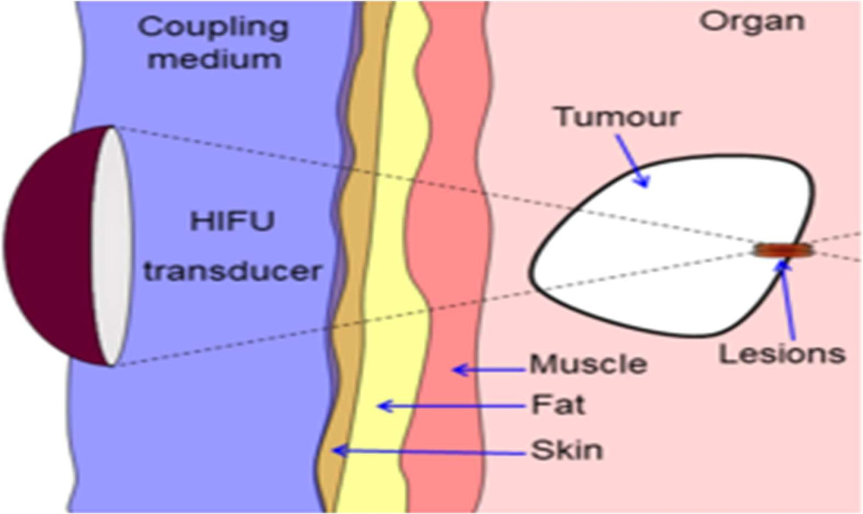Figure 1: The magnifying glass converge the sunrays to a focal point on a leaf converting the energy of light waves to become hot enough to burn a leaf.

Figure 2: Illustration of HIFU principle

The intensity range of therapeutic ultrasound is greater than that of diagnostic ultrasonography. Therapeutic ultrasound intensity differs depending on effect. High intensity range is used for tissue ablation.
Lower intensity range is employed to achieve localized biological effects while inducing mechanical impacts on the cellular level. HIFU transducers are intended to concentrate or converge a beam to a single spot. The ultrasound may be focused using a variety of approaches, including geometric focusing, which employs the spherically concave surface of HIFU transducers to assist concentrate the beam at a spot, and beam focusing, which uses an acoustic lens to converge the beam. Electronic focusing is also one of the focusing techniques which use phased array transducers composed of piezoelectric crystals.

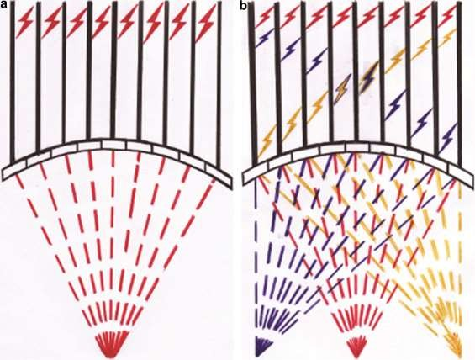

Figure 3: Electronic steering of the HIFU beam. (a) Phased array transducer is composed of multiple elements, each of which has a separate excitation signal (continuous black lines) with a specific phase. Emitted ultrasonic beams follow their corresponding phase and converge at the original geometric focus. Changing the phase of the excitation signal in (b) changes the direction of the ultrasound beams causing them to converge into a new focus ¹

PROCEDURE
Ultrasound energy is absorbed, reflected, or deflected when it interacts with tissue. The emission of wave energy is based on transducer vibration, which alternates the acoustical pressure of the coupling medium resulting in tissue movement (dilatation and contraction). Due to the fluctuations in pressure, the absorbed energy at the focal point is converted into heat. The rapid increase in tissue temperature up to 60° C or higher, resulting in tissue necrosis or coagulation leaving behind an elementary lesion.
The formation of a lesion involves two primary effects: thermal effect, which is directly connected to tissue temperature, and cavitation effect, which is caused by the presence of air bubbles in front of the transducer focus. Acoustic cavitation occurs when small gas bubbles develop and interact with ultrasound radiation at high acoustic intensities. Two types of acoustic cavitation are present: stable and inertial. Stable cavitation occurs when bubbles oscillate and grows in size, transfers the heat to the surrounding fluid resulting in mild temperature rise. Bubbles collapse violently at a particular pressure threshold, causing injury to adjacent tissue; this process is known as inertial cavitation.^{[1]}
Effective HIFU treatment procedure includes different stages. The diagnosis of tumor is done with the help of diagnostic ultrasound or MRI. Then the tumor visibility is ascertained with the help of diagnostic ultrasound which helps to establish a desired acoustic window for treatment delivery. The target volume is identified and localized. Another critical element is determining the appropriate ultrasonic exposure to ablate the tissue. In the case of ultrasound imaging guidance, a combination of focal peak intensity and exposure duration is utilized, resulting in a hyper echoic zone at the target, but in the case of MR imaging guidance, this combination is changed using MR thermometry until the desired temperature is obtained. The acoustic energy may be delivered in different ways depending on the target volume. Smaller target volume can be ablated with single exposure keeping the transducer stationary for about 2-10s. For larger volumes, the transducer may be moved in discrete steps and fired at each position to achieve desired tissue killing. Also, transducer can be moved in predetermined trajectories to attain desired cell killing.
The final step in the HIFU method is to evaluate tissue ablation after therapy. Vasculature can be seen using contrast enhanced MR and ultrasound imaging. Successful HIFU ablation results in occlusion of blood vessels reducing the uptake of contrast post treatment [ ^{5]}

IMAGING GUIDANCE OF HIFU
Ultrasound and Magnetic Resonance Imaging (MR) are now employed for target tissue identification, HIFU beam localization, and therapy monitoring. As HIFU treatment guidance, each has benefits and disadvantages.
MRI enables for detailed spatial evaluation of the target tissue and adjacent structures. When ultrasonic imaging is employed, an echogenic cloud forms as a result of tissue cavitation, limiting examination of deeper tissues. This is not the case with MR imaging. MR imaging is the only approach that uses MR thermometry to produce quantitative temperature data.
Due to susceptibility to motion artefacts from respiratory movements, MR guided focused ultrasound surgery (MRgFUS) is limited for the treatment of tumors in moving bodily organs, such as liver tumors. Clinical thermometry is missing in ultrasound guided focused ultrasound surgery (USgFUS).^{[1]}

CLINICAL APPLICATIONS OF HIFU

Non- FDA Approved Applications
  - Ablation of Hepatic Tumors.

  - Ablation of Breast Tumors.

FDA Approved Applications
  - Ablation of Uterine Leiomyomas.
  - Ablation of Bone Metastasis.
  - Ablation of Prostate Cancer.
  - Neurological Applications.

ADVANTAGES OF HIFU

  - Because HIFU is non-ionizing, it poses no radiation danger.
  - No dose limitation allows repeated therapy.
  - There is a reduced danger of harm to non-target healthy tissue since it allows for precision therapy. ^{[4]}
  - Because the heating process depends less on thermal conduction, HIFU ablation has a lower heat sink impact.

LIMITATIONS OF HIFU

The movement of organs during HIFU operations might result in partial target ablation or collateral injury. Incomplete target ablation may result from ultrasound reflection by bone or gas-containing tissue. Skin burns may come from poor acoustic coupling at the skin transducer contact.

COMPARISON WITH OTHER TISSUE ABLATION DEVICES

HIFU | RFA
Heat generated by focusing low energy ultrasound beam. | Resistive heating by alternating radiofrequency alternating current.
Ability to focus the treatment area. | Heat given to healthy tissues too.
Good depth of penetration. | Unable to penetrate to deep tissues.
No direct contact required. | Direct contact required.
Precise and fractional heating. | Bulk heating.
Single treatment. | Several sessions.
- SUMMARY

High Intensity Focused Ultrasound (HIFU) is a novel and non-invasive therapeutic treatment that use concentrated ultrasound waves to thermally ablate a section of tissue, which means that the tissue is destroyed by the tremendous heat created by sound waves. In the cells, the extreme heat induces tissue coagulation, necrosis, cavitation, and heat shock. Focused ultrasound surgery (FUS) is another name for HIFU. This treatment seeks to preserve the patient's quality of life by treating neuropathic pain, uterine fibroids, prostate cancer, and tumors of the bone, breast, liver, kidney, and testes. In addition, efforts are being conducted to temporarily open the blood brain barrier (BBB) using HIFU to facilitate medication absorption into the blood. HIFU employs an ultrasonic transducer similar to those used in diagnostics but with higher intensity and an acoustic lens to concentrate sound waves to a specific location, boosting the temperature to 70-80° Celsius. Diagnostic Sonography with focused ultrasound (USgFUS or USgHIFU) or magnetic resonance guidance with focused ultrasound (MRgFUS) may be employed by the interventional radiologist. The interventional radiologist can choose between USgFUS and MRgFUS. The most popular is MRgFUS, which measures the degree of heating in real time. In USgFUS, a transducer comparable to the diagnostic one is utilized, but in MRgFUS, the transducer is put in the MRI table. The HIFU transducer is a cup-shaped transducer equipped with an acoustic lens that produces a converging beam of sound waves to focus on a certain targeted tissue. The temperature is raised to 70-80° Celsius, with a maximum temperature of 150° Celsius. HIFU is a hybrid invention in the radiology area that is used as a non-invasive and incision-free therapeutic procedure in the treatment of neuropathic pain, uterine fibroids, and many forms of cancer. HIFU is a non-invasive therapeutic procedure that has taken the place of surgical therapies. It poses fewer risks and allows patients to recover faster by employing non-ionizing radiation to deliver precise therapy. It demonstrates the radiology department's advancement in the realm of medical science. ^{[123]}

References

- Quality of Life Study of Patients with Localized Prostate Cancer Treated with HIFU - ME Consulte (em-consulte.com)
- Home - Focused Ultrasound Foundation (fusfoundation.org)
- Elhelf IAS, Albahar H, Shah U, Oto A, Cressman E, Almekkawy M. High intensity focused ultrasound: The fundamentals, clinical applications and research trends. Diagn Interv Imaging. 2018 Jun;99(6):349-359. doi: 10.1016/j.diii.2018.03.001. Epub 2018 May 18. PMID: 29778401.
- Dr >Gail ter Haar & Constantin Coussios (2007) High intensity focused ultrasound: Physical principles and devices, International Journal of Hyperthermia, 23:2, 89-104, DOI: 10.1080/02656730601186138

- Colombel, M, and A Gelet. "Principles and results of high-intensity focused ultrasound for localized prostate cancer." Prostate Cancer and Prostatic Diseases, vol. 7, no. 4, Dec. 2004, p. 289. Gale OneFile: Health and Medicine, link.gale.com/apps/doc/A189222609/HRCA?u=googlescholar&sid=bookmark-HRCA&xid=8d528900. Accessed 2 Aug. 2022.
- Stefan Thüroff, Christian Chaussy, Chapter 9 - High-Intensity Focused Ultrasound for Prostate Cancer,Editor(s): Li-Ming Su, Early Diagnosis and Treatment of Cancer Series: Prostate Cancer, W.B. Saunders,2010, Pages 177-192, ISBN 9781416045755, https://doi.org/10.1016/B978-1-4160-4575- 5.50015-3. (https://www.sciencedirect.com/science/article/pii/B9781416045755500153)

