The Shaping of Spaces: A Journey through Furniture Design History
By- ¹Ms.Chanchal Kumari, B.I.D. 5th Semester, Amity School of Architecture & Planning, Amity University Lucknow Campus, Mob. No: 9336511121, Email- ID: chanchal.kumari@s.amity.edu, ^{*2}Dr. Deepti Pande Rana, Associate, Amity School of Architecture & Planning, Amity University Lucknow Campus, Mb- 9454109002, Email-ID-dprana@lko.amity.edu

Abstract:
This research article examines the fascinating journey of the evolution of furniture design from the 1950s to the present, focusing on its impact on interior design. This study provides a comprehensive overview of the major changes in design concepts, materials and technology that led to the furniture industry's goal. Starting with the creative and artistic symbols of the Mid-Century Modern movement, this article explores later periods marked by experimentation, postmodernism, sustainability, and digital integration. Through constant observation of the designers and their ongoing work, this work demonstrates the integration of culture, society, and technology in furniture production. In addition, the study demonstrates the importance of security, adaptation and integration of technology and design today in terms of the effects on people's interior design today. Data science monitors this shift, providing interior designers with valuable resources to help them make informed decisions about combining aesthetics, functionality, and culture in their creative work.
Key Words: Furniture evolution, Technology integration, Interior design, Experimentation.
I. Introduction
Furniture design is at the center of interior spaces and affects both efficiency and beauty. This article examines the evolution of furniture (from the 1950s to the present), revealing its connection to design, technology, and people. Furniture is much more than a utilitarian object; It is a contribution of human creativity and innovation. Throughout history, furniture designers have sought ways to transform space into art and function. From the intricate craftsmanship of antique pieces to the flowing lines of modern design, the furniture represents the spirit of time and creates a dialogue between the past and the present within the confines of the interiors.
The study of the evolution of furniture design sheds light on the broader context of human history, culture and new construction. By following the evolution of design ideas, materials, and technology, we can gain a deeper understanding of how society changes and adapts over time. Also, examining past designs can encourage contemporary designers to combine the old with the modern, encouraging innovation while paying attention to heritage.
The main purpose of this research article is to provide a comprehensive review of furniture production from 1950 to the present. This article focuses on the connection between design and cultural change by examining important designs, important works, and influential designers. While the focus is on Western thought, this article will also touch on the global impact and cultural exchange of furniture design.
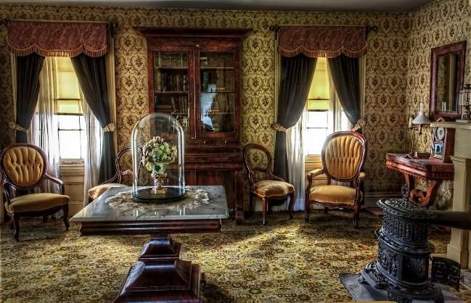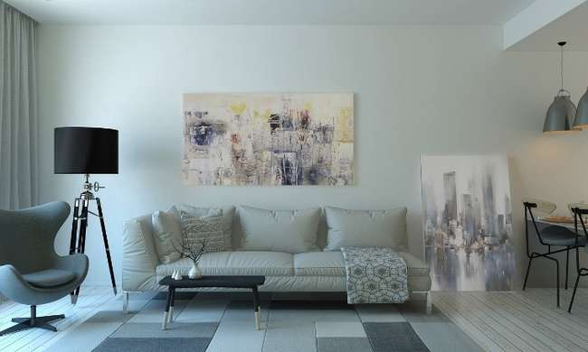
Fig.1 Traditional Fig.2 Contemporary
II. 1950s: Mid-Century Modernism and Beyond
The Mid-Century Modern movement emerged in response to the post-World War II era that emphasized work and less work. combination of nature and design. Furniture of this period is characterized by clear lines, organic shapes and the use of new materials such as plywood and fiberglass. Unlike previous styles, mid-century furniture focuses on combining form and function to create very good furniture that is not only beautiful but functional.
Many designers and architects played an important role in shaping and guiding the development of the mid-century modern era. Known for their outstanding contribution to furniture and design, Charles and Ray Eames have created iconic products such as the Eames Chaise Lounge and Ottoman. Eero Saarinen presents the Tulip table, which showcases his new approach to design and style. Arne Jacobsen's Egg chair has become a symbol of the times, using innovative materials and design options.
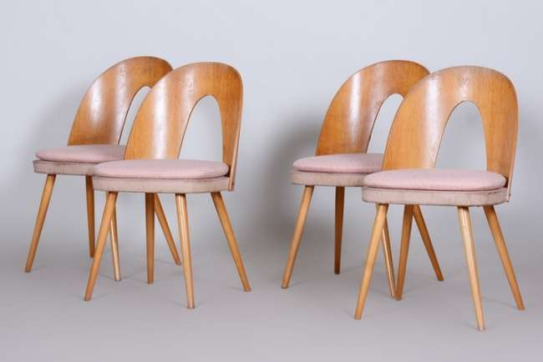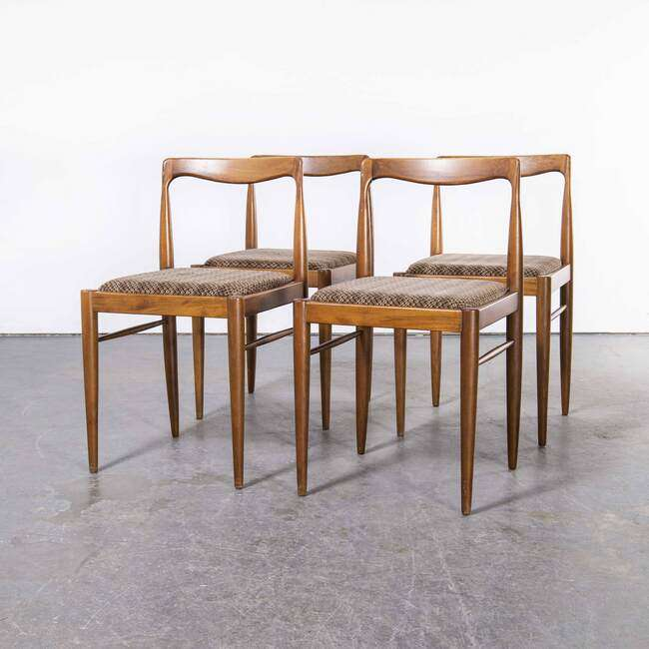
Fig. 3 Set Of Four Mid Century Modern Chairs Made In 1950s Czechia By Antonín šuman
1. Eames Chaise Lounge and Ottoman: Designed in 1956, this chair combines elegant comfort with modern elegance. Its molded plywood shell and premium leather interior represent the era's focus on combining form and function.
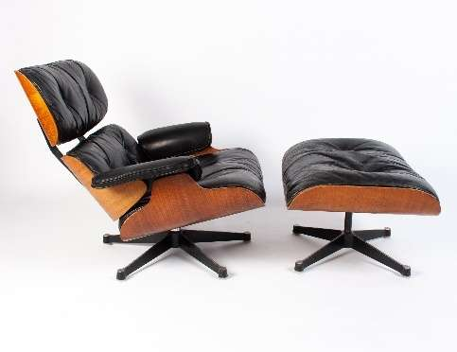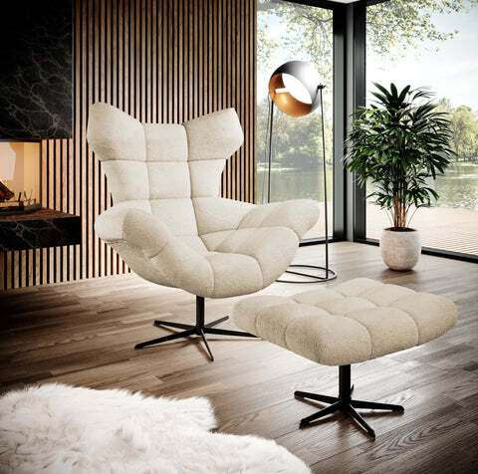
Fig 4. Eames Chaise Lounge and Ottoman
2.Tulip Table: Eero Saarinen's Tulip Table defies design with its single base and stylish round table. It represents the importance that power places on simplicity and the use of new materials.

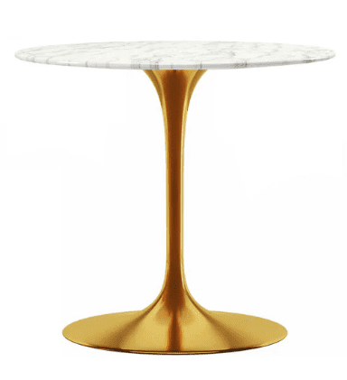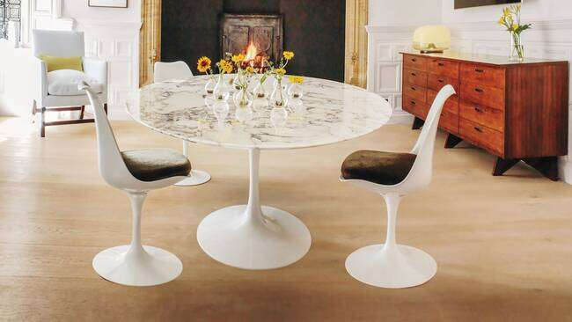
Fig 5. Tulip Table
The 1950s were marked by post-war austerity policies and a focus on consumption. As society evolves into technology and modernity, furniture designers are responding by using new materials and production methods. The rise of suburban life also influenced design; furniture has become more suitable for smaller living spaces. Also, the Cold War era led to the search for space-age design elements, with beautiful furniture moving away from flowing and futuristic materials.
III. 1960s and 1970s: Counterculture and Experimental Design
The 1960s and 1970s marked a turning point in furniture design that broke away from the clear lines and functionality of mid-century modernism. It's time to see the results of test materials, the use of non-standard materials, and the impact of opposition on furniture design.
In addition, increasing concerns about sustainability and the environment led to the rise of the environmentally conscious design movement in this period.
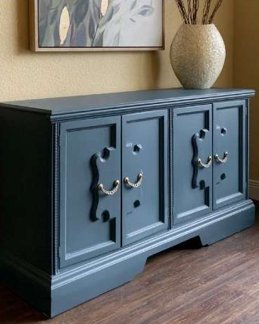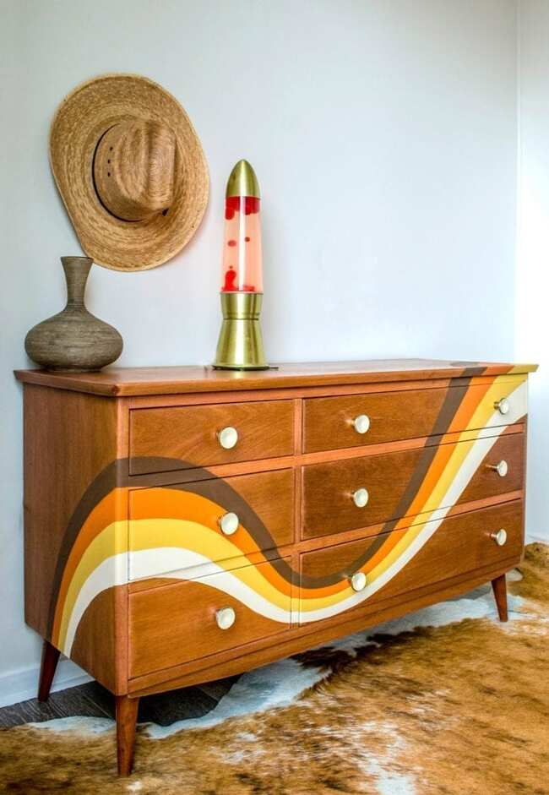
Fig 6. Gorgeous Vintage Turquoise Sideboard Fig 7. 1970S Inspired Chest drawers by Jeanie Simpson
The 1960s and 1970s saw a departure from the designs of mid-century modernism. Designers began to push the boundaries of furniture materials using more organic and sculptural forms. This change was created by the cultural changes that took place during this period as a response to the post-war policies of pacification and austerity. Designers like Eero Saarinen and Harry Bertoia moved away from the straight lines of mid-century modernism, experimenting with curves and fluid forms.
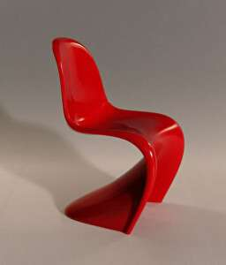
Fig. 8 Shiro Kuramata's Glass Chair, 1976, Fig 9. Panton, image by Stuhl
Experimenting with materials became an important aspect of furniture design in the 1960s and 1970s. Designers try to challenge the concept of furniture by combining non-standard materials such as plastic, fiberglass and acrylic. Pioneers like Verner Panton used molded plastic to create iconic chairs, demonstrating the potential of this material to create new shapes and textures. There are also unusual elements such as home furniture reflecting the new spirit of the period.
The psychedelic aesthetic of the time was embodied in furniture created with bright colors, beautiful patterns and extraordinary choices. Led by Italian designers like Joe Colombo, the Plastic Dreams movement uses a futuristic and playful design approach heavily influenced by the imagination and power of pop culture.
As environmental concerns arose in the 1960s and 1970s, furniture designers began to explore sustainable and environmentally responsible designs. This marks a shift towards using renewable resources, reducing waste, and creating a long life. The "hippie" trend of living in harmony with nature has influenced the design of furniture as well as handicrafts and handicrafts. This period laid the foundation for the eco-design movement, which will receive more attention in the years to come.

IV. 1980s and 1990s: Postmodernism and Eclecticism
The world of furniture design underwent major changes in the 1980s and 1990s with the emergence of Postmodernism and Eclecticism. This time we went against the modern ideas of previous years and added play, art and elegance to furniture design. This article examines the main features of post-modern furniture, the blurring of the boundaries between art and design, the integration of the fun and the ironic, and the effects of the success of furniture design in this period.
Postmodern furniture design emerged as a response to the simplicity and minimalism of Modernism. Postmodernism celebrates diversity, historical data and critical concepts rather than following a single structure. Furniture makers of this period worked with a variety of styles, materials, and materials, often combining elements from different periods and cultures. This led to the emergence of furniture that defies traditional classification and embraces eclecticism
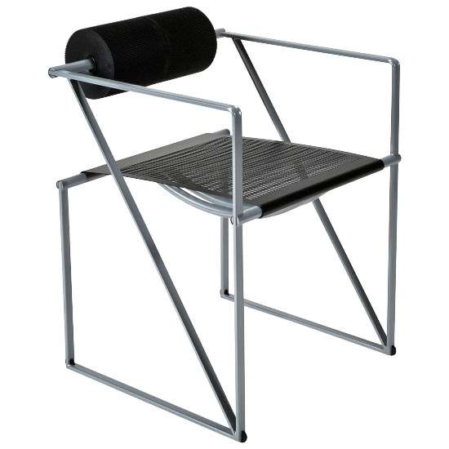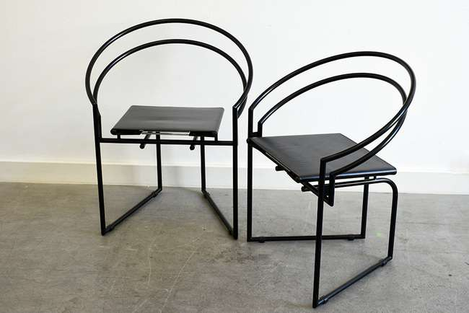
Fig 10. Seconda Chair by Mario Botta for Alias Fig 11. Latonda chairs by Mario Botta for Alias
In the 1980s and 1990s, the lines between art and design in furniture became blurred. Designers began to see furniture as both a tool and an expression of art. This change challenges ideas of using furniture, allowing experimentation with negative images, materials, and ideas. Furniture is not only functional, but also a means of artistic exploration and self-expression.
One of the features of the design of later furniture is the combination of playful and ironic elements. Designers of this era often replace the seriousness of modern design with fun, wit, and whimsy. This is reflected in the almost cartoonish furniture materials with exaggerated proportions and unexpected material combinations. Vibrant colors, bold patterns and the use of unconventional materials further emphasize the whimsical nature of postmodern furniture.
In the 1980s and 1990s, technology changed furniture design. New materials (plastic, laminate, metal) are driving creativity, while computer-aided design (CAD) is changing the process. Designers use digital tools to effectively create complex and previously complex forms.

V. 2000s: Minimalism, Technology Consolidation and Globalization
The 2000s marked an important period in the development of the furniture design landscape, characterized by a combination of minimalist aesthetics, seamless technology integration, increasing international trade influence, and furniture design. The importance of design for sustainability and responsibility. In this period, the traditional and luxurious designs of the past were moved away and replaced by stylish, functional, and technologically advanced furniture that reflects the changing lifestyle and values of the modern world.
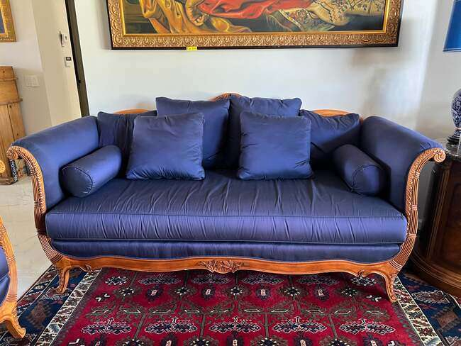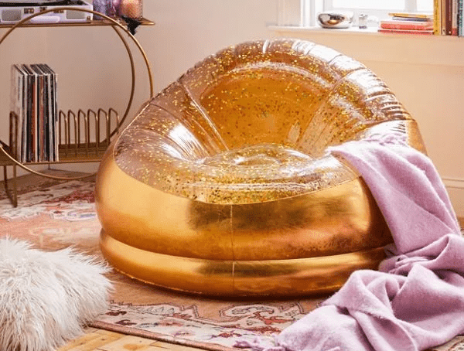
Fig. 12 2000s French Style Cobalt Blue Drexel Fig 13. Sparkling Lucy Glitter Inflatable
Heritage Sofa Chairish Chair
In the 2000s, minimalism made a comeback by focusing on simple, functional and orderly life. This resonates with the community looking for a common space. Minimalist furniture with clear lines, geometric shapes and neutral colors blends seamlessly into modern interiors.
Design luminaries such as Dieter Rams and Naoto Fukasawa were instrumental in bringing minimalist aesthetics to the fore. As an advocate of the "less is more" principle, Rams has created iconic products that combine functionality and beauty, such as the Braun SK 4 Phonosuper and the 606 Universal Shelving System. Fukasawa championed the "most important" design, as seen in his "MUJI CD Player", which promotes the beauty of modern products with a sense of indifference.
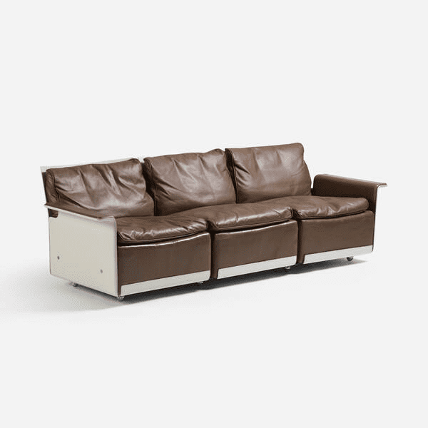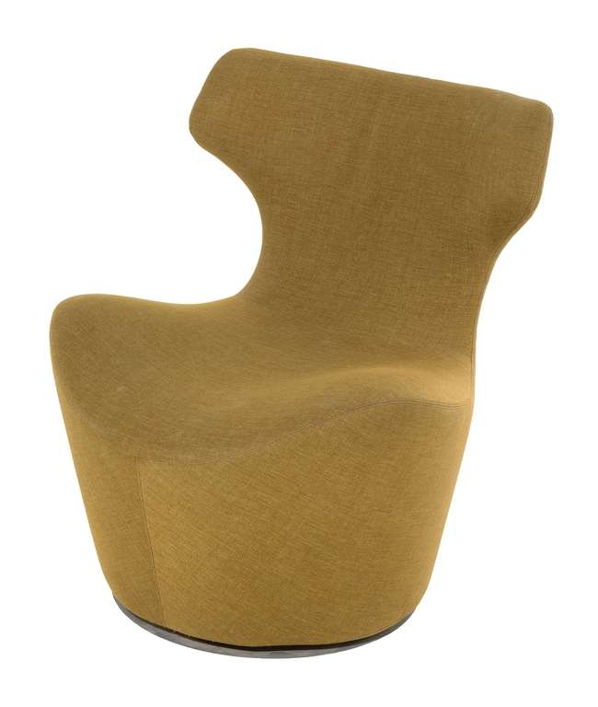
Fig 14. Dieter Rams First generation Fig 15. Naoto Fukasawa 'PAPILIO' CHAIR FOR B&B
620 sofa ITALIA, circa 2000s
The 2000s witnessed a revolution in which technology was seamlessly integrated into furniture design. The advent of smart furniture and design has changed the way people interact with the living space. Innovations such as smart chairs with built-in charging stations, coffee tables with integrated speakers and beds with adjustable features symbolize the marriage of technology and furniture
Smart furniture revolutionizes living spaces by offering convenience and increasing functionality. MIT Media Lab's City Home project exemplifies this change with modular designs that transform a room into multiple spaces with a single click. This innovation combines furniture and technology to change the way people interact and improve living spaces.
VI. The Modern Age (Contemporary): Diversity, Sustainability, and Individuality
Modern furniture design has undergone a unique transformation, characterized by a combination of various design influences that are important for sustainability, personalization and the combination of art and design frontier. This article explains the various aspects of modern furniture design, showing the combination of different styles of beauty, practicality, personal design, and the combination of art, design and craftsmanship.
Designers now draw inspiration from cultures around the world to create furniture that transcends geographical boundaries. Multicultural aesthetics became a driving force and elements from different regions were seamlessly integrated into the furniture design. Scandinavian minimalism, for example, combines with Japanese wabi-sabi to create functionally and spiritually inspiring objects. This combination not only supports the design, but also promotes the satisfaction of the culture.

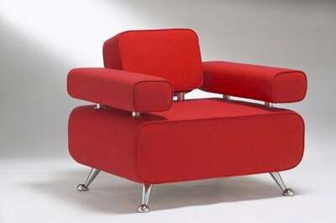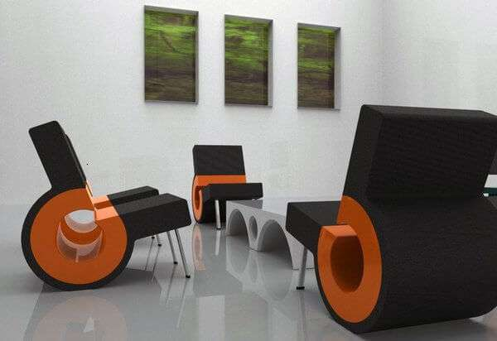
Fig. 16 Contemporary furnishings blend traditional styles with modern lines.
Modern landscape furniture designs, where environmental concerns are increasingly focused on, also focus on sustainability. Designers are increasingly opting for eco-friendly materials such as recycled wood, bamboo, and recycled metal. In addition, new production techniques such as 3D printing and prototypes reduce waste and energy. The integration of sustainable practices not only meets the needs of environmentally conscious customers, but also sets an example for other businesses to follow.
In this era, the boundaries between art, design and craft work have become fluid. Furniture is not just about functionality; it serves as a canvas for art. Designers collaborate with talented people to create products that blur the lines between furniture and art. This led to a limited collection that placed emphasis on functionality as well as beauty and storytelling. The combination of design and craftsmanship gives furniture a new life, making it a testament to human creativity.
VII. Case Studies: Emphasizing Fundamental Design Movements and Studies
This section examines iconic furniture designs from different eras and shows how they represent their era.
1 | 1950s: Eames Chaise Lounge and Ottoman | 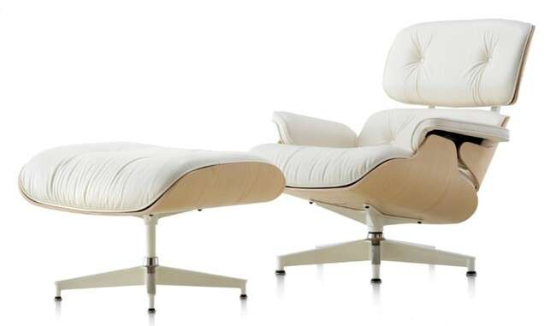  Fig 17. Eames Chaise Lounge and Ottoman | One of the 1950s designs is the Eames Chaise Lounge and Ottoman designed by Charles and Ray Eames. This product represents the comfort and elegance values of the time. The molded plywood shell of the seat, the soft leather upholstery, and the way the rubber shock-absorbing fittings are used make it easy to be groundbreaking for its time. The combination of form and function has become a symbol of mid-century modern design.
2 | 1960s: Egg Chair by Arne Jacobsen | 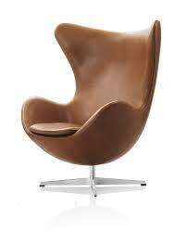  Fig 18. Egg Chair by Arne Jacobsen | Arne Jacobsen's Egg Chair is a great example of the popular culture and futuristic aesthetic of the 1960s. The organic, cocoon-like chair defies design standards. Made of new techniques such as molded foam, the Egg Chair underlines the period's focus on experimentation and sculptural form
3 | 1970s: Wassily Chair by Marcel Breuer | 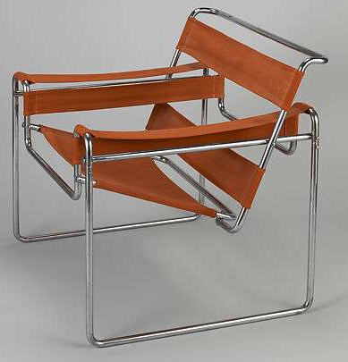  Fig 19. Wassily Chair by Marcel Breuer | Marcel Breuer's Wassily Chair from the 1970s reflects the era's exploration of industrial products and minimalism. Made of curved steel tubing and canvas, this design expresses the fusion of modern details with the use of non-traditional materials. The open and simple design of this sofa reflects the 70's emphasis on simplicity.
4 | 1980s: Carlton Bookcase | 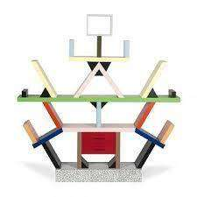  Fig 20. : Carlton Bookcase | by Memphis Group The 1980s saw the emergence of the Memphis Group, a design group known for their post-modern and avant-garde designs. The Carlton bookcase designed by Ettore Sottsass is a prime example of this. Their asymmetrical arrangements, vibrant colors and playful geometric shapes compete to create patterns of symmetry and soft tones
5 | 1990s: Philippe Starck's Louis Ghost Chair | 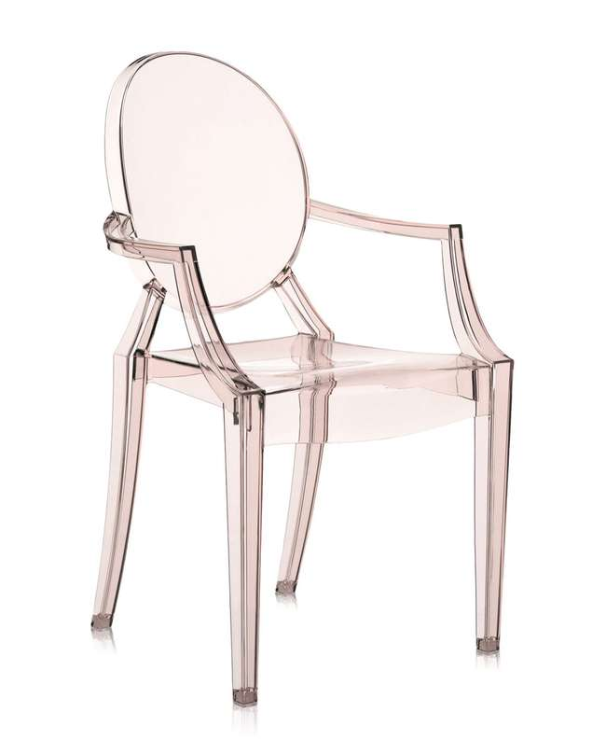  Fig 21. Philippe Starck's Louis Ghost Chair | Philippe Starck rose to prominence in the 1990s with his Louis Ghost chair. This product seamlessly blends traditional beauty with modern materials, reinvigorating the classic Louis XVI armchair with clear polycarbonate. The transparency of the chair and the revival of the historical design show the fusion of past and present in this period.
6 | 2000s: iPod Chair by Philippe Starck | 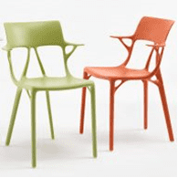  Fig 22. iPod Chair by Philippe Starck | The iPod chair continues Starck's innovative spirit and represents the technology-driven 2000s. With built-in speakers and an iPod dock, this sofa combines furniture with digital entertainment. He talked about the era that focused on the use of technology in everyday products.
7 | 2010s: Nendo's Nest Shelf | 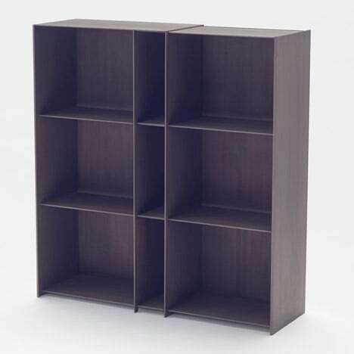  Fig 23. Nendo's Nest shelves | The 2010s saw an increase in design and creative use of materials. Nendo's Nest Shelf embodies this style with its bird's nest inspired design. Made from recycled materials, the product complies with decades of environmental concern awareness.

VIII. Technological advances and their impact on furniture design

1 | 3D Printing: Shaping the Future of Furniture Design | 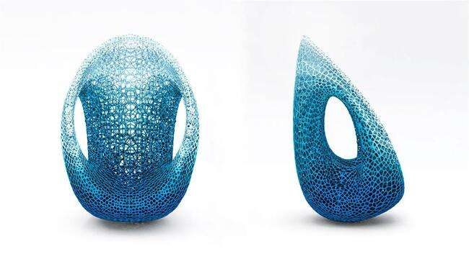 | 3D printing, or additive manufacturing, has revolutionized furniture design by transforming ideas into physical prototypes layer by layer. The technology enables flexible designs that overcome traditional manufacturing limitations.
2 | Digital Modeling: Transforming Conceptualization and Design Visualization | 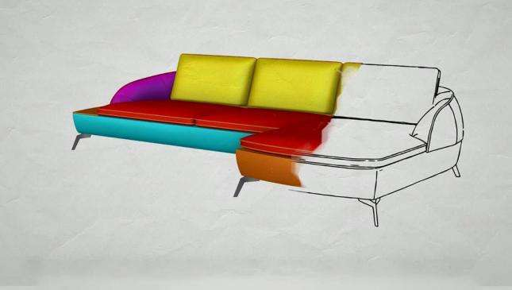 | Digital modeling also plays an important role in modern furniture design. Computer-aided design (CAD) software allows designers to create accurate and accurate virtual furniture models before furniture is made available. This process simplifies design iteration cycles and reduces the potential for errors and waste during production.
3 | Virtual Reality: In the World of Furniture | 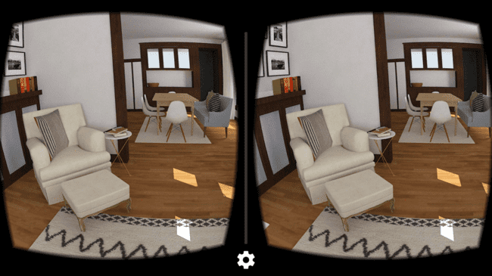 | Virtual Reality (VR) and Augmented Reality (AR) technologies have become powerful tools in furniture design. This technology changes the way design is seen, evaluated and optimized by allowing designers, clients and customers to experience furniture details in a virtual environment.
IX. The Future of Furniture Design: Anticipated Trends and Innovations
A. Speculations on future designs and cultural influences
As we enter a new era, the future of the table Party design will provide technology, sustainability, and culture. Changes will come from social changes, technological leaps, and ecological awareness. We expect a return to minimalism and functionality, emphasizing urban living with quality, multi-purpose design.
Cultural trends will emerge that combine modern design craft, influenced by global interaction. Personalization will develop, allowing people to cut furniture according to their own style, to think for themselves. Future vision; innovation, awareness of space, rich culture and self-made furniture.
B. Integrating Sustainable Development and Circular Design Principles
In an age of environmental concerns, it is important to integrate sustainable development and circular design into furniture design.
Designers should use environmentally friendly materials and techniques such as recycled wood and recycled metal to reduce their environmental impact. Equity, reducing waste, increasing quality and efficiency will become more important. This method can extend the life of the furniture and reduce replacement. Cooperation between manufacturers and designers can lead to recycling services for the proper disposal or restoration of old furniture.
C. The Role of Artificial Intelligence in Furniture Design
Artificial Intelligence (AI) will change the furniture design. Intelligence can help create new and ergonomic furniture by processing a lot of data and generating design ideas. Artificial intelligence algorithms predict user preferences, enabling personalized furniture solutions. Using various design algorithms as a process, parametric design enhances creativity and customization. AI-powered generative tools make it easy to explore design options.
In addition, artificial intelligence supports stability in furniture production. AI-powered lifecycle assessment tools analyze environmental impacts to help designers make informed decisions about materials, manufacturing, and shipping. The integration of artificial intelligence drives changes in the field, promoting design, identity, and ecological responsibility.
X. Conclusion:
In summary, the history of furniture design from the 1950s to the present shows that there is an interaction between creativity, social change, and technical education. This shift reflects the shift from ornate style to a minimalist aesthetic suitable for home, urbanism, and ecological awareness. Cultural influences and technological developments have had a lasting impact on landscape design.
Furniture design is important in the creation of living spaces; affects the ambiance, comfort and happiness. It connects the past and the future and embodies the essence of every moment. As we move forward, we are proud of the designers who created our environment, ensuring that the evolution of furniture design continues to attract and inspire, creating timeless classics that will be passed on to future generations.

XI. References
https://www.onlinedesignteacher.com/2016/02/furniture-design-history.html
https://www.pamono.com/stories/minimalist-furniture-design-history-essence
https://study.com/academy/lesson/history-of-furniture-design-timeline-evolution.html
https://www.causeafrockus.com/2013/11/1960s-1970s-furniture-interior-design/
https://www.kissthedesign.ch/en/product/latonda-chair-mario-botta-alias/
https://www.popsugar.co.uk/home/early-2000s-home-decor-47376933#photo-47376896
https://www.wright20.com/auctions/2018/07/dieter-rams-the-jf-chen-collection/131?sort_by=estimate&sort_order=desc
https://www.google.com/search?sca_esv=562133542&rlz=1C1CHBF_enIN971IN971&sxsrf=AB5stBjz4G-3gKqi9cW3tEYPbvjE0sERlA:1693639252093&q=2010s:+Nendo%27s+Nest+Shelf&tbm=isch&source=lnms&sa=X&ved=2ahUKEwiap_7vsYuBAxWjXGwGHcJaDH8Q0pQJegQIERAB&biw=1366&bih=619&dpr=1#imgrc=x5MsdRQMAqT8TM&imgdii=aobHk1kKzVM4TM
https://www.dezeen.com/2015/09/17/nendo-expandable-nest-shelves-embedded-with-carbon-fibre-london-design-festival-2015/

