Pulsed Electric Field: A Promising Technique for Future Food Processing

Mehul Chudasama
Department of Dairy and Food Technology
Parul Institute of Technology, Parul University
Vadodara, India
mehul.chudasama29347@paruluniversity.ac.in

Manish Tiwari
Department of Dairy and Food Technology
Parul Institute of Technology, Parul University
Vadodara, India
mehul.chudasama29347@paruluniversity.ac.in

Jyotirmoy Goyary
Department of Dairy and Food Technology
Parul Institute of Technology, Parul University
Vadodara, India
mehul.chudasama29347@paruluniversity.ac.in
Abstract
Pulsed Electric Field (PEF) technology is a promising technique for future food processing. It involves applying short pulses of high-voltage electric fields to food products, resulting in microbial inactivation and quality improvement. PEF offers a non-thermal alternative to traditional methods, such as pasteurization, while preserving the sensory and nutritional attributes of food. It has demonstrated efficacy against various microorganisms and can be applied to liquids, semi-solids, and solids. PEF not only controls microbial growth but also enhances food quality by facilitating compound extraction and improving texture. Although challenges exist, ongoing advancements are addressing them and expanding the application of PEF in the food industry. PEF holds significant potential as an energy-efficient and environmentally friendly processing technique for producing high-quality, minimally processed foods.

Keywords- Pulsed Electric Field; microbial inactivation; pasteurization alternative; non-thermal processing

I. Introduction
Pulsed Electric Fields PEF is a non-thermal food preservation method that uses short pulses of electrical current to inactivate microorganisms with minimal impact on food quality. The goal of PEF technology is to provide consumers with high-quality food. In terms of food quality, PEF technology is considered to be superior to traditional heat treatment methods because it avoids or significantly reduces harmful changes in food sensory and physical properties. For example, PEF technology has proven to have advantages over heat treatment because it kills microbes while better retaining the original color, taste, texture and nutritional value of unprocessed foods. Using PEF technology, a high voltage pulse is applied to a liquid or semi-solid food product placed between two electrodes. Most PEF studies have focused on the effect of PEF treatment on the inactivation of microorganisms in milk, milk products, egg products, juices, and other liquid foods.

A. History
Pioneering work of experiments of application of pulsed electric fields for food processing has been reported by the German engineer Heinz Doevenspeck, resulting in a patent (Doevenspeck 1960), describing the application of pulsed electric fields for disruption of cells in food material to improve separation of phases (Doevenspeck 1961). An industrial scale plant with a capacity of up to 2500 kg/h has been erected for processing of beef and pork material as well as fish waste material as early as 1961 in fat smeltery in Germany. On his quest for possible applicants of the technique Doevenspeck, active as a consulting engineer, came in contact with Münch, technical director for animal material processing at Krupp Maschinentechnik in 1985, recognizing the techniques potential. After a restriction of perchloroethylene use for fat extraction, Krupp Maschinentechnik was seeking for alternative processing techniques to induce cell disintegration and to improve phase separation of fish slurry in a screw press (Sitzmann 2006). Since then, consulted by Doevenspeck, a work group consisting of Münch, Sitzmann as well as other co-workers developed the processes ELCRACK® and ELSTERIL® (Sitzmann and Münch 1988; Sitzmann and Münch 1989). Since 1986 an ELSTERIL® pilot plant was developed, consisting of a high voltage pulse generator with a peak voltage of 15 kV and a repetition rate of 22 Hz. The storage capacity was varied between 0.5 and 5 µF, an ignitron was used to discharge the electrical energy stored (Grahl 1994). Five different batches as well as continuous treatment chambers have been developed, equipped with two parallel plate carbon electrodes, the electrode gap was 0.5 or 1.2 cm, a flow rate of 165 l/h was used (Grahl 1994). In cooperation with FMC Europe in 1990 no detrimental effects on orange juice quality were found. After the failure with the first industrial unit, the financial support by Krupp was reduced substantially. Sitzmann continued the activity in the field of PEF applications running his own businesses, DWS and Nafutec GmbH, subsequently (Anonymous 1995; Sitzmann 1995).

B. Principle
The basic principle of the PEF technology is the application of short pulses of high electric fields with duration of microseconds micro- to milliseconds and intensity in the order of 10- 80 kV/cm.
Processing time = Number of pulses ⨯ Pulse duration
The process is based on pulsed electrical currents delivered to a product placed between a set of electrodes; the distance between electrodes is termed as the treatment gap of the PEF chamber. The applied high voltage results in an electric field that causes microbial inactivation. The electric field may be applied in the form of exponentially decaying, square wave, bipolar, or oscillatory pulses and at ambient, sub-ambient, or slightly above ambient temperature. After the treatment, the food is packaged aseptically and stored under refrigeration. applied to a food product held between two electrodes inside a chamber, usually at room temperature. Food is capable of transferring electricity because of the presence of several ions, giving the product in question a certain degree of electrical conductivity. So, when an electrical field is applied, electrical current flows into the liquid food and is transferred to each point in the liquid because of the charged molecules present (Zhang et al., 1995).

C. How does PEF inactivate microorganisms?
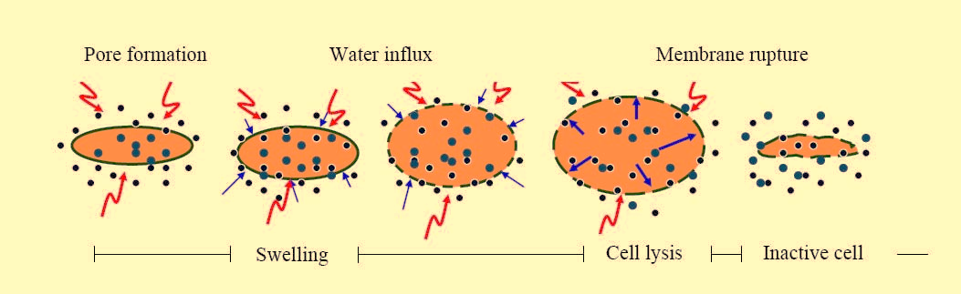
PEF treatment has lethal effects on various vegetative bacteria, mold, and yeast. Efficacy of spore inactivation by PEF in combination with heat or other hurdles is a subject of current research. A series of short, high-voltage pulses breaks the cell membranes of vegetative microorganisms in liquid media by expanding existing pores (electroporation) or creating new ones. Pore formation is reversible or irreversible depending on factors such as the electric field intensity, the pulse duration, and number of pulses Figure 1. The membranes of PEF-treated cells become permeable to small molecules; permeation causes swelling and eventual rupture of the cell membrane.
Figure 1 – Electroporation of cell

II. PEF Components:
A simple Pulsed Electric Field setup consists of,
1. High Voltage Pulse Generator
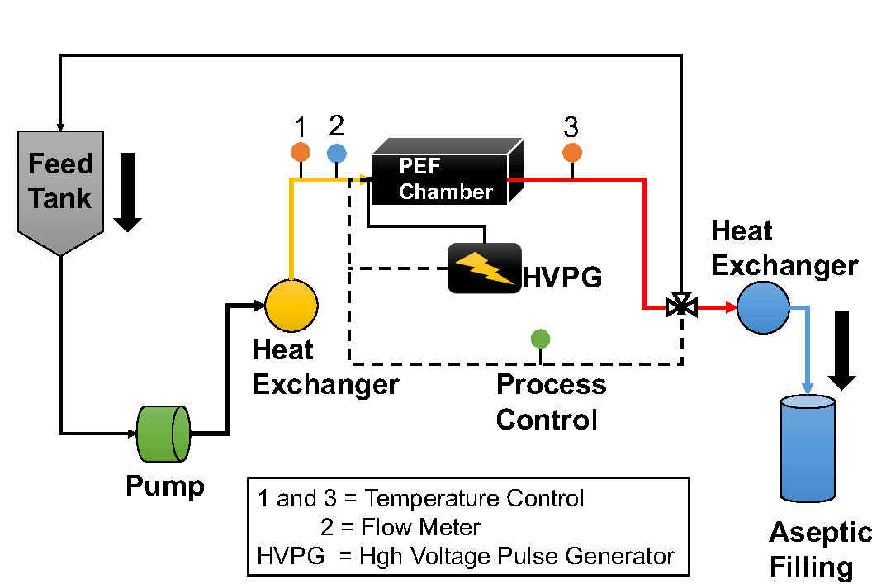
It provides electrical pulses of desired voltage, shape and duration.
Figure 2 – Flow diagram of continuous Pulsed Electric Field system

2. A Treatment Chamber
The treatment chamber consists of least two electrodes, with and insulating region in between, where the treatment of the products takes place. One electrode is connected to the voltage source and other to the ground. The electrode material may be carbon, gold, platinum, metal oxide, carbon-brass electrode. Most commonly Stainless-Steel electrode is used. An insulating material holds the electrodes in fixed positions and forms the chamber containing the food to be processed. Insulator materials used are polythene, polypropylene, nylon, polysulfone, Plexiglas, PVC.

Figure 3 - Continuous PEF treatment chambers: (1) parallel plate, (2) coaxial, and (3) co-linear configuration (Source: Toepfl et al., 2005).

3. Control System:
It consists two major devices are an oscilloscope and a temperature probe. The oscilloscope measures the voltage across the treatment chamber and shows the output voltage shape.

A. PEF parameters to be consider:

- Field strength: Field strength refers to the intensity of the electric field applied during PEF treatment. It is typically measured in kilovolts per centimeter (kV/cm). Higher field strengths result in greater disruption of cell membranes, leading to improved microbial inactivation and increased extraction efficiency.
- Pulse length: Pulse length represents the duration of each individual electric pulse applied during PEF treatment. It is usually measured in microseconds (µs). Longer pulse lengths allow for more energy to be transferred to the food product, leading to increased microbial inactivation. However, excessively long pulses may cause excessive heating and undesirable effects on food quality.
- Number of pulses: The number of pulses refers to the total count of electric pulses applied to the food product during the PEF treatment. Increasing the number of pulses can enhance microbial inactivation, but an optimal range must be determined to prevent excessive energy transfer and unwanted effects.
- Start temperature: Start temperature refers to the initial temperature of the food product before the PEF treatment begins. It influences the overall effectiveness of the treatment since higher temperatures can increase the electrical conductivity of the food, resulting in better energy transfer and enhanced microbial inactivation.
- End temperature: End temperature represents the final temperature of the food product after the PEF treatment. The temperature change during PEF treatment depends on factors such as energy input, product characteristics, and treatment time. It is important to monitor and control the end temperature to avoid thermal effects that may negatively impact food quality.
- Treatment chamber: The treatment chamber is the physical space where the PEF treatment takes place. It consists of electrodes through which the electric pulses are applied to the food product. The design of the treatment chamber affects the distribution and uniformity of the electric field, which in turn influences the treatment efficacy.
- Volume: Volume refers to the quantity or size of the food product being treated within the PEF system. It is important to consider the volume to ensure consistent treatment throughout the batch and to determine appropriate process parameters for efficient microbial inactivation.
- Treatment gap: The treatment gap represents the distance between the electrodes in the PEF treatment chamber. It determines the electric field strength and uniformity within the food product. An optimal treatment gap should be chosen to ensure efficient energy transfer and uniform treatment.
- Flow rate: Flow rate refers to the rate at which the food product is passed through the treatment chamber during PEF treatment. It is typically measured in liters per hour (L/h) or any other suitable unit. The flow rate affects the residence time and the treatment intensity experienced by the food product, which has implications for microbial inactivation and quality preservation.
- Residence time: Residence time is the duration for which the food product remains within the treatment chamber during PEF treatment. It is calculated by dividing the volume of the food product by the flow rate. The residence time influences the extent of microbial inactivation and the energy delivered to the food product.

B. Microbial parameters:
- Type of Microorganism: Different microorganisms have varying levels of resistance to PEF treatment. Factors such as the species, strain, age, and physiological state of microorganisms can influence their susceptibility to PEF. Generally, PEF has been found to be effective against a wide range of microorganisms, including bacteria, yeasts, molds, and some viruses. Common foodborne pathogens like Escherichia coli, Salmonella spp., Listeria monocytogenes, and Campylobacter jejuni have been studied regarding their response to PEF treatment. These bacteria can cause foodborne illnesses, and PEF has been found effective in reducing their populations. Various spoilage-causing yeasts and molds, such as Saccharomyces cerevisiae, Candida spp., and Aspergillus spp., have also been targeted with PEF treatment. PEF can inhibit their growth and extend the shelf life of products prone to fungal spoilage, such as fruit juices and dairy products.
- Medium Composition: The composition of the surrounding medium or food matrix can affect microbial inactivation by PEF. Factors such as pH, ionic strength, and the presence of certain compounds (e.g., sugars, salts, proteins) can influence the sensitivity of microorganisms to PEF treatment. Acidic conditions, such as those found in fruit juices, can enhance the microbial inactivation achieved by PEF. Acidic environments make bacteria more vulnerable, and therefore PEF treatment can lead to significant reductions in populations of acid-tolerant pathogens like E. coli O157:H7 and Salmonella spp. Some microorganisms, particularly yeasts, exhibit increased resistance to PEF in high-sugar environments. For instance, the spoilage yeast Zygosaccharomyces bailii can be more resilient in high-sugar solutions, thus requiring higher PEF treatment parameters for effective inactivation.
- Oxygen Concentration: The presence or absence of oxygen can impact the effectiveness of PEF treatment. Some microorganisms are more resistant to PEF in anaerobic conditions compared to aerobic conditions. Oxygen can potentially react with reactive oxygen species generated during PEF treatment, leading to enhanced microbial inactivation.
- Time of Incubation: After PEF treatment, microorganisms may require a certain period of time to exhibit the full extent of inactivation. This is referred to as the incubation or post-treatment holding time. During this time, damaged cells may continue to lose viability, and sub-lethally injured cells may die off. The duration of the incubation period can vary depending on the specific microorganism and processing conditions.

C. Product parameters:
- Conductivity: The electrical conductivity of the product being treated can influence the efficiency and effectiveness of PEF treatment. It is a measure of how well a substance conducts electric current. Higher conductivity can result in increased energy transfer and potentially higher microbial inactivation. Fruit juices, such as orange juice or apple juice, typically have a higher conductivity due to their natural sugars and electrolyte content. Higher conductivity in fruit juices can enhance the effectiveness of PEF treatment for microbial reduction. Dairy products like milk or yogurt have relatively lower conductivity. However, the addition of electrolytes or salts can increase the conductivity, thereby improving the efficiency of PEF treatment for microbial control.
- Composition: The overall composition of the product can impact the response of microorganisms to PEF treatment. Different components present in the product matrix can affect the efficacy of microbial inactivation. Solid foods with complex compositions, such as meat or vegetables, contain structural barriers that can shield microorganisms from the electric field. The presence of cellular structures, fibrous materials, or protective layers can influence the effectiveness of PEF treatment in penetrating and inactivating microorganisms. Liquid products with simpler compositions, such as clear juices or liquid dairy products, offer fewer barriers to the electric field, allowing for better penetration and microbial inactivation.
- Ionic Strength: The concentration of ions in the product, often referred to as ionic strength, can impact the efficacy of PEF treatment. Ionic strength affects the electrical conductivity and the ability of electric fields to disrupt microorganisms. Foods preserved in brines or solutions with high salt concentrations have increased ionic strength. Higher ionic strength can enhance the effectiveness of PEF treatment for microbial control, especially against salt-tolerant microorganisms like Staphylococcus aureus or Vibrio parahaemolyticus. Foods with low salt content, such as fresh fruits or low-sodium products, have lower ionic strength. Lower ionic strength may require higher PEF treatment parameters to achieve comparable microbial reductions.
- pH: The acidity or alkalinity of the product, as measured by pH, can influence microbial inactivation by PEF. pH affects the electrical conductivity and the stability of microorganisms. Acidic foods, such as citrus juices or pickled vegetables with low pH values, can enhance the efficacy of PEF treatment. Lower pH creates an environment that is more conducive to microbial inactivation. Foods with neutral or alkaline pH, such as milk or plant-based beverages, may require higher PEF treatment parameters to achieve significant microbial reductions due to reduced electrical conductivity and increased microbial stability.
- Water Activity: Water activity (aw) is a measure of the availability of water for microbial growth. It affects the resistance of microorganisms to PEF treatment. Dry or dehydrated products, such as dried fruits or jerky, have low water activity. Microorganisms in low-water activity foods may exhibit increased resistance to PEF treatment, requiring higher treatment parameters for effective inactivation. Moist or high-moisture products, like fresh produce or sauces, have high water activity. Microorganisms in high-water activity foods are generally more susceptible to PEF treatment, making it more effective for microbial control.

III. Applications
Pulsed Electric Field can be widely used for preservation of food products without any heat treatments. Application of pulsed electric fields technology has been successfully demonstrated for the pasteurization of foods such as juices, milk, yogurt, soups, and liquid eggs. Application of PEF processing is restricted to food products with no air bubbles and with low electrical conductivity.

- Fruit Juices
- Milk
- Yogurt
- Soups
- Liquid Eggs
- Extraction of Sugar
- Extraction of Oils
- Extraction of other cellular compounds
- Reduction of solid waste (sludge) from waste water
- Enhance Drying (Heat & Mass Transfer)
- Modification of Enzyme Activity
- Preservation of solid & semi-solid foods

Table 1: Microbial inactivation in some food products by use of PEF:

Food | PEF system | Treatment condition | Log reduction | Source
Skim Milk | Batch parallel plate | 30 kV/cm, 1500 pulses per second | < 1.5 | Beveridge et al., 2002
 | - | 41 kV/cm. 2.5 μs, 10-63 pulses per second | 2.3 – 4.5 | Dutreux et al., 2000
 | Batch parallel plate | 50 kV/cm, 62 μs, < 30 °C | 2.5 | Cortesea et al., 2011
Liquid Eggs | Coaxial | 36 kV/cm, 37 °C | 6 | Martin-Belloso, et al., 1997
Orange Juice | - | 28 kV/cm, 75 μs, 55 °C | 3.79 |  | Gurtler et al., 2010
 | - | 40 kV/cm. 100 μs. 56 °C | 6.3 |  | McNamee et al., 2010
Apple Juice | Bench scale OSU 4-H model  (Ohio University) | 36 kV/cm,1-10 μs,  400, 600, 800 pulses per second | 3.5  4.5  6 |  | Charles-Rodriguez et al., 2007

6. Advantages:
- Requires less treatment time & temperature
- Potential of substitute for conventional heat pasteurization
- Pasteurize liquid food products
- Increase shelf life and maintain food safety
- Minimally processed foods
- Fresh quality
- Higher nutritional value
- Colour and flavour retention
- Inactivates vegetative micro-organisms including yeasts, spoilage micro-organisms and pathogens
- 4-6 log reduction of micro-organisms
- Increase in fruit juice and oil extraction yield

7. Disadvantages:
- Expensive
- Still under research and development
- Less commercial units available
- The method of inactivation is still theoretical
- Not suitable for solid foods
- Electrode lifetime
- Foods containing air bubbles can cause spark inside treatment chamber
- Not possible to use in foods with higher or variable electrical conductivity

8. Conclusion:
Application of PEF for food preservation provides tremendous potential to preserve high quality products at lower temperatures and short resistance times to retain the fresh-like character and nutritional value. The task of development of the equipment with reliable, industrial scale generation of high-strength electric field pulses still remain a challenge for the engineers. The availability of these pulse generation systems will be a prerequisite for industrial application and popularization of PEF treatment in food industry. The uniformity of treatment intensity distribution has to be improved by optimization of the PEF treatment. Research of pulsed electric fields technology is ongoing around the world. Most of the research conducted up until now has been in the laboratory and on a pilot plant scale level, and has shown promising results. There is need for exhaustive study to develop PEF solution for commercial scale.

References:
Anonymous (1995). Kalt erwischt. Wirtschaftswoche (12), 119-123.

Beveridge, J. R., Macgregor, S. J., Marsili, L., Anderson, J. G., Rowan, N. J., & Farish, O. (2002). Comparison of the effectiveness of biphase and monophase rectangular pulses for the inactivation of microorganisms using pulsed electric fields. IEEE Transactions on Plasma Science, (30), 1525–1531.

Charles-Rodriguez, A. V., Nevarez-Moorillon, G. V., Zhang, Q. H., & Ortega-Rivas, E. (2007). Comparison of thermal processing and pulsed electric fields treatment in pasteurization of apple juice. Food and Bioproducts Processing, (85), 93–97.

Cortesea, P., Dellacasaa, G., Gemmea, R., Bonettab, S., Bonettab, S., Carrarob, E., Pizzichemic, M. (2011). A Pulsed Electric Field (PEF) bench static system to study bacteria inactivation. Nuclear Physics B (Proc. Suppl.), (215), 162–164.

Doevenspeck, H. (1960). Verfahren und Vorrichtung zur Gewinnung der einzelnen Phasen aus dispersen Systemen.German Patent, DE 1237541

Doevenspeck, H. (1961). Influencing cells and cell walls by electrostatic impulses. Fleischwirtschaft 13(12):968- 987.

Dutreux, N., Notermans, S., Wijtes, T., Gongora- Nieto, M. M., BarbosaCanovas, G. V., & Swanson, B. G. (2000). Pulsed electric fields inactivation of attached and free-living Escherichia coli and Listeria innocua under several conditions. International Journal of Food Microbiology, (54), 91–98.

Grahl, T. (1994). Abtöten von Mikroorganismen mit Hilfe elektrischer Hochspannungsimpulse. Hamburg, TU Hamburg-Harburg, Germany.

Gurtler, J. B., Rivera, R. B., Zhang, H. Q., & Geveke, D. J. (2010). Selection of surrogate bacteria in place of E. coli O157:H7 and Salmonella typhimurium for pulsed electric field treatment of orange juice. International Journal of Food Microbiology, (139), 1–8.

Martin-Belloso, O., Vega-Mercado, H., Qin, B. L., Chang, F. J., BarbosaCanovas, G. V., & Swanson, B. G. (1997). Inactivation of Escherichia coli suspended in liquid egg using pulsed electric fields. Journal of Food Processing and Preservation, (21), 193–208.

Mcnamee, C., Noci, F., Cronin, D. A., Lyng, J. G., Morgan, D., J., & Scannell, A. G. M. (2010). PEF based hurdle strategy to control Pichia fermentans, listeria innocua and Escherichia coli k12 in orange juice. International Journal of Food Microbiology, (138), 13–18.

Sitzmann, W. and Münch, E.-W. (1988). ELCRACK® und ELSTERIL® - Zwei neue Verfahren zur gezielten Beeinflussung von Phasengrenzflächen. GVC Fachausschuss, Brussel, Belgium.

Sitzmann, W. and Münch, E.-W. (1989). Elektrische Verfahren zur Keimabtötung. Die Ernährungsindustrie 6: 54-58.

Sitzmann, W. (1995). High voltage pulse techniques. New methods for food preservation. G. W. Gould. London, Graham & Hill.

Sitzmann, W. (2006). Technologieentwicklung der Elektroporation. Personal communication.

Toepfl, S. Heinz, V., Knorr, D. (2005). Overview of Pulsed Electric Field Processing for Food. In “Emerging Technologies in Food Processing” ed. Sun, Da-Wen. Elseveir Academic Press, San Diego, California, USA, pp. 69.

Zhang, Q., Barbosa-Cánovas, G. V. and Swanson, B. G. (1995). Engineering aspects of pulsed electric field pasteurization. Journal of Food Engineering (25): 261-281.

