ANALYSIS OF CRYSTAL STRUCTURE, OPTICAL AND SUPERPARAMAGNETIC PROPERTIES OF NiFeO
NANOPARTICLES
C. Thangamani¹, K.Rajalakshmi² K. Pushpanathan³
¹Department of Physics, M .KUMARASAMY COLLEGE OF ENGINEERING, AFFILIATED TO ANNA UNIVERSITY.
²Assistant Professor,Department of Chemistry,Shrimati Indira Gandhi College,Tiruchirappalli-620002.
³Department of Physics, Government Arts College, Karur -639 005, Tamilnadu, India
1.1 INTRODUCTION

This chapter mainly focuses the synthesis and characterization of undoped and ion doped nickel oxide nanoparticles. Prepared nanopowders have been characterized by x-ray diffraction method, UV-Vis spectrometer ,\Particles size analysis , photoluminescence spectrometer, Fourier transform infrared spectrometer, transmission electron microscope (TEM) atomic force microscope (AFM) , energy dispersive X-ray spectrum (EDS) and vibrating sample magnetometer at room temperature. The particle size were carried out by particle size analyzer. X - ray diffraction study confirmed the average crystallite sizes is decreasing when increasing the dopant concentrations Tauc’s relation result confirmed the energy gap of the synthesized nanoparticles is less than that of bulk NiO. The functional group identified from the formation of NiO and Fe doping.AFM analysis confirmed that Fe doping increases the particles size reduces.PL studies confirmed that the violet emission from the NiO and Fe doped NiO is assumed to be the recombination from the defect centers such as O and Ni interstitials. Room temperature magnetic behavior confirmed that the prepared nanoparticles are paramagnetic nature.

1.2 PHASE ANALYSIS

Figure.1.1 represents the x-ray diffraction pattern of undoped and Fe doped NiO nanoparticle recorded at room temperature. The sharp and strong diffraction peaks present at 2θ of 31.24º,43.09º,62.65º,75.36º and 79.23º corresponds to reflection planes of (111),(200),(220),(311) and (222) of undoped and 0,1, 3 ,5 and 7 wt % of Fe doped NiO nanoparticles respectively. All diffraction peaks are well matches with JCPDS card no [87-0712], which is, confirmed the formation of face centered cubic structure. Comparing to undoes, we have seen that the intensity variation of 1 and 3 wt% Fe dopant .No other impurity phase can observe in XRD pattern. It is confirmed that Fe ions doped with NiO ions. Further increase in Fe concentration 5 and 7 wt%, an additional peak of low intensity was identified in the XRD figure 1.1(d and e) that was attributed to the mixed phase of FeO and α-Fe₂O₄ . The diffraction peaks were compared with JCPDS data no [85-0967]. Similar result reported by Yanglong Hou et al. [1].This is the maximum solubility limit for Fe with NiO.Due to this reason it produces phase transition at 5and 7 wt% . The average crystalline size has been calculated by using Scherer equation [2]

D = $\frac{0.9λ}{βCosθ}$
Where D is crystalline size, λ is the X-ray wavelength (for Cu Kα radiation, λ = 1.54 nm), θ is the diffraction angle and β is the full width at half maximum of the diffraction peak at 2θ. The average crystalline size found to be 28, 17, 13, 1.5, and 5.5 nm for NiO and Fe doped NiO nanoparticles respectively. The crystalline size of NiO has been decreasing on increasing the dopant of Fe concentrations. At higher (7%), doping concentration is more effective when compared to lower concentration. From this result the Fe doped NiO samples obtainable better in controlled the crystalline size than the undoped NiO. Here the (200) peak was used to identify the structural parameters like that lattice constant (a) and volume of cubic unit cell (V) and it has been calculated from XRD data via the following formula
$d$_{(hkl)} = $\frac{a}{\sqrt{(h+k+l)}}$
V= a³
The calculated lattice constants were a = 4.18, 4.18, 4.20.4.96 and 5.18 Å for undoped and 0,1, 3 ,5 and 7 wt % of Fe doped NiO nanoparticles respectively. The lattice constant increases with increase in the dopant concentration. In addition that the volume of cubic unit cell were 73, 73, 73, 75 and 77 Å ³ respectively, there is no changes in undoped NiO and minimum dopant of Fe, but in 5 and 7 % Fe dopant cubic unit cell volume was increasing. From this result, the crystalline nature of prepared samples of NiO and Fe doped NiO was dependant on the dopant concentration.[3]
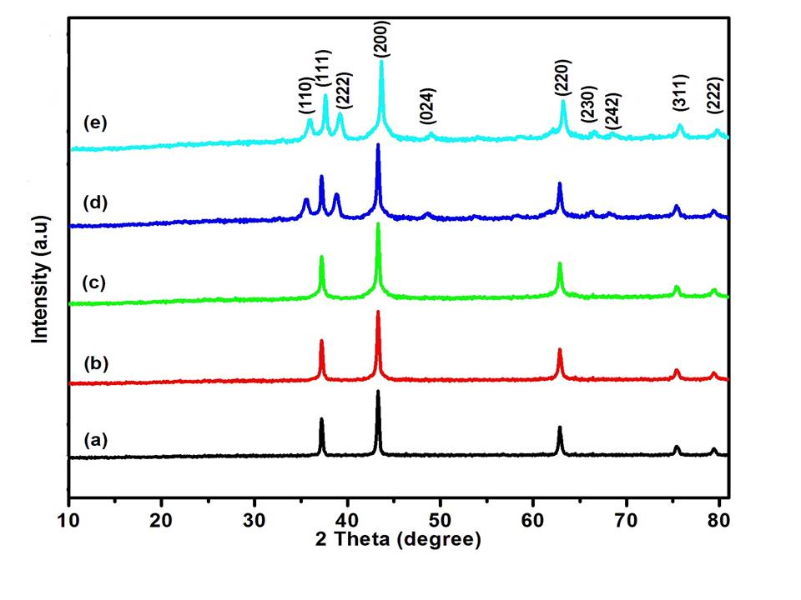

Figure 1. 1 X-ray diffraction pattern of the Ni_{1-x}Fe_{x}O (x= 0, 0.01, 0.03, 0.05 and 0.07) nanopowders

1.3 TAUC’S RELATION AND EGERGY GAP CALCULATION

Then our investigation was continued for the calculation of energy gap of nanoparticles with the familiar Tauc’s equation (αhν)² = β (hν-E_{g}), where α is the absorption co-efficient, hν is the energy of the photon and β is a constant calculated from the refractive index and electron–hole effective mass [4] .

Figure 1.2 Tauc’s plot of Ni_{1-x}Fe_{x}Onanopowders: (a) x = 0, (b) x = 0.01, (c) x = 0.03, (d) x = 0.05 and (e) x = 0.01.
The dotted lines show the best fitted results. The extrapolation of the liner portion of the plot on the x-axis (hν) gives the E_{g} value. The energy gap value obtained thus decreases as ~3.40, 3.37, 3.30, 3.21 and 3.15 eV for x = 0, 0.0, 0.01, 0.03, 0.05 and 0.07, respectively. Energy gap estimation based on Tauc’s equation is illustrated in the figure1.2. Generally, doping may widen the energy gap of the semiconductor material with respect to Burstein – Moss effect [5]. But in our present study, E_{g} decreases with the boost in Fe doping, which can be attributed to band gap renormalization of E_{g} value of FeO because the E_{g} of FeO is ~ 2.67 eV [11] which is smaller than that (~ 3.7 eV) of NiO . Hence, the formation of modest amount of FeO reduces the energy gap of Fe doped NiO nanoparticles below 3.40 eV.

1.4 PARTICLE SIZE ANALYSIS
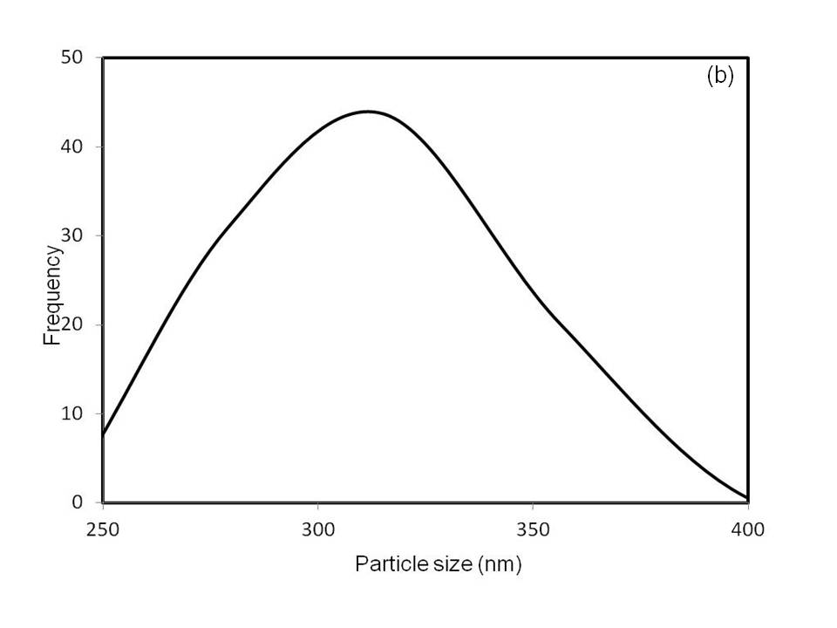
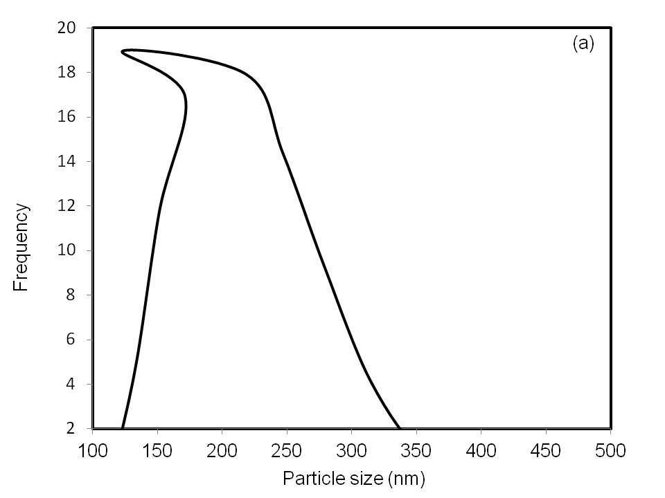

Figure 1.3 Particle size analysis image of (a) undoped (b) 7 wt % Fe doped NiO nanoparticles

Particle analyzer (HORBIA SZ100) did the particle sizes and the scattering angle is 90. The size of the particles formed were 280 and 123 nm studied by the particle size analyzer. [6] The XRD result of the sample reveals that the phases change from undoped to Fe doped samples In the Figure 1.3 shows the average particle size of undoped and 7% Fe doped NiO. The average particle size is less than~ 30 nm for undoped NiO and 12 nm for 7 (wt%) Fe doped NiO nanoparticles. All the results from particle analyzer are in good agreement with the XRD and TEM results of crystallite sizes.

1.5 PHOTOLUMINESCENCE (PL) STUDY

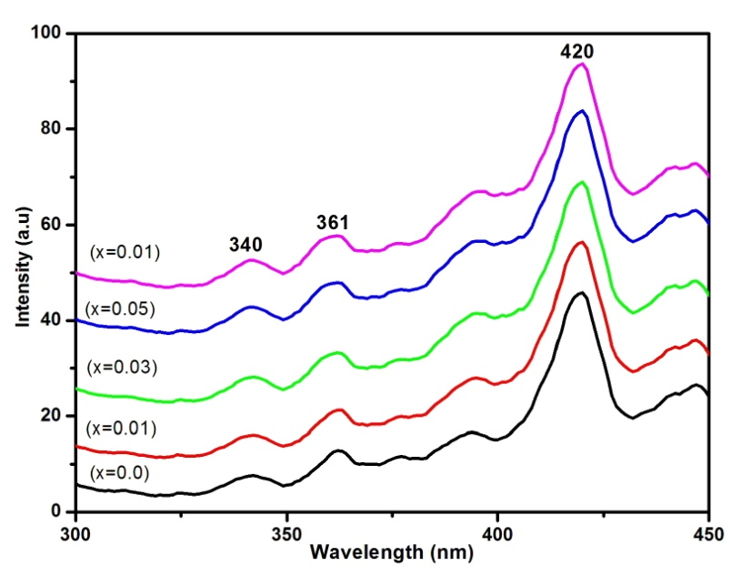

Figure 1.4 Room temperature PL spectrum of Ni1-xFexO (x= 0, 0.01, 0.03, 0.05 and 0.07) nanopowders.

Photoluminescence (PL) is a powerful tool for probing the light emission properties of semiconductors. Room temperature photoluminescence spectra of the NiO and Fe doped NiO nanoparticles are shown in Figure 1.4 The bands emission is observed in the range of 300-450nm. All the samples have lower intensity UV emission peak. The UV emission is around 340-361 nm, When increasing the dopant concentrations the intensity is decreasing, it is due to the change in size surface defect. Many authors reported that the UV emission refers to the exciton recombination corresponding to the near band edge (NBE) [7]. In addition that the strong violet emission peak at 420 nm for all samples, it is possible to the violet emission from the NiO and Fe doped NiO is assumed to be the recombination from the defect centers such as O and Ni interstitials [8].

1.6 ATOMIC FORCE MICROSCOPY

Figure 1.5 (a&,b) and 1.6 (a&,b) shows the AFM 2D image and corresponding 3D image of the undoped and 7 (wt %) Fe doped NiO nanoparticles in a scan area of 2X2µm.
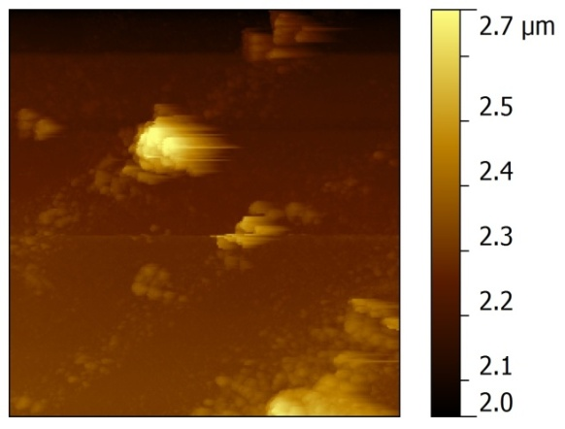
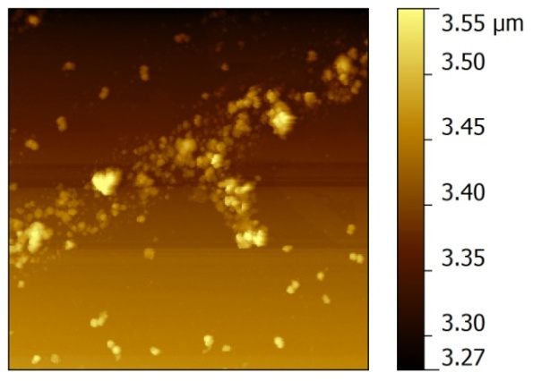

Figure 1.5 AFM 2D image of (a) Undoped (b) 7 wt % Fe doped NiO nanoparticles
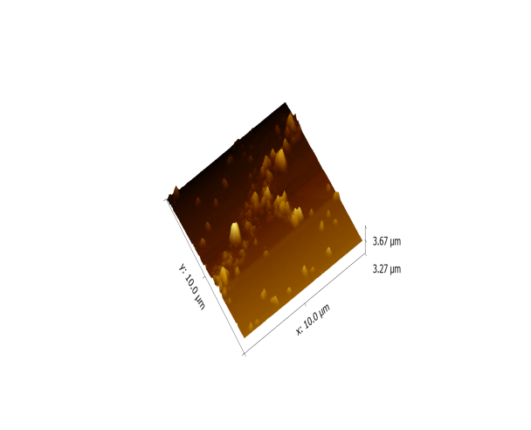
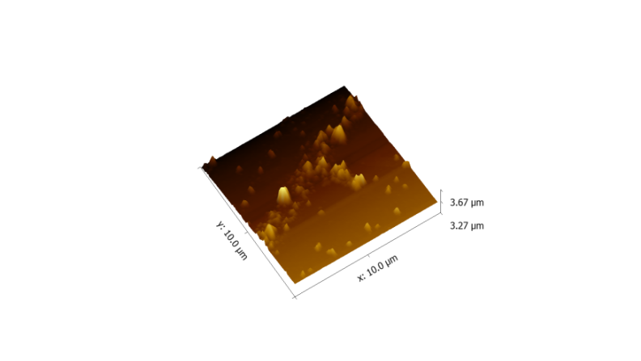
Figure 1.6 AFM 3D image of (a) Undoped (b) 7 wt % Fe doped NiO
nanoparticle

AFM images were obtained by measurement of the interaction between the tip and the nanoparticles. The AFM results reveal that the grain size varies with the increase in Fe concentration and this affects the physical properties of the prepared nanoparticles .The AFM results reveal that there is no usual variation in the grain size with the change in Fe concentration. The results confirmed that the grain size decreases with the increase in Fe concentration. However, no regular variation in the roughness of the Fe doped NiO has been observed with the change in Fe concentration. [9,10]

1.7 TEM AND EDX ANALYSIS

Figure 1.7 (a-c) shows transmission electron microscopy (TEM) image and selected area electron diffraction (SAED) of NiO and Fe doped NiO nanoparticles.
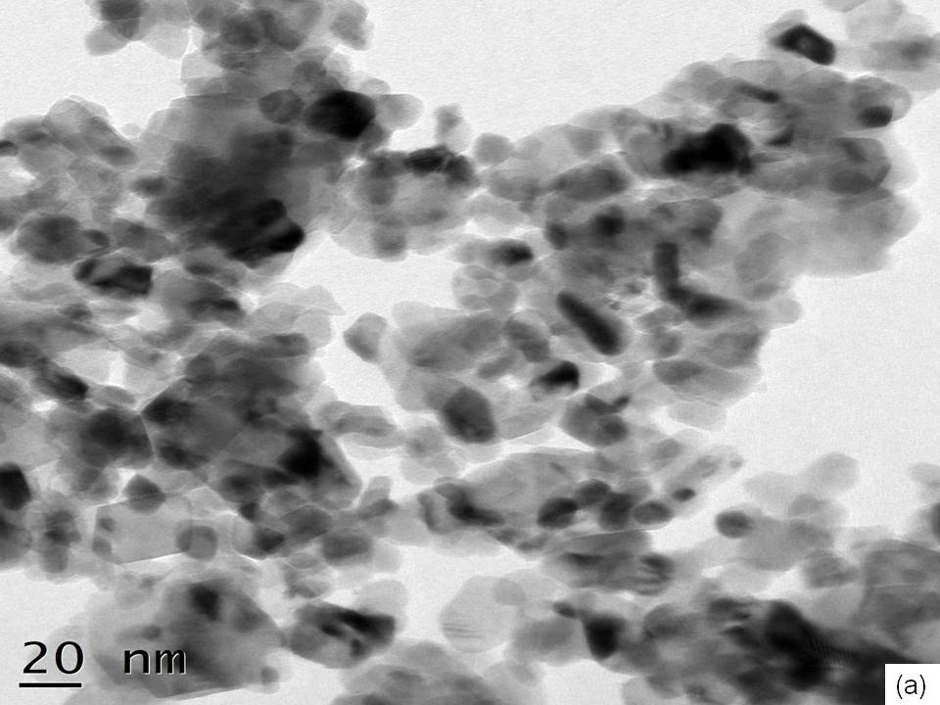
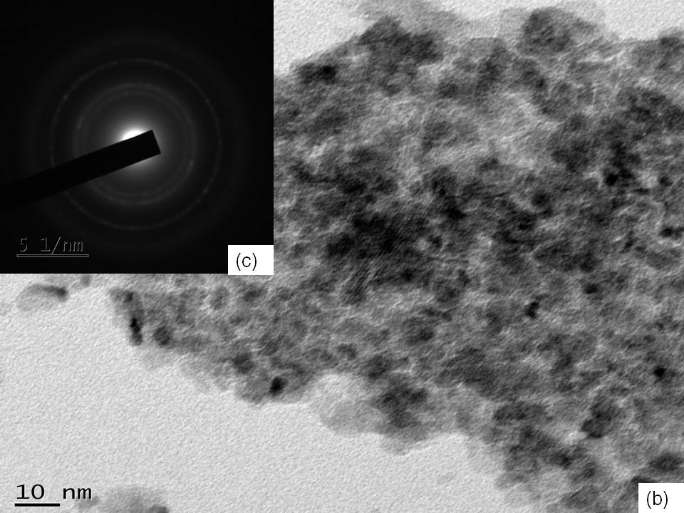

Figure 1.7 TEM image of (a) Undoped (b) 7 wt % Fe doped NiO (c) SAED pattern of 7 wt % Fe doped NiO nanoparticles

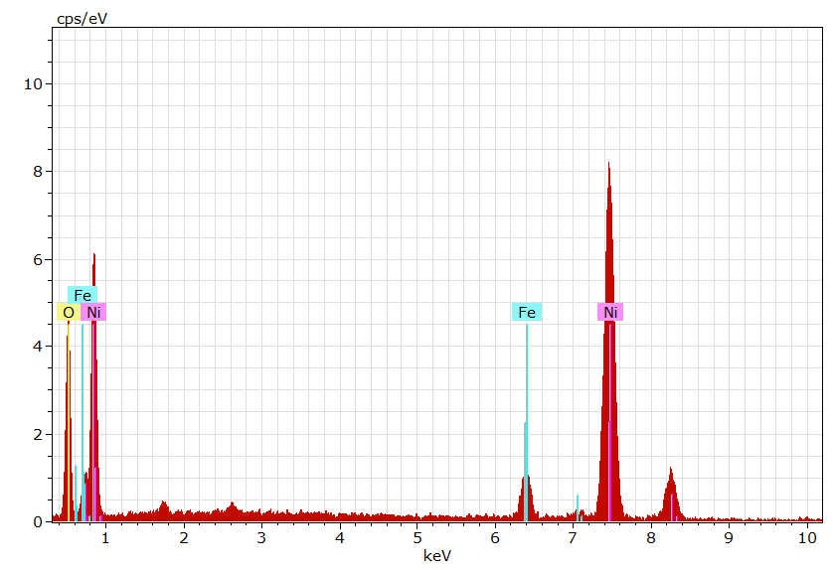

Figure 1.8 EDS image of 5 (wt %) Fe doped NiO nanoparticles

It clearly specifies that the average crystalline size of Undoped NiO is to be present in the range of 20nm and having a cubic structure.[12] From the figure 1.7 (a). Note that the particles are in agglomeration with nearby ions and unequal size. The crystalline size obtained from TEM images is almost correlated to XRD analysis .As can be seen from figure1.7(b) formation of the 7 wt% Fe doped NiO nanoparticles has been transformed to nanoclusters . Herein the particles are severing agglomeration and Fe ions incorporation with Ni site. The particles size found to be below 10 nm and the similar result confirmed by XRD analysis. Figure 1.7 (c) represents the SAED pattern of Fe doped NiO samples, which are, observed in clear rings of polycrystalline nature and it, confirmed the face centered cubic. The d-spacing value estimated from SAED patterns were established to be in excellent agreement with structure analysis. The EDS analysis of 5 wt % Fe doped NiO illustrates the figure 1.8. The analysis confirmed that there only ions of Ni, Fe and O ions only. Fe ions were found in the EDS spectra, signifying the Fe ions effectively doped in the NiO lattice.[11,13]

1.8 FTIR SPECTRA OF NiO/Fe DOPED NiO NANOPARTICLES

FT-IR spectroscopy is a helpful tool to identify the organic functional group of the prepared samples. Figure 1.8 shows the FTIR spectrum of NiO and different concentrations of Fe doped NiO nanoparticles respectively and presented in the range of 4000 to 400 cm⁻¹ .There is no more impurities peaks observed from this spectrum analysis .The first absorption band centered at 3430 and 1630 cm⁻¹ is attributed to the O-H stretching and bending vibration of water groups. The broad absorption at 1017 cm⁻¹ assigned to O-C=O symmetric and asymmetric stretching vibration modes. Here in a weak peak appear at 709-670 cm⁻¹ represents the Ni-O phase present in the system and the peak of 570 cm⁻¹ have a weak peak for all Fe doped NiO samples. This is not show for undoped sample then the Ni ions incorporated with Fe lattice. The broadness of Ni-O absorption band at 420 cm⁻¹ confirms that the Ni-O nanoparticles are crystallized. Irrespective of the dopant Fe ions reduces the absorption peak of 429 cm⁻¹. Finally, FTIR spectra confirmed the presence of Fe, Ni and O ions in synthesized sample. This is good agreement with the XRD results [14,15].

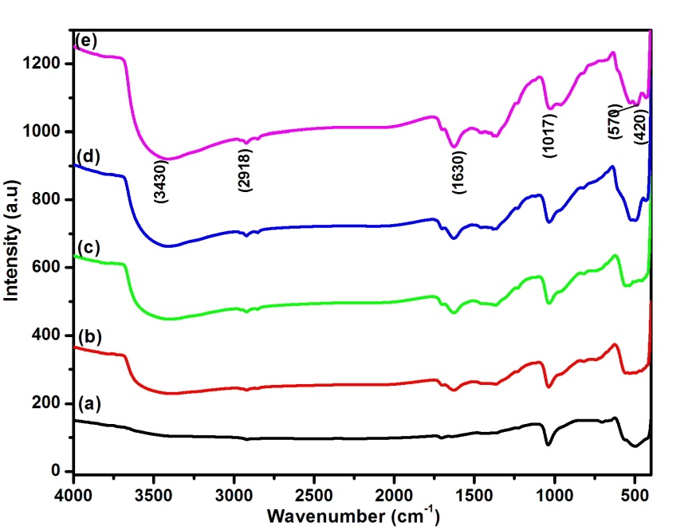

Figure 1.9 FTIR spectrum of (a) undoped (b) 1, (c) 3, (d) 5 and
(e) 7 (wt%) Fe doped NiO nanoparticles.

1.9 MAGNETIC CHARACTERIZATION
Room temperature magnetic behavior of undoped and 7% Fe doped NiO samples was measured by using vibrating sample magnetometer. The magnetization (M_{s}) for undoped and 7 % Fe doped sample is 9.0382 x 10⁻⁶ and 35.848 x 10⁻³ emu, respectively. Figure 1.10 (a) shows the hysteresis loop of undoped NiO shows the ferromagnetic nature. Room temperature ferromagnetic behavior of NiO nanoparticles has been reported [16]..From Figure1.10 (b) noted that 7 % Fe doped NiO hysteresis loop shows the shape of superparamagnetic material .It is confirmed that Fe³⁺ ion can replacement for Ni²⁺ ions in the NiO host lattice.[17] The observed magnetization value is increases with enhanced doping concentration of Fe in NiO nanoparticles and it is reason for superparamagnetic behavior of soft magnetic material [18].
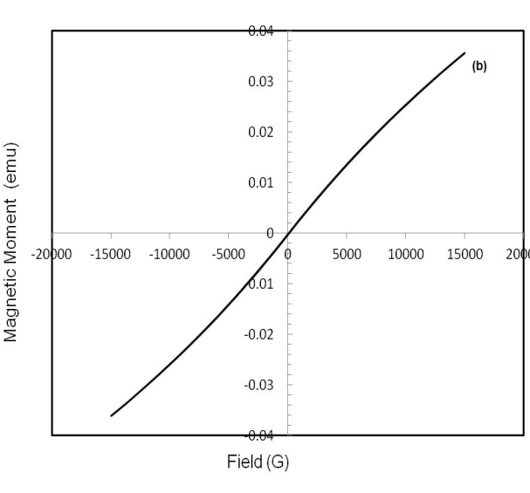
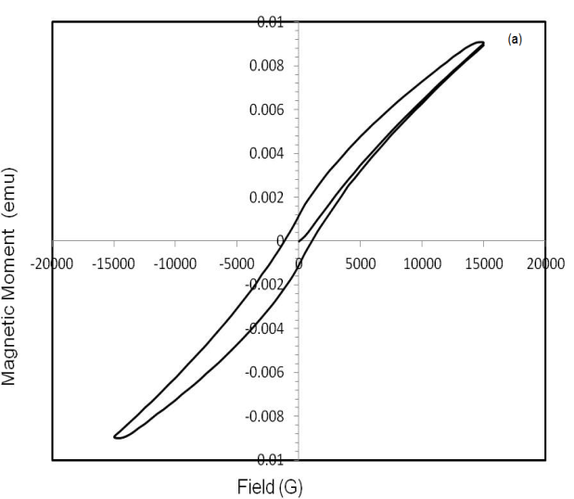

Figure 1.10 M-H hysteresis loop of (a) undoped (b) 7 (wt%) Fe doped NiO nanoparticles
Also, the reduced particle size of 7% of Fe doped NiO (5.5nm) as compare to NiO (28 nm) is also suggestive to enhance magnetization value. In addition to this the coercivity of 1120 G and 13.09G for the undoped and 7% of Fe doped NiO sample [19]. For superparamagnetism, coercivity should be less than 60 G. Finally, it is concluded that Fe doped NiO nanoclusters are superparamagnetic nature and it may be used in the area of magnetic storage device.
1.10 Conclusion
NiO and Fe doped NiO nanoparticles have been successfully synthesized by chemical precipitation method. XRD result confirmed that the synthesized samples have FCC structure and the average grain size decreases with Mn concentration increases. This result is also confirmed by particles size analyzes and TEM analysis. Tauc’s relation result confirmed the energy gap of the synthesized nanoparticles is less than that of bulk NiO.. The functional group identified from the formation of NiO and Fe doping. EDX analysis confirmed that there only ions of Ni, Fe and O ions only AFM analysis confirmed that Mn doping increases the particles size reduces. PL studies confirmed that the violet emission from the NiO and Fe doped NiO is assumed to be the recombination from the defect centers such as O and Ni interstitials. Room temperature magnetic behavior confirmed that the prepared nanoparticles are superparamagnetic nature.

References
- .H. Z. Lin, B. An, C.W. Nan, R. Zhao, X. Xu, M. Kobayashi, “Ferromagnetism in antiferromagnetic NiO-based thin films”, J. Appl. Phys., Vol. 110 (2011) pp. 043921-4.

- Y. Hou, Z. Xu, S. S. Angew “Controlled Synthesis and Chemical Conversions of FeO Nanoparticles”, Chem. Int. Ed., Vol. 46 (2007) pp. 6329 –6332.

- Yanglong Hou, 2007 J. Xie, C. Xu, N. Kohler, Y. Hou, S. Sun, “Controlled PEGylation of monodisperse Fe₃O₄ nanoparticles for reduced non‐specific uptake by macrophage cells” Advanced Materials, Vol. 19 (2007) pp. 3163-3166.

- J. Tauc, A. Menthe, “States in gap”, Journal of Non-Crystalline Solids, Vol. 8 (1972) pp. 569-585.

- J.I. Pankove, “Optical process in semiconductors”, Prentice–Hall, Englewood Cliffs, N J, (1971).

- G. Sinffect of grian size on optical properties of FeO nanoparticles, AIP Conference Procedings, Vol. 1728 (2016) 020409.

- P.M. Ponnusamy, S. Agilan, N. Muthukumarasamy and D. Velauthapillai, “Structural, optical and magnetic properties of undoped NiO and Fe-doped NiO nanoparticles synthesized by wet-chemical process”, Materials Characterization (2016), doi: 10.1016/j.matchar.2016.02.020.
- K. Anandan, V. Rajendran, “Structural, optical and magnetic properties of undoped NiO and Fe-doped NiO nanoparticles synthesized by wet-chemical process”, Nanosci. Nanotech., Vol. 2 (2012) pp. 24–29

- K. Sathishkumar, N. Shanmugam, N. Kanndasan, S. Cholan, G. Viruthagiri, “Influence of Zn²⁺ ions incorporation on the magnetic and pseudo capacitance behaviors of NiO nanoparticles”, Mater. Sci. Semicond. Processing, Vol. 27 (2014) pp. 846–853.

- J. Wang, J. Cai, Y.H. Lin, and C.W. Nan “Room-temperature ferromagnetism observed in Fe-doped NiO”, Applied Physics Letters, Vol. 87 (2005) pp. 202501.

- S. Peng, C. Wang, J. Xie, and S. Sun, “Synthesis and Stabilization of Monodisperse Fe Nanoparticles”, J. Am. Chem. Soc., Vol. 128 (33) (2006) pp. 10676–10677.

- A. Kurokawa, N. Saka, L. Zhu, H. Takeuchi, S. Yano, T. Yanoh, K. Onuma, T. Kondo, K. Miike, T. Miyasaka, and Y. Ichiyanagi, “Magnetic properties of Fe-doped NiO nanoparticles”, Journal of the Korean Physical Society, Vol. 63 (2013) pp. 716.

- D. Gao, J. Zhang, J. Zhu, Q. Jing, Z. Zhang, S. Wenbo, S. Huigang, D. Xue, “Vacancy-Mediated Magnetism in Pure Copper Oxide Nanoparticles”, Nanoscale Res. Lett. Vol. 5 (2010) pp. 769.

- S. Harish, M. Navaneethan, J. Archana, S. Ponnusamy C. Muthamizhchelvan, Y. Hayakawa, “Chemical synthesis and properties of spindle-like CuO nanostructures with porous nature”, Mater. Lett. Vol. 139 (2015) pp. 59-62

- S.Berbethmary,K.Nalini,K.Rajalakshmi,Synthesis,Characterisation and thermoelectric properties of Ca substituted nanostructured SrMnO3 by sol-gel hydrothermal method,Material Today:Proceedings57(2022) 2344.
- L.F. Koao, B.F. Dejene, H.C. Swart and T.E. Motaung, “Dependent of Reaction Time on Cu-Doped ZnO Nanostructures Prepared by Chemical Bath Method”, Inter. J. Lumin. Appln, Vol. 5 (2015) pp. 54-61.

- S. N. Sahu, K. K. Nanda, “Nanostructure semiconductors: Physics and applications”, Proc. Indian National Science Academy. Vol. 67 (A) (2001) pp. 103-130.

- P. Singh, A. Kaushal, D. Kaur, “Mn doped ZnO nanorystalline thin films prepared by ultrasonic spray pyrolysis”, Journal of Alloys Compounds, Vol. 471(2009) pp. 11-15.

- T. Jan, J. Iqbal, Q. Mansor, M. Ismail, M.S. Haider Naqvi, A. Gul, S.F.H. Naqvi, F. Abbas, “Synthesis, physical properties and antibacterial activity of Ce doped CuO: a novel nanomaterials”, J. Phys. D Appl. Phys, Vol. 47 (2014) pp. 355301(7pp).

