**BIOSYNTHESIS OF SILVER NANOPARTICLES USING THE CULTURE SUPERNATANT OF CYANOBACTERIA *Phormidium fragile* AND ITS BIOCIDAL EFFECT ON *Xanthomonas oryzae.***

**A.L. Palanisamy**

PG & Research Department of Botany,

Alagappa Government Ars College – Karaikudi – 630 003, India.

**1.Introduction**

Nanobiotechnology refer to fabrication of biological material with metal ions. It is an eco-friendly technology and have not use synthetic chemicals. The bio nanomaterials are the most promising since they exhibit strong antibacterial characteristics and allow for the invention of brand-new drugs to combat strains that are resistant to numerous drugs.

Previous literature revealed that the Bio nanomaterial synthesis using micro algae as source has been unexplored. Recently there are a few reports that microalgae is being used as a bio factory for synthesis of metabolic Nanoparticles

In the current research, the culture supernatant of cyanobacteria *Phormidium fragile* was used for synthesis of silver nanoparticles and the nano material was characterized by using UV-visible spectroscopy, XRD, and FTIR. The synthesized nanoparticle was used for the study of bactericidal assay against rice blight bacterial pathogen *Xanthomonas oryzae.*

**2.Objectives**

1. To synthesis silver nanoparticles using the culture supernatant of Cyanobacteria *Phormidium fragile* as reducing agent.

2. To characterize the synthesized nanoparticles by UV-visible spectroscopy, XRD, And FT IR.

3. To study the bactericidal effect of nanoparticles against the blight disease pathogen of rice *Xanthomonas oryzae.*

**3.Methodology**

*Phormidium fragile's* culture supernatant was filtered using Whatman No. 1 filter paper, and the filtrate was then centrifuged at 5000 rpm for 5 minutes before being transferred to a 250 mL Erlenmeyer flask and kept at 40 °C for subsequent investigations. The filtrate is used for reducing and stabilizing agent with 1mM silver nitrate (AgNo3) solution. By acquiring the UV-Visible spectra of the reaction mixture at different time intervals via 1hr, 2hr, 3hr, 4hr, and 5hr, the reduction of Ag+ ions was detected. by scanning the absorbance spectra in 250-650 nm range of wavelength. The freeze- dried, powdered silver nanoparticles were used for FTIR and XRD analysis (Jain *et al.,* 2009).

*The bacteria Xanthomonas oryzae* was used for the experiment. The pathogen was sub-cultured on nutrient agar medium and disc diffusion assay was performed to observe the dose dependent assay of nano material on test bacteria. A single colony of bacteria was grown overnight in nutrient broth medium, and then the log phase culture of *Xanthomonas oryzae* was swabbed over the agar plates to create the bacterial culture. Following that, nutrient agar plates were covered with discs coated in nanoparticles and some antibiotic discs, and the plates were incubated for 24 hours at 30℃. A clean zone surrounding the disc after incubation showed signs of antibacterial activity. The zone of inhibition's diameter was calculated in millimetres. Three duplicates of each test will be run.

**RESULT AND DISCUSSION**

**4.1 Formation of silver nanoparticles**

It was explored how *Phormidium fragile* culture supernatant produced silver nanoparticles. Two flasks of *Phormidium fragile* culture supernatant following a 12-hour interaction with Ag+ ions are shown in Fig. 2. The supernatant was seen to have no change in colour. Right flask shows the colour after the reaction is complete, which is brownish before the interaction with the silver ions. The presence of a yellowish-brown colour in a solution containing a biological agent is conclusive proof that silver nanoparticles have formed in the reaction medium and are doing so due to the nanoparticles' activation of surface plasmon vibrations (Sastry et al., 1998).

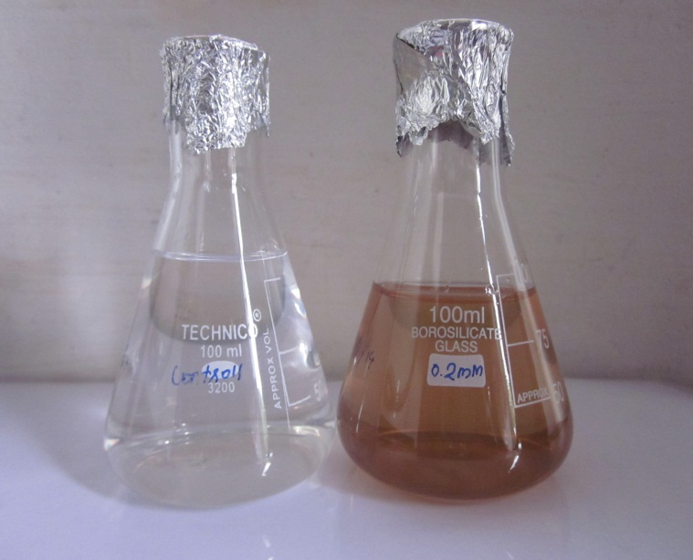

**Fig .2: Conical flasks containing the aqueous extract before to (left flask) and following the 12-hour reaction with Ag+ (right flask).**

**4.2 Ultraviolet-Visible spectroscopy**

UV-visible spectroscopy is used to identify silver nanoparticles. In a graph (Fig. 3), the UV-visible spectra of the culture supernatant of *Phormidium fragile* in reaction medium at various reaction time intervals are displayed. The silver nanoparticles' surface plasmon resonance peak was seen in the spectra to occur between 410 and 420 nm. Using a quartz cuvette containing silver nitrate as the reference, the UV-visible spectrum of the colloid of silver nanoparticles has been recorded as a function of time. For the examination of metal nanoparticles, this method has proven to be highly helpful (Sastry et al., 1998).

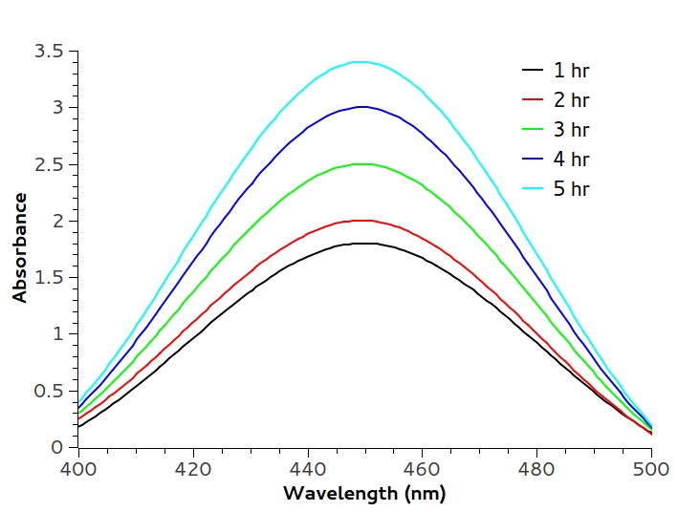

**4.3 X-ray diffraction Analysis**

The distinctive XRD Peaks (Fig. 4) further supported the conclusion that silver nanoparticles were synthesized utilizing the culture supernatant of *Phormidium fragile.* Seven peaks can be seen in the XRD pattern, with the strongest peaks occurring in the spectrum of 2 values between 32.19 and 77.29 (Table 1). The Joint Committee on Powder Diffraction Standards has released an XRD spectrum of the crystalline silver structure (file no. 04-0783). It is possible to correlate the diffraction at the 32.190, 38.07, 64.50, and 77.29 wavelengths with the (111), (200), (220), and (311), respectively, planes of the face-centered cubic (fcc) silver.

The Debye-Scherer equation and the measured FWHM values for the 111, 200, 220, and 311 planes of reflection were utilized to determine the size of the nanoparticles. The particles ranged in size from 0.023 nm to 2.2 nm, with an average particle size of 2.6 nm. The structure and particle size of nanoparticles were determined using wide angle X-ray diffraction (WAXs). Bragg peak broadening is an example of face-centered cubic (fcc). Sathyavathi and others (2010)). Thus, the XRD pattern clearly demonstrated that the nanoparticles produced by the *Phormidium fragile* culture supernatant are crystalline in nature (Huang et al., 2007).

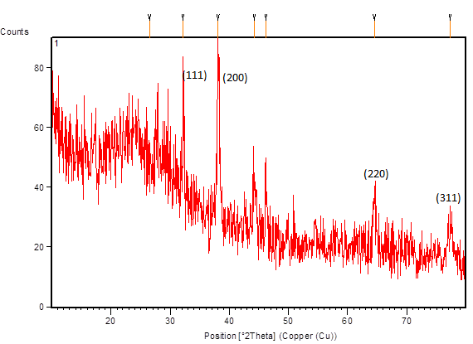

**fig.4. XRD Pattern of synthesized silver nanoparticles (peaks corresponding to silver).**

**Table 1. Size of the NPs synthesized by the extract of *Phormidium fragile*.**

|  |  |  |  |  |  |
| --- | --- | --- | --- | --- | --- |
| **Pos(2T◦h)** | **Height**  **(cts)** | **FWHM Left(2Th◦)** | **d spacing**  **(A◦)** | **Rel.int(%)** | **Size of**  **Silver nanoparticles**  **(nm)** |
| 6.5(2)  32.190(8)  38.072(2)  44.25(4)  46.21(3)  64.50(5)  77.29(7) | 14(2)  49(6)  42(5)  14(2)  14(3)  10(2)  9(2) | 8(1)  0.07(2)  0.39(7)  0.6(1)  0.32(8)  0.6(1)  1.0(2) | 3.35956  2.77854  2.36212  2.04505  1.96313  1.44349  1.23343 | 27.63  100.00  85.59  28.35  28.27  21.21  17.57 | 0.023  2.2  0.38  0.25  1.00  0.36  0.25 |
| Average size of the Nano particle is = 0.63 | | | | | |

**4.FTIR-Analysis**

It was observe that the possible interaction between silver ions withaqueous extract of *Phormidium fragile* is shown in Fig.5.The small peak at 3919.08, 3779.94, 3692.97 were corresponding to O-HStretching.The peak at 3409.02 represent N-H (amines, amides).The small peaks at 2921.83 represent C-H (in alkanes), C=N respectively.The strong brond peaks at 1597.68 and 1383.15 were corrsponding to C=C, C-H (in alkanes) respectively. The broad bond at 1026.25 represent C-O (either, alchol etc.). These bonds are located at a location that is similar to that of native proteins, according to Golbulic et al. (2000).



**Fig. 5: FTIR of the band representing various functional groups.**

**4.5 Bactericidal assay**

The antibacterial activity of synthesized nanoparticles and commercially available antibiotics were carried out against *Xanthomonas oryzae.* The silver nanoparticle showed considerable zone of inhibition against *Xanthomonas oryzae.* The zone of inhibition of commercial antibiotics likeTetracyclineand Ampicillin disc showed inhibition hallow of 3.8mm and 2.9mm respectively (Table 2and fig .6).

The inhibitory zone was described using the triplicate mean value and mm. It was also investigated how well different silver-based antibacterial agents in polyamide released silver ions into an aqueous media. Algae, yeast, and fungi were among the plants in which the effectiveness of various silver-based antimicrobial agents in polyamide towards their silver ions discharged in aqueous medium was documented (Arya, 2010).

**Table 2: Zone of inhibition (mm) of Nano particle against Xanthomonas oryzae**.

|  |  |  |  |  |
| --- | --- | --- | --- | --- |
| **S.NO** | **Name of the organism** | **Nano particles 10µg/ml** | **Antibiotics** | |
| **Tetracycline 10µg/ml** | **Ampicillin 10µg/ml** |
| 1. | *Xanthomonas oryzae* | 2.7 | 3.8 | 2.9 |
|  |  |

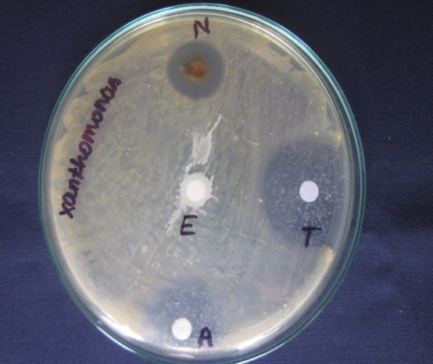

**Fig: 6 *Xanthomonas oryzae* N- Nanoparticles T – Tetracycline A – Ampicillin E- Plant Extract**

**5. Summary**

A significant subfield of nanotechnology is developing around the environmentally responsible creation of nanoparticles. Traditionally metallic silver nanoparticles are synthesized by wet chemical synthesis techniques. Such approach uses toxic chemicals. The present study deals with the alternative, cost effective and green approach. For the reduction of silver ions, *Phormidium fragile* culture supernatant is employed. Changes in the reduction medium's colour are typically used to detect the synthesis of silver nanoparticles. The medium's colour changes to brown.

In UV visible spectroscopy, the peak value increases between 440-460 nm rang , indicating the biosynthesis of nano particles. Further, the synthesized silver nano particles are confirmed by XRD The peaks at 32.19, 38.07, 64.50 and 77.29 indicates silver nano particle.

Using the Debye-Scherer formula, the nanoparticle's average size is determined. The average size of nanoparticles was determined to be 0.63 nm. Xanthomonas *oryzae* is the target of the synthesized nanoparticles' antibacterial action. The zone of inhibition for the synthesized nanoparticle, measuring 2.7 mm, was found to have an inhibitory impact on Xanthomonas oryzae.

**References**

1. Jain, D.H., K. Daima., S.Kachiwaha and S.L.Kotheri.2009. Synthesis of plants mediated silver nanoparticles using papaya fruit extract an evolution of their antimicrobial activities. Digest Journal of Nanomaterials and Biostrutures. 4:557-563.
2. Golbulic.S, L.senog 2000..Early cyano bacterial record preservation 393.(41). Gole A ,C. Dash ,S.R Sainker ,A.B .Mandle ,M. Rao ,M. Sastry, Anal. Chem.72(2000)14041.
3. Taniguchi, N. 1974. On the basic concept of nanotechnology. Proc. Intl. Conf. Prod. Eng. Tokyo, Part II. Japan Society of Precision Engineering.
4. Huang J, Li Q, Sun D, Lu Y, Su Y, Yang X, Wang H, Wang Y, Shao W, He N, Hong J, Chen C. Biosynthesis of silver and gold nanoparticles by novel sundried *Cinnamomum camphora* leaf. Nanotechnology,2007; (18):105104-105114.

1. Sastry, M., V. Patil and S.R. Sanker. 1998. Electrostatically controlled diffusion of carboxylic acid derivatized silver colloidal particles in thermally evaporated fatty amine films. F Phys. Chem. B. 102: 1404-10.
2. Sathyavathi, R., M. Balamurali Krishna., S. Venugopal Rao., R. Saritha and Narayana Rao. 2010 Biosynthesis of silver nanoparticles using Coriandrum sativum leaf extract and their application in nonlinear optics. Adv. Sci Letters, 3:1-6.
3. Chopra, I.,2007. The increasing use of silver-based products as antimicrobial agents: A useful development or a cause for concern-Author response.J. Antimicrob.Chemother.,59587-590.
4. Karthick.R Ganesh s, evaluation of antibacterial activity of silver nano particles synthsisfrombacteria2011(3).131-140
5. Leela A, Vivekanandan M. Tapping the unexploited plant resources for the synthesis of silver nanoparticles. African Journal of Biotechnology, 2008;(7):3162-3165.
6. Singh, A., Jain, D., Upadhyay, M.K., Khandelwal and Verma, H.N. (2010) Green synthesis of silver nanoparticles using Ar­gemone mexicana leaf extracts and evaluation of their antimicrobial activities. Digest Journal of Nanomaterials and Biostruc­tures,5,483-48.
7. Arya, v.2010, Living system eco-friendly nanoparticle Digest J. Nano meter. Biostr., 5:9-21.