"Metal ions as crucial elements in biological processes: A comprehensive overview"

Aruna Kodipaka¹, Ravi Kumar Vuradi², Praveen Kumar Airva³, Navaneetha Nambigari^{1,2*}and Satyanarayana Sirasani^{2*}.
1. Department of Chemistry, University College of Science, Osmania University, Saifabad, Hyderabad – 500 004, Telangana State, INDIA.
2. Department of Chemistry, University College of Science, Osmania University, Tarnaka, Hyderabad – 500 007, Telangana State, INDIA.
3. Department of Biotechnology, Sri Satya Sai University of Technology & Medical Sciences, Opp. Oilfed Plant, Bhopal- Indore Road, Sehore, 466001, Madhya Pradesh, INDIA.
Email: nitha379@gmail.com. navaneeta@osmania.ac.in. ssnsirasani@gmail.com.
  - Introduction
- Importance of metal ions in life
Metal ions are vital for all living things, comprising plants, animals, and humans. It has been well acknowledged that they have played a vital function in biological systems ever since the beginning of time. They are indispensable for maintaining the sanctity of life and their lack may result in atypical development, severe malfunction, cancer, or even death in some cases. They are promised in a wide range of structural and functional activities and a wide range of metabolic progressions, and they may take on a variety of forms to achieve their goals. When cells communicate with one alternative and with other cells, they contribute to the integrity of the nucleotide base pairs that make up DNA and manage transcription. Materials such as metals are required for the proper utility of neurons, muscle cells, the brain, the heart and oxygen transport. A metallo-enzyme is a type of enzyme that encompasses metals, and there are many of them. As with all metal-binding enzymes, each enzyme has at least one coordination site for the metal, and the metal is in general located in a manner that matches the shape of the substrate. They play a vital role in enzymes' functions. Metalloenzymes are enzymes that catalyse reactions because of the existence of a metal ion. Matrix metalloproteases and nitrogenase are some of the metallo enzymes that fall into this category. In addition, some of the proteins comprise metal, which is necessary for their functions. Metal ions, necessary for life, may be destructive in excess. Sodium, potassium, cadmium, manganese, iron, nickel, copper, chromium, zinc, molybdenum, vanadium, and cobalt are important for human health. Anemia is instigated by Fe and Co-deficiency. Cu deficiency causes brain and heart problems. Zinc insufficiency causes growth retardation and skin aberrations, and calcium deficiency causes bone degeneration., Nonetheless, such as Hg and Pb, definite metal ions can be hazardous due to their lethal properties, making them particularly dangerous. Metal ions normalize enzyme-catalyzed reactions by altering the flow of electrons concluded substrates or proteins. Since biochemical reactions are catalyzed by particular metallo enzymes proceed very slowly in the lack of the metal ion used is incompatible with the reaction. This creates it possible to align functional groups in the active site and bond substrates by means of metal ions. As a result, medicinal bioinorganic chemistry research is progressively focusing on diseases caused by a lack or oversupply of numerous metal ions at the molecular level. When it approaches to discovering new medicines, metal ions are needed. Metals other than essential metal ions are also engaged in the pharmaceutical industry for various commitments. Cisplatin and auranofin are two chemotherapy drugs commonly used to indulgence genito-urinary cancer and head and neck cancer, respectively.
- Transition metal complexes
Transition metal complexes, which are made up of organic ligands, have been acute in the progress of human civilization, particularly in terms of their uses. For example, Ruthenium (Ru) and Platinum metal complexes have flashed considerable attention in various fields. Ru, which occupies an intermediate site in the second row of transition metals, owns both early and late transition metal characteristics in the usual world. The element has a exclusive set of qualities that can be used in a variety of profitable and scientific fields, including medicine, electronics, and diagnostics, as a outcome of its Lewis acidic but less oxophilic nature. Organometallic complexes are unsteady when exposed to air or water. However, numerous bioactive Ru complexes have been discovered that are more stable and less disposed to oxygen and Sulphur than previous peer group. Noble Ru complexes with worthy bio-activity and bio-availability are being established by researchers worldwide. The reduced state of Ru (II) is more responsive than the oxidized state of Ru (III) in physiological conditions. While it is practicable that ligands with varied geometries can direct the six-coordinate octahedral structure of the two oxidation states, it is visualized that they will play a role in a range of biological methods. It is possible to build a wide variety of chiral Ru complexes by changing the ancillary ligands, permitting for a wide range of complexes. Ligand exchange reactions are expected to agree to labile central ligands to connect to disease targets. A cell's lifetime is a reasonable evaluation for the ligand exchange rate of Ru (II) complexes, which ranges from 0.01 to 0.001 s⁻¹. As a result, Ru is deliberated a viable alternative to drugs based on Platinum (Pt). Compared to Platinum-based compounds, Ru compounds are less lethal, and some of them are highly choosy for tumours. The ability of Ruthenium to simulator iron binding to biomolecules may have directed to these phenomena. Because of the increased iron demands, Ru complexes may be more capably delivered to cancer cells if cancer cells have overexpressed transferrin receptors. Bioactive Ru polypyridyl complexes 1–3 (Fig. 1) were first established by Dwyer et al. in 1952., and subsequently, various Ru complexes were acknowledged in the hunt for medicinal and diagnostic agents. Researchers focus much consideration on the potential anti-cancer properties of Ru (II) and Ru (III) complexes. Other usages for these compounds are being studied, such as antiviral and anti-parasitic medicines. The precise methods via which Ru complexes are probably operative against cancer and infections. Most Ru compounds have been observed for antibacterial activity and cytotoxicity in various tumour cells. Researchers are fascinated in the interactions between DNA and Ru complexes due to their latest expansion as chemical and regioselective probes for bioimaging, DNA molecule arrangements, DNA bioanalysis agents, and molecular light switching. Due to their structural difficulty, three-dimensional metal complex structures make excellent building blocks for DNA interaction arrangements. Because Ru complexes can bind to DNA in an unusual way and have different photophysical, photochemical, and electrochemical properties, people are concerned in learning more about them.
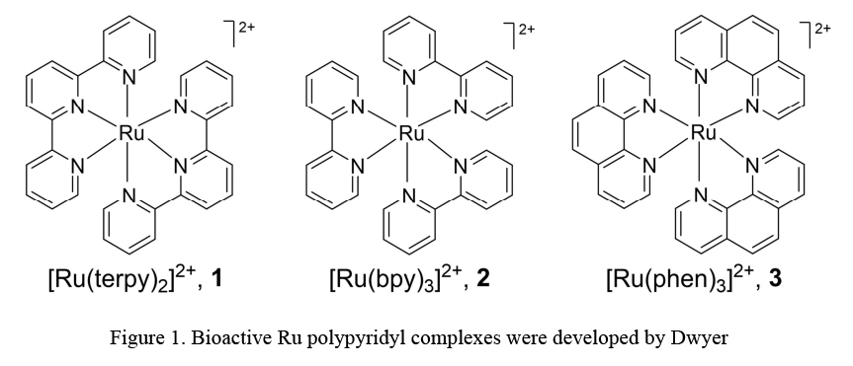
- Structure of DNA and modes of binding
A fundamental description of the structure of DNA is required in order to understand the binding mechanisms of double-stranded DNA. The phosphophate group, nitrogen bases (Adenine, Guanine, Cytosine), and deoxyribose sugar are the building blocks of DNA (Figure.2). The double helix form of deoxyribonucleic acid is achieved by twisting two antiparallel polynucleotide strands together in a helical arrangement. The double helix shape of deoxyribonucleic acid is attained by winding two antiparallel polynucleotide strands together in a helical pattern. Diverse structural variations exist in duplex DNA. The B-DNA is the most predominant type of DNA, followed by "A" and "Z" types.The diameter and pitch of the base pairs in B-DNA are about two nanometers, and they are oriented perpendicular to the helical axis. With a 0.34 nm gap between each base pair, to each helix turn has 10 base pairs. The major groove of B-DNA has measurements of 7.5 Aº depth, 5.7 Aº width, whereas the minor groove has magnitudes of 8.4 Aº depth and 11.7 Aº width. The bases are paired and stacked at a 36º torsion angle.
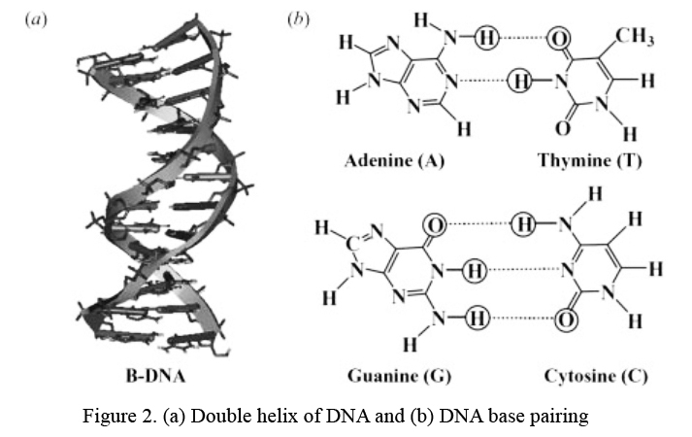
DNA can be bound irreversibly by covalent bonds or reversibly by non-covalent bonds made when small molecules bind. Antitumor medications are an example of an irreversible covalent binder (e.g., Cisplatin and its analogues). Covalent bond formation among Cisplatin and Guanine bases at the N7 position in DNA is accountable for cisplatin's capacity to cross-link, ensuing in intra strand and inter strand cross links. Some of the cell retorts resulting from Cisplatin–DNA covalent interaction comprise replication, transcription, and apoptosis. With Ruthenium complexes, the N7 location of guanine can be cross-linked in the same way as Cisplatin. Reversible non-covalent connection of small DNA molecules is largely mediated by hydrophobic p-p piling interactions, also known as chiral recognition. Planar aromatic molecules and DNA are non-covalently linked. Non-specific exterior association, binding to DNA grooves, and intercalation between DNA bases are the three primary classes of non-covalent binding molecules to DNA. The most recurrent kind of non-covalent binding of minute molecules to DNA is non-specific external association. The three primary mechanisms by which tiny molecules bind to DNA in a non-covalent manner are intercalation between DNA bases, non-specific external connection, and binding to DNA grooves. (Figure. 3). External binding is predominantly electrostatic, which is determined by the ion or molecule's charge, hydrophobicity, and ion size. Moreover, phosphate groups may be covalently connected to metal ions. The DNA duplex may be externally attached via positive metal ions or metal complexes with the negatively charged DNA backbone, and the creation of collections is necessary.
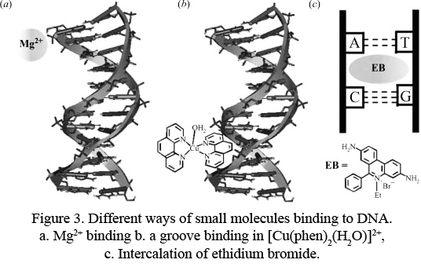
Larger molecules comprising proteins, metal complexes, and oligonucleotides characteristically interact with DNA over the major groove of the double helix instead of the minor groove. Small, flat, and cationic DNA binding molecules select the minor groove, but larger molecules prefer the major groove. An antibiotic that combats tumours, bleomycin, attaches to DNA through its minor groove. Netropsin and distamycin, as two patterns of antiviral antibiotics, are frequently AT-selective DNA minor groove binders. DNA groove binders consist of duocarycins, mitomycins, enedynes, and other DNA-targeted anti-cancer drugs. Subsequently the DNA groove binders are sequence-specific, they may be employed to build and manufacture novel DNA molecular systems fingerprinting and applications for action. Metal complexes comprising organic compounds, such as dipyrido[3,2-a:2′,3′-c]phenazine (dppz), have been revealed to covalently link to the primary groove of DNA. Non-covalent π-π stacking interactions concerning the molecules that are planar and have long aromatic rings and planar aromatic bases stabilise DNA binding in the intercalative mode, which is perpendicularly allied with the major two-fold axis of the double helix. Proflavin , Ethidium bromide, and acridine with a planar aromatic structure display an intercalative DNA binding technique for example [Ru(phen)₂(dppz)]²⁺.
- Cleavage of DNA
Nucleobases, deoxyribose sugars, and phosphodiester linkages are all probable targets in the DNA cleavage process (Figure 4). Cléavage of DNA take place due to the hydrolysis of phosphodiester links in the DNA molecule. DNA oxidation happens when the deoxyribose sugar or nucleobases of DNA are oxidized, as in the case of sugar oxidation. The existence of primary agents is sufficient to basis hydrolytic DNA degradation. However, the enclosure of other co-reactants such as reducing and oxidising agents or light under aerobic conditions is requisite to induce oxidative DNA cleavage. It has also been discovered that oxidative DNA breakdown follows in anaerobic conditions.
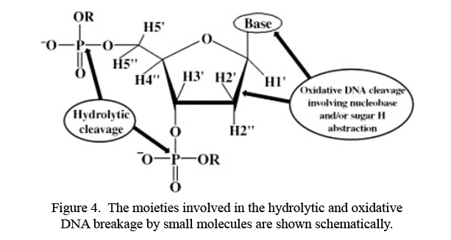
The deoxyribose sugar constituent must have one hydrogen removed from it in direction for the oxidative DNA breakdown to be completed. The oxidation of a nucleobase, remarkably the electron-rich guanine base, may also be used to divide DNA ever since it has the lowest potential for oxidation of any DNA base. A metal complex attached to DNA and singlet oxygen can attack guanine, which is positioned at the position of electron transfer. Oxidation can't be static because it stops the cell's repair process from employed properly, which leads to cell death or apoptosis.
Cleavage of DNA by hydrolytic enzymes.
At the physiological pH of 7, DNA has an extensive half-life and is hydrolytically passive. Several nucleases occur naturally, e.g. purple acid phosphatase, endonuclease IV, and Lewis acid transition metal ions. Hydrolases must have three characteristics in order to be in effect:(1) Lewis acidity, (2) oxygen affinity, and (3) substitutional lability. A nucleophilic attack of water oxygen on phosphorus consequences in the creation of a five-coordinate phosphate transitional in the hydrolysis of phosphodiester links in DNA. (Figure. 5). A exhaustive examination of Lanthanide complexes was accepted out by Schneider and colleagues, who were able to recognize the kinetic parameters of plasmid DNA cleavage.
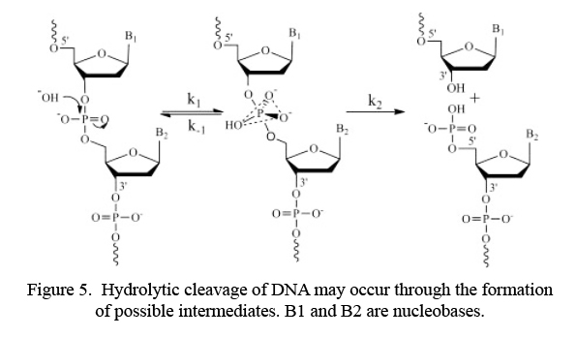
DNA cleavage using oxidative methods
The deoxyribose sugar Hydrogen atoms or nucleobases may be the goals of oxidative DNA breaking. After being stimulated by an external agent, metal complexes that have been cautiously designed for their redox properties produce sensitive oxygen species, which can cause DNA strand scission under oxygenated limits (Figure. 6)., Exogenous agents (Iron-(II)-bleomycin, Iron-(II)-EDTA) cause oxidative cleavage of DNA, which is mentioned to as "chemical nuclease".
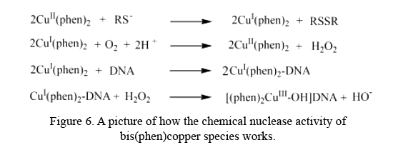
When open to light, synthetic nucleases can cause oxidative DNA fracture. Under certain conditions, oxidation of the nucleobase or sugar moiety by reactive oxygen species or radicals generated by photo activated molecules may occur in an aerobic or anaerobic medium liable on the conditions present. Chemical nuclease activity is one of the best common oxidative DNA breaks. The other form is photo activated DNA cleavage. This approach consists of three processes: (1) direct electron transfer; (2) the excited photosensitizer transfers triplet energy to O₂, which oxidises by producing singlet oxygen; and (3) the formation of an adduct with base. It is critical to develop metal complexes that can breakdown double-stranded DNA sequences under common conditions. The major groove accesses the 30- and one 20-position hydrogen atom, while the minor groove accesses the 50-, 40-, and 10-positions of B-form DNA. The minor groove targets one 50-hydrogen atom, whereas the DNA backbone is avoided. The minor groove of B-DNA has both 50- and 40- hydrogen atoms. Colson and Sevilla discovered that H^{1′} abstraction was the most energy-efficient method, whilst H²′ removal was the least energy-efficient method. H1′ has also been proven to be inaccessible to oxidising species that are passed in the solvent. Hydrogen atoms with a 5′ and 4′ are at ease to reach. According to Spotheim-Maurizot et al., the probability of hydroxyl radical-induced hydrogen abstraction from an 80 base pair duplex is noteworthy in the 5′ and 4′ positions. Apart from Fe-Bleomycin (BLMs), Sigman and colleagues discovered another outmoded metal-based chemical nuclease, bis(1,10-phenanthroline) Copper(I) complex, [Cu(phen)₂]⁺¹ , while examining how phen inhibits Escherichia coli DNA Polymerase-I. Hydroxyl radicals and Copper bound species such as [ CuO]⁺ and [Cu (OH)]²⁺ are examples of these (Figure 6). DNA is covalently involved to the iron complex of EDTA by means of a tiny spacer. Ethidium bromide is an intercalator for DNA (Figure 7). Responsive Fe (II) species are created when the complex is condensed, and these species may mimic the oxidative DNA cleavage activity of Fe-BLMs. This is a distinctive Fenton-type chemical event.
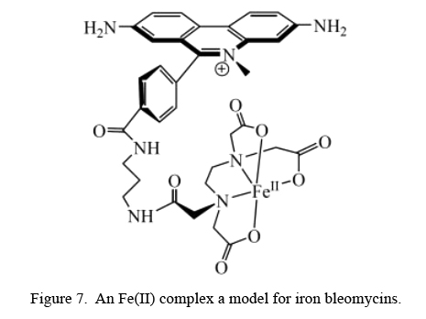
- The photo cleavage of DNA: A look at the mechanisms
In the chronological, light therapy has been used to treat a wide range of diseases, together with skin cancer, vitiligo, and rheumatoid arthritis. Even, high-energy UV is extremely mutagenic and genotoxic, leading to the following properties on the human body: breaking single or double strands and cross-linking in the middle of bases. Due to the dangers of UV light, researchers are employed to develop phototherapeutic photosensitizers that are initiated by low-intensity visible and UV light to accomplish desired healing results, particularly for illnesses such as cancer, which are presently untreatable. To appreciate the photochemistry of photodynamic treatment (PDT) agents and the mechanism of act and the reaction pathways of the photosensitizing molecule itself, it is vital to understand their photochemistry. Photosensitizers are materials that can take in light and send energy to other molecules to start chemical reactions. This is one of the main thoughts behind photodynamic therapy. Stochel and colleagues (Figure 8) printed an excellent review in which they encompassed an excellent Jablonski diagram that may be used to characterize the activities of photoactivated molecules in action.
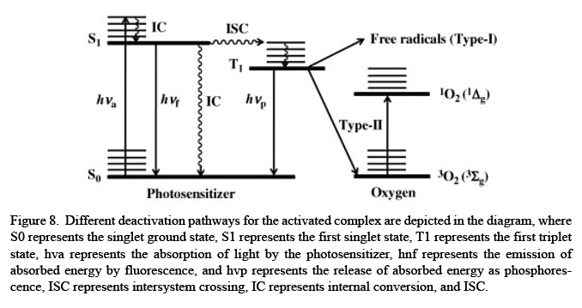
When a molecule captivates light of the appropriate wavelength, it arrives a photoactivated state, which causes major variations in the charge–electron distribution of the molecule, causing in changes in its chemical and physical properties. Bestowing to a review work by Burrows and Muller, light-activated particles may go through a number of physical segments. Figure 9 depicts the physical stages that light-activated molecules can go through.
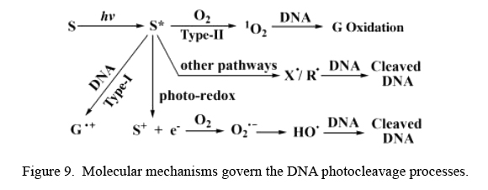
The photoactivated molecule undertakes photochemical reactions from their lowermost energy excited states, in addition to radiative procedures, when they are exposed to light (e.g., fluorescence and phosphorescence). The Type-I, Type-II, and photo-redox paths are the most commonly used techniques of deactivating a photo activated molecule. Each of these paths has been thoroughly studied in the literature.
Mechanism of Type I pathway
In photodynamic therapy (PDT), which covers the transfer of electrons from a DNA guanine base to a photosensitizer in a photo-excited state, the Type-I procedure is a crucial avenue. An organic molecule in a sufficiently stable triplet excited level may generation of chemically reactive free radicals. 8-oxoguanine can bring DNA damage. By oxidising guanine, which can make a Type-I pathway, riboflavin, and anthraquinones, photographic stimulation helps DNA strands break apart. According to the researchers, the photo activation of the enediynes may effect in the breakdown of both single-stranded and double-stranded DNA. PDT desires to invest in the research and development of compounds that follow the Type-I pathway since these compounds may be dynamic in cells with low oxygen levels, distinctive in cancer cells.
Mechanism Type-II pathway
The photosensitizer's triplet state, which has an energy of more than 94 kJ M⁻¹, is shifted towards the acceptor, which is regularly triplet state molecular oxygen, in the Type-II method. As a result, a reactive singlet oxygen species is made. In PDT, organic dyes like phthalocyanine and cytotoxic singlet oxygen through a Type II pathway, which is destructive to cells. During the photo cleavage of DNA, guanine is altered to 8-oxo-guanine, which is a product of the Type-II pathway. The photosensitizer must be incapable to be oxidised over singlet oxygen, transfer of energy to a triplet oxygen molecule must be competent, with correct energy level must outcome in a high singlet oxygen quantum yield, and the triplet state must stay long adequate to make the PDT Type-II process function. These are the most often encountered criteria for pesticides and herbicides generated from organic sources. When there isn't enough oxygen in the cell, the Type-I pathway is superior at damaging DNA than when there is sufficient oxygen. This makes these compounds less active. For the photosensitizer to work, it also desires to be safe in the dark and for cancer cells to captivate it more than healthy cells. The possibility that some compounds may form reactive oxygen species in cells when they are not exposed to light is known as "dark toxicity," and it has been presented in many studies. It is recommended that PDT applications evade the use of such compounds. Metal complexes and organic macrocyclic dyes can cause DNA damage through the singlet oxygen path.
Photo redox pathway
When an excited molecule undergoes redox reactions and is exposed to oxygen, the photo redox pathway causes oxidative DNA damage. When a molecule releases an electron, it causes reductive DNA cleavage. A photo redox method must be used when both Type-I and Type-II procedures be unsuccessful to destroy DNA. Organic photo sensors can yield hydrogen peroxide and oxygen radicals when they oxidise organic photosensitizers in redox-active metal complexes. This procedure has the advantage of not requiring any external oxidising or reducing chemicals, contrasting other procedures that do.
Alternative routes
Additional pathways might result in DNA damage in count to the three main mechanisms of photo-induced DNA damage involving halogen-free radicals (X). Additionally, the impairment caused by the photo release of alkyl radicals, carbon monoxide, or nitric oxide can be acknowledged. A limited number of different pathways are presented for compounds that photo-irradiate with near-infrared light. It is also probable to create alkyl radicals by consuming organometallic complexes that are half-sandwiched. Halogenated organic molecules can breakdown the C-X bond, which makes C-based radicals that can interruption DNA.
- Ruthenium polypyridyl analogues as anticancer
Cisplatin (4), a Platinum (Pt) anti-cancer drug, is an amazing illustration of turning an accidental finding into a medicine. Three anti-cancer drugs based on Platinum have been licenced and are now utilised in clinical practice, including carboplatin (5) and oxaliplatin (6), (Figure 10).
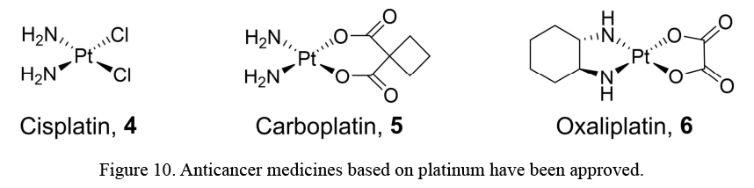
Though Pt-based medications have had great achievement as chemotherapies, they do come with a few disadvantages: they are ineffective against a large number of commonly happening cancers; There is widespread drug resistance; additionally, they have a number of disparaging adverse reactions, including nausea, hair loss, and nerve damage. Ru compounds have developed as the most promising possibilities in the hunt for alternative metal-based anti-cancer medicines. Several Ru-based anti-cancer drugs have been developed. Nevertheless, none are now used in therapeutic settings. Only a few number of anti-cancer Ru-based medications are currently being used in clinical settings. NAMI-A, KP1019, TLD1443 and other Ru-based chemotherapeutics have all made it into clinical trials, prominent to Ru-based anti-cancer medication research being a perceptible area of focus in the pharmaceutical industry, (Figure 11).
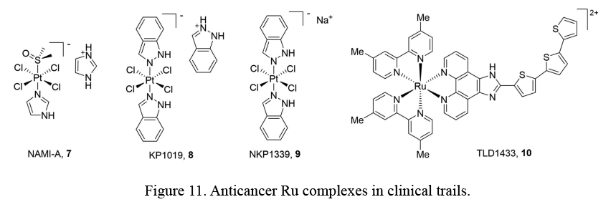
But in vitro and in vivo studies using NAMI-A and KP1019 have discovered significantly different characteristics, in view of their structural resemblance. When tested in secondary tumours, NAMI-A had antiangiogenic and antimetastatic activity, even though KP1019 displayed action in a variety of primary tumour types. Phase I & Phase 2a medical studies of TLD1433 (10) for the treatment of bladder cancer with PDT have started.
Ruthenium polypyridyl
Scientists are enthusiastically searching for novel, Ru-based cancer treatments with an extensive range of activity and fewer contrary reactions. Five polypyridyl compounds were water-soluble and near-IR dynamic with Ru (II) prepared by Cadoso et al. The complexes were incandescent in the near IR region because they joined non-covalently to bind to the HSA protein. Cellular localization & metal complex dispersal may be seen using this method. Using luminous confocal microscopy, scientists discovered that the compounds were vastly absorbed by HCT116 cells. The complexes' capability to inhibit the development of cancer cells was evaluated & all of their IC values were analogous to those of cisplatin. For the most part, the cytotoxicity of RuphenImH (11) was ascribed to its hydrogen-bonding ability of the imidazole ligand (Figure 12).
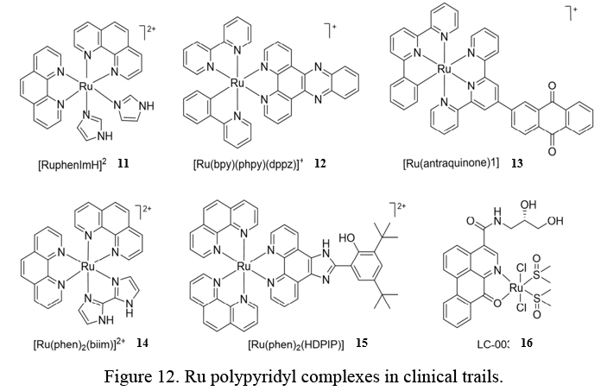
An anti-cancer agent established by Huang et al. was an inert complex of [Ru(bpy)(phpy) (dppz)] ⁺. Two hours later incubation with compound 12 in cancer cells, 90percent of a complex structure had grouped in the nucleus of the cancer cell. The cancer cell lines on the panel, 11 anti-cancer actions were tested, and the compound exhibited IC values ranging from 0.6–4.3 M, which are orders of magnitude not more than those of cisplatin. 11 lipophilicity and stability were improved for cancer cell nuclei penetration via a covalent connection in the middle of Ru and carbon. Anthraquinones containing Ru (II) were also presented to be high cytotoxicity for both cancer cells in normoxic and hypoxic disorders, bestowing to Zeng et al. The cytotoxicity of the complexes is equivalent to or superior to cis-platin in the HeLa, A549, and A549R tumour cell line. Whose anti-cancer abilities have been connected to its lipophilicity & capability to enter cells. In 3D multicellular tumour spheroids and hypoxic cells, cisplatin was 46-fold more proficient at affecting cell death and 61-fold beyond that of the utmost active chemical 13. Mitochondrial apoptosis was exaggerated by compound 13 in hypoxic HeLa cells from end to end numerous synergistic paths. Xia et al. 3 Ru (II) complexes and with a bivalent bisimidazolo ligands were made and studied. In an interaction investigation, Ru complexes and human telomeric G-quadruplex DNA show a strong affinity for each other. The most in effect of them all in causing mixed or hybrid G-quadruplexes was [Ru(phen)(biim)] (14). In compare to the positive control cisplatin, 14 had the most inhibitory action in the direction of HeLa, A549, and HepG2 cells because of their capacity to bind to G-quadruplex DNA. Tumor cell apoptosis by compound 14 through apoptotic mitochondrial pathways. Han et al. also stated on the synthesis of Ru (II) polypyridyl complexes and then the analysis of their anti-cancer actions. Compounds all inhibited cell improvement within G0/G1 phases in A549 cells by decreasing only the possible of the mitochondrial membrane. [Ru(phen) (HDPIP)] (15), the most active compound, was shown to have cytotoxicity comparable to cisplatin in SK-BR-3, MG-63, A549, and BEL-7402 cell lines. According to the outcomes, A549 was the most sensitive cell line, even if MG-63 was the least. Compound 15 stimulated cell death in A549 cells by increasing ROS levels and weakening mitochondrial membrane potential, specifying that ROS-mediated mitochondrial dysfunction is the mechanism over which Compound 15 causes apoptosis. Chen et al. Additionally, they combined chiral oxoaporphine (FOA) with three water-soluble Ru (II) complexes. 4-(2,3-dihydroxy propyl) ligands and verified their anti-cancer properties in vitro and in vivo. The compounds become stable telomeric and G-quadruplex DNA in the c-myc promoter by hindering telomerase. In vitro cytotoxicity tests discovered that compound LC-003 (16) inhibited the proliferation of the human cancer cell lines MGC80-3, A549, Hep-G2, HeLa, BEL-7402, and the HL-7702. Cisplatin, the positive control, was not exaggerated. The BEL-7404 tumour cell was more responsive to compound 16 compared to the common HL-7702 cell line. Additionally, the BEL-7402 xenograft mice model, 16 showed in vivo tumour growth suppression effectiveness & superior in vivo safe profiles of cisplatins. This thesis creätes a variety of Ru (II) complexes with auxiliary ligands and their wide-ranging characterization is accomplished with the help of a variety of spectroscopic methods. The potency of these ruthenium complexes to bind DNA was examined using various spectroscopic techniques, including UV-Vis absorption, fluorescence emission, and viscosity tests, among others. Molecular modelling studies are carried out to understand the mechanism better.
- Ruthenium analogues as antibacterial agents
A public health hazard, antibiotic resistance impacts not only the human population but also the veterinary and agricultural businesses. According to the CDC, antibiotic-resistant bacteria and fungi cause more than 35,000 deaths annually in the United States. As a result, more and more people are suffering from bad health. According to the World Health Organization, drug-resistant contagions may result in the death of 10 million people each year by 2050. Antibiotic resistance is a serious problem that desires to be fixed as soon as possible. To do this, we need to find new antimicrobial drugs, because many of the molecules existence tested in clinical trials now are made from well-known antibiotics. Anticancer and antimicrobial agents have been developed using Ruthenium-based metal complexes, which show special characteristics such as (1) numerous oxidation states, Ru (II) and Ru (III); (2) ligand exchange capabilities identical to platinum complexes; (3) strong light absorption characteristics; (4) quickly absorbed & eliminated from the body; and (5) multiple binding patterns with various biomolecules,,,, via intercalation, groove binding, as well as covalent bonding, the ruthenium complexes interact with nucleic acids (2,21–24). [Ru (bpy)₂(dppz)]²⁺ & dppz [Ru (phen)₂(dppz)²⁺ (phen = 1,10-phenanthroline, bpy= 2,20bipyridine & dppz=dipyrido[3,2-a:20,30-c]phenazine) It has been found to have important interactions with DNA through intercalation in the 1990s. Researchers have discovered the antibacterial complexes’ [Ru(phen)₂(dppz)]²⁺ & [Ru(2,9-Me₂phen)₂(dppz)]²⁺ (2,9-Me₂phen = 2,9-dimethyl-1,10-phenanthroline) possess strong activity counter to Gram (+ve) bacteria. They studied the antibacterial properties of these compounds in mice. Bactericidal action against Gram (+) and Gram (-) bacteria is validated by the lipophilic complex, [Ru(bb7)(dppz)]²⁺ which composed of [Ru(bb7)(dppz)]²⁺ and [Ru(bb7)(dppz). The complexes, mer-[RuIII(2-bimc)₃]. have been established to be stable. [RuIVCl2(2,3-pydcH)₂] and water, 2,3,pydcH = pyridine-2,3-dicarboxylic acid and 2-bimc = 1H-benzimidazole-2-carboxylic acid). 4H₂O possess bacteriostatic characteristics & growth of Gram (+ve) and Gram (-ve) bacteria is inhibited. When the metal complex was put into cells, lactate dehydrogenase leakage was found to be the cause of the complex's bactericidal effect, which was assumed to be caused by an irregular shape of the cell. Carbapenem compounds and ruthenium complexes were used to target bacterial infections and predominantly those that accumulate in bacteria. The peptide-linked ruthenium complexes were combined with selenium-based nanoparticles to increase biocompatibility and stability. Ru-based compounds have promised antibacterial capabilities. Though, no ruthenium-based antimicrobial agent has been licensed for scientific use by the FDA. Ruthenium complexes are noteworthy because of their photo physical properties, which enable them to produce Reactive Oxygen Species (ROS) which cause cytotoxic effects after being exposed to light. Photoactive Ru complexes operate as the drug transporters when exposed to light.
References:

- Metal Ions in Biological Systems. In: Seiler HG, Sigel H, Sigel A, editors. 14:1982.
- Holm RH, Pierre Kennepohl P, Solomon EI. Structural and Functional Aspects of Metal Sites in Biology. Chem Rev. 1996;96(7):2239‒2314. doi: 10.1021/cr9500390
- Reedijk J. Metal-ligand exchange kinetics in platinum and ruthenium complexes. Platin Metals Rev. 2008;52(1):2–11. doi:10.1595/147106708X255987
- Dwyer F, Gyarfas E, Rogers W, et al. Biological activity of complex ions. Nature, 170, 4318, 190-91. 170190a0 (doi:10.1038/ 170190a0)
- J. D. Watson and F. C. H. Crick, Molecular Structure of Nucleic Acids: A Structure for Deoxyribose Nucleic Acid. Nature (London), 171, 737 (1953). https://doi.org/10.1038/171737a0
- Chakravarty, A.R. and Roy, M. (2011). Photoactivated DNA Cleavage and Anticancer Activity of 3d Metal Complexes. In Progress in Inorganic Chemistry, K.D. Karlin (Ed.). https://doi.org/10.1002/9781118148235.ch3.
- C. Hiort, P. Lincoln, and B. Norden, DNA binding of. DELTA. - and. LAMBDA. -[Ru(phen)2DPPZ]2+. J. Am. Chem. Soc., 115, 3448 (1993). https://doi.org/10.1021/ja00062a007
- A. Roigk, R. Hettich, and H.-J. Schneider, Unusual Catalyst Concentration Effects in the Hydrolysis of Phenyl Phosphate Esters and of DNA: A Systematic Investigation of the Lanthanide Series. Inorg. Chem., 37, 751 (1998) https://doi.org/10.1021/ic970297a
- D. S. Sigman, A. Mazumder, and D. M. Perrin, Chemical nucleases. Chem. Rev., 93, 2295 (1993). https://doi.org/10.1021/cr00022a011
- D. S.Sigman,T.W. Bruice,A.Mazumdar, C.L.Sutton, Targeted chemical nucleases. Acc. Chem.Res.,26, 98(1993). https://doi.org/10.1021/ar00027a004
- A. O. Colson and M. D. Sevilla, Structure and Relative Stability of Deoxyribose Radicals in a Model DNA Backbone: Ab Initio Molecular Orbital Calculations. J. Phys. Chem., 99, 3867 (1995). https://doi.org/10.1021/j100011a064
- R. P. Hertzberg and P. B. Dervan, Cleavage of double helical DNA by methidium-propyl-EDTA-iron(II). J. Am. Chem. Soc., 104, 313 (1982). https://doi.org/10.1021/ja00365a069
- K. Szaciłowski, W. Macyk, A. Drzewiecka-Matuszek, M. Brindell, and G. Stochel, Bioinorganic Photochemistry: Frontiers and Mechanisms. Chem. Rev., 105, 2647 (2005). https://doi.org/10.1021/cr030707e
- C. J. Burrows and J. G. Muller, Oxidative Nucleobase Modifications Leading to Strand Scission. Chem. Rev., 98, 1109 (1998). https://doi.org/10.1021/cr960421s
- Rosenberg B, Vancamp L, Trosko J, et al. Platinum compounds:ca new class of potent antitumour agents. Nature. 1969;222c (5191):385–386. doi:10.1038/222385a0
- Eisenberger M, Hornedo J, Silva H, et al. Carboplatin (NSC-241- 240): an active platinum analog for the treatment of squamous-cell carcinoma of the head and neck. J Clin Oncol. 1986;4(10):1506–1509. doi:10.1200/JCO.1986.4.10.1506
- Extra J, Espie M, Calvo F, et al. Phase I study of oxaliplatin in patients with advanced cancer. Cancer Chemother Pharmacol. 1990; 25:299–303. doi: 10.1007/BF00684890.
- Uss-Fink G. Areneruthenium complexes as anticancer agents. Dalton Trans. 2010;39(7):1673–1688. doi:10.1039/B916860P
- Kostova I. Ruthenium complexes as anticancer agents. Curr Med Chem. 2006;13(9):1085–1107. doi:10.2174/092986706776360941
- Cardoso C, Lima M, Cheleski J, et al. Luminescent ruthenium complexes for theranostic applications. J Med Chem. 2014; 57:4906–4915. https://doi.org/10.1021/jm5005946
- Huang H, Zhang P, Yu B, et al. Targeting nucleus DNA with a cyclometalated dipyridophenazineruthenium(II) complex. J Med Chem. 2014;57(21):8971–8983. doi:10.1021/jm501095r
- Zeng L, Chen Y, Huang H, et al. Cyclometalated ruthenium(II) anthraquinonoid complexes exhibit strong anticancer activity in hypoxic tumor cells. Chem Eur J. 2015; 21:15308–15319. https://doi.org/10.1002/chem.201502154
- Xia Y, Chen Q, Qin X, et al. Studies of ruthenium(ii)-2,2′- bisimidazole complexes on binding to G-quadruplex DNA and inducing apoptosis in HeLa cells. New J Chem. 2013;37 (11):3706–3715. doi:10.1039/c3nj00542a
- Han B, Jiang G, Wang J, et al. The studies on bioactivity in vitro of ruthenium(ii) polypyridyl complexes towards human lung carcinoma A549 cells. RSC Adv. 2014;4(77):40899–40906. doi:10.1039/ C4RA07102F
- Chen Z, Qin Q, Qin J, et al. Water-soluble ruthenium(II) complexes with chiral 4-(2,3-dihydroxypropyl)-formamide oxoaporphine (FOA): in vitro and in vivo anticancer activity by stabilization of G-quadruplex DNA, inhibition of telomerase activity, and induction of tumor cell apoptosis. J Med Chem. 2015; 58:4771–4789. doi: 10.1021/acs.jmedchem.5b00444.
- Centers for Disease Control and Prevention (2021). Available at: https://www.cdc.gov/drugresistance/biggest-threats.html. Accessed on 20 March 2021
- Yang, Y., G. Liao and C. Fu (2018) Recent advances on octahedral polypyridyl ruthenium(II) complexes as antimicrobial agents. Polymers 10, 650–672. doi: 10.3390/polym10060650.
- Clarke, M. J. (2002) Ruthenium metallopharmaceuticals. Coord. Chem. Rev. 232, 69–93. https://doi.org/10.1016/S0010-8545(02)00025-5
- Clarke, M. J., F. Zhu and D. R. Frasca (1999) Non-platinum chemotherapeutic metallopharmaceuticals. Chem. Rev. 99, 2511– 2534. https://doi.org/10.1021/cr9804238
- Flamme, M., E. Clarke, G. Gasser and M. Hollenstein (2018) Applications of ruthenium complexes covalently linked to nucleic acid derivatives. Molecules 23(7), 1515. https://doi.org/10.3390/molecules23071515
- Liu, X., B. Sun, R. E. M. Kell, H. M. Southam, J. A. Butler, X. Li, R. K. Poole, F. R. Keene and J. G. Collins (2018) The antimicrobial activity of mononuclear Ruthenium(II) complexes containing the dppz ligand. ChemPlusChem 83, 643–650. https://doi.org/10.1002/cplu.201800042
- Jabłonska-Wawrzycka, A., P. Rogala, G. Czerwonka, S. Michałkiewicz, M. Hodorowicz and B. Barszcz (2019) Synthesis, structural characterization and antimicrobial evaluation of ruthenium complexes with heteroaromatic carboxylic acids. Chem. Biodivers. 16. https://doi.org/10.1002/cbdv.201900403
- Hernandez-Hernandez, J. G., C. A. H. Aguilar, P. Thangarasu and J. Hernandez-Trujillo (2020). Photochemical and antibacterial properties of ruthenium complex of N, N’-bis(benzimidazole-2yl-ethyl) ethylenediamine under visible light: Experimental and theoretical studies. J. Mol. Struct. 1203, 127377. https://doi.org/10.1016/j.molstruc.2019.127377
- Reinhardt, A. and I. Neundorf (2016). Design and application of antimicrobial peptide conjugates. Int. J. Mol. Sci. 17, 701. https://doi.org/10.3390%2Fijms17050701
- Huang, N., X. Chen, X. Zhu, M. Xu and J. Liu (2017) Ruthenium complexes/polypeptide self-assembled nanoparticles for identification of bacterial infection and targeted antibacterial research. Biomaterials 141, 296–313. https://doi.org/10.1016/j.biomaterials.2017.07.005

