Bio plastics: Products, Trends and Innovations
Mohammad Jalaluddin Abbas and Hina Parwez
Laboratory of Ecology, Department of Zoology,
Aligarh Muslim University, Aligarh-202002
Abstract: Indian industries are focusing on developing sustainable solutions for better environment, human health and agricultural sustainable. This industrial civilization might be reducing plastic hazards for the environmental problems. Therefore, industrial sustainability in biotechnology in now being involves in various approaches like development of bio-plastics, biofuels, bioremediation and enzymatic detergents etc. In the present chapter, we are focusing on the industrial future innovations, trends and the products of bioplastics that is highly potential area of future biotechnological developments for human health as well as for better Natural environment.
Keywords: Bioplastics, industry, commercialization, environment, Human health
Introduction
Plastics are transitional products using generally since last 150 years. The industrial system has been uniquely driven by a linear model over the 150 years, which is based on the production of goods starting from fossil raw materials, their commercialization, their use, and final disposal as waste to be discharged or incinerated [1, 2]. This traditional plastic sector shows an iconic representation of this linear model mainly in reference to the packaging field, with its large volume production almost exclusively intended for products for single use or very short‐term use and sometimes long period followed by a fast transition to the waste state.
For many reasons like technical restrictions for commingled plastics recycling [3] and or lack of infrastructure dedicated to recycling distributed over the territory, for a long time plastic waste was not considered a resource to be valued, however mainly a global problem giving rise to huge negative externalities. Therefore, shifting towards sustainable model is clearly understandable in several forms of industrial developments and innovations. Bioplastic is one of them, the renewable products dedicated to waste treatment of plastics. Thus, bioplastics are kind of plastics products produced from natural and renewable raw materials biomass sources [4].
Actually in natural decomposition, microbes such as bacteria and fungi break the chemical bonds holding substances together. The chemical bonds in organic compounds have specific shapes that entice microbes to bind and then begin decomposition. On the other hand, petroleum-based plastics are polymers longer molecules than what would occur in nature, making it harder for microbes to recognize them and bind, leading to the inability of plastic to be broken down. Several ther factors impact the timeline to degrade plastics, like the polymer it is made from and the environment it is discarded in, on average, single-use plastic bottles will take about 100-450 years to degrade fully, while a plastic bag can take anywhere from 10 to 1,000 years to degrade in a landfill. To solve this problem, scientists are working to create new types of plastics made with biological materials that can degrade quickly, therefore do not rely on fossil fuels, and have a smaller carbon footprint.
These new types of plastics made with biological-based ingredients are called bio based plastics r bioplastics. Early research indicates that they could be a significant improvement over petroleum-based plastics used generally. To clarify, bioplastics are plastics made at least in part with renewable biological matter (like vegetable fats and oils, corn starch, wood chips, saw dust, and food waste), or they are plastics that can degrade in a reasonable time. Thus, bio based plastics or Bioplastics are those plastics derived from renewable biomass sources instead of fossil fuels or oil used.
Structural modifications
Bio based plastics mostly studied, are linear polyesters produced intracellularly by microorganisms as carbon and energy reserves (bio-based) with similar physicochemical properties to the conventional plastics. They are also biodegradable and biocompatible, which makes them the next-generation eco-friendly materials (5, 6). PHAs are resistant to water and moisture and present a high range of in-use temperature and low oxygen and water vapor permeability (7). The mechanical, thermal, and physical properties of PHAs depend on the monomer composition, microstructure, and molecular weight distribution (7). Polyhydroxybutyrate, one of the most common PHA produced in general and it is brittle and stiff, which limits their application (7). The incorporation of other monomers, such as hydroxyvalerate (HV), produces a copolymer with improved mechanical properties (more flexible and tougher) (7 & 8). Therefore, changes in the PHA micro structure can be seen as a tool to tuning the polymer properties and allowing the application of PHAs in a wide range of various types of industries (9).
With this in mind, bioplastics are being developed and tested as sustainable replacements for single-use plastics for packaging, utensils, bottles, food containers, 3D printing, fashionable things, and even medical implants. But since bioplastics have different properties than their petroleum-based counterparts it can require an innovative mindset to use them industrially. Not all bioplastics possess the same durability, thermo stability and waterproof properties as like as conventional plastic. In addition to this phenomenon, refining polymers from agricultural waste at an industrial level needs further research to develop to be as efficient as petroleum refinement.
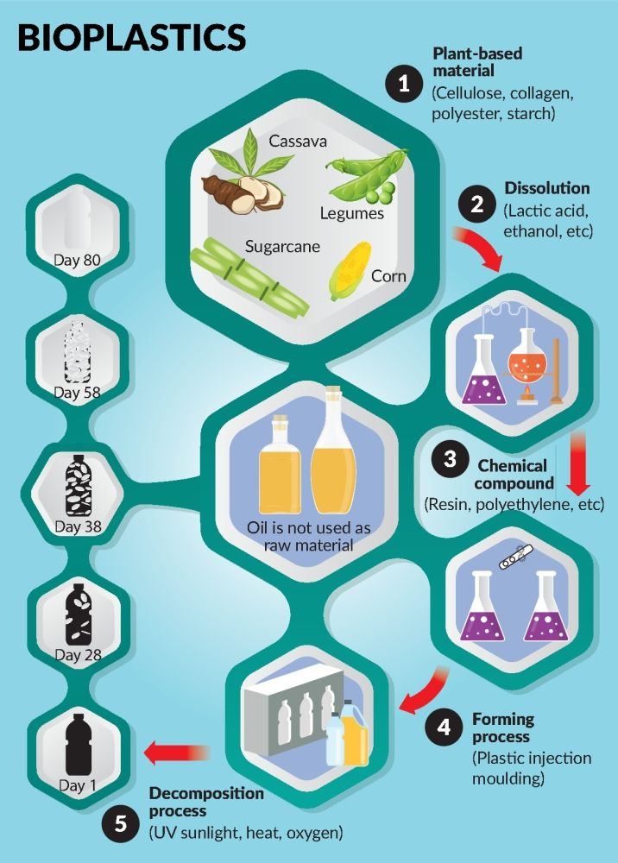
Figure- 1. Structural modifications, decomposition and Sources of Bioplastics
CLASSIFICATION OF BIOPLASTICS
Plastics can be made from bio-based materials or sometimes fossils based materials and can be biodegradable or non-biodegradable plastics while bioplastic can be fully made from renewable-material, whereas biodegradable plastic is made of either fossil-based polymer or a combination of renewable and fossil materials.
There are three main types of bioplastics which are-
1. biodegradable and biobased,
2. biodegradable and fossil-based, and
3. non-biodegradable and bio based plastics; while
non-biodegradable and petroleum based plastics are another type of plastics generally known as conventional plastic.
Table 1. Types of bioplastics:
Class | Bio-Based | Petroleum Based | References
Biodegradable | Bioplastics -Eg: Polylactic acid, Polyhydroxy alkanoates, Cellulose, Starch | Bioplastics -Eg: Polybutylene succinate, Polybutylene adipate terephthalate, Polycaprolactone | [10], [11],[12],[13]
Nonbiodegradable | Bioplastics -Eg: Biopolypropylene, Biopolyethylene | Conventional plastics -Eg: Polypropylene, Polyethylene, Polystrene, Polyvinyl chloride | [11],[12],[14], [15]
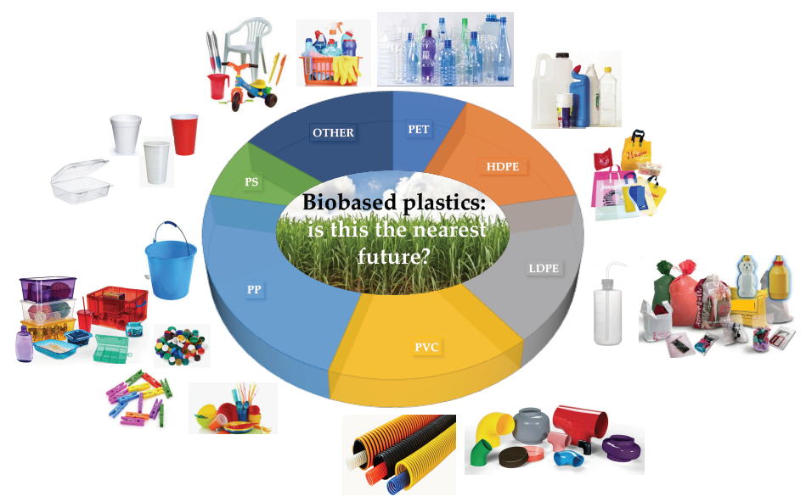
Figure-2. Some Products of Bioplastics
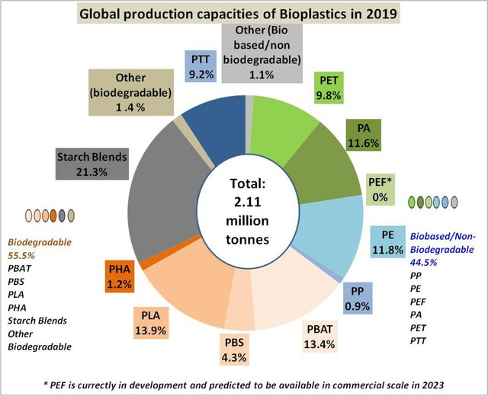
Figure-3. Global Production capacities of Bioplastics in 2019 [16], Content available from Journal of Polymers and the Environment
Packaging (both ﬂexible and rigid packaging) is the largest ﬁeld of application for bio-based plastics, which accounts for over 50% of 2.11 million tons of bio-based plastic production (in 2019, see figure No. 3), followed by textile, consumer goods, agriculture and horticulture, automotive and transport goods, coatings and adhesives, building and construction, electrics and electronics, and several others like toys etc.

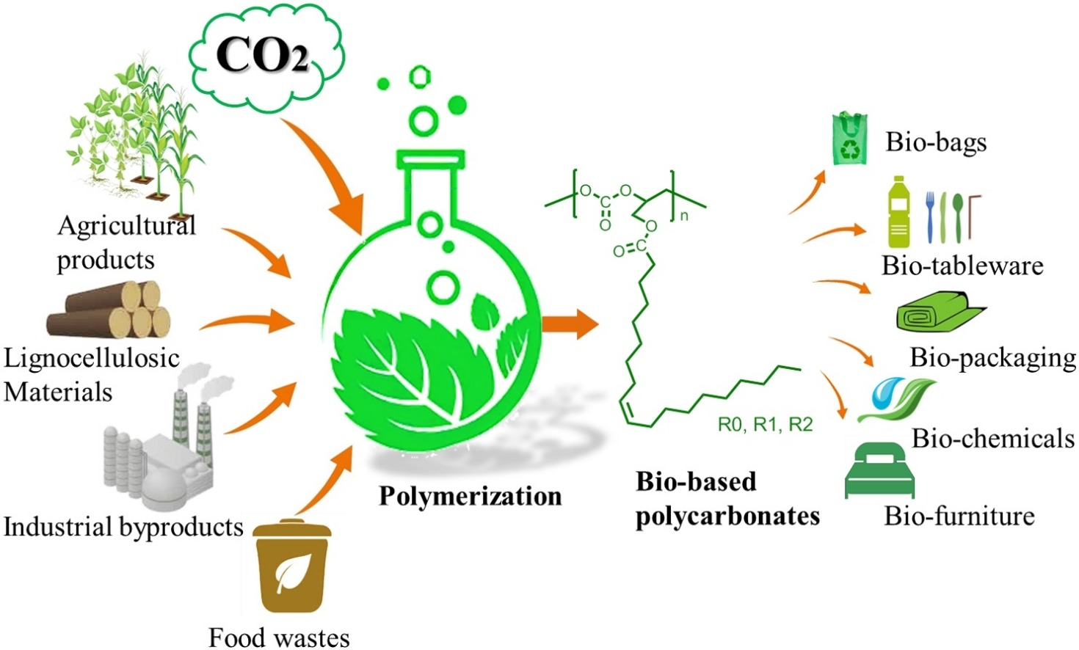
Figure- 4. Polymerization and Thermoforming in Bioplastics

Thermoforming in Bioplastics
Bioplastics like PLA use renewable bio based carbon. Based on the renewable carbon in the product, it provides an intrinsic reduction in the carbon footprint [17]. However, the concept behind the use of bio renewable feed stocks for reducing the carbon footprint is either not calculated in the many LCA reports or if it is, then it is lumped together with other related carbon emissions as well as the “intrinsic value proposition” is lost. Intrinsic zero carbon value propositions is best explained by nature’s biological carbon cycle. The natural carbon cycle varies through various environmental compartments with specific mass, rates and according to time scales.
Carbon is present in the atmosphere as CO2, essentially as inorganic carbon. CO2 is a life-sustaining, heat-trapping gas, and needs to be maintained at or around current levels to maintain life-sustaining temperature of the planet. Although there have been discussions on the severity of effects associated with different levels of CO2, there has been consensus on how uncontrolled increases in CO2 levels in atmosphere will lead to global warming. It is therefore necessary to understand the importance of reducing CO2 levels in the atmosphere or to try and maintain their current levels. This is best explained by growing biomass crops annually as feed stocks to produce carbon-based products. This liberates CO2 at the end of the life cycle of the product after use, which is captured by planting new crops in the next season. The carbon footprint is defined as neutral or zero when the rate of CO2 release to the environment at the end of life is equal to the rate of fixation done by photo synthetically by the next generation biomass of crop planted [17,18].

When considering fossil feed stocks, the rate of carbon fixation is in millions of years, while the end-of-life release rate into the environment is 1 to 10 years. This means that the fossil-feed stock will release more CO2 than fixation, resulting in an increased carbon footprint. Therefore it is not sustainable and leads to severe environmental impacts. Thus, for every 100 kg of polyolefin (polyethylene, propylene) or polyester manufactured from a fossil feedstock, there is an intrinsic net 314 kg CO2 (85.7% fossil carbon) or 229 kg of CO2 (62.5% fossil carbon) released into the environment, respectively, at end-of-life (see Figure 4).

What is industrial biotechnology?
- The use of biological substances for the processing and production of enzymes, chemicals, materials and energy.

- Industrial biotechnology creates materials, chemicals and energy using biological processes at the heart of the technology.

What is its impact?
Industrial biotechnology has already delivered considerable benefits to the UK and globally. It has helped the development of antibiotics, vaccines, cleaning materials, personal care products, recycling wastes and reducing energy consumption in chemical manufacturing.

Industrial biotechnology is generally used and processed for the production of several enzymes, medicines, chemicals, materials used for various purposes and energy products of bioengineering and bio processes. Industrial biotechnology help us in development of all the antibiotics along with immunization vaccines, cleaning materials, personal care products, more than 100 of recycling wastes and reducing energy consumption in chemical manufacturing and several other bio based products. It impact beneficial effect on natural and climatic environment as well as human survival strategies in various ways.
Discussions
At first, the word “biodegradability” may refers to a broad range of enzymatic as well as chemical reactions those mediated by bacteria or other biological organisms. This is due to the efficiencies of which are governed by the conditions in which these polymers biodegrade [19]. Microorganisms, industrial or home composting as an endof life option, as well as anaerobic digestion, may also decompose bioplastics, encouraging a more sustainable circular economy [20]. Therefore, it does not imply that the need for fossil fuels is eliminated. With this, the amount of greenhouse gas emissions associated with bioplastic production is much reduced now these days. Because the carbon dioxide (CO2) taken from the air during photosynthesis compensates for the CO2 released during biodegradation, it can be carbon neutral or even carbon negative [21, 22].
Bio based plastic representing new plastic generation because it is paving the way towards sustainability, renewability, and biodegradability. Their mechanical behaviour can be measured in terms of tensile, flexural, impact, and hardness. Reinforcing agents are added to bio based plastics due to strengthen their mechanical properties and expand their fields of application. For biocomposites, the choice of filler type, aspect ratio, filler loading and surface treatment applied greatly influenced to the final mechanical properties. To tailor the performance of final composites, uniform dispersion of reinforcement inside the matrix and a strong degree of interaction between them might be required in their composite materials. The hydrophilic fibres are modified for further compatibility enhancement because of its hydrophobic behavior of the polymer matrix. These all properties makes the bio based plastics the future plastics and climatically fit for better survival of human beings as a need of today.
Conclusions and Future Needs
Bioplastic is as like as natural polymeric material that is developing extensively over the last two decades. It is better option for sustainable use due to its good biocompatibility, biodegradability, and material properties. Bio based plastic production has become one of the most active research areas in recent years and needs of today’s also. Bioplastic has generally usable in packaging industries; spray materials, appliance materials, electronic products, agricultural products, automation products, chemical media, and several solvents. In the production of bioplastics, the inter linkage of biotechnology processes is a key strategy that aimed at maximizing the use of food as well as other wastes materials and increasing the potential revenue of the entire bioprocessing chain which is naturally fit for human life strategies.
Conflicts of Interest
The authors declare no conflict of interest.

References

- Fabbri P, Bertin L, Cavani F, Viaggi D, Fava F, Fisher Kukk P and Wydra S (2019). Final Report of the Task 3 BIOSPRI Tender Study on Support to R&I Policy in the Area of Bio‐based Products and Services, delivered to the European Commission (DG RTD). Study funded under contract no. 2016/RTD/F2/OP/PP‐04541‐2016.
- Markets and Markets (2020) Bioplastics & Biopolymers Market by Type (Non‐Biodegradable/Bio‐Based, Biodegradable), End‐Use Industry (Packaging, Consumer Goods, Automotive & Transportation, Textiles, Agriculture & Horticulture), Region ‐ Global Forecast to 2025. Report.
- Utracki LA (2002) Compatibilization of polymer blends. Can J Chem Eng 80, pp. 1008–1016. [Google Scholar]
- Sarifah Fauziah Syed Draman, Izathul Shafina Sidek1, Siti Rozaimah Sheikh Abdullah and Nornizar Anuar (2019). Current development on bioplastics and its future prospects: an introductory review. DOI: http://doi.org/10.26480/itechmag.01.2019.03.08
- Albuquerque M.G.E., Eiroa M., Torres C., Nunes B.R., Reis M.A.M. (2007). Strategies for the development of a side stream process for polyhydroxyalkanoate (PHA) production from sugar cane molasses. Journal of Biotechnology, Volume 130, Issue 4, 15 July 2007, Pages 411-421. https://doi.org/10.1016/j.jbiotec.2007.05.011
- Albuquerque M.G.E., Torres C.A.V., Reis M.A.M. (2010). Polyhydroxyalkanoate (PHA) production by a mixed microbial culture using sugar molasses: Effect of the influent substrate concentration on culture selection. Water Research, Volume 44, Issue 11, June 2010, Pages 3419-3433. https://doi.org/10.1016/j.watres.2010.03.021
- Reis Maria A.M., Filomena Freitas and Vitor D. Alves (2011). Advances in bacterial exopolysaccharides: from production to biotechnological applications. Trends in Biotechnology, August 2011, Vol. 29, No. 8. doi:10.1016/j.tibtech.2011.03.008
- Lee et al., (2014). Preparation and Characterization of Bioplastic-Based Green Renewable Composites from Tapioca with Acetyl Tributyl Citrate as a Plasticizer. Materials 2014, 7(8), 5617-5632; https://doi.org/10.3390/ma7085617
- Fernanda R. Oliveira, Anil K. Patel, Deb P. Jaisi, Sushil Adhikari, Hui Lu d, Samir Kumar Khanal et al. (2017). Environmental application of biochar: Current status and perspectives. Bioresource Technology. Volume 246, December 2017, Pages 110-122. https://doi.org/10.1016/j.biortech.2017.08.122
- Mohapatra, A., Prasad, S., Sharma, H. (2015). Bioplastics- Utilization of Waste Banana Peels for Synthesis of Polymeric Films.
- Syed Ali Ashter, (2014). Thermoforming of Single and Multilayer Laminates. Chapter 9 - Safety, Recycling and Environmental Issues of Thermoforming and its Products. https://doi.org/10.1016/B978-1-4557-3172-5.00009-8
- Emadian, S. M., Onay, T. T., Demirel, B. (2017). Biodegradation of bioplastics in natural environments. Waste Management. 59, 526–536.
- Mónica Carvalheira, Bruno C. Marreiros, and M.A.M Reis (2022). Chapter 13 - Acids (VFAs) and bioplastic (PHA) recovery. Clean Energy and Resource Recovery Wastewater Treatment Plants as Biorefineries, Volume 2, Pages 245-254. https://doi.org/10.1016/B978-0-323-90178-9.00016-0
- Hubbe, M.A.; Lavoine, N.; Lucia, L.A.; Dou, C. (2020). Formulating Bioplastic Composites for Biodegradability, Recycling, and Performance: A Review. Bio Resources., 16, 2021–2083. [CrossRef]
- Narancic, T.; Cerrone, F.; Beagan, N.; O’Connor, K.E (2020). Recent Advances in Bioplastics: Application and Biodegradation. Polymers., 12, 920. [CrossRef]
- Coppola, G.; Gaudio, M.T.; Lopresto, C.G.; Calabro, V.; Curcio, S.; Chakraborty, S (2021). Bioplastic from Renewable Biomass: A Facile Solution for a Greener Environment. Earth Syst. Environ., 5, 231–251. [CrossRef]
- Reichert, C.L.; Bugnicourt, E.; Coltelli, M.B.; Cinelli, P.; Lazzeri, A.; Canesi, I.; Braca, F.; Martínez, B.M.; Alonso, R.; Agostinis, L.; et al. (2020). Bio-Based Packaging: Materials, Modifications, Industrial Applications and Sustainability. Polymers, 12, 1558. [CrossRef]
- Mao H-I, Wang L-Y, Chen C-W, Hsu K-H, Tsai C-H, Cho C-J, Yu Y-Y, Rwei S-P, Kuo C-C (2021). Enhanced crystallization rate of bio-based poly(butylene succinate-co-propylene succinate) copolymers motivated by glycerol. J Polym Res 28(3):92
- Ilyas, R. A.,. Sapuan, S. M., Sanyang, M. L., Ishak, M. R. (2016). Nanocrystalline cellulose reinforced starch-based nanocomposite: A review. Conference Paper. 82–87.
- Soykeabkaew, N., Tawichai, N., Thanomsilp, C., O. Suwantong, O. (2017). Nanocellulose-Reinforced Green Composite Materials. Walailak Jounal Science & Technology. 14(5), 353–368.
- Lackner, M. (2015). Bioplastics - Biobased plastics as renewable and/or biodegradable alternatives to petroplastics. Kirk-Othmer Encyclopedia of Chemical Technology.
- Sun, Q. (2015). Development of Bio-based and Biodegradable Film from Carbon Dioxide Based Polymer and Poly (Lactic acid). University of Guelph.

