Emerging Mxenes materials for efficient supercapacitor applications: Current Trends and Future Perspectives
S. Arun Kumar¹, A. Gowdhaman¹, C. Balaji¹, Prabhu Sengodan², Venkadeshkumar Ramar³, R. Ramesh¹ and P.M. Anbarasan^{1*}
¹Department of Physics, Periyar University, Salem, Tamil nadu, India.
²Department of Chemistry, Bar-Ilan Institute for Nanotechnology and Advanced Materials, Bar-Ilan University, Ramat-Gan52900, Israel.
³Zuckerberg Institute for Water Research, The Jacob Blaustein Institutes for Desert Research, Ben Gurion University of the Negev, 84990 Midreshet Ben Gurion, Israel.
*Corresponding author: anbarasanpm@gmail.com
Abstract
In recent years, MXene has become one of the most advanced potential electrode materials used in high-performance supercapacitor applications. MXene nanomaterials possessed theoretical capacity, specific surface area, mass load, flexibility, and outstanding mechanical qualities. MXene and related nanocomposites demonstrated their potential as new electrode materials. A wide variety of instances of MXene electrode materials are given in detail to further demonstrate the modifications brought about by these composites. This chapter discusses the most recent advances in the research of MXene-based SCs and their composites for supercapacitor applications. This chapter primarily addressed the electrochemical properties of composite electrode materials made of MXene and MXene-based compounds for energy storage applications.
Introduction
With the high-speed development of electronic devices in the modern societies the electrical energy is most important in the recent days. In these concerns, the sustainability, environmental freely and high efficiency energy conversion devices are required in this next generation lifestyles. Taking in this action, the electrochemical energy storage devices were helped to overcome these issues due to its specified with energy and power densities [1-5].
The EESDs were consists of capacitor, electrochemical supercapacitor, battery and fuel-cell. Based on the variation of energy and power density values the above-mentioned devices were categorised. Capacitor is one of the high-power density energy storage devices, which the charges were accumulates via dielectric medium. Batteries are considered as the off-middle energy and power density tools. In same way, fuel-cell as a high-energy density energy storage and conversion tool. Supercapacitor has a midway of the energy and power densities in the EESD systems due to its special features of remarkable theoretical capacitance, long-life duration performance [6-10].
The achievement of high-performrance in supercapacitors, we need to focus on the electrode material. In this connection, various (1D, 2D and 3D) dimensional based materials are involved in charge storage process. Herein, two-dimensional (2D) materials have the most potential in the supercapacitor applications. Because of their outstanding mechanical, electrical, electronic, and chemical capabilities, single-layer atom-thick materials have made significant advances in a variety of industries, including semiconductors, electrodes, photovoltaics, water purification, etc.
Among them, graphene is a well-known material that has the distinction of being the first 2D material to be found in 2004. Since its discovery, graphene has been the only material used in electronics and has attracted significant scientific interest.
The first of the family, a non-oxide, layered Ti₃C₂ ceramic, was created in 2011 from its three-dimensional bulk crystalline Ti₃AlC₂ phase by a chemical process known as exfoliation that included selective etching at room temperature. This was quickly followed by the discovery and synthesis of more than a dozen other MXenes structures, an endeavour driven by worldwide skyrocketing deposition rates.
In this chapter contains the synthesis of MXene and their composites for supercapacitor applications and to evaluate the charge storage properties.
MXene as an 2D Material
MXenes are new kind of two-dimensional compounds that are essentially stacked carbides, carbonitrides, and nitrides were combined with transition metals [11]. These are identified as M_{n+1}X_{n} (n = 1, 2, or 3), where "M" denotes an transition metal (such as Sc, Ti, Zr, V, Nb, Cr, or Mo) and "X" denotes either carbon or nitrogen. Due to its sheet-like structure, the "ene" in MXene is modelled after graphene. More than one "M" may be present in them, and these "Ms" may be arranged as ordered phases or solid solutions. Alternatively, in the representation of functionalized MXenes (M_{n+1}X_{n}T_{x}), the additional denotation "T" refers to free active group surface terminations (like -H, -F, = O and -OH) that were left over from the aqueous etchants (HF, H₂O, HCl) used during the selective etching of element "A" from their parent MAX phase [12-13]. The MXenes are given a hydrophilic quality by these terminations, which also significantly affects their electrochemical and dielectric properties. Furthermore, MXene with a specified termination can be produced via controlled chemical processing, intercalation and delamination, thermal annealing, and exfoliation techniques.
The MAX phases are a group of layered structures with the formula M_{n}AX_{n+1} (n = 1-3), where 'A' can be Al, P, Si, Ga, S, As, Ge, In, Sn, etc. In the MAX phase, the MX layer and the "A" layer are alternately layered. In contrast to the extremely strong M-X connection, the A element is bonded relatively weakly and more reactive, so selective etching eliminates it while leaving the MX arrangement intact [14] (Luo, 2018). MXenes are generated from the parent MAX phase lattice structure and feature hexagonal symmetry at the structural level. There are three main ways to prepare MXenes. One has a single M element, like Ti₂C and Mo₂C, another is a solid solution of one or more M elements arranged randomly, like (Ti,V)₂C₂ and (Cr,V)₃C₂, and the last type is double-ordered M elements, like Mo₂TiC₂ and Mo₂Ti₂C₃, where either a single M element layer or two layers of a single M element are arranged between layers of a second M element. Accordingly, each of these MXenes can be represented as M₂X, M₃X₂, and M₄X₃, which are derivations of their respective MAX phases, M₂AX, M₃AX₂, and M₄AX₃, respectively. The structure of these MAX phases and their associated MXenes is seen in Fig. 1.
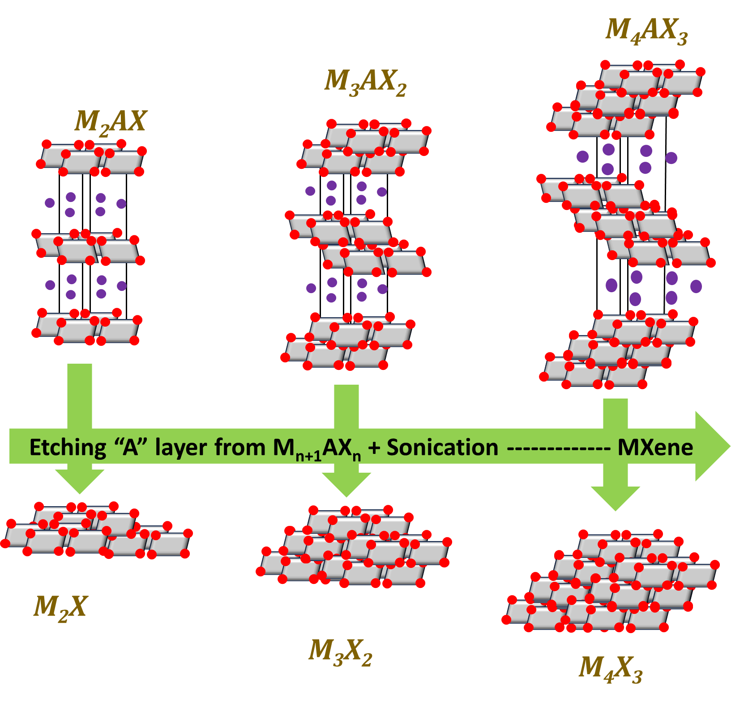
Fig. 1 Structure of different MAX phases and their respective Mxenes [15].
Fig. 2 depicts the aforementioned procedure to remove the “A” element form the MXene nanostrutute. Other MXenes, including Ti₂C, Ta₄C₃, (Ti_{0.5}, Nb_{0.5})₂C, Ti₃CN, (V_{0.5}, Cr_{0.5})₃C₂, Ti₂C₃, and Cr₂TiC₂, were also synthesised using this technique. Alternative etchants for the preparation of various MXenes include NH₄HF₂ and a combination of LiF and HCl. As time went on, several efforts were made to generate various MXenes by utilising various etchants and etching processes. It goes without saying that key factors in chemical reactions include temperature, etching time, etchant concentration, MAX phase particle size, and etching parameters.
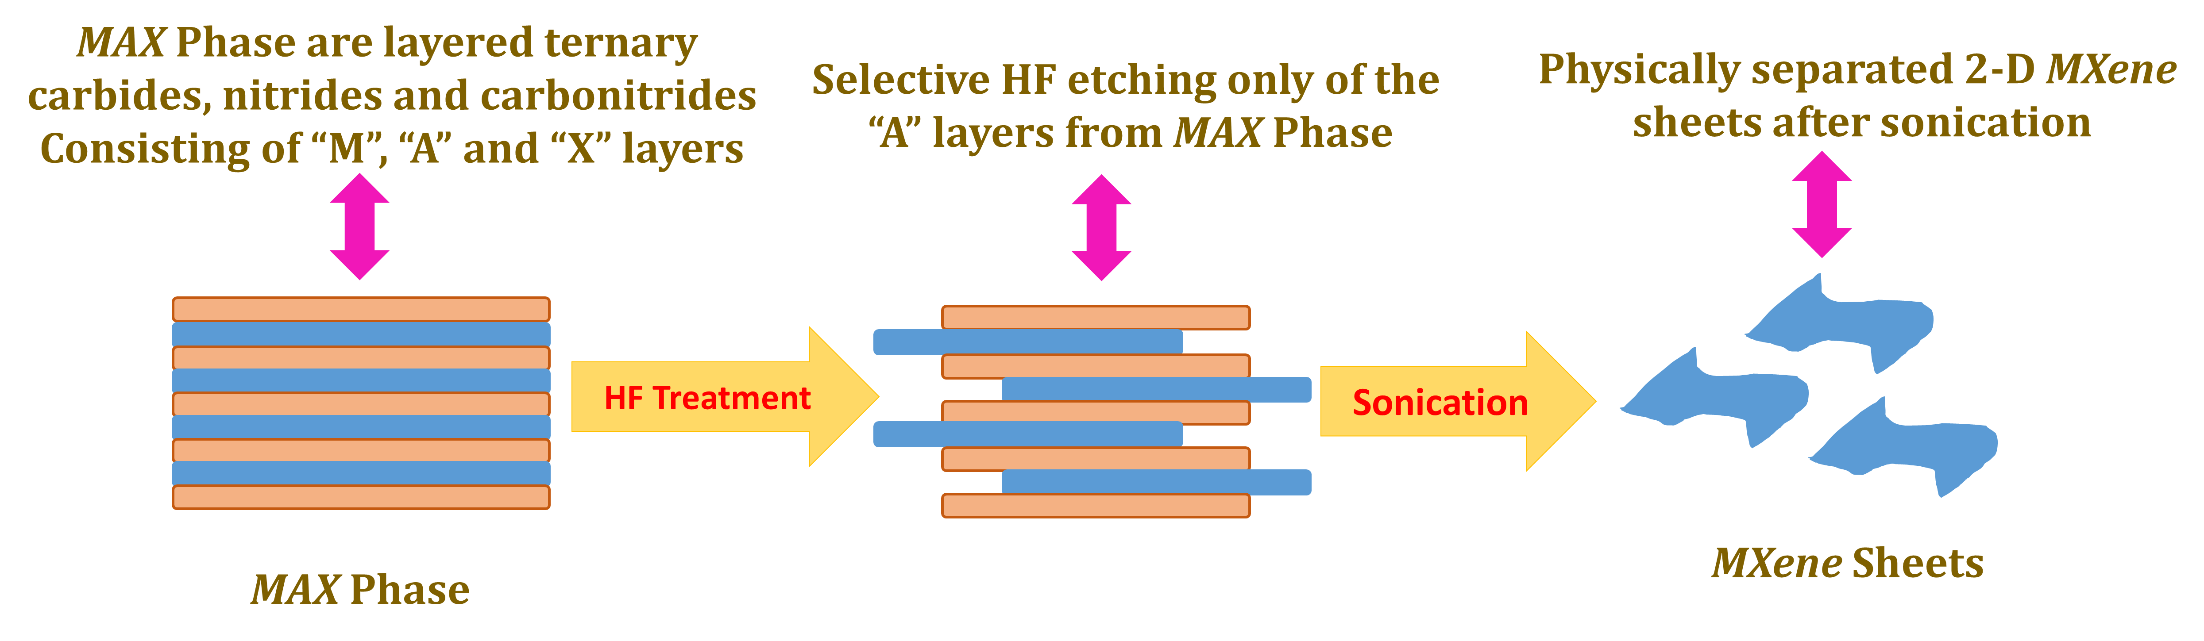
Fig. 2 Schematic for the preparation route of MXenes from the MAX phases [15].
MXene – Properties
Due to their exciting combination of features, Mxenes - relatively the more recent addition to the family of 2D materials - have raised a number of captivating problems for researchers from the various fields. Due to the fact that they are ceramic, they are stable mechanically and chemically in nature. They have very large interlayer spacing, even larger than that of graphite, and their structural shapes include both mono-layer and multilayer structures. The thickness of the layers possible to modify in this structure. This open area between the layers is capable of ion intercalation, which implies that ions of various sizes can be injected into this gap. This property is crucial for the material to be employed as a cathode in energy conversion applications [16-17].
Thus, as the layered structure is partially delaminated, it not only permits ion intercalation but also the creation of an electric double layer (EDL), which aids in charge storage in capacitors. The contact between MXene layers is primarily caused by hydrogen bonding and van der Waals attraction. Functional groups acting as terminations offer numerous chances to design the desired surface properties and aid in the regulation of their electrochemical, thermoelectric, and dielectric properties. Surface terminations transform the normally metallic MXenes into semiconductors like Sc₂CF₂, Sc₂CO₂, and Ti₂CO₂. Additionally, MXenes have extremely active transition components (M). The same can also be made using a variety of transition metals, each of which can be customised for a variety of purposes [18]. Direct functional theory has estimated that some of these MXenes have in-plane elastic constants above 500 GPa, which is even higher than the stiffness of routinely used structural steel, which is 400 GPa [19]. The MXenes must have excellent structural, mechanical, electrochemical, ion mobility, and electronic transport properties in order to be used as electrode materials.
The 'M' atoms serve as the source of their electrical characteristics. Surface functionalized MXenes often exhibit semiconducting nature, while all unfunctionalized MXenes exhibit metallic nature. Sc-based MXenes such Sc₂CF₂, Sc₂C(OH)₂, and Sc₂CH₂ nanotubes and Mo₂CT_{x} films have been proven to have semiconductor-like characteristics using Density Functional Theory (DFT) optimised computations. It was discovered that the Ti vacancy defects were responsible for the high conductivity of Ti-based MXenes such Ti₃C₂T_{x}. In addition to their use in energy storage devices, their high conductivity property has opened them up for possible applications as transparent conductors, magnetic materials, superconductors, absorbents for heavy metals, and flexible electronic devices.
MXenes have previously been experimentally included for a variety of prospective uses, including rechargeable metal-ion batteries, supercapacitors, field effect transistors, electromagnetic interference shielding, hydrogen storage, sensors, catalysts, composites, and biomedical devices [20].
MXene – Synthesis process
There are two methods for synthesising MXenes. In the top-down approach, thin layers of MXene films are exfoliated from their MAX phase/non-MAX phase precursors, whereas in the bottom-up approach, diverse materials are mixed to generate MXene thin films.
The synthesis procedures determine the structure, features, and qualities of MXene. Fig. 3 is a flow diagram categorising several top-down and bottom-up synthesis methods of MXenes.
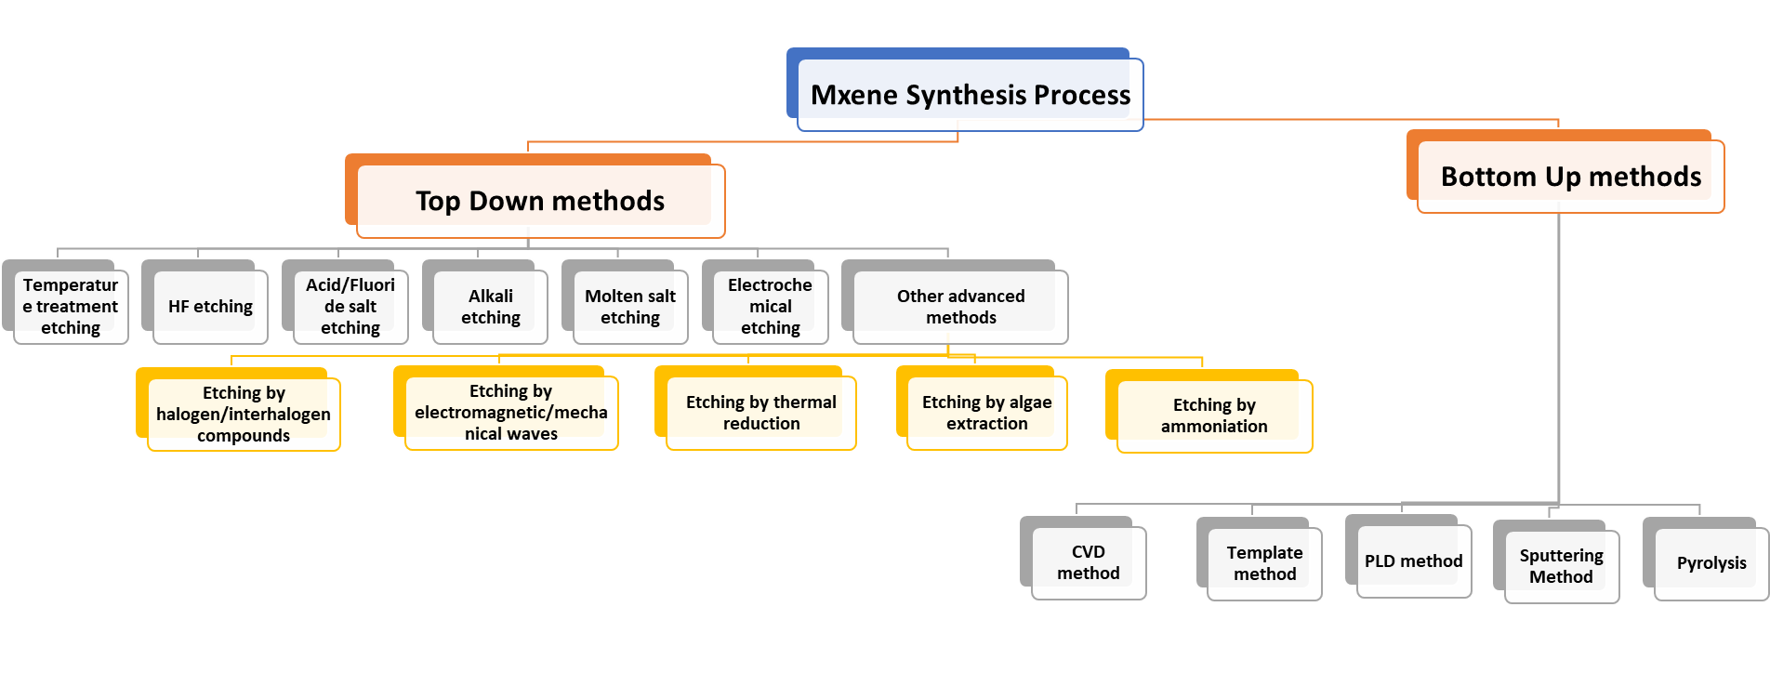
Fig. 3. Top-down and bottom-up synthesis approaches of MXene [21]
MXene for energy storage application
The demand for energy storage technologies like electrochemical batteries and supercapacitors is expected to increase gradually over the coming years to the industrial trends and progressive national policies. At the same time the world moves away from fossil fuel-based energy generation towards that derived from renewable sources like wind and sun, among others. They have a wide range of uses, from small electric mobility systems and handheld electronics to big electric grid systems [22].
The most widely used electrochemical energy storage (EES) solution is lithium-ion batteries, but they also have a lot of problems. These batteries raise a number of unique safety and cost issues. They suffer from extremely long charge times as well. Because of their wider availability and multivalent nature, it is thought that battery electrode materials have reached their operational limits and that newer, better devices utilising other metal ions, such as sodium, potassium, magnesium, calcium, etc., are now required. Improved development and selection of electrode and electrolyte materials are also necessary for these more recent systems in order to achieve maximum efficiency [23].
There are various obstacles to the development of LIBs and supercapacitors, but two are particularly significant: 1. Obtaining high energy and power density simultaneously for these devices is rather challenging. 2. There is a clear shortage of resources, which is causing supply chain problems, which are raising their prices [24]. Furthermore, the problem of utilising and storing all of the energy produced at bigger sizes has pushed scientists to include high performance materials into these devices for maximum efficiency.
Supercapacitors and rechargeable batteries both have advantages and disadvantages when it comes to functionality in the various electronic tools. In exchange for low power densities, batteries produce extremely high energy densities. In contrast, supercapacitors have relatively low energy densities and superior power densities in addition to a quick charge-discharge rate. In order to researchers have worked a lot to develop the electrodes that can deliver a combination of longer life cycles, high energy densities, and high-power densities [25]. These qualities have been made possible by Mxenes due to its good capable energy storage phenomena. Here are a few study findings that confirm MXene and MXene-based hybrid structures as the high-efficient electrode materials for innovative supercapacitor devices.
MXene for supercapacitor application
Supercapacitors are likely capacitors with a capacitance that is between that of rechargeable batteries and that of electrolytic batteries. In comparison to a standard rechargeable battery, they provide charges faster and have longer charge-discharge cycles. Supercapacitors can be broadly classified into two types, each with a unique method for storing and transferring charge storage process [26].
Some supercapacitors operate without going through phase shift; instead, they use redox processes, intercalations, and electro absorption, which are quite quick and offer higher energy densities. These are known as pseudocapacitors and are very dissimilar to electrical double layer capacitors (EDLCs), which essentially function by generating an electrical double layer at the interface of the electrode and electrolyte solution. This interface's capacitance increases with the specific surface area. Carbon or its derivatives, such as activated carbon and graphite, are the most common materials used as electrodes in EDLCs.
Traditional materials for pseudocapacitors, such as MnO₂, MoO₃, Nb₂O₅, RuO₂, etc., do give high capacitance, but they fall short due to their poor electrical conductivity. MXenes have made significant advancements in an electrochemical supercapacitor. Due to their distinct structure and electrical characteristics make them ideally well-matched for supercapacitor applications. In-depth studies have shown that these materials, both on their own and in combination with other heteroatoms, have achieved very high volumetric capacitance, structural stability, flexibility, and rate performance due to lower ion diffusion barrier and ultrahigh ion storage and delivery. The interlayer provides a large space for unhindered and fast electron movement. Table 1 represents the pure MXene and their electrochemical properties in supercapacitor applications.
Electrode | Etchant | Electrolyte | Capacitance (F cm⁻³) at scan rate (mV s⁻¹) | Rate performance (%) | Cycling retention (in cycles) | Ref.
Ti₃C₂T_{x} | HF | 1 M KOH | 340 at 20 | 62.2 | 100 % (10,000) | 27
Ti₃C₂T_{x} | HCl/LiF | 1 M H₂SO₄ | 910 at 2 | 81.3 | 100 % (10,000) | 28
d-Ti₃C₂T_{x} | HF | 1 M H₂SO₄ | 520 at 2 | 42.3 | 100 % (10,000) | 29
KOH-400- Ti₃C₂T_{x} | HF | 1 M H₂SO₄ | 517 at 1 | - | 99 % (10,000) | 30
MXLLC | HCl/LiF | 3 M H₂SO₄ | 200 at 2 | - | 100 % (20,000) | 31
Ti₃C₂T_{x} | NaOH | 1 M H₂SO₄ | 511 at 2 | - | 89 % (10,000) | 32
Ti₃C₂T_{x} hydrogel | HCl/LiF | 3 M H₂SO₄ | 1500 at 2 | 56.8 | 90 % (10,000) | 33
Ti₃C₂T_{x} hydrogel | HCl/LiF | 3 M H₂SO₄ | 226 at 1 | 83.1 | 95 % (10,000) | 34
Ti₃C₂T_{x} aerogel | HCl/LiF | 1 M KOH | 87.1 at 2 | 76.6 | 97 % (10,000) | 35
MXene – C12 | HF/LiCl | EMIMTFSI | 492 at 1 | 38.9 | 95 % (10,000) | 36

Conclusion
Mxene, a brand-new two-dimensional substance, has generated considerable interest in the scientific community due to its excellent mechanical, electrical, and especially electrochemical capabilities, much like graphene. This special features of that Mxene will be widely used in the next generation of extremely effective electrochemical devices for energy storage and conversion process, which are greatly needed in small-scale portable electronic devices, mobile phones, and tablets. Moreover, MXene and MXene-based hybrid structures are being tested as potential electrode materials on a range of aqueous electrolytic parameters, including power density, energy density, life cycle, charge-discharge cycles, structural stability, volumetric capacitance, areal capacitance, flexibility and deformability, rate performance, ion diffusion barrier, electron mobility, electrical and thermal conductivities. Some of the preparation process involved such as etching techniques, post-etching treatments like sonication, annealing, etc., have been developed for ideal intercalation and exfoliation, desired interlayer spacing, removal of excess surface terminations and designed inclusion of dopants to make the thin and flexible Mxene-based composite films. To ensure that technology is broadly implemented at minimal environmental free, low cost and structural stability in future.
References
- Kumar SA, Sindhuja V, Gowdhaman A, Balaji C, Ramesh R, Anbarasan PM. Construction of vertically aligned MnCo2O4 needles and Bi2WO6 globules as optimal electrode materials for hybrid supercapacitor. Electrochimica Acta. 2023 Aug 10;459:142545.
- Kumar SA, Balaji C, Gowdhaman A, Ramesh R, Anbarasan PM. Achieving High Energy Density in Supercapattery by Employing CuFe2O4 Microsheets and Bi2O3 Microspheres. Colloids and Surfaces A: Physicochemical and Engineering Aspects. 2023 Jun 10:131856.
- Prabhu S, Maruthapandi M, Durairaj A, Kumar SA, Luong JH, Ramesh R, Gedanken A. Design of three-dimensional hexagonal petal-like nickel-copper cobaltite//luffa sponge-derived activated carbon electrode materials for high-performance solid-state supercapattery. Fuel. 2023 Jul 15;344:128122.
- Gowdhaman A, Kumar SA, Elumalai D, Balaji C, Sabarinathan M, Ramesh R, Navaneethan M. Ni-MOF derived NiO/Ni/r-GO nanocomposite as a novel electrode material for high-performance asymmetric supercapacitor. Journal of Energy Storage. 2023 May 1;61:106769.
- Kumar SA, Saravanakumar B, Mohanty S, Ramadoss A. Design of open-porous three-dimensional starfish-like Co3O4/Ni forest electrode for efficient energy storage devices. Journal of Alloys and Compounds. 2022 Mar 10;896:163070.
- Prabhu S, Maruthapandi M, Durairaj A, Arun Kumar S, Luong JH, Ramesh R, Gedanken A. Performances of Co2+-substituted NiMoO4 nanorods in a solid-state hybrid supercapacitor. ACS Applied Energy Materials. 2023 Jan 23;6(3):1321-31.
- Aswathy NR, Kumar SA, Mohanty S, Nayak SK, Palai AK. Polyaniline/multi-walled carbon nanotubes filled biopolymer based flexible substrate electrodes for supercapacitor applications. Journal of Energy Storage. 2021 Mar 1;35:102256.
- Kumar SA, Mohanty A, Saravanakumar B, Mohanty S, Nayak SK, Ramadoss A. Three-dimensional Bi 2 O 3/Ti microspheres as an advanced negative electrode for hybrid supercapacitors. Chemical Communications. 2020;56(85):12973-6.
- Chettiannan B, Srinivasan AK, Arumugam G, Shajahan S, Haija MA, Rajendran R. Incorporation of α-MnO2 Nanoflowers into Zinc-Terephthalate Metal–Organic Frameworks for High-Performance Asymmetric Supercapacitors. ACS omega. 2023 Feb 9;8(7):6982-93.
- Sengodan P, Govindan R, Arumugam G, Chettiannan B, Navaneethan M, Pallavolu MR, Hussien M, Selvaraj M, Rajendran R. A rational design of MnO2/CuO/r-GO hybrid and biomass-derived activated carbon for asymmetric supercapacitors. Journal of Energy Storage. 2022 Jun 1;50:104625.
- Naguib M, Mochalin VN, Barsoum MW, Gogotsi Y. 25th anniversary article: MXenes: a new family of two‐dimensional materials. Advanced materials. 2014 Feb;26(7):992-1005.
- Barsoum MW. MAX phases: properties of machinable ternary carbides and nitrides. John Wiley & Sons; 2013 Nov 13.
- Deysher G, Shuck CE, Hantanasirisakul K, Frey NC, Foucher AC, Maleski K, Sarycheva A, Shenoy VB, Stach EA, Anasori B, Gogotsi Y. Synthesis of Mo4VAlC4 MAX phase and two-dimensional Mo4VC4 MXene with five atomic layers of transition metals. ACS nano. 2019 Dec 5;14(1):204-17.
- Luo K, Zha XH, Zhou Y, Guo Z, Lin CT, Huang Q, Zhou S, Zhang R, Du S. First-principles study on the electrical and thermal properties of the semiconducting Sc 3 (CN) F 2 MXene. RSC advances. 2018;8(40):22452-9.
- Alnoor H, Elsukova A, Palisaitis J, Persson I, Tseng EN, Lu J, Hultman L, Persson PÅ. Exploring MXenes and their MAX phase precursors by electron microscopy. Materials Today Advances. 2021 Mar 1;9:100123.
- Tang H, Hu Q, Zheng M, Chi Y, Qin X, Pang H, Xu Q. MXene–2D layered electrode materials for energy storage. Progress in Natural Science: Materials International. 2018 Apr 1;28(2):133-47.
- Zhu J, Ha E, Zhao G, Zhou Y, Huang D, Yue G, Hu L, Sun N, Wang Y, Lee LY, Xu C. Recent advance in MXenes: a promising 2D material for catalysis, sensor and chemical adsorption. Coordination Chemistry Reviews. 2017 Dec 1;352:306-27.
- Tang H, Hu Q, Zheng M, Chi Y, Qin X, Pang H, Xu Q. MXene–2D layered electrode materials for energy storage. Progress in Natural Science: Materials International. 2018 Apr 1;28(2):133-47.
- Kurtoglu M, Naguib M, Gogotsi Y, Barsoum MW. First principles study of two-dimensional early transition metal carbides. Mrs Communications. 2012 Dec;2:133-7.
- Khazaei M, Ranjbar A, Arai M, Sasaki T, Yunoki S. Electronic properties and applications of MXenes: a theoretical review. Journal of Materials Chemistry C. 2017;5(10):2488-503.
- Panda S, Deshmukh K, Pasha SK, Theerthagiri J, Manickam S, Choi MY. MXene based emerging materials for supercapacitor applications: Recent advances, challenges, and future perspectives. Coordination Chemistry Reviews. 2022 Jul 1;462:214518.
- Nasrin K, Sudharshan V, Subramani K, Sathish M. Insights into 2D/2D MXene heterostructures for improved synergy in structure toward next‐generation supercapacitors: a review. Advanced Functional Materials. 2022 May;32(18):2110267.
- Javed MS, Zhang X, Ali S, Mateen A, Idrees M, Sajjad M, Batool S, Ahmad A, Imran M, Najam T, Han W. Heterostructured bimetallic–sulfide@ layered Ti3C2Tx–MXene as a synergistic electrode to realize high-energy-density aqueous hybrid-supercapacitor. Nano Energy. 2022 Oct 1;101:107624.
- Tang J, Wu F, Dai X, Zhou J, Pang H, Duan X, Xiao B, Li D, Long J. Robust MXene adding enables the stable interface of silicon anodes for high-performance Li-ion batteries. Chemical Engineering Journal. 2023 Jan 15;452:139139.
- Yang F, Hegh D, Song D, Zhang J, Usman KA, Liu C, Wang Z, Ma W, Yang W, Qin S, Razal JM. Synthesis of nitrogen-sulfur co-doped Ti3C2Tx MXene with enhanced electrochemical properties. Materials Reports: Energy. 2022 Feb 1;2(1):100079.
- Melkiyur I, Rathinam Y, Kumar PS, Sankaiya A, Pitchaiya S, Ganesan R, Velauthapillai D. A comprehensive review on novel quaternary metal oxide and sulphide electrode materials for supercapacitor: Origin, fundamentals, present perspectives and future aspects. Renewable and Sustainable Energy Reviews. 2023 Mar 1;173:113106
- Maria R Lukatskaya, Olha Mashtalir, Chang E Ren, Yohan Dall'Agnese, Patrick Rozier, Pierre Louis Taberna, Michael Naguib, Patrice Simon, Michel W Barsoum, Yury Gogotsi, Cation intercalation and high volumetric capacitance of two-dimensional titanium carbide, Science, 2013 Sep 27;341(6153):1502-5
- Michael Ghidiu , Maria R Lukatskaya , Meng-Qiang Zhao , Yury Gogotsi , Michel W Barsoum, Conductive two-dimensional titanium carbide 'clay' with high volumetric capacitance, Nature, 2014 Dec 4;516(7529):78-81
- Dall'Agnese Y, Lukatskaya MR, Cook KM, Taberna PL, Gogotsi Y, Simon P. High capacitance of surface-modified 2D titanium carbide in acidic electrolyte. Electrochemistry Communications. 2014 Nov 1;48:118-22.
- Li J, Yuan X, Lin C, Yang Y, Xu L, Du X, Xie J, Lin J, Sun J. Achieving high pseudocapacitance of 2D titanium carbide (MXene) by cation intercalation and surface modification. Advanced Energy Materials. 2017 Aug;7(15):1602725.
- Xia Y, Mathis TS, Zhao MQ, Anasori B, Dang A, Zhou Z, Cho H, Gogotsi Y, Yang S. Thickness-independent capacitance of vertically aligned liquid-crystalline MXenes. Nature. 2018 May 17;557(7705):409-12.
- Li T, Yao L, Liu Q, Gu J, Luo R, Li J, Yan X, Wang W, Liu P, Chen B, Zhang W. Fluorine‐free synthesis of high‐purity Ti3C2Tx (T= OH, O) via alkali treatment. Angewandte Chemie International Edition. 2018 May 22;57(21):6115-9.
- Lukatskaya MR, Kota S, Lin Z, Zhao MQ, Shpigel N, Levi MD, Halim J, Taberna PL, Barsoum MW, Simon P, Gogotsi Y. Ultra-high-rate pseudocapacitive energy storage in two-dimensional transition metal carbides. Nature Energy. 2017 Jul 10;2(8):1-6.
- Deng Y, Shang T, Wu Z, Tao Y, Luo C, Liang J, Han D, Lyu R, Qi C, Lv W, Kang F. Fast gelation of Ti3C2Tx MXene initiated by metal ions. Advanced Materials. 2019 Oct;31(43):1902432.
- Li L, Zhang M, Zhang X, Zhang Z. New Ti3C2 aerogel as promising negative electrode materials for asymmetric supercapacitors. Journal of power Sources. 2017 Oct 1;364:234-41.
- Liang K, Matsumoto RA, Zhao W, Osti NC, Popov I, Thapaliya BP, Fleischmann S, Misra S, Prenger K, Tyagi M, Mamontov E. Engineering the Interlayer Spacing by Pre‐Intercalation for High Performance Supercapacitor MXene Electrodes in Room Temperature Ionic Liquid. Advanced Functional Materials. 2021 Aug;31(33):2104007.

